Supplementary Figure 1

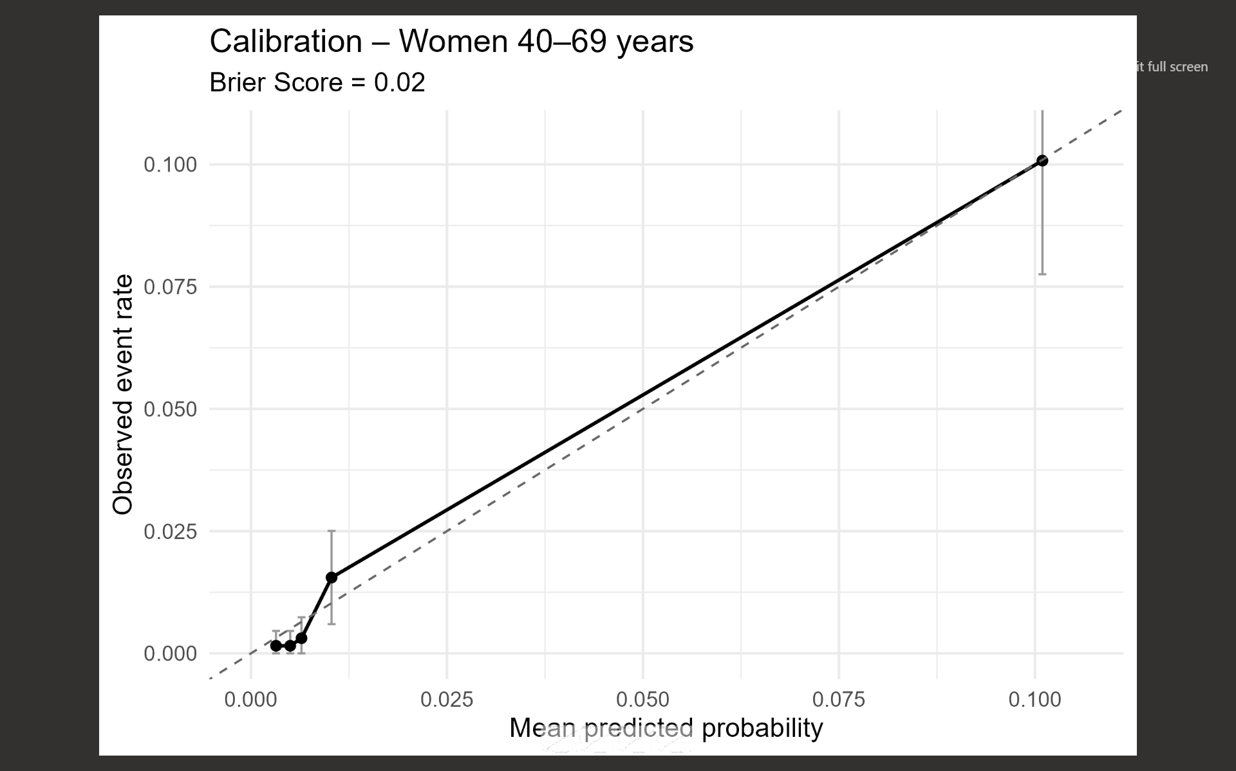

Supplementary Figure 2

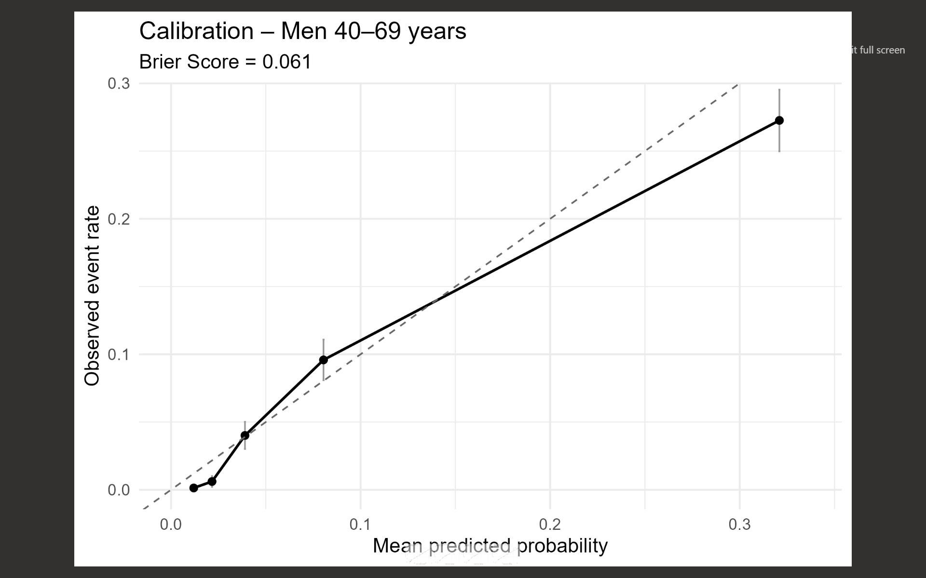
Supplementary Figure 3
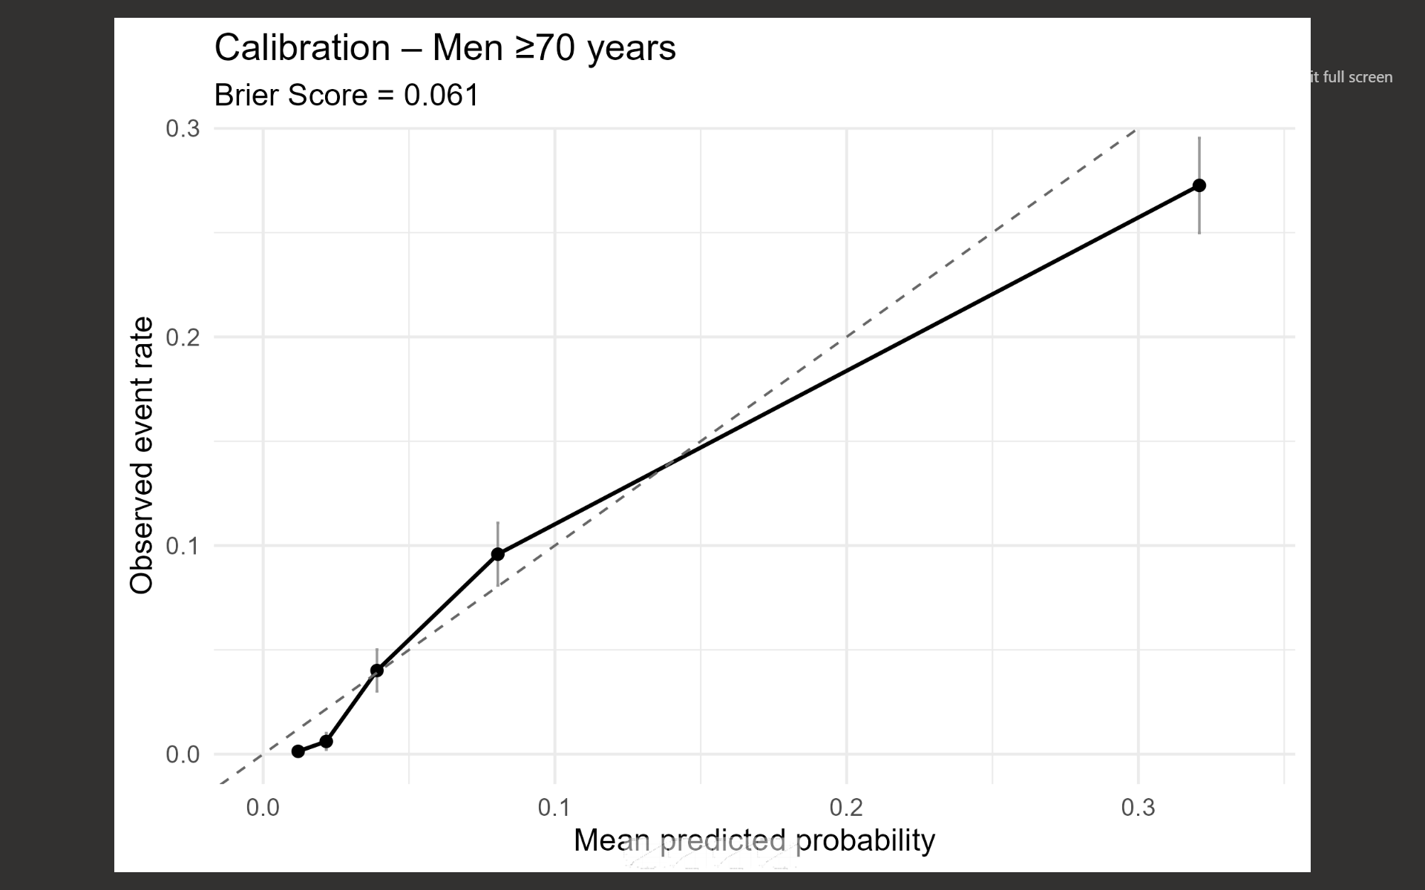

Supplementary Figure 4

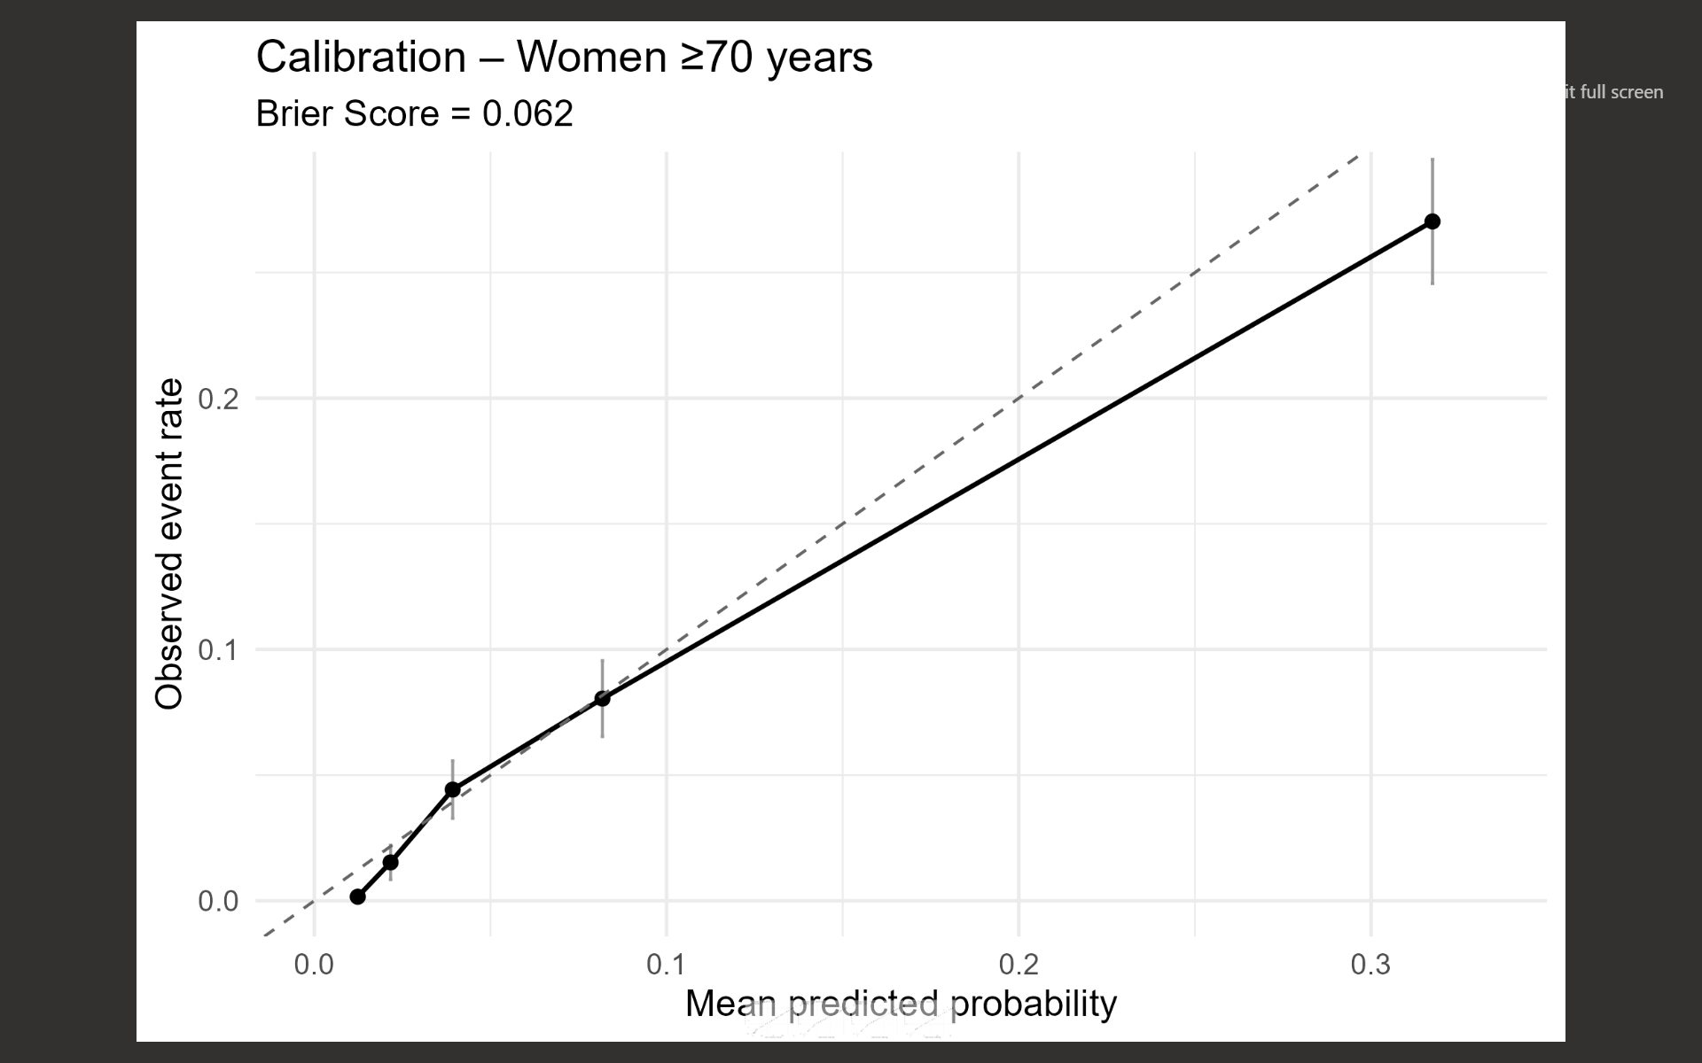
Supplementary Figure 5. Top variables in men 40 to 69 years.
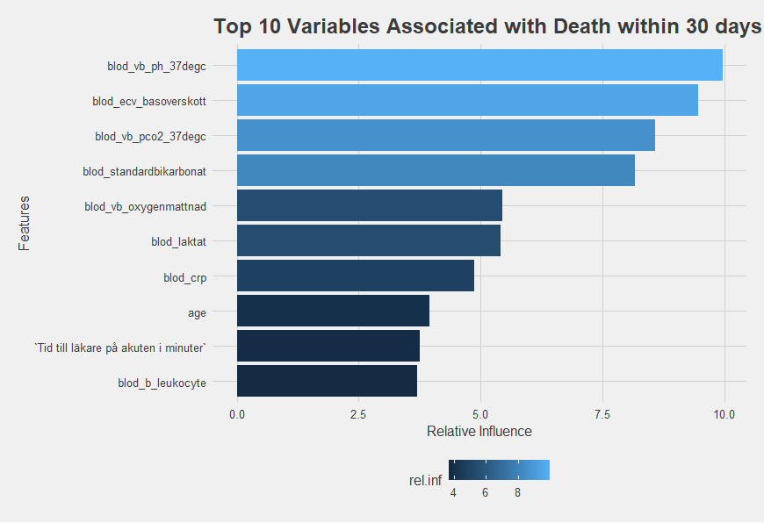

Supplementary Figure 6. Top variables in men ≥70 years.
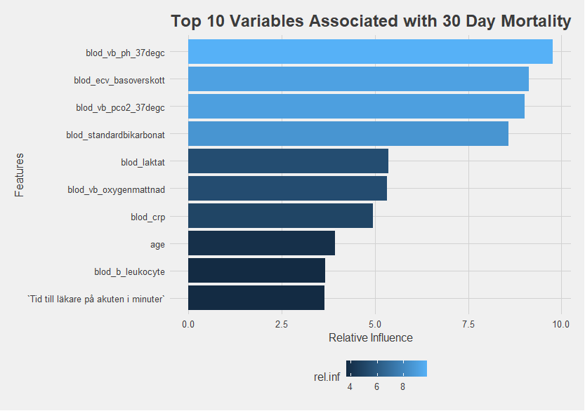

Supplementary Figure 7. Top variables in women 40 to 69 years.

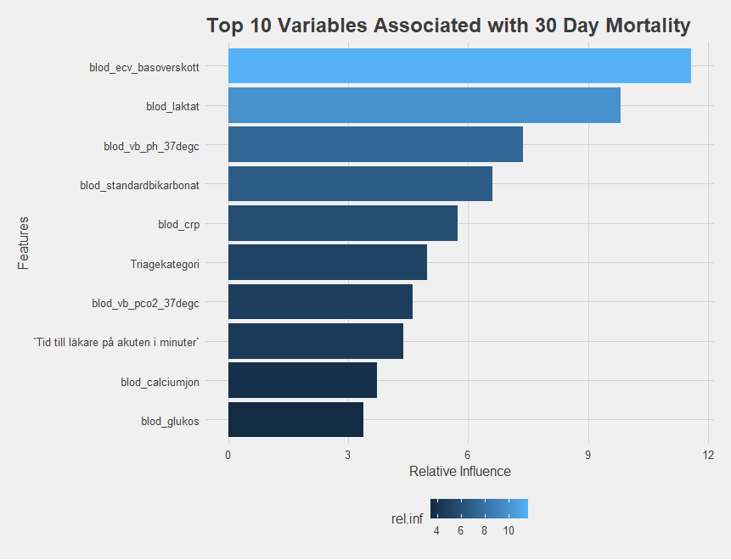

Supplementary Figure 8. Top variables in women ≥70 years.

