Table S1. Distribution of variables with missing data.
Variables | Number of missing | Proportion of missing
BMI | 1142 | 14.13%
SBP | 1125 | 13.92%
DBP | 1125 | 13.92%
Height | 1122 | 13.88%
Weight | 1105 | 13.67%
WC | 1100 | 13.61%
Smoking status | 177 | 2.19%
Drinking status | 36 | 0.45%
LDL | 14 | 0.17%
Residence | 8 | 0.10%
Marital status | 1 | 0.01%
HDL | 1 | 0.01%

Table S2. Variance inflation factor.
Characteristic | VIF | SE | VIF_LP | VIF_UP
CTI | 1.31 | 0.021 | 1.27 | 1.35
Age | 1.28 | 0.020 | 1.25 | 1.32
Gender | 1.61 | 0.025 | 1.56 | 1.66
Residence | 1.12 | 0.018 | 1.08 | 1.15
Education | 1.06 | 0.017 | 1.02 | 1.09
Marital status | 1.07 | 0.017 | 1.04 | 1.11
Smoking status | 1.20 | 0.019 | 1.16 | 1.24
Drinking status | 1.12 | 0.018 | 1.08 | 1.15
BMI | 1.02 | 0.016 | 0.99 | 1.05
WC | 1.14 | 0.018 | 1.11 | 1.18
Hypertension | 1.63 | 0.026 | 1.58 | 1.68
Diabetes | 1.23 | 0.019 | 1.19 | 1.26
Dyslipidemia | 1.08 | 0.017 | 1.05 | 1.12
Meds for hypertension | 1.31 | 0.021 | 1.27 | 1.35
Meds for diabetes | 1.17 | 0.018 | 1.13 | 1.20
Meds for dyslipidemia | 1.07 | 0.017 | 1.03 | 1.10
SBP | 1.83 | 0.029 | 1.77 | 1.89
DBP | 1.60 | 0.025 | 1.55 | 1.65
TC | 1.87 | 0.030 | 1.82 | 1.93
HDL | 1.22 | 0.019 | 1.18 | 1.26
LDL | 1.74 | 0.027 | 1.69 | 1.79
Uric Acid | 1.14 | 0.018 | 1.11 | 1.18
Liver disease | 1.01 | 0.016 | 0.98 | 1.05
Kidney disease | 1.02 | 0.016 | 0.98 | 1.05
Lung disease | 1.03 | 0.016 | 1.00 | 1.06
Digestive disease | 1.03 | 0.016 | 1.00 | 1.06
Region of China | 1.02 | 0.016 | 0.99 | 1.06
Blood glucose status | 1.09 | 0.017 | 1.06 | 1.13

Table S3. Correlation between TyG index, CRP and CVD incidence.
Characteristic | Event(%) | Model 1 |  | Model 2 |  | Model 3
Characteristic | Event(%) | HR(95%CI) | p | HR(95%CI) | p | HR(95%CI) | p
TyG(per 1 unit) | 2133(26.39%) | 1.32(1.21-1.43) | <0.001 | 1.31(1.21-1.43) | <0.001 | 1.36(1.14-1.62) | <0.001
TyG quartile
Q1 | 440(21.77%) | Ref |  | Ref |  | Ref
Q2 | 502(24.84%) | 1.16(1.02-1.31) | 0.027 | 1.13(0.99-1.29) | 0.060 | 1.09(0.95-1.24) | 0.207
Q3 | 574(28.40%) | 1.36(1.20-1.53) | <0.001 | 1.29(1.14-1.46) | <0.001 | 1.19(1.03-1.36) | 0.017
Q4 | 617(30.53%) | 1.48(1.31-1.68) | <0.001 | 1.45(1.28-1.64) | <0.001 | 1.28(1.07-1.52) | 0.006
P for trend |  |  | <0.001 |  | <0.001 |  | 0.005
CRP(per 1 unit) | 2133(26.39%) | 1.01(1.00-1.01) | 0.015 | 1.00(1.00-1.01) | 0.062 | 1.00(1.00-1.01) | 0.229
CRP quartile
Q1 | 468(22.52%) | Ref |  | Ref |  | Ref
Q2 | 498(24.96%) | 1.14(1.00-1.29) | 0.049 | 1.09(0.96-1.24) | 0.173 | 1.02(0.89-1.16) | 0.800
Q3 | 565(28.38%) | 1.30(1.15-1.47) | <0.001 | 1.23(1.08-1.39) | 0.001 | 1.09(0.96-1.24) | 0.170
Q4 | 602(29.80%) | 1.45(1.28-1.63) | <0.001 | 1.33(1.18-1.50) | <0.001 | 1.15(1.01-1.31) | 0.031
P for trend |  |  | <0.001 |  | <0.001 |  | 0.031
Model 1: unadjusted for any covariates; Model 2: adjusted for gender, age, residence, marital status, education level, smoking status, and drinking status; Model 3: based on model 2, BMI, WC, SBP, DBP, TC, LDL, HDL, uric acid, hypertension, diabetes, dyslipidemia, liver diseases, kidney diseases, lung diseases, digestive diseases, hypertension drugs, diabetes drugs, dyslipidemia drugs, blood sugar status, and geographical area were adjusted.

Table S4. Interaction between CTI and Blood glucose status, Age, Gender and Marital status.
Variables | LogLik | Chisq | p
Blood glucose status | -18302.35 | 0.57 | 0.451
Age | -18295.37 | 14.54 | 0.000
Gender | -18302.44 | 0.39 | 0.535
Marital status | -18300.48 | 4.30 | 0.038

Table S5. In female, the relationship between CTI and CVD incidence on both sides of inflection point.

Term | Model 1 |  | Model 2 |  | Model 3
Term | HR(95%CI) | p | HR(95%CI) | p | HR(95%CI) | p
CTI < cutpoint | 3.63(1.71-7.70) | <0.001 | 2.70(1.27-5.75) | 0.010 | 2.42(1.04-5.63) | 0.040
CTI ≥ cutpoint | 1.39(0.94-2.05) | 0.102 | 1.28(0.86-1.90) | 0.223 | 0.99(0.62-1.57) | 0.958

Table S6. According to whether there is hypertension, the correlation between CTI and CVD incidence.
Disease | Characteristic | Event(%) | Model 1 |  | Model 2 |  | Model 3
Disease | Characteristic | Event(%) | HR(95%CI) | p | HR(95%CI) | p | HR(95%CI) | p
Hypertension | CTI(per 1 unit) | 1015(35.19%) | 1.48(1.18-1.86) | <0.001 | 1.45(1.15-1.83) | 0.002 | 1.39(1.02-1.88) | 0.034
Hypertension | CTI quartile
Hypertension | Q1 | 146(28.40%) | Ref |  | Ref |  | Ref
Hypertension | Q2 | 216(34.67%) | 1.26(1.03-1.56) | 0.028 | 1.23(0.99-1.51) | 0.059 | 1.26(1.02-1.57) | 0.033
Hypertension | Q3 | 291(36.88%) | 1.37(1.12-1.67) | 0.002 | 1.30(1.07-1.59) | 0.01 | 1.34(1.08-1.66) | 0.008
Hypertension | Q4 | 362(37.79%) | 1.45(1.20-1.76) | <0.001 | 1.40(1.15-1.70) | <0.001 | 1.39(1.11-1.75) | 0.005
Hypertension | P for trend |  |  | <0.001 |  | 0.001 |  | 0.009
Non-Hypertension | CTI(per 1 unit) | 1118(21.50%) | 1.80(1.43-2.27) | <0.001 | 1.65(1.31-2.08) | <0.001 | 1.56(1.16-2.10) | 0.003
Non-Hypertension | CTI quartile
Non-Hypertension | Q1 | 260(17.25%) | Ref |  | Ref |  | Ref
Non-Hypertension | Q2 | 300(21.46%) | 1.28(1.08-1.51) | 0.004 | 1.22(1.03-1.44) | 0.019 | 1.21(1.02-1.43) | 0.031
Non-Hypertension | Q3 | 293(23.78%) | 1.42(1.21-1.68) | <0.001 | 1.34(1.14-1.59) | <0.001 | 1.25(1.04-1.50) | 0.015
Non-Hypertension | Q4 | 265(24.93%) | 1.58(1.33-1.87) | <0.001 | 1.49(1.25-1.77) | <0.001 | 1.43(1.16-1.75) | <0.001
Non-Hypertension | P for trend |  |  | <0.001 |  | <0.001 |  | <0.001
Model 1: unadjusted for any covariates; Model 2: adjusted for gender, age, residence, marital status, education level, smoking status, and drinking status; Model 3: based on model 2, BMI, WC, SBP, DBP, TC, LDL, HDL, uric acid, diabetes, dyslipidemia, liver diseases, kidney diseases, lung diseases, digestive diseases, blood sugar status, and geographical area were adjusted.

Table S7. According to whether there is diabetes, the correlation between CTI and CVD incidence.
Disease | Characteristic | Event(%) | Model 1 |  | Model 2 |  | Model 3
Disease | Characteristic | Event(%) | HR(95%CI) | p | HR(95%CI) | p | HR(95%CI) | p
Diabetes | CTI(per 1 unit) | 396(31.06%) | 1.44(1.03-2.02) | 0.035 | 1.34(0.95-1.90) | 0.093 | 1.23(0.79-1.92) | 0.357
Diabetes | CTI quartile
Diabetes | Q1 | 22(19.13%) | Ref |  | Ref |  | Ref
Diabetes | Q2 | 66(32.20%) | 1.78(1.10-2.88) | 0.019 | 1.64(1.01-2.67) | 0.045 | 1.80(1.09-2.97) | 0.022
Diabetes | Q3 | 92(31.62%) | 1.77(1.11-2.81) | 0.017 | 1.61(1.00-2.57) | 0.048 | 1.66(1.01-2.72) | 0.044
Diabetes | Q4 | 216(32.53%) | 1.87(1.21-2.90) | 0.005 | 1.71(1.10-2.66) | 0.017 | 1.68(1.02-2.74) | 0.04
Diabetes | P for trend |  |  | 0.034 |  | 0.084 |  | 0.362
Non-Diabetes | CTI(per 1 unit) | 1737(25.51%) | 2.03(1.67-2.47) | <0.001 | 1.81(1.49-2.21) | <0.001 | 1.49(1.17-1.91) | 0.001
Non-Diabetes | CTI quartile
Non-Diabetes | Q1 | 384(20.15%) | Ref |  | Ref |  | Ref
Non-Diabetes | Q2 | 450(24.78%) | 1.27(1.11-1.45) | <0.001 | 1.22(1.06-1.39) | 0.005 | 1.19(1.03-1.37) | 0.016
Non-Diabetes | Q3 | 492(28.44%) | 1.48(1.29-1.69) | <0.001 | 1.39(1.22-1.59) | <0.001 | 1.27(1.10-1.47) | 0.001
Non-Diabetes | Q4 | 411(30.29%) | 1.66(1.45-1.91) | <0.001 | 1.56(1.35-1.79) | <0.001 | 1.37(1.16-1.62) | <0.001
Non-Diabetes | P for trend |  |  | <0.001 |  | <0.001 |  | <0.001
Model 1: unadjusted for any covariates; Model 2: adjusted for gender, age, residence, marital status, education level, smoking status, and drinking status; Model 3: based on model 2, BMI, WC, SBP, DBP, TC, LDL, HDL, uric acid, hypertension, dyslipidemia, liver diseases, kidney diseases, lung diseases, digestive diseases, blood sugar status, and geographical area were adjusted.

Table S8. According to whether there is dyslipidemia, the correlation between CTI and CVD incidence.
Disease | Characteristic | Event(%) | Model 1 |  | Model 2 |  | Model 3
Disease | Characteristic | Event(%) | HR(95%CI) | p | HR(95%CI) | p | HR(95%CI) | p
Dyslipidemia | CTI(per 1 unit) | 2017(26.68%) | 1.98(1.68-2.33) | <0.001 | 1.80(1.53-2.13) | <0.001 | 1.47(1.18-1.83) | <0.001
Dyslipidemia | CTI quartile
Dyslipidemia | Q1 | 356(19.84%) | Ref |  | Ref |  | Ref
Dyslipidemia | Q2 | 488(25.87%) | 1.36(1.18-1.55) | <0.001 | 1.30(1.13-1.49) | <0.001 | 1.27(1.10-1.46) | <0.001
Dyslipidemia | Q3 | 564(29.22%) | 1.56(1.36-1.78) | <0.001 | 1.46(1.28-1.67) | <0.001 | 1.33(1.16-1.54) | <0.001
Dyslipidemia | Q4 | 609(31.25%) | 1.75(1.54-2.00) | <0.001 | 1.64(1.44-1.87) | <0.001 | 1.42(1.22-1.67) | <0.001
Dyslipidemia | P for trend |  |  | <0.001 |  | <0.001 |  | <0.001
Non-Dyslipidemia | CTI(per 1 unit) | 116(22.10%) | 1.58(0.77-3.24) | 0.213 | 1.39(0.65-2.98) | 0.402 | 1.71(0.72-4.07) | 0.229
Non-Dyslipidemia | CTI quartile
Non-Dyslipidemia | Q1 | 50(22.03%) | Ref |  | Ref |  | Ref
Non-Dyslipidemia | Q2 | 28(20.74%) | 0.94(0.59-1.49) | 0.785 | 0.88(0.55-1.41) | 0.603 | 0.93(0.55-1.58) | 0.784
Non-Dyslipidemia | Q3 | 20(21.98%) | 0.98(0.58-1.66) | 0.933 | 0.83(0.48-1.44) | 0.515 | 0.67(0.36-1.24) | 0.203
Non-Dyslipidemia | Q4 | 18(25.00%) | 1.33(0.78-2.28) | 0.297 | 1.29(0.74-2.23) | 0.367 | 1.51(0.81-2.82) | 0.192
Non-Dyslipidemia | P for trend |  |  | 0.395 |  | 0.663 |  | 0.496
Model 1: unadjusted for any covariates; Model 2: adjusted for gender, age, residence, marital status, education level, smoking status, and drinking status; Model 3: based on model 2, BMI, WC, SBP, DBP, TC, LDL, HDL, uric acid, hypertension, diabetes, liver diseases, kidney diseases, lung diseases, digestive diseases, blood sugar status, and geographical area were adjusted.

Table S9. According to whether there is liver disease, the correlation between CTI and CVD incidence.
Disease | Characteristic | Event(%) | Model 1 |  | Model 2 |  | Model 3
Disease | Characteristic | Event(%) | HR(95%CI) | p | HR(95%CI) | p | HR(95%CI) | p
Liver disease | CTI(per 1 unit) | 98(36.70%) | 1.47(0.68-3.16) | 0.324 | 1.41(0.64-3.11) | 0.395 | 1.48(0.48-4.55) | 0.497
Liver disease | CTI quartile
Liver disease | Q1 | 22(28.21%) | Ref |  | Ref |  | Ref
Liver disease | Q2 | 28(41.79%) | 1.56(0.89-2.72) | 0.12 | 1.53(0.85-2.76) | 0.157 | 1.41(0.76-2.62) | 0.277
Liver disease | Q3 | 24(38.10%) | 1.36(0.76-2.43) | 0.297 | 1.48(0.81-2.71) | 0.198 | 1.49(0.75-2.96) | 0.252
Liver disease | Q4 | 24(40.68%) | 1.77(0.99-3.16) | 0.053 | 1.71(0.95-3.07) | 0.076 | 1.99(0.93-4.29) | 0.078
Liver disease | P for trend |  |  | 0.083 |  | 0.099 |  | 0.069
Non-Liver disease | CTI(per 1 unit) | 2035(26.03%) | 2.01(1.71-2.36) | <0.001 | 1.82(1.54-2.14) | <0.001 | 1.47(1.18-1.82) | <0.001
Non-Liver disease | CTI quartile
Non-Liver disease | Q1 | 384(19.76%) | Ref |  | Ref |  | Ref
Non-Liver disease | Q2 | 488(24.97%) | 1.31(1.14-1.49) | <0.001 | 1.26(1.10-1.44) | <0.001 | 1.22(1.07-1.40) | 0.004
Non-Liver disease | Q3 | 560(28.60%) | 1.53(1.34-1.74) | <0.001 | 1.43(1.25-1.62) | <0.001 | 1.28(1.11-1.47) | <0.001
Non-Liver disease | Q4 | 603(30.73%) | 1.73(1.52-1.96) | <0.001 | 1.61(1.42-1.84) | <0.001 | 1.37(1.18-1.60) | <0.001
Non-Liver disease | P for trend |  |  | <0.001 |  | <0.001 |  | <0.001
Model 1: unadjusted for any covariates; Model 2: adjusted for gender, age, residence, marital status, education level, smoking status, and drinking status; Model 3: based on model 2, BMI, WC, SBP, DBP, TC, LDL, HDL, uric acid, hypertension, diabetes, dyslipidemia, kidney diseases, lung diseases, digestive diseases, blood sugar status, and geographical area were adjusted.

Table S10. According to whether there is kidney disease, the correlation between CTI and CVD incidence.

Disease | Characteristic | Event(%) | Model 1 |  | Model 2 |  | Model 3
Disease | Characteristic | Event(%) | HR(95%CI) | p | HR(95%CI) | p | HR(95%CI) | p
Kidney disease | CTI(per 1 unit) | 154(33.12%) | 2.47(1.44-4.25) | 0.001 | 2.69(1.52-4.77) | <0.001 | 3.63(1.65-8.02) | 0.001
Kidney disease | CTI quartile
Kidney disease | Q1 | 32(26.45%) | Ref |  | Ref |  | Ref
Kidney disease | Q2 | 27(23.28%) | 0.89(0.54-1.49) | 0.669 | 0.94(0.56-1.58) | 0.815 | 1.02(0.59-1.77) | 0.946
Kidney disease | Q3 | 37(34.26%) | 1.43(0.89-2.29) | 0.14 | 1.32(0.82-2.13) | 0.261 | 1.40(0.81-2.43) | 0.227
Kidney disease | Q4 | 58(48.33%) | 2.12(1.38-3.26) | <0.001 | 2.18(1.41-3.39) | <0.001 | 2.44(1.43-4.17) | 0.001
Kidney disease | P for trend |  |  | <0.001 |  | <0.001 |  | <0.001
Non-Kidney disease | CTI(per 1 unit) | 1979(25.97%) | 1.93(1.63-2.28) | <0.001 | 1.74(1.47-2.06) | <0.001 | 1.38(1.11-1.73) | 0.004
Non-Kidney disease | CTI quartile
Non-Kidney disease | Q1 | 374(19.68%) | Ref |  | Ref |  | Ref
Non-Kidney disease | Q2 | 489(25.67%) | 1.35(1.18-1.55) | <0.001 | 1.29(1.13-1.48) | <0.001 | 1.26(1.09-1.44) | 0.001
Non-Kidney disease | Q3 | 547(28.59%) | 1.53(1.34-1.74) | <0.001 | 1.43(1.25-1.63) | <0.001 | 1.28(1.11-1.48) | <0.001
Non-Kidney disease | Q4 | 569(29.93%) | 1.69(1.48-1.92) | <0.001 | 1.58(1.38-1.80) | <0.001 | 1.34(1.14-1.57) | <0.001
Non-Kidney disease | P for trend |  |  | <0.001 |  | <0.001 |  | <0.001
Model 1: unadjusted for any covariates; Model 2: adjusted for gender, age, residence, marital status, education level, smoking status, and drinking status; Model 3: based on model 2, BMI, WC, SBP, DBP, TC, LDL, HDL, uric acid, hypertension, diabetes, dyslipidemia, liver diseases, lung diseases, digestive diseases, blood sugar status, and geographical area were adjusted.

Table S11. According to whether there is lung disease, the correlation between CTI and CVD incidence.

Disease | Characteristic | Event(%) | Model 1 |  | Model 2 |  | Model 3
Disease | Characteristic | Event(%) | HR(95%CI) | p | HR(95%CI) | p | HR(95%CI) | p
Lung disease | CTI(per 1 unit) | 304(37.72%) | 1.15(0.75-1.76) | 0.519 | 1.12(0.73-1.72) | 0.6 | 1.15(0.67-1.97) | 0.614
Lung disease | CTI quartile
Lung disease | Q1 | 51(30.18%) | Ref |  | Ref |  | Ref
Lung disease | Q2 | 92(45.10%) | 1.61(1.15-2.27) | 0.006 | 1.55(1.10-2.19) | 0.013 | 1.61(1.12-2.30) | 0.009
Lung disease | Q3 | 71(35.68%) | 1.21(0.84-1.73) | 0.3 | 1.13(0.79-1.62) | 0.514 | 1.08(0.74-1.58) | 0.703
Lung disease | Q4 | 90(38.46%) | 1.46(1.03-2.06) | 0.031 | 1.41(1.00-1.99) | 0.051 | 1.44(0.97-2.14) | 0.074
Lung disease | P for trend |  |  | 0.187 |  | 0.251 |  | 0.326
Non-Lung disease | CTI(per 1 unit) | 1829(25.13%) | 2.09(1.76-2.48) | <0.001 | 1.88(1.58-2.24) | <0.001 | 1.51(1.20-1.91) | <0.001
Non-Lung disease | CTI quartile
Non-Lung disease | Q1 | 355(19.17%) | Ref |  | Ref |  | Ref
Non-Lung disease | Q2 | 424(23.34%) | 1.25(1.09-1.44) | 0.002 | 1.20(1.04-1.38) | 0.011 | 1.17(1.01-1.35) | 0.038
Non-Lung disease | Q3 | 513(28.16%) | 1.55(1.35-1.77) | <0.001 | 1.45(1.27-1.66) | <0.001 | 1.31(1.13-1.52) | <0.001
Non-Lung disease | Q4 | 537(30.05%) | 1.73(1.52-1.98) | <0.001 | 1.62(1.41-1.85) | <0.001 | 1.38(1.17-1.62) | <0.001
Non-Lung disease | P for trend |  |  | <0.001 |  | <0.001 |  | <0.001
Model 1: unadjusted for any covariates; Model 2: adjusted for gender, age, residence, marital status, education level, smoking status, and drinking status; Model 3: based on model 2, BMI, WC, SBP, DBP, TC, LDL, HDL, uric acid, hypertension, diabetes, dyslipidemia, liver diseases, kidney diseases, digestive diseases, blood sugar status, and geographical area were adjusted.

Table S12. According to whether there is digestive disease, the correlation between CTI and CVD incidence.

Disease | Characteristic | Event(%) | Model 1 |  | Model 2 |  | Model 3
Disease | Characteristic | Event(%) | HR(95%CI) | p | HR(95%CI) | p | HR(95%CI) | p
Digestive disease | CTI(per 1 unit) | 600(30.41%) | 2.19(1.61-2.96) | <0.001 | 1.94(1.42-2.64) | <0.001 | 1.44(0.94-2.20) | 0.091
Digestive disease | CTI quartile
Digestive disease | Q1 | 134(23.14%) | Ref |  | Ref |  | Ref
Digestive disease | Q2 | 148(29.96%) | 1.35(1.07-1.70) | 0.012 | 1.33(1.05-1.68) | 0.018 | 1.22(0.96-1.56) | 0.102
Digestive disease | Q3 | 151(32.97%) | 1.53(1.21-1.93) | <0.001 | 1.44(1.14-1.82) | 0.002 | 1.22(0.94-1.58) | 0.134
Digestive disease | Q4 | 167(37.78%) | 1.88(1.50-2.36) | <0.001 | 1.77(1.41-2.23) | <0.001 | 1.45(1.09-1.92) | 0.01
Digestive disease | P for trend |  |  | <0.001 |  | <0.001 |  | 0.01
Non-Digestive disease | CTI(per 1 unit) | 1533(25.09%) | 1.98(1.64-2.39) | <0.001 | 1.81(1.49-2.19) | <0.001 | 1.46(1.14-1.88) | 0.002
Non-Digestive disease | CTI quartile
Non-Digestive disease | Q1 | 272(18.86%) | Ref |  | Ref |  | Ref
Non-Digestive disease | Q2 | 368(24.10%) | 1.32(1.13-1.54) | <0.001 | 1.25(1.07-1.47) | 0.005 | 1.23(1.05-1.45) | 0.011
Non-Digestive disease | Q3 | 433(27.70%) | 1.54(1.32-1.79) | <0.001 | 1.43(1.23-1.67) | <0.001 | 1.31(1.11-1.54) | 0.001
Non-Digestive disease | Q4 | 460(29.13%) | 1.71(1.47-1.98) | <0.001 | 1.59(1.37-1.85) | <0.001 | 1.37(1.15-1.64) | <0.001
Non-Digestive disease | P for trend |  |  | <0.001 |  | <0.001 |  | <0.001
Model 1: unadjusted for any covariates; Model 2: adjusted for gender, age, residence, marital status, education level, smoking status, and drinking status; Model 3: based on model 2, BMI, WC, SBP, DBP, TC, LDL, HDL, uric acid, hypertension, diabetes, dyslipidemia, liver diseases, kidney diseases, lung diseases, blood sugar status, and geographical area were adjusted.

Table S13. According to blood sugar status, gender, the correlation between CTI and CVD incidence.
Blood glucose status | Gender | Characteristic | Event(%) | Model 1 |  | Model 2 |  | Model 3
 |  |  |  | HR(95%CI) | p | HR(95%CI) | p | HR(95%CI) | p
Hyperglycemia | Male | CTI(per 1 unit) | 568(25.30%) | 1.94(1.43-2.61) | <0.001 | 2.06(1.51-2.80) | <0.001 | 1.60(1.08-2.38) | 0.020
Hyperglycemia | Male | CTI quartile
Hyperglycemia | Male | Q1 | 74(17.33%) | Ref |  | Ref |  | Ref
Hyperglycemia | Male | Q2 | 127(25.15%) | 1.48(1.11-1.97) | 0.008 | 1.43(1.07-1.90) | 0.016 | 1.52(1.13-2.03) | 0.005
Hyperglycemia | Male | Q3 | 154(26.19%) | 1.62(1.23-2.13) | <0.001 | 1.55(1.17-2.04) | 0.002 | 1.44(1.08-1.93) | 0.014
Hyperglycemia | Male | Q4 | 213(29.38%) | 1.92(1.47-2.50) | <0.001 | 1.92(1.47-2.51) | <0.001 | 1.65(1.22-2.24) | 0.001
Hyperglycemia | Male | P for trend |  |  | <0.001 |  | <0.001 |  | 0.008
Hyperglycemia | Female | CTI(per 1 unit) | 759(30.17%) | 1.67(1.28-2.17) | <0.001 | 1.49(1.14-1.95) | 0.004 | 1.19(0.83-1.69) | 0.346
Hyperglycemia | Female | CTI quartile
Hyperglycemia | Female | Q1 | 91(22.09%) | Ref |  | Ref |  | Ref
Hyperglycemia | Female | Q2 | 158(27.77%) | 1.30(1.00-1.68) | 0.049 | 1.23(0.95-1.60) | 0.114 | 1.16(0.89-1.51) | 0.265
Hyperglycemia | Female | Q3 | 235(34.11%) | 1.59(1.25-2.03) | <0.001 | 1.50(1.17-1.91) | 0.001 | 1.38(1.06-1.79) | 0.015
Hyperglycemia | Female | Q4 | 275(32.51%) | 1.58(1.25-2.01) | <0.001 | 1.44(1.13-1.82) | 0.003 | 1.26(0.95-1.67) | 0.107
Hyperglycemia | Female | P for trend |  |  | <0.001 |  | 0.005 |  | 0.187
Normal Blood Glucose | Male | CTI(per 1 unit) | 371(23.83%) | 1.89(1.19-2.99) | 0.007 | 1.78(1.12-2.83) | 0.015 | 1.41(0.81-2.45) | 0.219
Normal Blood Glucose | Male | CTI quartile
Normal Blood Glucose | Male | Q1 | 110(20.48%) | Ref |  | Ref |  | Ref
Normal Blood Glucose | Male | Q2 | 113(24.51%) | 1.27(0.97-1.65) | 0.078 | 1.24(0.95-1.62) | 0.109 | 1.20(0.91-1.58) | 0.189
Normal Blood Glucose | Male | Q3 | 87(26.05%) | 1.35(1.02-1.79) | 0.037 | 1.31(0.98-1.73) | 0.064 | 1.14(0.84-1.55) | 0.414
Normal Blood Glucose | Male | Q4 | 61(27.11%) | 1.50(1.10-2.05) | 0.011 | 1.46(1.06-2.00) | 0.019 | 1.35(0.94-1.93) | 0.100
Normal Blood Glucose | Male | P for trend |  |  | 0.006 |  | 0.013 |  | 0.129
Normal Blood Glucose | Female | CTI(per 1 unit) | 435(24.63%) | 2.59(1.70-3.94) | <0.001 | 2.15(1.40-3.31) | <0.001 | 2.19(1.32-3.63) | 0.002
Normal Blood Glucose | Female | CTI quartile
Normal Blood Glucose | Female | Q1 | 131(20.31%) | Ref |  | Ref |  | Ref
Normal Blood Glucose | Female | Q2 | 118(24.28%) | 1.23(0.96-1.58) | 0.102 | 1.15(0.90-1.48) | 0.272 | 1.18(0.91-1.53) | 0.221
Normal Blood Glucose | Female | Q3 | 108(26.34%) | 1.35(1.05-1.74) | 0.021 | 1.23(0.95-1.59) | 0.117 | 1.28(0.96-1.70) | 0.094
Normal Blood Glucose | Female | Q4 | 78(34.67%) | 1.95(1.47-2.58) | <0.001 | 1.75(1.32-2.33) | <0.001 | 1.79(1.29-2.48) | <0.001
Normal Blood Glucose | Female | P for trend |  |  | <0.001 |  | <0.001 |  | <0.001
Model 1: unadjusted for any covariates; Model 2: adjusted for age, residence, marital status, education level, smoking status, and drinking status; Model 3: based on model 2, BMI, WC, SBP, DBP, TC, LDL, HDL, uric acid, hypertension, diabetes, dyslipidemia, liver diseases, kidney diseases, lung diseases, digestive diseases, hypertension drugs, diabetes drugs, dyslipidemia drugs, and geographical area were adjusted.

Table S14. According to blood sugar status, age, the correlation between CTI and CVD incidence.

Blood glucose status | Age | Characteristic | Event(%) | Model 1 |  | Model 2 |  | Model 3
 |  |  |  | HR(95%CI) | p | HR(95%CI) | p | HR(95%CI) | p
Hyperglycemia | 45-60 | CTI(per 1 unit) | 667(23.75%) | 2.05(1.56-2.69) | <0.001 | 2.06(1.56-2.71) | <0.001 | 1.46(1.01-2.12) | 0.045
Hyperglycemia | 45-60 | CTI quartile
Hyperglycemia | 45-60 | Q1 | 87(16.54%) | Ref |  | Ref |  | Ref
Hyperglycemia | 45-60 | Q2 | 136(21.76%) | 1.34(1.02-1.75) | 0.034 | 1.31(1.00-1.71) | 0.051 | 1.23(0.93-1.61) | 0.145
Hyperglycemia | 45-60 | Q3 | 191(26.06%) | 1.65(1.28-2.12) | <0.001 | 1.62(1.26-2.09) | <0.001 | 1.42(1.09-1.86) | 0.011
Hyperglycemia | 45-60 | Q4 | 253(27.35%) | 1.79(1.41-2.29) | <0.001 | 1.77(1.39-2.26) | <0.001 | 1.37(1.02-1.82) | 0.034
Hyperglycemia | 45-60 | P for trend |  |  | <0.001 |  | <0.001 |  | 0.066
Hyperglycemia | ≥60 | CTI(per 1 unit) | 660(33.81%) | 1.56(1.17-2.09) | 0.002 | 1.45(1.08-1.95) | 0.012 | 1.27(0.87-1.86) | 0.208
Hyperglycemia | ≥60 | CTI quartile
Hyperglycemia | ≥60 | Q1 | 78(24.92%) | Ref |  | Ref |  | Ref
Hyperglycemia | ≥60 | Q2 | 149(33.18%) | 1.37(1.04-1.80) | 0.024 | 1.34(1.02-1.76) | 0.037 | 1.39(1.05-1.85) | 0.020
Hyperglycemia | ≥60 | Q3 | 198(36.40%) | 1.54(1.18-2.00) | 0.001 | 1.47(1.13-1.91) | 0.004 | 1.44(1.09-1.90) | 0.010
Hyperglycemia | ≥60 | Q4 | 235(36.38%) | 1.65(1.28-2.13) | <0.001 | 1.55(1.20-2.01) | <0.001 | 1.49(1.10-2.00) | 0.009
Hyperglycemia | ≥60 | P for trend |  |  | <0.001 |  | 0.002 |  | 0.042
Normal Blood Glucose | 45-60 | CTI(per 1 unit) | 440(20.68%) | 2.68(1.76-4.07) | <0.001 | 2.65(1.74-4.03) | <0.001 | 2.14(1.30-3.52) | 0.003
Normal Blood Glucose | 45-60 | CTI quartile
Normal Blood Glucose | 45-60 | Q1 | 132(16.10%) | Ref |  | Ref |  | Ref
Normal Blood Glucose | 45-60 | Q2 | 133(22.13%) | 1.44(1.13-1.83) | 0.003 | 1.46(1.15-1.86) | 0.002 | 1.36(1.06-1.75) | 0.017
Normal Blood Glucose | 45-60 | Q3 | 98(22.02%) | 1.41(1.08-1.83) | 0.010 | 1.40(1.08-1.83) | 0.011 | 1.21(0.91-1.62) | 0.190
Normal Blood Glucose | 45-60 | Q4 | 77(29.39%) | 2.04(1.54-2.70) | <0.001 | 2.03(1.53-2.70) | <0.001 | 1.87(1.36-2.58) | <0.001
Normal Blood Glucose | 45-60 | P for trend |  |  | <0.001 |  | <0.001 |  | <0.001
Normal Blood Glucose | ≥60 | CTI(per 1 unit) | 366(30.63%) | 1.46(0.91-2.33) | 0.113 | 1.35(0.84-2.17) | 0.217 | 1.34(0.77-2.33) | 0.299
Normal Blood Glucose | ≥60 | CTI quartile
Normal Blood Glucose | ≥60 | Q1 | 109(30.11%) | Ref |  | Ref |  | Ref
Normal Blood Glucose | ≥60 | Q2 | 98(28.32%) | 0.96(0.73-1.26) | 0.753 | 0.95(0.72-1.24) | 0.691 | 0.99(0.75-1.32) | 0.948
Normal Blood Glucose | ≥60 | Q3 | 97(32.44%) | 1.13(0.86-1.49) | 0.376 | 1.10(0.83-1.44) | 0.515 | 1.12(0.82-1.52) | 0.470
Normal Blood Glucose | ≥60 | Q4 | 62(32.98%) | 1.24(0.91-1.70) | 0.169 | 1.18(0.86-1.63) | 0.293 | 1.18(0.83-1.70) | 0.361
Normal Blood Glucose | ≥60 | P for trend |  |  | 0.117 |  | 0.225 |  | 0.307
Model 1: unadjusted for any covariates; Model 2: adjusted for gender, residence, marital status, education level, smoking status, and drinking status; Model 3: based on model 2, BMI, WC, SBP, DBP, TC, LDL, HDL, uric acid, hypertension, diabetes, dyslipidemia, liver diseases, kidney diseases, lung diseases, digestive diseases, hypertension drugs, diabetes drugs, dyslipidemia drugs, and geographical area were adjusted.

Table S15. According to blood sugar status, marital status, the correlation between CTI and CVD incidence.
Blood glucose status | Marital status | Characteristic | Event(%) | Model 1 |  | Model 2 |  | Model 3
 |  |  |  | HR(95%CI) | p | HR(95%CI) | p | HR(95%CI) | p
Hyperglycemia | Other | CTI(per 1 unit) | 165(30.84%) | 1.20(0.67-2.14) | 0.535 | 1.18(0.65-2.15) | 0.596 | 0.87(0.40-1.88) | 0.721
Hyperglycemia | Other | CTI quartile
Hyperglycemia | Other | Q1 | 22(23.40%) | Ref |  | Ref |  | Ref
Hyperglycemia | Other | Q2 | 41(36.28%) | 1.72(1.03-2.89) | 0.040 | 1.67(0.98-2.82) | 0.058 | 1.99(1.13-3.52) | 0.018
Hyperglycemia | Other | Q3 | 52(34.67%) | 1.69(1.03-2.79) | 0.039 | 1.60(0.97-2.66) | 0.068 | 1.69(0.96-2.98) | 0.068
Hyperglycemia | Other | Q4 | 50(28.09%) | 1.47(0.89-2.43) | 0.132 | 1.43(0.86-2.38) | 0.166 | 1.41(0.77-2.58) | 0.263
Hyperglycemia | Other | P for trend |  |  | 0.370 |  | 0.426 |  | 0.827
Hyperglycemia | Married | CTI(per 1 unit) | 1162(27.50%) | 1.91(1.55-2.36) | <0.001 | 1.79(1.44-2.21) | <0.001 | 1.37(1.03-1.81) | 0.029
Hyperglycemia | Married | CTI quartile
Hyperglycemia | Married | Q1 | 143(19.19%) | Ref |  | Ref |  | Ref
Hyperglycemia | Married | Q2 | 244(25.39%) | 1.34(1.09-1.65) | 0.005 | 1.26(1.03-1.55) | 0.027 | 1.24(1.00-1.53) | 0.046
Hyperglycemia | Married | Q3 | 337(29.90%) | 1.62(1.33-1.97) | <0.001 | 1.50(1.24-1.83) | <0.001 | 1.38(1.12-1.69) | 0.003
Hyperglycemia | Married | Q4 | 438(31.44%) | 1.79(1.48-2.16) | <0.001 | 1.66(1.37-2.00) | <0.001 | 1.40(1.13-1.75) | 0.003
Hyperglycemia | Married | P for trend |  |  | <0.001 |  | <0.001 |  | 0.008
Hyperglycemia | Other | CTI(per 1 unit) | 165(30.84%) | 1.20(0.67-2.14) | 0.535 | 1.18(0.65-2.15) | 0.596 | 0.87(0.40-1.88) | 0.721
Hyperglycemia | Other | CTI quartile
Hyperglycemia | Other | Q1 | 22(23.40%) | Ref |  | Ref |  | Ref
Hyperglycemia | Other | Q2 | 41(36.28%) | 1.72(1.03-2.89) | 0.040 | 1.67(0.98-2.82) | 0.058 | 1.99(1.13-3.52) | 0.018
Hyperglycemia | Other | Q3 | 52(34.67%) | 1.69(1.03-2.79) | 0.039 | 1.60(0.97-2.66) | 0.068 | 1.69(0.96-2.98) | 0.068
Hyperglycemia | Other | Q4 | 50(28.09%) | 1.47(0.89-2.43) | 0.132 | 1.43(0.86-2.38) | 0.166 | 1.41(0.77-2.58) | 0.263
Hyperglycemia | Other | P for trend |  |  | 0.370 |  | 0.426 |  | 0.827
Normal Blood Glucose | Married | CTI(per 1 unit) | 708(23.64%) | 2.35(1.68-3.28) | <0.001 | 2.16(1.54-3.04) | <0.001 | 1.86(1.25-2.77) | 0.002
Normal Blood Glucose | Married | CTI quartile
Normal Blood Glucose | Married | Q1 | 212(19.70%) | Ref |  | Ref |  | Ref
Normal Blood Glucose | Married | Q2 | 205(23.81%) | 1.26(1.04-1.53) | 0.019 | 1.21(0.99-1.46) | 0.057 | 1.17(0.95-1.42) | 0.134
Normal Blood Glucose | Married | Q3 | 172(25.79%) | 1.38(1.13-1.69) | 0.002 | 1.29(1.06-1.58) | 0.013 | 1.18(0.95-1.48) | 0.142
Normal Blood Glucose | Married | Q4 | 119(30.43%) | 1.73(1.38-2.17) | <0.001 | 1.67(1.34-2.10) | <0.001 | 1.58(1.22-2.04) | <0.001
Normal Blood Glucose | Married | P for trend |  |  | <0.001 |  | <0.001 |  | 0.001
Normal Blood Glucose | Other | CTI(per 1 unit) | 98(29.88%) | 1.46(0.63-3.38) | 0.382 | 1.25(0.51-3.10) | 0.628 | 1.08(0.37-3.19) | 0.885
Normal Blood Glucose | Other | CTI quartile
Normal Blood Glucose | Other | Q1 | 29(27.36%) | Ref |  | Ref |  | Ref
Normal Blood Glucose | Other | Q2 | 26(30.23%) | 1.16(0.68-1.98) | 0.576 | 1.30(0.75-2.24) | 0.348 | 1.34(0.75-2.40) | 0.324
Normal Blood Glucose | Other | Q3 | 23(29.87%) | 1.10(0.63-1.92) | 0.730 | 1.13(0.63-2.01) | 0.683 | 1.25(0.66-2.36) | 0.501
Normal Blood Glucose | Other | Q4 | 20(33.90%) | 1.53(0.86-2.70) | 0.147 | 1.39(0.75-2.56) | 0.296 | 1.27(0.62-2.59) | 0.510
Normal Blood Glucose | Other | P for trend |  |  | 0.187 |  | 0.360 |  | 0.525
Model 1: unadjusted for any covariates; Model 2: adjusted for gender, age, residence, education level, smoking status, and drinking status; Model 3: based on model 2, BMI, WC, SBP, DBP, TC, LDL, HDL, uric acid, hypertension, diabetes, dyslipidemia, liver diseases, kidney diseases, lung diseases, digestive diseases, hypertension drugs, diabetes drugs, dyslipidemia drugs, and geographical area were adjusted.

Table S16. After excluding missing values, the relationshipbetween CTI and CVD incidence.
Characteristic | Event(%) | Model 1 |  | Model 2 |  | Model 3
Characteristic | Event(%) | HR(95%CI) | p | HR(95%CI) | p | HR(95%CI) | p
CTI(per 1 unit) | 1774(0.26%) | 2.02(1.70-2.41) | <0.001 | 1.82(1.52-2.18) | <0.001 | 1.40(1.10-1.77) | 0.006
CTI quartile
Q1 | 340(0.20%) | Ref |  | Ref |  | Ref
Q2 | 428(0.25%) | 1.31(1.14-1.51) | <0.001 | 1.24(1.08-1.43) | 0.003 | 1.20(1.04-1.39) | 0.013
Q3 | 481(0.28%) | 1.51(1.31-1.73) | <0.001 | 1.39(1.21-1.60) | <0.001 | 1.25(1.08-1.45) | 0.004
Q4 | 525(0.31%) | 1.74(1.52-1.99) | <0.001 | 1.60(1.39-1.83) | <0.001 | 1.36(1.16-1.61) | <0.001
P for trend |  |  | <0.001 |  | <0.001 |  | <0.001
Model 1: unadjusted for any covariates; Model 2: adjusted for gender, age, residence, marital status, education level, smoking status, and drinking status; Model 3: based on model 2, BMI, WC, SBP, DBP, TC, LDL, HDL, uric acid, hypertension, diabetes, dyslipidemia, liver diseases, kidney diseases, lung diseases, digestive diseases, hypertension drugs, diabetes drugs, dyslipidemia drugs, blood sugar status, and geographical area were adjusted.

Table S17. After excluding the deceased subjects, the relationship between CTI and CVD incidence.
Characteristic | Event(%) | Model 1 |  | Model 2 |  | Model 3
Characteristic | Event(%) | HR(95%CI) | p | HR(95%CI) | p | HR(95%CI) | p
CTI(per 1 unit) | 2133(0.27%) | 1.97(1.68-2.31) | <0.001 | 1.78(1.52-2.10) | <0.001 | 1.47(1.18-1.81) | <0.001
CTI quartile
Q1 | 406(0.20%) | Ref |  | Ref |  | Ref
Q2 | 516(0.26%) | 1.32(1.15-1.50) | <0.001 | 1.26(1.10-1.43) | <0.001 | 1.23(1.08-1.41) | 0.002
Q3 | 584(0.29%) | 1.52(1.34-1.72) | <0.001 | 1.41(1.24-1.60) | <0.001 | 1.29(1.13-1.48) | <0.001
Q4 | 627(0.32%) | 1.72(1.52-1.95) | <0.001 | 1.59(1.40-1.80) | <0.001 | 1.41(1.21-1.64) | <0.001
P for trend |  |  | <0.001 |  | <0.001 |  | <0.001
Model 1: unadjusted for any covariates; Model 2: adjusted for gender, age, residence, marital status, education level, smoking status, and drinking status; Model 3: based on model 2, BMI, WC, SBP, DBP, TC, LDL, HDL, uric acid, hypertension, diabetes, dyslipidemia, liver diseases, kidney diseases, lung diseases, digestive diseases, hypertension drugs, diabetes drugs, dyslipidemia drugs, blood sugar status, and geographical area were adjusted.

Table S18. Logistic regression model was used to analyze the relationship between CTI and CVD incidence.
Characteristic | Event(%) | Model 1 |  | Model 2 |  | Model 3
Characteristic | Event(%) | OR(95%CI) | p | OR(95%CI) | p | OR(95%CI) | p
CTI(per 1 unit) | 2133(0.26%) | 2.06(1.70-2.49) | <0.001 | 1.85(1.52-2.25) | <0.001 | 1.33(1.00-1.77) | 0.048
CTI quartile
Q1 | 406(0.20%) | Ref |  | Ref |  | Ref
Q2 | 516(0.26%) | 1.36(1.18-1.58) | <0.001 | 1.33(1.14-1.54) | <0.001 | 1.24(1.05-1.47) | 0.014
Q3 | 584(0.29%) | 1.62(1.40-1.87) | <0.001 | 1.53(1.31-1.77) | <0.001 | 1.30(1.09-1.55) | 0.004
Q4 | 627(0.31%) | 1.79(1.55-2.07) | <0.001 | 1.66(1.44-1.93) | <0.001 | 1.36(1.12-1.66) | 0.002
P for trend |  |  | <0.001 |  | <0.001 |  | 0.004
Model 1: unadjusted for any covariates; Model 2: adjusted for gender, age, residence, marital status, education level, smoking status, and drinking status; Model 3: based on model 2, BMI, WC, SBP, DBP, TC, LDL, HDL, uric acid, hypertension, diabetes, dyslipidemia, liver diseases, kidney diseases, lung diseases, digestive diseases, hypertension drugs, diabetes drugs, dyslipidemia drugs, blood sugar status, and geographical area were adjusted.

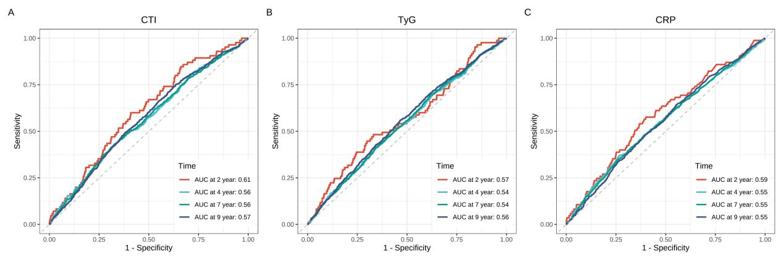
Fig. S1. Receiver operating characteristic curves for CRP, TyG index, and CTI predicting CVD incidence.

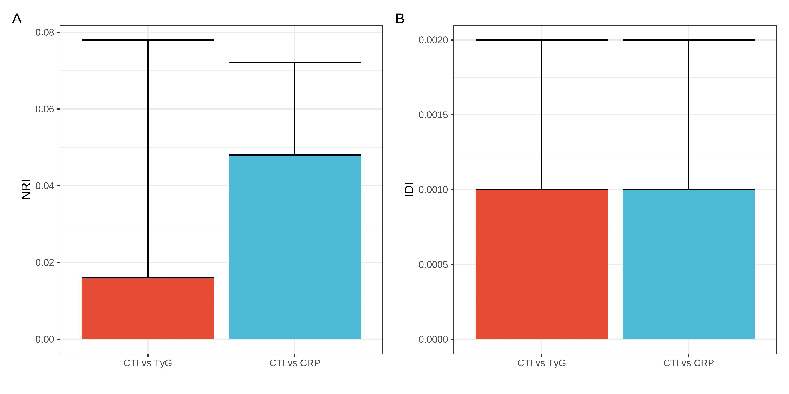
Fig. S2. Evaluation of model performance.

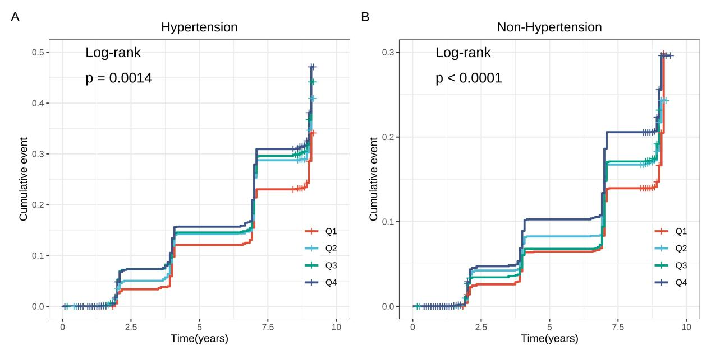
Fig. S3. Kaplan-Meier curve analysis describes the cumulative incidence of CVD in CTI quartile (presence/absence of hypertension).

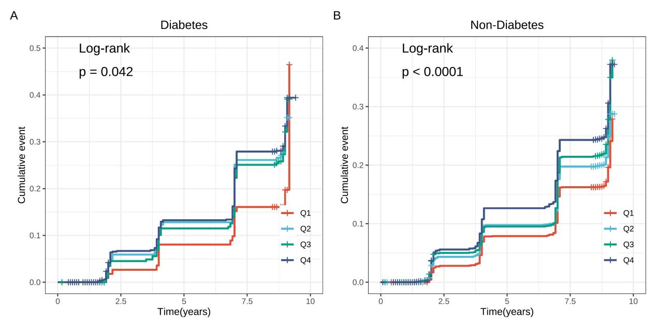
Fig. S4. Kaplan-Meier curve analysis describes the cumulative incidence of CVD in CTI quartile (presence/absence of diabetes).

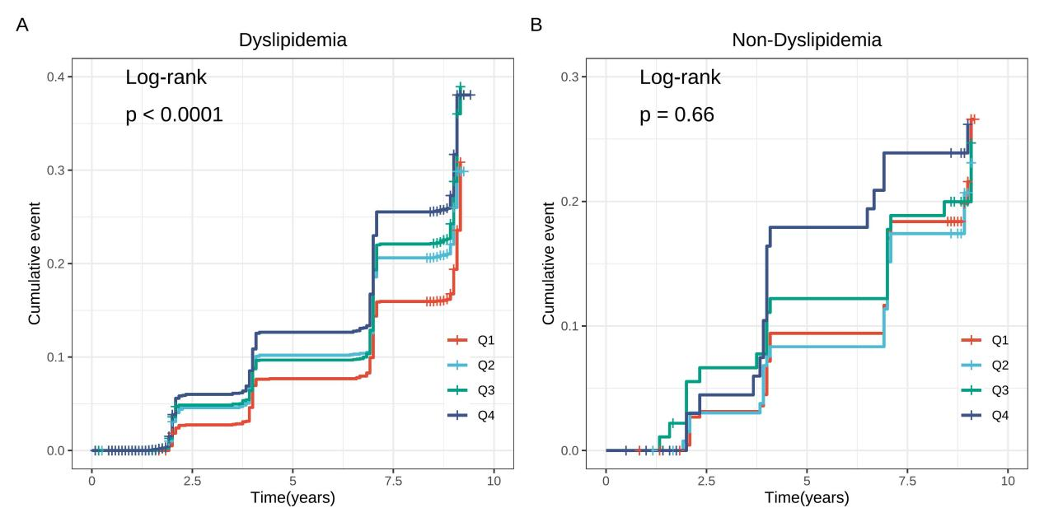
Fig. S5. Kaplan-Meier curve analysis describes the cumulative incidence of CVD in CTI quartile (presence/absence of dyslipidemia).

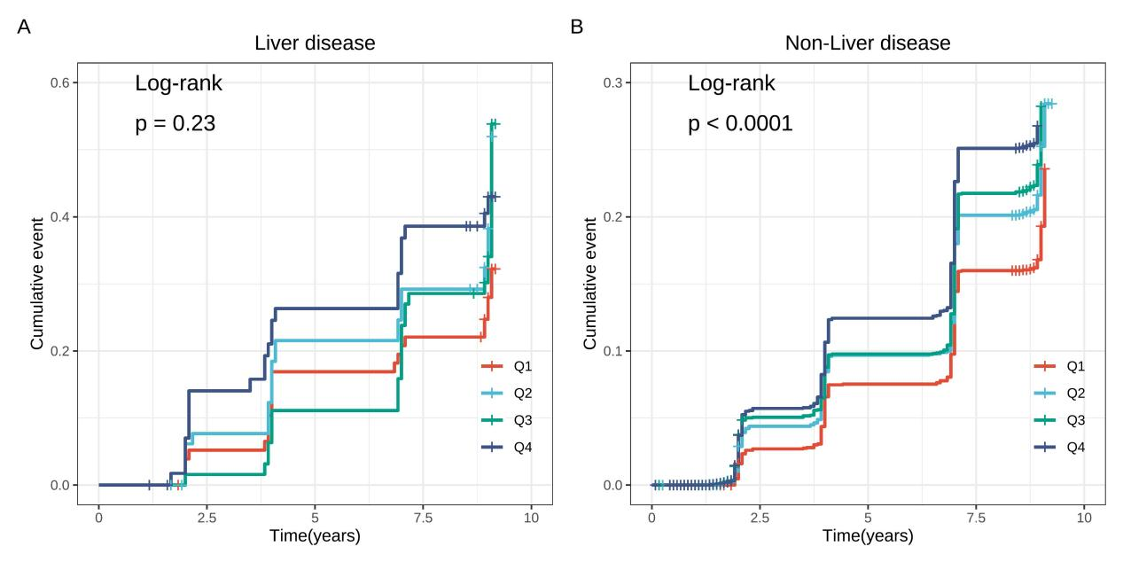
Fig. S6. Kaplan-Meier curve analysis describes the cumulative incidence of CVD in CTI quartile (presence/absence of liver disease).

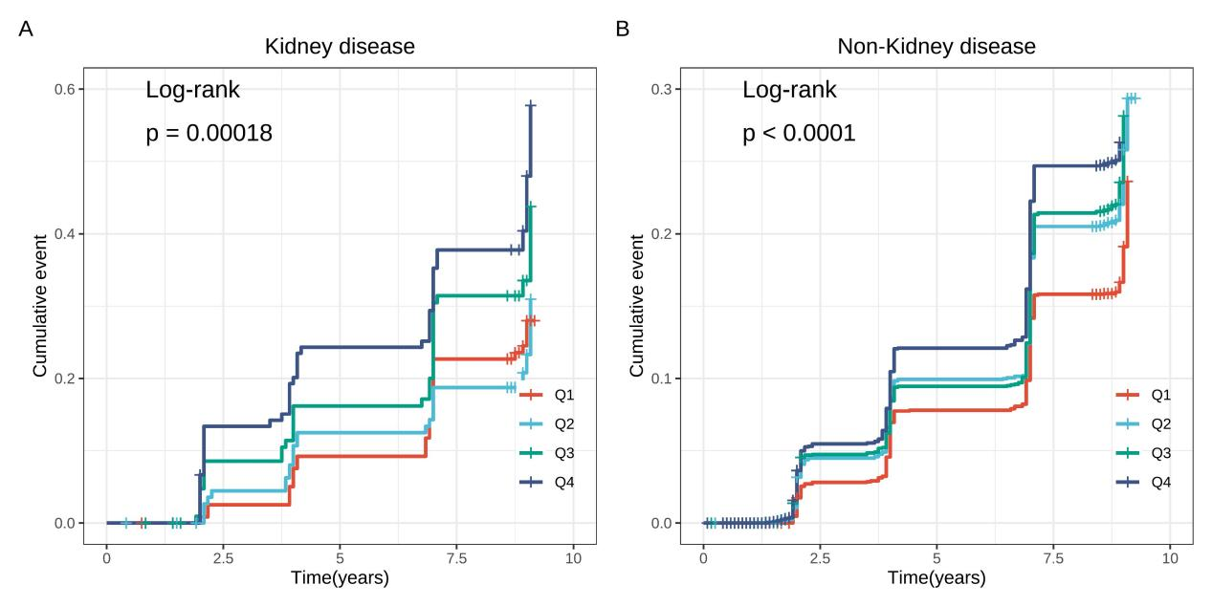
Fig. S7. Kaplan-Meier curve analysis describes the cumulative incidence of CVD in CTI quartile (presence/absence of kidney disease).

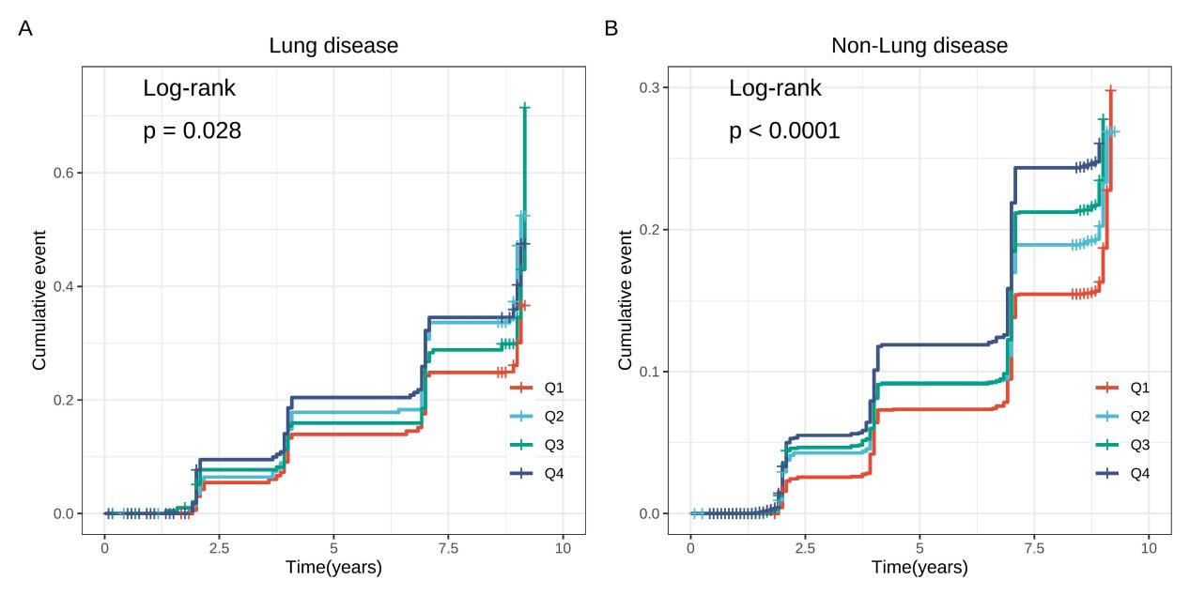
Fig. S8. Kaplan-Meier curve analysis describes the cumulative incidence of CVD in CTI quartile (presence/absence of lung disease).

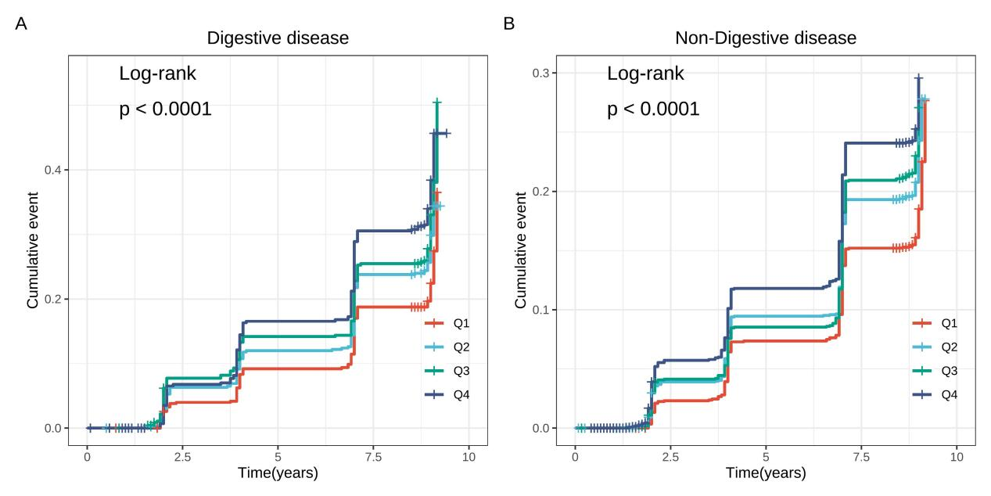
Fig. S9. Kaplan-Meier curve analysis describes the cumulative incidence of CVD in CTI quartile (presence/absence of digestive disease).

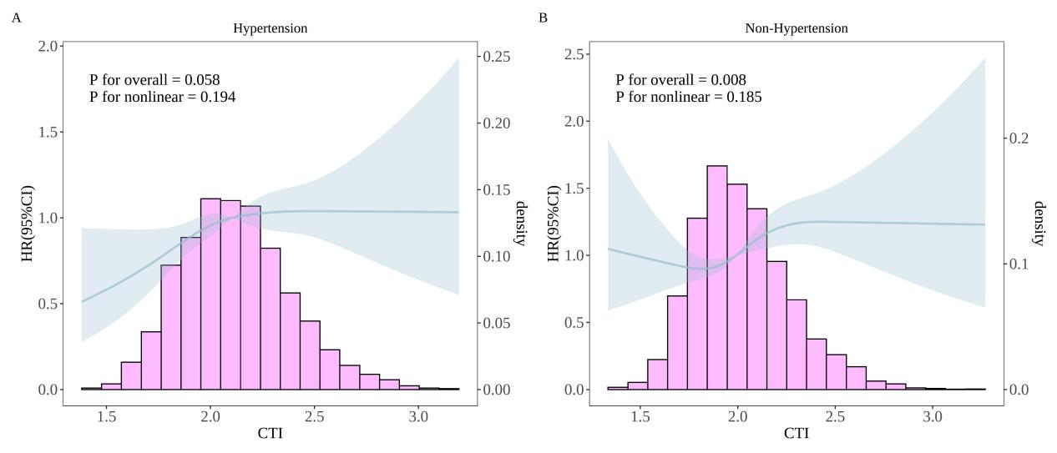
Fig. S10. RCS analysis between CTI and CVD incidence (presence/absence of hypertension）. Adjusted for gender, age, residence, marital status, education level, smoking status, and drinking status, BMI, WC, SBP, DBP, TC, LDL, HDL, uric acid, diabetes, dyslipidemia, liver diseases, kidney diseases, lung diseases, digestive diseases, blood sugar status, and geographical area were adjusted.

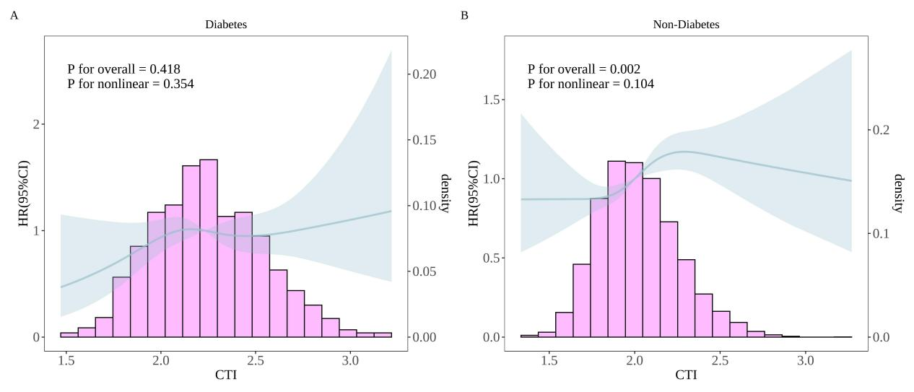
Fig. S11. RCS analysis between CTI and CVD incidence (presence/absence of diabetes). Adjusted for gender, age, residence, marital status, education level, smoking status, and drinking status, BMI, WC, SBP, DBP, TC, LDL, HDL, uric acid, hypertension, dyslipidemia, liver diseases, kidney diseases, lung diseases, digestive diseases, blood sugar status, and geographical area were adjusted.

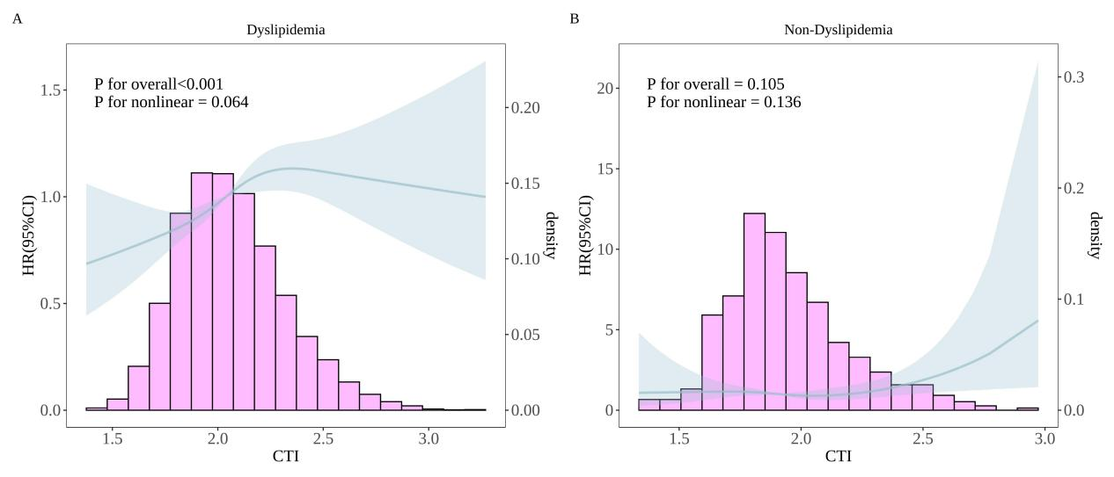
Fig. S12. RCS analysis between CTI and CVD incidence (presence/absence of dyslipidemia). Adjusted for gender, age, residence, marital status, education level, smoking status, and drinking status, BMI, WC, SBP, DBP, TC, LDL, HDL, uric acid, hypertension, diabetes, liver diseases, kidney diseases, lung diseases, digestive diseases, blood sugar status, and geographical area were adjusted.

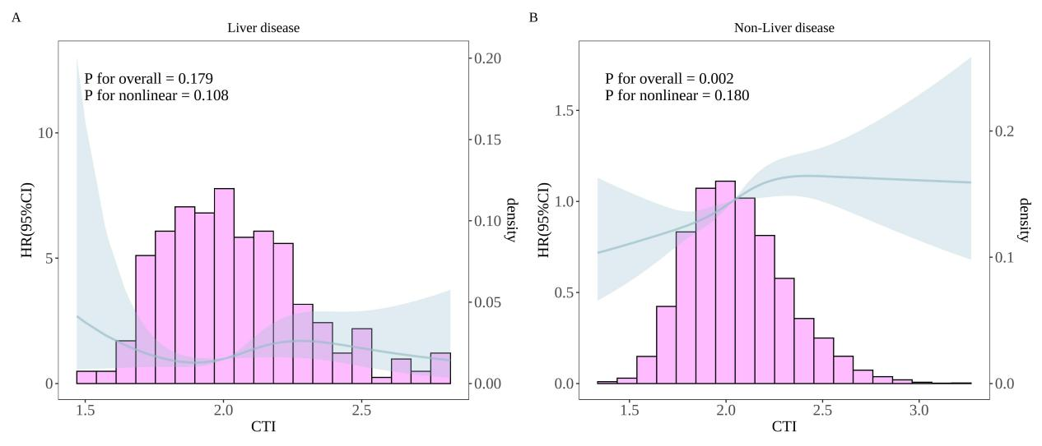

Fig. S13. RCS analysis between CTI and CVD incidence (presence/absence of liver disease). Adjusted for gender, age, residence, marital status, education level, smoking status, and drinking status, BMI, WC, SBP, DBP, TC, LDL, HDL, uric acid, hypertension, diabetes, dyslipidemia, kidney diseases, lung diseases, digestive diseases, blood sugar status, and geographical area were adjusted.

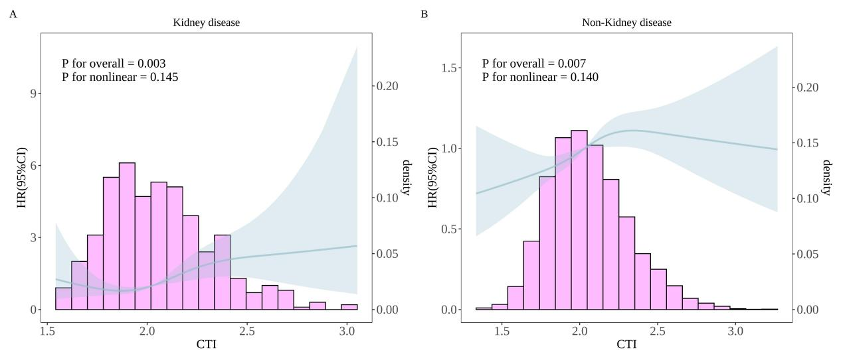

Fig. S14. RCS analysis between CTI and CVD incidence (presence/absence of kidney disease). Adjusted for gender, age, residence, marital status, education level, smoking status, and drinking status, BMI, WC, SBP, DBP, TC, LDL, HDL, uric acid, hypertension, diabetes, dyslipidemia, liver diseases, lung diseases, digestive diseases, blood sugar status, and geographical area were adjusted.

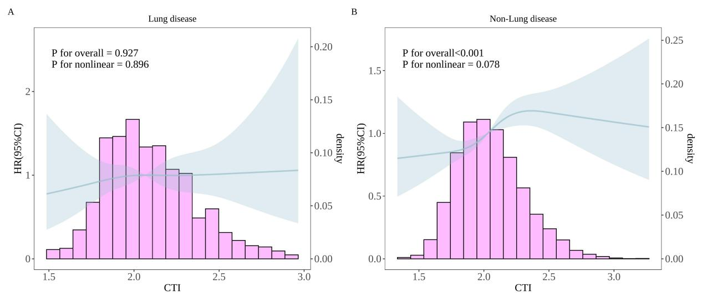
Fig. S15. RCS analysis between CTI and CVD incidence (presence/absence of lung disease). Adjusted for gender, age, residence, marital status, education level, smoking status, and drinking status, BMI, WC, SBP, DBP, TC, LDL, HDL, uric acid, hypertension, diabetes, dyslipidemia, liver diseases, kidney diseases, digestive diseases, blood sugar status, and geographical area were adjusted.

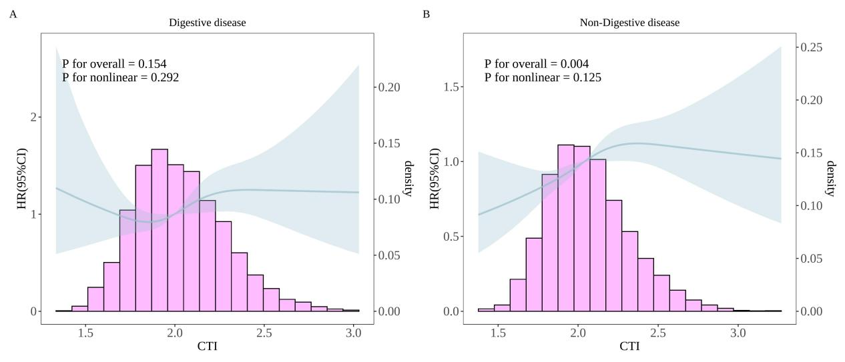
Fig. S16. RCS analysis between CTI and CVD incidence (presence/absence of digestive disease). Adjusted for gender, age, residence, marital status, education level, smoking status, and drinking status, BMI, WC, SBP, DBP, TC, LDL, HDL, uric acid, hypertension, diabetes, dyslipidemia, liver diseases, kidney diseases, lung diseases, blood sugar status, and geographical area were adjusted.

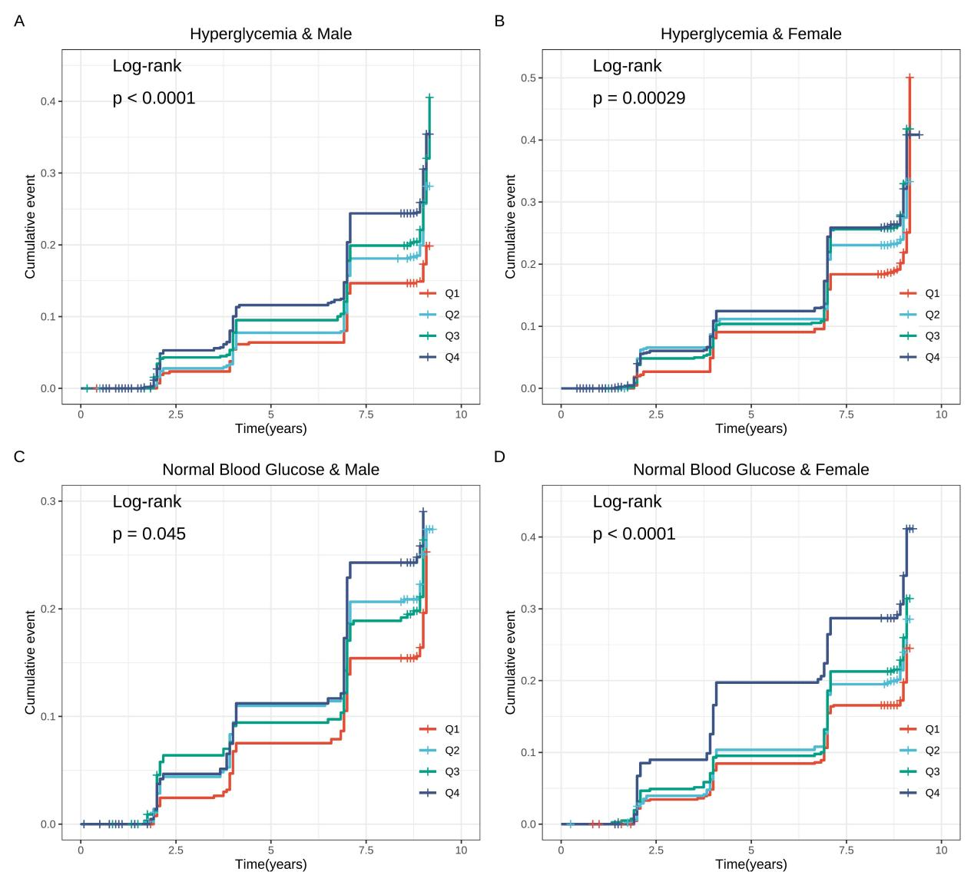
Fig. S17. Kaplan-Meier curve analysis shows the cumulative incidence of CVD in CTI quartile array (according to blood glucose status and gender).

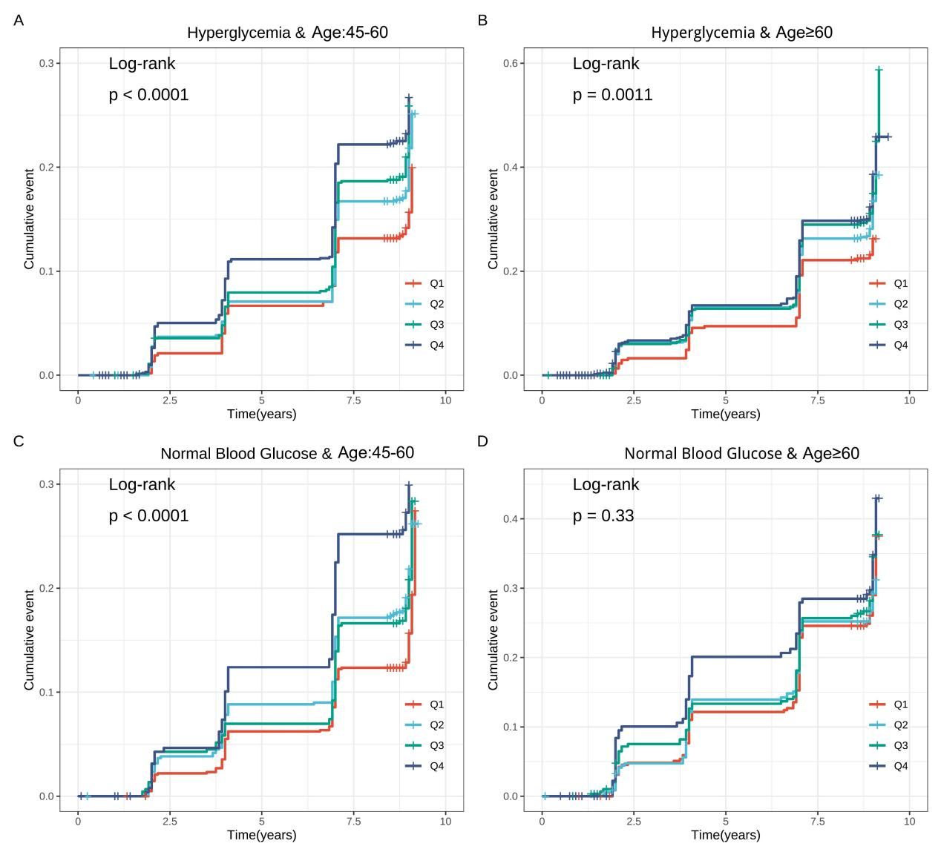

Fig. S18. Kaplan-Meier curve analysis shows the cumulative incidence of CVD in CTI quartile array (according to blood glucose status and age).

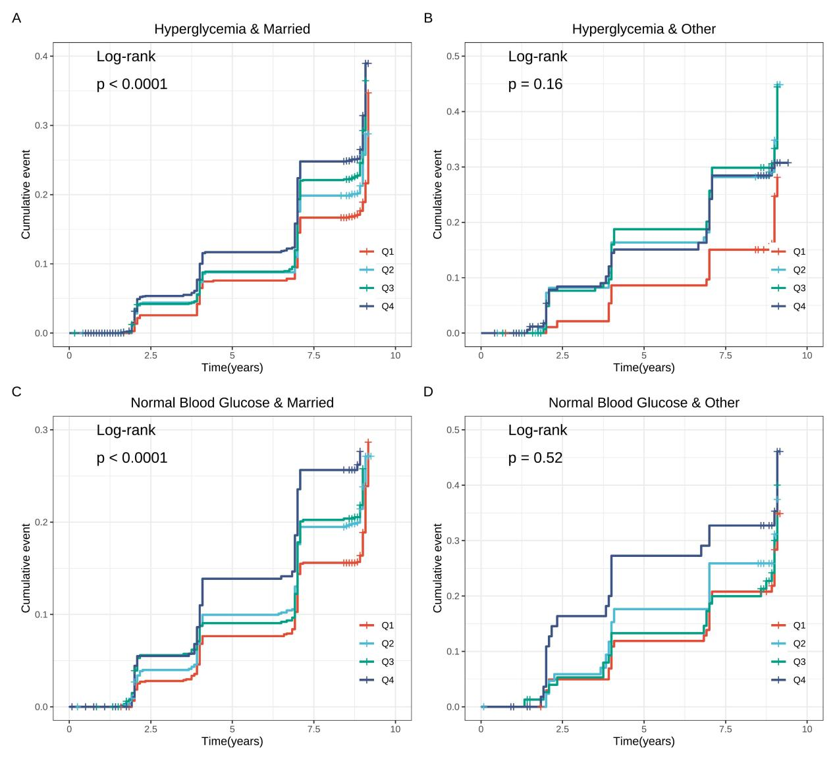
Fig. S19. Kaplan-Meier curve analysis shows the cumulative incidence of CVD in CTI quartile array (according to blood glucose status and marital status).

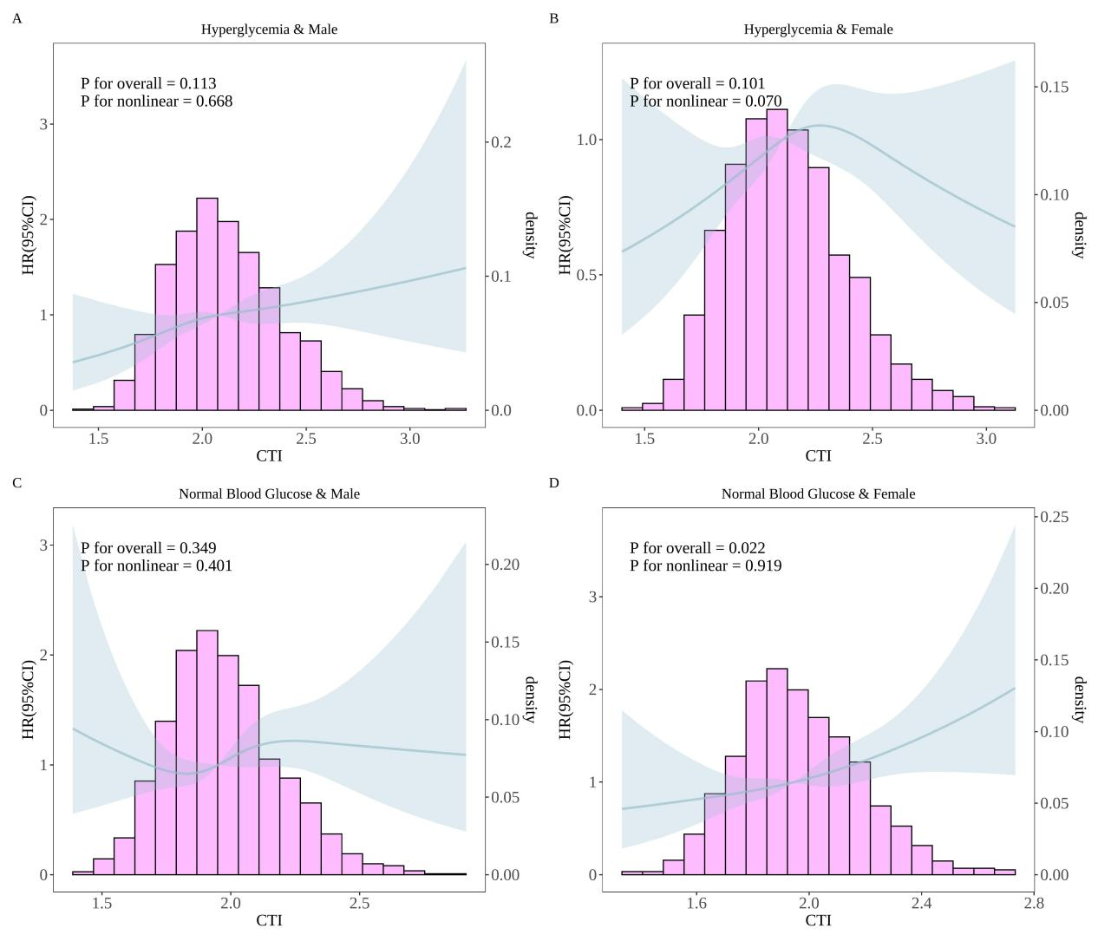
Fig. S20. RCS analysis between CTI and CVD incidence (according to blood glucose status and gender). Adjusted for age, residence, marital status, education level, smoking status, and drinking status, BMI, WC, SBP, DBP, TC, LDL, HDL, uric acid, hypertension, diabetes, dyslipidemia, liver diseases, kidney diseases, lung diseases, digestive diseases, hypertension drugs, diabetes drugs, dyslipidemia drugs, and geographical area were adjusted.

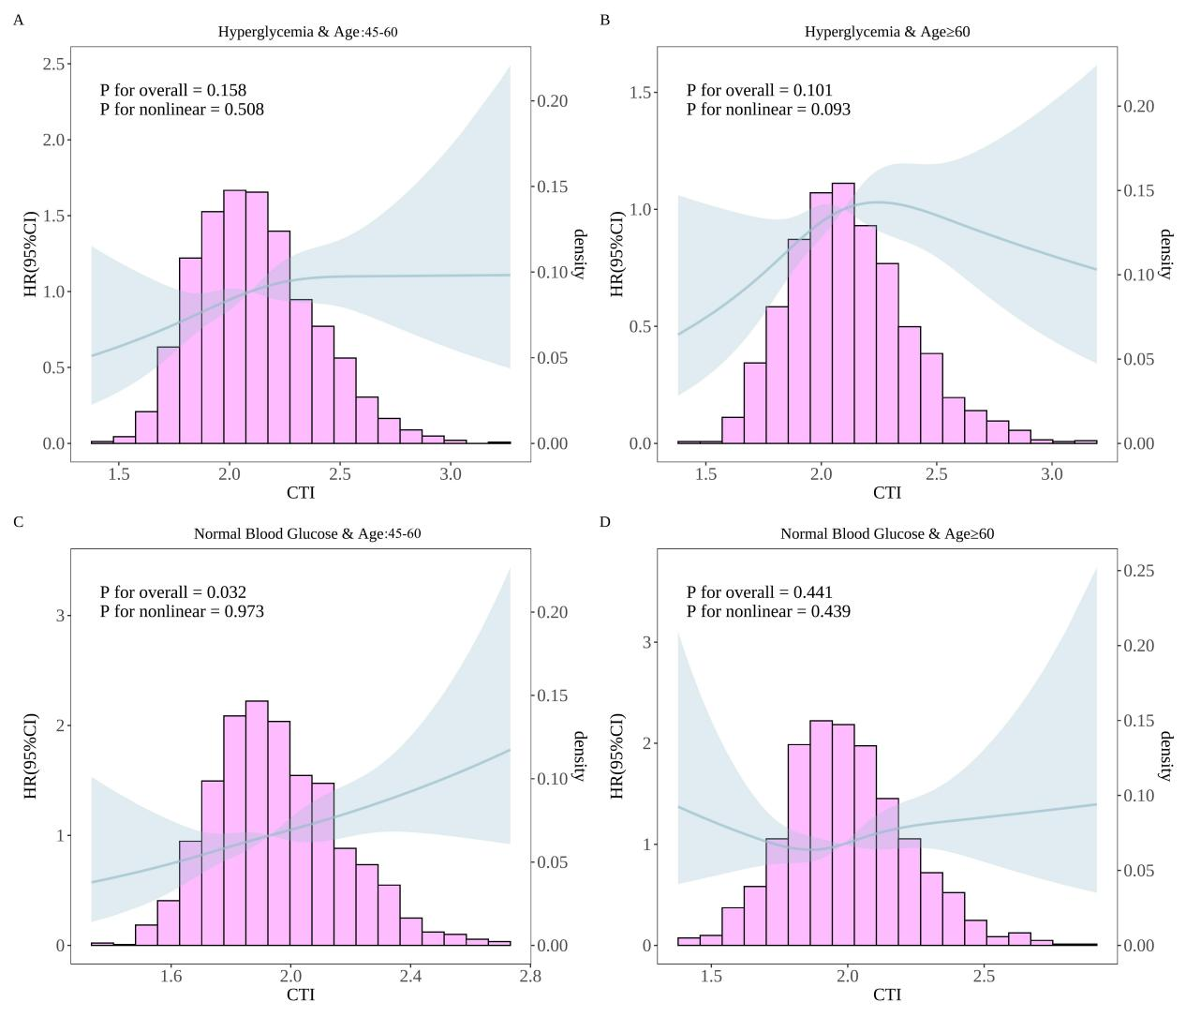
Fig. S21. RCS analysis between CTI and CVD incidence (according to blood glucose status and age). Adjusted for gender, residence, marital status, education level, smoking status, and drinking status, BMI, WC, SBP, DBP, TC, LDL, HDL, uric acid, hypertension, diabetes, dyslipidemia, liver diseases, kidney diseases, lung diseases, digestive diseases, hypertension drugs, diabetes drugs, dyslipidemia drugs, and geographical area were adjusted.

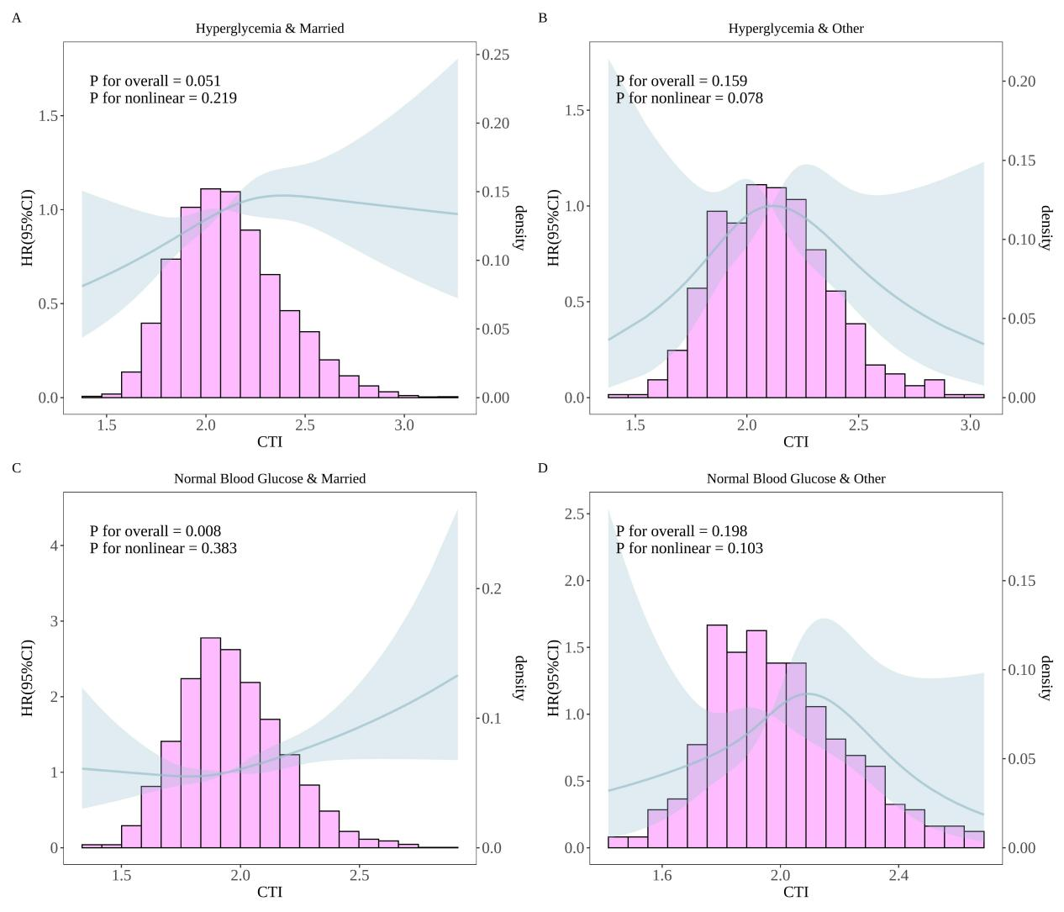
Fig. S22. RCS analysis between CTI and CVD incidence (according to blood glucose status and marital status). Adjusted for gender, age, residence, education level, smoking status, and drinking status, BMI, WC, SBP, DBP, TC, LDL, HDL, uric acid, hypertension, diabetes, dyslipidemia, liver diseases, kidney diseases, lung diseases, digestive diseases, hypertension drugs, diabetes drugs, dyslipidemia drugs, and geographical area were adjusted.

