Additional Files
Additional files
Abbreviations 1
Figure S1. The study flowchart 2
Figure S2. Kaplan-Meier survival analysis of critically ill AF patients based on SHR and SOFA strata across multiple time points 3
Figure S3. Calibration curves of the nomogram for in-hospital, 30-day, and 1-year mortality prediction in critically ill AF patients 4
Table S1. Subgroup analyses of cox proportional hazard models for in-hospital mortality 6
Table S2. Subgroup analyses of cox proportional hazard models for 30-day mortality 7
Table S3. Subgroup analyses of cox proportional hazard models for 365-day mortality 8

Abbreviations
AKI | Acute kidney injury
AF | Atrial fibrillation
AMI | Acute myocardial infarction
AGEs | Advanced glycation end-roducts
ATP | Adenosine triphosphate
CI | Confidence interval
FBG | Fasting blood glucose
HR | Hazard ratio
ICU | Intensive care unit
IR | Insulin resistance
IQR | Interquartile range
MAE | Mean absolute error
MIMIC | Massachusetts institute of technology computational physiology laboratory
RCS | Restricted cubic splines
SHR | Stress hyperglycemia ratio
SOFA | Sequential organ failure assessment
SAPS II | Simplified acute physiology score II
SHAP | Shapley additive explanations
SIRS | Systemic inflammatory response syndrome

Figure S1. The study flowchart

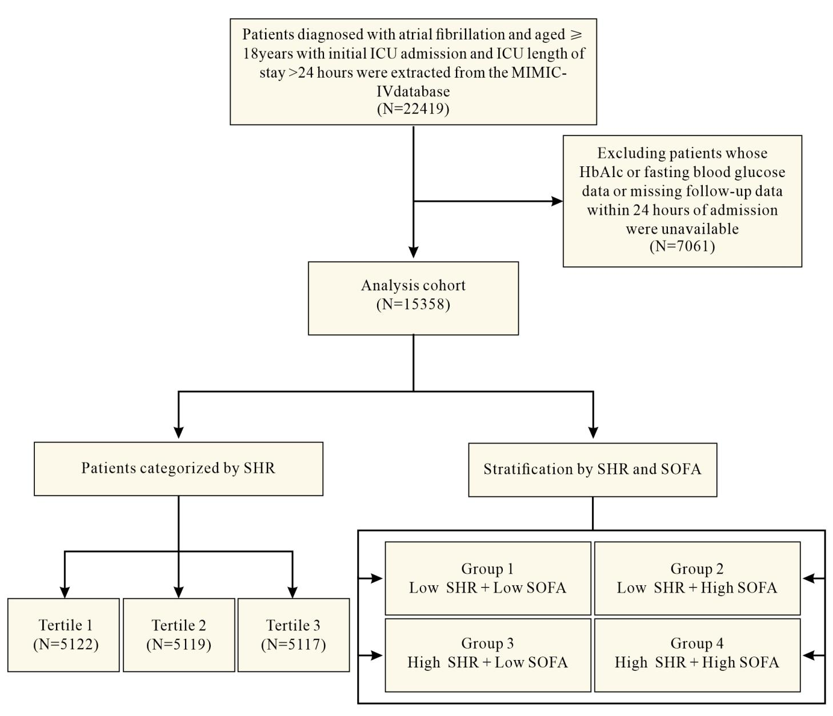

Figure S2. Kaplan-Meier survival analysis of critically ill AF patients based on SHR and SOFA strata across multiple time points

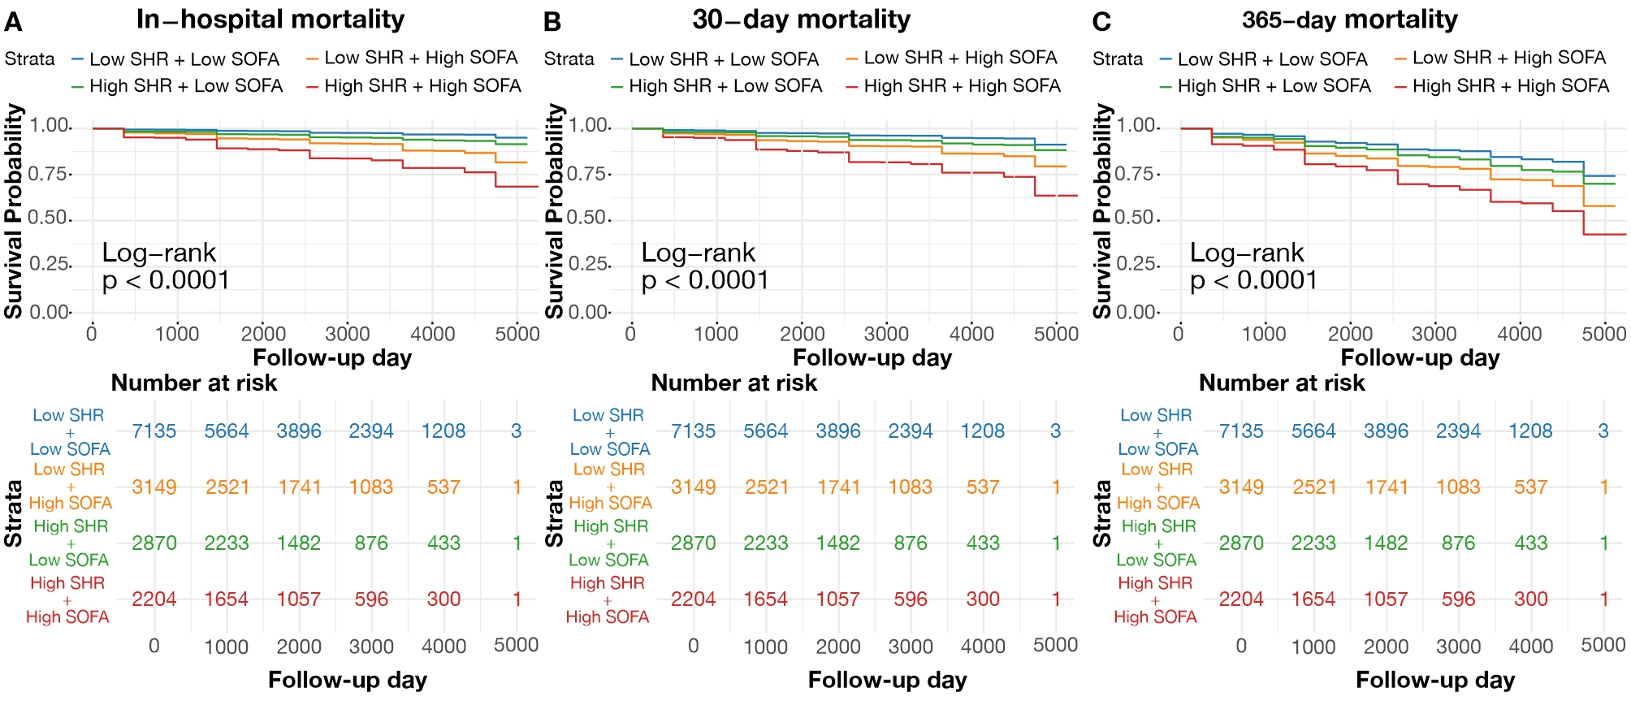

Kaplan-Meier survival curves illustrate the survival probabilities at in-hospital (A), at 30 days (B), and at one year (C), highlighting the differential mortality risks associated with varying levels of SHR and SOFA.
Figure S3. Calibration curves of the nomogram for in-hospital, 30-day, and 1-year mortality prediction in critically ill AF patients

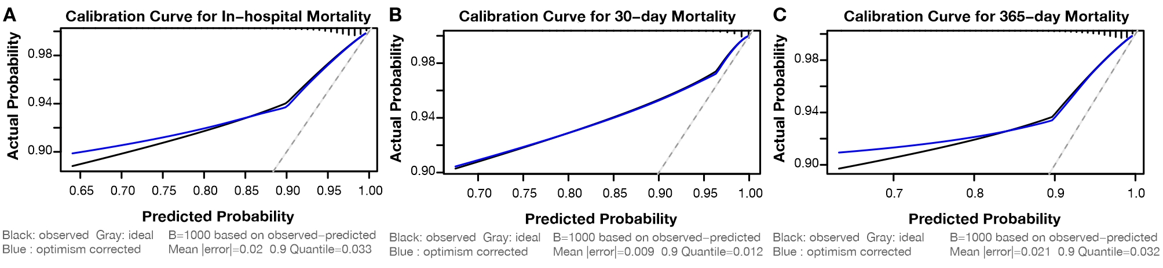

This composite figure displays calibration curves for the predicted probabilities of mortality at three distinct time intervals-hospitalization (A), 30 days (B), and one year (C)-after admission for critically ill patients with atrial fibrillation. The black line represents observed probabilities, the grey line indicates the ideal calibration scenario, and the blue line shows the optimism-corrected probabilities based on 1000 bootstrap resamples.

Supplementary Table 1. Subgroup analyses of cox proportional hazard models for in-hospital mortality
Variable | Group
 | Low SHR and Low SOFA | Low SHR and High SOFA | High SHR and Low SOFA | High SHR and High SOFA
Age ≥65
YES | 1.00 | 2.15 (1.65-2.80) | 1.76 (1.34-2.32) | 3.26 (2.48-4.27)
NO | 1.00 | 4.23 (2.73-6.56) | 2.06 (1.26-3.37) | 6.93 (4.50-10.66)
Female
YES | 1.00 | 2.29 (1.66-3.15) | 1.42 (1.01-1.99) | 3.54 (2.57-4.87)
NO | 1.00 | 2.89 (2.11-3.95) | 2.29 (1.62-3.23) | 4.65 (3.38-6.41)
AMI
YES | 1.00 | 2.53 (1.57-4.08) | 1.56 (0.92-2.66) | 4.36 (2.68-7.09)
NO | 1.00 | 2.29 (1.66-3.15) | 1.42 (1.01-1.99) | 3.54 (2.57-4.87)
HF
YES | 1.00 | 2.15 (1.46-3.15) | 1.33 (0.85-2.06) | 3.23 (2.19-4.78)
NO | 1.00 | 2.78 (2.12-3.65) | 1.99 (1.49-2.65) | 4.46 (3.39-5.88)
AKI
YES | 1.00 | 2.63 (2.05-3.37) | 1.74 (1.31-2.32) | 3.91 (3.01-5.03)
NO | 1.00 | 1.38 (0.74-2.56) | 1.89 (1.20-2.98) | 4.08 (2.35-7.07)
Diabetes
YES | 1.00 | 1.67 (1.17-2.40) | 1.24 (0.85-1.81) | 2.78 (1.95-3.96)
NO | 1.00 | 3.25 (2.45-4.32) | 2.21 (1.62-3.02) | 5.07 (3.78-6.80)
HR, hazard ratio;
Model: Adjusted For Age; Gender; Heart Rate; Respiratory Rate; SAPSII; SIRS; PT; Sodium; Total Calcium; Potassium; Creatinine; PLT; WBC; Bicarbonate; Mean Blood Pressure; Congestive Heart Failure; Diabetes; AKI; Invasive Ventilation, Insulin; Aspirin; Statin.

Supplementary Table 2. Subgroup analyses of cox proportional hazard models for 30-day mortality
Variable | Group
 | Low SHR and Low SOFA | Low SHR and High SOFA | High SHR and Low SOFA | High SHR and High SOFA
Age ≥65
YES | 1.00 | 1.94 (1.57-2.41) | 1.43 (1.14-1.78) | 2.83 (2.25-3.55)
NO | 1.00 | 3.10 (2.08-4.62) | 1.70 (1.08-2.68) | 5.48 (3.72-8.09)
Female
YES | 1.00 | 1.79 (1.37-2.34) | 1.27 (0.98-1.66) | 2.78 (2.13-3.65)
NO | 1.00 | 2.47 (1.89-3.23) | 1.66 (1.23-2.25) | 3.99 (3.02-5.25)
AMI
YES | 1.00 | 2.26 (1.52-3.37) | 1.30 (0.83-2.04) | 3.56 (2.35-5.38)
NO | 1.00 | 2.11 (1.70-2.61) | 1.47 (1.17-1.83) | 3.25 (2.61-4.04)
HF
YES | 1.00 | 2.34 (1.67-3.27) | 1.11 (0.74-1.64) | 3.18 (2.24-4.49)
NO | 1.00 | 2.00 (1.60-2.52) | 1.57 (1.24-1.97) | 3.40 (2.70-4.28)
AKI
YES | 1.00 | 1.98 (1.61-2.42) | 1.36 (1.08-1.72) | 2.97 (2.41-3.65)
NO | 1.00 | 1.78 (1.08-2.93) | 1.52 (1.02-2.25) | 3.84 (2.36-6.23)
Diabetes
YES | 1.00 | 1.62 (1.18-2.23) | 1.08 (0.78-1.51) | 2.52 (1.84-3.46)
NO | 1.00 | 2.43 (1.92-3.06) | 1.68 (1.30-2.15) | 3.84 (3.01-4.90)
HR, hazard ratio;
Model: Adjusted For Age; Gender; Heart Rate; Respiratory Rate; SAPSII; SIRS; PT; Sodium; Total Calcium; Potassium; Creatinine; PLT; WBC; Bicarbonate; Mean Blood Pressure; Congestive Heart Failure; Diabetes; AKI; Invasive Ventilation, Insulin; Aspirin; Statin.

Supplementary Table 3. Subgroup analyses of cox proportional hazard models for 365-day mortality
Variable | Group
 | Low SHR and Low SOFA | Low SHR and High SOFA | High SHR and Low SOFA | High SHR and High SOFA
Age ≥65
YES | 1.00 | 1.70 (1.48-1.95) | 1.24 (1.08-1.42) | 2.24 (1.93-2.60)
NO | 1.00 | 2.14 (1.70-2.69) | 1.21 (0.95-1.55) | 3.28 (2.61-4.12)
Female
YES | 1.00 | 1.86 (1.56-2.22) | 1.12 (0.94-1.33) | 2.61 (2.17-3.13)
NO | 1.00 | 1.72 (1.47-2.02) | 1.33 (1.13-1.57) | 2.37 (2.00-2.80)
AMI
YES | 1.00 | 1.56 (1.23-1.97) | 1.06 (0.82-1.35) | 2.23 (1.74-2.86)
NO | 1.00 | 1.86 (1.63-2.13) | 1.27 (1.11-1.45) | 2.51 (2.17-2.90)
HF
YES | 1.00 | 1.60 (1.33-1.93) | 1.14 (0.94-1.38) | 2.09 (1.72-2.54)
NO | 1.00 | 1.89 (1.62-2.20) | 1.23 (1.06-1.44) | 2.76 (2.36-3.24)
AKI
YES | 1.00 | 1.67 (1.47-1.89) | 1.11 (0.96-1.28) | 2.18 (1.91-2.49)
NO | 1.00 | 1.32 (0.92-1.87) | 1.48 (1.18-1.85) | 3.48 (2.50-4.85)
Diabetes
YES | 1.00 | 1.41 (1.17-1.69) | 0.99 (0.83-1.18) | 1.99 (1.65-2.39)
NO | 1.00 | 2.06 (1.77-2.40) | 1.40 (1.19-1.65) | 2.84 (2.40-3.35)
HR, hazard ratio;
Model: Adjusted For Age; Gender; Heart Rate; Respiratory Rate; SAPSII; SIRS; PT; Sodium; Total Calcium; Potassium; Creatinine; PLT; WBC; Bicarbonate; Mean Blood Pressure; Congestive Heart Failure; Diabetes; AKI; Invasive Ventilation, Insulin; Aspirin; Statin.

