Supplementary Material for
La Grotta R., et al. A Glucose Time In Range of 70% Attenuates the Senescence-Inducing and Pro-Inflammatory Effects of Hyperglycemia
Content Page
Supplementary Table 1. List of primers used for the study……………………………………..… 2
Supplementary Table 2. Clinical characteristics of participants categorized according to overall TAR ≥ or < 30% ……………………………………………………………..………………........... 3
Supplementary Figure 1. Effect of variable degrees of TIR on monocytes adhesion to endothelial cells…………………………………………………………………………………………………...4
Supplementary Figure 2. Effect of variables degrees of TIR on monocytes inflammation. ……………………………………………………………………………………………………......5
Supplementary Figure 3. Expression of additional markers of inflammation in PBMCs from people with T1D……………………………………………………………………………………………...6
Supplementary Figure 4. Linear regression analyses exploring the correlation between TIR and the mRNA expression of IL-6, CXCL1, MCP-1, and p16……………………………...………………..7
Supplementary Figure 5. Expression of markers in PBMCs from people with T1D categorized according to overall TAR ≥ or < 30%............……………………....………………………………..8

Supplementary Table 1. List of primers used for the study
Primer | Sequence
GAPDH for | TCC TCT GAC TTC AAC AGC GAC
GAPDH rev | TCT CTC TTC CTC TTG TGC TCT T
IL-1α for | CTT TCC CTG CCT GAC CTT ATT
IL-1α rev | GAA TGA AGC TAC TGC CCT ACT C
IL-1β for | CCA GCT ACG AAT CTC CGA CC
IL-1β rev | CAT GGC CAC AAC AAC TGA CG
IL-6 for | TGC AAT AAC CAC CCC TGA CC
IL-6 rev | GTG CCC ATG CTA CAT TTG CC
IL-8 for | GGA CAA GAG CCA GGA AGA AA
IL-8 rev | CCT ACA ACA GAC CCA CAC AAT A
MCP-1 for | AGT CTC TGC CGC CCT TCT
MCP-1 rev | GTG ACT GGG GCA TTG ATT G
NLRP3 for | TCT CAC GCA CCT TTA CCT GC
NLRP3 rev | GAT CCC AGC AGC AGT GTG AC
p16 for | CAT AGA TGC CGC GGA AGG T
p16 rev | CTA AGT TTC CCG AGG TTT CTC AGA
p21 for | ACC GAG ACA CCA CTG GAG GG
p21 rev | CCT GCC TCC TCC CAA CTC ATC
PAI-1 for | CAG ATG AGG ACA GAG TGG TTT C
PAI-1 rev | GTG GGC TGA TTA GGC TTC TAT T
TNF-α for | GTG ACA AGC CTG TAG CCC AT
TNF-α rev | TAT CTC TCA GCT CCA CGC CA

Supplementary Table 2. Clinical characteristics of participants categorized according to the Time Above Range (TAR, i.e. all strata > 180 mg/dl) < or ≥ 30%.

Variable | TAR < 30  (n=20) | TAR ≥30  (n=17) | p-value
Age (years) | 13,6 ± 3,4 | 13 ± 2,5 | 0,584
Male, n (%) | 16 (80) | 12 (70,6) | 0,703
Prepubertal, n (%) | 5 (25) | 3 (17,6) | 0,7013
Pubertal, n (%) | 9 (45) | 10 (58,9) | 0,5148
Postpubertal, n (%) | 6 (30) | 4 (23,5) | 0,7246
HbA1c (%) | 6,5 (6,2-6,7) | 7,3 (6,9-8,3) | <0,001
BMI (kg/m²) | 19,9 (16,9-23,4) | 17,7 (15,6-19,1) | 0,209
Systolic blood pressure (mmHg) | 110,5 (103-122,5) | 108 (105-115) | 0,804
Diastolic blood pressure (mmHg) | 62,4 ± 8,3 | 66,5 ± 8,1 | 0,142
Total cholesterol (mg/dl) | 4,2 (3,8-4,8) | 4,2 (3,8-4,8) | 0,689
LDL cholesterol (mg/dl) | 2,4 (2,1-2,8) | 2,4 (1,9-2,8) | 0,982
HDL cholesterol (mg/dl) | 1,4 (1,4-1,7) | 1,5 (1,2-1,9) | 0,931
Triglycerides (mg/dl) | 0,75 (0,6-1,2) | 0,6 (0,4-0,8) | 0,183
Celiac disease autoantibodies  (TTG) -tTG IgA | 1,9 (1,6-2,2) | 2,3 (1,6-3,5) | 0,259
Thyroid autoantibodies  (S-anti TG) | 1,3 (1,3-1,6) | 1,3 (1,3-1,3) | 0,501
Thyroid autoantibodies S-anti TPO | 29 (28-39,5) | 31 (28-39) | 0,994

Data are presented as mean ± SD, median (Q1-Q3), or n (%) according to the type of variable and its distribution. Significant p values are highlighted in bold.

Supplementary Figure 1. Effect of variable degrees of TIR on monocytes adhesion to endothelial cells.
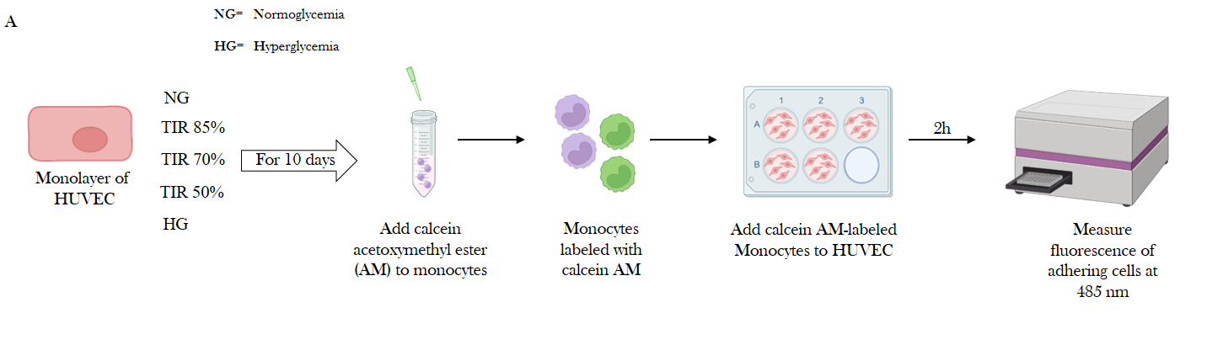
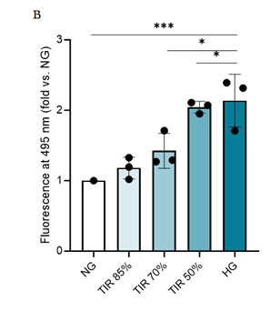
A Graphical summary of the experimental design. B Degree of adhesion of monocytes on endothelial cells exposed to the different conditions of TIR (50%, 70%, and 85%), as well as to constant normoglycemia (NG) or hyperglycemia (HG) for 10 days. Monocytes adhesion is measured through fluorescence quantification expressed as fold increase vs NG. Data are mean ± SD of three independent experiments. *p < 0.05, ***p < 0.001. For all comparison, ANOVA followed by Tukey test was used.
Supplementary Figure 2. Effect of variables degrees of TIR on monocytes inflammation.

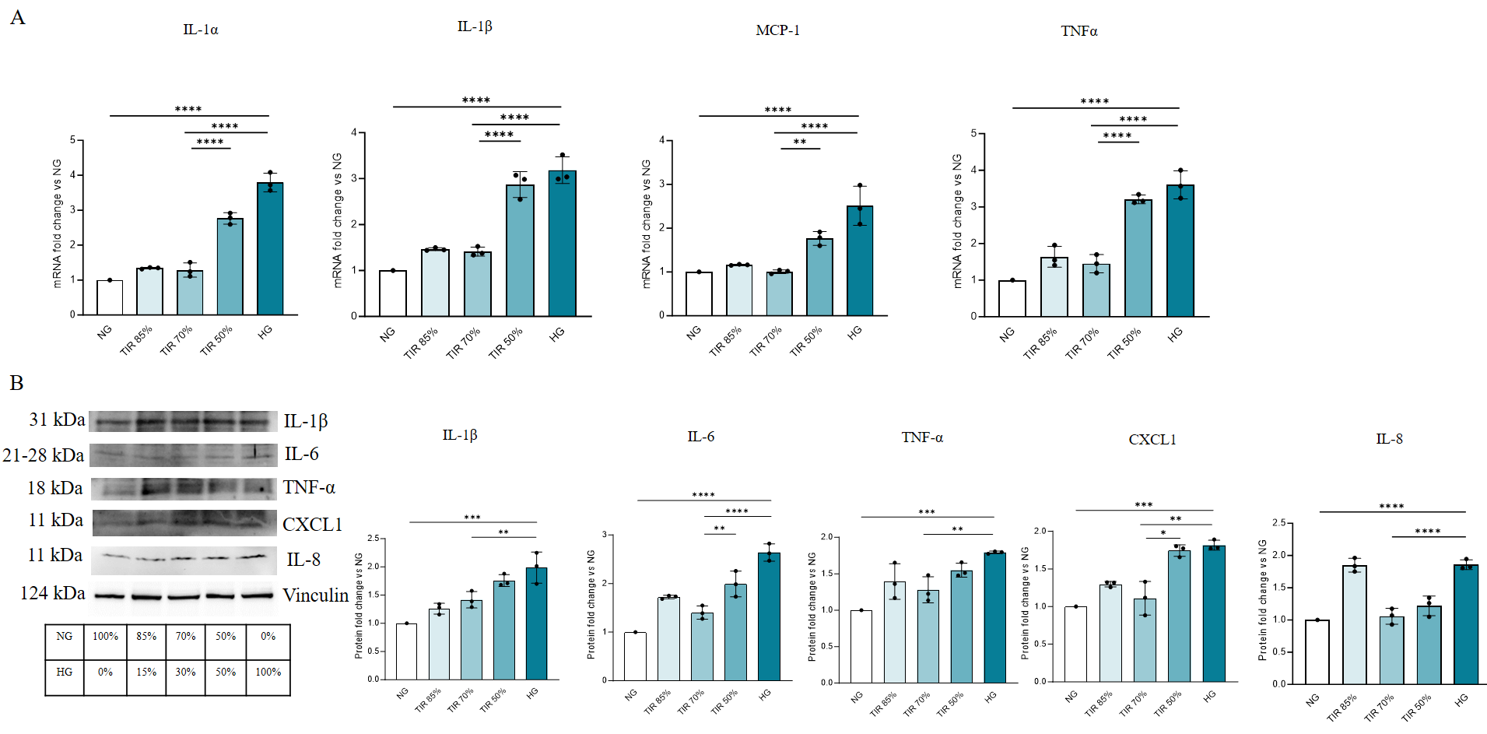
THP-1 monocytes were exposed to increasing degrees of TIR (50%, 70%, and 85%), as well as to constant normoglycemia (NG) or hyperglycemia (HG) for 5 days. A mRNA expression levels of IL-1α, IL-1β, TNFα, and MCP-1, assessed through RT-PCR and presented as fold changes over NG, and B representative Western Blots of IL-1β, IL-6, IL-8, TNFα, and CXCL1, along with their quantitation through densitometric analyses, presented as fold changes over NG and normalized using Vinculin as internal control. Data are mean ± SD of three independent experiments. *p < 0.05; **p < 0.01; ***p < 0.001; ****p<0.0001. For all comparison, ANOVA followed by Tukey test was used.

Supplementary Figure 3. Expression of additional markers of inflammation in PBMCs from people with T1D.
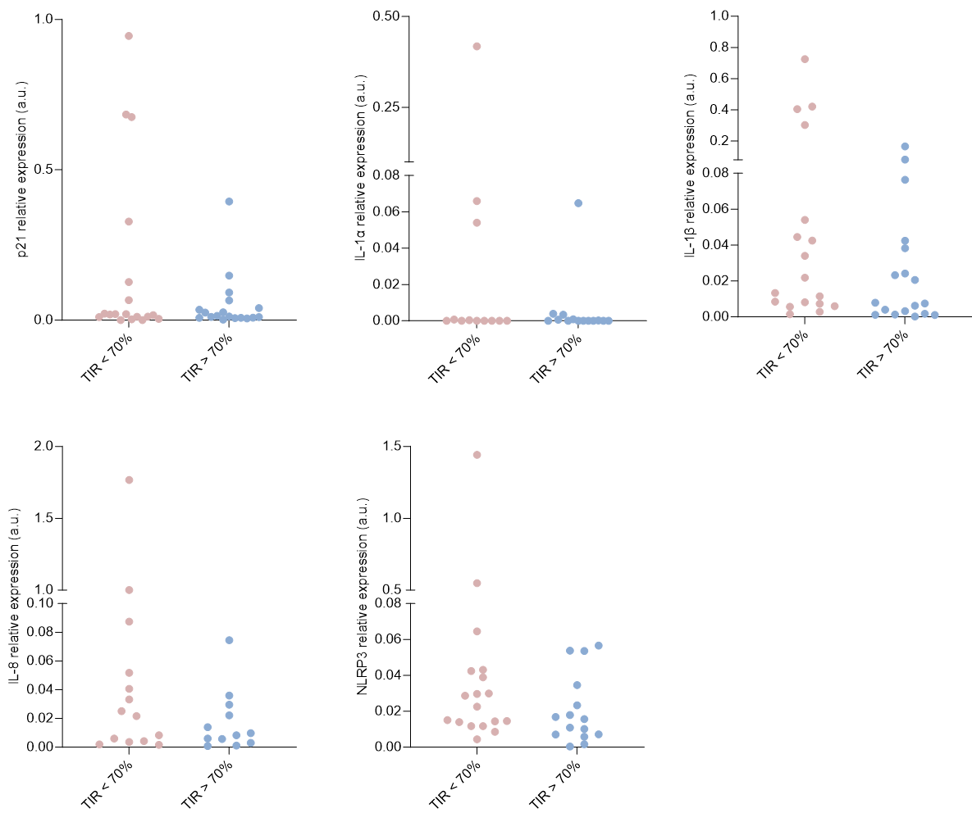
mRNAs expression levels of p21, IL-1α, IL-1β, IL-8 and NLRP3, normalized to β-Actin and presented as relative expression, in PBMCs from people with T1D and a TIR < or > 70% in the previous 14 days. No significant differences were detected using ANCOVA adjusted for HbA1c values.

Supplementary Figure 4. Linear regression analyses exploring the correlation between TIR and the mRNA expression of IL-6, CXCL1, MCP-1, and p16.
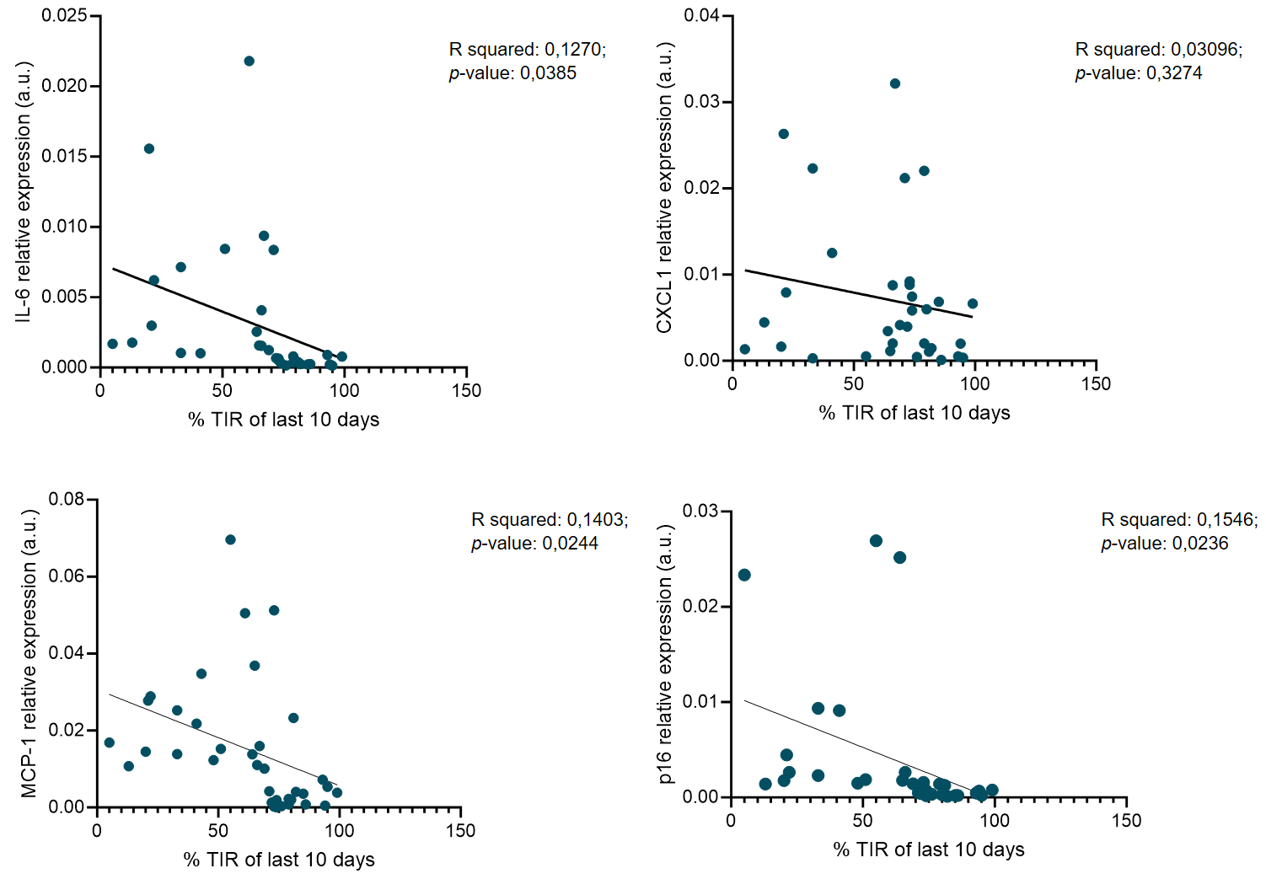
Linear regression graphs, along with the relative R squared and p-values, showing a correlation between TIR values, used as a continuous variable, and the mRNA expression of IL-6, CXCL1, and p16 in PBMCs from people with early T1D. R-squared with the relative p values are reported in the graphs.

Supplementary Figure 5. Expression of inflammation and senescence markers in PBMCs from people with T1D categorized according to overall TAR (i.e. including all the Time Above Range strata above 180 mg/dl of blood glucose) < vs ≥ 30%.
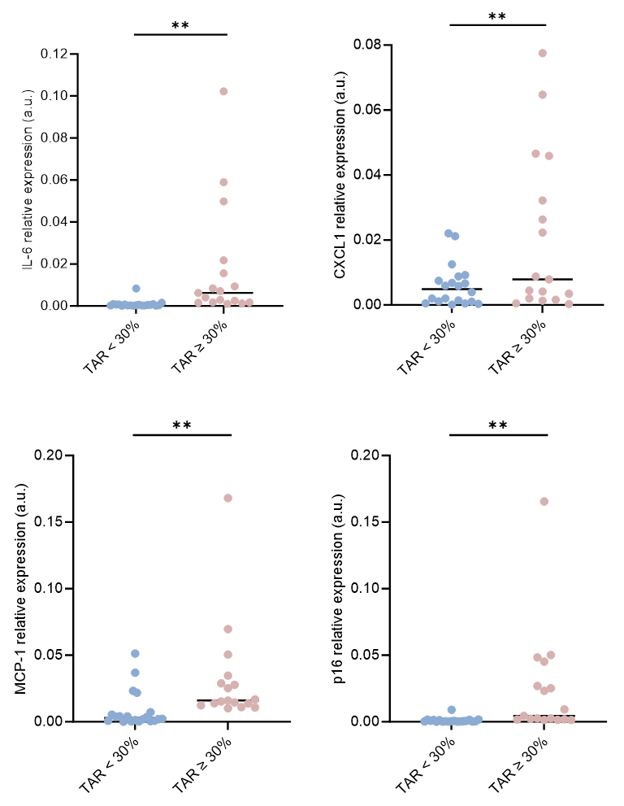
Expression levels of IL-6, CXCL1, MCP-1 and p16 mRNAs, normalized to β-Actin, and presented as relative expression, in PBMCs from people with T1D and a TAR < vs ≥ 30%, as recorded in the previous 14 days. Data are mean ± SD and individual points are shown. **p < 0.01. For all comparison, ANCOVA adjusted for HbA1c was used.

