Supplemental Materials to
Improved sex-specific cardiovascular risk prediction with multi-omics data in people with type 2 diabetes

Table of Contents
Supplemental Table S1. Selected multi-omic biomarkers and data sources 2
Supplemental Table S2. Definition of endpoint major cardiovascular event (MACE) 3
Supplemental Table S3. ß-coefficients of the variables of the SCORE2-Diabetes model extended by 15 proteins for 10-year prediction of major cardiovascular events 4
Supplemental Table S4. NRI and IDI for 10-year MACE prediction by extending the SCORE2-Diabetes model with single- and multi-omics data (N=990) 6
Supplemental Table S5. ß-coefficients of the variables of the SCORE2-Diabetes model extended by selected multi-omics biomarkers for 10-year prediction of major cardiovascular events 7
Supplemental Figure S1. Flow charts of participant selection for proteomics-based and multi-omics-based cardiovascular risk prediction analyses 9
Supplemental Figure S2. ROC curves comparing the discrimination of the SCORE2-Diabetes model with and without proteomics extension for 10-year MACE risk (N=1,751) 10
Supplemental Figure S3. Calibration curves of the SCORE2-Diabetes model with and without proteomics extension for 10-year MACE risk prediction (N=1,751) 11
Supplemental Figure S4. ROC curves comparing the discrimination of the SCORE2-Diabetes model with and without multi-omics extension for 10-year MACE risk (N=990) 12
Supplemental Figure S5. Calibration curves of the SCORE2-Diabetes model with and without multi-omics extension for 10-year MACE risk prediction (N=990) 13
Supplemental Figure S6. Associations of selected multi-omics biomarkers and 10-year risk of MACE (N=990) 14
Supplemental Figure S7. Spearman correlation matrices for selected multi-omics biomarkers (N=990) 15

Supplemental Table S1. Selected multi-omic biomarkers and data sources
Omics | Males | Females | Reference
Genes | PRS for CVD with 1.42 million non-zero SNP variants | PRS for CVD with 1.42 million non-zero SNP variants | The CVD-PRS was derived using a genome-wide meta-analysis of 9 external GWAS datasets comprising 1,840,289 individuals and has been previously published [21].
Metabolites | Acetate, albumin, creatinine, omega-3-pct, VLDL-size | Albumin, creatinine, GlycA, lactate | The metabolites were selected using sex-specific LASSO regression in the UKB (n=7,180). See previous work [22].
Proteins | ACTA2, CHGA, CRNN, ENPP5, GAST, NT-proBNP, POSTN, TRIM21, WFDC2 | CTRC, EFHD1, HS3ST3B1, IL22, SMOC1, TNC, WFDC2 | The proteins were selected using sex-specific LASSO regression in this study using UKB data (n=1,751).
Abbreviations: ACTA2, Actin Alpha 2; CHGA, Chromogranin-A; CRNN, Cornulin; CTRC, Chymotrypsin-C; CVD, Cardiovascular Disease; EFHD1, EF-hand domain-containing protein D1; ENPP5, Ectonucleotide pyrophosphatase/phosphodiesterase family member 5; GAST, Gastrin; HS3ST3B1, Heparan sulfate glucosamine 3-O-sulfotransferase 3B1; IL22, Interleukin-22; NT-proBNP, N-terminal prohormone of brain natriuretic peptide; Omega-3-pct, Omega-3 fatty acids percentage of total fatty acids; PRS, polygenic risk score; SMOC1, SPARC-related modular calcium-binding protein 1; SNP, single nucleotide polymorphism; TNC, Tenascin-C; TRIM21; E3 ubiquitin-protein ligase TRIM21; VLDL-size, Average diameter for very-low-density lipoprotein particles; WFDC2, WAP four-disulfide core domain protein.

Supplemental Table S2. Definition of endpoint major cardiovascular event (MACE)
Fatal MACE – cause-specific mortality due to any of the following:
Endpoints included | ICD10-codes
Hypertensive disease | I10-16
Ischemic heart disease | I20-25
Arrhythmias, heart failure | I46-52
Cerebrovascular disease | I60-69
Atherosclerosis/aortic aneurysm | I70-73
Sudden death and death within 24 hours of symptom onset | R96.0-96.1
Endpoints excluded from the above endpoint: | ICD10-codes
Myocarditis, unspecified | I51.4
Subarachnoid haemorrhage | I60
Subdural hemorrhage | I62
Cerebral aneurysm | I67.1
Cerebral arteritis | I68.2
Moyamoya | I67.5
Non-fatal MACE | ICD10-codes
Non-fatal myocardial infarction | I21-I23
Non-fatal stroke | I61, I63-I66, I69

Supplemental Table S3. ß-coefficients of the variables of the SCORE2-Diabetes model extended by 15 proteins for 10-year prediction of major cardiovascular events
Risk factor (units) | Coefficient
Risk factor (units) | Male | Female
SCORE2-Diabetes variables
Age (per 5 years) | -0.0897 | 0.6155
Current smoking | -0.1200 | 0.0700
SBP (per 20 mmHg) | -0.0720 | 0.0787
Total cholesterol (per 1 mmol/L) | 0.2928 | 0.1959
HDL cholesterol (per 0.5 mmol/L) | -0.0420 | -0.2396
Smoking interaction with age | -0.0378 | -0.0678
SBP interaction with age | 0.1047 | -0.1130
Total cholesterol interaction with age | -0.0626 | -0.1599
HDL interaction with age | 0.0193 | 0.2325
Diabetes age at diagnosis (per 5 years) | 0.0113 | -0.0997
HbA_{1c} (per 9.34 mmol/mol) | 0.1009 | -0.0455
Ln eGFR (per 0.15 ml/min/1.73m²) | 0.2262 | 0.1099
Ln eGFR² (quadratic term) | 0.0101 | 0.0137
HbA_{1c} interaction with age | 0.0192 | -0.1586
Ln eGFR interaction with age | 0.0197 | 0.0691
Additional proteins (per 1 SD)
ACTA2 | 0.3303 | -
CHGA | 0.1079 | -
CRNN | -0.2856 | -
CTRC | - | -0.7099
EFHD1 | - | 0.5865
ENPP5 | -0.3111 | -
GAST | 0.0965 | -
HS3ST3B1 | - | 0.4250
IL22 | - | 0.4918
NT-proBNP | 0.2030 | -
POSTN | 0.3851 | -
SMOC1 | - | 0.4752
TNC | - | 0.6270
TRIM21 | -0.3095 | -
WFDC2 | 0.8349 | 0.4915
Abbreviations: ACTA2, Actin Alpha 2; CHGA, Chromogranin-A; CRNN, Cornulin; CTRC, Chymotrypsin-C; EFHD1, EF-hand domain-containing protein D1; eGFR, estimated glomerular filtration rate; ENPP5, Ectonucleotide pyrophosphatase/phosphodiesterase family member 5; GAST, Gastrin; HbA_{1c}, glycated hemoglobin; HDL, High-density lipoprotein; HS3ST3B1, Heparan sulfate glucosamine 3-O-sulfotransferase 3B1; IL22, Interleukin-22; NT-proBNP, N-terminal prohormone of brain natriuretic peptide; POSTN, Periostin; SBP, systolic blood pressure; SD, standard deviation; SMOC1, SPARC-related modular calcium-binding protein 1; TNC, Tenascin-C; TRIM21; E3 ubiquitin-protein ligase TRIM21; WFDC2, WAP four-disulfide core domain protein.

Supplemental Table S4. NRI and IDI for 10-year MACE prediction by extending the SCORE2-Diabetes model with single- and multi-omics data (N=990)
 | NRI |  |  |  |  |  |  | IDI
 | Total |  | Male |  | Female |  |  | Total |  | Male |  | Female
 | NRI_{total(%)} (95% CI) | P-valueª | NRI_{total(%)} (95% CI) | P-valueª | NRI_{total(%)} (95% CI) | P-valueª |  | IDI (95%CI) | P-valueª | IDI (95% CI) | P-valueª | IDI (95% CI) | P-valueª
Panel A
SCORE2-Diabetes (ref)
SCORE2-Diabetes+PRS | 2.6  (-4.1, 11.8) | 0.526 | 15.5  (-3.0, 32.9) | 0.090 | 6.0  (-4.2, 11.4) | 0.130 |  | 0.015 (0.003, 0.029) | 0.040 | 0.019 (0.001, 0.035) | 0.040 | 0.002  (-0.021, 0.020) | 0.832
SCORE2-Diabetes+Metabolomics | 3.8  (-8.7, 11.4) | 0.462 | 7.7  (-10.5, 16.2) | 0.258 | 4.1  (-8.0, 16.1) | 0.502 |  | 0.003  (-0.016, 0.027) | 0.812 | 0.005  (-0.019, 0.033) | 0.535 | 0.006  (-0.028, 0.040) | 0.693
SCORE2-Diabetes+Proteomics | 30.6  (23.8, 47.8) | <0.001 | 51.2  (18.3, 67.9) | <0.001 | 29.5  (18.4, 42.1) | <0.001 |  | 0.098 (0.052, 0.130) | <0.001 | 0.105 (0.058, 0.146) | <0.001 | 0.111 (0.028, 0.210 | <0.001
Panel B
SCORE2-Diabetes+Proteomics (ref)
SCORE2-Diabetes+Proteomics+PRS | 3.1  (-4.5, 3.3) | 0.948 | -1.5  (-7.0, 4.1) | 0.595 | 1.9  (-6.3, 5.9) | 0.538 |  | -0.003  (-0.010, 0.003) | 0.535 | -0.005  (-0.017, 0.003) | 0.238 | 0.000  (-0.006, 0.006) | 0.931
SCORE2-Diabetes+Proteomics+Metabolomics | -0.8  (-5.3, 7.7) | 0.811 | 9.8  (-5.4, 17.0) | 0.086 | 1.9  (-9.5, 12.4) | 0.733 |  | 0.001  (-0.023, 0.027) | 0.812 | -0.005  (-0.037, 0.027) | 0.792 | -0.002  (-0.022, 0.028) | 0.832
Panel C
SCORE2-Diabetes+Proteomics+Metabolomics (ref)
SCORE2-Diabetes+Multi-omics | -1.4  (-3.7, 1.9) | 0.339 | -2.6  (-4.4, 3.9) | 0.220 | 0.3  (-4.6, 4.4) | 0.895 |  | -0.002  (-0.005, 0.002) | 0.455 | -0.002  (-0.009, 0.003) | 0.495 | -0.001  (-0.006, 0.003) | 0.752
ªP-values indicate the statistical significance of the change in NRI or IDI compared to the reference (ref) model in each respective panel. The NRI was calculated based on predefined 10-year MACE risk categories: 0–15%, >15–30%, and >30%. Statistically significant values (P < 0.05) are shown in bold.
Abbreviations: CI, confidence interval; IDI, integrated discrimination index; MACE, major adverse cardiovascular event; NRI, net reclassification index; PRS, polygenic risk score.

Supplemental Table S5. ß-coefficients of the variables of the SCORE2-Diabetes model extended by selected multi-omics biomarkers for 10-year prediction of major cardiovascular events
Risk factor (units) | Coefficient
Risk factor (units) | Male | Female
SCORE2-Diabetes variables
Age (per 5 years) | -0.6712 | 0.9063
Current smoking | -0.3326 | -0.0181
SBP (per 20 mmHg) | -0.2602 | 0.0900
Total cholesterol (per 1 mmol/L) | 0.2097 | 0.2351
HDL cholesterol (per 0.5 mmol/L) | 0.0064 | -0.5594
Smoking interaction with age | -0.0378 | -0.0678
SBP interaction with age | 0.2976 | -0.0918
Total cholesterol interaction with age | -0.2730 | -0.0340
HDL interaction with age | -0.0264 | 0.2162
Diabetes age at diagnosis (per 5 years) | 0.0051 | -0.1638
HbA_{1c} (per 9.34 mmol/mol) | 0.0470 | 0.0147
Ln eGFR (per 0.15 ml/min/1.73m²) | -0.2007 | -0.1060
Ln eGFR² (quadratic term) | -0.0115 | 0.0291
HbA_{1c} interaction with age | -0.0093 | -0.2434
Ln eGFR interaction with age | 0.0085 | 0.0364
Additional PRS (per 1 SD)
CVD-PRS | 0.0673 | 0.0403
Additional metabolites (per 1 SD)
Acetate | -0.1210 | -
Albumin | 0.3158 | 0.1281
Creatinine | -0.3306 | -0.3978
GlycA | - | -0.0636
Omega-3-pct | -0.1954 | -
Lactate | - | 0.1075
VLDL-size | -0.0901 | -
Additional proteins (per 1 SD)
ACTA2 | 0.1979 | -
CHGA | 0.0220 | -
CRNN | -0.1997 | -
CTRC | - | -0.8490
EFHD1 | - | 0.1114
ENPP5 | -0.3899 | -
GAST | 0.2080 | -
HS3ST3B1 | - | 0.5037
IL22 | - | 0.5579
NT-proBNP | 0.1940 | -
POSTN | 0.4796 | -
SMOC1 | - | 0.2765
TNC | - | 0.6748
TRIM21 | -0.4930 | -
WFDC2 | 0.8517 | 0.5199
Abbreviations: ACTA2, Actin Alpha 2; CHGA, Chromogranin-A; CRNN, Cornulin; CTRC, Chymotrypsin-C; CVD, Cardiovascular Disease; EFHD1, EF-hand domain-containing protein D1; eGFR, estimated glomerular filtration rate; ENPP5, Ectonucleotide pyrophosphatase/phosphodiesterase family member 5; GAST, Gastrin; HbA_{1c}, glycated hemoglobin; HDL, High-density lipoprotein; HS3ST3B1, Heparan sulfate glucosamine 3-O-sulfotransferase 3B1; IL22, Interleukin-22; NT-proBNP, N-terminal prohormone of brain natriuretic peptide; Omega-3-pct, The Omega-3 fatty acids percentage of total fatty acids; PRS, polygenic risk score; SBP, Systolic blood pressure; SD, standard deviation; SMOC1, SPARC-related modular calcium-binding protein 1; TNC, Tenascin-C; TRIM21; E3 ubiquitin-protein ligase TRIM21; VLDL-size, Average diameter for very-low-density lipoprotein particles; WFDC2, WAP four-disulfide core domain protein.
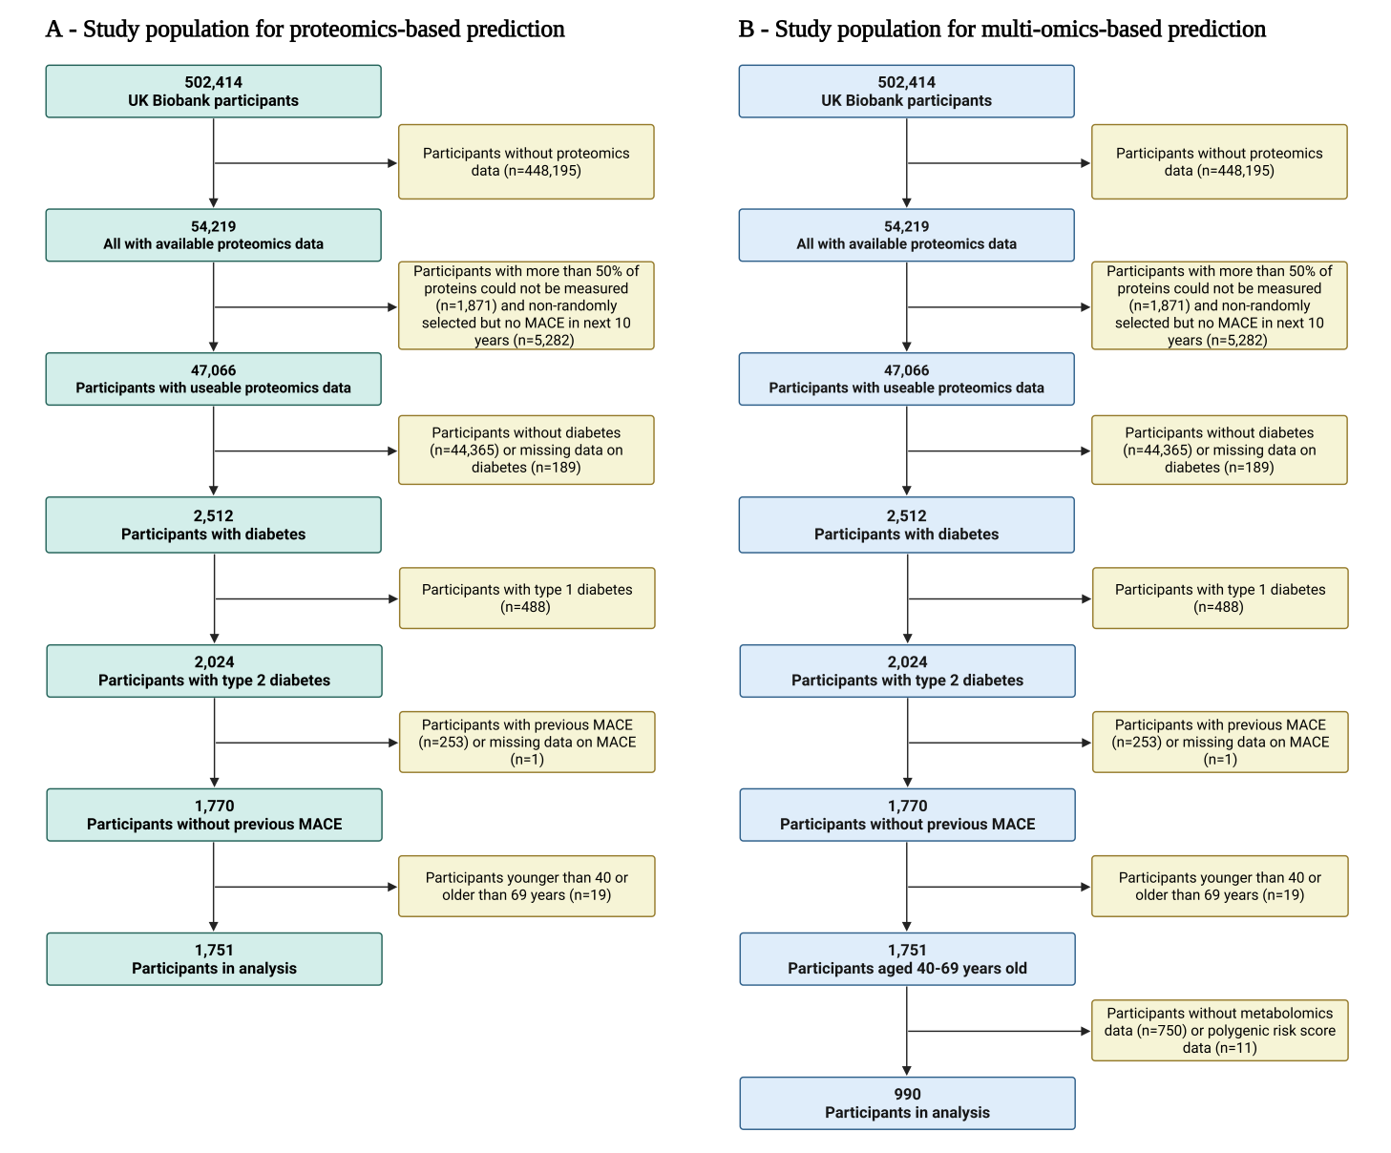

Supplemental Figure S1. Flow charts of participant selection for proteomics-based and multi-omics-based cardiovascular risk prediction analyses
Panel A shows participant selection for the proteomics-based cohort; Panel B shows selection for the multi-omics cohort.

Supplemental Figure S2. ROC curves comparing the discrimination of the SCORE2-Diabetes model with and without proteomics extension for 10-year MACE risk (N=1,751)
Panels show receiver operating characteristic (ROC) curves for the SCORE2-Diabetes model (red) and the model extended with sex-specific proteomic signatures (blue) in the total population (Panel A), male participants (Panel B), and female participants (Panel C). Shaded areas represent 95% confidence intervals.

Supplemental Figure S3. Calibration curves of the SCORE2-Diabetes model with and without proteomics extension for 10-year MACE risk prediction (N=1,751)

Calibration of the SCORE2-Diabetes model (red) and the extended model incorporating proteomic biomarkers (blue) is shown in the total population (Panel A), male participants (Panel B), and female participants (Panel C).

Supplemental Figure S4. ROC curves comparing the discrimination of the SCORE2-Diabetes model with and without multi-omics extension for 10-year MACE risk (N=990)
Panels display receiver operating characteristic (ROC) curves for the SCORE2-Diabetes model (red) and the model extended with multi-omics biomarkers (blue) in the total population (Panel A), male participants (Panel B), and female participants (Panel C). The multi-omics model refers to the integration of proteomics, metabolomics, and the CVD-PRS.

Supplemental Figure S5. Calibration curves of the SCORE2-Diabetes model with and without multi-omics extension for 10-year MACE risk prediction (N=990)

Calibration of the SCORE2-Diabetes model (red) and the extended model incorporating multi-omic biomarkers (blue) is shown in the total population (Panel A), male participants (Panel B), and female participants (Panel C). The multi-omics model refers to the integration of proteomics, metabolomics, and the CVD-PRS.

Supplemental Figure S6. Associations of selected multi-omics biomarkers and 10-year risk of MACE (N=990)
Forest plots display hazard ratios (HRs) and 95% confidence intervals (CIs) for incident MACE per 1-standard deviation (SD) increment in the concentration of each sex-specific biomarker. Analyses were conducted separately for male (Panel A) and female (Panel B) participants, with adjustments for all clinical covariates in the SCORE2-Diabetes model. Statistically significant associations are indicated by asterisks (* P < 0.05, ** P < 0.01, *** P < 0.001 assessed with FDR).
Abbreviations: HR, hazard ratio; CI, confidence interval; FDR, false discovery rate; other protein abbreviations as in Figure S2.

Supplemental Figure S7. Spearman correlation matrices for selected multi-omics biomarkers (N=990)
Correlation plots display the pairwise Spearman correlation coefficients among sex-specific multi-omics biomarkers in male (Panel A) and female (Panel B) participants
Abbreviations: ACTA2, Actin Alpha 2; CHGA, Chromogranin-A; CRNN, Cornulin; CTRC, Chymotrypsin-C; CVD, cardiovascular disease; EFHD1, EF-hand domain-containing protein D1; ENPP5, Ectonucleotide pyrophosphatase/phosphodiesterase family member 5; GAST, Gastrin; HS3ST3B1, Heparan sulfate glucosamine 3-O-sulfotransferase 3B1; IL22, Interleukin-22; NT-proBNP, N-terminal prohormone of brain natriuretic peptide; Omega-3-pct, The Omega-3 fatty acids percentage of total fatty acids; PRS, polygenic risk score; SMOC1, SPARC-related modular calcium-binding protein 1; TNC, Tenascin-C; TRIM21; E3 ubiquitin-protein ligase TRIM21; VLDL-size, Average diameter for very-low-density lipoprotein particles; WFDC2, WAP four-disulfide core domain protein.

