Very Long-Chain Saturated Fatty Acids in Plasma Lipids: Association with Cardiometabolic Risk Influenced by Lipid Interactions
Additional File 1.
Expanded Methods. Detailed Methods.
Supplementary Table 1. Prospective associations of VLCSFA lipid species (per 1-SD) with CVD.
Supplementary Table 2. Prospective associations of VLCSFA lipid species (per 1-SD) with T2D.
Supplementary Table 3. Sex-specific prospective associations of VLCSFA lipid species (per 1-SD) with T2D for lipids with significant sex interactions.
Supplementary Figure 1. Flow-chart of the T2D and CVD case-cohort design.
Supplementary Figure 2. Spearman rank correlation coefficients for C20:0 across lipid species.
Supplementary Figure 3 Spearman rank correlation coefficients for C22:0 across lipid species.
Supplementary Figure 4. Spearman rank correlation coefficients for C24:0 across lipid species.
Supplementary Figure 5. Within class correlations (lipids from the same class with different saturated fatty acid).

Expanded Methods
Lipids were extracted in methanol:dichloromethane, concentrated under nitrogen and reconstituted in ammonium acetate dichloromethane:methanol. A SelexION® -5500 QTRAP mass spectrometer operated in multiple reaction monitoring (MRM) mode and positive/negative switching was used. The lipid extracts were infused into the ionization source and separated by differential mobility spectrometry. Lipid mass and characteristic fragments were determined using 1,100 MRM transitions and 50 isotopically labeled internal standards that were simultaneously introduced with the biological sample. Molecular species were quantified by taking the ratio of the signal intensity of each target compound to that of its assigned internal standard, then multiplying by the concentration of internal standards included in the sample.
To assess stability during long-term storage, we compared median concentrations of all assayed lipids in baseline plasma (1994–1998) with plasma collected for a pilot study in 2014–2016 (n=35), analyzing both sets concurrently in 2016. Median levels were comparable, providing no evidence that prolonged storage altered lipid concentrations.

Supplementary Tables
Table S1. Prospective associations of VLCSFA lipid species (per 1-SD) with CVD.
 | Model |  | HR (95% CI) | p-value
C20:0
Ceramide C20:0 | Basic |  | 1.02 (0.77; 1.34) | 0.892
Ceramide C20:0 | Only-precursors |  | 0.69 (0.46; 1.04) | 0.074
Ceramide C20:0 | All-class |  | 0.72 (0.47; 1.12) | 0.148
Ceramide C20:0 | All-neighbors |  | 0.72 (0.47; 1.12) | 0.148
Sphingomyelin C20:0 | Basic |  | 0.63 (0.52; 0.76) | <0.001
Sphingomyelin C20:0 | Only-precursors |  | 0.63 (0.52; 0.76) | <0.001
Sphingomyelin C20:0 | All-class |  | 0.74 (0.51; 1.09) | 0.130
Sphingomyelin C20:0 | All-neighbors |  | 0.75 (0.48; 1.16) | 0.191
Dihydroceramide C20:0 | Basic |  | 1.17 (0.96; 1.44) | 0.127
Dihydroceramide C20:0 | Only-precursors |  | 1.23 (1.00; 1.52) | 0.053
Dihydroceramide C20:0 | All-class |  | 1.20 (0.96; 1.50) | 0.111
Dihydroceramide C20:0 | All-neighbors |  | 1.34 (1.05; 1.70) | 0.019
Free Fatty Acid C20:0 | Basic |  | 1.13 (0.98; 1.30) | 0.094
Free Fatty Acid C20:0 | Only-precursors |  | 1.13 (0.95; 1.34) | 0.160
Free Fatty Acid C20:0 | All-class |  | 1.11 (0.92; 1.32) | 0.278
Free Fatty Acid C20:0 | All-neighbors |  | 0.68 (0.50; 0.91) | 0.009
Hexosylceramide C20:0 | Basic |  | 0.93 (0.70; 1.24) | 0.621
Hexosylceramide C20:0 | Only-precursors |  | 0.81 (0.59; 1.12) | 0.203
Hexosylceramide C20:0 | All-class |  | 0.82 (0.59; 1.13) | 0.219
Hexosylceramide C20:0 | All-neighbors |  | 0.82 (0.59; 1.13) | 0.219
Lactosylceramide C20:0 | Basic |  | 1.29 (1.08; 1.52) | 0.004
Lactosylceramide C20:0 | Only-precursors |  | 1.11 (0.90; 1.36) | 0.340
Lactosylceramide C20:0 | All-class |  | 1.00 (0.79; 1.27) | 0.996
Lactosylceramide C20:0 | All-neighbors |  | 1.00 (0.79; 1.27) | 0.996
Monoglyceride C20:0 | Basic |  | 1.24 (1.06; 1.45) | 0.008
Monoglyceride C20:0 | Only-precursors |  | 1.19 (1.00; 1.41) | 0.053
Monoglyceride C20:0 | All-class |  | 1.46 (1.14; 1.88) | 0.003
Monoglyceride C20:0 | All-neighbors |  | 1.70 (1.28; 2.25) | <0.001
Diglyceride C20:0 | Basic |  | 0.98 (0.84; 1.14) | 0.762
Diglyceride C20:0 | Only-precursors |  | 0.90 (0.77; 1.06) | 0.220
Diglyceride C20:0 | All-class |  | 0.90 (0.77; 1.06) | 0.220
Diglyceride C20:0 | All-neighbors |  | 0.69 (0.57; 0.84) | <0.001
Triglyceride C20:0 | Basic |  | 1.17 (0.84; 1.62) | 0.350
Triglyceride C20:0 | Only-precursors |  | 0.97 (0.67; 1.41) | 0.883
Triglyceride C20:0 | All-class |  | 0.97 (0.67; 1.41) | 0.883
Triglyceride C20:0 | All-neighbors |  | 0.97 (0.67; 1.41) | 0.883
Cholesteryl ester C20:0 | Basic |  | 1.59 (1.43; 1.76) | <0.001
Cholesteryl ester C20:0 | Only-precursors |  | 1.59 (1.43; 1.76) | <0.001
Cholesteryl ester C20:0 | All-class |  | 1.23 (1.02; 1.48) | 0.027
Cholesteryl ester C20:0 | All-neighbors |  | 1.33 (1.06; 1.68) | 0.015
Phosphatidylcholine C20:0 | Basic |  | 0.89 (0.77; 1.04) | 0.138
Phosphatidylcholine C20:0 | Only-precursors |  | 0.88 (0.75; 1.03) | 0.116
Phosphatidylcholine C20:0 | All-class |  | 0.88 (0.75; 1.03) | 0.116
Phosphatidylcholine C20:0 | All-neighbors |  | 0.88 (0.75; 1.03) | 0.116
C22:0
Ceramide C22:0 |  | Basic | 0.78 (0.50; 1.22) | 0.278
 |  | Only-precursors | 0.75 (0.47; 1.20) | 0.238
 |  | All-class | 0.75 (0.47; 1.21) | 0.240
 |  | All-neighbors | 0.75 (0.44; 1.28) | 0.297
Sphingomyelin C22:0 |  | Basic | 0.56 (0.44; 0.72) | <0.001
 |  | Only-precursors | 0.87 (0.53; 1.41) | 0.566
 |  | All-class | 0.70 (0.42; 1.17) | 0.177
 |  | All-neighbors | 0.70 (0.42; 1.17) | 0.177
Dihydroceramide C22:0 |  | Basic | 1.20 (0.95; 1.52) | 0.118
 |  | Only-precursors | 1.18 (0.92; 1.50) | 0.186
 |  | All-class | 1.21 (0.91; 1.60) | 0.184
 |  | All-neighbors | 1.25 (0.89; 1.76) | 0.196
Free Fatty Acid C22:0 |  | Basic | 1.12 (0.97; 1.28) | 0.118
 |  | Only-precursors | 1.07 (0.91; 1.26) | 0.396
 |  | All-class | 1.01 (0.83; 1.22) | 0.940
 |  | All-neighbors | 1.01 (0.83; 1.22) | 0.940
Hexosylceramide C22:0 |  | Basic | 0.84 (0.56; 1.25) | 0.384
 |  | Only-precursors | 0.84 (0.56; 1.27) | 0.415
 |  | All-class | 0.84 (0.56; 1.26) | 0.407
 |  | All-neighbors | 0.96 (0.63; 1.46) | 0.856
Lactosylceramide C22:0 |  | Basic | 1.13 (0.92; 1.39) | 0.245
 |  | Only-precursors | 1.02 (0.82; 1.27) | 0.837
 |  | All-class | 1.28 (0.98; 1.68) | 0.073
 |  | All-neighbors | 1.10 (0.83; 1.45) | 0.503
Monoglyceride C22:0 |  | Basic | 1.06 (0.93; 1.21) | 0.403
 |  | Only-precursors | 0.84 (0.69; 1.01) | 0.067
 |  | All-class | 0.92 (0.72; 1.17) | 0.491
 |  | All-neighbors | 0.87 (0.68; 1.12) | 0.275
Cholesteryl ester C22:0 |  | Basic | 1.35 (1.14; 1.59) | <0.001
 |  | Only-precursors | 1.10 (0.92; 1.32) | 0.295
 |  | All-class | 1.03 (0.86; 1.24) | 0.737
 |  | All-neighbors | 1.02 (0.84; 1.25) | 0.815
Phosphatidylethanolamine C22:0 |  | Basic | 0.98 (0.87; 1.12) | 0.813
 |  | Only-precursors | 0.98 (0.87; 1.12) | 0.813
 |  | All-class | 0.98 (0.87; 1.12) | 0.813
 |  | All-neighbors | 0.88 (0.77; 1.01) | 0.067
C24:0
Ceramide C24:0 |  | Basic | 0.83 (0.53; 1.32) | 0.441
 |  | Only-precursors | 0.79 (0.50; 1.26) | 0.325
 |  | All-class | 0.79 (0.50; 1.26) | 0.325
 |  | All-neighbors | 1.00 (0.53; 1.87) | 0.999
Sphingomyelin C24:0 |  | Basic | 1.32 (0.99; 1.75) | 0.060
 |  | Only-precursors | 1.36 (1.02; 1.81) | 0.036
 |  | All-class | 1.28 (0.95; 1.71) | 0.100
 |  | All-neighbors | 1.28 (0.91; 1.80) | 0.151
Dihydroceramide C24:0 |  | Basic | 1.00 (0.81; 1.23) | 0.997
 |  | Only-precursors | 0.91 (0.72; 1.15) | 0.418
 |  | All-class | 0.91 (0.72; 1.15) | 0.418
 |  | All-neighbors | 0.62 (0.39; 0.98) | 0.042
Free Fatty Acid C24:0 |  | Basic | 1.12 (0.98; 1.28) | 0.109
 |  | Only-precursors | 1.14 (0.98; 1.33) | 0.100
 |  | All-class | 1.14 (0.98; 1.33) | 0.100
 |  | All-neighbors | 1.07 (0.90; 1.26) | 0.449
Hexosylceramide C24:0 |  | Basic | 1.21 (0.80; 1.83) | 0.362
 |  | Only-precursors | 1.42 (0.90; 2.24) | 0.127
 |  | All-class | 1.33 (0.83; 2.13) | 0.228
 |  | All-neighbors | 1.39 (0.80; 2.44) | 0.246
Lactosylceramide C24:0 |  | Basic | 0.85 (0.68; 1.05) | 0.132
 |  | Only-precursors | 0.71 (0.54; 0.92) | 0.010
 |  | All-class | 0.71 (0.54; 0.92) | 0.010
 |  | All-neighbors | 0.62 (0.46; 0.83) | 0.001
Monoglyceride C24:0 |  | Basic | 1.04 (0.91; 1.19) | 0.540
 |  | Only-precursors | 0.87 (0.69; 1.10) | 0.249
 |  | All-class | 0.87 (0.69; 1.10) | 0.249
 |  | All-neighbors | 0.80 (0.62; 1.02) | 0.073
Cholesteryl ester C24:0 |  | Basic | 1.67 (1.48; 1.88) | <0.001
 |  | Only-precursors | 1.37 (1.11; 1.69) | 0.004
 |  | All-class | 1.37 (1.11; 1.69) | 0.004
 |  | All-neighbors | 1.34 (1.09; 1.66) | 0.006
VLCSFA, very long chain saturated fatty acids; CVD, cardiovascular disease; HR, hazard ratio; CI, confidence interval.
The basic model was adjusted for age, sex, waist circumference, height, leisure-time physical activity, smoking status, alcohol intake, education level, fasting status at blood draw, total energy intake, blood pressure (diastolic and systolic), standard clinical blood lipid markers (total cholesterol and triglycerides), antihypertensive medication, lipid-lowering medication, acetylsalicylic acid medication, prevalent diabetes, glycated hemoglobin, and the respective sum of the lipid class. The precursors-only model was additionally adjusted for neighboring precursor lipids (shorter carbon chain length) within the same lipid class. The all-class model was further adjusted for all lipid neighbors within the same class. The all-neighbors model was adjusted for all direct neighbors.
Triglycerides and cholesteryl esters were not adjusted for clinical measures of triglycerides and total cholesterol, respectively.

Table S2. Prospective associations of VLCSFA lipid species (per 1-SD) with T2D.
 | Model | HR (95% CI) |  | p-value
C20:0
Ceramide C20:0 | Basic | 1.36 (1.05; 1.77) |  | 0.022
Ceramide C20:0 | Only-precursors | 0.77 (0.52; 1.15) |  | 0.199
Ceramide C20:0 | All-class | 0.52 (0.35; 0.79) |  | 0.002
Ceramide C20:0 | All-neighbors | 0.52 (0.35; 0.79) |  | 0.002
Sphingomyelin C20:0 | Basic | 1.01 (0.84; 1.22) |  | 0.889
Sphingomyelin C20:0 | Only-precursors | 1.01 (0.84; 1.22) |  | 0.889
Sphingomyelin C20:0 | All-class | 0.64 (0.45; 0.93) |  | 0.017
Sphingomyelin C20:0 | All-neighbors | 0.61 (0.40; 0.91) |  | 0.016
Dihydroceramide C20:0 | Basic | 1.35 (1.11; 1.63) |  | 0.003
Dihydroceramide C20:0 | Only-precursors | 1.36 (1.11; 1.67) |  | 0.003
Dihydroceramide C20:0 | All-class | 1.32 (1.07; 1.63) |  | 0.009
Dihydroceramide C20:0 | All-neighbors | 1.36 (1.07; 1.72) |  | 0.011
Free Fatty Acid C20:0 | Basic | 1.06 (0.92; 1.23) |  | 0.413*
Free Fatty Acid C20:0 | Only-precursors | 1.08 (0.91; 1.27) |  | 0.387*
Free Fatty Acid C20:0 | All-class | 1.11 (0.93; 1.33) |  | 0.257*
Free Fatty Acid C20:0 | All-neighbors | 0.69 (0.51; 0.94) |  | 0.018
Hexosylceramide C20:0 | Basic | 0.92 (0.70; 1.21) |  | 0.545
Hexosylceramide C20:0 | Only-precursors | 0.92 (0.67; 1.25) |  | 0.583
Hexosylceramide C20:0 | All-class | 0.78 (0.56; 1.07) |  | 0.118
Hexosylceramide C20:0 | All-neighbors | 0.78 (0.56; 1.07) |  | 0.118
Lactosylceramide C20:0 | Basic | 1.21 (1.04; 1.42) |  | 0.014
Lactosylceramide C20:0 | Only-precursors | 1.15 (0.95; 1.39) |  | 0.145
Lactosylceramide C20:0 | All-class | 0.93 (0.75; 1.15) |  | 0.488
Lactosylceramide C20:0 | All-neighbors | 0.93 (0.75; 1.15) |  | 0.488
Monoglyceride C20:0 | Basic | 1.25 (1.07; 1.45) |  | 0.005*
Monoglyceride C20:0 | Only-precursors | 1.25 (1.05; 1.50) |  | 0.012*
Monoglyceride C20:0 | All-class | 1.25 (0.97; 1.61) |  | 0.087*
Monoglyceride C20:0 | All-neighbors | 1.49 (1.12; 1.99) |  | 0.006*
Diglyceride C20:0 | Basic | 0.94 (0.80; 1.11) |  | 0.467
Diglyceride C20:0 | Only-precursors | 0.83 (0.70; 0.99) |  | 0.035
Diglyceride C20:0 | All-class | 0.83 (0.70; 0.99) |  | 0.035
Diglyceride C20:0 | All-neighbors | 0.82 (0.67; 1.00) |  | 0.053
Triglyceride C20:0 | Basic | 0.73 (0.53; 1.00) |  | 0.049
Triglyceride C20:0 | Only-precursors | 0.65 (0.45; 0.93) |  | 0.018
Triglyceride C20:0 | All-class | 0.65 (0.45; 0.93) |  | 0.018
Triglyceride C20:0 | All-neighbors | 0.65 (0.45; 0.93) |  | 0.018
Cholesteryl ester C20:0 | Basic | 1.13 (0.97; 1.31) |  | 0.112
Cholesteryl ester C20:0 | Only-precursors | 1.13 (0.97; 1.31) |  | 0.112
Cholesteryl ester C20:0 | All-class | 1.29 (1.07; 1.56) |  | 0.007
Cholesteryl ester C20:0 | All-neighbors | 1.39 (1.08; 1.80) |  | 0.011
Phosphatidylcholine C20:0 | Basic | 0.86 (0.75; 0.99) |  | 0.032
Phosphatidylcholine C20:0 | Only-precursors | 0.90 (0.77; 1.05) |  | 0.183
Phosphatidylcholine C20:0 | All-class | 0.90 (0.77; 1.05) |  | 0.183
Phosphatidylcholine C20:0 | All-neighbors | 0.90 (0.77; 1.05) |  | 0.183
C22:0
Ceramide C22:0 | Basic |  | 2.03 (1.30; 3.16) |  | 0.002
Ceramide C22:0 | Only-precursors |  | 1.84 (1.18; 2.89) |  | 0.008
Ceramide C22:0 | All-class |  | 1.79 (1.15; 2.79) |  | 0.010
Ceramide C22:0 | All-neighbors |  | 1.69 (1.02; 2.78) |  | 0.040
Sphingomyelin C22:0 | Basic |  | 1.25 (0.98; 1.58) |  | 0.071
Sphingomyelin C22:0 | Only-precursors |  | 2.19 (1.38; 3.46) |  | 0.001
Sphingomyelin C22:0 | All-class |  | 2.02 (1.25; 3.26) |  | 0.004
Sphingomyelin C22:0 | All-neighbors |  | 2.02 (1.25; 3.26) |  | 0.004
Dihydroceramide C22:0 | Basic |  | 1.26 (1.01; 1.57) |  | 0.043
Dihydroceramide C22:0 | Only-precursors |  | 1.21 (0.96; 1.52) |  | 0.103
Dihydroceramide C22:0 | All-class |  | 1.45 (1.11; 1.90) |  | 0.007
Dihydroceramide C22:0 | All-neighbors |  | 1.21 (0.88; 1.67) |  | 0.241
Free Fatty Acid C22:0 | Basic |  | 0.98 (0.85; 1.12) |  | 0.738
Free Fatty Acid C22:0 | Only-precursors |  | 0.93 (0.79; 1.10) |  | 0.416
Free Fatty Acid C22:0 | All-class |  | 0.91 (0.76; 1.10) |  | 0.351
Free Fatty Acid C22:0 | All-neighbors |  | 0.91 (0.76; 1.10) |  | 0.351
Hexosylceramide C22:0 | Basic |  | 1.47 (1.00; 2.17) |  | 0.051
Hexosylceramide C22:0 | Only-precursors |  | 1.55 (1.06; 2.28) |  | 0.024
Hexosylceramide C22:0 | All-class |  | 1.56 (1.07; 2.29) |  | 0.022
Hexosylceramide C22:0 | All-neighbors |  | 1.73 (1.17; 2.56) |  | 0.006
Lactosylceramide C22:0 | Basic |  | 1.43 (1.20; 1.70) |  | <0.001
Lactosylceramide C22:0 | Only-precursors |  | 1.38 (1.14; 1.66) |  | 0.001
Lactosylceramide C22:0 | All-class |  | 1.27 (1.01; 1.60) |  | 0.045
Lactosylceramide C22:0 | All-neighbors |  | 1.33 (1.04; 1.70) |  | 0.024
Monoglyceride C22:0 | Basic |  | 1.11 (0.98; 1.25) |  | 0.097
Monoglyceride C22:0 | Only-precursors |  | 0.95 (0.79; 1.14) |  | 0.570
Monoglyceride C22:0 | All-class |  | 0.86 (0.69; 1.08) |  | 0.200
Monoglyceride C22:0 | All-neighbors |  | 0.87 (0.68; 1.10) |  | 0.235
Cholesteryl ester C22:0 | Basic |  | 0.90 (0.78; 1.04) |  | 0.143
Cholesteryl ester C22:0 | Only-precursors |  | 0.87 (0.75; 1.02) |  | 0.090
Cholesteryl ester C22:0 | All-class |  | 0.92 (0.78; 1.08) |  | 0.299
Cholesteryl ester C22:0 | All-neighbors |  | 0.92 (0.77; 1.11) |  | 0.377
Phosphatidylethanolamine C22:0 | Basic |  | 0.99 (0.88; 1.12) |  | 0.862
Phosphatidylethanolamine C22:0 | Only-precursors |  | 0.99 (0.88; 1.12) |  | 0.862
Phosphatidylethanolamine C22:0 | All-class |  | 0.99 (0.88; 1.12) |  | 0.862
Phosphatidylethanolamine C22:0 | All-neighbors |  | 0.93 (0.82; 1.06) |  | 0.301
C24:0
Ceramide C24:0 | Basic |  | 0.55 (0.37; 0.82) |  | 0.004
Ceramide C24:0 | Only-precursors |  | 0.61 (0.41; 0.92) |  | 0.019
Ceramide C24:0 | All-class |  | 0.61 (0.41; 0.92) |  | 0.019
Ceramide C24:0 | All-neighbors |  | 0.46 (0.27; 0.79) |  | 0.005
Sphingomyelin C24:0 | Basic |  | 1.36 (1.05; 1.77) |  | 0.019
Sphingomyelin C24:0 | Only-precursors |  | 1.25 (0.95; 1.65) |  | 0.114
Sphingomyelin C24:0 | All-class |  | 1.25 (0.94; 1.66) |  | 0.121
Sphingomyelin C24:0 | All-neighbors |  | 1.61 (1.15; 2.26) |  | 0.005
Dihydroceramide C24:0 | Basic |  | 0.82 (0.70; 0.98) |  | 0.025
Dihydroceramide C24:0 | Only-precursors |  | 0.68 (0.55; 0.84) |  | <0.001
Dihydroceramide C24:0 | All-class |  | 0.68 (0.55; 0.84) |  | <0.001
Dihydroceramide C24:0 | All-neighbors |  | 1.18 (0.80; 1.74) |  | 0.401
Free Fatty Acid C24:0 | Basic |  | 1.01 (0.88; 1.16) |  | 0.858
Free Fatty Acid C24:0 | Only-precursors |  | 1.03 (0.88; 1.20) |  | 0.688
Free Fatty Acid C24:0 | All-class |  | 1.03 (0.88; 1.20) |  | 0.688
Free Fatty Acid C24:0 | All-neighbors |  | 1.11 (0.94; 1.31) |  | 0.232
Hexosylceramide C24:0 | Basic |  | 0.84 (0.58; 1.20) |  | 0.325
Hexosylceramide C24:0 | Only-precursors |  | 1.04 (0.70; 1.55) |  | 0.837
Hexosylceramide C24:0 | All-class |  | 1.09 (0.72; 1.64) |  | 0.689
Hexosylceramide C24:0 | All-neighbors |  | 0.56 (0.33; 0.92) |  | 0.023
Lactosylceramide C24:0 | Basic |  | 1.37 (1.12; 1.68) |  | 0.002
Lactosylceramide C24:0 | Only-precursors |  | 1.16 (0.91; 1.49) |  | 0.239
Lactosylceramide C24:0 | All-class |  | 1.16 (0.91; 1.49) |  | 0.239
Lactosylceramide C24:0 | All-neighbors |  | 1.31 (1.00; 1.73) |  | 0.053
Monoglyceride C24:0 | Basic |  | 1.17 (1.03; 1.32) |  | 0.012
Monoglyceride C24:0 | Only-precursors |  | 1.16 (0.92; 1.46) |  | 0.203
Monoglyceride C24:0 | All-class |  | 1.16 (0.92; 1.46) |  | 0.203
Monoglyceride C24:0 | All-neighbors |  | 1.13 (0.88; 1.44) |  | 0.341
Cholesteryl ester C24:0 | Basic |  | 0.96 (0.80; 1.14) |  | 0.627
Cholesteryl ester C24:0 | Only-precursors |  | 0.83 (0.65; 1.06) |  | 0.134
Cholesteryl ester C24:0 | All-class |  | 0.83 (0.65; 1.06) |  | 0.134
Cholesteryl ester C24:0 | All-neighbors |  | 0.79 (0.62; 1.00) |  | 0.054
VLCSFA, very long chain saturated fatty acids; T2D, type-2 diabetes; HR, hazard ratio; CI, confidence interval.
The basic model was adjusted for age, sex, waist circumference, height, leisure-time physical activity, smoking status, alcohol intake, education level, fasting status at blood draw, total energy intake, blood pressure (diastolic and systolic), standard clinical blood lipid markers (total cholesterol and triglycerides), antihypertensive medication, lipid-lowering medication, acetylsalicylic acid medication, and the respective sum of the lipid class. The only-precursors model was additionally adjusted for neighboring precursor lipids (shorter carbon chain length) within the same lipid class. The all-class model was further adjusted for all lipid neighbors within the same class. The all-neighbors model was adjusted for all direct neighbors.
Triglycerides and cholesteryl esters were not adjusted for clinical measures of triglycerides and total cholesterol, respectively.
(*) Indicates a statistically significant (FDR<0.05) interaction with sex.

Table S3. Sex-specific prospective associations of VLCSFA lipid species (per 1-SD) with T2D for lipids with significant sex interactions.
C20:0 | Adjustment Model | HR (95% CI) | p-value
Men
Free Fatty Acid C20:0 | Basic | 1.31 (1.08; 1.59) | 0.006
Free Fatty Acid C20:0 | Only-precursors | 1.33 (1.06; 1.65) | 0.012
Free Fatty Acid C20:0 | All-class | 1.37 (1.08; 1.73) | 0.008
Free Fatty Acid C20:0 | All-neighbors | 0.76 (0.52; 1.10) | 0.147
Monoglyceride C20:0 | Basic | 1.47 (1.20; 1.80) | <0.001
Monoglyceride C20:0 | Only-precursors | 1.55 (1.23; 1.94) | <0.001
Monoglyceride C20:0 | All-class | 1.67 (1.19; 2.33) | 0.003
Monoglyceride C20:0 | All-neighbors | 1.90 (1.31; 2.75) | 0.001
Women
Free Fatty Acid C20:0 | Basic | 0.86 (0.71; 1.04) | 0.117
Free Fatty Acid C20:0 | Only-precursors | 0.90 (0.72; 1.12) | 0.342
Free Fatty Acid C20:0 | All-class | 0.88 (0.69; 1.12) | 0.283
Free Fatty Acid C20:0 | All-neighbors | 0.54 (0.35; 0.82) | 0.004
Monoglyceride C20:0 | Basic | 0.96 (0.77; 1.20) | 0.735
Monoglyceride C20:0 | Only-precursors | 0.93 (0.72; 1.21) | 0.580
Monoglyceride C20:0 | All-class | 0.78 (0.54; 1.12) | 0.173
Monoglyceride C20:0 | All-neighbors | 0.94 (0.62; 1.42) | 0.767
VLCSFA, very long chain saturated fatty acids; T2D, type-2 diabetes; HR, hazard ratio; CI, confidence interval.
The basic model was adjusted for age, waist circumference, height, leisure-time physical activity, smoking status, alcohol intake, education level, fasting status at blood draw, total energy intake, blood pressure (diastolic and systolic), standard clinical blood lipid markers (total cholesterol and triglycerides), antihypertensive medication, lipid-lowering medication, acetylsalicylic acid medication, and the respective sum of the lipid class. The only-precursors model was additionally adjusted for neighboring precursor lipids (shorter carbon chain length) within the same lipid class. The all-class model was further adjusted for all lipid neighbors within the same class. The all-neighbors model was adjusted for all direct neighbors.

Supplemental Figures
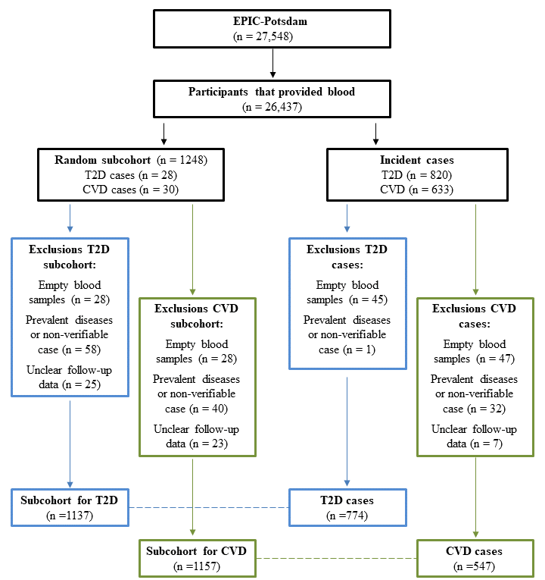

Figure S1. Flow-chart of the T2D and CVD case-cohort design.
T2D indicates type-2 diabetes and CVD cardiovascular disease.
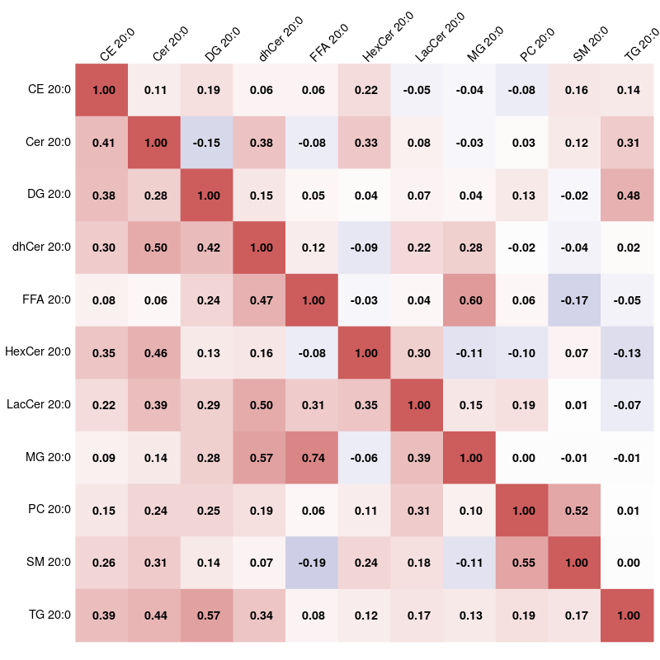

Figure S2. Spearman rank correlation coefficients for C20:0 across lipid species.
Lower-left triangle shows raw Spearman rank correlation coefficients, and upper-right triangle partial (adjusted for all other C20:0 molecular species) coefficients.
CE indicates cholesteryl esters; Cer, ceramides; DG, diacylglycerols; dhCer, dihydroceramides; FFA, free fatty acids; HexCer, hexosylceramides; LacCer, lactosylceramides; MG, monoacylglycerols; PC, phosphatidylcholines; SM, sphingomyelins; TG, and triacylglycerides.

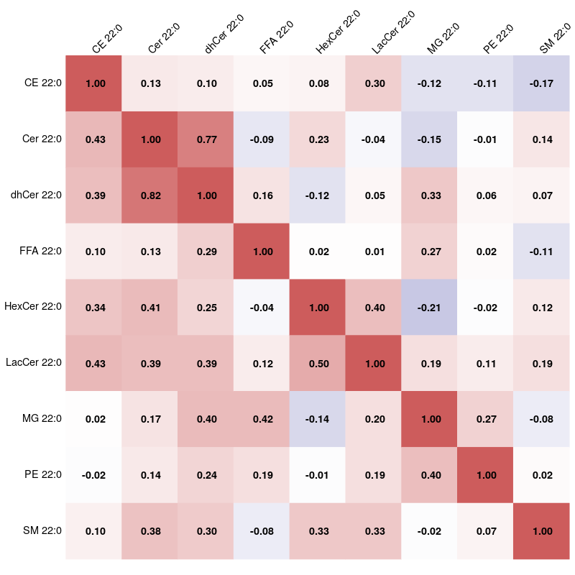

Figure S3. Spearman rank correlation coefficients for C22:0 across lipid species.
Lower-left triangle shows raw Spearman rank correlation coefficients, and upper-right triangle partial (adjusted for all other C22:0 molecular species) coefficients.
CE indicates cholesteryl esters; Cer, ceramides; dhCer, dihydroceramides; FFA, free fatty acids; HexCer, hexosylceramides; LacCer, lactosylceramides; MG, monoacylglycerols; PE, phosphatidylethanolamines; and SM, sphingomyelins.

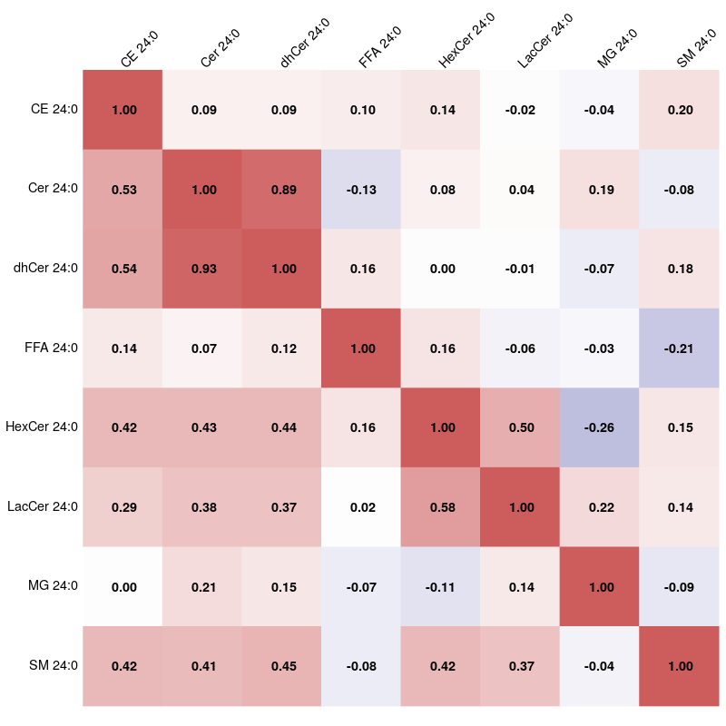

Figure S4. Spearman rank correlation coefficients for C24:0 across lipid species.
Lower-left triangle shows raw Spearman rank correlation coefficients, and upper-right triangle partial (adjusted for all other C24:0 molecular species) coefficients.
CE indicates cholesteryl esters; Cer, ceramides; dhCer, dihydroceramides; FFA, free fatty acids; HexCer, hexosylceramides; LacCer, lactosylceramides; MG, monoacylglycerols; and SM, sphingomyelins.

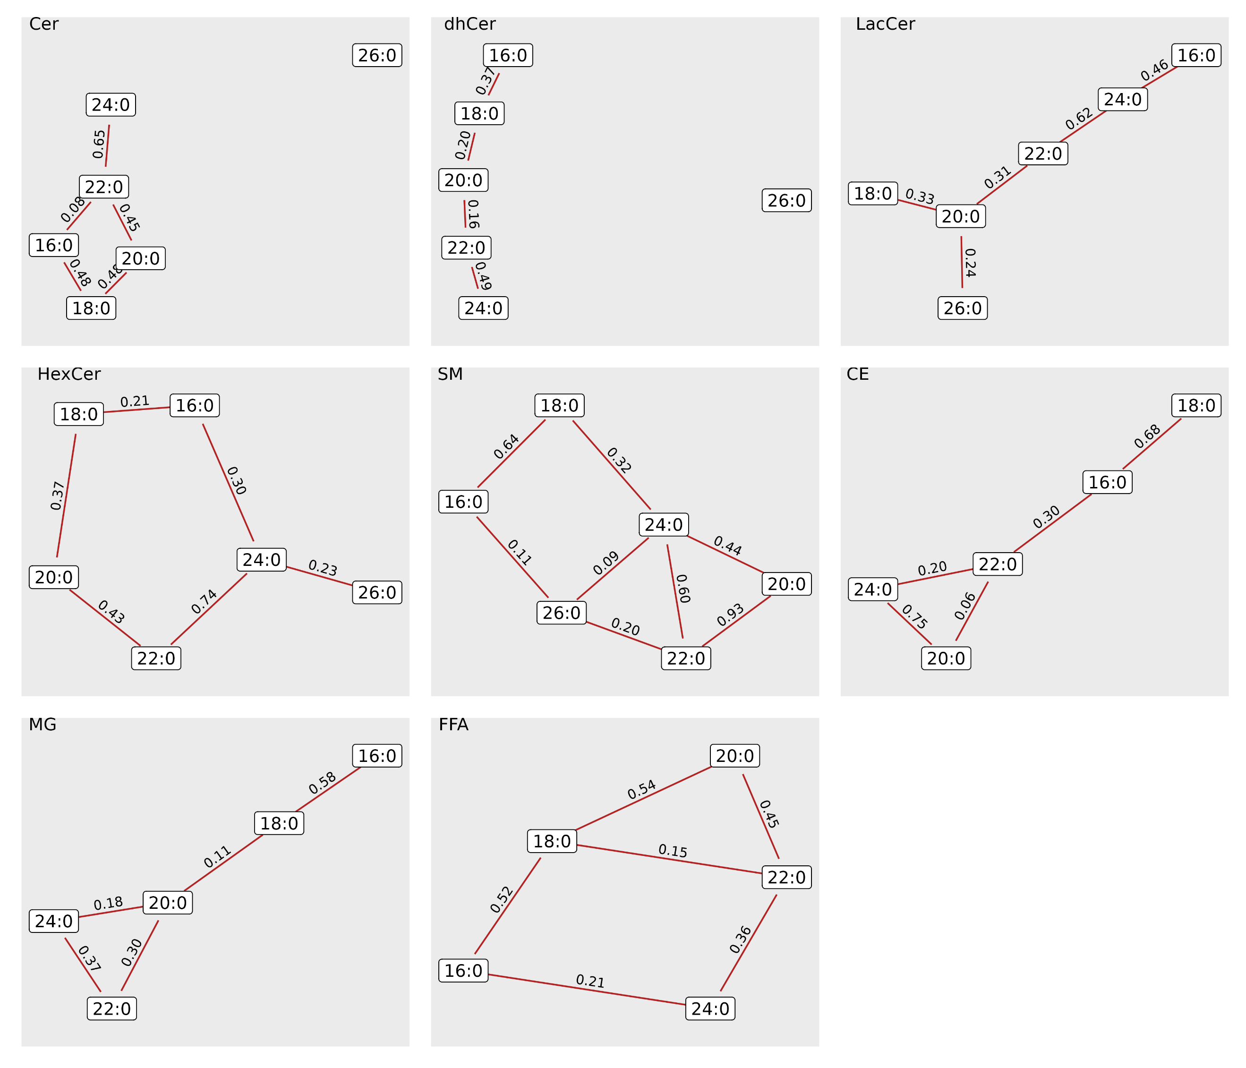
Figure S5. Within class correlations (lipids from the same class with different saturated fatty acid).
CE indicates cholesteryl esters; Cer, ceramides; dhCer, dihydroceramides; FFA, free fatty acids; HexCer, hexosylceramides; LacCer, lactosylceramides; MG, monoacylglycerols; and SM, sphingomyelins.

