Supplementary Table: Primers Sequences

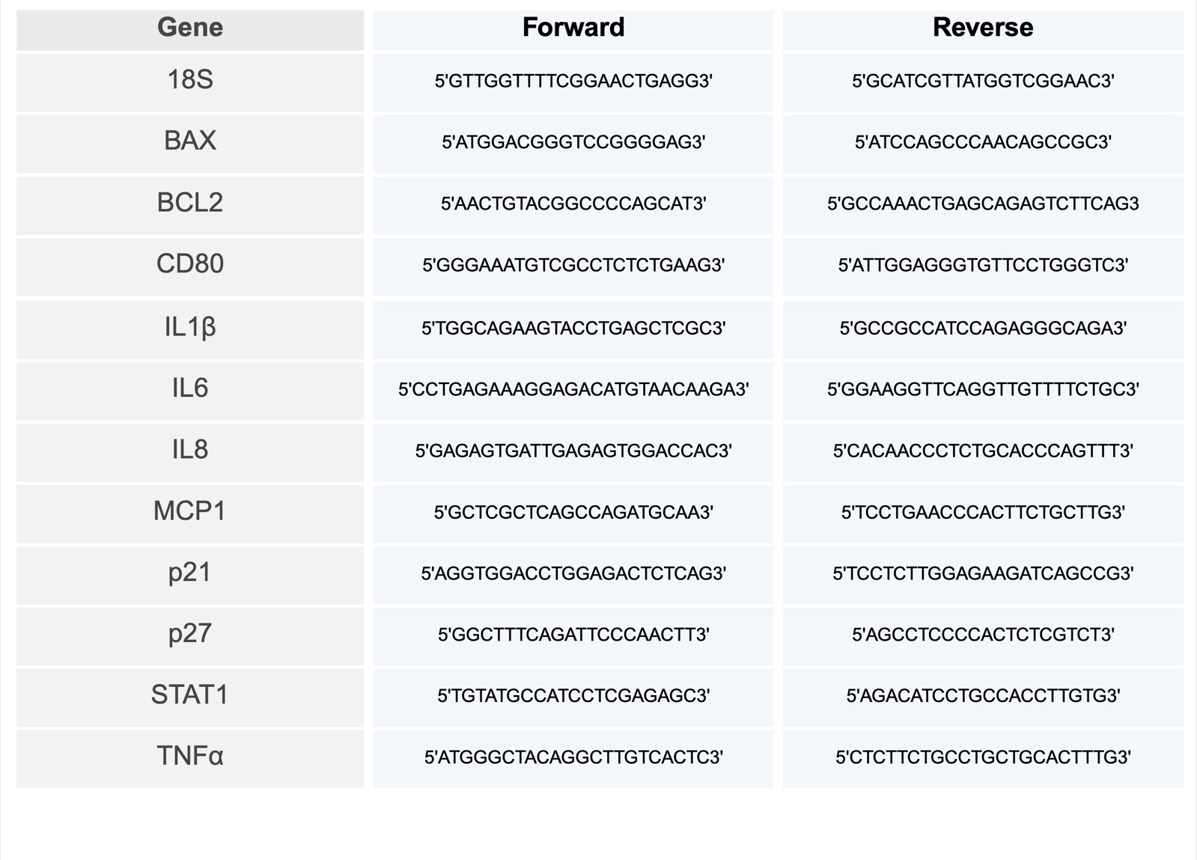

Supplementary figures

Supplementary Fig1: The effect of Empagliflozin (EMPA) on HbA1c in patients with T2DM who have had an acute myocardial infarction. (A) depicts the experimental protocol where patients were allocated to Arm-A (EMPA prescribed immediately post-acute event - blue) or Arm-B (EMPA prescribed 90days post-acute event - purple). HbA1c was measured at day T0, T90 and T180 in (B) Arm A and (C) Arm B. Data represents change over time within each Arm expressed as mean ± SEM. A Kruskal Wallis with Dunns post-hoc correction was used for statistical analysis.

Supplementary Fig2: The effect of EMPA on ATP release and inflammasome priming/activation in MDMs isolated from T2DM-AMI patients. (A) depicts the experimental protocol with patients allocated to either Arm-A (EMPA prescribed immediately post-acute event - blue) or Arm-B (EMPA prescribed 90days post-acute event - purple). Blood samples were taken and EMPA prescribed at the intervals indicated. PBMCs were extracted, and monocytes isolated and differentiated into macrophages. Expression of IL1β mRNA (B), ATP release (C) and caspase-1 activity (D) was measured in unstimulated cells. Data shows inter-Arm comparisons expressed as mean % change over time compared to T0. Data is presented as mean ± SEM with sample size provided. A mixed effects model with Tukey’s multiple comparison test was used for between group analysis.

Supplementary Fig3: The effect of EMPA on TNFα expression, TNFα and IL6 release in MDMs from T2DM-AMI patients. (A) depicts the experimental protocol with patients allocated to either Arm-A (EMPA prescribed immediately post-acute event - blue) or Arm-B (EMPA prescribed 90days post-acute event - purple). Blood samples were taken and EMPA prescribed at the intervals indicated. PBMCs were extracted, and monocytes isolated and differentiated into macrophages. Data shows inter-Arm comparisons expressed as mean % change over time compared to T0 for TNFα mRNA expression in MDMs (B), and TNFα (C) and IL6 (D) release from 4hr LPS-stimulated cells. A mixed effects model with Tukey’s multiple comparison test was used for interarm analysis respectively.

Supplementary Fig4: The effect of EMPA on expression of M1 markers in MDMs from T2DM-AMI patients. (A) depicts the experimental protocol with patients allocated to either Arm-A (EMPA prescribed immediately post-acute event - blue) or Arm-B (EMPA prescribed 90days post-acute event - purple). Blood samples were taken and EMPA prescribed at the intervals indicated. PBMCs were extracted, and monocytes isolated and differentiated into macrophages. Data shows inter-Arm comparisons expressed as mean % change over time compared to T0 for MCP1 (B), STAT1 (C) and CD80 (D), mRNA expression in untreated MDMs. A mixed effects model with Tukey’s multiple comparison test was used for interarm analysis respectively.

Supplementary Fig5: The effect of EMPA on expression of cell senescence/SASP markers in MDMs from T2DM-AMI patients. (A) depicts the experimental protocol with patients allocated to either Arm-A (EMPA prescribed immediately post-acute event - blue) or Arm-B (EMPA prescribed 90days post-acute event - purple). Blood samples were taken and EMPA prescribed at the intervals indicated. PBMCs were extracted, and monocytes isolated and differentiated into macrophages. Data shows inter-Arm comparisons expressed as mean % change over time compared to T0 for P21 (B), P27 (C), BCL2 (D), BAX (E), and IL8 (F) mRNA expression in untreated cells. Similarly, plasma MMP-9 (G), Serpin-E1 (H), and OPN (I) was measured. A mixed effects model with Tukey’s multiple comparison test was used for interarm analysis respectively.

