Association between the Triglyceride–Glucose–Frailty Index and All-Cause and Cardiovascular Mortality in Individuals with Cardiovascular–Kidney–Metabolic Syndrome: The Mediating Role of the Poverty–Income Ratio

Yan Wang^{1,2}, Ning Wei^{1,2}, Meng Li^{1,2}, Jun-Wen Liu^{1,2}, Hong-Bin Lin^{1,2}, Hong-Fei Zhang^{1,2}

Author affiliations:
¹ Department of Anesthesiology, Zhujiang Hospital, Southern Medical University, Guangzhou, 510280, China
² Institute of Perioperative Medicine and Organ Protection, Zhujiang Hospital of Southern Medical University, Guangzhou, 510280, China

Corresponding authors:
Dr. Hong-Fei Zhang; zhanghongfei@smu.edu.cn
Department of Anesthesiology, Zhujiang Hospital; Institute of Perioperative Medicine and Organ Protection, Zhujiang Hospital of Southern Medical University, Guangzhou, 510280, China

Content
I. Frailty index calculation and missing data of study variables 4
Table S1 Composition and scoring criteria of the 49-item frailty index 4
Table S2 Frequency and distribution of missing data among study variables 8
II. Unadjusted association between baseline variables and mortality 9
Table S3 The unadjusted association between baseline variables and all-cause mortality (n = 15044). 9
Table S4 The unadjusted association between baseline variables and cardiovascular mortality (n = 15044) 10
III. Cox regression analyses for TyGFI, TyG, and FI with mortality 12
Table S5. Association between TyGFI and mortality in adults with CKM syndrome: Cox regression analysis after multiple imputation 12
Table S6 Cox regression model for TyG (per-1 unit) and mortality in adults with CKM syndrome 13
Table S7 Cox regression model for FI (per-0.1 unit) and mortality in adults with CKM syndrome 14
IV. Interaction analyses of TyG and FI 15
Table S8 Additive and multiplicative joint interaction of TyG and frailty index on all-cause mortality 15
Table S9 Additive and multiplicative joint interaction of TyG and frailty index on CVD mortality 16
V. Subgroup analyses of TyGFI and mortality 17
Table S10 Subgroup analysis of the association between TyGFI and all-cause mortality 17
Table S11 Subgroup analysis of the association between TyGFI and CVD mortality 18
VI Cox regression and competing risk models for cardiovascular mortality 20
Table S12 Association of TyGFI with cardiovascular mortality assessed by Cox regression and competing risk models 21
VII. Threshold effect analyses of TyGFI and mortality 21
Table S13 Threshold effect analysis of the TyGFI and all-cause mortality 22
Table S14 Threshold effect analysis of the TyGFI and CVD mortality 22
VIII. Proportional hazards assumption test 22
Table S15 Schoenfeld residual tests for proportional hazards assumption 23
IV. Figures for dose-response relationships and Schoenfeld residual diagnostic plots 24
Fig. S1 Restricted cubic splines depicting the dose-response relationships between TyG and mortality outcomes. 24
Fig. S2 Restricted cubic splines depicting the dose-response relationships between FI and mortality outcomes. 25
Fig. S3 Schoenfeld residual diagnostic plots for TYG-FI over follow-up time in Cox proportional hazards models. 26

I. Frailty index calculation and missing data of study variables

Table S1 Composition and scoring criteria of the 49-item frailty index
Domain | No. | Variable Description | Scoring Criteria | Rationale for Inclusion
Cognitive Function
 | 1 | Self-reported confusion or memory problems | Present = 1; Absent = 0 | Cognitive impairment is a key marker of age-related decline and frailty
Functional Limitations and Dependence
 | 2 | Difficulty managing finances | Any difficulty = 1; No difficulty = 0 | Instrumental ADL reflecting cognitive-executive function
 | 3 | Difficulty with stooping, crouching, or kneeling | Any difficulty = 1; No difficulty = 0 | Mobility limitation indicating physical frailty
 | 4 | Difficulty lifting or carrying groceries | Any difficulty = 1; No difficulty = 0 | Upper body strength limitation
 | 5 | Difficulty performing household chores | Any difficulty = 1; No difficulty = 0 | Instrumental ADL reflecting physical capacity
 | 6 | Difficulty preparing meals | Any difficulty = 1; No difficulty = 0 | Instrumental ADL essential for independent living
 | 7 | Difficulty standing up from armless chair | Any difficulty = 1; No difficulty = 0 | Lower body strength and balance indicator
 | 8 | Difficulty getting in/out of bed | Any difficulty = 1; No difficulty = 0 | Basic mobility function
 | 9 | Difficulty using fork, knife, or cup | Any difficulty = 1; No difficulty = 0 | Fine motor skills and basic ADL
 | 10 | Difficulty dressing yourself | Any difficulty = 1; No difficulty = 0 | Basic ADL essential for self-care
 | 11 | Difficulty standing for prolonged periods | Any difficulty = 1; No difficulty = 0 | Endurance and postural control
 | 12 | Difficulty grasping or holding small objects | Any difficulty = 1; No difficulty = 0 | Fine motor skills and hand function
 | 13 | Difficulty attending social events | Any difficulty = 1; No difficulty = 0 | Social participation capacity
 | 14 | Difficulty pushing or pulling large objects | Any difficulty = 1; No difficulty = 0 | Overall body strength indicator
 | 15 | Difficulty walking one-quarter mile | Any difficulty = 1; No difficulty = 0 | Ambulatory endurance
 | 16 | Difficulty climbing 10 steps | Any difficulty = 1; No difficulty = 0 | Lower extremity function and cardiopulmonary capacity
Depressive Symptoms (PHQ-9 Components)
 | 17 | Little interest or pleasure in activities | Nearly every day = 1; More than half the days = 0.66; Several days = 0.33; Not at all = 0 | Anhedonia as core depression symptom
 | 18 | Feeling down, depressed, or hopeless | Nearly every day = 1; More than half the days = 0.66; Several days = 0.33; Not at all = 0 | Core depressive mood symptom
 | 19 | Sleep disturbances | Nearly every day = 1; More than half the days = 0.66; Several days = 0.33; Not at all = 0 | Sleep problems common in depression and frailty
 | 20 | Fatigue or low energy | Nearly every day = 1; More than half the days = 0.66; Several days = 0.33; Not at all = 0 | Fatigue overlaps with physical frailty
 | 21 | Appetite disturbance | Nearly every day = 1; More than half the days = 0.66; Several days = 0.33; Not at all = 0 | Nutritional risk indicator
 | 22 | Negative self-perception | Nearly every day = 1; More than half the days = 0.66; Several days = 0.33; Not at all = 0 | Self-esteem and mental health indicator
 | 23 | Concentration difficulties | Nearly every day = 1; More than half the days = 0.66; Several days = 0.33; Not at all = 0 | Cognitive aspect of depression
Comorbidities
 | 24 | Arthritis (self-reported physician diagnosis) | Confirmed diagnosis = 1; Borderline/suspect = 0.5; Absent = 0 | Musculoskeletal morbidity
 | 25 | Thyroid disorder | Confirmed diagnosis = 1; Borderline/suspect = 0.5; Absent = 0 | Endocrine system disorder
 | 26 | Chronic bronchitis | Confirmed diagnosis = 1; Borderline/suspect = 0.5; Absent = 0 | Respiratory system morbidity
 | 27 | Any cancer | Confirmed diagnosis = 1; Borderline/suspect = 0.5; Absent = 0 | Major chronic disease
 | 28 | Congestive heart failure | Confirmed diagnosis = 1; Borderline/suspect = 0.5; Absent = 0 | Cardiovascular morbidity
 | 29 | Coronary heart disease | Confirmed diagnosis = 1; Borderline/suspect = 0.5; Absent = 0 | Cardiovascular morbidity
 | 30 | Angina pectoris | Confirmed diagnosis = 1; Borderline/suspect = 0.5; Absent = 0 | Cardiovascular morbidity
 | 31 | Myocardial infarction | Confirmed diagnosis = 1; Borderline/suspect = 0.5; Absent = 0 | Cardiovascular morbidity
 | 32 | Stroke | Confirmed diagnosis = 1; Borderline/suspect = 0.5; Absent = 0 | Cerebrovascular morbidity
 | 33 | Hypertension | Confirmed diagnosis = 1; Borderline/suspect = 0.5; Absent = 0 | Cardiovascular risk factor
 | 34 | Diabetes | Confirmed diagnosis = 1; Borderline/suspect = 0.5; Absent = 0 | Metabolic disorder
 | 35 | Chronic kidney disease | Confirmed diagnosis = 1; Borderline/suspect = 0.5; Absent = 0 | Renal system morbidity
 | 36 | Urinary incontinence | Present = 1; Borderline/suspect = 0.5; Absent = 0 | Genitourinary dysfunction
Healthcare Utilization and General Health Status
 | 37 | Self-rated overall health | Fair or Poor = 1; Good, Very good, or Excellent = 0 | Subjective health perception
 | 38 | Health compared to one year ago | Worse = 1; Same or Better = 0 | Health trajectory indicator
 | 39 | Hospitalization in past 12 months | Yes = 1; No = 0 | Healthcare utilization and acute illness
 | 40 | Healthcare visits in past year | None = 0; 1-5 visits = 0.5; >5 visits = 1 | Healthcare service utilization pattern
 | 41 | Number of prescription medications | None = 0; 1-4 medications = 0.5; ≥5 medications = 1 | Polypharmacy and disease burden
Physical Performance and Anthropometric Measures
 | 42 | Body mass index (kg/m²) | <18.5 or ≥30 = 1; 25.0-29.9 = 0.5; 18.5-24.9 = 0 | Malnutrition or obesity indicator
 | 43 | Handgrip strength (kg)ᵃ | Below sex- and BMI-specific cutoff = 1; At or above cutoff = 0 | Muscle strength and physical frailty
Laboratory Parameters
 | 44 | Glycated hemoglobin (%) | >5.7% = 1; ≤5.7% = 0 | Dysglycemia and diabetes risk
 | 45 | Red blood cell count (×10⁶/μL) | Outside normal rangeᵇ = 1; Within normal range = 0 | Anemia or polycythemia
 | 46 | Hemoglobin (g/dL) | Outside normal rangeᶜ = 1; Within normal range = 0 | Oxygen-carrying capacity
 | 47 | Red cell distribution width (%) | <11.6% or >14.6% = 1; 11.6-14.6% = 0 | RBC size variability, inflammatory marker
 | 48 | Lymphocyte percentage (%) | <20% or >40% = 1; 20-40% = 0 | Immune function indicator
 | 49 | Neutrophil percentage (%) | <40% or >80% = 1; 40-80% = 0 | Inflammatory/immune response
Footnotes:
FI was calculated as the ratio of deficits present to the total number of variables (49 items), with scores ranging from 0 to 1.
ᵃ Sex- and BMI-specific cutoffs for low handgrip strength: males with BMI ≤24 kg/m², <29 kg; BMI 24.1-28 kg/m², <30 kg; BMI >28 kg/m², <32 kg; females with BMI ≤23 kg/m², <17 kg; BMI 23.1-26 kg/m², <17.3 kg; BMI 26.1-29 kg/m², <18 kg; BMI >29 kg/m², <21 kg.
ᵇ Normal ranges for red blood cell count: 4.7-6.1 × 10⁶ cells/μL for males; 4.2-5.4 × 10⁶ cells/μL for females.
ᶜ Normal ranges for hemoglobin: 13.5-18.0 g/dL for males; 12.0-16.0 g/dL for females.
Variables included in the FI met the following criteria: associated with health status, prevalence between 1% and 80%, increased with age, and had <20% missing data. The FI construction followed the cumulative deficit approach described by Searle et al. and Hakeem et al.
ADL, activities of daily living; BMI, body mass index; FI, frailty index; PHQ-9, Patient Health Questionnaire-9.

Table S2 Frequency and distribution of missing data among study variables
Variable | Missing, n | Missing, %
age | 0 | 0
Sex | 0 | 0
Race | 0 | 0
Marital Status | 4 | 0.03
Education level | 16 | 0.11
Smoke status | 15 | 0.10
Drink | 3213 | 21.36
BMI | 193 | 1.28
PIR | 1300 | 8.64
Hypertension | 22 | 0.15
Diabetes | 204 | 1.37
Stroke | 16 | 0.11
BUN | 54 | 0.36
Scr | 53 | 0.35
eGFR | 53 | 0.35
HbA1c | 27 | 0.18
FBG | 0 | 0
TG | 0 | 0
TyG | 0 | 0
FI | 0 | 0
TyGFI | 0 | 0
All-cause mortality | 0 | 0
CVD mortality | 0 | 0
CKM | 0 | 0
BMI, body mass index; PIR, poverty income ratio; BUN, blood urea nitrogen; Scr, serum creatinine; eGFR, estimated glomerular filtration rate; HbA1c, glycosylated hemoglobin type A1c; FBG, fasting blood glucose; TG, triglyceride; TyG, triglyceride-glucose index; FI, frailty index; CKM, cardiovascular-kidney-metabolic.

II. Unadjusted association between baseline variables and mortality

Table S3 The unadjusted association between baseline variables and all-cause mortality (n = 15044).
Exposure | Statistics | Hazard ratio (95% CI) | P value
TyGFI | 1.34 ± 0.91 | 1.99 (1.91, 2.06) | <0.0001
TyGFI tertile
Low | 5015 (33.34%) | Reference
Middle | 5014 (33.33%) | 2.53 (2.10, 3.04) | <0.0001
High | 5015 (33.34%) | 7.75 (6.55, 9.16) | <0.0001
Age, years | 50.62 ± 17.67 | 1.10 (1.09, 1.10) | <0.0001
Sex, (%)
Male | 7388 (49.11%) | Reference
Female | 7656 (50.89%) | 0.71 (0.64, 0.78) | <0.0001
Race, (%)
Mexican American | 2370 (15.75%) | Reference
Non-Hispanic White | 1524 (10.13%) | 1.08 (0.82, 1.42) | 0.6018
Non-Hispanic Black | 6339 (42.14%) | 2.96 (2.48, 3.54) | <0.0001
Other Hispanic | 3026 (20.11%) | 1.93 (1.57, 2.36) | <0.0001
Other races | 1785 (11.87%) | 0.93 (0.70, 1.25) | 0.6390
Marital Status, (%)
Married/living with a partner | 9148 (60.82%) | 1.0
All others | 5892 (39.18%) | 1.64 (1.49, 1.81) | <0.0001
Education level, (%)
<High school | 3809 (25.35%) | 1.0
≥high school | 11219 (74.65%) | 0.63 (0.57, 0.69) | <0.0001
Smoke status, (%)
Never | 8279 (55.09%) | Reference
Former | 3786 (25.19%) | 2.22 (1.99, 2.47) | <0.0001
Current | 2964 (19.72%) | 1.33 (1.17, 1.52) | <0.0001
Drink, (%)
No | 3440 (29.08%) | Reference
Yes | 8391 (70.92%) | 0.84 (0.75, 0.93) | 0.0015
BMI, kg/m² | 29.30 ± 7.09 | 0.99 (0.98, 1.00) | 0.0062
PIR | 2.50 ± 1.61 | 0.85 (0.83, 0.88) | <0.0001
Hypertension, (%)
No | 9155 (60.94%) | Reference
Yes | 5867 (39.06%) | 3.07 (2.77, 3.40) | <0.0001
Diabetes, (%)
No | 11425 (76.99%) | Reference
Yes | 3415 (23.01%) | 2.98 (2.70, 3.29) | <0.0001
Stroke, (%)
No | 14421 (95.96%) | Reference
Yes | 607 (4.04%) | 4.46 (3.86, 5.16) | <0.0001
BUN, mg/dL | 13.73 ± 6.09 | 1.07 (1.06, 1.07) | <0.0001
Scr, mg/dL | 0.90 ± 0.47 | 1.39 (1.35, 1.43) | <0.0001
eGFR, ml/min/1.73m² | 94.65 ± 22.74 | 0.96 (0.96, 0.96) | <0.0001
HbA1c, % | 5.81 ± 1.13 | 1.24 (1.21, 1.27) | <0.0001
FBG, mg/dL | 110.54 ± 36.25 | 1.01 (1.01, 1.01) | <0.0001
TG, mg/dL | 129.65 ± 113.04 | 1.00 (1.00, 1.00) | 0.3508
TyG | 8.65 ± 0.68 | 1.25 (1.17, 1.34) | <0.0001
FI | 0.15 ± 0.10 | 702.96 (494.34, 999.60) | <0.0001
CKM
0 | 1278 (8.50%) | Reference
1 | 2523 (16.77%) | 2.56 (1.52, 4.32) | 0.0004
2 | 8636 (57.40%) | 6.33 (3.92, 10.24) | <0.0001
3 | 853 (5.67%) | 12.46 (7.55, 20.57) | <0.0001
4 | 1754 (11.66%) | 28.78 (17.77, 46.62) | <0.0001
Data are expressed as the mean ± SD, or percentage. BMI, body mass index; PIR, poverty income ratio; BUN, blood urea nitrogen; Scr, serum creatinine; eGFR, estimated glomerular filtration rate; HbA1c, glycosylated hemoglobin type A1c; FBG, fasting blood glucose; TG, triglyceride; TyG, triglyceride-glucose index; FI, frailty index; CKM, cardiovascular-kidney-metabolic.

Table S4 The unadjusted association between baseline variables and cardiovascular mortality (n = 15044)
Exposure | Statistics | Hazard ratio (95% CI) | P value
TyGFI | 1.34 ± 0.91 | 2.06 (1.93, 2.20) | <0.0001
TyGFI tertile
Low | 5015 (33.34%) | 1.0
Middle | 5014 (33.33%) | 2.68 (1.89, 3.79) | <0.0001
High | 5015 (33.34%) | 9.25 (6.76, 12.65) | <0.0001
Age, years | 50.62 ± 17.67 | 1.12 (1.11, 1.12) | <0.0001
Sex
Male | 7388 (49.11%) | 1.0
Female | 7656 (50.89%) | 0.63 (0.53, 0.75) | <0.0001
Race, (%)
Mexican American | 2370 (15.75%) | 1.0
Non-Hispanic White | 1524 (10.13%) | 1.17 (0.71, 1.91) | 0.5403
Non-Hispanic Black | 6339 (42.14%) | 3.11 (2.24, 4.32) | <0.0001
Other Hispanic | 3026 (20.11%) | 2.31 (1.61, 3.33) | <0.0001
Other races | 1785 (11.87%) | 0.99 (0.58, 1.68) | 0.9730
Marital Status, (%)
Married/living with a partner | 9148 (60.82%) | 1.0
All others | 5892 (39.18%) | 1.76 (1.48, 2.10) | <0.0001
Education level, (%)
<High school | 3809 (25.35%) | 1.0
≥high school | 11219 (74.65%) | 0.65 (0.54, 0.78) | <0.0001
Smoke status, (%)
Never | 8279 (55.09%) | 1.0
Former | 3786 (25.19%) | 1.65 (1.36, 2.00) | <0.0001
Current | 2964 (19.72%) | 0.86 (0.67, 1.11) | 0.2523
Drink, (%)
No | 3440 (29.08%) | 1.0
Yes | 8391 (70.92%) | 0.71 (0.59, 0.86) | 0.0005
BMI, mean (SD), kg/m² | 29.30 ± 7.09 | 1.00 (0.99, 1.01) | 0.7941
PIR | 2.50 ± 1.61 | 0.87 (0.82, 0.92) <0.0001
Hypertension, (%)
No | 9155 (60.94%) | 1.0
Yes | 5867 (39.06%) | 3.68 (3.05, 4.44) | <0.0001
Diabetes, (%)
No | 11425 (76.99%) | 1.0
Yes | 3415 (23.01%) | 3.34 (2.80, 3.98) | <0.0001
Stroke, (%)
No | 14421 (95.96%) | 1.0
Yes | 607 (4.04%) | 5.30 (4.16, 6.76) | <0.0001
BUN, mg/dL | 13.73 ± 6.09 | 1.07 (1.06, 1.08) | <0.0001
Scr, mg/dL | 0.90 ± 0.47 | 1.40 (1.33, 1.46) | <0.0001
eGFR, ml/min/1.73m² | 94.65 ± 22.74 | 0.96 (0.96, 0.96) | <0.0001
HbA1c, % | 5.81 ± 1.13 | 1.27 (1.22, 1.33) | <0.0001
FBG, mg/dL | 110.54 ± 36.25 | 1.01 (1.00, 1.01) | <0.0001
TG, mg/dL | 129.65 ± 113.04 | 1.00 (1.00, 1.00) | 0.8130
TyG | 8.65 ± 0.68 | 1.31 (1.16, 1.48) | <0.0001
CKM, (%)
0 | 1278 (8.50%) | 1.0
1 | 2523 (16.77%) | 8.99 (1.20, 67.53) | 0.0329
2 | 8636 (57.40%) | 31.68 (4.44, 225.86) | 0.0006
3 | 853 (5.67%) | 50.23 (6.89, 366.41) | 0.0001
4 | 1754 (11.66%) | 194.62 (27.30, 1387.62) | <0.0001
Data are expressed as the mean ± SD, or percentage. BMI, body mass index; PIR, poverty income ratio; BUN, blood urea nitrogen; Scr, serum creatinine; eGFR, estimated glomerular filtration rate; HbA1c, glycosylated hemoglobin type A1c; FBG, fasting blood glucose; TG, triglyceride; TyG, triglyceride-glucose index; FI, frailty index; CKM, cardiovascular-kidney-metabolic.

III. Cox regression analyses for TyGFI, TyG, and FI with mortality

Table S5. Association between TyGFI and mortality in adults with CKM syndrome: Cox regression analysis after multiple imputation
Exposure | Model 1  HR (95% CI) | P value | Model 2  HR (95% CI) | P value | Model 3  HR (95% CI) | P value
All-cause mortality
TyGFI | 1.99 (1.92~2.06) | <0.001 | 1.65 (1.59~1.73) | <0.001 | 1.55 (1.47~1.63) | <0.001
TyGFI tertiles
T1 (0.08-0.82) | Reference |  | Reference |  | Reference
T2 (0.82-1.49) | 2.53 (2.1~3.04) | <0.001 | 1.56 (1.3~1.88) | <0.001 | 1.57 (1.3~1.89) | <0.001
T3 (1.49-5.98) | 7.76 (6.56~9.17) | <0.001 | 3.67 (3.09~4.35) | <0.001 | 3.15 (2.62~3.78) | <0.001
P for trend | 2.87 (2.67~3.1) | <0.001 | 2.05 (1.9~2.22) | <0.001 | 1.84 (1.7~2.01) | <0.001
CVD mortality
TyGFI | 2.06 (1.93~2.2) | <0.001 | 1.7 (1.58~1.83) | <0.001 | 1.56 (1.43~1.7) | <0.001
TyGFI tertiles
T1 (0.08-0.82) | Reference |  | Reference |  | Reference
T2 (0.82-1.49) | 2.68 (1.89~3.79) | <0.001 | 1.55 (1.1~2.2) | 0.013 | 1.51 (1.06~2.16) | 0.023
T3 (1.49-5.98) | 9.25 (6.76~12.66) | <0.001 | 3.97 (2.89~5.47) | <0.001 | 3.24 (2.3~4.55) | <0.001
P for trend | 3.18 (2.77~3.65) | <0.001 | 2.19 (1.89~2.52) | <0.001 | 1.91 (1.64~2.23) | <0.001
CI, confidence interval; HR, hazard ratio; T, tertiles; CVD, cardiovascular disease; TyGFI, TyGFrailty index; BMI, body mass index; PIR, poverty income ratio; eGFR, estimated glomerular filtration rate; CVD, cardiovascular disease; CKM, cardiovascular-kidney-metabolic.
Model 1: no covariates were adjusted
Model 2: Adjusted for age, sex and race
Model 3: Adjusted for age, sex, race, BMI, marital status, PIR, education, smoke, drink, eGFR, hypertension, stroke

Table S6 Cox regression model for TyG (per-1 unit) and mortality in adults with CKM syndrome
Exposure | Model 1  HR (95% CI) | P value | Model 2  HR (95% CI) | P value | Model 3  HR (95% CI) | P value
All-cause mortality
TyG | 1.25 (1.17~1.34) | <0.001 | 1.15 (1.06~1.25) | 0.001 | 1.06 (0.96~1.17) | 0.224
TyG tertiles
T1 (5.65-8.34) | 0.8 (0.7~0.91) | 0.001 | 1.1 (0.96~1.25) | 0.17 | 1.07 (0.92~1.24) | 0.372
T2 (8.34-8.90) | Reference |  | Reference |  | Reference
T3 (8.90-12.84) | 1.14 (1.02~1.28) | 0.02 | 1.21 (1.08~1.35) | 0.001 | 1.09 (0.96~1.24) | 0.18
P for trend | 1.08 (1.02~1.14) | 0.013 | 1.1 (1.04~1.16) | 0.001 | 1.04 (0.98~1.11) | 0.178
CVD mortality
TyG | 1.31 (1.16~1.48) | <0.001 | 1.28 (1.11~1.48) | 0.001 | 1.07 (0.91~1.27) | 0.419
TyG tertiles
T1 (5.65-8.34) | Reference |  | Reference |  | Reference
T2 (8.34-8.90) | 1.64 (1.29~2.09) | <0.001 | 1.21 (0.95~1.54) | 0.122 | 1.14 (0.87~1.49) | 0.345
T3 (8.90-12.84) | 1.76 (1.39~2.23) | <0.001 | 1.42 (1.12~1.8) | 0.004 | 1.19 (0.91~1.57) | 0.2
P for trend | 1.29 (1.15~1.44) | <0.001 | 1.19 (1.06~1.33) | 0.004 | 1.09 (0.95~1.24) | 0.217
CI, confidence interval; HR, hazard ratio; T, tertiles; CVD, cardiovascular disease; TyG, triglyceride glucose; BMI, body mass index; PIR, poverty income ratio; eGFR, estimated glomerular filtration rate; CVD, cardiovascular disease; CKM, cardiovascular-kidney-metabolic.
Model 1: no covariates were adjusted
Model 2: Adjusted for age, sex and race
Model 3: Adjusted for age, sex, race, BMI, marital status, PIR, education, smoke, drink, eGFR, hypertension, stroke

Table S7 Cox regression model for FI (per-0.1 unit) and mortality in adults with CKM syndrome
Exposure | Model 1  HR (95% CI) | P value | Model 2  HR (95% CI) | P value | Model 3  HR (95% CI) | P value
All-cause mortality
FI | 1.93 (1.86~2) | <0.001 | 1.61 (1.55~1.68) | <0.001 | 1.52 (1.44~1.61) | <0.001
FI tertiles
T1 (0.01-0.10) | Reference |  | Reference |  | Reference
T2 (0.10-0.17) | 2.59 (2.16~3.11) | <0.001 | 1.62 (1.35~1.95) | <0.001 | 1.66 (1.36~2.04) | <0.001
T3 (0.17-0.67) | 7.73 (6.55~9.13) | <0.001 | 3.75 (3.16~4.45) | <0.001 | 3.2 (2.62~3.9) | <0.001
P for trend | 2.84 (2.64~3.06) | <0.001 | 2.06 (1.9~2.22) | <0.001 | 1.83 (1.67~2) | <0.001
CVD mortality
FI | 2 (1.88~2.12) | <0.001 | 1.64 (1.54~1.76) | <0.001 | 1.49 (1.36~1.64) | <0.001
FI tertiles
T1 (0.01-0.10) | Reference |  | 1(Ref) |  | Reference
T2 (0.10-0.17) | 2.73 (1.93~3.87) | <0.001 | 1.6 (1.13~2.26) | 0.009 | 1.63 (1.12~2.37) | 0.011
T3 (0.17-0.67) | 9.43 (6.89~12.9) | <0.001 | 4.15 (3.02~5.72) | <0.001 | 3.35 (2.33~4.82) | <0.001
P for trend | 3.2 (2.79~3.67) | <0.001 | 2.23 (1.93~2.58) | <0.001 | 1.9 (1.62~2.25) | <0.001
CI, confidence interval; HR, hazard ratio; T, tertiles; CVD, cardiovascular disease; FI, frailty index; BMI, body mass index; PIR, poverty income ratio; eGFR, estimated glomerular filtration rate; CVD, cardiovascular disease; CKM, cardiovascular-kidney-metabolic.
Model 1: no covariates were adjusted
Model 2: Adjusted for age, sex and race
Model 3: Adjusted for age, sex, race, BMI, marital status, PIR, education, smoke, drink, eGFR, hypertension, stroke

IV. Interaction analyses of TyG and FI

Table S8 Additive and multiplicative joint interaction of TyG and frailty index on all-cause mortality
Measure | Estimate | 95% CI | P-value
Individual Effects
Reference (FI Low, TyG Low) | 1 | NA | NA
FI High, TyG Low | 2.58 | 2.09 - 3.19 | <0.001
FI Low, TyG High | 1.18 | 0.93 - 1.50 | 0.16
Both High (FI High, TyG High) | 2.26 | 1.83 - 2.78 | <0.001
Multiplicative Interaction
HR (Both High vs. Reference) | 0.74 | 0.57 - 0.97 | 0.03
Additive Interaction
RERI | -0.51 | -0.96 - -0.06 | 0.99
AP | -0.22 | -0.41 - -0.04 | 0.01
SI | 0.71 | 0.56 - 0.90 | 0.48
Note: FI Low is defined as FI < 0.13, FI High as FI ≥ 0.13; TyG Low is defined as TyG < 8.62, TyG High as TyG ≥ 8.62. The terms "RERI", "AP", and "SI" refer to relative excess risk due to interaction, attributable proportion due to interaction, and synergy index, respectively.

Table S9 Additive and multiplicative joint interaction of TyG and frailty index on CVD mortality
Measure | Estimate | 95% CI | P-value
Individual Effects on CVD Mortality
Reference (FI Low, TyG Low) | 1 | NA | NA
FI High, TyG Low | 3.85 | 2.50 - 5.92 | <0.001
FI Low, TyG High | 1.59 | 0.98 - 2.56 | 0.06
Both High (FI High, TyG High) | 3.31 | 2.16 - 5.07 | <0.001
Multiplicative Interaction
HR (Both High vs. Reference) | 0.54 | 0.32 - 0.91 | 0.02
Additive Interaction
RERI | -1.12 | -2.35 - 0.10 | 0.96
AP | -0.34 | -0.66 - 0.01 | 0.02
SI | 0.67 | 0.49 - 0.92 | 0.47
Note: FI Low is defined as FI < 0.13, FI High as FI ≥ 0.13; TyG Low is defined as TyG < 8.62, TyG High as TyG ≥ 8.62. The terms "RERI", "AP", and "SI" refer to relative excess risk due to interaction, attributable proportion due to interaction, and synergy index, respectively.

V. Subgroup analyses of TyGFI and mortality

Table S10 Subgroup analysis of the association between TyGFI and all-cause mortality
Subgroup | No. of participants | Event % | HR (95%CI) | P value | P for interaction
Age, years
≤60 | 9708 | 293 (3) | 1.72 (1.51~1.97) | <0.001 | <0.001
＞60 | 5336 | 1317 (24.7) | 1.55 (1.45~1.65) | <0.001
BMI,kg/m2
≤25 | 4229 | 488 (11.5) | 1.86 (1.68~2.11) | <0.001 | <0.001
＞25 | 10622 | 1056 (9.9) | 1.49 (1.41~1.61) | <0.001
PIR
≤2.09 | 6858 | 893 (13) | 1.48 (1.4~1.61) | <0.001 | 0.001
＞2.09 | 6886 | 600 (8.7) | 1.82 (1.64~2.01) | <0.001
Education level
<High school | 3809 | 586 (15.4) | 1.47 (1.34~1.61) | <0.001 | 0.008
≥High school | 11219 | 1021 (9.1) | 1.7 (1.57~1.83) | <0.001
Stroke
No | 14421 | 1396 (9.7) | 1.64 (1.54~1.75) | <0.001 | 0.001
Yes | 607 | 211 (34.8) | 1.29 (1.1~1.52) | 0.002
Hypertension
No | 9155 | 562 (6.1) | 1.6 (1.44~1.78) | <0.001 | 0.558
Yes | 5867 | 1043 (17.8) | 1.57 (1.46~1.68) | <0.001
Diabetes Mellitus
No | 11425 | 888 (7.8) | 1.62 (1.49~1.75) | <0.001 | 0.093
Yes | 3415 | 702 (20.6) | 1.48 (1.35~1.61) | <0.001
FBG,mg/dL
≤102 | 7495 | 567 (7.6) | 1.67 (1.5~1.86) | <0.001 | 0.132
＞102 | 7549 | 1043 (13.8) | 1.55 (1.44~1.66) | <0.001
HbA1c,%
≤5.6 | 7479 | 526 (7) | 1.51 (1.37~1.68) | <0.001 | 0.675
＞5.6 | 7538 | 1082 (14.4) | 1.6 (1.49~1.72) | <0.001
BUN,mg/dL
≤13.0 | 7178 | 509 (7.1) | 1.57 (1.42~1.75) | <0.001 | 0.135
＞13.0 | 7812 | 1096 (14) | 1.54 (1.44~1.66) | <0.001
Scr,mg/dL
≤0.84 | 7342 | 455 (6.2) | 1.47 (1.31~1.65) | <0.001 | 0.375
＞0.84 | 7649 | 1150 (15) | 1.61 (1.5~1.72) | <0.001
eGFR,ml/min/1.73m²
≤97.59 | 7495 | 1359 (18.1) | 1.62 (1.53~1.73) | <0.001 | 0.619
＞97.59 | 7496 | 246 (3.3) | 1.44 (1.24~1.68) | <0.001
Adjusted for age, sex, race, body mass index (BMI), marital status, poverty-income ratio (PIR), educational level, smoking status, alcohol consumption status, estimated glomerular filtration rate (eGFR), hypertension, and stroke, with the exception of variables specific to this subgroup. Age and BMI were categorized according to international standard criteria, while all other continuous variables were stratified by median values.

Table S11 Subgroup analysis of the association between TyGFI and CVD mortality
Subgroup | No. of participants | Event % | HR (95%CI) | P value | P for interaction
Age, years
≤60 | 9708 | 65 (0.7) | 1.71 (1.29~2.28) | <0.001 | 0.003
＞60 | 5336 | 445 (8.3) | 1.52 (1.36~1.69) | <0.001
BMI, kg/m²
≤25 | 4229 | 135 (3.2) | 1.91 (1.52~2.41) | <0.001 | 0.013
＞25 | 10622 | 352 (3.3) | 1.47 (1.31~1.65) | <0.001
PIR
≤2.09 | 6858 | 277 (4) | 1.33 (1.17~1.51) | <0.001 | <0.001
＞2.09 | 6886 | 199 (2.9) | 2.06 (1.73~2.45) | <0.001
Education level
<High school | 3809 | 181 (4.8) | 1.31 (1.11~1.55) | 0.002 | 0.105
≥High school | 11219 | 329 (2.9) | 1.68 (1.47~1.92) | <0.001
Stroke
No | 14421 | 431 (3) | 1.63 (1.46~1.83) | <0.001 | 0.003
Yes | 607 | 77 (12.7) | 1.08 (0.82~1.41) | 0.583
Hypertension
No | 9155 | 158 (1.7) | 1.59 (1.31~1.93) | <0.001 | 0.668
Yes | 5867 | 351 (6) | 1.46 (1.29~1.65) | <0.001
Diabetes Mellitus
No | 11425 | 267 (2.3) | 1.7 (1.48~1.97) | <0.001 | 0.007
Yes | 3415 | 235 (6.9) | 1.28 (1.09~1.5) | 0.002
FBG,mg/dL
≤102 | 7495 | 167 (2.2) | 1.76 (1.45~2.13) | <0.001 | 0.015
＞102 | 7549 | 343 (4.5) | 1.44 (1.27~1.63) | <0.001
HbA1c, %
≤5.6 | 7479 | 149 (2) | 1.59 (1.32~1.9) | <0.001 | 0.079
＞5.6 | 7538 | 360 (4.8) | 1.46 (1.29~1.66) | <0.001
BUN,mg/dL
≤13.0 | 7178 | 133 (1.9) | 1.51 (1.23~1.85) | <0.001 | 0.251
＞13.0 | 7812 | 376 (4.8) | 1.48 (1.31~1.67) | <0.001
Scr, mg/dL
≤0.84 | 7342 | 121 (1.6) | 1.47 (1.17~1.84) | 0.001 | 0.826
＞0.84 | 7649 | 388 (5.1) | 1.52 (1.36~1.72) | <0.001
eGFR, ml/min/1.73m²
≤97.59 | 7495 | 455 (6.1) | 1.53 (1.37~1.71) | <0.001 | 0.84
＞97.59 | 7496 | 54 (0.7) | 1.42 (1.03~1.97) | 0.035
Adjusted for age, sex, race, body mass index (BMI), marital status, poverty-income ratio (PIR), educational level, smoking status, alcohol consumption status, estimated glomerular filtration rate (eGFR), hypertension, and stroke, with the exception of variables specific to this subgroup. Age and BMI were categorized according to international standard criteria, while all other continuous variables were stratified by median values.

VI Cox regression and competing risk models for cardiovascular mortality

Table S12 Association of TyGFI with cardiovascular mortality assessed by Cox regression and competing risk models
Exposure | Cox Model HR  (95% CI) | P value | Competing Risk Model SHR (95% CI) | P value
Continuous TyGFI | 1.52 (1.32-1.76) | <0.001 | 1.19 (1.04-1.35) | 0.010
TyGFI tertiles
T1 (0.08-0.82) | Reference | - | Reference | -
T2 (0.82-1.49) | 1.58 (1.09-2.30) | 0.017 | 1.34 (0.87-2.06) | 0.181
T3 (1.49-5.98) | 3.14 (2.18-4.52) | <0.001 | 2.18 (1.43-3.34) | <0.001
Adjusted for age, sex, race, marital status, education level, smoking status, alcohol consumption, BMI, hypertension, stroke history, eGFR, and poverty-income ratio. TyGFI was analyzed both as a continuous variable and a categorical variable with T1 set as the reference group.
Abbreviations: CI, confidence interval; CVD, cardiovascular disease; eGFR, estimated glomerular filtration rate; HR, hazard ratio; BMI, body mass index; PIR, poverty-income ratio; SHR, subdistribution hazard ratio; T, tertiles; TyGFI, TyGFrailty index.

VII. Threshold effect analyses of TyGFI and mortality

Table S13 Threshold effect analysis of the TyGFI and all-cause mortality
Models | Per-unit increase |  | Per-SD increase
Models | HR (95%CI) | P value | HR (95%CI) | P value
Turning point (K) | 2.29 |  | 1.04
TyGFI < K | 2.16 (1.87, 2.49) | < 0.001 | 2.01 (1.77,2.29) | < 0.001
TyGFI≥ K | 1.34 (1.14,1.57) | < 0.001 | 1.3 (1.13,1.50) | < 0.001
P value for LRT test |  | < 0.001 |  | < 0.001
95% CI for turning point | 2.23, 2.35 |  | 0.98,1.11
Data were presented as HR (95% CI) and P value. Adjusted for age, sex, race, BMI, marital status, PIR, education, smoke, drink, eGFR, hypertension, stroke. CI, confidence interval; HR, hazard ratio; LRT, logarithm likelihood ratio test.

Table S14 Threshold effect analysis of the TyGFI and CVD mortality
Models | Per-unit increase |  | Per-SD increase
Models | HR (95%CI) | P value | HR (95%CI) | P value
Turning point (K) | 2.19 |  | 0.93
TyGFI < K | 2.49 (1.88, 3.30) | < 0.001 | 2.29 (1.77,2.95) | < 0.001
TyGFI≥ K | 1.21 (0.93,1.58) | 0.166 | 1.19 (0.93,1.51) | 0.167
P value for LRT test |  | < 0.001 |  | <0.001
95% CI for turning point | 2.12, 2.25 |  | 0.86, 1.01
Data were presented as HR (95% CI) and P value. Adjusted for age, sex, race, BMI, marital status, PIR, education, smoke, drink, eGFR, hypertension, stroke. CI, confidence interval; HR, hazard ratio; LRT, logarithm likelihood ratio test.

VIII. Proportional hazards assumption test

Table S15 Schoenfeld residual tests for proportional hazards assumption
Variables | All-cause Mortality |  | CVD Mortality
 | Chi-square | P-value | Chi-square | P-value
TyGFI | 0.814 | 0.367 | 1.226 | 0.268
Age | 4.012 | 0.26 | 4.366 | 0.225
Sex | 2.474 | 0.116 | 1.385 | 0.239
Race | 5.932 | 0.204 | 1.263 | 0.868
Marital status | 3.049 | 0.692 | 2.741 | 0.74
Education | 0.353 | 0.838 | 0.263 | 0.877
Smoke | 0.478 | 0.489 | 0.244 | 0.621
Drink | 0 | 0.998 | 0.11 | 0.74
Hypertension | 0.035 | 0.852 | 0.091 | 0.763
Stroke | 0.004 | 0.948 | 1.429 | 0.232
PIR | 0.139 | 0.709 | 0.4 | 0.527
BMI | 0.741 | 0.389 | 0.26 | 0.61
eGFR | 0.271 | 0.603 | 0.704 | 0.401
Global | 24.817 | 0.36 | 14.247 | 0.92
Note: All P-values > 0.05 indicate that the proportional hazards assumption is satisfied.
CVD, cardiovascular disease; TyGFI, TyG Frailty index; BMI, body mass index; PIR, poverty income ratio; eGFR, estimated glomerular filtration rate.

IV. Figures for dose-response relationships and Schoenfeld residual diagnostic plots
A | 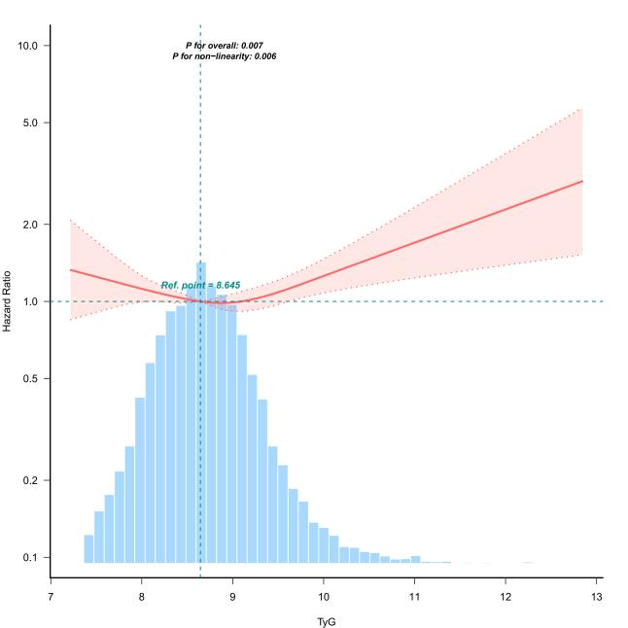 | B | 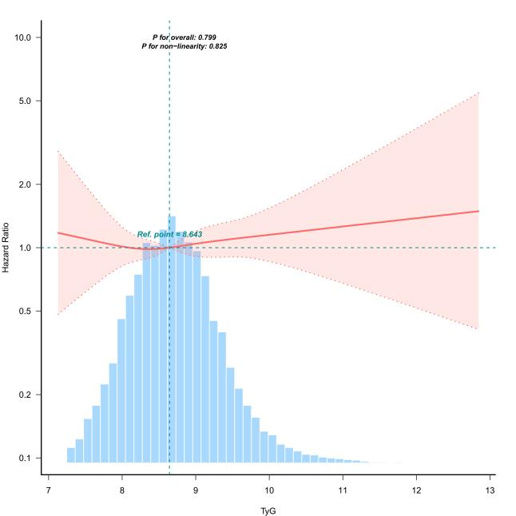
Fig. S1 Restricted cubic splines depicting the dose-response relationships between TyG and mortality outcomes. Adjustment factors included age, sex, race, BMI, marital status, PIR, education level, smoking status, alcohol consumption, eGFR, hypertension, and stroke history. A Association between TyG and all-cause mortality in CKM stages 0–4; B Association between TyG and cardiovascular mortality in CKM stages 0–4. TyG, triglyceride glucose; CKM, cardiovascular-kidney-metabolic; HR, hazard ratio; BMI, body mass index; PIR, poverty income ratio; eGFR, estimated glomerular filtration rate.

A | 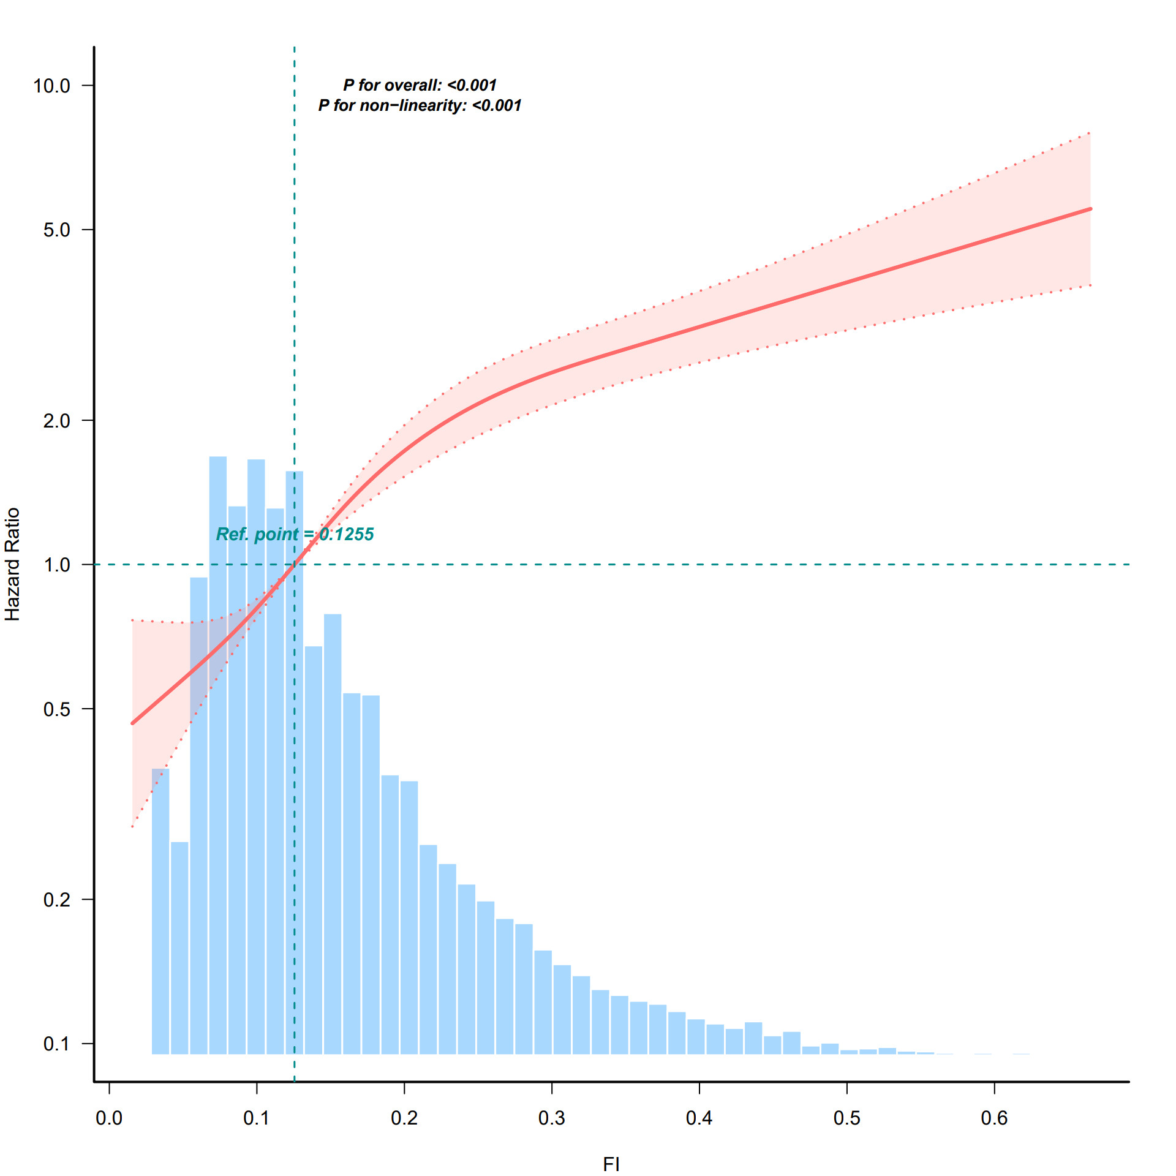 | B | 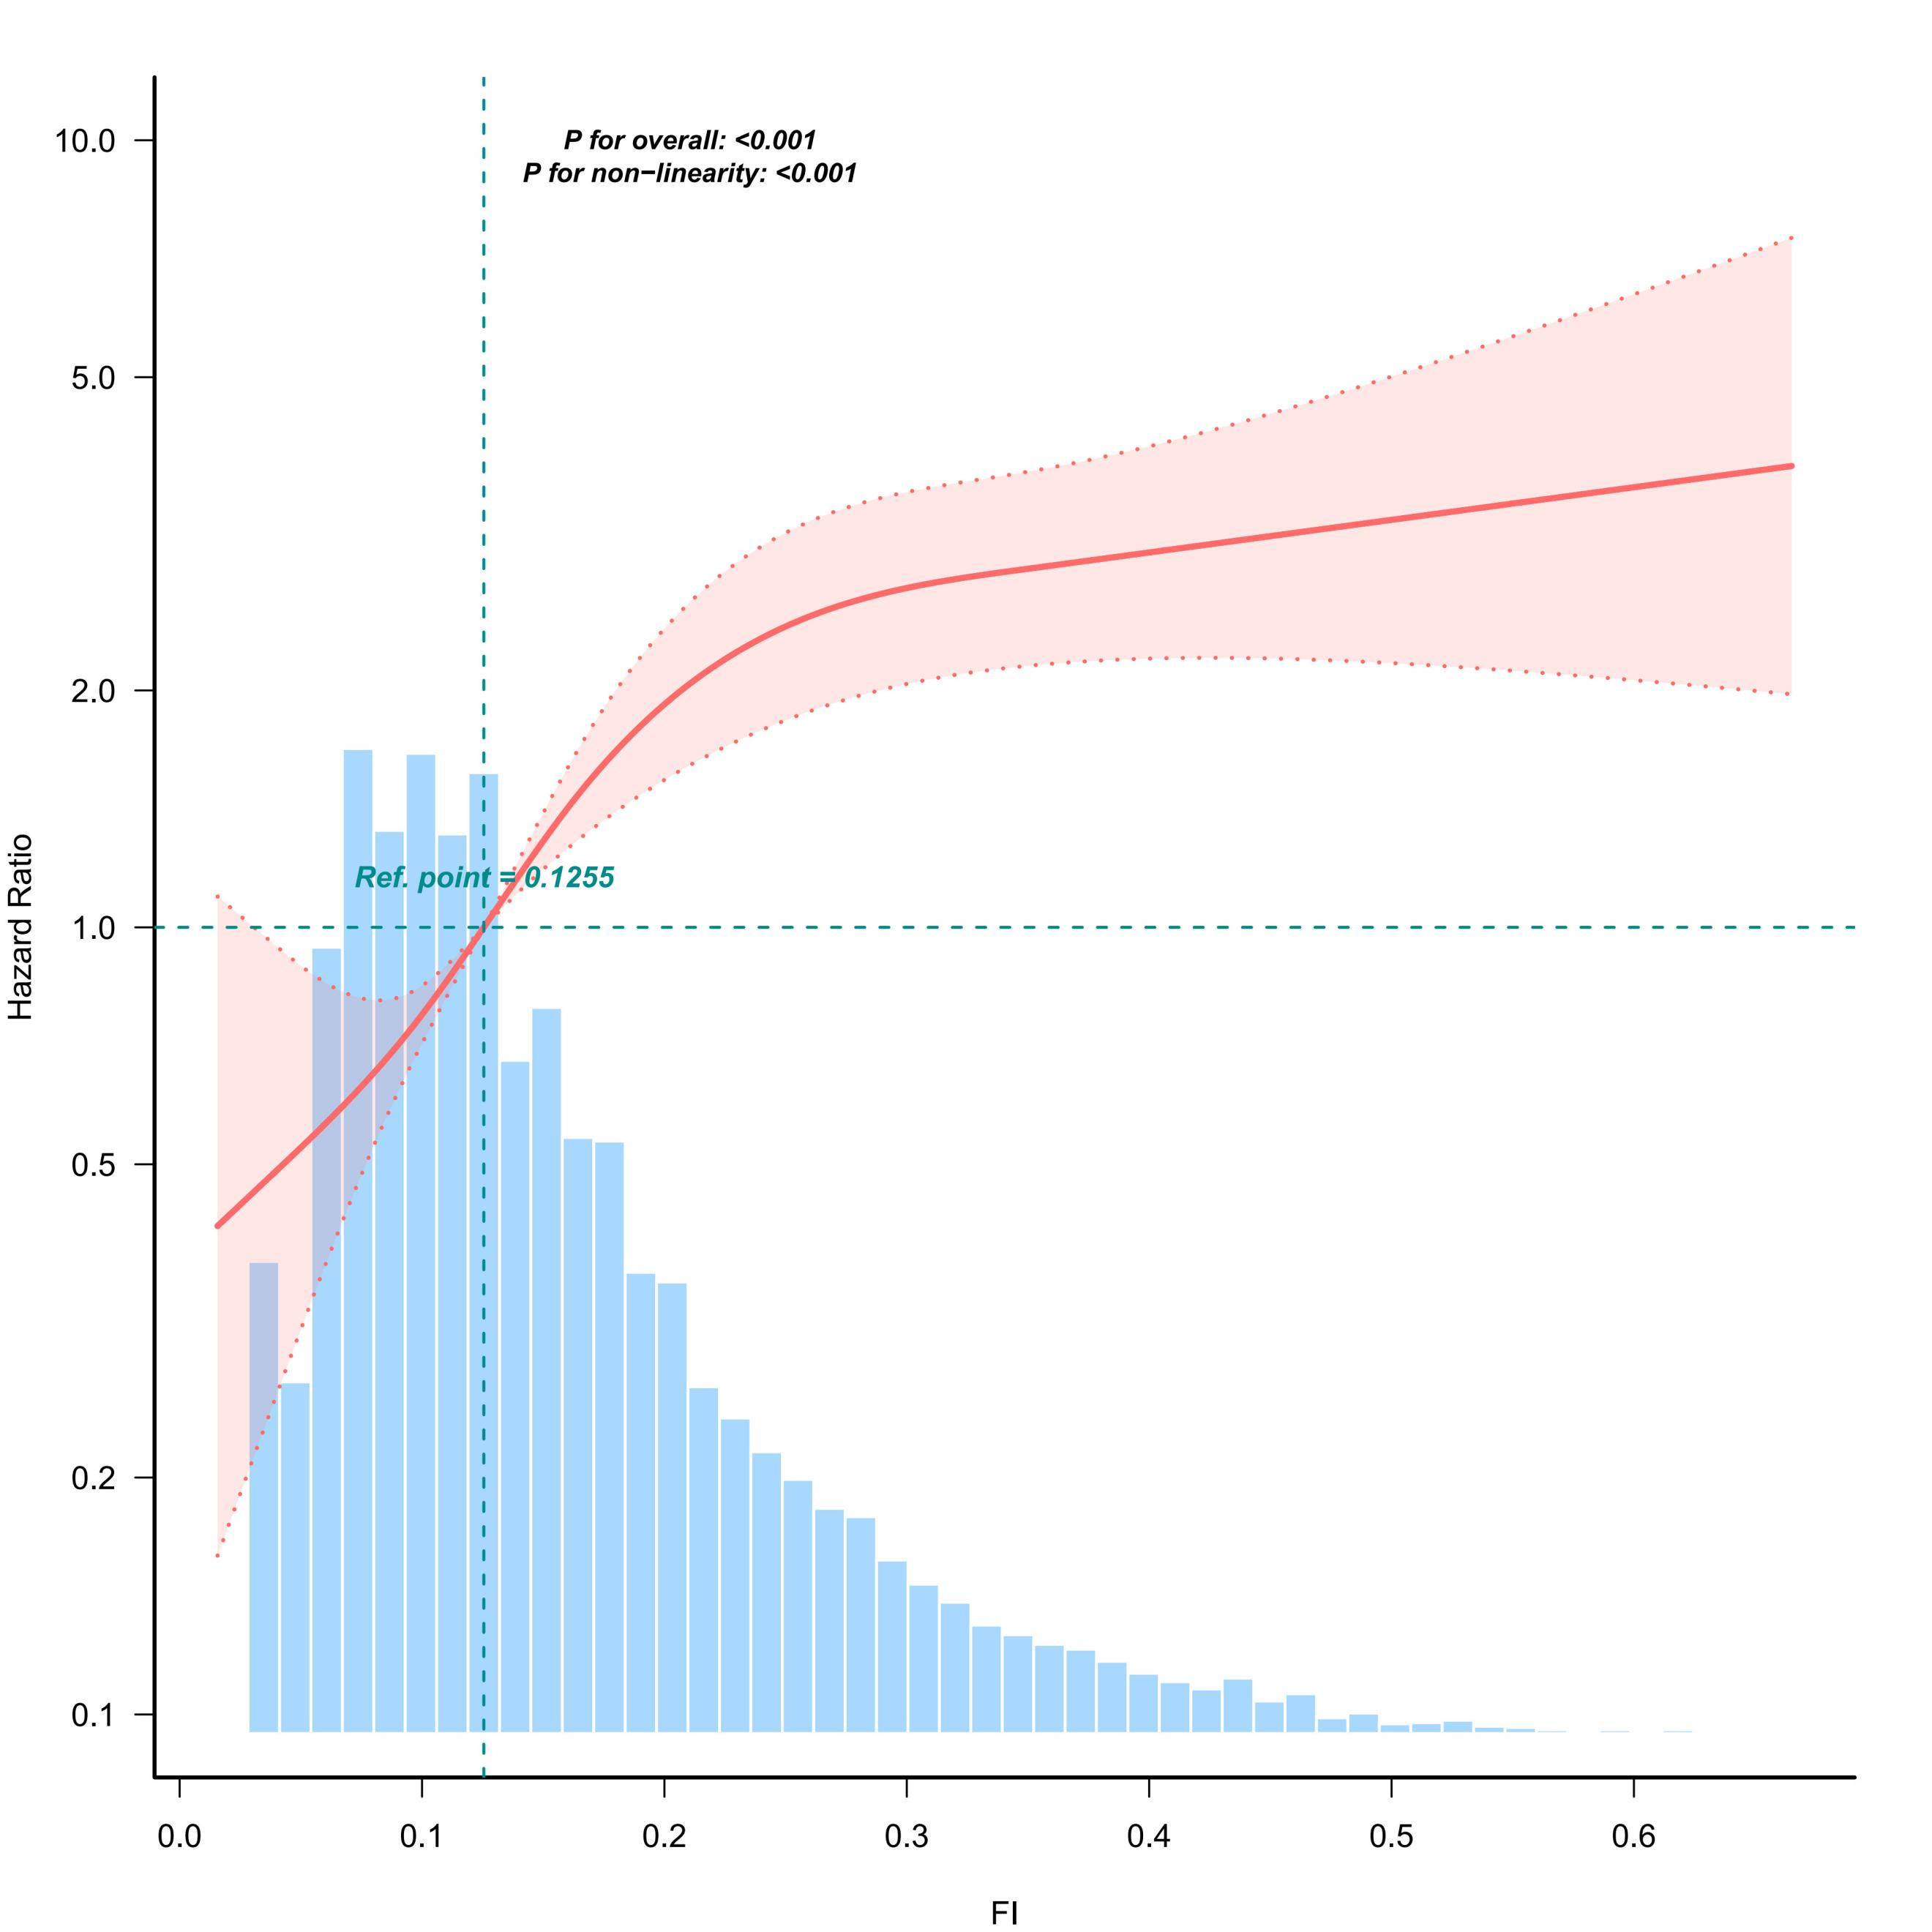

Fig. S2 Restricted cubic splines depicting the dose-response relationships between FI and mortality outcomes. Adjustment factors included age, sex, race, BMI, marital status, PIR, education level, smoking status, alcohol consumption, eGFR, hypertension, and stroke history. A Association between FI and all-cause mortality in CKM stages 0–4; B Association between FI and cardiovascular mortality in CKM stages 0–4. FI, frailty index; CKM, cardiovascular-kidney-metabolic; HR, hazard ratio; BMI, body mass index; PIR, poverty income ratio; eGFR, estimated glomerular filtration rate.

A | 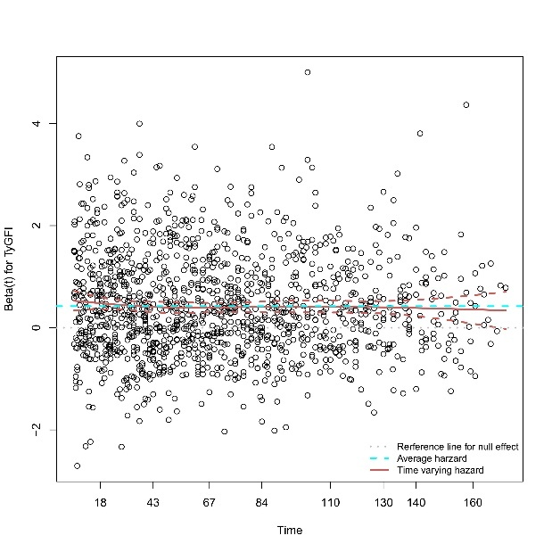 | B | 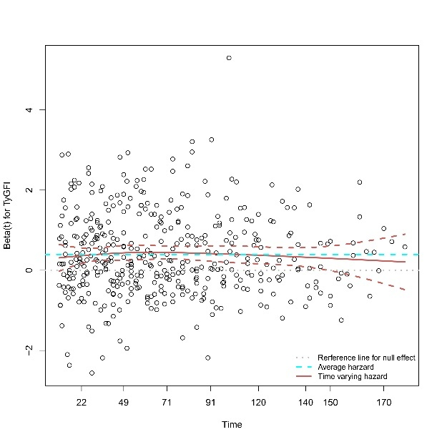
Fig. S3 Schoenfeld residual diagnostic plots for TYG-FI over follow-up time in Cox proportional hazards models. These residual plots depict the time-varying hazard coefficients (Beta(t)) of TYG-FI across survival time for (A) all-cause mortality events and (B) cardiovascular mortality events. Blue line: average hazard (reference line for null effect); Red line: time-varying hazard with 95% confidence interval (CI, dotted lines).

