Cumulative exposure to the estimated glucose disposal rate and incident stroke in individuals with cardiovascular–kidney–metabolic syndrome stages 0–4: 6-year longitudinal evidence from CHARLS

Yan Wang^{1,2#}, Ning Wei^{1,2#}, Meng Li^{1,2}, Jun-Wen Liu^{1,2}, Hong-Bin Lin^{1,2}, Hong-Fei Zhang^{1,2}

Author affiliations:
¹ Department of Anesthesiology, Zhujiang Hospital, Southern Medical University, Guangzhou, 510280, China
² Institute of Perioperative Medicine and Organ Protection, Zhujiang Hospital of Southern Medical University, Guangzhou, 510280, China
# Yan Wang, Ning Wei contributed equally to this work.

Corresponding authors:
Dr. Hong-Fei Zhang; zhanghongfei@smu.edu.cn
Department of Anesthesiology, Zhujiang Hospital; Institute of Perioperative Medicine and Organ Protection, Zhujiang Hospital of Southern Medical University, Guangzhou, 510280, China
Table S1 Cox regression for associations between eGDR change patterns, cumulative eGDR, and stroke in subjects with CKM syndrome stages 0–4
Variable | Total number | Events, n (%) | Model 1 | P value | Model 2 | P value | Model 3 | P value
Variable | Total number | Events, n (%) | HR (95% CI) |  | HR (95% CI) |  | HR (95% CI) | P value
eGDR change patterns
Class 2 | 1121 | 144 (12.8) | Reference |  | Reference |  | Reference
Class 1 | 1883 | 86 (4.6) | 0.35 (0.27~0.46) | <0.001 | 0.37 (0.29~0.49) | <0.001 | 0.46 (0.35~0.62) | <0.001
Class 3 | 1410 | 43 (3) | 0.23 (0.16~0.33) | <0.001 | 0.24 (0.17~0.34) | <0.001 | 0.32 (0.22~0.47) | <0.001
Class 4 | 834 | 63 (7.6) | 0.57 (0.43~0.77) | <0.001 | 0.58 (0.43~0.78) | <0.001 | 0.69 (0.51~0.94) | 0.020
Cumulative eGDR | 5248 | 336 (6.4) | 0.94 (0.93~0.95) | <0.001 | 0.94 (0.93~0.96) | <0.001 | 0.96 (0.94~0.97) | <0.001
Tertiles of Cumulative eGDR
T1 | 1749 | 192 (11) | Reference |  | Reference |  | Reference
T2 | 1749 | 90 (5.1) | 0.45 (0.35~0.58) | <0.001 | 0.48 (0.37~0.62) | <0.001 | 0.58 (0.44~0.75) | <0.001
T3 | 1750 | 54 (3.1) | 0.29 (0.22~0.4) | <0.001 | 0.31 (0.23~0.42) | <0.001 | 0.4 (0.29~0.56) | <0.001
P for trend |  |  |  | <0.001 |  | <0.001 |  | <0.001
CI, confidence interval; HR, hazard ratio; T, tertiles; eGDR, estimated glucose disposal rate; BMI, body mass index; eGFR, estimated glomerular filtration rate; CKM, cardiovascular-kidney-metabolic.
Model 1: no covariates were adjusted
Model 2: Adjusted for age, gender and marital status
Model 3: Adjusted for age, gender, marital status, BMI, educational level, smoke status, drink status, eGFR, dyslipidemia, diabetes

Table S2 Subgroup analysis of eGDR change patterns and stroke incidence in subjects with CKM syndrome (stages 0–4)
Subgroup | Variable | N | Events, n (%) | HR (95%CI) | P value | P for interaction
Age |  |  |  |  |  | 0.529
< 60, years
 | class2 | 543 | 65 (12) | 1(Ref)
 | class1 | 1185 | 44 (3.7) | 0.39 (0.26~0.59) | <0.001
 | class3 | 831 | 19 (2.3) | 0.23 (0.13~0.42) | <0.001
 | class4 | 443 | 27 (6.1) | 0.55 (0.35~0.88) | 0.013
 | P for trend | 3002 | 155 (5.2) | 0.77 (0.64~0.92) | 0.004
≥ 60, years
 | class2 | 578 | 79 (13.7) | 1(Ref)
 | class1 | 698 | 42 (6) | 0.53 (0.35~0.79) | 0.002
 | class3 | 579 | 24 (4.1) | 0.42 (0.25~0.7) | 0.001
 | class4 | 391 | 36 (9.2) | 0.82 (0.54~1.25) | 0.365
 | P for trend | 2246 | 181 (8.1) | 0.91 (0.78~1.06) | 0.224
Gender |  |  |  |  |  | 0.217
Female
 | class2 | 698 | 94 (13.5) | 1(Ref)
 | class1 | 1068 | 43 (4) | 0.38 (0.26~0.56) | <0.001
 | class3 | 746 | 25 (3.4) | 0.35 (0.21~0.58) | <0.001
 | class4 | 441 | 32 (7.3) | 0.64 (0.42~0.97) | 0.036
 | P for trend | 2953 | 194 (6.6) | 0.81 (0.69~0.95) | 0.009
Male
 | class2 | 423 | 50 (11.8) | 1(Ref)
 | class1 | 815 | 43 (5.3) | 0.61 (0.39~0.98) | 0.039
 | class3 | 664 | 18 (2.7) | 0.31 (0.16~0.58) | <0.001
 | class4 | 393 | 31 (7.9) | 0.82 (0.51~1.34) | 0.43
 | P for trend | 2295 | 142 (6.2) | 0.91 (0.76~1.09) | 0.289
BMI |  |  |  |  |  | 0.608
< 30, kg/m²
 | class2 | 963 | 119 (12.4) | 1(Ref)
 | class1 | 1854 | 84 (4.5) | 0.46 (0.35~0.62) | <0.001
 | class3 | 1398 | 43 (3.1) | 0.32 (0.22~0.46) | <0.001
 | class4 | 763 | 60 (7.9) | 0.71 (0.52~0.98) | 0.036
 | P for trend | 4978 | 306 (6.1) | 0.83 (0.74~0.93) | 0.002
≥ 30, kg/m²
 | class2 | 158 | 25 (15.8) | 1(Ref)
 | class1 | 29 | 2 (6.9) | 0.51 (0.11~2.41) | 0.393
 | class3 | 12 | 0 (0) | 0 (0~Inf) | 0.997
 | class4 | 71 | 3 (4.2) | 0.32 (0.09~1.11) | 0.073
 | P for trend | 270 | 30 (11.1) | 0.64 (0.41~0.98) | 0.042
Smoke |  |  |  |  |  | 0.822
Never
 | class2 | 766 | 95 (12.4) | 1(Ref)
 | class1 | 1221 | 51 (4.2) | 0.44 (0.3~0.63) | <0.001
 | class3 | 835 | 26 (3.1) | 0.34 (0.21~0.56) | <0.001
 | class4 | 493 | 34 (6.9) | 0.66 (0.44~1) | 0.048
 | P for trend | 3315 | 206 (6.2) | 0.82 (0.71~0.96) | 0.012
Ever
 | class2 | 355 | 49 (13.8) | 1(Ref)
 | class1 | 662 | 35 (5.3) | 0.5 (0.31~0.8) | 0.004
 | class3 | 575 | 17 (3) | 0.29 (0.15~0.55) | <0.001
 | class4 | 341 | 29 (8.5) | 0.73 (0.45~1.2) | 0.215
 | P for trend | 1933 | 130 (6.7) | 0.88 (0.73~1.06) | 0.175
Drink |  |  |  |  |  | 0.957
Never
 | class2 | 733 | 90 (12.3) | 1(Ref)
 | class1 | 1186 | 53 (4.5) | 0.47 (0.32~0.67) | <0.001
 | class3 | 860 | 24 (2.8) | 0.33 (0.2~0.54) | <0.001
 | class4 | 497 | 33 (6.6) | 0.65 (0.43~0.99) | 0.046
 | P for trend | 3276 | 200 (6.1) | 0.81 (0.7~0.95) | 0.009
Ever
 | class2 | 387 | 53 (13.7) | 1(Ref)
 | class1 | 696 | 33 (4.7) | 0.45 (0.28~0.73) | 0.001
 | class3 | 549 | 19 (3.5) | 0.31 (0.17~0.57) | <0.001
 | class4 | 336 | 30 (8.9) | 0.75 (0.47~1.22) | 0.252
 | P for trend | 1968 | 135 (6.9) | 0.89 (0.75~1.07) | 0.223
Dyslipemia |  |  |  |  |  | 0.238
No
 | class2 | 832 | 82 (9.9) | 1(Ref)
 | class1 | 1733 | 79 (4.6) | 0.52 (0.38~0.72) | <0.001
 | class3 | 1355 | 42 (3.1) | 0.36 (0.23~0.54) | <0.001
 | class4 | 746 | 56 (7.5) | 0.78 (0.55~1.1) | 0.159
 | P for trend | 4666 | 259 (5.6) | 0.89 (0.79~1.02) | 0.09
Yes
 | class2 | 267 | 57 (21.3) | 1(Ref)
 | class1 | 128 | 7 (5.5) | 0.25 (0.11~0.57) | 0.001
 | class3 | 42 | 1 (2.4) | 0.13 (0.02~0.95) | 0.045
 | class4 | 79 | 7 (8.9) | 0.46 (0.2~1.04) | 0.062
 | P for trend | 516 | 72 (14) | 0.65 (0.47~0.9) | 0.009
Diabetes |  |  |  |  |  | 0.002
No
 | class2 | 949 | 111 (11.7) | 1(Ref)
 | class1 | 1832 | 83 (4.5) | 0.49 (0.36~0.66) | <0.001
 | class3 | 1390 | 41 (2.9) | 0.32 (0.22~0.49) | <0.001
 | class4 | 769 | 63 (8.2) | 0.8 (0.58~1.1) | 0.17
 | P for trend | 4940 | 298 (6) | 0.9 (0.79~1.01) | 0.081
Yes
 | class2 | 170 | 32 (18.8) | 1(Ref)
 | class1 | 51 | 3 (5.9) | 0.32 (0.09~1.15) | 0.081
 | class3 | 20 | 2 (10) | 0.77 (0.16~3.68) | 0.742
 | class4 | 63 | 0 (0) | 0 (0~Inf) | 0.996
 | P for trend | 304 | 37 (12.2) | 0.41 (0.22~0.79) | 0.008
CKM |  |  |  |  |  | 0.613
0-2
 | class2 | 326 | 28 (8.6) | 1(Ref)
 | class1 | 876 | 30 (3.4) | 0.51 (0.29~0.88) | 0.016
 | class3 | 649 | 15 (2.3) | 0.4 (0.2~0.84) | 0.014
 | class4 | 273 | 20 (7.3) | 1 (0.55~1.82) | 0.995
 | P for trend | 2124 | 93 (4.4) | 1 (0.8~1.25) | 0.992
3-4
 | class2 | 795 | 116 (14.6) | 1(Ref)
 | class1 | 1007 | 56 (5.6) | 0.49 (0.34~0.69) | <0.001
 | class3 | 761 | 28 (3.7) | 0.32 (0.2~0.52) | <0.001
 | class4 | 561 | 43 (7.7) | 0.62 (0.43~0.89) | 0.011
 | P for trend | 3124 | 243 (7.8) | 0.81 (0.71~0.93) | 0.003
Adjusted for all covariates except for this subgroup of variables. CI, confidence interval; HR, hazard ratio; BMI, body mass index; CKM, cardiovascular-kidney-metabolic.

Table S3 Association between eGDR change patterns, cumulative eGDR, and stroke in adults with CKM syndrome: cox regression analysis after multiple imputation
Variable | Model 1 | P value | Model 2 | P value | Model 3 | P value
 | HR (95% CI) |  | HR (95% CI) |  | HR (95% CI)
eGDR change patterns
Class 2 | Reference |  | Reference |  | Reference
Class 1 | 0.35 (0.27~0.46) | <0.001 | 0.37 (0.29~0.49) | <0.001 | 0.45 (0.34~0.6) | <0.001
Class 3 | 0.23 (0.16~0.33) | <0.001 | 0.24 (0.17~0.34) | <0.001 | 0.32 (0.21~0.46) | <0.001
Class 4 | 0.57 (0.43~0.77) | <0.001 | 0.58 (0.43~0.78) | <0.001 | 0.67 (0.49~0.91) | 0.012
Cumulative eGDR | 0.94 (0.93~0.95) | <0.001 | 0.94 (0.93~0.96) | <0.001 | 0.95 (0.94~0.97) | <0.001
Tertiles of Cumulative eGDR
T1 | Reference |  | Reference |  | Reference
T2 | 0.45 (0.35~0.58) | <0.001 | 0.48 (0.37~0.62) | <0.001 | 0.56 (0.43~0.73) | <0.001
T3 | 0.29 (0.22~0.4) | <0.001 | 0.31 (0.23~0.42) | <0.001 | 0.39 (0.28~0.55) | <0.001
P for trend | <0.001 |  | <0.001 |  | <0.001
CI, confidence interval; HR, hazard ratio; T, tertiles; eGDR, estimated glucose disposal rate; BMI, body mass index; eGFR, estimated glomerular filtration rate; CKM, cardiovascular-kidney-metabolic.
Model 1: no covariates were adjusted
Model 2: Adjusted for age, gender and marital status
Model 3: Adjusted for age, gender, marital status, BMI, educational level, smoke status, drink status, eGFR, dyslipidemia, diabetes
With missing data: The number of missing values for the covariates were: 2 (0.038%) for education levels, 4 (0.076%) for drinking status, 4 (0.076%) for diabetes and 66 (1.26%) for dyslipidemia. Multiple imputation was applied to handle missing values in all continuous and categorical variables, followed by analyses on the imputed datasets

Table S4 Association between eGDR change patterns, cumulative eGDR, and stroke in adults with CKM syndrome: logistic regression analysis after multiple imputation
Variable | Model 1 | P value | Model 2 | P value | Model 3 | P value
 | OR (95% CI) |  | OR (95% CI) |  | OR (95% CI)
eGDR change patterns
Class 2 | Reference |  | Reference |  | Reference
Class 1 | 0.32 (0.25~0.43) | <0.001 | 0.34 (0.26~0.46) | <0.001 | 0.46 (0.28~0.78) | 0.004
Class 3 | 0.21 (0.15~0.3) | <0.001 | 0.22 (0.16~0.32) | <0.001 | 0.33 (0.17~0.65) | 0.001
Class 4 | 0.55 (0.41~0.76) | <0.001 | 0.55 (0.41~0.76) | <0.001 | 0.70 (0.43~1.12) | 0.133
Cumulative eGDR | 0.94 (0.93~0.95) | <0.001 | 0.94 (0.93~0.95) | <0.001 | 0.95 (0.93~0.96) | <0.001
Tertiles of Cumulative eGDR
T1 | Reference |  | Reference |  | Reference
T2 | 0.44 (0.34~0.57) | <0.001 | 0.47 (0.36~0.61) | <0.001 | 0.54 (0.41~0.72) | <0.001
T3 | 0.26 (0.19~0.35) | <0.001 | 0.27 (0.20~0.37) | <0.001 | 0.34 (0.24~0.48) | <0.001
P for trend | <0.001 |  | <0.001 |  | <0.001
CI, confidence interval; OR, odds ratio; T, tertiles; eGDR, estimated glucose disposal rate; BMI, body mass index; eGFR, estimated glomerular filtration rate; CKM, cardiovascular-kidney-metabolic.
Model 1: no covariates were adjusted
Model 2: Adjusted for age, gender and marital status
Model 3: Adjusted for age, gender, marital status, BMI, educational level, smoke status, drink status, eGFR, dyslipidemia, diabetes
With missing data: The number of missing values for the covariates were: 2 (0.038%) for education levels, 4 (0.076%) for drinking status, 4 (0.076%) for diabetes and 66 (1.26%) for dyslipidemia. Multiple imputation was applied to handle missing values in all continuous and categorical variables, followed by analyses on the imputed datasets

 | 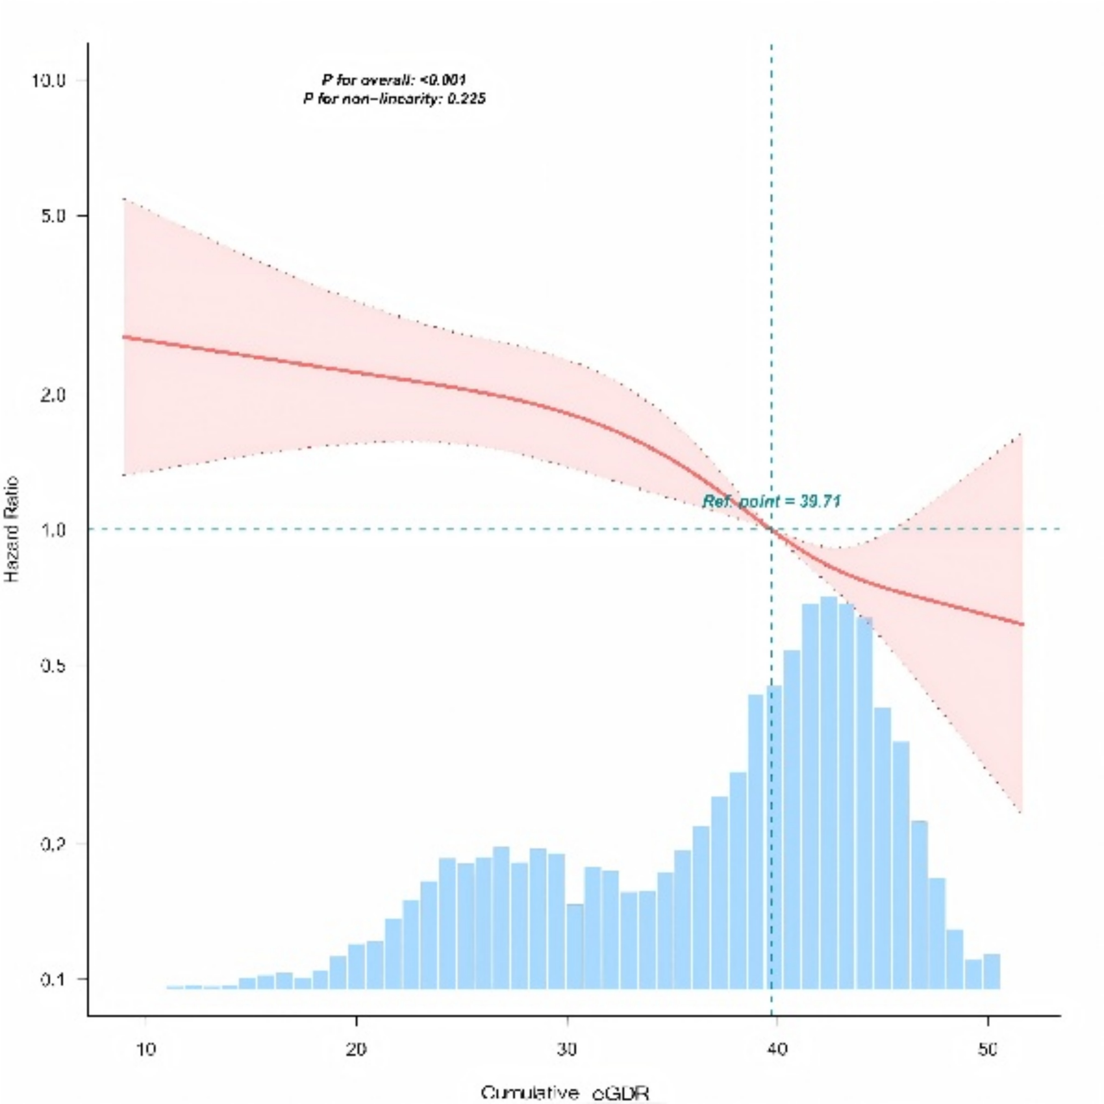
 | A
 | 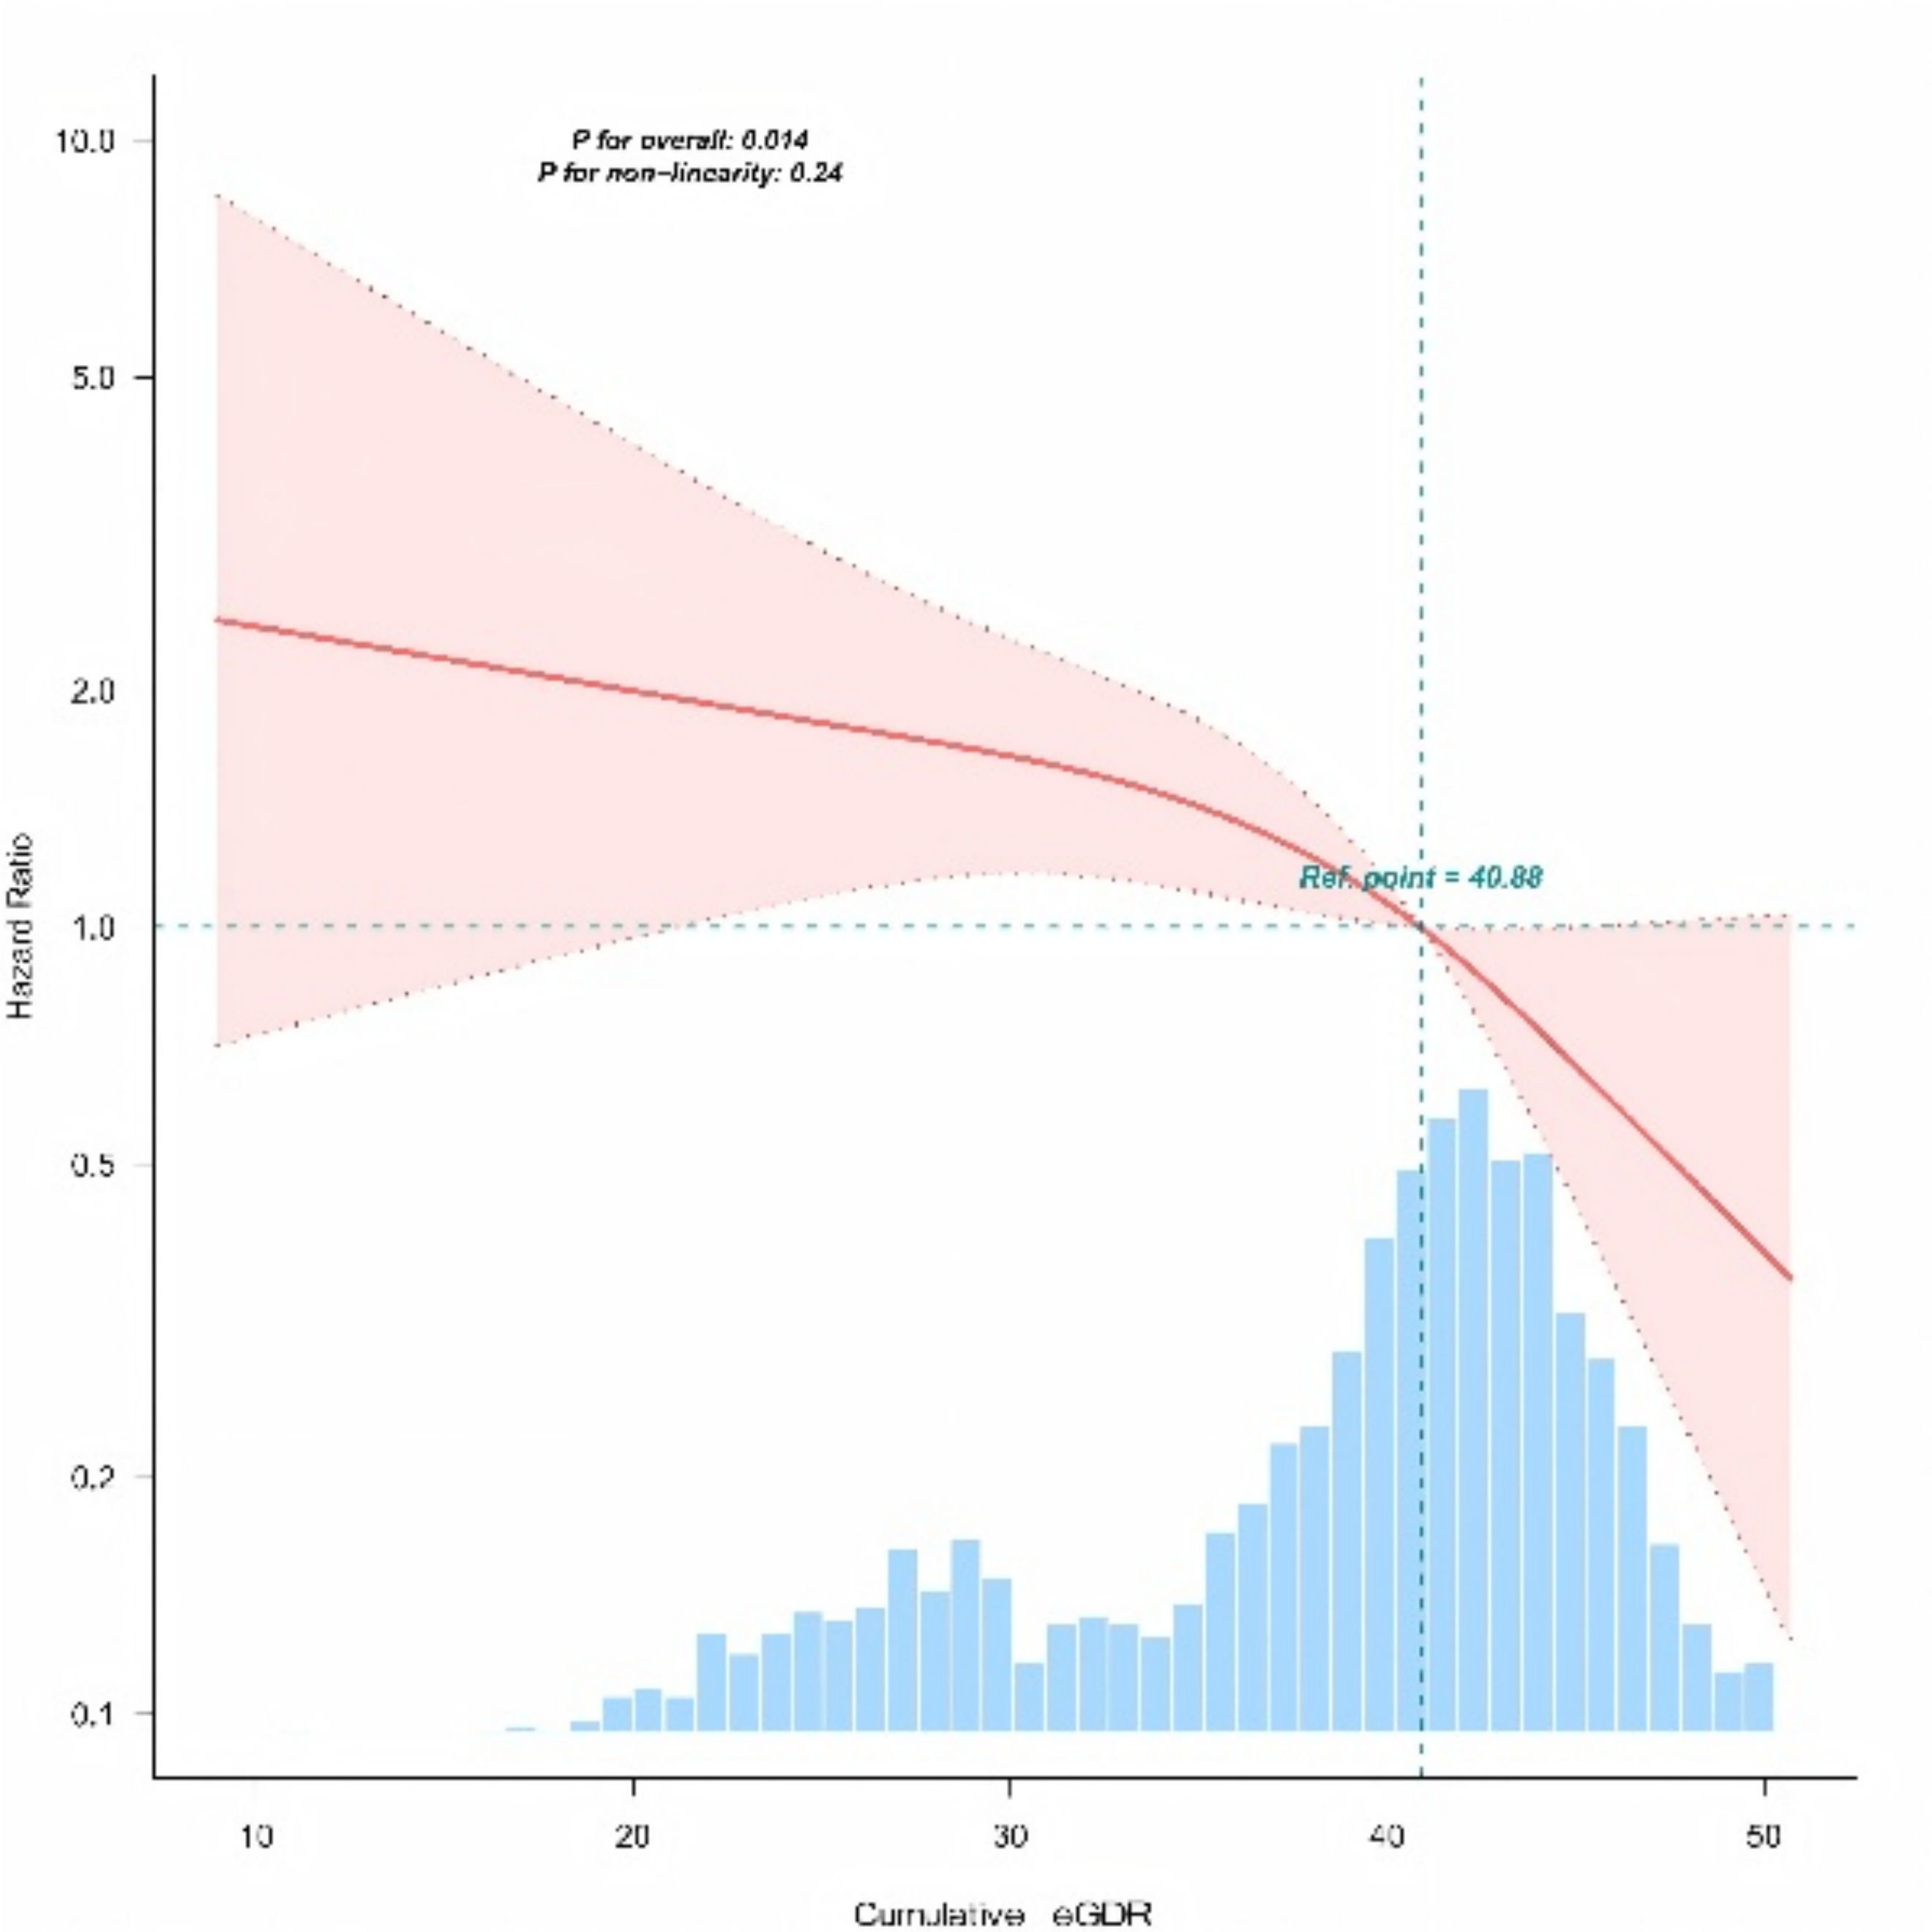 |  | 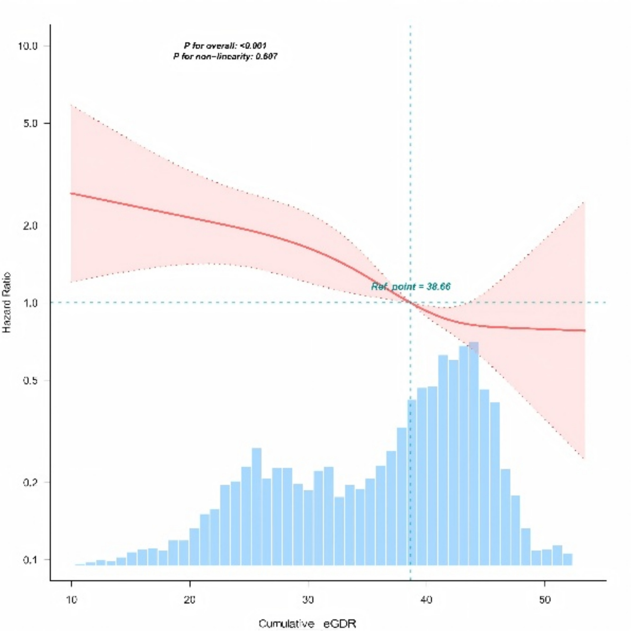
 | B |  | C

Fig. S1 The RCS analysis of the relationship between cumulative eGDR and stroke incidence in participants with CKM syndrome (stages 0–4). Adjustment variables included for age, gender, marital status, body mass index (BMI), educational attainment, smoking status, alcohol consumption status, estimated glomerular filtration rate (eGFR), dyslipidemia, and diabetes. (A) Relationship between cumulative eGDR and stroke incidence in participants with CKM syndrome (Stages 0–4); (B) Relationship between cumulative eGDR and stroke incidence in participants with non-advanced CKM syndrome (Stages 0–2); (C) Relationship between cumulative eGDR and stroke incidence in participants with advanced CKM syndrome (stages 3–4). BMI, body mass index; eGFR, estimated glomerular filtration rate; CKM, cardiovascular-kidney-metabolic; HR, hazard ratio

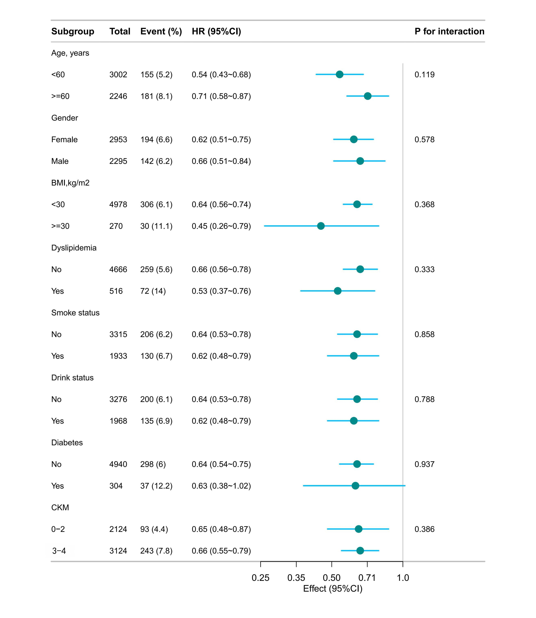
Fig. S2 Subgroup analysis of cumulative eGDR (per 0.1 unit) and stroke incidence in subjects with CKM syndrome (stages 0–4). Adjusted for all covariates except for this subgroup of variables. BMI, body mass index; CKM, cardiovascular-kidney-metabolic; HR, hazard ratio

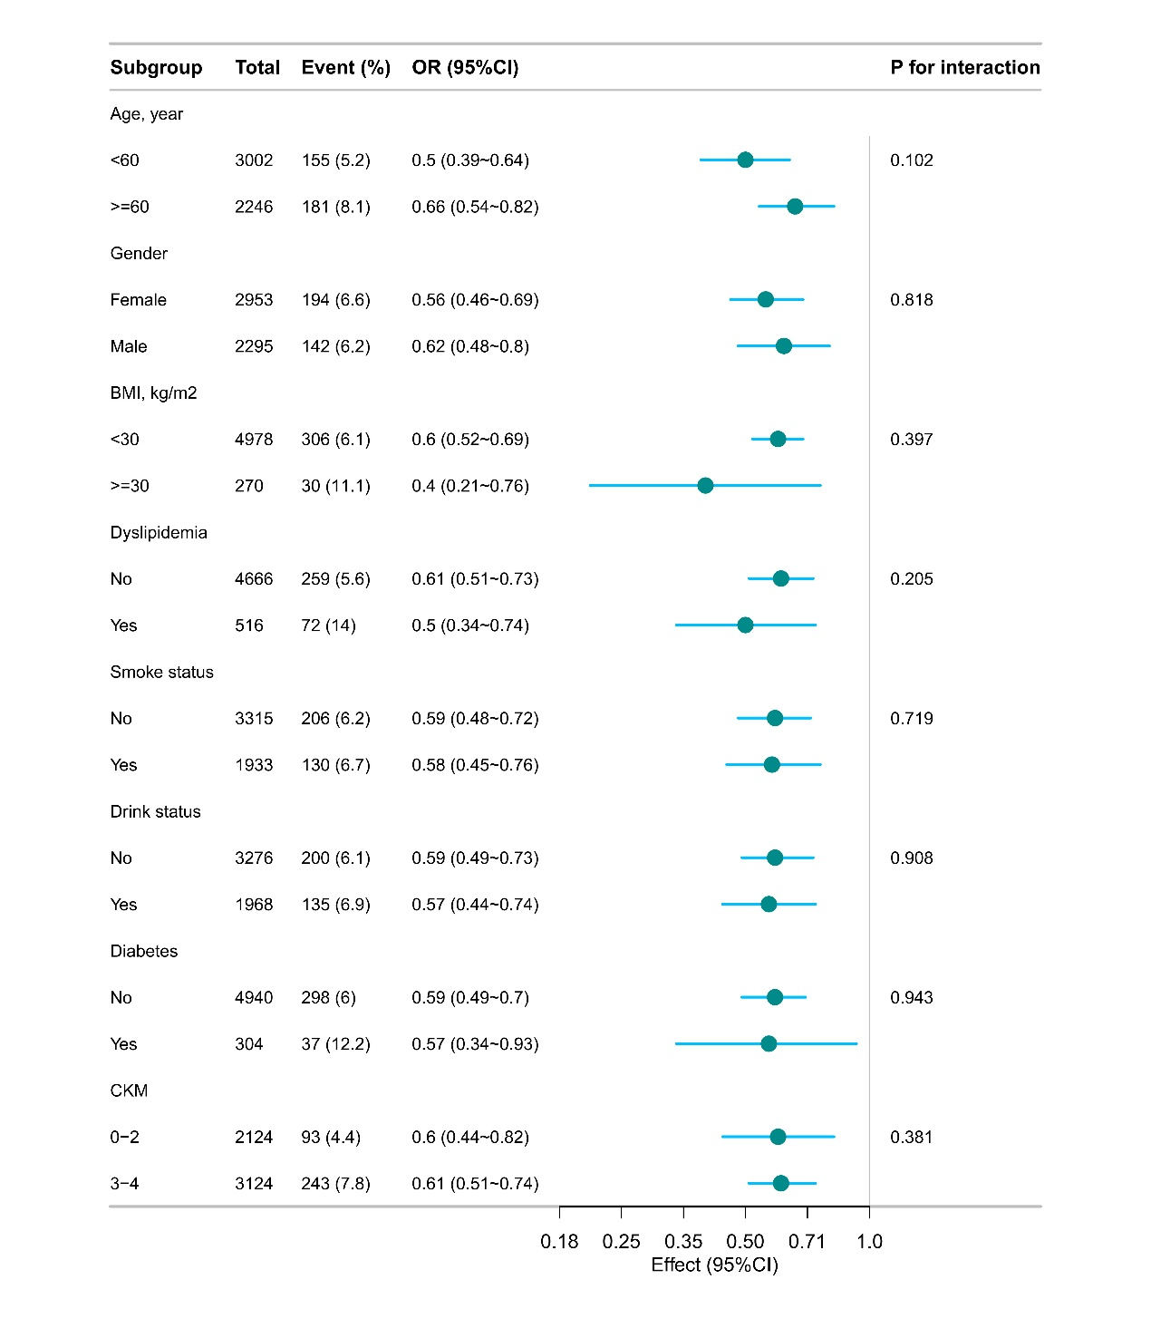
Fig. S3 Subgroup analysis of cumulative eGDR (per 0.1 unit) and stroke incidence in subjects with CKM syndrome (stages 0–4). Adjusted for all covariates except for this subgroup of variables. BMI, body mass index; CKM, cardiovascular-kidney-metabolic; OR, odds ratio

