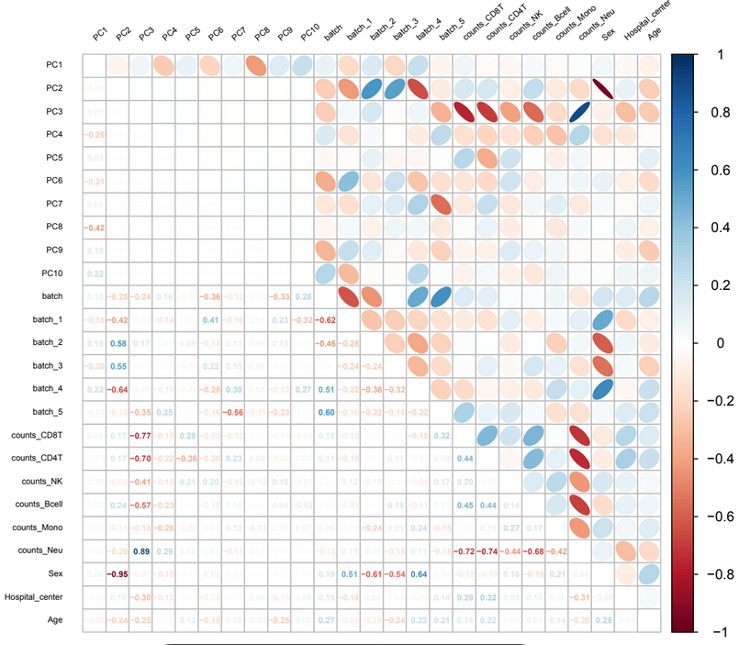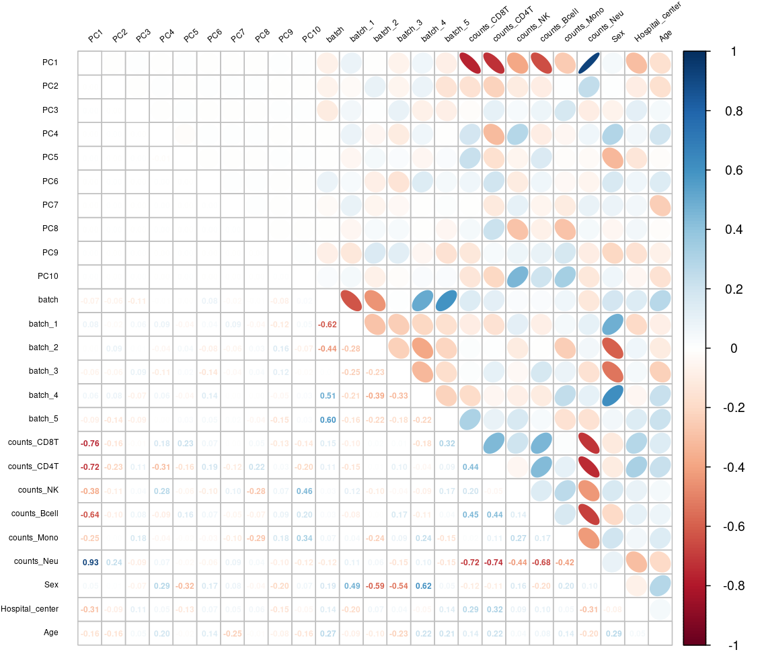
Supplementary Figure 1. Heatmap with the correlation between the principal components of prepubertal DNA methylation and potential counfounders. Before (left) and after (right) to denoise by batch variable.

