Supplemental Material 1
Table of content:
- Supplementary Tables
  - Table S1. Linear regression results for the fitness-associated proteins showing differences across glycaemic status groups, adjusted for age and medication use.
  - Table S2. Exercise responsiveness of fitness-associated proteins showing significant changes after aerobic training, identified using age-adjusted linear mixed-effect model in an independent training intervention cohort.
- Supplementary Figures
  - Figure S1. Heatmap illustrating age and medication adjusted partial Spearman correlation between proteins and fitness variables.
  - Figure S2. Heatmap illustrating age and medication adjusted partial Spearman correlation between fitness-associated proteins and clinical variables.
Table S1. Linear regression results for fitness-associated proteins showing differences across glycaemic groups, adjusted for age and medication use.
Protein | NGT | IGT | T2D | FDR
n | 23 | 10 | 5
C3 |  | -0,02 | 0,26* | 0.070
CRISP3 |  | -0,10 | -0,81* | 0.070
GPX3 |  | 0,04 | -0,47* | 0.070
GSN |  | -0,07 | -0,35** | 0.046
MMP2 |  | 0,04 | -0,41* | 0.070
QSOX1 |  | -0,15 | -0,32* | 0.074
Shown are regression values for significant proteins, expressed as coefficient estimates, that differed significantly between NGT and T2D groups and remained significant after Benjamin-Hochberg (FDR <0.1), with a consistent monotonic change across all groups. Models were adjusted for age and medication use. *p < 0.05, **p < 0.01 compared with the NGT group. FDR indicates Benjamin-Hochberg false discovery rate. IGT, impaired glucose tolerance; NGT, normal glucose tolerance; T2D type-2 diabetes.

Table S2. Exercise responsiveness of fitness-associated proteins showing significant changes after aerobic training, identified using age-adjusted linear mixed-effect model in an independent training intervention cohort.
Protein | Estimate (post-pre) | P | FDR
C5 | 2885 | 0.0012 | 0.006
COLEC10 | 179 | <0.001 | <0.001
HSPG2 | 91 | <0.001 | <0.001
IGFALS | 1407 | <0.001 | <0.001
ITIH2 | 4207 | 0.0002 | 0.001
GPX3 | -1187 | 0.0011 | 0.006
IL1RAP | -313 | <0.001 | <0.001
PRG4 | -407 | 0.0031 | 0.014
Exercise responsiveness was assessed as pre- and post-training change using linear mixed-effect model with participant as a random effect and adjustment for age. The estimate represents the fixed-effect coefficient for time (post vs pre), indicating the direction and magnitude of change following training. Only proteins remaining significant after Benjamin-Hochberg (FDR < 0.05) are shown. P-values represent fixed effects for time (post vs pre).

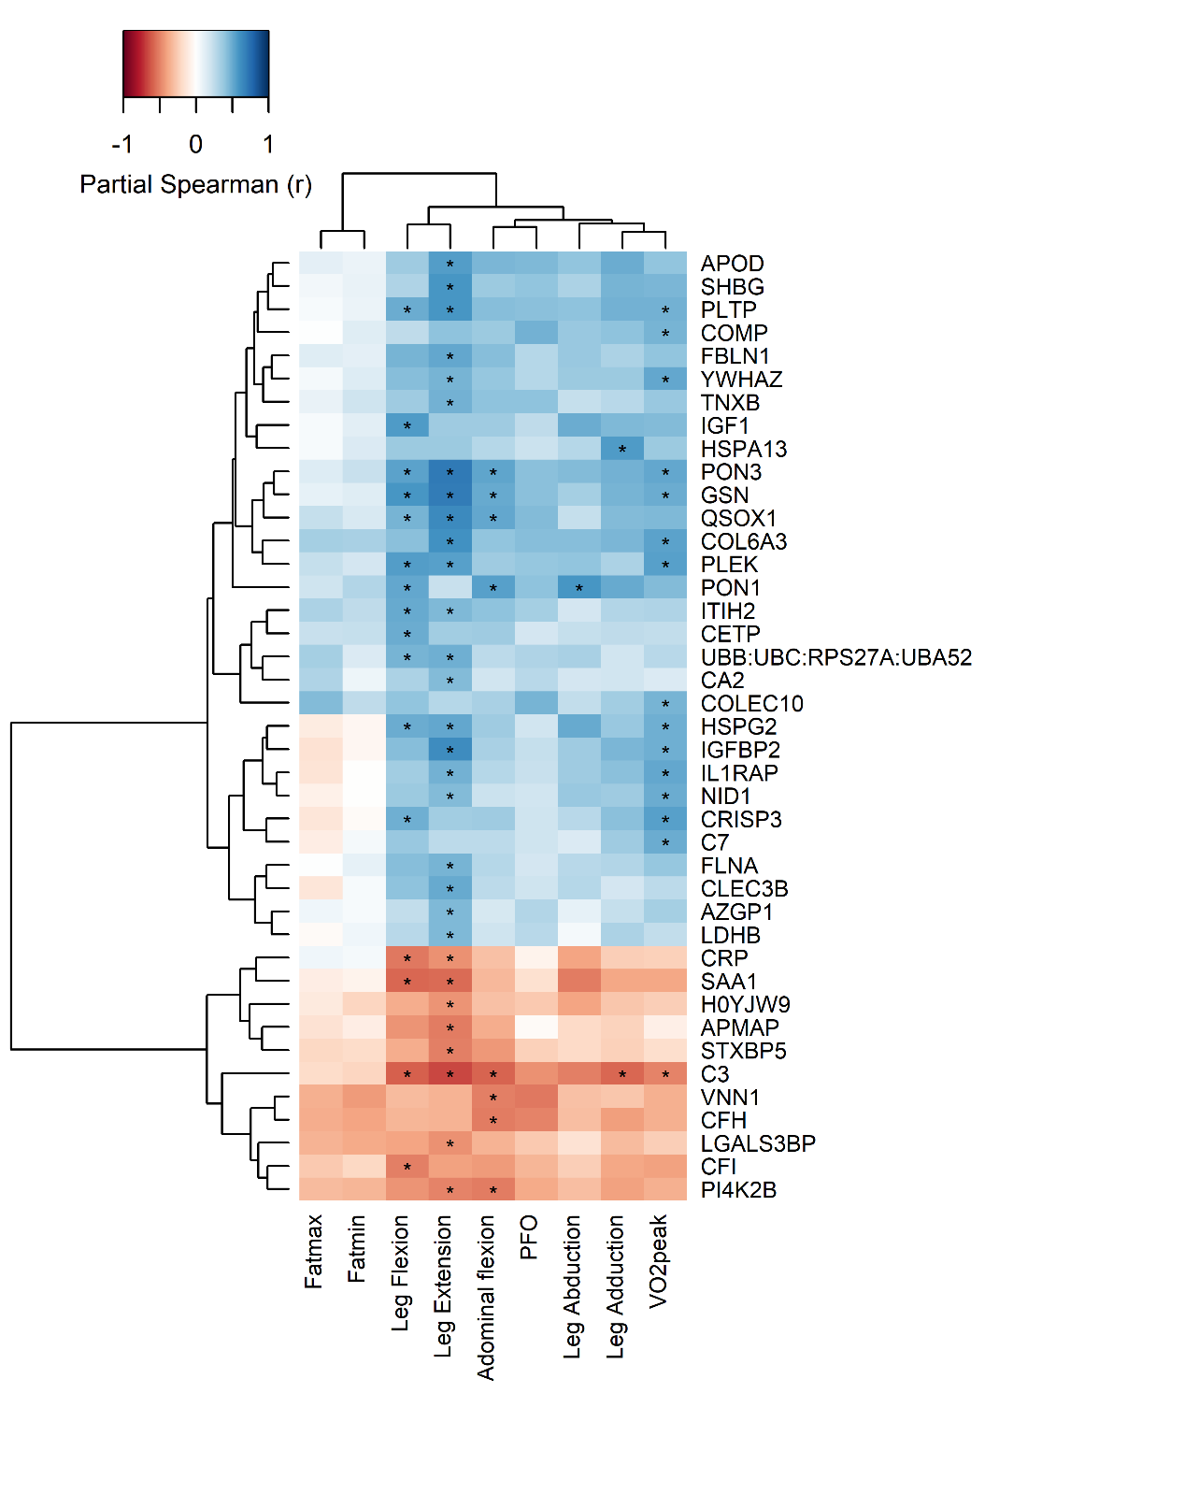
Figure S1. Heatmap illustrating partial Spearman correlation between circulating proteins and fitness variables. Correlations were adjusted for age and medication use. Asterisks denote statistically significant association after Benjamin-Hochberg correction (FDR < 0.1).
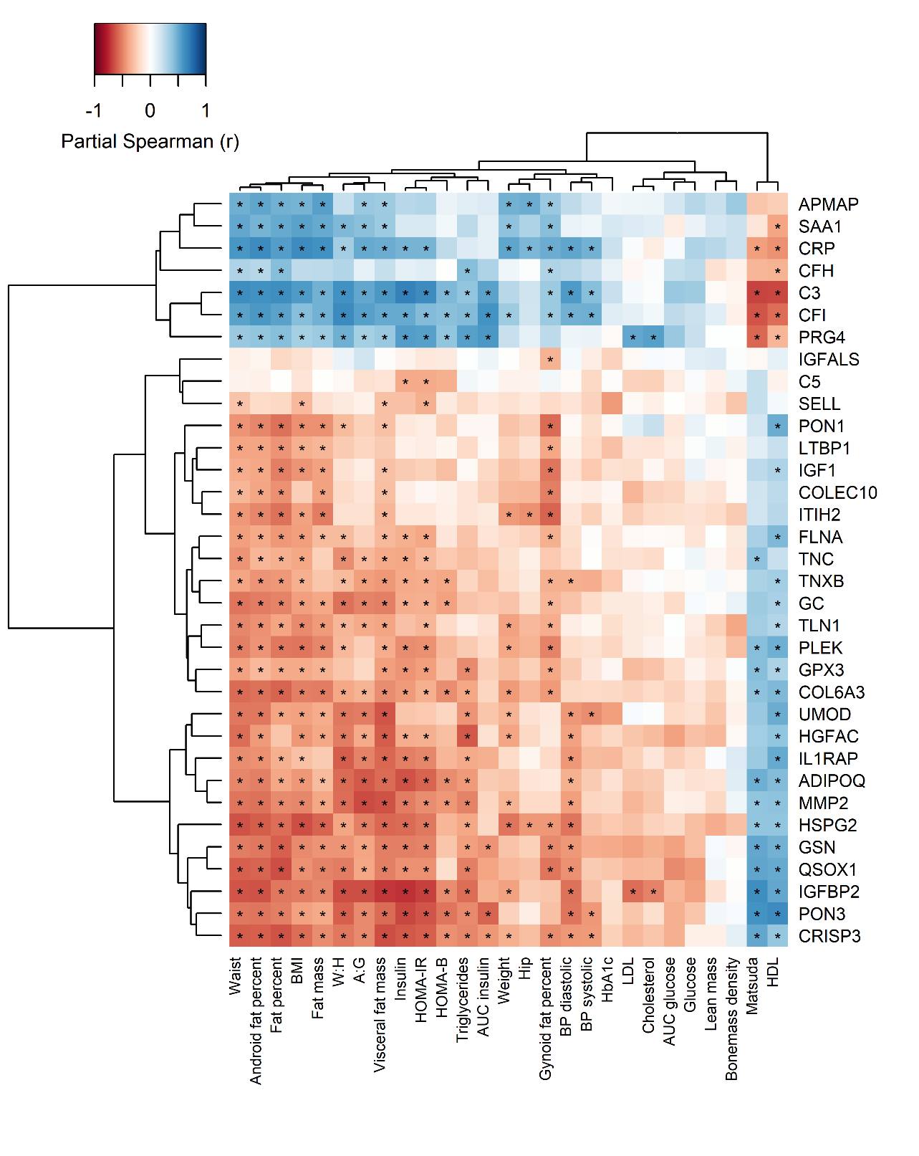
Figure S2. Heatmap illustrating partial Spearman correlation between circulating fitness-associated proteins and clinical variables. Correlations were adjusted for age and medication use. Asterisks denote statistically significant association after Benjamin-Hochberg correction (FDR < 0.1).

