Ancestry-Specific Genetics of Amino Acids and Microbiota-Related Metabolites Reveal Causal Effects on Cardiometabolic Disease in Chinese Populations

Supplementary Material

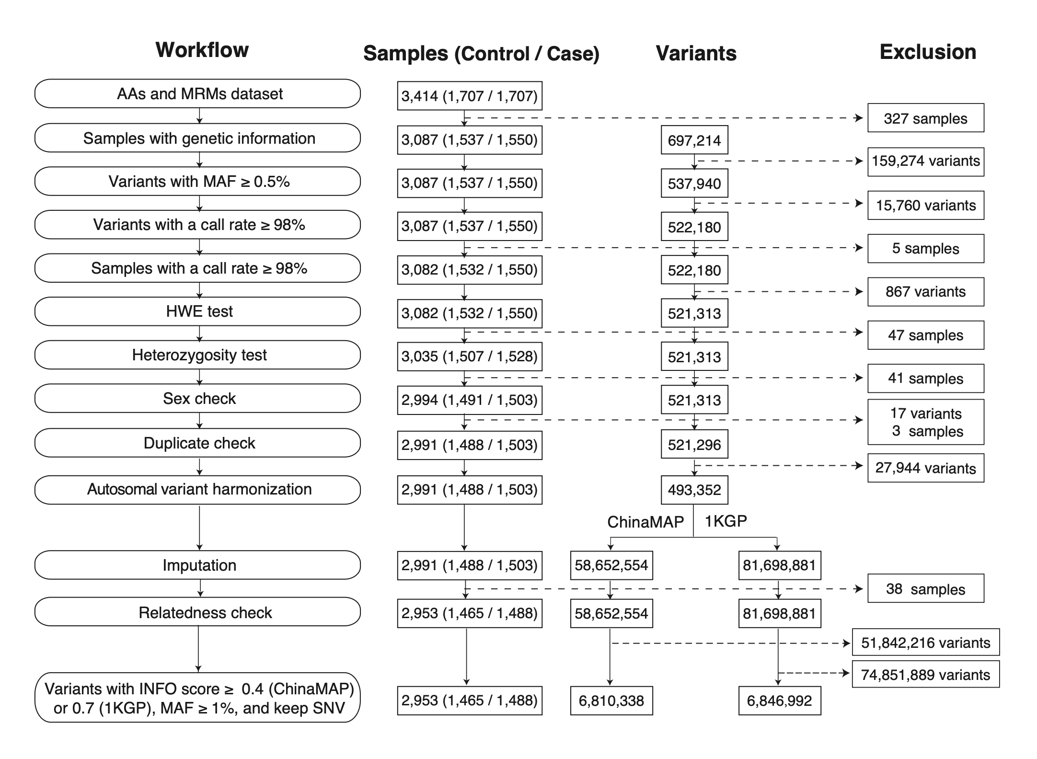

Figure S1. Genetic data quality control and imputation workflow.

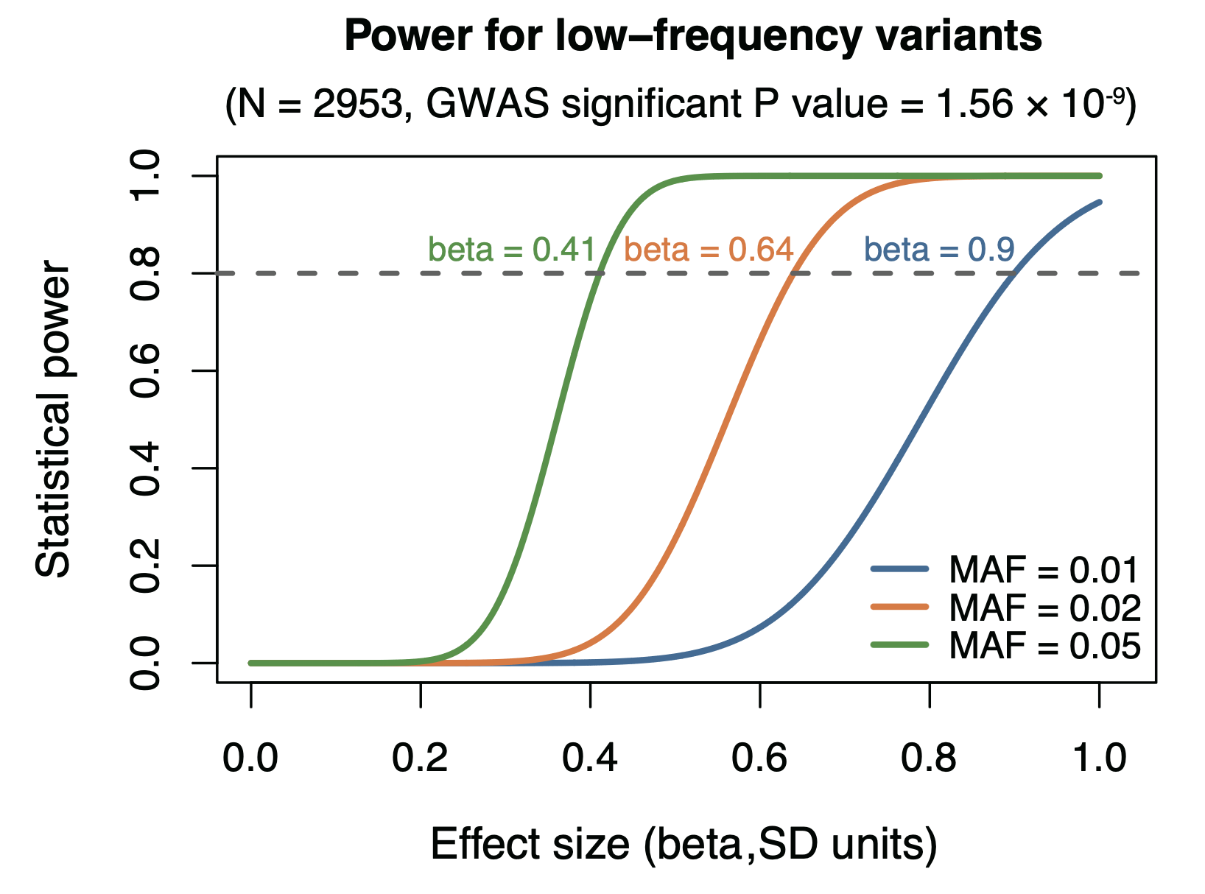
Figure S2. GWAS power estimation for low-frequency variants. Power curves are shown for representative minor allele frequencies (MAF = 0.01, 0.02 and 0.05) at the sample size (N = 2,953) and significance threshold (P = 1.56 × 10⁻⁹). The dashed horizontal line denotes 80% power under ideal conditions, with the corresponding minimum detectable effect sizes (beta, SD units) indicated.

