Online-Only Supplemental Material
Method
Untargeted metabolomic profiles
Before conducting high-resolution metabolomic analysis, plasma samples were taken out from storage at -80°C and thawed on ice. To eliminate any precipitate proteins, a sample of 50 μL was treated with 100 μL of ice-cold LC-MS grade acetonitrile, left to stabilize for 30 minutes on ice, and then spun in a centrifuge (16.1×g at 4 °C) for 10 minutes. Then, the sample was transferred to a 200 μL autosampler vial and kept at 4°C for analysis within 22 hours.
We used a dual pump configuration in the operating of chromatography system, allowing parallel separation of analytes and column flushing. For two high-resolution metabolomics methods – hydrophilic interaction liquid chromatography (HILIC) with positive electrospray ionization (ESI) and C18 hydrophobic reversed-phase chromatography with negative ESI – the mobile phase flow rate was initially set at 0.35 mL/min for the first 1.5 minutes, then increased to 0.5 mL/min and maintained for the final 4 minutes. The high-resolution mass spectrometer was operated at a resolution of 120,000 and within a mass-to-charge ratio (m/z) range of 85-1275. During untargeted data acquisition, no specific masses were selected for exclusion or inclusion, and data was only acquired in MS1 mode.
Before any statistical analysis, we conducted quality control, data normalization, and data transformation (as shown in Supplemental Fig. S1). Firstly, metabolomic features with detection less than 50% were removed. After completeness check, our metabolomic data had 9617 features in the HILIC positive mode and 8844 features in the C18 negative mode. All 101 plasma samples had detected features > 50%. Missing metabolomic intensity data was imputed by half of the minimum intensities of each metabolomic feature. Quantile normalization and log₂ transformation were further performed to normalize the data [1].
The coefficients of variation (CVs) of the 78 Qstd3 samples [2] inserted in analytical batches were calculated to control the data quality for untargeted metabolomic data. Before CV analyzing, all metabolomic features were log₂ transformed to achieve similar scale with the metabolomic data of GDM cohort samples. The distribution of CVs for all features is presented in Supplemental Fig. S2. The medians (1st quartile, 3rd quartile) of CVs across 10685 detected HILIC positive features and 9811 detected C18 negative features were 0.050 (0.033, 0.069) and 0.047 (0.029, 0.068). In order to control for potential batch effects, metabolomic features with CVs > 0.3 were excluded from all statistical analyses.
Statistical analysis
To clarify the interpretation of the association estimates between individual late-pregnancy metabolomic features and diabetes traits after delivery, consider the following model:
Y’ = β₀ + β₁X’, where X’= log₂(X) and Y’ = ln(Y), representing the log₂-transformed exposure and the natural log-transformed outcome, respectively.
For two exposure levels X₁ and X₂: Y’₂ - Y’₁ = (β₀ + β₁X’₂) – (β₀ + β₁X’₁), which can be rewritten as: ln(Y₂) - ln(Y₁) = β₁ [log₂(X₂) – log₂(X₁)], and further rewritten as: ln(Y₂/ Y₁) = β₁ [log₂(X₂/X₁)].
When X₂ represents a doubling of X₁, then X₂/X₁=2, and since log₂(2) = 1, we obtain: ln(Y₂/ Y₁) = β₁ [log₂(X₂/X₁)] = β₁ [log₂(2)] = β₁.
Exponentiating both sides: Y₂/ Y₁ = exp(β₁).
Thus, exp(β₁) represents the relative change in the outcome per doubling of the exposure. The percent change per doubling of X therefore calculated as:
(Y₂ - Y₁)/ Y₁ = [exp (β₁) – 1] * 100%.
Results
Cross-sectional Associations between Metabolomics during Late Pregnancy and Diabetes Traits at the First Post-delivery Visit
We found that higher plasma levels of N-acetyl-L-aspartate, 2-oxobutanoate, FA 12:0 (laurate), arachidonic acid, 12,13-epoxy-9-alkoxy-(10E)-octadecenoate and 6-deoxy-L-galactose during the 3rd trimester of pregnancy were associated with lower fasting glucose levels at the first post-delivery visit (15-60 months post-delivery) (Fig. S6, panel A) (all p-values < 0.05). Additionally, higher levels of N-acetyl-L-aspartate, L-lysine, arachidonic acid, 12,13-epoxy-9-alkoxy-(10E)-octadecenoate, estrone/2-hydroxyestradiol-17beta, 25-hydroxycholesterol, (9Z)-octadecenoic acid and 6-deoxy-L-galactose were associated with lower 2-hour glucose levels (all p-values < 0.05). Conversely, higher plasma levels of L-methionine and agmatine were associated with higher 2-hour glucose level (both p-values < 0.05). Higher levels of L-citrulline were associated with lower level of SI and DI (all p-values < 0.05). Higher levels of threonine/homoserine, FA 12:0 (laurate), arachidonic acid, 25-hydroxycholesterol, (9Z)-octadecenoic acid, vitamin D3, along with lower levels of L-citrulline were associated with higher SI during the first post-delivery visit (all p-values < 0.05). Furthermore, higher levels of threonine/homoserine, FA 20:0 (arachidic acid) and 6-deoxy-L-galactose, and lower levels of L-methionine, L-citrulline, L-2-amino-3-oxobutanoic acid, and N-Acetyl-L-glutamate/dihydrolipoamide were associated with higher DI during the first post-delivery visit (all p-values < 0.05). Similar trends were observed in a subgroup of 80 women who were not diagnosed with diabetes at the initial post-delivery visit (15-60 months after delivery) (Supplemental Fig. S6, panel B).

Table S1. Associations between annotated metabolomic featuresª and diabetes incidence during the first five years after delivery.
m/z​ | RT (sec)​ | Method RT​ | Hazard Ratio^{b} | Adduct​ | Metabolite​ | KEGG ID​^{c} | Mummichog predicted pathways associated with diabetes incidence
Features with confirmed chemical identity:​
131.1291​ | 84.7​ | HILIC+​ | 1.36 (0.99, 1.88) | M+H[1+]​ | Agmatine​ | C00179​ | Arginine and Proline Metabolism;Urea cycle/amino group metabolism​
132.0656​ | 70.5​ | HILIC+​ | 1.57 (0.95, 2.60) | M+H[1+]​ | Hydroxyproline/5-Aminolevulinate​ | C01157/C00430​ | Arginine and Proline Metabolism;Glycine, serine, alanine and threonine metabolism;Urea cycle/amino group metabolism​
120.0655​ | 71.4​ | HILIC+​ | 0.64 (0.46, 0.89) | M+H[1+]​ | Threonine/Homoserine​ | C00188/C00022​ | Glycine, serine, alanine and threonine metabolism​
385.3462​ | 25​ | HILIC+​ | 0.84 (0.76, 0.93) | M-H2O+H[1+]​ | 25-hydroxycholesterol​ | C15519​ | C21-steroid hormone biosynthesis and metabolism​
199.1703​ | 184.2​ | C18-​ | 0.86 (0.77, 0.96) | M-H[-]​ | FA 12:0 (Laurate)​ | C02679​ | De novo fatty acid biosynthesis​
305.2484​ | 242.2​ | C18-​ | 0.90 (0.82, 0.99) | M-H[-]​ | FA 20:3 (Homolinoleic acid)​ | C03242​ | De novo fatty acid biosynthesis​
311.2953​ | 290.3​ | C18-​ | 0.91 (0.75, 1.11) | M-H[-]​ | FA 20:0 (Arachidic acid)​ | C06425​ | De novo fatty acid biosynthesis​
277.217​ | 222.8​ | C18-​ | 0.70 (0.41, 1.21) | M-H[-]​ | FA 18:3 n-3 or n-6 (Linolenic acid)​ | C06427​ | Linoleate metabolism;De novo fatty acid biosynthesis​
Features with predicted chemical name (by Mummichog):​
152.0547​ | 51.8​ | HILIC+​ | 1.33 (1.09, 1.63) | M(S34)+H[1+]​ | L-Methionine​ | C00073​ | Arginine and Proline Metabolism;Glycine, serine, alanine and threonine metabolism;Urea cycle/amino group metabolism​
128.0706​ | 267​ | HILIC+​ | 0.95 (0.82, 1.10) | M-H2O+H[1+]​ | L-2-Aminoadipate 6-semialdehyde​ | C04076​ | Arginine and Proline Metabolism;Lysine metabolism;Urea cycle/amino group metabolism​
 |  |  |  | M+H[1+]​ | 2,3,4,5-Tetrahydropyridine-2-carboxylate​ | C00450​ | Lysine metabolism​
111.0917​ | 94.6​ | HILIC+​ | 0.75 (0.66, 0.86) | M-H4O2+H[1+]​ | L-Lysine​ | C00047​ | Lysine metabolism​
171.1491​ | 112.6​ | HILIC+​ | 0.85 (0.77, 0.94) | M-H2O+H[1+]​ | N6,N6,N6-Trimethyl-L-lysine​ | C03793​ | Lysine metabolism​
176.1468​ | 78.3​ | HILIC+​ | 0.71 (0.47, 1.06) | M(C13)+H[1+]​ | Histone N6,N6-dimethyl-L-lysine​ | C05545​ | Lysine metabolism​
85.0284​ | 98.4​ | HILIC+​ | 0.83 (0.75, 0.92) | M-H2O+H[1+]​ | 2-Oxobutanoate​ | C00109​ | Glycine, serine, alanine and threonine metabolism;Squalene and cholesterol biosynthesis​
100.0393​ | 117.9​ | HILIC+​ | 1.38 (0.77, 2.48) | M-H2O+H[1+]​ | L-2-Amino-3-oxobutanoic acid​ | C03508​ | Glycine, serine, alanine and threonine metabolism​
190.0713​ | 21.8​ | HILIC+​ | 1.17 (0.91, 1.50) | M-H2O+H[1+]​ | Dihydrolipoamide​ | C00579​ | Glycine, serine, alanine and threonine metabolism;Lysine metabolism​
 |  |  |  | M+H[1+]​ | N-Acetyl-L-glutamate​ | C00624​ | Urea cycle/amino group metabolism​
162.055​ | 128.9​ | HILIC+​ | 0.90 (0.80, 1.02) | M-H2O+H[1+]​ | Hippurate​ | C01586​ | Urea cycle/amino group metabolism​
114.0196​ | 45.4​ | C18-​ | 0.98 (0.90, 1.08) | M-H2O-H[-]​ | D-Aspartate​ | C00402​ | Alanine and Aspartate Metabolism​
126.0196​ | 290.6​ | C18-​ | 0.44 (0.23, 0.84) | M-H2O-H[-]​ | alpha-Ketoglutaramate​ | C00940​ | Alanine and Aspartate Metabolism​
146.9937​ | 294.5​ | C18-​ | 1.60 (1.00, 2.56) | M-H+O[-]​ | Oxaloacetate​ | C00036​ | Alanine and Aspartate Metabolism​
156.0303​ | 148.6​ | C18-​ | 0.79 (0.63, 0.99) | M-H2O-H[-]​ | N-Acetyl-L-aspartate​ | C01042​ | Alanine and Aspartate Metabolism​
174.0883​ | 22​ | C18-​ | 1.44 (0.98, 2.11) | M-H[-]​ | L-Citrulline​ | C00327​ | Alanine and Aspartate Metabolism​
187.0976​ | 203.9​ | C18-​ | 0.72 (0.60, 0.87) | M-H[-]​ | Azelaic acid​ | C08261​ | Linoleate metabolism​
216.0512​ | 132.7​ | C18-​ | 1.47 (0.94, 2.30) | M+ACN-H[-]​ | L-Ascorbate​ | C00072​ | Linoleate metabolism​
157.1234​ | 297.5​ | C18-​ | 0.9 (0.76, 1.08) | M-H[-]​ | Nonanoate​ | C01601​ | Linoleate metabolism​
309.2059​ | 215​ | C18-​ | 0.67 (0.46, 1.00) | M-H[-]​ | 12,13-epoxy-9-alkoxy-(10E)-octadecenoate​ | CE5528​ | Linoleate metabolism​
308.1978​ | 162.1​ | C18-​ | 0.95 (0.89, 1.01) | M-H2O-H[-]​ | 12,13-epoxy-9-hydroperoxy-(10E)-octadecenoate​ | CE5922​ | Linoleate metabolism​
317.2251​ | 253.7​ | C18-​ | 0.75 (0.65, 0.87) | M+Cl[-]​ | (9Z)-Octadecenoic acid​ | C00712​ | De novo fatty acid biosynthesis​
363.2529​ | 235.3​ | C18-​ | 0.76 (0.59, 0.98) | M+CH3COO[-]​ | Arachidonic acid​ | C00219​ | De novo fatty acid biosynthesis​
271.1692​ | 189.9​ | HILIC+​ | 0.50 (0.35, 0.72) | M+H[1+]​ | Estrone​ | C00468​ | C21-steroid hormone biosynthesis and metabolism​
 |  |  |  | M-H2O+H[1+]​ | 2-Hydroxyestradiol-17beta​ | C05301​ | C21-steroid hormone biosynthesis and metabolism​
355.2241​ | 188​ | HILIC+​ | 0.87 (0.69, 1.09) | M+Na[1+]​ | 21-Hydroxypregnenolone​ | C05485​ | C21-steroid hormone biosynthesis and metabolism​
401.341​ | 227.9​ | HILIC+​ | 0.93 (0.81, 1.06) | M-H2O+H[1+]​ | 20alpha,22beta-Dihydroxycholesterol​ | C05501​ | C21-steroid hormone biosynthesis and metabolism​
 |  |  |  | M+H2O+H[1+]​ | 7-Dehydrodesmosterol​ | C05107​ | Squalene and cholesterol biosynthesis​
386.3496​ | 25​ | HILIC+​ | 0.91 (0.74, 1.13) | M(C13)+H[1+]​ | Vitamin D3​ | C05443​ | Squalene and cholesterol biosynthesis​
244.9852​ | 289.2​ | C18-​ | 0.56 (0.43, 0.73) | M+Br81[-]​ | 6-Deoxy-L-galactose​ | C01019​ | Keratan sulfate degradation;N-Glycan Degradation;Fructose and mannose metabolism​
202.0722​ | 51.6​ | C18-​ | 1.20 (0.90, 1.59) | M-H2O-H[-]​ | N-Acetyl-D-glucosamine​ | C00140​ | Keratan sulfate degradation;N-Glycan Degradation​
225.017​ | 31.2​ | C18-​ | 1.17 (1.00, 1.37) | M-H2O-H[-]​ | L-Fucose 1-phosphate​ | C02985​ | Fructose and mannose metabolism​
ª Metabolomic features involved in statistically significant pathways identified by Mummichog pathway analysis to be associated with diabetes incidence rate up to 12 years after delivery. The top eight were features with confirmed chemical identities using MS2 spectra compared with authentic compounds according to the Metabolomics Standards Initiative (MSI) level 1 criteria.
^{b} Cox proportional hazards models were used to assess the associations between each late-pregnancy metabolomic feature and diabetes incidence during the first five years after delivery adjusting for covariates including age at delivery, along with time-varying covariates including BMI, additional pregnancy, and daily calorie intake at each follow-up visit during the post-delivery period. Association estimates are interpreted as the hazard of developing diabetes per doubling in relative abundance of metabolomic feature among 101 Hispanic women with GDM. Hazard ratio is bolded if p-value < 0.05.
^{c} Chemical IDs presented in the table are mostly KEGG ID, except CE5528​ and CE5922.

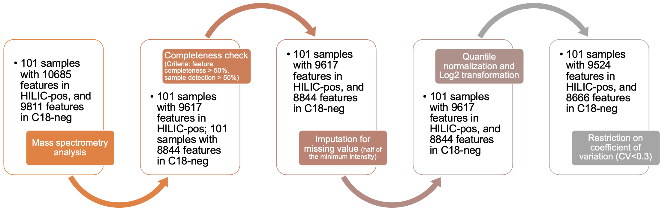

Fig. S1 The flow chart of quality control, data normalization and data transformation for metabolomic features.

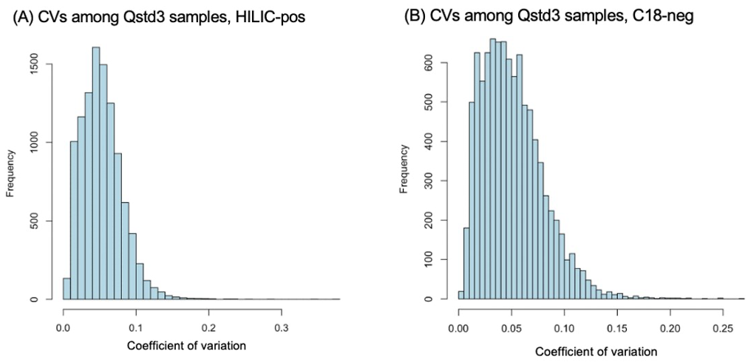

Fig. S2 Distributions of coefficients of variation (CVs) among Qstd3 samples for untargeted metabolomics data.

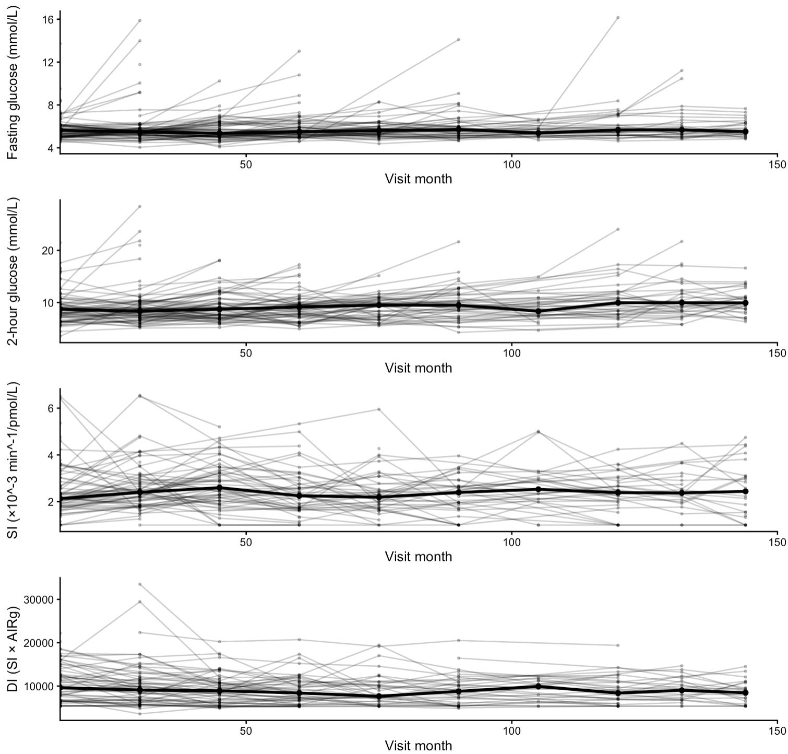
Fig. S3 Individual trajectories and median trends of diabetes traits across post-delivery visits among 101 women with gestational diabetes mellitus.

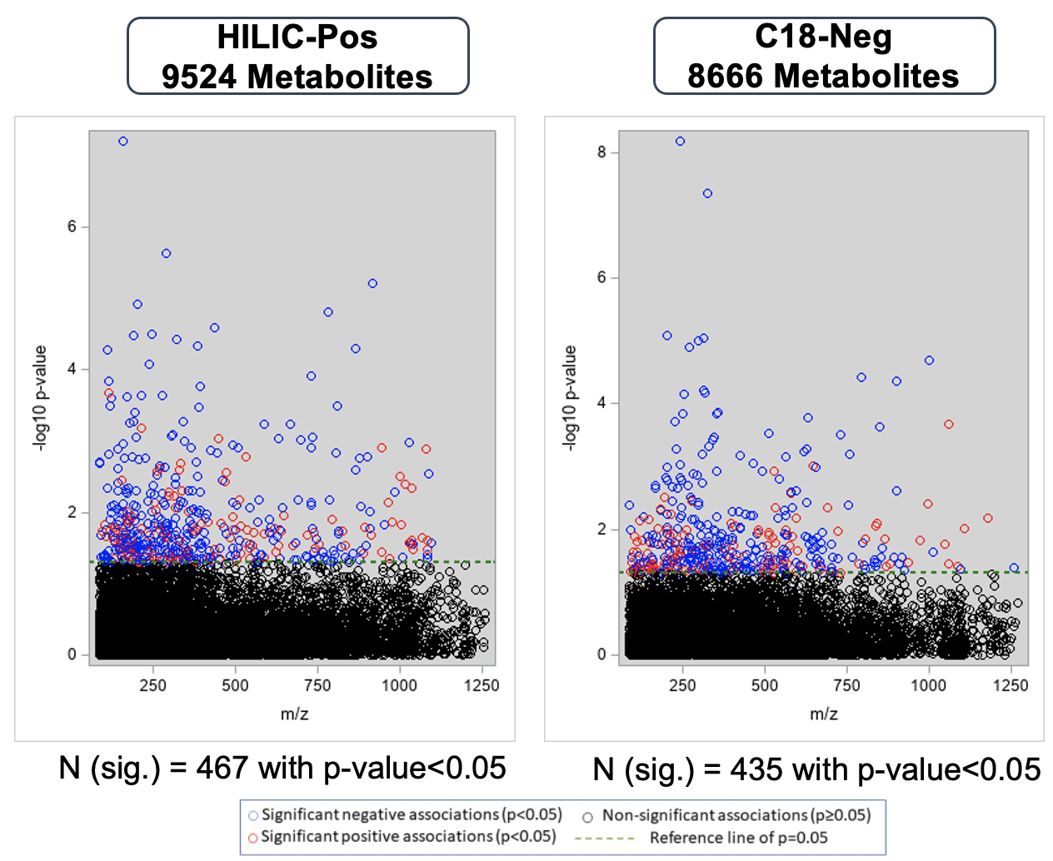

Fig. S4 Metabolome-wide associations between metabolomic features with CVs among Qstd3 samples < 0.3 and diabetes incidence post-delivery in 101 women with GDM.

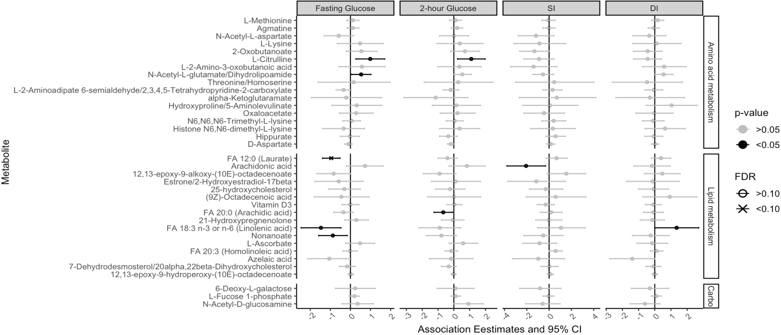
Fig. S5 Longitudinal associations of metabolomic signatures in the 3rd trimester of pregnancy with metabolic outcome traits 12 years post-delivery among 80 women with gestational diabetes mellitus who did not develop type 2 diabetes by their first post-delivery visit.
Mixed effects models were used to assess the associations between individual late-pregnancy metabolomic feature and metabolic outcome traits after delivery adjusting for covariates including age at delivery, along with time-varying covariates including BMI, additional pregnancy, and daily calorie intake at each follow-up visit during the post-delivery period. Association estimates are interpreted as the annual percentage change in metabolic outcome traits per doubling in relative abundance of metabolomic feature among 80 Hispanic women with GDM, who were not diagnosed with diabetes their first post-delivery visit. Carbo = Carbohydrate metabolism.

(A)
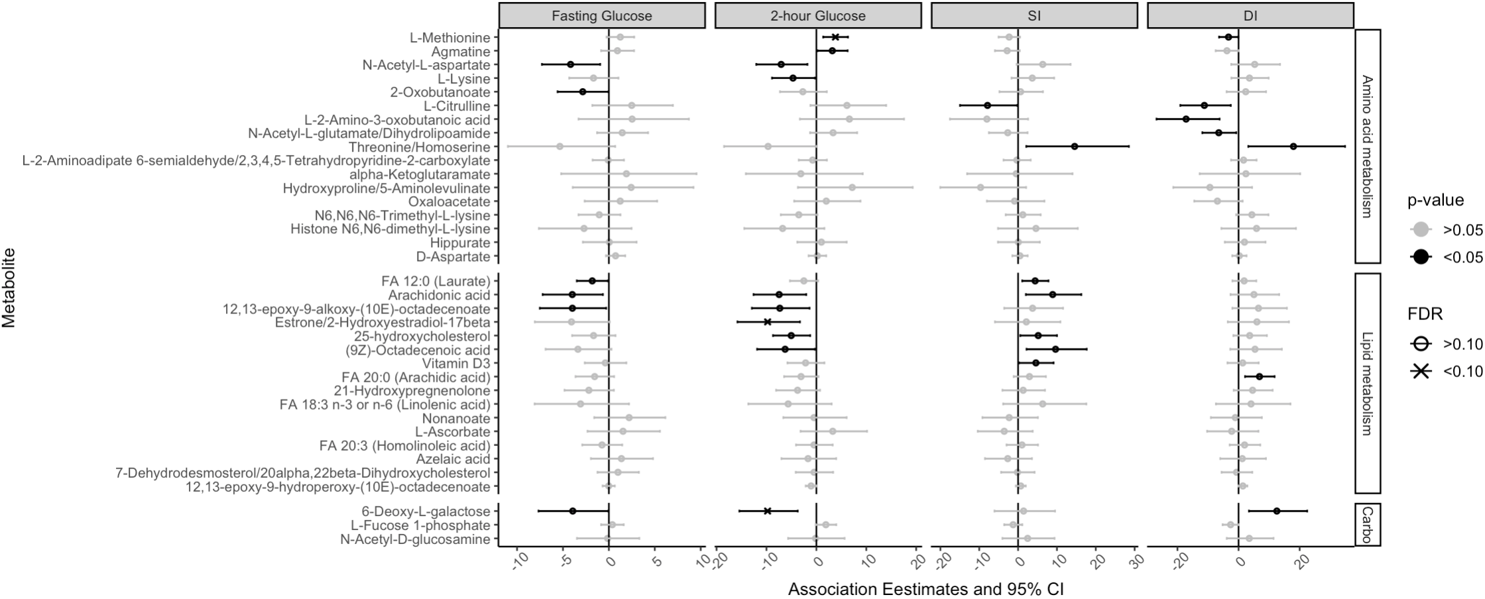
(B)
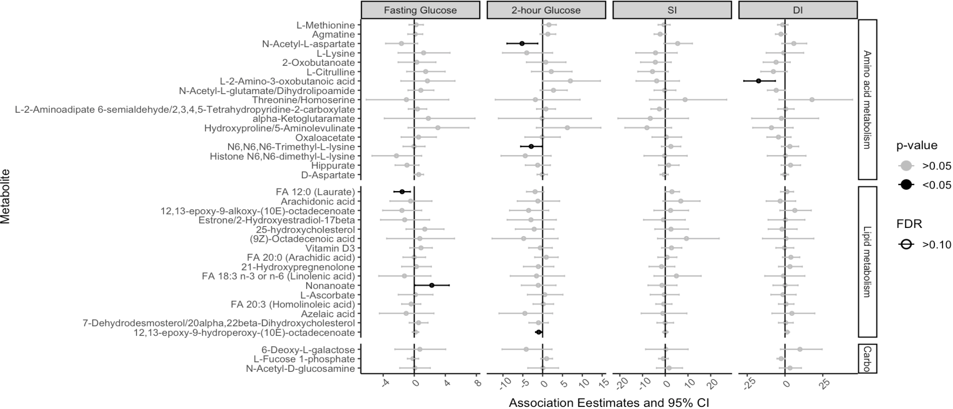
Fig. S6 Associations between metabolomic signatures in the 3rd trimester of pregnancy and metabolic outcome traits at the first post-delivery visit (15-60 months after delivery).
Panel A shows association estimates among 101 women with gestational diabetes mellitus (GDM). Panel B shows association estimates among 80 women with GDM who were not diagnosed with diabetes at their first post-delivery visit. Mixed effects models were used to assess the associations between individual late-pregnancy metabolomic feature and metabolic outcome traits after delivery adjusting for covariates including age at delivery, along with time-varying covariates including BMI, additional pregnancy, and daily calorie intake at each follow-up visit during the post-delivery period. Association estimates are interpreted as the percentage change in metabolic outcome traits at the first post-delivery visit per doubling in relative abundance of metabolomic feature among women with GDM. Carbo = Carbohydrate metabolism.
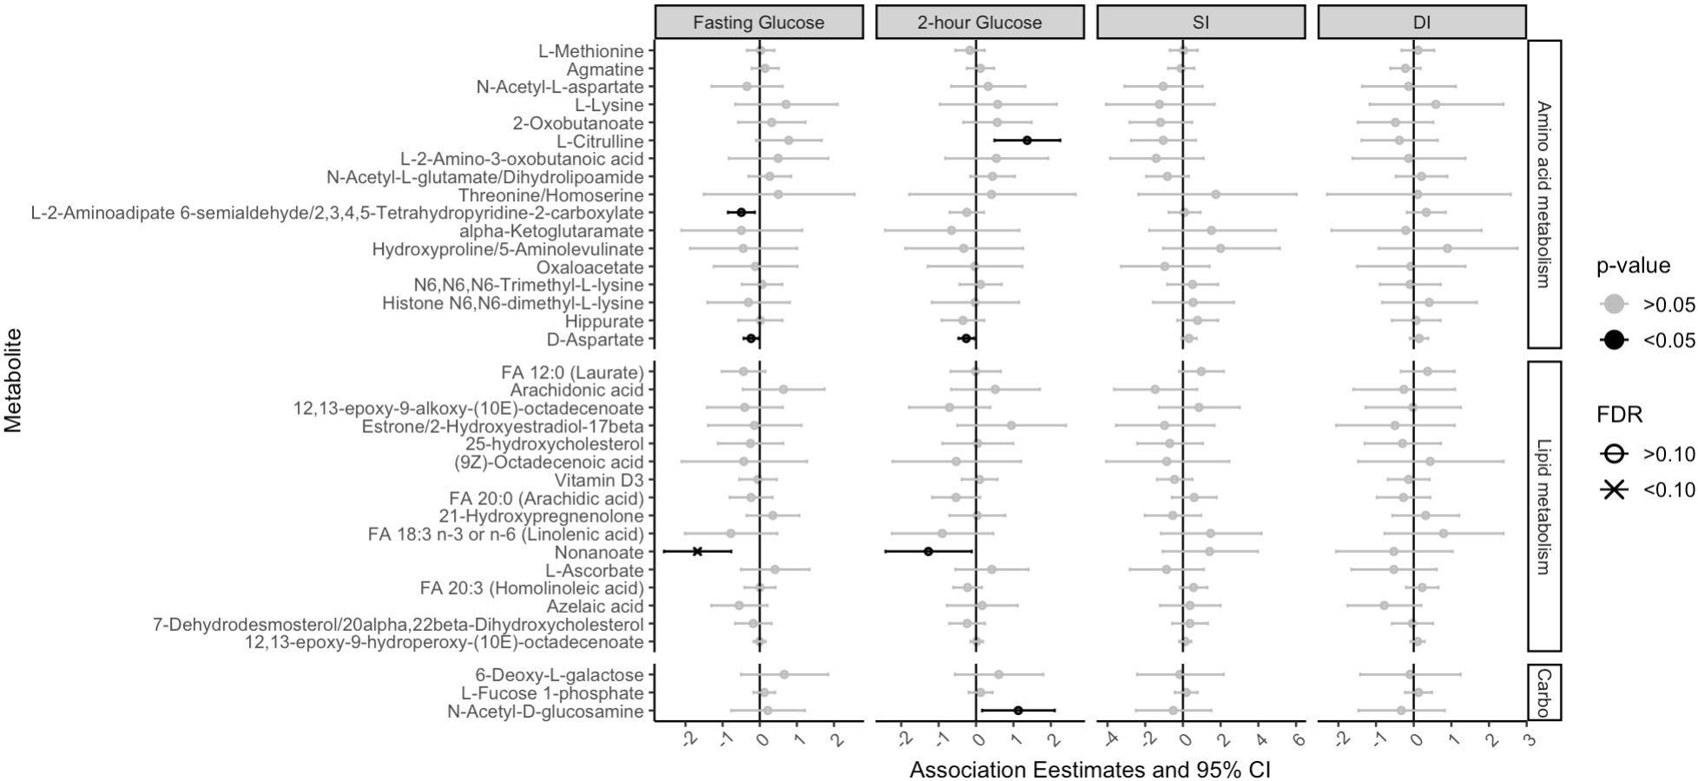
Fig. S7 Longitudinal associations of metabolomic signatures in the 3rd trimester of pregnancy with metabolic outcome traits 12 years post-delivery among 101 women with gestational diabetes mellitus.
Mixed effects models were used to assess the associations between individual late-pregnancy metabolomic feature and diabetes traits after delivery adjusting for the baseline levels of diabetes traits, and covariates including age at delivery, along with time-varying covariates including BMI, additional pregnancy, and daily calorie intake at each follow-up visit during the post-delivery period. Association estimates are interpreted as the annual percentage change in metabolic outcome traits per doubling in relative abundance of metabolomic feature among 101 Hispanic women. Carbo = Carbohydrate metabolism.

Reference

1. Lee J, Park J, Lim MS, Seong SJ, Seo JJ, Park SM, Lee HW, Yoon YR: Quantile normalization approach for liquid chromatography-mass spectrometry-based metabolomic data from healthy human volunteers. Anal Sci 2012, 28(8):801-805.
2. Liu KH, Nellis M, Uppal K, Ma C, Tran V, Liang Y, Walker DI, Jones DP: Reference Standardization for Quantification and Harmonization of Large-Scale Metabolomics. Anal Chem 2020, 92(13):8836-8844.

