Supplementary Methods I. Definition of insulin resistance (IR) surrogate indices
In accordance with previous studies, the estimated glucose disposal rate (eGDR) index and other IR indices were calculated as follows:
- eGDR = 21.158 − (0.09 × waist circumference [WC, cm]) − (3.407 × hyperetnsion [yes = 1/no = 0]) − (0.551 × glycosylated hemoglobin A1c [HbA1c, %]);
- Triglyceride-glucose (TyG) index = Ln (fasting triglyceride [mg/dL] × fasting glucose [mg/dL]/2);
- TyG-WC index = TyG index × WC (cm);
- TyG-body mass index (TyG-BMI) index = TyG index × BMI;
- TyG-waist-to-height ratio (TyG-WHtR) index = TyG index × WC (cm)/height (cm);
- Triglyceride-to-high density lipoprotein cholesterol (HDL-C) ratio (TG/HDL-C) = fasting triglyceride (mg/dL)/fasting HDL-C (mg/dL).

Supplementary Table 1: Definition of CHD and HF
Outcomes | First occurrences |  | Coronary recanalization surgery (OPCS4, Filed 41272, 41282) | Other
Outcomes | Data field | ICD | Coronary recanalization surgery (OPCS4, Filed 41272, 41282) | Other
Coronary heart disease | 131298 131299  131300 131301  131303 131304  131305 131306 | I21  I22  I23  I24  I25 | “K40.1","K40.2","K40.3",  "K40.4","K40.8","K40.9",  "K41.1","K41.2","K41.3",  "K41.4","K41.8","K41.9", "K45.1","K45.2","K45.3",  "K45.4","K45.5","K45.6",  "K45.8","K45.9" | Algorithmically-defined outcomes: 42000  42002  42004  Self-reported:  6150; 20002
Heart failure | 131354 131355 | I50 | - | -
ICD: International Classification of Diseases version 10; OPCS4: Office of Population Censuses and Surveys Classification of Interventions and Procedures version 4; CHD: coronary heart disease; HF: heart failure;

Supplementary Table 2. Association between eGDR and clinical outcomes risk in stratified analyses
 | HR for per -SD increase  (Model 1) | P | HR for per -SD increase  (Model 2) | P-
Heart failure
Gender
Male (13861) | 0.65 (0.63-0.68) | <0.001 | 0.50 (0.35-0.70) | <0.001
Female (6468) | 0.66 (0.62-0.71) | <0.001 | 0.50 (0.33-0.77) | <0.001
Age
>=60 (14737) | 0.65 (0.62-0.67) | <0.001 | 0.48 (0.34-0.68) | <0.001
<60 (5592) | 0.66 (0.61-0.72) | <0.001 | 0.47 (0.31-0.73) | <0.001
All-cause death
Gender
Male (13861) | 0.76 (0.73-0.79) | <0.001 | 0.60 (0.44-0.84) | <0.001
Female (6468) | 0.72 (0.68-0.77) | <0.001 | 0.64 (0.43-0.95) | <0.001
Age
>=60 (14737) | 0.74 (0.71-0.76) | <0.001 | 0.64 (0.47-0.86) | <0.001
<60 (5592) | 0.69 (0.64-0.74) | <0.001 | 0.55 (0.37-0.82) | <0.001
eGDR: Estimated glucose disposal rate; TYG index: Triglyceride-glucose index; TYG-BMI: eGDR: Estimated glucose disposal rate; TyG index: Triglyceride-glucose index; TyG-BMI: Triglyceride-glucose-body mass index; TyG-WC: Triglyceride-glucose-waist circumference; TyG-WHtR: Triglyceride-glucose-waist-to-height ratio; TG/HDL-C ratio: Triglyceride/high-density lipoprotein cholesterol ratio; HF: heart failure;
Model 1 was adjusted IR indices only, while model 2 was adjusted variables plus age, sex, qualifications, BMI, Townsend deprivation index, smoking status, alcohol intake, C-reactive protein, household income, employment status, history of diabetes, history of hypertension, history of cancer, history of hyperlipidemia, estimated glomerular filtration rate, and physical activity time, use of aspirin, antihypertensive medication, insulin and lipid-lowering medication.

Supplementary Table 3. Association between eGDR and clinical outcomes in sensitivity a
analyses
 | Participants | HR for per -SD increase  (Model 1) | P-value | HR for per -SD increase  (Model 2) | P-value
Heart failure
Sensitivity analysis 1 | 20025 | 0.64(0.56-0.74) | <0.001 | 0.49(0.37-0.65) | <0.001
Sensitivity analysis 2 | 19678 | 0.62（0.58-0.69） | <0.001 | 0.50（0.38-0.62） | <0.001
All-cause death
Sensitivity analysis 1 | 20025 | 0.72 (0.69-0.74) | <0.001 | 0.63 (0.47-0.86) | <0.001
Sensitivity analysis 2 | 19678 | 0.67 (0.64-0.71) | <0.001 | 0.65 (0.57-0.72) | <0.001

Sensitivity analysis 1: Excluding participants who developed HF within 2 years to reduce potential reverse causations;
Sensitivity analysis 2: Participants with imputed covariates were excluded to examine whether the results were influenced by the missing data imputation method.
eGDR: Estimated glucose disposal rate; TyG index: Triglyceride-glucose index; TyG-BMI: Triglyceride-glucose-body mass index; TyG-WC: Triglyceride-glucose-waist circumference; TyG-WHtR: Triglyceride-glucose-waist-to-height ratio; TG/HDL-C ratio: Triglyceride/high-density lipoprotein cholesterol ratio;
Model 1 was adjusted IR indices only, while model 2 was adjusted variables plus age, sex, qualifications, BMI, Townsend deprivation index, smoking status, alcohol intake, C-reactive protein, household income, employment status, history of diabetes, history of hypertension, history of cancer, history of hyperlipidemia, estimated glomerular filtration rate, and physical activity time, use of aspirin, antihypertensive medication, insulin and lipid-lowering medication.

Figure 1. Predictive performances of different IR indices for all-cause death
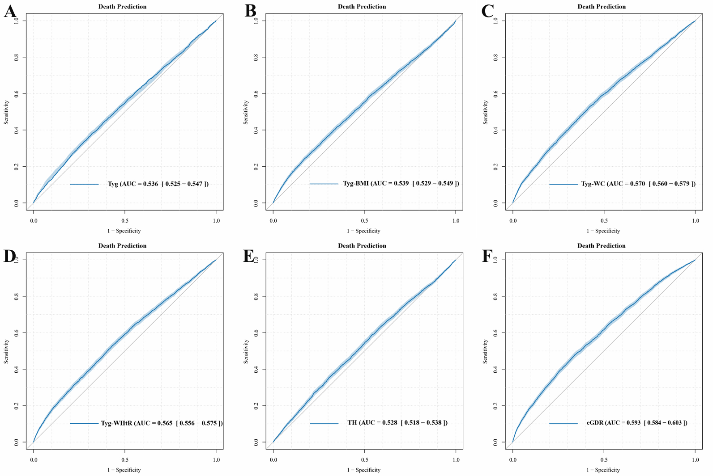
A: Predictive value of TyG for all-cause death in CHD patients.
B: Predictive value of TyG-WC for all-cause death in CHD patients.
C: Predictive value of TyG-BMI for all-cause death in CHD patients.
D: Predictive value of TyG-WHR for all-cause death in CHD patients.
E: Predictive value of TC/LDH for all-cause death in CHD patients.
F: Predictive value of eGDR for all-cause death in CHD patients.
eGDR: Estimated glucose disposal rate; CHD: coronary heart disease; HF: heart failure; TyG index: triglyceride-glucose index; TyG-BMI: triglyceride-glucose body mass index; TyG-WC: triglyceride-glucose-waist circumference; TyG-WHtR: triglyceride-glucose-waist-to-height ratio; TG/HDL-C ratio: triglyceride/high-density lipoprotein cholesterol ratio. IR: insulin resistance.

Supplementary Figure 2: Predictive performances of eGDR and cTnI for incident heart failure and all-cause death.
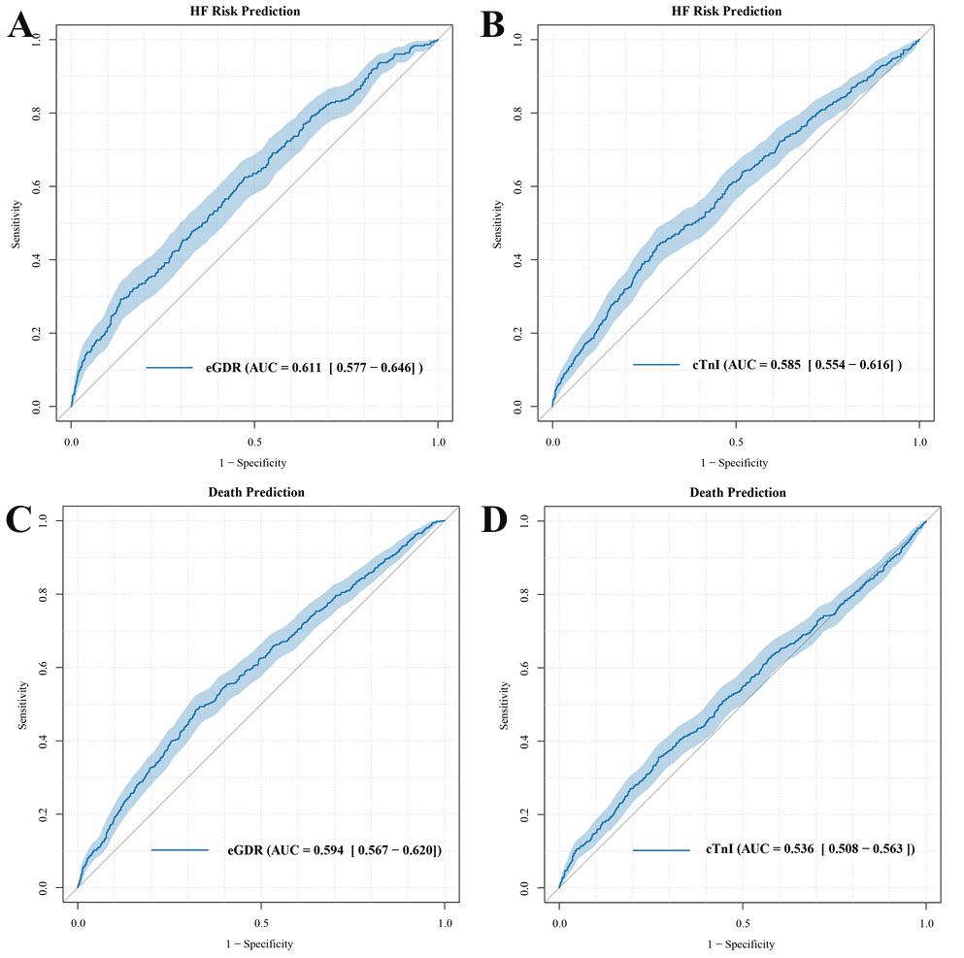
A: Predictive value of eGDR for incident HF in CHD patients.
B: Predictive value of cTnI for incident HF in CHD patients.
C: Predictive value of eGDR for all-cause death in CHD patients.
D: Predictive value of cTnI for all-cause death in CHD patients.
eGDR: Estimated glucose disposal rate; cTnI: cardiac troponin I; HF: heart failure; CHD: coronary heart disease; AUC: area under the curve.

