The Cholesterol, High-Density Lipoprotein, and Glucose Index and Its Derived Indices Predict Diabetic Kidney Disease Development and Progression: Evidence from Two Nationwide Cohorts and a Biopsy-Proven Clinical Cohort

Figure Legends
Figure 1. The flowchart of participants enrollment in CHARLS 2011–2020 cohort.
Figure 2. Predictive performance of CHG-derived and other insulin resistance indices for incident DKD in CHARLS 2011–2020 cohort. (A) Standard ROC curves for overall predictive accuracy. Fully adjusted models accounted for baseline eGFR, HbA1c, age, sex, marital status, education, Hukou, drinking, smoking, and 11 comorbidities (hypertension, dyslipidemia, chronic lung/liver/heart diseases, stroke, digestive diseases, emotional/psychiatric problems, memory-related diseases, arthritis, and asthma). (B) Time-dependent ROC curves assessing dynamic predictive efficacy at 5- and 8-year follow-ups. Standard AUCs were estimated using 200 bootstrap iterations, while dynamic predictive accuracy was evaluated using time-dependent AUCs and validated via 10-fold cross-validation.
Figure 3. Kaplan-Meier curves for incident DKD stratified by quartiles of CHG-derived and other insulin resistance indices in CHARLS 2011–2020 cohort. DKD-free survival probabilities are shown across quartiles (Q1–Q4) of (A) CHG, (B) CHG-BMI, (C) CHG-WC, (D) TyG, (E) METS-IR, and (F) TG/HDL ratio. Cumulative survival differences among quartiles were assessed using the log-rank test. Risk tables below each plot denote the number of participants at risk at 2-year intervals.
Figure 4. Restricted cubic spline (RCS) curves for incident DKD risk by CHG-derived and other insulin resistance indices in CHARLS 2011–2020 cohort. Dose-response relationships are shown for (A) CHG, (B) CHG-WC, (C) CHG-BMI, (D) TyG, (E) METS-IR, and (F) TG/HDL ratio. Solid red lines and pink shaded areas represent multivariable-adjusted hazard ratios (HR) and 95% CIs, with the reference point (HR = 1.0) set at the median. Background teal histograms display relative probability densities. The covariates adjusted in models were consistent with fully adjusted Model 3 in Cox proportional hazards models. Optimal knots (red rugs on the x-axis) were determined by the minimum AIC. P-overall and P-non-linear indicate the significance of the overall and non-linear associations, respectively.
Figure 5. Subgroup analyses evaluating incident DKD risk by CHG-derived indices in CHARLS 2011–2020 cohort. Forest plots display hazard ratios (HRs) and 95% CIs per 1-SD increment in (A) CHG, (B) CHG-BMI, and (C) CHG-WC across ten clinical subgroups. Red squares and horizontal lines represent HRs and 95% CIs, respectively (dashed vertical line: reference HR = 1.0). The covariates adjusted in models were consistent with fully adjusted Model 3 in Cox proportional hazards models (except for the stratification variable itself in each subgroup). P for interaction tests whether associations vary significantly across strata.

Table Legends
Table 1. Baseline characteristics of participants enrolled in the study from CHARLS 2011-2020 cohort.
Table 2. Cox proportional hazards regression analysis of the associations of CHG-related indices and other insulin resistance markers with incident DKD in CHARLS 2011–2020 cohort.
Table 3. Clinical and pathological characteristics of patients with biopsy-proven DKD in a cross-sectional cohort stratified by eGFR.
Table 4. Logistic regression analysis of the associations of the CHG index and other insulin resistance markers with DKD progression (eGFR < 60 mL/min/1.73 m²) in a cross-sectional cohort of patients with biopsy-proven DKD.

Supplementary Figures
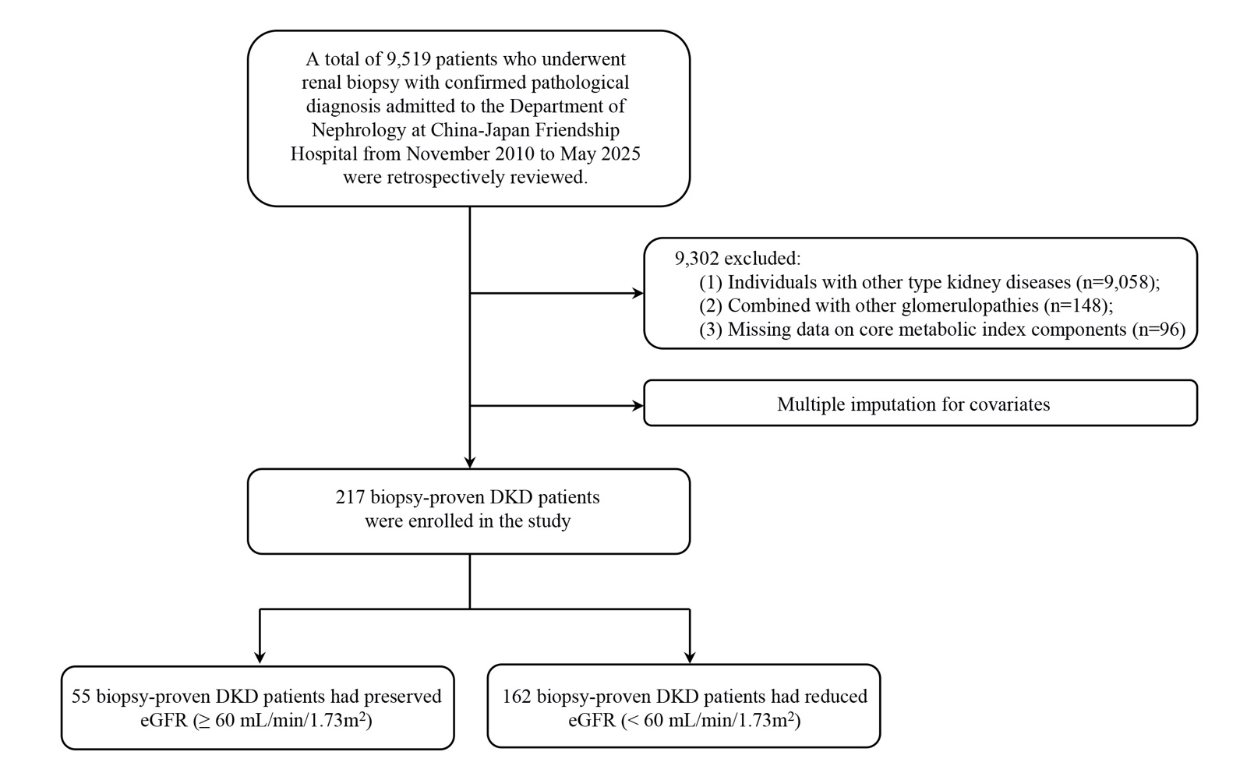
Figure S1. The flowchart of participants enrollment in biopsy-proven DKD cohort.

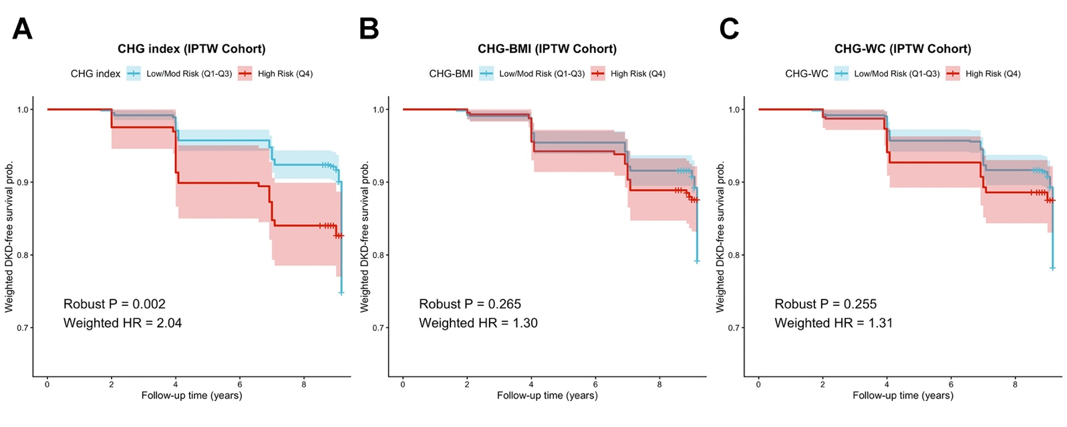
Figure S2. Weighted Kaplan-Meier survival curves for incident DKD following inverse probability of treatment weighting (IPTW) in CHARLS 2011-2020 cohort. Panels show IPTW-adjusted DKD-free survival probabilities (shaded areas: 95% CIs) comparing high-risk (Q4; red lines) vs. low/moderate-risk (Q1–Q3; light blue lines) groups for (A) CHG, (B) CHG-BMI, and (C) CHG-WC. To balance confounders, stabilized IPTW was applied using propensity scores based on demographics, lifestyle, baseline eGFR, and 10 comorbidities. Potential mediators (HbA1c and dyslipidemia) were deliberately excluded to avoid over-adjustment bias. Insets display weighted HRs and robust P values derived from IPTW-adjusted Cox models with robust variance estimators.

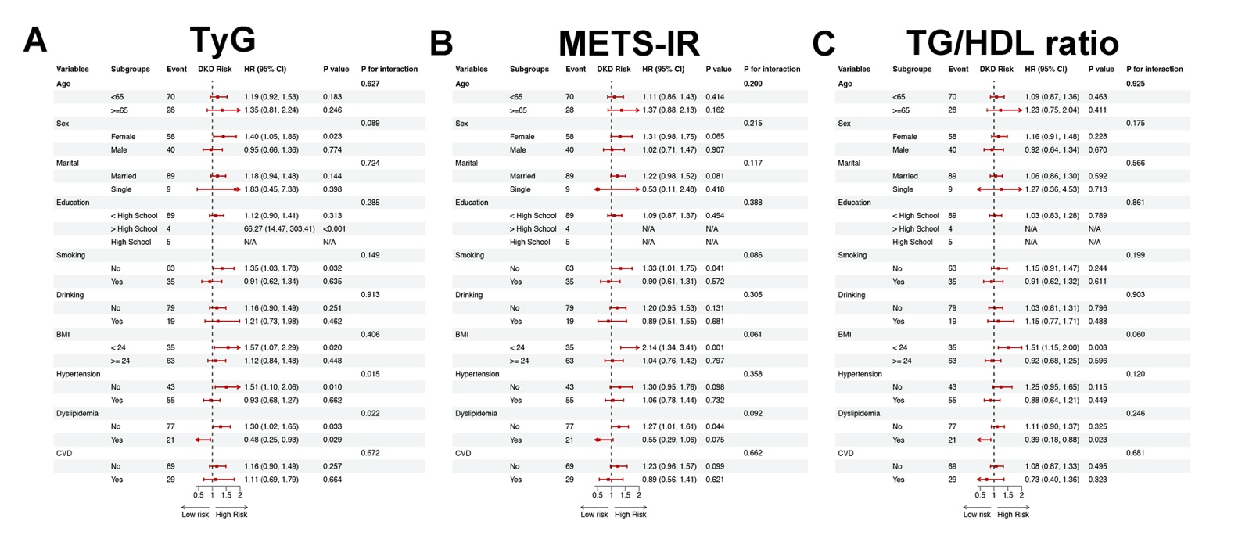
Figure S3. Subgroup analyses evaluating incident DKD risk by other insulin resistance markers in CHARLS 2011–2020 cohort. Forest plots display hazard ratios (HRs) and 95% CIs per 1-SD increment in (A) TyG, (B) METS-IR, and (C) TG/HDL ratio across ten clinical subgroups. Red squares and horizontal lines represent HRs and 95% CIs, respectively (dashed vertical line: reference HR = 1.0). The covariates adjusted in models were consistent with fully adjusted Model 3 in Cox proportional hazards models (except for the stratification variable itself in each subgroup). P for interaction tests whether associations vary significantly across strata.

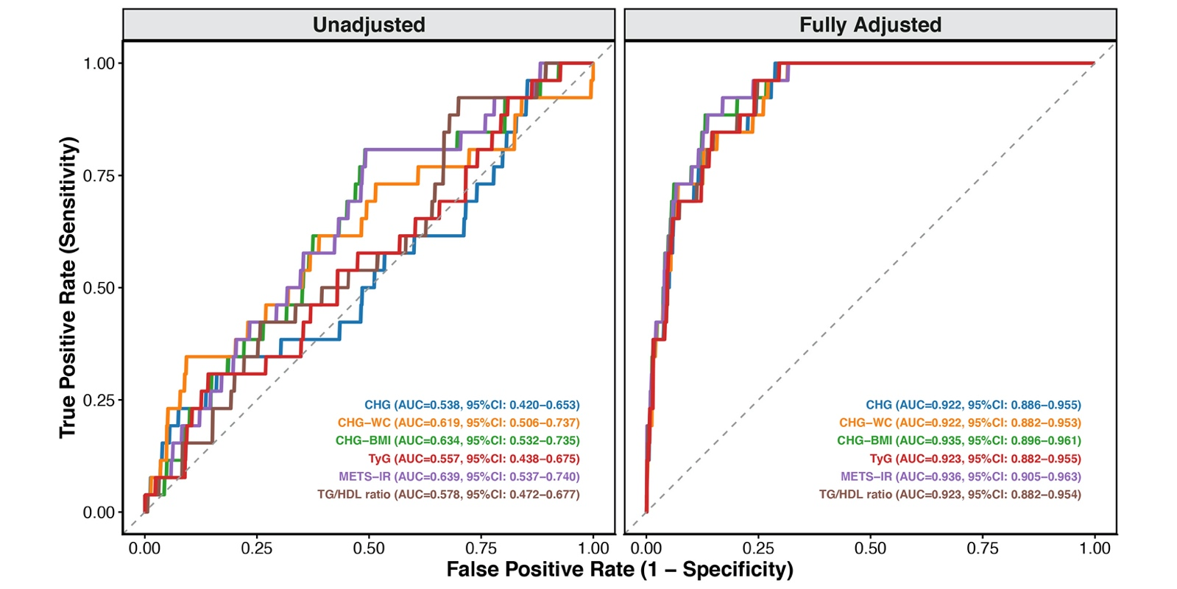
Figure S4. ROC curves for incident DKD defined by strict biochemical criteria (eGFR decline ≥ 20% and < 60 mL/min/1.73 m²) in the CHARLS 2011–2015 cohort. Unadjusted (left) and fully adjusted (right) ROC curves evaluate CHG, CHG-WC, CHG-BMI, TyG, METS-IR, and TG/HDL ratio. To capture true disease progression and avoid misclassification from transient physiological fluctuations, this analysis was restricted to participants with complete baseline and 4-year blood samples, redefining incident DKD as a strict ≥ 20% eGFR reduction. Fully adjusted standard models controlled for the covariates same as fully adjusted Model 3 in Cox proportional hazards model. Apparent AUCs and 95% CIs, derived from 500 bootstrap iterations, are displayed.

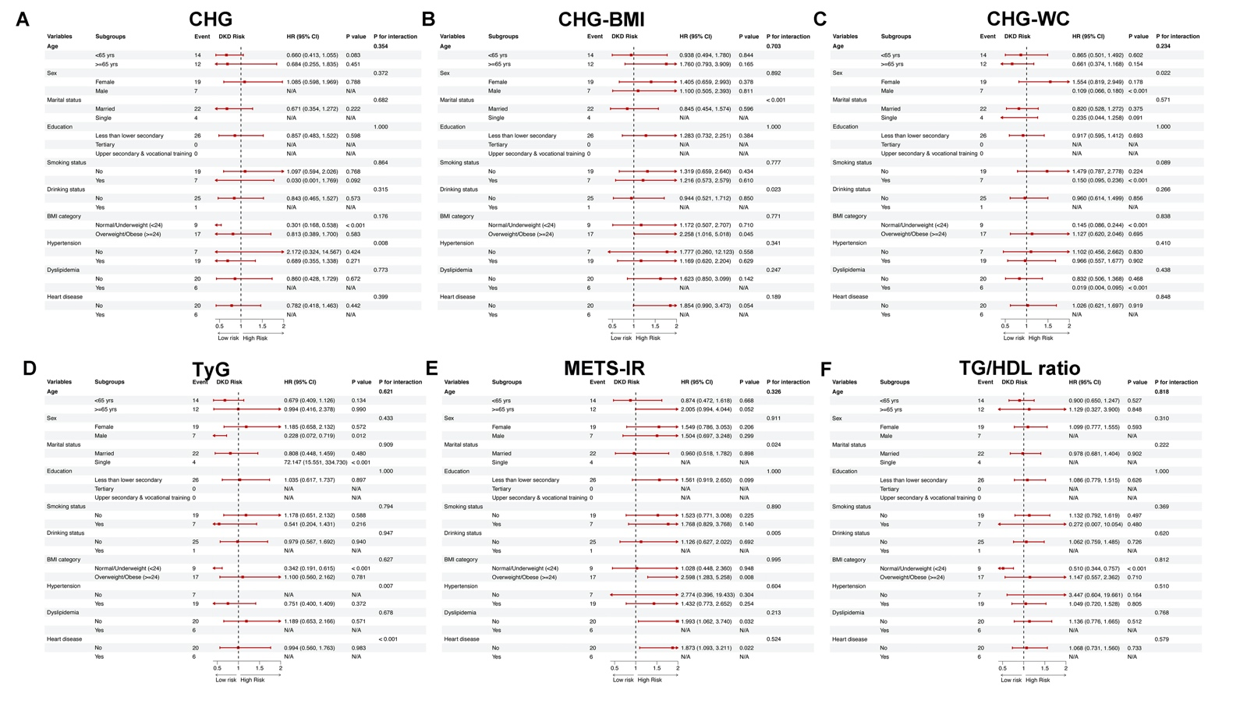
Figure S5. Subgroup analyses for incident DKD risk defined by strict biochemical criteria (eGFR decline ≥ 20% and < 60 mL/min/1.73 m²) in the CHARLS 2011–2015 cohort. The forest plots illustrate the hazard ratios (HRs) and 95% CIs for incident DKD corresponding to a 1-SD increase in (A) CHG, (B) CHG-BMI, (C) CHG-WC, (D) TyG, (E) METS-IR, and (F) TG/HDL ratio across 10 baseline subgroups. Incident DKD was defined by strict biochemical thresholds (eGFR < 60 mL/min/1.73 m² with a ≥ 20% decline). Continuous indices were winsorized (1st-99th percentiles) and standardized. The covariates adjusted in models were consistent with fully adjusted Model 3 in Cox proportional hazard regression analysis (except for the stratification variable itself in each subgroup). P for interaction evaluates effect heterogeneity across strata.

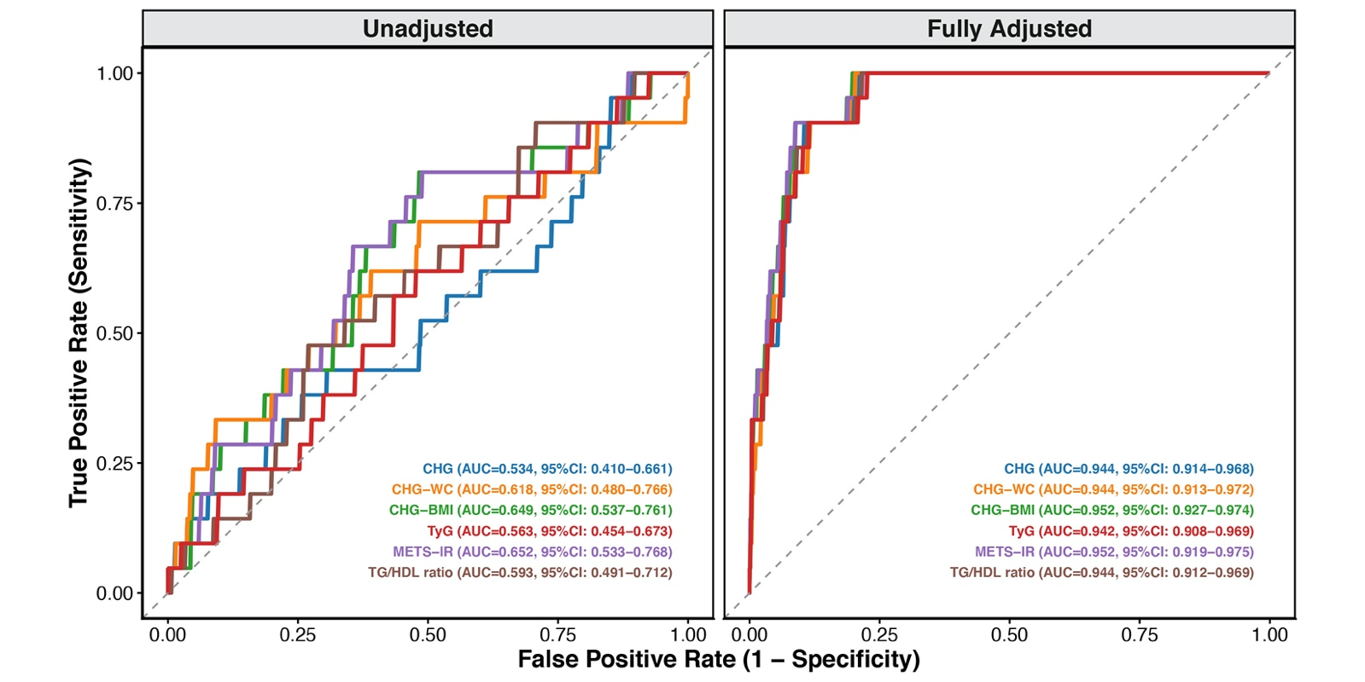
Figure S6. ROC curves for incident DKD among participants with preserved baseline kidney function (eGFR ≥ 70 mL/min/1.73 m²) in the CHARLS 2011–2015 cohort. Unadjusted (left) and fully adjusted (right) ROC curves evaluate CHG, CHG-WC, CHG-BMI, TyG, METS-IR, and TG/HDL ratio. To avoid overestimating clinically meaningful disease progression in individuals with baseline eGFR values close to the diagnostic threshold, analysis was restricted to participants with complete baseline and 4-year blood samples, and preserved baseline eGFR (≥ 70 mL/min/1.73 m²). Fully adjusted standard models controlled for the covariates same as fully adjusted Model 3 in Cox proportional hazards models. Apparent AUCs and 95% CIs, derived from 500 bootstrap iterations, are displayed.

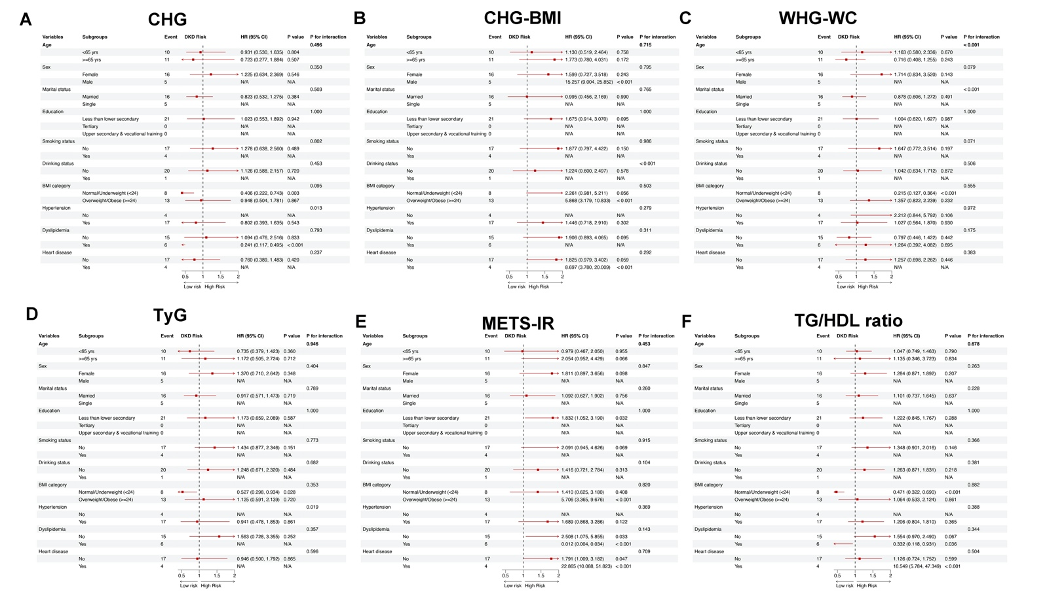
Figure S7. Subgroup analyses for incident DKD risk among participants with preserved baseline kidney function (eGFR ≥ 70 mL/min/1.73 m²) in the CHARLS 2011–2015 cohort. The forest plots illustrate the hazard ratios (HRs) and 95% CIs for incident DKD corresponding to a 1-SD increase in (A) CHG, (B) CHG-BMI, (C) CHG-WC, (D) TyG, (E) METS-IR, and (F) TG/HDL ratio across 10 baseline subgroups. Incident DKD was defined by strict biochemical thresholds (eGFR < 60 mL/min/1.73 m² with a ≥ 20% decline). Continuous indices were winsorized (1st-99th percentiles) and standardized. The covariates adjusted in models were consistent with fully adjusted Model 3 in Cox proportional hazards models (except for the stratification variable itself in each subgroup). P for interaction evaluates effect heterogeneity across strata.

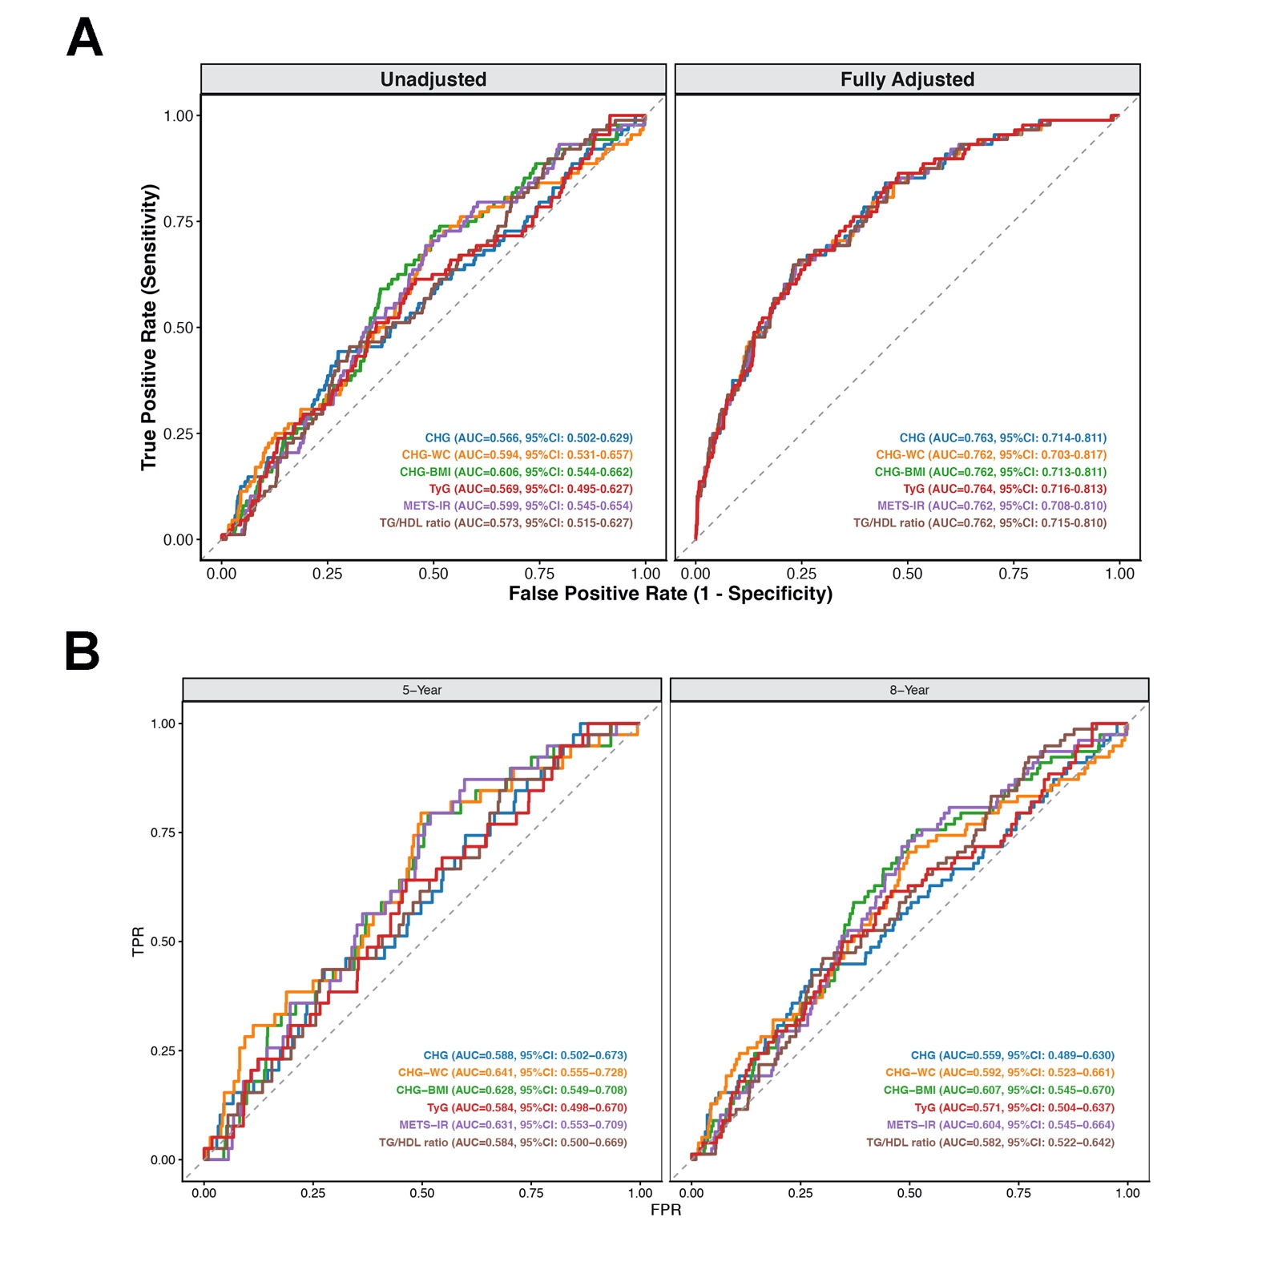
Figure S8. Standard and time-dependent ROC curves for incident DKD in a restricted CHARLS cohort excluding early-onset cases (prior to 2013). To eliminate reverse causality from latent kidney damage, participants developing early-onset DKD in 2013 were excluded, with the remaining cohort followed through 2020 for incident DKD (defined by self-reported diagnosis or eGFR < 60 mL/min/1.73 m²). Fully adjusted standard models controlled for the covariates same as fully adjusted Model 3 in Cox proportional hazards models. Standard AUCs (A) were estimated using 500 bootstrap iterations, while dynamic predictive accuracy (B) was evaluated using time-dependent AUCs and validated via 10-fold cross-validation.
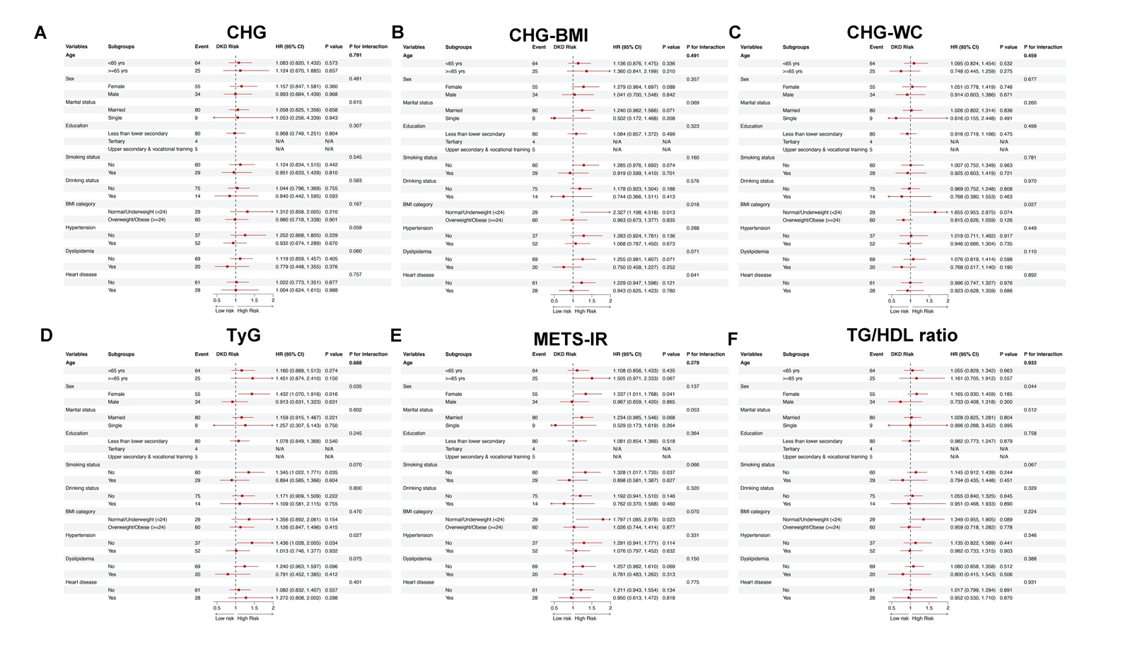
Figure S9. Subgroup analyses for incident DKD risk in a restricted CHARLS cohort excluding early-onset cases (prior to 2013). The forest plots illustrate the hazard ratios (HRs) and 95% CIs for incident DKD corresponding to a 1-SD increase in (A) CHG, (B) CHG-BMI, (C) CHG-WC, (D) TyG, (E) METS-IR, and (F) TG/HDL ratio across 10 baseline subgroups. Incident DKD was defined by self-reported diagnosis or eGFR < 60 mL/min/1.73 m² during CHARLS 2013-2020 cohort. Continuous indices were winsorized (1st-99th percentiles) and standardized. The covariates adjusted in models were consistent with fully adjusted Model 3 in Cox proportional hazards models (except for the stratification variable itself in each subgroup). P for interaction evaluates effect heterogeneity across strata.

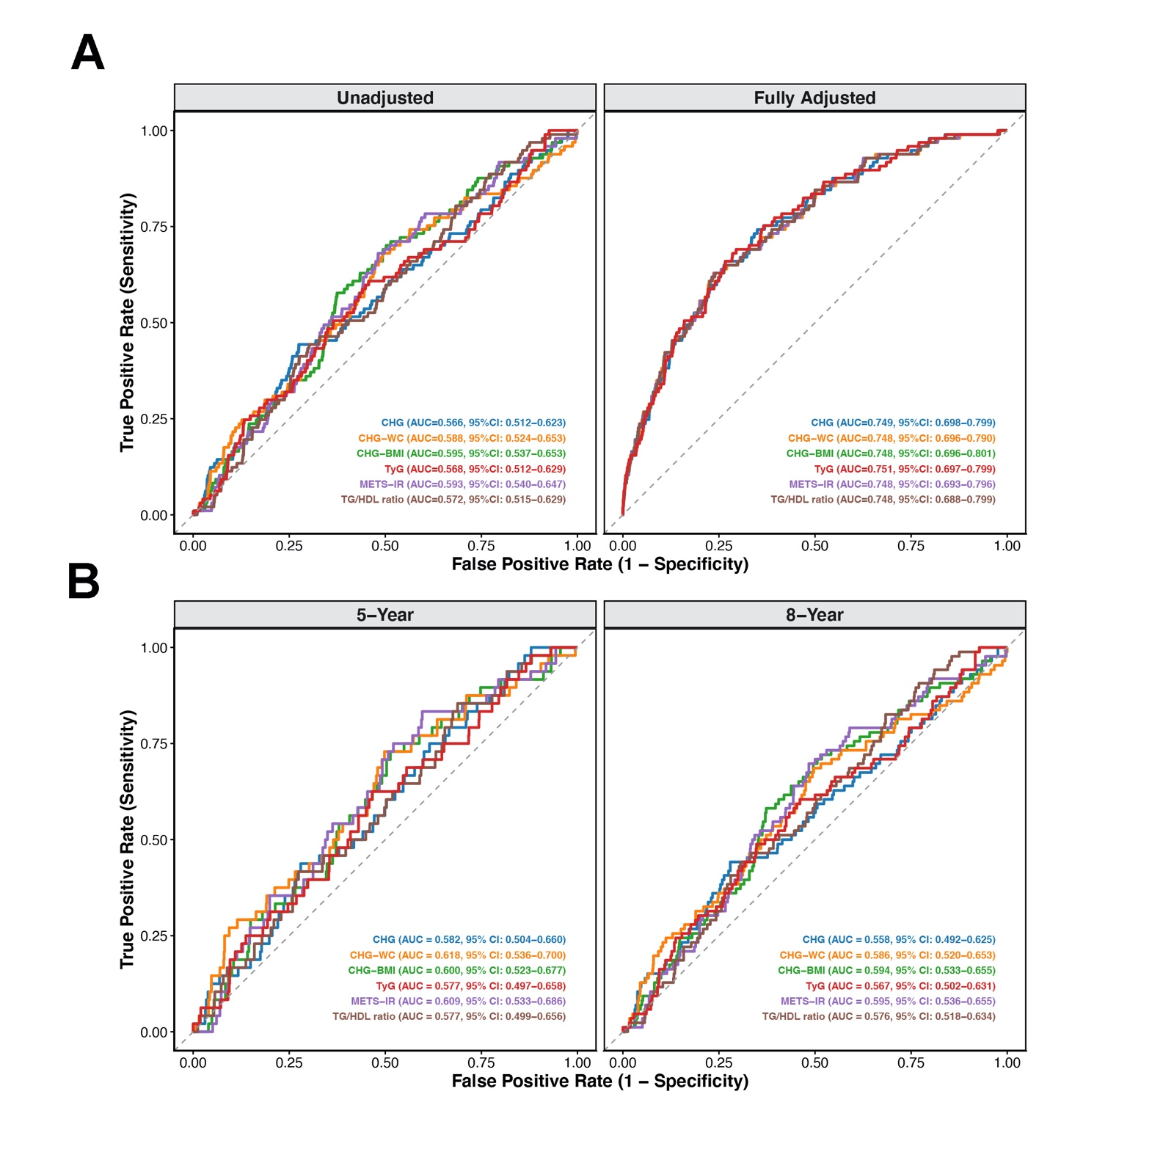
Figure S10. Standard and time-dependent ROC curves for incident DKD in a strict complete-case CHARLS 2011-2020 cohort. To rule out imputation bias, this complete-case analysis (excluding missing baseline covariates) followed participants from CHARLS 2011–2020 cohort for incident DKD (defined by self-reported diagnosis or eGFR < 60 mL/min/1.73 m²). Fully adjusted standard models controlled for the covariates same as fully adjusted Model 3 in Cox proportional hazards models. Standard AUCs (A) were estimated using 500 bootstrap iterations, while dynamic predictive accuracy (B) was evaluated using time-dependent AUCs and validated via 10-fold cross-validation.
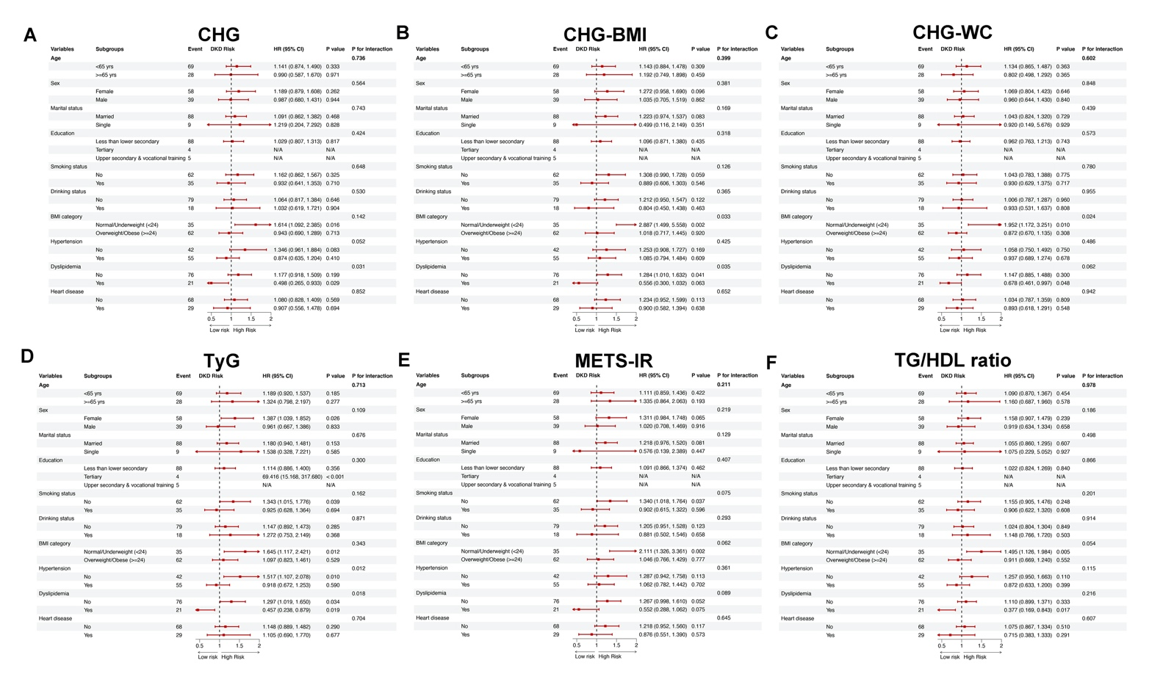
Figure S11. Subgroup analyses for incident DKD risk in a strict complete-case CHARLS 2011-2020 cohort. The forest plots illustrate the hazard ratios (HRs) and 95% CIs for incident DKD corresponding to a 1-SD increase in (A) CHG, (B) CHG-BMI, (C) CHG-WC, (D) TyG, (E) METS-IR, and (F) TG/HDL ratio across 10 baseline subgroups. Incident DKD was defined by self-reported diagnosis or eGFR < 60 mL/min/1.73 m² during CHARLS 2011-2020 cohort without imputation. Continuous indices were winsorized (1st-99th percentiles) and standardized. The covariates adjusted in models were consistent with fully adjusted Model 3 in Cox proportional hazards models (except for the stratification variable itself in each subgroup). P for interaction evaluates effect heterogeneity across strata.

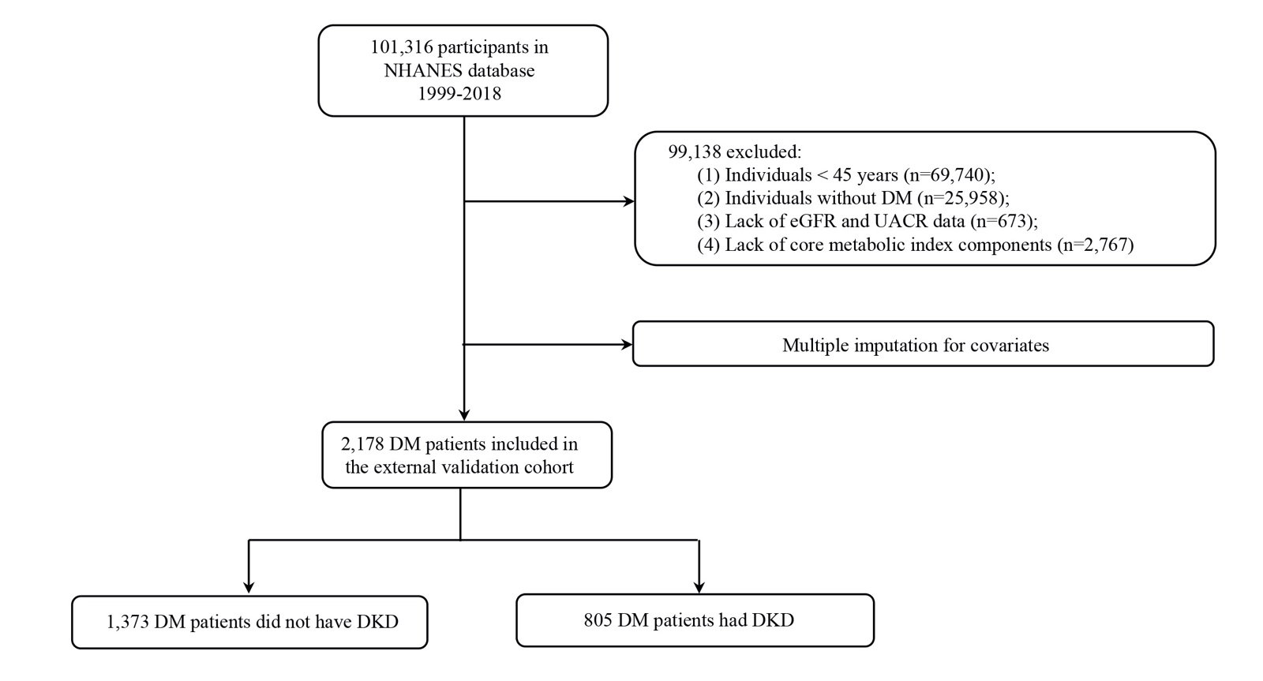
Figure S12. The flowchart of participants enrollment in NHANES 1999–2018 cohort.

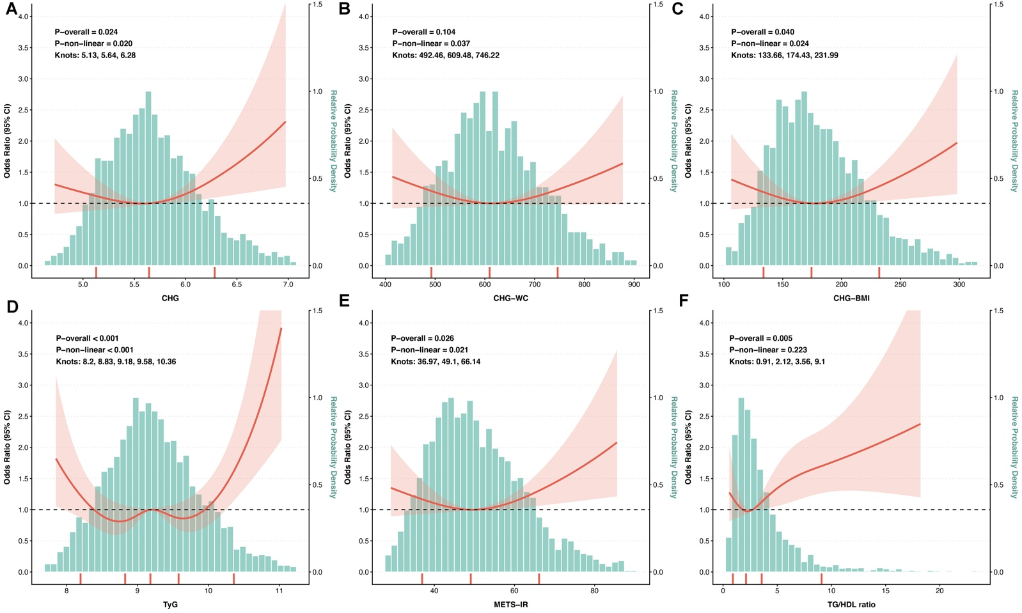
Figure S13. Restricted cubic spline (RCS) curves for incident DKD risk by CHG-derived and other insulin resistance indices in NHANES independent external validation 1999-2018 cohort. Dose-response relationships are shown for (A) CHG, (B) CHG-WC, (C) CHG-BMI, (D) TyG, (E) METS-IR, and (F) TG/HDL ratio. The solid red lines represent the multivariable-adjusted Odds Ratios (ORs), while the surrounding shaded areas indicate the 95% Confidence Intervals (CIs). The covariates adjusted in models were consistent with fully adjusted Model 3 in Logistic regression analysis. Optimal knots (red rugs on the x-axis) were determined by the minimum AIC. P-overall and P-non-linear indicate the significance of the overall and non-linear associations, respectively.
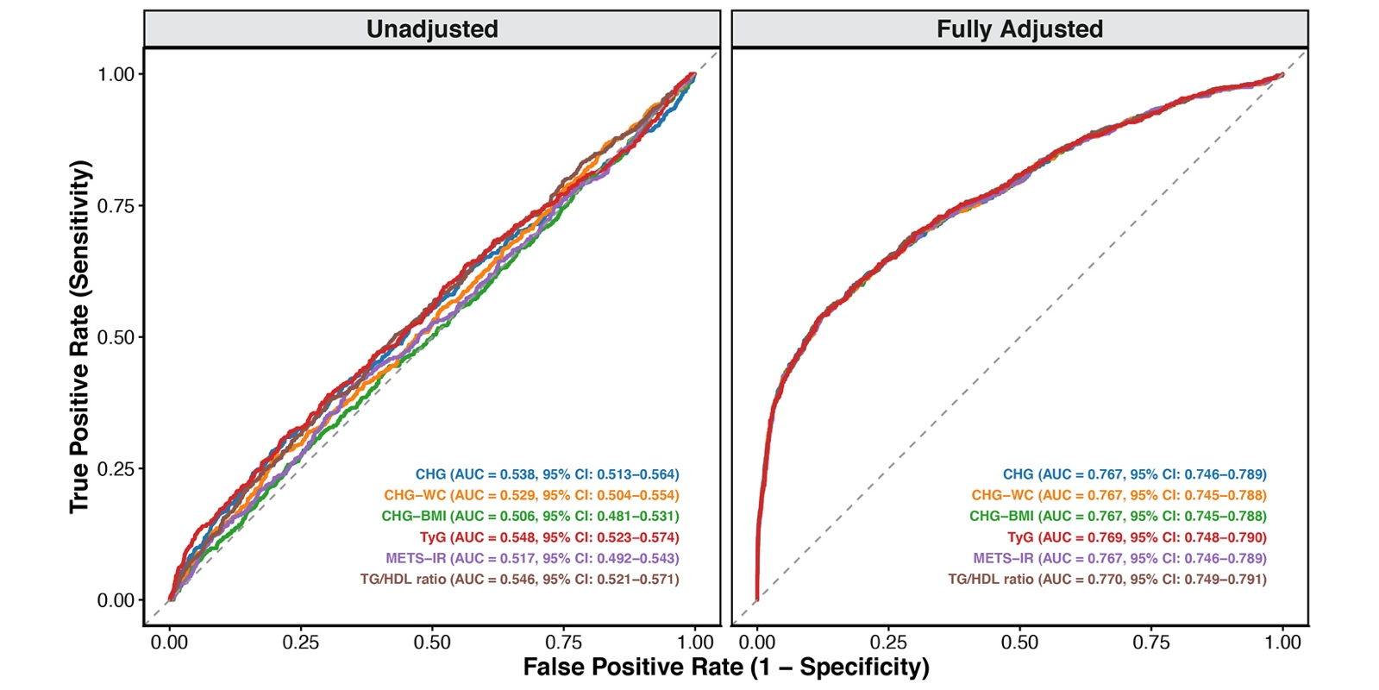
Figure S14. Predictive performance of CHG-derived indices and other insulin resistance markers for DKD in the NHANES independent external validation 1999-2018 cohort. Unadjusted (left) and fully adjusted (right) ROC curves evaluate the CHG index, CHG-WC, CHG-BMI, TyG, METS-IR, and TG/HDL ratio. To rigorously validate the primary findings across different ethnic backgrounds and healthcare systems, this cross-sectional analysis utilized the NHANES dataset. DKD was comprehensively defined according to the standard KDIGO criteria. Multiple imputation by chained equations (MICE) was applied to handle missing data. Fully adjusted models controlled for the covariates same as adjusted Model 3 in Logistic regression analysis. Apparent AUCs and 95% CIs are displayed, with model optimism and robustness further evaluated via 200 bootstrap iterations.

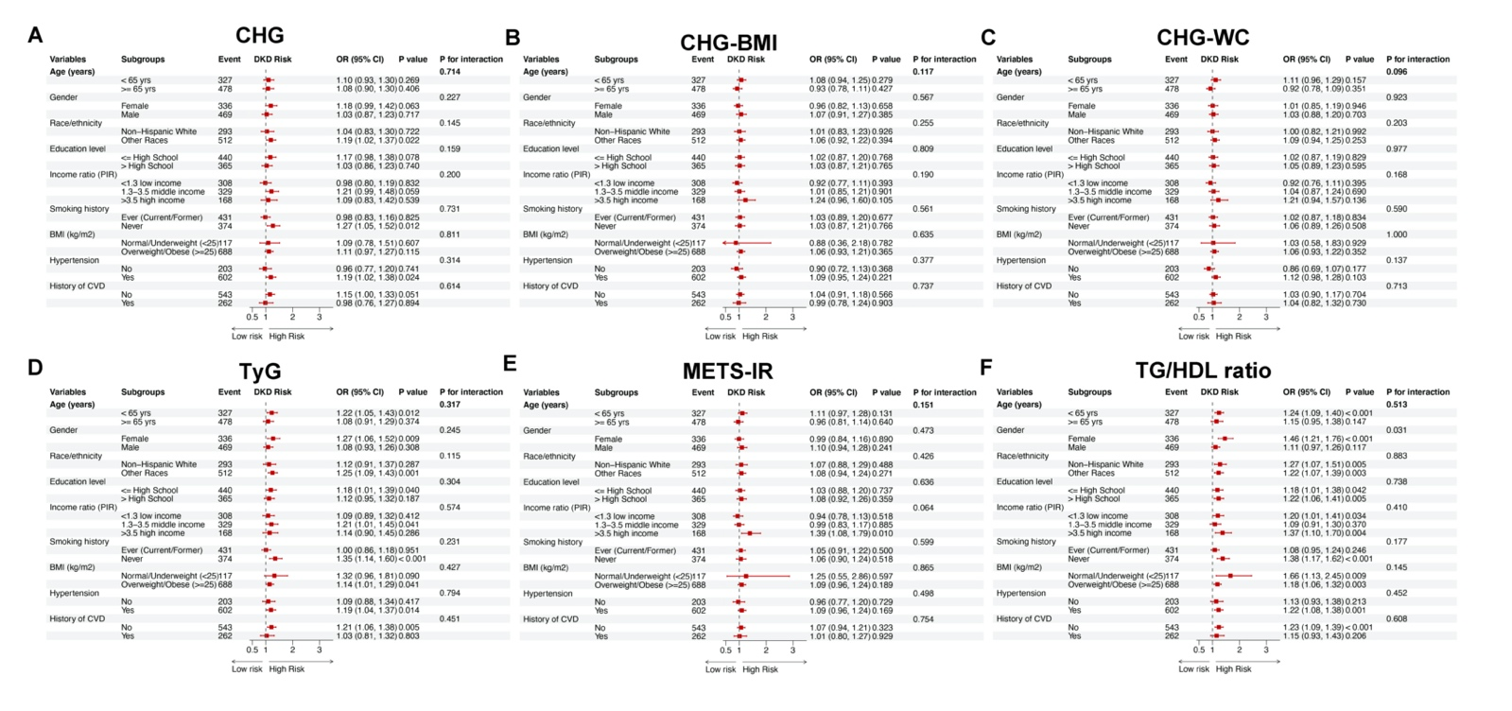
Figure S15. Subgroup analyses for incident DKD risk in NHANES independent external validation 1999-2018 cohort. Forest plots show the multivariable-adjusted odds ratios (ORs) and 95% confidence intervals (CIs) for DKD associated with per 1-SD increment of each index across various prespecified subgroups: (A) CHG, (B) CHG-BMI, (C) CHG-WC, (D) TyG, (E) METS-IR, and (F) TG/HDL ratio. The associations were evaluated using multivariable logistic regression models. The covariates adjusted in models were consistent with fully adjusted Model 3 in Logistic regression analysis (except for the stratification variable itself in each subgroup). The P for interaction was calculated using the Likelihood Ratio Test to assess the modifying effects of the stratifying variables.

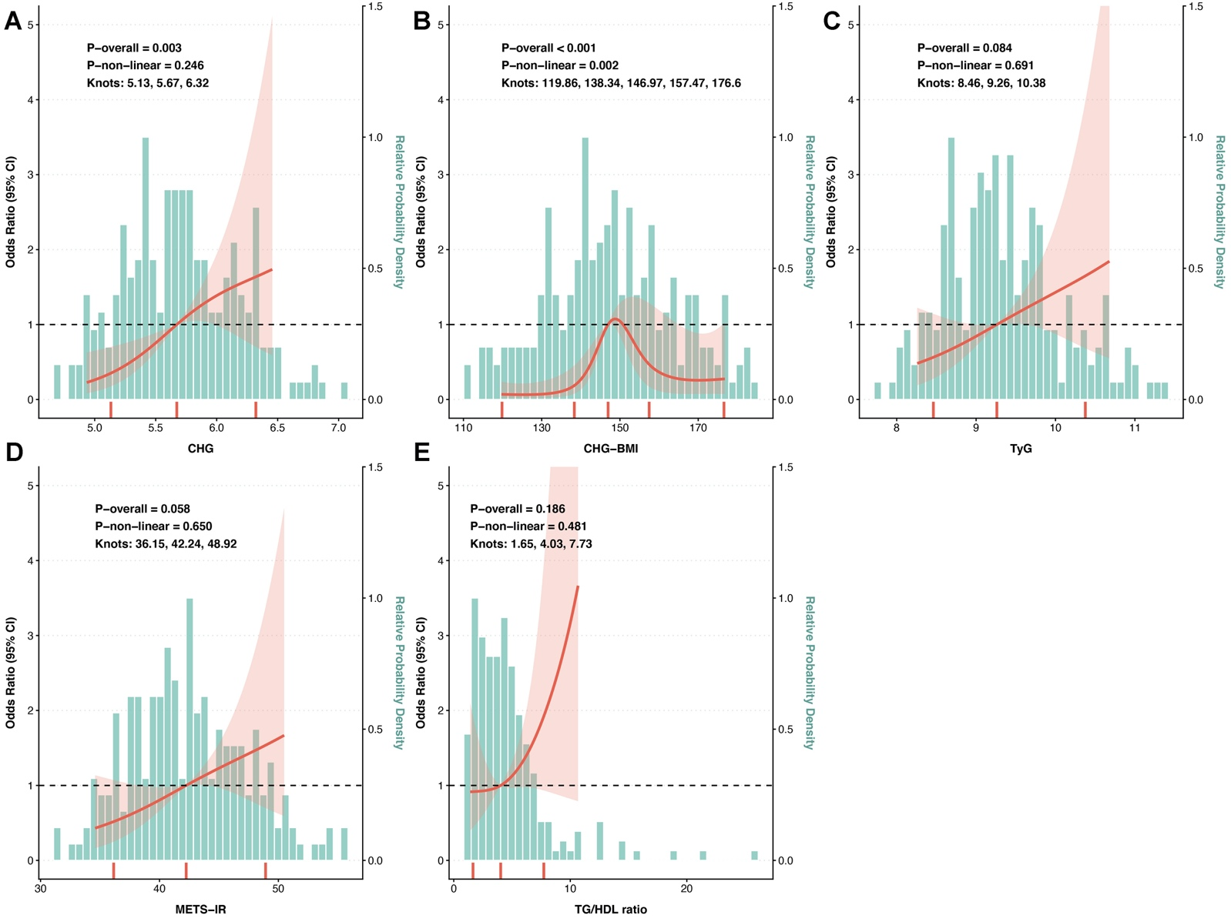
Figure S16. Restricted cubic spline (RCS) curves for renal impairment risk by the CHG index and other metabolic markers in the biopsy-proven DKD independent clinical cohort. Dose-response relationships are shown for (A) CHG, (B) CHG-BMI, (C) TyG, (D) METS-IR and (E) TG/HDL ratio. The solid red lines represent the multivariable-adjusted Odds Ratios (ORs), while the surrounding shaded areas indicate the 95% Confidence Intervals (CIs). The horizontal dashed black lines denote the reference OR of 1.0 centered at the median value of each index, and the background turquoise histograms reflect the relative probability density distributions. The covariates adjusted in models were consistent with fully adjusted Model 3 in Logistic regression analysis. Optimal knots (red rugs on the x-axis) were determined by the minimum AIC. P-overall and P-non-linear indicate the significance of the overall and non-linear associations, respectively.

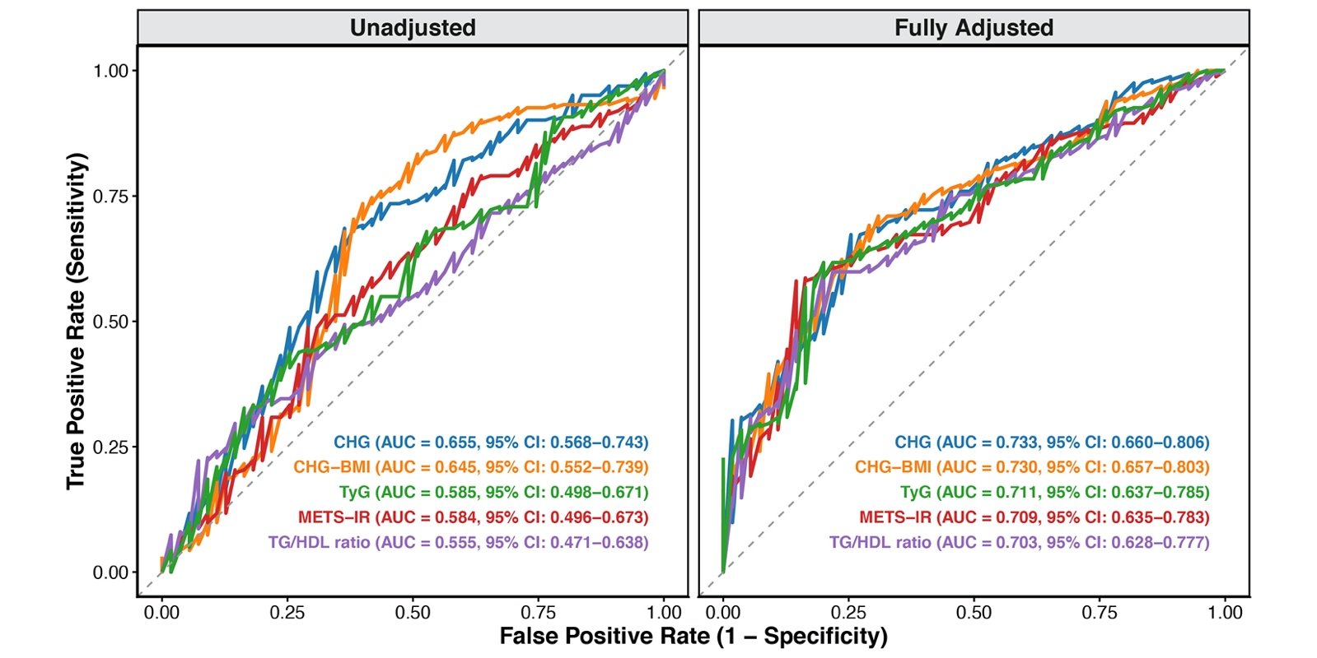
Figure S17. Predictive performance of the CHG index and other metabolic markers for eGFR decline in the biopsy-proven DKD independent clinical cohort. Unadjusted (left) and fully adjusted (right) ROC curves evaluate the CHG, CHG-BMI, TyG, METS-IR and TG/HDL ratio. While the primary cohort assessed incident DKD development, this independent real-world cohort of biopsy-proven DKD patients (China-Japan Friendship Hospital) investigated if the CHG index reflects disease progression and severity. Renal impairment was strictly defined as an eGFR < 60 mL/min/1.73 m². Multiple imputation by chained equations (MICE) was applied to handle missing data. Fully adjusted models controlled for the covariates same as adjusted Model 3 in Logistic regression analysis. Apparent AUCs and 95% CIs are displayed, with model optimism and robustness further evaluated via 200 bootstrap iterations.

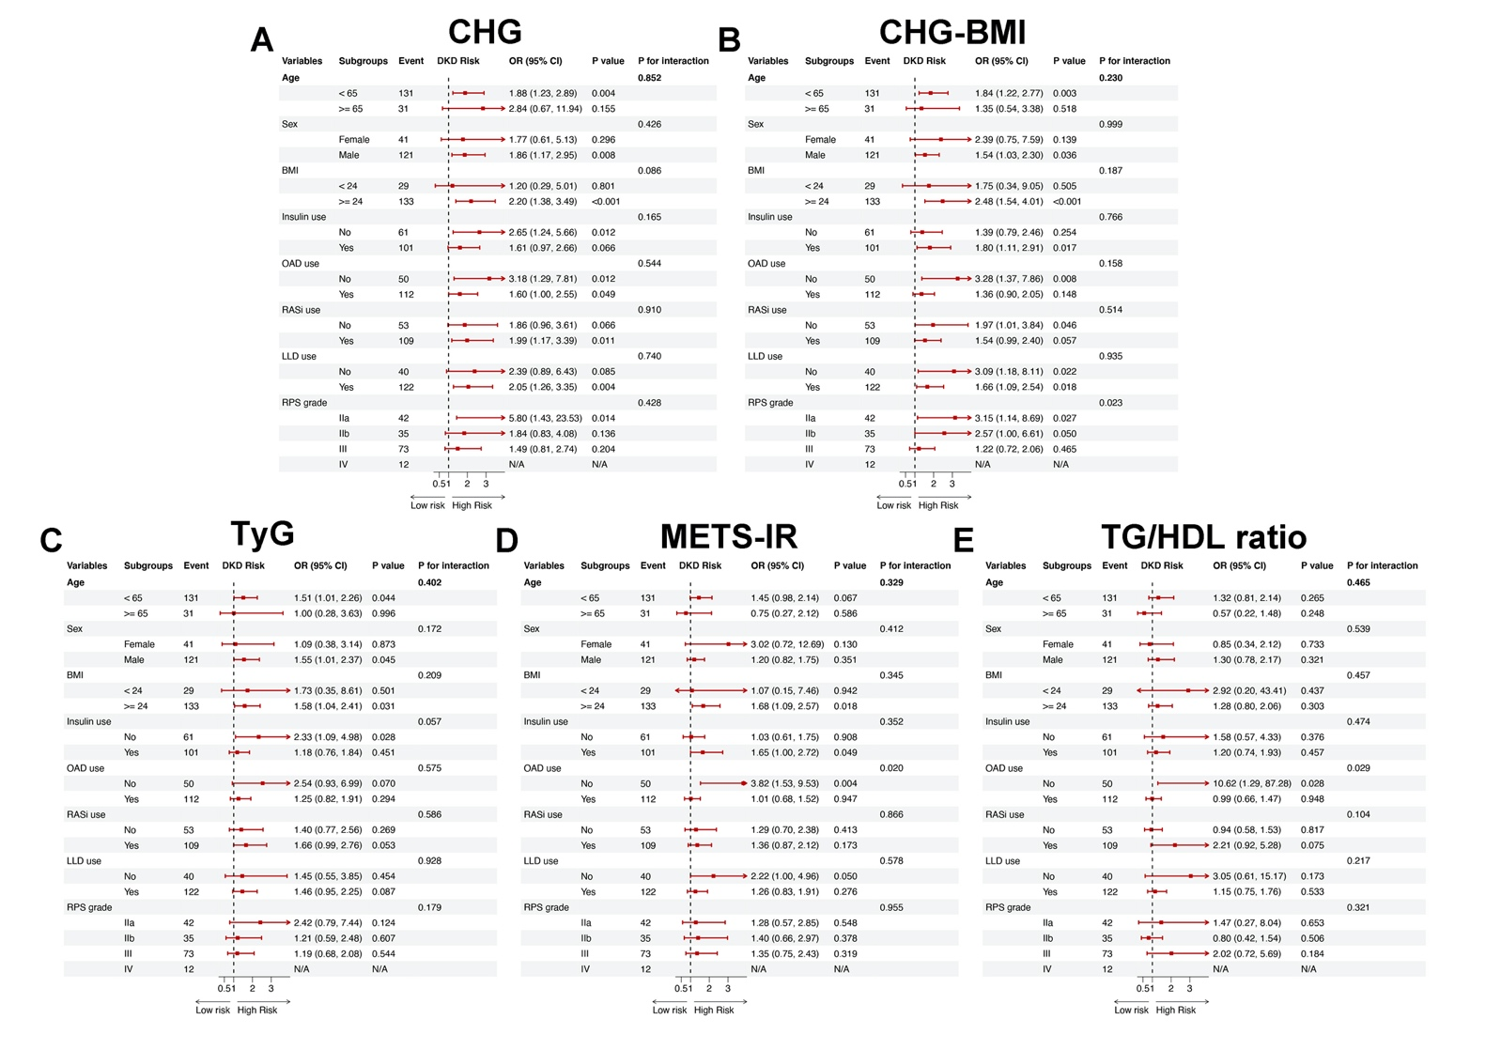
Figure S18. Subgroup analyses for eGFR decline risk in NHANES in the biopsy-proven DKD independent clinical cohort. Forest plots show the multivariable-adjusted odds ratios (ORs) and 95% confidence intervals (CIs) for DKD associated with per 1-SD increment of each index across various prespecified subgroups: (A) CHG, (B) CHG-BMI, (C) TyG, (D) METS-IR, and (E) TG/HDL ratio. The associations were evaluated using multivariable logistic regression models. The covariates adjusted in models were consistent with fully adjusted Model 3 in Logistic regression analysis (except for the stratification variable itself in each subgroup). The P for interaction was calculated using the Likelihood Ratio Test to assess the modifying effects of the stratifying variables.

Table S1. Distribution of missing values for covariates included in the CHARLS, NHANES, and biopsy-proven DKD cohorts.
Variables | Missing_Count | Missing_Rate (%)
CHARLS cohort (n=986)
Dyslipidemia | 14 | 1.42
Low-density lipoprotein cholesterol, LDL-C | 12 | 1.22
Diabetes mellitus | 6 | 0.61
Diastolic blood pressure, DBP | 5 | 0.51
Liver disease | 5 | 0.51
Heart disease | 5 | 0.51
Estimated glomerular filtration rate, eGFR | 3 | 0.3
Hypertension | 3 | 0.3
Emotional or psychiatric problems | 3 | 0.3
Systolic blood pressure, SBP | 2 | 0.2
Stroke | 2 | 0.2
Memory-related disease | 2 | 0.2
Asthma | 1 | 0.1
Chronic lung disease | 1 | 0.1
NHANES (n=2,178)
Education | 395 | 18.14
PIR | 229 | 10.51
HbA1c | 6 | 0.28
Marital | 3 | 0.14
Biopsy-proven DKD cohort from China-Japan Friendship Hospital (n=217)
Neutrophil | 4 | 1.84
Platelet | 4 | 1.84
Monocyte | 4 | 1.84
Lymphocyte | 4 | 1.84
RBC | 4 | 1.84
Hb | 4 | 1.84
Data are presented as the number and percentage of missing values for each variable. Variables with complete data are excluded. Missing covariates were handled via multiple imputation by chained equations (MICE) using five pooled datasets for the final regression analyses.
Abbreviations: CHARLS, China Health and Retirement Longitudinal Study; NHANES, National Health and Nutrition Examination Survey; DKD, diabetic kidney disease; LDL-C, low-density lipoprotein cholesterol; DBP, diastolic blood pressure; SBP, systolic blood pressure; eGFR, estimated glomerular filtration rate; PIR, ratio of family income to poverty; HbA1c, glycated hemoglobin A1c; RBC, red blood cell; Hb, hemoglobin.
Table S2. Associations of CHG-derived indices with the risk of incident DKD in the CHARLS 2011-2020 cohort using inverse probability of treatment weighting (IPTW).
Index | Total N (Weighted) | IPTW HR (95% CI) | P value
CHG index | 963 | 2.04 (1.29, 3.20) | 0.002
CHG-BMI | 963 | 1.30 (0.82, 2.05) | 0.265
CHG-WC | 963 | 1.31 (0.82, 2.08) | 0.255
Each index was dichotomized into high-risk (Q4) versus low/moderate-risk (Q1–Q3) groups. Propensity scores were estimated via multivariable logistic regression using age, sex, baseline eGFR, marital status, education, hukou, smoking, drinking, and 10 comorbidities. HbA1c and dyslipidemia were deliberately excluded to prevent over-adjusting potential causal mediators. Stabilized IPTW was applied to Cox models to balance covariates, and HRs, 95% CIs, and P values were calculated using robust variance estimators.
Abbreviations: DKD, diabetic kidney disease; IPTW, inverse probability of treatment weighting; HR, hazard ratio; CI, confidence interval; CHG, comprehensive health glucose-lipid index; BMI, body mass index; WC, waist circumference; eGFR, estimated glomerular filtration rate.

Table S3. E-value analysis assessing the robustness of the associations between CHG-derived indices and DKD against unmeasured confounding across the three independent cohorts.
Cohort | Model | Index | Comparison | Effect Size | Effect Size (95% CI) | E-value (Point Estimate) | E-value (Lower CI)
CHARLS (Primary) | Model 2 | CHG index | Continuous | HR | 1.72 (1.21, 2.45) | 2.27 | 1.54
CHARLS (Primary) | Model 2 | CHG-BMI | Q4 vs Q1 | HR | 2.36 (1.20, 4.62) | 3.01 | 1.53
CHARLS (Primary) | Model 2 | CHG-WC | Q4 vs Q1 | HR | 1.70 (0.91, 3.16) | 2.24 | 1.00
NHANES (External) | Model 2 | CHG index | Continuous | OR | 1.81 (1.31, 2.48) | 2.03 | 1.55
NHANES (External) | Model 2 | CHG-BMI | Q4 vs Q1 | OR | 1.39 (0.90, 2.14) | 1.64 | 1.00
NHANES (External) | Model 2 | CHG-WC | Q4 vs Q1 | OR | 1.59 (1.06, 2.38) | 1.83 | 1.20
Biopsy DKD (Clinical) | Model 3 | CHG index | Continuous | OR | 3.34 (1.54, 7.23) | 3.06 | 1.79
Biopsy DKD (Clinical) | Model 3 | CHG index | Q4 vs Q1 | OR | 3.78 (1.34, 10.64) | 3.30 | 1.58
Biopsy DKD (Clinical) | Model 3 | CHG-BMI | Continuous | OR | 1.03 (1.01, 1.05) | 1.14 | 1.08
Biopsy DKD (Clinical) | Model 3 | CHG-BMI | Q3 vs Q1 | OR | 7.20 (2.58, 20.10) | 4.81 | 2.59
Biopsy DKD (Clinical) | Model 3 | CHG-BMI | Q4 vs Q1 | OR | 3.66 (1.43, 9.35) | 3.23 | 1.68
The E-value for the point estimate quantifies the minimum strength of association on the risk ratio scale that an unmeasured confounder would need to have with both the exposure (CHG-derived indices) and the outcome (DKD) to fully explain away the observed effect, conditional on the measured covariates. The E-value for the lower limit of the 95% CI indicates the magnitude of unmeasured confounding required to shift the confidence interval to include the null value (making the result statistically non-significant). An E-value of 1.00 for the lower CI implies that the original 95% CI already approaches or includes the null. E-values were calculated based on the highest rigorously adjusted and statistically significant models for each cohort: Model 2 for the CHARLS and NHANES cohorts, and Model 3 for the biopsy-proven DKD cohort.
Abbreviations: BMI, body mass index; CHARLS, China Health and Retirement Longitudinal Study; CHG, cholesterol, high-density lipoprotein, and glucose index; CI, confidence interval; DKD, diabetic kidney disease; HR, hazard ratio; NHANES, National Health and Nutrition Examination Survey; OR, odds ratio; Q, quartile; WC, waist circumference.

Table S4. Standard ROC analysis of the CHG-related indices and other insulin resistance markers for predicting incident DKD in the CHARLS 2011-2020 cohort.
Outcome | Marker | Model | AUC | 95% CI | Corrected AUC (Bootstrap) | Best Cut-off | Sensitivity | Specificity | P value
Incident DKD | CHG | Unadjusted | 0.567 | 0.505-0.628 | 0.565 | 6.090 | 0.439 | 0.727 | 0.035
Incident DKD | CHG-WC | Unadjusted | 0.585 | 0.524-0.646 | 0.582 | 516.485 | 0.673 | 0.505 | 0.007
Incident DKD | CHG-BMI | Unadjusted | 0.594 | 0.537-0.651 | 0.407 | 142.603 | 0.704 | 0.496 | 0.001
Incident DKD | TyG | Unadjusted | 0.569 | 0.508-0.630 | 0.569 | 9.328 | 0.612 | 0.545 | 0.027
Incident DKD | METS-IR | Unadjusted | 0.592 | 0.535-0.648 | 0.410 | 40.404 | 0.684 | 0.519 | 0.002
Incident DKD | TG/HDL ratio | Unadjusted | 0.573 | 0.516-0.630 | 0.557 | 5.036 | 0.449 | 0.701 | 0.012
Incident DKD | CHG | Fully Adjusted | 0.746 | 0.697-0.796 | 0.690 | Prob: 0.088 | 0.735 | 0.653 | < 0.001
Incident DKD | CHG-WC | Fully Adjusted | 0.745 | 0.694-0.795 | 0.686 | Prob: 0.128 | 0.582 | 0.789 | < 0.001
Incident DKD | CHG-BMI | Fully Adjusted | 0.745 | 0.695-0.795 | 0.687 | Prob: 0.085 | 0.735 | 0.634 | < 0.001
Incident DKD | TyG | Fully Adjusted | 0.749 | 0.700-0.799 | 0.693 | Prob: 0.104 | 0.673 | 0.720 | < 0.001
Incident DKD | METS-IR | Fully Adjusted | 0.745 | 0.695-0.795 | 0.691 | Prob: 0.085 | 0.735 | 0.634 | < 0.001
Incident DKD | TG/HDL ratio | Fully Adjusted | 0.745 | 0.695-0.795 | 0.687 | Prob: 0.085 | 0.745 | 0.638 | < 0.001
Data are presented as AUC with 95% CI. For the unadjusted models, the best cut-off values were determined by maximizing the Youden index, with corresponding sensitivity and specificity reported. For the fully adjusted models, the optimal cut-off is expressed as the predicted probability (Prob) threshold. Corrected AUC was calculated using internal validation with 200 bootstrap resamples to account for potential overfitting. Fully adjusted standard models controlled for the covariates same as fully adjusted Model 3 in Cox proportional hazards models.
Abbreviations: DKD: diabetic kidney disease; ROC: receiver operating characteristic; AUC: area under the curve; CI: confidence interval; CHG: cholesterol, high-density lipoprotein, and glucose index; TyG: triglyceride-glucose index; METS-IR: metabolic score for insulin resistance; TG/HDL: triglyceride to high-density lipoprotein ratio; WC: waist circumference; BMI: body mass index.

Table S5. Time-dependent ROC analysis of the CHG-related indices and other insulin resistance markers for predicting incident DKD in the CHARLS 2011-2020 cohort.
Outcome | Time Point  (years) | Marker | AUC | 95% CI | 10-Fold CV AUC | Best Cut-off | Sensitivity | Specificity | P value
Incident DKD | 5 | CHG | 0.582 | 0.504-0.660 | 0.577 | 5.521 | 0.438 | 0.722 | 0.039
Incident DKD | 8 | CHG | 0.559 | 0.493-0.625 | 0.549 | 5.535 | 0.437 | 0.722 | 0.081
Incident DKD | 5 | CHG-WC | 0.617 | 0.535-0.699 | 0.614 | 522.66 | 0.729 | 0.501 | 0.005
Incident DKD | 8 | CHG-WC | 0.583 | 0.517-0.649 | 0.578 | 523.075 | 0.678 | 0.502 | 0.013
Incident DKD | 5 | CHG-BMI | 0.600 | 0.522-0.677 | 0.455 | 145.891 | 0.729 | 0.485 | 0.012
Incident DKD | 8 | CHG-BMI | 0.593 | 0.533-0.654 | 0.465 | 146.503 | 0.724 | 0.482 | 0.003
Incident DKD | 5 | TyG | 0.577 | 0.497-0.658 | 0.570 | 9.185 | 0.625 | 0.535 | 0.06
Incident DKD | 8 | TyG | 0.568 | 0.504-0.632 | 0.554 | 9.185 | 0.609 | 0.541 | 0.038
Incident DKD | 5 | METS-IR | 0.609 | 0.532-0.685 | 0.451 | 43.259 | 0.833 | 0.402 | 0.005
Incident DKD | 8 | METS-IR | 0.594 | 0.536-0.653 | 0.472 | 40.576 | 0.701 | 0.516 | 0.002
Incident DKD | 5 | TG/HDL ratio | 0.577 | 0.499-0.655 | 0.489 | 5.324 | 0.854 | 0.308 | 0.053
Incident DKD | 8 | TG/HDL ratio | 0.578 | 0.520-0.636 | 0.458 | 2.192 | 0.448 | 0.697 | 0.008
Data are presented as the AUC with 95% CI. The best cut-off values were determined by maximizing the Youden index, with corresponding sensitivity and specificity reported. To internally validate the predictive performance and mitigate potential overfitting, a 10-fold cross-validation approach was employed, and the cross-validated AUC is provided.
DKD: diabetic kidney disease; ROC: receiver operating characteristic; AUC: area under the curve; CI: confidence interval; CV: cross-validation; CHG: cholesterol, high-density lipoprotein, and glucose index; WC: waist circumference; BMI: body mass index; TyG: triglyceride-glucose index; METS-IR: metabolic score for insulin resistance; TG/HDL: triglyceride to high-density lipoprotein ratio.

Table S6. Incremental predictive value analysis of CHG-related indices and other insulin resistance for incident DKD in CHARLS 2011-2020 cohort.
Model | C-index (95%CI) | P for DeLong test | Continuous NRI (95%CI) | P value (NRI) | IDI (95%CI) | P value (IDI)
Basic model | 0.631(0.572-0.689) |  | Ref |  | Ref
Basic model + CHG | 0.645(0.590-0.700) | 0.301 | 0.105(-0.099-0.213) | 0.179 | 0.003(-0.005-0.015) | 0.458
Basic model + CHG_BMI | 0.631(0.573-0.689) | 0.645 | 0.123(-0.119-0.181) | 0.408 | 0.000(0.000-0.001) | 0.030
Basic model + CHG_WC | 0.638(0.579-0.696) | 0.487 | 0.033(-0.151-0.239) | 0.637 | 0.001(-0.003-0.006) | 0.488
Basic model + TyG | 0.647(0.593-0.702) | 0.260 | 0.112(-0.125-0.248) | 0.289 | 0.004(-0.005-0.015) | 0.438
Basic model + TG_HDL_ratio | 0.630(0.571-0.688) | 0.557 | -0.077(-0.221-0.130) | 0.507 | 0.000(-0.001-0.000) | 0.886
Basic model + METS_IR | 0.631(0.573-0.689) | 0.737 | 0.137(-0.105-0.180) | 0.408 | 0.001(0.000-0.001) | 0.030
Basic model adjustment included: age, gender, HTN and smoke.

Table S7. Selection of the optimal number of knots for restricted cubic spline models based on the Akaike information criterion in CHARLS 2011-2020 cohort.
Index | Knots_3_AIC | Knots_4_AIC | Knots_5_AIC | Optimal_Knots
CHG | 1275.07971 | 1277.04742 | 1277.50756 | 3
CHG-WC | 1234.68061 | 1236.70254 | 1236.04845 | 3
CHG-BMI | 1242.88399 | 1244.89776 | 1246.84941 | 3
TyG | 1273.8224 | 1275.8435 | 1275.31697 | 3
METS-IR | 1242.90004 | 1244.66484 | 1246.57886 | 3
TG/HDL ratio | 1258.52279 | 1259.74182 | 1256.45333 | 5
AIC: Akaike information criterion. The lowest AIC indicates the optimal model fit.
The covariates adjusted in RCS models were consistent with fully adjusted Model 3 in Cox proportional hazards regression models.
Table S8. Sensitivity analysis using Cox proportional hazards regression models to evaluate the associations of CHG-derived indices and other insulin resistance markers with the risk of incident DKD (defined as a ≥ 20% decline in eGFR) in the CHARLS 2011–2015 cohort.
Indices | ªCrude model |  | ^{b}Model 1 |  | ^{c}Model 2 |  | ^{d}Model 3
Indices | HR (95% CI) | P value | HR (95% CI) | P value | HR (95% CI) | P value | HR (95% CI) | P value
CHG index | 1.73 (0.93, 3.22) | 0.082 | 1.98 (1.12, 3.52) | 0.019 | 1.45 (0.79, 2.68) | 0.233 | 0.89 (0.36, 2.20) | 0.798
Q1 | 1.00 (Reference) |  | 1.00 (Reference) |  | 1.00 (Reference) |  | 1.00 (Reference)
Q2 | 0.78 (0.26, 2.32) | 0.654 | 0.74 (0.24, 2.25) | 0.59 | 0.75 (0.23, 2.43) | 0.626 | 0.63 (0.19, 2.09) | 0.446
Q3 | 0.54 (0.16, 1.86) | 0.33 | 0.53 (0.15, 1.86) | 0.324 | 0.45 (0.12, 1.73) | 0.246 | 0.30 (0.08, 1.22) | 0.093
Q4 | 1.24 (0.46, 3.34) | 0.667 | 1.51 (0.55, 4.14) | 0.419 | 0.96 (0.34, 2.74) | 0.943 | 0.40 (0.10, 1.59) | 0.193
P for trend |  | 0.748 |  | 0.492 |  | 0.893 |  | 0.133
CHG-BMI | 1.00 (1.00, 1.00) | <0.001 | 1.01 (1.01, 1.01) | <0.001 | 1.01 (1.01, 1.01) | <0.001 | 1.00 (1.00, 1.00) | <0.001
Q1 | 1.00 (Reference) |  | 1.00 (Reference) |  | 1.00 (Reference) |  | 1.00 (Reference)
Q2 | 0.22 (0.02, 1.94) | 0.172 | 0.23 (0.03, 2.13) | 0.196 | 0.17 (0.02, 1.61) | 0.122 | 0.16 (0.02, 1.52) | 0.110
Q3 | 2.18 (0.69, 6.86) | 0.184 | 2.22 (0.68, 7.21) | 0.186 | 1.90 (0.50, 7.30) | 0.347 | 1.56 (0.39, 6.19) | 0.529
Q4 | 2.15 (0.68, 6.87) | 0.195 | 2.84 (0.85, 9.47) | 0.090 | 2.14 (0.53, 8.57) | 0.284 | 1.38 (0.28, 6.72) | 0.694
P for trend |  | 0.030 |  | 0.012 |  | 0.069 |  | 0.330
CHG-WC | 1.00 (1.00, 1.01) | 0.168 | 1.00 (1.00, 1.01) | 0.105 | 1,00 (1.00, 1.01) | 0.486 | 1 (0.99, 1.00) | 0.61
Q1 | 1.00 (Reference) |  | 1.00 (Reference) |  | 1.00 (Reference) |  | 1.00 (Reference)
Q2 | 0.51 (0.12, 2.14) | 0.36 | 0.56 (0.13, 2.39) | 0.429 | 0.33 (0.07, 1.55) | 0.158 | 0.32 (0.07, 1.50) | 0.148
Q3 | 1.15 (0.37, 3.63) | 0.809 | 1.06 (0.33, 3.44) | 0.926 | 0.59 (0.16, 2.24) | 0.438 | 0.53 (0.14, 2.02) | 0.355
Q4 | 2.00 (0.70, 5.76) | 0.198 | 2.47 (0.83, 7.35) | 0.105 | 1.27 (0.37, 4.31) | 0.701 | 0.83 (0.20, 3.46) | 0.793
P for trend |  | 0.076 |  | 0.043 |  | 0.275 |  | 0.937
TyG | 1.41 (0.92, 2.14) | 0.113 | 1.68 (1.11, 2.52) | 0.013 | 1.36 (0.88, 2.11) | 0.167 | 1.08 (0.62, 1.88) | 0.782
Q1 | 1.00 (Reference) |  | 1.00 (Reference) |  | 1.00 (Reference) |  | 1.00 (Reference)
Q2 | 0.85 (0.26, 2.79) | 0.792 | 1.11 (0.32, 3.85) | 0.869 | 1.17 (0.31, 4.36) | 0.818 | 0.98 (0.26, 3.68) | 0.975
Q3 | 1.31 (0.44, 3.90) | 0.628 | 1.27 (0.41, 3.89) | 0.676 | 1.16 (0.816) | 0.816 | 0.95 (0.28, 3.22) | 0.931
Q4 | 1.41 (0.49, 4.05) | 0.529 | 2.51 (0.83, 7.58) | 0.102 | 1.76 (0.55, 5.68) | 0.342 | 0.98 (0.24, 3.98) | 0.982
P for trend |  | 0.404 |  | 0.113 |  | 0.36 |  | 0.966
TG/HDL ratio | 1.02 (0.99, 1.05) | 0.248 | 1.03 (1.00, 1.06) | 0.045 | 1.02 (0.99, 1.05) | 0.328 | 1.01 (0.98, 1.04) | 0.64
Q1 | 1.00 (Reference) |  | 1.00 (Reference) |  | 1.00 (Reference) |  | 1.00 (Reference)
Q2 | 5.47 (1.20, 25.00) | 0.028 | 7.41 (1.54, 35.62) | 0.012 | 6.95 (1.33, 36.36) | 0.022 | 6.23 (1.19, 32.62) | 0.03
Q3 | 1.67 (0.28, 10.00) | 0.574 | 1.95 (0.32, 11.88) | 0.012 | 1.80 (0.27, 12.12) | 0.546 | 1.51 (0.23, 10.13) | 0.671
Q4 | 5.48 (1.22, 24.74) | 0.027 | 8.22 (1.77, 38.15) | 0.012 | 5.92 (1.16, 30.28) | 0.033 | 4.32 (0.80, 23.30) | 0.089
P for trend |  | 0.089 |  | 0.012 |  | 0.175 |  | 0.466
METS-IR | 1.01 (1.00, 1.01) | <0.001 | 1.04 (1.04, 1.05) | <0.001 | 1.03 (1.02, 1.03) | <0.001 | 1.02 (1.01, 1.02) | <0.001
Q1 | 1.00 (Reference) |  | 1.00 (Reference) |  | 1.00 (Reference) |  | 1.00 (Reference)
Q2 | 0.23 (0.03, 2.06) | 0.189 | 0.26 (0.03, 2.38) | 0.233 | 0.22 (0.02, 2.28) | 0.206 | 0.19 (0.02, 1.91) | 0.157
Q3 | 2.11 (0.66, 6.74) | 0.208 | 2.77 (0.85, 8.99) | 0.09 | 2.11 (0.55, 8.17) | 0.278 | 1.57 (0.40, 6.23) | 0.522
Q4 | 2.36 (0.75, 7.43) | 0.141 | 3.13 (0.95, 10.24) | 0.06 | 2.14 (0.54, 8.54) | 0.281 | 1.31 (0.29, 5.97) | 0.723
P for trend |  | 0.022 |  | 0.007 |  | 0.08 |  | 0.328
In this sensitivity analysis, incident DKD was defined as a ≥ 20% decline in eGFR from baseline to exclude transient fluctuations and focus on strictly preserved renal function (eGFR ≥ 70 mL/min/1.73 m²).
ªCrude Model: unadjusted.
^{b}Model 1: adjusted for baseline eGFR, age, sex, marital status, education level, Hukou, drinking, and smoking.
^{c}Model 2: adjusted for Model 1 plus hypertension, dyslipidemia, chronic lung disease, liver disease, heart disease, stroke, stomach/digestive disease, emotional/psychiatric problems, memory-related disease, arthritis, and asthma.
^{d}Model 3: adjusted for Model 2 plus baseline HbA1c.
HR: hazard ratio; CI: confidence interval; Q: quartile.

Table S9. Sensitivity analysis using ROC curves to evaluate the predictive performance of CHG-derived indices and other insulin resistance markers for incident DKD (defined as a ≥ 20% decline in eGFR) in the CHARLS 2011–2015 cohort.
Outcome | Marker | Model | AUC | 95% CI | Corrected AUC (Bootstrap) | Best Cut-off | Sensitivity | Specificity | P value
Incident DKD | CHG | Unadjusted | 0.538 | 0.420-0.653 | 0.532 | 6.338 | 0.346 | 0.814 | 0.555
Incident DKD | CHG-WC | Unadjusted | 0.619 | 0.506-0.737 | 0.620 | 635.915 | 0.346 | 0.908 | 0.063
Incident DKD | CHG-BMI | Unadjusted | 0.634 | 0.532-0.735 | 0.636 | 144.476 | 0.808 | 0.509 | 0.014
Incident DKD | TyG | Unadjusted | 0.557 | 0.438-0.675 | 0.549 | 10.218 | 0.308 | 0.859 | 0.332
Incident DKD | METS-IR | Unadjusted | 0.639 | 0.537-0.740 | 0.638 | 40.404 | 0.808 | 0.508 | 0.009
Incident DKD | TG/HDL ratio | Unadjusted | 0.578 | 0.472-0.677 | 0.594 | 2.021 | 0.923 | 0.301 | 0.150
Incident DKD | CHG | Fully Adjusted | 0.922 | 0.886-0.955 | 0.851 | 0.016 | 1.000 | 0.713 | <0.001
Incident DKD | CHG-WC | Fully Adjusted | 0.922 | 0.882-0.953 | 0.846 | 0.017 | 0.962 | 0.729 | <0.001
Incident DKD | CHG-BMI | Fully Adjusted | 0.935 | 0.896-0.961 | 0.871 | 0.047 | 0.885 | 0.869 | <0.001
Incident DKD | TyG | Fully Adjusted | 0.923 | 0.882-0.955 | 0.857 | 0.020 | 0.962 | 0.759 | <0.001
Incident DKD | METS-IR | Fully Adjusted | 0.936 | 0.905-0.963 | 0.871 | 0.032 | 0.923 | 0.83 | <0.001
Incident DKD | TG/HDL ratio | Fully Adjusted | 0.923 | 0.882-0.954 | 0.852 | 0.019 | 0.962 | 0.753 | <0.001
Data are presented as AUC with 95% CI. For the unadjusted models, the best cut-off values were determined by maximizing the Youden index, with corresponding sensitivity and specificity reported. For the fully adjusted models, the optimal cut-off is expressed as the predicted probability (Prob) threshold. Corrected AUC was calculated using internal validation with 500 bootstrap resamples to account for potential overfitting. Fully adjusted standard models controlled for the covariates same as fully adjusted Model 3 in Cox proportional hazards models. Incident DKD in this sensitivity analysis was strictly defined as a ≥ 20% decline in eGFR.
Abbreviations: DKD: diabetic kidney disease; ROC: receiver operating characteristic; AUC: area under the curve; CI: confidence interval; CHG: cholesterol, high-density lipoprotein, and glucose index; TyG: triglyceride-glucose index; METS-IR: metabolic score for insulin resistance; TG/HDL: triglyceride to high-density lipoprotein ratio; WC: waist circumference; BMI: body mass index.

Table S10. Sensitivity analysis using Cox proportional hazards regression models to evaluate the associations of CHG-derived indices and other insulin resistance markers with the risk of incident DKD (excluding participants with borderline baseline eGFR < 70 mL/min/1.73 m²) in the CHARLS 2011–2015 cohort.
Indices | Crude model |  | Model 1 |  | Model 2 |  | Model 3
Indices | HR (95% CI) | P value | HR (95% CI) | P value | HR (95% CI) | P value | HR (95% CI) | P value
CHG | 1.70 (0.86, 3.37) | 0.128 | 1.76 (0.90, 3.44) | 0.096 | 1.02 (0.49, 2.14) | 0.953 | 1.24 (0.47, 3.27) | 0.661
Q1 | 1.00 (Reference) |  | 1.00 (Reference) |  | 1.00 (Reference) |  | 1.00 (Reference)
Q2 | 0.60 (0.17, 2.12) | 0.424 | 0.55 (0.15, 2.06) | 0.375 | 0.60 (0.16, 2.31) | 0.459 | 0.60 (0.16, 2.33) | 0.465
Q3 | 0.61 (0.17, 2.15) | 0.437 | 0.51 (0.14, 1.87) | 0.31 | 0.41 (0.10, 1.64) | 0.205 | 0.42 (0.10, 1.73) | 0.228
Q4 | 1.18 (0.40, 3.50) | 0.77 | 1.25 (0.39, 4.06) | 0.709 | 0.60 (0.17, 2.09) | 0.422 | 0.64 (0.14, 2.87) | 0.561
P for trend |  | 0.75 |  | 0.735 |  | 0.386 |  | 0.442
CHG-BMI | 1.00 (1.00, 1.00) | <0.001 | 1.01 (1.01, 1.01) | <0.001 | 1.00 (1.00, 1.00) | <0.001 | 1.00 (1.00, 1.00) | <0.001
T1 | 1.00 (Reference) |  | 1.00 (Reference) |  | 1.00 (Reference) |  | 1.00 (Reference)
T2 | 0.30 (0.03, 2.91) | 0.3 | 0.35 (0.04, 3.48) | 0.372 | 0.23 (0.02, 2.82) | 0.249 | 0.26 (0.02, 3.38) | 0.304
T3 | 2.29 (0.60, 8.64) | 0.223 | 3.21 (0.80, 12.89) | 0.1 | 2.25 (0.45, 11.25) | 0.323 | 3.0 (0.53, 16.90) | 0.213
P for trend | 2.89 (0.78, 10.66) | 0.112 | 3.77 (0.97, 14.71) | 0.056 | 1.68 (0.32, 8.75) | 0.541 | 3.02 (0.43, 21.45) | 0.269
CHG-WC |  | 0.02 |  | 0.009 |  | 0.223 |  | 0.083
Q1 | 1.00 (Reference) |  | 1.00 (Reference) |  | 1.00 (Reference) |  | 1.00 (Reference)
Q2 | 0.45 (0.08, 2.44) | 0.351 | 0.64 (0.12, 3.59) | 0.616 | 0.32 (0.05, 1.97) | 0.22 | 0.29 (0.05, 1.82) | 0.187
Q3 | 1.26 (0.35, 4.48) | 0.72 | 1.62 (0.42, 6.25) | 0.483 | 0.70 (0.16, 3.02) | 0.63 | 0.73 (0.16, 3.28) | 0.686
Q4 | 2.30 (0.71, 7.47) | 0.166 | 2.99 (0.88, 10.09) | 0.078 | 1.11 (0.28, 4.42) | 0.884 | 1.97 (0.43, 9.01) | 0.384
P for trend |  | 0.061 |  | 0.036 |  | 0.498 |  | 0.286
TyG | 1.43 (0.90, 2.26) | 0.129 | 1.60 (1.01, 2.51) | 0.043 | 1.12 (0.67, 1.88) | 0.668 | 1.29 (0.69, 2.39) | 0.422
Q1 | 1.00 (Reference) |  | 1.00 (Reference) |  | 1.00 (Reference) |  | 1.00 (Reference)
Q2 | 0.91 (0.23, 3.65) | 0.895 | 1.11 (0.26, 4.69) | 0.891 | 1.10 (0.24, 4.97) | 0.899 | 1.12 (0.25, 5.08) | 0.884
Q3 | 2.06 (0.62, 6.84) | 0.238 | 1.75 (0.50, 6.14) | 0.382 | 1.48 (0.39, 5.63) | 0.563 | 1.51 (0.40, 5.77) | 0.546
Q4 | 1.32 (0.35, 4.90) | 0.682 | 2.17 (0.54, 8.72) | 0.274 | 1.05 (0.26, 4.35) | 0.942 | 1.25 (0.23, 6.77) | 0.793
P for trend |  | 0.407 |  | 0.196 |  | 0.843 |  | 0.645
TG/HDL ratio | 1.02 (0.99, 1.05) | 0.204 | 1.03 (1.00, 1.06) | 0.051 | 1.02 (0.98, 1.05) | 0.363 | 1.02 (0.98, 1.05) | 0.286
Q1 | 1.00 (Reference) |  | 1.00 (Reference) |  | 1.00 (Reference) |  | 1.00 (Reference)
Q2 | 2.99 (0.60, 14.82) | 0.18 | 3.51 (0.69, 18.00) | 0.132 | 2.36 (0.43, 12.95) | 0.322 | 2.37 (0.43, 13.00) | 0.32
Q3 | 3.35 (0.68, 16.62) | 0.138 | 2.94 (0.57, 15.08) | 0.195 | 2.01 (0.37, 10.88) | 0.418 | 2.04 (0.38, 11.08) | 0.409
Q4 | 3.60 (0.75, 17.32) | 0.11 | 5.02 (1.00, 25.23) | 0.05 | 1.65 (0.29, 9.30) | 0.57 | 1.84 (0.30, 11.26) | 0.51
P for trend |  | 0.126 |  | 0.07 |  | 0.781 |  | 0.647
METS-IR | 1.01 (1.00, 1.01) | <0.001 | 1.04 (1.04, 1.05) | <0.001 | 1.02 (1.01, 1.02) | <0.001 | 1.02 (1.02, 1.03) | <0.001
T1 | 1.00 (Reference) |  | 1.00 (Reference) |  | 1.00 (Reference) |  | 1.00 (Reference)
T2 | 1.45 (0.41, 5.13) | 0.567 | 2.02 (0.55, 7.44) | 0.292 | 1.49 (0.36, 6.22) | 0.587 | 1.60 (0.37, 6.95) | 0.528
T3 | 2.49 (0.79, 7.84) | 0.118 | 3.11 (0.94, 10.31) | 0.064 | 1.36 (0.32, 5.72) | 0.676 | 1.74 (0.34, 9.02) | 0.51
P for trend |  | 0.099 |  | 0.058 |  | 0.746 |  | 0.535
In this sensitivity analysis, participants with borderline eGFR (60–69 mL/min/1.73 m²) were excluded to focus exclusively on strictly preserved renal function (eGFR ≥ 70 mL/min/1.73 m²). Due to extremely low DKD incidence causing zero-event non-convergence in quartiles, CHG-BMI was adaptively categorized into tertiles (T1–T3) to ensure statistical validity.
ªCrude Model: unadjusted.
^{b}Model 1: adjusted for baseline eGFR, age, sex, marital status, education level, Hukou, drinking, and smoking.
^{c}Model 2: adjusted for Model 1 plus hypertension, dyslipidemia, chronic lung disease, liver disease, heart disease, stroke, stomach/digestive disease, emotional/psychiatric problems, memory-related disease, arthritis, and asthma.
^{d}Model 3: adjusted for Model 2 plus baseline HbA1c.
HR: hazard ratio; CI: confidence interval; Q: quartile; T: tertile.

Table S11. Sensitivity analysis using ROC curves to evaluate the predictive performance of CHG-derived indices and other insulin resistance markers for incident DKD (excluding participants with borderline baseline eGFR < 70 mL/min/1.73 m²) in the CHARLS 2011–2015 cohort.
Outcome | Marker | Model | AUC | 95% CI | Corrected AUC (Bootstrap) | Best Cut-off | Sensitivity | Specificity | P value
Incident DKD | CHG | Unadjusted | 0.534 | 0.410-0.661 | 0.515 | 6.183 | 0.381 | 0.743 | 0.628
Incident DKD | CHG-WC | Unadjusted | 0.618 | 0.480-0.766 | 0.612 | 635.915 | 0.333 | 0.908 | 0.108
Incident DKD | CHG-BMI | Unadjusted | 0.649 | 0.537-0.761 | 0.651 | 145.255 | 0.810 | 0.517 | 0.017
Incident DKD | TyG | Unadjusted | 0.563 | 0.454-0.673 | 0.557 | 9.328 | 0.619 | 0.524 | 0.313
Incident DKD | METS-IR | Unadjusted | 0.652 | 0.533-0.768 | 0.654 | 40.596 | 0.810 | 0.512 | 0.014
Incident DKD | TG/HDL ratio | Unadjusted | 0.593 | 0.491-0.712 | 0.595 | 5.566 | 0.476 | 0.731 | 0.120
Incident DKD | CHG | Fully Adjusted | 0.944 | 0.914-0.968 | 0.860 | 0.053 | 0.905 | 0.895 | <0.001
Incident DKD | CHG-WC | Fully Adjusted | 0.944 | 0.913-0.972 | 0.859 | 0.019 | 1.000 | 0.797 | <0.001
Incident DKD | CHG-BMI | Fully Adjusted | 0.952 | 0.927-0.974 | 0.876 | 0.061 | 0.905 | 0.912 | <0.001
Incident DKD | TyG | Fully Adjusted | 0.942 | 0.908-0.969 | 0.863 | 0.051 | 0.905 | 0.886 | <0.001
Incident DKD | METS-IR | Fully Adjusted | 0.952 | 0.919-0.975 | 0.878 | 0.060 | 0.905 | 0.912 | <0.001
Incident DKD | TG/HDL ratio | Fully Adjusted | 0.944 | 0.912-0.969 | 0.864 | 0.050 | 0.905 | 0.889 | <0.001
Data are presented as AUC with 95% CI. For the unadjusted models, the best cut-off values were determined by maximizing the Youden index, with corresponding sensitivity and specificity reported. For the fully adjusted models, the optimal cut-off is expressed as the predicted probability (Prob) threshold. Corrected AUC was calculated using internal validation with 500 bootstrap resamples to account for potential overfitting. Fully adjusted standard models controlled for the covariates same as fully adjusted Model 3 in Cox proportional hazards models. In this sensitivity analysis, participants with borderline baseline renal function (eGFR 60–69 mL/min/1.73 m²) were excluded to exclusively evaluate individuals with strictly preserved renal function (eGFR ≥ 70 mL/min/1.73 m²).
Abbreviations: DKD: diabetic kidney disease; ROC: receiver operating characteristic; AUC: area under the curve; CI: confidence interval; CHG: cholesterol, high-density lipoprotein, and glucose index; TyG: triglyceride-glucose index; METS-IR: metabolic score for insulin resistance; TG/HDL: triglyceride to high-density lipoprotein ratio; WC: waist circumference; BMI: body mass index.

Table S12. Sensitivity analysis using Cox proportional hazards regression models to evaluate the associations of CHG-derived indices and other insulin resistance markers with the risk of incident DKD (excluding participants who developed DKD within the first 2 years of follow-up) in the CHARLS 2011–2020 cohort.
Indices | Crude model |  | Model 1 |  | Model 2 |  | Model 3
Indices | HR (95% CI) | P value | HR (95% CI) | P value | HR (95% CI) | P value | HR (95% CI) | P value
CHG | 1.50 (1.06, 2.12) | 0.021 | 1.73 (1.20, 2.49) | 0.003 | 1.67 (1.15, 2.43) | 0.007 | 1.14 (0.75, 1.74) | 0.549
Q1 | 1.00 (Reference) |  | 1.00 (Reference) |  | 1.00 (Reference) |  | 1.00 (Reference)
Q2 | 1.03 (0.55, 1.95) | 0.92 | 0.98 (0.51, 1.86) | 0.945 | 0.96 (0.50, 1.84) | 0.911 | 0.93 (0.49, 1.78) | 0.832
Q3 | 1.15 (0.61, 2.15) | 0.673 | 1.11 (0.59, 2.10) | 0.74 | 1.12 (0.59, 2.12) | 0.731 | 0.92 (0.48, 1.77) | 0.807
Q4 | 1.76 (0.98, 3.16) | 0.058 | 2.02 (1.12, 3.67) | 0.02 | 1.88 (1.03, 3.44) | 0.041 | 1.12 (0.57, 2.20) | 0.737
P for trend |  | 0.046 |  | 0.016 |  | 0.029 |  | 0.744
CHG-BMI | 1.00 (1.00, 1.00) | 0.883 | 1.00 (1.00, 1.00) | 0.876 | 1.00 (1.00, 1.00) | 0.883 | 1.00 (1.00, 1.00) | 0.908
Q1 | 1.00 (Reference) |  | 1.00 (Reference) |  | 1.00 (Reference) |  | 1.00 (Reference)
Q2 | 1.75 (0.81, 3.80) | 0.155 | 1.91 (0.87, 4.16) | 0.106 | 1.88 (0.85, 4.15) | 0.118 | 2.04 (0.92, 4.53) | 0.078
Q3 | 3.03 (1.49, 6.17) | 0.002 | 3.44 (1.67, 7.08) | <0.001 | 3.04 (1.45, 6.36) | 0.003 | 2.64 (1.25, 5.56) | 0.011
Q4 | 2.91 (1.42, 5.97) | 0.004 | 3.41 (1.64, 7.07) | <0.001 | 2.91 (1.36, 6.24) | 0.006 | 2.31 (1.07, 4.96) | 0.032
P for trend |  | <0.001 |  | <0.001 |  | 0.003 |  | 0.041
CHG-WC | 1.00 (1.00, 1.00) | 0.046 | 1.00 (1.00, 1.01) | 0.024 | 1.00 (1.00, 1.00) | 0.18 | 1.00 (1.00, 1.00) | 0.812
Q1 | 1.00 (Reference) |  | 1.00 (Reference) |  | 1.00 (Reference) |  | 1.00 (Reference)
Q2 | 0.98 (0.48, 2.00) | 0.948 | 1.00 (0.49, 2.04) | 0.991 | 0.99 (0.48, 2.05) | 0.974 | 1.00 (0.48, 2.07) | 0.992
Q3 | 2.04 (1.10, 3.76) | 0.023 | 2.01 (1.08, 3.76) | 0.028 | 1.72 (0.91, 3.27) | 0.097 | 1.45 (0.76, 2.78) | 0.256
Q4 | 1.93 (1.03, 3.63) | 0.041 | 2.14 (1.13, 4.04) | 0.019 | 1.74 (0.90, 3.37) | 0.101 | 1.18 (0.59, 2.35) | 0.635
P for trend |  | 0.007 |  | 0.003 |  | 0.036 |  | 0.463
TyG | 1.30 (1.03, 1.64) | 0.025 | 1.45 (1.13, 1.86) | 0.003 | 1.39 (1.08, 1.79) | 0.011 | 1.20 (0.92, 1.56) | 0.175
Q1 | 1.00 (Reference) |  | 1.00 (Reference) |  | 1.00 (Reference) |  | 1.00 (Reference)
Q2 | 0.65 (0.32, 1.29) | 0.215 | 0.60 (0.30, 1.20) | 0.149 | 0.57 (0.28, 1.16) | 0.119 | 0.55 (0.27, 1.11) | 0.093
Q3 | 1.35 (0.76, 2.38) | 0.307 | 1.31 (0.74, 2.33) | 0.359 | 1.20 (0.67, 2.16) | 0.533 | 1.07 (0.59, 1.94) | 0.816
Q4 | 1.38 (0.78, 2.42) | 0.27 | 1.58 (0.89, 2.83) | 0.12 | 1.43 (0.79, 2.58) | 0.233 | 1.04 (0.56, 1.93) | 0.899
P for trend |  | 0.081 |  | 0.026 |  | 0.066 |  | 0.455
TG/HDL ratio | 1.00 (0.98, 1.02) | 0.972 | 1.01 (0.99, 1.02) | 0.606 | 1.00 (0.98, 1.02) | 0.879 | 1.00 (0.98, 1.02) | 0.954
Q1 | 1.00 (Reference) |  | 1.00 (Reference) |  | 1.00 (Reference) |  | 1.00 (Reference)
Q2 | 1.60 (0.82, 3.13) | 0.17 | 1.60 (0.81, 3.15) | 0.173 | 1.53 (0.77, 3.02) | 0.223 | 1.54 (0.78, 3.07) | 0.215
Q3 | 1.46 (0.74, 2.89) | 0.278 | 1.38 (0.69, 2.75) | 0.364 | 1.22 (0.60, 2.47) | 0.586 | 1.24 (0.61, 2.51) | 0.557
Q4 | 2.28 (1.22, 4.27) | 0.01 | 2.59 (1.38, 4.88) | 0.003 | 2.16 (1.13, 4.13) | 0.021 | 2.15 (1.12, 4.13) | 0.021
P for trend |  | 0.013 |  | 0.005 |  | 0.035 |  | 0.036
METS-IR | 1.00 (1.00, 1.00) | 0.881 | 1.00 (1.00, 1.00) | 0.872 | 1.00 (1.00, 1.00) | 0.882 | 1.00 (1.00, 1.00) | 0.9
Q1 | 1.00 (Reference) |  | 1.00 (Reference) |  | 1.00 (Reference) |  | 1.00 (Reference)
Q2 | 1.02 (0.48, 2.18) | 0.951 | 1.10 (0.51, 2.35) | 0.811 | 1.08 (0.50, 2.33) | 0.845 | 1.07 (0.50, 2.31) | 0.862
Q3 | 2.49 (1.32, 4.71) | 0.005 | 2.61 (1.36, 4.98) | 0.004 | 2.23 (1.15, 4.36) | 0.018 | 1.95 (1.00, 3.81) | 0.051
Q4 | 2.05 (1.06, 3.98) | 0.034 | 2.39 (1.22, 4.69) | 0.011 | 2.02 (0.99, 4.10) | 0.052 | 1.69 (0.83, 3.43) | 0.145
P for trend |  | 0.004 |  | 0.011 |  | 0.013 |  | 0.065
ªCrude Model: unadjusted.
^{b}Model 1: adjusted for baseline eGFR, age, sex, marital status, education level, Hukou, drinking, and smoking.
^{c}Model 2: adjusted for Model 1 plus hypertension, dyslipidemia, chronic lung disease, liver disease, heart disease, stroke, stomach/digestive disease, emotional/psychiatric problems, memory-related disease, arthritis, and asthma.
^{d}Model 3: adjusted for Model 2 plus baseline HbA1c.
HR: hazard ratio; CI: confidence interval; Q: quartile.

Table S13. Sensitivity analysis using standard ROC curves to evaluate the predictive performance of CHG-derived indices and other insulin resistance markers for incident DKD (excluding participants who developed DKD within the first 2 years of follow-up) in the CHARLS 2011–2020 cohort.
Outcome | Marker | Model | AUC | 95% CI | Corrected AUC (Bootstrap) | Best Cut-off | Sensitivity | Specificity | P value
Incident DKD | CHG | Unadjusted | 0.566 | 0.502-0.629 | 0.567 | 6.090 | 0.443 | 0.725 | 0.049
Incident DKD | CHG-WC | Unadjusted | 0.594 | 0.531-0.657 | 0.595 | 516.485 | 0.705 | 0.507 | 0.004
Incident DKD | CHG-BMI | Unadjusted | 0.606 | 0.544-0.662 | 0.602 | 142.603 | 0.727 | 0.498 | <0.001
Incident DKD | TyG | Unadjusted | 0.569 | 0.495-0.627 | 0.570 | 9.328 | 0.614 | 0.543 | 0.034
Incident DKD | METS-IR | Unadjusted | 0.599 | 0.545-0.654 | 0.598 | 40.404 | 0.693 | 0.519 | <0.001
Incident DKD | TG/HDL ratio | Unadjusted | 0.573 | 0.515-0.627 | 0.573 | 5.036 | 0.455 | 0.698 | 0.016
Incident DKD | CHG | Fully Adjusted | 0.763 | 0.714-0.811 | 0.706 | 0.111 | 0.648 | 0.768 | <0.001
Incident DKD | CHG-WC | Fully Adjusted | 0.762 | 0.703-0.817 | 0.701 | 0.111 | 0.648 | 0.765 | <0.001
Incident DKD | CHG-BMI | Fully Adjusted | 0.762 | 0.713-0.811 | 0.704 | 0.111 | 0.648 | 0.765 | <0.001
Incident DKD | TyG | Fully Adjusted | 0.764 | 0.716-0.813 | 0.703 | 0.101 | 0.670 | 0.731 | <0.001
Incident DKD | METS-IR | Fully Adjusted | 0.762 | 0.708-0.810 | 0.707 | 0.112 | 0.648 | 0.765 | <0.001
Incident DKD | TG/HDL ratio | Fully Adjusted | 0.762 | 0.715-0.810 | 0.703 | 0.112 | 0.648 | 0.770 | <0.001
Data are presented as AUC with 95% CI. For the unadjusted models, the best cut-off values were determined by maximizing the Youden index, with corresponding sensitivity and specificity reported. For the fully adjusted models, the optimal cut-off is expressed as the predicted probability (Prob) threshold. Corrected AUC was calculated using internal validation with 200 bootstrap resamples to account for potential overfitting. Fully adjusted standard models controlled for the covariates same as fully adjusted Model 3 in Cox proportional hazards models. To minimize potential reverse causality, participants who developed DKD within the first two years of follow-up were explicitly excluded from this sensitivity analysis.
Abbreviations: DKD: diabetic kidney disease; ROC: receiver operating characteristic; AUC: area under the curve; CI: confidence interval; eGFR: estimated glomerular filtration rate; CHG: cholesterol, high-density lipoprotein, and glucose index; TyG: triglyceride-glucose index; METS-IR: metabolic score for insulin resistance; TG/HDL: triglyceride to high-density lipoprotein ratio; WC: waist circumference; BMI: body mass index.

Table S14. Sensitivity analysis using time-dependent ROC curves to evaluate the predictive performance of CHG-derived indices and other insulin resistance markers for incident DKD (excluding participants who developed DKD within the first 2 years of follow-up) in the CHARLS 2011–2020 cohort.
Outcome | Time Point  (years) | Marker | AUC | 95% CI | 10-Fold CV AUC | Best Cut-off | Sensitivity | Specificity | P value
Incident DKD | 5 | CHG | 0.588 | 0.502-0.673 | 0.581 | 5.518 | 0.436 | 0.725 | 0.045
Incident DKD | 8 | CHG | 0.559 | 0.489-0.630 | 0.554 | 5.522 | 0.436 | 0.725 | 0.098
Incident DKD | 5 | CHG-WC | 0.641 | 0.555-0.728 | 0.632 | 521.072 | 0.795 | 0.503 | 0.001
Incident DKD | 8 | CHG-WC | 0.592 | 0.523-0.661 | 0.583 | 523.039 | 0.705 | 0.503 | 0.009
Incident DKD | 5 | CHG-BMI | 0.628 | 0.549-0.708 | 0.411 | 145.832 | 0.795 | 0.487 | 0.002
Incident DKD | 8 | CHG-BMI | 0.607 | 0.545-0.670 | 0.469 | 146.445 | 0.756 | 0.483 | < 0.001
Incident DKD | 5 | TyG | 0.584 | 0.498-0.670 | 0.581 | 9.178 | 0.641 | 0.537 | 0.055
Incident DKD | 8 | TyG | 0.571 | 0.504-0.637 | 0.569 | 9.178 | 0.615 | 0.543 | 0.037
Incident DKD | 5 | METS-IR | 0.631 | 0.553-0.709 | 0.426 | 41.294 | 0.795 | 0.481 | < 0.001
Incident DKD | 8 | METS-IR | 0.604 | 0.545-0.664 | 0.475 | 40.509 | 0.718 | 0.518 | < 0.001
Incident DKD | 5 | TG/HDL ratio | 0.584 | 0.500-0.669 | 0.436 | 5.265 | 0.872 | 0.309 | 0.051
Incident DKD | 8 | TG/HDL ratio | 0.582 | 0.522-0.642 | 0.467 | 2.178 | 0.462 | 0.699 | 0.007
Data are presented as the AUC with 95% CI. The best cut-off values were determined by maximizing the Youden index, with corresponding sensitivity and specificity reported. To internally validate the predictive performance and mitigate potential overfitting, a 10-fold cross-validation approach was employed, and the cross-validated AUC is provided. To minimize potential reverse causality, participants who developed DKD within the first two years of follow-up were explicitly excluded from this sensitivity analysis.
DKD: diabetic kidney disease; ROC: receiver operating characteristic; AUC: area under the curve; CI: confidence interval; CV: cross-validation; CHG: cholesterol, high-density lipoprotein, and glucose index; WC: waist circumference; BMI: body mass index; TyG: triglyceride-glucose index; METS-IR: metabolic score for insulin resistance; TG/HDL: triglyceride to high-density lipoprotein ratio.
Table S15. Sensitivity analysis using Cox proportional hazards regression models to evaluate the associations of CHG-derived indices and other insulin resistance markers with the risk of incident DKD (based on complete-case analysis) in the CHARLS 2011–2020 cohort.
Indices | ªCrude model |  | ^{b}Model 1 |  | ^{c}Model 2 |  | ^{d}Model 3
Indices | HR (95% CI) | P value | HR (95% CI) | P value | HR (95% CI) | P value | HR (95% CI) | P value
CHG | 1.42 (1.03, 1.95) | 0.030 | 1.70 (1.21, 2.41) | 0.003 | 1.70 (1.19, 2.42) | 0.003 | 1.19 (0.80, 1.76) | 0.398
Q1 | 1.00 (Reference) |  | 1.00 (Reference) |  | 1.00 (Reference) |  | 1.00 (Reference)
Q2 | 1.00 (0.55, 1.83) | 0.999 | 0.98 (0.53, 1.80) | 0.943 | 1.03 (0.56, 1.92) | 0.917 | 1.00 (0.54, 1.86) | 0.994
Q3 | 1.00 (0.54, 1.82) | 0.990 | 0.99 (0.54, 1.82) | 0.973 | 1.03 (0.55, 1.91) | 0.935 | 0.87 (0.47, 1.64) | 0.670
Q4 | 1.66 (0.96, 2.87) | 0.067 | 1.94 (1.12, 3.38) | 0.019 | 1.96 (1.10, 3.48) | 0.022 | 1.20 (0.64, 2.26) | 0.568
P for trend |  | 0.064 |  | 0.020 |  | 0.024 |  | 0.660
CHG-BMI | 1.00 (1.00, 1.00) | 0.883 | 1.00 (1.00, 1.00) | 0.875 | 1.00 (1.00, 1.00) | 0.886 | 1.00 (1.00, 1.00) | 0.911
Q1 | 1.00 (Reference) |  | 1.00 (Reference) |  | 1.00 (Reference) |  | 1.00 (Reference)
Q2 | 1.56 (0.78, 3.15) | 0.209 | 1.71 (0.84, 3.46) | 0.136 | 1.64 (0.80, 3.36) | 0.178 | 1.76 (0.85, 3.62) | 0.128
Q3 | 2.65 (1.39, 5.04) | 0.003 | 3.09 (1.61, 5.95) | <0.001 | 2.64 (1.35, 5.19) | 0.005 | 2.32 (1.18, 4.58) | 0.015
Q4 | 2.50 (1.31, 4.78) | 0.006 | 2.96 (1.53, 5.72) | 0.001 | 2.53 (1.27, 5.05) | 0.008 | 1.99 (0.99, 3.99) | 0.052
P for trend |  | 0.002 |  | <0.001 |  | 0.004 |  | 0.056
CHG-WC | 1.00 (1.00, 1.00) | 0.050 | 1.00 (1.00, 1.00) | 0.020 | 1.00 (1.00, 1.00) | 0.128 | 1.00 (1.00, 1.00) | 0.984
Q1 | 1.00 (Reference) |  | 1.00 (Reference) |  | 1.00 (Reference) |  | 1.00 (Reference)
Q2 | 1.02 (0.52, 1.99) | 0.963 | 1.05 (0.53, 2.06) | 0.892 | 1.04 (0.52, 2.07) | 0.908 | 1.04 (0.52, 2.07) | 0.918
Q3 | 1.91 (1.06, 3.43) | 0.032 | 1.91 (1.05, 3.48) | 0.034 | 1.72 (0.93, 3.20) | 0.084 | 1.48 (0.79, 2.76) | 0.218
Q4 | 1.91 (1.06, 3.45) | 0.032 | 2.12 (1.17, 3.85) | 0.013 | 1.72 (0.92, 3.19) | 0.088 | 1.20 (0.63, 2.28) | 0.588
P for trend |  | 0.007 |  | 0.003 |  | 0.036 |  | 0.446
TyG | 1.28 (1.03, 1.59) | 0.025 | 1.45 (1.15, 1.83) | 0.002 | 1.39 (1.09, 1.77) | 0.008 | 1.21 (0.94, 1.55) | 0.135
Q1 | 1.00 (Reference) |  | 1.00 (Reference) |  | 1.00 (Reference) |  | 1.00 (Reference)
Q2 | 0.81 (0.42, 1.53) | 0.507 | 0.78 (0.41, 1.49) | 0.452 | 0.73 (0.38, 1.41) | 0.348 | 0.71 (0.37, 1.37) | 0.302
Q3 | 1.40 (0.80, 2.46) | 0.237 | 1.42 (0.80, 2.50) | 0.230 | 1.32 (0.74, 2.36) | 0.349 | 1.19 (0.66, 2.13) | 0.571
Q4 | 1.46 (0.84, 2.56) | 0.181 | 1.71 (0.97, 3.02) | 0.064 | 1.51 (0.84, 2.73) | 0.166 | 1.13 (0.61, 2.08) | 0.704
P for trend |  | 0.062 |  | 0.016 |  | 0.050 |  | 0.372
TG/HDL ratio | 1.00 (0.98, 1.01) | 0.968 | 1.01 (0.99, 1.02) | 0.372 | 1.00 (0.99, 1.02) | 0.725 | 1.00 (0.98, 1.02) | 0.816
Q1 | 1.00 (Reference) |  | 1.00 (Reference) |  | 1.00 (Reference) |  | 1.00 (Reference)
Q2 | 1.58 (0.86, 2.91) | 0.143 | 1.56 (0.84, 2.90) | 0.158 | 1.44 (0.77, 2.70) | 0.256 | 1.46 (0.78, 2.75) | 0.239
Q3 | 1.38 (0.74, 2.59) | 0.312 | 1.39 (0.74, 2.62) | 0.310 | 1.24 (0.65, 2.38) | 0.507 | 1.25 (0.65, 2.37) | 0.505
Q4 | 1.89 (1.04, 3.41) | 0.035 | 2.17 (1.19, 3.96) | 0.011 | 1.76 (0.94, 3.29) | 0.076 | 1.76 (0.94, 3.29) | 0.078
P for trend |  | 0.063 |  | 0.021 |  | 0.125 |  | 0.134
METS-IR | 1.00 (1.00, 1.00) | 0.880 | 1.00 (1.00, 1.00) | 0.869 | 1.00 (1.00, 1.00) | 0.885 | 1.00 (1.00, 1.00) | 0.904
Q1 | 1.00 (Reference) |  | 1.00 (Reference) |  | 1.00 (Reference) |  | 1.00 (Reference)
Q2 | 1.09 (0.55, 2.15) | 0.812 | 1.18 (0.59, 2.34) | 0.642 | 1.17 (0.58, 2.36) | 0.654 | 1.25 (0.62, 2.52) | 0.539
Q3 | 2.20 (1.21, 3.98) | 0.009 | 2.38 (1.30, 4.37) | 0.005 | 2.04 (1.09, 3.84) | 0.027 | 1.84 (0.98, 3.47) | 0.058
Q4 | 1.97 (1.07, 3.61) | 0.030 | 2.35 (1.27, 4.37) | 0.007 | 1.96 (1.02, 3.76) | 0.044 | 1.70 (0.88, 3.26) | 0.112
P for trend |  | 0.005 |  | <0.001 |  | 0.017 |  | 0.073
ªCrude Model: unadjusted.
^{b}Model 1: adjusted for baseline eGFR, age, sex, marital status, education level, Hukou, drinking, and smoking.
^{c}Model 2: adjusted for Model 1 plus hypertension, dyslipidemia, chronic lung disease, liver disease, heart disease, stroke, stomach/digestive disease, emotional/psychiatric problems, memory-related disease, arthritis, and asthma.
^{d}Model 3: adjusted for Model 2 plus baseline HbA1c.
HR: hazard ratio; CI: confidence interval; Q: quartile.

Table S16. Sensitivity analysis using standard ROC curves to evaluate the predictive performance of CHG-derived indices and other insulin resistance markers for incident DKD (based on complete-case analysis) in the CHARLS 2011–2020 cohort.
Outcome | Marker | Model | AUC | 95% CI | Corrected AUC (Bootstrap) | Best Cut-off | Sensitivity | Specificity | P value
Incident DKD | CHG | Unadjusted | 0.566 | 0.512-0.623 | 0.566 | 6.090 | 0.443 | 0.725 | 0.037
Incident DKD | CHG-WC | Unadjusted | 0.588 | 0.524-0.653 | 0.585 | 516.485 | 0.680 | 0.507 | 0.005
Incident DKD | CHG-BMI | Unadjusted | 0.595 | 0.537-0.653 | 0.598 | 151.924 | 0.577 | 0.626 | 0.001
Incident DKD | TyG | Unadjusted | 0.568 | 0.512-0.629 | 0.566 | 9.328 | 0.608 | 0.543 | 0.030
Incident DKD | METS-IR | Unadjusted | 0.593 | 0.540-0.647 | 0.591 | 40.404 | 0.680 | 0.519 | 0.001
Incident DKD | TG/HDL ratio | Unadjusted | 0.572 | 0.515-0.629 | 0.577 | 5.036 | 0.443 | 0.698 | 0.014
Incident DKD | CHG | Fully Adjusted | 0.749 | 0.698-0.799 | 0.694 | 0.110 | 0.660 | 0.734 | <0.001
Incident DKD | CHG-WC | Fully Adjusted | 0.748 | 0.696-0.790 | 0.691 | 0.120 | 0.629 | 0.764 | <0.001
Incident DKD | CHG-BMI | Fully Adjusted | 0.748 | 0.696-0.801 | 0.690 | 0.119 | 0.629 | 0.763 | <0.001
Incident DKD | TyG | Fully Adjusted | 0.751 | 0.697-0.799 | 0.692 | 0.101 | 0.691 | 0.705 | <0.001
Incident DKD | METS-IR | Fully Adjusted | 0.748 | 0.693-0.796 | 0.692 | 0.119 | 0.629 | 0.763 | <0.001
Incident DKD | TG/HDL ratio | Fully Adjusted | 0.748 | 0.688-0.799 | 0.692 | 0.118 | 0.629 | 0.761 | <0.001
Data are presented as AUC with 95% CI. For the unadjusted models, the best cut-off values were determined by maximizing the Youden index, with corresponding sensitivity and specificity reported. For the fully adjusted models, the optimal cut-off is expressed as the predicted probability (Prob) threshold. Corrected AUC was calculated using internal validation with 200 bootstrap resamples to account for potential overfitting. Fully adjusted standard models controlled for the covariates same as fully adjusted Model 3 in Cox proportional hazards models. To confirm the robustness of our findings and rule out potential biases introduced by the multiple imputation procedure, a complete-case analysis was conducted in this sensitivity analysis, restricting the cohort exclusively to participants with no missing data across all covariates.
Abbreviations: DKD: diabetic kidney disease; ROC: receiver operating characteristic; AUC: area under the curve; CI: confidence interval; eGFR: estimated glomerular filtration rate; CHG: cholesterol, high-density lipoprotein, and glucose index; TyG: triglyceride-glucose index; METS-IR: metabolic score for insulin resistance; TG/HDL: triglyceride to high-density lipoprotein ratio; WC: waist circumference; BMI: body mass index.

Table S17. Sensitivity analysis using time-dependent ROC curves to evaluate the predictive performance of CHG-derived indices and other insulin resistance markers for incident DKD (based on complete-case analysis) in the CHARLS 2011–2020 cohort.
Outcome | Time Point  (years) | Marker | AUC | 95% CI | 10-Fold CV AUC | Best Cut-off | Sensitivity | Specificity | P value
Incident DKD | 5 | CHG | 0.582 | 0.504-0.660 | 0.580 | 5.522 | 0.437 | 0.720 | 0.039
Incident DKD | 8 | CHG | 0.558 | 0.492-0.625 | 0.557 | 5.535 | 0.442 | 0.721 | 0.086
Incident DKD | 5 | CHG-WC | 0.618 | 0.536-0.700 | 0.607 | 521.072 | 0.729 | 0.502 | 0.005
Incident DKD | 8 | CHG-WC | 0.586 | 0.520-0.653 | 0.584 | 523.039 | 0.686 | 0.503 | 0.011
Incident DKD | 5 | CHG-BMI | 0.600 | 0.523-0.677 | 0.433 | 145.774 | 0.729 | 0.487 | 0.011
Incident DKD | 8 | CHG-BMI | 0.594 | 0.533-0.655 | 0.455 | 135.893 | 0.581 | 0.627 | 0.002
Incident DKD | 5 | TyG | 0.577 | 0.497-0.658 | 0.577 | 9.186 | 0.625 | 0.534 | 0.06
Incident DKD | 8 | TyG | 0.567 | 0.502-0.631 | 0.565 | 9.186 | 0.605 | 0.539 | 0.043
Incident DKD | 5 | METS-IR | 0.609 | 0.533-0.686 | 0.439 | 43.214 | 0.833 | 0.404 | 0.005
Incident DKD | 8 | METS-IR | 0.595 | 0.536-0.655 | 0.456 | 40.576 | 0.698 | 0.516 | 0.002
Incident DKD | 5 | TG/HDL ratio | 0.577 | 0.499-0.656 | 0.476 | 5.299 | 0.854 | 0.312 | 0.052
Incident DKD | 8 | TG/HDL ratio | 0.576 | 0.518-0.634 | 0.492 | 5.299 | 0.826 | 0.316 | 0.010
Data are presented as the AUC with 95% CI. The best cut-off values were determined by maximizing the Youden index, with corresponding sensitivity and specificity reported. To internally validate the predictive performance and mitigate potential overfitting, a 10-fold cross-validation approach was employed, and the cross-validated AUC is provided. To confirm the robustness of our findings and rule out potential biases introduced by the multiple imputation procedure, a complete-case analysis was conducted in this sensitivity analysis, restricting the cohort exclusively to participants with no missing data across all covariates.
DKD: diabetic kidney disease; ROC: receiver operating characteristic; AUC: area under the curve; CI: confidence interval; CV: cross-validation; CHG: cholesterol, high-density lipoprotein, and glucose index; WC: waist circumference; BMI: body mass index; TyG: triglyceride-glucose index; METS-IR: metabolic score for insulin resistance; TG/HDL: triglyceride to high-density lipoprotein ratio.

Table S18. Survey-weighted baseline characteristics of the NHANES 1999–2018 external validation cohort according to the presence of DKD.
Indices | Total  (n=6,731,101) | Non-DKD group  (n=4,579,546) | DKD group  (n=2,151,555) | P value
Age (years) | 63.11 ± 10.15 | 61.83 ± 9.53 | 65.85 ± 10.88 | <0.001
Gender [n(%)] |  |  |  | 0.500
Female | 983 (45.13) | 647 (45.85) | 336 (43.58)
Male | 1,195 (54.87) | 726 (54.15) | 469 (56.42)
Race/ethnicity [n(%)] |  |  |  | 0.020
Mexican American | 378 (8.51) | 238 (8.29) | 140 (8.98)
Non-Hispanic Black | 522 (12.84) | 314 (11.81) | 208 (15.03)
Non-Hispanic White | 795 (64.65) | 502 (66.70) | 293 (60.29)
Other Race | 483 (14.00) | 319 (NA) | 164 (NA)
Marital status [n(%)] |  |  |  | 0.015
Married/Living with partner | 1,492 (72.17) | 982 (74.70) | 510 (66.77)
Widowed/Divorced/Separated | 686 (27.83) | 391 (25.30) | 295 (33.23)
Education level [n(%)] |  |  |  | 0.007
College or more | 1,051 (56.61) | 686 (59.59) | 365 (50.27)
High school or equivalent | 635 (30.38) | 404 (28.95) | 231 (33.45)
Less than high school | 492 (13.01) | 283 (11.47) | 209 (16.28)
Family income-to-poverty ratio [n(%)]
<1.3 low income | 715 (21.77) | 407 (19.06) | 308 (27.56)
1.3-3.5 middle income | 906 (41.07) | 577 (39.61) | 329 (44.19)
>3.5 high income | 557 (37.15) | 389 (41.33) | 168 (28.26)
Smoking history [n(%)] |  |  |  | 0.500
Current smoker | 330 (14.19) | 204 (13.79) | 126 (15.04)
Former smoker | 780 (37.04) | 475 (36.28) | 305 (38.67)
Never smoker | 1,068 (48.77) | 694 (49.93) | 374 (46.30)
Hypertension [n(%)] | 1,468 (67.24) | 866 (63.17) | 602 (75.91) | <0.001
CVD [n(%)] | 525 (23.82) | 263 (19.93) | 262 (32.12) | <0.001
BMI (kg/m²) | 32.41 ± 6.93 | 32.53 ± 6.94 | 32.16 ± 6.90 | 0.400
TC (mg/dL) | 183.20 ± 45.97 | 183.16 ± 44.02 | 183.29 ± 49.88 | 0.300
TG (mg/dL) | 166.33 ± 136.43 | 158.86 ± 130.57 | 182.22 ± 146.96 | 0.028
FBG (mg/dL) | 161.82 ± 56.52 | 157.72 ± 51.03 | 170.55 ± 65.92 | 0.001
HbA1c (%) | 7.30 ± 1.51 | 7.14 ± 1.36 | 7.65 ± 1.74 | <0.001
eGFR (mL/min/1.73 m²) | 89.51 ± 21.55 | 95.21 ± 15.31 | 77.37 ± 27.15 | <0.001
CHG | 5.68 ± 0.48 | 5.66 ± 0.45 | 5.73 ± 0.54 | 0.035
CHG-BMI | 184.56 ± 43.61 | 184.41 ± 43.08 | 184.88 ± 44.73 | 0.800
CHG-WC | 630.69 ± 107.70 | 628.21 ± 104.86 | 635.96 ± 113.40 | 0.200
TyG | 9.27 ± 0.71 | 9.21 ± 0.67 | 9.38 ± 0.78 | 0.003
METS-IR | 52.30 ± 13.01 | 52.13 ± 12.79 | 52.65 ± 13.49 | 0.400
TG/HDL ratio | 4.10 ± 4.80 | 3.87 ± 4.57 | 4.59 ± 5.22 | 0.022
Continuous variables are expressed as weighted mean ± standard deviation (SD), and categorical variables are presented as unweighted absolute counts (N) with weighted percentages (%). To appropriately account for the complex, multistage, probability sampling design of the NHANES, all baseline estimates and statistical tests incorporated the 20-year combined sample weights, primary sampling units (PSU), and strata. Differences between the DKD and Non-DKD groups were evaluated using the survey-weighted Student's t-test for continuous variables and the Rao-Scott Chi-square test for categorical variables.
NHANES: National Health and Nutrition Examination Survey; DKD: diabetic kidney disease; SD: standard deviation; PIR: ratio of family income to poverty; CVD: cardiovascular disease; BMI: body mass index; TC: total cholesterol; TG: triglycerides; FBG: fasting blood glucose; HbA1c: glycated hemoglobin; CHG: cholesterol, high-density lipoprotein, and glucose index; TyG: triglyceride-glucose index; METS-IR: metabolic score for insulin resistance; TG/HDL: triglyceride to high-density lipoprotein ratio.
Table S19. External validation using complex survey-weighted logistic regression models to evaluate the associations of CHG-derived indices and other insulin resistance markers with the odds of prevalent DKD in the NHANES 1999-2018 cohort.
Indices | ªCrude model |  | ^{b}Model 1 |  | ^{c}Model 2 |  | ^{d}Model 3
Indices | OR (95% CI) | P value | OR (95% CI) | P value | OR (95% CI) | P value | OR (95% CI) | P value
CHG | 1.37 (1.06, 1.77) | 0.019 | 1.80 (1.31, 2.48) | <0.001 | 1.81 (1.31, 2.48) | <0.001 | 1.22 (0.85, 1.75) | 0.294
Q1 | 1.00 (Reference) |  | 1.00 (Reference) |  | 1.00 (Reference) |  | 1.00 (Reference)
Q2 | 0.76 (0.54, 1.07) | 0.12 | 0.85 (0.59, 1.23) | 0.394 | 0.85 (0.59, 1.23) | 0.394 | 0.84 (0.59, 1.21) | 0.354
Q3 | 1.05 (0.71, 1.53) | 0.819 | 1.20 (0.78, 1.84) | 0.416 | 1.21 (0.79, 1.86) | 0.379 | 1.10 (0.72, 1.67) | 0.654
Q4 | 1.29 (0.86, 1.93) | 0.217 | 1.85 (1.15, 2.98) | 0.013 | 1.84 (1.14, 2.98) | 0.014 | 1.20 (0.69, 2.09) | 0.515
P for trend |  | 0.074 |  | 0.002 |  | 0.002 |  | 0.328
CHG-BMI | 1.00 (1.00, 1.00) | 0.86 | 1.00 (1.00, 1.01) | 0.09 | 1.00 (1.00, 1.01) | 0.209 | 1.00 (1.00, 1.00) | 0.933
Q1 | 1.00 (Reference) |  | 1.00 (Reference) |  | 1.00 (Reference) |  | 1.00 (Reference)
Q2 | 0.75 (0.54, 1.05) | 0.097 | 0.84 (0.58, 1.23) | 0.376 | 0.82 (0.56, 1.19) | 0.3 | 0.78 (0.53, 1.14) | 0.196
Q3 | 0.73 (0.50, 1.07) | 0.11 | 0.81 (0.53, 1.24) | 0.337 | 0.77 (0.49, 1.18) | 0.232 | 0.69 (0.44, 1.06) | 0.095
Q4 | 1.05 (0.73, 1.50) | 0.808 | 1.50 (0.97, 2.31) | 0.07 | 1.39 (0.90, 2.14) | 0.147 | 1.11 (0.72, 1.71) | 0.644
P for trend |  | 0.721 |  | 0.077 |  | 0.158 |  | 0.701
CHG-WC | 1.00 (1.00, 1.00) | 0.259 | 1.00 (1.00, 1.00) | 0.017 | 1.00 (1.00, 1.00) | 0.053 | 1.00 (1.00, 1.00) | 0.933
Q1 | 1.00 (Reference) |  | 1.00 (Reference) |  | 1.00 (Reference) |  | 1.00 (Reference)
Q2 | 0.86 (0.58, 1.27) | 0.449 | 0.87 (0.59, 1.27) | 0.464 | 0.84 (0.56, 1.24) | 0.377 | 0.78 (0.52, 1.16) | 0.221
Q3 | 0.73 (0.51, 1.04) | 0.088 | 0.71 (0.48, 1.04) | 0.078 | 0.68 (0.46, 1.01) | 0.056 | 0.60 (0.41, 0.89) | 0.012
Q4 | 1.23 (0.90, 1.69) | 0.195 | 1.71 (1.16, 2.53) | 0.008 | 1.59 (1.06, 2.38) | 0.027 | 1.18 (0.77, 1.81) | 0.446
P for trend |  | 0.184 |  | 0.01 |  | 0.028 |  | 0.52
TyG | 1.37 (1.17, 1.62) | <0.001 | 1.57 (1.27, 1.95) | <0.001 | 1.55 (1.25, 1.94) | <0.001 | 1.27 (1.01, 1.60) | 0.045
Q1 | 1.00 (Reference) |  | 1.00 (Reference) |  | 1.00 (Reference) |  | 1.00 (Reference)
Q2 | 1.01 (0.72, 1.41) | 0.955 | 1.09 (0.75, 1.60) | 0.648 | 1.08 (0.74, 1.57) | 0.706 | 1.04 (0.71, 1.54) | 0.831
Q3 | 1.04 (0.70, 1.55) | 0.844 | 1.13 (0.70, 1.83) | 0.615 | 1.10 (0.68, 1.78) | 0.698 | 0.99 (0.61, 1.61) | 0.965
Q4 | 1.54 (1.07, 2.22) | 0.022 | 1.9 (1.22, 2.96) | 0.006 | 1.86 (1.19, 2.92) | 0.008 | 1.3 (0.80, 2.10) | 0.295
P for trend |  | 0.022 |  | 0.007 |  | 0.009 |  | 0.359
TG/HDL ratio | 1.03 (1.00, 1.06) | 0.049 | 1.04 (1.01, 1.07) | 0.004 | 1.04 (1.01, 1.07) | 0.006 | 1.03 (1.00, 1.06) | 0.028
Q1 | 1.00 (Reference) |  | 1.00 (Reference) |  | 1.00 (Reference) |  | 1.00 (Reference)
Q2 | 1.25 (0.87, 1.79) | 0.224 | 1.27 (0.85, 1.89) | 0.244 | 1.23 (0.82, 1.83) | 0.317 | 1.24 (0.82, 1.87) | 0.305
Q3 | 1.05 (0.75, 1.49) | 0.761 | 1.11 (0.79, 1.56) | 0.555 | 1.08 (0.77, 1.52) | 0.651 | 1.02 (0.73, 1.42) | 0.906
Q4 | 1.55 (1.09, 2.19) | 0.015 | 1.82 (1.25, 2.67) | 0.003 | 1.76 (1.19, 2.60) | 0.005 | 1.58 (1.04, 2.41) | 0.036
P for trend |  | 0.036 |  | 0.005 |  | 0.009 |  | 0.068
METS-IR | 1.00 (0.99, 1.01) | 0.522 | 1.01 (1.00, 1.02) | 0.083 | 1.01 (1.00, 1.02) | 0.222 | 1.00 (0.99, 1.01) | 0.863
Q1 | 1.00 (Reference) |  | 1.00 (Reference) |  | 1.00 (Reference) |  | 1.00 (Reference)
Q2 | 0.89 (0.62, 1.28) | 0.538 | 0.90 (0.62, 1.31) | 0.58 | 0.86 (0.59, 1.26) | 0.455 | 0.79 (0.53, 1.17) | 0.239
Q3 | 0.96 (0.67, 1.38) | 0.835 | 1.08 (0.71, 1.66) | 0.714 | 1.03 (0.67, 1.58) | 0.895 | 0.93 (0.61, 1.43) | 0.74
Q4 | 1.08 (0.77, 1.50) | 0.666 | 1.34 (0.91, 1.96) | 0.14 | 1.21 (0.82, 1.79) | 0.33 | 1.00 (0.67, 1.50) | 0.997
P for trend |  | 0.531 |  | 0.078 |  | 0.197 |  | 0.72
Data are presented as odds ratios (OR) with 95% confidence intervals (CI). To account for the complex, multistage, probability sampling design of the NHANES, all analyses incorporated the appropriate 20-year combined sample weights, primary sampling units (PSU), and strata to generate nationally representative estimates.
ªCrude model: unadjusted.
^{b}Model 1: adjusted for age, sex, race/ethnicity, education level, marital status, ratio of family income to poverty (PIR), and smoking status.
^{c}Model 2: adjusted for covariates in Model 1 plus hypertension and cardiovascular disease (CVD).
^{d}Model 3: adjusted for all covariates in Model 2 plus HbA1c.
DKD: diabetic kidney disease; NHANES: National Health and Nutrition Examination Survey; OR: odds ratio; CI: confidence interval; PIR: ratio of family income to poverty; CVD: cardiovascular disease; CHG: cholesterol, high-density lipoprotein, and glucose index; BMI: body mass index; WC: waist circumference; TyG: triglyceride-glucose index; TG/HDL: triglyceride to high-density lipoprotein ratio; METS-IR: metabolic score for insulin resistance; Q: quartile.
Table S20. Selection of the optimal number of knots for restricted cubic spline models based on the Akaike information criterion in NHANES external validation 1999-2018 cohort.
Index | Knots_3_AIC | Knots_4_AIC | Knots_5_AIC | Optimal_Knots
CHG | -503.345 | -502.08215 | -500.5587 | 3
CHG-WC | -510.28761 | -508.86559 | -508.13274 | 3
CHG-BMI | -508.92033 | -507.47473 | -506.64782 | 3
TyG | -519.6652 | -519.10573 | -522.27827 | 5
METS-IR | -511.78592 | -509.58331 | -509.15115 | 3
TG/HDL ratio | -514.17078 | -514.93075 | -513.0543 | 4
AIC: Akaike information criterion. The lowest AIC indicates the optimal model fit.
The covariates adjusted in RCS models were consistent with fully adjusted Model 3 in Logistic regression analysis.
Table S21. ROC analysis evaluating the predictive efficacy of CHG-derived indices and other insulin resistance markers for prevalent DKD in the NHANES validation 1999-2018 cohort.
Outcome | Marker | Model | AUC | 95% CI | Corrected AUC (Bootstrap) | Best Cut-off | Sensitivity | Specificity | P value
NHANES DKD | CHG | Unadjusted | 0.538 | 0.513-0.564 | 0.539 | 5.964 | 0.309 | 0.781 | 0.003
NHANES DKD | CHG-WC | Unadjusted | 0.529 | 0.504-0.554 | 0.529 | 692.126 | 0.27 | 0.801 | 0.024
NHANES DKD | CHG-BMI | Unadjusted | 0.506 | 0.481-0.531 | 0.498 | 207.324 | 0.257 | 0.775 | 0.639
NHANES DKD | TyG | Unadjusted | 0.548 | 0.523-0.574 | 0.550 | 9.659 | 0.304 | 0.787 | < 0.001
NHANES DKD | METS-IR | Unadjusted | 0.517 | 0.492-0.543 | 0.515 | 53.513 | 0.404 | 0.656 | 0.181
NHANES DKD | TG/HDL ratio | Unadjusted | 0.546 | 0.521-0.571 | 0.545 | 3.707 | 0.376 | 0.701 | < 0.001
NHANES DKD | CHG | Fully Adjusted | 0.698 | 0.676-0.721 | 0.687 | Prob: 0.305 | 0.788 | 0.497 | < 0.001
NHANES DKD | CHG-WC | Fully Adjusted | 0.699 | 0.677-0.722 | 0.688 | Prob: 0.380 | 0.631 | 0.660 | < 0.001
NHANES DKD | CHG-BMI | Fully Adjusted | 0.700 | 0.677-0.722 | 0.687 | Prob: 0.383 | 0.629 | 0.663 | < 0.001
NHANES DKD | TyG | Fully Adjusted | 0.701 | 0.679-0.724 | 0.690 | Prob: 0.309 | 0.783 | 0.505 | < 0.001
NHANES DKD | METS-IR | Fully Adjusted | 0.701 | 0.679-0.723 | 0.689 | Prob: 0.382 | 0.636 | 0.662 | < 0.001
NHANES DKD | TG/HDL ratio | Fully Adjusted | 0.704 | 0.681-0.726 | 0.693 | Prob: 0.384 | 0.626 | 0.672 | < 0.001
Data are presented as AUC with 95% CI. For the unadjusted models, the best cut-off values were determined by maximizing the Youden index, with corresponding sensitivity and specificity reported. For the fully adjusted models, the optimal cut-off is expressed as the predicted probability (Prob) threshold. Corrected AUC was calculated using internal validation with 200 bootstrap resamples to account for potential overfitting. Fully adjusted models controlled for the covariates same as adjusted Model 3 in Logistic regression analysis.
DKD: diabetic kidney disease; NHANES: National Health and Nutrition Examination Survey; ROC: receiver operating characteristic; AUC: area under the curve; CI: confidence interval; PIR: ratio of family income to poverty; CVD: cardiovascular disease; CHG: cholesterol, high-density lipoprotein, and glucose index; BMI: body mass index; WC: waist circumference; TyG: triglyceride-glucose index; TG/HDL: triglyceride to high-density lipoprotein ratio; METS-IR: metabolic score for insulin resistance.

Table S22. Selection of the optimal number of knots for restricted cubic spline models based on the Akaike information criterion in a cross-sectional cohort of patients with biopsy-proven DKD.
Index | Knots_3_AIC | Knots_4_AIC | Knots_5_AIC | Optimal_Knots
CHG | -12.769665 | -10.958218 | -11.646995 | 3
CHG-BMI | -18.691434 | -17.067528 | -22.542814 | 5
TyG | -3.5932605 | -1.7205232 | -3.4574229 | 3
METS-IR | -5.6151315 | -3.7963605 | -2.490466 | 3
TG/HDL ratio | -3.7601322 | -2.2590339 | -0.5126899 | 3
AIC: Akaike information criterion. The lowest AIC indicates the optimal model fit.
The covariates adjusted in RCS models were consistent with fully adjusted Model 3 in Logistic regression analysis.
Table S23. ROC analysis evaluating the predictive efficacy of CHG-derived indices and other insulin resistance markers for DKD progression in a cross-sectional cohort of patients with biopsy-proven DKD.
Outcome | Marker | Model | AUC | 95% CI | Corrected AUC (Bootstrap) | Best Cut-off | Sensitivity | Specificity | P value
Biopsy-proven DKD | CHG | Unadjusted | 0.655 | 0.568-0.743 | 0.650 | 5.557 | 0.685 | 0.636 | < 0.001
Biopsy-proven DKD | CHG-BMI | Unadjusted | 0.645 | 0.552-0.739 | 0.644 | 141.597 | 0.735 | 0.6 | 0.002
Biopsy-proven DKD | TyG | Unadjusted | 0.585 | 0.498-0.671 | 0.578 | 9.447 | 0.438 | 0.745 | 0.054
Biopsy-proven DKD | METS-IR | Unadjusted | 0.584 | 0.496-0.673 | 0.573 | 42.784 | 0.488 | 0.709 | 0.061
Biopsy-proven DKD | TG/HDL ratio | Unadjusted | 0.555 | 0.471-0.638 | 0.538 | 5.355 | 0.333 | 0.818 | 0.198
Biopsy-proven DKD | CHG | Fully Adjusted | 0.733 | 0.660-0.806 | 0.677 | Prob: 0.736 | 0.673 | 0.745 | < 0.001
Biopsy-proven DKD | CHG-BMI | Fully Adjusted | 0.730 | 0.657-0.803 | 0.673 | Prob: 0.731 | 0.71 | 0.691 | < 0.001
Biopsy-proven DKD | TyG | Fully Adjusted | 0.711 | 0.637-0.785 | 0.649 | Prob: 0.757 | 0.617 | 0.8 | < 0.001
Biopsy-proven DKD | METS-IR | Fully Adjusted | 0.709 | 0.635-0.783 | 0.644 | Prob: 0.786 | 0.58 | 0.855 | < 0.001
Biopsy-proven DKD | TG/HDL ratio | Fully Adjusted | 0.703 | 0.628-0.777 | 0.633 | Prob: 0.776 | 0.599 | 0.8 | < 0.001
Data are presented as AUC with 95% CI. For the unadjusted models, the best cut-off values were determined by maximizing the Youden index, with corresponding sensitivity and specificity reported. For the fully adjusted models, the optimal cut-off is expressed as the predicted probability (Prob) threshold. Corrected AUC was calculated using internal validation with 200 bootstrap resamples to account for potential overfitting. Fully adjusted models controlled for the covariates same as adjusted Model 3 in Logistic regression analysis. DKD progression was defined as eGFR < 60 mL/min/1.73 m².
DKD: diabetic kidney disease; ROC: receiver operating characteristic; AUC: area under the curve; CI: confidence interval; CHG: cholesterol, high-density lipoprotein, and glucose index; TyG: triglyceride-glucose index; TG/HDL: triglyceride to high-density lipoprotein ratio; Hb: hemoglobin; HbA1c: glycated hemoglobin.

