Table S1. Detailed description of the 30 items used to construct the frailty index in CHARLS and their corresponding cut-off values.

No | Description of the items | Cut-off value
No | CHARLS | Cut-off value
1 | Self-reported physician diagnosed hypertension | Yes = 1, No = 0
2 | Self-reported physician diagnosed diabetes | Yes = 1, No = 0
3 | Self-reported physician diagnosed cancer | Yes = 1, No = 0
4 | Self-reported physician diagnosed arthritis | Yes = 1, No = 0
5 | Self-reported physician diagnosed chronic lung disease | Yes = 1, No = 0
6 | Self-reported physician diagnosed asthma | Yes = 1, No = 0
7 | Self-reported physician diagnosed any emotional, nervous, or psychiatric problems | Yes = 1, No = 0
8 | Self-reported physician diagnosed memory-related disease | Yes = 1, No = 0
9 | Self-reported vision problems | Yes = 1, No = 0 in the CHARLS
10 | Self-reported hearing problems | Yes = 1, No = 0 in the CHARLS
11 | Self-reported general health status | Poor or fair = 1, excellent, very good, or good = 0
12 | Difficulty with dressing | Yes = 1, No = 0
13 | Difficulty with bathing or showering | Yes = 1, No = 0
14 | Difficulty with eating | Yes = 1, No = 0
15 | Difficulty with getting in and out of bed | Yes = 1, No = 0
16 | Difficulty with using the toilet | Yes = 1, No = 0
17 | Difficulty with managing money | Yes = 1, No = 0
18 | Difficulty with taking medications | Yes = 1, No = 0
19 | Difficulty with shopping for groceries | Yes = 1, No = 0
20 | Difficulty with preparing meals | Yes = 1, No = 0
21 | Difficulty with doing housework | Yes = 1, No = 0
22 | Mobility: difficulty with walking 100 yards | Yes = 1, No = 0
23 | Mobility: difficulty with getting up from a chair after sitting for long periods | Yes = 1, No = 0
24 | Mobility: difficulty with climbing several flights of stairs without resting | Yes = 1, No = 0
25 | Mobility: difficulty with lifting or carrying weights over 10 pounds/jins | Yes = 1, No = 0
26 | Mobility: difficulty with picking up a coin from the table | Yes = 1, No = 0
27 | Mobility: difficulty with stooping, kneeling, or crouching | Yes = 1, No = 0
28 | Mobility: difficulty with reaching arms above shoulder level | Yes = 1, No = 0
29 | Depression: CESD-10 questionnaire | CESD-10 >10 =1, ≤10 =0 in the CHARLS
30 | Cognition: (memory test score + orientation test score) / 14 | Continuous, ranging from 0 to 1

Memory-related disease indicates Alzheimer’s disease or dementia, organic brain senility, or other serious memory impairment.
Depression is evaluated using Center for Epidemiologic Studies Depression Scale (CESD). In the CHARLS, CESD-10 is used, and the total score ranges from 0 to 30. The higher score indicates more severe depressive symptoms.
The memory score is the average of words that are not recalled in the immediate and delayed word recall tasks. The memory score ranges from 0 to 10. The orientation test comprises four questions about the day of the week, the month, the date of the month, and the year. One point is given for each wrong answer, and the range is from 0 to 4.

Table S2. Distribution of missing data.
Characteristics | No. of missing values | Percent (%)
Age | 0 | 0
Gender | 0 | 0
Marital status | 0 | 0
Educational level | 0 | 0
Smoking status | 0 | 0
Body mass index | 326 | 9.9
Drinking status | 2 | 0.1
Hypertension | 0 | 0
Dyslipidemia | 22 | 0.7
Cancer | 18 | 0.41
SBP | 341 | 10.3
DBP | 345 | 10.4
HDL_C | 0 | 0
LDL_C | 5 | 0.2
TC | 0 | 0

Table S3. Collinearity Statistics
Variable | GVIF | DF | GVIF^(1/(2*Df)) |  | Variable | GVIF | DF | GVIF^(1/(2*Df))
TyG-FI | 1.183 | 1 | 1.088 |  | Cumu TyG-FI | 1.295 | 1 | 1.138
Age | 1.471 | 1 | 1.213 |  | Age | 1.431 | 1 | 1.196
Gender | 2.628 | 1 | 1.621 |  | Gender | 2.646 | 1 | 1.627
Marital | 1.081 | 1 | 1.04 |  | Marital | 1.065 | 1 | 1.032
Education | 1.294 | 2 | 1.066 |  | Education | 1.32 | 2 | 1.072
Residence | 1.078 | 1 | 1.038 |  | Residence | 1.103 | 1 | 1.05
Smoke | 1.943 | 1 | 1.394 |  | Smoke | 1.87 | 1 | 1.367
Drink | 1.569 | 1 | 1.253 |  | Drink | 1.574 | 1 | 1.254
BMI | 1.014 | 1 | 1.007 |  | BMI | 1.012 | 1 | 1.006
SBP | 2.984 | 1 | 1.727 |  | SBP | 2.968 | 1 | 1.723
DBP | 2.51 | 1 | 1.584 |  | DBP | 2.485 | 1 | 1.576
Hypertension | 1.765 | 1 | 1.329 |  | Hypertension | 1.75 | 1 | 1.323
Dyslipidemia | 1.107 | 1 | 1.052 |  | Dyslipidemia | 1.123 | 1 | 1.06
HDL | 1.121 | 1 | 1.059 |  | HDL | 1.121 | 1 | 1.059
LDL | 2.326 | 1 | 1.525 |  | LDL | 2.368 | 1 | 1.539
TC | 2.263 | 1 | 1.504 |  | TC | 2.297 | 1 | 1.516

Table S4. Performance metrics for 8 models in the benchmark training dataset
Model | AUC | ACC | BBRIER | FBETA | PRAUC | Recall | SENS | SPEC | NPV | PPV
CATBOOST | 0.7795149 | 0.9287527 | 0.0620247 | 0.0897314 | 0.2323199 | 0.0508495 | 0.0508495 | 0.9963001 | 0.9317631 | 0.4300000
EXTRATREES | 0.7695232 | 0.9257308 | 0.0619225 | 0.0785231 | 0.2123792 | 0.0145889 | 0.0145889 | 0.9958447 | 0.9293174 | 0.3124657
KKNN | 0.6707126 | 0.919255 | 0.0734972 | 0.0906427 | 0.1465792 | 0.059161 | 0.059161 | 0.9856239 | 0.9315086 | 0.2233333
NNET | 0.5006994 | 0.9287527 | 0.0662283 | 0.9198613 | 0.0713427 | 0.0249761 | 0.0236511 | 0.9621421 | 0.9287527 | 0.3145621
RANGER | 0.7795316 | 0.9274559 | 0.0612164 | 0.1356421 | 0.2323735 | 0.0145889 | 0.0145889 | 0.9976817 | 0.92942 | 0.4516587
RPART | 0.6398897 | 0.9136441 | 0.0728186 | 0.0522753 | 0.1328895 | 0.0364849 | 0.0364849 | 0.980968 | 0.9299633 | 0.0972222
SVM | 0.5607089 | 0.9270267 | 0.0648942 | 0.6341572 | 0.1779705 | 0..4581267 | 0.0231564 | 0.9981481 | 0.9286349 | 0.2451272
XGBOOST | 0.7135143 | 0.9097537 | 0.157458 | 0.1023025 | 0.1596944 | 0.0757882 | 0.0757882 | 0.9739931 | 0.9319794 | 0.1874359
Abbreviations: AUC: Area Under the Curve; ACC: Accuracy; BBRIER: Brier Score; FBETA: F-beta Score; PRAUC: Area Under the Precision-Recall Curve; SENS: Sensitivity; SPEC: Specificity; NPV: Negative Predictive Value; PPV: Positive Predictive Value; CATBOOST: CatBoost; EXTRATREES: Extra Trees; KKNN: k-Nearest Neighbors; NNET: Neural Network; RANGER: Random Forest; RPART: Recursive Partitioning; SVM: Support Vector Machine; XGBOOST: XGBoost.

Table S5. Predictive Performance Metrics of the Final RANGER (Random Forest) Model in the Independent Test Cohort for Incident Cardiometabolic Multimorbidity
Item | Measures Value
Area Under the receiver operating characteristic Curve | 0.8094
Accuracy | 0.9285
Brier Score | 0.0591
F-beta Score | NA
Area Under the Precision | 0.2824
precision | NA
Recall | 0
Sensitivity | 0
Specificity | 1
Balanced Accuracy | 0.5
Classification Error | 0.0715
Diagnostic Odds Ratio | NA
False Negative | 71
False Negative Rate | 1
False Omission Rate | 0.0715
False Positive | 0
False Positive Rate | 0
Logarithmic Loss | 0.2145
Negative Predictive Value | 0.9285
Positive Predictive Value | NA
True Negative | 922
True Negative Rate | 1
True Positive | 0
True Positive Rate | 0

Table.S6.Mediation analysis results of TyG-FI index on cardiometabolic multimorbidity via C-reactive protein.
Item | Estimate | Lower 95%CI | Upper  95%CI | P value
TyG-FI
Average Causal Mediation Effects | -0.9386 | -2.6744 | 0.6589 | 0.268
Average Direct Effects | -139.3299 | -209.1193 | -93.5942 | 0
Total Effect | -140.2685 | -209.8297 | -94.1832 | 0
Proportion of Mediated | 0.0067 | -0.0048 | 0.0178 | 0.268
CummuTyG-FI
Average Causal Mediation Effects | -0.268 | -1.0605 | 0.81 | 0.532
Average Direct Effects | -71.6251 | -111.9396 | -48.2366 | 0
Total Effect | -71.8931 | -112.406 | -48.297 | 0
Proportion of Mediated | 0.0037 | -0.0115 | 0.0137 | 0.532
TyG-FI, Triglyceride-Glucose-Frailty Index; CummuTyG-FI, Cumulative Triglyceride -Glucose-Frailty Index; ACME, Average Causal Mediation Effects ; A
DE, Average Direct Effects ; Total Effect, overall effect of exposure on outcome; CI,
Confidence Interval.

Table.S7.Mediation analysis results of TyG-FI index on cardiometabolic multimorbidity via uric acid.

Item | Estimate | Lower  95%CI | Upper  95%CI | P value
TyG-FI
Average Causal Mediation Effects | -0.106 | -1.7988 | 1.3428 | 0.88
Average Direct Effects | -138.8598 | -209.1604 | -92.7947 | 0
Total Effect | -138.9658 | -208.4344 | -93.1903 | 0
Proportion of Mediated | 8e-04 | -0.0096 | 0.014 | 0.88
CummuTyG-FI
Average Causal Mediation Effects | 0.0031 | -0.373 | 0.3475 | 0.952
Average Direct Effects | -72.1819 | -112.9004 | -48.3095 | 0
Total Effect | -72.1788 | -112.7602 | -48.3924 | 0
Proportion of Mediated | 0 | -0.0046 | 0.0051 | 0.952
TyG-FI, Triglyceride-Glucose-Frailty Index; CummuTyG-FI, Cumulative Triglyceride-Glucose-Frailty Index; ACME, Average Causal Mediation Effects); ADE, Average Direct Effects; Total Effect, overall effect of exposure on outcome; CI, Confidence Interval.
TableS8. Baseline Characteristics of Study Participants Before and After Multiple Imputation
Variables | After Imputation  (n = 3309) | Before Imputation  (n = 2908) | p
Age, Mean ± SD | 56.6 ± 7.8 | 56.7 ± 7.8 | 0.057
Gender, n (%) |  |  | 0.937
Male | 1673 (50.6) | 1471 (50.6)
Female | 1636 (49.4) | 1437 (49.4)
Marital, n (%) |  |  | 0.933
Married | 3058 (92.4) | 2687 (92.4)
Others | 251 ( 7.6) | 221 (7.6)
Education level, n (%) |  |  | 0.011
Illiteracy | 497 (15.0) | 439 (15.1)
Middle school below | 2339 (70.7) | 2073 (71.3)
Middle school and above | 473 (14.3) | 396 (13.6)
Residence, n (%) |  |  | < 0.001
Rural | 1300 (39.3) | 1097 (37.7)
Urban | 2009 (60.7) | 1811 (62.3)
Smoke, n (%) |  |  | 0.427
Never | 1953 (59.0) | 1709 (58.8)
Others | 1356 (41.0) | 1199 (41.2)
Drink, n (%) |  |  | 0.812
No | 1908 (57.7) | 1680 (57.8)
Yes | 1399 (42.3) | 1228 (42.2)
BMI(Kg/m²), Median (IQR) | 23.5 (21.3, 26.1) | 23.5 (21.3, 26.0) | 0.004
SBP, Mean ± SD | 128.0 ± 19.8 | 127.9 ± 19.7 | 0.11
DBP, Mean ± SD | 75.5 ± 11.8 | 75.4 ± 11.8 | 0.05
Hypertension, n (%) |  |  | 0.479
No | 2076 (62.7) | 1818 (62.5)
Yes | 1233 (37.3) | 1090 (37.5)
Dyslipidemia, n (%) |  |  | 0.073
No | 2925 (89.0) | 2598 (89.3)
Yes | 362 (11.0) | 310 (10.7)
Glu, Mean ± SD | 108.6 ± 33.7 | 108.5 ± 33.4 | 0.598
Crea, Mean ± SD | 0.8 ± 0.2 | 0.8 ± 0.2 | 0.511
TC, Mean ± SD | 193.1 ± 37.3 | 192.8 ± 36.9 | 0.244
TG, Median (IQR) | 108.0 (75.2, 160.2) | 107.1 (74.3, 158.4) | 0.016
HDL, Mean ± SD | 50.5 ± 15.3 | 50.8 ± 15.2 | 0.009
LDL, Mean ± SD | 116.0 ± 34.0 | 115.8 ± 34.0 | 0.35
CRP, Median (IQR) | 1.0 (0.5, 2.0) | 1.0 (0.5, 2.0) | 0.268
Hba1c, Mean ± SD | 5.2 ± 0.8 | 5.2 ± 0.8 | 0.603
UA, Mean ± SD | 4.5 ± 1.2 | 4.4 ± 1.2 | < 0.001
FI, Median (IQR) | 0.1 (0.0, 0.1) | 0.1 (0.0, 0.1) | 0.712
FollowTime, Mean ± SD | 105.5 ± 14.5 | 105.6 ± 14.3 | 0.073
TyG, Mean ± SD | 8.7 ± 0.7 | 8.7 ± 0.7 | 0.003
TyG_FI2011, Median (IQR) | 0.7 (0.4, 1.3) | 0.7 (0.4, 1.3) | 0.902
TyG_FI2015, Median (IQR) | 1.0 (0.6, 1.7) | 1.0 (0.6, 1.7) | 0.225
CummuTyG_FI, Median (IQR) | 2.7 (1.6, 4.4) | 2.7 (1.6, 4.3) | 0.41
CMM, n (%) |  |  | 0.772
No | 3073 (92.9) | 2702 (92.9)
Yes | 236 ( 7.1) | 206 (7.1)
BMI, Body Mass Index; SBP, systolic blood pressure; DBP, diastolic blood pressure; TC, total cholesterol; TG, triglycerides; HDL-C, high-density lipoprotein cholesterol; LDL-C, low-density lipoprotein cholesterol; HbA1c, glycated hemoglobin; FBG, fasting blood glucose; FI, Frailty Index; CRP, C reactive protein; Glu, Fasting glucose; Crea, Creatinine; UA, Uric Acid; TyG, Triglyceride Glucose; CMM, Cardiometabolic Multimorbidity.
Table S9. Cox regression analysis for the association between TyG-FI and CMM without chronic disease (hypertension, dyslipdemia） at baseline (N=3,077)
 | Model 1 |  | Model 2 |  | Model 3 |  | Model4
 | HR(95%CI) | P value | HR(95%CI) | P value | HR(95%CI) | P value | HR(95%CI) | P value
TyG-FI | 2.09 (1.82~2.39) | <0.001 | 2.02 (1.75~2.33) | <0.001 | 2.04 (1.77~2.35) | <0.001 | 1.91 (1.66~2.2) | <0.001
TyG-FI Quartile
Q1 | 1(Ref) |  | 1(Ref) |  |  |  | 1(Ref)
Q2 | 3.29 (1.55~6.96) | 0.002 | 3.16 (1.49~6.7) | 0.003 | 3.34 (1.57~7.11) | 0.002 | 3.1 (1.46~6.61) | 0.003
Q3 | 6.77 (3.34~13.73) | <0.001 | 6.53 (3.22~13.28) | <0.001 | 6.88 (3.38~14.01) | <0.001 | 6.44 (3.16~13.14) | <0.001
Q4 | 11.63 (5.85~23.12) | <0.001 | 10.9 (5.44~21.81) | <0.001 | 11.57 (5.76~23.27) | <0.001 | 10.36 (5.14~20.86) | <0.001
Trend test | 2.05 (1.75~2.39) | <0.001 | 2.01 (1.71~2.35) | <0.001 | 2.03 (1.73~2.38) | <0.001 | 1.97 (1.68~2.31) | <0.001
Cumulative TyG-FI | 1.34 (1.28~1.4) | <0.001 | 1.34 (1.28~1.4) | <0.001 | 1.35 (1.29~1.41) | <0.001 | 1.32 (1.26~1.39) | <0.001
Cumulative TyG-FI Quartile
Q1 | 1(Ref) |  | 1(Ref) |  |  |  | 1(Ref)
Q2 | 3.9 (1.58~9.62) | 0.003 | 3.88 (1.57~9.57) | 0.003 | 4.1 (1.66~10.14) | 0.002 | 3.74 (1.51~9.26) | 0.004
Q3 | 9.32 (3.99~21.77) | <0.001 | 9.24 (3.95~21.63) | <0.001 | 9.83 (4.19~23.07) | <0.001 | 8.83 (3.76~20.76) | <0.001
Q4 | 20.96 (9.19~47.81) | <0.001 | 20.73 (9.03~47.62) | <0.001 | 22.6 (9.79~52.19) | <0.001 | 19.56 (8.45~45.26) | <0.001
Trend test | 2.48 (2.09~2.94) | <0.001 | 2.47 (2.07~2.94) | <0.001 | 2.53 (2.12~3.02) | <0.001 | 2.43 (2.03~2.91) | <0.001
Model1 adjusted none,adjusted age,sex,Model2 adjusted age, gender, Model 3,adjusted for variables in Model 2 and marital status,educational level, residence,smoking status,BMI and drinking status,Model 3 adjusted for variables in Model 3 and SBP, DBP, TC,HDL-C, and LDL-C. HR,hazard ratio; CI, confidence interval; Ref, reference.

Table S10. Subgroup analysis of the association between TyG-FI (Quantile) and CMM stratified by different factors
Subgroup | Variable | n total | n event_% | HR ( 95CI ) | P for interaction
Age |  |  |  |  | 0.8
<60
 | Q1 | 622 | 9 (1.4) | 1(Ref)
 | Q2 | 530 | 19 (3.6) | 1.97 (0.89~4.4)
 | Q3 | 514 | 38 (7.4) | 4.1 (1.95~8.64)
 | Q4 | 488 | 69 (14.1) | 6.67 (3.22~13.84)
 | Trend.test | 2154 | 135 (6.3) | 1.85 (1.53~2.23)
≥60
 | Q1 | 205 | 2 (1) | 1(Ref)
 | Q2 | 297 | 14 (4.7) | 4.43 (1~19.63)
 | Q3 | 313 | 32 (10.2) | 8.88 (2.11~37.39)
 | Q4 | 340 | 53 (15.6) | 12.47 (2.98~52.13)
 | Trend.test | 1155 | 101 (8.7) | 1.81 (1.43~2.3)
BMI(Kg/m²) |  |  |  |  | 0.231
<25
 | Q1 | 593 | 3 (0.5) | 1(Ref)
 | Q2 | 577 | 16 (2.8) | 4.59 (1.33~15.84)
 | Q3 | 534 | 35 (6.6) | 10.14 (3.08~33.32)
 | Q4 | 488 | 48 (9.8) | 14.89 (4.57~48.53)
 | Trend.test | 2192 | 102 (4.7) | 1.99 (1.6~2.48)
≥25
 | Q1 | 234 | 8 (3.4) | 1(Ref)
 | Q2 | 250 | 17 (6.8) | 1.67 (0.71~3.91)
 | Q3 | 293 | 35 (11.9) | 3.03 (1.38~6.67)
 | Q4 | 340 | 74 (21.8) | 4.99 (2.3~10.8)
 | Trend.test | 1117 | 134 (12) | 1.71 (1.4~2.09)
Gender |  |  |  |  | 0.952
Male
 | Q1 | 499 | 7 (1.4) | 1(Ref)
 | Q2 | 456 | 20 (4.4) | 2.89 (1.21~6.87)
 | Q3 | 394 | 34 (8.6) | 5.37 (2.33~12.35)
 | Q4 | 324 | 46 (14.2) | 9.24 (4.05~21.08)
 | Trend.test | 1673 | 107 (6.4) | 1.94 (1.58~2.38)
Female
 | Q1 | 328 | 4 (1.2) | 1(Ref)
 | Q2 | 371 | 13 (3.5) | 2.2 (0.71~6.81)
 | Q3 | 433 | 36 (8.3) | 4.98 (1.75~14.15)
 | Q4 | 504 | 76 (15.1) | 7.5 (2.69~20.91)
 | Trend.test | 1636 | 129 (7.9) | 1.83 (1.47~2.27)
Smoke status |  |  |  |  | 0.595
Never
 | Q1 | 442 | 7 (1.6) | 1(Ref)
 | Q2 | 459 | 14 (3.1) | 1.61 (0.65~4.02)
 | Q3 | 514 | 42 (8.2) | 4.05 (1.79~9.14)
 | Q4 | 538 | 78 (14.5) | 6.37 (2.86~14.15)
 | Trend.test | 1953 | 141 (7.2) | 1.87 (1.53~2.28)
Others
 | Q1 | 385 | 4 (1) | 1(Ref)
 | Q2 | 368 | 19 (5.2) | 4.31 (1.45~12.78)
 | Q3 | 313 | 28 (8.9) | 7.23 (2.49~20.97)
 | Q4 | 290 | 44 (15.2) | 11.43 (3.98~32.85)
 | Trend.test | 1356 | 95 (7) | 1.87 (1.5~2.34)
Drink status |  |  |  |  | 0.865
Never
 | Q1 | 455 | 7 (1.5) | 1(Ref)
 | Q2 | 456 | 19 (4.2) | 2.1 (0.87~5.02)
 | Q3 | 483 | 39 (8.1) | 4.07 (1.8~9.23)
 | Q4 | 516 | 74 (14.3) | 6.15 (2.76~13.69)
 | Trend.test | 1910 | 139 (7.3) | 1.75 (1.44~2.12)
Others
 | Q1 | 372 | 4 (1.1) | 1(Ref)
 | Q2 | 371 | 14 (3.8) | 3.23 (1.05~9.91)
 | Q3 | 344 | 31 (9) | 7.1 (2.46~20.5)
 | Q4 | 312 | 48 (15.4) | 12.19 (4.26~34.91)
 | Trend.test | 1399 | 97 (6.9) | 2.07 (1.64~2.61)
Hypertension |  |  |  |  | 0.425
No
 | Q1 | 668 | 5 (0.7) | 1(Ref)
 | Q2 | 538 | 17 (3.2) | 4.13 (1.51~11.31)
 | Q3 | 474 | 24 (5.1) | 7.5 (2.83~19.88)
 | Q4 | 396 | 29 (7.3) | 10.54 (3.99~27.85)
 | Trend.test | 2076 | 75 (3.6) | 1.9 (1.52~2.39)
Yes
 | Q1 | 159 | 6 (3.8) | 1(Ref)
 | Q2 | 289 | 16 (5.5) | 1.42 (0.55~3.66)
 | Q3 | 353 | 46 (13) | 3.26 (1.38~7.71)
 | Q4 | 432 | 93 (21.5) | 5.34 (2.3~12.41)
 | Trend.test | 1233 | 161 (13.1) | 1.81 (1.49~2.2)
Dyslipidaemia |  |  |  |  | 0.652
No
 | Q1 | 782 | 9 (1.2) | 1(Ref)
 | Q2 | 757 | 24 (3.2) | 2.56 (1.19~5.54)
 | Q3 | 720 | 49 (6.8) | 5.56 (2.71~11.42)
 | Q4 | 683 | 83 (12.2) | 9.37 (4.62~18.99)
 | Trend.test | 2942 | 165 (5.6) | 1.98 (1.67~2.35)
Yes
 | Q1 | 45 | 2 (4.4) | 1(Ref)
 | Q2 | 70 | 9 (12.9) | 2.1 (0.44~9.96)
 | Q3 | 107 | 21 (19.6) | 2.8 (0.63~12.42)
 | Q4 | 145 | 39 (26.9) | 3.84 (0.88~16.81)
 | Trend.test | 367 | 71 (19.3) | 1.43 (1.05~1.94)
HR, hazard ratio,CI, confidence interval, Ref, reference.Adj,adjusted, Q,quantile,covariate included age, gender, marital status, educational level,
smoking status, drinking status, hypertension, dyslipidemia, systolic blood pressure, diastolic blood pressure, total cholesterol, HDL-C,
and LDL-C.

Table S11. Subgroup analysis of the association between cumulative TyG-FI (Quantile) and CMM stratified by different factors
Subgroup | Variable | n total | n event_% | HR ( 95CI ) | P for interaction
Age |  |  |  |  | 0.446
<60
 | Q1 | 609 | 6 (1) | 1(Ref)
 | Q2 | 562 | 19 (3.4) | 2.91 (1.15~7.34)
 | Q3 | 505 | 32 (6.3) | 5.39 (2.22~13.09)
 | Q4 | 478 | 78 (16.3) | 12.93 (5.46~30.62)
 | Trend.test | 2154 | 135 (6.3) | 2.24 (1.82~2.75)
≥60
 | Q1 | 218 | 1 (0.5) | 1(Ref)
 | Q2 | 265 | 8 (3) | 5.8 (0.72~46.51)
 | Q3 | 322 | 31 (9.6) | 19.39 (2.62~143.26)
 | Q4 | 350 | 61 (17.4) | 31.07 (4.25~226.97)
 | Trend.test | 1155 | 101 (8.7) | 2.27 (1.75~2.96)
BMI(Kg/m²) |  |  |  |  | 0.558
<25
 | Q1 | 596 | 3 (0.5) | 1(Ref)
 | Q2 | 573 | 14 (2.4) | 3.99 (1.14~13.96)
 | Q3 | 534 | 24 (4.5) | 7.54 (2.25~25.35)
 | Q4 | 489 | 61 (12.5) | 19.53 (5.99~63.67)
 | Trend.test | 2192 | 102 (4.7) | 2.43 (1.9~3.09)
≥25
 | Q1 | 231 | 4 (1.7) | 1(Ref)
 | Q2 | 254 | 13 (5.1) | 2.77 (0.9~8.57)
 | Q3 | 293 | 39 (13.3) | 7.02 (2.46~19.98)
 | Q4 | 339 | 78 (23) | 12.16 (4.31~34.31)
 | Trend.test | 1117 | 134 (12) | 2.1 (1.69~2.61)
Gender |  |  |  |  | 0.715
Male
 | Q1 | 510 | 5 (1) | 1(Ref)
 | Q2 | 471 | 18 (3.8) | 3.49 (1.27~9.58)
 | Q3 | 387 | 34 (8.8) | 8.58 (3.27~22.52)
 | Q4 | 305 | 50 (16.4) | 16.18 (6.19~42.26)
 | Trend.test | 1673 | 107 (6.4) | 2.29 (1.84~2.84)
Female
 | Q1 | 317 | 2 (0.6) | 1(Ref)
 | Q2 | 356 | 9 (2.5) | 3.43 (0.74~15.96)
 | Q3 | 440 | 29 (6.6) | 7.4 (1.75~31.29)
 | Q4 | 523 | 89 (17) | 17.36 (4.21~71.52)
 | Trend.test | 1636 | 129 (7.9) | 2.37 (1.84~3.06)
Smoke status |  |  |  |  | 0.511
Never
 | Q1 | 427 | 4 (0.9) | 1(Ref)
 | Q2 | 474 | 11 (2.3) | 2.18 (0.69~6.89)
 | Q3 | 503 | 34 (6.8) | 5.73 (2~16.4)
 | Q4 | 549 | 92 (16.8) | 13.65 (4.89~38.09)
 | Trend.test | 1953 | 141 (7.2) | 2.44 (1.94~3.06)
Others
 | Q1 | 400 | 3 (0.8) | 1(Ref)
 | Q2 | 353 | 16 (4.5) | 5.18 (1.46~18.33)
 | Q3 | 324 | 29 (9) | 10.1 (2.96~34.46)
 | Q4 | 279 | 47 (16.8) | 18.61 (5.49~63.1)
 | Trend.test | 1356 | 95 (7) | 2.15 (1.7~2.73)
Drink status |  |  |  |  | 0.21
Never
 | Q1 | 433 | 1 (0.2) | 1(Ref)
 | Q2 | 447 | 16 (3.6) | 12.68 (1.68~95.95)
 | Q3 | 502 | 35 (7) | 22.88 (3.11~168.18)
 | Q4 | 528 | 87 (16.5) | 49.93 (6.87~362.86)
 | Trend.test | 1910 | 139 (7.3) | 2.32 (1.85~2.91)
Others
 | Q1 | 394 | 6 (1.5) | 1(Ref)
 | Q2 | 380 | 11 (2.9) | 1.72 (0.63~4.71)
 | Q3 | 325 | 28 (8.6) | 4.97 (2.01~12.28)
 | Q4 | 300 | 52 (17.3) | 9.96 (4.11~24.09)
 | Trend.test | 1399 | 97 (6.9) | 2.23 (1.77~2.83)
Hypertension
No |  |  |  |  | 0.599
 | Q1 | 673 | 4 (0.6) | 1(Ref)
 | Q2 | 551 | 15 (2.7) | 4.82 (1.59~14.61)
 | Q3 | 470 | 19 (4) | 7.87 (2.64~23.41)
 | Q4 | 382 | 37 (9.7) | 19.77 (6.89~56.77)
 | Trend.test | 2076 | 75 (3.6) | 2.36 (1.85~3.02)
Yes
 | Q1 | 154 | 3 (1.9) | 1(Ref)
 | Q2 | 276 | 12 (4.3) | 2.09 (0.59~7.46)
 | Q3 | 357 | 44 (12.3) | 6.03 (1.86~19.58)
 | Q4 | 446 | 102 (22.9) | 11.49 (3.59~36.8)
 | Trend.test | 1233 | 161 (13.1) | 2.2 (1.77~2.74)
Dyslipidaemia |  |  |  |  | 0.539
No
 | Q1 | 784 | 6 (0.8) | 1(Ref)
 | Q2 | 749 | 19 (2.5) | 3.17 (1.26~7.98)
 | Q3 | 729 | 44 (6) | 7.43 (3.13~17.6)
 | Q4 | 680 | 96 (14.1) | 17.83 (7.66~41.5)
 | Trend.test | 2942 | 165 (5.6) | 2.47 (2.04~2.99)
Yes
 | Q1 | 43 | 1 (2.3) | 1(Ref)
 | Q2 | 78 | 8 (10.3) | 3.3 (0.4~26.94)
 | Q3 | 98 | 19 (19.4) | 5.98 (0.77~46.17)
 | Q4 | 148 | 43 (29.1) | 9.76 (1.28~74.52)
 | Trend.test | 367 | 71 (19.3) | 1.79 (1.29~2.49)
HR, hazard ratio,CI, confidence interval, Ref, reference.Adj,adjusted, Q,quantile,covariate included age, gender, marital status, educational level,
smoking status, drinking status, hypertension, dyslipidemia, systolic blood pressure, diastolic blood pressure, total cholesterol, HDL-C,
and LDL-C.

Table S12. E-values Assessing Sensitivity to Unmeasured Confounding for Associations Between TyG-FI , Cumulative TyG-FI Exposure and CMM Risk
 | Model 4 |  |  | E-Value
 | HR(95%CI) | P- value |  | Point | Lower
TyG-FI | 1.8 (1.57~2.05) | <0.001 |  | 3.00 | 2.52
TyG-FI Quartile
Q1 | 1(Ref)
Q2 | 2.49 (1.25~4.95) | 0.009 |  | 4.42 | 1.81
Q3 | 5 (2.62~9.54) | <0.001 |  | 9.47 | 4.68
Q4 | 7.86 (4.16~14.86) | <0.001 |  | 15.20 | 7.79
Trend test | 1.85 (1.59~2.14) | <0.001 |  | 3.10 | 2.59
Cumulative TyG-FI | 1.29 (1.23~1.34) | <0.001 |  | 1.90 | 1.76
Cumulative TyG-FI Quartile
Q1 | 1(Ref)
Q2 | 3.26 (1.42~7.53) | 0.006 |  | 5.97 | 2.19
Q3 | 7.29 (3.31~16.08) | <0.001 |  | 14.06 | 6.08
Q4 | 15.22 (6.99~33.14) | <0.001 |  | 29.93 | 13.46
Trend test | 2.26 (1.92~2.66) | <0.001 |  | 3.95 | 3.25
OR, odds ratio; CI, Confidence Interval. E-value sensitivity analysis was only performed for
associations derived from fully adjusted model (Model 4).Adjusted for age, gender, marital status, educational level, residence, smoking status, BMI and drinking status,hypertension, dyslipdemia,HDL,LDL and TC

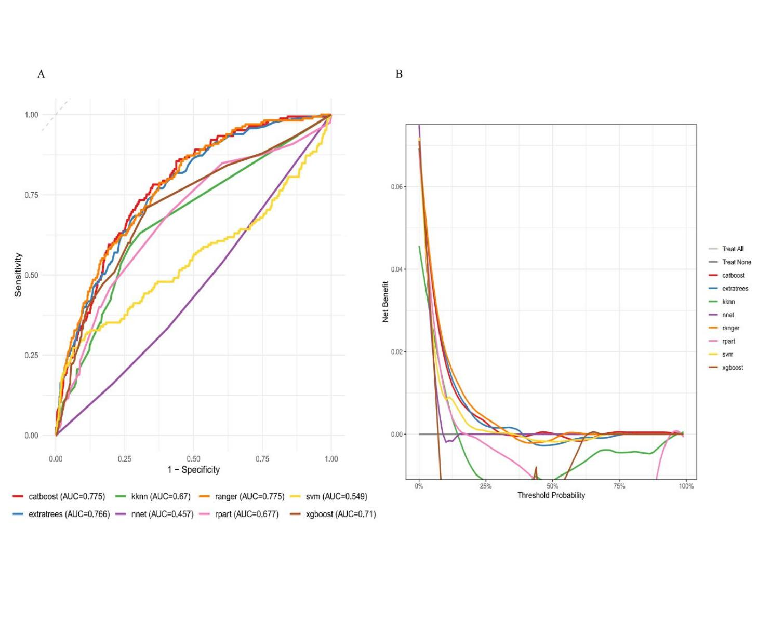Fig.S1.Performance evaluation of machine learning models for CMM using Receiver Operating Characteristic (ROC) analysis and Decision Curve Analysis(DCA).Panel A: Receiver Operating Characteristic (ROC) curves comparing the diagnostic performance of eight machine learning models: CatBoost, K-Nearest Neighbors (knn), Random Forest (ranger), Support Vector Machine (svm), Extra Trees (extratrees), Neural Network (nnet), Decision Tree (rpart), and XGBoost (xgboost). The Area Under the Curve (AUC) value for each model is indicated in the legend. The diagonal dashed line represents the performance of a random classifier (AUC = 0.50). Models with higher AUC values demonstrate better discrimination ability between the positive and negative classes. Panel B: Decision Curve Analysis (DCA) evaluating the clinical utility of the same eight machine learning models across different threshold probabilities. The net benefit, which quantifies the trade-off between true positive rate and false positive rate weighted by the threshold probability, is plotted on the y-axis. The ‘Treat All’ strategy (assuming all patients are positive) and ‘Treat None’ strategy (assuming no patients are positive) serve as reference lines. Models whose curves lie above both reference lines across a range of threshold probabilities offer clinical net benefit. The relative height of the curves indicates the magnitude of net benefit provided by each model at specific thresholds.
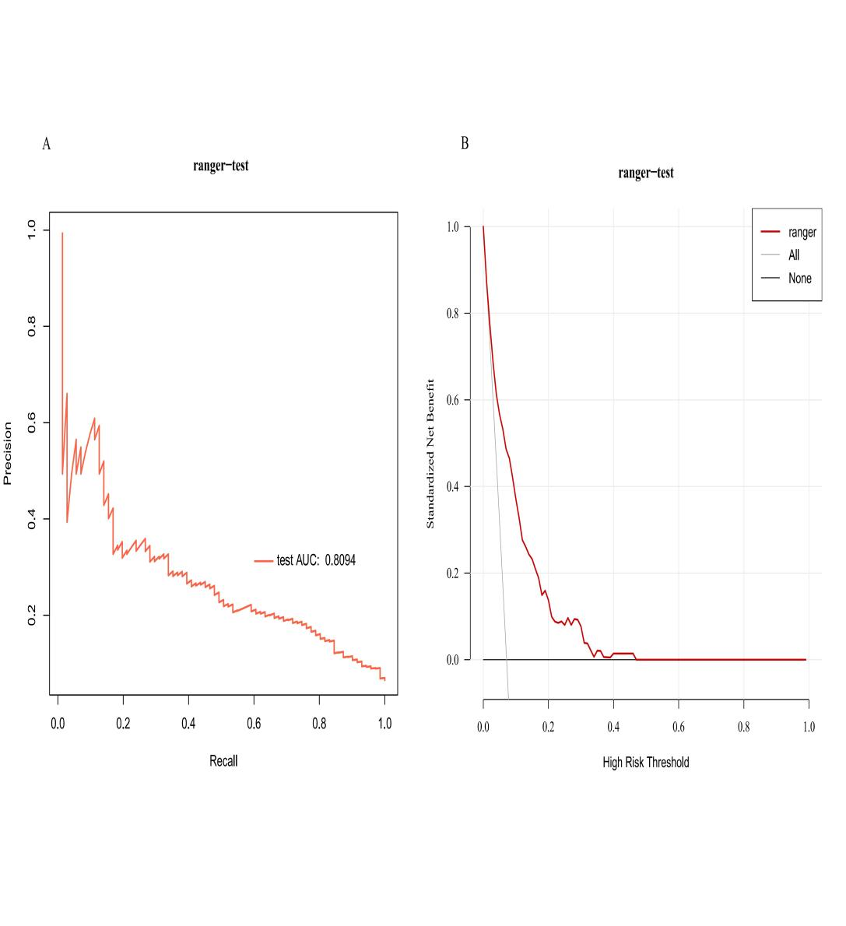
Figure S2. Performance of the Ranger model and Clinical Utility of the Optimal Ranger Model for Predicting Cardiometabolic Multimorbidity (CMM)Risk.(A) Precision-Recall (PR) Curve: Performance of the Ranger model on the independent test set for predicting incident cardiometabolic multimorbidity. The Area Under the PR Curve (AUC-PR = 0.8094) indicates robust performance, particularly relevant for the imbalanced outcome characteristic of CMM development in this cohort. Higher precision across various recall levels suggests the model's potential utility in clinical decision-making where false positives carry significant implications.(B) Standardized Decision Curve Analysis (DCA): Assessment of the net clinical benefit provided by the Ranger model across a range of high-risk thresholds, normalized by the prevalence of CMM. The model's curve (blue) demonstrates superior net benefit compared to the "Treat All" (grey dashed line) and "Treat None" (black dashed line) strategies across most clinically relevant threshold probabilities (approximately 20% to 80%). This indicates that using the Ranger model for risk stratification would lead to better clinical outcomes than blanket intervention or non-intervention strategies over a wide range of decision thresholds pertinent to preventive interventions for CMM. The maximum net benefit occurs around the 40% threshold probability.

