Supplementary Figure 1: Study flowchart
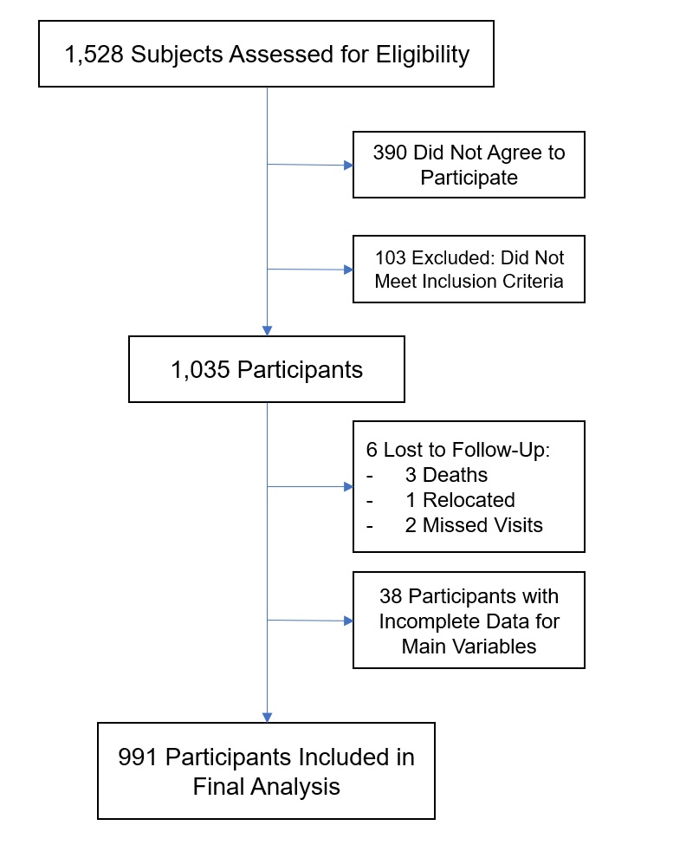

Supplementary Figure 2: PCA for Ahlqvist clusters
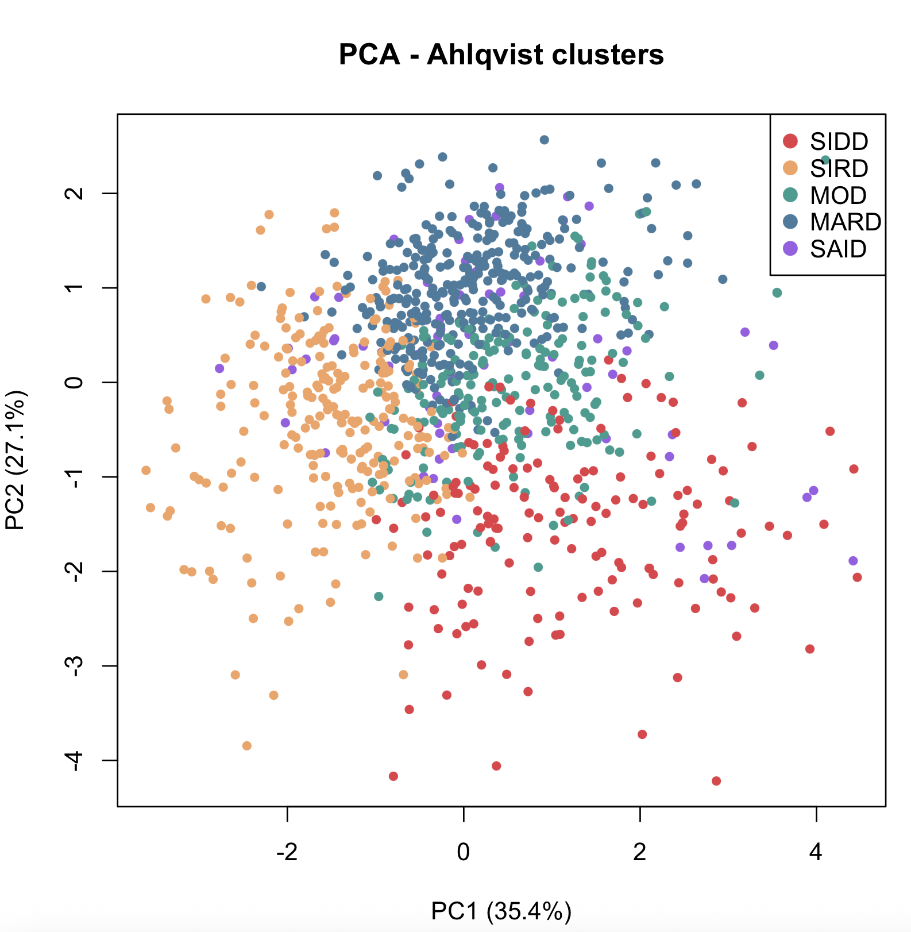
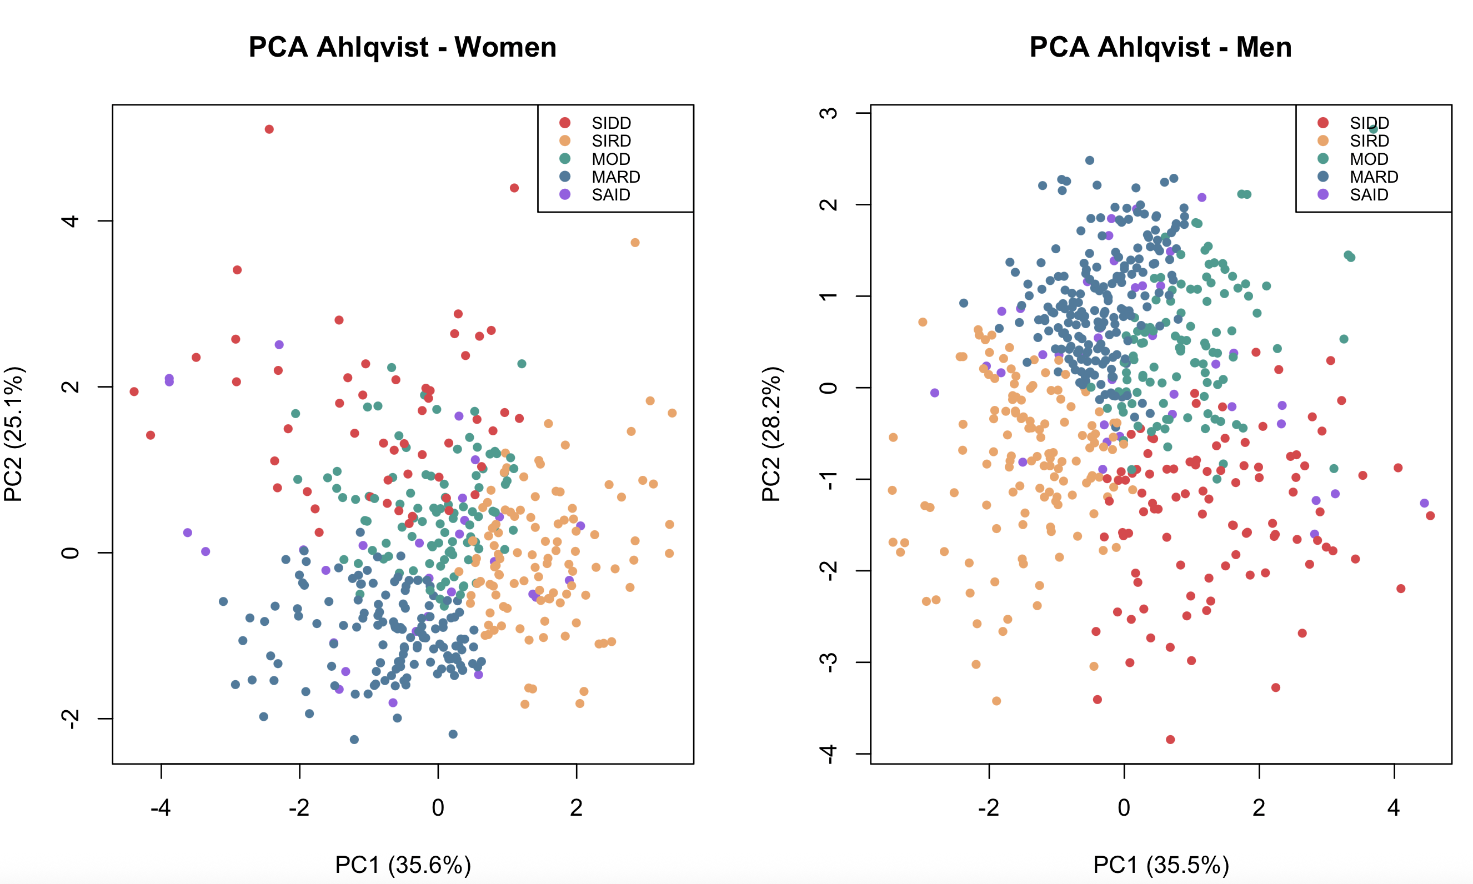
Abbreviations: MARD, mild age-related diabetes; MOD, mild obesity-related diabetes; PCA, principal component analysis; PC1, principal component 1; PC2, principal component 2; SAID, severe autoimmune diabetes; SIDD, severe insulin-deficient diabetes; SIRD, severe insulin-resistant diabetes.

Supplementary Figure 3: PCA in unconstrained analysis
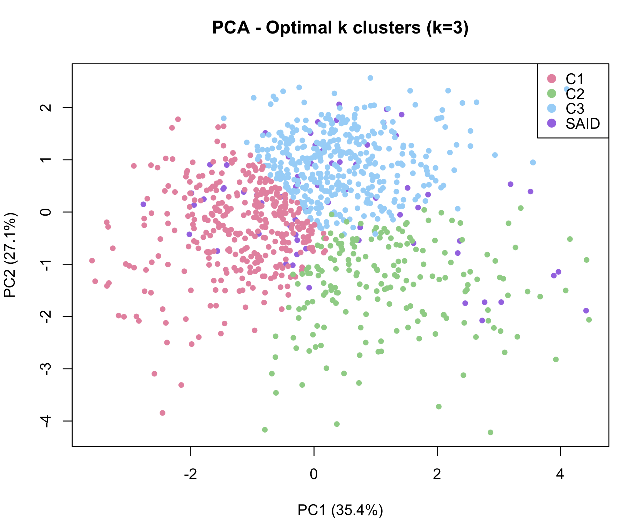
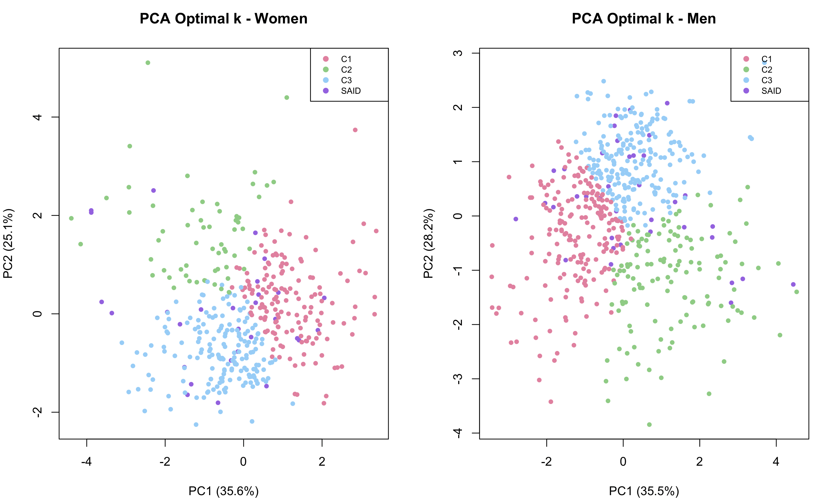
Abbreviations: C1, cluster 1; C2, cluster 2; C3, cluster 3; PCA, principal component analysis; PC1, principal component 1; PC2, principal component 2; SAID, severe autoimmune diabetes.

Supplementary Figure 4: Migration of participants by clustering method
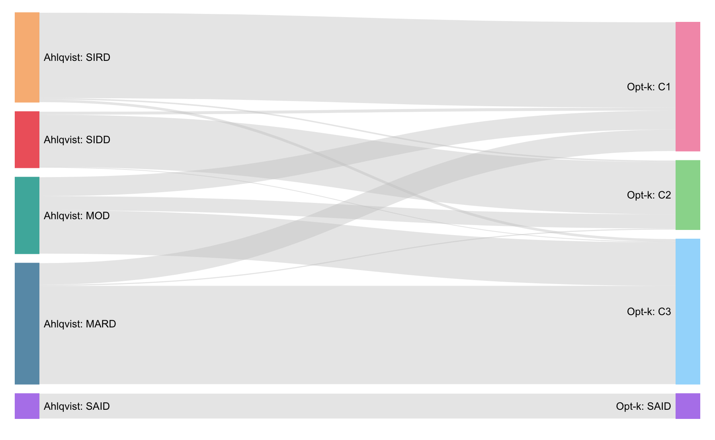

Abbreviations: C1, cluster 1; C2, cluster 2; C3, cluster 3; MARD, mild age-related diabetes; MOD, mild obesity-related diabetes; Opt-k: Optimal k clustering; SAID, severe autoimmune diabetes; SIDD, severe insulin-deficient diabetes; SIRD, severe insulin-resistant diabetes.

Supplementary Table 1: Baseline characteristics of study participants
 | Total  (N= 991) | Male  (N= 569) | Female  (N= 422)
Age at diabetes diagnosis (years), mean (SD) | 57.6 (13.2) | 56.3 (12.8) | 59.4 (13.5)
BMI (kg/m2), mean (SD) | 31.5 (5.9) | 31.1 (5.6) | 31.9 (6.3)
HbA1c (mmol/mol), mean (SD) | 64.8 (23.5) | 67.6 (24.9) | 61.0 (20.8)
HOMA2-IR, mean (SD) | 2.6 (2.3) | 2.7 (2.8) | 2.4 (1.2)
HOMA2-beta, mean (SD) | 109.7 (56.4) | 110.6 (57.0) | 108.5 (55.6)
Positive autoantibodies (yes), N (%) | 67 (6.8) | 38 (6.7) | 29 (6.9)

Abbreviations: BMI, body mass index; HbA1c, glycated haemoglobin; HOMA2-B, Homeostasis Model Assessment 2 of β-cell function; HOMA2-IR, Homeostasis Model Assessment 2 of Insulin Resistance.

