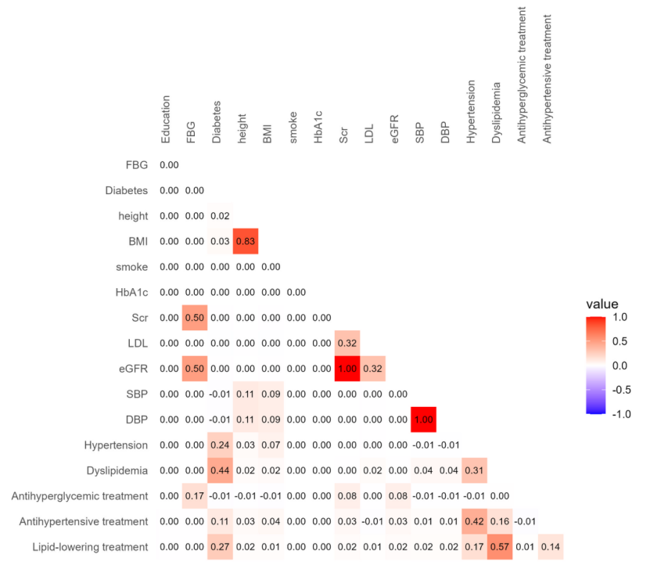
Figure S1 Missing data pattern correlation matrix.
This correlation matrix displays the relationships between missing patterns of variables. Missing values ​​are encoded as 1, and non-missing values ​​are encoded as 0. Pairwise.complete.obs method is used to calculate pairwise correlations. Higher values ​​indicate stronger correlations between missing patterns.
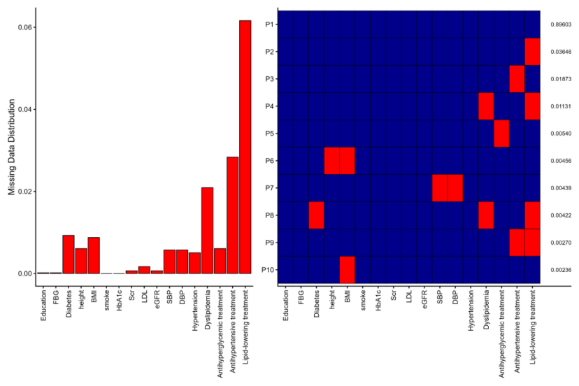
Figure S2 Cross-plot of missing data.
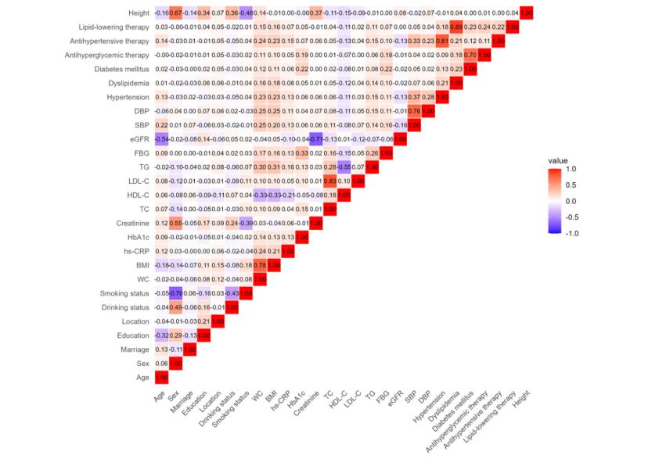
Figure S3 Spearman's correlations among the baseline clinical data.
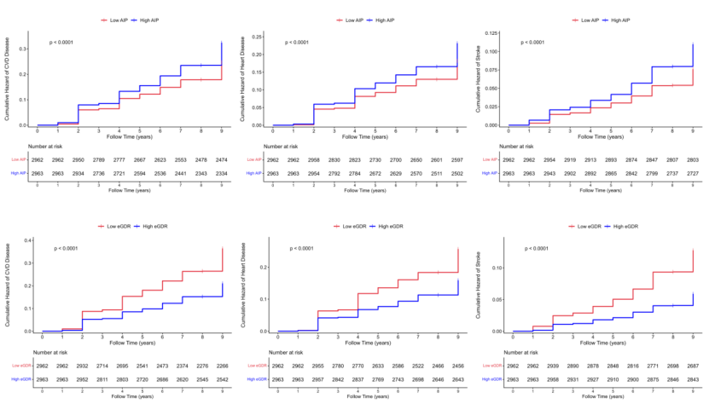Figure S4 Kaplan–Meier plot of CVD，heart disease and stroke by AIP and eGDR level.
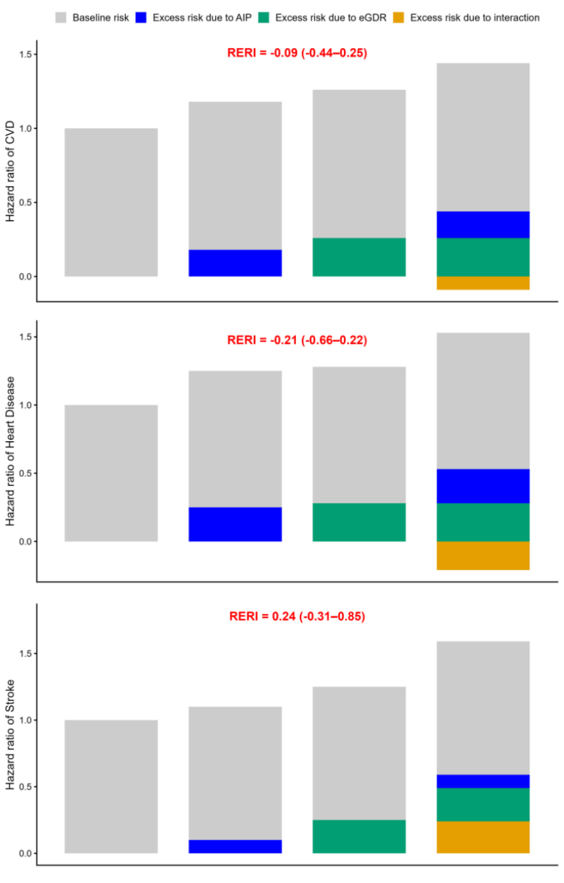
Figure S5 Additive interaction and risk component decomposition of AIP and eGDR on CVD, heart disease and stroke incidence in CKM stage 0–3 population (Model 3)

