Supplementary Material
Title: Evaluation of the Lipid Accumulation Product for MASLD Risk Stratification in Type 2 Diabetes: Establishing Sex-Specific Thresholds and Clinical Utility
Authors: Xiaoxiao Qu^{1†}, Guanhong Li^{2†}, Hongqun Tao¹, Xuanmei Ye¹, Jialu Huang¹, Quanzi Chen¹, Jing Xu³, Minghua Jiang¹, Wang Jia^{4*}, Qipeng Xie¹*

Supplementary Figure 1. Participant Inclusion Flowchart (WMU).................. Page 4
Supplementary Table 1. Comparison of baseline characteristics between included participants and those excluded due to incomplete LAP data. (WMU）......... Page 5-6
Supplementary Figure 2. Diagnostic plots for the multivariate logistic regression model in the WMU cohort................................................................................ Page 7-8
Supplementary Figure 3 . ROC curves showing the incremental discriminative value of LAP over its individual components............................................................ Page 9
Supplementary Table 2. Predictive performance and clinical gain of the models. (WMU)............................................................................................................. Page 10
Supplementary Table 3. Missing data analysis of clinical variables in the WMU cohort................................................................................................................ Page 11
Supplementary Figure 4. RCS analysis of the association between LAP and the risk of MASLD. (WMU).............................................. Page 12
Supplementary Table 4. Odds ratios (95% CI) of MASLD according to continuous and tertile categories of log₁₀LAP. (WMU)...................................................... Page 13
Supplementary Table 5. Association of log₁₀LAP quintiles with the risk of MASLD: a multivariable Logistic regression analysis. (WMU)......................................... Page 14
Supplementary Table 6. Association between log₁₀LAP quartiles and MASLD risk: a sensitivity analysis after removing extreme values. (WMU)............................ Page 15
Supplementary Table 7. Robustness of the Association between Lipid Accumulation Product and MASLD: A Sensitivity Analysis Excluding Body Mass Index.（WMU)........................................................................................................... Page 16
Supplementary Figure 5. E-value analysis for the association between log₁₀LAP and MASLD. (WMU).......................................................................................... Page 17-18
Supplementary Table 8. Comparison of diagnostic performance between raw and log₁₀LAP thresholds. (WMU)............................................................................ Page 19
Supplementary Table 9. Diagnostic performance of the LAP-based model for MASLD in patients with T2DM. (WMU)........................................................................ Page 20
Supplementary Figure 6. DCA comparing the clinical utility of LAP and BMI models. (WMU).............................................................................................................. Page 21
Supplementary Table 10. Subgroup analysis of the LAP-based model's diagnostic performance for MASLD. (WMU)................................................................ Page 22
Supplementary Figure 7. Comparison of diagnostic performance between log₁₀LAP and the TyG index. (WMU).......................................................................... Page 23-24
Supplementary Table 11. Reclassification and Discrimination Improvement of log₁₀LAP compared with the TyG Index. (WMU).......................................... Page 25
Supplementary Figure 8. Association and complementary value of LAP and FIB-4 index in T2DM patients. (WMU)...................................................................... Page 26
Supplementary Table 12. Internal Validation of LAP Cut-offs via 1,000 Bootstrap Resamples. (WMU).......................................................................................... Page 27
Supplementary Figure 9. Flowchart of participant selection in the NHANES 2017–2018 cohort............................................................................................. Page 28
Supplementary Table 13. Baseline characteristics of research participants stratified by quartiles of log₁₀LAP (NHANES)............................................................. Page 29-31 Supplementary Table 14. Association between log₁₀LAP and the risk of MASLD in the NHANES cohort..........................................................................................Page 32
Supplementary Figure 10. Comparison of diagnostic performance and clinical utility among the three diagnostic models. (NHANES)............................................. Page 33
Supplementary Table 15. Association between log₁₀LAP tertiles and MASLD risk in the NHANES cohort......................................................................................... Page 34
Supplementary Table 16 Association between log₁₀LAP quintiles and MASLD risk in the NHANES cohort......................................................................................... Page 35
Supplementary Table 17. Association between log₁₀LAP quartiles and MASLD risk after exclusion of extreme values (0.5th–99.5th percentiles) in the NHANES cohort............................................................................................................... Page 36

Supplementary Figure 1. Participant Inclusion Flowchart (WMU)
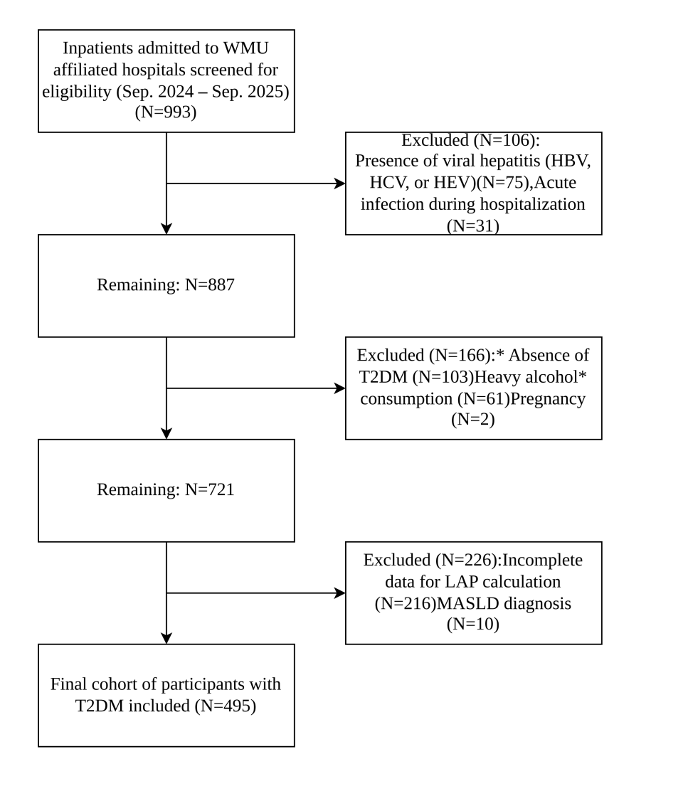

Heavy alcohol consumption was defined as daily intake >25 g for men and >15 g for women according to the National Institute for Nutrition and Health, Chinese Center for Disease Control and Prevention. Abbreviations: HBV, hepatitis B virus; HCV, hepatitis C virus; HEV, hepatitis E virus; LAP, lipid accumulation product; MASLD, metabolic dysfunction-associated steatotic liver disease; T2DM, type 2 diabetes mellitus. WMU, The Second Affiliated Hospital and Yuying Children’s Hospital of Wenzhou Medical University

Supplementary Table 1. Comparison of baseline characteristics between included participants and those excluded due to incomplete LAP data. (WMU）
Variables | Included (n = 495) | Excluded (n = 216) | P value
Age, Mean ± SD | 58.9 ± 14.8 | 59.4 ± 14.7 | 0.637
Sex, n (%) |  |  | 0.494
Men | 275 (55.6) | 114 (52.8)
Women | 220 (44.4) | 102 (47.2)
BMI, Mean ± SD | 24.2 ± 4.9 | 24.3 ± 4.1 | 0.801
Hypertension, n (%) |  |  | 0.621
No | 201 (40.6) | 92 (42.6)
Yes | 294 (59.4) | 124 (57.4)
Hyperlipidemia, n (%) |  |  | 0.773
No | 180 (36.4) | 81 (37.5)
Yes | 315 (63.6) | 135 (62.5)
Smoking, n (%) |  |  | 0.417
No | 358 (72.8) | 159 (75.7)
Yes | 134 (27.2) | 51 (24.3)
Drink, n (%) |  |  | 0.901
No | 385 (78.3) | 166 (78.7)
Yes | 107 (21.7) | 45 (21.3)
WBC, Mean±SD (×10⁹/L) | 7.2 ± 2.7 | 7.1 ± 2.9 | 0.857
PLT, Mean±SD (×10⁹/L) | 223.8 ± 74.6 | 223.3 ± 67.2 | 0.93
ALT, Median (IQR) (U/L) | 19.0 (14.0, 29.0) | 19.0 (13.0, 33.0) | 0.605
AST, Median (IQR) (U/L) | 19.0 (16.0, 25.0) | 20.0 (16.0, 28.0) | 0.041
Cr, Median (IQR) (umol/L) | 68.0 (53.0, 85.0) | 68.0 (54.0, 84.8) | 0.967
UA, Mean±SD (umol/L) | 347.2 ± 114.6 | 341.0 ± 106.9 | 0.523
VD, Mean±SD (ng/mL) | 22.1 ± 8.6 | 21.6 ± 7.7 | 0.486
HbA1c, Mean ± SD, % | 9.3 ± 2.4 | 8.9 ± 2.6 | 0.135
Arb, n (%) |  |  | 0.146
No | 335 (67.7) | 158 (73.1)
Yes | 160 (32.3) | 58 (26.9)
Statins, n (%) |  |  | 0.296
No | 117 (23.6) | 59 (27.3)
Yes | 378 (76.4) | 157 (72.7)
Ezetimibe, n (%) |  |  | 0.079
No | 423 (85.5) | 195 (90.3)
Yes | 72 (14.5) | 21 (9.7)
MASLD, n (%) |  |  | 0.296
No | 170 (34.3) | 83 (38.4)
Yes | 325 (65.7) | 133 (61.6)
Data are presented as mean ± standard deviation (SD) for normally distributed continuous variables, median (interquartile range, IQR) for skewed continuous variables, or number (percentage) for categorical variables. P values were calculated using Student’s t-test for normally distributed continuous variables, Mann–Whitney U test for skewed continuous variables, and chi-square test or Fisher’s exact test for categorical variables. ALT, alanine aminotransferase; AST, aspartate aminotransferase; BMI, body mass index; WC, waist circumference; Cr, creatinine; IQR, interquartile range; log₁₀LAP, log-transformed lipid accumulation product; PLT, platelet count; SD, standard deviation; UA, uric acid; VD, vitamin D; WBC, white blood cell count; TG, triglycerides; MASLD, metabolic dysfunction-associated steatotic liver disease. WMU, The Second Affiliated Hospital and Yuying Children’s Hospital of Wenzhou Medical University

Supplementary Figure 2. Diagnostic plots for the multivariate logistic regression model in the WMU cohort.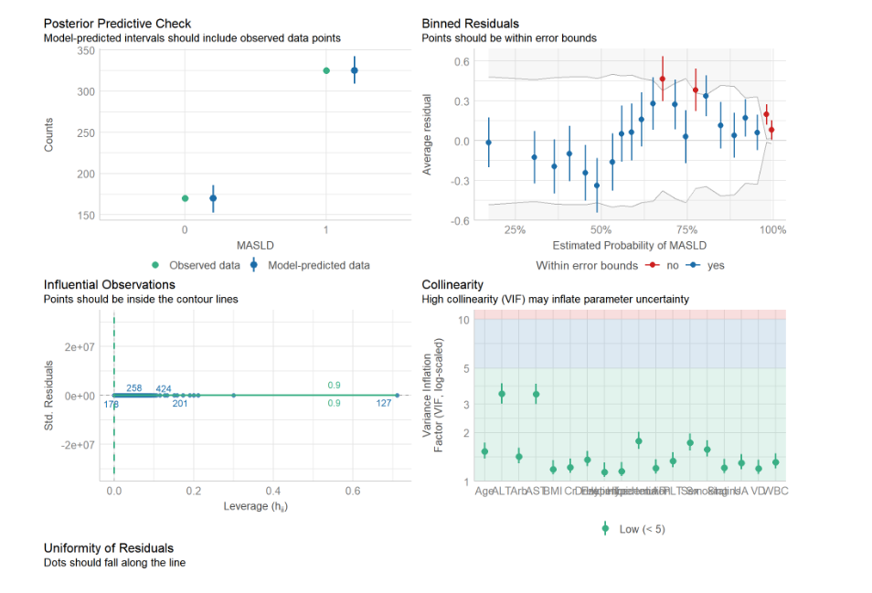
This figure displays a comprehensive assessment of the model fit and statistical assumptions for the logistic regression analysis. (A) Posterior Predictive Check (Top Left): The plot compares the observed data (green dots) with the model-predicted intervals (blue lines). The close alignment between the observed and predicted distributions suggests that the model accurately captures the underlying data structure. (B) Binned Residuals (Top Right): This plot evaluates the agreement between observed and predicted probabilities across binned risk groups. Although minor deviations are observed in the high-probability range (red dots), the majority of points fall within the simulated error bounds (grey area), indicating an overall adequate model fit. (C) Influential Observations (Bottom Left): The plot of standardized residuals against leverage identifies potential outliers. All observations fall within the Cook’s distance contour lines, confirming that no single influential data point is disproportionately driving the model estimates. (D) Collinearity (Bottom Right): The Variance Inflation Factor (VIF) plot assesses multicollinearity among the included covariates. All VIF values are well below the threshold of 5 (green dots), indicating that multicollinearity is not a confusing factor in the model.

Supplementary Figure 3 . ROC curves showing the incremental discriminative value of LAP over its individual components.
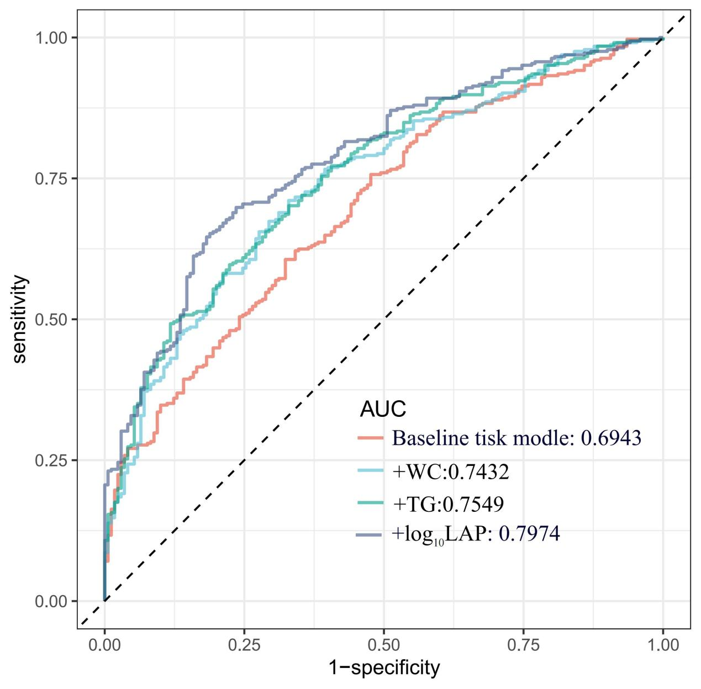
The receiver operating characteristic (ROC) curves compare the diagnostic performance of four models for MASLD. The baseline risk model (red line) shows an AUC of 0.6943. The addition of individual components, WC (green line, AUC: 0.7432) and TG (blue line, AUC: 0.7549), incrementally improved the model performance. Notably, the model incorporating log₁₀LAP (purple line, AUC: 0.7974) achieved the highest AUC, demonstrating a superior synergistic effect in identifying MASLD compared to using WC or TG alone. Abbreviations: AUC, area under the curve; LAP, lipid accumulation product; ROC, receiver operating characteristic; TG, triglycerides; WC, waist circumference.

Supplementary Table 2. Predictive performance and clinical gain of the models. (WMU)
Model | NRI  (95%Cl) | P | IDI  (95%Cl) | P
Baseline tisk model | Ref. | Ref. | Ref. | Ref.
+WC | 0.1806[-0.0034-0.3647] | 0.054 | 0.0139[0.0034-0.0244] | 0.009
+TG | 0.4293[0.2522-0.6064] | <0.001 | 0.0373[0.0208-0.0537] | <0.001
+log₁₀LAP | 0.5881[0.4111-0.7651] | <0.001 | 0.1076[0.0797-0.1356] | <0.001
Baseline tisk model： model 4 excluding BMI
BMI Body-mass index, LAP Lipid accumulation product, NRI Net reclassification improvement, IDI Integrated discrimination improvement, CI Confidence interval.log₁₀LAP, log-transformed lipid accumulation product.

Supplementary Table 3. Missing data analysis of clinical variables in the WMU cohort
Variable | Valid Samples | Missing Samples | Missing Ratios, %
Age | 495 | 0 | 0
ALT | 479 | 16 | 3.23
Arb | 495 | 0 | 0
AST | 487 | 8 | 1.61
BMI | 490 | 5 | 1.01
Cr | 478 | 17 | 3.43
Drink | 492 | 3 | 0.60
Ezetimibe | 495 | 0 | 0
Hyperlipidemia | 495 | 0 | 0
Hypertension | 495 | 0 | 0
PLT | 480 | 15 | 3.02
Sex | 495 | 0 | 0
Smoking | 492 | 3 | 0.60
Statins | 495 | 0 | 0
UA | 478 | 17 | 3.43
VD | 473 | 22 | 4.44
WBC | 480 | 15 | 3.02
ALT, alanine aminotransferase; AST, aspartate aminotransferase; BMI, body mass index; Cr, creatinine; PLT, platelet count; UA, uric acid; VD, vitamin D; WBC, white blood cell count; WMU, The Second Affiliated Hospital and Yuying Children’s Hospital of Wenzhou Medical University

Supplementary Figure 4.Restricted cubic spline (RCS) analysis of the association between LAP and the risk of MASLD. (WMU)
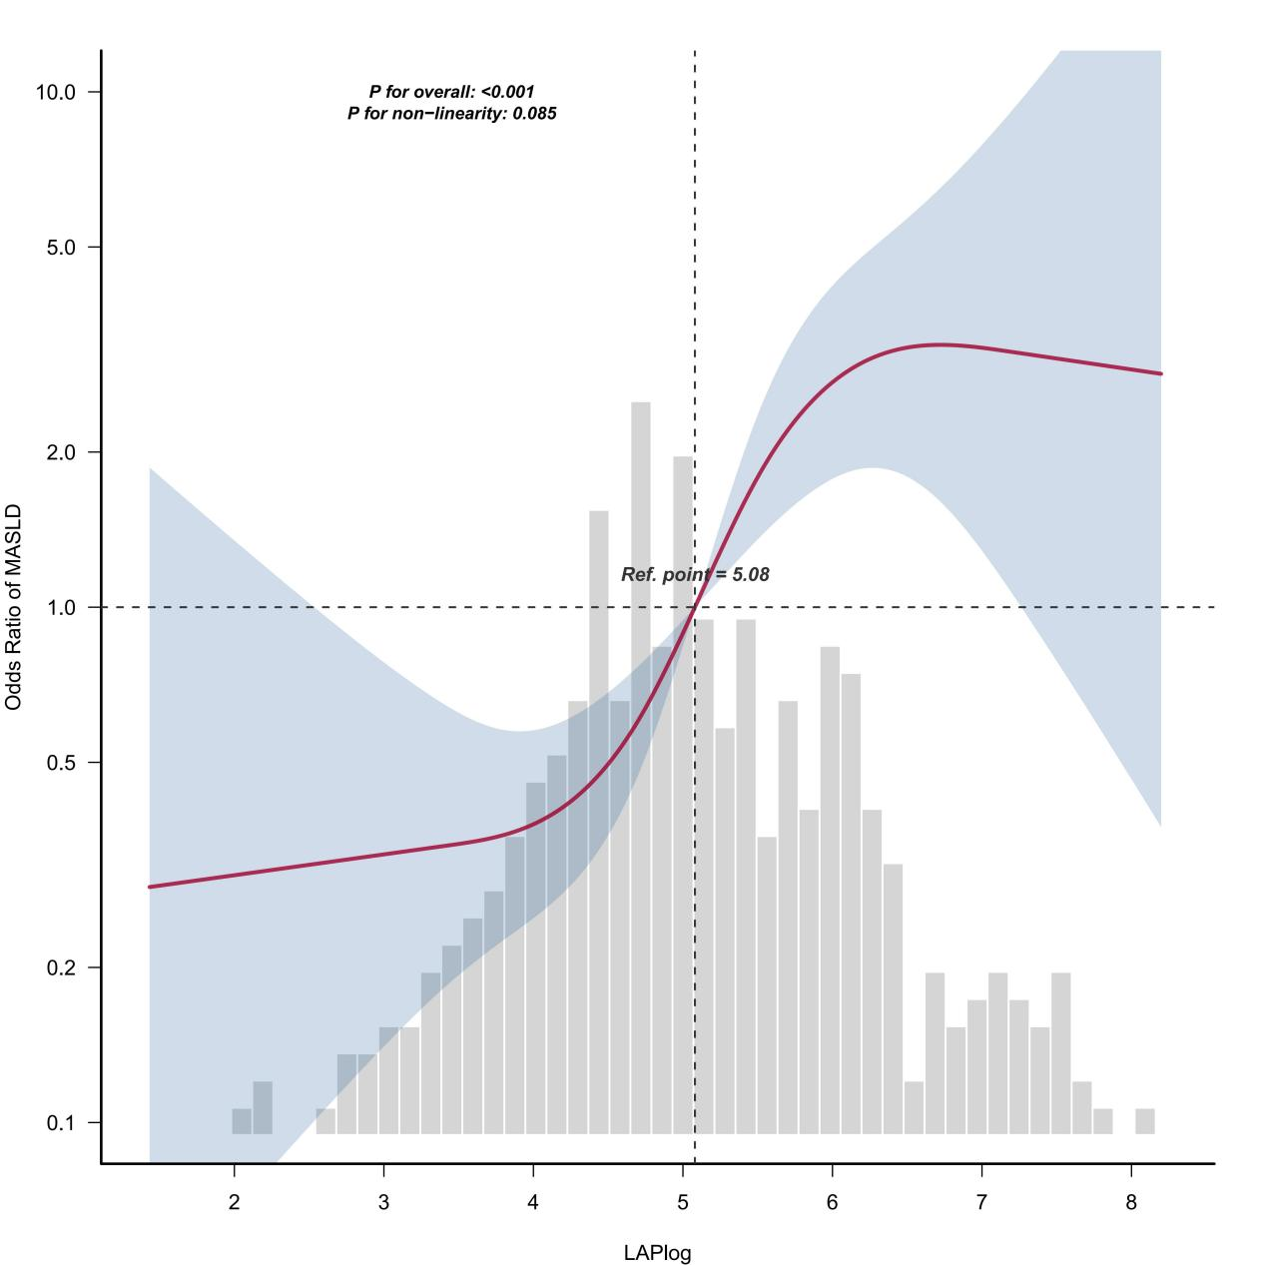
A restricted cubic spline (RCS) model with four knots was employed to visualize the association between log₁₀LAP levels and the probability of MASLD in the total population. The solid line represents the estimated probability, while the shaded area denotes the 95% confidence interval. The background histogram illustrates the distribution density of log₁₀LAP within the study cohort. To ensure model stability and minimize the influence of extreme outliers, the X-axis is restricted to the range between the 1.5th and 98.5th percentiles of the log₁₀LAP distribution. A significant linear relationship was observed between log₁₀LAP and MASLD risk (P for overall < 0.001; P for non-linearity = 0.085).

Supplementary Table 4. Odds ratios (95% CI) of MASLD according to continuous and tertile categories of log₁₀LAP. (WMU)
Categories | Unadjust |  | Model 1 |  | Model 2 |  | Model 3 |  | Model 4
Categories | OR (95%CI) | P | OR (95%CI) | P | OR (95%CI) | P | OR (95%CI) | P | OR (95%CI) | P
log₁₀LAP | 2.27 (1.85~2.79) | <0.001 | 2.28 (1.86~2.80) | <0.001 | 1.90  (1.52~2.36) | <0.001 | 1.84 (1.46~2.31) | <0.001 | 1.83 (1.43~2.35) | <0.001
log₁₀LAP tertiles
T1 (≤4.6) | 1(Ref) |  | 1(Ref) |  | 1(Ref) |  | 1(Ref) |  | 1(Ref)
T2 (4.6-5.5) | 3.1 (1.97~4.87) | <0.001 | 3.18 (2.01~5.02) | <0.001 | 2.63 (1.63~4.23) | <0.001 | 2.72 (1.67~4.43) | <0.001 | 2.79 (1.62~4.81) | <0.001
T3 (≥5.5) | 9.85 (5.67~17.12) | <0.001 | 9.73 (5.58~16.96) | <0.001 | 5.34 (2.89~9.88) | <0.001 | 5.41 (2.86~10.21) | <0.001 | 5.79 (2.92~11.49) | <0.001
P for trend |  | <0.001 |  | <0.001 |  | <0.001 |  | <0.001 |  | <0.001
OR (Odds Ratio); CI Confidence interval
log₁₀LAP, log-transformed lipid accumulation product.BMI Body-mass index, WBC White blood cell count, PLT Platelet count, ALT Alanine aminotransferase, AST Aspartate aminotransferase, Cr Serum creatinine, UA Uric acid, VD Vitamin D, ARB Angiotensin-receptor blocker, Statins HMG-CoA reductase inhibitors, Ezetimibe Ezetimibe
Unadjust: unadjusted
Model 1: adjusted for age and sex
Model 2: adjusted for variables in Model 1 plus smoking, alcohol consumption, BMI, hypertension, and hyperlipidemia
Model 3: adjusted for variables in Model 2 plus WBC, PLT, ALT, AST, Cr, VD, and UA
Model 4: adjusted for variables in Model 3 plus ARB, statins, and ezetimibe, HbA1C, Duration.of.diabetes

Supplementary Table 5. Association of log₁₀LAP quintiles with the risk of MASLD: a multivariable Logistic regression analysis. (WMU)
Categories | Unadjust |  | Model 1 |  | Model 2 |  | Model 3 |  | Model 4
Categories | OR (95%CI) | P | OR (95%CI) | P | OR (95%CI) | P | OR (95%CI) | P | OR (95%CI) | P
log₁₀LAP | 2.27 (1.85~2.79) | <0.001 | 2.28 (1.86~2.80) | <0.001 | 1.90  (1.52~2.36) | <0.001 | 1.84 (1.46~2.31) | <0.001 | 1.83 (1.43~2.35) | <0.001
log₁₀LAP Q5
Q1 (≤4.1) | 1(Ref) |  | 1(Ref) |  | 1(Ref) |  | 1(Ref) |  | 1(Ref)
Q2 (4.1-4.7) | 1.79 (1.01~3.17) | 0.045 | 1.85 (1.04~3.29) | 0.037 | 1.47 (0.8~2.67) | 0.212 | 1.47 (0.8~2.71) | 0.215 | 1.12 (0.55~2.25) | 0.758
Q3 (4.7-5.3) | 4.21 (2.32~7.62) | <0.001 | 4.37 (2.39~7.98) | <0.001 | 3.3 (1.76~6.2) | <0.001 | 3.35 (1.76~6.36) | <0.001 | 3.13 (1.52~6.44) | 0.002
Q4 (5.3-6.1) | 9.49 (4.83~18.64) | <0.001 | 9.7 (4.92~19.13) | <0.001 | 5.76 (2.77~11.97) | <0.001 | 5.86 (2.75~12.48) | <0.001 | 5.65 (2.5~12.78) | <0.001
Q5 (≥6.1) | 16.46 (7.6~35.63) | <0.001 | 16.32 (7.52~35.41) | <0.001 | 8.55 (3.69~19.82) | <0.001 | 8.32 (3.51~19.74) | <0.001 | 6.96 (2.81~17.27) | <0.001
P for trend |  | <0.001 |  | <0.001 |  | <0.001 |  | <0.001 |  | <0.001
OR (Odds Ratio); CI Confidence interval
log₁₀LAP, log-transformed lipid accumulation product.BMI Body-mass index, WBC White blood cell count, PLT Platelet count, ALT Alanine aminotransferase, AST Aspartate aminotransferase, Cr Serum creatinine, UA Uric acid, VD Vitamin D, ARB Angiotensin-receptor blocker, Statins HMG-CoA reductase inhibitors, Ezetimibe Ezetimibe
Unadjust: unadjusted
Model 1: adjusted for age and sex
Model 2: adjusted for variables in Model 1 plus smoking, alcohol consumption, BMI, hypertension, and hyperlipidemia
Model 3: adjusted for variables in Model 2 plus WBC, PLT, ALT, AST, Cr, VD, and UA
Model 4: adjusted for variables in Model 3 plus ARB, statins, and ezetimibe, HbA1C, Duration.of.diabetes

Supplementary Table 6. Association between log₁₀LAP quartiles and MASLD risk: a sensitivity analysis after removing
extreme values. (WMU)
Categories | Unadjust |  | Model 1 |  | Model 2 |  | Model 3 |  | Model 4
Categories | OR (95%CI) | P | OR (95%CI) | P | OR (95%CI) | P | OR (95%CI) | P | OR (95%CI) | P
log₁₀LAP | 2.43  (1.97~3) | <0.001 | 2.44 (1.97~3.02) | <0.001 | 2.01  (1.6~2.53) | <0.001 | 1.99 (1.57~2.53) | <0.001 | 1.93  (1.49~2.5) | <0.001
log₁₀LAP Q4
Q1 (≤4.3) | 1(Ref) |  | 1(Ref) |  | 1(Ref) |  | 1(Ref) |  | 1(Ref)
Q2 (4.3-5.0) | 1.66 (1.00~2.75) | 0.049 | 1.69 (1.02~2.8) | 0.044 | 1.32 (0.78~2.25) | 0.306 | 1.36 (0.79~2.34) | 0.271 | 1.07 (0.57~1.98) | 0.840
Q3 (5.0-5.9) | 5.8 (3.29~10.23) | <0.001 | 5.98 (3.37~10.61) | <0.001 | 4.2 (2.29~7.71) | <0.001 | 4.35 (2.32~8.15) | <0.001 | 4.84  (2.39~9.8) | <0.001
Q4 (≥5.9) | 12.64 (6.42~24.88) | <0.001 | 12.72 (6.43~25.16) | <0.001 | 6.52 (3.09~13.76) | <0.001 | 6.18 (2.86~13.36) | <0.001 | 4.69 (2.12~10.36) | <0.001
P for trend |  | <0.001 |  | <0.001 |  | <0.001 |  | <0.001 |  | <0.001
OR (Odds Ratio); CI Confidence interval
log₁₀LAP, log-transformed lipid accumulation product.BMI Body-mass index, WBC White blood cell count, PLT Platelet count, ALT Alanine aminotransferase, AST Aspartate aminotransferase, Cr Serum creatinine, UA Uric acid, VD Vitamin D, ARB Angiotensin-receptor blocker, Statins HMG-CoA reductase inhibitors, Ezetimibe Ezetimibe
Unadjust: unadjusted
Model 1: adjusted for age and sex
Model 2: adjusted for variables in Model 1 plus smoking, alcohol consumption, BMI, hypertension, and hyperlipidemia
Model 3: adjusted for variables in Model 2 plus WBC, PLT, ALT, AST, Cr, VD, and UA
Model 4: adjusted for variables in Model 3 plus ARB, statins, and ezetimibe, HbA1C, Duration.of.diabetes

Supplementary Table 7. Robustness of the Association between Lipid Accumulation Product and MASLD: A Sensitivity Analysis Excluding Body Mass Index. （WMU)
Categories | Unadjust |  | Model 1 |  | Model 2 |  | Model 3 |  | Model 4
Categories | OR (95%CI) | P | OR (95%CI) | P | OR (95%CI) | P | OR (95%CI) | P | OR (95%CI) | P
log₁₀LAP | 2.27 (1.85~2.79) | <0.001 | 2.28 (1.86~2.80) | <0.001 | 2.15 (1.74~2.65) | <0.001 | 2.09 (1.67~2.61) | <0.001 | 2.06  (1.62~2.62) | <0.001
log₁₀LAP Q4
Q1 (≤4.3) | 1(Ref) |  | 1(Ref) |  | 1(Ref) |  | 1(Ref) |  | 1(Ref)
Q2 (4.3-5.0) | 1.63 (0.99~2.69) | 0.057 | 1.66 (1.00~2.75) | 0.049 | 1.56 (0.94~2.61) | 0.088 | 1.55 (0.91~2.62) | 0.105 | 1.25  (0.69~2.27) | 0.459
Q3 (5.0-5.9) | 5.40 (3.08~9.46) | <0.001 | 5.55 (3.15~9.79) | <0.001 | 4.92 (2.76~8.77) | <0.001 | 4.75 (2.59~8.71) | <0.001 | 5.52 (2.79~10.92) | <0.001
Q4 (≥5.9) | 12.11 (6.15~23.84) | <0.001 | 12.07 (6.11~23.84) | <0.001 | 10.01 (4.97~20.15) | <0.001 | 9.2 (4.41~19.22) | <0.001 | 7.98 (3.7~17.21) | <0.001
P for trend |  | <0.001 |  | <0.001 |  | <0.001 |  | <0.001 |  | <0.001
OR (Odds Ratio); CI Confidence interval
log₁₀LAP, log-transformed lipid accumulation product.BMI Body-mass index, WBC White blood cell count, PLT Platelet count, ALT Alanine aminotransferase, AST Aspartate aminotransferase, Cr Serum creatinine, UA Uric acid, VD Vitamin D, ARB Angiotensin-receptor blocker, Statins HMG-CoA reductase inhibitors, Ezetimibe Ezetimibe
Unadjust: unadjusted
Model 1: adjusted for age and sex
Model 2: adjusted for variables in Model 1 plus smoking, alcohol consumption, hypertension, and hyperlipidemia
Model 3: adjusted for variables in Model 2 plus WBC, PLT, ALT, AST, Cr, VD, and UA
Model 4: adjusted for variables in Model 3 plus ARB, statins, and ezetimibe, HbA1C, Duration.of.diabetes

Supplementary Figure 5.E-value analysis for the association between log₁₀LAP and MASLD. (WMU)
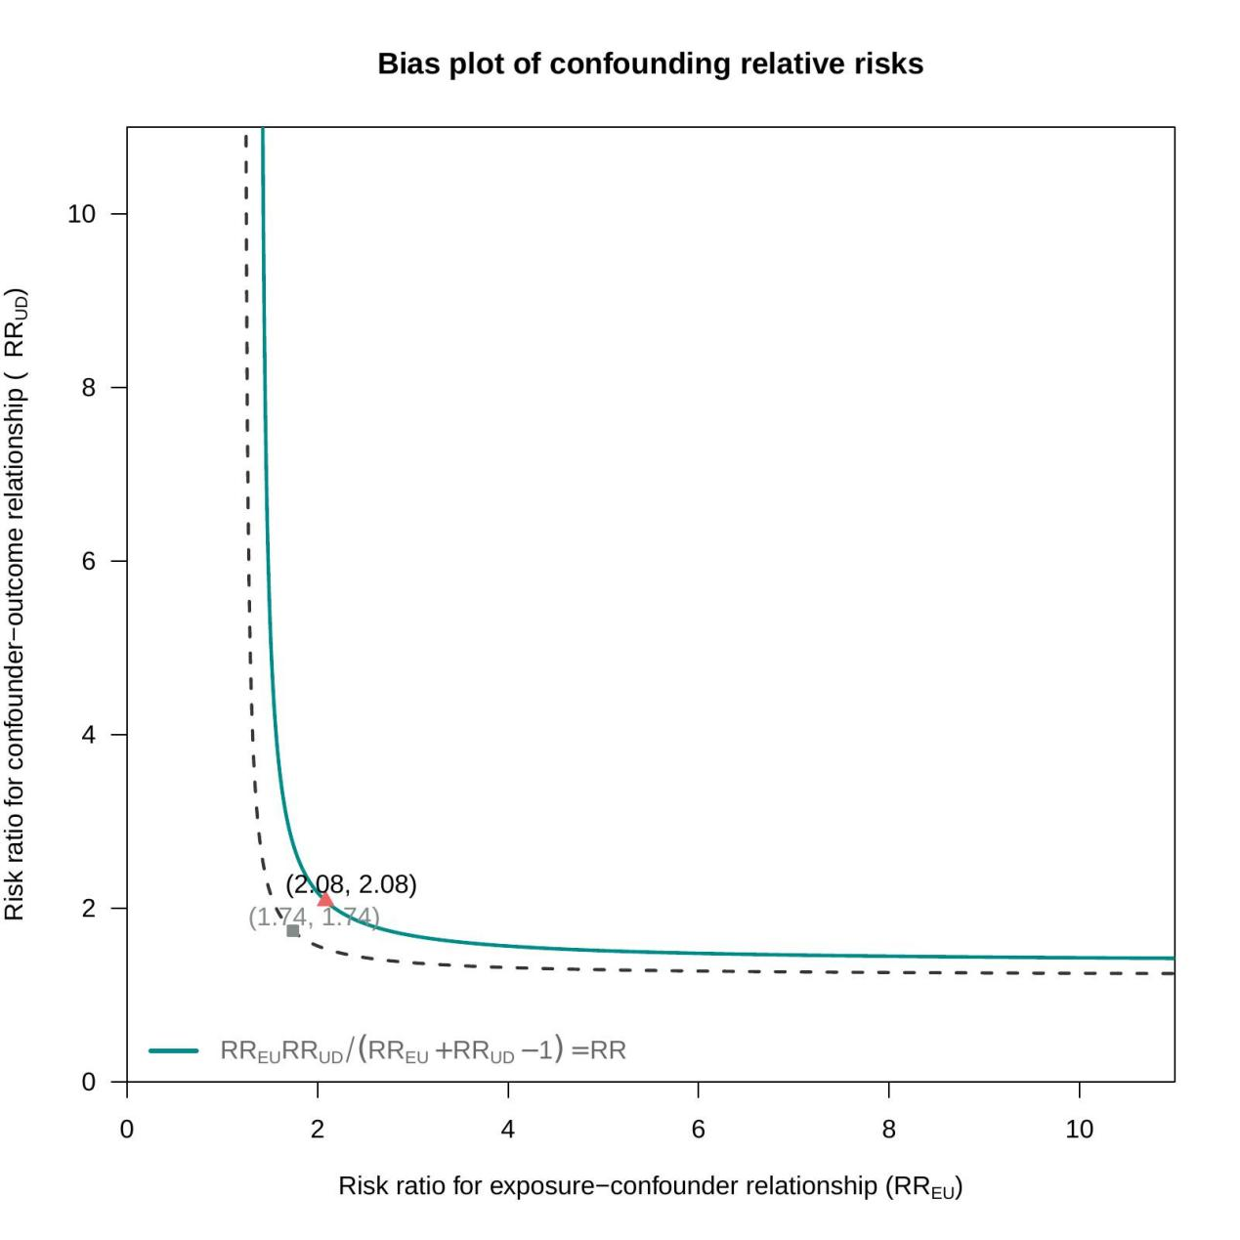
E-value analysis of unmeasured confounding factors in the association between log₁₀LAP and MASLD. LAP: Lipid Accumulation Product. The bias plot illustrates the calculated E-values to assess the potential impact of unmeasured confounding factors on the association between log₁₀LAP and MASLD. The solid line represents the risk ratio of the exposure–confounder relationship (RR_UD), while the dashed line represents the risk ratio of the exposure–disease relationship (RR). The plot shows that the association between log₁₀LAP and MASLD remains robust unless an unmeasured confounder is associated with both log₁₀LAP and MASLD risk with a magnitude greater than 2.08. The point (2.08, 2.08) is marked to highlight this threshold. Plotting the risk ratio of the exposure–confounder relationship against the risk ratio of the exposure–disease relationship shows that as the strength of a potential unmeasured confounder increases, the curve approaches the dashed line.

Supplementary Table 8. Comparison of diagnostic performance between raw and log₁₀LAP thresholds. (WMU)
Threshold Level | Raw LAP Cut-off | log10​LAP Equivalent | Sensitivity | Specificity
Lower Threshold | 20.4 | 1.3096 | 0.8523 | 0.429
Upper Threshold | 27 | 1.4314 | 0.7538 | 0.500
Note: Data derived from the clinical T2DM study cohort (N=495). log₁₀LAP was used for statistical modeling to ensure variance stability, while raw LAP values are provided to facilitate direct clinical application. Due to the strictly monotonic nature of the logarithmic transformation, the diagnostic performance (Sensitivity and Specificity) remains mathematically identical across both scales. The point estimates derived from the original dataset fall within the 95% CIs of 1,000 bootstrap resamples, confirming the stability and reliability of these sex-specific thresholds for retrospective risk screening.

Supplementary Table 9. Diagnostic performance of the LAP-based model for MASLD in patients with T2DM. (WMU)
Groups | Optimal Cut-off | Sens,% | Spec,% | PPV,% | NPV,% | AUC (95%CI)
Total | 0.6611 | 71.38 | 77.65 | 85.93 | 58.67 | 0.782 (0.743-0.821)
Males | 20.4 (Raw LAP) | 70.00 | 80.00 | 86.90 | 58.46 | 0.787 (0.727-0.842)
Females | 27.0 (Raw LAP) | 71.23 | 72.00 | 83.20 | 56.25 | 0.767 (0.702-0.832)
Abbreviations: LAP, lipid accumulation product; MASLD, metabolic dysfunction-associated steatotic liver disease; T2DM, type 2 diabetes mellitus; Sens, sensitivity; Spec, specificity; PPV, positive predictive value; NPV, negative predictive value; AUC, area under the receiver operating characteristic curve; CI, confidence interval.Raw LAP:Raw Lipid Accumulation Product.

Supplementary Figure 6. DCA comparing the clinical utility of LAP and BMI models. (WMU)
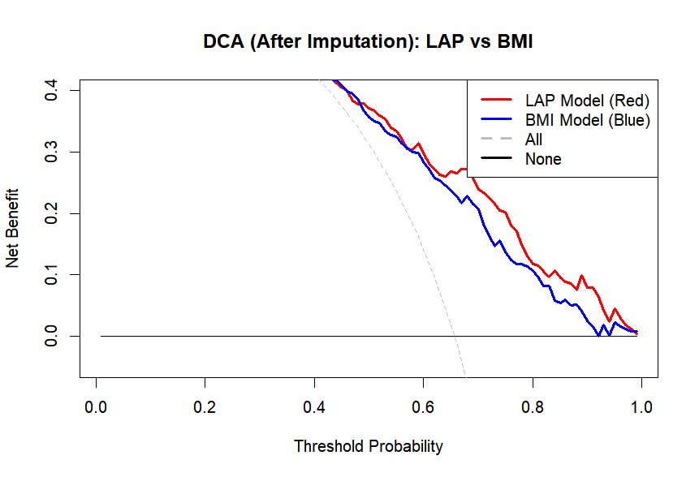
Abbreviations: BMI, body mass index; LAP, lipid accumulation product; MASLD, metabolic dysfunction-associated steatotic liver disease; T2DM, type 2 diabetes mellitus. Clinical Utility: Decision curve analysis evaluates the clinical usefulness of different diagnostic strategies. This plot compares four scenarios: (i) the LAP-based model (red solid line), (ii) the BMI-based model (blue solid line), (iii) the "All" strategy (gray dashed line), which assumes all T2DM patients have MASLD and receive intervention, and (iv) the "None" strategy (black horizontal line), which assumes no patients have MASLD. The y-axis represents the Net Benefit. A strategy is considered clinically beneficial if its curve lies above both the "All" and "None" lines. The x-axis represents the Threshold Probability, indicating the level of risk at which a clinician would initiate further diagnostic workup or treatment. Across a broad clinical range of threshold probabilities (approximately 0.15 to 0.90), the LAP model (red) consistently provides a higher net benefit compared to the BMI model (blue).
Supplementary Table 10. Subgroup analysis of the LAP-based model's diagnostic performance for MASLD. （WMU)
Subgroups | N | AUC (95% CI)
Total Population | 495 | 0.782 (0.740–0.824)
Sex
Males | 274 | 0.790 (0.734–0.847)
Females | 221 | 0.774 (0.710–0.837)
Age (years)
< 55 | 170 | 0.855 (0.793–0.917)
≥55 | 325 | 0.738 (0.682–0.793)
BMI (kg/m²)
< 24 | 218 | 0.711 (0.642–0.781)
≥24 | 277 | 0.747 (0.675–0.818)
AUC, area under the receiver operating characteristic curve; CI, confidence interval; LAP, lipid accumulation product; MASLD, metabolic dysfunction-associated steatotic liver disease; BMI, body mass index; T2DM, type 2 diabetes mellitus.
Supplementary Figure 7. Comparison of diagnostic performance between log₁₀LAP and the TyG index. (WMU)

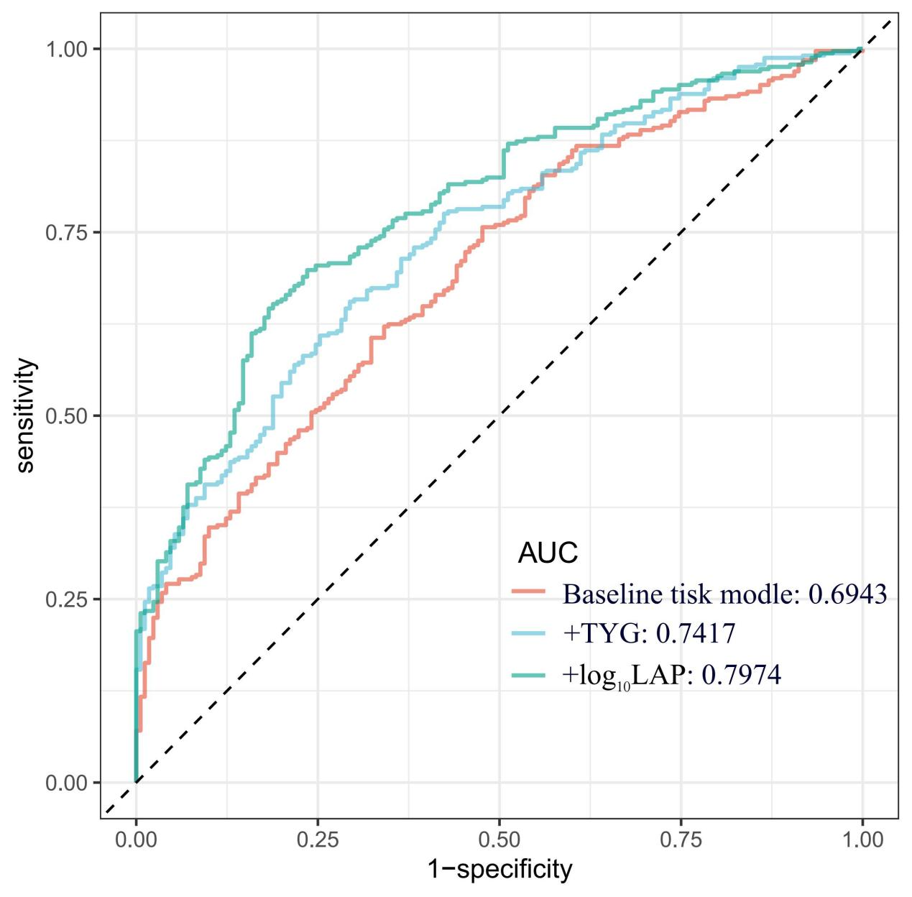

The receiver operating characteristic (ROC) curves illustrate the comparative discriminative performance of the baseline risk model, the TyG-augmented model, and the log₁₀LAP-augmented model. The red line represents the baseline risk model (AUC = 0.6943); the blue line represents the baseline model augmented with the Triglyceride-Glucose (TyG) index (AUC = 0.7417); and the green line represents the baseline model augmented with log₁₀LAP (AUC = 0.7974). The model incorporating log₁₀LAP achieved a significantly higher AUC compared to both the baseline and the TyG-augmented models (P < 0.05).
Abbreviations: AUC, area under the curve; LAP, lipid accumulation product; MASLD, metabolic dysfunction-associated steatotic liver disease; TyG, triglyceride-glucose index.

Supplementary Table 11. Reclassification and Discrimination Improvement of log₁₀LAP compared with the TyG Index. (WMU)
Model | NRI  (95%Cl) | P | IDI  (95%Cl) | P
Baseline tisk model | Ref. | Ref. | Ref. | Ref.
+TYG | 0.4505[0.2715-0.6295] | <0.001 | 0.0511[0.0305-0.0718] | <0.001
+log₁₀LAP | 0.5881[0.4111-0.7651] | <0.001 | 0.1076[0.0797-0.1356] | <0.001
The table presents the incremental value provided by adding the TyG index or log₁₀LAP to the baseline risk model. The Net Reclassification Improvement (NRI) and Integrated Discrimination Improvement (IDI) demonstrate that the addition of log₁₀LAP resulted in a more substantial improvement in both risk reclassification (NRI: 0.5881) and integrated discrimination (IDI: 0.1076) compared to the TyG index.

Supplementary Figure 8. Association and complementary value of LAP and FIB-4 index in T2DM patients. (WMU)
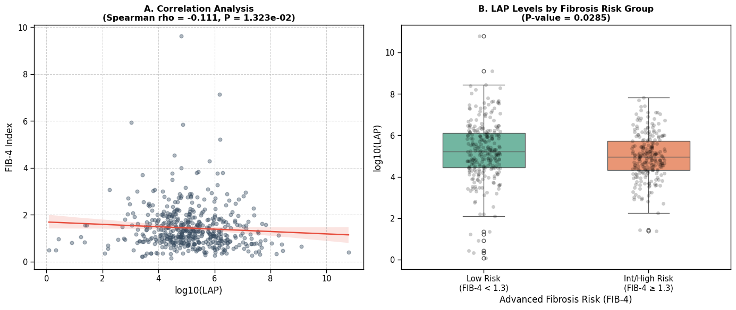
(A) Scatter plot showing the correlation between log₁₀LAP and the FIB-4 index. The regression line (red) and the distribution of individual data points demonstrate a weak negative correlation (Spearman rho = -0.111, P = 0.013), suggesting that LAP and FIB-4 reflect independent clinical dimensions of liver assessment.
(B) Box-and-whisker plot of log₁₀LAP levels stratified by fibrosis risk. Patients were categorized into a "Low Risk" group (FIB-4 < 1.3, n=263) and an "Intermediate/High Risk" group (FIB-4 ≥ 1.3, n=232). The "Low Risk" group exhibited significantly higher LAP levels compared to the higher risk group (5.24 ± 1.45 vs. 4.98 ± 1.10, P = 0.0285). The horizontal lines within the boxes represent the median values; the boxes represent the interquartile range (IQR), and the whiskers extend to 1.5 times the IQR. Individual data points are overlaid to show the total distribution.
Abbreviations: LAP, Lipid Accumulation Product; FIB-4, Fibrosis-4 Index; T2DM, Type 2 Diabetes Mellitus

Supplementary Table 12. Internal Validation of LAP Cut-offs via 1,000 Bootstrap Resamples. (WMU)
Subgroup | Proposed Cut-off | Sensitivity | 95% CI (Bootstrap) | Specificity | 95% CI Bootstrap | AUC (Optimism-corrected AUC)
Men | 20.4 | 0.8333 | 0.7814 – 0.8846 | 0.4632 | 0.3696 – 0.5679 | 0.7574
Women | 27.0 | 0.7724 | 0.7027 – 0.8421 | 0.6133 | 0.5065 – 0.7272 | 0.7626
Abbreviations: AUC, area under the receiver operating characteristic curve; LAP, lipid accumulation product; CI, confidence interval.
Internal validation was performed using a bootstrap resampling procedure with 1,000 replicates. In each resample, the pre-specified cut-offs (20.4 for men and 27.0 for women) were held constant, and their diagnostic performance was evaluated to assess stability and reliability. Optimism-corrected AUCs were calculated to quantify potential overfitting. The near-zero optimism (−0.0008 for men and -0.0006 for women) suggested minimal overfitting of the diagnostic thresholds.

Supplementary Figure 9. External Validation:Flowchart of participant selection in the NHANES 2017–2018 cohort
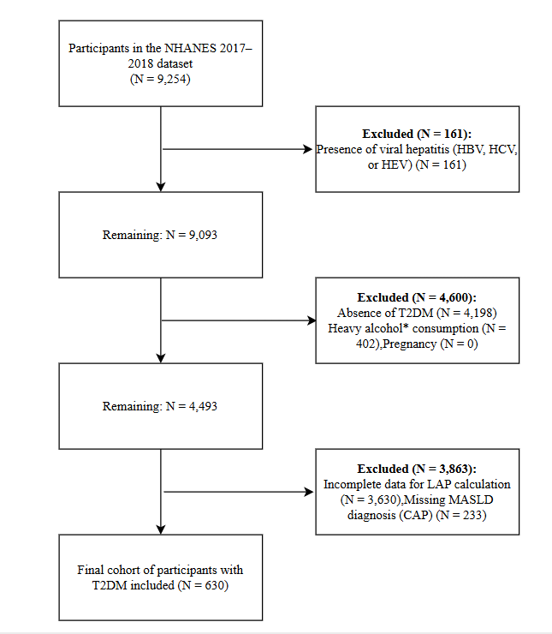
Abbreviations: HBV, hepatitis B virus; HCV, hepatitis C virus; HEV, hepatitis E virus; LAP, lipid accumulation product; MASLD, metabolic dysfunction-associated steatotic liver disease; T2DM, type 2 diabetes mellitus.

Supplementary Table 13. External Validation: Baseline characteristics of research participants stratified by quartiles of log₁₀LAP (NHANES).
Variables | Total（N=630） | Q1(N = 158) | Q2(N = 157) | Q3(N = 157) | Q4(N = 158) | P
Age, mean (SE),y | 63.2 ± 12.5 | 64.3 ± 14.1 | 64.6 ± 10.8 | 62.9 ± 12.3 | 60.9 ± 12.6 | 0.037
Sex, n (%) |  |  |  |  |  | 0.002
Men | 349 (55.4) | 100 (63.3) | 80 (51) | 71 (45.2) | 98 (62)
Women | 281 (44.6) | 58 (36.7) | 77 (49) | 86 (54.8) | 60 (38)
BMI, mean (SE),kg/m² | 31.8 ± 7.3 | 26.5 ± 4.6 | 30.2 ± 5.3 | 33.8 ± 6.4 | 36.7 ± 8.0 | < 0.001
Hypertension, n (%) |  |  |  |  |  | < 0.001
No | 431 (68.4) | 91 (57.6) | 106 (67.5) | 108 (68.8) | 126 (79.7)
Yes | 199 (31.6) | 67 (42.4) | 51 (32.5) | 49 (31.2) | 32 (20.3)
Hyperlipidemia, n (%) |  |  |  |  |  | < 0.001
No | 381 (60.5) | 78 (49.4) | 91 (58) | 99 (63.1) | 113 (71.5)
Yes | 249 (39.5) | 80 (50.6) | 66 (42) | 58 (36.9) | 45 (28.5)
Smoking, n (%) |  |  |  |  |  | 0.602
No | 449 (71.3) | 109 (69) | 108 (68.8) | 117 (74.5) | 115 (72.8)
Yes | 181 (28.7) | 49 (31) | 49 (31.2) | 40 (25.5) | 43 (27.2)
Drink, n (%) |  |  |  |  |  | 0.447
No | 251 (39.8) | 59 (37.3) | 68 (43.3) | 67 (42.7) | 57 (36.1)
Yes | 379 (60.2) | 99 (62.7) | 89 (56.7) | 90 (57.3) | 101 (63.9)
WBC, mean(SE),  10⁹ cells/L | 7.6 ± 2.2 | 6.6 ± 1.7 | 7.6 ± 2.3 | 7.9 ± 2.1 | 8.2 ± 2.1 | 0.002
PLT, mean(SE), 10⁹ cells/L | 236.5 ± 70.0 | 225.4 ± 66.2 | 236.0 ± 71.9 | 248.7 ± 73.6 | 235.9 ± 66.6 | 0.340
ALT, mean(SE), U/L | 22.4 ± 14.2 | 19.6 ± 13.0 | 21.4 ± 12.7 | 23.3 ± 16.1 | 25.4 ± 14.1 | 0.003
AST, mean(SE), U/L | 21.5 ± 11.0 | 20.5 ± 9.2 | 21.6 ± 11.5 | 21.1 ± 11.5 | 22.8 ± 11.5 | 0.089
Cr, mean(SE), umol/L | 79.6  (62.1, 97.9) | 80.4  (66.7, 96.1) | 76.0  (59.2, 96.4) | 78.7  (58.3, 94.6) | 82.7  (67.4, 101.7) | 0.940
UA, mean(SE), umol/L | 339.0 ± 94.6 | 321.2 ± 85.2 | 331.5 ± 94.4 | 337.9 ± 102.2 | 365.2 ± 91.1 | 0.490
VD, mean(SE)  ,nmol/L | 68.6 ± 35.3 | 75.3 ± 35.8 | 67.3 ± 31.7 | 66.1 ± 33.3 | 65.5 ± 39.3 | 0.120
HbA1c, Mean ± SD % | 7.4 ± 1.6 | 7.1 ± 1.7 | 7.4 ± 1.5 | 7.4 ± 1.6 | 7.7 ± 1.6 | 0.004
Duration.of.diabetes, Median (IQR)（Year) | 12.0  (5.0, 19.0) | 13.0  (7.0, 20.0) | 11.0  (5.0, 18.0) | 10.0  (4.0, 18.0) | 12.0  (5.0, 19.0) | 0.322
ARB, n (%) |  |  |  |  |  | 0.904
No | 495 (78.6) | 122 (77.2) | 124 (79) | 122 (77.7) | 127 (80.4)
Yes | 135 (21.4) | 36 (22.8) | 33 (21) | 35 (22.3) | 31 (19.6)
Stain, n (%) |  |  |  |  |  | 0.809
No | 619 (98.3) | 156 (98.7) | 153 (97.5) | 155 (98.7) | 155 (98.1)
Yes | 11 ( 1.7) | 2 (1.3) | 4 (2.5) | 2 (1.3) | 3 (1.9)
Ezetimibe, n (%) |  |  |  |  |  | < 0.001
No | 256 (40.6) | 112 (70.9) | 66 (42) | 51 (32.5) | 27 (17.1)
Yes | 374 (59.4) | 46 (29.1) | 91 (58) | 106 (67.5) | 131 (82.9)
ALT, alanine aminotransferase; AST, aspartate aminotransferase; BMI, body mass index; WC, waist circumference; Cr, creatinine; IQR, interquartile range; log₁₀LAP, log-transformed lipid accumulation product; PLT, platelet count; SD, standard deviation; UA, uric acid; VD, Vitamin D; WBC, white blood cell count. TG, triglycerides; MASLD, metabolic dysfunction-associated steatotic liver disease;
Data are presented as mean ± SD for normally distributed continuous variables, median (IQR) for skewed continuous variables, or number (percentage) for categorical variables.
One-way ANOVA for normally distributed continuous variables; Kruskal-Wallis test for skewed continuous variables; Chi-squared test or Fisher’s exact test for categorical variables.

Supplementary Table 14. Association between log₁₀LAP and the risk of MASLD in the NHANES cohort
Categories | Unadjust |  | Model 1 |  | Model 2 |  | Model3 |  |  | Model 4
Categories | OR (95%CI) | P value | OR (95%CI) | P value | OR (95%CI) | P value | OR (95%CI) |  | P value | OR (95%CI) | P value
log₁₀LAP Q4
Q1 | 1(Ref) |  | 1(Ref) |  | 1(Ref) |  | 1(Ref) |  |  | 1(Ref)
Q2 | 3.36 (2.1~5.36) | <0.001 | 3.63 (2.26~5.85) | <0.001 | 3.72  (2.3~6.02) | <0.001 | 3.29 (2~5.4) |  | <0.001 | 3.35 (2.02~5.54) | <0.001
Q3 | 5.06 (3.13~8.17) | <0.001 | 5.67 (3.47~9.27) | <0.001 | 5.65 (3.42~9.32) | <0.001 | 4.7 (2.79~7.94) |  | <0.001 | 4.77 (2.81~8.1) | <0.001
Q4 | 11.81 (6.9~20.23) | <0.001 | 12.25 (7.1~21.13) | <0.001 | 12.26 (6.99~21.52) | <0.001 | 10.27 (5.65~18.68) |  | <0.001 | 10.69 (5.8~19.68) | <0.001
P for trend |  | <0.001 |  | <0.001 |  | <0.001 |  |  | <0.001 |  | <0.001
OR (Odds Ratio); CI Confidence interval
log₁₀LAP, log-transformed lipid accumulation product.BMI Body-mass index, WBC White blood cell count, PLT Platelet count, ALT Alanine aminotransferase, AST Aspartate aminotransferase, Cr Serum creatinine, UA Uric acid, VD Vitamin D, ARB Angiotensin-receptor blocker, Statins HMG-CoA reductase inhibitors, Ezetimibe Ezetimibe
Unadjust: unadjusted
Model 1: adjusted for age and sex
Model 2: adjusted for variables in Model 1 plus smoking, alcohol consumption, BMI, hypertension, and hyperlipidemia
Model 3: adjusted for variables in Model 2 plus WBC, PLT, ALT, AST, Cr, VD, UA
Model 4: adjusted for variables in Model 3 plus ARB, statins, ezetimibe, Duration.of.diabetes and HbA1c.
Supplementary Figure 10. Comparison of diagnostic performance and clinical utility among the three diagnostic models. (NHANES)

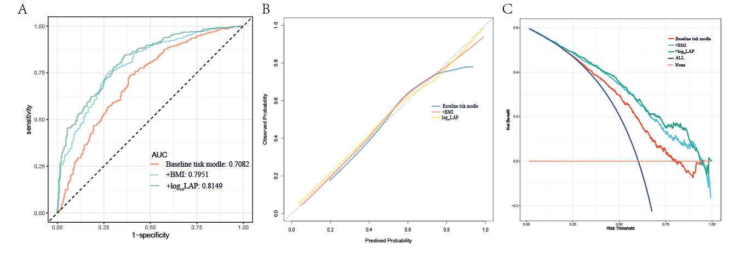
(A) Receiver operating characteristic (ROC) curves; (B) Calibration curves; (C) Decision curve analysis (DCA).
Model 1 (Baseline risk model) includes [Age ,Sex ,Hypertension ,Hyperlipidemia ,Smoking ,Drink ,WBC ,PLT ,ALT ,AST ,Cr ,UA ,VD ,HbA1c ,Duration.of.diabetes, Arb ,Stain ,Ezetimibe]; Model 2 (BMI-augmented model) includes Model 1 plus BMI; Model 3 (LAP-augmented model) includes Model 1 plus log₁₀LAP.
Panel A illustrates the discriminative ability of the three models, with Model 3 achieving the highest AUC (0.8149).
Panel B shows the calibration of the models, where the alignment between predicted and observed MASLD probabilities is depicted; Model 3 demonstrates close proximity to the ideal 45-degree dashed line.
Panel C presents the DCA, illustrating the clinical net benefit of each model across a range of threshold probabilities.
Abbreviations: AUC, area under the curve; BMI, body mass index; LAP, lipid accumulation product; MASLD, metabolic dysfunction-associated steatotic liver diseas

Supplementary Table 15. Association between log₁₀LAP tertiles and MASLD risk in the NHANES cohort
Categories | Unadjust |  | Model 1 |  | Model 2 |  | Model3 |  |  | Model 4
Categories | OR (95%CI) | P value | OR (95%CI) | P value | OR (95%CI) | P value | OR (95%CI) | P value |  | OR (95%CI) | P value
log₁₀LAP tertiles
T1 | 1(Ref) |  | 1(Ref) |  | 1(Ref) |  | 1(Ref) |  |  | 1(Ref)
T2 | 2.7  (1.82~4) | <0.001 | 2.83 (1.9~4.23) | <0.001 | 2.76 (1.84~4.15) | <0.001 | 2.36 (1.55~3.6) | <0.001 |  | 2.4 (1.56~3.67) | <0.001
T3 | 7.12 (4.58~11.07) | <0.001 | 7.32 (4.68~11.45) | <0.001 | 7.19 (4.53~11.39) | <0.001 | 5.81 (3.57~9.45) | <0.001 |  | 5.81 (3.54~9.56) | <0.001
P for trend |  | <0.001 |  | <0.001 |  | <0.001 |  | <0.001 |  |  | <0.001
OR (Odds Ratio); CI Confidence interval
log₁₀LAP, log-transformed lipid accumulation product.BMI Body-mass index, WBC White blood cell count, PLT Platelet count, ALT Alanine aminotransferase, AST Aspartate aminotransferase, Cr Serum creatinine, UA Uric acid, VD Vitamin D, ARB Angiotensin-receptor blocker, Statins HMG-CoA reductase inhibitors, Ezetimibe Ezetimibe
Unadjust: unadjusted
Model 1: adjusted for age and sex
Model 2: adjusted for variables in Model 1 plus smoking, alcohol consumption, BMI, hypertension, and hyperlipidemia
Model 3: adjusted for variables in Model 2 plus WBC, PLT, ALT, AST, Cr, VD, UA, Duration.of.diabetes and HbA1c

Supplementary Table 16 Association between log₁₀LAP quintiles and MASLD risk in the NHANES cohort
Categories | Unadjust |  | Model 1 |  | Model 2 |  | Model3 |  | Model 4
Categories | OR (95%CI) | P value | OR (95%CI) | P value | OR (95%CI) | P value | OR (95%CI) | P value | OR (95%CI) | P value
log₁₀LAP quintiles
Q1 | 1(Ref) |  | 1(Ref) |  | 1(Ref) |  | 1(Ref) |  | 1(Ref)
Q2 | 3.98 (2.34~6.76) | <0.001 | 4.29 (2.51~7.35) | <0.001 | 3.32 (1.94~5.69) | <0.001 | 2.91 (1.67~5.07) | <0.001 | 3.11 (1.77~5.46) | <0.001
Q3 | 6.76 (3.9~11.74) | <0.001 | 7.36 (4.2~12.9) | <0.001 | 4.17 (2.43~7.18) | <0.001 | 3.34 (1.9~5.88) | <0.001 | 3.47 (1.96~6.16) | <0.001
Q4 | 15.24 (8.14~28.52) | <0.001 | 15.77 (8.38~29.69) | <0.001 | 7.29 (4.12~12.9) | <0.001 | 5.5 (3.01~10.06) | <0.001 | 5.87 (3.18~10.82) | <0.001
Q5 | 1.84 (1.62~2.1) | <0.001 | 1.86 (1.63~2.12) | <0.001 | 15.11 (7.91~28.86) | <0.001 | 12.33 (6.24~24.37) | <0.001 | 12.6 (6.28~25.26) | <0.001
P for trend |  | <0.001 |  | <0.001 |  | <0.001 |  | <0.001 |  | <0.001
OR (Odds Ratio); CI Confidence interval
log₁₀LAP, log-transformed lipid accumulation product.BMI Body-mass index,WBC White blood cell count, PLT Platelet count, ALT Alanine aminotransferase, AST Aspartate aminotransferase, Cr Serum creatinine, UA Uric acid, VD Vitamin D, ARB Angiotensin-receptor blocker, Statins HMG-CoA reductase inhibitors, Ezetimibe Ezetimibe
Unadjust: unadjusted
Model 1: adjusted for age and sex
Model 2: adjusted for variables in Model 1 plus smoking, alcohol consumption, BMI, hypertension, and hyperlipidemia
Model 3: adjusted for variables in Model 2 plus WBC, PLT, ALT, AST, Cr, VD, UA, Duration.of.diabetes and HbA1c

Supplementary Table 17. Association between log₁₀LAP quartiles and MASLD risk after exclusion of extreme values (0.5th–99.5th percentiles) in the NHANES cohort
Categories | Unadjust |  | Model 1 |  | Model 2 |  | Model3 |  | Model 4
Categories | OR (95%CI) | P value | OR (95%CI) | P value | OR (95%CI) | P value | OR (95%CI) | P value | OR (95%CI) | P value
log₁₀LAP Q4
Q1 | 1(Ref) |  | 1(Ref) |  | 1(Ref) |  | 1(Ref) |  | 1(Ref)
Q2 | 3.49 (2.17~5.62) | <0.001 | 3.49 (2.17~5.62) | <0.001 | 3.59  (2.22~5.8) | <0.001 | 3.2 (1.95~5.24) | <0.001 | 3.23 (1.96~5.34) | <0.001
Q3 | 5.3 (3.24~8.68) | <0.001 | 5.3 (3.24~8.68) | <0.001 | 5.31 (3.22~8.76) | <0.001 | 4.5 (2.68~7.57) | <0.001 | 4.53 (2.67~7.66) | <0.001
Q4 | 11.49 (6.65~19.83) | <0.001 | 11.49 (6.65~19.83) | <0.001 | 11.53 (6.57~20.22) | <0.001 | 9.81 (5.41~17.77) | <0.001 | 10.18 (5.55~18.66) | <0.001
P for trend |  | <0.001 |  | <0.001 |  | <0.001 |  | <0.001 |  | <0.001
OR (Odds Ratio); CI Confidence interval
log₁₀LAP, log-transformed lipid accumulation product.BMI Body-mass index, WBC White blood cell count, PLT Platelet count, ALT Alanine aminotransferase, AST Aspartate aminotransferase, Cr Serum creatinine, UA Uric acid, VD Vitamin D, ARB Angiotensin-receptor blocker, Statins HMG-CoA reductase inhibitors, Ezetimibe Ezetimibe
Unadjust: unadjusted
Model 1: adjusted for age and sex
Model 2: adjusted for variables in Model 1 plus smoking, alcohol consumption, BMI, hypertension, and hyperlipidemia
Model 3: adjusted for variables in Model 2 plus WBC, PLT, ALT, AST, Cr, VD, UA and HbA1c
Model 4: adjusted for variables in Model 3 plus ARB, statins, ezetimibe, Duration.of.diabetes and HbA1c.

