Supplementary Figure 1. Mortality rate (A) and follow-up years (B) among adolescents by weight categories
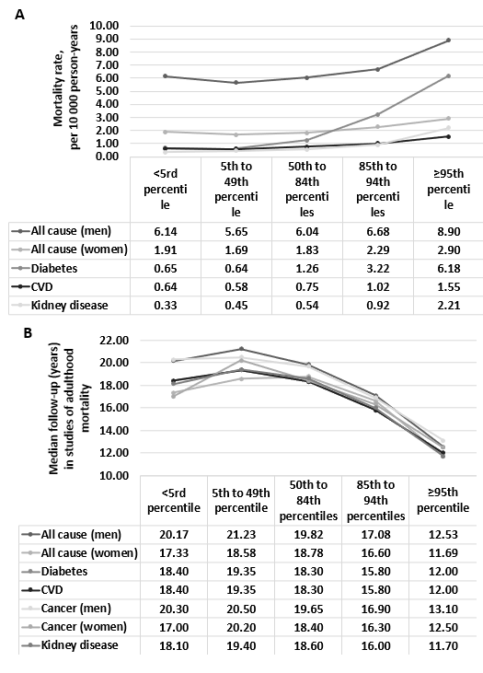
Legend: A Mortality rate, per 10 000 person-years, data extracted from Twig et al, 2014[46] for all-cause mortality, Twig G. et al 2016[49] for CVD mortality, Twig G. et al 2018[50] for kidney disease mortality, Twig et al 2016[48] for CVD mortality. B Median follow-up Data extracted from Twig et al, 2014[46], Twig G. et al 2016[49] for diabetes mortality, Furer et al 2020[33] for cancer mortality, Twig. et al 2018[50] for kidney disease mortality, Twig et al 2016[48] for CVD mortality. Follow-up ended at the time of reported death, or end of follow-up, (for all-cause mortality: or the age of 50 years, whichever came first.

