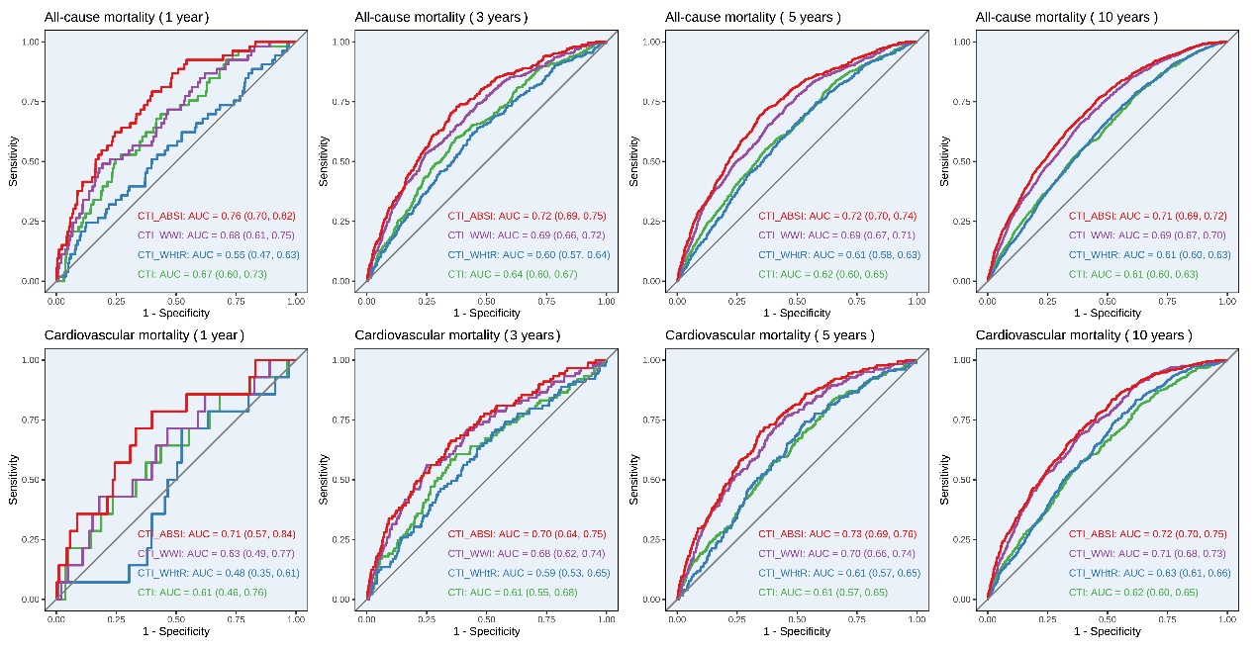
Figure S1. Time-dependent ROC analysis for predicting all-cause mortality and cardiovascular mortality during 1, 3, 5, 10-year follow up
Abbreviation: AUC = area under the curves; CTI = C-reactive protein-triglyceride-glucose index; CTI-ABSI = C-reactive protein-triglyceride-glucose index-a body shape index; CTI-WHtR = C-reactive protein-triglyceride-glucose index-waist-to-height ratio; CTI-WWI = C-reactive protein-triglyceride-glucose index-weight-adjusted waist index; ROC = Receiver operating characteristic

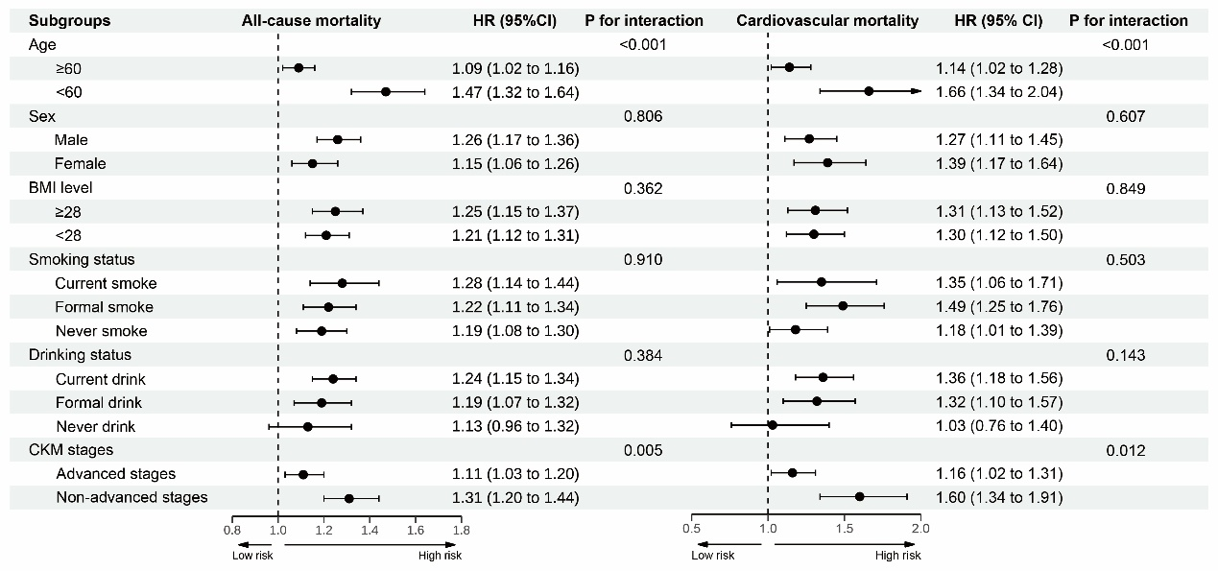
Figure S2. Subgroup analysis of the association between the per SD increase of the CTI index and all-cause as well as cardiovascular mortality
Model adjusted for age, sex, ethnicity, education, marital status, family income to federal poverty ratio level, smoking, drinking, cardiovascular-kidney-metabolic syndrome stages, estimated glomerular filtration rate, high density lipoprotein cholesterol, and albumin. Advanced CKM stages were CKM stage 3 and 4, and non-advanced CKM stages were CKM stage 0, 1 and 2.
Abbreviation: BMI = body mass index; CKM = cardiovascular-kidney-metabolic syndrome; CTI = C-reactive protein-triglyceride-glucose index

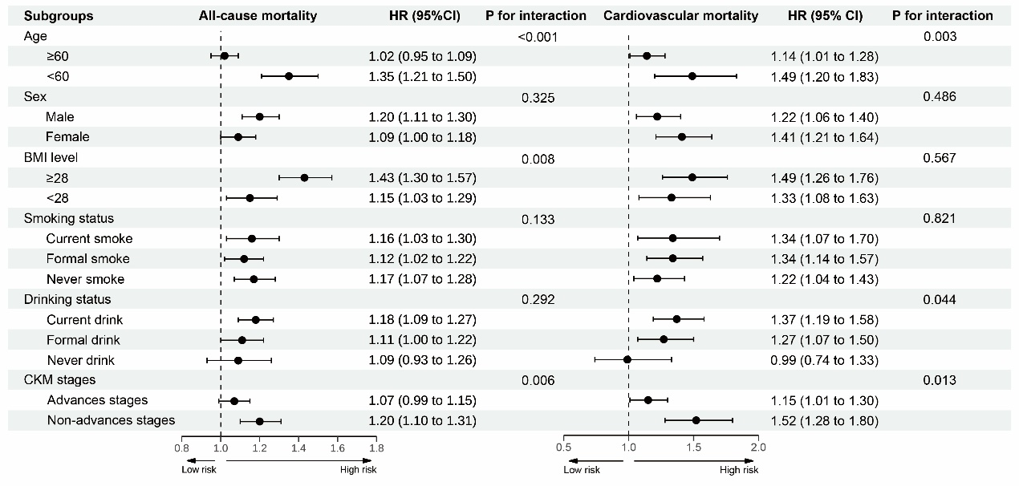
Figure S3. Subgroup analysis of the association between the per SD increase of the CTI-WHtR index and all-cause as well as cardiovascular mortality
Model adjusted for age, sex, ethnicity, education, marital status, family income to federal poverty ratio level, smoking, drinking, cardiovascular-kidney-metabolic syndrome stages, estimated glomerular filtration rate, high density lipoprotein cholesterol, and albumin. Advanced CKM stages were CKM stage 3 and 4, and non-advanced CKM stages were CKM stage 0, 1 and 2.
Abbreviation: BMI = body mass index; CKM = cardiovascular-kidney-metabolic syndrome; CTI-WHtR = C-reactive protein-triglyceride-glucose index-waist-to-height ratio

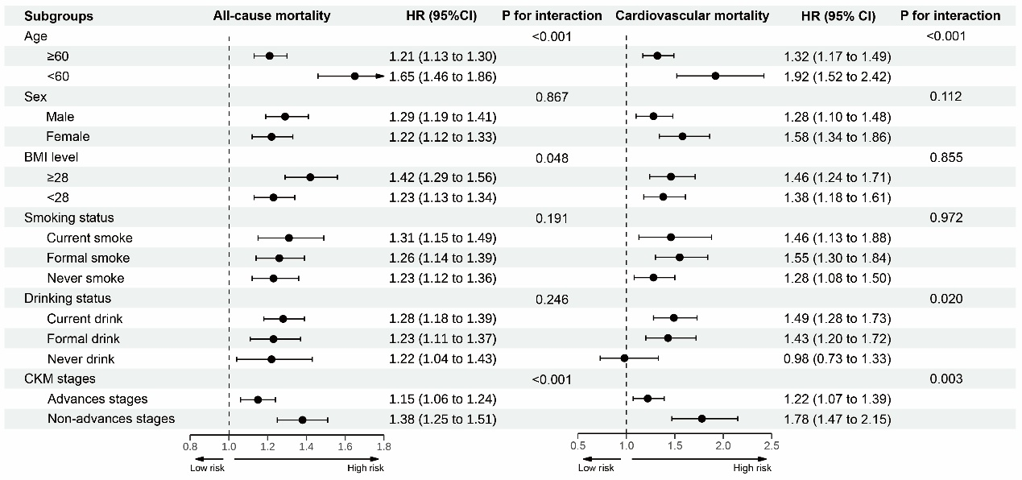
Figure S4. Subgroup analysis of the association between the per SD increase of the CTI-WWI index and all-cause as well as cardiovascular mortality
Model adjusted for age, sex, ethnicity, education, marital status, family income to federal poverty ratio level, smoking, drinking, cardiovascular-kidney-metabolic syndrome stages, estimated glomerular filtration rate, high density lipoprotein cholesterol, and albumin. Advanced CKM stages were CKM stage 3 and 4, and non-advanced CKM stages were CKM stage 0, 1 and 2.
Abbreviation: BMI = body mass index; CKM = cardiovascular-kidney-metabolic syndrome; CTI-WWI = C-reactive protein-triglyceride-glucose index-weight-adjusted waist index

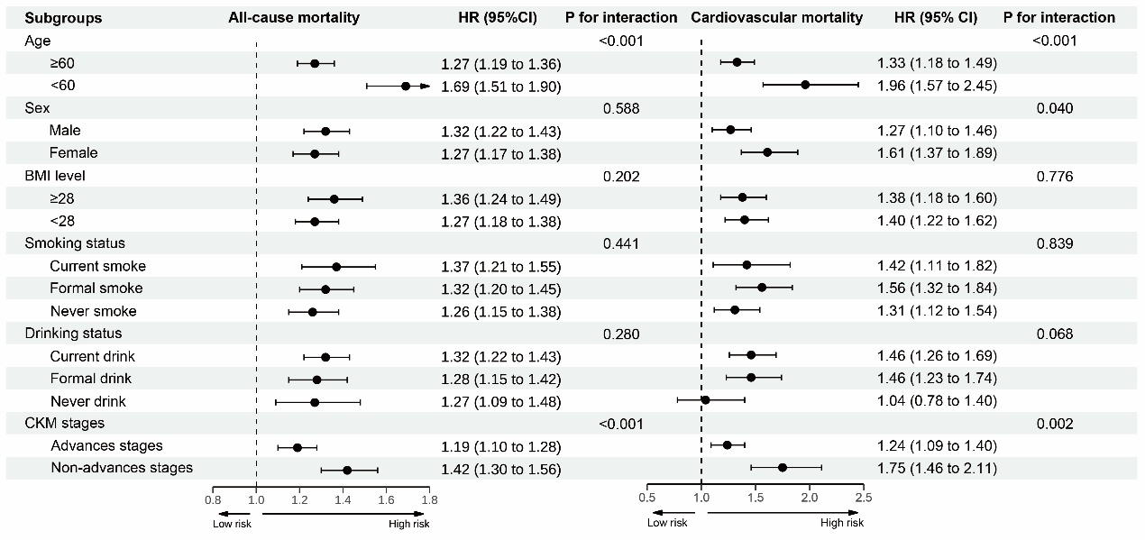
Figure S5. Subgroup analysis of the association between the per SD increase of the CTI-ABSI index and all-cause as well as cardiovascular mortality
Model adjusted for age, sex, ethnicity, education, marital status, family income to federal poverty ratio level, smoking, drinking, cardiovascular-kidney-metabolic syndrome stages, estimated glomerular filtration rate, high density lipoprotein cholesterol, and albumin. Advanced CKM stages were CKM stage 3 and 4, and non-advanced CKM stages were CKM stage 0, 1 and 2.
Abbreviation: BMI = body mass index; CKM = cardiovascular-kidney-metabolic syndrome; CTI-ABSI = C-reactive protein-triglyceride-glucose index-a body shape index

Table S1 The baseline characteristics of included and excluded participants after excluding individuals under 20 years old
Characteristics | Overall | Excluded | Included | P value
Characteristics | N=32464 | N=21523 | N=10941 | P value
Demographic information
Age, years | 50.02 (18.88) | 50.09 (19.45) | 49.89 (17.69) | 0.372
Gender, n (%) |  |  |  | <0.001
Female | 16,938 (52.2) | 11,563 (53.7) | 5,375 (49.1)
Male | 15526 (47.8) | 9960 (46.3) | 5566 (50.9)
Ethnicity, n (%) |  |  |  | <0.001
Hispanic | 8707 (26.8) | 5663 (26.3) | 3044 (27.8)
Non-hispanic black | 6388 (19.7) | 4391 (20.4) | 1997 (18.3)
Non-hispanic white | 15993 (49.3) | 10513 (48.8) | 5480 (50.1)
Other | 1376 (4.2) | 956 (4.4) | 420 (3.8)
Education, n (%) |  |  |  | <0.001
Bachelor degree or more | 6124 (18.9) | 4001 (18.7) | 2123 (19.4)
Some college | 8469 (26.2) | 5514 (25.7) | 2955 (27.0)
High school diploma or less | 17781 (54.9) | 11933 (55.6) | 5848 (53.5)
Marital status, n (%) |  |  |  | <0.001
Never married | 5231 (16.4) | 3556 (16.8) | 1675 (15.6)
Formerly married | 7407 (23.2) | 5095 (24.1) | 2312 (21.5)
Married | 19255 (60.4) | 12479 (59.1) | 6776 (63.0)
PIR level, n (%) |  |  |  | <0.001
<1.30 | 8758 (29.7) | 5961 (30.6) | 2797 (27.8)
1.30-2.99 | 9589 (32.5) | 6372 (32.7) | 3217 (32.0)
≥3.00 | 11178 (37.9) | 7142 (36.7) | 4036 (40.2)
Smoking, n (%) |  |  |  | <0.001
Current smoke | 7055 (21.8) | 4596 (21.4) | 2459 (22.5)
Former smoke | 8350 (25.8) | 5445 (25.4) | 2905 (26.6)
Never smoke | 17009 (52.5) | 11432 (53.2) | 5577 (51.0)
Drinking, n (%) |  |  |  | <0.001
Current drink | 18125 (64.8) | 11096 (63.2) | 7029 (67.4)
Former drink | 5780 (20.7) | 3743 (21.3) | 2037 (19.5)
Never drink | 4064 (14.5) | 2707 (15.4) | 1357 (13.0)
Body mass index, kg/m² | 28.58 (6.40) | 28.64 (6.63) | 28.49 (6.02) | 0.062
Systolic blood pressure, mmHg | 124.53 (19.66) | 124.67 (20.06) | 124.32 (19.06) | 0.156
Diastolic blood pressure, mmHg | 70.27 (12.83) | 70.15 (13.15) | 70.45 (12.36) | 0.061
Waist circumference, cm | 98.09 (15.55) | 98.21 (15.94) | 97.88 (14.89) | 0.075
Comorbidities
CKM stages, n (%) |  |  |  | <0.001
Stages 0 | 1176 (7.4) | 120 (2.4) | 1056 (9.7)
Stages 1 | 2055 (12.9) | 113 (2.3) | 1942 (17.7)
Stages 2 | 7122 (44.9) | 1349 (27.3) | 5773 (52.8)
Stages 3 | 1688 (10.6) | 753 (15.3) | 935 (8.5)
Stages 4 | 3836 (24.2) | 2601 (52.7) | 1235 (11.3)
Diabetes mellitus, n (%) | 4379 (26.7) | 2829 (52.1) | 1550 (14.2) | <0.001
Hypertension, n (%) | 13187 (40.7) | 8686 (40.5) | 4501 (41.1) | 0.238
Chronic kidney disease, n (%) | 5607 (19.5) | 3747 (21.1) | 1860 (17.0) | <0.001
Cardiovascular disease, n (%) | 3836 (11.8) | 2601 (12.1) | 1235 (11.3) | 0.037
Metabolic syndrome, n (%) | 8846 (54.7) | 4407 (83.4) | 4439 (40.7) | <0.001
Laboratory indices
CTI | 9.04 (0.95) | 9.20 (1.11) | 9.00 (0.89) | <0.001
CTI-WHtR | 5.32 (1.21) | 5.48 (1.48) | 5.29 (1.15) | <0.001
CTI-WWI | 99.69 (15.47) | 103.13 (18.90) | 98.92 (14.48) | <0.001
CTI-ABSI | 0.74 (0.10) | 0.75 (0.13) | 0.73 (0.09) | <0.001
Total cholesterol, mg/dL | 200.06 (42.85) | 200.89 (43.76) | 198.70 (41.29) | <0.001
Triglyceride, mg/dL | 144.71 (124.60) | 162.34 (181.39) | 139.75 (102.63) | <0.001
LDLC, mg/dL | 117.88 (36.16) | 115.43 (38.42) | 118.54 (35.50) | <0.001
HDLC, mg/dL | 52.96 (16.24) | 53.03 (16.56) | 52.83 (15.70) | 0.302
Fasting plasma glucose, mg/dL | 106.51 (36.02) | 108.12 (47.40) | 106.04 (31.91) | 0.004
HbA1c, % | 5.40 [5.10, 5.80] | 5.40 [5.10, 5.80] | 5.40 [5.20, 5.80] | <0.001
eGFR, mL/min/1.73m2 | 95.63 (23.83) | 95.53 (24.90) | 95.81 (21.98) | 0.334
Albumin, g/L | 42.29 (3.72) | 42.16 (3.99) | 42.51 (3.21) | <0.001
C-reactive protein, mg/dL | 0.47 (0.90) | 0.49 (0.93) | 0.43 (0.86) | <0.001
Medicine
Statins use, n (%) | 4543 (14.0) | 2958 (13.7) | 1585 (14.5) | 0.071
Antihypertensive use, n (%) | 9636 (29.7) | 6414 (29.8) | 3222 (29.4) | 0.52
Anti-diabetic use, n (%) | 3010 (9.3) | 2054 (9.5) | 956 (8.7) | 0.019
Data were expressed as mean (standard deviation), medians (interquartile range), or n (%). Abbreviation: CKM = cardiovascular-kidney-metabolic syndrome; CTI = C-reactive protein-triglyceride-glucose index; CTI-ABSI = C-reactive protein-triglyceride-glucose index-a body shape index; CTI-WHtR = C-reactive protein-triglyceride-glucose index-waist-to-height ratio; CTI-WWI = C-reactive protein-triglyceride-glucose index-weight-adjusted waist index; eGFR = estimated glomerular filtration rate; HbA1c = glycohemoglobin; HDLC: high density lipoprotein cholesterol; LDLC: low density lipoprotein cholesterol; PIR: family income to federal poverty ratio.

Table S2 The weighted baseline characteristics of study individuals according to the CTI index quartiles
Characteristics | Overall | Quartile 1 | Quartile 2 | Quartile 3 | Quartile 4 | P value
Demographic information
Age, years | 46.18±0.30 | 40.63±0.40 | 46.08±0.45 | 48.96±0.45 | 50.38±0.36 | <0.001
Gender, n (%) |  |  |  |  |  | <0.001
Female | 5031 (49.9) | 1325 (53.4) | 1181 (45.8) | 1246 (48.8) | 1279 (51.4)
Male | 5152 (50.1) | 1236 (46.6) | 1391 (54.2) | 1317 (51.2) | 1208 (48.6)
Ethnicity, n (%) |  |  |  |  |  | <0.001
Hispanic | 2842 (12.4) | 558 (10.0) | 686 (12.2) | 766 (14.2) | 832 (14.0)
Non-hispanic black | 1800 (10.1) | 583 (12.5) | 474 (10.4) | 422 (9.4) | 321 (7.7)
Non-hispanic white | 5153 (72.2) | 1295 (71.3) | 1308 (72.3) | 1282 (71.3) | 1268 (74.4)
Other | 388 (5.2) | 125 (6.3) | 104 (5.1) | 93 (5.1) | 66 (4.0)
Education, n (%) |  |  |  |  |  | <0.001
Bachelor degree or more | 2013 (25.7) | 708 (34.4) | 544 (26.5) | 439 (22.1) | 322 (17.8)
Some college | 2792 (30.4) | 779 (31.2) | 698 (30.7) | 673 (29.7) | 642 (29.9)
High school diploma or less | 5367 (43.8) | 1073 (34.4) | 1328 (42.9) | 1446 (48.3) | 1520 (52.3)
Marital status, n (%) |  |  |  |  |  | <0.001
Never married | 1528 (15.8) | 601 (22.9) | 379 (16.1) | 299 (12.2) | 249 (11.6)
Formerly married | 2114 (16.8) | 385 (12.4) | 555 (17.9) | 565 (18.5) | 609 (20.9)
Married | 6377 (65.5) | 1540 (64.7) | 1597 (66.0) | 1660 (69.4) | 1580 (67.5)
PIR level, n (%) |  |  |  |  |  | <0.001
<1.30 | 2575 (17.5) | 560 (16.2) | 595 (16.9) | 655 (18.9) | 765 (23.6)
1.30-2.99 | 3007 (27.3) | 710 (27.5) | 764 (28.5) | 796 (30.6) | 737 (30.1)
≥3.00 | 3812 (49.2) | 1089 (56.3) | 1022 (54.6) | 914 (50.6) | 787 (46.3)
Smoking, n (%) |  |  |  |  |  | <0.001
Current smoke | 2231 (23.6) | 511 (21.3) | 555 (23.6) | 543 (23.0) | 622 (27.3)
Former smoke | 2712 (25.7) | 543 (21.4) | 663 (24.0) | 745 (28.6) | 761 (30.3)
Never smoke | 5240 (50.7) | 1507 (57.4) | 1354 (52.5) | 1275 (48.4) | 1104 (42.5)
Drinking, n (%) |  |  |  |  |  | <0.001
Current drink | 1254 (10.2) | 289 (10.3) | 285 (9.6) | 316 (9.9) | 364 (12.8)
Former drink | 1878 (15.6) | 334 (11.2) | 441 (15.7) | 536 (18.9) | 567 (20.1)
Never drink | 6634 (70.7) | 1818 (78.5) | 1734 (74.7) | 1606 (71.2) | 1476 (67.2)
Body mass index, kg/m² | 28.21±0.09 | 24.69±0.10 | 27.47±0.14 | 29.78±0.14 | 31.86±0.17 | <0.001
Systolic blood pressure, mmHg | 121.25±0.27 | 115.51±0.43 | 120.77±0.41 | 124.02±0.45 | 126.28±0.45 | <0.001
Diastolic blood pressure, mmHg | 70.91±0.23 | 68.67±0.35 | 70.67±0.31 | 72.48±0.32 | 72.42±0.37 | <0.001
Waist circumference, cm | 97.01±0.24 | 87.02±0.26 | 95.37±0.38 | 101.43±0.33 | 106.90±0.40 | <0.001
Comorbidities
CKM stages, n (%) |  |  |  |  |  | <0.001
Stages 0 | 992 (13.0) | 720 (33.4) | 216 (11.2) | 54 (2.9) | 2 (0.1)
Stages 1 | 1845 (19.6) | 778 (30.0) | 681 (28.3) | 322 (13.0) | 64 (3.1)
Stages 2 | 5383 (54.6) | 825 (30.9) | 1220 (49.2) | 1625 (68.7) | 1713 (75.8)
Stages 3 | 856 (4.6) | 92 (1.8) | 194 (3.9) | 264 (5.7) | 306 (7.6)
Stages 4 | 1107 (8.3) | 146 (3.9) | 261 (7.4) | 298 (9.7) | 402 (13.4)
Diabetes mellitus, n (%) | 1341 (9.5) | 86 (2.2) | 192 (5.3) | 333 (9.9) | 730 (23.4) | <0.001
Hypertension, n (%) | 4163 (34.8) | 623 (18.9) | 966 (32.3) | 1203 (42.0) | 1371 (50.2) | <0.001
Chronic kidney disease, n (%) | 1677 (12.0) | 239 (6.8) | 364 (10.4) | 460 (13.0) | 614 (19.3) | <0.001
Cardiovascular disease, n (%) | 1107 (8.3) | 146 (3.9) | 261 (7.4) | 298 (9.7) | 402 (13.4) | <0.001
Metabolic syndrome, n (%) | 4136 (36.6) | 229 (7.2) | 655 (22.5) | 1314 (50.5) | 1938 (76.2) | <0.001
Laboratory indices
CTI | 8.91±0.01 | 7.85±0.01 | 8.70±0.00 | 9.29±0.00 | 10.11±0.01 | <0.001
CTI-WHtR | 5.14±0.02 | 4.03±0.01 | 4.88±0.02 | 5.58±0.02 | 6.40±0.03 | <0.001
CTI-WWI | 96.56±0.22 | 81.14±0.19 | 93.22±0.18 | 102.52±0.17 | 113.75±0.24 | <0.001
CTI-ABSI | 0.72±0.00 | 0.62±0.00 | 0.70±0.00 | 0.76±0.00 | 0.83±0.00 | <0.001
Total cholesterol, mg/dL | 198.63±0.58 | 184.15±0.85 | 195.40±0.82 | 203.48±0.98 | 215.68±1.35 | <0.001
Triglyceride, mg/dL | 137.45±1.26 | 74.53±0.62 | 107.89±0.97 | 145.83±1.26 | 243.47±4.54 | <0.001
LDLC, mg/dL | 118.61±0.47 | 108.36±0.76 | 119.47±0.74 | 124.83±0.86 | 124.61±1.09 | <0.001
HDLC, mg/dL | 52.98±0.24 | 60.90±0.42 | 54.34±0.34 | 49.54±0.39 | 44.96±0.32 | <0.001
Fasting plasma glucose, mg/dL | 102.04±0.33 | 93.79±0.29 | 98.02±0.36 | 102.33±0.40 | 117.00±1.07 | <0.001
HbA1c, % | 5.30 [5.10, 5.60] | 5.20 [5.00, 5.40] | 5.30 [5.10, 5.50] | 5.40 [5.20, 5.70] | 5.60 [5.30, 6.00] | <0.001
eGFR, mL/min/1.73m² | 98.29±0.41 | 102.58±0.53 | 98.58±0.53 | 96.11±0.59 | 94.84±0.62 | <0.001
Albumin, g/L | 42.84±0.07 | 43.79±0.10 | 43.04±0.08 | 42.41±0.09 | 41.87±0.10 | <0.001
C-reactive protein, mg/dL | 0.40±0.01 | 0.08±0.00 | 0.22±0.01 | 0.46±0.01 | 0.94±0.03 | <0.001
Medicine
Statins use, n (%) | 1478 (12.7) | 236 (7.1) | 352 (11.9) | 444 (16.4) | 446 (16.6) | <0.001
Antihypertensive use, n (%) | 2976 (24.1) | 408 (11.9) | 664 (20.8) | 856 (29.2) | 1048 (38.1) | <0.001
Anti-diabetic use, n (%) | 822 (5.7) | 61 (1.6) | 124 (3.3) | 217 (6.1) | 420 (13.4) | <0.001
Data were expressed as mean (standard deviation), medians (interquartile range), or n (%). Abbreviation: CKM = cardiovascular-kidney-metabolic syndrome; CTI = C-reactive protein-triglyceride-glucose index; CTI-ABSI = C-reactive protein-triglyceride-glucose index-a body shape index; CTI-WHtR = C-reactive protein-triglyceride-glucose index-waist-to-height ratio; CTI-WWI = C-reactive protein-triglyceride-glucose index-weight-adjusted waist index; eGFR = estimated glomerular filtration rate; HbA1c = glycohemoglobin; HDLC: high density lipoprotein cholesterol; LDLC: low density lipoprotein cholesterol; PIR: family income to federal poverty ratio.

Table S3 The association between CTI-related indices and all-cause and cardiovascular mortality after being weighted
Groups | Model 1 |  | Model 2 |  | Model 3
Groups | HR (95%CI) | P value | HR (95%CI) | P value | HR (95%CI) | P value
All-cause mortality
CTI, per SD increase | 1.58 (1.50-1.67) | <0.001 | 1.32 (1.25-1.39) | <0.001 | 1.25 (1.17-1.34) | <0.001
CTI groups
Quartile 1 | Ref | - | Ref | - | Ref | -
Quartile 2 | 2.09 (1.73-2.53) | <0.001 | 1.33 (1.08-1.64) | 0.007 | 1.27 (1.03-1.56) | 0.028
Quartile 3 | 2.68 (2.21-3.24) | <0.001 | 1.38 (1.13-1.69) | 0.002 | 1.31 (1.06-1.62) | 0.013
Quartile 4 | 3.67 (3.08-4.38) | <0.001 | 1.93 (1.63-2.27) | <0.001 | 1.64 (1.37-1.97) | <0.001
CTI-WHtR, per SD increase | 1.50 (1.43-1.58) | <0.001 | 1.22 (1.15-1.29) | <0.001 | 1.18 (1.10-1.26) | <0.001
CTI-WHtR groups
Quartile 1 | Ref | - | Ref | - | Ref | -
Quartile 2 | 1.90 (1.58-2.29) | <0.001 | 1.05 (0.86-1.29) | 0.638 | 0.98 (0.78-1.21) | 0.821
Quartile 3 | 2.64 (2.20-3.17) | <0.001 | 1.19 (0.99-1.43) | 0.065 | 1.10 (0.90-1.34) | 0.376
Quartile 4 | 3.47 (2.93-4.10) | <0.001 | 1.48 (1.24-1.77) | <0.001 | 1.29 (1.08-1.55) | 0.006
CTI-WWI, per SD increase | 1.97 (1.87-2.09) | <0.001 | 1.36 (1.28-1.44) | <0.001 | 1.29 (1.20-1.38) | <0.001
CTI-WWI groups
Quartile 1 | Ref | - | Ref | - | Ref | -
Quartile 2 | 2.58 (2.07-3.21) | <0.001 | 1.35 (1.09-1.68) | 0.007 | 1.19 (0.94-1.50) | 0.143
Quartile 3 | 3.91 (3.15-4.85) | <0.001 | 1.49 (1.19-1.86) | <0.001 | 1.30 (1.01-1.68) | 0.043
Quartile 4 | 6.87 (5.63-8.38) | <0.001 | 2.08 (1.67-2.59) | <0.001 | 1.66 (1.32-2.09) | <0.001
CTI-ABSI, per SD increase | 2.08 (1.96-2.21) | <0.001 | 1.45 (1.37-1.54) | <0.001 | 1.31 (1.22-1.39) | <0.001
CTI-ABSI groups
Quartile 1 | Ref | - | Ref | - | Ref | -
Quartile 2 | 2.21 (1.75-2.78) | <0.001 | 1.26 (1.01-1.57) | 0.038 | 1.10 (0.86-1.41) | 0.441
Quartile 3 | 4.01 (3.21-5.01) | <0.001 | 1.56 (1.27-1.93) | <0.001 | 1.30 (1.00-1.68) | 0.047
Quartile 4 | 7.42 (6.10-9.04) | <0.001 | 2.33 (1.92-2.82) | <0.001 | 1.68 (1.31-2.16) | <0.001
Cardiovascular mortality
CTI, per SD increase | 1.62 (1.47-1.79) | <0.001 | 1.35 (1.20-1.52) | <0.001 | 1.36 (1.17-1.56) | <0.001
CTI groups
Quartile 1 | Ref | - | Ref | - | Ref | -
Quartile 2 | 2.27 (1.60-3.22) | <0.001 | 1.39 (0.99-1.95) | 0.061 | 1.31 (0.92-1.88) | 0.135
Quartile 3 | 3.16 (2.24-4.46) | <0.001 | 1.54 (1.10-2.15) | 0.012 | 1.52 (1.02-2.27) | 0.042
Quartile 4 | 4.04 (2.89-5.64) | <0.001 | 2.04 (1.49-2.79) | <0.001 | 1.96 (1.36-2.83) | <0.001
CTI-WHtR, per SD increase | 1.63 (1.50-1.76) | <0.001 | 1.34 (1.21-1.50) | <0.001 | 1.36 (1.19-1.56) | <0.001
CTI-WHtR groups
Quartile 1 | Ref | - | Ref | - | Ref | -
Quartile 2 | 2.29 (1.61-3.26) | <0.001 | 1.19 (0.85-1.67) | 0.301 | 1.20 (0.82-1.77) | 0.345
Quartile 3 | 3.02 (2.17-4.19) | <0.001 | 1.26 (0.94-1.71) | 0.128 | 1.26 (0.86-1.86) | 0.24
Quartile 4 | 4.33 (3.16-5.94) | <0.001 | 1.74 (1.29-2.34) | <0.001 | 1.69 (1.15-2.47) | 0.008
CTI-WWI, per SD increase | 2.15 (1.95-2.36) | <0.001 | 1.45 (1.30-1.62) | <0.001 | 1.49 (1.29-1.72) | <0.001
CTI-WWI groups
Quartile 1 | Ref | - | Ref | - | Ref | -
Quartile 2 | 3.45 (2.11- 5.64) | <0.001 | 1.69 (1.08-2.65) | 0.022 | 1.59 (0.96-2.64) | 0.073
Quartile 3 | 5.06 (3.25- 7.87) | <0.001 | 1.74 (1.14-2.66) | 0.011 | 1.83 (1.14-2.94) | 0.012
Quartile 4 | 10.21 (6.59-15.82) | <0.001 | 2.77 (1.82-4.23) | <0.001 | 2.73 (1.67-4.46) | <0.001
CTI-ABSI, per SD increase | 2.23 (2.01-2.46) | <0.001 | 1.52 (1.35-1.71) | <0.001 | 1.47 (1.28-1.68) | <0.001
CTI-ABSI groups
Quartile 1 | Ref | - | Ref | - | Ref | -
Quartile 2 | 2.29 (1.51- 3.48) | <0.001 | 1.24 (0.85-1.81) | 0.275 | 1.16 (0.76-1.76) | 0.500
Quartile 3 | 4.50 (2.92- 6.96) | <0.001 | 1.59 (1.05-2.41) | 0.028 | 1.55 (0.96-2.52) | 0.075
Quartile 4 | 8.98 (6.11-13.20) | <0.001 | 2.53 (1.77-3.63) | <0.001 | 2.26 (1.47-3.48) | <0.001
Model 1 was unadjusted; model 2 adjusted for age and sex; model 3 adjusted for model 2 plus ethnicity, education, marital status, family income to federal poverty ratio level, smoking, drinking, cardiovascular-kidney-metabolic syndrome stages, estimated glomerular filtration rate, high density lipoprotein cholesterol, and albumin.
Abbreviation: CTI = C-reactive protein-triglyceride-glucose index; CTI-ABSI = C-reactive protein-triglyceride-glucose index-a body shape index; CTI-WHtR = C-reactive protein-triglyceride-glucose index-waist-to-height ratio; CTI-WWI = C-reactive protein-triglyceride-glucose index-weight-adjusted waist index

Table S4 Predictive effect of CTI, CTI-WHtR, CTI-WWI, and CTI-ABSI on all-cause and cardiovascular mortality.
 | AUC (95%CI) | P value  (vs. CTI) | P value  (vs. CTI-WHtR) | P value  (vs. CTI-WWI) | P value  (vs. CTI-ABSI)
All-cause mortality
CTI | 0.630 (0.618-0.643) | - | 0.035 | <0.001 | <0.001
CTI-WHtR | 0.620 (0.608-0.633) | - | - | <0.001 | <0.001
CTI-WWI | 0.690 (0.678-0.702) | - | - | - | <0.001
CTI-ABSI | 0.711 (0.700-0.723) | - | - | - | -
Cardiovascular mortality
CTI | 0.614 (0.593-0.635) | - | 0.127 | <0.001 | <0.001
CTI-WHtR | 0.626 (0.606-0.645) | - | - | <0.001 | <0.001
CTI-WWI | 0.678 (0.659-0.697) | - | - | - | <0.001
CTI-ABSI | 0.690 (0.671-0.709) | - | - | - | -
Abbreviation: AUC = area under the curves; CTI = C-reactive protein-triglyceride-glucose index; CTI-ABSI = C-reactive protein-triglyceride-glucose index-a body shape index; CTI-WHtR = C-reactive protein-triglyceride-glucose index-waist-to-height ratio; CTI-WWI = C-reactive protein-triglyceride-glucose index-weight-adjusted waist index

Table S5 The association between CTI-related indices and all-cause mortality using stratification (strata) or time‑dependent coefficients (tt)
Groups | All-cause mortality*
Groups | HR (95%CI) | P value
CTI, per SD increase | 1.23 (1.16-1.30) | <0.001
CTI groups
Quartile 1 | Ref | -
Quartile 2 | 1.19 (1.02-1.40) | 0.030
Quartile 3 | 1.20 (1.02-1.41) | 0.025
Quartile 4 | 1.51 (1.28-1.78) | <0.001
CTI-WHtR, per SD increase | 1.16 (1.10-1.23) | <0.001
CTI-WHtR groups
Quartile 1 | Ref | -
Quartile 2 | 0.99 (0.84-1.16) | 0.913
Quartile 3 | 1.07 (0.91-1.26) | 0.402
Quartile 4 | 1.28 (1.09-1.51) | 0.003
CTI-WWI, per SD increase | 1.31 (1.24-1.39) | <0.001
CTI-WWI groups
Quartile 1 | Ref | -
Quartile 2 | 1.25 (1.03-1.50) | 0.021
Quartile 3 | 1.38 (1.15-1.66) | 0.001
Quartile 4 | 1.79 (1.48-2.15) | <0.001
CTI-ABSI, per SD increase | 1.35 (1.28-1.43) | <0.001
CTI-ABSI groups
Quartile 1 | Ref | -
Quartile 2 | 1.17 (0.96-1.42) | 0.118
Quartile 3 | 1.44 (1.19-1.74) | <0.001
Quartile 4 | 1.89 (1.56-2.29) | <0.001
*Corrected for PH violations: stratified by sex, time‑dependent coefficients for age and albumin.
Abbreviation: HR = hazard ratio; SD = Standard Deviation; CTI = C-reactive protein-triglyceride-glucose index; CTI-ABSI = C-reactive protein-triglyceride-glucose index-a body shape index; CTI-WHtR = C-reactive protein-triglyceride-glucose index-waist-to-height ratio; CTI-WWI = C-reactive protein-triglyceride-glucose index-weight-adjusted waist index

