Supplementary information
Table S1. Proportional subdistribution hazards assumption tests for the Fine–Gray models in CHARLS and ELSA
Table S2. GVIF analysis for the revised fully adjusted models in CHARLS and ELSA
Table S3. Calibration intercept, slope, and Brier score of the competing-risk prediction models in CHARLS and ELSA
Table S4. Cause-specific Cox sensitivity analysis for incident CMM in CHARLS and ELSA
Table S5. Sensitivity analysis with additional adjustment for LDL-C and HDL-C in CHARLS and ELSA
Table S6. Complete-case sensitivity analysis for incident CMM in CHARLS
Table S7. Sensitivity analysis excluding follow-up duration under 2 years in CHARLS
Table S8. Sensitivity analysis by redefining hypertension as ≥130/80 mmHg in CHARLS
Table S9. Sensitivity analysis with additional adjustment for depressive symptoms and grip strength in CHARLS
Table S10. Fine–Gray association comparison between additive and multiplicative CTI-WC specifications in CHARLS
Table S11. Seven-year discrimination results of additive and multiplicative CTI-WC specifications in CHARLS
Table S12. Seven-year reclassification results of additive and multiplicative CTI-WC specifications in CHARLS

Figure S1. Spearman correlation matrix of CTI-, TyG-, and obesity-modified indices in the CHARLS cohort
Figure S2. Spearman correlation matrix of CTI-, TyG-, and obesity-modified indices in the ELSA cohort
Figure S3. Schoenfeld residual plots for testing the proportional hazards assumption in the CHARLS cohort
Figure S4. Schoenfeld residual plots for testing the proportional hazards assumption in the ELSA cohort
Figure S5. Restricted cubic spline analyses of CTI-related indices and incident CMM in the ELSA cohort
Figure S6. Exploratory pathway analyses of CTI-WHtR in relation to incident CMM via SBP and ePWV in the CHARLS cohort

Table S1. Proportional subdistribution hazards assumption tests for the Fine–Gray models in CHARLS and ELSA
Model | Variable Name | CHARLS χ2 | CHARLS P value | ELSA χ² | ELSA P value
CTI-WHtR model | CTI-WHtR (Main exposure) | 0.36 | 0.548 | 0.03 | 0.858
 | Age | 0.16 | 0.693 | 0.38 | 0.537
 | Gender | 0.28 | 0.599 | 0.48 | 0.487
 | Education level | 0.36 | 0.549 | 0.03 | 0.857
 | Marital status | 0.10 | 0.752 | 0.73 | 0.392
 | Smoking status | 0.13 | 0.714 | 0.10 | 0.755
 | Alcohol consumption | 0.23 | 0.632 | 0.00 | 0.977
 | Hypertension | 0.89 | 0.347 | 0.24 | 0.624
 | Global test | 3.99 | 0.858 | 1.72 | 0.989
CTI-WC model | CTI-WC (Main exposure) | 0.93 | 0.335 | 0.04 | 0.836
 | Age | 0.15 | 0.696 | 0.39 | 0.534
 | Gender | 0.27 | 0.605 | 0.49 | 0.484
 | Education level | 0.35 | 0.556 | 0.03 | 0.857
 | Marital status | 0.10 | 0.749 | 0.74 | 0.391
 | Smoking status | 0.14 | 0.711 | 0.10 | 0.756
 | Alcohol consumption | 0.22 | 0.637 | 0.00 | 0.978
 | Hypertension | 0.88 | 0.349 | 0.24 | 0.626
 | Global Test | 4.32 | 0.827 | 1.70 | 0.989

Table S2. GVIF analysis for the revised fully adjusted models in CHARLS and ELSA
Variable Name | GVIF | Df | GVIF^(1/(2*Df))
CHARLS Cohort
Age | 1.1737 | 1 | 1.0834
Sex | 2.5618 | 1 | 1.6006
Education | 1.2375 | 1 | 1.1124
Marital status[1] | 1.0138 | 1 | 1.0069
Smoking | 2.0917 | 1 | 1.4463
Alcohol use | 1.4734 | 1 | 1.2138
Hypertension | 1.0983 | 1 | 1.0480
ELSA Cohort
Age | 1.1831 | 1 | 1.0877
Sex | 1.0773 | 1 | 1.0379
Education level | 1.1546 | 1 | 1.0745
Marital status | 1.0727 | 1 | 1.0357
Smoking status | 1.0464 | 1 | 1.0229
Alcohol consumption | 1.0669 | 1 | 1.0329
Hypertension | 1.0950 | 1 | 1.0464

Table S3. Calibration intercept, slope, and Brier score of the competing-risk prediction models in CHARLS and ELSA
Model | Calibration intercept | Calibration slope | Brier score
CHARLS cohort
Base | 0.022 | 1.174 | 0.048
Base + TyG | 0.024 | 1.128 | 0.048
Base + CTI | 0.030 | 1.127 | 0.048
Base + CTI-WC | 0.016 | 1.043 | 0.048
Base + CTI-WHtR | 0.019 | 1.062 | 0.048
ELSA cohort
Base | 0.002 | 1.077 | 0.064
Base + TyG | 0.002 | 1.128 | 0.063
Base + CTI | 0.002 | 1.126 | 0.063
Base + CTI-WC | 0.002 | 1.076 | 0.064
Base + CTI-WHtR | 0.002 | 1.066 | 0.064

Table S4. Cause-specific Cox sensitivity analysis for incident CMM in CHARLS and ELSA
Index | Model | per SD HR (95% CI) | P per SD | Q4 vs Q1 HR (95% CI) | P Q4 vs Q1 | P for trend
CHARLS cohort
CTI-WC | Model 1 | 1.65 (1.49–1.82) | <0.001 | 4.33 (2.93–6.40) | <0.001 | <0.001
CTI-WC | Model 2 | 1.64 (1.49–1.82) | <0.001 | 4.42 (2.98–6.54) | <0.001 | <0.001
CTI-WC | Model 3 | 1.59 (1.43–1.76) | <0.001 | 4.02 (2.70–5.99) | <0.001 | <0.001
CTI-WHtR | Model 1 | 1.65 (1.49–1.82) | <0.001 | 4.16 (2.84–6.08) | <0.001 | <0.001
CTI-WHtR | Model 2 | 1.65 (1.49–1.83) | <0.001 | 4.39 (2.96–6.51) | <0.001 | <0.001
CTI-WHtR | Model 3 | 1.59 (1.43–1.77) | <0.001 | 3.99 (2.67–5.96) | <0.001 | <0.001
CTI | Model 1 | 1.49 (1.34–1.65) | <0.001 | 3.48 (2.38–5.08) | <0.001 | <0.001
CTI | Model 2 | 1.47 (1.32–1.64) | <0.001 | 3.34 (2.29–4.89) | <0.001 | <0.001
CTI | Model 3 | 1.43 (1.28–1.59) | <0.001 | 3.07 (2.09–4.51) | <0.001 | <0.001
TyG-WC | Model 1 | 1.60 (1.45–1.77) | <0.001 | 4.15 (2.84–6.08) | <0.001 | <0.001
TyG-WC | Model 2 | 1.61 (1.45–1.78) | <0.001 | 4.15 (2.83–6.07) | <0.001 | <0.001
TyG-WC | Model 3 | 1.55 (1.40–1.72) | <0.001 | 3.76 (2.55–5.55) | <0.001 | <0.001
TyG-WHtR | Model 1 | 1.60 (1.44–1.77) | <0.001 | 4.16 (2.85–6.05) | <0.001 | <0.001
TyG-WHtR | Model 2 | 1.62 (1.45–1.80) | <0.001 | 4.23 (2.88–6.22) | <0.001 | <0.001
TyG-WHtR | Model 3 | 1.56 (1.40–1.74) | <0.001 | 3.85 (2.60–5.70) | <0.001 | <0.001
TyG | Model 1 | 1.33 (1.20–1.48) | <0.001 | 2.43 (1.69–3.48) | <0.001 | <0.001
TyG | Model 2 | 1.34 (1.20–1.49) | <0.001 | 2.42 (1.68–3.47) | <0.001 | <0.001
TyG | Model 3 | 1.30 (1.16–1.45) | <0.001 | 2.23 (1.55–3.21) | <0.001 | <0.001
ELSA cohort
CTI-WC | Model 1 | 1.23 (1.09–1.38) | 0.001 | 1.62 (1.16–2.28) | 0.005 | 0.010
CTI-WC | Model 2 | 1.24 (1.09–1.41) | 0.001 | 1.62 (1.14–2.30) | 0.007 | 0.012
CTI-WC | Model 3 | 1.18 (1.03–1.34) | 0.016 | 1.39 (0.97–2.00) | 0.073 | 0.100
CTI-WHtR | Model 1 | 1.21 (1.07–1.37) | 0.002 | 1.52 (1.09–2.12) | 0.015 | 0.008
CTI-WHtR | Model 2 | 1.20 (1.06–1.35) | 0.004 | 1.44 (1.02–2.02) | 0.036 | 0.016
CTI-WHtR | Model 3 | 1.13 (0.99–1.29) | 0.063 | 1.23 (0.86–1.74) | 0.256 | 0.140
CTI | Model 1 | 1.30 (1.15–1.48) | <0.001 | 1.87 (1.31–2.67) | <0.001 | 0.002
CTI | Model 2 | 1.29 (1.14–1.46) | <0.001 | 1.80 (1.26–2.58) | 0.001 | 0.004
CTI | Model 3 | 1.23 (1.08–1.40) | 0.002 | 1.55 (1.07–2.24) | 0.021 | 0.018
TyG-WC | Model 1 | 1.19 (1.06–1.34) | 0.005 | 1.73 (1.23–2.43) | 0.002 | 0.003
TyG-WC | Model 2 | 1.22 (1.07–1.39) | 0.003 | 1.62 (1.12–2.35) | 0.011 | 0.014
TyG-WC | Model 3 | 1.16 (1.02–1.33) | 0.027 | 1.28 (0.93–1.87) | 0.421 | 0.103
TyG-WHtR | Model 1 | 1.18 (1.04–1.33) | 0.008 | 1.38 (0.99–1.93) | 0.056 | 0.009
TyG-WHtR | Model 2 | 1.17 (1.03–1.32) | 0.012 | 1.33 (0.95–1.85) | 0.099 | 0.015
TyG-WHtR | Model 3 | 1.11 (0.98–1.26) | 0.112 | 1.15 (0.81–1.62) | 0.443 | 0.111
TyG | Model 1 | 1.24 (1.10–1.40) | <0.001 | 1.66 (1.17–2.36) | 0.005 | 0.002
TyG | Model 2 | 1.25 (1.11–1.41) | <0.001 | 1.64 (1.15–2.33) | 0.006 | 0.002
TyG | Model 3 | 1.20 (1.06–1.36) | 0.003 | 1.47 (1.03–2.10) | 0.036 | 0.015

Table S5. Sensitivity analysis with additional adjustment for LDL-C and HDL-C in CHARLS and ELSA
Index | per SD sHR (95% CI) | P per SD | Q4 vs Q1 sHR (95% CI) | P Q4 vs Q1 | P for trend
CHARLS cohort
CTI-WC | 1.48 (1.31–1.67) | <0.001 | 3.10 (2.01–4.78) | <0.001 | <0.001
CTI-WHtR | 1.47 (1.30–1.66) | <0.001 | 3.00 (1.94–4.63) | <0.001 | <0.001
CTI | 1.28 (1.13–1.45) | <0.001 | 2.16 (1.42–3.30) | <0.001 | <0.001
TyG-WC | 1.44 (1.27–1.62) | <0.001 | 2.88 (1.88–4.41) | <0.001 | <0.001
TyG-WHtR | 1.43 (1.26–1.62) | <0.001 | 2.90 (1.88–4.47) | <0.001 | <0.001
TyG | 1.13 (0.99–1.29) | 0.062 | 1.46 (0.97–2.18) | 0.067 | 0.112
ELSA cohort
CTI-WC | 1.16 (1.00–1.35) | 0.055 | 1.30 (0.88–1.93) | 0.189 | 0.214
CTI-WHtR | 1.11 (0.95–1.29) | 0.184 | 1.15 (0.78–1.69) | 0.471 | 0.295
CTI | 1.21 (1.04–1.40) | 0.012 | 1.45 (0.96–2.19) | 0.080 | 0.151
TyG-WC | 1.15 (0.99–1.34) | 0.074 | 1.28 (0.86–1.90) | 0.193 | 0.197
TyG-WHtR | 1.09 (0.94–1.27) | 0.267 | 1.08 (0.74–1.58) | 0.699 | 0.239
TyG | 1.20 (1.04–1.38) | 0.011 | 1.43 (0.96–2.12) | 0.080 | 0.037

Table S6. Complete-case sensitivity analysis for incident CMM in CHARLS
 | Model 1 |  | Model 2 |  | Model 3
Characteristic | sHR (95% CI) | P-value | sHR (95% CI) | P-value | sHR (95% CI) | P-value
Continuous CTI-WHtR | 1.66 (1.50–1.83) | <0.001 | 1.65 (1.49–1.83) | <0.001 | 1.59 (1.43–1.78) | <0.001
Quartiles of CTI-WHtR
Q1 (Ref.) | 1.00 |  | 1.00 |  | 1.00
Q2 | 1.55 (0.96–2.50) | 0.072 | 1.57 (0.97–2.53) | 0.065 | 1.54 (0.95–2.49) | 0.078
Q3 | 2.68 (1.74–4.14) | <0.001 | 2.70 (1.74–4.18) | <0.001 | 2.59 (1.67–4.01) | <0.001
Q4 | 4.39 (2.91–6.62) | <0.001 | 4.40 (2.89–6.69) | <0.001 | 3.99 (2.59–6.15) | <0.001
P for trend |  | <0.001 |  | <0.001 |  | <0.001
Continuous CTI-WC | 1.65 (1.50–1.82) | <0.001 | 1.64 (1.49–1.81) | <0.001 | 1.58 (1.43–1.76) | <0.001
Quartiles of CTI-WC
Q1 (Ref.) | 1.00 |  | 1.00 |  | 1.00
Q2 | 1.60 (0.99–2.59) | 0.055 | 1.62 (1.00–2.61) | 0.050 | 1.59 (0.98–2.57) | 0.059
Q3 | 2.71 (1.74–4.22) | <0.001 | 2.68 (1.72–4.16) | <0.001 | 2.58 (1.66–4.02) | <0.001
Q4 | 4.37 (2.88–6.63) | <0.001 | 4.38 (2.88–6.65) | <0.001 | 3.97 (2.59–6.09) | <0.001
P for trend |  | <0.001 |  | <0.001 |  | <0.001
Continuous CTI | 1.43 (1.29–1.58) | <0.001 | 1.42 (1.28–1.57) | <0.001 | 1.37 (1.23–1.53) | <0.001
Quartiles of CTI
Q1 (Ref.) | 1.00 |  | 1.00 |  | 1.00
Q2 | 1.82 (1.18–2.81) | 0.007 | 1.77 (1.15–2.73) | 0.010 | 1.73 (1.12–2.67) | 0.014
Q3 | 2.50 (1.65–3.77) | <0.001 | 2.39 (1.58–3.61) | <0.001 | 2.28 (1.51–3.46) | <0.001
Q4 | 3.14 (2.11–4.69) | <0.001 | 3.02 (2.02–4.52) | <0.001 | 2.76 (1.83–4.15) | <0.001
P for trend |  | <0.001 |  | <0.001 |  | <0.001
Continuous TyG-WHtR | 1.63 (1.47–1.80) | <0.001 | 1.63 (1.47–1.82) | <0.001 | 1.58 (1.41–1.77) | <0.001
Quartiles of TyG-WHtR
Q1 (Ref.) | 1.00 |  | 1.00 |  | 1.00
Q2 | 1.93 (1.20–3.10) | 0.006 | 1.98 (1.24–3.18) | 0.004 | 1.96 (1.22–3.15) | 0.005
Q3 | 2.61 (1.66–4.10) | <0.001 | 2.69 (1.72–4.22) | <0.001 | 2.56 (1.62–4.03) | <0.001
Q4 | 4.55 (2.97–6.95) | <0.001 | 4.71 (3.06–7.25) | <0.001 | 4.30 (2.76–6.69) | <0.001
P for trend |  | <0.001 |  | <0.001 |  | <0.001
Continuous TyG-WC | 1.62 (1.47–1.80) | <0.001 | 1.62 (1.47–1.80) | <0.001 | 1.57 (1.41–1.75) | <0.001
Quartiles of TyG-WC
Q1 (Ref.) | 1.00 |  | 1.00 |  | 1.00
Q2 | 2.01 (1.24–3.28) | 0.005 | 2.06 (1.26–3.35) | 0.004 | 2.02 (1.24–3.30) | 0.005
Q3 | 2.90 (1.83–4.60) | <0.001 | 2.92 (1.84–4.63) | <0.001 | 2.82 (1.77–4.48) | <0.001
Q4 | 4.69 (3.02–7.27) | <0.001 | 4.77 (3.08–7.41) | <0.001 | 4.35 (2.76–6.84) | <0.001
P for trend |  | <0.001 |  | <0.001 |  | <0.001
Continuous TyG | 1.30 (1.17–1.45) | <0.001 | 1.31 (1.17–1.46) | <0.001 | 1.27 (1.13–1.42) | <0.001
Quartiles of TyG
Q1 (Ref.) | 1.00 |  | 1.00 |  | 1.00
Q2 | 1.60 (1.07–2.40) | 0.023 | 1.58 (1.05–2.37) | 0.028 | 1.55 (1.03–2.33) | 0.034
Q3 | 2.04 (1.39–3.01) | <0.001 | 1.98 (1.34–2.92) | <0.001 | 1.89 (1.28–2.79) | 0.001
Q4 | 2.19 (1.49–3.21) | <0.001 | 2.17 (1.47–3.19) | <0.001 | 1.99 (1.34–2.95) | <0.001
P for trend |  | <0.001 |  | <0.001 |  | <0.001

Table S7. Sensitivity analysis excluding follow-up duration under 2 years in CHARLS
 | Model 1 |  | Model 2 |  | Model 3
Characteristic | sHR (95% CI) | P-value | sHR (95% CI) | P-value | sHR (95% CI) | P-value
Continuous CTI-WHtR | 1.65 (1.50–1.83) | <0.001 | 1.65 (1.49–1.83) | <0.001 | 1.60 (1.43–1.78) | <0.001
Quartiles of CTI-WHtR
Q1 (Ref.) | 1.00 |  | 1.00 |  | 1.00
Q2 | 1.34 (0.84–2.14) | 0.214 | 1.35 (0.85–2.16) | 0.203 | 1.33 (0.83–2.12) | 0.232
Q3 | 2.56 (1.69–3.88) | <0.001 | 2.58 (1.70–3.93) | <0.001 | 2.47 (1.63–3.76) | <0.001
Q4 | 4.03 (2.72–5.98) | <0.001 | 4.04 (2.69–6.05) | <0.001 | 3.69 (2.43–5.60) | <0.001
P for trend |  | <0.001 |  | <0.001 |  | <0.001
Continuous CTI-WC | 1.65 (1.50–1.82) | <0.001 | 1.64 (1.49–1.81) | <0.001 | 1.59 (1.43–1.77) | <0.001
Quartiles of CTI-WC
Q1 (Ref.) | 1.00 |  | 1.00 |  | 1.00
Q2 | 1.33 (0.84–2.12) | 0.227 | 1.34 (0.84–2.13) | 0.220 | 1.32 (0.83–2.09) | 0.248
Q3 | 2.62 (1.73–3.96) | <0.001 | 2.59 (1.71–3.92) | <0.001 | 2.50 (1.65–3.80) | <0.001
Q4 | 3.96 (2.67–5.88) | <0.001 | 3.95 (2.67–5.87) | <0.001 | 3.62 (2.42–5.43) | <0.001
P for trend |  | <0.001 |  | <0.001 |  | <0.001
Continuous CTI | 1.49 (1.35–1.65) | <0.001 | 1.48 (1.33–1.63) | <0.001 | 1.44 (1.29–1.60) | <0.001
Quartiles of CTI
Q1 (Ref.) | 1.00 |  | 1.00 |  | 1.00
Q2 | 1.82 (1.17–2.82) | 0.008 | 1.76 (1.13–2.72) | 0.012 | 1.73 (1.11–2.68) | 0.015
Q3 | 2.73 (1.81–4.13) | <0.001 | 2.59 (1.71–3.92) | <0.001 | 2.50 (1.65–3.79) | <0.001
Q4 | 3.56 (2.38–5.31) | <0.001 | 3.40 (2.27–5.08) | <0.001 | 3.17 (2.11–4.76) | <0.001
P for trend |  | <0.001 |  | <0.001 |  | <0.001
Continuous TyG-WHtR | 1.61 (1.45–1.78) | <0.001 | 1.61 (1.45–1.80) | <0.001 | 1.56 (1.39–1.75) | <0.001
Quartiles of TyG-WHtR
Q1 (Ref.) | 1.00 |  | 1.00 |  | 1.00
Q2 | 1.54 (0.98–2.42) | 0.060 | 1.58 (1.01–2.48) | 0.046 | 1.56 (0.99–2.44) | 0.054
Q3 | 2.23 (1.46–3.40) | <0.001 | 2.30 (1.51–3.51) | <0.001 | 2.18 (1.43–3.33) | <0.001
Q4 | 3.97 (2.68–5.88) | <0.001 | 4.12 (2.76–6.16) | <0.001 | 3.77 (2.50–5.70) | <0.001
P for trend |  | <0.001 |  | <0.001 |  | <0.001
Continuous TyG-WC | 1.60 (1.44–1.77) | <0.001 | 1.61 (1.45–1.78) | <0.001 | 1.56 (1.39–1.74) | <0.001
Quartiles of TyG-WC
Q1 (Ref.) | 1.00 |  | 1.00 |  | 1.00
Q2 | 1.46 (0.92–2.32) | 0.108 | 1.49 (0.94–2.36) | 0.093 | 1.47 (0.92–2.33) | 0.105
Q3 | 2.58 (1.69–3.92) | <0.001 | 2.61 (1.71–3.97) | <0.001 | 2.52 (1.65–3.84) | <0.001
Q4 | 4.01 (2.69–5.98) | <0.001 | 4.09 (2.74–6.10) | <0.001 | 3.76 (2.49–5.69) | <0.001
P for trend |  | <0.001 |  | <0.001 |  | <0.001
Continuous TyG | 1.33 (1.20–1.47) | <0.001 | 1.34 (1.21–1.49) | <0.001 | 1.31 (1.17–1.46) | <0.001
Quartiles of TyG
Q1 (Ref.) | 1.00 |  | 1.00 |  | 1.00
Q2 | 1.62 (1.08–2.44) | 0.021 | 1.61 (1.07–2.42) | 0.023 | 1.60 (1.07–2.41) | 0.024
Q3 | 2.29 (1.55–3.36) | <0.001 | 2.22 (1.51–3.27) | <0.001 | 2.16 (1.47–3.18) | <0.001
Q4 | 2.42 (1.65–3.55) | <0.001 | 2.40 (1.63–3.54) | <0.001 | 2.26 (1.53–3.33) | <0.001
P for trend |  | <0.001 |  | <0.001 |  | <0.001

Table S8. Sensitivity analysis by redefining hypertension as ≥130/80 mmHg in CHARLS
 | Model 1 |  | Model 2 |  | Model 3
Characteristic | sHR (95% CI) | P-value | sHR (95% CI) | P-value | sHR (95% CI) | P-value
Continuous CTI-WHtR | 1.64 (1.50–1.80) | <0.001 | 1.65 (1.50–1.81) | <0.001 | 1.54 (1.39–1.70) | <0.001
Quartiles of CTI-WHtR
Q1 (Ref.) | 1.00 |  | 1.00 |  | 1.00
Q2 | 1.39 (0.90–2.17) | 0.139 | 1.41 (0.91–2.19) | 0.127 | 1.33 (0.85–2.07) | 0.211
Q3 | 2.59 (1.75–3.85) | <0.001 | 2.63 (1.76–3.92) | <0.001 | 2.38 (1.60–3.54) | <0.001
Q4 | 4.10 (2.82–5.97) | <0.001 | 4.17 (2.84–6.11) | <0.001 | 3.40 (2.30–5.02) | <0.001
P for trend |  | <0.001 |  | <0.001 |  | <0.001
Continuous CTI-WC | 1.64 (1.50–1.80) | <0.001 | 1.64 (1.50–1.80) | <0.001 | 1.53 (1.39–1.69) | <0.001
Quartiles of CTI-WC
Q1 (Ref.) | 1.00 |  | 1.00 |  | 1.00
Q2 | 1.46 (0.94–2.27) | 0.095 | 1.46 (0.94–2.27) | 0.093 | 1.39 (0.89–2.16) | 0.145
Q3 | 2.78 (1.87–4.14) | <0.001 | 2.75 (1.85–4.10) | <0.001 | 2.50 (1.68–3.72) | <0.001
Q4 | 4.11 (2.81–6.02) | <0.001 | 4.11 (2.81–6.01) | <0.001 | 3.36 (2.28–4.94) | <0.001
P for trend |  | <0.001 |  | <0.001 |  | <0.001
Continuous CTI | 1.47 (1.34–1.61) | <0.001 | 1.46 (1.32–1.60) | <0.001 | 1.38 (1.25–1.52) | <0.001
Quartiles of CTI
Q1 (Ref.) | 1.00 |  | 1.00 |  | 1.00
Q2 | 1.84 (1.22–2.78) | 0.004 | 1.79 (1.19–2.71) | 0.006 | 1.72 (1.14–2.60) | 0.010
Q3 | 2.73 (1.85–4.03) | <0.001 | 2.61 (1.77–3.86) | <0.001 | 2.35 (1.59–3.48) | <0.001
Q4 | 3.41 (2.33–4.98) | <0.001 | 3.28 (2.24–4.79) | <0.001 | 2.80 (1.90–4.12) | <0.001
P for trend |  | <0.001 |  | <0.001 |  | <0.001
Continuous TyG-WHtR | 1.60 (1.45–1.76) | <0.001 | 1.62 (1.46–1.79) | <0.001 | 1.51 (1.36–1.68) | <0.001
Quartiles of TyG-WHtR
Q1 (Ref.) | 1.00 |  | 1.00 |  | 1.00
Q2 | 1.67 (1.08–2.56) | 0.020 | 1.72 (1.12–2.64) | 0.014 | 1.64 (1.06–2.52) | 0.026
Q3 | 2.43 (1.63–3.65) | <0.001 | 2.53 (1.69–3.79) | <0.001 | 2.26 (1.50–3.39) | <0.001
Q4 | 4.16 (2.85–6.08) | <0.001 | 4.39 (2.98–6.47) | <0.001 | 3.61 (2.43–5.36) | <0.001
P for trend |  | <0.001 |  | <0.001 |  | <0.001
Continuous TyG-WC | 1.60 (1.45–1.76) | <0.001 | 1.61 (1.46–1.77) | <0.001 | 1.50 (1.36–1.67) | <0.001
Quartiles of TyG-WC
Q1 (Ref.) | 1.00 |  | 1.00 |  | 1.00
Q2 | 1.77 (1.14–2.75) | 0.011 | 1.80 (1.16–2.80) | 0.009 | 1.73 (1.11–2.68) | 0.015
Q3 | 2.75 (1.83–4.15) | <0.001 | 2.79 (1.85–4.21) | <0.001 | 2.51 (1.67–3.79) | <0.001
Q4 | 4.34 (2.94–6.41) | <0.001 | 4.43 (3.00–6.55) | <0.001 | 3.66 (2.46–5.44) | <0.001
P for trend |  | <0.001 |  | <0.001 |  | <0.001
Continuous TyG | 1.33 (1.21–1.47) | <0.001 | 1.34 (1.21–1.48) | <0.001 | 1.27 (1.14–1.41) | <0.001
Quartiles of TyG
Q1 (Ref.) | 1.00 |  | 1.00 |  | 1.00
Q2 | 1.72 (1.18–2.51) | 0.005 | 1.71 (1.17–2.51) | 0.006 | 1.62 (1.10–2.37) | 0.013
Q3 | 2.14 (1.48–3.09) | <0.001 | 2.10 (1.45–3.03) | <0.001 | 1.89 (1.31–2.73) | <0.001
Q4 | 2.43 (1.69–3.48) | <0.001 | 2.42 (1.69–3.48) | <0.001 | 2.07 (1.43–2.99) | <0.001
P for trend |  | <0.001 |  | <0.001 |  | <0.001

Table S9. Sensitivity analysis with additional adjustment for depressive symptoms and grip strength in CHARLS
 | Model 1 |  | Model 2 |  | Model 3
Characteristic | sHR (95% CI) | P-value | sHR (95% CI) | P-value | sHR (95% CI) | P-value
Continuous CTI-WHtR | 1.64 (1.50–1.80) | <0.001 | 1.65 (1.50–1.81) | <0.001 | 1.64 (1.48–1.81) | <0.001
Quartiles of CTI-WHtR
Q1 (Ref.) | 1.00 |  | 1.00 |  | 1.00
Q2 | 1.39 (0.90–2.17) | 0.139 | 1.41 (0.91–2.19) | 0.127 | 1.40 (0.90–2.18) | 0.131
Q3 | 2.59 (1.75–3.85) | <0.001 | 2.63 (1.76–3.92) | <0.001 | 2.56 (1.72–3.80) | <0.001
Q4 | 4.10 (2.82–5.97) | <0.001 | 4.17 (2.84–6.11) | <0.001 | 3.97 (2.69–5.86) | <0.001
P for trend |  | <0.001 |  | <0.001 |  | <0.001
Continuous CTI-WC | 1.64 (1.50–1.80) | <0.001 | 1.64 (1.50–1.80) | <0.001 | 1.64 (1.48–1.81) | <0.001
Quartiles of CTI-WC
Q1 (Ref.) | 1.00 |  | 1.00 |  | 1.00
Q2 | 1.46 (0.94–2.27) | 0.095 | 1.46 (0.94–2.27) | 0.093 | 1.46 (0.94–2.26) | 0.094
Q3 | 2.78 (1.87–4.14) | <0.001 | 2.75 (1.85–4.10) | <0.001 | 2.71 (1.82–4.03) | <0.001
Q4 | 4.11 (2.81–6.02) | <0.001 | 4.11 (2.81–6.01) | <0.001 | 3.99 (2.72–5.86) | <0.001
P for trend |  | <0.001 |  | <0.001 |  | <0.001
Continuous CTI | 1.47 (1.34–1.61) | <0.001 | 1.46 (1.32–1.60) | <0.001 | 1.43 (1.29–1.58) | <0.001
Quartiles of CTI
Q1 (Ref.) | 1.00 |  | 1.00 |  | 1.00
Q2 | 1.84 (1.22–2.78) | 0.004 | 1.79 (1.19–2.71) | 0.006 | 1.74 (1.15–2.64) | 0.008
Q3 | 2.73 (1.85–4.03) | <0.001 | 2.61 (1.77–3.86) | <0.001 | 2.52 (1.70–3.72) | <0.001
Q4 | 3.41 (2.33–4.98) | <0.001 | 3.28 (2.24–4.79) | <0.001 | 3.07 (2.09–4.51) | <0.001
P for trend |  | <0.001 |  | <0.001 |  | <0.001
Continuous TyG-WHtR | 1.60 (1.45–1.76) | <0.001 | 1.62 (1.46–1.79) | <0.001 | 1.61 (1.45–1.79) | <0.001
Quartiles of TyG-WHtR
Q1 (Ref.) | 1.00 |  | 1.00 |  | 1.00
Q2 | 1.67 (1.08–2.56) | 0.020 | 1.72 (1.12–2.64) | 0.014 | 1.74 (1.14–2.67) | 0.011
Q3 | 2.43 (1.63–3.65) | <0.001 | 2.53 (1.69–3.79) | <0.001 | 2.49 (1.66–3.72) | <0.001
Q4 | 4.16 (2.85–6.08) | <0.001 | 4.39 (2.98–6.47) | <0.001 | 4.23 (2.87–6.25) | <0.001
P for trend |  | <0.001 |  | <0.001 |  | <0.001
Continuous TyG-WC | 1.60 (1.45–1.76) | <0.001 | 1.61 (1.46–1.77) | <0.001 | 1.61 (1.46–1.79) | <0.001
Quartiles of TyG-WC
Q1 (Ref.) | 1.00 |  | 1.00 |  | 1.00
Q2 | 1.77 (1.14–2.75) | 0.011 | 1.80 (1.16–2.80) | 0.009 | 1.83 (1.18–2.83) | 0.007
Q3 | 2.75 (1.83–4.15) | <0.001 | 2.79 (1.85–4.21) | <0.001 | 2.81 (1.87–4.22) | <0.001
Q4 | 4.34 (2.94–6.41) | <0.001 | 4.43 (3.00–6.55) | <0.001 | 4.40 (2.96–6.54) | <0.001
P for trend |  | <0.001 |  | <0.001 |  | <0.001
Continuous TyG | 1.33 (1.21–1.47) | <0.001 | 1.34 (1.21–1.48) | <0.001 | 1.31 (1.18–1.46) | <0.001
Quartiles of TyG
Q1 (Ref.) | 1.00 |  | 1.00 |  | 1.00
Q2 | 1.72 (1.18–2.51) | 0.005 | 1.71 (1.17–2.51) | 0.006 | 1.70 (1.16–2.48) | 0.006
Q3 | 2.14 (1.48–3.09) | <0.001 | 2.10 (1.45–3.03) | <0.001 | 2.03 (1.41–2.93) | <0.001
Q4 | 2.43 (1.69–3.48) | <0.001 | 2.42 (1.69–3.48) | <0.001 | 2.32 (1.61–3.34) | <0.001
P for trend |  | <0.001 |  | <0.001 |  | <0.001

Table S10. Fine–Gray association comparison between additive and multiplicative CTI-WC specifications in CHARLS
Model | Term | sHR (95% CI) | P
Base + CTI | z_CTI | 1.42 (1.28–1.56) | <0.001
Base + WC | z_WC | 1.54 (1.38–1.72) | <0.001
Base + CTI + WC | z_CTI | 1.27 (1.14–1.41) | <0.001
 | z_WC | 1.43 (1.27–1.60) | <0.001
Base + CTI-WC | z_CTI_WC | 1.59 (1.44–1.75) | <0.001

Table S11. Seven-year discrimination results of additive and multiplicative CTI-WC specifications in CHARLS
Model | C-statistic | 7-year AUC (95% CI) | AUC P value
Base | 0.616 | 0.636 (0.603–0.668)
Base + CTI | 0.661 | 0.679 (0.649–0.709) | <0.001
Base + WC | 0.673 | 0.677 (0.645–0.708) | 0.007
Base + CTI + WC | 0.687 | 0.694 (0.664–0.724) | <0.001
Base + CTI-WC | 0.687 | 0.695 (0.666–0.725) | <0.001

Table S12. Seven-year reclassification results of additive and multiplicative CTI-WC specifications in CHARLS
Model | NRI | NRI P value | IDI | IDI P value
Base
Base + CTI | 0.356 | <0.001 | 0.007 | <0.001
Base + WC | 0.364 | <0.001 | 0.011 | <0.001
Base + CTI + WC | 0.422 | <0.001 | 0.013 | <0.001
Base + CTI-WC | 0.427 | <0.001 | 0.013 | <0.001

Figure S1. Spearman correlation matrix of CTI-, TyG-, and obesity-modified indices in the CHARLS cohort
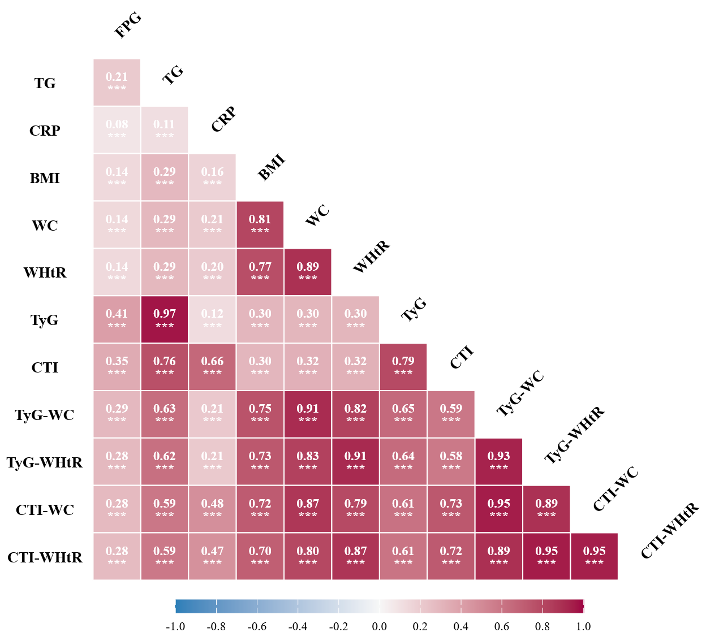

Figure S2. Spearman correlation matrix of CTI-, TyG-, and obesity-modified indices in the ELSA cohort
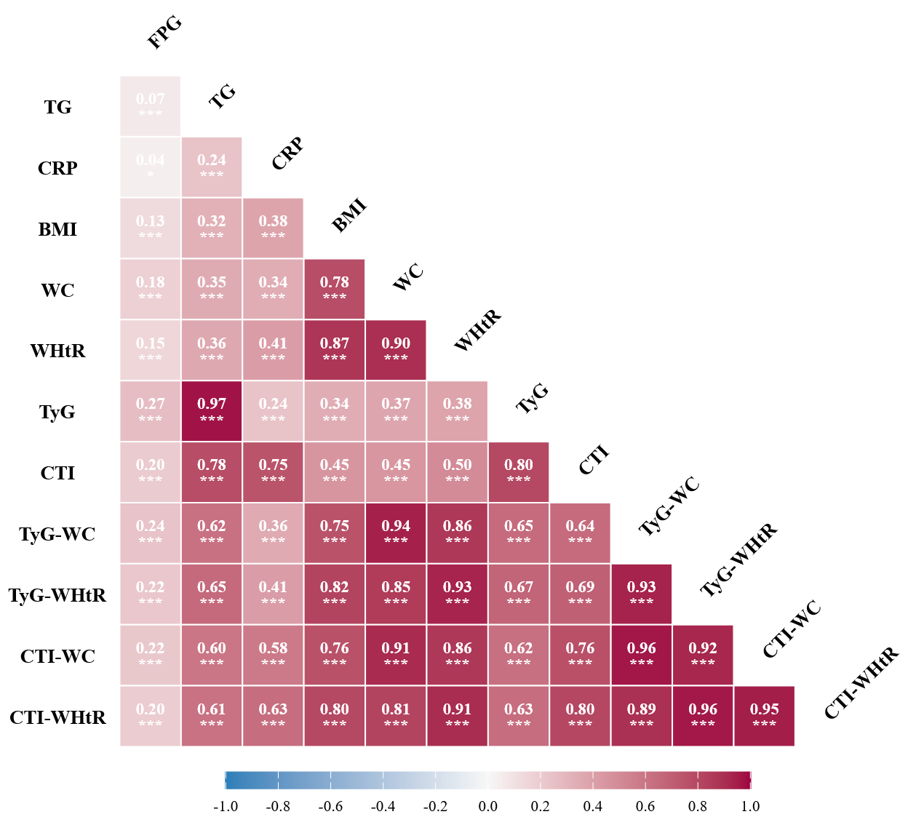

Figure S3. Schoenfeld residual plots for testing the proportional hazards assumption in the CHARLS cohort
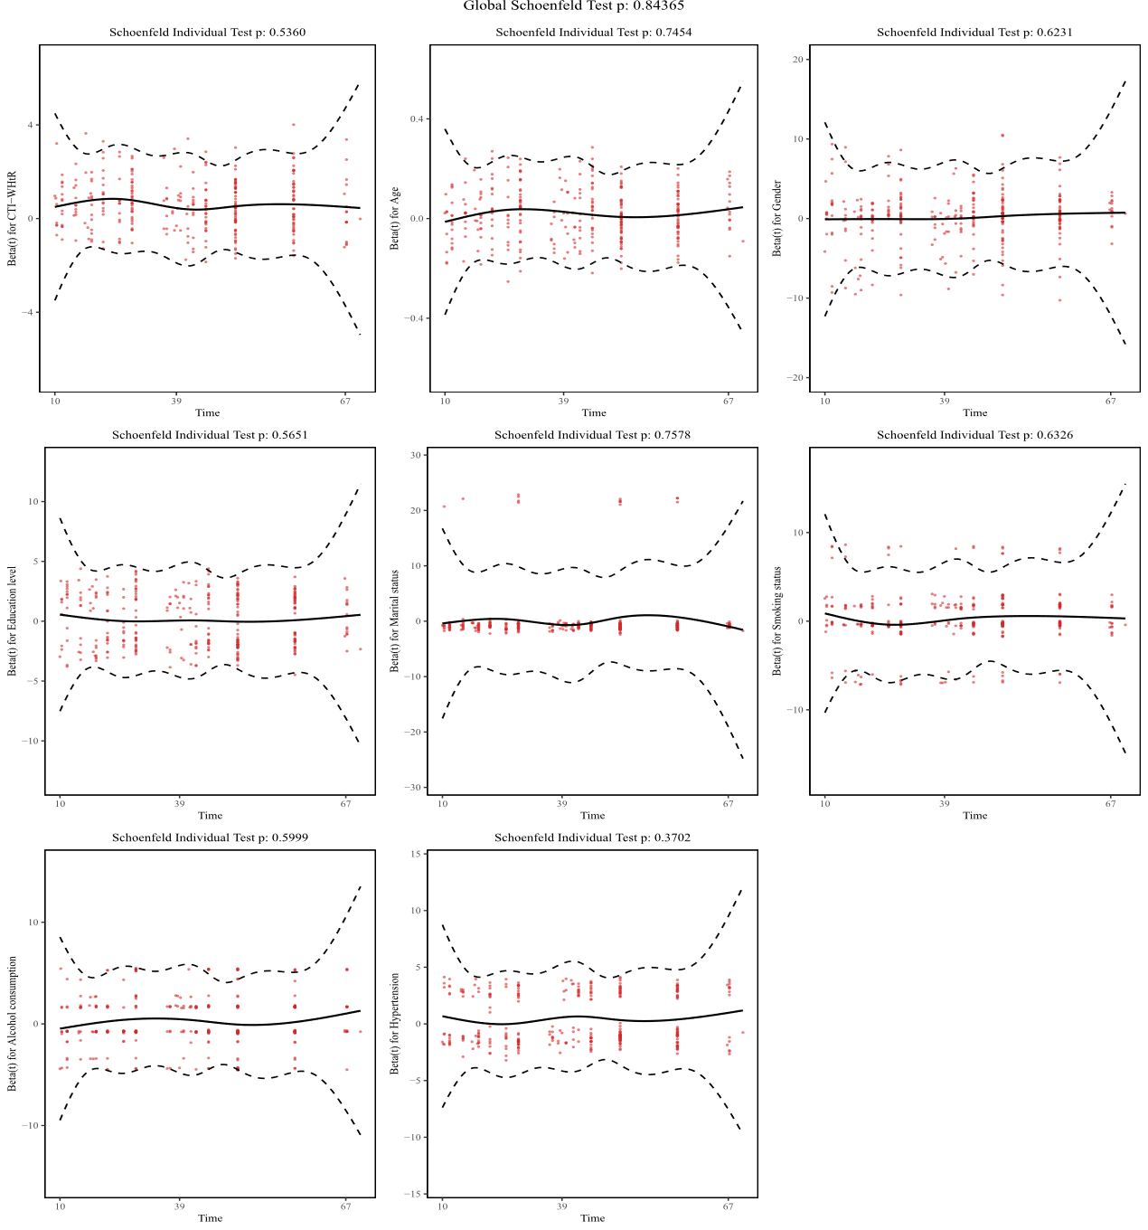

Figure S4. Schoenfeld residual plots for testing the proportional hazards assumption in the ELSA cohort
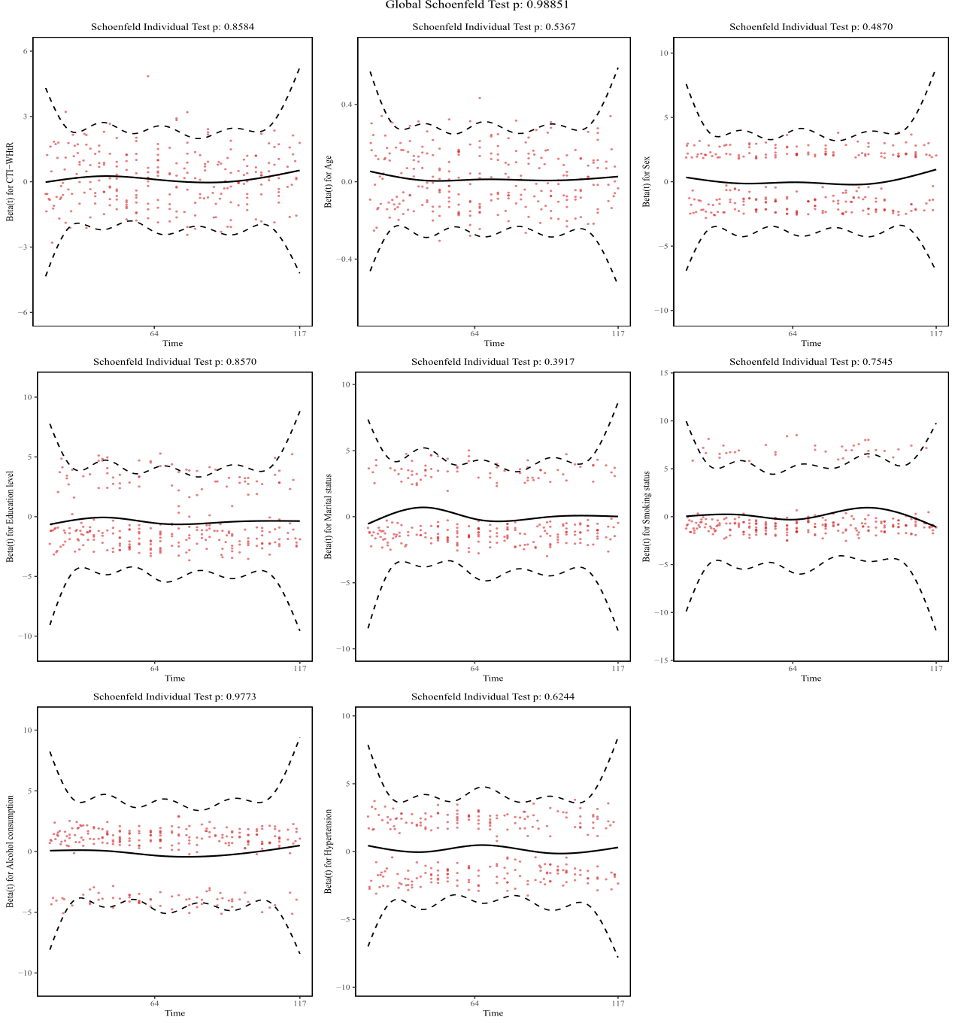

Figure S5. Restricted cubic spline analyses of CTI-related indices and incident CMM in the ELSA cohort
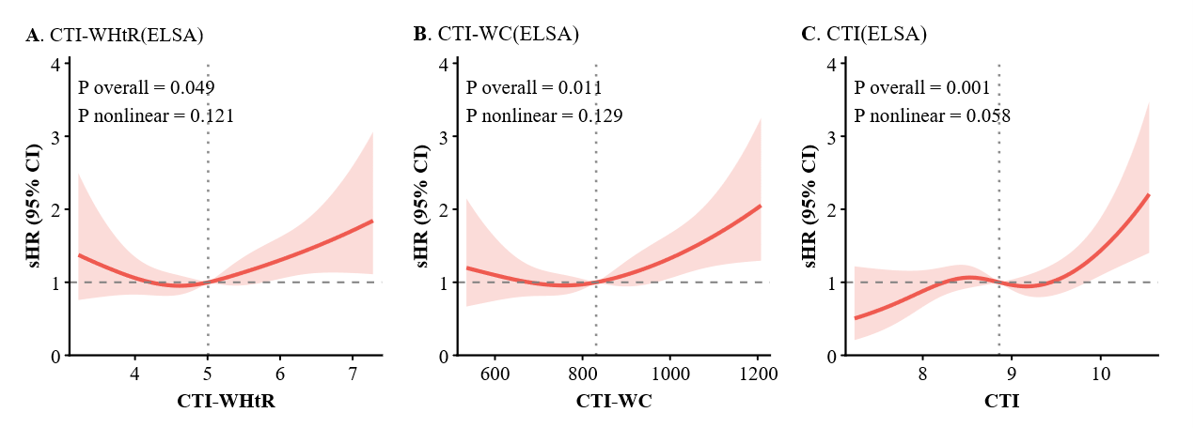

Figure S6. Exploratory pathway analyses of CTI-WHtR in relation to incident CMM via SBP and ePWV in the CHARLS cohort

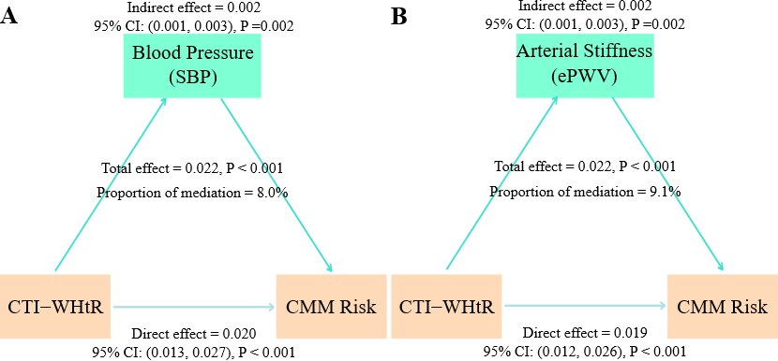

1. Zhang L, Yan M, Hu C, Tao Y, Cheng Z, Zhang Y, et al. Association between body roundness index trajectories and the risk of cardiometabolic multimorbidity in Chinese middle-aged and older adults: Evidence from the China health and retirement longitudinal study. Int J Cardiol Cardiovasc Risk Prev. 2026; 28(200556.

