Supplementary Materials Files

To: Growth differentiation factor-15 and the incidence, bidirectional progression, and risk prediction of atherosclerotic cardiovascular disease and metabolic dysfunction-associated steatotic liver disease in individuals with cardiovascular-kidney-metabolic syndrome stages 0–3

by Xiaojing Chen, Haoxian Tang, Zhuokai Xu, Xueying Chen, Cuihong Tian, Nan Luo, Jingtao Huang, Hanyuan Lin, Xuan Zhang, Qinglong Yang, Kunyao Liang, Pan Chen, Xianghui Qiu, Liwen Jiang, Wenfeng Lin, Wenqi Chen, Youti Zhang, Xuerui Tan, Jiabao Lai, Yequn Chen.

Supplementary Methods

Supplementary Table

Supplementary Table 1. Definitions of CKM Health Stages (Green indicates that all criteria must be met, yellow indicates that meeting any one criterion is sufficient).

Supplementary Table 2 Missingness of variables (number and percentage).

Supplementary Table 3. Baseline characteristics of participants according to GDF-15 level.

Supplementary Table 4. Transition probabilities for each disease state at 1, 5, 10, and 15 years among participants with GDF-15 levels in the top 10% and top 5% of the study population.

Supplementary Table 5. Mediation analysis of GDF-15 with ASCVD and MASLD based on the multi-state model.

Supplementary Figure

Supplementary Figure 1. Screening of covariates for different outcomes.

Supplementary Figure 2. Biochemical and metabolic characteristics of GDF-15.

Supplementary Figure 3. Aalen-Johansen cumulative incidence curves of ASCVD (A) and MASLD (B), with all-cause mortality treated as a competing event.

Supplementary Figure 4. Sensitivity analysis of associations of GDF-15 with incident ASCVD, MASLD, and their comorbidity using an alternative outcome definition that additionally included haemorrhagic stroke (ICD-10 codes I60-I62 and I64).

Supplementary Figure 5. Sensitivity analysis of the associations of GDF-15 with incident ASCVD, MASLD, and their comorbidity during follow-up, with cardiovascular risk in CKM stage 3 assessed using the SCORE2 score.

Supplementary Figure 6. Sensitivity analysis of the associations of GDF-15 with incident ASCVD, MASLD, and their comorbidity during follow-up, with cardiovascular risk in CKM stage 3 assessed using the SCORE2 score (N = 30,438).

Supplementary Figure 7. Sensitivity analysis of variable importance of GDF-15 in predicting ASCVD and MASLD and their comorbidity amongst cardiometabolic risk factors, with cardiovascular risk in CKM stage 3 assessed using the SCORE2 score (N = 30,438).

Supplementary Figure 8. Sensitivity analysis of the associations of GDF-15 with incident ASCVD, MASLD, and their comorbidity during follow-up, using Cox regression models.

Supplementary Figure 9. Sensitivity analysis of variable importance of GDF-15 in predicting ASCVD and MASLD and their comorbidity amongst cardiometabolic risk factors, using Cox regression models.
Supplementary Methods

1. Random forest imputation
A random forest model was trained on the observed data for each variable to predict missing values, and the procedure was iteratively repeated until the prediction error no longer decreased. This method enables flexible, nonparametric imputation for mixed-type and high-dimensional data ^{[1,2]}. This method was implemented using the R package “missRanger”.

References:
[1] Stekhoven DJ, Bühlmann P. MissForest--non-parametric missing value imputation for mixed-type data. Bioinformatics. 2012;28(1):112-118. doi:10.1093/bioinformatics/btr597
[2] Tang H, Zhang X, Luo N, et al. Temporal trends in the planetary health diet index and its association with cardiovascular, kidney, and metabolic diseases: A comprehensive analysis from global and individual perspectives. J Nutr Health Aging. 2025;29(5):100520. doi:10.1016/j.jnha.2025.100520

2. Multi-state Markov model (MSM)
MSMs extend conventional survival and competing risk models by describing disease processes as transitions between multiple discrete states over time. Instead of modeling only the time to a single event, MSMs characterize the full event history, including intermediate events and competing outcomes, through a set of transition-specific hazard functions. Each individual is assumed to occupy a defined state at any given time, and transitions between states (e.g., healthy → disease → death) are modeled using time-to-event methods, typically within a counting-process framework [1,2].
Transition intensities (hazards) quantify the instantaneous risk of moving from one state to another and can be estimated using Cox proportional hazards models with state-specific baseline hazards. From these transition hazards, cumulative transition probabilities, state occupation probabilities, and cumulative incidence functions can be derived. This framework allows simultaneous modeling of competing risks and intermediate events, thereby capturing dynamic disease progression and time-dependent prognosis. MSMs therefore provide a flexible approach for analyzing complex longitudinal event histories, accounting for multiple pathways, recurrent transitions, and time-varying covariate effects. This method was implemented using the R package “mstate”.
MSMs were further applied in the current study to investigate potential modification effects [3]. We defined a mediator as a new-onset disease occurring during follow-up, representing an intermediate state, as some individuals transition to this state while others do not. Regardless of whether the transition through the mediator (path b-c) is considered, a persistent association of GDF-15 with the outcome along the direct pathway (path a) indicates that the effect of GDF-15 cannot be fully explained by the intermediate disease, as illustrated in the schematic.

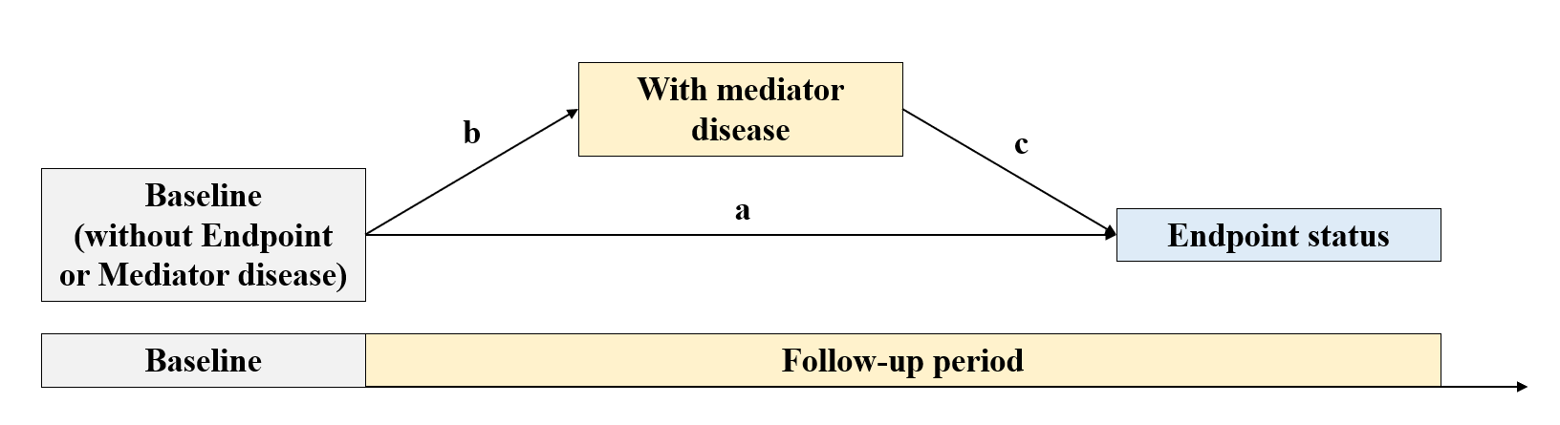

References:
[1] Putter H, Fiocco M, Geskus RB. Tutorial in biostatistics: competing risks and multi-state models. Stat Med. 2007;26(11):2389-2430. doi:10.1002/sim.2712
[2] Tang H, Huang J, Zhang X, et al. Association between triglyceride glucose-body mass index and the trajectory of cardio-renal-metabolic multimorbidity: insights from multi-state modelling. Cardiovasc Diabetol. 2025;24(1):133. Published 2025 Mar 21. doi:10.1186/s12933-025-02693-w
[3] Sabia S, Fayosse A, Dumurgier J, et al. Association of ideal cardiovascular health at age 50 with incidence of dementia: 25 year follow-up of Whitehall II cohort study. BMJ. 2019;366:l4414. Published 2019 Aug 7. doi:10.1136/bmj.l4414

2. Shapley Additive Explanations (SHAP)
SHAP was a game theory-based method for interpreting machine learning models that fairly attributes model contributions to individual variables while capturing nonlinear relationships and interactions [1]. To account for time-varying effects in survival analysis, the extended SurvSHAP(t) framework was applied to estimate time-dependent variable importance along the survival curve, thereby revealing both immediate and evolving effects on survival probability [2]. The sign and magnitude of SHAP values indicate the direction and strength of each variable’s effect. Overall variable importance was visualized using bee swarm plots based on the mean absolute SHAP values across all time points, and temporal variation during follow-up was also illustrated. Additionally, locally estimated scatterplot smoothing (LOESS) regression was used to characterize the dose-response relationship between GDF-15 and SurvSHAP(t). This method was implemented using the R package “survex”.

References:
[1] Lundberg SM, Nair B, Vavilala MS, et al. Explainable machine-learning predictions for the prevention of hypoxaemia during surgery. Nat Biomed Eng. 2018;2(10):749-760. doi:10.1038/s41551-018-0304-0
[2] Spytek M, Krzyziński M, Langbein SH, Baniecki H, Wright MN, Biecek P. survex: an R package for explaining machine learning survival models. Bioinformatics. 2023;39(12):btad723. doi:10.1093/bioinformatics/btad723

3. Net reclassification improvement (NRI) and integrated discrimination improvement (IDI)
Continuous NRI quantifies correct upward and downward risk reclassification for events and non-events, whereas IDI measures improvement in discrimination by comparing differences in mean predicted risks between models [1,2]. Censoring was addressed using inverse probability of censoring weighting (IPCW), and confidence intervals were estimated using perturbation-resampling. This method was implemented using the R package “survIDINRI”.

References:
[1] Pencina MJ, D'Agostino RB Sr, Steyerberg EW. Extensions of net reclassification improvement calculations to measure usefulness of new biomarkers. Stat Med. 2011;30(1):11-21. doi:10.1002/sim.4085
[2] Uno H, Tian L, Cai T, Kohane IS, Wei LJ. A unified inference procedure for a class of measures to assess improvement in risk prediction systems with survival data. Stat Med. 2013;32(14):2430-2442. doi:10.1002/sim.5647

4. CKD-EPI Creatinine-Cystatin C Age, Sex Equation (2021)

Sex | Serum Creatinine (mg/dL) | Serum Cystatin C (mg/L) | Equation
Female | ≤0.7 | ≤0.8 | GFR= 135 × (Scr/0.7)^{-0.219} × (Scys/0.8)^{-0.323} × 0.9961^{Age} × 0.963
 | ≤0.7 | >0.8 | GFR= 135 × (Scr/0.7)^{-0.219} × (Scys/0.8)^{-0.778} × 0.9961^{Age} × 0.963
 | >0.7 | ≤0.8 | GFR= 135 × (Scr/0.7)^{-0.544} × (Scys/0.8)^{-0.323} × 0.9961^{Age} × 0.963
 | >0.7 | >0.8 | GFR= 135 × (Scr/0.7)^{-0.544} × (Scys/0.8)^{-0.778} × 0.9961^{Age} × 0.963
Male | ≤0.9 | ≤0.8 | GFR= 135 × (Scr/0.9)^{-0.144} × (Scys/0.8)^{-0.323} × 0.9961^{Age}
 | ≤0.9 | >0.8 | GFR= 135 × (Scr/0.9)^{-0.144} × (Scys/0.8)^{-0.778} × 0.9961^{Age}
 | >0.9 | ≤0.8 | GFR= 135 × (Scr/0.9)^{-0.544} × (Scys/0.8)^{-0.323} × 0.9961^{Age}
 | >0.9 | >0.8 | GFR= 135 × (Scr/0.9)^{-0.544} × (Scys/0.8)^{-0.778} × 0.9961^{Age}

The CKD-EPI Creatinine-Cystatin C Age, Sex Equation (2021) can be expressed as a single equation 135 × min(Scr/k, 1)^{α} × max(Scr/k, 1)^{-0.544} × min(Scys/0.8, 1)^{-0.323} × max(Scys/0.8, 1)^{-0.778} × 0.9961^{age} × 0.963 [if female] where Scr is serum creatinine, Scys is serum cystatin C, k is 0.7 for females and 0.9 males, α is -0.219 for females and -0.144 for males, min indicates the minimum of Scr/k or 1, max indicates the maximum of Scr/k or 1.

References:
[1] Inker LA, Eneanya ND, Coresh J, et al. New Creatinine- and Cystatin C-Based Equations to Estimate GFR without Race. N Engl J Med. 2021;385(19):1737-1749. doi:10.1056/NEJMoa2102953

4. PREVENT (Predicting Risk of Cardiovascular Disease EVENTs)

ASCVD (Base 10 year)
Women | log-Odds = -3.819975 + 0.719883 × (age – 55) /10 + 0.1176967 × ((TC – HDL) × 0.02586 – 3.5) – 0.151185 × (HDL × 0.02586 – 1.3) /0.3 – 0.0835358 × (min(SBP, 110) – 110) /20 + 0.3592852 × (max(SBP, 110) – 130) /20 + 0.8348585 × (if diabetes) + 0.4831078 × (if current smoker) + 0.4864619 × (min(eGFR, 60) – 60) / -15 + 0.0397779 × (max(eGFR, 60) – 90) / -15 + 0.2265309 × (if using anti-hypertensive medication) – 0.0592374 × (if using statin) – 0.0395762 × (if using anti-hypertensive medication) × (max(SBP, 110) – 130) /20 + 0.0844423 × (if using statin) × ((TC – HDL) × 0.02586 – 3.5) – 0.0567839 × (age – 55) /10 × ((TC – HDL) × 0.02586 – 3.5) + 0.0325692 × (age – 55) /10 × (HDL × 0.02586 – 1.3) /0.3 – 0.1035985 × (age – 55) /10 × (max(SBP, 110) – 130) /20 – 0.2417542 × (age – 55) /10 × (if diabetes) – 0.0791142 × (age – 55) /10 × (if current smoker) – 0.1671492 × (age – 55) /10 × (min(eGFR, 60) – 60) / -15  Risk = exp(log-Odds) / (1 + exp(log-Odds))
Men | log-Odds = – 3.500655 + 0.7099847 × (age – 55) /10 + 0.1658663 × ((TC – HDL) × 0.02586 – 3.5) – 0.1144285 × (HDL × 0.02586 – 1.3) /0.3 – 0.2837212 × (min(SBP, 110) – 110) /20 + 0.3239977 × (max(SBP, 110) – 130) /20 + 0.7189597 × (if diabetes) + 0.3956973 × (if current smoker) + 0.3690075 × (min(eGFR, 60) – 60) / -15 + 0.0203619 × (max(eGFR, 60) – 90) / -15 + 0.2036522 × (if using anti-hypertensive medication) – 0.0865581 × (if using statin) – 0.0322916 × (if using anti-hypertensive medication) × (max(SBP, 110) – 130) /20 + 0.114563 × (if using statin) × ((TC – HDL) × 0.02586 – 3.5) – 0.0300005 × (age – 55) /10 × ((TC – HDL) × 0.02586 – 3.5) + 0.0232747 × (age – 55) /10 × (HDL × 0.02586 – 1.3) /0.3 – 0.0927024 × (age – 55) /10 × (max(SBP, 110) – 130) /20 – 0.2018525 × (age – 55) /10 × (if diabetes) – 0.0970527 × (age – 55) /10 × (if current smoker) – 0.1217081  × (age – 55) /10 × (min(eGFR, 60) – 60) / -15  Risk = exp(log-Odds) / (1 + exp(log-Odds))

References:
[1] Khan SS, Matsushita K, Sang Y, et al. Development and Validation of the American Heart Association's PREVENT Equations. Circulation. 2024;149(6):430-449. doi:10.1161/CIRCULATIONAHA.123.067626

5. SCORE2 (Systematic COronary Risk Evaluation 2)

1) Calculation of Linear Predictor
Risk factor (units) |  | Risk Factor Value | Transformed  value |  | Log HRx transformed value
 |  | Risk Factor Value |  |  | Male |  |  |  |  | Female
Age (yrs) |  | 50 | (50-60)/5 = -2 |  | 0.3742 x -2 |  | = -0.7484 |  |  | 0.4648 x -2 | = -0.9296
Smoking (current vs. other) |  | yes | 1 |  | 0.6012 x 1 |  | = 0.6012 |  |  | 0.7744 x 1 | = 0.7744
Systolic blood pressure (SBP, mm Hg) |  | 140 | (140 - 120)/20 = 1 |  | 0.2777 x 1 |  | = 0.2777 |  |  | 0.3131 x 1 | = 0.3131
Total cholesterol (mmol/L) |  | 6.3 | (6.3 - 6)/1 = 0.3 |  | 0.1458 x 0.3 |  | = 0.04374 |  |  | 0.1002 x 0.3 | = 0.03006
HDL cholesterol (mmol/L) |  | 1.4 | (1.4- 1.3)/0.5 = 0.2 |  | -0.2698 x 0.2 |  | = -0.05396 |  |  | -0.2606 x 0.2 | = -0.05212
Smoking x age interaction |  |  | -2 x 1 = -2 |  | -0.0755 x -2 |  | = 0.151 |  |  | -0.1088 x -2 | = 0.2176
SBP x age interaction |  |  | -2 x 1 = -2 |  | -0.0255 x -2 |  | = 0.051 |  |  | -0.0277 x -2 | = 0.0554
Total cholesterol x age interaction |  |  | -2 x 0.3 = -0.6 |  | -0.0281 x -0.6 |  | = 0.01686 |  |  | -0.0226 x -0.6 | = 0.01356
HDL cholesterol x age interaction |  |  | -2 x 0.2 = -0.4 |  | 0.0426 x -0.4 |  | = -0.01704 |  |  | 0.0613 x -0.4 | = -0.02452
 |  |  |  | Linear predictor: | ∑ = 0.3221 |  |  |  |  | ∑ = 0.39788
2) 10-year risk estimation (un-calibrated) = 1-basesurv ^{exp(linear predictor)}
 |  |  | Male  1-0.9605 ^{exp(0.3221)}=0.0541 |  |  |  |  | Female  1-0.9776 ^{exp(0.39788)}=0.0332
3) Calibration of risk estimate according to region specific scaling factors
Calibrated 10-year risk = 1-exp(-exp(scale1 + scale2 x ln(-ln(1-un-calibrated 10-yr risk))
Risk region | Male |  |  |  |  | Female
Low | 1-exp(-exp(-0.5699+0.7476 x ln(-ln(1-0.0541))))  = 0.0631 |  |  |  |  | 1-exp(-exp(-0.7380+0.7019 x ln(-ln(1-0.0332))))  = 0.0434
Moderate | 1-exp(-exp(-0.1565+0.8009 x ln(-ln(1-0.0541))))  = 0.0811 |  |  |  |  | 1-exp(-exp(-0.3143+0.7701 x ln(-ln(1-0.0332))))  = 0.0523
High | 1-exp(-exp(0.3207+0.9360 x ln(-ln(1-0.0541))))  = 0.0881 |  |  |  |  | 1-exp(-exp(0.5710+0.9369 x ln(-ln(1-0.0332))))  = 0.0713
Very high | 1-exp(-exp(0.5836+0.8294 x ln(-ln(1-0.0541))))  = 0.1506 |  |  |  |  | 1-exp(-exp(0.9412+0.8329 x ln(-ln(1-0.0332))))  = 0.1414
Note: final estimate should be multiplied by 100 in order to express as a percentage rather than a probability

References:
[1] SCORE2 working group and ESC Cardiovascular risk collaboration. SCORE2 risk prediction algorithms: new models to estimate 10-year risk of cardiovascular disease in Europe. Eur Heart J. 2021;42(25):2439-2454. doi:10.1093/eurheartj/ehab309

6. Biomarkers of insulin resistance
Triglyceride-glucose index (TyG) = ln [fasting plasma glucose × triglyceride /2]. Triglyceride and fasting plasma glucose in mg/dL.
C-reactive protein-triglyceride glucose index (CTI) = 0.412 × ln (c-reactive protein) + [ln (triglyceride × fasting plasma glucose)] / 2. CRP in mg/L. Triglyceride and fasting plasma glucose in mg/dL.
Triglyceride to high density lipoprotein cholesterol ratio (TG/HDL-C) = triglyceride / HDL-C. Triglyceride and HDL-C in mg/ dL.
Estimated glucose disposal rate (eGDR) = 21.158 − (0.09 × waist circumference) − (3.407 × hypertension) − (0.551 × HbA1c). Waist circumference in cm, hypertension (yes = 1/no = 0), and HbA1c (%)

References:
[1] Han SS, Liu Q, Zeng ZM, et al. Association of various insulin resistance surrogate indices with aging acceleration and future risk of cardiovascular disease in individuals with cardiovascular-kidney-metabolic syndrome stages 0-3: insights from CHARLS 2011-2020 data. Cardiovasc Diabetol. 2026;25(1):77. Published 2026 Feb 4. doi:10.1186/s12933-026-03084-5

7. Biomarkers of systemic inflammation
Systemic immune inflammation index (SII) = neutrophils × platelets / lymphocyte.
Systemic inflammation response index (SIRI) = monocyte × neutrophil / lymphocyte

References:
[1] Qin P, Ho FK, Celis-Morales CA, Pell JP. Association between systemic inflammation biomarkers and incident cardiovascular disease in 423,701 individuals: evidence from the UK biobank cohort. Cardiovasc Diabetol. 2025;24(1):162. Published 2025 Apr 15. doi:10.1186/s12933-025-02721-9

8. Biomarkers of liver
Fatty liver index (FLI) = e 0.953×ln(TG)+0.139×BMI+0.718×ln(GGT)+0.053×WC−15.745 /1 + e0.953×ln(TG)+0.139×BMI+0.718×ln(GGT)+0.053×WC−15.745 ×100, BMI: body mass index (kg/m2); TG, triglyceride (mg/dL); GGT, γ-glutamyl transferase (IU/L); WC, waist circumference (cm).
Fibrosis-4 score (FIB-4) = (age × aspartate aminotransferase) / (platelet × √alanine transaminase). Age in year, platelet in 10⁹/L, aspartate aminotransferase and alanine transaminase in U/L.
Aspartate aminotransferase to platelet ratio index (APRI) = [(aspartate aminotransferase / upper limit of normal) / platelet]×100. Platelet in 10⁹/L, aspartate aminotransferase in U/L.

References:
[1] Wang J, Tu G, Tao Q, et al. The prognostic significance of cholesterol, high-density lipoprotein and glucose (CHG) index in evaluating all-cause mortality risk in metabolic dysfunction-associated steatotic liver disease (MASLD) individuals: evidence from two cohort studies. Cardiovasc Diabetol. Published online April 6, 2026. doi:10.1186/s12933-026-03171-7
[2] Liu X, Zhang HJ, Fang CC, et al. Association Between Noninvasive Liver Fibrosis Scores and Heart Failure in a General Population. J Am Heart Assoc. 2024;13(22):e035371. doi:10.1161/JAHA.123.035371

Supplementary Table 1. Definitions of CKM Health Stages (Green indicates that all criteria must be met, yellow indicates that meeting any one criterion is sufficient).
CKM health stages | Definition | Indicators | Criterion | Condition
Stage 0: No CKM health risk factors | Individuals without overweight/obesity, metabolic risk factors (hypertension, hypertriglyceridemia, MetS, diabetes), CKD, or subclinical/clinical CVD | Without overweight/obesity | BMI < 25 kg/m² (or < 23 kg/m² if Asian ancestry). | All criteria are met
Stage 0: No CKM health risk factors |  | Without abdominal obesity | Waist circumference < 88/102 cm in female/male (or if Asian ancestry < 80/90 cm in female/male) | All criteria are met
Stage 0: No CKM health risk factors |  | Without prediabetes/diabetes | Fasting blood glucose < 100 mg/dL (5.6 mmol/L) and HbA1c < 5.7% (39 mmol/mol) and without self-reported diagnosis of prediabetes/diabetes, use of insulin, or oral hypoglycemic agents | All criteria are met
Stage 0: No CKM health risk factors |  | Without hypertension | SBP < 130 mmHg and DBP < 80 mmHg without self-reported diagnosis of hypertension or use of antihypertensive medications | All criteria are met
Stage 0: No CKM health risk factors |  | Without hypertriglyceridemia | Triglycerides < 135 mg/dL | All criteria are met
Stage 0: No CKM health risk factors |  | Without CKD | Low-risk CKD in KDIGO classification according to eGFR and  UACR: UACR < 30 mg/g (< 3 mg/mmol) and eGFR ≥ 60 ml/min/1.73m² | All criteria are met
Stage 0: No CKM health risk factors |  | Without subclinical/clinical CVD | Without high predicted 10-y CVD risk (PREVENT, < 20%) | All criteria are met
Stage 0: No CKM health risk factors |  | Without subclinical/clinical CVD | Without history of coronary heart disease, heart failure, stroke, peripheral artery disease, and atrial fibrillation | All criteria are met
Stage 1: Excess and/or dysfunctional adiposity | Individuals with overweight/obesity, abdominal obesity, or dysfunctional adipose tissue, without the presence of other metabolic risk factors or CKD | With overweight/obesity | BMI ≥ 25 kg/m² (or ≥ 23 kg/m² if Asian ancestry) | Any of the three criteria is met
Stage 1: Excess and/or dysfunctional adiposity |  | With abdominal obesity | Waist circumference ≥ 88/102 cm in women/men (or if Asian ancestry, ≥ 80/90 cm in women/men) | Any of the three criteria is met
Stage 1: Excess and/or dysfunctional adiposity |  | Prediabetes | Fasting blood glucose between 100 and 125 mg/dL (5.6-6.9 mmol/L) or HbA1c between 5.7% and 6.4% (39-47 mmol/mol) | Any of the three criteria is met
Stage 1: Excess and/or dysfunctional adiposity |  | Without hypertension | SBP <130 mmHg and DBP <80 mmHg without self-reported diagnosis of hypertension or use of antihypertensive medications | All criteria are met
Stage 1: Excess and/or dysfunctional adiposity |  | Without hypertriglyceridemia | Triglycerides < 135 mg/dL | All criteria are met
Stage 1: Excess and/or dysfunctional adiposity |  | Without diabetes | Fasting blood glucose < 126 mg/dL (7.0 mmol/L) and HbA1c < 6.5% (48mmol/mol) and without self-reported diagnosis of diabetes, use of insulin, or oral hypoglycemic agents | All criteria are met
Stage 1: Excess and/or dysfunctional adiposity |  | Without MetS | MetS is defined by the presence of ≥ 3 of the following: (1) waist circumference ≥ 88 cm for women and ≥ 102 cm for men (if Asian ancestry, ≥ 80 cm for women and ≥ 90 cm for men), (2) high-density cholesterol < 40 mg/dL for men and < 50 mg/dL for women; (3) triglycerides ≥ 150 mg/dL; (4) elevated blood pressure (systolic blood pressure ≥ 130 mm Hg and/or diastolic blood pressure ≥ 80 mm Hg and/or use of antihypertensive medications); and (5) fasting blood glucose ≥ 100 mg/dL (5.6 mmol/L) | All criteria are met
Stage 1: Excess and/or dysfunctional adiposity |  | Without CKD | Low-risk CKD in KDIGO classification according to eGFR and  UACR: UACR < 30 mg/g (< 3 mg/mmol) and eGFR ≥ 60 ml/min/1.73m² | All criteria are met
Stage 1: Excess and/or dysfunctional adiposity |  | Without subclinical/clinical CVD | Without high predicted 10-y CVD risk. (PREVENT, <20%) | All criteria are met
Stage 1: Excess and/or dysfunctional adiposity |  | Without subclinical/clinical CVD | Without history of coronary heart disease, heart failure, stroke, peripheral artery disease, and atrial fibrillation | All criteria are met
Stage 2: Metabolic risk factors and CKD | Individuals with metabolic risk factors (hypertriglyceridemia, hypertension, MetS, diabetes) or CKD | With hypertriglyceridemia | Triglycerides ≥ 135 mg/dL | Any of the five criteria is met
Stage 2: Metabolic risk factors and CKD |  | With hypertension | SBP ≥ 130mm Hg, DBP ≥ 80mm Hg, or self-reported diagnosis of hypertension or use of antihypertensive medication | Any of the five criteria is met
Stage 2: Metabolic risk factors and CKD |  | With diabetes | Fasting blood glucose ≥ 126 mg/dL (7.0 mmol/L), HbA1c ≥ 6.5% (48mmol/mol), or self-reported diagnosis of diabetes, use of insulin, or oral hypoglycemic agents | Any of the five criteria is met
Stage 2: Metabolic risk factors and CKD |  | With MetS | MetS is defined by the presence of ≥ 3 of the following: (1) waist circumference ≥ 88 cm for women and ≥ 102 cm for men (if Asian ancestry, ≥ 80 cm for women and ≥ 90 cm for men), (2) high-density cholesterol < 40 mg/dL for men and < 50 mg/dL for women; (3) triglycerides ≥ 150 mg/dL; (4) elevated blood pressure (systolic blood pressure ≥ 130 mm Hg and/or diastolic blood pressure ≥ 80 mm Hg and/or use of antihypertensive medications); and (5) fasting blood glucose ≥ 100 mg/dL (5.6 mmol/L) | Any of the five criteria is met
Stage 2: Metabolic risk factors and CKD |  | With moderate-to-high-risk CKD | Moderate-to-high-risk CKD in KDIGO classification:  UACR ≥ 30 mg/g (≥ 3 mg/mmol) and eGFR ≥ 60 ml/min/1.73m²,  UACR < 300 mg/g (< 30 mg/mmol) and eGFR 45-59 ml/min/1.73m²,  or UACR < 30 mg/g (< 3 mg/mmol) and eGFR 30-44 ml/min/1.73m² | Any of the five criteria is met
Stage 2: Metabolic risk factors and CKD |  | Without very high-risk CKD | No very high-risk CKD in KDIGO classification:  eGFR ≥ 60 ml/min/1.73m²,  eGFR 45-59 ml/min/1.73m² and UACR < 300 mg/g (< 30 mg/mmol),  or eGFR 30-44 ml/min/1.73m² and UACR < 30 mg/g (< 3 mg/mmol) | All criteria are met
Stage 2: Metabolic risk factors and CKD |  | Without subclinical/clinical CVD | Without high predicted 10-y CVD risk (PREVENT, <20%) | All criteria are met
Stage 2: Metabolic risk factors and CKD |  | Without subclinical/clinical CVD | Without history of coronary heart disease, heart failure, stroke, peripheral artery disease, and atrial fibrillation. | All criteria are met
Stage 3: Subclinical CVD in CKM | Subclinical CVD in CKM | With very high-risk CKD | Very high-risk CKD in KDIGO classification:  eGFR＜ 30 ml/min/1.73m²,  eGFR 30-44 ml/min/1.73m² and UACR ≥ 30 mg/g (≥ 3 mg/mmol),  or eGFR 45-59 ml/min/1.73m² and UACR ≥ 300 mg/g (≥ 30 mg/mmol) | Any of the two criteria is met
Stage 3: Subclinical CVD in CKM | Subclinical CVD in CKM | With subclinical CVD | high predicted 10-y CVD risk (PREVENT, ≥ 20%) | Any of the two criteria is met
Stage 3: Subclinical CVD in CKM | Subclinical CVD in CKM | Without clinical CVD | Without history of coronary heart disease, heart failure, stroke, peripheral artery disease, and atrial fibrillation | The criterion is met
Stage 3: Subclinical CVD in CKM | Subclinical CVD in CKM | With overweight/obesity | BMI ≥ 25 kg/m² (or ≥ 23 kg/m² if Asian ancestry) | Any of the eight criteria is met
Stage 3: Subclinical CVD in CKM | Subclinical CVD in CKM | With abdominal obesity | Waist circumference ≥ 88/102 cm in women/men (or if Asian ancestry, ≥ 80/90 cm in women/men) | Any of the eight criteria is met
Stage 3: Subclinical CVD in CKM | Subclinical CVD in CKM | With hypertriglyceridemia | Triglycerides ≥ 135 mg/dL | Any of the eight criteria is met
Stage 3: Subclinical CVD in CKM | Subclinical CVD in CKM | With hypertension | SBP ≥ 130mm Hg or DBP ≥ 80mm Hg or self-reported diagnosis of hypertension or use of antihypertensive medication | Any of the eight criteria is met
Stage 3: Subclinical CVD in CKM | Subclinical CVD in CKM | With prediabetes | Fasting blood glucose between 100 and125 mg/dL (5.6-6.9 mmol/L) or HbA1c between 5.7% and 6.4% (39-47 mmol/mol) | Any of the eight criteria is met
Stage 3: Subclinical CVD in CKM | Subclinical CVD in CKM | With diabetes | Fasting blood glucose ≥ 126 mg/dL (7.0 mmol/L), HbA1c ≥ 6.5% (48mmol/mol), or self-reported diagnosis of diabetes, use of insulin, or oral hypoglycemic agents | Any of the eight criteria is met
Stage 3: Subclinical CVD in CKM | Subclinical CVD in CKM | With MetS | MetS is defined by the presence of ≥ 3 of the following: (1) waist circumference ≥ 88 cm for women and ≥ 102 cm for men (if Asian ancestry, ≥ 80 cm for women and ≥ 90 cm for men), (2) high-density cholesterol < 40 mg/dL for men and < 50 mg/dL for women; (3) triglycerides ≥ 150 mg/dL; (4) elevated blood pressure (systolic blood pressure ≥ 130 mm Hg and/or diastolic blood pressure ≥ 80 mm Hg and/or use of antihypertensive medications); and (5) fasting blood glucose ≥ 100 mg/dL (5.6 mmol/L) | Any of the eight criteria is met
Stage 3: Subclinical CVD in CKM | Subclinical CVD in CKM | With moderate-to-high-risk CKD | Moderate-to-high-risk CKD in KDIGO classification:  UACR ≥ 30 mg/g (≥ 3 mg/mmol) and eGFR ≥ 60 ml/min/1.73m²,  UACR < 300 mg/g (< 30 mg/mmol) and eGFR 45-59 ml/min/1.73m²,  or UACR < 30 mg/g (< 3 mg/mmol) and eGFR 30-44 ml/min/1.73m². | Any of the eight criteria is met
Stage 4: Clinical CVD in CKM | Clinical CVD (coronary heart disease, heart failure, stroke, peripheral artery disease, AFib) among individuals with excess/dysfunctional adiposity, other metabolic risk factors, or CKD | With clinical CVD | With history of coronary heart disease, heart failure, stroke, peripheral artery disease, or atrial fibrillation. | The criterion is met
Stage 4: Clinical CVD in CKM |  | With overweight/obesity | BMI ≥ 25 kg/m² (or ≥ 23 kg/m² if Asian ancestry) | Any of the nine criteria is met
Stage 4: Clinical CVD in CKM |  | With abdominal obesity | Waist circumference ≥ 88/102 cm in women/men (or if Asian ancestry, ≥ 80/90 cm in women/men) | Any of the nine criteria is met
Stage 4: Clinical CVD in CKM |  | With hypertriglyceridemia | Triglycerides ≥ 135 mg/dL | Any of the nine criteria is met
Stage 4: Clinical CVD in CKM |  | With hypertension | SBP ≥ 130mm Hg or DBP ≥ 80mm Hg or self-reported diagnosis of hypertension or use of antihypertensive medication | Any of the nine criteria is met
Stage 4: Clinical CVD in CKM |  | With prediabetes | Fasting blood glucose between 100 and 125 mg/dL (5.6-6.9 mmol/L) or HbA1c between 5.7% and 6.4% (39-47 mmol/mol) | Any of the nine criteria is met
Stage 4: Clinical CVD in CKM |  | With diabetes | Fasting blood glucose ≥ 126 mg/dL (7.0 mmol/L), HbA1c ≥ 6.5% (48mmol/mol), or self-reported diagnosis of diabetes, use of insulin, or oral hypoglycemic agents | Any of the nine criteria is met
Stage 4: Clinical CVD in CKM |  | With MetS | MetS is defined by the presence of ≥ 3 of the following: (1) waist circumference ≥ 88 cm for women and ≥ 102 cm for men (if Asian ancestry, ≥ 80 cm for women and ≥ 90 cm for men), (2) high-density cholesterol <40 mg/dL for men and < 50 mg/dL for women; (3) triglycerides ≥ 150 mg/dL; (4) elevated blood pressure (systolic blood pressure ≥ 130 mm Hg and/or diastolic blood pressure ≥ 80 mm Hg and/or use of antihypertensive medications); and (5) fasting blood glucose ≥ 100 mg/dL (5.6 mmol/L) | Any of the nine criteria is met
Stage 4: Clinical CVD in CKM |  | With moderate-to-high-risk CKD | Moderate-to-high-risk CKD in KDIGO classification:  UACR ≥ 30 mg/g (≥ 3 mg/mmol) and eGFR ≥ 60 ml/min/1.73m²,  UACR < 300 mg/g (< 30 mg/mmol) and eGFR 45-59 ml/min/1.73m²,  or UACR < 30 mg/g (< 3 mg/mmol) and eGFR 30-44 ml/min/1.73m² | Any of the nine criteria is met
Stage 4: Clinical CVD in CKM |  | With very high-risk CKD | Very high-risk CKD in KDIGO classification:  eGFR＜ 30 ml/min/1.73m²,  eGFR 30-44 ml/min/1.73m² and UACR ≥ 30 mg/g (≥ 3 mg/mmol),  or eGFR 45-59 ml/min/1.73m² and UACR ≥ 300 mg/g (≥ 30 mg/mmol) | Any of the nine criteria is met
Abbreviations: BMI, body mass index; CKD, chronic kidney disease; CKM, cardiovascular-kidney-metabolic; CVD, cardiovascular disease; DBP, diastolic
blood pressure; eGFR, estimated glomerular filtration rate; MetS, metabolic syndrome; HDL, high-density lipoprotein; KDIGO, The Kidney Disease, Improving Global Outcomes; PREVENT, Predicting Risk of cardiovascular disease EVENTs; SBP, systolic blood pressure; UACR, urinary albumin to creatinine ratio.

References:
[1] Ndumele CE, Rangaswami J, Chow SL, et al. Cardiovascular-Kidney-Metabolic Health: A Presidential Advisory From the American Heart Association. Circulation. 2023;148(20):1606-1635. doi:10.1161/CIR.0000000000001184
[2] Liu K, Hu J, Huang Y, He D, Zhang J. Triglyceride-glucose-related indices and risk of cardiovascular disease and mortality in individuals with cardiovascular-kidney-metabolic (CKM) syndrome stages 0-3: a prospective cohort study of 282,920 participants in the UK Biobank. Cardiovasc Diabetol. 2025;24(1):277. Published 2025 Jul 10. doi:10.1186/s12933-025-02842-1
[3] Li J, Lei L, Wang W, et al. Social Risk Profile and Cardiovascular-Kidney-Metabolic Syndrome in US Adults. J Am Heart Assoc. 2024;13(16):e034996. doi:10.1161/JAHA.124.034996
[4] Tang H, Zhang X, Luo N, et al. Temporal trends in the planetary health diet index and its association with cardiovascular, kidney, and metabolic diseases: A comprehensive analysis from global and individual perspectives. J Nutr Health Aging. 2025;29(5):100520. doi:10.1016/j.jnha.2025.100520

Supplementary Table 2 Missingness of variables (number and percentage).
Variable | Missing (n) | Missing (%)
Age | 0 | 0
sex | 0 | 0
Townsend deprivation index | 32 | 0.001078
physical activity | 6522 | 0.219618
smoking status | 108 | 0.003637
Albumin | 2272 | 0.076506
Alkaline phosphatase | 11 | 0.00037
Alanine aminotransferase | 15 | 0.000505
Apolipoprotein A | 2428 | 0.081759
Apolipoprotein B | 150 | 0.005051
Aspartate aminotransferase | 99 | 0.003334
Direct bilirubin | 4654 | 0.156716
Urea | 14 | 0.000471
Calcium | 2271 | 0.076472
Total cholesterol | 6 | 0.000202
Creatinine | 0 | 0
C-reactive protein | 75 | 0.002526
Cystatin C | 0 | 0
Gamma-glutamyl transferase | 20 | 0.000673
Glucose | 2298 | 0.077382
HbA1c | 1293 | 0.04354
High-density lipoprotein cholesterol | 2285 | 0.076944
Insulin-like growth factor 1 | 177 | 0.00596
Low-density lipoprotein cholesterol | 48 | 0.001616
Lipoprotein(a) | 5830 | 0.196316
Phosphate | 2337 | 0.078695
SHBG | 2530 | 0.085194
Total bilirubin | 102 | 0.003435
Testosterone | 2965 | 0.099842
Total protein | 2299 | 0.077415
Triglycerides | 10 | 0.000337
Urate | 45 | 0.001515
Vitamin D | 1392 | 0.046873
White blood cell count | 671 | 0.022595
Red blood cell count | 671 | 0.022595
Hemoglobin | 671 | 0.022595
Hematocrit | 671 | 0.022595
Mean corpuscular volume | 671 | 0.022595
Mean corpuscular hemoglobin | 672 | 0.022629
Mean corpuscular hemoglobin concentration | 672 | 0.022629
Red blood cell distribution width | 671 | 0.022595
Platelet count | 671 | 0.022595
Plateletcrit | 671 | 0.022595
Mean platelet volume | 671 | 0.022595
Platelet distribution width | 671 | 0.022595
Lymphocyte count | 706 | 0.023773
Monocyte count | 706 | 0.023773
Neutrophil count | 706 | 0.023773
Eosinophil count | 706 | 0.023773
Basophil count | 706 | 0.023773
Nucleated red blood cell count | 706 | 0.023773
Lymphocyte percentage | 706 | 0.023773
Monocyte percentage | 706 | 0.023773
Neutrophil percentage | 706 | 0.023773
Eosinophil percentage | 706 | 0.023773
Basophil percentage | 706 | 0.023773
Nucleated red blood cell percentage | 707 | 0.023807
Reticulocyte percentage | 1130 | 0.038051
Reticulocyte count | 1130 | 0.038051
Mean reticulocyte volume | 1130 | 0.038051
Mean sphered cell volume | 1130 | 0.038051
Immature reticulocyte fraction | 1130 | 0.038051
High light scatter reticulocyte percentage | 1130 | 0.038051
High light scatter reticulocyte count | 1130 | 0.038051

Supplementary Table 3. Baseline characteristics of participants according to GDF-15 level.
Characteristic | Overall  N = 29,697 | Quartile 1 (<-0.37)  N = 7,426 | Quartile 2 (-0.37 to < -0.08)  N = 7,425 | Quartile 3 (-0.08 to < 0.25)  N = 7,422 | Quartile 4 (≥0.25)  N = 7,424 | P value
Age at recruitment, years |  |  |  |  |  | <0.001
Mean (SD) | 56.16 (8.20) | 49.40 (6.72) | 55.13 (7.29) | 58.64 (6.92) | 61.49 (6.43)
Sex, n (%) |  |  |  |  |  | <0.001
Female | 17,022 (57.32) | 4,553 (61.31) | 4,532 (61.04) | 4,263 (57.44) | 3,674 (49.49)
Male | 12,675 (42.68) | 2,873 (38.69) | 2,893 (38.96) | 3,159 (42.56) | 3,750 (50.51)
Townsend deprivation index |  |  |  |  |  | <0.001
Median (IQR) | -2.21 (-3.69, 0.39) | -2.27 (-3.73, 0.34) | -2.33 (-3.77, 0.10) | -2.32 (-3.72, 0.14) | -1.88 (-3.52, 1.00)
Current smoking, n (%) |  |  |  |  |  | <0.001
No | 26,728 (90.00) | 7,020 (94.53) | 6,889 (92.78) | 6,747 (90.91) | 6,072 (81.79)
Yes | 2,969 (10.00) | 406 (5.47) | 536 (7.22) | 675 (9.09) | 1,352 (18.21)
Physical activity, MET.min/week |  |  |  |  |  | <0.001
Median (IQR) | 2,552.65 (1,102.00, 3,554.31) | 2,373.00 (1,055.00, 3,426.00) | 2,457.00 (1,093.00, 3,516.01) | 2,646.67 (1,186.50, 3,598.24) | 2,744.96 (1,066.25, 3,639.00)
BMI, kg/m² |  |  |  |  |  | <0.001
Mean (SD) | 26.98 (4.44) | 26.05 (3.93) | 26.65 (4.27) | 27.08 (4.32) | 28.13 (4.91)
DM, n (%) |  |  |  |  |  | <0.001
No | 28,059 (94.48) | 7,288 (98.14) | 7,238 (97.48) | 7,149 (96.32) | 6,384 (85.99)
Yes | 1,638 (5.52) | 138 (1.86) | 187 (2.52) | 273 (3.68) | 1,040 (14.01)
SBP, mmHg |  |  |  |  |  | <0.001
Mean (SD) | 136.11 (18.02) | 129.84 (16.12) | 134.97 (17.42) | 137.98 (17.91) | 141.64 (18.45)
LDL-C, mmol/L |  |  |  |  |  | <0.001
Mean (SD) | 3.60 (0.85) | 3.53 (0.79) | 3.67 (0.83) | 3.68 (0.83) | 3.53 (0.92)
HDL-C, mmol/L |  |  |  |  |  | <0.001
Mean (SD) | 1.48 (0.37) | 1.51 (0.36) | 1.52 (0.37) | 1.49 (0.37) | 1.40 (0.37)
CRP, mg/L |  |  |  |  |  | <0.001
Median (IQR) | 1.24 (0.63, 2.55) | 0.87 (0.46, 1.74) | 1.11 (0.57, 2.20) | 1.32 (0.69, 2.64) | 1.87 (0.93, 3.84)
Glycated haemoglobin, mmol/mol |  |  |  |  |  | <0.001
Mean (SD) | 35.64 (6.05) | 33.86 (4.33) | 34.94 (4.48) | 35.59 (4.75) | 38.18 (8.67)
Creatinine, μmol/L |  |  |  |  |  | <0.001
Mean (SD) | 71.71 (16.86) | 68.68 (12.74) | 69.74 (13.07) | 71.62 (13.72) | 76.80 (24.02)
Cystatin C, mg/L |  |  |  |  |  | <0.001
Mean (SD) | 0.90 (0.16) | 0.81 (0.10) | 0.86 (0.11) | 0.91 (0.12) | 1.01 (0.22)
GDF-15 |  |  |  |  |  | <0.001
Median (IQR) | -0.08 (-0.37, 0.25) | -0.56 (-0.71, -0.46) | -0.22 (-0.29, -0.15) | 0.07 (0.00, 0.15) | 0.53 (0.37, 0.81)
CKM stage, n (%) |  |  |  |  |  | <0.001
Stage 0 | 2,447 (8.24) | 1,061 (14.29) | 656 (8.84) | 481 (6.48) | 249 (3.35)
Stage 1 | 2,489 (8.38) | 910 (12.25) | 700 (9.43) | 520 (7.01) | 359 (4.84)
Stage 2 | 23,981 (80.75) | 5,444 (73.31) | 6,047 (81.44) | 6,326 (85.23) | 6,164 (83.03)
Stage 3 | 780 (2.63) | 11 (0.15) | 22 (0.30) | 95 (1.28) | 652 (8.78)
ASCVD, n (%) |  |  |  |  |  | <0.001
No | 26,911 (90.62) | 7,132 (96.04) | 6,897 (92.89) | 6,720 (90.54) | 6,162 (83.00)
Yes | 2,786 (9.38) | 294 (3.96) | 528 (7.11) | 702 (9.46) | 1,262 (17.00)
MASLD, n (%) |  |  |  |  |  | <0.001
No | 29,241 (98.46) | 7,348 (98.95) | 7,336 (98.80) | 7,326 (98.71) | 7,231 (97.40)
Yes | 456 (1.54) | 78 (1.05) | 89 (1.20) | 96 (1.29) | 193 (2.60)
Abbreviations: ASCVD, atherosclerotic cardiovascular disease; BMI, body mass index; CKM, cardiovascular-kidney-metabolic; CRP, C-reactive protein; DM, diabetes mellitus; GDF-15, growth/differentiation factor-15; IQR, interquartile range; LDL-C, low-density lipoprotein cholesterol; MASLD, metabolic dysfunction-associated steatotic liver disease; SBP, systolic blood pressure; SD, standard deviation; HDL-C, high-density lipoprotein cholesterol.

Supplementary Table 4. Transition probabilities for each disease state at 1, 5, 10, and 15 years among participants with GDF-15 levels in the top 10% and top 5% of the study population.
Years | Transition | Top 10% | Top 5%
1 | Baseline → ASCVD | 1.04574 | 1.485898
1 | Baseline → MASLD | 0.202456 | 0.202618
1 | ASCVD → MASLD | 0.20202 | 0.33557
1 | MASLD → ASCVD | 1.298701 | 0
5 | Baseline → ASCVD | 7.130039 | 9.58604
5 | Baseline → MASLD | 0.927314 | 1.110389
5 | ASCVD → MASLD | 1.255155 | 1.18853
5 | MASLD → ASCVD | 7.191316 | 8.108108
10 | Baseline → ASCVD | 15.75118 | 20.05407
10 | Baseline → MASLD | 2.031845 | 2.321138
10 | ASCVD → MASLD | 3.689609 | 5.488366
10 | MASLD → ASCVD | 18.68954 | 27.24649
15 | Baseline → ASCVD | 23.23906 | 29.47173
15 | Baseline → MASLD | 3.083567 | 3.670015
15 | ASCVD → MASLD | 5.734025 | 9.481816
15 | MASLD → ASCVD | 34.95163 | Cannot be calculated

Abbreviations: ASCVD, atherosclerotic cardiovascular disease; GDF-15, growth/differentiation factor 15; MASLD, metabolic dysfunction-associated steatotic liver disease.

Supplementary Table 5. Mediation analysis of GDF-15 with ASCVD and MASLD based on the multi-state model.
Endpoint | Mediator | Trans | HR (95%CI) | P value
ASCVD | CKD | Baseline → Mediator | 1.25 (1.10–1.42) | 6.37E-04
ASCVD | CKD | Baseline → ASCVD (Direct effect) | 1.35 (1.24–1.48) | 6.80E-11
ASCVD | CKD | Mediator → ASCVD | 1.62 (1.19–2.20) | 2.04E-03
ASCVD | Hypertension | Baseline → Mediator | 1.14 (1.05–1.24) | 1.55E-03
ASCVD | Hypertension | Baseline → ASCVD (Direct effect) | 1.43 (1.26–1.63) | 7.15E-08
ASCVD | Hypertension | Mediator → ASCVD | 1.33 (1.08–1.64) | 6.94E-03
ASCVD | T2DM | Baseline → Mediator | 1.53 (1.39–1.69) | 7.71E-17
ASCVD | T2DM | Baseline → ASCVD (Direct effect) | 1.35 (1.22–1.49) | 3.35E-09
ASCVD | T2DM | Mediator → ASCVD | 1.38 (1.09–1.74) | 7.34E-03
MASLD | CKD | Baseline → Mediator | 1.29 (1.15–1.45) | 1.69E-05
MASLD | CKD | Baseline → MASLD (Direct effect) | 1.68 (1.45–1.95) | 4.77E-12
MASLD | CKD | Mediator → MASLD | 1.78 (0.88–3.60) | 1.07E-01
MASLD | Hypertension | Baseline → Mediator | 1.18 (1.09–1.28) | 3.72E-05
MASLD | Hypertension | Baseline → MASLD (Direct effect) | 1.53 (1.24–1.88) | 7.16E-05
MASLD | Hypertension | Mediator → MASLD | 1.64 (1.05–2.55) | 2.83E-02
MASLD | T2DM | Baseline → Mediator | 1.52 (1.38–1.68) | 6.99E-17
MASLD | T2DM | Baseline → MASLD (Direct effect) | 1.59 (1.34–1.89) | 1.87E-07
MASLD | T2DM | Mediator → MASLD | 2.05 (1.32–3.18) | 1.30E-03
Abbreviations: ASCVD, atherosclerotic cardiovascular disease; CKD, chronic kidney disease; DM, diabetes mellitus; GDF-15, growth/differentiation factor 15; MASLD, metabolic dysfunction-associated steatotic liver disease.

Supplementary Figure 1. Screening of covariates for different outcomes.
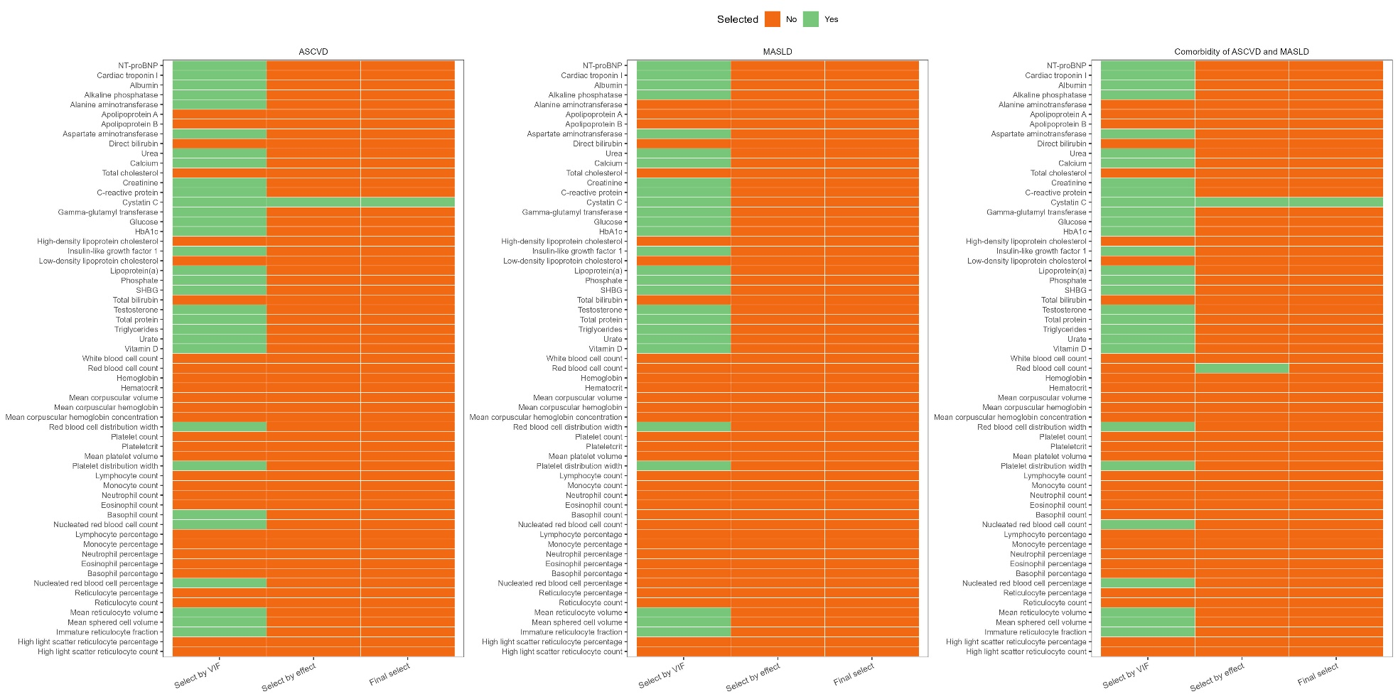
Abbreviations: APRI, aspartate aminotransferase to platelet ratio index; ASCVD, atherosclerotic cardiovascular disease; CRP, C-reactive protein; CTI, C-reactive protein-triglyceride glucose index; eGDR, Estimated glucose disposal rate; FIB-4, fibrosis-4 score; GDF-15, growth/differentiation factor 15; IDI, integrated discrimination improvement; MASLD, metabolic dysfunction-associated steatotic liver disease; NRI, net reclassification improvement; NT-proBNP, N-terminal prohormone of brain natriuretic peptide; PREVENT, Predicting Risk of cardiovascular disease EVENTs; SCORE, Systematic COronary Risk Evaluation; SII, systemic immune-inflammation index; SIRI, system inflammation response index; SHBG, sex hormone–binding globulin; TG/HDL-c, Triglyceride to high-density lipoprotein cholesterol ratio; TyG, triglyceride-glucose index.

Supplementary Figure 2. Biochemical and metabolic characteristics of GDF-15.
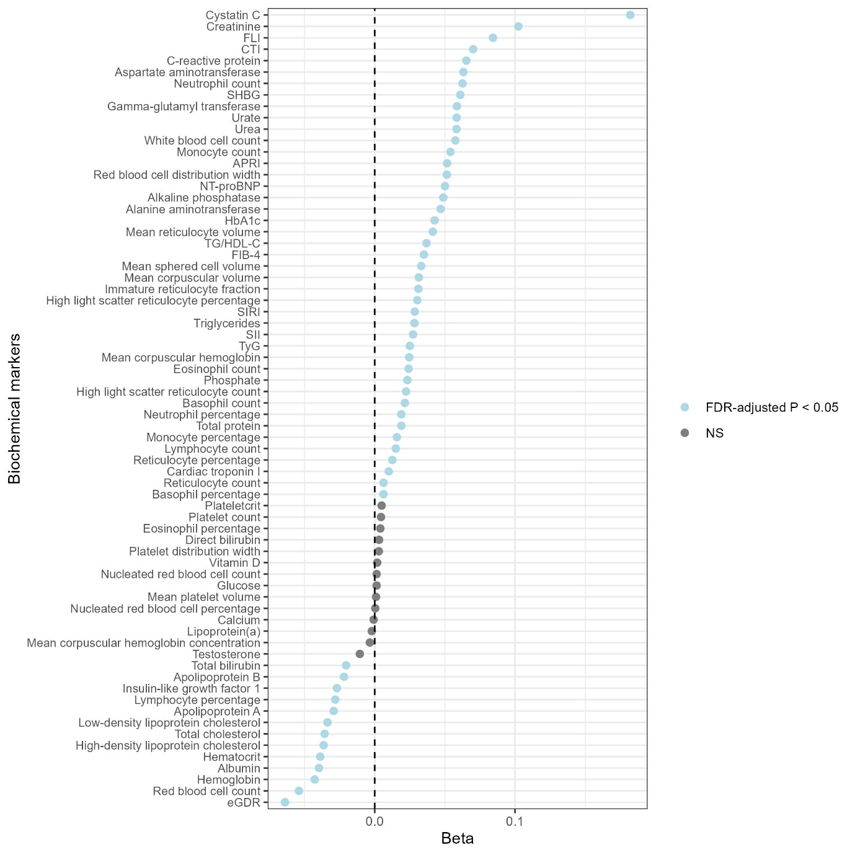
Abbreviations: APRI, aspartate aminotransferase to platelet ratio index; ASCVD, atherosclerotic cardiovascular disease; CRP, C-reactive protein; CTI, C-reactive protein-triglyceride glucose index; eGDR, Estimated glucose disposal rate; FIB-4, fibrosis-4 score; GDF-15, growth/differentiation factor 15; IDI, integrated discrimination improvement; MASLD, metabolic dysfunction-associated steatotic liver disease; NRI, net reclassification improvement; NT-proBNP, N-terminal prohormone of brain natriuretic peptide; PREVENT, Predicting Risk of cardiovascular disease EVENTs; SCORE, Systematic COronary Risk Evaluation; SII, systemic immune-inflammation index; SIRI, system inflammation response index; SHBG, sex hormone–binding globulin; TG/HDL-c, Triglyceride to high-density lipoprotein cholesterol ratio; TyG, triglyceride-glucose index. All models were adjusted for age, sex, BMI, DM, SBP, smoking status, Townsend deprivation index, physical activity, and CKM stage
Supplementary Figure 3. Aalen-Johansen cumulative incidence curves of ASCVD (A) and MASLD (B), with all-cause mortality treated as a competing event.
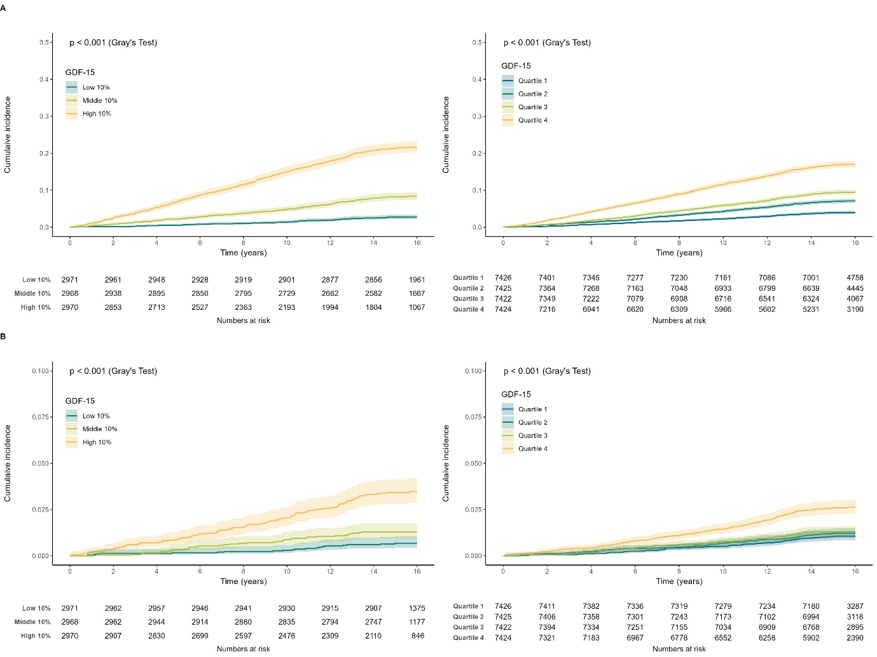
Abbreviations: ASCVD, atherosclerotic cardiovascular disease; MASLD, metabolic dysfunction-associated steatotic liver disease; GDF-15, growth/differentiation factor 15.
Supplementary Figure 4. Sensitivity analysis of associations of GDF-15 with incident ASCVD, MASLD, and their comorbidity, using an alternative outcome definition that additionally included haemorrhagic stroke (ICD-10 codes I60-I62 and I64).
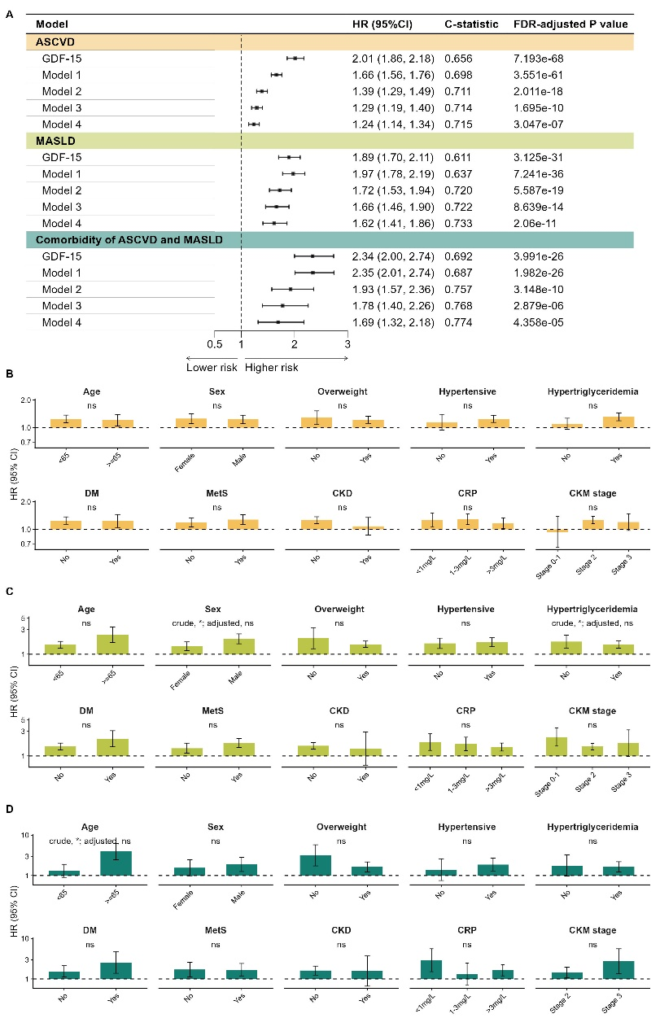
(A) Hazard ratios for incident ASCVD and MASLD and their comorbidity according to GDF-15 increase. Model 1 was adjusted for age and sex. Model 2 was further adjusted for BMI, DM, SBP, LDL-C, creatinine, CRP and smoking status. Model 3 was further adjusted for HDL-C, eGFR, UACR and glycated haemoglobin. Model 4 was further adjusted for cystatin C, Townsend deprivation index, physical activity, and CKM stage. (B) Subgroup analysis for ASCVD. (C) Subgroup analysis for MASLD. (D) Subgroup analysis for the comorbidity of ASCVD and MASLD. “ns” indicated no statistical significance (P for interaction > 0.05), whereas “*” indicated P < 0.05.

Abbreviations: ASCVD, atherosclerotic cardiovascular disease; BMI, body mass index; CI, confidence interval; CKD, chronic kidney disease; CKM, cardiovascular-kidney-metabolic; CRP, C-reactive protein; DM, diabetes mellitus; eGFR, estimated glomerular filtration rate; FDR, false discovery rate; GDF-15, growth differentiation factor-15; HDL-C, high-density lipoprotein cholesterol; HR, hazard ratio; LDL-C, low-density lipoprotein cholesterol; MASLD, metabolic dysfunction–associated steatotic liver disease; MetS, metabolic syndrome; SBP, systolic blood pressure; SCORE, Systematic COronary Risk Evaluation; UACR, urinary albumin-to-creatinine ratio.
Supplementary Figure 5. Sensitivity analysis of variable importance of GDF-15 in predicting ASCVD and MASLD and their comorbidity amongst cardiometabolic risk factors, using an alternative outcome definition that additionally included haemorrhagic stroke (ICD-10 codes I60-I62 and I64).
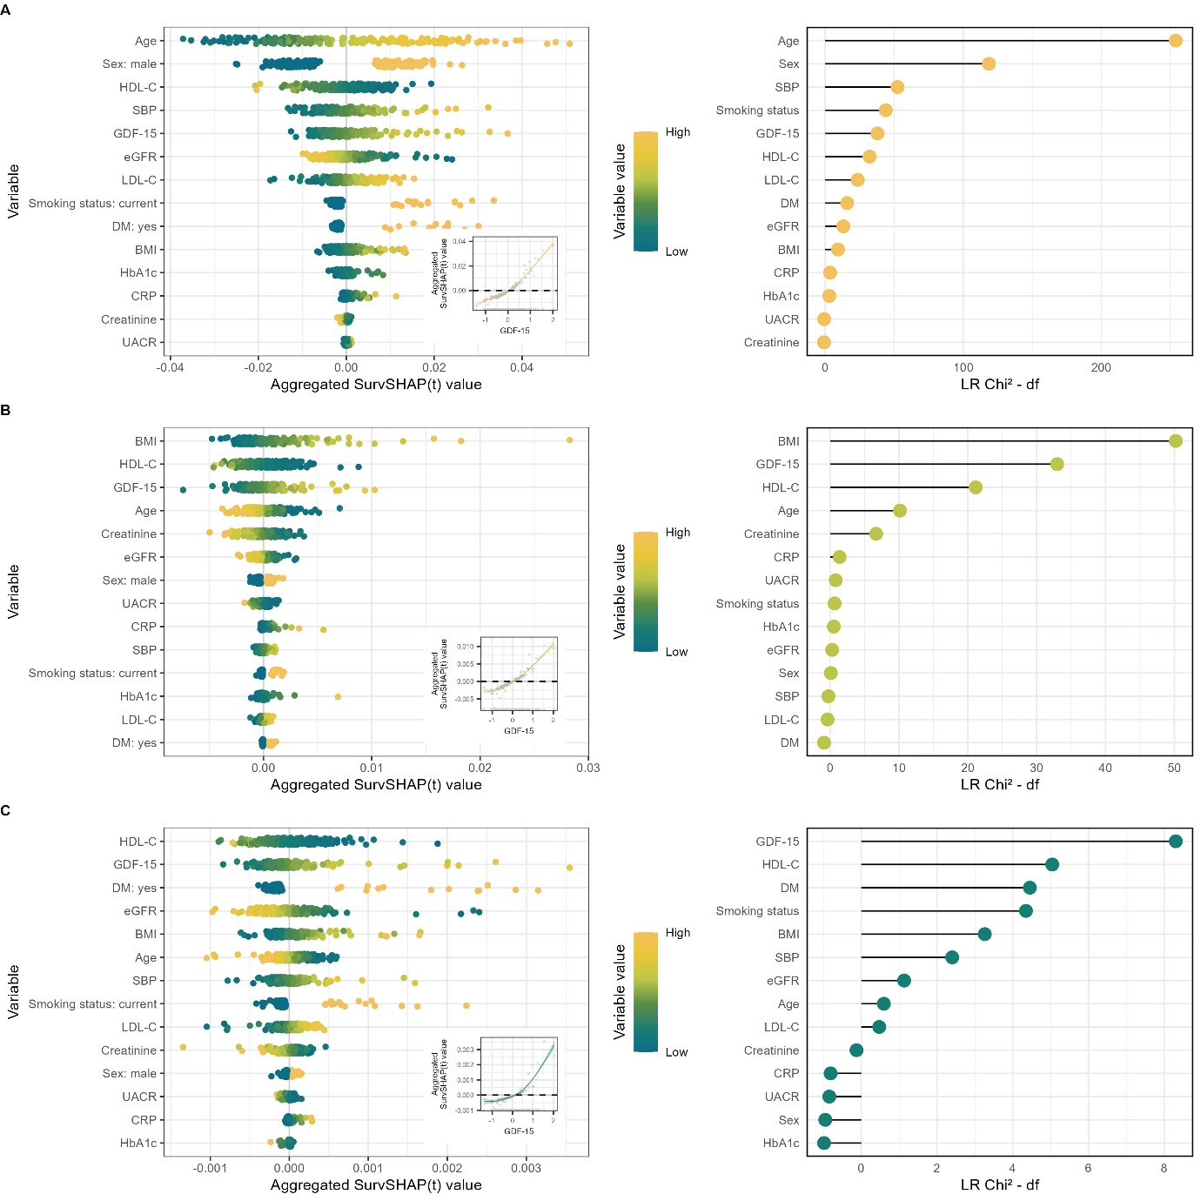

(A) Variable importance for ASCVD prediction assessed using SHAP (beeswarm plot) and likelihood ratio Chi² statistics minus degrees of freedom (lollipop plot). (B) Variable importance for MASLD prediction. (C) Variable importance for comorbidity of ASCVD and MASLD prediction.

Abbreviations: ASCVD, atherosclerotic cardiovascular disease; CI, confidence interval; GDF-15, growth differentiation factor-15; HR, hazard ratio; MASLD, metabolic dysfunction–associated steatotic liver disease; SHAP, SHapley Additive exPlanations.
Supplementary Figure 6. Sensitivity analysis of the associations of GDF-15 with incident ASCVD, MASLD, and their comorbidity during follow-up, with cardiovascular risk in CKM stage 3 assessed using the SCORE2 score (N = 30,438).
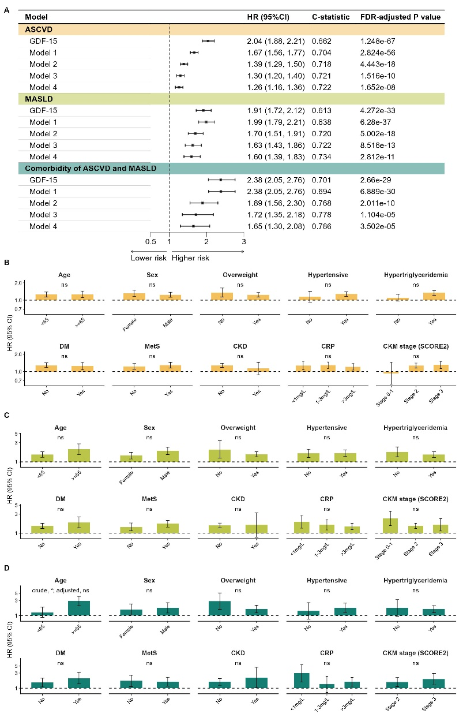
(A) Hazard ratios for incident ASCVD and MASLD and their comorbidity according to GDF-15 increase. Model 1 was adjusted for age and sex. Model 2 was further adjusted for BMI, DM, SBP, LDL-C, creatinine, CRP and smoking status. Model 3 was further adjusted for HDL-C, eGFR, UACR and glycated haemoglobin. Model 4 was further adjusted for cystatin C, Townsend deprivation index, physical activity, and CKM stage. (B) Subgroup analysis for ASCVD. (C) Subgroup analysis for MASLD. (D) Subgroup analysis for the comorbidity of ASCVD and MASLD. “ns” indicated no statistical significance (P for interaction > 0.05), whereas “*” indicated P < 0.05.

Abbreviations: ASCVD, atherosclerotic cardiovascular disease; BMI, body mass index; CI, confidence interval; CKD, chronic kidney disease; CKM, cardiovascular-kidney-metabolic; CRP, C-reactive protein; DM, diabetes mellitus; eGFR, estimated glomerular filtration rate; FDR, false discovery rate; GDF-15, growth differentiation factor-15; HDL-C, high-density lipoprotein cholesterol; HR, hazard ratio; LDL-C, low-density lipoprotein cholesterol; MASLD, metabolic dysfunction–associated steatotic liver disease; MetS, metabolic syndrome; SBP, systolic blood pressure; SCORE, Systematic COronary Risk Evaluation; UACR, urinary albumin-to-creatinine ratio.
Supplementary Figure 7. Sensitivity analysis of variable importance of GDF-15 in predicting ASCVD and MASLD and their comorbidity amongst cardiometabolic risk factors, with cardiovascular risk in CKM stage 3 assessed using the SCORE2 score (N = 30,438).
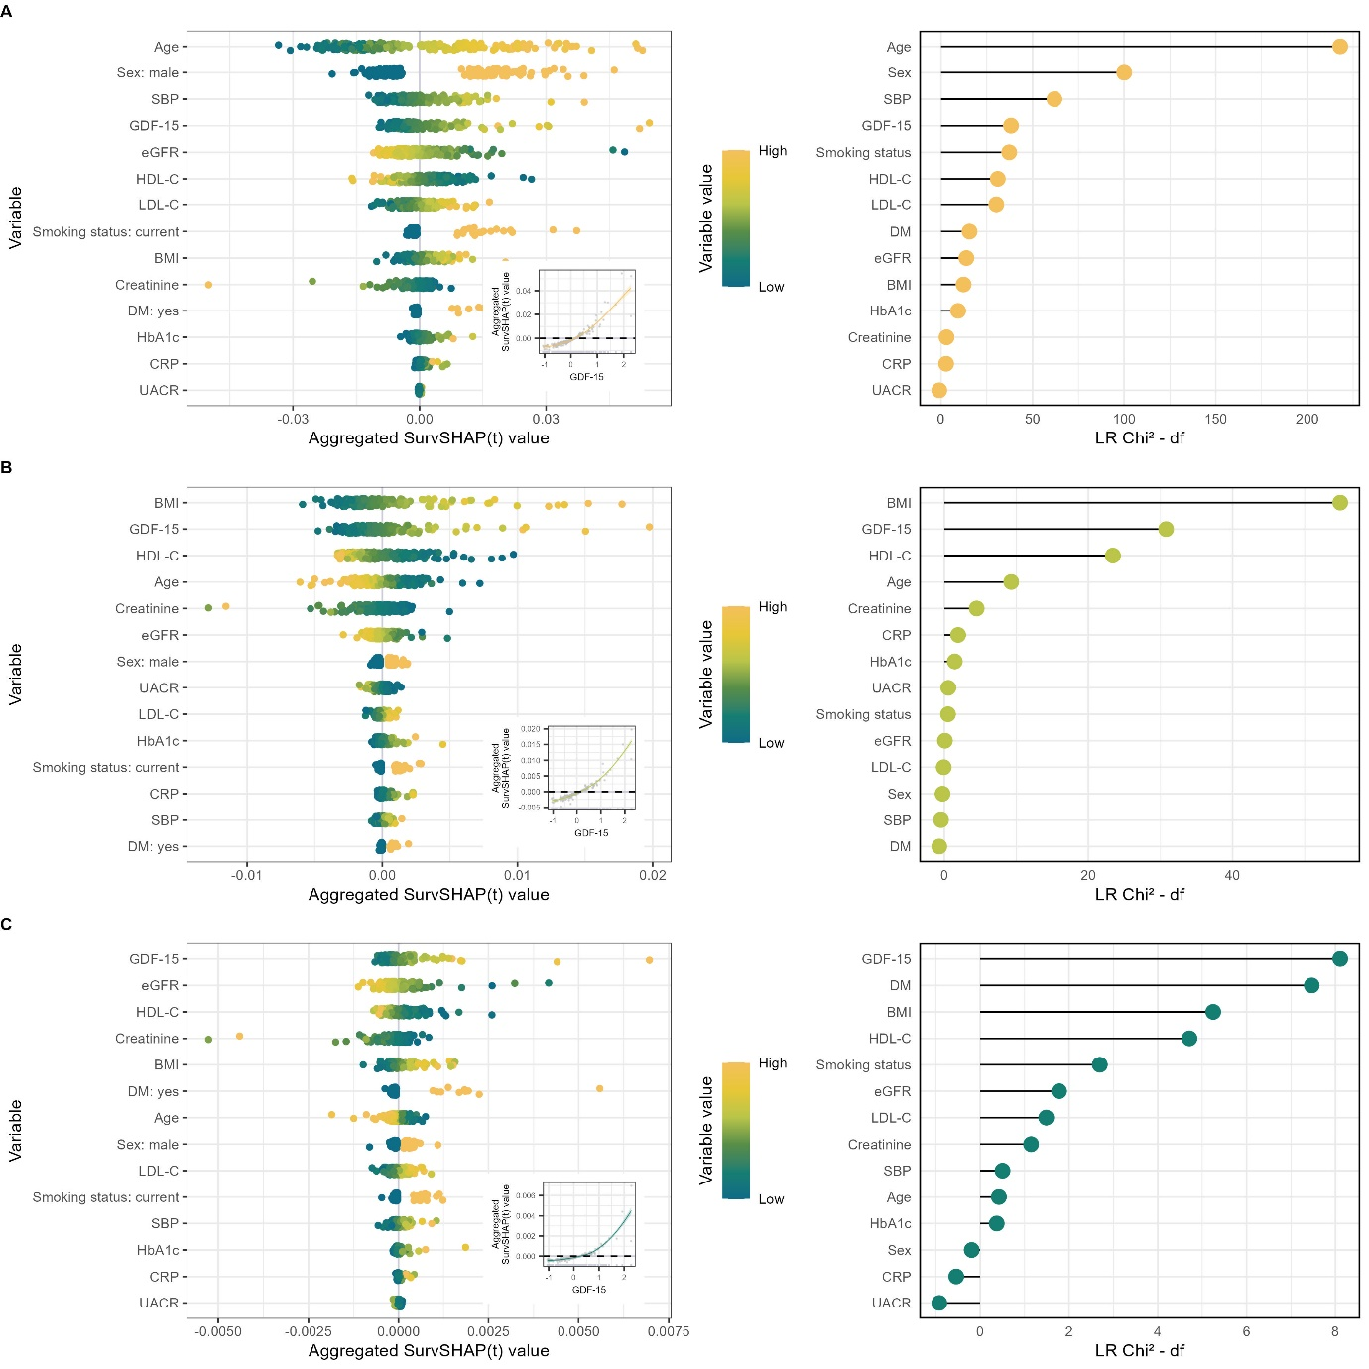

(A) Variable importance for ASCVD prediction assessed using SHAP (beeswarm plot) and likelihood ratio Chi² statistics minus degrees of freedom (lollipop plot). (B) Variable importance for MASLD prediction. (C) Variable importance for comorbidity of ASCVD and MASLD prediction.

Abbreviations: ASCVD, atherosclerotic cardiovascular disease; CI, confidence interval; GDF-15, growth differentiation factor-15; HR, hazard ratio; MASLD, metabolic dysfunction–associated steatotic liver disease; SHAP, SHapley Additive exPlanations.
Supplementary Figure 8. Sensitivity analysis of the associations of GDF-15 with incident ASCVD, MASLD, and their comorbidity during follow-up, using Cox regression models.
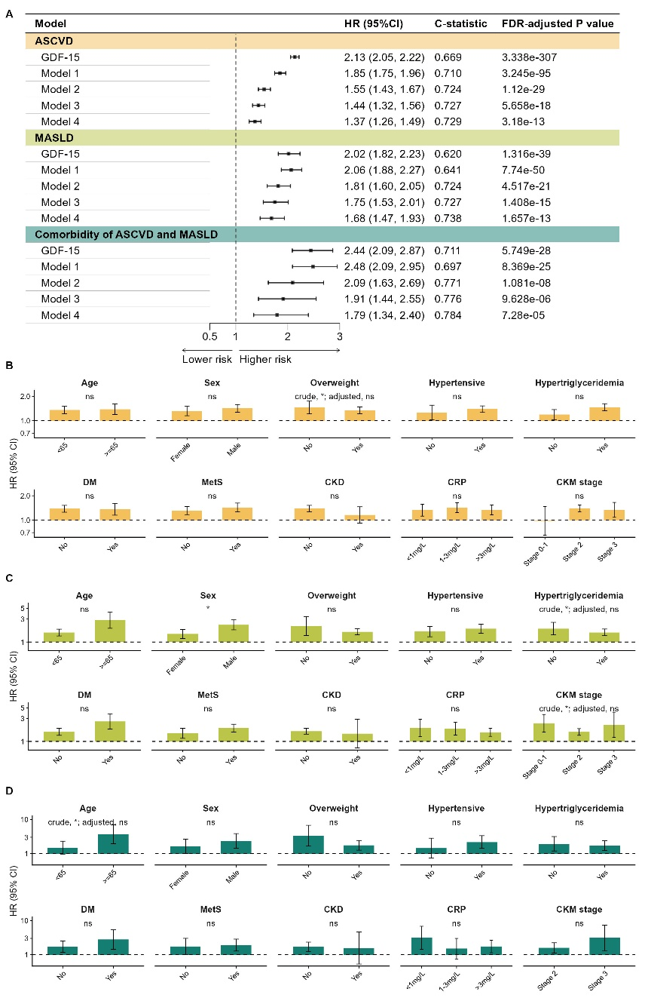
(A) Hazard ratios for incident ASCVD and MASLD and their comorbidity according to GDF-15 increase. Model 1 was adjusted for age and sex. Model 2 was further adjusted for BMI, DM, SBP, LDL-C, creatinine, CRP and smoking status. Model 3 was further adjusted for HDL-C, eGFR, UACR and glycated haemoglobin. Model 4 was further adjusted for cystatin C, Townsend deprivation index, physical activity, and CKM stage. (B) Subgroup analysis for ASCVD. (C) Subgroup analysis for MASLD. (D) Subgroup analysis for the comorbidity of ASCVD and MASLD. “ns” indicated no statistical significance (P for interaction > 0.05), whereas “*” indicated P < 0.05.

Abbreviations: ASCVD, atherosclerotic cardiovascular disease; BMI, body mass index; CI, confidence interval; CKD, chronic kidney disease; CKM, cardiovascular-kidney-metabolic; CRP, C-reactive protein; DM, diabetes mellitus; eGFR, estimated glomerular filtration rate; FDR, false discovery rate; GDF-15, growth differentiation factor-15; HDL-C, high-density lipoprotein cholesterol; HR, hazard ratio; LDL-C, low-density lipoprotein cholesterol; MASLD, metabolic dysfunction–associated steatotic liver disease; MetS, metabolic syndrome; SBP, systolic blood pressure; SCORE, Systematic COronary Risk Evaluation; UACR, urinary albumin-to-creatinine ratio.
Supplementary Figure 9. Sensitivity analysis of variable importance of GDF-15 in predicting ASCVD and MASLD and their comorbidity amongst cardiometabolic risk factors, using Cox regression models.
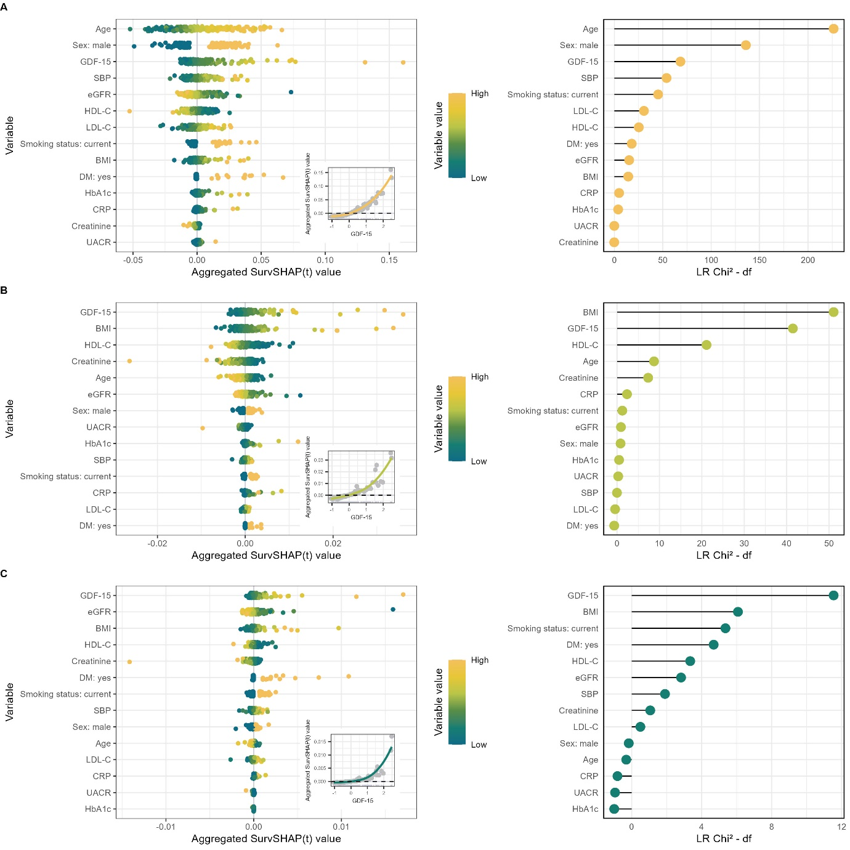

(A) Variable importance for ASCVD prediction assessed using SHAP (beeswarm plot) and likelihood ratio Chi² statistics minus degrees of freedom (lollipop plot). (B) Variable importance for MASLD prediction. (C) Variable importance for comorbidity of ASCVD and MASLD prediction.

Abbreviations: ASCVD, atherosclerotic cardiovascular disease; CI, confidence interval; GDF-15, growth differentiation factor-15; HR, hazard ratio; MASLD, metabolic dysfunction–associated steatotic liver disease; SHAP, SHapley Additive exPlanations.

