Supplemental Contents
STable 1. The 49 items used to construct the frailty index and their respective scoring algorithms 2
STable 2. Variance inflation factor values for all the variables in the multivariable Cox model 5
STable 3. Relationship between MASLD and CVD mortality after accounting for frailty based on frailty index quartiles. 6
STable 4. Subgroup analysis results for the relationship between MASLD, frailty and CVD mortality 7
SFigure 1. Flow diagram showing participant selection for this study in NHANES III 9
SFigure 2. Standardized mean differences for baseline covariates before and after using propensity score matching technique between participants with MASLD and those with cardiometabolic risk factors alone 10
SFigure 3. Description of the frailty index distribution (A- results for total participants; B- results for participants with MASLD and with cardiometabolic risk factors alone separately. The dash lines represent the mean value of frailty index) 11
SFigure 4. Restricted cubic spline for the relationship between frailty index and CVD mortality 12
SFigure 5. Mediation analysis results of the association between MASLD and risk of CVD mortality by frailty 13

STable 1. The 49 items used to construct the frailty index and their respective scoring algorithms
Items | Scoring algorithms
Cognition
1.Experience confusion/memory problems | 1: yes; 0: no
Dependence
2. Managing money difficulty | 0: no difficulty; 0.33: Some difficulty; 0.66: much difficulty; 1: unable to do
3. Walking for a quarter mile difficulty | 0: no difficulty; 0.33: Some difficulty; 0.66: much difficulty; 1: unable to do
4. Walking up ten steps difficulty | 0: no difficulty; 0.33: Some difficulty; 0.66: much difficulty; 1: unable to do
5. Stooping, crouching, kneeling difficulty | 0: no difficulty; 0.33: Some difficulty; 0.66: much difficulty; 1: unable to do
6. Lifting or carrying difficulty | 0: no difficulty; 0.33: Some difficulty; 0.66: much difficulty; 1: unable to do
7. House chore difficulty | 0: no difficulty; 0.33: Some difficulty; 0.66: much difficulty; 1: unable to do
8. Preparing meals difficulty | 0: no difficulty; 0.33: Some difficulty; 0.66: much difficulty; 1: unable to do
9. Standing up from armless chair difficulty | 0: no difficulty; 0.33: Some difficulty; 0.66: much difficulty; 1: unable to do
10. Getting in and out of bed difficulty | 0: no difficulty; 0.33: Some difficulty; 0.66: much difficulty; 1: unable to do
11. Using fork, knife, drinking from cup difficulty | 0: no difficulty; 0.33: Some difficulty; 0.66: much difficulty; 1: unable to do
12. Dressing yourself difficulty | 0: no difficulty; 0.33: Some difficulty; 0.66: much difficulty; 1: unable to do
13. Standing for long periods difficulty | 0: no difficulty; 0.33: Some difficulty; 0.66: much difficulty; 1: unable to do
14. Grasp/holding small objects difficulty | 0: no difficulty; 0.33: Some difficulty; 0.66: much difficulty; 1: unable to do
15. Attending social event difficulty | 0: no difficulty; 0.33: Some difficulty; 0.66: much difficulty; 1: unable to do
16. Leisure activity at home difficulty | 0: no difficulty; 0.33: Some difficulty; 0.66: much difficulty; 1: unable to do
17. Push or pull large objects difficulty | 0: no difficulty; 0.33: Some difficulty; 0.66: much difficulty; 1: unable to do
Depressive conditions
18. Have little interest in doing things | 1: nearly every day; 0.66: more than half the days; 0.33: several days; 0: no
19. Feeling down, depressed, or hopeless | 1: nearly every day; 0.66: more than half the days; 0.33: several days; 0: no
20. Trouble sleeping or sleeping too much | 1: nearly every day; 0.66: more than half the days; 0.33: several days; 0: no
21. Feeling tired or having little energy | 1: nearly every day; 0.66: more than half the days; 0.33: several days; 0: no
22. Poor appetite or overeating | 1: nearly every day; 0.66: more than half the days; 0.33: several days; 0: no
23. Feeling bad about yourself | 1: nearly every day; 0.66: more than half the days; 0.33: several days; 0: no
24. Trouble concentrating on things | 1: nearly every day; 0.66: more than half the days; 0.33: several days; 0: no
Comorbidities
25. Doctor ever said you had arthritis | 1: yes; 0: no
26. Ever told you had thyroid problem | 1: yes; 0: no
27. Ever told you had chronic bronchitis | 1: yes; 0: no
28. Ever told you had cancer or malignancy | 1: yes; 0: no
29. Ever told had congestive heart failure | 1: yes; 0: no
30. Ever told you had coronary heart disease | 1: yes; 0: no
31. Ever told you had angina/angina pectoris | 1: yes; 0: no
32. Ever told you had heart attack | 1: yes; 0: no
33. Ever told you had a stroke | 1: yes; 0: no
34. Ever told you had high blood pressure | 1: yes; 0: no
35. Doctor told you have diabetes | 1: yes; 0.5: borderline; 0: no
36. Ever told you had weak/failing kidneys | 1: yes; 0: no
37. Urine leakage bother you? | 1: greatly; 0.75: very much; 0.5: somewhat; 0.25: only a little; 0: no
Hospital and Care
38. General health condition | 1: fair, poor; 0: excellent, very good, good
39. Health now compared with 1 year ago | 1: worse; 0: about the same, better
40. Overnight hospital patient in last year | 1: yes; 0: no
41. Times receive healthcare over past year | 1: ≥5; 0.5: 1-4; 0: no
42. Number of prescription medicines taken | 1: ≥5; 0.5: 1-4; 0: no
Physical Anthropometry
43. Body mass index (kg/m²) | 1: <18.5, ≥30; 0.5: ≥25, <30; 0: ≥18.5, <25
Laboratory values
44. Glycohemoglobin (%) | 1: >5.7%; 0: 0%-5.7%
45. Red blood cell count (million cells/ul) | Male: 0: ≥4.7, <6.1; 1: Other  Female: 0: ≥4.2, <5.4; 1: Other
46. Hemoglobin (g/dl) | Male: 0: ≥13.5, <18; 1: Other  Female: 0: ≥12, <16; 1: Other
47. Red cell distribution width (%) | 0: ≥11.6, <14.6; 1: Other
48. Lymphocyte percent (%) | 0: ≥20, <40; 1: Other
49. Segmented neutrophils percent (%) | 0: ≥40, <80; 1: Other

STable 2. Variance inflation factor values for all the variables in the multivariable Cox model¹
Variables | Variance inflation factor (VIF)
MASLD | 1.08
Age | 1.30
Sex | 1.09
BMI | 1.08
Smoking status | 1.06
Alcohol consumption | 1.04
Race | 1.05
Marital status | 1.07
Education level | 1.06
Sedentary lifestyle | 1.05
Hypertension | 1.14
Hyperlipidemia | 1.05
Diabetes mellitus | 1.08
Frailty index | 1.00
¹ The Cox model included MASLD, age, sex, BMI, smoking status, alcohol consumption, race, marital status, education level, sedentary lifestyle, hypertension, hyperlipidemia, diabetes mellitus, and frailty index. All VIF values were below 4, indicating no significant multicollinearity.

STable 3. Relationship between MASLD and CVD mortality after accounting for frailty based on frailty index quartiles¹
Frailty index | No. of CVD deaths/total participants | HR (95%CI) for FI² | HR (95% CI) for MASLD
Q1 (FI ≤ 0.1) | 390/3,096 | 1.29 (0.53, 3.15) | 0.84 (0.58, 1.22)
Q2 (0.21 ≥ FI > 0.1) | 418/3,114 | 1.47 (0.62, 3.51) | 0.93 (0.56, 1.54)
Q3 (0.45 ≥ FI > 0.21) | 417/3,148 | 2.02 (1.04, 3.93) | 1.35 (1.03, 1.77)
Q4 (FI > 0.45) | 150/1,055 | 2.22 (1.13, 4.34) | 1.70 (1.07, 2.69)
Total | 1,375/10,413 | 1.62 (1.14, 2.31) | 1.19 (1.07, 1.32)
¹ Models adjusted for age, sex, BMI, smoking status, alcohol consumption, race, marital status, education, sedentary lifestyle, hypertension, hyperlipidemia, diabetes mellitus, and frailty index
² The HR for FI is presented per standard deviation (SD) increase.

STable 4. Subgroup analysis results for the relationship between MASLD, frailty and CVD mortality¹
Subgroup | No. of CVD deaths/ total participants | HR (95% CI) for MASLD | P for interaction² | HR (95% CI) for FI³
Age
≤ 60 years | 504/7,815 | 1.08 (0.90, 1.30) | 0.07 | 1.29 (0.83, 2.00)
> 60 years | 871/2,598 | 1.44 (1.12, 1.87) | 0.07 | 2.38 (1.44, 3.93)
Sex
Male | 686/4,590 | 1.05 (0.84, 1.32) | 0.18 | 2.14 (1.23, 3.72)
Female | 689/5,823 | 1.26 (1.04, 1.53) | 0.18 | 1.17 (0.69, 1.97)
Smoking status
Non-smoker | 1,026/7,763 | 1.09 (0.91, 1.30) | 0.16 | 1.51 (1.00, 2.29)
Smoker | 349/2,650 | 1.42 (1.05, 1.90) | 0.16 | 1.75 (0.88, 3.46)
Alcohol drinking status
Non-drinker | 1,207/8,941 | 1.17 (1.01, 1.36) | 0.84 | 1.53 (1.07, 2.18)
Drinker | 168/1,472 | 1.00 (0.63, 1.59) | 0.84 | 2.54 (0.97, 6.70)
Hypertension
No | 532/6,938 | 1.07 (0.84, 1.35) | 0.61 | 1.51 (0.84, 2.72)
Yes | 808/3,218 | 1.12 (0.92, 1.36) | 0.61 | 1.73 (1.04, 2.88)
Hyperlipidemia
No | 816/7,645 | 1.05 (0.88, 1.27) | 0.13 | 1.78 (1.09, 2.93)
Yes | 511/2,393 | 1.32 (1.06, 1.65) | 0.13 | 1.32 (0.73, 2.41)
Diabetes mellitus
No | 1,015/8,949 | 1.00 (0.78, 1.28) | 0.56 | 1.56 (1.00, 2.43)
Yes | 334/1,217 | 1.03 (0.88, 1.20) | 0.56 | 1.68 (0.72, 3.96)
Obesity
No | 881/7,121 | 1.03 (0.85, 1.23) | 0.69 | 1.77 (1.09, 2.88)
Yes | 494/3,292 | 1.15 (0.88, 1.52) | 0.69 | 1.24 (0.71, 2.17)
FIB-4
< 1.3 | 788/8,372 | 1.10 (0.90, 1.35) | 0.47 | 2.03 (1.22, 3.37)
≥ 1.3 | 587/2,041 | 1.30 (1.02, 1.65) | 0.47 | 1.21 (0.69, 2.12)
¹ Models adjusted for age, sex, BMI, smoking status, alcohol consumption, race, marital status, education, sedentary lifestyle, hypertension, hyperlipidemia, diabetes mellitus, and frailty index.
² The P value represents the significance of the interaction effect between MASLD and subgroup variables.
³ The HR for FI is presented per standard deviation (SD) increase.

SFigure 1. Flow diagram showing participant selection for this study in NHANES III
20,050 participants in NHANES III (1988-1994)

6,194 excluded due to missing information on abdomen ultrasound;
10 excluded due to missing information on mortality;
1,929 excluded because they had no any cardiometabolic risk factor

11,917 participants with any of cardiometabolic risk factor
876 excluded due to diagnosis of viral hepatitis or alcoholic liver disease;
270 excluded due to diagnosis of MetALD (metabolic dysfunction and alcohol-associated liver disease)
10,413 participants included for analyses
11,559 participants remained
358 excluded due to missing information on alcohol drinking

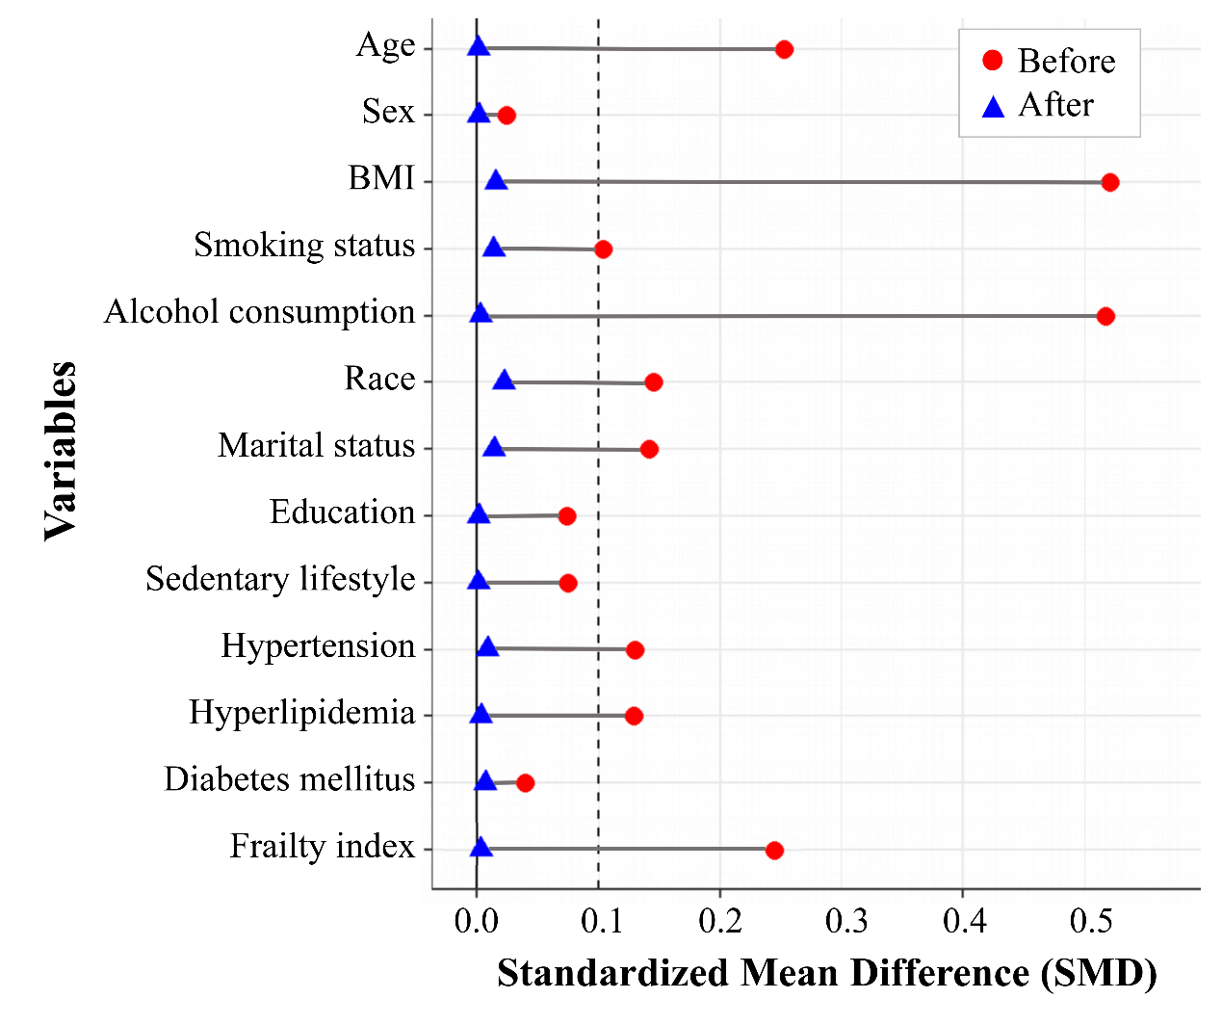
SFigure 2. Standardized mean differences for baseline covariates before and after using propensity score matching technique between participants with MASLD and those with cardiometabolic risk factors alone

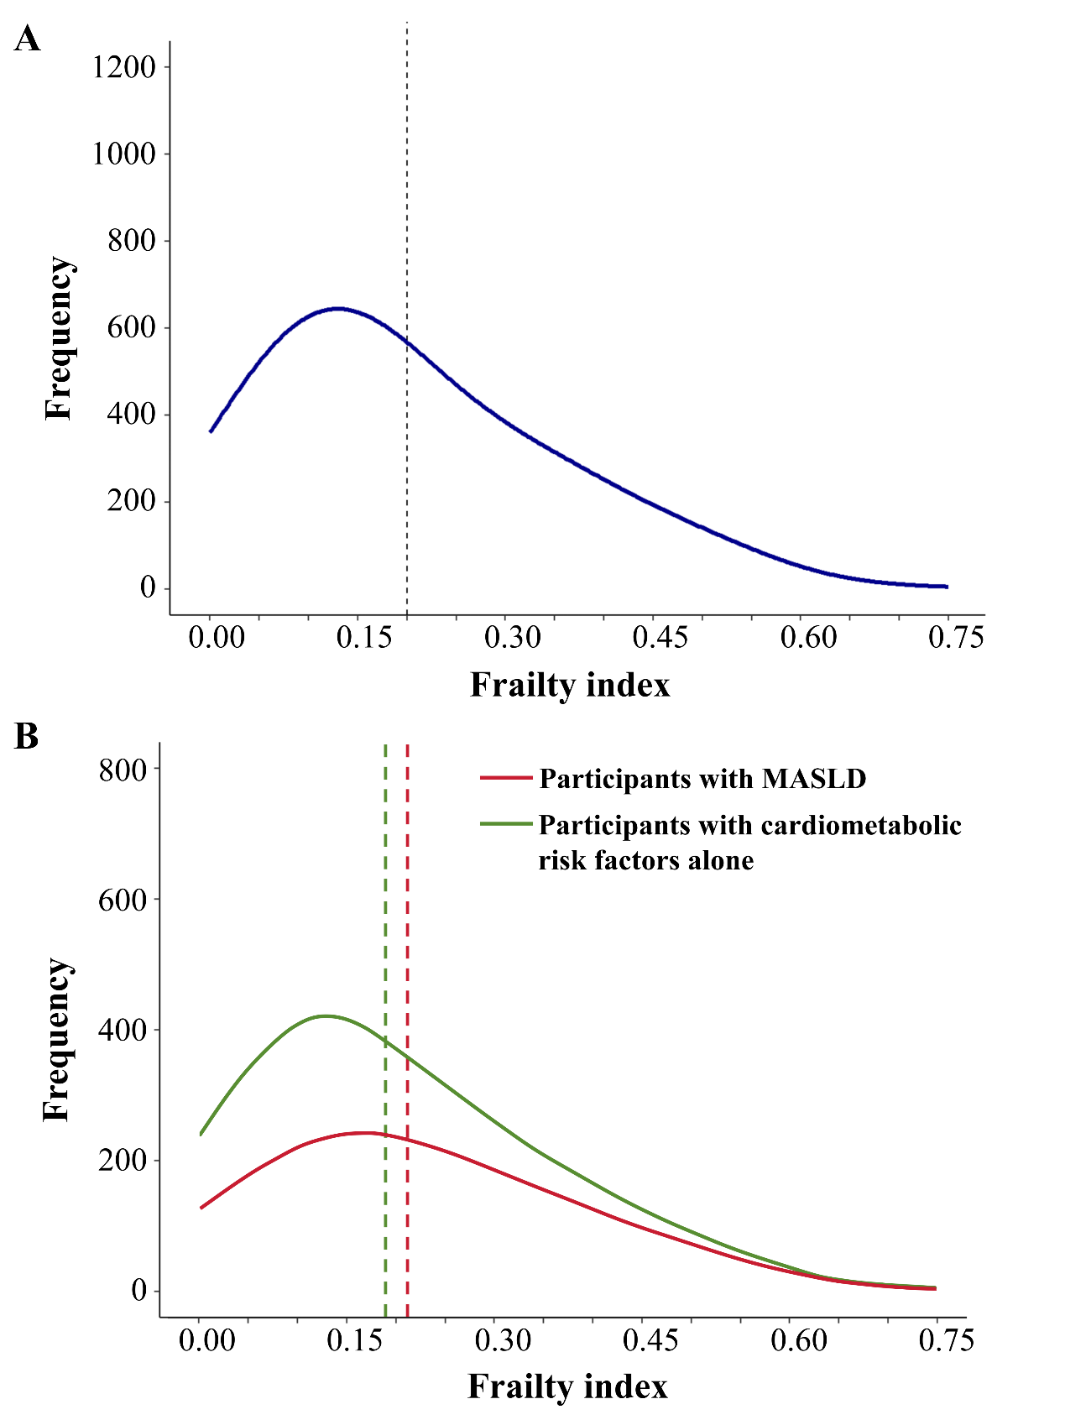
SFigure 3. Description of the frailty index distribution (A- results for total participants; B- results for participants with MASLD and with cardiometabolic risk factors alone separately. The dash lines represent the mean value of frailty index)

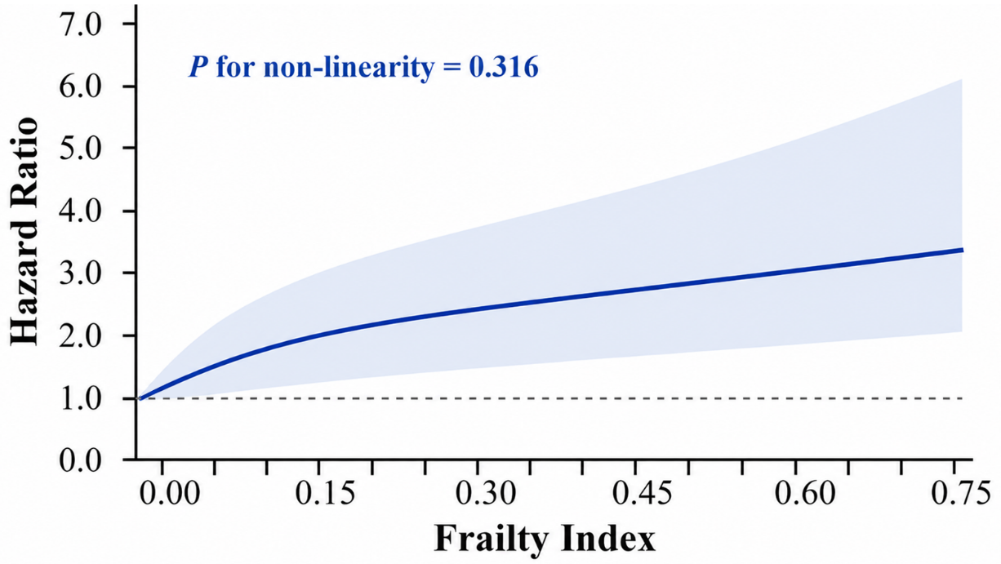
SFigure 4. Restricted cubic spline for the relationship between frailty index and CVD mortality¹
¹ Models adjusted for age, sex, BMI, smoking status, alcohol consumption, race, marital status, education, sedentary lifestyle, hypertension, hyperlipidemia, and diabetes mellitus.

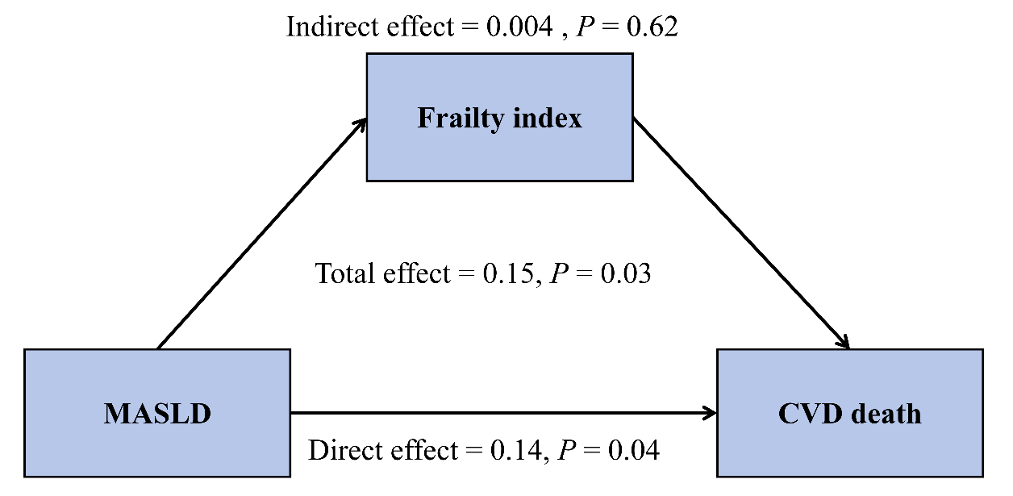
SFigure 5. Mediation analysis results of the association between MASLD and risk of CVD mortality by frailty¹
¹ Model adjusted for age, sex, BMI, smoking status, alcohol consumption, race, marital status, education, sedentary lifestyle, hypertension, hyperlipidemia, diabetes mellitus, and frailty index

