Maternal BMI modulates cord plasma NT-proBNP in gestational diabetes linking cardiac stress to insulin-cortisol crosstalk

Carolina Tocantins^{1,2,3,4,} Anna Rieder^{1,5,6}, Jasmin Zaunschirm-Strutz^{1,6,7}, Senka Ljubojevic-Holzer⁸, Bernhard Schwaberger⁹, Andreas Steiner¹, Elisa Weiß¹, Christina Stern¹*, Susana P. Pereira^{2,3,10,11}, Ursula Hiden¹*
Supplementary material

Table S1. Linear regression showing the effect of GDM treatment on NT-proBNP levels in umbilical cord blood plasma.
Predictor | Model | Coefficient B (SE) | 95% CI | p
GDM treatment  (GDM A vs. GDM AB ) | M₀ | 0.075 (0.124) | -0.183 to 0.333 | 0.551
GDM treatment  (GDM A vs. GDM AB ) | M₁ | -0.089 (0.132) | -0.187 to 0.364 | 0.509
GDM treatment  (GDM A vs. GDM AB ) | M_{S} | -0.126 (0.147) | -0.438 to 0.186 | 0.404
B: unstandardized coefficients; SE: standard error; CI: confidence interval. Linear regression analysis was performed in GDM participants with available NT-proBNP measurements (n = 24). In M₀, no model was applied, in model 1 (M₁) corrected for gestational age at delivery and neonatal sex, and the sensitivity model M_{S} additionally corrected for delivery mode, BMI at delivery and maternal age.
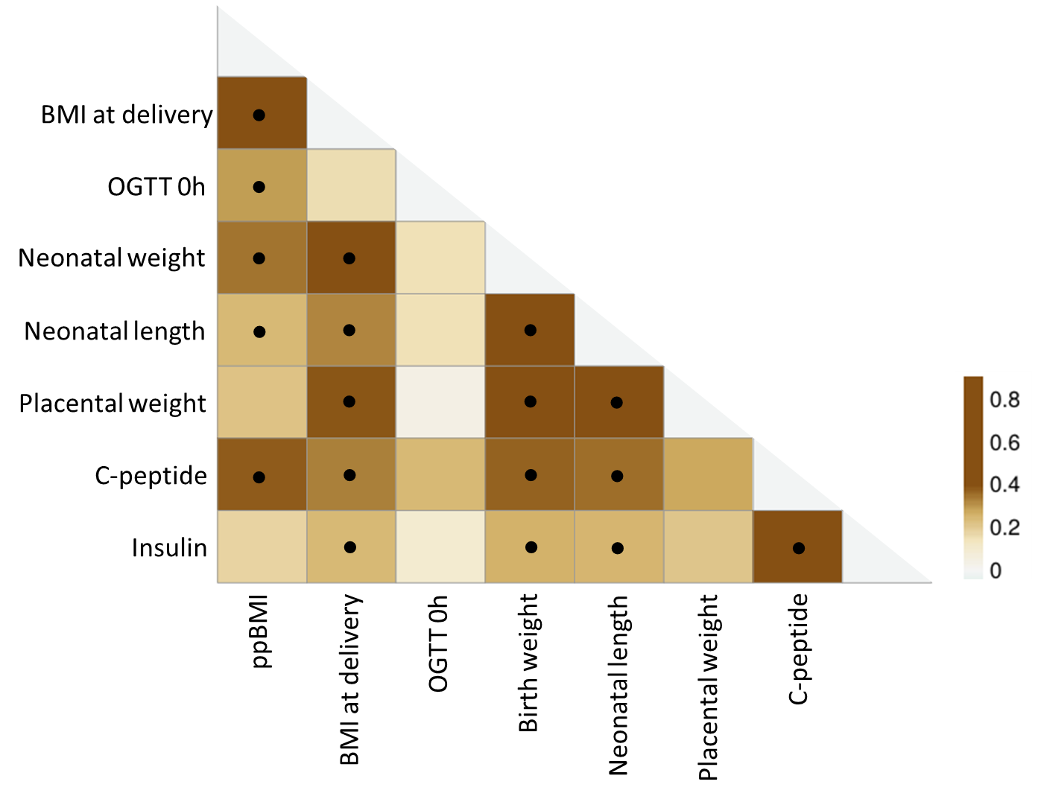
Figure S1. Intercorrelation of NT-proBNP-associated maternal and neonatal anthropometric parameters and umbilical cord plasma markers. For correlation analysis, data were log transformed to achieve normal distribution (Shapiro-Wilk test) and analysed using partial correlation, corrected for pregnancy length and neonatal sex. Correlations with a p < 0.05 were regarded as statistically significant and are represented with the symbol ●. The heatmap was generated with ClustVis online tool based on the corresponding correlation coefficient values. OGTT 0h: maternal fasting glucose during mid-pregnancy oral glucose tolerance test; ppBMI: pre-pregnancy BMI.

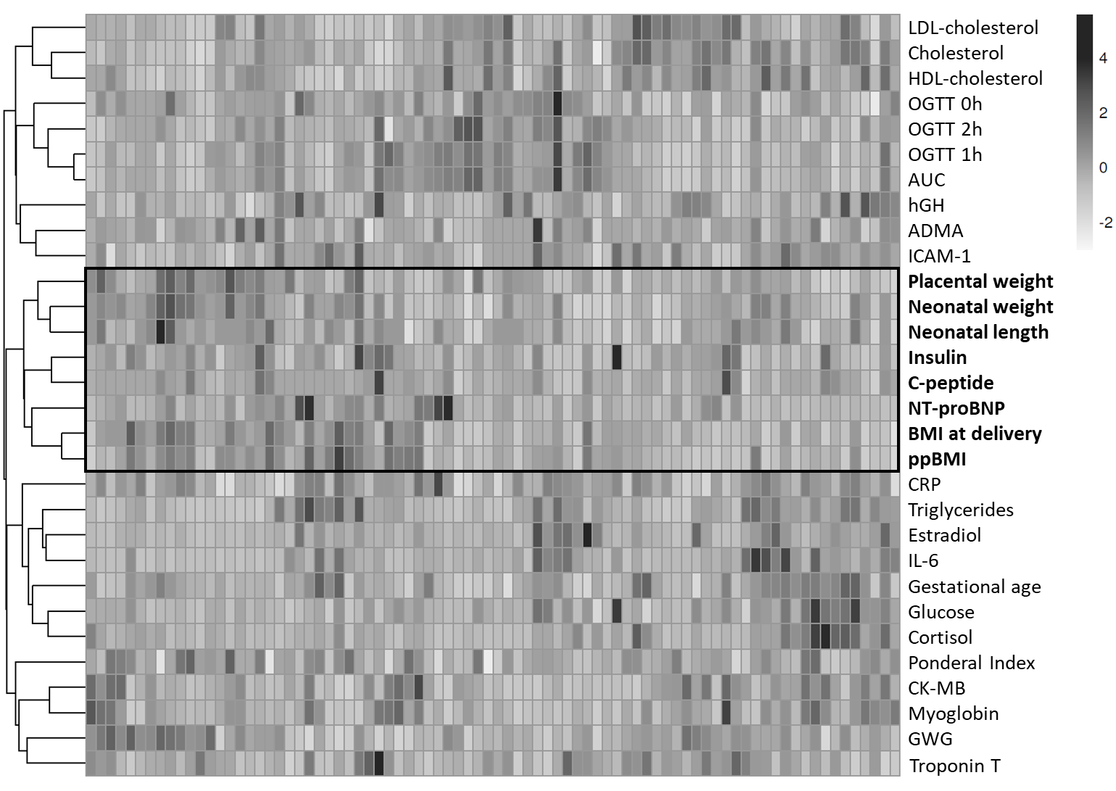
Figure S2. Hierarchical cluster analysis of maternal and neonatal characteristics and umbilical cord plasma biomarkers. Maternal and neonatal parameters were clustered using Manhattan distance clustering with complete clustering after unit variance scaling. Variables joining at the same branch reflect comparable patterns across the dataset. N-terminal pro-B-type natriuretic peptide (NT-proBNP) clustered with placental weight, neonatal weight and length, umbilical cord plasma C-peptide and insulin, body mass index (BMI) at delivery, and pre-pregnancy BMI (ppBMI). Clustering was performed using ClustVis online tool. LDL, low-density lipoprotein; HDL, high-density lipoprotein; OGTT, oral glucose tolerance test; AUC, area under the curve (OGTT); hGH, human growth hormone; ADMA, asymmetric dimethylarginine; ICAM-1, intercellular adhesion molecule 1; CRP, C-reactive protein; IL-6, interleukin-6; CK-MB, creatine kinase–myocardial band; GWG, gestational weight gain.

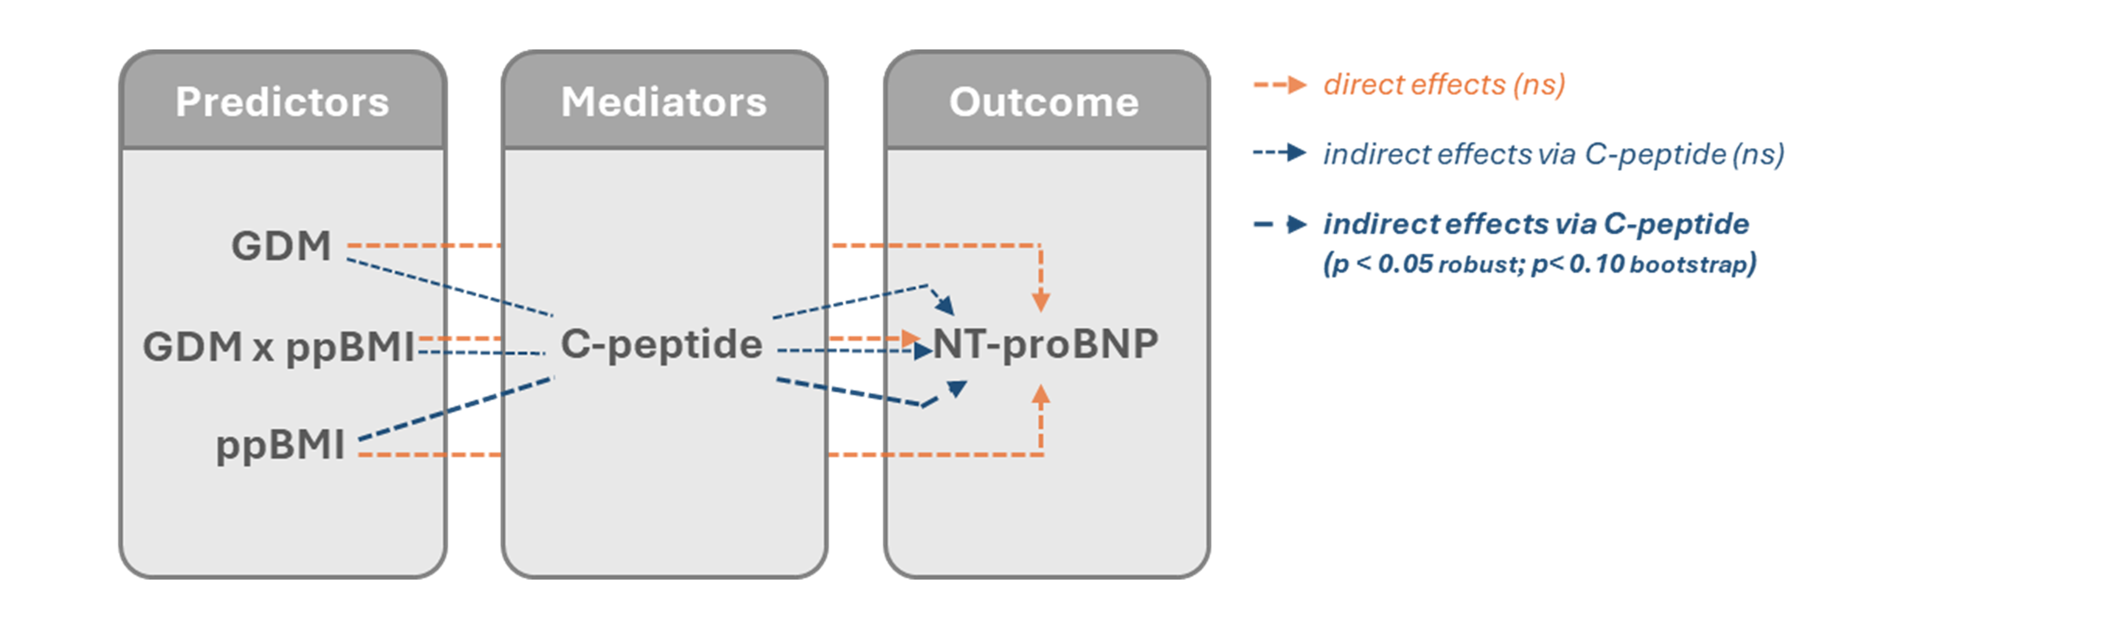
Figure S3. Overview of the mediation model. GDM, ppBMI, and the interaction between GDM and ppBMI (GDM x ppBMI) were included as predictors. Umbilical cord plasma C-peptide levels were examined as mediator and NT-proBNP as outcome.

Table S2. Robust and bootstrap mediation analysis of the association between maternal pre-pregnancy BMI (ppBMI) and NT-proBNP via C-peptide using GDM and its interaction with ppBMI.
 | Standardized estimate (β) | p-value | 95% CI
Robust
Indirect effects
ppBMI → C-peptide → NT-proBNP | 0.175 | 0.023 | 0.023 to 0.327
GDM → C-peptide → NT-proBNP | 0.005 | 0.924 | -0.098 to 0.108
GDM x ppBMI → C-peptide → NT-proBNP | -0.044 | 0.541 | -0.186 to 0.097
Direct effects
ppBMI → NT-proBNP | 0.044 | 0.263 | -0.133 to 0.441
GDM → NT-proBNP | 0.127 | 0.198 | -0.101 to 0.370
GDM x ppBMI → NT-proBNP | 0.221 | 0.891 | -0.196 to 0.241
Total effects
ppBMI → NT-proBNP | 0.219 | 0.05 | <0.001 to 0.437
GDM → NT-proBNP | 0.132 | 0.281 | -0.090 to 0.443
GDM x ppBMI → NT-proBNP | 0.176 | 0.195 | -0.108 to 0.372
Individual paths
ppBMI → C-peptide | 0.419 | 0.002 | 0.155 to 0.682
GDM → C-peptide | 0.012 | 0.924 | -0.234 to 0.258
GDM x ppBMI → C-peptide | -0.106 | 0.532 | -0.438 to 0.226
C-peptide → NT-proBNP | 0.418 | <0.001 | 0.184 to 0.651
Bootstrap (2000 replications)
Indirect effects
ppBMI → C-peptide → NT-proBNP | 0.175 | 0.076 | -0.024 to 0.390
GDM → C-peptide → NT-proBNP | 0.005 | 0.941 | -0.115 to 0.153
GDM x ppBMI → C-peptide → NT-proBNP | -0.044 | 0.675 | -0.278 to 0.138
Direct effects
ppBMI → NT-proBNP | 0.044 | 0.757 | -0.257 to 0.311
GDM → NT-proBNP | 0.127 | 0.311 | -0.122 to 0.369
GDM x ppBMI → NT-proBNP | 0.221 | 0.179 | -0.095 to 0.535
Total effects
ppBMI → NT-proBNP | 0.219 | 0.060 | -0.013 to 0.445
GDM → NT-proBNP | 0.132 | 0.319 | -0.162 to 0.362
GDM x ppBMI → NT-proBNP | 0.176 | 0.217 | -0.098 to 0.455
Individual paths
ppBMI → C-peptide | 0.419 | 0.005 | 0.108 to 0.710
GDM → C-peptide | 0.012 | 0.932 | -0.270 to 0.281
GDM x ppBMI → C-peptide | -0.106 | 0.604 | -0.510 to 0.297
C-peptide → NT-proBNP | 0.418 | 0.006 | 0.030 to 0.648

Table S3. Bootstrap mediation analysis of the association between maternal pre-pregnancy BMI (ppBMI) and NT-proBNP via placental weight using the area under the curve (AUC) of the maternal oral glucose tolerance test (OGTT) and its interaction with ppBMI.
 | Standardized estimate (β) | p-value | 95% CI
Bootstrap (2000 resamples)
Indirect effects
ppBMI → Placental weight → NT-proBNP | 0.053 | 0.208 | -0.002 to 0.167
OGTT AUC → Placental weight → NT-proBNP | -0.036 | 0.310 | -0.135 to 0.009
OGTT AUC x ppBMI → Placental weight → NT-proBNP | -0.007 | 0.811 | -0.085 to 0.048
Direct effects
ppBMI → NT-proBNP | 0.268 | 0.031 | 0.027 to 0.503
OGTT AUC → NT-proBNP | 0.164 | 0.157 | -0.099 to 0.363
OGTT AUC x ppBMI → NT-proBNP | -0.016 | 0.865 | -0.191 to 0.180
Total effects
ppBMI → NT-proBNP | 0.321 | 0.006 | 0.092 to 0.545
OGTT AUC → NT-proBNP | 0.128 | 0.289 | -0.139 to 0.336
OGTT AUC x Placental weight → NT-proBNP | -0.023 | 0.806 | -0.204 to 0.175
Individual paths
ppBMI → Placental weight | 0.263 | 0.017 | 0.025 to 0.458
OGTT AUC → Placental weight | -0.181 | 0.127 | -0.391 to 0.085
OGTT AUC x ppBMI → Placental weight | -0.036 | 0.783 | -0.284 to 0.229
Placental weight → NT-proBNP | 0.202 | 0.056 | -0.029 to 0.395

