Table S1. Recorded use of secondary-prevention medications at baseline, 1-year, and 2-year follow-up as a proportion of the baseline CAMI cohort according to CHG tertiles
Variables | Overall  (n=8,782) | CHG T1  (n=2,928) | CHG T2  (n=2,927) | CHG T3  (n=2,927) | P value
Baseline
β-blockers, n (%) | 6,333 (72.1) | 2,097 (71.6) | 2,092 (71.5) | 2,144 (73.2) | 0.243
Aspirin, n (%) | 8,516 (97.0) | 2,824 (96.4) | 2,838 (97.0) | 2,854 (97.5) | 0.061
DAPT, n (%) | 7,521 (85.6) | 2,500 (85.4) | 2,505 (85.6) | 2,516 (86.0) | 0.816
ACEI/ARB, n (%) | 5,100 (58.1) | 1,673 (57.1) | 1,707 (58.3) | 1,720 (58.8) | 0.428
Lipid lowering therapy, n (%) | 7,974 (90.8) | 2,655 (90.7) | 2,664 (91.0) | 2,655 (90.7) | 0.885
1-year follow-up
β-blockers, n (%) | 6,025 (68.6) | 1,994 (68.1) | 2,014 (68.8) | 2,017 (68.9) | 0.768
Aspirin, n (%) | 8,246 (93.9) | 2,738 (93.5) | 2,751 (94.0) | 2,757 (94.2) | 0.536
DAPT, n (%) | 5,961 (67.9) | 1,939 (66.2) | 2,011 (68.7) | 2,011 (68.7) | 0.063
ACEI/ARB, n (%) | 4,502 (51.3) | 1,487 (50.8) | 1,502 (51.3) | 1,513 (51.7) | 0.785
Lipid lowering therapy, n (%) | 8,045 (91.6) | 2,662 (90.9) | 2,690 (91.9) | 2,693 (92.0) | 0.252
2-year follow-up
β-blockers, n (%) | 5,632 (64.1) | 1,897 (64.8) | 1,876 (64.1) | 1,859 (63.5) | 0.595
Aspirin, n (%) | 8,004 (91.1) | 2,659 (90.8) | 2,652 (90.6) | 2,693 (92.0) | 0.126
DAPT, n (%) | 1,637 (18.6) | 580 (19.8) | 527 (18.0) | 530 (18.1) | 0.138
ACEI/ARB, n (%) | 4,004 (45.6) | 1,291 (44.1) | 1,358 (46.4) | 1,355 (46.3) | 0.135
Lipid lowering therapy, n (%) | 7,682 (87.5) | 2,568 (87.7) | 2,529 (86.4) | 2,585 (88.3) | 0.078
T1, T2, and T3 represent the lowest, middle, and highest tertiles of the CHG index within each cohort, respectively.
Values are n (%), with denominators fixed at the baseline CHG-tertile sample size. Patients who died before a given visit, were lost to follow-up, or had missing item-level data were retained in the denominator and counted as non-users.
Abbreviations: ACEI/ARB: angiotensin-converting enzyme inhibitor/angiotensin receptor blocker; CHG: cholesterol, high-density lipoprotein, and glucose; DAPT: dual antiplatelet therapy.

Table S2. Baseline characteristics of included patients and patients excluded because of missing key variables in the CAMI cohort

Variables | Included patients  (n = 8,782) | Excluded patients  (n = 17,376) | P value
Age, years | 61.5 [53.0, 70.0] | 62.0 [53.0, 71.0] | 0.018
Sex, male, n (%) | 6,587 (75.0) | 12,860 (74.0) | 0.086
BMI, kg/m² | 24.4 [22.1, 26.4] | 24.3 [22.0, 26.3] | 0.071
Smoking, n (%) | 4,134 (47.1) | 8,040 (46.3) | 0.214
Hypertension, n (%) | 4,374 (49.8) | 8,760 (50.4) | 0.356
Hyperlipidemia, n (%) | 434 (4.9) | 785 (4.5) | 0.139
T2DM, n (%) | 1,685 (19.2) | 3,400 (19.6) | 0.468
Family history of CAD, n (%) | 338 (3.8) | 620 (3.6) | 0.282
Previous MI, n (%) | 666 (7.6) | 1,350 (7.8) | 0.584
Previous Stroke, n (%) | 843 (9.6) | 1,735 (10.0) | 0.322
Previous HF, n (%) | 188 (2.1) | 420 (2.4) | 0.167
Previous CABG, n (%) | 39 (0.4) | 80 (0.5) | 0.563
Previous PVD, n (%) | 52 (0.6) | 115 (0.7) | 0.421
Previous CKD, n (%) | 88 (1.0) | 200 (1.2) | 0.276
Previous COPD, n (%) | 156 (1.8) | 350 (2.0) | 0.198
SBP, mmHg | 129.0 [112.0, 145.0] | 128.0 [112.0, 145.0] | 0.092
Heart rate, bpm | 76.0 [66.0, 87.0] | 77.0 [66.0, 88.0] | 0.041
Killip class III/IV, n (%) | 1,852 (21.1) | 3,790 (21.8) | 0.184
Cr, μmol/L | 72.70 [61.0, 87.5] | 73.5 [61.5, 88.0] | 0.064
β-blockers, n (%) | 6,333 (72.1) | 12,420 (71.5) | 0.309
Aspirin, n (%) | 8,516 (97.0) | 16,790 (96.6) | 0.096
DAPT, n (%) | 7,521 (85.6) | 14,760 (84.9) | 0.143
ACEI/ARB, n (%) | 5,100 (58.1) | 10,020 (57.7) | 0.542
Lipid lowering therapy, n (%) | 7,974 (90.8) | 15,680 (90.2) | 0.128
Excluded patients refers only to those excluded due to missing key variables (n=17,376).
Abbreviations: ACEI/ARB, angiotensin-converting enzyme inhibitor/angiotensin receptor blocker; BMI, body mass index; CABG, coronary artery bypass grafting; CAD, coronary artery disease; CAMI, China Acute Myocardial Infarction; CKD, chronic kidney disease; COPD, chronic obstructive pulmonary disease; Cr, creatinine; DAPT, dual antiplatelet therapy; HF, heart failure; MI, myocardial infarction; PVD, peripheral vascular disease; SBP, systolic blood pressure; T2DM, type 2 diabetes mellitus.

Table S3. Univariable Cox regression analysis of baseline characteristics for 2-year mortality in the CAMI cohort

Variables | HR (95%CI) | P value
Age, years | 1.05 (1.04–1.06) | < 0.001
Sex, male | 0.95 (0.80–1.12) | 0.524
Smoking | 1.18 (1.02–1.36) | 0.025
BMI, kg/m² | 1.02 (0.92–1.13) | 0.706
Hypertension | 1.30 (1.12–1.51) | < 0.001
Hyperlipidemia | 1.15 (0.88–1.50) | 0.312
T2DM | 1.82 (1.55–2.15) | < 0.001
Family history of CAD | 0.95 (0.70–1.28) | 0.731
Previous MI | 1.45 (1.18–1.78) | < 0.001
Previous stroke | 1.52 (1.25–1.85) | < 0.001
Previous HF | 2.65 (2.05–3.42) | < 0.001
Previous CABG | 1.60 (0.85–3.02) | 0.145
Previous PVD | 1.48 (0.92–2.38) | 0.105
Previous CKD | 1.60 (0.91–2.82) | 0.102
Previous COPD | 1.58 (1.12–2.22) | 0.008
SBP, mmHg | 0.93 (0.89–1.02) | 0.110
Heart rate, bpm | 1.22 (0.70–1.74) | 0.684
Killip class III/IV | 3.45 (2.85–4.18) | < 0.001
FBG, mmol/L | 1.07 (1.05–1.09) | < 0.001
TC, mmol/L | 1.10 (1.02–1.18) | 0.015
LDL-C, mmol/L | 1.14 (1.05–1.24) | 0.002
HDL-C, mmol/L | 0.62 (0.48–0.80) | < 0.001
TG, mmol/L | 1.04 (0.98–1.10) | 0.185
Cr, μmol/L | 1.08 (1.06–1.10) | < 0.001
CHG index | 1.52 (1.32-1.75) | < 0.001
TyG index | 1.43 (1.21-1.70) | < 0.001
β-blockers | 1.00 (0.83–1.20) | 0.830
Aspirin | 0.97 (0.79–1.18) | 0.732
DAPT | 0.90 (0.69–1.17) | 0.440
ACEI/ARB | 0.83 (0.42–1.65) | 0.591
Lipid lowering therapy | 1.18 (0.88–1.57) | 0.274

Abbreviations: ACEI/ARB: angiotensin-converting enzyme inhibitor/angiotensin receptor blocker; BMI: body mass index; CABG: coronary artery bypass grafting; CAD: coronary artery disease; CAMI: China Acute Myocardial Infarction; CHG: cholesterol, high-density lipoprotein, and glucose; CKD: chronic kidney disease; COPD: chronic obstructive pulmonary disease; Cr: creatinine; DAPT: dual antiplatelet therapy; FBG: fasting blood glucose; HDL-C: high-density lipoprotein cholesterol; HF: heart failure; LDL-C: low-density lipoprotein cholesterol; MI: myocardial infarction; PVD: peripheral vascular disease; SBP: systolic blood pressure; T2DM: type 2 diabetes mellitus; TC: total cholesterol; TG: triglyceride; TyG: triglyceride-glucose.

Table S4. Univariable Cox regression analysis of baseline characteristics for all-cause mortality in the Fuwai Hospital cohort

Variables | HR (95%CI) | P value
Age, years | 1.04 (1.02–1.06) | < 0.001
Sex, male | 0.85 (0.60–1.20) | 0.352
Smoking | 0.90 (0.76–1.05) | 0.189
BMI, kg/m² | 0.98 (0.94–1.02) | 0.425
STEMI | 1.10 (0.85–1.45) | 0.458
Killip class III/IV | 2.85 (2.10–3.85) | < 0.001
Hypertension | 1.25 (1.02–1.55) | 0.035
T2DM | 1.75 (1.35–2.25) | < 0.001
Previous HF | 2.15 (1.55–2.98) | < 0.001
Previous stroke | 1.45 (1.05–1.98) | 0.022
Previous PCI | 1.20 (0.88–1.65) | 0.254
Previous CABG | 1.35 (0.85–2.15) | 0.197
Previous PVD | 1.40 (0.95–2.05) | 0.085
LDL-C, mmol/L | 1.12 (1.02–1.25) | 0.023
TG, mmol/L | 1.05 (0.98–1.12) | 0.155
FBG, mmol/L | 1.06 (1.03–1.10) | < 0.001
HbA1c, % | 1.16 (1.08–1.25) | < 0.001
hs-CRP, mg/L | 1.02 (0.99–1.05) | 0.065
CHG index | 1.45 (1.12-1.88) | 0.005
TyG index | 1.35 (1.10-1.65) | 0.004
LVEF, % | 0.92 (0.86–0.97) | 0.020
Primary PCI | 0.86 (0.65–1.15) | 0.238
β-blockers | 0.65 (0.45–0.92) | 0.015
Aspirin | 0.95 (0.86-1.05) | 0.337
DAPT | 0.55 (0.35–0.85) | 0.007
ACEI/ARB/ARNI | 0.92 (0.65-1.31) | 0.647
Lipid lowering therapy | 0.87 (0.73–1.03) | 0.112

Abbreviations: ACEI/ARB/ARNI: angiotensin-converting enzyme inhibitor/angiotensin receptor blocker/angiotensin receptor–neprilysin inhibitor; BMI: body mass index; CABG: coronary artery bypass grafting; CHG: cholesterol, high-density lipoprotein, and glucose; DAPT: dual antiplatelet therapy; FBG: fasting blood glucose; HbA1c: hemoglobin A1c; HF: heart failure; hs-CRP: high-sensitivity C-reactive protein; LDL-C: low-density lipoprotein cholesterol; LVEF: left ventricular ejection fraction; PCI: percutaneous coronary intervention; PVD: peripheral vascular disease; STEMI: ST-segment elevation myocardial infarction; T2DM: type 2 diabetes mellitus; TG: triglyceride; TyG: triglyceride-glucose.

Table S5. Discriminative performance of the CHG index, its individual components, and the TyG index for mortality in the CAMI cohort
Outcome | Marker | AUC (95% CI) | ΔAUC | FDR-adjusted P value
In-hospital mortality
 | CHG index | 0.789 (0.755–0.823) | - | -
 | TC | 0.610 (0.566–0.654) | -0.179 | <0.001
 | FBG | 0.735 (0.698–0.772) | -0.054 | 0.018
 | HDL-C | 0.635 (0.592–0.678) | -0.154 | <0.001
 | TyG index | 0.756 (0.720–0.792) | -0.033 | 0.032
1-year mortality | CHG index | 0.753 (0.719–0.787) | - | -
 | TC | 0.598 (0.560–0.636) | -0.155 | <0.001
 | FBG | 0.712 (0.676–0.748) | -0.041 | 0.026
 | HDL-C | 0.624 (0.586–0.662) | -0.129 | <0.001
 | TyG index | 0.724 (0.689–0.759) | -0.029 | 0.041
2-year mortality | CHG index | 0.751 (0.720–0.782) | - | -
 | TC | 0.595 (0.560–0.630) | -0.156 | <0.001
 | FBG | 0.708 (0.675–0.741) | -0.043 | 0.021
 | HDL-C | 0.628 (0.593–0.663) | -0.123 | <0.001
 | TyG index | 0.732 (0.701–0.763) | -0.019 | 0.047
Abbreviations: AUC, area under the curve; CHG, cholesterol, high-density lipoprotein, and glucose; CI, confidence interval; FBG, fasting blood glucose; FDR, false discovery rate; HDL-C, high-density lipoprotein cholesterol; TC, total cholesterol; TyG, triglyceride-glucose.

Table S6. Incremental prognostic information provided by the CHG index, its individual components, and the TyG index beyond the GRACE score in the CAMI cohort
Outcome | Model | AUC (95% CI) | ΔAUC | FDR-adjusted P value | NRI (95% CI) | P value | IDI (95% CI) | P value
In-hospital mortality | GRACE model | 0.765 (0.743–0.798) | - | - | - | - | - | -
 | + TC | 0.769 (0.744–0.800) | 0.004 | 0.428 | 0.009 (-0.012–0.030) | 0.391 | 0.003 (-0.004–0.010) | 0.406
 | + FBG | 0.781 (0.756–0.812) | 0.016 | 0.096 | 0.024 (-0.004–0.052) | 0.091 | 0.011 (-0.002–0.024) | 0.094
 | + HDL-C | 0.772 (0.747–0.803) | 0.007 | 0.286 | 0.014 (-0.009–0.037) | 0.233 | 0.005 (-0.003–0.013) | 0.219
 | + TyG index | 0.767 (0.744–0.799) | 0.002 | 0.641 | 0.008 (-0.014–0.030) | 0.476 | 0.002 (-0.005–0.009) | 0.584
 | + CHG index | 0.815 (0.801–0.849) | 0.050 | <0.001 | 0.052 (0.021–0.083) | <0.001 | 0.035 (0.012–0.058) | <0.001
1-year mortality | GRACE model | 0.732 (0.710–0.758) | - | - | - | - | - | -
 | + TC | 0.736 (0.714–0.761) | 0.004 | 0.452 | 0.011 (-0.011–0.033) | 0.326 | 0.003 (-0.004–0.010) | 0.391
 | + FBG | 0.746 (0.724–0.771) | 0.014 | 0.118 | 0.027 (-0.001–0.055) | 0.058 | 0.012 (-0.001–0.025) | 0.071
 | + HDL-C | 0.739 (0.717–0.764) | 0.007 | 0.274 | 0.016 (-0.008–0.040) | 0.190 | 0.006 (-0.002–0.014) | 0.146
 | + TyG index | 0.738 (0.716–0.763) | 0.006 | 0.298 | 0.015 (-0.008–0.038) | 0.201 | 0.005 (-0.003–0.013) | 0.218
 | + CHG index | 0.768 (0.748–0.783) | 0.036 | <0.001 | 0.065 (0.035–0.095) | <0.001 | 0.042 (0.020–0.064) | <0.001
2-year mortality | GRACE model | 0.712 (0.698–0.736) | - | - | - | - | - | -
 | + TC | 0.716 (0.701–0.739) | 0.004 | 0.438 | 0.010 (-0.012–0.032) | 0.374 | 0.003 (-0.004–0.010) | 0.412
 | + FBG | 0.726 (0.711–0.749) | 0.014 | 0.106 | 0.026 (-0.002–0.054) | 0.066 | 0.011 (-0.002–0.024) | 0.082
 | + HDL-C | 0.719 (0.704–0.742) | 0.007 | 0.261 | 0.015 (-0.009–0.039) | 0.218 | 0.006 (-0.002–0.014) | 0.154
 | + TyG index | 0.721 (0.706–0.744) | 0.009 | 0.171 | 0.018 (-0.006–0.042) | 0.142 | 0.007 (-0.001–0.015) | 0.086
 | + CHG index | 0.752 (0.741–0.771) | 0.040 | <0.001 | 0.058 (0.028–0.088) | <0.001 | 0.038 (0.015–0.061) | <0.001
Table S7. Discriminative performance of the CHG index, its individual components, and the TyG index for all-cause mortality in the Fuwai Hospital cohort
Outcome | Marker | 1-year AUC (95% CI) | ΔAUC | FDR-adjusted P value | 3-year AUC (95% CI) | ΔAUC | FDR-adjusted P value
All-cause mortality | CHG index | 0.702 (0.653–0.751) | - | - | 0.725 (0.686–0.764) | - | -
 | TC | 0.585 (0.532–0.638) | -0.117 | <0.001 | 0.592 (0.548–0.636) | -0.133 | <0.001
 | FBG | 0.668 (0.616–0.720) | -0.034 | 0.044 | 0.690 (0.648–0.732) | -0.035 | 0.042
 | HDL-C | 0.612 (0.560–0.664) | -0.090 | 0.006 | 0.628 (0.584–0.672) | -0.097 | 0.004
 | TyG index | 0.664 (0.612–0.716) | -0.038 | 0.032 | 0.685 (0.643–0.727) | -0.040 | 0.017

Abbreviations: AUC, area under the curve; CHG, cholesterol, high-density lipoprotein, and glucose; CI, confidence interval; FBG, fasting blood glucose; FDR, false discovery rate; HDL-C, high-density lipoprotein cholesterol; TC, total cholesterol; TyG, triglyceride-glucose.

Table S8. Sensitivity analyses for the association between the CHG index and mortality after excluding patients who died within 48 hours of admission

Event Type | CHG | Total (Events) | Model 1 |  | Model 2 |  | Model 3
Event Type | CHG | Total (Events) | HR (95% CI) | P _{value} | HR (95% CI) | P _{value} | HR (95% CI) | P _{value}
*CAMI
In-hospital | T1 | 2915 (18) | 1.00 (Ref) | — | 1.00 (Ref) | — | 1.00 (Ref) | —
 | T2 | 2912 (38) | 1.62 (1.02-2.58) | 0.041 | 1.55 (0.95-2.45) | 0.078 | 1.48 (0.91-2.42) | 0.116
 | T3 | 2913 (54) | 2.65 (1.82-3.85) | <0.001 | 2.50 (1.70-3.68) | <0.001 | 2.35 (1.56-3.58) | <0.001
 | Per 1 unit | 8740 (110) | 1.48 (1.25-1.75) | <0.001 | 1.42 (1.18-1.70) | <0.001 | 1.39 (1.12-1.68) | 0.002
1-year | T1 | 2915 (35) | 1.00 (Ref) | — | 1.00 (Ref) | — | 1.00 (Ref) | —
 | T2 | 2912 (62) | 1.55 (1.05-2.28) | 0.025 | 1.48 (0.98-2.22) | 0.062 | 1.43 (0.92-2.18) | 0.105
 | T3 | 2913 (103) | 2.38 (1.78-3.18) | <0.001 | 2.30 (1.70-3.10) | <0.001 | 2.22 (1.63-3.06) | <0.001
 | Per 1 unit | 8740 (200) | 1.45 (1.25-1.68) | <0.001 | 1.40 (1.18-1.65) | <0.001 | 1.35 (1.12-1.63) | 0.001
2-year | T1 | 2915 (58) | 1.00 (Ref) | — | 1.00 (Ref) | — | 1.00 (Ref) | —
 | T2 | 2912 (95) | 1.52 (1.12-2.05) | 0.008 | 1.48 (1.08-2.02) | 0.015 | 1.41 (1.03-1.95) | 0.033
 | T3 | 2913 (155) | 2.45 (1.82-3.30) | <0.001 | 2.35 (1.75-3.15) | <0.001 | 2.29 (1.69–3.13) | <0.001
 | Per 1 unit | 8740 (308) | 1.42 (1.25–1.62) | <0.001 | 1.38 (1.18–1.60) | <0.001 | 1.33 (1.13–1.55) | 0.001
#Fuwai Hospital
All-cause | T1 | 1155 (21) | 1.00 (Ref) | — | 1.00 (Ref) | — | 1.00 (Ref) | —
 | T2 | 1154 (37) | 1.70 (0.98–2.95) | 0.058 | 1.62 (0.90–2.92) | 0.088 | 1.56 (0.88–2.85) | 0.105
 | T3 | 1154 (54) | 2.38 (1.45–3.92) | <0.001 | 2.18 (1.30–3.65) | 0.004 | 2.08 (1.21–3.56) | 0.003
 | Per 1 unit | 3463 (112) | 1.38 (1.08–1.76) | 0.01 | 1.35 (1.04–1.72) | 0.022 | 1.31 (1.04–1.71) | 0.018

T1, T2, and T3 represent the lowest, middle, and highest tertiles of the CHG index within each cohort, respectively.
*Adjustments: Model 1: unadjusted. Model 2: adjusted for age, BMI, sex, and smoking. Model 3: additionally adjusted for ACEI/ARB, aspirin, β-blockers, Cr, family history of CAD, DAPT, hyperlipidemia, hypertension, Killip class III/IV, LDL-C, previous CABG, previous COPD, previous HF, previous MI, previous stroke, lipid lowering therapy, and T2DM.
#Adjustments: Model 1: unadjusted. Model 2: adjusted for age, BMI, sex, and smoking. Model 3: additionally adjusted for ACEI/ARB/ARNI, aspirin, β-blockers, DAPT, HbA1c, hypertension, Killip class III/IV, LDL-C, LVEF, previous CABG, previous HF, previous PVD, previous stroke, lipid lowering therapy, STEMI, and T2DM.
Abbreviations: ACEI/ARB/ARNI: angiotensin-converting enzyme inhibitor/angiotensin receptor blocker/angiotensin receptor–neprilysin inhibitor; AMI: acute myocardial infarction; BMI: body mass index; CABG: coronary artery bypass grafting; CAD: coronary artery disease; CAMI: China Acute Myocardial Infarction; CHG: cholesterol, high-density lipoprotein, and glucose; CI: confidence interval; COPD: chronic obstructive pulmonary disease; Cr: creatinine; DAPT: dual antiplatelet therapy; HbA1c: hemoglobin A1c; HF: heart failure; HR: hazard ratio; LDL-C: low-density lipoprotein cholesterol; LVEF: left ventricular ejection fraction; MI: myocardial infarction; PVD: peripheral vascular disease; Ref: reference; STEMI: ST-segment elevation myocardial infarction; T2DM: type 2 diabetes mellitus.

Table S9. Association between the CHG index and mortality in the complete-case sensitivity analysis
Event Type | CHG | Total (Events) | Model 1 |  | Model 2 |  | Model 3
Event Type | CHG | Total (Events) | HR (95% CI) | P _{value} | HR (95% CI) | P _{value} | HR (95% CI) | P _{value}
CAMI cohort
In-hospital | T1 | 2794 (24) | 1.00 (Ref) | — | 1.00 (Ref) | — | 1.00 (Ref) | —
 | T2 | 2793 (43) | 1.80 (1.08-3.00) | 0.024 | 1.68 (1.02-2.75) | 0.041 | 1.55 (0.98-2.55) | 0.058
 | T3 | 2793 (78) | 3.30 (2.05-5.30) | <0.001 | 2.92 (1.82-4.68) | <0.001 | 2.62 (1.61-4.28) | <0.001
 | Per 1 unit | 8380 (145) | 1.62 (1.35-1.95) | <0.001 | 1.52 (1.25-1.85) | <0.001 | 1.45 (1.19-1.78) | <0.001
1-year | T1 | 2794 (40) | 1.00 (Ref) | — | 1.00 (Ref) | — | 1.00 (Ref) | —
 | T2 | 2793 (68) | 1.65 (1.12-2.42) | 0.011 | 1.55 (1.05-2.30) | 0.028 | 1.48 (1.01-2.18) | 0.047
 | T3 | 2793 (125) | 2.80 (2.15-3.65) | <0.001 | 2.75 (1.92-3.40) | <0.001 | 2.55 (1.79-3.28) | <0.001
 | Per 1 unit | 8380 (233) | 1.55 (1.32-1.82) | <0.001 | 1.48 (1.25-1.72) | <0.001 | 1.40 (1.18-1.66) | <0.001
2-year | T1 | 2794 (62) | 1.00 (Ref) | — | 1.00 (Ref) | — | 1.00 (Ref) | —
 | T2 | 2793 (102) | 1.60 (1.18-2.18) | 0.003 | 1.50 (1.10-2.05) | 0.012 | 1.45 (1.06-1.95) | 0.022
 | T3 | 2793 (172) | 2.82 (2.08-3.80) | <0.001 | 2.52 (1.88-3.42) | <0.001 | 2.38 (1.76-3.22) | <0.001
 | Per 1 unit | 8380 (336) | 1.50 (1.30-1.72) | <0.001 | 1.42 (1.22-1.65) | <0.001 | 1.36 (1.15-1.59) | <0.001
#Fuwai Hospital
All-cause | T1 | 1106 (21) | 1.00 (Ref) | — | 1.00 (Ref) | — | 1.00 (Ref) | —
 | T2 | 1107 (36) | 1.72 (1.00-2.95) | 0.05 | 1.62 (0.94-2.80) | 0.082 | 1.56 (0.88-2.71) | 0.105
 | T3 | 1107 (52) | 2.52 (1.52-4.18) | <0.001 | 2.28 (1.35-3.80) | 0.002 | 2.13 (1.25-3.61) | 0.002
 | Per 1 unit | 3320 (109) | 1.42 (1.10-1.85) | 0.008 | 1.35 (1.04-1.75) | 0.025 | 1.31 (1.03-1.72) | 0.042
T1, T2, and T3 represent the lowest, middle, and highest tertiles of the CHG index within each cohort, respectively.
*Adjustments: Model 1: unadjusted. Model 2: adjusted for age, BMI, sex, and smoking. Model 3: additionally adjusted for ACEI/ARB, aspirin, β-blockers, Cr, family history of CAD, DAPT, hyperlipidemia, hypertension, Killip class III/IV, LDL-C, previous CABG, previous COPD, previous HF, previous MI, previous stroke, lipid lowering therapy, and T2DM.
#Adjustments: Model 1: unadjusted. Model 2: adjusted for age, BMI, sex, and smoking. Model 3: additionally adjusted for ACEI/ARB/ARNI, aspirin, β-blockers, DAPT, HbA1c, hypertension, Killip class III/IV, LDL-C, LVEF, previous CABG, previous HF, previous PVD, previous stroke, lipid lowering therapy, STEMI, and T2DM.
Abbreviations: ACEI/ARB/ARNI: angiotensin-converting enzyme inhibitor/angiotensin receptor blocker/angiotensin receptor–neprilysin inhibitor; AMI: acute myocardial infarction; BMI: body mass index; CABG: coronary artery bypass grafting; CAD: coronary artery disease; CAMI: China Acute Myocardial Infarction; CHG: cholesterol, high-density lipoprotein, and glucose; CI: confidence interval; COPD: chronic obstructive pulmonary disease; Cr: creatinine; DAPT: dual antiplatelet therapy; HbA1c: hemoglobin A1c; HF: heart failure; HR: hazard ratio; LDL-C: low-density lipoprotein cholesterol; LVEF: left ventricular ejection fraction; MI: myocardial infarction; PVD: peripheral vascular disease; Ref: reference; STEMI: ST-segment elevation myocardial infarction; T2DM: type 2 diabetes mellitus.

Table S10. Association between the CHG index and mortality using multiple imputation by chained equations (MICE) for missing covariates
Event Type | CHG | Total (Events) | Model 1 |  | Model 2 |  | Model 3
Event Type | CHG | Total (Events) | HR (95% CI) | P _{value} | HR (95% CI) | P _{value} | HR (95% CI) | P _{value}
CAMI cohort
In-hospital | T1 | 2928 (25) | 1.00 (Ref) | — | 1.00 (Ref) | — | 1.00 (Ref) | —
 | T2 | 2927 (45) | 1.82 (1.10-2.98) | 0.018 | 1.70 (1.05-2.75) | 0.031 | 1.60 (0.98-2.60) | 0.065
 | T3 | 2927 (82) | 3.35 (2.10-5.32) | <0.001 | 3.00 (1.88-4.75) | <0.001 | 2.68 (1.65-4.35) | <0.001
 | Per 1 unit | 8782 (152) | 1.65 (1.38-1.98) | <0.001 | 1.58 (1.30-1.90) | <0.001 | 1.50 (1.22-1.85) | <0.001
1-year | T1 | 2928 (42) | 1.00 (Ref) | — | 1.00 (Ref) | — | 1.00 (Ref) | —
 | T2 | 2927 (70) | 1.68 (1.15-2.45) | 0.007 | 1.60 (1.08-2.35) | 0.018 | 1.52 (1.02-2.22) | 0.038
 | T3 | 2927 (130) | 2.85 (2.15-3.65) | <0.001 | 2.82 (1.98-3.45) | <0.001 | 2.60 (1.82-3.35) | <0.001
 | Per 1 unit | 8782 (242) | 1.58 (1.35-1.85) | <0.001 | 1.52 (1.30-1.78) | <0.001 | 1.45 (1.22-1.70) | <0.001
2-year | T1 | 2928 (65) | 1.00 (Ref) | — | 1.00 (Ref) | — | 1.00 (Ref) | —
 | T2 | 2927 (105) | 1.62 (1.20-2.20) | 0.002 | 1.55 (1.15-2.10) | 0.006 | 1.48 (1.10-2.00) | 0.012
 | T3 | 2927 (180) | 2.88 (2.15-3.85) | <0.001 | 2.60 (1.92-3.48) | <0.001 | 2.42 (1.80-3.28) | <0.001
 | Per 1 unit | 8782 (350) | 1.52 (1.32-1.75) | <0.001 | 1.48 (1.28-1.70) | <0.001 | 1.40 (1.20-1.65) | <0.001
#Fuwai Hospital
All-cause | T1 | 1155 (22) | 1.00 (Ref) | — | 1.00 (Ref) | — | 1.00 (Ref) | —
 | T2 | 1156 (38) | 1.78 (1.05-3.00) | 0.038 | 1.68 (0.98-2.85) | 0.062 | 1.60 (0.92-2.75) | 0.092
 | T3 | 1155 (55) | 2.58 (1.58-4.25) | <0.001 | 2.35 (1.40-3.88) | 0.001 | 2.18 (1.30-3.65) | 0.003
 | Per 1 unit | 3466 (115) | 1.48 (1.15-1.92) | 0.004 | 1.40 (1.08-1.82) | 0.012 | 1.35 (1.05-1.78) | 0.035
T1, T2, and T3 represent the lowest, middle, and highest tertiles of the CHG index within each cohort, respectively.
*Adjustments: Model 1: unadjusted. Model 2: adjusted for age, BMI, sex, and smoking. Model 3: additionally adjusted for ACEI/ARB, aspirin, β-blockers, Cr, family history of CAD, DAPT, hyperlipidemia, hypertension, Killip class III/IV, LDL-C, previous CABG, previous COPD, previous HF, previous MI, previous stroke, lipid lowering therapy, and T2DM.
#Adjustments: Model 1: unadjusted. Model 2: adjusted for age, BMI, sex, and smoking. Model 3: additionally adjusted for ACEI/ARB/ARNI, aspirin, β-blockers, DAPT, HbA1c, hypertension, Killip class III/IV, LDL-C, LVEF, previous CABG, previous HF, previous PVD, previous stroke, lipid lowering therapy, STEMI, and T2DM.
Abbreviations: ACEI/ARB/ARNI: angiotensin-converting enzyme inhibitor/angiotensin receptor blocker/angiotensin receptor–neprilysin inhibitor; AMI: acute myocardial infarction; BMI: body mass index; CABG: coronary artery bypass grafting; CAD: coronary artery disease; CAMI: China Acute Myocardial Infarction; CHG: cholesterol, high-density lipoprotein, and glucose; CI: confidence interval; COPD: chronic obstructive pulmonary disease; Cr: creatinine; DAPT: dual antiplatelet therapy; HbA1c: hemoglobin A1c; HF: heart failure; HR: hazard ratio; LDL-C: low-density lipoprotein cholesterol; LVEF: left ventricular ejection fraction; MI: myocardial infarction; PVD: peripheral vascular disease; Ref: reference; STEMI: ST-segment elevation myocardial infarction; T2DM: type 2 diabetes mellitus.

Table S11. Sensitivity analysis for 2-year mortality after further adjustment for secondary-prevention medications recorded at the 1-year follow-up in the CAMI cohort
Event Type | CHG | Total (Events) | Model 4
Event Type | CHG | Total (Events) | HR (95% CI) | P _{value}
2-year mortality | T1 | 2928 (65) | 1.00 (Ref) | —
 | T2 | 2927 (105) | 1.49 (1.10-1.98) | 0.008
 | T3 | 2927 (180) | 2.43 (1.79-3.26) | <0.001
 | Per 1 unit | 8782 (350) | 1.41 (1.20-1.65) | <0.001
T1, T2, and T3 represent the lowest, middle, and highest tertiles of the CHG index within each cohort, respectively.
Adjustments: Model 4 was adjusted for age, sex, BMI, smoking, Cr, family history of CAD, hyperlipidemia, hypertension, Killip class III/IV, LDL-C, previous CABG, previous COPD, previous HF, previous MI, previous stroke, T2DM, baseline β-blockers, baseline aspirin, baseline DAPT, baseline ACEI/ARB, baseline lipid lowering therapy, and corresponding secondary-prevention medications recorded at the 1-year follow-up.
Abbreviations: ACEI/ARB: angiotensin-converting enzyme inhibitor/angiotensin receptor blocker; BMI: body mass index; CABG: coronary artery bypass grafting; CAD: coronary artery disease; CAMI: China Acute Myocardial Infarction; CHG: cholesterol, high-density lipoprotein, and glucose; CI: confidence interval; COPD: chronic obstructive pulmonary disease; Cr: creatinine; DAPT: dual antiplatelet therapy; HF: heart failure; HR: hazard ratio; LDL-C: low-density lipoprotein cholesterol; MI: myocardial infarction; T2DM: type 2 diabetes mellitus.

Table S12. Sensitivity analysis using a common adjustment model available in both cohorts
Cohort | Outcome | CHG | Total (Events) | HR (95% CI) | P value
CAMI cohort | In-hospital mortality | T1 | 2928 (25) | 1.00 (Ref) | —
CAMI cohort | In-hospital mortality | T2 | 2927 (45) | 1.86 (1.15–3.02) | 0.011
CAMI cohort | In-hospital mortality | T3 | 2927 (82) | 2.71 (1.67–4.39) | <0.001
CAMI cohort | In-hospital mortality | Per 1-unit increase | 8782 (152) | 1.50 (1.22–1.84) | <0.001
CAMI cohort | 1-year mortality | T1 | 2928 (42) | 1.00 (Ref) | —
CAMI cohort | 1-year mortality | T2 | 2927 (70) | 1.63 (1.24–2.15) | <0.001
CAMI cohort | 1-year mortality | T3 | 2927 (130) | 2.61 (1.94–3.51) | <0.001
CAMI cohort | 1-year mortality | Per 1-unit increase | 8782 (242) | 1.43 (1.22–1.67) | <0.001
CAMI cohort | 2-year mortality | T1 | 2928 (65) | 1.00 (Ref) | —
CAMI cohort | 2-year mortality | T2 | 2927 (105) | 1.51 (1.19–1.93) | 0.001
CAMI cohort | 2-year mortality | T3 | 2927 (180) | 2.44 (1.80–3.30) | <0.001
CAMI cohort | 2-year mortality | Per 1-unit increase | 8782 (350) | 1.39 (1.19–1.63) | <0.001
Fuwai Hospital cohort | All-cause mortality | T1 | 1155 (22) | 1.00 (Ref) | —
Fuwai Hospital cohort | All-cause mortality | T2 | 1156 (38) | 1.68 (0.96–2.93) | 0.068
Fuwai Hospital cohort | All-cause mortality | T3 | 1155 (55) | 2.22 (1.31–3.76) | 0.003
Fuwai Hospital cohort | All-cause mortality | Per 1-unit increase | 3466 (115) | 1.37 (1.05–1.79) | 0.020
T1, T2, and T3 represent the lowest, middle, and highest tertiles of the CHG index within each cohort, respectively.
The common adjustment model included age, sex, BMI, smoking, hypertension, T2DM, Killip class III/IV, LDL-C, previous CABG, previous HF, previous stroke, aspirin, β-blockers, DAPT, and lipid-lowering therapy.
Abbreviations: BMI, body mass index; CABG, coronary artery bypass grafting; CHG, cholesterol, high-density lipoprotein, and glucose; CI, confidence interval; DAPT, dual antiplatelet therapy; HF, heart failure; HR, hazard ratio; LDL-C, low-density lipoprotein cholesterol; Ref, reference; T2DM, type 2 diabetes mellitus.

Table S13. Subgroup analysis for the association between CHG index and 2-year mortality in the CAMI registry
Subgroups | n | Events | HR (95% CI) | P for interaction
Age |  |  |  | 0.528
< 65 years | 5,302 | 165 | 2.52 (1.82–3.48)
≥ 65 years | 3,480 | 185 | 2.25 (1.60–3.15)
Sex |  |  |  | 0.812
Male | 6,587 | 252 | 2.35 (1.70–3.25)
Female | 2,195 | 98 | 2.45 (1.65–3.65)
BMI |  |  |  | 0.385
< 24.0 kg/m² | 3,120 | 145 | 2.55 (1.72–3.78)
≥ 24.0 kg/m² | 5,662 | 205 | 2.25 (1.58–3.20)
Hypertension |  |  |  | 0.645
Yes | 4,374 | 210 | 2.32 (1.68–3.18)
No | 4,408 | 140 | 2.45 (1.72–3.50)
T2DM |  |  |  | 0.092
Yes | 1,685 | 110 | 2.15 (1.52–3.05)
No | 7,097 | 240 | 2.65 (1.92–3.68)
AMI Type |  |  |  | 0.421
STEMI | 5,708 | 215 | 2.42 (1.75–3.35)
NSTEMI | 3,074 | 135 | 2.28 (1.58–3.28)
Killip Class |  |  |  | 0.158
I–II | 6,930 | 180 | 2.50 (1.82–3.45)
III–IV | 1,852 | 170 | 2.18 (1.55–3.08)
Abbreviations: AMI: acute myocardial infarction; BMI: body mass index; CAMI: China Acute Myocardial Infarction; CHG: cholesterol, high-density lipoprotein, and glucose; CI: confidence interval; HR: hazard ratio; NSTEMI: non-ST-segment elevation myocardial infarction; STEMI: ST-segment elevation myocardial infarction; T2DM: type 2 diabetes mellitus.

Table S14. Subgroup analysis for the association between CHG index and mortality in the Fuwai Hospital cohort
Subgroups | n | Events | HR (95% CI) | P for interaction
Age |  |  |  | 0.684
< 65 years | 2,150 | 45 | 2.30 (1.15–4.60)
≥ 65 years | 1,316 | 70 | 2.05 (1.10–3.85)
Sex |  |  |  | 0.91
Male | 2,749 | 88 | 2.18 (1.20–3.95)
Female | 717 | 27 | 2.08 (1.05–4.15)
BMI |  |  |  | 0.421
<24.0kg/m² | 1,080 | 42 | 2.35 (1.12–4.95)
≥24.0kg/m² | 2,386 | 73 | 2.05 (1.08–3.88)
AMI Type |  |  |  | 0.521
STEMI | 2,253 | 75 | 2.25 (1.22–4.15)
NSTEMI | 1,213 | 40 | 1.98 (1.02–3.85)
LVEF |  |  |  | 0.115
≥ 50% | 2,426 | 55 | 2.45 (1.25–4.80)
< 50% | 1,040 | 60 | 1.85 (1.05–3.25)
Killip Class |  |  |  | 0.235
I–II | 3,154 | 85 | 2.28 (1.30–4.02)
III–IV | 312 | 30 | 1.92 (0.95–3.88)

Abbreviations: AMI: acute myocardial infarction; BMI: body mass index; CHG: cholesterol, high-density lipoprotein, and glucose; CI: confidence interval; HR: hazard ratio; LVEF: left ventricular ejection fraction; NSTEMI: non-ST-segment elevation myocardial infarction; STEMI: ST-segment elevation myocardial infarction.

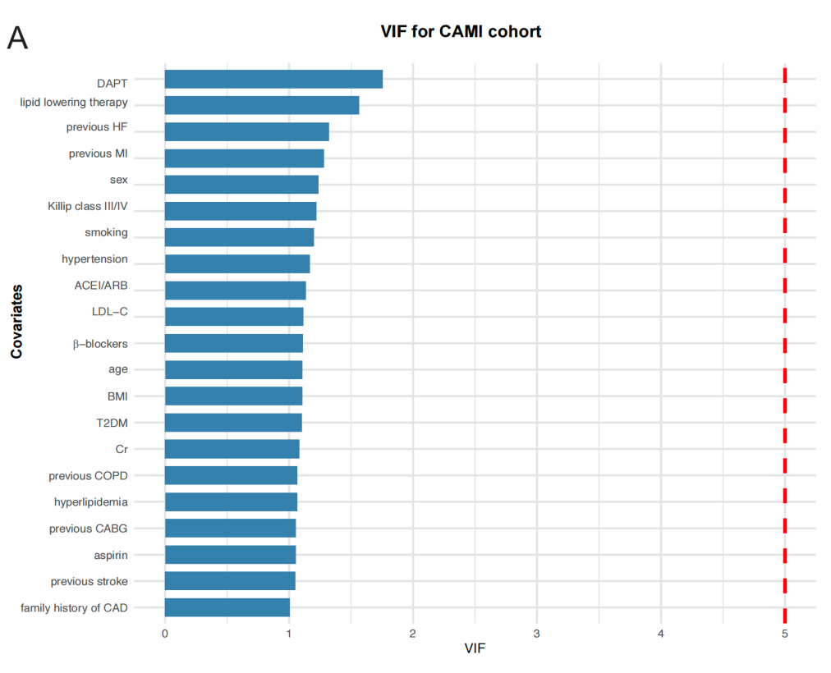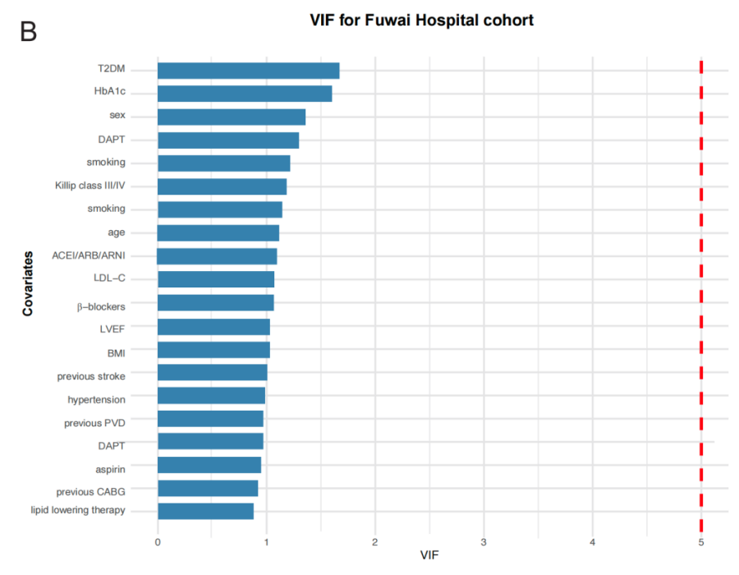

Figure S1. Variance Inflation Factor (VIF) analysis for covariates included in the fully adjusted models.
- VIF values for the CAMI cohort. B. VIF values for the Fuwai Hospital cohort. The red dashed line indicates the threshold of VIF = 5.
Abbreviations: ACEI/ARB/ARNI: angiotensin-converting enzyme inhibitor/angiotensin receptor blocker/angiotensin receptor–neprilysin inhibitor; BMI: body mass index; CABG: coronary artery bypass grafting; CAD: coronary artery disease; CAMI: China Acute Myocardial Infarction; Cr: creatinine; DAPT: dual antiplatelet therapy; HbA1c: hemoglobin A1c; HF: heart failure; LDL-C: low-density lipoprotein cholesterol; LVEF: left ventricular ejection fraction; MI: myocardial infarction; PVD: peripheral vascular disease; STEMI: ST-segment elevation myocardial infarction; T2DM: type 2 diabetes mellitus; VIF: variance inflation factor.

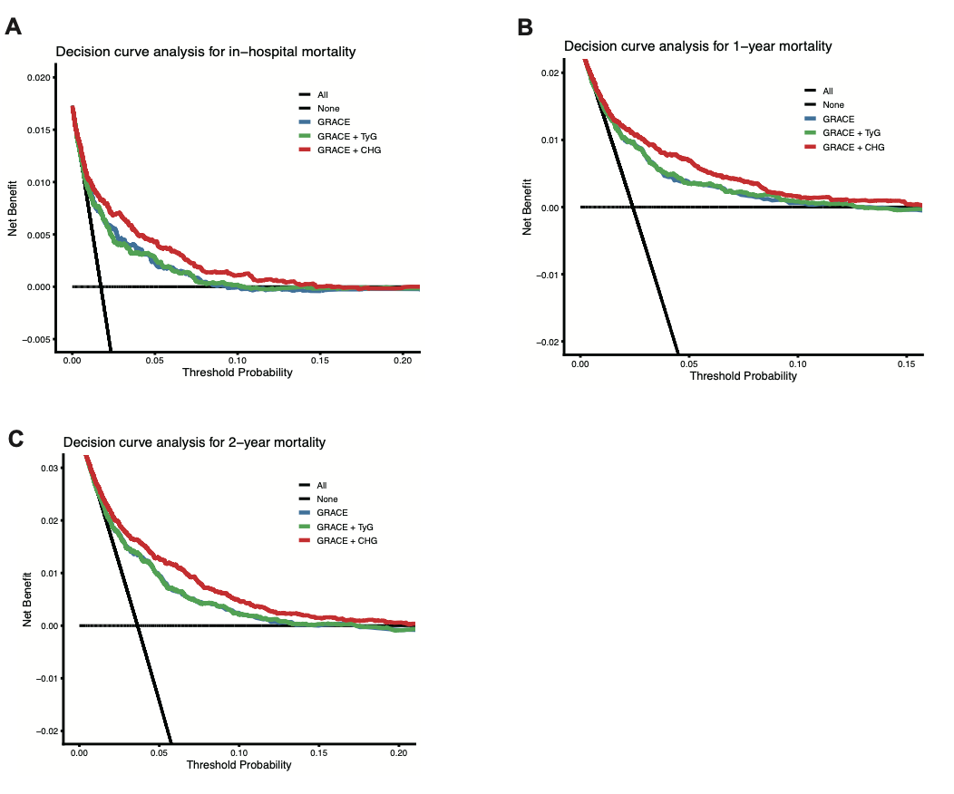
Figure S2. Decision Curve Analysis (DCA) for evaluating model net benefit in the CAMI cohort
- Net benefit for predicting in-hospital mortality. B. Net benefit for predicting 1-year mortality. C. Net benefit for predicting 2-year mortality.
Abbreviations: CAMI: China Acute Myocardial Infarction; CHG: cholesterol, high-density lipoprotein, and glucose; DCA: decision curve analysis; GRACE: Global Registry of Acute Coronary Events; TyG: triglyceride-glucose.

