Supplementary table 1. CKM stage definitions.
CKM stage | Definition
Stage 0 | No CKM syndrome risk factors.
Stage 1 | Overweight/abdominal obesity: BMI ≥ 24 kg/m²; WC ≥ 80/90 cm in female/male; FBG 100-124 mg/dL or HbA1c 5.7%-6.4%.
Stage 2 | Any of the following: Diabetes (FPG ≥ 126 mg/dL or HbA1c ≥ 6.5%, and/or self-reported physician diagnosis, and/or hypoglycemic agents); Hypertension (self-reported physician diagnosis, and/or antihypertensive medication use, and/or average SBP/DBP ≥ 140/90 mmHg); Metabolic syndrome (≥3 of 5: WC ≥ 90 cm for males and ≥ 85 cm for females; FBG ≥ 6.1 mmol/L or 2-hour glucose ≥ 7.8 mmol/L and/or diagnosed diabetes receiving treatment; SBP/DBP ≥ 130/85 mmHg and/or diagnosed hypertension receiving treatment; TG ≥ 1.70 mmol/L; HDL-C < 1.04 mmol/L); Dyslipidemia (self-reported physician diagnosis, and/or current lipid-lowering drugs, and/or TC ≥ 240 mg/dL, TG ≥ 150 mg/dL, HDL-C < 40 mg/dL, LDL-C ≥ 160 mg/dL); CKD (self-reported chronic kidney disease or eGFR < 60 mL/min/1.73 m²).
Stage 3 | Subclinical CVD: eGFR < 30 mL/min/1.73 m²; and/or Framingham risk score ≥ 20%.
Notes: CKM stages were assigned according to the highest applicable criterion.
Abbreviations: BMI, body mass index; CKD, chronic kidney disease; CKM, cardiovascular-kidney-metabolic; CVD, cardiovascular disease; eGFR, estimated glomerular filtration rate; HbA1c, glycated hemoglobin; HDL-C, high-density lipoprotein cholesterol; LDL-C, low-density lipoprotein cholesterol; SBP/DBP, systolic/diastolic blood pressure; TC, total cholesterol; TG, triglycerides; WC, waist circumference.

Supplementary table 2. Availability of the 30 frailty index items at Waves 1 and 3 among age-eligible baseline participants.
Item No. | FI domain | FI component | Scoring rule | Wave 1 available, n | Wave 1 missing, n | Wave 1 mean deficit | Wave 3 available, n | Wave 3 missing, n | Wave 3 mean deficit
1 | Comorbidity | Hypertension | Yes = 1; No = 0 | 16716 | 215 | 0.264 | 13660 | 3271 | 0.355
2 | Comorbidity | Diabetes | Yes = 1; No = 0 | 16653 | 278 | 0.063 | 13585 | 3346 | 0.102
3 | Comorbidity | Cancer | Yes = 1; No = 0 | 16726 | 205 | 0.009 | 13742 | 3189 | 0.017
4 | Comorbidity | Arthritis | Yes = 1; No = 0 | 16764 | 167 | 0.329 | 13737 | 3194 | 0.462
5 | Comorbidity | Chronic lung disease | Yes = 1; No = 0 | 16737 | 194 | 0.099 | 13755 | 3176 | 0.15
6 | Comorbidity | Asthma | Yes = 1; No = 0 | 16736 | 195 | 0.045 | 13770 | 3161 | 0.065
7 | Comorbidity | Psychiatric problem | Yes = 1; No = 0 | 16730 | 201 | 0.015 | 13757 | 3174 | 0.025
8 | Comorbidity | Memory-related disease | Yes = 1; No = 0 | 16748 | 183 | 0.019 | 13748 | 3183 | 0.033
9 | Sensory function | Vision problem | Yes = 1; No = 0 | 16814 | 117 | 0.063 | 12548 | 4383 | 0.055
10 | Sensory function | Hearing problem | Yes = 1; No = 0 | 16808 | 123 | 0.09 | 11958 | 4973 | 0.076
11 | Self-rated health | Self-reported health | Fair/Poor/Very poor = 1; Excellent/Very good/Good = 0 | 16821 | 110 | 0.744 | 13225 | 3706 | 0.771
12 | Activities of daily living | Difficulty dressing | Yes = 1; No = 0 | 16609 | 322 | 0.053 | 13916 | 3015 | 0.072
13 | Activities of daily living | Difficulty bathing | Yes = 1; No = 0 | 16598 | 333 | 0.069 | 13893 | 3038 | 0.09
14 | Activities of daily living | Difficulty eating | Yes = 1; No = 0 | 16611 | 320 | 0.031 | 13914 | 3017 | 0.032
15 | Activities of daily living | Difficulty getting in or out of bed | Yes = 1; No = 0 | 16609 | 322 | 0.057 | 13911 | 3020 | 0.083
16 | Activities of daily living | Difficulty using the toilet | Yes = 1; No = 0 | 16609 | 322 | 0.118 | 13911 | 3020 | 0.155
17 | Instrumental activities | Difficulty managing money | Yes = 1; No = 0 | 16743 | 188 | 0.129 | 13856 | 3075 | 0.123
18 | Instrumental activities | Difficulty taking medications | Yes = 1; No = 0 | 16763 | 168 | 0.07 | 13914 | 3017 | 0.059
19 | Instrumental activities | Difficulty shopping | Yes = 1; No = 0 | 16761 | 170 | 0.094 | 13903 | 3028 | 0.103
20 | Instrumental activities | Difficulty preparing meals | Yes = 1; No = 0 | 16775 | 156 | 0.092 | 13908 | 3023 | 0.111
21 | Instrumental activities | Difficulty doing housework | Yes = 1; No = 0 | 16774 | 157 | 0.096 | 13942 | 2989 | 0.15
22 | Physical function | Difficulty walking 100 yards | Yes = 1; No = 0 | 15565 | 1366 | 0.017 | 13895 | 3036 | 0.091
23 | Physical function | Difficulty getting up from a chair | Yes = 1; No = 0 | 16771 | 160 | 0.274 | 13907 | 3024 | 0.307
24 | Physical function | Difficulty climbing stairs | Yes = 1; No = 0 | 16657 | 274 | 0.403 | 13738 | 3193 | 0.448
25 | Physical function | Difficulty lifting or carrying 10 pounds | Yes = 1; No = 0 | 16774 | 157 | 0.121 | 13881 | 3050 | 0.161
26 | Physical function | Difficulty picking up a coin | Yes = 1; No = 0 | 16772 | 159 | 0.041 | 13890 | 3041 | 0.053
27 | Physical function | Difficulty stooping, kneeling, or crouching | Yes = 1; No = 0 | 16767 | 164 | 0.297 | 13894 | 3037 | 0.357
28 | Physical function | Difficulty reaching arms above shoulder level | Yes = 1; No = 0 | 16776 | 155 | 0.105 | 13897 | 3034 | 0.124
29 | Psychological function | Depressive symptoms | CESD-10 score >=10 = 1; <10 = 0 | 15382 | 1549 | 0.37 | 13163 | 3768 | 0.348
30 | Cognitive function | Cognitive deficit score | [(10 - episodic memory score) + orientation errors] / 14 | 12839 | 4092 | 0.517 | 11811 | 5120 | 0.55
Notes: Wave 1 and Wave 3 availability were both evaluated within the same 16,931 age-eligible participants interviewed at baseline. Wave 3 counts therefore reflect the availability of the corresponding frailty index items among this baseline cohort rather than the full Wave 3 survey sample. Mean deficit values were calculated among participants with non-missing values for the corresponding item at each wave. For the cognitive deficit score, orientation errors were based on month, day, year, and day of week; higher values indicate worse cognition.
Abbreviations: FI, frailty index.

Supplementary table 3 Variable names and formulas of the 14 insulin resistance-related surrogate markers
Variable | Formula
eGDR | 21.158 - 0.09 × waist circumference (cm) - 3.407 × hypertension status (1=yes, 0=no) - 0.551 × HbA1c (%)
METS-IR | ln[(2 × fasting glucose [mg/dL]) + TG (mg/dL)] × BMI (kg/m²) / ln[HDL-C (mg/dL)]
CHG | ln[(TC [mg/dL] × fasting glucose [mg/dL]) / (2 × HDL-C [mg/dL])]
TG/HDL-C | TG (mg/dL) / HDL-C (mg/dL)
SPISE | 600 × HDL-C^0.185 / [TG (mg/dL)^0.2 × BMI (kg/m²)^1.338]
AIP | log10[TG (mmol/L) / HDL-C (mmol/L)]
TyG | ln[TG (mg/dL) × fasting glucose (mg/dL) / 2]
TyG-BMI | TyG × BMI (kg/m²)
TyG-WC | TyG × waist circumference (cm)
TyG-WHtR | TyG × WHtR [waist circumference (cm) / height (cm)]
TyG-BRI | TyG × BRI [364.2 - 365.5 × sqrt{1 - [(WC (m) / 2π)^2 / (0.5 × height (m))^2]}]
TyG-ABSI | TyG × ABSI [waist circumference (m) / {BMI (kg/m²)^(2/3) × height (m)^(1/2)}]
TyG-WWI | TyG × WWI [waist circumference (cm) / sqrt(weight (kg))]
TyG-CVAI | TyG × CVAI [men: -267.93 + 0.68 × age (years) + 0.03 × BMI (kg/m²) + 4.00 × WC (cm) + 22.00 × log10(TG [mmol/L]) - 16.32 × HDL-C (mmol/L); women: -187.32 + 1.71 × age (years) + 4.23 × BMI (kg/m²) + 1.12 × WC (cm) + 39.76 × log10(TG [mmol/L]) - 11.66 × HDL-C (mmol/L)]
Notes: Markers were calculated using wave-specific values before constructing cumulative measures.
Abbreviations: ABSI, a body shape index; AIP, atherogenic index of plasma; BRI, body roundness index; CHG, cholesterol, high-density lipoprotein, and glucose index; CVAI, Chinese visceral adiposity index; eGDR, estimated glucose disposal rate; METS-IR, metabolic score for insulin resistance; SPISE, single-point insulin sensitivity estimator; TyG, triglyceride-glucose index; WHtR, waist-to-height ratio; WWI, weight-adjusted-waist index.

Supplementary table 4. Missing values and imputation methods
Variable | Data type | Missing n | Missing % | Imputation method
Education | Categorical | 26 | 0.80% | Multinomial regression
Marital status | Categorical | 271 | 8.70% | Logistic regression
Residence | Categorical | 18 | 0.60% | Logistic regression
Drinking status | Categorical | 3 | 0.10% | Multinomial regression
White blood cell count | Continuous | 29 | 0.90% | PMM
Hemoglobin | Continuous | 26 | 0.80% | PMM
Platelet count | Continuous | 27 | 0.90% | PMM
Hypoglycemic agent use | Categorical | 1 | 0.00% | Logistic regression
Notes: Missing covariates were imputed using multiple imputation by chained equations.
Abbreviations: PMM, predictive mean matching.

Supplementary table 5. Availability of key laboratory variables at waves 1 and 3 among age-eligible baseline participants.
Variable | Wave 1 available, n (%) | Wave 1 missing, n (%) | Wave 3 available, n (%) | Wave 3 missing, n (%)
Total cholesterol | 11231 (66.3%) | 5700 (33.7%) | 9541 (56.4%) | 7390 (43.6%)
Triglycerides | 11232 (66.3%) | 5699 (33.7%) | 9541 (56.4%) | 7390 (43.6%)
Fasting blood glucose | 11214 (66.2%) | 5717 (33.8%) | 9558 (56.5%) | 7373 (43.5%)
HDL-C | 11238 (66.4%) | 5693 (33.6%) | 9541 (56.4%) | 7390 (43.6%)
LDL-C | 11219 (66.3%) | 5712 (33.7%) | 9540 (56.3%) | 7391 (43.7%)
C-reactive protein | 11239 (66.4%) | 5692 (33.6%) | 9539 (56.3%) | 7392 (43.7%)
Creatinine | 11213 (66.2%) | 5718 (33.8%) | 9540 (56.3%) | 7391 (43.7%)
HbA1c | 11282 (66.6%) | 5649 (33.4%) | 9573 (56.5%) | 7358 (43.5%)

Supplementary table 6. Exploratory piecewise Cox analyses of estimated turning points for the 14 cumulative IR-FI indices.
Exposure | Estimated turning point | Linear HR per 1-SD increase (95% CI) | HR below turning point per 1-SD increase (95% CI) | HR above turning point per 1-SD increase (95% CI) | P for overall association | P for nonlinearity | P for piecewise versus linear model | Below turning point, participants/events | Above turning point, participants/events
Cumulative TyG-FI | 4.096 | 1.386 (1.290, 1.489) | 2.879 (2.000, 4.145) | 1.263 (1.157, 1.380) | <0.001 | <0.001 | <0.001 | 1555/210 | 1555/421
Cumulative eGDR-FI | -0.356 | 1.170 (1.067, 1.284) | 0.609 (0.485, 0.765) | 1.312 (1.194, 1.442) | <0.001 | <0.001 | <0.001 | 653/123 | 2457/508
Cumulative METS-IR-FI | 14.614 | 1.370 (1.280, 1.466) | 4.046 (2.514, 6.512) | 1.267 (1.171, 1.372) | <0.001 | <0.001 | <0.001 | 1368/173 | 1742/458
Cumulative CHG-FI | 2.499 | 1.382 (1.287, 1.485) | 2.917 (2.032, 4.189) | 1.258 (1.152, 1.373) | <0.001 | <0.001 | <0.001 | 1586/217 | 1524/414
Cumulative TG/HDL-C-FI | 0.807 | 1.149 (1.099, 1.201) | 47.278 (13.605, 164.290) | 1.114 (1.058, 1.173) | <0.001 | <0.001 | <0.001 | 1213/155 | 1897/476
Cumulative SPISE-FI | -0.154 | 1.129 (1.037, 1.230) | 0.850 (0.757, 0.954) | 1.411 (1.265, 1.574) | <0.001 | <0.001 | <0.001 | 964/172 | 2146/459
Cumulative TyG-BMI-FI | 84.474 | 1.372 (1.281, 1.469) | 4.006 (2.484, 6.459) | 1.269 (1.172, 1.375) | <0.001 | <0.001 | <0.001 | 1337/166 | 1773/465
Cumulative TyG-WC-FI | 323.66 | 1.387 (1.293, 1.488) | 3.706 (2.403, 5.717) | 1.270 (1.169, 1.380) | <0.001 | <0.001 | <0.001 | 1431/182 | 1679/449
Cumulative TyG-WHtR-FI | 1.902 | 1.376 (1.282, 1.477) | 4.361 (2.636, 7.214) | 1.272 (1.173, 1.381) | <0.001 | <0.001 | <0.001 | 1306/160 | 1804/471
Cumulative TyG-BRI-FI | 10.508 | 1.328 (1.240, 1.423) | 25.925 (8.784, 76.510) | 1.257 (1.167, 1.354) | <0.001 | <0.001 | <0.001 | 933/97 | 2177/534
Cumulative TyG-ABSI-FI | 0.325 | 1.380 (1.284, 1.483) | 3.269 (2.187, 4.888) | 1.260 (1.156, 1.374) | <0.001 | <0.001 | <0.001 | 1493/197 | 1617/434
Cumulative TyG-WWI-FI | 41.625 | 1.377 (1.281, 1.480) | 3.635 (2.330, 5.670) | 1.266 (1.163, 1.378) | <0.001 | <0.001 | <0.001 | 1400/180 | 1710/451
Cumulative TyG-CVAI-FI | 352.723 | 1.333 (1.245, 1.427) | 5.174 (3.087, 8.672) | 1.230 (1.137, 1.330) | <0.001 | <0.001 | <0.001 | 1462/186 | 1648/445
Cumulative AIP-FI | -0.117 | 1.110 (1.032, 1.194) | 0.719 (0.601, 0.861) | 1.219 (1.134, 1.312) | <0.001 | <0.001 | <0.001 | 560/116 | 2550/515
Notes: Estimated turning points were derived from exploratory piecewise Cox models adjusted for the Model 3 covariates. Hazard ratios are reported per 1-SD increase in the corresponding cumulative IR-FI index. Participant/event counts refer to observations below and above the estimated turning point. The turning points are data-derived and should not be interpreted as clinically validated thresholds.
Abbreviations: CI, confidence interval; FI, frailty index; HR, hazard ratio; IR, insulin resistance; SD, standard deviation.

Supplementary table 7. Baseline characteristics of included and excluded participants.
Variable | Excluded | Included | P value
Age | 59.40 +/- 10.04 | 57.80 +/- 8.37 | <0.001
Provisional FI at wave 1 | 0.16 +/- 0.14 | 0.13 +/- 0.10 | <0.001
Observed FI items at wave 1 | 29.15 +/- 2.98 | 29.76 +/- 0.66 | <0.001
Gender: Female | 6980 (50.5%) | 1683 (54.1%) | <0.001
Gender: Male | 6841 (49.5%) | 1427 (45.9%)
Education: Below primary | 6157 (44.5%) | 1461 (47.0%) | <0.001
Education: Middle school | 2839 (20.5%) | 709 (22.8%)
Education: High school and above | 4403 (31.9%) | 909 (29.2%)
Education: Missing | 340 (2.5%) | 26 (0.8%)
Education: Primary school | 82 (0.6%) | 5 (0.2%)
Marital status: Married | 10820 (78.3%) | 2720 (87.5%) | <0.001
Marital status: Other | 1280 (9.3%) | 119 (3.8%)
Marital status: Missing | 1721 (12.5%) | 271 (8.7%)
Residence: Rural | 10393 (75.2%) | 2686 (86.4%) | <0.001
Residence: Missing | 115 (0.8%) | 18 (0.6%)
Residence: Urban | 3313 (24.0%) | 406 (13.1%)
CKM staging available, n (%) | 4897 (35.4%) | 3110 (100.0%) | <0.001
CKM stage 4, n (%) | 1121 (8.1%) | 0 (0.0%) | <0.001
Final analytic inclusion among age-eligible baseline participants, n (%) | 13821 (81.6%) | 3110 (18.4%)

Supplementary Table 8. Distribution of events and censoring across follow-up intervals for composite cardiovascular disease, heart disease, and stroke
Outcome | Follow-up interval | Incident events, n | Deaths before the outcome, n | Administratively censored at study end, n | Lost to follow-up, n
Composite CVD | Wave 3 to Wave 4 | 443 | 75 | 0 | 72
Composite CVD | Wave 4 to Wave 5 | 188 | 0 | 2332 | 0
Heart disease | Wave 3 to Wave 4 | 294 | 0 | 0 | 71
Heart disease | Wave 4 to Wave 5 | 151 | 85 | 2507 | 2
Stroke | Wave 3 to Wave 4 | 178 | 0 | 0 | 80
Stroke | Wave 4 to Wave 5 | 67 | 81 | 2702 | 2
Notes: Events were assigned to the survey wave at which the diagnosis was first reported. In the primary composite CVD analysis, participants who died before an incident CVD report were censored at their last disease-free post-Wave-3 assessment; the death date was used in the Fine–Gray analysis. In the component-outcome analyses, participants who died before the relevant outcome were censored on the ascertained death date. Administrative censoring denotes event-free follow-up through Wave 5. Other loss to follow-up denotes an earlier last disease-free assessment without a preceding death.
Abbreviation: CVD, cardiovascular disease.

Supplementary table 9. Prediction increment for all 14 cumulative IR-FI indicators
Exposure | N | Events | Harrell's C | Delta Harrell's C | 5-year AUC | Delta AUC | IDI | IDI P
Cumulative TyG-FI | 3110 | 631 | 0.625 -> 0.663 | 0.038 | 0.632 -> 0.677 | 0.045 | 0.029 (0.016, 0.045) | <0.001
Cumulative eGDR-FI | 3110 | 631 | 0.625 -> 0.625 | 0 | 0.632 -> 0.632 | 0 | 0.006 (0.003, 0.012) | <0.001
Cumulative METS-IR-FI | 3110 | 631 | 0.625 -> 0.663 | 0.039 | 0.632 -> 0.678 | 0.046 | 0.029 (0.015, 0.044) | <0.001
Cumulative CHG-FI | 3110 | 631 | 0.625 -> 0.662 | 0.038 | 0.632 -> 0.677 | 0.045 | 0.029 (0.016, 0.042) | <0.001
Cumulative TG/HDL-C-FI | 3110 | 631 | 0.625 -> 0.642 | 0.017 | 0.632 -> 0.652 | 0.02 | 0.010 (0.003, 0.019) | 0.008
Cumulative SPISE-FI | 3110 | 631 | 0.625 -> 0.626 | 0.001 | 0.632 -> 0.634 | 0.002 | 0.004 (-0.000, 0.012) | 0.052
Cumulative TyG-BMI-FI | 3110 | 631 | 0.625 -> 0.663 | 0.038 | 0.632 -> 0.678 | 0.046 | 0.028 (0.014, 0.045) | <0.001
Cumulative TyG-WC-FI | 3110 | 631 | 0.625 -> 0.664 | 0.039 | 0.632 -> 0.679 | 0.047 | 0.030 (0.018, 0.046) | <0.001
Cumulative TyG-WHtR-FI | 3110 | 631 | 0.625 -> 0.662 | 0.037 | 0.632 -> 0.677 | 0.045 | 0.028 (0.015, 0.043) | <0.001
Cumulative TyG-BRI-FI | 3110 | 631 | 0.625 -> 0.657 | 0.032 | 0.632 -> 0.671 | 0.039 | 0.024 (0.013, 0.037) | <0.001
Cumulative TyG-ABSI-FI | 3110 | 631 | 0.625 -> 0.662 | 0.037 | 0.632 -> 0.677 | 0.045 | 0.028 (0.015, 0.044) | <0.001
Cumulative TyG-WWI-FI | 3110 | 631 | 0.625 -> 0.661 | 0.036 | 0.632 -> 0.676 | 0.044 | 0.028 (0.015, 0.044) | <0.001
Cumulative TyG-CVAI-FI | 3110 | 631 | 0.625 -> 0.659 | 0.034 | 0.632 -> 0.673 | 0.041 | 0.024 (0.013, 0.038) | <0.001
Cumulative AIP-FI | 3110 | 631 | 0.625 -> 0.629 | 0.004 | 0.632 -> 0.637 | 0.006 | 0.003 (-0.000, 0.011) | 0.052
Notes: Incremental performance was assessed in the first completed imputed dataset after adding each cumulative IR-FI product to Model 3, which contained neither IR nor FI. Harrell’s C and 5-year AUC are shown for Model 3 and the updated model. IDI confidence intervals and P values were estimated using 500 perturbation resamples.
Abbreviations: AUC, area under the curve; CI, confidence interval; FI, frailty index; IDI, integrated discrimination improvement; IR, insulin resistance.

Supplementary table 10. Association estimates for cumulative IR alone, FI alone, IR + FI, and the IR-FI product across all 14 indicators.
Indicator | IR alone HR (95% CI) | IR alone P | FI alone HR (95% CI) | FI alone P | IR+FI: IR HR (95% CI) | IR+FI: IR P | IR+FI: FI HR (95% CI) | IR+FI: FI P | Product HR (95% CI) | Product P
TyG | 1.132 (1.044, 1.229) | 0.003 | 1.382 (1.285, 1.485) | <0.001 | 1.129 (1.040, 1.227) | 0.004 | 1.378 (1.282, 1.481) | <0.001 | 1.388 (1.292, 1.491) | <0.001
CHG | 1.150 (1.058, 1.250) | 0.001 | 1.382 (1.285, 1.485) | <0.001 | 1.147 (1.055, 1.247) | 0.001 | 1.378 (1.282, 1.481) | <0.001 | 1.384 (1.289, 1.487) | <0.001
METS-IR | 1.170 (1.077, 1.271) | <0.001 | 1.382 (1.285, 1.485) | <0.001 | 1.161 (1.069, 1.262) | <0.001 | 1.376 (1.280, 1.479) | <0.001 | 1.372 (1.282, 1.468) | <0.001
eGDR | 1.354 (1.204, 1.522) | <0.001 | 1.382 (1.285, 1.485) | <0.001 | 1.320 (1.175, 1.483) | <0.001 | 1.370 (1.274, 1.473) | <0.001 | 1.165 (1.063, 1.278) | 0.001
SPISE | 1.141 (1.041, 1.251) | 0.005 | 1.382 (1.285, 1.485) | <0.001 | 1.138 (1.039, 1.246) | 0.005 | 1.379 (1.283, 1.482) | <0.001 | 1.132 (1.039, 1.233) | 0.004
TG/HDL-C | 1.073 (0.996, 1.157) | 0.063 | 1.382 (1.285, 1.485) | <0.001 | 1.072 (0.995, 1.156) | 0.067 | 1.380 (1.284, 1.484) | <0.001 | 1.149 (1.099, 1.201) | <0.001
AIP | 1.110 (1.023, 1.205) | 0.012 | 1.382 (1.285, 1.485) | <0.001 | 1.109 (1.021, 1.204) | 0.014 | 1.379 (1.283, 1.483) | <0.001 | 1.113 (1.035, 1.196) | 0.004
TyG-BMI | 1.162 (1.069, 1.264) | <0.001 | 1.382 (1.285, 1.485) | <0.001 | 1.152 (1.060, 1.252) | <0.001 | 1.376 (1.280, 1.479) | <0.001 | 1.374 (1.283, 1.471) | <0.001
TyG-WC | 1.207 (1.110, 1.313) | <0.001 | 1.382 (1.285, 1.485) | <0.001 | 1.194 (1.097, 1.299) | <0.001 | 1.373 (1.277, 1.475) | <0.001 | 1.389 (1.295, 1.490) | <0.001
TyG-WHtR | 1.182 (1.084, 1.290) | <0.001 | 1.382 (1.285, 1.485) | <0.001 | 1.160 (1.063, 1.266) | <0.001 | 1.370 (1.274, 1.473) | <0.001 | 1.378 (1.283, 1.479) | <0.001
TyG-BRI | 1.168 (1.073, 1.272) | <0.001 | 1.382 (1.285, 1.485) | <0.001 | 1.141 (1.048, 1.243) | 0.002 | 1.370 (1.274, 1.473) | <0.001 | 1.329 (1.242, 1.423) | <0.001
TyG-ABSI | 1.154 (1.063, 1.253) | <0.001 | 1.382 (1.285, 1.485) | <0.001 | 1.135 (1.043, 1.234) | 0.003 | 1.372 (1.276, 1.475) | <0.001 | 1.383 (1.287, 1.486) | <0.001
TyG-WWI | 1.159 (1.063, 1.265) | <0.001 | 1.382 (1.285, 1.485) | <0.001 | 1.134 (1.038, 1.240) | 0.005 | 1.370 (1.275, 1.473) | <0.001 | 1.379 (1.283, 1.481) | <0.001
TyG-CVAI | 1.199 (1.101, 1.306) | <0.001 | 1.382 (1.285, 1.485) | <0.001 | 1.186 (1.089, 1.292) | <0.001 | 1.373 (1.278, 1.476) | <0.001 | 1.334 (1.247, 1.428) | <0.001

Supplementary table 11. Discrimination comparison for cumulative IR alone, FI alone, IR + FI, and the IR-FI product across all 14 indicators.
Indicator | IR alone Harrell's C | FI alone Harrell's C | IR+FI Harrell's C | Product Harrell's C | Delta C: IR+FI vs FI | Delta C: Product vs FI | Delta C: IR+FI vs Product | P for adding IR to FI | Model with higher Harrell's C
TyG | 0.63 | 0.6615 | 0.6646 | 0.663 | 0.0031 | 0.0015 | 0.0016 | 0.004 | IR + FI
CHG | 0.63 | 0.6615 | 0.6651 | 0.6627 | 0.0036 | 0.0012 | 0.0024 | 0.002 | IR + FI
METS-IR | 0.6301 | 0.6615 | 0.6664 | 0.6636 | 0.0049 | 0.0021 | 0.0028 | <0.001 | IR + FI
eGDR | 0.6328 | 0.6615 | 0.6683 | 0.625 | 0.0068 | -0.0365 | 0.0433 | <0.001 | IR + FI
SPISE | 0.627 | 0.6615 | 0.6639 | 0.6259 | 0.0024 | -0.0356 | 0.038 | 0.005 | IR + FI
TG/HDL-C | 0.6266 | 0.6615 | 0.6624 | 0.6426 | 0.0009 | -0.0189 | 0.0198 | 0.08 | IR + FI
AIP | 0.6289 | 0.6615 | 0.664 | 0.6296 | 0.0025 | -0.0319 | 0.0344 | 0.015 | IR + FI
TyG-BMI | 0.6296 | 0.6615 | 0.666 | 0.6634 | 0.0045 | 0.0019 | 0.0025 | 0.001 | IR + FI
TyG-WC | 0.6324 | 0.6615 | 0.6673 | 0.6645 | 0.0058 | 0.003 | 0.0028 | <0.001 | IR + FI
TyG-WHtR | 0.6305 | 0.6615 | 0.6654 | 0.6624 | 0.0039 | 0.0009 | 0.003 | <0.001 | IR + FI
TyG-BRI | 0.6299 | 0.6615 | 0.6649 | 0.6573 | 0.0034 | -0.0042 | 0.0076 | 0.003 | IR + FI
TyG-ABSI | 0.6313 | 0.6615 | 0.665 | 0.6625 | 0.0035 | 0.001 | 0.0025 | 0.003 | IR + FI
TyG-WWI | 0.6306 | 0.6615 | 0.6644 | 0.6618 | 0.0029 | 0.0003 | 0.0026 | 0.006 | IR + FI
TyG-CVAI | 0.6315 | 0.6615 | 0.6666 | 0.6593 | 0.0051 | -0.0022 | 0.0073 | <0.001 | IR + FI

Supplementary table 12. Association estimates comparing wave 3 and cumulative IR + FI across all 14 indicators
Indicator | Wave 3 IR HR (95% CI) | Wave 3 IR P | Wave 3 FI HR (95% CI) | Wave 3 FI P | Cumulative IR HR (95% CI) | Cumulative IR P | Cumulative FI HR (95% CI) | Cumulative FI P
TyG | 1.096 (1.010, 1.190) | 0.028 | 1.383 (1.289, 1.483) | <0.001 | 1.129 (1.040, 1.227) | 0.004 | 1.378 (1.282, 1.481) | <0.001
CHG | 1.074 (0.990, 1.165) | 0.084 | 1.381 (1.288, 1.482) | <0.001 | 1.147 (1.055, 1.247) | 0.001 | 1.378 (1.282, 1.481) | <0.001
METS-IR | 1.112 (1.031, 1.200) | 0.006 | 1.379 (1.285, 1.480) | <0.001 | 1.161 (1.069, 1.262) | <0.001 | 1.376 (1.280, 1.479) | <0.001
eGDR | 1.291 (1.168, 1.426) | <0.001 | 1.362 (1.269, 1.461) | <0.001 | 1.320 (1.175, 1.483) | <0.001 | 1.370 (1.274, 1.473) | <0.001
SPISE | 1.128 (1.032, 1.233) | 0.008 | 1.381 (1.287, 1.482) | <0.001 | 1.138 (1.039, 1.246) | 0.005 | 1.379 (1.283, 1.482) | <0.001
TG/HDL-C | 1.063 (0.992, 1.139) | 0.086 | 1.380 (1.286, 1.481) | <0.001 | 1.072 (0.995, 1.156) | 0.067 | 1.380 (1.284, 1.484) | <0.001
AIP | 1.100 (1.014, 1.192) | 0.021 | 1.380 (1.287, 1.481) | <0.001 | 1.109 (1.021, 1.204) | 0.014 | 1.379 (1.283, 1.483) | <0.001
TyG-BMI | 1.113 (1.031, 1.201) | 0.006 | 1.380 (1.286, 1.480) | <0.001 | 1.152 (1.060, 1.252) | <0.001 | 1.376 (1.280, 1.479) | <0.001
TyG-WC | 1.164 (1.071, 1.266) | <0.001 | 1.376 (1.282, 1.476) | <0.001 | 1.194 (1.097, 1.299) | <0.001 | 1.373 (1.277, 1.475) | <0.001
TyG-WHtR | 1.133 (1.040, 1.235) | 0.004 | 1.374 (1.280, 1.475) | <0.001 | 1.160 (1.063, 1.266) | <0.001 | 1.370 (1.274, 1.473) | <0.001
TyG-BRI | 1.124 (1.034, 1.222) | 0.006 | 1.372 (1.279, 1.473) | <0.001 | 1.141 (1.048, 1.243) | 0.002 | 1.370 (1.274, 1.473) | <0.001
TyG-ABSI | 1.107 (1.018, 1.202) | 0.017 | 1.376 (1.282, 1.477) | <0.001 | 1.135 (1.043, 1.234) | 0.003 | 1.372 (1.276, 1.475) | <0.001
TyG-WWI | 1.108 (1.015, 1.209) | 0.022 | 1.375 (1.281, 1.475) | <0.001 | 1.134 (1.038, 1.240) | 0.005 | 1.370 (1.275, 1.473) | <0.001
TyG-CVAI | 1.167 (1.073, 1.270) | <0.001 | 1.375 (1.282, 1.476) | <0.001 | 1.186 (1.089, 1.292) | <0.001 | 1.373 (1.278, 1.476) | <0.001

Supplementary table 13. Discrimination comparison between wave 3 and cumulative IR + FI across all 14 indicators
Indicator | Wave 3 Harrell's C | Wave 3 P for adding IR to FI | Cumulative Harrell's C | Cumulative P for adding IR to FI | Delta Harrell's C
TyG | 0.6615 | 0.03 | 0.6646 | 0.004 | 0.0031
CHG | 0.6610 | 0.089 | 0.6651 | 0.002 | 0.0041
METS-IR | 0.6629 | 0.008 | 0.6664 | <0.001 | 0.0035
eGDR | 0.6691 | <0.001 | 0.6683 | <0.001 | -0.0007
SPISE | 0.6623 | 0.007 | 0.6639 | 0.005 | 0.0016
TG/HDL-C | 0.6612 | 0.101 | 0.6624 | 0.08 | 0.0012
AIP | 0.6622 | 0.022 | 0.664 | 0.015 | 0.0018
TyG-BMI | 0.6629 | 0.008 | 0.666 | 0.001 | 0.0031
TyG-WC | 0.664 | <0.001 | 0.6673 | <0.001 | 0.0033
TyG-WHtR | 0.6626 | 0.005 | 0.6654 | <0.001 | 0.0028
TyG-BRI | 0.663 | 0.007 | 0.6649 | 0.003 | 0.0019
TyG-ABSI | 0.6623 | 0.017 | 0.665 | 0.003 | 0.0027
TyG-WWI | 0.662 | 0.022 | 0.6644 | 0.006 | 0.0024
TyG-CVAI | 0.6643 | <0.001 | 0.6666 | <0.001 | 0.0023

Supplementary table 14. Association estimates comparing wave 3 and cumulative IR-FI product across all 14 indicators
Indicator | Wave 3 HR (95% CI) | Wave 3 P | Cumulative HR (95% CI) | Cumulative P
TyG | 1.389 (1.295, 1.490) | <0.001 | 1.388 (1.292, 1.491) | <0.001
CHG | 1.382 (1.289, 1.482) | <0.001 | 1.384 (1.289, 1.487) | <0.001
METS-IR | 1.362 (1.276, 1.453) | <0.001 | 1.372 (1.282, 1.468) | <0.001
eGDR | 1.196 (1.103, 1.296) | <0.001 | 1.165 (1.063, 1.278) | 0.001
SPISE | 1.107 (1.017, 1.206) | 0.019 | 1.132 (1.039, 1.233) | 0.004
TG/HDL-C | 1.135 (1.090, 1.183) | <0.001 | 1.149 (1.099, 1.201) | <0.001
AIP | 1.101 (1.024, 1.185) | 0.01 | 1.113 (1.035, 1.196) | 0.004
TyG-BMI | 1.365 (1.279, 1.457) | <0.001 | 1.374 (1.283, 1.471) | <0.001
TyG-WC | 1.386 (1.294, 1.484) | <0.001 | 1.389 (1.295, 1.490) | <0.001
TyG-WHtR | 1.378 (1.286, 1.477) | <0.001 | 1.378 (1.283, 1.479) | <0.001
TyG-BRI | 1.325 (1.242, 1.413) | <0.001 | 1.329 (1.242, 1.423) | <0.001
TyG-ABSI | 1.381 (1.288, 1.482) | <0.001 | 1.383 (1.287, 1.486) | <0.001
TyG-WWI | 1.381 (1.287, 1.481) | <0.001 | 1.379 (1.283, 1.481) | <0.001
TyG-CVAI | 1.337 (1.251, 1.428) | <0.001 | 1.334 (1.247, 1.428) | <0.001
Notes: Analyses used the first completed imputed dataset and the Model 3 covariate set. Wave 3 and cumulative IR-FI products were standardized separately. HRs are reported per 1-SD increase in the corresponding product.

Supplementary table 15. Discrimination comparison for wave 3 and cumulative IR-FI product across all 14 indicators
Indicator | Wave 3 Harrell's C | Cumulative Harrell's C | Delta Harrell's C
TyG | 0.6617 | 0.663 | 0.0013
CHG | 0.6610 | 0.6627 | 0.0017
METS-IR | 0.6607 | 0.6636 | 0.0029
eGDR | 0.6281 | 0.625 | -0.0031
SPISE | 0.6253 | 0.6259 | 0.0006
TG/HDL-C | 0.6404 | 0.6426 | 0.0022
AIP | 0.6277 | 0.6296 | 0.0019
TyG-BMI | 0.6612 | 0.6634 | 0.0022
TyG-WC | 0.6628 | 0.6645 | 0.0017
TyG-WHtR | 0.6614 | 0.6624 | 0.001
TyG-BRI | 0.6564 | 0.6573 | 0.0009
TyG-ABSI | 0.6616 | 0.6625 | 0.0009
TyG-WWI | 0.6612 | 0.6618 | 0.0006
TyG-CVAI | 0.6572 | 0.6593 | 0.0022
Notes: Harrell’s C statistics were calculated in the first completed imputed dataset using Model 3. ΔHarrell’s C was calculated as the cumulative-product value minus the corresponding Wave 3-product value.

Supplementary table 16. Practical prioritization of cumulative IR-FI indicators based on simplicity, routine availability, redundancy, and cohort performance.
Indicator | Core non-FI inputs | Non-FI measured inputs, n | Mean absolute |rho| with other indicators | Harrell's C (base -> model) | ΔHarrell’s C
Cumulative TyG-WC-FI | FBG, TG, WC | 3 | 0.787 | 0.625 -> 0.664 | 0.039
Cumulative METS-IR-FI | FBG, TG, HDL-C, BMI | 4 | 0.793 | 0.625 -> 0.663 | 0.039
Cumulative TyG-BMI-FI | FBG, TG, BMI | 3 | 0.79 | 0.625 -> 0.663 | 0.038
Cumulative TyG-FI | FBG, TG | 2 | 0.754 | 0.625 -> 0.662 | 0.038
Cumulative CHG-FI | FBG, TC, HDL-C | 3 | 0.757 | 0.625 -> 0.663 | 0.038
Cumulative TyG-ABSI-FI | FBG, TG, WC, BMI, height | 5 | 0.76 | 0.625 -> 0.662 | 0.037
Cumulative TyG-WHtR-FI | FBG, TG, WC, height | 4 | 0.786 | 0.625 -> 0.662 | 0.037
Cumulative TyG-WWI-FI | FBG, TG, WC, weight | 4 | 0.768 | 0.625 -> 0.661 | 0.036
Cumulative TyG-CVAI-FI | FBG, TG, HDL-C, age, BMI, WC | 6 | 0.788 | 0.625 -> 0.659 | 0.034
Cumulative TyG-BRI-FI | FBG, TG, WC, height | 4 | 0.791 | 0.625 -> 0.657 | 0.032
Cumulative TG/HDL-C-FI | TG, HDL-C | 2 | 0.735 | 0.625 -> 0.642 | 0.017
Cumulative AIP-FI | TG, HDL-C | 2 | 0.216 | 0.625 -> 0.629 | 0.004
Cumulative SPISE-FI | TG, HDL-C, BMI | 3 | 0.331 | 0.625 -> 0.626 | 0.001
Cumulative eGDR-FI | WC, HTN status, HbA1c | 3 | 0.225 | 0.625 -> 0.625 | 0

Supplementary table 17. Component-outcome summary across all 14 cumulative IR-FI indicators
Outcome | Exposure | Model 3 HR (95% CI) | Model 3 P
Heart disease | Cumulative TyG-FI | 1.327 (1.218, 1.446) | <0.001
Heart disease | Cumulative eGDR-FI | 1.170 (1.048, 1.306) | 0.005
Heart disease | Cumulative METS-IR-FI | 1.312 (1.209, 1.423) | <0.001
Heart disease | Cumulative CHG-FI | 1.327 (1.218, 1.445) | <0.001
Heart disease | Cumulative TG/HDL-C-FI | 1.089 (1.023, 1.159) | 0.007
Heart disease | Cumulative SPISE-FI | 1.101 (0.996, 1.216) | 0.059
Heart disease | Cumulative TyG-BMI-FI | 1.322 (1.218, 1.435) | <0.001
Heart disease | Cumulative TyG-WC-FI | 1.329 (1.222, 1.445) | <0.001
Heart disease | Cumulative TyG-WHtR-FI | 1.324 (1.216, 1.441) | <0.001
Heart disease | Cumulative TyG-BRI-FI | 1.292 (1.190, 1.402) | <0.001
Heart disease | Cumulative TyG-ABSI-FI | 1.321 (1.212, 1.440) | <0.001
Heart disease | Cumulative TyG-WWI-FI | 1.321 (1.212, 1.440) | <0.001
Heart disease | Cumulative TyG-CVAI-FI | 1.278 (1.177, 1.388) | <0.001
Heart disease | Cumulative AIP-FI | 1.045 (0.957, 1.141) | 0.33
Stroke | Cumulative TyG-FI | 1.456 (1.306, 1.623) | <0.001
Stroke | Cumulative eGDR-FI | 1.118 (0.968, 1.290) | 0.128
Stroke | Cumulative METS-IR-FI | 1.446 (1.306, 1.601) | <0.001
Stroke | Cumulative CHG-FI | 1.443 (1.296, 1.607) | <0.001
Stroke | Cumulative TG/HDL-C-FI | 1.226 (1.157, 1.300) | <0.001
Stroke | Cumulative SPISE-FI | 1.226 (1.070, 1.405) | 0.003
Stroke | Cumulative TyG-BMI-FI | 1.435 (1.293, 1.592) | <0.001
Stroke | Cumulative TyG-WC-FI | 1.454 (1.308, 1.616) | <0.001
Stroke | Cumulative TyG-WHtR-FI | 1.441 (1.295, 1.603) | <0.001
Stroke | Cumulative TyG-BRI-FI | 1.368 (1.237, 1.514) | <0.001
Stroke | Cumulative TyG-ABSI-FI | 1.450 (1.301, 1.617) | <0.001
Stroke | Cumulative TyG-WWI-FI | 1.446 (1.297, 1.612) | <0.001
Stroke | Cumulative TyG-CVAI-FI | 1.396 (1.263, 1.543) | <0.001
Stroke | Cumulative AIP-FI | 1.243 (1.119, 1.379) | <0.001
Notes: HRs are shown per 1-SD increase using Model 3.
Abbreviations: CI, confidence interval; FI, frailty index; HR, hazard ratio; IR, insulin resistance; SD, standard deviation.

Supplementary table 18. Fine-Gray competing-risk analysis for all 14 cumulative IR-FI indicators
Exposure | N | Events | Competing deaths | Fine-Gray SHR (95% CI) | P value
Cumulative TyG-FI | 3110 | 631 | 75 | 1.375 (1.276, 1.481) | <0.001
Cumulative eGDR-FI | 3110 | 631 | 75 | 1.160 (1.042, 1.291) | 0.007
Cumulative METS-IR-FI | 3110 | 631 | 75 | 1.365 (1.273, 1.463) | <0.001
Cumulative CHG-FI | 3110 | 631 | 75 | 1.368 (1.268, 1.477) | <0.001
Cumulative TG/HDL-C-FI | 3110 | 631 | 75 | 1.150 (1.092, 1.211) | <0.001
Cumulative SPISE-FI | 3110 | 631 | 75 | 1.132 (1.021, 1.253) | 0.018
Cumulative TyG-BMI-FI | 3110 | 631 | 75 | 1.367 (1.272, 1.468) | <0.001
Cumulative TyG-WC-FI | 3110 | 631 | 75 | 1.376 (1.278, 1.482) | <0.001
Cumulative TyG-WHtR-FI | 3110 | 631 | 75 | 1.368 (1.270, 1.473) | <0.001
Cumulative TyG-BRI-FI | 3110 | 631 | 75 | 1.325 (1.233, 1.424) | <0.001
Cumulative TyG-ABSI-FI | 3110 | 631 | 75 | 1.367 (1.268, 1.474) | <0.001
Cumulative TyG-WWI-FI | 3110 | 631 | 75 | 1.366 (1.267, 1.473) | <0.001
Cumulative TyG-CVAI-FI | 3110 | 631 | 75 | 1.325 (1.232, 1.425) | <0.001
Cumulative AIP-FI | 3110 | 631 | 75 | 1.108 (1.022, 1.201) | 0.013
Notes: Death before incident CVD was treated as a competing event.
Abbreviations: CI, confidence interval; CVD, cardiovascular disease; FI, frailty index; IR, insulin resistance; SHR, subdistribution hazard ratio.

Supplementary table 19. Proportional hazards assumption tests
Exposure | N | Events | Model 3 exposure P | Model 3 global P | Model 3 + CKM stage exposure P | Model 3 + CKM stage global P
Cumulative AIP-FI | 3110 | 631 | 0.742 | 0.143 | 0.763 | 0.179
Cumulative CHG-FI | 3110 | 631 | 0.554 | 0.114 | 0.539 | 0.147
Cumulative METS-IR-FI | 3110 | 631 | 0.766 | 0.146 | 0.752 | 0.185
Cumulative SPISE-FI | 3110 | 631 | 0.263 | 0.117 | 0.276 | 0.152
Cumulative TG/HDL-C-FI | 3110 | 631 | 0.859 | 0.144 | 0.853 | 0.176
Cumulative TyG-ABSI-FI | 3110 | 631 | 0.591 | 0.12 | 0.575 | 0.155
Cumulative TyG-BMI-FI | 3110 | 631 | 0.764 | 0.145 | 0.748 | 0.184
Cumulative TyG-BRI-FI | 3110 | 631 | 0.958 | 0.149 | 0.938 | 0.189
Cumulative TyG-CVAI-FI | 3110 | 631 | 0.871 | 0.142 | 0.888 | 0.178
Cumulative TyG-FI | 3110 | 631 | 0.518 | 0.123 | 0.505 | 0.159
Cumulative TyG-WC-FI | 3110 | 631 | 0.776 | 0.132 | 0.757 | 0.168
Cumulative TyG-WHtR-FI | 3110 | 631 | 0.731 | 0.134 | 0.713 | 0.171
Cumulative TyG-WWI-FI | 3110 | 631 | 0.612 | 0.124 | 0.595 | 0.159
Cumulative eGDR-FI | 3110 | 631 | 0.174 | 0.12 | 0.182 | 0.151
Notes: Proportional hazards assumptions were assessed using Schoenfeld residual-based tests.
Abbreviations: CKM, cardiovascular-kidney-metabolic; FI, frailty index; IR, insulin resistance.

Supplementary table 20. Strict 30/30 FI sensitivity analysis
Exposure | Variables | Crude HR (95% CI) | Crude P | Model 1 HR (95% CI) | Model 1 P | Model 2 HR (95% CI) | Model 2 P | Model 3 HR (95% CI) | Model 3 P | Model 3 + CKM stage HR (95% CI) | Model 3 + CKM stage P
Cumulative TyG-FI | Per 1-SD increase | 1.447 (1.332, 1.571) | <0.001 | 1.426 (1.307, 1.557) | <0.001 | 1.425 (1.301, 1.561) | <0.001 | 1.362 (1.234, 1.503) | <0.001 | 1.368 (1.239, 1.511) | <0.001
Cumulative TyG-FI | Q1 | Reference |  | Reference |  | Reference |  | Reference |  | Reference
Cumulative TyG-FI | Q2 | 1.702 (1.164, 2.489) | 0.006 | 1.663 (1.136, 2.435) | 0.009 | 1.702 (1.160, 2.496) | 0.007 | 1.578 (1.073, 2.321) | 0.021 | 1.576 (1.071, 2.319) | 0.021
Cumulative TyG-FI | Q3 | 2.408 (1.680, 3.453) | <0.001 | 2.341 (1.629, 3.366) | <0.001 | 2.347 (1.628, 3.384) | <0.001 | 2.171 (1.496, 3.149) | <0.001 | 2.163 (1.490, 3.140) | <0.001
Cumulative TyG-FI | Q4 | 3.380 (2.392, 4.777) | <0.001 | 3.238 (2.270, 4.617) | <0.001 | 3.256 (2.263, 4.685) | <0.001 | 2.831 (1.936, 4.139) | <0.001 | 2.829 (1.935, 4.135) | <0.001
Cumulative TyG-FI | P for trend |  | <0.001 |  | <0.001 |  | <0.001 |  | <0.001 |  | <0.001
Cumulative eGDR-FI | Per 1-SD increase | 1.359 (1.244, 1.484) | <0.001 | 1.328 (1.214, 1.453) | <0.001 | 1.312 (1.199, 1.436) | <0.001 | 1.199 (1.059, 1.357) | 0.004 | 1.203 (1.060, 1.364) | 0.004
Cumulative eGDR-FI | Q1 | Reference |  | Reference |  | Reference |  | Reference |  | Reference
Cumulative eGDR-FI | Q2 | 0.823 (0.585, 1.158) | 0.263 | 0.848 (0.602, 1.193) | 0.342 | 0.858 (0.609, 1.211) | 0.383 | 0.842 (0.596, 1.190) | 0.329 | 0.836 (0.590, 1.183) | 0.31
Cumulative eGDR-FI | Q3 | 1.067 (0.773, 1.474) | 0.691 | 1.083 (0.784, 1.497) | 0.626 | 1.092 (0.788, 1.513) | 0.598 | 1.037 (0.733, 1.466) | 0.838 | 1.012 (0.709, 1.445) | 0.946
Cumulative eGDR-FI | Q4 | 1.965 (1.474, 2.618) | <0.001 | 1.891 (1.416, 2.524) | <0.001 | 1.860 (1.391, 2.486) | <0.001 | 1.592 (1.069, 2.371) | 0.022 | 1.568 (1.043, 2.356) | 0.031
Cumulative eGDR-FI | P for trend |  | <0.001 |  | <0.001 |  | <0.001 |  | 0.041 |  | 0.054
Cumulative METS-IR-FI | Per 1-SD increase | 1.480 (1.366, 1.604) | <0.001 | 1.465 (1.346, 1.595) | <0.001 | 1.459 (1.335, 1.593) | <0.001 | 1.388 (1.259, 1.531) | <0.001 | 1.395 (1.265, 1.539) | <0.001
Cumulative METS-IR-FI | Q1 | Reference |  | Reference |  | Reference |  | Reference |  | Reference
Cumulative METS-IR-FI | Q2 | 2.030 (1.378, 2.991) | <0.001 | 1.999 (1.356, 2.948) | <0.001 | 2.045 (1.385, 3.018) | <0.001 | 1.924 (1.301, 2.847) | 0.001 | 1.929 (1.302, 2.857) | 0.001
Cumulative METS-IR-FI | Q3 | 2.495 (1.715, 3.632) | <0.001 | 2.432 (1.667, 3.548) | <0.001 | 2.425 (1.659, 3.546) | <0.001 | 2.271 (1.544, 3.341) | <0.001 | 2.286 (1.552, 3.369) | <0.001
Cumulative METS-IR-FI | Q4 | 3.862 (2.700, 5.525) | <0.001 | 3.784 (2.621, 5.463) | <0.001 | 3.780 (2.599, 5.499) | <0.001 | 3.285 (2.215, 4.871) | <0.001 | 3.301 (2.222, 4.903) | <0.001
Cumulative METS-IR-FI | P for trend |  | <0.001 |  | <0.001 |  | <0.001 |  | <0.001 |  | <0.001
Cumulative CHG-FI | Per 1-SD increase | 1.447 (1.333, 1.570) | <0.001 | 1.426 (1.307, 1.555) | <0.001 | 1.424 (1.301, 1.559) | <0.001 | 1.358 (1.232, 1.498) | <0.001 | 1.366 (1.238, 1.507) | <0.001
Cumulative CHG-FI | Q1 | Reference |  | Reference |  | Reference |  | Reference |  | Reference
Cumulative CHG-FI | Q2 | 1.644 (1.122, 2.409) | 0.011 | 1.611 (1.098, 2.363) | 0.015 | 1.647 (1.120, 2.420) | 0.011 | 1.532 (1.039, 2.258) | 0.032 | 1.526 (1.034, 2.251) | 0.033
Cumulative CHG-FI | Q3 | 2.427 (1.693, 3.478) | <0.001 | 2.366 (1.647, 3.398) | <0.001 | 2.378 (1.650, 3.428) | <0.001 | 2.183 (1.506, 3.166) | <0.001 | 2.185 (1.506, 3.171) | <0.001
Cumulative CHG-FI | Q4 | 3.402 (2.408, 4.805) | <0.001 | 3.261 (2.287, 4.651) | <0.001 | 3.284 (2.281, 4.729) | <0.001 | 2.868 (1.959, 4.199) | <0.001 | 2.862 (1.955, 4.191) | <0.001
Cumulative CHG-FI | P for trend |  | <0.001 |  | <0.001 |  | <0.001 |  | <0.001 |  | <0.001
Cumulative TG/HDL-C-FI | Per 1-SD increase | 1.231 (1.169, 1.296) | <0.001 | 1.231 (1.165, 1.301) | <0.001 | 1.233 (1.165, 1.305) | <0.001 | 1.219 (1.136, 1.308) | <0.001 | 1.234 (1.150, 1.325) | <0.001
Cumulative TG/HDL-C-FI | Q1 | Reference |  | Reference |  | Reference |  | Reference |  | Reference
Cumulative TG/HDL-C-FI | Q2 | 1.610 (1.116, 2.324) | 0.011 | 1.586 (1.098, 2.291) | 0.014 | 1.606 (1.111, 2.322) | 0.012 | 1.515 (1.045, 2.196) | 0.029 | 1.567 (1.077, 2.281) | 0.019
Cumulative TG/HDL-C-FI | Q3 | 2.094 (1.473, 2.976) | <0.001 | 2.041 (1.433, 2.908) | <0.001 | 1.996 (1.397, 2.852) | <0.001 | 1.855 (1.294, 2.661) | <0.001 | 1.933 (1.338, 2.793) | <0.001
Cumulative TG/HDL-C-FI | Q4 | 3.078 (2.199, 4.307) | <0.001 | 2.982 (2.114, 4.206) | <0.001 | 2.906 (2.051, 4.116) | <0.001 | 2.397 (1.661, 3.460) | <0.001 | 2.563 (1.751, 3.750) | <0.001
Cumulative TG/HDL-C-FI | P for trend |  | <0.001 |  | <0.001 |  | <0.001 |  | <0.001 |  | <0.001
Cumulative SPISE-FI | Per 1-SD increase | 1.320 (1.172, 1.487) | <0.001 | 1.321 (1.175, 1.486) | <0.001 | 1.294 (1.153, 1.453) | <0.001 | 1.161 (1.026, 1.313) | 0.018 | 1.167 (1.029, 1.324) | 0.017
Cumulative SPISE-FI | Q1 | Reference |  | Reference |  | Reference |  | Reference |  | Reference
Cumulative SPISE-FI | Q2 | 0.755 (0.539, 1.060) | 0.104 | 0.802 (0.570, 1.127) | 0.203 | 0.812 (0.576, 1.146) | 0.236 | 0.800 (0.565, 1.132) | 0.207 | 0.798 (0.563, 1.131) | 0.203
Cumulative SPISE-FI | Q3 | 1.004 (0.733, 1.376) | 0.98 | 1.093 (0.794, 1.506) | 0.584 | 1.091 (0.790, 1.507) | 0.597 | 0.990 (0.712, 1.375) | 0.951 | 0.998 (0.708, 1.405) | 0.989
Cumulative SPISE-FI | Q4 | 1.776 (1.339, 2.354) | <0.001 | 1.877 (1.404, 2.509) | <0.001 | 1.829 (1.364, 2.451) | <0.001 | 1.457 (1.059, 2.006) | 0.021 | 1.486 (1.066, 2.071) | 0.02
Cumulative SPISE-FI | P for trend |  | <0.001 |  | <0.001 |  | <0.001 |  | 0.01 |  | 0.009
Cumulative TyG-BMI-FI | Per 1-SD increase | 1.481 (1.365, 1.607) | <0.001 | 1.469 (1.347, 1.602) | <0.001 | 1.464 (1.338, 1.602) | <0.001 | 1.387 (1.256, 1.531) | <0.001 | 1.392 (1.260, 1.537) | <0.001
Cumulative TyG-BMI-FI | Q1 | Reference |  | Reference |  | Reference |  | Reference |  | Reference
Cumulative TyG-BMI-FI | Q2 | 2.253 (1.523, 3.331) | <0.001 | 2.228 (1.505, 3.296) | <0.001 | 2.268 (1.530, 3.362) | <0.001 | 2.124 (1.430, 3.155) | <0.001 | 2.120 (1.426, 3.152) | <0.001
Cumulative TyG-BMI-FI | Q3 | 2.488 (1.692, 3.658) | <0.001 | 2.435 (1.652, 3.590) | <0.001 | 2.426 (1.642, 3.586) | <0.001 | 2.263 (1.523, 3.364) | <0.001 | 2.260 (1.519, 3.363) | <0.001
Cumulative TyG-BMI-FI | Q4 | 4.190 (2.910, 6.033) | <0.001 | 4.132 (2.843, 6.005) | <0.001 | 4.149 (2.832, 6.079) | <0.001 | 3.595 (2.408, 5.367) | <0.001 | 3.585 (2.399, 5.358) | <0.001
Cumulative TyG-BMI-FI | P for trend |  | <0.001 |  | <0.001 |  | <0.001 |  | <0.001 |  | <0.001
Cumulative TyG-WC-FI | Per 1-SD increase | 1.491 (1.372, 1.619) | <0.001 | 1.475 (1.351, 1.610) | <0.001 | 1.470 (1.342, 1.610) | <0.001 | 1.397 (1.264, 1.544) | <0.001 | 1.402 (1.268, 1.550) | <0.001
Cumulative TyG-WC-FI | Q1 | Reference |  | Reference |  | Reference |  | Reference |  | Reference
Cumulative TyG-WC-FI | Q2 | 1.791 (1.211, 2.648) | 0.004 | 1.771 (1.197, 2.620) | 0.004 | 1.823 (1.230, 2.702) | 0.003 | 1.706 (1.148, 2.534) | 0.008 | 1.704 (1.146, 2.532) | 0.009
Cumulative TyG-WC-FI | Q3 | 2.599 (1.797, 3.759) | <0.001 | 2.540 (1.752, 3.683) | <0.001 | 2.549 (1.754, 3.706) | <0.001 | 2.362 (1.616, 3.453) | <0.001 | 2.359 (1.612, 3.452) | <0.001
Cumulative TyG-WC-FI | Q4 | 3.803 (2.668, 5.419) | <0.001 | 3.692 (2.566, 5.312) | <0.001 | 3.714 (2.561, 5.385) | <0.001 | 3.241 (2.196, 4.782) | <0.001 | 3.240 (2.194, 4.784) | <0.001
Cumulative TyG-WC-FI | P for trend |  | <0.001 |  | <0.001 |  | <0.001 |  | <0.001 |  | <0.001
Cumulative TyG-WHtR-FI | Per 1-SD increase | 1.465 (1.351, 1.589) | <0.001 | 1.455 (1.333, 1.589) | <0.001 | 1.450 (1.324, 1.589) | <0.001 | 1.376 (1.245, 1.520) | <0.001 | 1.381 (1.249, 1.526) | <0.001
Cumulative TyG-WHtR-FI | Q1 | Reference |  | Reference |  | Reference |  | Reference |  | Reference
Cumulative TyG-WHtR-FI | Q2 | 1.934 (1.308, 2.859) | 0.001 | 1.922 (1.298, 2.844) | 0.001 | 1.966 (1.326, 2.914) | <0.001 | 1.852 (1.247, 2.752) | 0.002 | 1.858 (1.250, 2.761) | 0.002
Cumulative TyG-WHtR-FI | Q3 | 2.591 (1.782, 3.766) | <0.001 | 2.565 (1.759, 3.739) | <0.001 | 2.567 (1.756, 3.752) | <0.001 | 2.402 (1.635, 3.530) | <0.001 | 2.402 (1.632, 3.535) | <0.001
Cumulative TyG-WHtR-FI | Q4 | 3.952 (2.765, 5.651) | <0.001 | 3.885 (2.685, 5.620) | <0.001 | 3.917 (2.686, 5.713) | <0.001 | 3.401 (2.290, 5.051) | <0.001 | 3.404 (2.291, 5.060) | <0.001
Cumulative TyG-WHtR-FI | P for trend |  | <0.001 |  | <0.001 |  | <0.001 |  | <0.001 |  | <0.001
Cumulative TyG-BRI-FI | Per 1-SD increase | 1.432 (1.331, 1.542) | <0.001 | 1.430 (1.319, 1.550) | <0.001 | 1.415 (1.301, 1.540) | <0.001 | 1.347 (1.225, 1.480) | <0.001 | 1.347 (1.226, 1.480) | <0.001
Cumulative TyG-BRI-FI | Q1 | Reference |  | Reference |  | Reference |  | Reference |  | Reference
Cumulative TyG-BRI-FI | Q2 | 2.315 (1.576, 3.401) | <0.001 | 2.310 (1.571, 3.397) | <0.001 | 2.343 (1.592, 3.448) | <0.001 | 2.219 (1.505, 3.272) | <0.001 | 2.234 (1.514, 3.296) | <0.001
Cumulative TyG-BRI-FI | Q3 | 2.398 (1.634, 3.517) | <0.001 | 2.385 (1.618, 3.515) | <0.001 | 2.369 (1.604, 3.499) | <0.001 | 2.167 (1.457, 3.223) | <0.001 | 2.179 (1.460, 3.252) | <0.001
Cumulative TyG-BRI-FI | Q4 | 3.972 (2.767, 5.703) | <0.001 | 4.001 (2.745, 5.831) | <0.001 | 3.968 (2.707, 5.817) | <0.001 | 3.328 (2.223, 4.982) | <0.001 | 3.345 (2.228, 5.023) | <0.001
Cumulative TyG-BRI-FI | P for trend |  | <0.001 |  | <0.001 |  | <0.001 |  | <0.001 |  | <0.001
Cumulative TyG-ABSI-FI | Per 1-SD increase | 1.445 (1.332, 1.568) | <0.001 | 1.426 (1.306, 1.557) | <0.001 | 1.423 (1.299, 1.559) | <0.001 | 1.361 (1.233, 1.503) | <0.001 | 1.367 (1.238, 1.510) | <0.001
Cumulative TyG-ABSI-FI | Q1 | Reference |  | Reference |  | Reference |  | Reference |  | Reference
Cumulative TyG-ABSI-FI | Q2 | 1.728 (1.177, 2.537) | 0.005 | 1.687 (1.148, 2.481) | 0.008 | 1.729 (1.174, 2.547) | 0.006 | 1.601 (1.084, 2.364) | 0.018 | 1.603 (1.085, 2.369) | 0.018
Cumulative TyG-ABSI-FI | Q3 | 2.559 (1.782, 3.674) | <0.001 | 2.488 (1.728, 3.583) | <0.001 | 2.508 (1.736, 3.623) | <0.001 | 2.330 (1.604, 3.384) | <0.001 | 2.325 (1.599, 3.380) | <0.001
Cumulative TyG-ABSI-FI | Q4 | 3.467 (2.445, 4.916) | <0.001 | 3.321 (2.316, 4.761) | <0.001 | 3.344 (2.312, 4.835) | <0.001 | 2.909 (1.979, 4.278) | <0.001 | 2.907 (1.977, 4.275) | <0.001
Cumulative TyG-ABSI-FI | P for trend |  | <0.001 |  | <0.001 |  | <0.001 |  | <0.001 |  | <0.001
Cumulative TyG-WWI-FI | Per 1-SD increase | 1.444 (1.332, 1.567) | <0.001 | 1.430 (1.309, 1.562) | <0.001 | 1.426 (1.301, 1.564) | <0.001 | 1.360 (1.231, 1.502) | <0.001 | 1.366 (1.236, 1.509) | <0.001
Cumulative TyG-WWI-FI | Q1 | Reference |  | Reference |  | Reference |  | Reference |  | Reference
Cumulative TyG-WWI-FI | Q2 | 1.763 (1.196, 2.598) | 0.004 | 1.735 (1.176, 2.560) | 0.006 | 1.784 (1.207, 2.638) | 0.004 | 1.669 (1.125, 2.475) | 0.011 | 1.670 (1.126, 2.478) | 0.011
Cumulative TyG-WWI-FI | Q3 | 2.585 (1.794, 3.726) | <0.001 | 2.535 (1.754, 3.665) | <0.001 | 2.547 (1.757, 3.693) | <0.001 | 2.361 (1.620, 3.443) | <0.001 | 2.362 (1.618, 3.449) | <0.001
Cumulative TyG-WWI-FI | Q4 | 3.645 (2.565, 5.181) | <0.001 | 3.546 (2.464, 5.103) | <0.001 | 3.587 (2.469, 5.211) | <0.001 | 3.124 (2.111, 4.623) | <0.001 | 3.120 (2.108, 4.618) | <0.001
Cumulative TyG-WWI-FI | P for trend |  | <0.001 |  | <0.001 |  | <0.001 |  | <0.001 |  | <0.001
Cumulative TyG-CVAI-FI | Per 1-SD increase | 1.473 (1.365, 1.588) | <0.001 | 1.462 (1.346, 1.587) | <0.001 | 1.445 (1.326, 1.574) | <0.001 | 1.370 (1.244, 1.509) | <0.001 | 1.378 (1.251, 1.518) | <0.001
Cumulative TyG-CVAI-FI | Q1 | Reference |  | Reference |  | Reference |  | Reference |  | Reference
Cumulative TyG-CVAI-FI | Q2 | 1.971 (1.336, 2.909) | <0.001 | 1.959 (1.326, 2.894) | <0.001 | 1.981 (1.339, 2.931) | <0.001 | 1.832 (1.235, 2.718) | 0.003 | 1.852 (1.245, 2.753) | 0.002
Cumulative TyG-CVAI-FI | Q3 | 2.756 (1.902, 3.994) | <0.001 | 2.713 (1.863, 3.949) | <0.001 | 2.681 (1.838, 3.911) | <0.001 | 2.430 (1.654, 3.568) | <0.001 | 2.471 (1.671, 3.653) | <0.001
Cumulative TyG-CVAI-FI | Q4 | 3.780 (2.637, 5.417) | <0.001 | 3.657 (2.522, 5.301) | <0.001 | 3.577 (2.455, 5.210) | <0.001 | 2.969 (1.990, 4.429) | <0.001 | 3.041 (2.024, 4.570) | <0.001
Cumulative TyG-CVAI-FI | P for trend |  | <0.001 |  | <0.001 |  | <0.001 |  | <0.001 |  | <0.001
Cumulative AIP-FI | Per 1-SD increase | 1.250 (1.133, 1.378) | <0.001 | 1.234 (1.120, 1.360) | <0.001 | 1.224 (1.111, 1.348) | <0.001 | 1.148 (1.035, 1.273) | 0.009 | 1.166 (1.046, 1.299) | 0.006
Cumulative AIP-FI | Q1 | Reference |  | Reference |  | Reference |  | Reference |  | Reference
Cumulative AIP-FI | Q2 | 0.683 (0.492, 0.948) | 0.023 | 0.704 (0.506, 0.977) | 0.036 | 0.719 (0.517, 1.001) | 0.051 | 0.726 (0.521, 1.012) | 0.059 | 0.728 (0.522, 1.015) | 0.061
Cumulative AIP-FI | Q3 | 0.955 (0.708, 1.289) | 0.764 | 0.995 (0.737, 1.343) | 0.973 | 1.006 (0.743, 1.363) | 0.969 | 0.970 (0.713, 1.321) | 0.848 | 0.974 (0.710, 1.335) | 0.867
Cumulative AIP-FI | Q4 | 1.316 (0.994, 1.742) | 0.055 | 1.319 (0.995, 1.748) | 0.054 | 1.305 (0.983, 1.733) | 0.065 | 1.110 (0.828, 1.486) | 0.485 | 1.133 (0.834, 1.539) | 0.423
Cumulative AIP-FI | P for trend |  | 0.014 |  | 0.014 |  | 0.019 |  | 0.255 |  | 0.247
Notes: The strict 30/30 FI definition was applied; model definitions are provided in the main text.
Abbreviations: CI, confidence interval; CKM, cardiovascular-kidney-metabolic; FI, frailty index; HR, hazard ratio; IR, insulin resistance; SD, standard deviation.

Supplementary table 21. Complete-case sensitivity analysis
Exposure | Variables | HR (95% CI) | P value
Cumulative TyG-FI | Per 1-SD increase | 1.428 (1.325, 1.538) | <0.001
Cumulative TyG-FI | Q1 | Reference
Cumulative TyG-FI | Q2 | 1.796 (1.329, 2.428) | <0.001
Cumulative TyG-FI | Q3 | 2.382 (1.771, 3.205) | <0.001
Cumulative TyG-FI | Q4 | 3.264 (2.416, 4.409) | <0.001
Cumulative TyG-FI | P for trend |  | <0.001
Cumulative eGDR-FI | Per 1-SD increase | 1.251 (1.137, 1.378) | <0.001
Cumulative eGDR-FI | Q1 | Reference
Cumulative eGDR-FI | Q2 | 0.769 (0.586, 1.010) | 0.059
Cumulative eGDR-FI | Q3 | 1.032 (0.785, 1.357) | 0.823
Cumulative eGDR-FI | Q4 | 1.765 (1.291, 2.413) | <0.001
Cumulative eGDR-FI | P for trend |  | 0.001
Cumulative METS-IR-FI | Per 1-SD increase | 1.414 (1.318, 1.516) | <0.001
Cumulative METS-IR-FI | Q1 | Reference
Cumulative METS-IR-FI | Q2 | 1.915 (1.414, 2.592) | <0.001
Cumulative METS-IR-FI | Q3 | 2.214 (1.635, 2.997) | <0.001
Cumulative METS-IR-FI | Q4 | 3.547 (2.628, 4.787) | <0.001
Cumulative METS-IR-FI | P for trend |  | <0.001
Cumulative CHG-FI | Per 1-SD increase | 1.424 (1.322, 1.534) | <0.001
Cumulative CHG-FI | Q1 | Reference
Cumulative CHG-FI | Q2 | 1.673 (1.239, 2.260) | <0.001
Cumulative CHG-FI | Q3 | 2.317 (1.725, 3.110) | <0.001
Cumulative CHG-FI | Q4 | 3.220 (2.390, 4.340) | <0.001
Cumulative CHG-FI | P for trend |  | <0.001
Cumulative TG/HDL-C-FI | Per 1-SD increase | 1.185 (1.130, 1.242) | <0.001
Cumulative TG/HDL-C-FI | Q1 | Reference
Cumulative TG/HDL-C-FI | Q2 | 1.771 (1.322, 2.371) | <0.001
Cumulative TG/HDL-C-FI | Q3 | 1.978 (1.478, 2.646) | <0.001
Cumulative TG/HDL-C-FI | Q4 | 2.651 (1.978, 3.552) | <0.001
Cumulative TG/HDL-C-FI | P for trend |  | <0.001
Cumulative SPISE-FI | Per 1-SD increase | 1.199 (1.092, 1.316) | <0.001
Cumulative SPISE-FI | Q1 | Reference
Cumulative SPISE-FI | Q2 | 0.878 (0.670, 1.152) | 0.348
Cumulative SPISE-FI | Q3 | 1.004 (0.771, 1.307) | 0.978
Cumulative SPISE-FI | Q4 | 1.608 (1.254, 2.063) | <0.001
Cumulative SPISE-FI | P for trend |  | <0.001
Cumulative TyG-BMI-FI | Per 1-SD increase | 1.413 (1.317, 1.516) | <0.001
Cumulative TyG-BMI-FI | Q1 | Reference
Cumulative TyG-BMI-FI | Q2 | 1.807 (1.342, 2.434) | <0.001
Cumulative TyG-BMI-FI | Q3 | 2.086 (1.550, 2.809) | <0.001
Cumulative TyG-BMI-FI | Q4 | 3.299 (2.455, 4.433) | <0.001
Cumulative TyG-BMI-FI | P for trend |  | <0.001
Cumulative TyG-WC-FI | Per 1-SD increase | 1.433 (1.333, 1.540) | <0.001
Cumulative TyG-WC-FI | Q1 | Reference
Cumulative TyG-WC-FI | Q2 | 1.814 (1.340, 2.458) | <0.001
Cumulative TyG-WC-FI | Q3 | 2.271 (1.682, 3.064) | <0.001
Cumulative TyG-WC-FI | Q4 | 3.533 (2.617, 4.768) | <0.001
Cumulative TyG-WC-FI | P for trend |  | <0.001
Cumulative TyG-WHtR-FI | Per 1-SD increase | 1.427 (1.327, 1.536) | <0.001
Cumulative TyG-WHtR-FI | Q1 | Reference
Cumulative TyG-WHtR-FI | Q2 | 1.870 (1.387, 2.521) | <0.001
Cumulative TyG-WHtR-FI | Q3 | 2.099 (1.555, 2.835) | <0.001
Cumulative TyG-WHtR-FI | Q4 | 3.446 (2.551, 4.656) | <0.001
Cumulative TyG-WHtR-FI | P for trend |  | <0.001
Cumulative TyG-BRI-FI | Per 1-SD increase | 1.390 (1.295, 1.491) | <0.001
Cumulative TyG-BRI-FI | Q1 | Reference
Cumulative TyG-BRI-FI | Q2 | 2.031 (1.502, 2.746) | <0.001
Cumulative TyG-BRI-FI | Q3 | 2.134 (1.573, 2.894) | <0.001
Cumulative TyG-BRI-FI | Q4 | 3.733 (2.743, 5.079) | <0.001
Cumulative TyG-BRI-FI | P for trend |  | <0.001
Cumulative TyG-ABSI-FI | Per 1-SD increase | 1.429 (1.326, 1.540) | <0.001
Cumulative TyG-ABSI-FI | Q1 | Reference
Cumulative TyG-ABSI-FI | Q2 | 1.712 (1.271, 2.305) | <0.001
Cumulative TyG-ABSI-FI | Q3 | 2.206 (1.644, 2.960) | <0.001
Cumulative TyG-ABSI-FI | Q4 | 3.183 (2.363, 4.287) | <0.001
Cumulative TyG-ABSI-FI | P for trend |  | <0.001
Cumulative TyG-WWI-FI | Per 1-SD increase | 1.428 (1.325, 1.539) | <0.001
Cumulative TyG-WWI-FI | Q1 | Reference
Cumulative TyG-WWI-FI | Q2 | 1.749 (1.297, 2.359) | <0.001
Cumulative TyG-WWI-FI | Q3 | 2.349 (1.751, 3.151) | <0.001
Cumulative TyG-WWI-FI | Q4 | 3.129 (2.315, 4.230) | <0.001
Cumulative TyG-WWI-FI | P for trend |  | <0.001
Cumulative TyG-CVAI-FI | Per 1-SD increase | 1.394 (1.299, 1.495) | <0.001
Cumulative TyG-CVAI-FI | Q1 | Reference
Cumulative TyG-CVAI-FI | Q2 | 1.769 (1.309, 2.390) | <0.001
Cumulative TyG-CVAI-FI | Q3 | 2.028 (1.500, 2.743) | <0.001
Cumulative TyG-CVAI-FI | Q4 | 3.667 (2.708, 4.966) | <0.001
Cumulative TyG-CVAI-FI | P for trend |  | <0.001
Cumulative AIP-FI | Per 1-SD increase | 1.144 (1.057, 1.238) | <0.001
Cumulative AIP-FI | Q1 | Reference
Cumulative AIP-FI | Q2 | 0.796 (0.614, 1.031) | 0.084
Cumulative AIP-FI | Q3 | 0.943 (0.733, 1.212) | 0.645
Cumulative AIP-FI | Q4 | 1.274 (1.011, 1.607) | 0.04
Cumulative AIP-FI | P for trend |  | 0.013
Notes: Complete-case analyses were based on Model 3.
Abbreviations: CI, confidence interval; FI, frailty index; HR, hazard ratio; IR, insulin resistance; SD, standard deviation.

Supplementary table 22. Sensitivity analysis excluding participants with CKM stage 0
Exposure | Variables | HR (95% CI) | P value
Cumulative TyG-FI | Per 1-SD increase | 1.379 (1.279, 1.487) | <0.001
Cumulative TyG-FI | Q1 | Reference
Cumulative TyG-FI | Q2 | 1.578 (1.191, 2.091) | 0.001
Cumulative TyG-FI | Q3 | 1.918 (1.451, 2.535) | <0.001
Cumulative TyG-FI | Q4 | 2.688 (2.027, 3.565) | <0.001
Cumulative TyG-FI | P for trend |  | <0.001
Cumulative eGDR-FI | Per 1-SD increase | 1.197 (1.089, 1.315) | <0.001
Cumulative eGDR-FI | Q1 | Reference
Cumulative eGDR-FI | Q2 | 0.709 (0.542, 0.927) | 0.012
Cumulative eGDR-FI | Q3 | 1.091 (0.834, 1.428) | 0.525
Cumulative eGDR-FI | Q4 | 1.601 (1.189, 2.155) | 0.002
Cumulative eGDR-FI | P for trend |  | 0.002
Cumulative METS-IR-FI | Per 1-SD increase | 1.369 (1.275, 1.470) | <0.001
Cumulative METS-IR-FI | Q1 | Reference
Cumulative METS-IR-FI | Q2 | 1.642 (1.239, 2.177) | <0.001
Cumulative METS-IR-FI | Q3 | 1.880 (1.419, 2.490) | <0.001
Cumulative METS-IR-FI | Q4 | 2.858 (2.160, 3.781) | <0.001
Cumulative METS-IR-FI | P for trend |  | <0.001
Cumulative CHG-FI | Per 1-SD increase | 1.376 (1.276, 1.483) | <0.001
Cumulative CHG-FI | Q1 | Reference
Cumulative CHG-FI | Q2 | 1.534 (1.154, 2.037) | 0.003
Cumulative CHG-FI | Q3 | 2.003 (1.515, 2.648) | <0.001
Cumulative CHG-FI | Q4 | 2.745 (2.066, 3.647) | <0.001
Cumulative CHG-FI | P for trend |  | <0.001
Cumulative TG/HDL-C-FI | Per 1-SD increase | 1.150 (1.096, 1.206) | <0.001
Cumulative TG/HDL-C-FI | Q1 | Reference
Cumulative TG/HDL-C-FI | Q2 | 1.750 (1.327, 2.310) | <0.001
Cumulative TG/HDL-C-FI | Q3 | 1.853 (1.403, 2.447) | <0.001
Cumulative TG/HDL-C-FI | Q4 | 2.548 (1.928, 3.366) | <0.001
Cumulative TG/HDL-C-FI | P for trend |  | <0.001
Cumulative SPISE-FI | Per 1-SD increase | 1.157 (1.059, 1.264) | 0.001
Cumulative SPISE-FI | Q1 | Reference
Cumulative SPISE-FI | Q2 | 0.910 (0.704, 1.176) | 0.471
Cumulative SPISE-FI | Q3 | 1.005 (0.779, 1.297) | 0.969
Cumulative SPISE-FI | Q4 | 1.577 (1.243, 2.001) | <0.001
Cumulative SPISE-FI | P for trend |  | <0.001
Cumulative TyG-BMI-FI | Per 1-SD increase | 1.371 (1.276, 1.473) | <0.001
Cumulative TyG-BMI-FI | Q1 | Reference
Cumulative TyG-BMI-FI | Q2 | 1.705 (1.285, 2.263) | <0.001
Cumulative TyG-BMI-FI | Q3 | 1.921 (1.448, 2.550) | <0.001
Cumulative TyG-BMI-FI | Q4 | 2.872 (2.164, 3.813) | <0.001
Cumulative TyG-BMI-FI | P for trend |  | <0.001
Cumulative TyG-WC-FI | Per 1-SD increase | 1.385 (1.286, 1.490) | <0.001
Cumulative TyG-WC-FI | Q1 | Reference
Cumulative TyG-WC-FI | Q2 | 1.689 (1.272, 2.244) | <0.001
Cumulative TyG-WC-FI | Q3 | 1.865 (1.402, 2.480) | <0.001
Cumulative TyG-WC-FI | Q4 | 3.029 (2.282, 4.020) | <0.001
Cumulative TyG-WC-FI | P for trend |  | <0.001
Cumulative TyG-WHtR-FI | Per 1-SD increase | 1.374 (1.275, 1.480) | <0.001
Cumulative TyG-WHtR-FI | Q1 | Reference
Cumulative TyG-WHtR-FI | Q2 | 1.751 (1.315, 2.331) | <0.001
Cumulative TyG-WHtR-FI | Q3 | 2.119 (1.596, 2.815) | <0.001
Cumulative TyG-WHtR-FI | Q4 | 2.876 (2.150, 3.847) | <0.001
Cumulative TyG-WHtR-FI | P for trend |  | <0.001
Cumulative TyG-BRI-FI | Per 1-SD increase | 1.332 (1.240, 1.432) | <0.001
Cumulative TyG-BRI-FI | Q1 | Reference
Cumulative TyG-BRI-FI | Q2 | 2.054 (1.540, 2.740) | <0.001
Cumulative TyG-BRI-FI | Q3 | 2.132 (1.592, 2.856) | <0.001
Cumulative TyG-BRI-FI | Q4 | 3.316 (2.461, 4.468) | <0.001
Cumulative TyG-BRI-FI | P for trend |  | <0.001
Cumulative TyG-ABSI-FI | Per 1-SD increase | 1.374 (1.274, 1.482) | <0.001
Cumulative TyG-ABSI-FI | Q1 | Reference
Cumulative TyG-ABSI-FI | Q2 | 1.599 (1.204, 2.125) | 0.001
Cumulative TyG-ABSI-FI | Q3 | 2.038 (1.538, 2.701) | <0.001
Cumulative TyG-ABSI-FI | Q4 | 2.853 (2.145, 3.796) | <0.001
Cumulative TyG-ABSI-FI | P for trend |  | <0.001
Cumulative TyG-WWI-FI | Per 1-SD increase | 1.372 (1.272, 1.480) | <0.001
Cumulative TyG-WWI-FI | Q1 | Reference
Cumulative TyG-WWI-FI | Q2 | 1.664 (1.252, 2.212) | <0.001
Cumulative TyG-WWI-FI | Q3 | 2.065 (1.556, 2.741) | <0.001
Cumulative TyG-WWI-FI | Q4 | 2.856 (2.140, 3.812) | <0.001
Cumulative TyG-WWI-FI | P for trend |  | <0.001
Cumulative TyG-CVAI-FI | Per 1-SD increase | 1.336 (1.245, 1.434) | <0.001
Cumulative TyG-CVAI-FI | Q1 | Reference
Cumulative TyG-CVAI-FI | Q2 | 1.601 (1.207, 2.124) | 0.001
Cumulative TyG-CVAI-FI | Q3 | 1.739 (1.310, 2.310) | <0.001
Cumulative TyG-CVAI-FI | Q4 | 3.082 (2.320, 4.095) | <0.001
Cumulative TyG-CVAI-FI | P for trend |  | <0.001
Cumulative AIP-FI | Per 1-SD increase | 1.118 (1.038, 1.205) | 0.003
Cumulative AIP-FI | Q1 | Reference
Cumulative AIP-FI | Q2 | 0.868 (0.679, 1.111) | 0.262
Cumulative AIP-FI | Q3 | 0.967 (0.760, 1.232) | 0.789
Cumulative AIP-FI | Q4 | 1.303 (1.042, 1.629) | 0.02
Cumulative AIP-FI | P for trend |  | 0.012
Notes: Analyses excluded participants with CKM stage 0 and were based on Model 3.
Abbreviations: CI, confidence interval; CKM, cardiovascular-kidney-metabolic; FI, frailty index; HR, hazard ratio; IR, insulin resistance; SD, standard deviation.

Supplementary table 23. Sensitivity analysis excluding participants with follow-up shorter than 2 years
Exposure | Variables | HR (95% CI) | P value
Cumulative TyG-FI | Per 1-SD increase | 1.386 (1.290, 1.489) | <0.001
Cumulative TyG-FI | Q1 | Reference
Cumulative TyG-FI | Q2 | 1.605 (1.209, 2.131) | 0.001
Cumulative TyG-FI | Q3 | 2.222 (1.688, 2.926) | <0.001
Cumulative TyG-FI | Q4 | 2.968 (2.242, 3.929) | <0.001
Cumulative TyG-FI | P for trend |  | <0.001
Cumulative eGDR-FI | Per 1-SD increase | 1.170 (1.067, 1.284) | <0.001
Cumulative eGDR-FI | Q1 | Reference
Cumulative eGDR-FI | Q2 | 0.751 (0.581, 0.970) | 0.028
Cumulative eGDR-FI | Q3 | 1.000 (0.773, 1.293) | 0.999
Cumulative eGDR-FI | Q4 | 1.547 (1.152, 2.078) | 0.004
Cumulative eGDR-FI | P for trend |  | 0.009
Cumulative METS-IR-FI | Per 1-SD increase | 1.370 (1.280, 1.466) | <0.001
Cumulative METS-IR-FI | Q1 | Reference
Cumulative METS-IR-FI | Q2 | 1.811 (1.363, 2.407) | <0.001
Cumulative METS-IR-FI | Q3 | 2.175 (1.640, 2.884) | <0.001
Cumulative METS-IR-FI | Q4 | 3.237 (2.442, 4.291) | <0.001
Cumulative METS-IR-FI | P for trend |  | <0.001
Cumulative CHG-FI | Per 1-SD increase | 1.382 (1.287, 1.485) | <0.001
Cumulative CHG-FI | Q1 | Reference
Cumulative CHG-FI | Q2 | 1.494 (1.125, 1.983) | 0.006
Cumulative CHG-FI | Q3 | 2.156 (1.638, 2.836) | <0.001
Cumulative CHG-FI | Q4 | 2.945 (2.228, 3.893) | <0.001
Cumulative CHG-FI | P for trend |  | <0.001
Cumulative TG/HDL-C-FI | Per 1-SD increase | 1.149 (1.099, 1.201) | <0.001
Cumulative TG/HDL-C-FI | Q1 | Reference
Cumulative TG/HDL-C-FI | Q2 | 1.706 (1.297, 2.244) | <0.001
Cumulative TG/HDL-C-FI | Q3 | 1.939 (1.478, 2.544) | <0.001
Cumulative TG/HDL-C-FI | Q4 | 2.544 (1.932, 3.349) | <0.001
Cumulative TG/HDL-C-FI | P for trend |  | <0.001
Cumulative SPISE-FI | Per 1-SD increase | 1.129 (1.037, 1.230) | 0.005
Cumulative SPISE-FI | Q1 | Reference
Cumulative SPISE-FI | Q2 | 0.868 (0.676, 1.113) | 0.264
Cumulative SPISE-FI | Q3 | 0.973 (0.760, 1.245) | 0.827
Cumulative SPISE-FI | Q4 | 1.496 (1.187, 1.885) | <0.001
Cumulative SPISE-FI | P for trend |  | <0.001
Cumulative TyG-BMI-FI | Per 1-SD increase | 1.372 (1.281, 1.469) | <0.001
Cumulative TyG-BMI-FI | Q1 | Reference
Cumulative TyG-BMI-FI | Q2 | 1.657 (1.252, 2.194) | <0.001
Cumulative TyG-BMI-FI | Q3 | 2.052 (1.557, 2.703) | <0.001
Cumulative TyG-BMI-FI | Q4 | 2.981 (2.259, 3.935) | <0.001
Cumulative TyG-BMI-FI | P for trend |  | <0.001
Cumulative TyG-WC-FI | Per 1-SD increase | 1.387 (1.293, 1.488) | <0.001
Cumulative TyG-WC-FI | Q1 | Reference
Cumulative TyG-WC-FI | Q2 | 1.726 (1.295, 2.300) | <0.001
Cumulative TyG-WC-FI | Q3 | 2.239 (1.690, 2.966) | <0.001
Cumulative TyG-WC-FI | Q4 | 3.303 (2.488, 4.385) | <0.001
Cumulative TyG-WC-FI | P for trend |  | <0.001
Cumulative TyG-WHtR-FI | Per 1-SD increase | 1.376 (1.282, 1.477) | <0.001
Cumulative TyG-WHtR-FI | Q1 | Reference
Cumulative TyG-WHtR-FI | Q2 | 1.852 (1.393, 2.462) | <0.001
Cumulative TyG-WHtR-FI | Q3 | 2.155 (1.622, 2.863) | <0.001
Cumulative TyG-WHtR-FI | Q4 | 3.274 (2.457, 4.364) | <0.001
Cumulative TyG-WHtR-FI | P for trend |  | <0.001
Cumulative TyG-BRI-FI | Per 1-SD increase | 1.328 (1.240, 1.423) | <0.001
Cumulative TyG-BRI-FI | Q1 | Reference
Cumulative TyG-BRI-FI | Q2 | 2.033 (1.528, 2.706) | <0.001
Cumulative TyG-BRI-FI | Q3 | 2.198 (1.650, 2.929) | <0.001
Cumulative TyG-BRI-FI | Q4 | 3.445 (2.565, 4.625) | <0.001
Cumulative TyG-BRI-FI | P for trend |  | <0.001
Cumulative TyG-ABSI-FI | Per 1-SD increase | 1.380 (1.284, 1.483) | <0.001
Cumulative TyG-ABSI-FI | Q1 | Reference
Cumulative TyG-ABSI-FI | Q2 | 1.676 (1.262, 2.224) | <0.001
Cumulative TyG-ABSI-FI | Q3 | 2.149 (1.625, 2.840) | <0.001
Cumulative TyG-ABSI-FI | Q4 | 3.077 (2.319, 4.083) | <0.001
Cumulative TyG-ABSI-FI | P for trend |  | <0.001
Cumulative TyG-WWI-FI | Per 1-SD increase | 1.377 (1.281, 1.480) | <0.001
Cumulative TyG-WWI-FI | Q1 | Reference
Cumulative TyG-WWI-FI | Q2 | 1.707 (1.284, 2.269) | <0.001
Cumulative TyG-WWI-FI | Q3 | 2.285 (1.729, 3.020) | <0.001
Cumulative TyG-WWI-FI | Q4 | 3.025 (2.273, 4.026) | <0.001
Cumulative TyG-WWI-FI | P for trend |  | <0.001
Cumulative TyG-CVAI-FI | Per 1-SD increase | 1.333 (1.245, 1.427) | <0.001
Cumulative TyG-CVAI-FI | Q1 | Reference
Cumulative TyG-CVAI-FI | Q2 | 1.739 (1.306, 2.315) | <0.001
Cumulative TyG-CVAI-FI | Q3 | 2.078 (1.565, 2.760) | <0.001
Cumulative TyG-CVAI-FI | Q4 | 3.436 (2.573, 4.587) | <0.001
Cumulative TyG-CVAI-FI | P for trend |  | <0.001
Cumulative AIP-FI | Per 1-SD increase | 1.110 (1.032, 1.194) | 0.005
Cumulative AIP-FI | Q1 | Reference
Cumulative AIP-FI | Q2 | 0.833 (0.655, 1.060) | 0.137
Cumulative AIP-FI | Q3 | 0.958 (0.758, 1.212) | 0.723
Cumulative AIP-FI | Q4 | 1.264 (1.016, 1.571) | 0.035
Cumulative AIP-FI | P for trend |  | 0.015
Notes: Analyses excluded participants with follow-up shorter than 2 years and were based on Model 3.
Abbreviations: CI, confidence interval; FI, frailty index; HR, hazard ratio; IR, insulin resistance; SD, standard deviation.

Supplementary table 24. Medication-adjusted sensitivity analysis
Exposure | Variables | HR (95% CI) | P value
Cumulative TyG-FI | Per 1-SD increase | 1.380 (1.284, 1.483) | <0.001
Cumulative TyG-FI | Q1 | Reference
Cumulative TyG-FI | Q2 | 1.600 (1.205, 2.124) | 0.001
Cumulative TyG-FI | Q3 | 2.223 (1.688, 2.928) | <0.001
Cumulative TyG-FI | Q4 | 2.966 (2.239, 3.928) | <0.001
Cumulative TyG-FI | P for trend |  | <0.001
Cumulative eGDR-FI | Per 1-SD increase | 1.154 (1.050, 1.268) | 0.003
Cumulative eGDR-FI | Q1 | Reference
Cumulative eGDR-FI | Q2 | 0.746 (0.578, 0.964) | 0.025
Cumulative eGDR-FI | Q3 | 0.988 (0.764, 1.278) | 0.928
Cumulative eGDR-FI | Q4 | 1.526 (1.134, 2.053) | 0.005
Cumulative eGDR-FI | P for trend |  | 0.013
Cumulative METS-IR-FI | Per 1-SD increase | 1.364 (1.274, 1.460) | <0.001
Cumulative METS-IR-FI | Q1 | Reference
Cumulative METS-IR-FI | Q2 | 1.801 (1.355, 2.394) | <0.001
Cumulative METS-IR-FI | Q3 | 2.181 (1.645, 2.891) | <0.001
Cumulative METS-IR-FI | Q4 | 3.226 (2.432, 4.278) | <0.001
Cumulative METS-IR-FI | P for trend |  | <0.001
Cumulative CHG-FI | Per 1-SD increase | 1.375 (1.280, 1.477) | <0.001
Cumulative CHG-FI | Q1 | Reference
Cumulative CHG-FI | Q2 | 1.491 (1.123, 1.979) | 0.006
Cumulative CHG-FI | Q3 | 2.156 (1.638, 2.836) | <0.001
Cumulative CHG-FI | Q4 | 2.935 (2.220, 3.881) | <0.001
Cumulative CHG-FI | P for trend |  | <0.001
Cumulative TG/HDL-C-FI | Per 1-SD increase | 1.150 (1.100, 1.203) | <0.001
Cumulative TG/HDL-C-FI | Q1 | Reference
Cumulative TG/HDL-C-FI | Q2 | 1.697 (1.290, 2.232) | <0.001
Cumulative TG/HDL-C-FI | Q3 | 1.956 (1.491, 2.566) | <0.001
Cumulative TG/HDL-C-FI | Q4 | 2.526 (1.918, 3.327) | <0.001
Cumulative TG/HDL-C-FI | P for trend |  | <0.001
Cumulative SPISE-FI | Per 1-SD increase | 1.123 (1.030, 1.224) | 0.008
Cumulative SPISE-FI | Q1 | Reference
Cumulative SPISE-FI | Q2 | 0.865 (0.674, 1.110) | 0.254
Cumulative SPISE-FI | Q3 | 0.968 (0.757, 1.239) | 0.798
Cumulative SPISE-FI | Q4 | 1.488 (1.179, 1.877) | <0.001
Cumulative SPISE-FI | P for trend |  | <0.001
Cumulative TyG-BMI-FI | Per 1-SD increase | 1.365 (1.275, 1.462) | <0.001
Cumulative TyG-BMI-FI | Q1 | Reference
Cumulative TyG-BMI-FI | Q2 | 1.646 (1.244, 2.179) | <0.001
Cumulative TyG-BMI-FI | Q3 | 2.060 (1.563, 2.714) | <0.001
Cumulative TyG-BMI-FI | Q4 | 2.973 (2.251, 3.925) | <0.001
Cumulative TyG-BMI-FI | P for trend |  | <0.001
Cumulative TyG-WC-FI | Per 1-SD increase | 1.380 (1.286, 1.481) | <0.001
Cumulative TyG-WC-FI | Q1 | Reference
Cumulative TyG-WC-FI | Q2 | 1.721 (1.291, 2.293) | <0.001
Cumulative TyG-WC-FI | Q3 | 2.249 (1.697, 2.979) | <0.001
Cumulative TyG-WC-FI | Q4 | 3.297 (2.483, 4.378) | <0.001
Cumulative TyG-WC-FI | P for trend |  | <0.001
Cumulative TyG-WHtR-FI | Per 1-SD increase | 1.370 (1.276, 1.471) | <0.001
Cumulative TyG-WHtR-FI | Q1 | Reference
Cumulative TyG-WHtR-FI | Q2 | 1.846 (1.388, 2.454) | <0.001
Cumulative TyG-WHtR-FI | Q3 | 2.157 (1.623, 2.866) | <0.001
Cumulative TyG-WHtR-FI | Q4 | 3.272 (2.454, 4.362) | <0.001
Cumulative TyG-WHtR-FI | P for trend |  | <0.001
Cumulative TyG-BRI-FI | Per 1-SD increase | 1.323 (1.235, 1.417) | <0.001
Cumulative TyG-BRI-FI | Q1 | Reference
Cumulative TyG-BRI-FI | Q2 | 2.020 (1.518, 2.689) | <0.001
Cumulative TyG-BRI-FI | Q3 | 2.196 (1.648, 2.926) | <0.001
Cumulative TyG-BRI-FI | Q4 | 3.421 (2.547, 4.595) | <0.001
Cumulative TyG-BRI-FI | P for trend |  | <0.001
Cumulative TyG-ABSI-FI | Per 1-SD increase | 1.375 (1.279, 1.477) | <0.001
Cumulative TyG-ABSI-FI | Q1 | Reference
Cumulative TyG-ABSI-FI | Q2 | 1.670 (1.258, 2.217) | <0.001
Cumulative TyG-ABSI-FI | Q3 | 2.153 (1.629, 2.847) | <0.001
Cumulative TyG-ABSI-FI | Q4 | 3.061 (2.306, 4.063) | <0.001
Cumulative TyG-ABSI-FI | P for trend |  | <0.001
Cumulative TyG-WWI-FI | Per 1-SD increase | 1.371 (1.276, 1.474) | <0.001
Cumulative TyG-WWI-FI | Q1 | Reference
Cumulative TyG-WWI-FI | Q2 | 1.696 (1.276, 2.255) | <0.001
Cumulative TyG-WWI-FI | Q3 | 2.286 (1.729, 3.021) | <0.001
Cumulative TyG-WWI-FI | Q4 | 3.018 (2.267, 4.018) | <0.001
Cumulative TyG-WWI-FI | P for trend |  | <0.001
Cumulative TyG-CVAI-FI | Per 1-SD increase | 1.326 (1.238, 1.420) | <0.001
Cumulative TyG-CVAI-FI | Q1 | Reference
Cumulative TyG-CVAI-FI | Q2 | 1.734 (1.302, 2.309) | <0.001
Cumulative TyG-CVAI-FI | Q3 | 2.081 (1.568, 2.763) | <0.001
Cumulative TyG-CVAI-FI | Q4 | 3.419 (2.559, 4.567) | <0.001
Cumulative TyG-CVAI-FI | P for trend |  | <0.001
Cumulative AIP-FI | Per 1-SD increase | 1.109 (1.031, 1.194) | 0.006
Cumulative AIP-FI | Q1 | Reference
Cumulative AIP-FI | Q2 | 0.833 (0.654, 1.060) | 0.137
Cumulative AIP-FI | Q3 | 0.957 (0.757, 1.211) | 0.715
Cumulative AIP-FI | Q4 | 1.257 (1.011, 1.563) | 0.040
Cumulative AIP-FI | P for trend |  | 0.018
Notes: Analyses additionally adjusted for medication use on the basis of Model 3.
Abbreviations: CI, confidence interval; FI, frailty index; HR, hazard ratio; IR, insulin resistance; SD, standard deviation.

Supplementary table 25. Modified-FI sensitivity analysis for all 14 cumulative IR-FI indicators after removal of hypertension and diabetes deficit items
Indicator | N | Events | HR (95% CI) | P value
TyG-FI with modified FI | 3096 | 625 | 1.354 (1.263, 1.451) | <0.001
TyG-BMI-FI with modified FI | 3096 | 625 | 1.342 (1.256, 1.434) | <0.001
TyG-WC-FI with modified FI | 3096 | 625 | 1.355 (1.266, 1.450) | <0.001
TyG-WHtR-FI with modified FI | 3096 | 625 | 1.346 (1.257, 1.442) | <0.001
TyG-BRI-FI with modified FI | 3096 | 625 | 1.310 (1.226, 1.399) | <0.001
TyG-ABSI-FI with modified FI | 3096 | 625 | 1.350 (1.259, 1.448) | <0.001
TyG-WWI-FI with modified FI | 3096 | 625 | 1.347 (1.256, 1.445) | <0.001
TyG-CVAI-FI with modified FI | 3096 | 625 | 1.309 (1.226, 1.397) | <0.001
CHG-FI with modified FI | 3096 | 625 | 1.351 (1.260, 1.447) | <0.001
METS-IR-FI with modified FI | 3096 | 625 | 1.339 (1.254, 1.430) | <0.001
TG/HDL-C-FI with modified FI | 3096 | 625 | 1.138 (1.090, 1.188) | <0.001
SPISE-FI with modified FI | 3096 | 625 | 1.120 (1.028, 1.221) | 0.01
AIP-FI with modified FI | 3096 | 625 | 1.097 (1.020, 1.181) | 0.013
eGDR-FI with modified FI | 3096 | 625 | 1.153 (1.055, 1.262) | 0.002

Supplementary table 26. Overlap-reduced models and corresponding Model 3 estimates for cumulative IR-FI indicators with greater direct or proxy covariate overlap
Exposure | Overlap class | Model | Per 1-SD HR (95% CI) | Per 1-SD P | Q4 vs Q1 HR (95% CI) | Q4 vs Q1 P | P for trend | Covariates retained | N | Events
Cumulative eGDR-FI | Direct component overlap | Overlap-reduced model | 1.275 (1.191, 1.366) | <0.001 | 1.725 (1.396, 2.131) | <0.001 | <0.001 | Age + Gender + Residence + Education + Married + smoking + drinking + LDL + CRP + egfr | 3110 | 631
Cumulative eGDR-FI | Direct component overlap | Model 3 | 1.170 (1.067, 1.284) | <0.001 | 1.547 (1.152, 2.078) | 0.004 | 0.009 | Age + Gender + Residence + Education + Married + smoking + drinking + LDL + CRP + egfr + SBP + HTN + DM + HLD | 3110 | 631
Cumulative METS-IR-FI | Clinical proxy overlap | Overlap-reduced model | 1.383 (1.296, 1.476) | <0.001 | 3.397 (2.571, 4.488) | <0.001 | <0.001 | Age + Gender + Residence + Education + Married + smoking + drinking + SBP + CRP + egfr + HTN | 3110 | 631
Cumulative METS-IR-FI | Clinical proxy overlap | Model 3 | 1.370 (1.280, 1.466) | <0.001 | 3.237 (2.442, 4.291) | <0.001 | <0.001 | Age + Gender + Residence + Education + Married + smoking + drinking + SBP + CRP + egfr + HTN + LDL + DM + HLD | 3110 | 631
Cumulative SPISE-FI | Clinical proxy overlap | Overlap-reduced model | 1.180 (1.085, 1.282) | <0.001 | 1.667 (1.329, 2.091) | <0.001 | <0.001 | Age + Gender + Residence + Education + Married + smoking + drinking + SBP + CRP + egfr + HTN | 3110 | 631
Cumulative SPISE-FI | Clinical proxy overlap | Model 3 | 1.129 (1.037, 1.230) | 0.005 | 1.496 (1.187, 1.885) | <0.001 | <0.001 | Age + Gender + Residence + Education + Married + smoking + drinking + SBP + CRP + egfr + HTN + LDL + HLD + DM | 3110 | 631
Cumulative TyG-CVAI-FI | Direct component overlap | Overlap-reduced model | 1.368 (1.285, 1.456) | <0.001 | 3.731 (2.814, 4.947) | <0.001 | <0.001 | Gender + Residence + Education + Married + smoking + drinking + SBP + CRP + egfr + HTN | 3110 | 631
Cumulative TyG-CVAI-FI | Direct component overlap | Model 3 | 1.333 (1.245, 1.427) | <0.001 | 3.436 (2.573, 4.587) | <0.001 | <0.001 | Gender + Residence + Education + Married + smoking + drinking + SBP + CRP + egfr + HTN + Age + LDL + DM + HLD | 3110 | 631

Supplementary table 27. Robustness summary across all 14 cumulative IR-FI indicators
Exposure | Primary Model 3 | CKM-stage adjusted | Time-varying SBP/LDL | Complete case | Exclude CKM0 | Exclude follow-up <2 years | Medication-adjusted | Strict 30/30 | Fine-Gray
Cumulative TyG-FI | 1.387 (1.290, 1.490); P=<0.001 | 1.385 (1.289, 1.488); P=<0.001 | 1.386 (1.290, 1.490); Δlog-HR 0.2% | 1.428 (1.325, 1.538); P=<0.001 | 1.379 (1.279, 1.487); P=<0.001 | 1.386 (1.290, 1.489); P=<0.001 | 1.380 (1.284, 1.483); P=<0.001 | 1.362 (1.234, 1.503); P=<0.001 | 1.375 (1.276, 1.481); P=<0.001
Cumulative eGDR-FI | 1.171 (1.067, 1.285); P=<0.001 | 1.165 (1.061, 1.280); P=0.001 | 1.171 (1.067, 1.284); Δlog-HR 0.1% | 1.251 (1.137, 1.378); P=<0.001 | 1.197 (1.089, 1.315); P=<0.001 | 1.170 (1.067, 1.284); P=<0.001 | 1.154 (1.050, 1.268); P=0.003 | 1.199 (1.059, 1.357); P=0.004 | 1.160 (1.042, 1.291); P=0.007
Cumulative METS-IR-FI | 1.371 (1.281, 1.467); P=<0.001 | 1.368 (1.278, 1.465); P=<0.001 | 1.370 (1.280, 1.466); Δlog-HR -0.1% | 1.414 (1.318, 1.516); P=<0.001 | 1.369 (1.275, 1.470); P=<0.001 | 1.370 (1.280, 1.466); P=<0.001 | 1.364 (1.274, 1.460); P=<0.001 | 1.388 (1.259, 1.531); P=<0.001 | 1.365 (1.273, 1.463); P=<0.001
Cumulative CHG-FI | 1.383 (1.287, 1.486); P=<0.001 | 1.381 (1.286, 1.484); P=<0.001 | 1.383 (1.287, 1.486); Δlog-HR 0.2% | 1.424 (1.322, 1.534); P=<0.001 | 1.376 (1.276, 1.483); P=<0.001 | 1.382 (1.287, 1.485); P=<0.001 | 1.375 (1.280, 1.477); P=<0.001 | 1.358 (1.232, 1.498); P=<0.001 | 1.368 (1.268, 1.477); P=<0.001
Cumulative TG/HDL-C-FI | 1.149 (1.099, 1.202); P=<0.001 | 1.152 (1.100, 1.205); P=<0.001 | 1.149 (1.098, 1.202); Δlog-HR 0.0% | 1.185 (1.130, 1.242); P=<0.001 | 1.150 (1.096, 1.206); P=<0.001 | 1.149 (1.099, 1.201); P=<0.001 | 1.150 (1.100, 1.203); P=<0.001 | 1.219 (1.136, 1.308); P=<0.001 | 1.150 (1.092, 1.211); P=<0.001
Cumulative SPISE-FI | 1.129 (1.036, 1.230); P=0.006 | 1.124 (1.030, 1.227); P=0.009 | 1.129 (1.036, 1.230); Δlog-HR -0.4% | 1.199 (1.092, 1.316); P=<0.001 | 1.157 (1.059, 1.264); P=0.001 | 1.129 (1.037, 1.230); P=0.005 | 1.123 (1.030, 1.224); P=0.008 | 1.161 (1.026, 1.313); P=0.018 | 1.132 (1.021, 1.253); P=0.018
Cumulative TyG-BMI-FI | 1.373 (1.281, 1.470); P=<0.001 | 1.370 (1.278, 1.468); P=<0.001 | 1.372 (1.281, 1.469); Δlog-HR -0.1% | 1.413 (1.317, 1.516); P=<0.001 | 1.371 (1.276, 1.473); P=<0.001 | 1.372 (1.281, 1.469); P=<0.001 | 1.365 (1.275, 1.462); P=<0.001 | 1.387 (1.256, 1.531); P=<0.001 | 1.367 (1.272, 1.468); P=<0.001
Cumulative TyG-WC-FI | 1.388 (1.293, 1.489); P=<0.001 | 1.385 (1.291, 1.486); P=<0.001 | 1.388 (1.293, 1.489); Δlog-HR 0.1% | 1.433 (1.333, 1.540); P=<0.001 | 1.385 (1.286, 1.490); P=<0.001 | 1.387 (1.293, 1.488); P=<0.001 | 1.380 (1.286, 1.481); P=<0.001 | 1.397 (1.264, 1.544); P=<0.001 | 1.376 (1.278, 1.482); P=<0.001
Cumulative TyG-WHtR-FI | 1.377 (1.282, 1.479); P=<0.001 | 1.374 (1.280, 1.476); P=<0.001 | 1.377 (1.282, 1.478); Δlog-HR 0.2% | 1.427 (1.327, 1.536); P=<0.001 | 1.374 (1.275, 1.480); P=<0.001 | 1.376 (1.282, 1.477); P=<0.001 | 1.370 (1.276, 1.471); P=<0.001 | 1.376 (1.245, 1.520); P=<0.001 | 1.368 (1.270, 1.473); P=<0.001
Cumulative TyG-BRI-FI | 1.330 (1.241, 1.424); P=<0.001 | 1.326 (1.238, 1.421); P=<0.001 | 1.328 (1.240, 1.423); Δlog-HR 0.0% | 1.390 (1.295, 1.491); P=<0.001 | 1.332 (1.240, 1.432); P=<0.001 | 1.328 (1.240, 1.423); P=<0.001 | 1.323 (1.235, 1.417); P=<0.001 | 1.347 (1.225, 1.480); P=<0.001 | 1.325 (1.233, 1.424); P=<0.001
Cumulative TyG-ABSI-FI | 1.381 (1.285, 1.485); P=<0.001 | 1.379 (1.283, 1.483); P=<0.001 | 1.381 (1.285, 1.485); Δlog-HR 0.3% | 1.429 (1.326, 1.540); P=<0.001 | 1.374 (1.274, 1.482); P=<0.001 | 1.380 (1.284, 1.483); P=<0.001 | 1.375 (1.279, 1.477); P=<0.001 | 1.361 (1.233, 1.503); P=<0.001 | 1.367 (1.268, 1.474); P=<0.001
Cumulative TyG-WWI-FI | 1.378 (1.282, 1.481); P=<0.001 | 1.376 (1.279, 1.479); P=<0.001 | 1.378 (1.282, 1.481); Δlog-HR 0.2% | 1.428 (1.325, 1.539); P=<0.001 | 1.372 (1.272, 1.480); P=<0.001 | 1.377 (1.281, 1.480); P=<0.001 | 1.371 (1.276, 1.474); P=<0.001 | 1.360 (1.231, 1.502); P=<0.001 | 1.366 (1.267, 1.473); P=<0.001
Cumulative TyG-CVAI-FI | 1.334 (1.246, 1.428); P=<0.001 | 1.332 (1.244, 1.427); P=<0.001 | 1.333 (1.246, 1.427); Δlog-HR 0.1% | 1.394 (1.299, 1.495); P=<0.001 | 1.336 (1.245, 1.434); P=<0.001 | 1.333 (1.245, 1.427); P=<0.001 | 1.326 (1.238, 1.420); P=<0.001 | 1.370 (1.244, 1.509); P=<0.001 | 1.325 (1.232, 1.425); P=<0.001
Cumulative AIP-FI | 1.110 (1.032, 1.194); P=0.005 | 1.113 (1.032, 1.200); P=0.006 | 1.110 (1.032, 1.194); Δlog-HR -0.1% | 1.144 (1.057, 1.238); P=<0.001 | 1.118 (1.038, 1.205); P=0.003 | 1.110 (1.032, 1.194); P=0.005 | 1.109 (1.031, 1.194); P=0.006 | 1.148 (1.035, 1.273); P=0.009 | 1.108 (1.022, 1.201); P=0.013
Notes: Values are HRs (95% CIs) per 1-SD increase.
Abbreviations: CI, confidence interval; CKM, cardiovascular-kidney-metabolic; FI, frailty index; HR, hazard ratio; IR, insulin resistance; LDL-C, low-density lipoprotein cholesterol; SBP, systolic blood pressure; SD, standard deviation.

Supplementary table 28. BH multiple-testing summary
Family | Comparison | Tests | Raw <0.05 | BH q<0.05
Primary incident CVD | Model 3 per 1-SD | 14 | 14 | 14
Primary incident CVD | Model 3 Q4 vs Q1 | 14 | 14 | 14
Primary incident CVD | Model 3 trend P | 14 | 14 | 14
Additional model | Model 3 + CKM per 1-SD | 14 | 14 | 14
RCS | Overall association | 14 | 14 | 14
RCS | Nonlinearity | 14 | 14 | 14
KM | Log-rank | 14 | 14 | 14
Prediction increment | IDI | 14 | 12 | 12
Component outcome | Heart disease per 1-SD | 14 | 12 | 12
Component outcome | Stroke per 1-SD | 14 | 13 | 13
Joint analysis | Dichotomized multiplicative interaction P | 14 | 0 | 0
Notes: Benjamini-Hochberg correction was applied within each comparison family.
Abbreviations: BH, Benjamini-Hochberg; CVD, cardiovascular disease; IDI, integrated discrimination improvement; RCS, restricted cubic spline.

Supplementary table 29. BH-adjusted primary incident CVD results
Exposure | Variables | Model 3 HR (95% CI) | Model 3 raw P | Model 3 BH q
Cumulative AIP-FI | Per 1-SD increase | 1.110 (1.032, 1.194) | 0.005 | 0.005
Cumulative AIP-FI | Q1 | Reference
Cumulative AIP-FI | Q2 | 0.833 (0.654, 1.061) | 0.138
Cumulative AIP-FI | Q3 | 0.958 (0.757, 1.212) | 0.72
Cumulative AIP-FI | Q4 | 1.263 (1.016, 1.571) | 0.036 | 0.036
Cumulative AIP-FI | P for trend |  | 0.016 | 0.016
Cumulative CHG-FI | Per 1-SD increase | 1.383 (1.287, 1.486) | <0.001 | <0.001
Cumulative CHG-FI | Q1 | Reference
Cumulative CHG-FI | Q2 | 1.494 (1.125, 1.985) | 0.006
Cumulative CHG-FI | Q3 | 2.156 (1.637, 2.838) | <0.001
Cumulative CHG-FI | Q4 | 2.951 (2.231, 3.902) | <0.001 | <0.001
Cumulative CHG-FI | P for trend |  | <0.001 | <0.001
Cumulative METS-IR-FI | Per 1-SD increase | 1.371 (1.281, 1.467) | <0.001 | <0.001
Cumulative METS-IR-FI | Q1 | Reference
Cumulative METS-IR-FI | Q2 | 1.813 (1.363, 2.411) | <0.001
Cumulative METS-IR-FI | Q3 | 2.175 (1.640, 2.886) | <0.001
Cumulative METS-IR-FI | Q4 | 3.239 (2.442, 4.297) | <0.001 | <0.001
Cumulative METS-IR-FI | P for trend |  | <0.001 | <0.001
Cumulative SPISE-FI | Per 1-SD increase | 1.129 (1.036, 1.230) | 0.006 | 0.006
Cumulative SPISE-FI | Q1 | Reference
Cumulative SPISE-FI | Q2 | 0.866 (0.674, 1.112) | 0.259
Cumulative SPISE-FI | Q3 | 0.971 (0.759, 1.244) | 0.817
Cumulative SPISE-FI | Q4 | 1.492 (1.183, 1.881) | <0.001 | <0.001
Cumulative SPISE-FI | P for trend |  | <0.001 | <0.001
Cumulative TG/HDL-C-FI | Per 1-SD increase | 1.149 (1.099, 1.202) | <0.001 | <0.001
Cumulative TG/HDL-C-FI | Q1 | Reference
Cumulative TG/HDL-C-FI | Q2 | 1.705 (1.296, 2.244) | <0.001
Cumulative TG/HDL-C-FI | Q3 | 1.940 (1.478, 2.546) | <0.001
Cumulative TG/HDL-C-FI | Q4 | 2.544 (1.931, 3.351) | <0.001 | <0.001
Cumulative TG/HDL-C-FI | P for trend |  | <0.001 | <0.001
Cumulative TyG-ABSI-FI | Per 1-SD increase | 1.381 (1.285, 1.485) | <0.001 | <0.001
Cumulative TyG-ABSI-FI | Q1 | Reference
Cumulative TyG-ABSI-FI | Q2 | 1.676 (1.262, 2.226) | <0.001
Cumulative TyG-ABSI-FI | Q3 | 2.149 (1.625, 2.843) | <0.001
Cumulative TyG-ABSI-FI | Q4 | 3.080 (2.320, 4.090) | <0.001 | <0.001
Cumulative TyG-ABSI-FI | P for trend |  | <0.001 | <0.001
Cumulative TyG-BMI-FI | Per 1-SD increase | 1.373 (1.281, 1.470) | <0.001 | <0.001
Cumulative TyG-BMI-FI | Q1 | Reference
Cumulative TyG-BMI-FI | Q2 | 1.657 (1.251, 2.195) | <0.001
Cumulative TyG-BMI-FI | Q3 | 2.053 (1.557, 2.706) | <0.001
Cumulative TyG-BMI-FI | Q4 | 2.982 (2.258, 3.939) | <0.001 | <0.001
Cumulative TyG-BMI-FI | P for trend |  | <0.001 | <0.001
Cumulative TyG-BRI-FI | Per 1-SD increase | 1.330 (1.241, 1.424) | <0.001 | <0.001
Cumulative TyG-BRI-FI | Q1 | Reference
Cumulative TyG-BRI-FI | Q2 | 2.034 (1.527, 2.708) | <0.001
Cumulative TyG-BRI-FI | Q3 | 2.200 (1.650, 2.933) | <0.001
Cumulative TyG-BRI-FI | Q4 | 3.444 (2.563, 4.628) | <0.001 | <0.001
Cumulative TyG-BRI-FI | P for trend |  | <0.001 | <0.001
Cumulative TyG-CVAI-FI | Per 1-SD increase | 1.334 (1.246, 1.428) | <0.001 | <0.001
Cumulative TyG-CVAI-FI | Q1 | Reference
Cumulative TyG-CVAI-FI | Q2 | 1.736 (1.303, 2.313) | <0.001
Cumulative TyG-CVAI-FI | Q3 | 2.078 (1.564, 2.761) | <0.001
Cumulative TyG-CVAI-FI | Q4 | 3.431 (2.568, 4.583) | <0.001 | <0.001
Cumulative TyG-CVAI-FI | P for trend |  | <0.001 | <0.001
Cumulative TyG-FI | Per 1-SD increase | 1.387 (1.290, 1.490) | <0.001 | <0.001
Cumulative TyG-FI | Q1 | Reference
Cumulative TyG-FI | Q2 | 1.606 (1.209, 2.134) | 0.001
Cumulative TyG-FI | Q3 | 2.223 (1.687, 2.929) | <0.001
Cumulative TyG-FI | Q4 | 2.972 (2.243, 3.937) | <0.001 | <0.001
Cumulative TyG-FI | P for trend |  | <0.001 | <0.001
Cumulative TyG-WC-FI | Per 1-SD increase | 1.388 (1.293, 1.489) | <0.001 | <0.001
Cumulative TyG-WC-FI | Q1 | Reference
Cumulative TyG-WC-FI | Q2 | 1.725 (1.293, 2.299) | <0.001
Cumulative TyG-WC-FI | Q3 | 2.240 (1.690, 2.968) | <0.001
Cumulative TyG-WC-FI | Q4 | 3.305 (2.488, 4.389) | <0.001 | <0.001
Cumulative TyG-WC-FI | P for trend |  | <0.001 | <0.001
Cumulative TyG-WHtR-FI | Per 1-SD increase | 1.377 (1.282, 1.479) | <0.001 | <0.001
Cumulative TyG-WHtR-FI | Q1 | Reference
Cumulative TyG-WHtR-FI | Q2 | 1.853 (1.392, 2.465) | <0.001
Cumulative TyG-WHtR-FI | Q3 | 2.155 (1.621, 2.865) | <0.001
Cumulative TyG-WHtR-FI | Q4 | 3.278 (2.458, 4.372) | <0.001 | <0.001
Cumulative TyG-WHtR-FI | P for trend |  | <0.001 | <0.001
Cumulative TyG-WWI-FI | Per 1-SD increase | 1.378 (1.282, 1.481) | <0.001 | <0.001
Cumulative TyG-WWI-FI | Q1 | Reference
Cumulative TyG-WWI-FI | Q2 | 1.705 (1.282, 2.269) | <0.001
Cumulative TyG-WWI-FI | Q3 | 2.286 (1.729, 3.023) | <0.001
Cumulative TyG-WWI-FI | Q4 | 3.028 (2.274, 4.033) | <0.001 | <0.001
Cumulative TyG-WWI-FI | P for trend |  | <0.001 | <0.001
Cumulative eGDR-FI | Per 1-SD increase | 1.171 (1.067, 1.285) | <0.001 | 0.001
Cumulative eGDR-FI | Q1 | Reference
Cumulative eGDR-FI | Q2 | 0.751 (0.581, 0.971) | 0.029
Cumulative eGDR-FI | Q3 | 1.000 (0.773, 1.293) | 0.997
Cumulative eGDR-FI | Q4 | 1.548 (1.152, 2.081) | 0.004 | 0.004
Cumulative eGDR-FI | P for trend |  | 0.01 | 0.01
Notes: Results are from Model 3; q values were Benjamini-Hochberg adjusted.
Abbreviations: BH, Benjamini-Hochberg; CI, confidence interval; CVD, cardiovascular disease; FI, frailty index; HR, hazard ratio; IR, insulin resistance; SD, standard deviation.

Supplementary table 30. BH-adjusted prediction increment results
Exposure | Comparison | IDI (95% CI) | Raw P | BH q
Cumulative TyG-FI | Model 3 vs Model 3 + cumulative IR-FI indicator | 0.029 (0.016, 0.045) | <0.001 | <0.001
Cumulative eGDR-FI | Model 3 vs Model 3 + cumulative IR-FI indicator | 0.006 (0.003, 0.012) | <0.001 | <0.001
Cumulative METS-IR-FI | Model 3 vs Model 3 + cumulative IR-FI indicator | 0.029 (0.015, 0.044) | <0.001 | <0.001
Cumulative CHG-FI | Model 3 vs Model 3 + cumulative IR-FI indicator | 0.029 (0.016, 0.042) | <0.001 | <0.001
Cumulative TG/HDL-C-FI | Model 3 vs Model 3 + cumulative IR-FI indicator | 0.010 (0.003, 0.019) | 0.008 | 0.009
Cumulative SPISE-FI | Model 3 vs Model 3 + cumulative IR-FI indicator | 0.004 (-0.000, 0.012) | 0.052 | 0.052
Cumulative TyG-BMI-FI | Model 3 vs Model 3 + cumulative IR-FI indicator | 0.028 (0.014, 0.045) | <0.001 | <0.001
Cumulative TyG-WC-FI | Model 3 vs Model 3 + cumulative IR-FI indicator | 0.030 (0.018, 0.046) | <0.001 | <0.001
Cumulative TyG-WHtR-FI | Model 3 vs Model 3 + cumulative IR-FI indicator | 0.028 (0.015, 0.043) | <0.001 | <0.001
Cumulative TyG-BRI-FI | Model 3 vs Model 3 + cumulative IR-FI indicator | 0.024 (0.013, 0.037) | <0.001 | <0.001
Cumulative TyG-ABSI-FI | Model 3 vs Model 3 + cumulative IR-FI indicator | 0.028 (0.015, 0.044) | <0.001 | <0.001
Cumulative TyG-WWI-FI | Model 3 vs Model 3 + cumulative IR-FI indicator | 0.028 (0.015, 0.044) | <0.001 | <0.001
Cumulative TyG-CVAI-FI | Model 3 vs Model 3 + cumulative IR-FI indicator | 0.024 (0.013, 0.038) | <0.001 | <0.001
Cumulative AIP-FI | Model 3 vs Model 3 + cumulative IR-FI indicator | 0.003 (-0.000, 0.011) | 0.052 | 0.052
Notes: IDI estimates compare Model 3 with Model 3 plus each cumulative IR-FI index.
Abbreviations: BH, Benjamini-Hochberg; CI, confidence interval; FI, frailty index; IDI, integrated discrimination improvement; IR, insulin resistance.

Supplementary table 31. BH-adjusted component-outcome results
Outcome | Exposure | Model 3 HR (95% CI) | Raw P | BH q
Heart disease | Cumulative TyG-FI | 1.327 (1.218, 1.446) | <0.001 | <0.001
Heart disease | Cumulative eGDR-FI | 1.170 (1.048, 1.306) | 0.005 | 0.006
Heart disease | Cumulative METS-IR-FI | 1.312 (1.209, 1.423) | <0.001 | <0.001
Heart disease | Cumulative CHG-FI | 1.327 (1.218, 1.445) | <0.001 | <0.001
Heart disease | Cumulative TG/HDL-C-FI | 1.089 (1.023, 1.159) | 0.007 | 0.008
Heart disease | Cumulative SPISE-FI | 1.101 (0.996, 1.216) | 0.059 | 0.063
Heart disease | Cumulative TyG-BMI-FI | 1.322 (1.218, 1.435) | <0.001 | <0.001
Heart disease | Cumulative TyG-WC-FI | 1.329 (1.222, 1.445) | <0.001 | <0.001
Heart disease | Cumulative TyG-WHtR-FI | 1.324 (1.216, 1.441) | <0.001 | <0.001
Heart disease | Cumulative TyG-BRI-FI | 1.292 (1.190, 1.402) | <0.001 | <0.001
Heart disease | Cumulative TyG-ABSI-FI | 1.321 (1.212, 1.440) | <0.001 | <0.001
Heart disease | Cumulative TyG-WWI-FI | 1.321 (1.212, 1.440) | <0.001 | <0.001
Heart disease | Cumulative TyG-CVAI-FI | 1.278 (1.177, 1.388) | <0.001 | <0.001
Heart disease | Cumulative AIP-FI | 1.045 (0.957, 1.141) | 0.33 | 0.33
Stroke | Cumulative TyG-FI | 1.456 (1.306, 1.623) | <0.001 | <0.001
Stroke | Cumulative eGDR-FI | 1.118 (0.968, 1.290) | 0.128 | 0.128
Stroke | Cumulative METS-IR-FI | 1.446 (1.306, 1.601) | <0.001 | <0.001
Stroke | Cumulative CHG-FI | 1.443 (1.296, 1.607) | <0.001 | <0.001
Stroke | Cumulative TG/HDL-C-FI | 1.226 (1.157, 1.300) | <0.001 | <0.001
Stroke | Cumulative SPISE-FI | 1.226 (1.070, 1.405) | 0.003 | 0.004
Stroke | Cumulative TyG-BMI-FI | 1.435 (1.293, 1.592) | <0.001 | <0.001
Stroke | Cumulative TyG-WC-FI | 1.454 (1.308, 1.616) | <0.001 | <0.001
Stroke | Cumulative TyG-WHtR-FI | 1.441 (1.295, 1.603) | <0.001 | <0.001
Stroke | Cumulative TyG-BRI-FI | 1.368 (1.237, 1.514) | <0.001 | <0.001
Stroke | Cumulative TyG-ABSI-FI | 1.450 (1.301, 1.617) | <0.001 | <0.001
Stroke | Cumulative TyG-WWI-FI | 1.446 (1.297, 1.612) | <0.001 | <0.001
Stroke | Cumulative TyG-CVAI-FI | 1.396 (1.263, 1.543) | <0.001 | <0.001
Stroke | Cumulative AIP-FI | 1.243 (1.119, 1.379) | <0.001 | <0.001
Notes: HRs are shown per 1-SD increase using Model 3; q values were Benjamini-Hochberg adjusted.
Abbreviations: BH, Benjamini-Hochberg; CI, confidence interval; FI, frailty index; HR, hazard ratio; IR, insulin resistance; SD, standard deviation.

Supplementary Table 32. Discrete-time survival sensitivity analysis of the associations between cumulative IR-FI indicators and incident cardiovascular disease
Indicator | Cox model HR per 1-SD (95% CI) | Discrete-time HR per 1-SD (95% CI) | P value
Cumulative TyG-FI | 1.387 (1.290, 1.490) | 1.376 (1.279, 1.480) | <0.001
Cumulative eGDR-FI | 1.171 (1.067, 1.285) | 1.164 (1.062, 1.276) | 0.001
Cumulative METS-IR-FI | 1.371 (1.281, 1.467) | 1.370 (1.277, 1.470) | <0.001
Cumulative CHG-FI | 1.383 (1.287, 1.486) | 1.371 (1.274, 1.475) | <0.001
Cumulative TG/HDL-FI | 1.149 (1.099, 1.202) | 1.173 (1.110, 1.239) | <0.001
Cumulative SPISE-FI | 1.129 (1.036, 1.230) | 1.124 (1.033, 1.223) | 0.007
Cumulative TyG-BMI-FI | 1.373 (1.281, 1.470) | 1.369 (1.275, 1.469) | <0.001
Cumulative TyG-WC-FI | 1.388 (1.293, 1.489) | 1.380 (1.284, 1.483) | <0.001
Cumulative TyG-WHtR-FI | 1.377 (1.282, 1.479) | 1.370 (1.274, 1.473) | <0.001
Cumulative TyG-BRI-FI | 1.330 (1.241, 1.424) | 1.330 (1.240, 1.427) | <0.001
Cumulative TyG-ABSI-FI | 1.381 (1.285, 1.485) | 1.371 (1.274, 1.475) | <0.001
Cumulative TyG-WWI-FI | 1.378 (1.282, 1.481) | 1.368 (1.271, 1.472) | <0.001
Cumulative TyG-CVAI-FI | 1.334 (1.246, 1.428) | 1.331 (1.241, 1.428) | <0.001
Cumulative AIP-FI | 1.110 (1.032, 1.194) | 1.105 (1.026, 1.190) | 0.008
Notes: Discrete-time survival models used the Wave 3 to Wave 4 and Wave 4 to Wave 5 survey intervals as the time scale and were fitted using a complementary log-log link with interval-specific baseline hazards. Each cumulative IR-FI indicator was standardized before construction of the person-period dataset. Models were adjusted for age, sex, residence, education, marital status, smoking, drinking, systolic blood pressure, low-density lipoprotein cholesterol, C-reactive protein, estimated glomerular filtration rate, hypertension, diabetes, and dyslipidemia. Estimates were pooled across 20 multiply imputed datasets using Rubin’s rules. A total of 3,110 participants contributed 5,630 person-period observations and 631 incident CVD events. Cox model estimates are presented for comparison.
Abbreviations: CI, confidence interval; CVD, cardiovascular disease; FI, frailty index; HR, hazard ratio; IR, insulin resistance; SD, standard deviation. Indicator-specific abbreviations are defined in Supplementary Table 3.
Supplementary table 33. Full subgroup analyses
Exposure | Subgroup | Level | N | Events | HR | P value | P for interaction
Cumulative TyG-FI | Age | <60 | 1884 | 331 | 1.495 (1.345, 1.662) | <0.001 | 0.026
Cumulative TyG-FI | Age | ≥60 | 1226 | 300 | 1.294 (1.173, 1.427) | <0.001 | 0.026
Cumulative TyG-FI | Sex | Female | 1683 | 370 | 1.353 (1.236, 1.482) | <0.001 | 0.28
Cumulative TyG-FI | Sex | Male | 1427 | 261 | 1.493 (1.319, 1.689) | <0.001 | 0.28
Cumulative TyG-FI | BMI | <28 | 2782 | 537 | 1.359 (1.255, 1.472) | <0.001 | 0.782
Cumulative TyG-FI | BMI | ≥28 | 328 | 94 | 1.535 (1.285, 1.833) | <0.001 | 0.782
Cumulative TyG-FI | Diabetes | No | 2933 | 575 | 1.386 (1.285, 1.495) | <0.001 | 0.471
Cumulative TyG-FI | Diabetes | Yes | 177 | 56 | 1.435 (1.134, 1.815) | 0.003 | 0.471
Cumulative TyG-FI | Hypertension | No | 2435 | 439 | 1.449 (1.321, 1.590) | <0.001 | 0.016
Cumulative TyG-FI | Hypertension | Yes | 675 | 192 | 1.308 (1.160, 1.475) | <0.001 | 0.016
Cumulative TyG-FI | CKM stage | CKM 0-1 | 920 | 138 | 1.474 (1.252, 1.736) | <0.001 | 0.294
Cumulative TyG-FI | CKM stage | CKM 2-3 | 2190 | 493 | 1.372 (1.266, 1.488) | <0.001 | 0.294
Cumulative eGDR-FI | Age | <60 | 1884 | 331 | 1.179 (1.033, 1.346) | 0.015 | 0.079
Cumulative eGDR-FI | Age | ≥60 | 1226 | 300 | 1.162 (1.019, 1.325) | 0.025 | 0.079
Cumulative eGDR-FI | Sex | Female | 1683 | 370 | 1.181 (1.057, 1.319) | 0.003 | 0.395
Cumulative eGDR-FI | Sex | Male | 1427 | 261 | 1.244 (1.032, 1.500) | 0.022 | 0.395
Cumulative eGDR-FI | BMI | <28 | 2782 | 537 | 1.123 (1.000, 1.261) | 0.05 | 0.36
Cumulative eGDR-FI | BMI | ≥28 | 328 | 94 | 1.322 (1.080, 1.617) | 0.007 | 0.36
Cumulative eGDR-FI | Diabetes | No | 2933 | 575 | 1.177 (1.059, 1.307) | 0.002 | 0.668
Cumulative eGDR-FI | Diabetes | Yes | 177 | 56 | 1.244 (1.002, 1.546) | 0.048 | 0.668
Cumulative eGDR-FI | Hypertension | No | 2435 | 439 | 1.101 (0.957, 1.267) | 0.179 | 0.331
Cumulative eGDR-FI | Hypertension | Yes | 675 | 192 | 1.329 (1.161, 1.521) | <0.001 | 0.331
Cumulative eGDR-FI | CKM stage | CKM 0-1 | 920 | 138 | 0.838 (0.624, 1.126) | 0.241 | 0.038
Cumulative eGDR-FI | CKM stage | CKM 2-3 | 2190 | 493 | 1.218 (1.106, 1.341) | <0.001 | 0.038
Cumulative METS-IR-FI | Age | <60 | 1884 | 331 | 1.468 (1.329, 1.621) | <0.001 | 0.027
Cumulative METS-IR-FI | Age | ≥60 | 1226 | 300 | 1.287 (1.171, 1.415) | <0.001 | 0.027
Cumulative METS-IR-FI | Sex | Female | 1683 | 370 | 1.339 (1.231, 1.457) | <0.001 | 0.176
Cumulative METS-IR-FI | Sex | Male | 1427 | 261 | 1.497 (1.328, 1.687) | <0.001 | 0.176
Cumulative METS-IR-FI | BMI | <28 | 2782 | 537 | 1.361 (1.255, 1.476) | <0.001 | 0.35
Cumulative METS-IR-FI | BMI | ≥28 | 328 | 94 | 1.436 (1.243, 1.660) | <0.001 | 0.35
Cumulative METS-IR-FI | Diabetes | No | 2933 | 575 | 1.376 (1.281, 1.478) | <0.001 | 0.391
Cumulative METS-IR-FI | Diabetes | Yes | 177 | 56 | 1.393 (1.105, 1.756) | 0.005 | 0.391
Cumulative METS-IR-FI | Hypertension | No | 2435 | 439 | 1.464 (1.337, 1.604) | <0.001 | 0.005
Cumulative METS-IR-FI | Hypertension | Yes | 675 | 192 | 1.268 (1.138, 1.413) | <0.001 | 0.005
Cumulative METS-IR-FI | CKM stage | CKM 0-1 | 920 | 138 | 1.537 (1.292, 1.828) | <0.001 | 0.115
Cumulative METS-IR-FI | CKM stage | CKM 2-3 | 2190 | 493 | 1.350 (1.252, 1.455) | <0.001 | 0.115
Cumulative CHG-FI | Age | <60 | 1884 | 331 | 1.506 (1.354, 1.676) | <0.001 | 0.016
Cumulative CHG-FI | Age | ≥60 | 1226 | 300 | 1.283 (1.164, 1.415) | <0.001 | 0.016
Cumulative CHG-FI | Sex | Female | 1683 | 370 | 1.354 (1.236, 1.483) | <0.001 | 0.349
Cumulative CHG-FI | Sex | Male | 1427 | 261 | 1.479 (1.310, 1.669) | <0.001 | 0.349
Cumulative CHG-FI | BMI | <28 | 2782 | 537 | 1.355 (1.252, 1.467) | <0.001 | 0.77
Cumulative CHG-FI | BMI | ≥28 | 328 | 94 | 1.548 (1.293, 1.854) | <0.001 | 0.77
Cumulative CHG-FI | Diabetes | No | 2933 | 575 | 1.386 (1.284, 1.495) | <0.001 | 0.383
Cumulative CHG-FI | Diabetes | Yes | 177 | 56 | 1.411 (1.132, 1.760) | 0.002 | 0.383
Cumulative CHG-FI | Hypertension | No | 2435 | 439 | 1.448 (1.320, 1.588) | <0.001 | 0.012
Cumulative CHG-FI | Hypertension | Yes | 675 | 192 | 1.304 (1.156, 1.469) | <0.001 | 0.012
Cumulative CHG-FI | CKM stage | CKM 0-1 | 920 | 138 | 1.477 (1.254, 1.741) | <0.001 | 0.248
Cumulative CHG-FI | CKM stage | CKM 2-3 | 2190 | 493 | 1.367 (1.262, 1.481) | <0.001 | 0.248
Cumulative TG/HDL-C-FI | Age | <60 | 1884 | 331 | 1.154 (1.089, 1.224) | <0.001 | 0.637
Cumulative TG/HDL-C-FI | Age | ≥60 | 1226 | 300 | 1.145 (1.065, 1.230) | <0.001 | 0.637
Cumulative TG/HDL-C-FI | Sex | Female | 1683 | 370 | 1.108 (1.046, 1.174) | <0.001 | 0.018
Cumulative TG/HDL-C-FI | Sex | Male | 1427 | 261 | 1.297 (1.187, 1.418) | <0.001 | 0.018
Cumulative TG/HDL-C-FI | BMI | <28 | 2782 | 537 | 1.120 (1.053, 1.191) | <0.001 | 0.478
Cumulative TG/HDL-C-FI | BMI | ≥28 | 328 | 94 | 1.187 (1.102, 1.279) | <0.001 | 0.478
Cumulative TG/HDL-C-FI | Diabetes | No | 2933 | 575 | 1.166 (1.109, 1.226) | <0.001 | 0.251
Cumulative TG/HDL-C-FI | Diabetes | Yes | 177 | 56 | 1.089 (0.973, 1.218) | 0.138 | 0.251
Cumulative TG/HDL-C-FI | Hypertension | No | 2435 | 439 | 1.124 (1.056, 1.196) | <0.001 | 0.473
Cumulative TG/HDL-C-FI | Hypertension | Yes | 675 | 192 | 1.143 (1.069, 1.222) | <0.001 | 0.473
Cumulative TG/HDL-C-FI | CKM stage | CKM 0-1 | 920 | 138 | 1.920 (1.364, 2.702) | <0.001 | 0.002
Cumulative TG/HDL-C-FI | CKM stage | CKM 2-3 | 2190 | 493 | 1.138 (1.085, 1.194) | <0.001 | 0.002
Cumulative SPISE-FI | Age | <60 | 1884 | 331 | 1.189 (1.036, 1.364) | 0.013 | 0.144
Cumulative SPISE-FI | Age | ≥60 | 1226 | 300 | 1.097 (0.987, 1.220) | 0.087 | 0.144
Cumulative SPISE-FI | Sex | Female | 1683 | 370 | 1.119 (1.009, 1.241) | 0.033 | 0.41
Cumulative SPISE-FI | Sex | Male | 1427 | 261 | 1.190 (1.011, 1.401) | 0.036 | 0.41
Cumulative SPISE-FI | BMI | <28 | 2782 | 537 | 1.035 (0.941, 1.139) | 0.478 | 0.015
Cumulative SPISE-FI | BMI | ≥28 | 328 | 94 | 1.620 (1.325, 1.982) | <0.001 | 0.015
Cumulative SPISE-FI | Diabetes | No | 2933 | 575 | 1.142 (1.044, 1.249) | 0.004 | 0.665
Cumulative SPISE-FI | Diabetes | Yes | 177 | 56 | 1.033 (0.768, 1.389) | 0.83 | 0.665
Cumulative SPISE-FI | Hypertension | No | 2435 | 439 | 1.098 (0.982, 1.228) | 0.099 | 0.491
Cumulative SPISE-FI | Hypertension | Yes | 675 | 192 | 1.172 (1.025, 1.340) | 0.02 | 0.491
Cumulative SPISE-FI | CKM stage | CKM 0-1 | 920 | 138 | 0.984 (0.815, 1.187) | 0.863 | 0.168
Cumulative SPISE-FI | CKM stage | CKM 2-3 | 2190 | 493 | 1.161 (1.055, 1.277) | 0.002 | 0.168
Cumulative TyG-BMI-FI | Age | <60 | 1884 | 331 | 1.470 (1.328, 1.626) | <0.001 | 0.033
Cumulative TyG-BMI-FI | Age | ≥60 | 1226 | 300 | 1.292 (1.174, 1.422) | <0.001 | 0.033
Cumulative TyG-BMI-FI | Sex | Female | 1683 | 370 | 1.343 (1.234, 1.462) | <0.001 | 0.166
Cumulative TyG-BMI-FI | Sex | Male | 1427 | 261 | 1.499 (1.326, 1.693) | <0.001 | 0.166
Cumulative TyG-BMI-FI | BMI | <28 | 2782 | 537 | 1.364 (1.257, 1.479) | <0.001 | 0.299
Cumulative TyG-BMI-FI | BMI | ≥28 | 328 | 94 | 1.436 (1.234, 1.670) | <0.001 | 0.299
Cumulative TyG-BMI-FI | Diabetes | No | 2933 | 575 | 1.377 (1.281, 1.480) | <0.001 | 0.418
Cumulative TyG-BMI-FI | Diabetes | Yes | 177 | 56 | 1.420 (1.118, 1.805) | 0.004 | 0.418
Cumulative TyG-BMI-FI | Hypertension | No | 2435 | 439 | 1.475 (1.344, 1.618) | <0.001 | 0.003
Cumulative TyG-BMI-FI | Hypertension | Yes | 675 | 192 | 1.274 (1.141, 1.422) | <0.001 | 0.003
Cumulative TyG-BMI-FI | CKM stage | CKM 0-1 | 920 | 138 | 1.524 (1.283, 1.809) | <0.001 | 0.137
Cumulative TyG-BMI-FI | CKM stage | CKM 2-3 | 2190 | 493 | 1.354 (1.255, 1.461) | <0.001 | 0.137
Cumulative TyG-WC-FI | Age | <60 | 1884 | 331 | 1.485 (1.339, 1.647) | <0.001 | 0.035
Cumulative TyG-WC-FI | Age | ≥60 | 1226 | 300 | 1.303 (1.182, 1.436) | <0.001 | 0.035
Cumulative TyG-WC-FI | Sex | Female | 1683 | 370 | 1.354 (1.240, 1.479) | <0.001 | 0.181
Cumulative TyG-WC-FI | Sex | Male | 1427 | 261 | 1.514 (1.339, 1.711) | <0.001 | 0.181
Cumulative TyG-WC-FI | BMI | <28 | 2782 | 537 | 1.371 (1.264, 1.486) | <0.001 | 0.373
Cumulative TyG-WC-FI | BMI | ≥28 | 328 | 94 | 1.477 (1.258, 1.733) | <0.001 | 0.373
Cumulative TyG-WC-FI | Diabetes | No | 2933 | 575 | 1.402 (1.301, 1.510) | <0.001 | 0.187
Cumulative TyG-WC-FI | Diabetes | Yes | 177 | 56 | 1.356 (1.082, 1.700) | 0.008 | 0.187
Cumulative TyG-WC-FI | Hypertension | No | 2435 | 439 | 1.476 (1.344, 1.621) | <0.001 | 0.005
Cumulative TyG-WC-FI | Hypertension | Yes | 675 | 192 | 1.298 (1.157, 1.455) | <0.001 | 0.005
Cumulative TyG-WC-FI | CKM stage | CKM 0-1 | 920 | 138 | 1.527 (1.284, 1.817) | <0.001 | 0.153
Cumulative TyG-WC-FI | CKM stage | CKM 2-3 | 2190 | 493 | 1.369 (1.266, 1.480) | <0.001 | 0.153
Cumulative TyG-WHtR-FI | Age | <60 | 1884 | 331 | 1.476 (1.329, 1.640) | <0.001 | 0.034
Cumulative TyG-WHtR-FI | Age | ≥60 | 1226 | 300 | 1.291 (1.172, 1.423) | <0.001 | 0.034
Cumulative TyG-WHtR-FI | Sex | Female | 1683 | 370 | 1.340 (1.228, 1.462) | <0.001 | 0.109
Cumulative TyG-WHtR-FI | Sex | Male | 1427 | 261 | 1.530 (1.343, 1.743) | <0.001 | 0.109
Cumulative TyG-WHtR-FI | BMI | <28 | 2782 | 537 | 1.358 (1.251, 1.474) | <0.001 | 0.366
Cumulative TyG-WHtR-FI | BMI | ≥28 | 328 | 94 | 1.470 (1.251, 1.727) | <0.001 | 0.366
Cumulative TyG-WHtR-FI | Diabetes | No | 2933 | 575 | 1.386 (1.285, 1.494) | <0.001 | 0.291
Cumulative TyG-WHtR-FI | Diabetes | Yes | 177 | 56 | 1.368 (1.092, 1.713) | 0.006 | 0.291
Cumulative TyG-WHtR-FI | Hypertension | No | 2435 | 439 | 1.459 (1.328, 1.602) | <0.001 | 0.005
Cumulative TyG-WHtR-FI | Hypertension | Yes | 675 | 192 | 1.295 (1.154, 1.454) | <0.001 | 0.005
Cumulative TyG-WHtR-FI | CKM stage | CKM 0-1 | 920 | 138 | 1.511 (1.270, 1.798) | <0.001 | 0.137
Cumulative TyG-WHtR-FI | CKM stage | CKM 2-3 | 2190 | 493 | 1.360 (1.256, 1.471) | <0.001 | 0.137
Cumulative TyG-BRI-FI | Age | <60 | 1884 | 331 | 1.411 (1.272, 1.564) | <0.001 | 0.054
Cumulative TyG-BRI-FI | Age | ≥60 | 1226 | 300 | 1.261 (1.149, 1.384) | <0.001 | 0.054
Cumulative TyG-BRI-FI | Sex | Female | 1683 | 370 | 1.295 (1.194, 1.405) | <0.001 | 0.03
Cumulative TyG-BRI-FI | Sex | Male | 1427 | 261 | 1.546 (1.343, 1.780) | <0.001 | 0.03
Cumulative TyG-BRI-FI | BMI | <28 | 2782 | 537 | 1.334 (1.225, 1.454) | <0.001 | 0.136
Cumulative TyG-BRI-FI | BMI | ≥28 | 328 | 94 | 1.403 (1.213, 1.623) | <0.001 | 0.136
Cumulative TyG-BRI-FI | Diabetes | No | 2933 | 575 | 1.349 (1.253, 1.451) | <0.001 | 0.172
Cumulative TyG-BRI-FI | Diabetes | Yes | 177 | 56 | 1.272 (1.032, 1.568) | 0.024 | 0.172
Cumulative TyG-BRI-FI | Hypertension | No | 2435 | 439 | 1.418 (1.295, 1.554) | <0.001 | 0.002
Cumulative TyG-BRI-FI | Hypertension | Yes | 675 | 192 | 1.257 (1.126, 1.403) | <0.001 | 0.002
Cumulative TyG-BRI-FI | CKM stage | CKM 0-1 | 920 | 138 | 1.539 (1.274, 1.859) | <0.001 | 0.037
Cumulative TyG-BRI-FI | CKM stage | CKM 2-3 | 2190 | 493 | 1.311 (1.216, 1.413) | <0.001 | 0.037
Cumulative TyG-ABSI-FI | Age | <60 | 1884 | 331 | 1.493 (1.341, 1.661) | <0.001 | 0.023
Cumulative TyG-ABSI-FI | Age | ≥60 | 1226 | 300 | 1.286 (1.167, 1.418) | <0.001 | 0.023
Cumulative TyG-ABSI-FI | Sex | Female | 1683 | 370 | 1.346 (1.229, 1.474) | <0.001 | 0.237
Cumulative TyG-ABSI-FI | Sex | Male | 1427 | 261 | 1.494 (1.319, 1.691) | <0.001 | 0.237
Cumulative TyG-ABSI-FI | BMI | <28 | 2782 | 537 | 1.353 (1.249, 1.466) | <0.001 | 0.755
Cumulative TyG-ABSI-FI | BMI | ≥28 | 328 | 94 | 1.547 (1.291, 1.853) | <0.001 | 0.755
Cumulative TyG-ABSI-FI | Diabetes | No | 2933 | 575 | 1.388 (1.286, 1.498) | <0.001 | 0.291
Cumulative TyG-ABSI-FI | Diabetes | Yes | 177 | 56 | 1.373 (1.096, 1.720) | 0.006 | 0.291
Cumulative TyG-ABSI-FI | Hypertension | No | 2435 | 439 | 1.445 (1.316, 1.587) | <0.001 | 0.012
Cumulative TyG-ABSI-FI | Hypertension | Yes | 675 | 192 | 1.309 (1.161, 1.476) | <0.001 | 0.012
Cumulative TyG-ABSI-FI | CKM stage | CKM 0-1 | 920 | 138 | 1.473 (1.247, 1.741) | <0.001 | 0.241
Cumulative TyG-ABSI-FI | CKM stage | CKM 2-3 | 2190 | 493 | 1.366 (1.260, 1.481) | <0.001 | 0.241
Cumulative TyG-WWI-FI | Age | <60 | 1884 | 331 | 1.488 (1.336, 1.657) | <0.001 | 0.025
Cumulative TyG-WWI-FI | Age | ≥60 | 1226 | 300 | 1.285 (1.165, 1.417) | <0.001 | 0.025
Cumulative TyG-WWI-FI | Sex | Female | 1683 | 370 | 1.340 (1.225, 1.466) | <0.001 | 0.164
Cumulative TyG-WWI-FI | Sex | Male | 1427 | 261 | 1.511 (1.328, 1.718) | <0.001 | 0.164
Cumulative TyG-WWI-FI | BMI | <28 | 2782 | 537 | 1.350 (1.245, 1.464) | <0.001 | 0.637
Cumulative TyG-WWI-FI | BMI | ≥28 | 328 | 94 | 1.522 (1.277, 1.813) | <0.001 | 0.637
Cumulative TyG-WWI-FI | Diabetes | No | 2933 | 575 | 1.383 (1.282, 1.493) | <0.001 | 0.337
Cumulative TyG-WWI-FI | Diabetes | Yes | 177 | 56 | 1.375 (1.099, 1.721) | 0.005 | 0.337
Cumulative TyG-WWI-FI | Hypertension | No | 2435 | 439 | 1.444 (1.314, 1.587) | <0.001 | 0.01
Cumulative TyG-WWI-FI | Hypertension | Yes | 675 | 192 | 1.306 (1.159, 1.472) | <0.001 | 0.01
Cumulative TyG-WWI-FI | CKM stage | CKM 0-1 | 920 | 138 | 1.478 (1.249, 1.751) | <0.001 | 0.203
Cumulative TyG-WWI-FI | CKM stage | CKM 2-3 | 2190 | 493 | 1.363 (1.257, 1.477) | <0.001 | 0.203
Cumulative TyG-CVAI-FI | Age | <60 | 1884 | 331 | 1.457 (1.310, 1.619) | <0.001 | 0.008
Cumulative TyG-CVAI-FI | Age | ≥60 | 1226 | 300 | 1.248 (1.141, 1.366) | <0.001 | 0.008
Cumulative TyG-CVAI-FI | Sex | Female | 1683 | 370 | 1.297 (1.189, 1.414) | <0.001 | 0.087
Cumulative TyG-CVAI-FI | Sex | Male | 1427 | 261 | 1.492 (1.323, 1.682) | <0.001 | 0.087
Cumulative TyG-CVAI-FI | BMI | <28 | 2782 | 537 | 1.315 (1.211, 1.428) | <0.001 | 0.399
Cumulative TyG-CVAI-FI | BMI | ≥28 | 328 | 94 | 1.424 (1.231, 1.648) | <0.001 | 0.399
Cumulative TyG-CVAI-FI | Diabetes | No | 2933 | 575 | 1.354 (1.260, 1.455) | <0.001 | 0.11
Cumulative TyG-CVAI-FI | Diabetes | Yes | 177 | 56 | 1.262 (1.016, 1.566) | 0.035 | 0.11
Cumulative TyG-CVAI-FI | Hypertension | No | 2435 | 439 | 1.414 (1.292, 1.547) | <0.001 | 0.003
Cumulative TyG-CVAI-FI | Hypertension | Yes | 675 | 192 | 1.257 (1.128, 1.402) | <0.001 | 0.003
Cumulative TyG-CVAI-FI | CKM stage | CKM 0-1 | 920 | 138 | 1.534 (1.260, 1.868) | <0.001 | 0.029
Cumulative TyG-CVAI-FI | CKM stage | CKM 2-3 | 2190 | 493 | 1.313 (1.219, 1.413) | <0.001 | 0.029
Cumulative AIP-FI | Age | <60 | 1884 | 331 | 1.112 (0.998, 1.239) | 0.054 | 0.638
Cumulative AIP-FI | Age | ≥60 | 1226 | 300 | 1.120 (1.015, 1.235) | 0.024 | 0.638
Cumulative AIP-FI | Sex | Female | 1683 | 370 | 1.052 (0.963, 1.150) | 0.262 | 0.03
Cumulative AIP-FI | Sex | Male | 1427 | 261 | 1.286 (1.117, 1.480) | <0.001 | 0.03
Cumulative AIP-FI | BMI | <28 | 2782 | 537 | 1.041 (0.955, 1.134) | 0.361 | 0.047
Cumulative AIP-FI | BMI | ≥28 | 328 | 94 | 1.268 (1.114, 1.443) | <0.001 | 0.047
Cumulative AIP-FI | Diabetes | No | 2933 | 575 | 1.108 (1.022, 1.200) | 0.012 | 0.848
Cumulative AIP-FI | Diabetes | Yes | 177 | 56 | 1.093 (0.911, 1.311) | 0.337 | 0.848
Cumulative AIP-FI | Hypertension | No | 2435 | 439 | 1.050 (0.949, 1.162) | 0.343 | 0.18
Cumulative AIP-FI | Hypertension | Yes | 675 | 192 | 1.158 (1.043, 1.286) | 0.006 | 0.18
Cumulative AIP-FI | CKM stage | CKM 0-1 | 920 | 138 | 0.877 (0.683, 1.125) | 0.301 | 0.146
Cumulative AIP-FI | CKM stage | CKM 2-3 | 2190 | 493 | 1.125 (1.043, 1.215) | 0.002 | 0.146
Notes: HRs are per 1-SD increase; P for interaction assesses subgroup heterogeneity.
Abbreviations: BMI, body mass index; CKM, cardiovascular-kidney-metabolic; FI, frailty index; HR, hazard ratio; IR, insulin resistance.

Supplementary table 34. Joint 2 × 2 analyses of cumulative IR markers and cumulative FI
Indicator | N | Events | High IR / Low FI |  | Low IR / High FI |  | High IR / High FI |  | P for interaction
Indicator | N | Events | HR (95% CI) | P | HR (95% CI) | P | HR (95% CI) | P | P for interaction
Cumulative TyG | 3110 | 631 | 1.273 (0.971, 1.668) | 0.081 | 1.978 (1.537, 2.545) | <0.001 | 2.246 (1.746, 2.889) | <0.001 | 0.504
Cumulative CHG | 3110 | 631 | 1.328 (1.007, 1.751) | 0.044 | 1.938 (1.495, 2.512) | <0.001 | 2.424 (1.868, 3.146) | <0.001 | 0.729
Cumulative METS-IR | 3110 | 631 | 1.323 (1.005, 1.742) | 0.046 | 1.953 (1.507, 2.531) | <0.001 | 2.409 (1.855, 3.129) | <0.001 | 0.683
Cumulative eGDR | 3110 | 631 | 1.711 (1.275, 2.295) | <0.001 | 2.097 (1.599, 2.752) | <0.001 | 2.966 (2.216, 3.968) | <0.001 | 0.281
Cumulative SPISE | 3110 | 631 | 1.284 (0.973, 1.696) | 0.078 | 2.012 (1.550, 2.611) | <0.001 | 2.288 (1.753, 2.988) | <0.001 | 0.479
Cumulative TG/HDL-C | 3110 | 631 | 1.184 (0.903, 1.553) | 0.221 | 1.779 (1.377, 2.298) | <0.001 | 2.328 (1.810, 2.994) | <0.001 | 0.559
Cumulative AIP | 3110 | 631 | 1.246 (0.949, 1.635) | 0.114 | 1.833 (1.416, 2.374) | <0.001 | 2.382 (1.848, 3.071) | <0.001 | 0.804
Cumulative TyG-BMI | 3110 | 631 | 1.402 (1.061, 1.851) | 0.017 | 2.095 (1.612, 2.722) | <0.001 | 2.412 (1.846, 3.153) | <0.001 | 0.252
Cumulative TyG-WC | 3110 | 631 | 1.596 (1.209, 2.106) | <0.001 | 2.090 (1.599, 2.733) | <0.001 | 2.752 (2.110, 3.589) | <0.001 | 0.268
Cumulative TyG-WHtR | 3110 | 631 | 1.347 (1.025, 1.772) | 0.033 | 1.908 (1.472, 2.474) | <0.001 | 2.462 (1.901, 3.188) | <0.001 | 0.8
Cumulative TyG-BRI | 3110 | 631 | 1.482 (1.125, 1.954) | 0.005 | 2.192 (1.689, 2.846) | <0.001 | 2.419 (1.856, 3.154) | <0.001 | 0.086
Cumulative TyG-ABSI | 3110 | 631 | 1.426 (1.088, 1.869) | 0.01 | 1.956 (1.512, 2.530) | <0.001 | 2.486 (1.936, 3.192) | <0.001 | 0.504
Cumulative TyG-WWI | 3110 | 631 | 1.235 (0.940, 1.624) | 0.13 | 1.849 (1.436, 2.382) | <0.001 | 2.280 (1.775, 2.928) | <0.001 | 0.989
Cumulative TyG-CVAI | 3110 | 631 | 1.502 (1.140, 1.979) | 0.004 | 2.054 (1.576, 2.677) | <0.001 | 2.633 (2.021, 3.431) | <0.001 | 0.36
Notes: Analyses used the first completed imputed dataset. Each risk-aligned cumulative IR marker and cumulative FI were dichotomized at their median values. The low-IR/low-FI group served as the reference. Models were adjusted using the Model 3 covariate set.

Supplementary table 35. Additive and multiplicative interaction analyses for cumulative IR and FI across all 14 indicators.
Indicator | N | Events | Continuous interaction HR (95% CI) | Continuous interaction P | Marker cutoff | FI cutoff | Dichotomized interaction P | RERI (95% CI) | AP (95% CI) | SI (95% CI)
TyG | 3110 | 631 | 0.981 (0.918, 1.048) | 0.564 | 34.27 | 0.469 | 0.504 | -0.005 (-0.516, 0.535) | -0.002 (-0.241, 0.238) | 0.996 (0.689, 1.796)
CHG | 3110 | 631 | 0.964 (0.906, 1.025) | 0.242 | 20.836 | 0.469 | 0.729 | 0.159 (-0.372, 0.722) | 0.065 (-0.162, 0.264) | 1.125 (0.784, 1.839)
METS-IR | 3110 | 631 | 0.971 (0.912, 1.032) | 0.342 | 137.624 | 0.469 | 0.683 | 0.133 (-0.478, 0.654) | 0.055 (-0.214, 0.245) | 1.104 (0.711, 1.722)
eGDR | 3110 | 631 | 0.906 (0.851, 0.964) | 0.002 | -0.192 | 0.469 | 0.281 | 0.158 (-0.482, 0.836) | 0.053 (-0.178, 0.248) | 1.087 (0.786, 1.603)
SPISE | 3110 | 631 | 0.968 (0.906, 1.034) | 0.329 | 0.101 | 0.469 | 0.479 | -0.008 (-0.585, 0.464) | -0.003 (-0.244, 0.193) | 0.994 (0.671, 1.568)
TG/HDL-C | 3110 | 631 | 1.007 (0.958, 1.058) | 0.79 | 8.88 | 0.469 | 0.559 | 0.365 (-0.200, 0.856) | 0.157 (-0.086, 0.340) | 1.378 (0.867, 2.599)
AIP | 3110 | 631 | 0.990 (0.929, 1.054) | 0.751 | -0.127 | 0.469 | 0.804 | 0.303 (-0.228, 0.789) | 0.127 (-0.105, 0.317) | 1.281 (0.843, 2.486)
TyG-BMI | 3110 | 631 | 0.968 (0.910, 1.030) | 0.304 | 802.332 | 0.469 | 0.252 | -0.084 (-0.679, 0.450) | -0.035 (-0.286, 0.184) | 0.944 (0.663, 1.458)
TyG-WC | 3110 | 631 | 0.950 (0.890, 1.014) | 0.127 | 2919.949 | 0.469 | 0.268 | 0.066 (-0.662, 0.619) | 0.024 (-0.236, 0.214) | 1.039 (0.713, 1.516)
TyG-WHtR | 3110 | 631 | 0.936 (0.878, 0.998) | 0.045 | 18.554 | 0.469 | 0.8 | 0.206 (-0.378, 0.680) | 0.084 (-0.148, 0.261) | 1.164 (0.790, 1.853)
TyG-BRI | 3110 | 631 | 0.933 (0.876, 0.992) | 0.028 | 142.169 | 0.469 | 0.086 | -0.256 (-0.956, 0.279) | -0.106 (-0.384, 0.117) | 0.847 (0.595, 1.285)
TyG-ABSI | 3110 | 631 | 0.932 (0.873, 0.996) | 0.037 | 2.847 | 0.469 | 0.504 | 0.104 (-0.472, 0.609) | 0.042 (-0.195, 0.236) | 1.075 (0.753, 1.688)
TyG-WWI | 3110 | 631 | 0.928 (0.869, 0.990) | 0.023 | 383.65 | 0.469 | 0.989 | 0.195 (-0.359, 0.686) | 0.085 (-0.157, 0.283) | 1.179 (0.778, 2.127)
TyG-CVAI | 3110 | 631 | 0.914 (0.855, 0.977) | 0.008 | 3294.88 | 0.469 | 0.36 | 0.077 (-0.571, 0.669) | 0.029 (-0.217, 0.237) | 1.050 (0.727, 1.638)
Notes: Analyses used the first completed imputed dataset. Continuous interaction models included standardized cumulative IR, standardized cumulative FI, and their cross-product term. Dichotomized analyses used median cutoffs. RERI, AP, and SI are reported with 95% confidence intervals obtained from 500 nonparametric bootstrap resamples.

Supplementary table 36. Exploratory stacked Cox comparison of the associations with heart disease and stroke across all 14 cumulative IR-FI indicators.
Exposure | Participants | Heart events | Stroke events | Both events | Heart HR per 1-SD (95% CI) | Stroke HR per 1-SD (95% CI) | Ratio of HRs (stroke vs heart) | P for coefficient difference | BH-adjusted P for coefficient difference
Cumulative TyG-FI | 3110 | 445 | 245 | 59 | 1.334 (1.228, 1.449) | 1.439 (1.311, 1.580) | 1.079 (0.969, 1.202) | 0.167 | 0.318
Cumulative eGDR-FI | 3110 | 445 | 245 | 59 | 1.141 (1.018, 1.279) | 1.161 (1.026, 1.314) | 1.017 (0.889, 1.164) | 0.802 | 0.802
Cumulative METS-IR-FI | 3110 | 445 | 245 | 59 | 1.322 (1.222, 1.431) | 1.419 (1.303, 1.545) | 1.073 (0.968, 1.189) | 0.179 | 0.318
Cumulative CHG-FI | 3110 | 445 | 245 | 59 | 1.331 (1.224, 1.447) | 1.431 (1.303, 1.570) | 1.075 (0.968, 1.194) | 0.179 | 0.318
Cumulative TG/HDL-C-FI | 3110 | 445 | 245 | 59 | 1.101 (1.039, 1.168) | 1.201 (1.137, 1.270) | 1.091 (1.029, 1.156) | 0.003 | 0.042
Cumulative SPISE-FI | 3110 | 445 | 245 | 59 | 1.107 (0.989, 1.240) | 1.209 (1.042, 1.403) | 1.092 (0.914, 1.305) | 0.333 | 0.389
Cumulative TyG-BMI-FI | 3110 | 445 | 245 | 59 | 1.330 (1.228, 1.440) | 1.412 (1.293, 1.541) | 1.061 (0.957, 1.177) | 0.259 | 0.336
Cumulative TyG-WC-FI | 3110 | 445 | 245 | 59 | 1.335 (1.231, 1.449) | 1.434 (1.311, 1.569) | 1.074 (0.967, 1.192) | 0.182 | 0.318
Cumulative TyG-WHtR-FI | 3110 | 445 | 245 | 59 | 1.333 (1.228, 1.447) | 1.416 (1.295, 1.548) | 1.062 (0.956, 1.180) | 0.264 | 0.336
Cumulative TyG-BRI-FI | 3110 | 445 | 245 | 59 | 1.300 (1.202, 1.406) | 1.345 (1.237, 1.463) | 1.035 (0.934, 1.146) | 0.512 | 0.551
Cumulative TyG-ABSI-FI | 3110 | 445 | 245 | 59 | 1.329 (1.222, 1.444) | 1.432 (1.306, 1.571) | 1.078 (0.970, 1.199) | 0.164 | 0.318
Cumulative TyG-WWI-FI | 3110 | 445 | 245 | 59 | 1.331 (1.224, 1.446) | 1.423 (1.299, 1.560) | 1.069 (0.962, 1.189) | 0.215 | 0.334
Cumulative TyG-CVAI-FI | 3110 | 445 | 245 | 59 | 1.285 (1.187, 1.390) | 1.377 (1.266, 1.499) | 1.072 (0.972, 1.183) | 0.165 | 0.318
Cumulative AIP-FI | 3110 | 445 | 245 | 59 | 1.050 (0.954, 1.156) | 1.224 (1.105, 1.355) | 1.165 (1.017, 1.335) | 0.028 | 0.196
Notes: Hazard ratios were estimated from the stacked Cox model and may differ slightly from those obtained from separately fitted component-outcome models because the Model 3 covariate coefficients were constrained to be common across outcomes.
Supplementary table 37. Exploratory mediation analyses for all 14 cumulative IR-FI indicators
Exposure | Measure | Effect | Estimate (95% CI) | P
Cumulative TyG-FI | HR | Indirect effect | 1.002 (0.995, 1.009) | 0.523
Cumulative TyG-FI | HR | Direct effect | 1.369 (1.277, 1.489) | <0.001
Cumulative TyG-FI | HR | Total effect | 1.383 (1.288, 1.501) | <0.001
Cumulative TyG-FI | Proportion | Proportion mediated | 0.007 (-0.016, 0.028)
Cumulative eGDR-FI | HR | Indirect effect | 1.042 (1.021, 1.068) | <0.001
Cumulative eGDR-FI | HR | Direct effect | 1.120 (1.002, 1.261) | 0.048
Cumulative eGDR-FI | HR | Total effect | 1.164 (1.048, 1.299) | 0.008
Cumulative eGDR-FI | Proportion | Proportion mediated | 0.273 (0.107, 0.929)
Cumulative METS-IR-FI | HR | Indirect effect | 1.007 (1.000, 1.015) | 0.033
Cumulative METS-IR-FI | HR | Direct effect | 1.352 (1.264, 1.463) | <0.001
Cumulative METS-IR-FI | HR | Total effect | 1.369 (1.279, 1.480) | <0.001
Cumulative METS-IR-FI | Proportion | Proportion mediated | 0.021 (0.001, 0.050)
Cumulative CHG-FI | HR | Indirect effect | 1.002 (0.995, 1.010) | 0.534
Cumulative CHG-FI | HR | Direct effect | 1.364 (1.270, 1.486) | <0.001
Cumulative CHG-FI | HR | Total effect | 1.378 (1.284, 1.497) | <0.001
Cumulative CHG-FI | Proportion | Proportion mediated | 0.007 (-0.014, 0.030)
Cumulative TG/HDL-C-FI | HR | Indirect effect | 1.006 (1.000, 1.014) | 0.051
Cumulative TG/HDL-C-FI | HR | Direct effect | 1.147 (1.091, 1.258) | <0.001
Cumulative TG/HDL-C-FI | HR | Total effect | 1.150 (1.095, 1.263) | <0.001
Cumulative TG/HDL-C-FI | Proportion | Proportion mediated | 0.040 (-0.000, 0.101)
Cumulative SPISE-FI | HR | Indirect effect | 1.018 (1.009, 1.031) | <0.001
Cumulative SPISE-FI | HR | Direct effect | 1.113 (1.006, 1.246) | 0.035
Cumulative SPISE-FI | HR | Total effect | 1.137 (1.030, 1.270) | 0.012
Cumulative SPISE-FI | Proportion | Proportion mediated | 0.141 (0.050, 0.614)
Cumulative TyG-BMI-FI | HR | Indirect effect | 1.007 (1.000, 1.015) | 0.040
Cumulative TyG-BMI-FI | HR | Direct effect | 1.354 (1.261, 1.464) | <0.001
Cumulative TyG-BMI-FI | HR | Total effect | 1.370 (1.277, 1.480) | <0.001
Cumulative TyG-BMI-FI | Proportion | Proportion mediated | 0.022 (0.001, 0.048)
Cumulative TyG-WC-FI | HR | Indirect effect | 1.006 (1.000, 1.013) | 0.070
Cumulative TyG-WC-FI | HR | Direct effect | 1.367 (1.276, 1.487) | <0.001
Cumulative TyG-WC-FI | HR | Total effect | 1.385 (1.293, 1.505) | <0.001
Cumulative TyG-WC-FI | Proportion | Proportion mediated | 0.019 (-0.002, 0.043)
Cumulative TyG-WHtR-FI | HR | Indirect effect | 1.006 (1.000, 1.014) | 0.065
Cumulative TyG-WHtR-FI | HR | Direct effect | 1.355 (1.255, 1.466) | <0.001
Cumulative TyG-WHtR-FI | HR | Total effect | 1.373 (1.274, 1.481) | <0.001
Cumulative TyG-WHtR-FI | Proportion | Proportion mediated | 0.019 (-0.001, 0.046)
Cumulative TyG-BRI-FI | HR | Indirect effect | 1.010 (1.004, 1.020) | <0.001
Cumulative TyG-BRI-FI | HR | Direct effect | 1.307 (1.216, 1.419) | <0.001
Cumulative TyG-BRI-FI | HR | Total effect | 1.326 (1.236, 1.435) | <0.001
Cumulative TyG-BRI-FI | Proportion | Proportion mediated | 0.037 (0.012, 0.076)
Cumulative TyG-ABSI-FI | HR | Indirect effect | 1.003 (0.996, 1.011) | 0.364
Cumulative TyG-ABSI-FI | HR | Direct effect | 1.362 (1.265, 1.469) | <0.001
Cumulative TyG-ABSI-FI | HR | Total effect | 1.377 (1.275, 1.483) | <0.001
Cumulative TyG-ABSI-FI | Proportion | Proportion mediated | 0.009 (-0.011, 0.034)
Cumulative TyG-WWI-FI | HR | Indirect effect | 1.004 (0.997, 1.011) | 0.251
Cumulative TyG-WWI-FI | HR | Direct effect | 1.358 (1.259, 1.478) | <0.001
Cumulative TyG-WWI-FI | HR | Total effect | 1.373 (1.276, 1.492) | <0.001
Cumulative TyG-WWI-FI | Proportion | Proportion mediated | 0.012 (-0.010, 0.038)
Cumulative TyG-CVAI-FI | HR | Indirect effect | 1.011 (1.004, 1.021) | 0.003
Cumulative TyG-CVAI-FI | HR | Direct effect | 1.313 (1.221, 1.426) | <0.001
Cumulative TyG-CVAI-FI | HR | Total effect | 1.332 (1.238, 1.443) | <0.001
Cumulative TyG-CVAI-FI | Proportion | Proportion mediated | 0.037 (0.012, 0.074)
Cumulative AIP-FI | HR | Indirect effect | 1.007 (1.001, 1.016) | 0.018
Cumulative AIP-FI | HR | Direct effect | 1.112 (1.025, 1.210) | 0.016
Cumulative AIP-FI | HR | Total effect | 1.123 (1.035, 1.220) | 0.010
Cumulative AIP-FI | Proportion | Proportion mediated | 0.064 (0.006, 0.235)
Notes: Analyses were based on the first completed imputed dataset. Indirect, direct, and total effects are presented as hazard ratios. Percentile-based 95% confidence intervals were obtained from 2,000 nonparametric bootstrap resamples. Two-sided P values were derived by doubling the smaller of the estimated lower- and upper-tail probabilities relative to the null value of 1, with finite-resampling correction. The proportion mediated is presented with its bootstrap 95% confidence interval without a separate P value.
Abbreviations: CI, confidence interval; FI, frailty index; IR, insulin resistance.

Supplementary Figure 1. Directed acyclic graph for the main analytical framework and covariate selection.
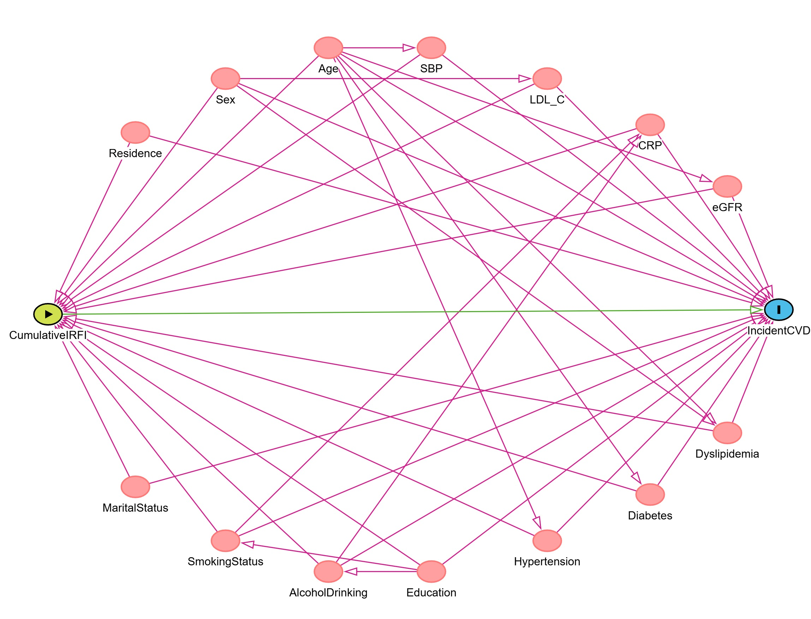
Notes: Directed acyclic graph used to guide covariate selection for the primary analyses.
Abbreviations: DAG, directed acyclic graph; CVD, cardiovascular disease; FI, frailty index; IR, insulin resistance.

Supplementary Figure 2. Reference-MICE covariate screening using Spearman correlation and VIF.
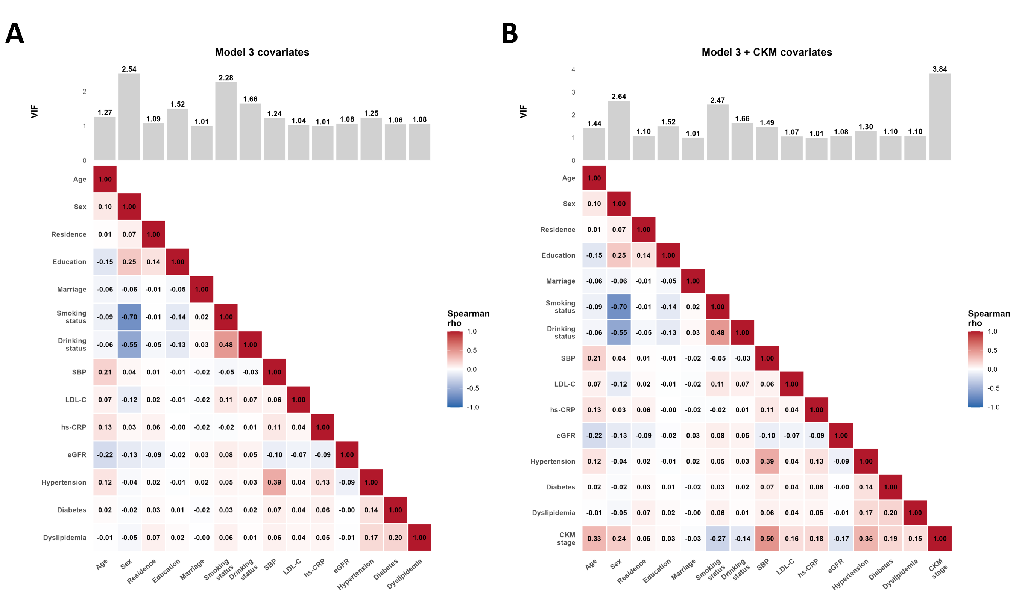
Notes: Panel A shows the Model 3 covariates, and panel B shows the Model 3 covariates plus CKM stage. Bars show VIF values, and squares show pairwise Spearman correlation coefficients.
Abbreviations: CKM, cardiovascular-kidney-metabolic; eGFR, estimated glomerular filtration rate; hs-CRP, high-sensitivity C-reactive protein; LDL-C, low-density lipoprotein cholesterol; MICE, multiple imputation by chained equations; rho, Spearman correlation coefficient; SBP, systolic blood pressure; VIF, variance inflation factor.

Supplementary Figure 3. Core cumulative IR-FI overlap screening with Model 3 covariates.
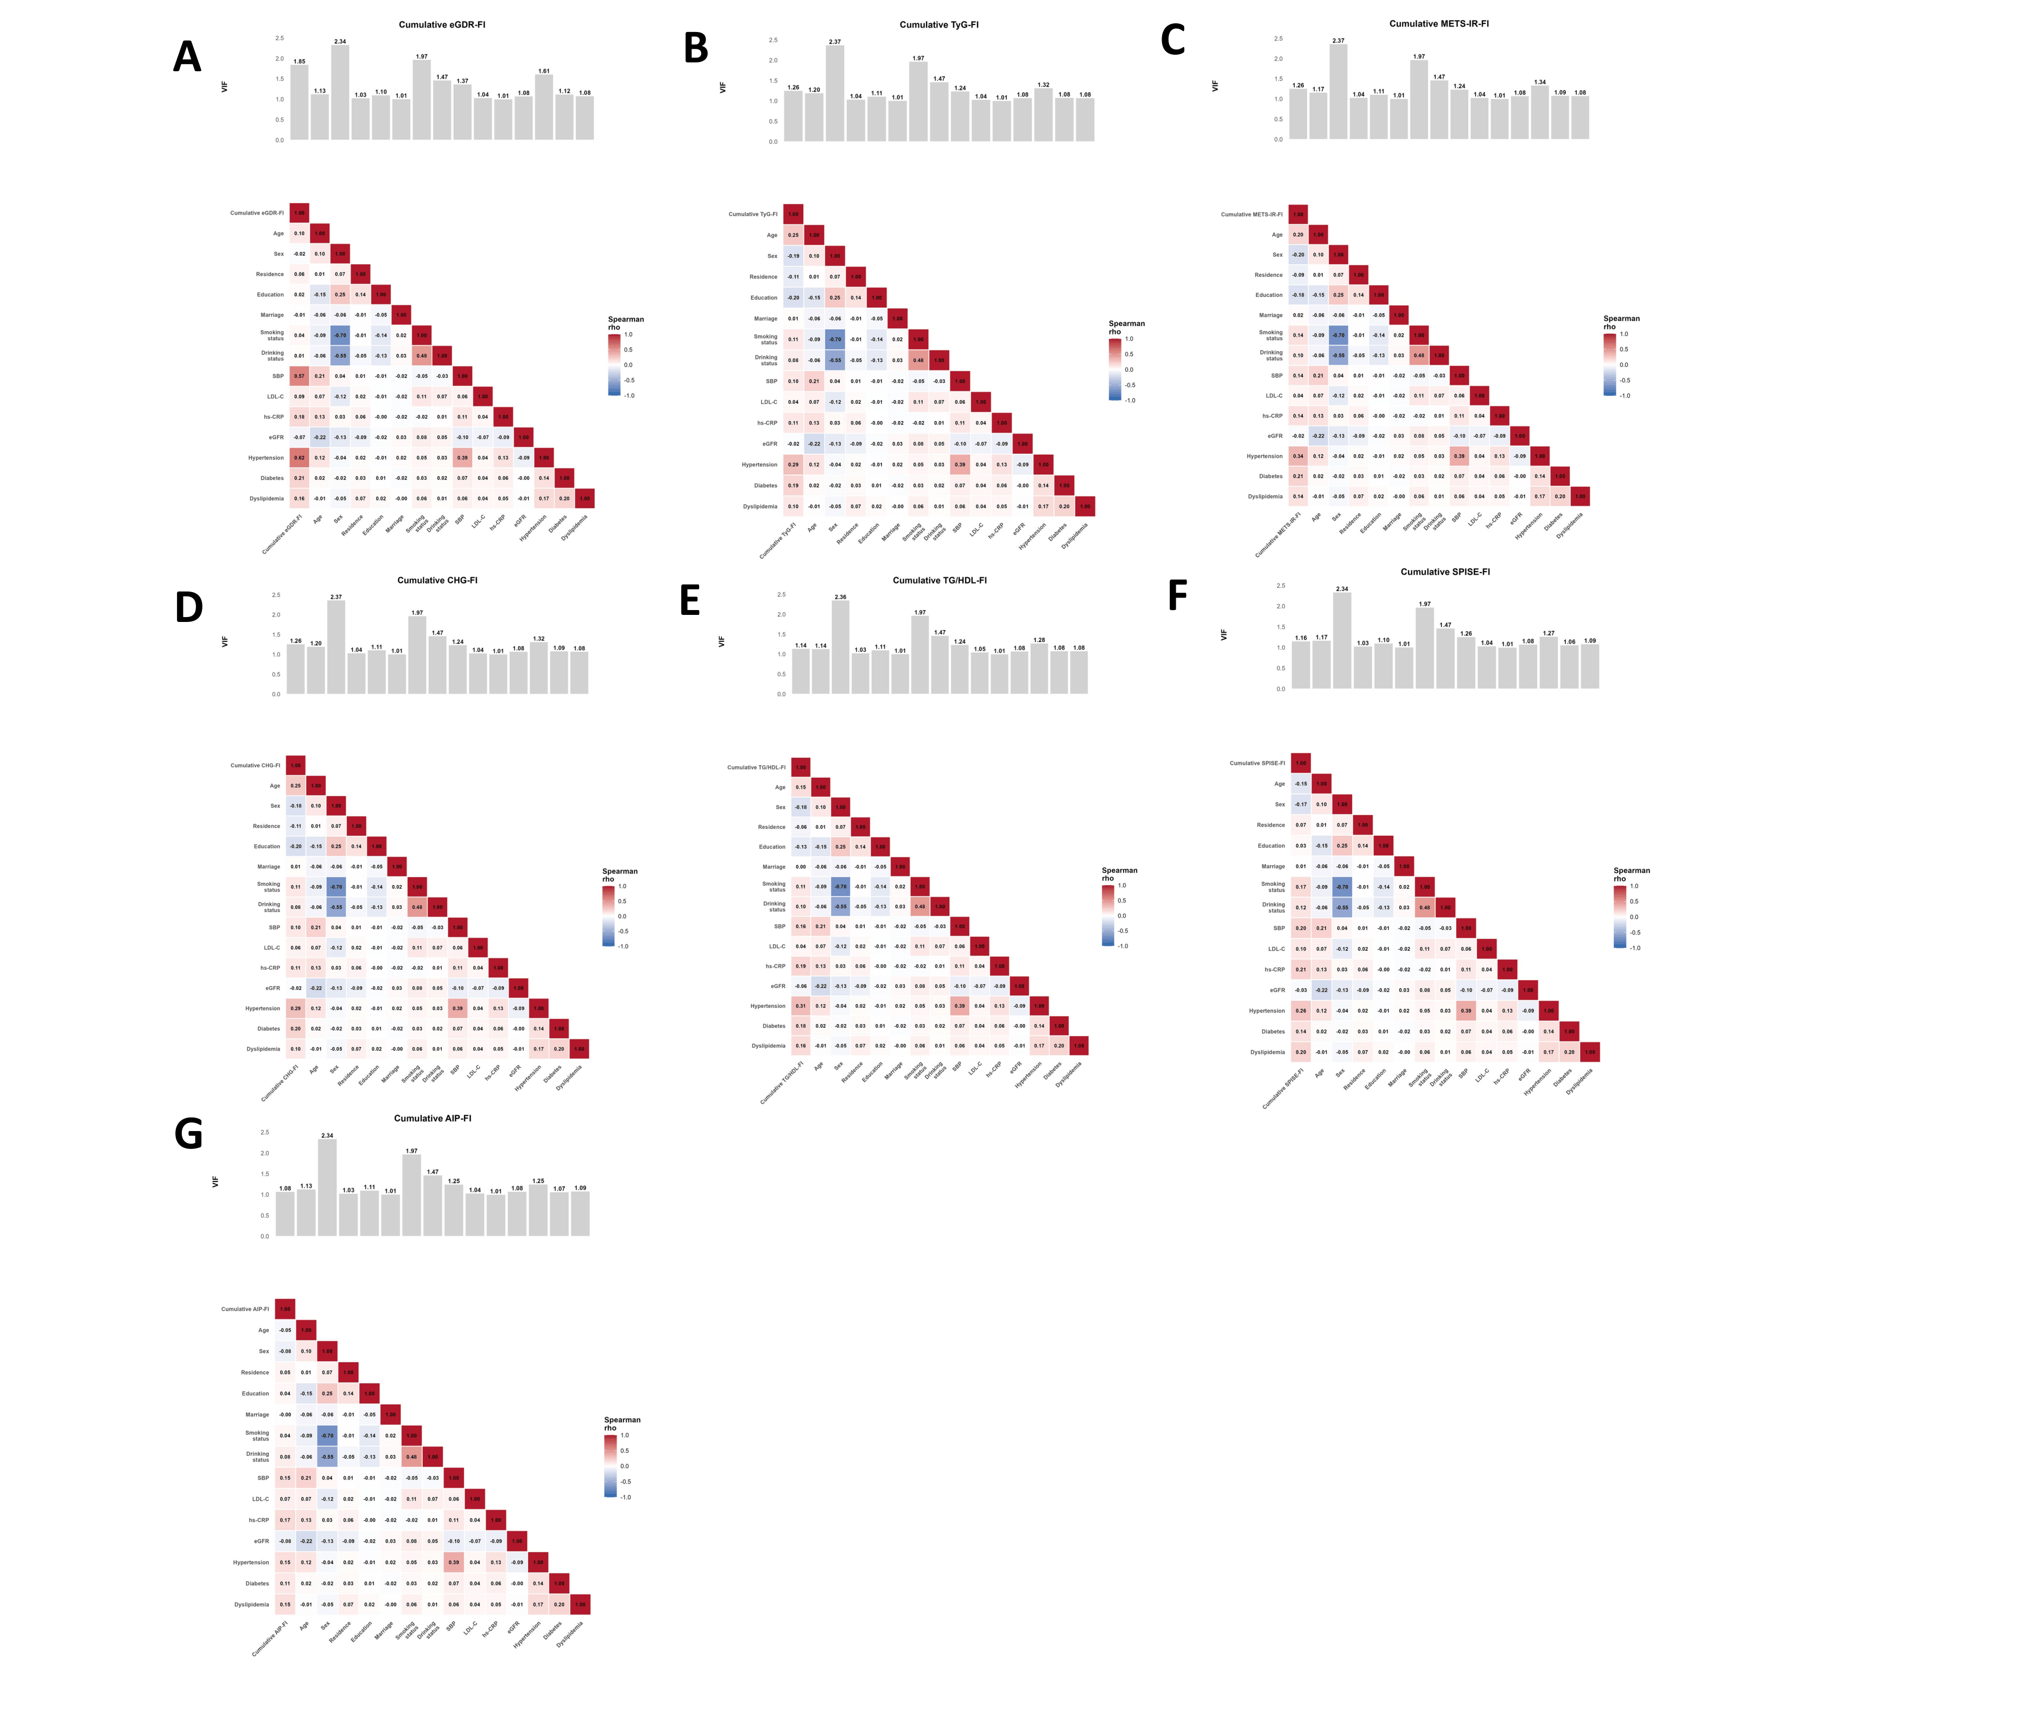
Notes: Bars show VIF values, and squares show pairwise Spearman correlation coefficients between the core cumulative IR-FI indicators and Model 3 covariates.
Abbreviations: AIP, atherogenic index of plasma; CHG, cholesterol, high-density lipoprotein, and glucose index; eGDR, estimated glucose disposal rate; eGFR, estimated glomerular filtration rate; FI, frailty index; hs-CRP, high-sensitivity C-reactive protein; IR, insulin resistance; LDL-C, low-density lipoprotein cholesterol; METS-IR, metabolic score for insulin resistance; rho, Spearman correlation coefficient; SBP, systolic blood pressure; SPISE, single-point insulin sensitivity estimator; TG, triglyceride; TyG, triglyceride-glucose index; VIF, variance inflation factor.

Supplementary Figure 4. TyG-family cumulative IR-FI overlap screening with Model 3 covariates
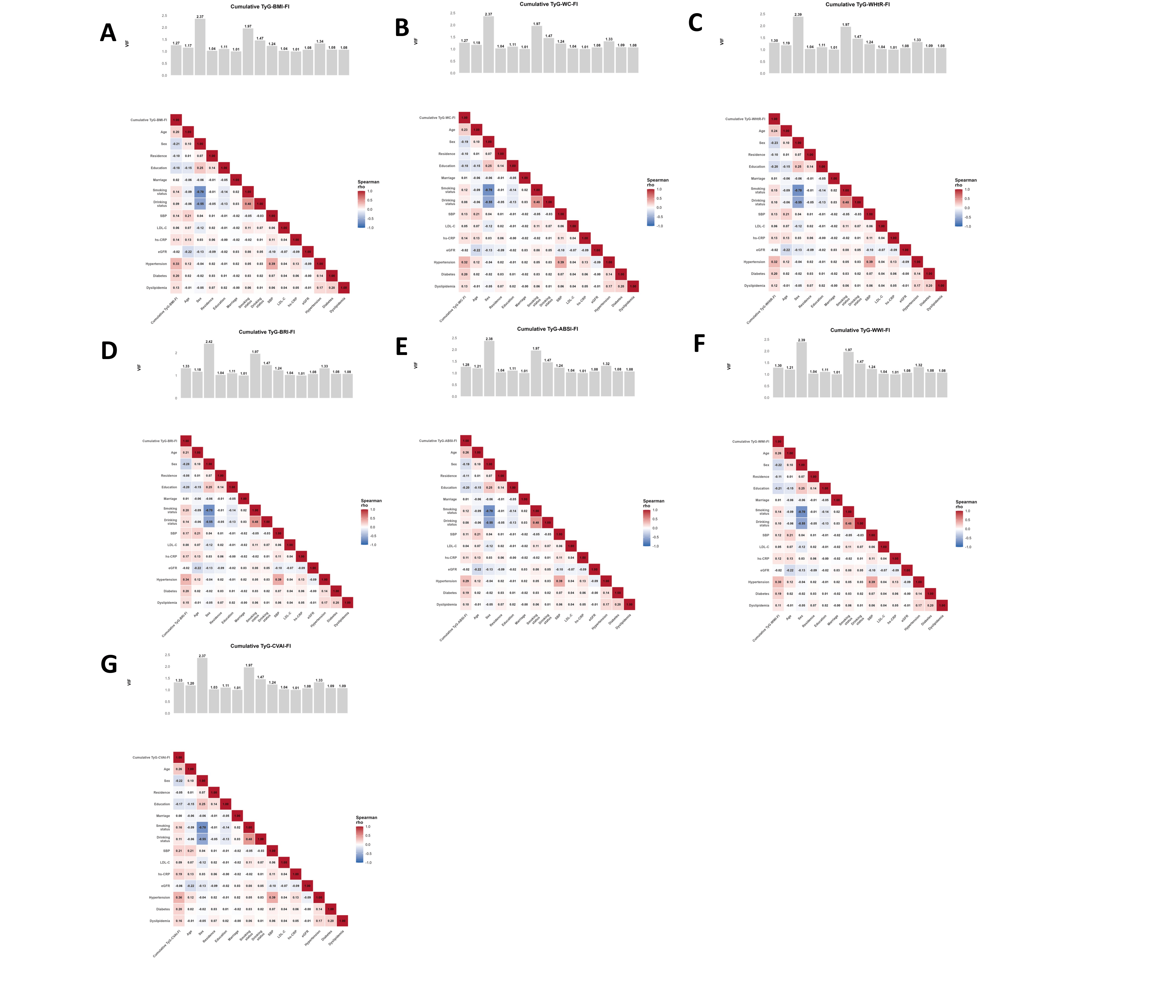
Notes: Bars show VIF values, and squares show pairwise Spearman correlation coefficients between the TyG-family cumulative IR-FI indicators and Model 3 covariates.
Abbreviations: ABSI, a body shape index; BMI, body mass index; BRI, body roundness index; CVAI, Chinese visceral adiposity index; eGFR, estimated glomerular filtration rate; FI, frailty index; hs-CRP, high-sensitivity C-reactive protein; IR, insulin resistance; LDL-C, low-density lipoprotein cholesterol; rho, Spearman correlation coefficient; SBP, systolic blood pressure; TyG, triglyceride-glucose index; VIF, variance inflation factor; WC, waist circumference; WHtR, waist-to-height ratio; WWI, weight-adjusted-waist index.
Supplementary Figure 5. Restricted cubic spline curves for the remaining cumulative IR-FI indicators.
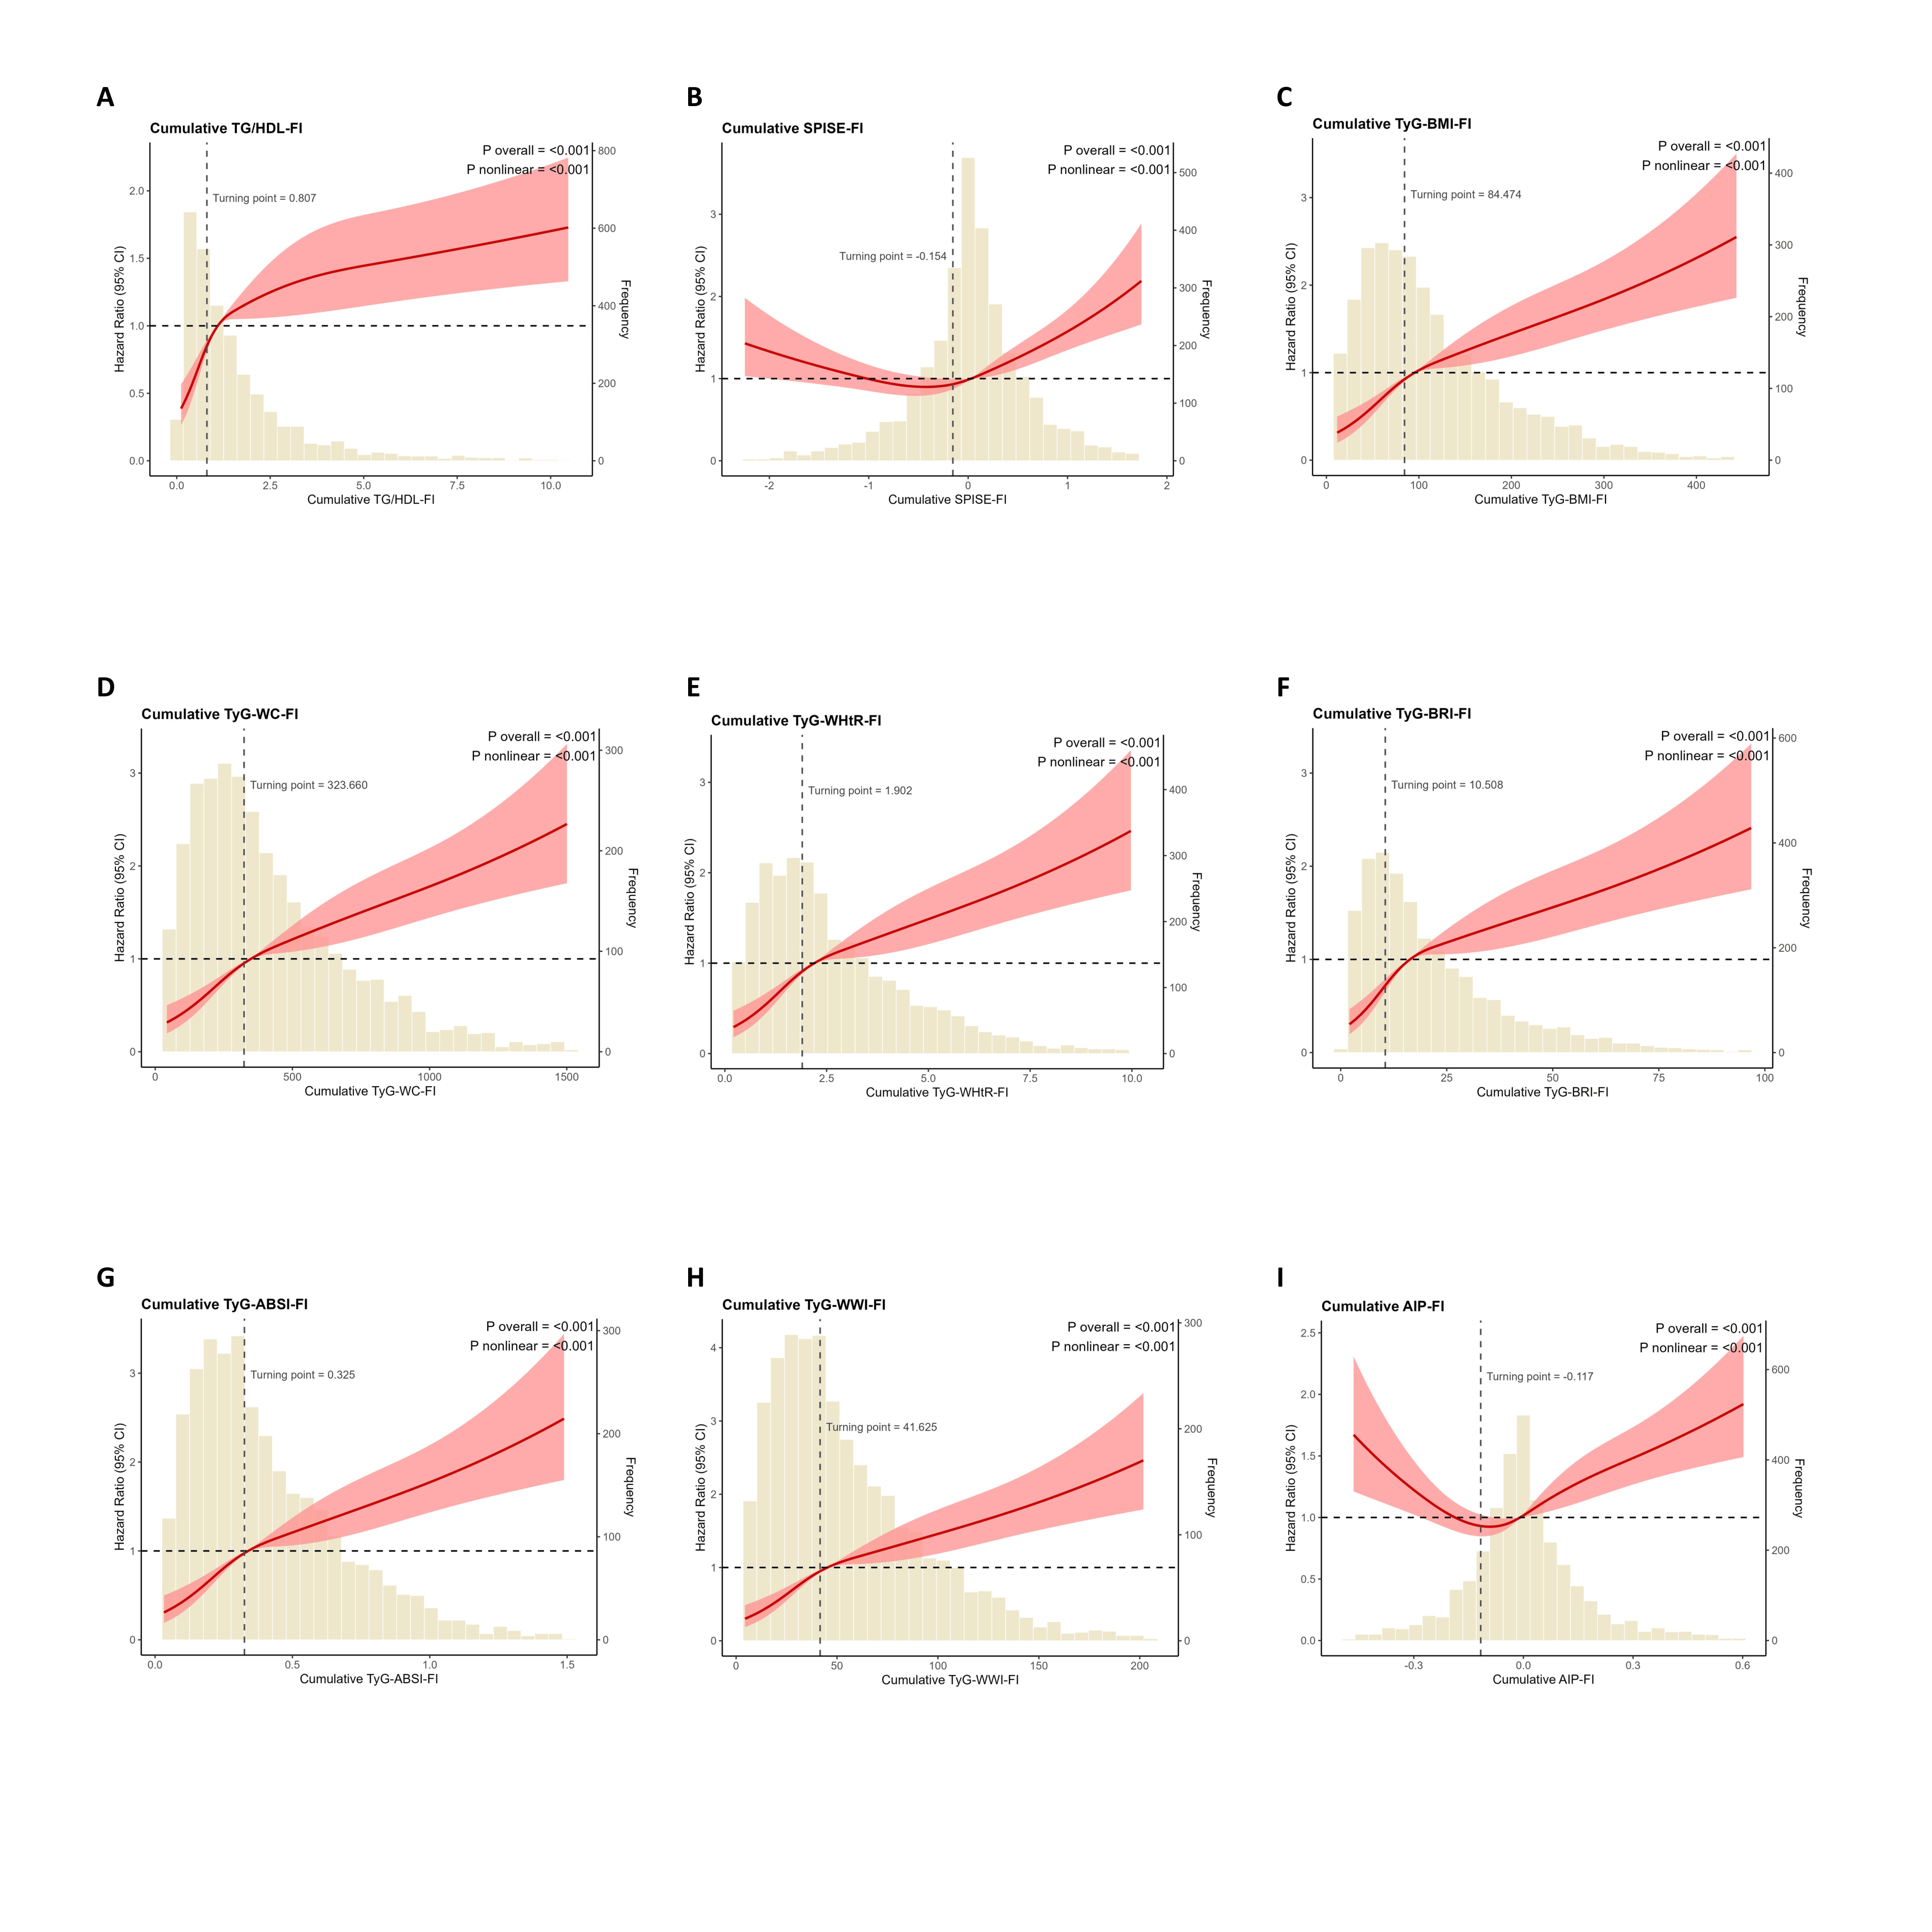
Notes: Restricted cubic spline curves for the remaining cumulative IR-FI indicators in relation to incident CVD. Shaded areas indicate 95% confidence intervals, and bars show the distribution of each indicator.
Abbreviations: ABSI, a body shape index; AIP, atherogenic index of plasma; BMI, body mass index; BRI, body roundness index; CI, confidence interval; CVD, cardiovascular disease; FI, frailty index; HDL, high-density lipoprotein; IR, insulin resistance; RCS, restricted cubic spline; SPISE, single-point insulin sensitivity estimator; TG, triglyceride; TyG, triglyceride-glucose index; WC, waist circumference; WHtR, waist-to-height ratio; WWI, weight-adjusted-waist index.

Supplementary Figure 6. Kaplan-Meier curves for the remaining cumulative IR-FI indicators.
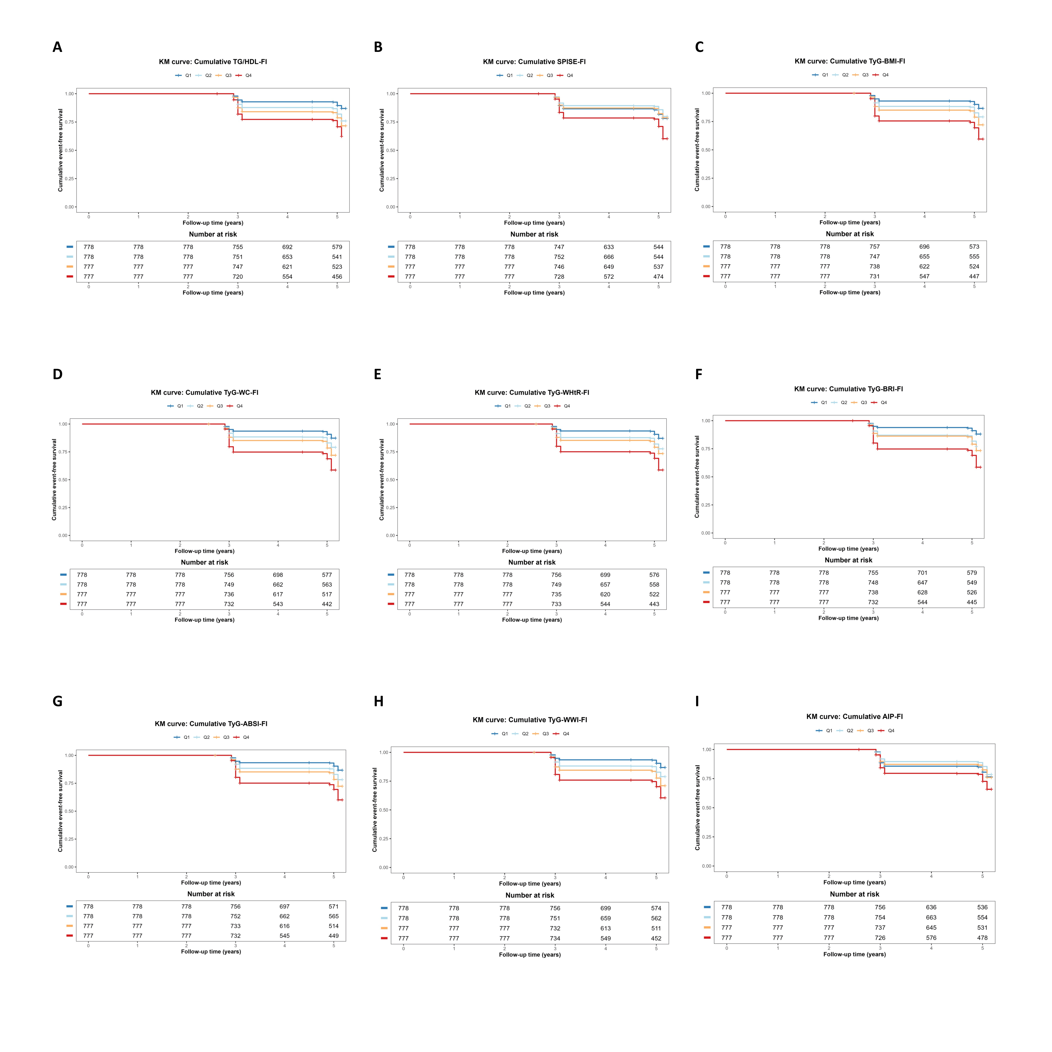
Notes: Kaplan-Meier curves showing cumulative event-free survival from year 2 onward across quartiles of the remaining cumulative IR-FI indicators. Q1-Q4 denote quartiles.
Abbreviations: ABSI, a body shape index; AIP, atherogenic index of plasma; BMI, body mass index; BRI, body roundness index; FI, frailty index; HDL, high-density lipoprotein; IR, insulin resistance; KM, Kaplan-Meier; SPISE, single-point insulin sensitivity estimator; TG, triglyceride; TyG, triglyceride-glucose index; WC, waist circumference; WHtR, waist-to-height ratio; WWI, weight-adjusted-waist index.

Supplementary Figure 7. Receiver operating characteristic curves comparing the discriminatory ability of all 14 cumulative insulin resistance-frailty integrated indices for incident cardiovascular disease.
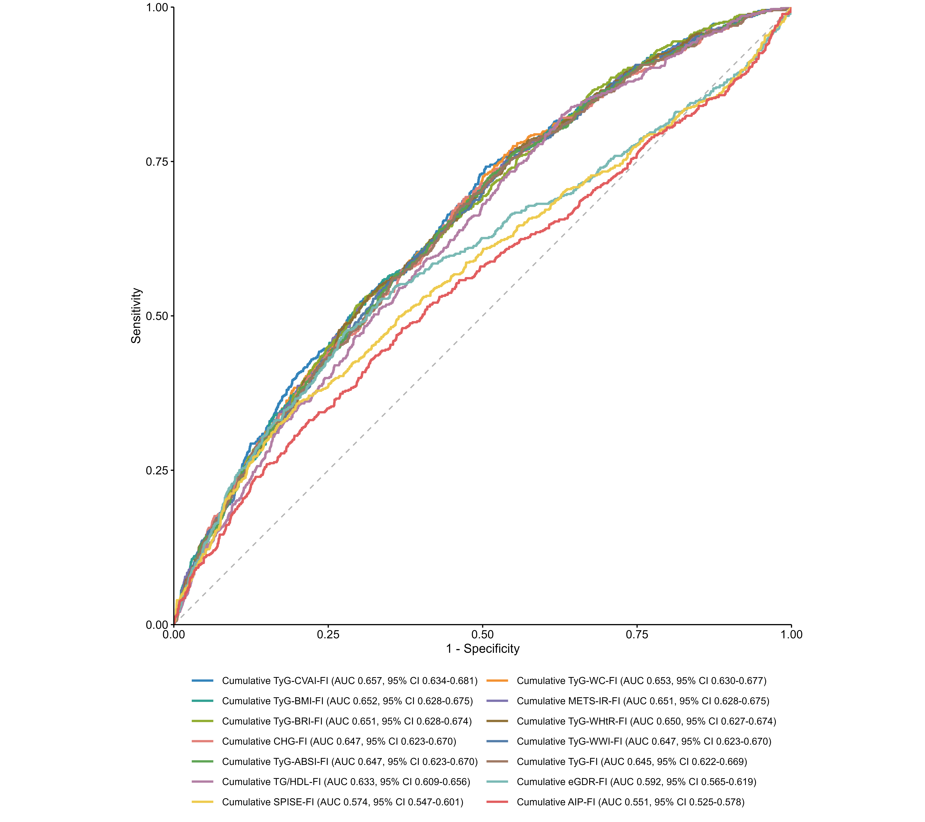
Notes: Receiver operating characteristic curves comparing all 14 cumulative IR-FI indices for incident CVD. Values in the legend represent AUCs with 95% CIs.
Abbreviations: ABSI, a body shape index; AIP, atherogenic index of plasma; AUC, area under the curve; BMI, body mass index; BRI, body roundness index; CHG, cholesterol, high-density lipoprotein cholesterol, and glucose index; CI, confidence interval; CVD, cardiovascular disease; CVAI, Chinese visceral adiposity index; eGDR, estimated glucose disposal rate; FI, frailty index; HDL-C, high-density lipoprotein cholesterol; IR, insulin resistance; METS-IR, metabolic score for insulin resistance; ROC, receiver operating characteristic; SPISE, single-point insulin sensitivity estimator; TG, triglyceride; TyG, triglyceride-glucose index; WC, waist circumference; WHtR, waist-to-height ratio; WWI, weight-adjusted-waist index.
Supplementary Figure 8. Spearman correlation heatmap of the 14 cumulative insulin resistance-frailty integrated indices.
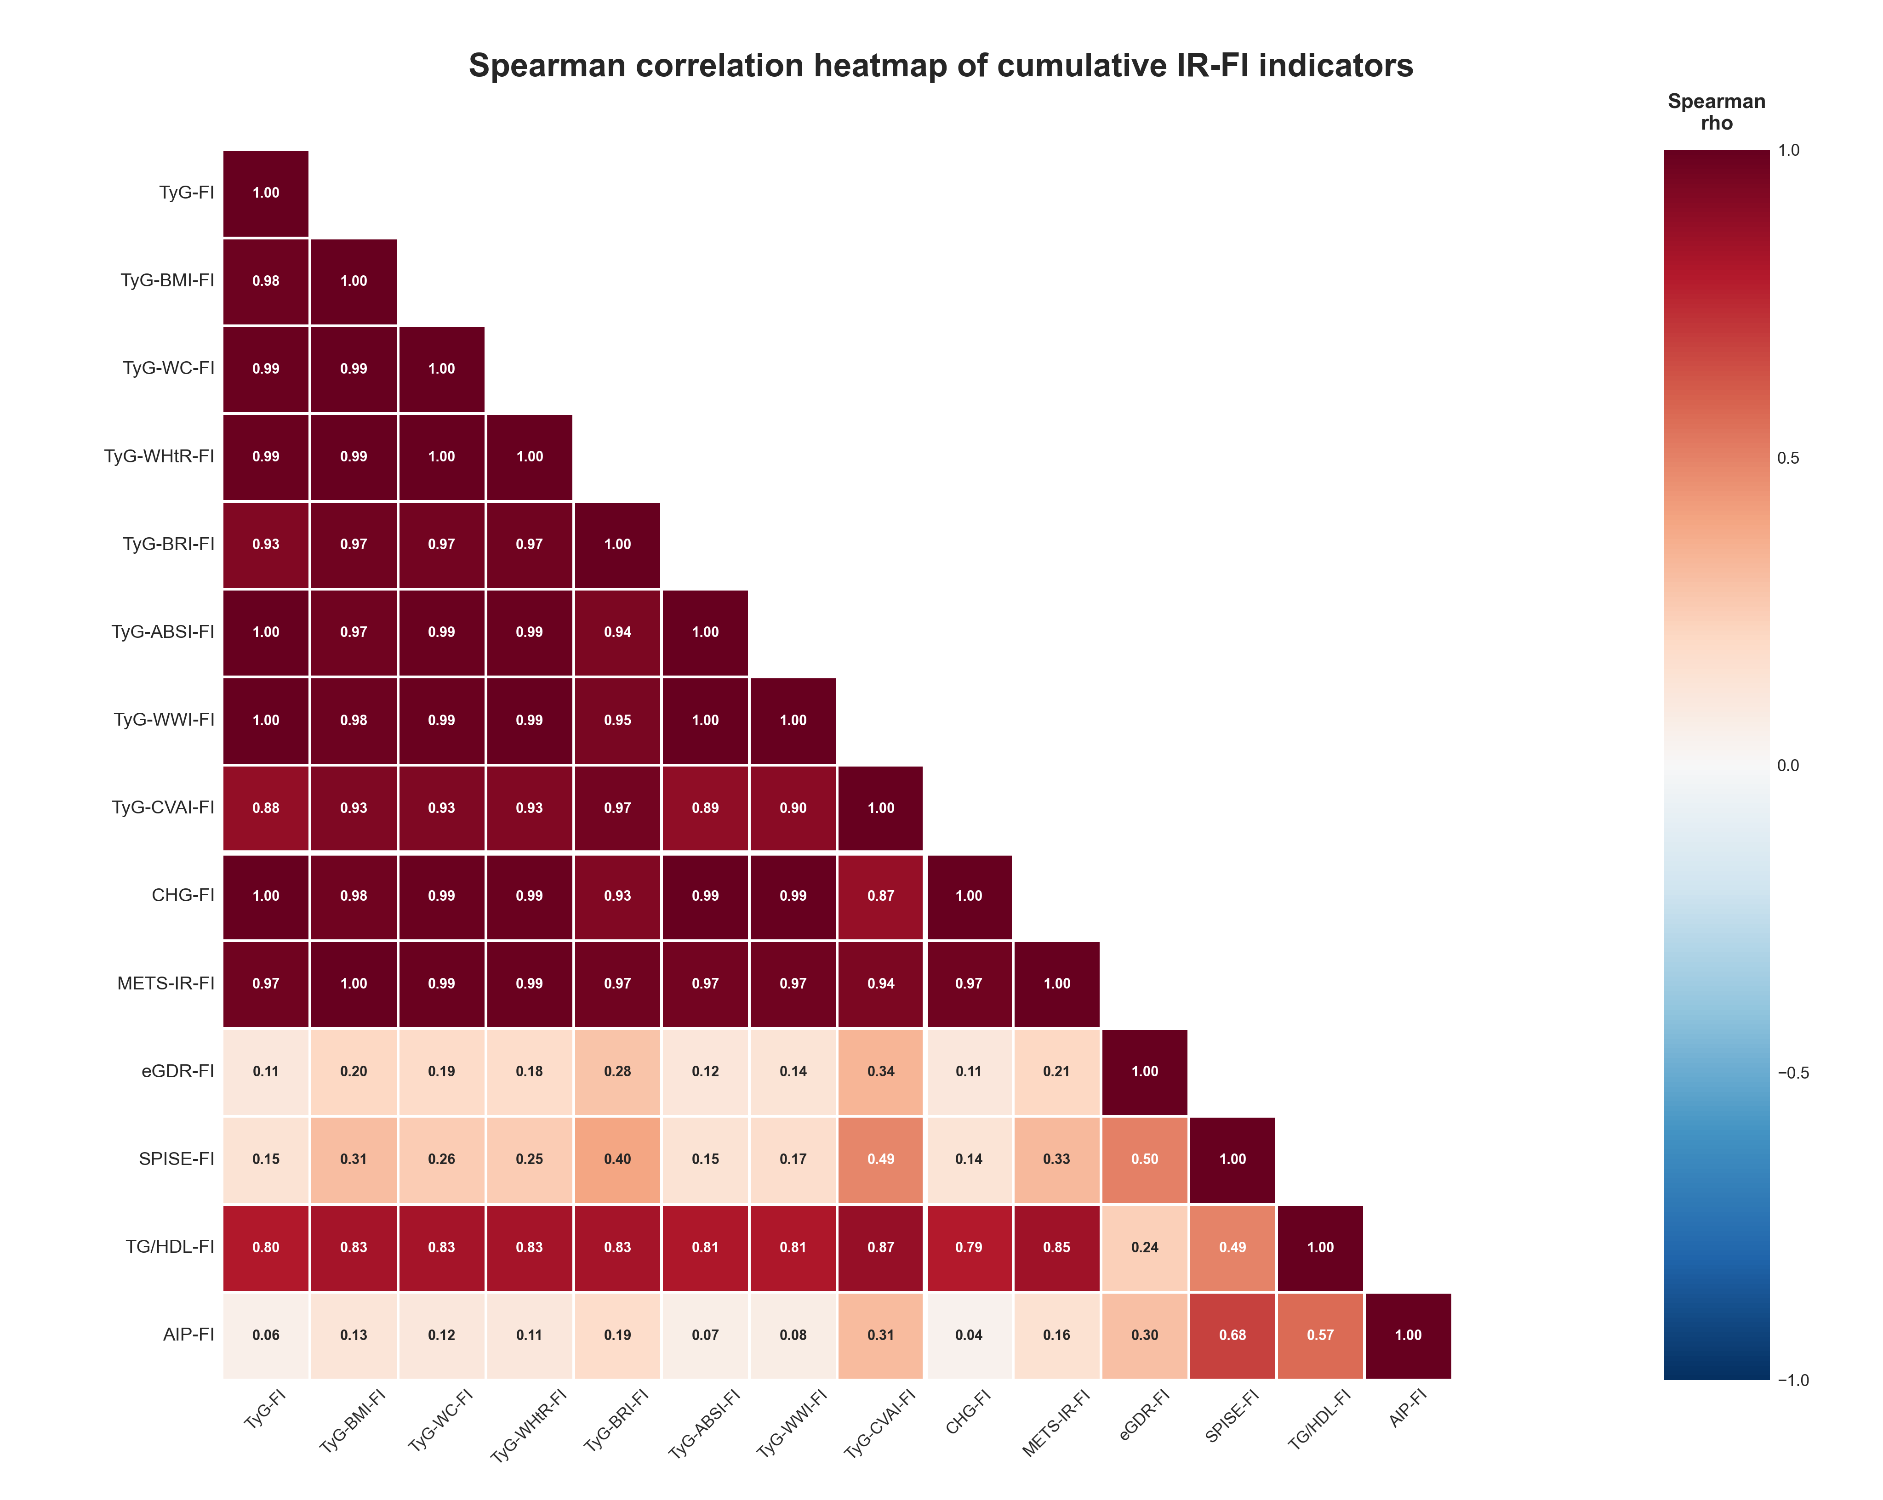
Notes: Squares show pairwise Spearman correlation coefficients (rho) among the 14 cumulative IR-FI indices.
Abbreviations: ABSI, a body shape index; AIP, atherogenic index of plasma; BMI, body mass index; BRI, body roundness index; CHG, cholesterol, high-density lipoprotein, and glucose index; CVAI, Chinese visceral adiposity index; eGDR, estimated glucose disposal rate; FI, frailty index; IR, insulin resistance; METS-IR, metabolic score for insulin resistance; rho, Spearman correlation coefficient; SPISE, single-point insulin sensitivity estimator; TG, triglyceride; TyG, triglyceride-glucose index; WC, waist circumference; WHtR, waist-to-height ratio; WWI, weight-adjusted-waist index.

Supplementary Figure 9. Exploratory mediation analyses for representative cumulative IR-FI indicators.
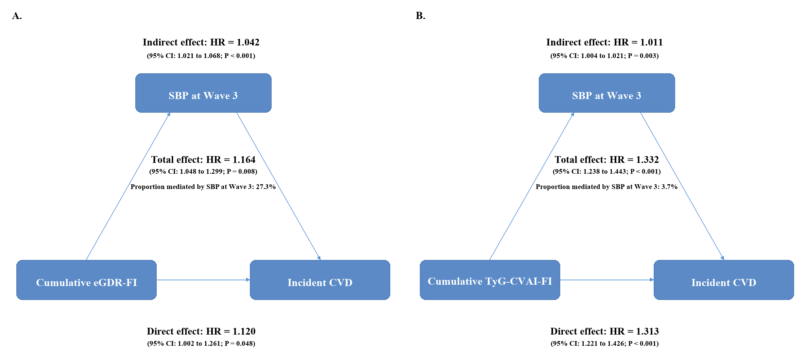Notes: Path diagrams show exploratory mediation analyses with systolic blood pressure at Wave 3 as the mediator. Confidence intervals and P values were derived from the same 2,000-resample bootstrap distributions.
Abbreviations: CI, confidence interval; CVD, cardiovascular disease; CVAI, Chinese visceral adiposity index; eGDR, estimated glucose disposal rate; FI, frailty index; HR, hazard ratio; IR, insulin resistance; SBP, systolic blood pressure; TyG, triglyceride-glucose index.

Supplementary Figure 10. Exploratory mediation results for the remaining cumulative IR-FI indicators.
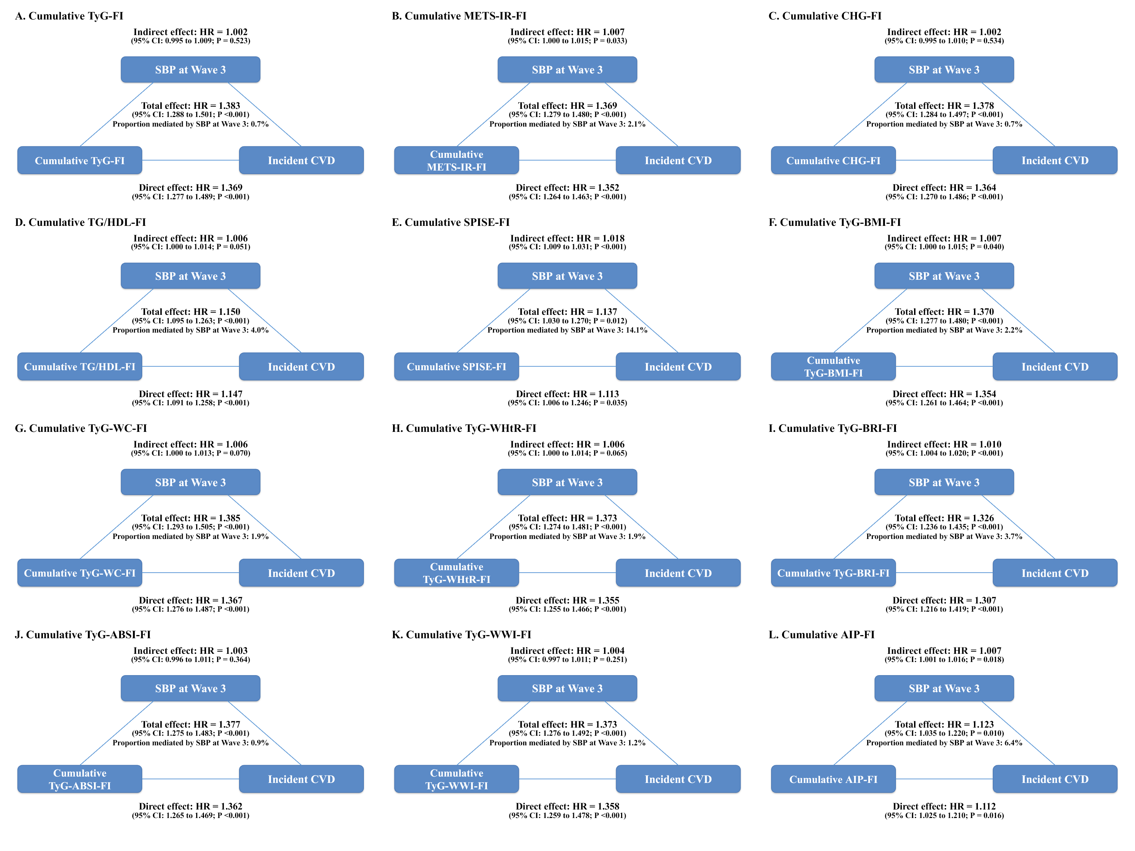Notes: Path diagrams show exploratory mediation results for the remaining indicators. Confidence intervals and P values were derived from the same 2,000-resample bootstrap distributions.
Abbreviations: ABSI, a body shape index; AIP, atherogenic index of plasma; BMI, body mass index; BRI, body roundness index; CHG, cholesterol, high-density lipoprotein, and glucose index; CI, confidence interval; CVD, cardiovascular disease; FI, frailty index; HR, hazard ratio; IR, insulin resistance; METS-IR, metabolic score for insulin resistance; SBP, systolic blood pressure; SPISE, single-point insulin sensitivity estimator; TG, triglyceride; TyG, triglyceride-glucose index; W3, wave 3; WC, waist circumference; WHtR, waist-to-height ratio; WWI, weight-adjusted-waist index.

