Supplementary Material
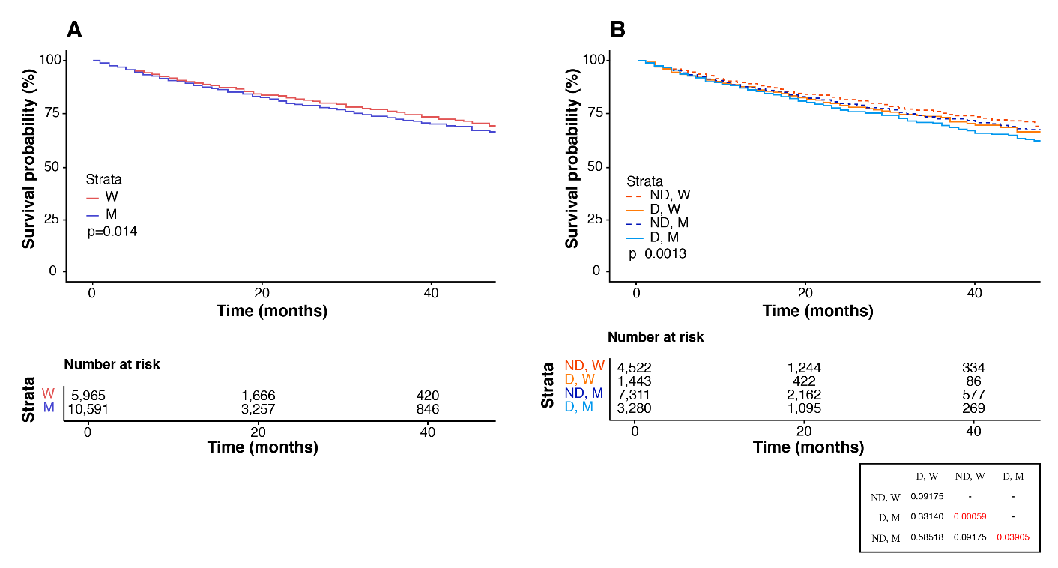
W, women; M, men; D, diabetes; ND, non-diabetes. The table presents pairwise comparisons.

Supplementary Figure 1. Overall survival according to sex in the overall cohort (panel A) and after stratification by diabetes status (panel B).
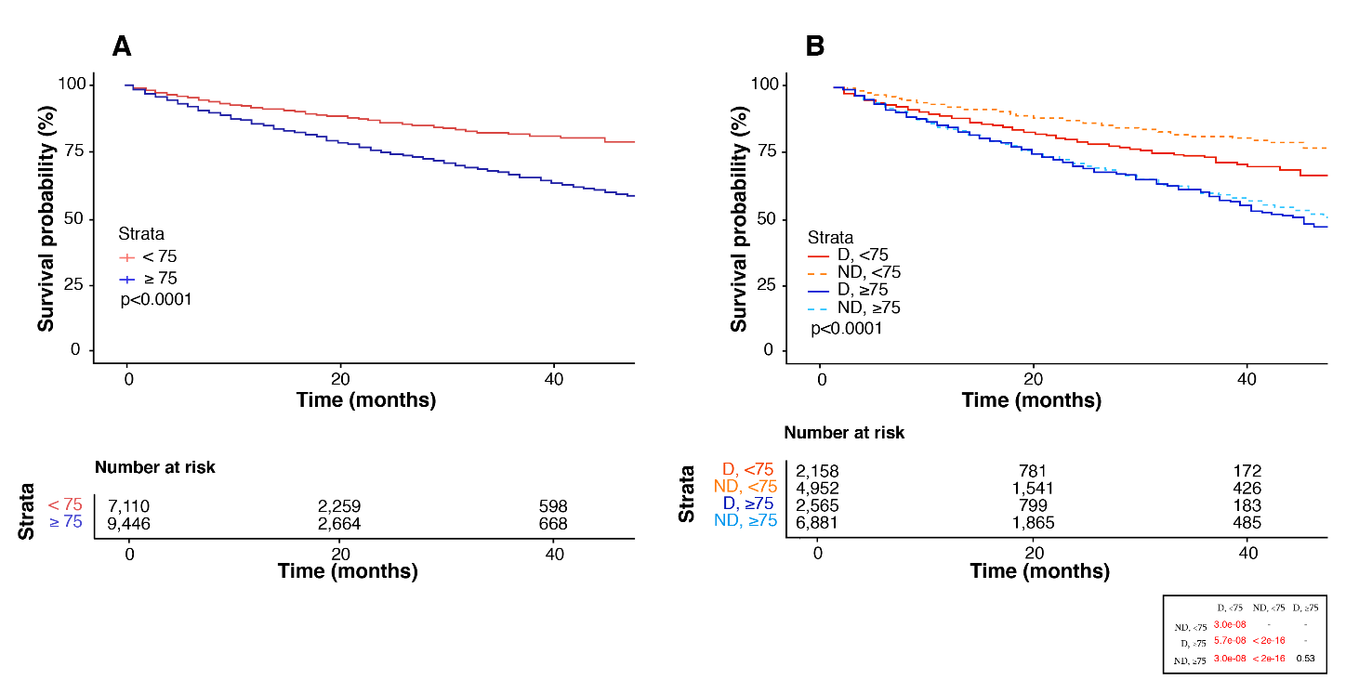

D, diabetes; ND, non-diabetes. The table presents pairwise comparisons.

Supplementary Figure 2. Overall survival according to age group (<75 vs ≥75 years) in the overall cohort (panel A) and after stratification by diabetes status (panel B).
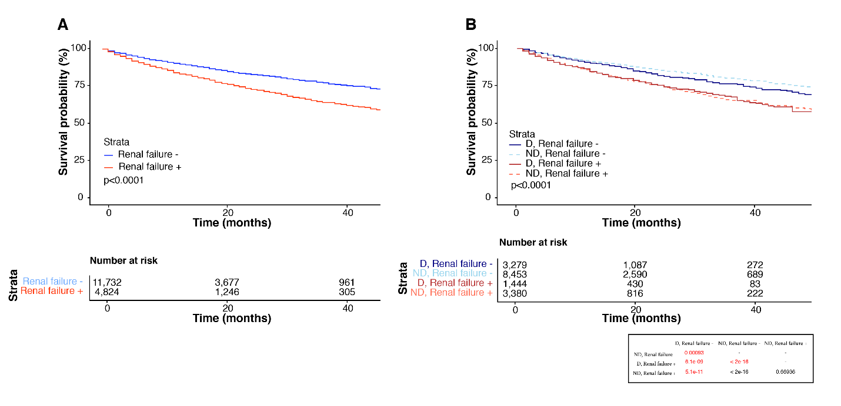

D, diabetes; ND, non-diabetes. The table presents pairwise comparisons.

Supplementary Figure 3. Overall survival according to clinician-reported renal failure in the overall cohort (panel A) and after stratification by diabetes status (panel B).

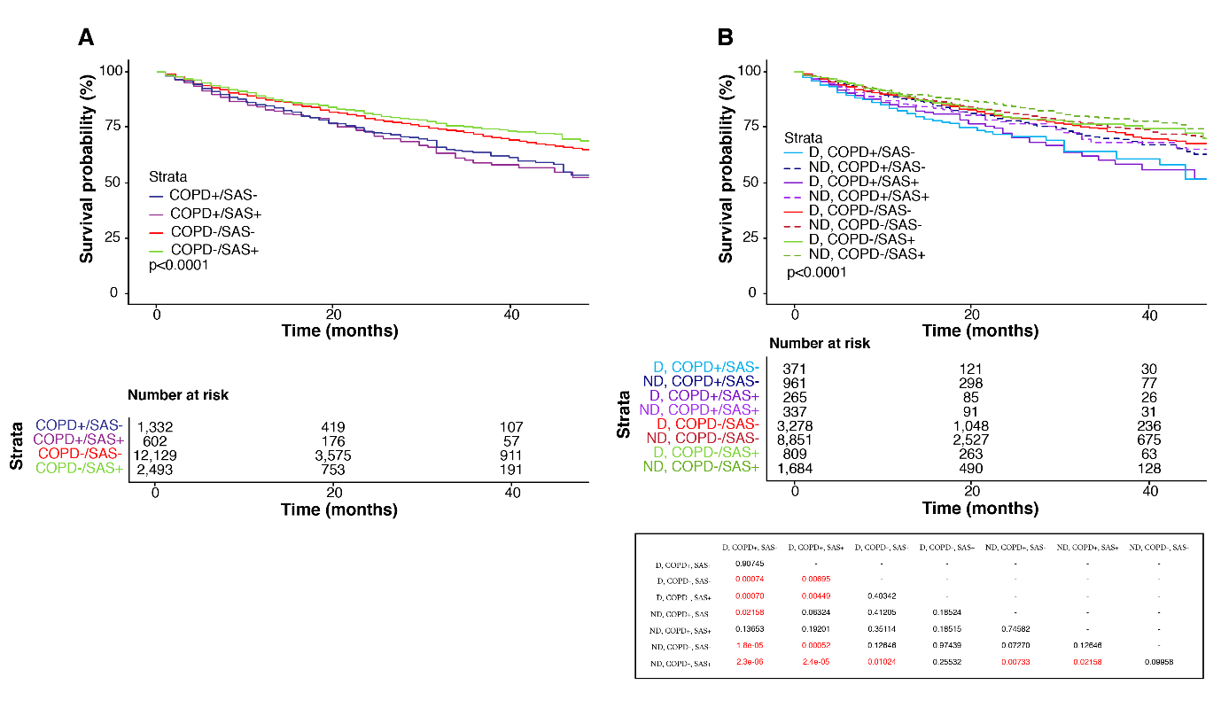

D, diabetes; ND, non-diabetes; COPD, chronic obstructive pulmonary disease; SAS, sleep apnea syndrome.
The table presents pairwise comparisons.

Supplementary Figure 4. Overall survival according to respiratory comorbidity profile in the overall cohort (panel A) and after stratification by diabetes status (panel B).

