Supplemental appendix
Elevated remnant cholesterol is estimated to mediate part of excess cardiovascular risk in the metabolic syndrome: Two cohort studies of 537,885 individuals
Table of contents:
Supplemental Table 1. Baseline characteristics of individuals with and without the metabolic syndrome.
Supplemental Table 2. Baseline characteristics of individuals without the metabolic syndrome stratified on use of lipid-lowering therapy.
Supplemental Figure 1. Flowchart for Copenhagen General Population Study and UK biobank.
Supplemental Figure 2. Correlation between lipids and lipoproteins in the Copenhagen General Population Study.
Supplemental Figure 3. Directed Acyclic Graph for mediated pathway from the metabolic syndrome through remnant cholesterol and triglycerides to outcomes.
Supplemental Figure 4. Directed Acyclic Graph for mediated pathway from the metabolic syndrome through LDL cholesterol to outcomes.
Supplemental Figure 5. Directed Acyclic Graph for mediated pathway from the metabolic syndrome through non-HDL cholesterol or apolipoprotein B to outcomes.
Supplemental Figure 6. Distribution of criteria in those fulfilling the definition of the metabolic syndrome.
Supplemental Figure 7. Mediated excess risk of ASCVD and its subcomponents myocardial infarction, ischemic stroke, peripheral artery disease, revascularisation, all-cause death by remnant cholesterol from the metabolic syndrome.
Supplemental Figure 8. Risk of cardiovascular disease and all-cause mortality in individuals with the metabolic syndrome from elevated remnant cholesterol with additional adjustment for total cholesterol.
Supplemental Figure 9. Mediated excess cardiovascular and all-cause mortality risk from the metabolic syndrome by remnant cholesterol with additional adjustment total cholesterol.
Supplemental Figure 10. Risk of cardiovascular disease and all-cause mortality in the metabolic syndrome from elevated remnant cholesterol. With additional adjustment for systolic blood pressure, body mass index, diabetes, education, and exercise.
Supplemental Figure 11. Mediated excess cardiovascular and all-cause mortality risk from the metabolic syndrome by remnant cholesterol. With additional adjustment for systolic blood pressure, body mass index, diabetes, education, and exercise.
Supplemental Figure 12. Subdistribution hazard ratios from a Fine and Gray analysis for cardiovascular disease and all-cause mortality in individuals with the metabolic syndrome considering the competing risk of non-cardiovascular death.
Supplemental Figure 13. Risk of cardiovascular disease and all-cause mortality in the metabolic syndrome from elevated remnant cholesterol in individuals with baseline lipid-lowering therapy use. Without imputation.
Supplemental Figure 14. Risk of cardiovascular disease and all-cause mortality in the metabolic syndrome from elevated remnant cholesterol in individuals without baseline lipid-lowering therapy use. Without imputation.
Supplemental Figure 15. Risk of cardiovascular disease and all-cause mortality in individuals with versus without the metabolic syndrome. Without imputation.
Supplemental Figure 16. Mediated excess cardiovascular and all-cause mortality risk from elevated remnant cholesterol in the metabolic syndrome in individuals with baseline lipid-lowering therapy use. Without imputation.
Supplemental Figure 17. Mediated excess cardiovascular and all-cause mortality risk from elevated remnant cholesterol in the metabolic syndrome in individuals without baseline lipid-lowering therapy use. Without imputation.
Supplemental Figure 18. Risk of cardiovascular disease and all-cause mortality in individuals with the metabolic syndrome from elevated remnant cholesterol and LDL cholesterol in women.
Supplemental Figure 19. Risk of cardiovascular disease and all-cause mortality in individuals with the metabolic syndrome from elevated remnant cholesterol and LDL cholesterol in men.
Supplemental Figure 20. Risk of cardiovascular disease and all-cause mortality in individuals with the metabolic syndrome from elevated remnant cholesterol. The metabolic syndrome defined with a diabetes criterion including both diabetes and elevated non-fasting plasma glucose.
Supplemental Figure 21. Mediated excess cardiovascular and all-cause mortality risk from elevated remnant cholesterol in the metabolic syndrome. The metabolic syndrome defined with a diabetes criterion including both diabetes and elevated non-fasting plasma glucose.
Supplemental Figure 22. Risk of cardiovascular disease and all-cause mortality in individuals with the metabolic syndrome from elevated remnant cholesterol. The metabolic syndrome defined with a modified triglycerides criterion of 2.0 mmol/L (177 mg/dL).
Supplemental Figure 23. Mediated excess cardiovascular and all-cause mortality risk from elevated remnant cholesterol in the metabolic syndrome. The metabolic syndrome defined with a modified triglycerides criterion of 2.0 mmol/L (177 mg/dL).
Supplemental Figure 24. Mediated excess cardiovascular and all-cause mortality risk from elevated remnant cholesterol in the metabolic syndrome. The metabolic syndrome defined as three or more of the four remaining criteria when the HDL criterion is left out.
Supplemental Figure 25. Mediated excess cardiovascular and all-cause mortality risk from elevated remnant cholesterol in the metabolic syndrome. The metabolic syndrome defined as three or more of the four remaining criteria when the triglycerides criterion is left out.
Supplemental Figure 26. Mediated excess cardiovascular and all-cause mortality risk from subcomponents of the metabolic syndrome mediated by remnant cholesterol. In individuals with baseline lipid-lowering therapy.
Supplemental Figure 27. Mediated excess cardiovascular and all-cause mortality risk from subcomponents of the metabolic syndrome mediated by remnant cholesterol. In individuals without baseline lipid-lowering therapy.
Supplemental Figure 28. Risk of cardiovascular disease and all-cause mortality by number of fulfilled metabolic syndrome criteria. In individuals with baseline lipid-lowering therapy.
Supplemental Figure 29. Risk of cardiovascular disease and all-cause mortality by number of fulfilled metabolic syndrome criteria. In individuals without baseline lipid-lowering therapy.
Supplemental Figure 30. Risk of cardiovascular disease and all-cause mortality from different types of metabolic syndrome. The metabolic syndrome modified by leaving out each subcomponent. In individuals with baseline lipid-lowering therapy.
Supplemental Figure 31. Risk of cardiovascular disease and all-cause mortality from different types of metabolic syndrome. The metabolic syndrome modified by leaving out each subcomponent. In individuals without baseline lipid-lowering therapy.
Supplemental Figure 32. Risk of cardiovascular disease and all-cause mortality in individuals with the metabolic syndrome and without baseline lipid-lowering therapy. Additional time-varying adjustment for initiation of lipid-lowering therapy.
Supplemental Figure 33. Risk of myocardial infarction and ASCVD in individuals with versus without the metabolic syndrome with additional adjustment for remnant cholesterol and LDL cholesterol levels.
Supplemental Figure 34. Risk of cardiovascular disease and all-cause mortality in individuals with the metabolic syndrome from elevated remnant cholesterol or elevated triglycerides per 1 standard deviation change.
Supplemental Table 1. Baseline characteristics of individuals with and without the metabolic syndrome.
 | Copenhagen General Population Study |  |  | UK Biobank
 | The metabolic syndrome | No metabolic syndrome |  | The metabolic syndrome | No metabolic syndrome
N | 35,050 | 82,058 |  | 143,909 | 276,868
Covariates for adjustment
Women, n (%) | 15,805 (45%) | 49,062 (60%) |  | 67,052 (47%) | 160,770 (58%)
Age, Years | 61 (51, 69) | 56 (47, 66) |  | 60 (52, 64) | 57 (49, 63)
Smokers, n (%) | 6,792 (19%) | 12,793 (16%) |  | 55,354 (39%) | 90,566 (33%)
Lipid-lowering therapy user, n (%) | 6,524 (19%) | 5,949 (7%) |  | 42,347 (29%) | 29,794 (11%)
Other covariates
Systolic blood pressure, mmHg | 145 (135, 158) | 132 (120, 148) |  | 143 (133, 154) | 132 (122, 146)
Waist circumference, cm | 99 (93, 107) | 85 (77, 93) |  | 99 (92, 106) | 85 (77, 93)
Remnant cholesterol, mmol/L | 0.9 (0.7, 1.1) | 0.5 (0.4, 0.6) |  | 0.8 (0.6, 1.0) | 0.6 (0.4, 0.7)
Remnant cholesterol, mg/dL | 34 (29, 43) | 20 (17, 25) |  | 31 (24, 39) | 22 (17, 28)
LDL cholesterol, mmol/L | 3.5 (2.8, 4.2) | 3.1 (2.5, 3.7) |  | 3.6 (2.9, 4.3) | 3.5 (3.0, 4.1)
LDL cholesterol, mg/dL | 135 (109, 160) | 119 (97, 143) |  | 139 (113, 164) | 135 (114, 157)
Triglycerides, mmol/L | 2.3 (1.9, 3.1) | 1.1 (0.8, 1.5) |  | 2.3 (1.8, 3.0) | 1.2 (0.9, 1.6)
Triglycerides, mg/dL | 205 (165, 274) | 100 (74, 131) |  | 200 (162, 263) | 106 (81, 137)
The metabolic syndrome criteria
High blood pressure, n (%) | 32,287 (92%) | 46,503 (57%) |  | 133,075 (93%) | 159,528 (58%)
Large waist circumference, n (%) | 33,413 (95%) | 36,739 (45%) |  | 136,846 (95%) | 117,827 (43%)
Low HDL cholesterol, n (%) | 17,096 (49%) | 5,488 (7%) |  | 71,639 (50%) | 18,349 (7%)
High triglycerides, n (%) | 31,007 (89%) | 11,761 (14%) |  | 125,073 (87%) | 49,084 (18%)
Diabetes, n (%) | 4,113 (12%) | 659 (1%) |  | 21,773 (15%) | 2,796 (1%)

In individuals without previous myocardial infarction. Categorical variables are presented as absolute number (%), continuous variables are presented as median (interquartile range). HDL=high-density lipoproteins. LDL=low-density lipoproteins.
Supplemental Table 2. Baseline characteristics of individuals without the metabolic syndrome stratified on use of lipid-lowering therapy.
Individuals without the metabolic syndrome | Copenhagen General Population Study |  |  | UK Biobank
Individuals without the metabolic syndrome | Lipid-lowering therapy | No lipid-lowering therapy |  | Lipid-lowering therapy | No lipid-lowering therapy
N | 5,949 | 76,109 |  | 29,794 | 247,074
Covariates for adjustment
Women, n (%) | 3,168 (53%) | 45,894 (60%) |  | 12,209 (41%) | 148,561 (60%)
Age, Years | 68 (61, 74) | 54 (46, 65) |  | 63 (59, 66) | 56 (48, 62)
Smokers, n (%) | 842 (14%) | 11,951 (16%) |  | 12,378 (42%) | 78,208 (32%)
Other covariates
Systolic blood pressure, mmHg | 142 (129, 156) | 131 (120, 147) |  | 139 (127, 153) | 131 (121, 145)
Waist circumference, cm | 90 (81, 97) | 85 (77, 92) |  | 90 (82, 97) | 84 (76, 92)
Remnant cholesterol, mmol/L | 0.5 (0.4, 0.6) | 0.5 (0.4, 0.6) |  | 0.5 (0.4, 0.6) | 0.6 (0.5, 0.7)
Remnant cholesterol, mg/dL | 20 (16, 23) | 20 (17, 25) |  | 18 (14, 23) | 23 (18, 29)
LDL cholesterol, mmol/L | 2.4 (2.0, 2.9) | 3.1 (2.6, 3.8) |  | 2.7 (2.4, 3.2) | 3.6 (3.1, 4.1)
LDL cholesterol, mg/dL | 92 (75, 113) | 121 (100, 145) |  | 106 (91, 123) | 138 (119, 159)
Triglycerides, mmol/L | 1.1 (0.9, 1.4) | 1.1 (0.8, 1.5) |  | 1.2 (0.9, 1.5) | 1.2 (0.9, 1.6)
Triglycerides, mg/dL | 100 (77, 125) | 100 (74, 131) |  | 106 (83, 131) | 106 (80.8, 138)
The metabolic syndrome criteria
High blood pressure, n (%) | 4776 (80%) | 41,727 (55%) |  | 23,350 (78%) | 136,178 (55%)
Large waist circumference, n (%) | 3,372 (57%) | 33,367 (44%) |  | 14,947 (50%) | 102,880 (42%)
Low HDL cholesterol, n (%) | 130 (2%) | 5,358 (7%) |  | 1,376 (5%) | 16,973 (7%)
High triglycerides, n (%) | 903 (15%) | 10,858 (14%) |  | 6,125 (21%) | 42,959 (17%)
Diabetes, n (%) | 270 (5%) | 389 (0.5%) |  | 1,587 (5%) | 1,209 (1%)

In individuals without previous myocardial infarction. Categorical variables are presented as absolute number (%), continuous variables are presented as median (interquartile range). HDL=high-density lipoproteins. LDL=low-density lipoproteins.
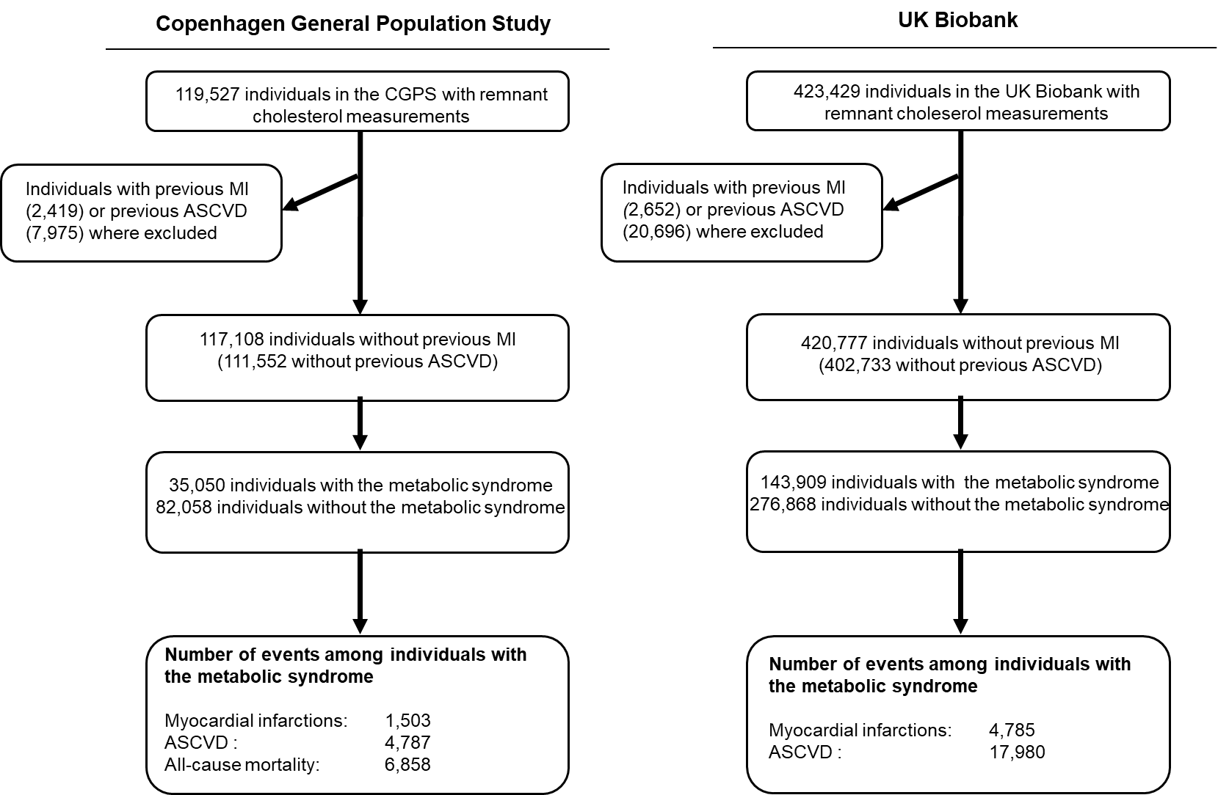
Supplemental Figure 1. Flowchart for Copenhagen General Population Study and UK biobank. ASCVD=atherosclerotic cardiovascular disease. CGPS=Copenhagen General Population Study.
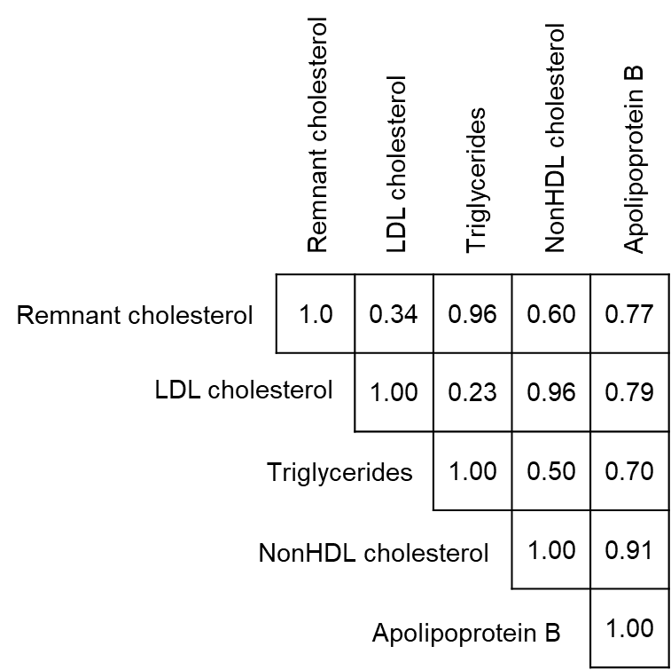

Supplemental Figure 2. Correlation between lipids and lipoproteins in the Copenhagen General Population Study.

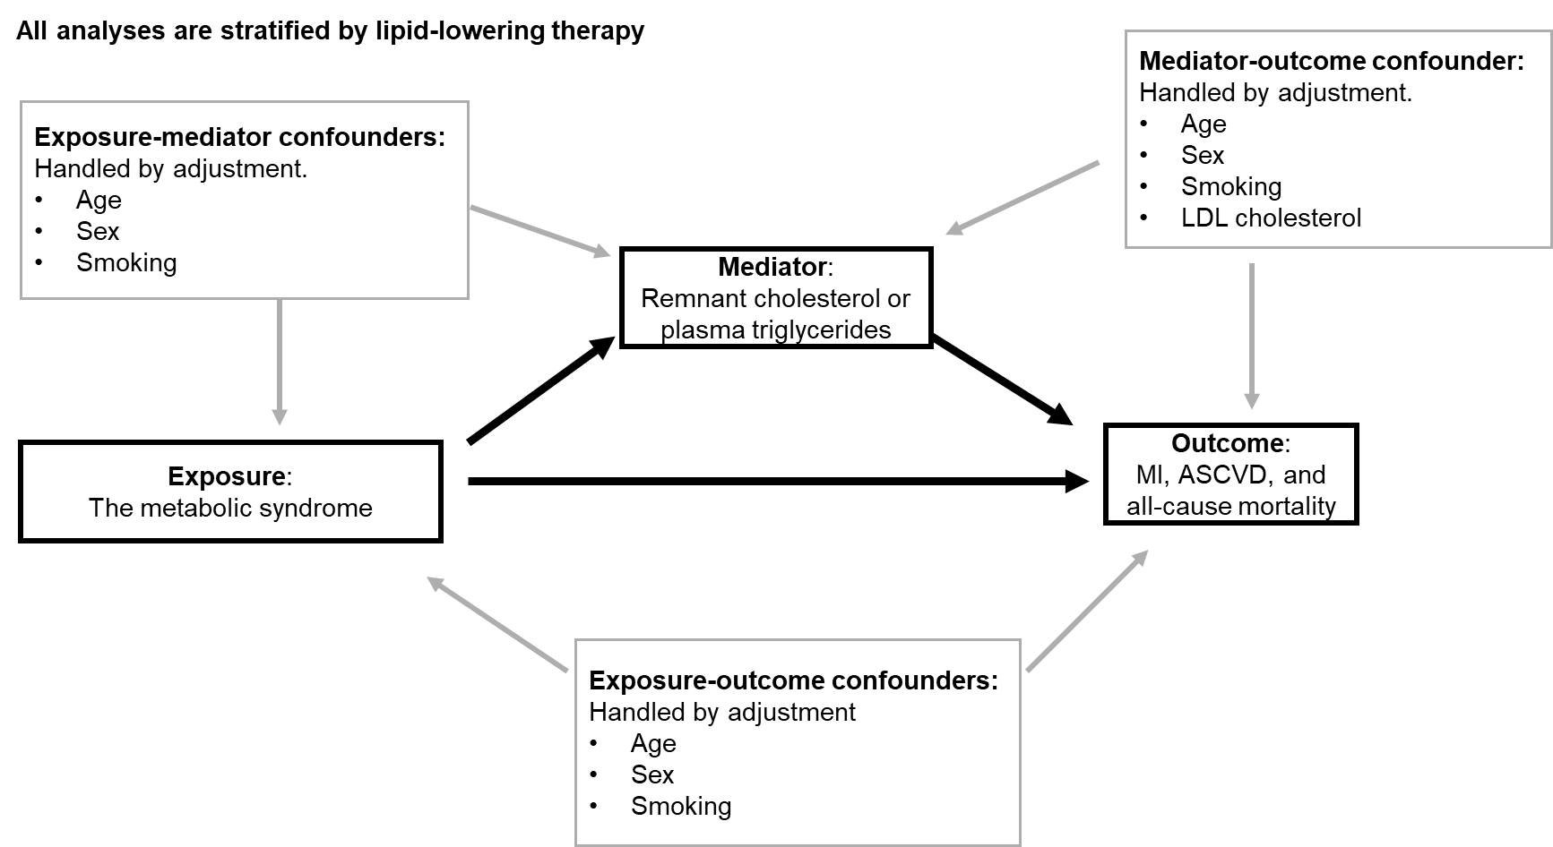

Supplemental Figure 3. Directed Acyclic Graph for mediated pathway from the metabolic syndrome through remnant cholesterol and triglycerides to outcomes.

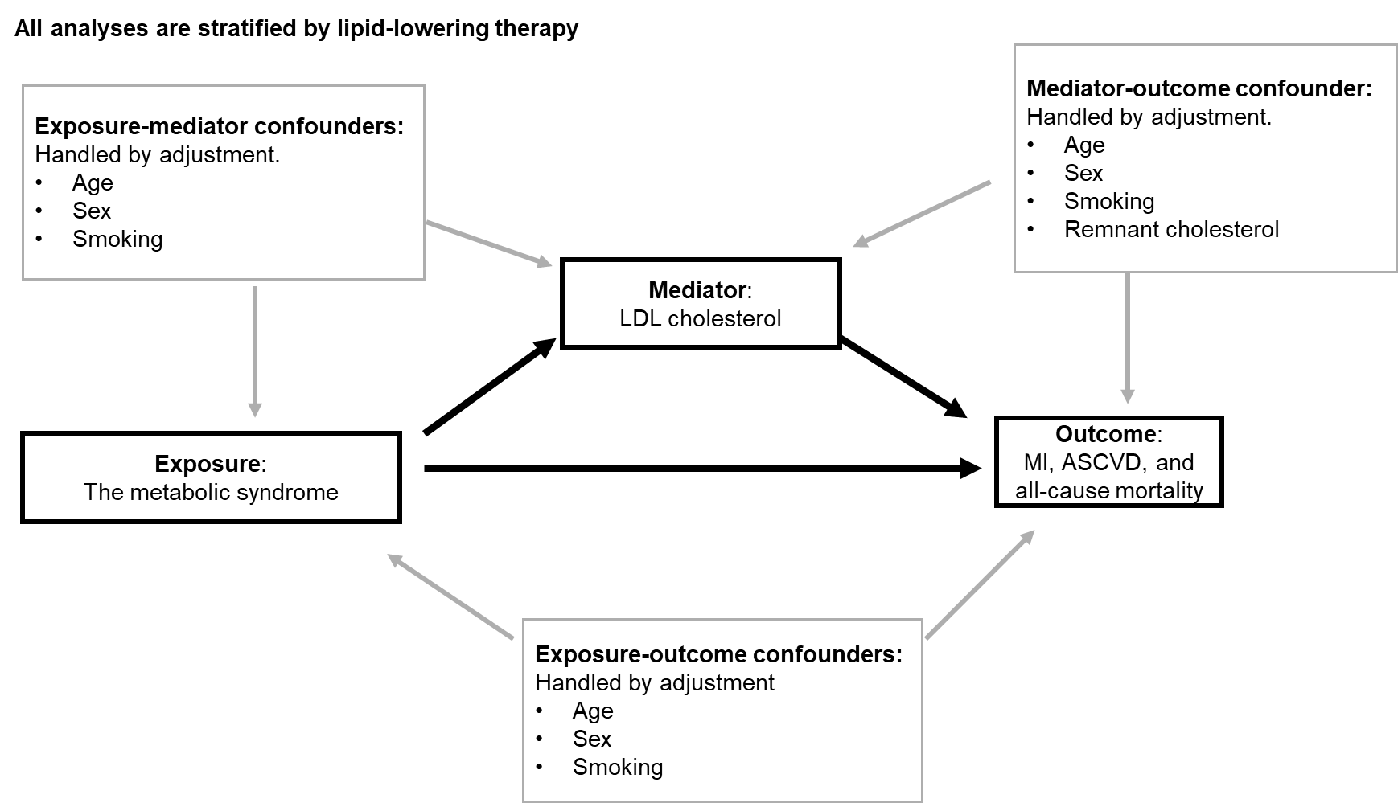

Supplemental Figure 4. Directed Acyclic Graph for mediated pathway from the metabolic syndrome through LDL cholesterol to outcomes.

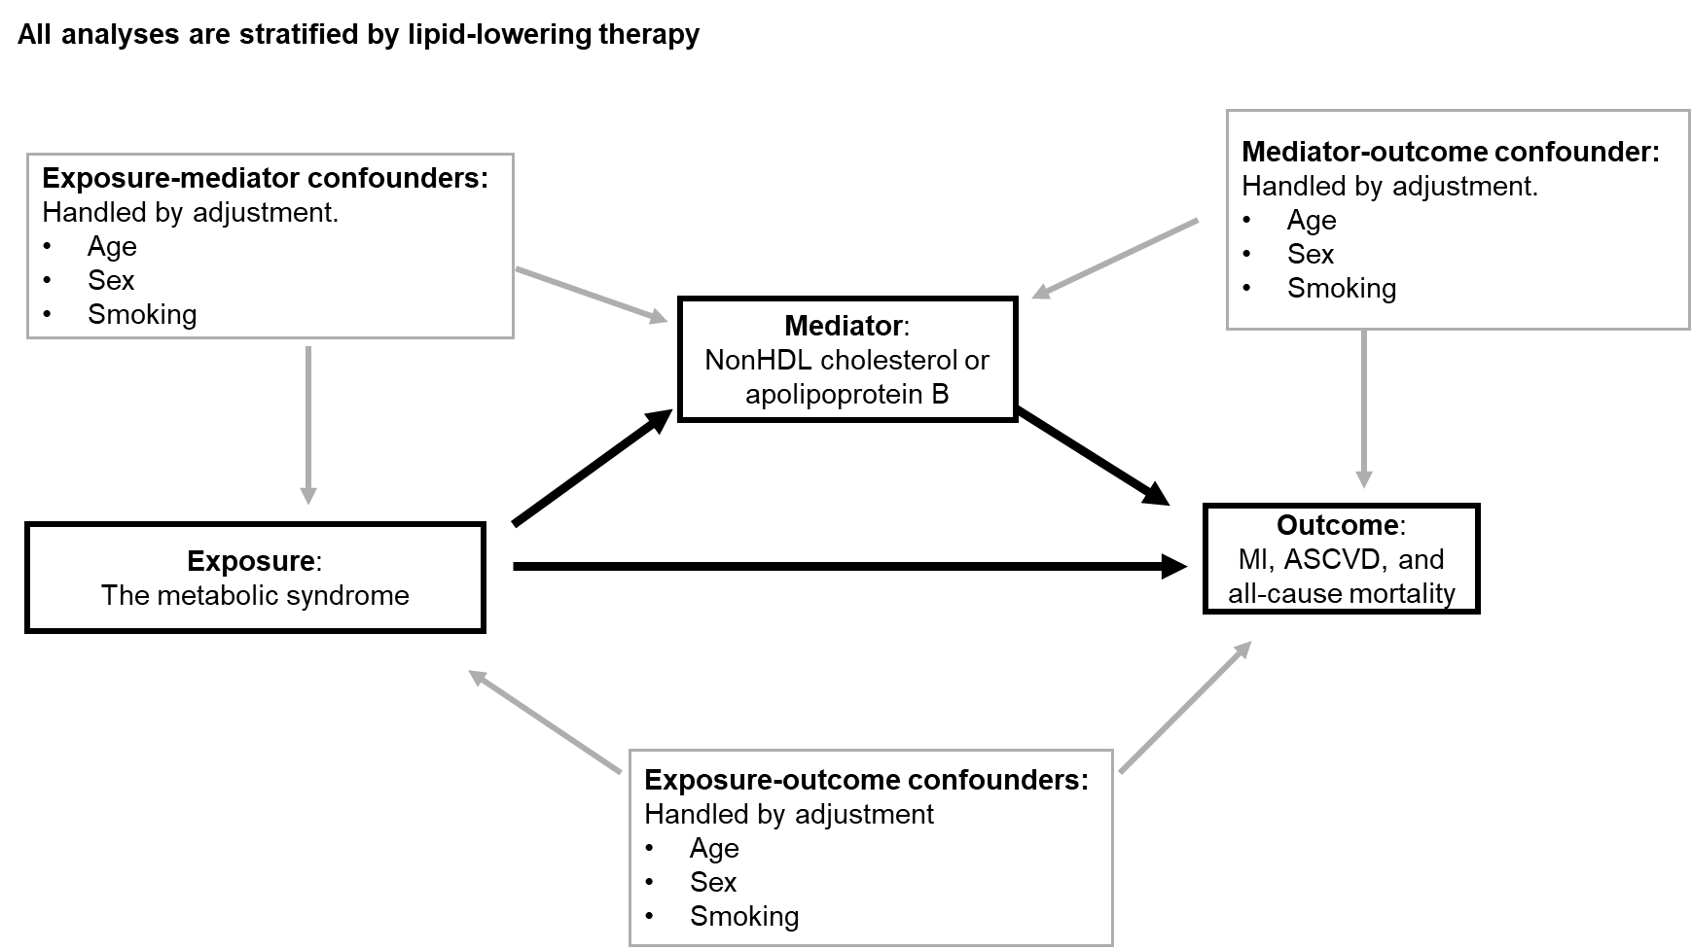
Supplemental Figure 5. Directed Acyclic Graph for mediated pathway from the metabolic syndrome through non-HDL cholesterol or apolipoprotein B to outcomes.

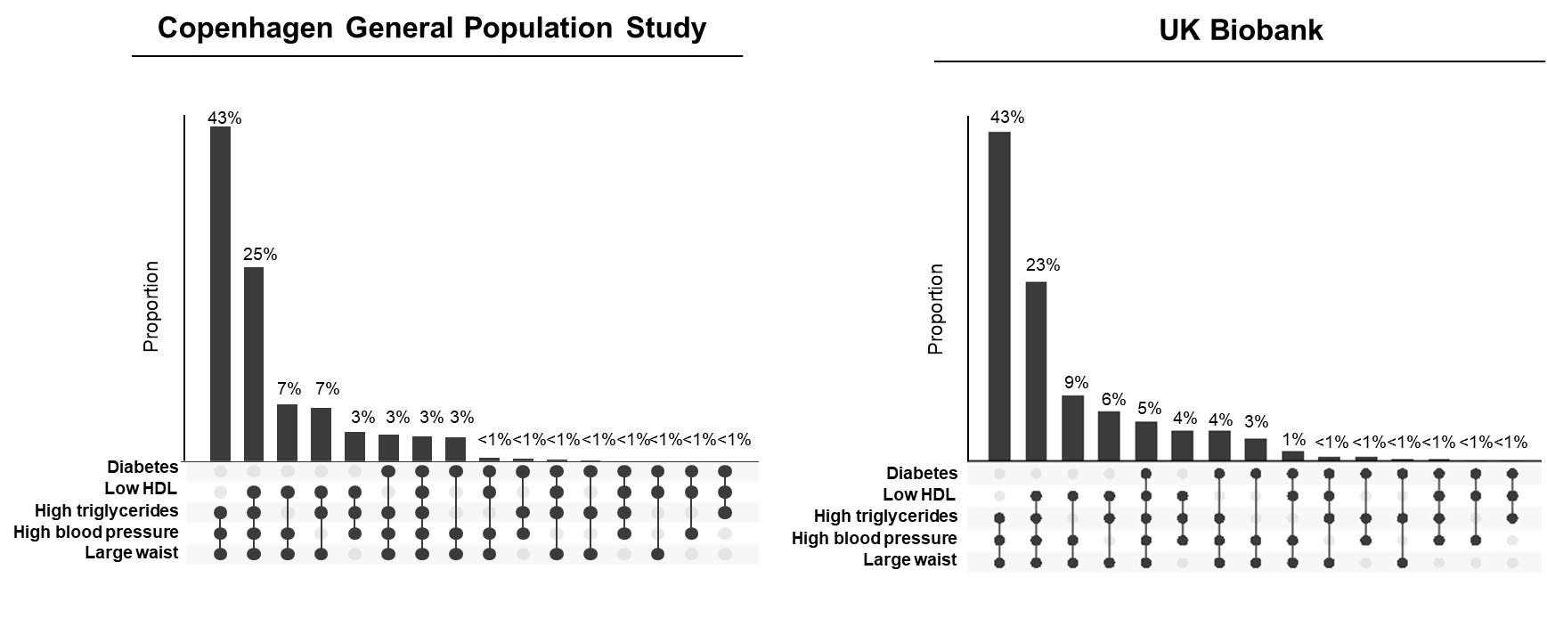
Supplemental Figure 6. Distribution of criteria in those fulfilling the definition of the metabolic syndrome. HDL=high-density lipoproteins.
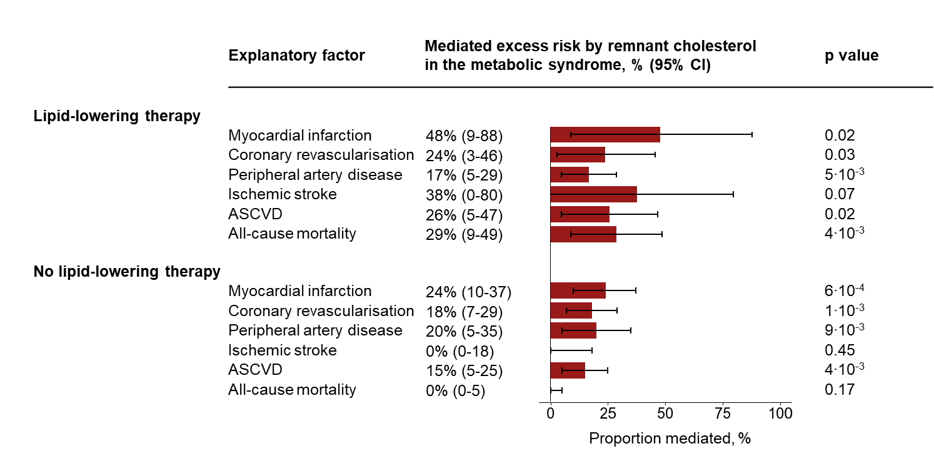
Supplemental Figure 7. Mediated excess risk of ASCVD and its subcomponents myocardial infarction, ischemic stroke, peripheral artery disease, coronary revascularisation, all-cause death by remnant cholesterol from the metabolic syndrome. In the Copenhagen General Population Study. Based on mediation analyses, stratified on baseline lipid-lowering therapy use, adjusted for age, sex, smoking status, and LDL cholesterol. The exposure was the metabolic syndrome. The mediating factor was remnant cholesterol. Outcomes were myocardial infarction, revascularization (defined as PCI or CABG), peripheral artery disease, ischemic stroke, ASCVD, and all-cause mortality. ASCVD=atherosclerotic cardiovascular disease. CABG = Coronary artery bypass graft. CI=confidence interval. PCI = Percutaneous coronary intervention.

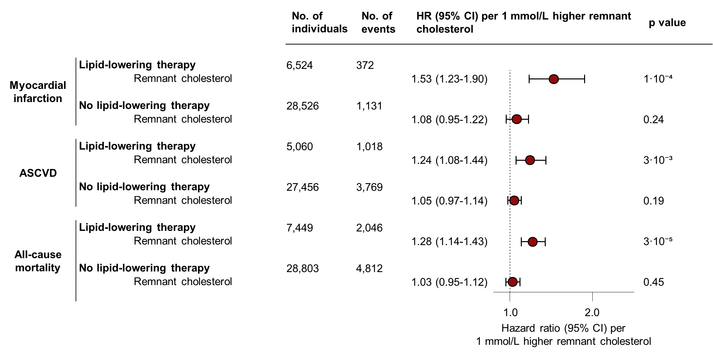
Supplemental Figure 8. Risk of cardiovascular disease and all-cause mortality in individuals with the metabolic syndrome from elevated remnant cholesterol with additional adjustment for total cholesterol. In the Copenhagen General Population Study. Based on Cox regressions in individuals with the metabolic syndrome stratified in baseline lipid-lowering therapy use, adjusted for age, sex, birthyear, smoking status, and total cholesterol. ASCVD=atherosclerotic cardiovascular disease. CI=confidence interval. LDL=low-density lipoproteins.

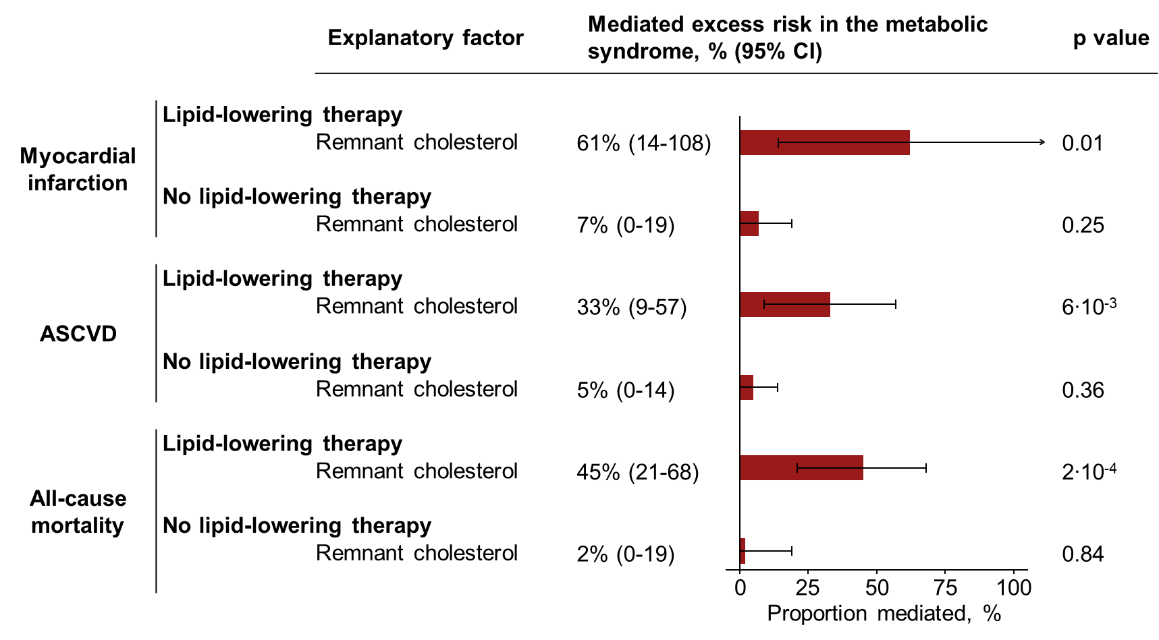
Supplemental Figure 9. Mediated excess cardiovascular and all-cause mortality risk from the metabolic syndrome by remnant cholesterol with additional adjustment total cholesterol. In the Copenhagen General Population Study. Based on mediation analyses, adjusted for age, sex, smoking status, and total cholesterol. The exposure was the metabolic syndrome. The mediating factor was remnant cholesterol. ASCVD=atherosclerotic cardiovascular disease. CI=confidence interval.

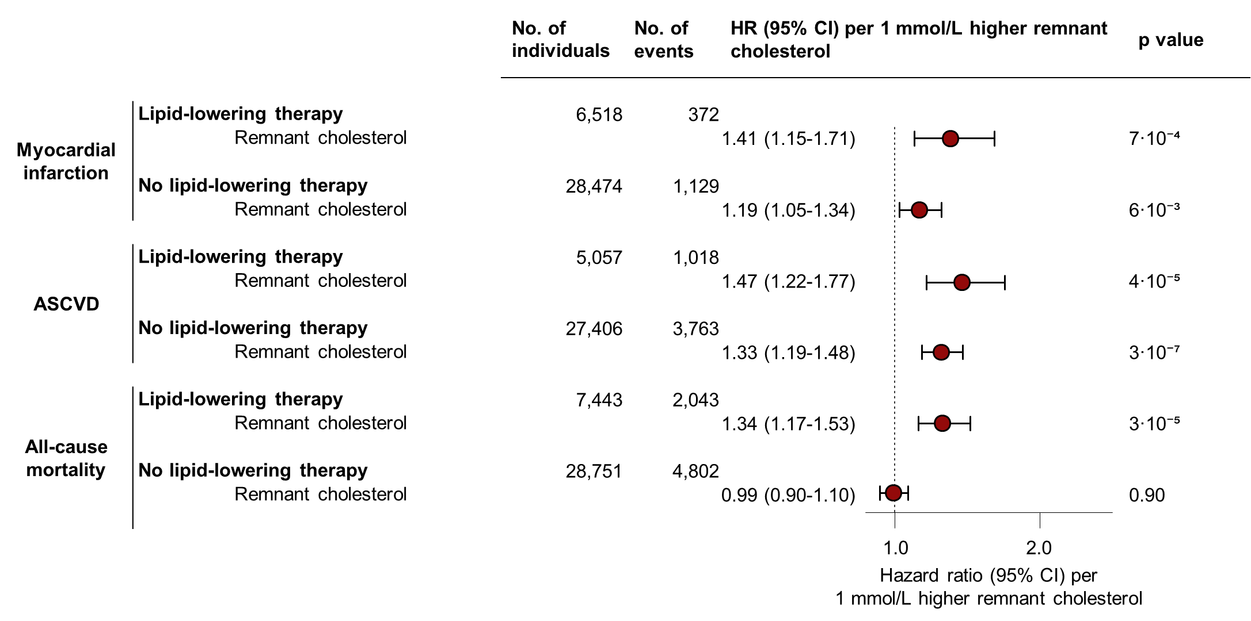
Supplemental Figure 10. Risk of cardiovascular disease and all-cause mortality in the metabolic syndrome from elevated remnant cholesterol. With additional adjustment for systolic blood pressure, body mass index, diabetes, education, and exercise. In the Copenhagen General Population Study. Based on Cox regressions in individuals with the metabolic syndrome, adjusted for age, sex, birthyear, smoking status, LDL cholesterol, systolic blood pressure, body mass index, diabetes, education, and exercise. ASCVD=atherosclerotic cardiovascular disease. ApoB = Apolipoprotein B. CI=confidence interval. LDL=low-density lipoproteins

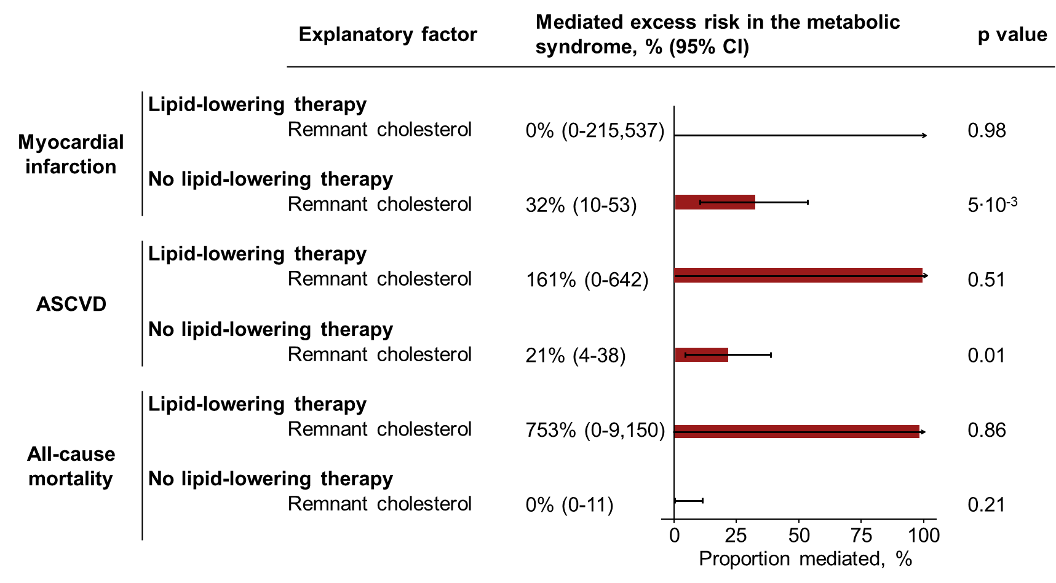Supplemental Figure 11. Mediated excess cardiovascular and all-cause mortality risk from the metabolic syndrome by remnant cholesterol. With additional adjustment for systolic blood pressure, body mass index, diabetes, education, and exercise. In In the Copenhagen General Population Study. Based on mediation analyses adjusted for age, sex, birthyear, smoking status, LDL cholesterol, systolic blood pressure, body mass index, diabetes, education, and exercise. The exposure was the metabolic syndrome. The mediating factor was remnant cholesterol. ASCVD=atherosclerotic cardiovascular disease. CI=confidence interval.

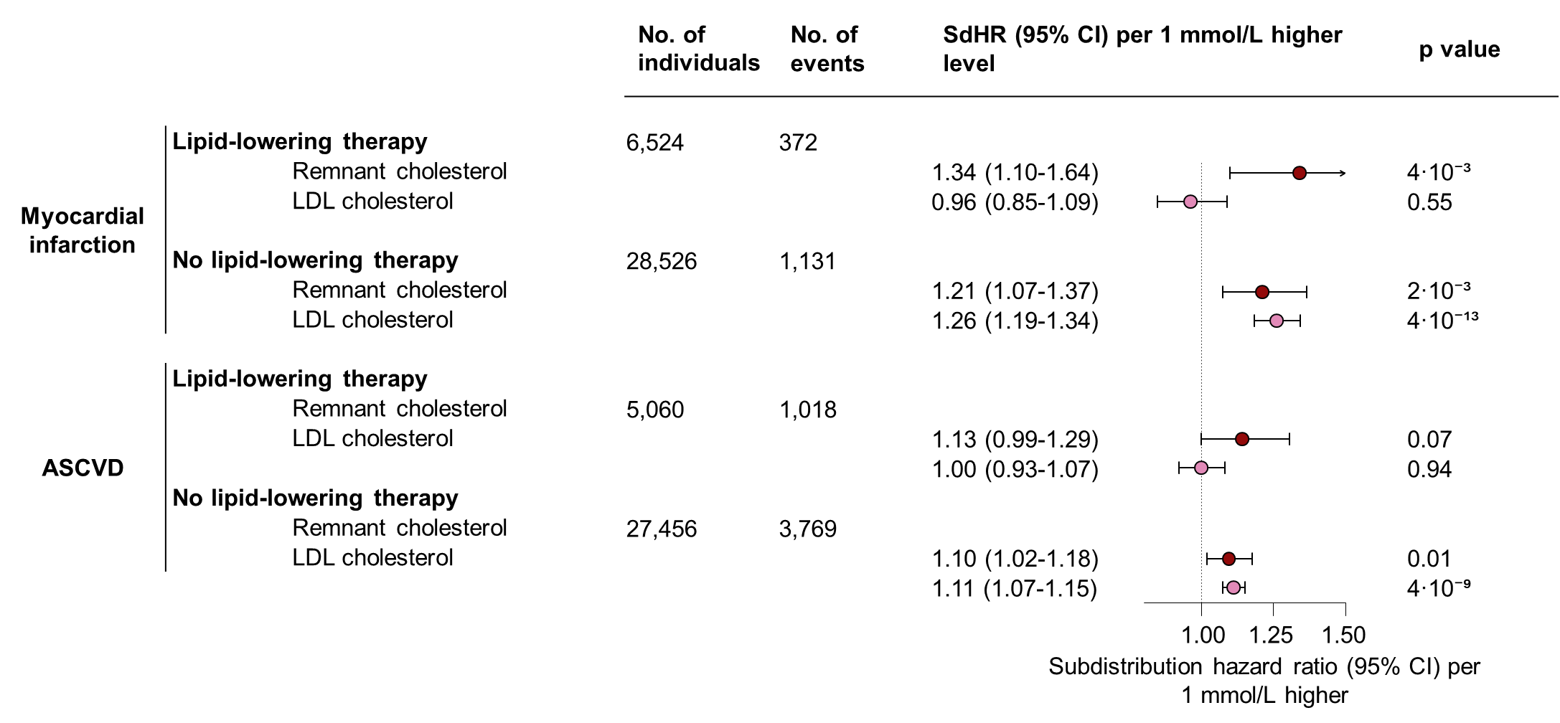
Supplemental Figure 12. Subdistribution hazard ratios from a Fine and Gray analysis for cardiovascular disease and all-cause mortality in individuals with the metabolic syndrome considering the competing risk of non-cardiovascular death. Based on Fine and Gray analyses in individuals with the metabolic syndrome, stratified on baseline lipid-lowering therapy use, and adjusted for age, sex, birthyear, smoking status, and LDL cholesterol. If the exposure was LDL cholesterol, adjustment was made for remnant cholesterol instead. In the Copenhagen General Population Study. ASCVD=atherosclerotic cardiovascular disease. CI=confidence interval. LDL=low-density lipoproteins. SdHR = Subdistribution hazard ratio.
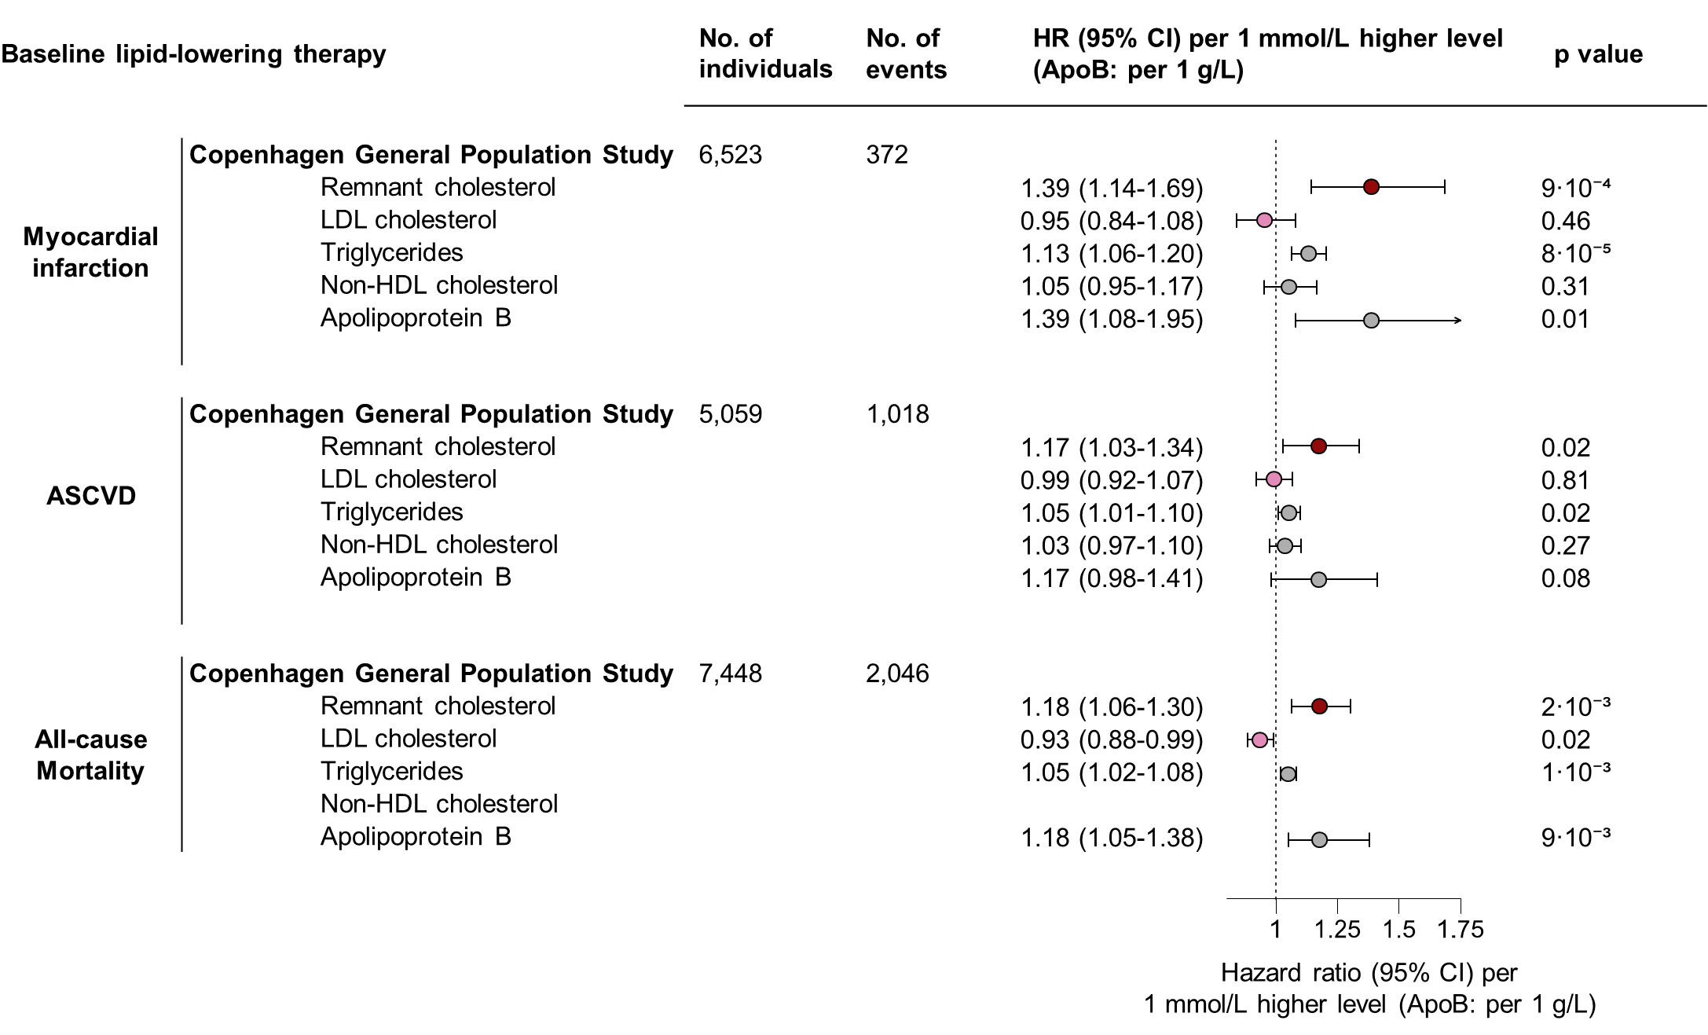
Supplemental Figure 13. Risk of cardiovascular disease and all-cause mortality in the metabolic syndrome from elevated remnant cholesterol in individuals with baseline lipid-lowering therapy use. Without imputation. In the Copenhagen General Population Study. Based on Cox regressions in individuals with the metabolic syndrome, adjusted for age, sex, birthyear, smoking status, and LDL cholesterol. If the exposure was LDL cholesterol, adjustment was done for remnant cholesterol instead. If the exposure was non-HDL cholesterol or apolipoprotein B, no adjustment was done for additional lipid parameters. ASCVD=atherosclerotic cardiovascular disease. ApoB = Apolipoprotein B. CI=confidence interval. HR= hazard ratio. LDL=low-density lipoproteins. No.=number. Non-HDL= non-high-density lipoprotein.

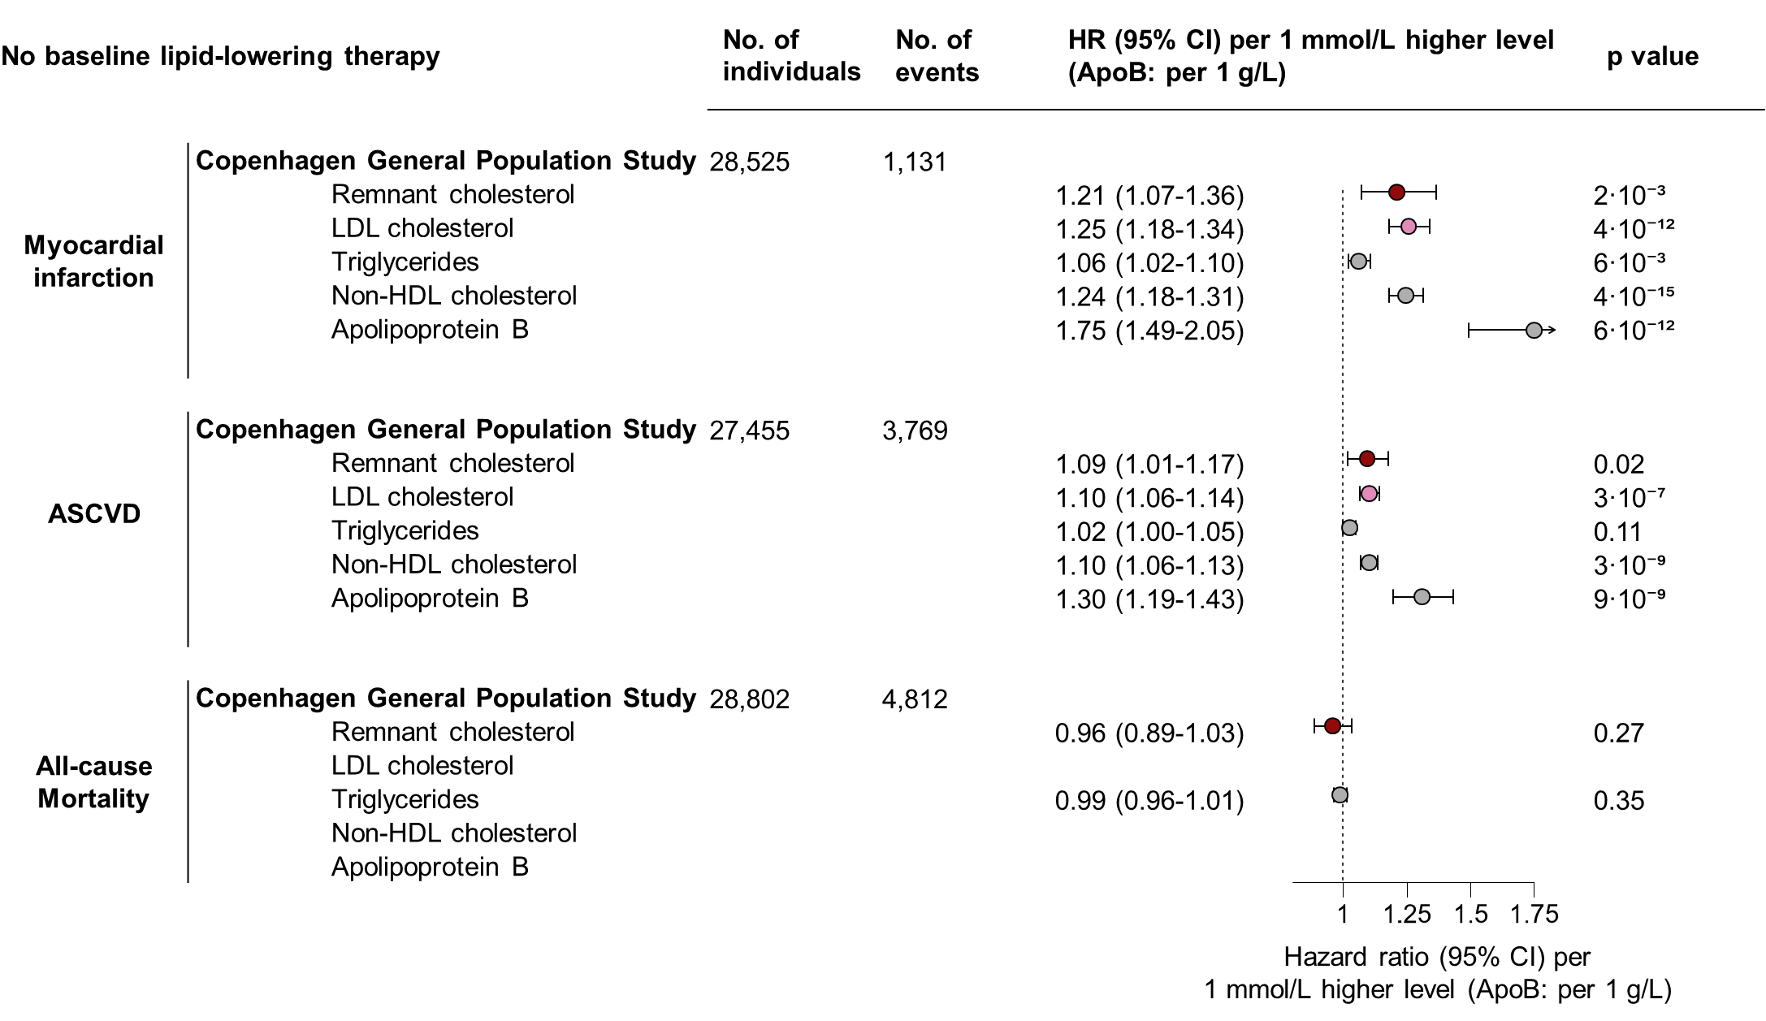
Supplemental Figure 14. Risk of cardiovascular disease and all-cause mortality in the metabolic syndrome from elevated remnant cholesterol in individuals without baseline lipid-lowering therapy use. Without imputation. In the Copenhagen General Population Study. Based on Cox regressions in individuals with the metabolic syndrome, adjusted for age, sex, birthyear, smoking status, and LDL cholesterol. If the exposure was LDL cholesterol, adjustment was done for remnant cholesterol instead. If the exposure was non-HDL cholesterol or apolipoprotein B, no adjustment was done for additional lipid parameters. ASCVD=atherosclerotic cardiovascular disease. ApoB = Apolipoprotein B. CI=confidence interval. HR= hazard ratio. LDL=low-density lipoproteins. No.=number. Non-HDL= non-high-density lipoprotein.

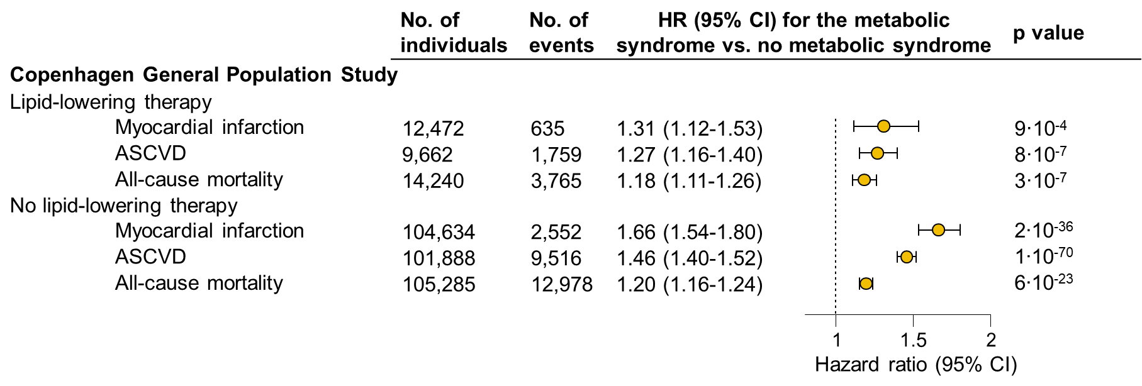
Supplemental Figure 15. Risk of cardiovascular disease and all-cause mortality in individuals with versus without the metabolic syndrome. Without imputation. In the Copenhagen General Population Study. Based on Cox models adjusted for age, sex, birthyear, and smoking status. Exposure was having the metabolic syndrome versus not having the metabolic syndrome. ASCVD = Atherosclerotic cardiovascular disease. CI = Confidence interval. HR = hazard ratio. LDL = Low-density lipoprotein. No. = number.

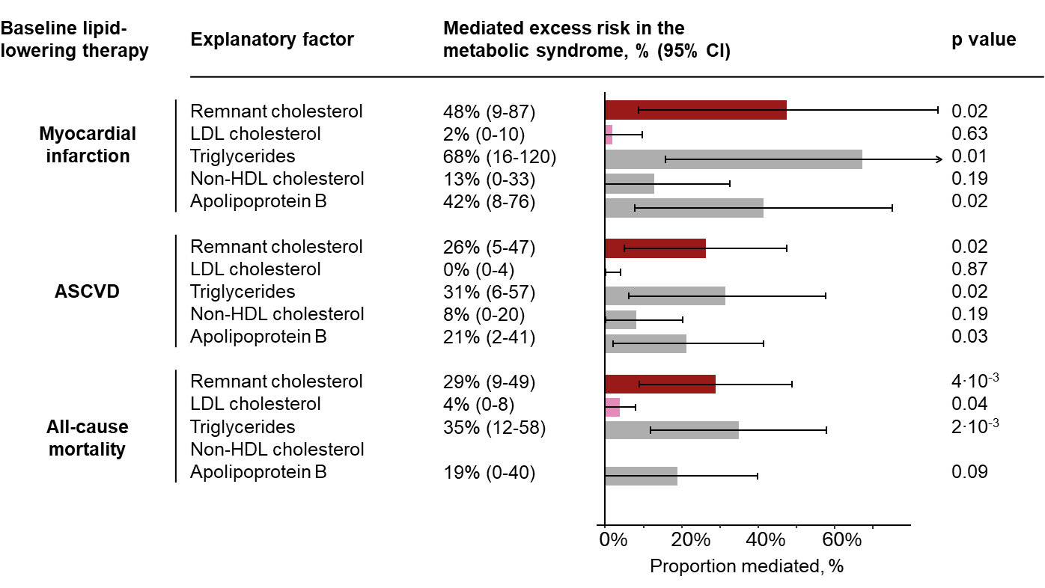
Supplemental figure 16. Mediated excess cardiovascular and all-cause mortality risk from elevated remnant cholesterol in the metabolic syndrome in individuals with baseline lipid-lowering therapy use. Without imputation. In the Copenhagen General Population Study. Based on mediation analyses, adjusted for age, sex, smoking status, and LDL cholesterol. If the explanatory factor was LDL cholesterol, adjustment was done for remnant cholesterol instead. If the explanatory factor was non-HDL cholesterol or apolipoprotein B, no adjustment was done for additional lipid parameters. The exposure was the metabolic syndrome. The mediating factors were remnant cholesterol, LDL cholesterol, triglycerides, non-HDL cholesterol, or apolipoprotein B. ASCVD=Atherosclerotic cardiovascular disease. CI=confidence interval. LDL=low-density lipoproteins. Non-HDL = Non-high-density lipoprotein.

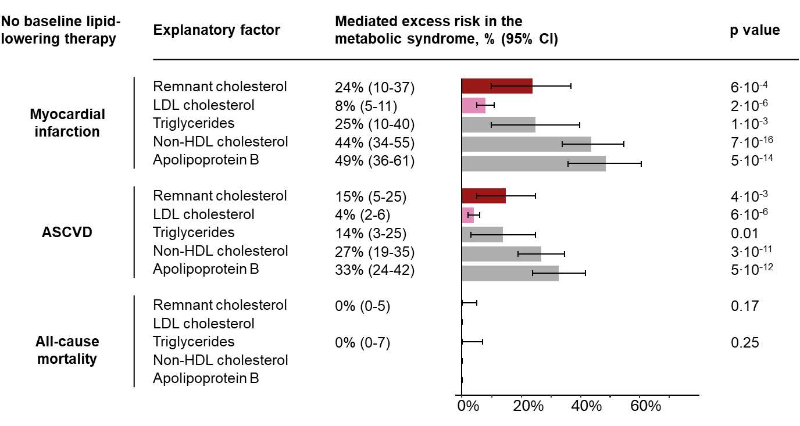
Supplemental figure 17. Mediated excess cardiovascular and all-cause mortality risk from elevated remnant cholesterol in the metabolic syndrome in individuals without baseline lipid-lowering therapy use. Without imputation. In the Copenhagen General Population Study. Based on mediation analyses, adjusted for age, sex, smoking status, and LDL cholesterol. If the explanatory factor was LDL cholesterol, adjustment was done for remnant cholesterol instead. If the explanatory factor was non-HDL cholesterol or apolipoprotein B, no adjustment was done for additional lipid parameters. The exposure was the metabolic syndrome. The mediating factors were remnant cholesterol, LDL cholesterol, triglycerides, non-HDL cholesterol, or apolipoprotein B. ASCVD=Atherosclerotic cardiovascular disease. CI=confidence interval. LDL=low-density lipoproteins. Non-HDL = Non-high-density lipoprotein.

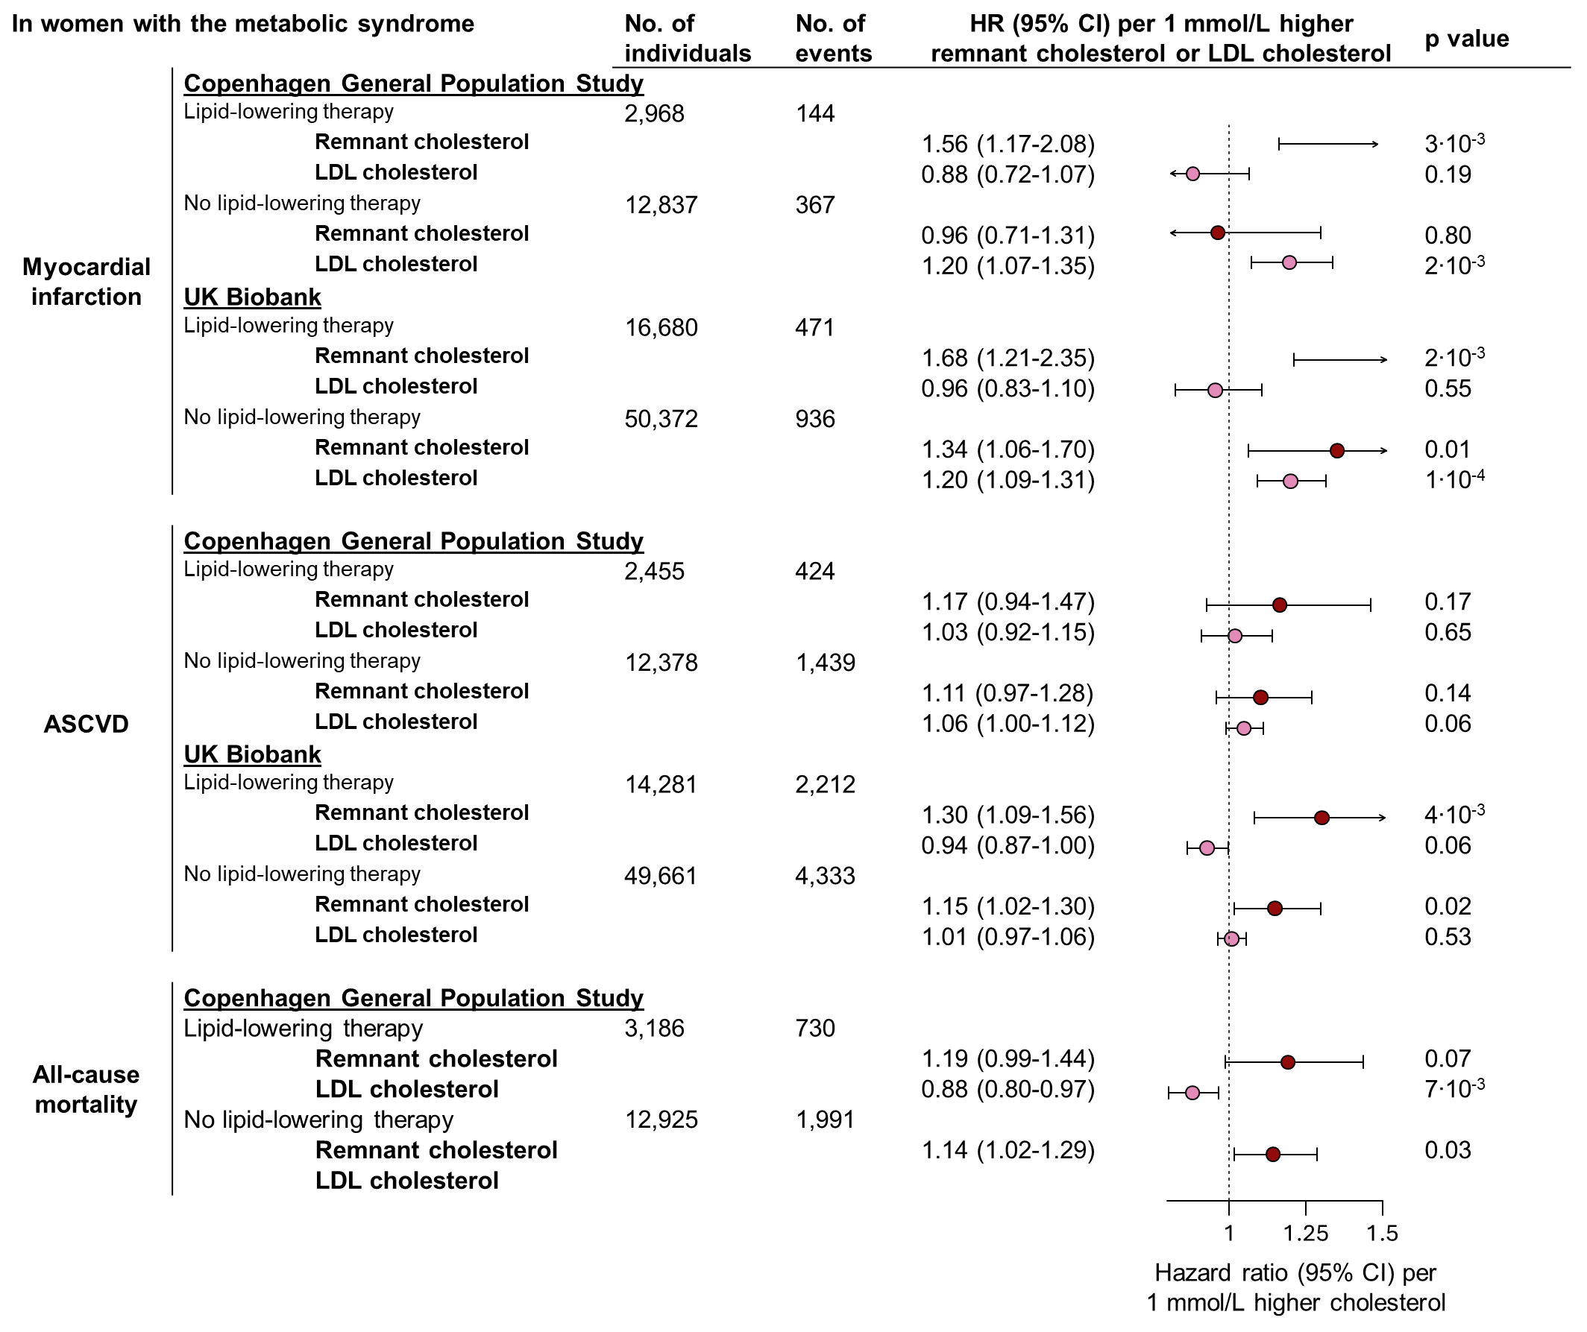
Supplemental Figure 18. Risk of cardiovascular disease and all-cause mortality in individuals with the metabolic syndrome from elevated remnant cholesterol and LDL cholesterol in women. Based on Cox regressions, adjusted for age, birthyear, smoking status, and LDL cholesterol. If the exposure was LDL cholesterol, adjustment was done for remnant cholesterol instead. ASCVD=atherosclerotic cardiovascular disease. CI=confidence interval. LDL=low-density lipoproteins
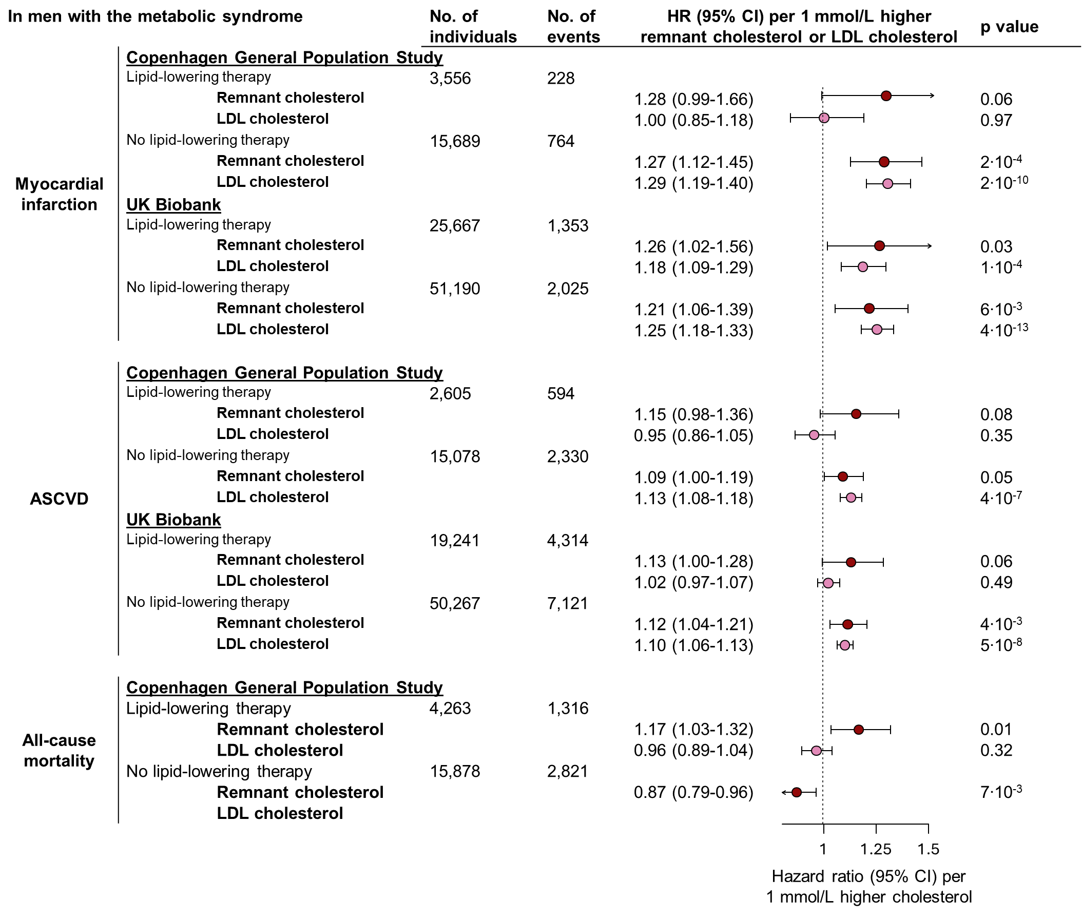
Supplemental Figure 19. Risk of cardiovascular disease and all-cause mortality in individuals with the metabolic syndrome from elevated remnant cholesterol and LDL cholesterol in men. Based on Cox regressions, adjusted for age, birthyear, smoking status, and LDL cholesterol. If the exposure was LDL cholesterol, adjustment was done for remnant cholesterol instead. ASCVD=atherosclerotic cardiovascular disease. CI=confidence interval. LDL=low-density lipoproteins
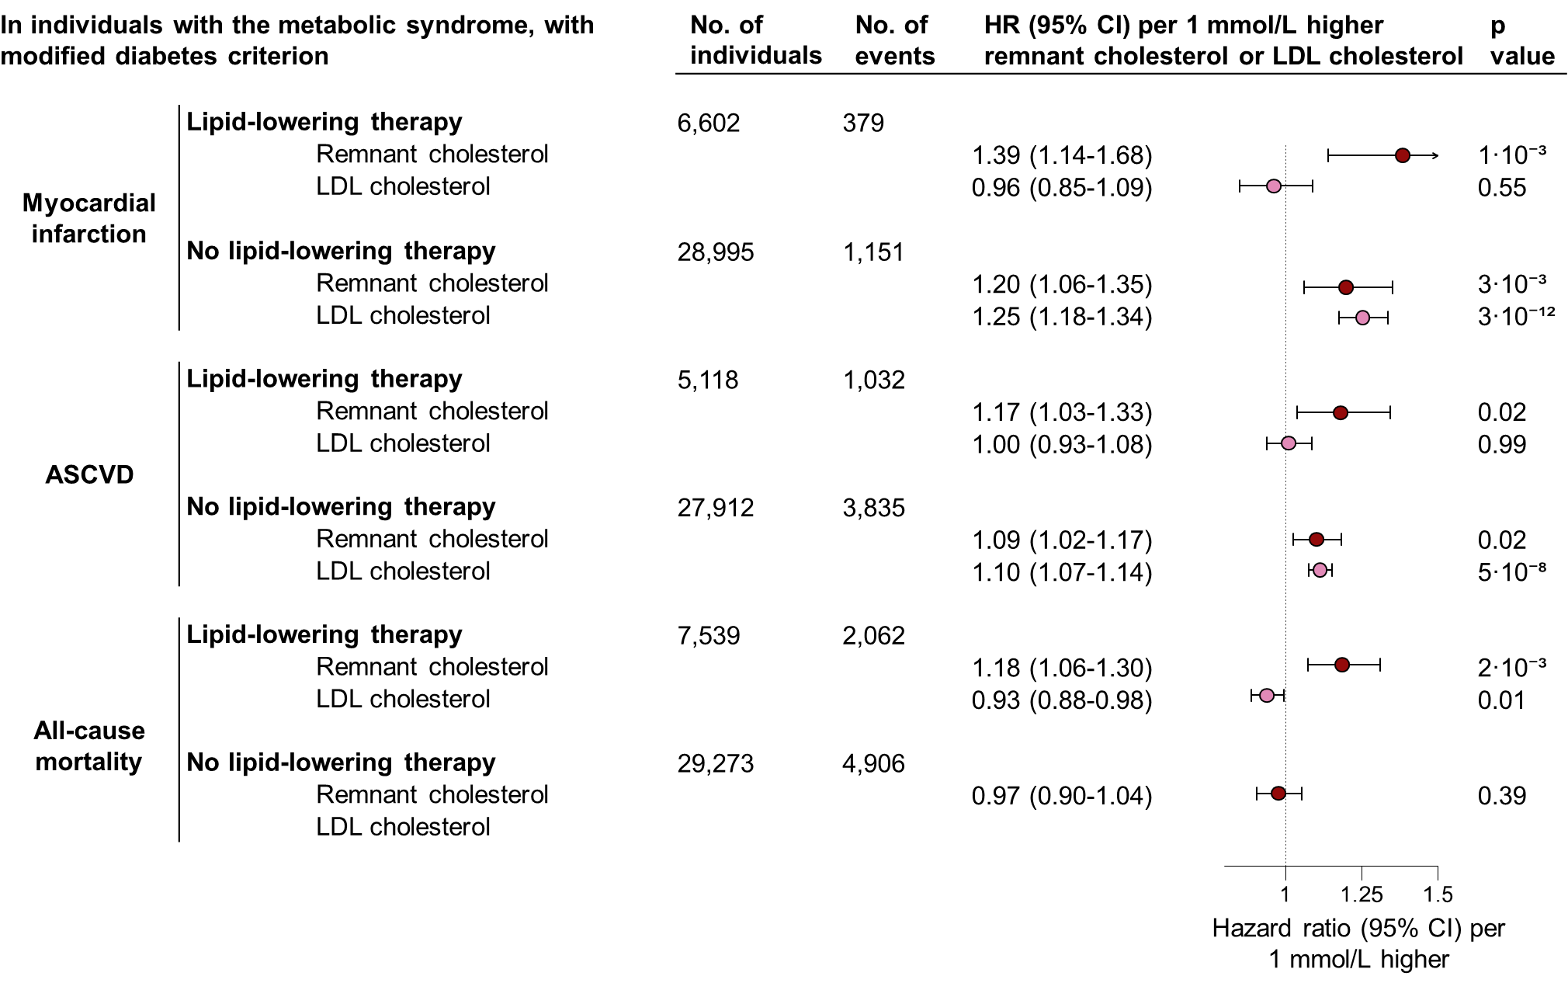
Supplemental Figure 20. Risk of cardiovascular disease and all-cause mortality in individuals with the metabolic syndrome from elevated remnant cholesterol. The metabolic syndrome defined with a diabetes criterion including both diabetes and elevated non-fasting plasma glucose. In the Copenhagen General Population Study. Based on Cox regression models in individuals with the metabolic syndrome, adjusted for age, sex, birthyear, smoking status, and LDL cholesterol. If the exposure was LDL cholesterol, adjustment was done for remnant cholesterol instead. ASCVD = Atherosclerotic cardiovascular disease. CI = Confidence interval. LDL = Low-density lipoprotein.
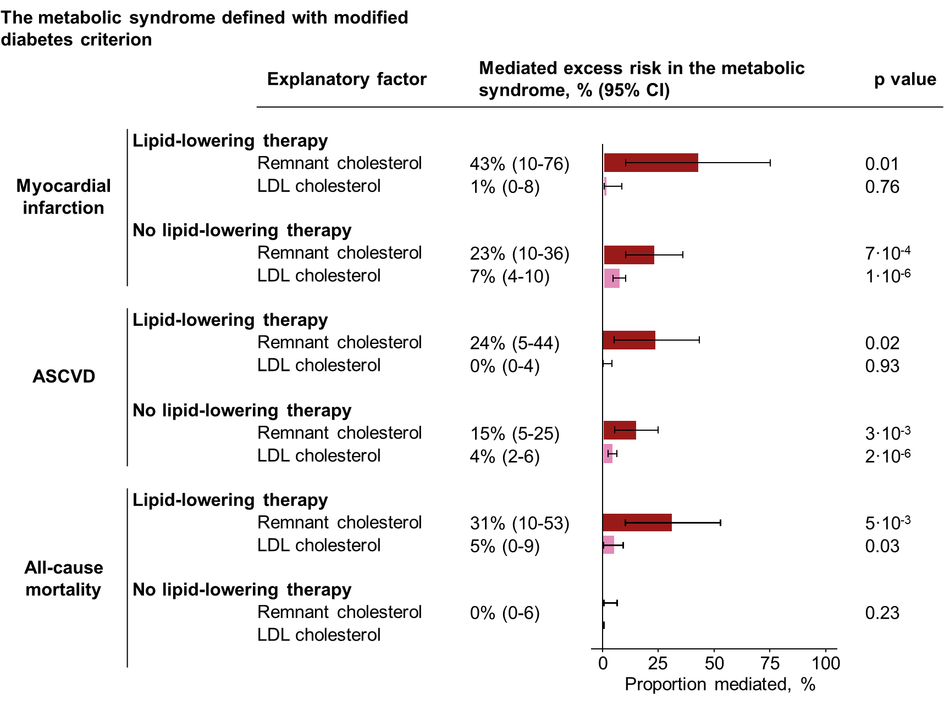
Supplemental figure 21. Mediated excess cardiovascular and all-cause mortality risk from elevated remnant cholesterol in the metabolic syndrome. The metabolic syndrome defined with a diabetes criterion including both diabetes and elevated non-fasting plasma glucose. In the Copenhagen General Population Study. Based on mediation analyses, adjusted for age, sex, smoking status, and LDL cholesterol. If the explanatory factor was LDL cholesterol, adjustment was done for remnant cholesterol instead. The exposure was the metabolic syndrome. The mediating factors were remnant cholesterol or LDL cholesterol. ASCVD=Atherosclerotic cardiovascular disease. CI=confidence interval. LDL=low-density lipoproteins

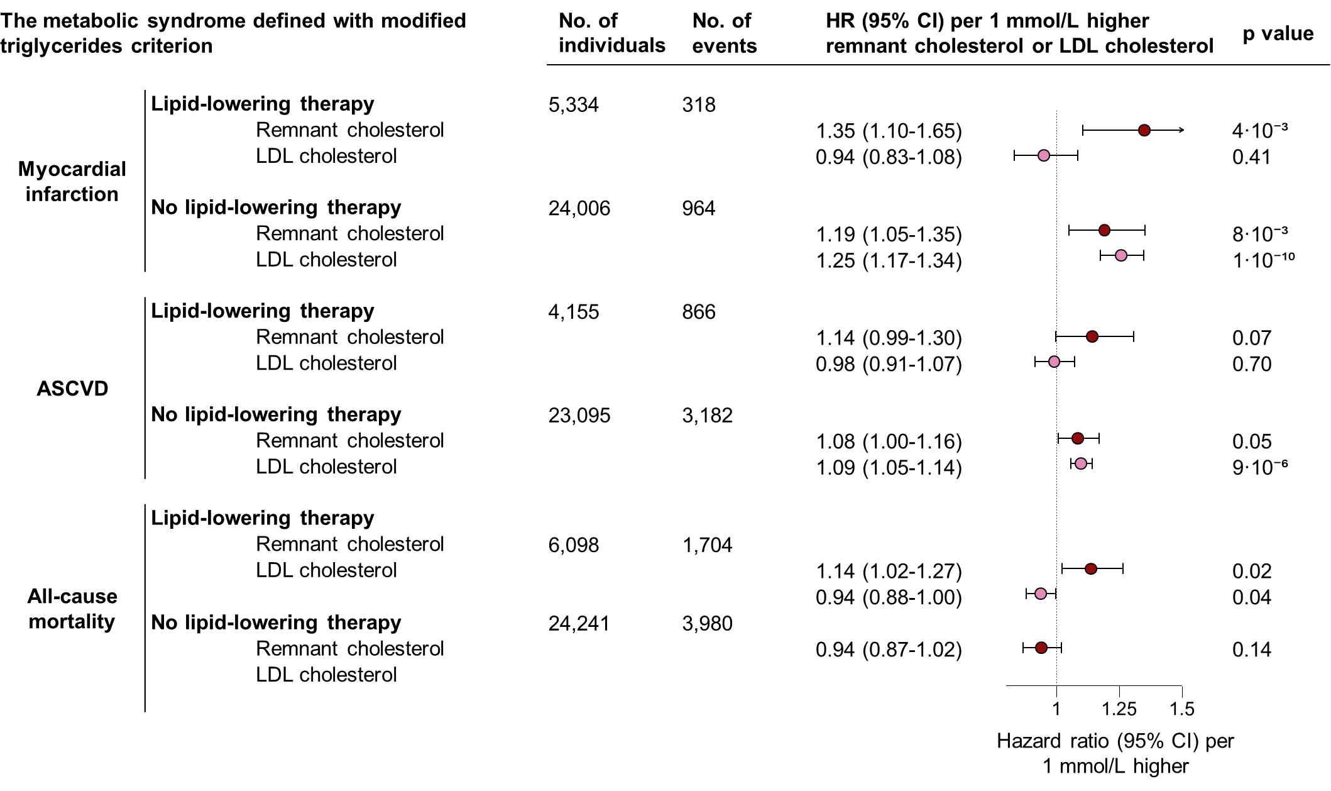Supplemental Figure 22. Risk of cardiovascular disease and all-cause mortality in individuals with the metabolic syndrome from elevated remnant cholesterol. The metabolic syndrome defined with a modified triglycerides criterion of 2.0 mmol/L (177 mg/dL). In the Copenhagen General Population Study. Based on Cox regression models in individuals with the metabolic syndrome, adjusted for age, sex, birthyear, smoking status, and LDL cholesterol. If the exposure was LDL cholesterol, adjustment was done for remnant cholesterol instead. ASCVD = Atherosclerotic cardiovascular disease. CI = Confidence interval. LDL = Low-density lipoprotein.
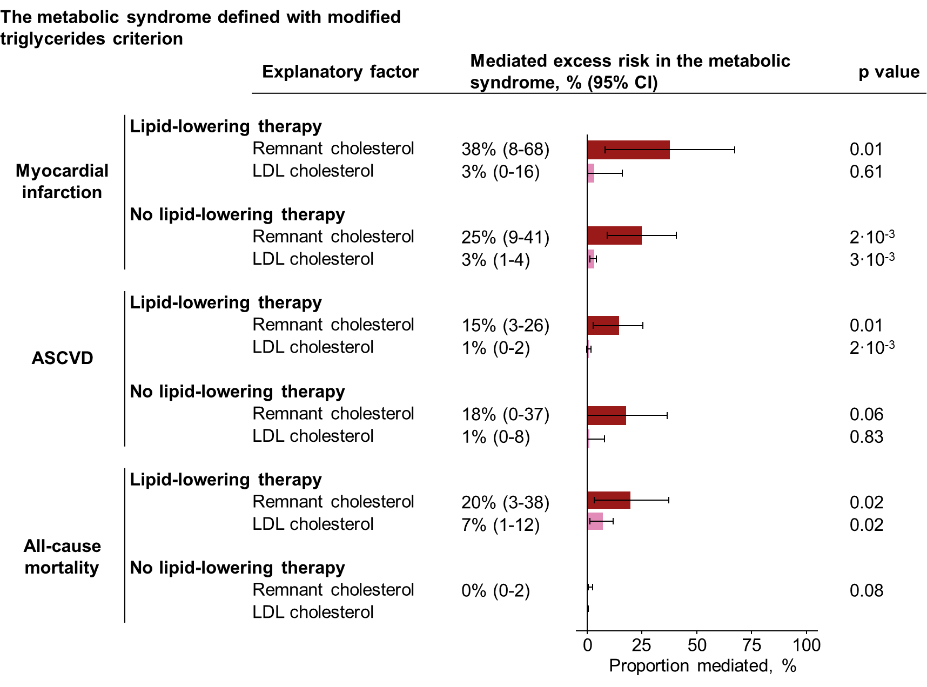
Supplemental figure 23. Mediated excess cardiovascular and all-cause mortality risk from elevated remnant cholesterol in the metabolic syndrome. The metabolic syndrome defined with a modified triglycerides criterion of 2.0 mmol/L (177 mg/dL). In the Copenhagen General Population Study. Based on mediation analyses, adjusted for age, sex, smoking status, and LDL cholesterol. If the explanatory factor was LDL cholesterol, adjustment was done for remnant cholesterol instead. The exposure was the metabolic syndrome. The mediating factors were remnant cholesterol or LDL cholesterol. ASCVD=Atherosclerotic cardiovascular disease. CI=confidence interval. LDL=low-density lipoproteins.
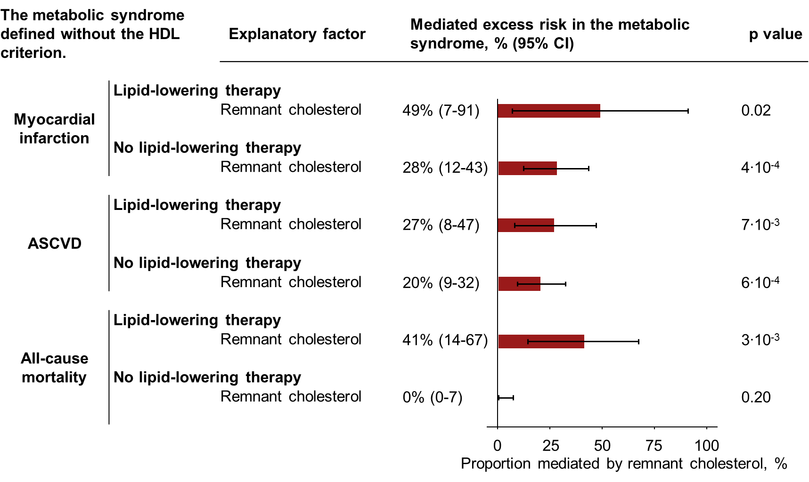
Supplemental figure 24. Mediated excess cardiovascular and all-cause mortality risk from elevated remnant cholesterol in the metabolic syndrome. The metabolic syndrome defined as three or more of the four remaining criteria when the HDL criterion is left out. In the Copenhagen General Population Study. Based on mediation analyses, adjusted for age, sex, smoking status, and LDL cholesterol. The exposure was the metabolic syndrome. The mediating factor was remnant cholesterol. CI=confidence interval. LDL=low-density lipoproteins.

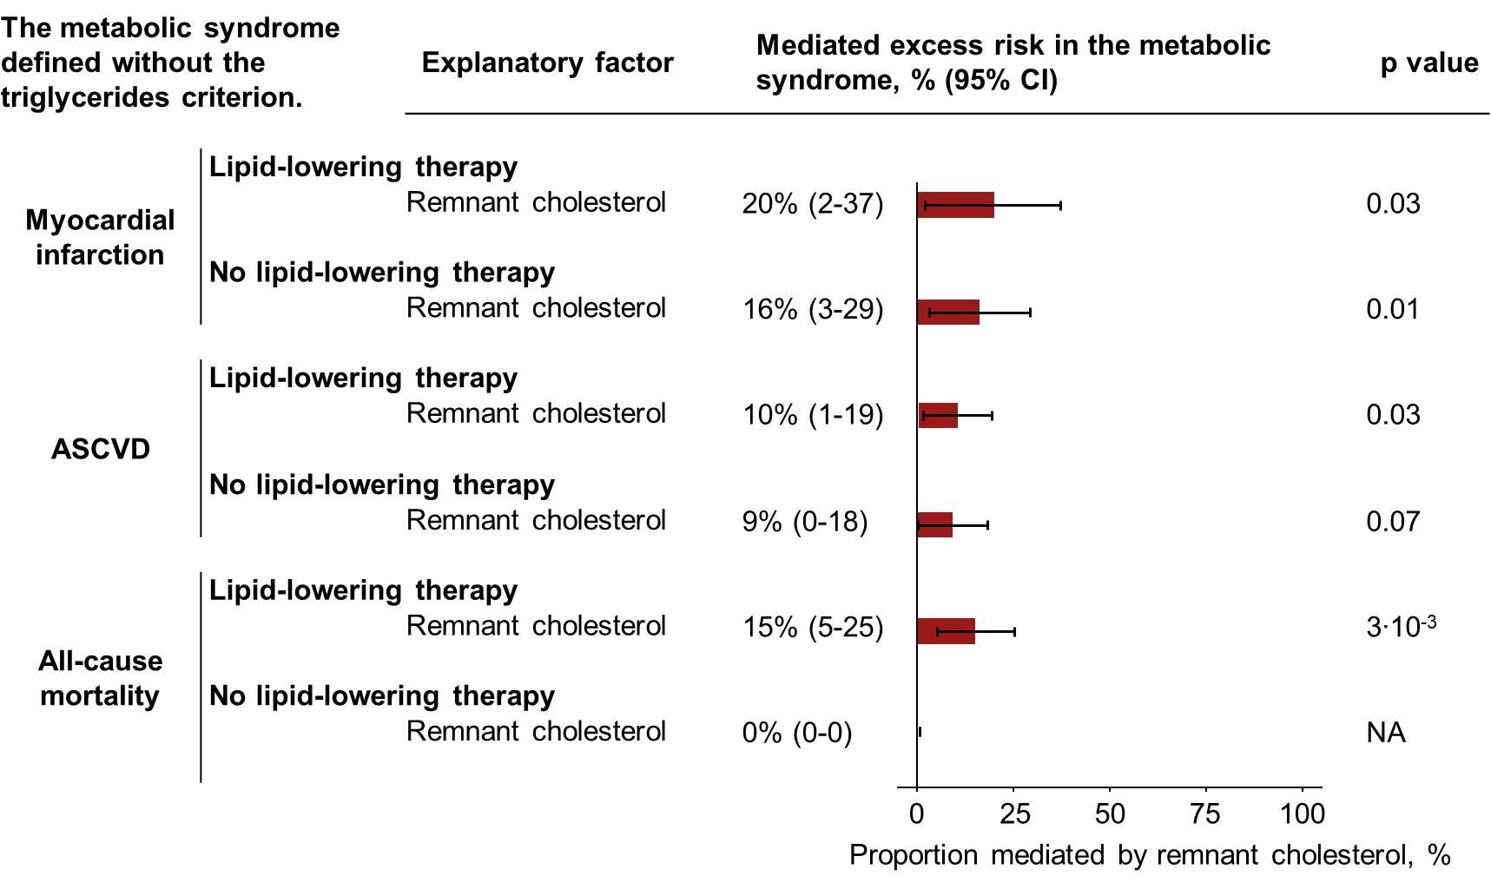

Supplemental figure 25. Mediated excess cardiovascular and all-cause mortality risk from elevated remnant cholesterol in the metabolic syndrome. The metabolic syndrome defined as three or more of the four remaining criteria when the triglycerides criterion is left out. In the Copenhagen General Population Study. Based on mediation analyses, adjusted for age, sex, smoking status, and LDL cholesterol. The exposure was the metabolic syndrome. The mediating factor was remnant cholesterol. CI=confidence interval. LDL=low-density lipoproteins.

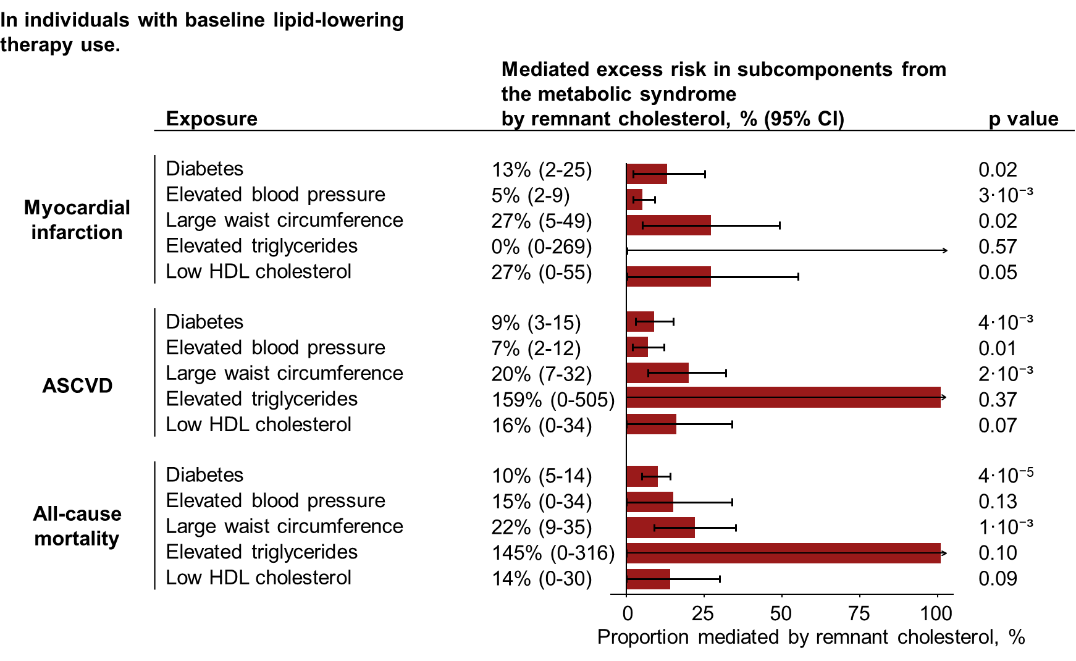
Supplemental figure 26. Mediated excess cardiovascular and all-cause mortality risk from subcomponents of the metabolic syndrome mediated by remnant cholesterol. In individuals with baseline lipid-lowering therapy. In the Copenhagen General Population Study. Based on mediation analyses, adjusted for age, sex, smoking status, and LDL cholesterol. Five different exposures were used in five different models. The exposures were the five criteria for the metabolic syndrome. The mediating factor was remnant cholesterol. ASCVD=Atherosclerotic cardiovascular disease. CI=confidence interval. HDL=high-density lipoprotein.
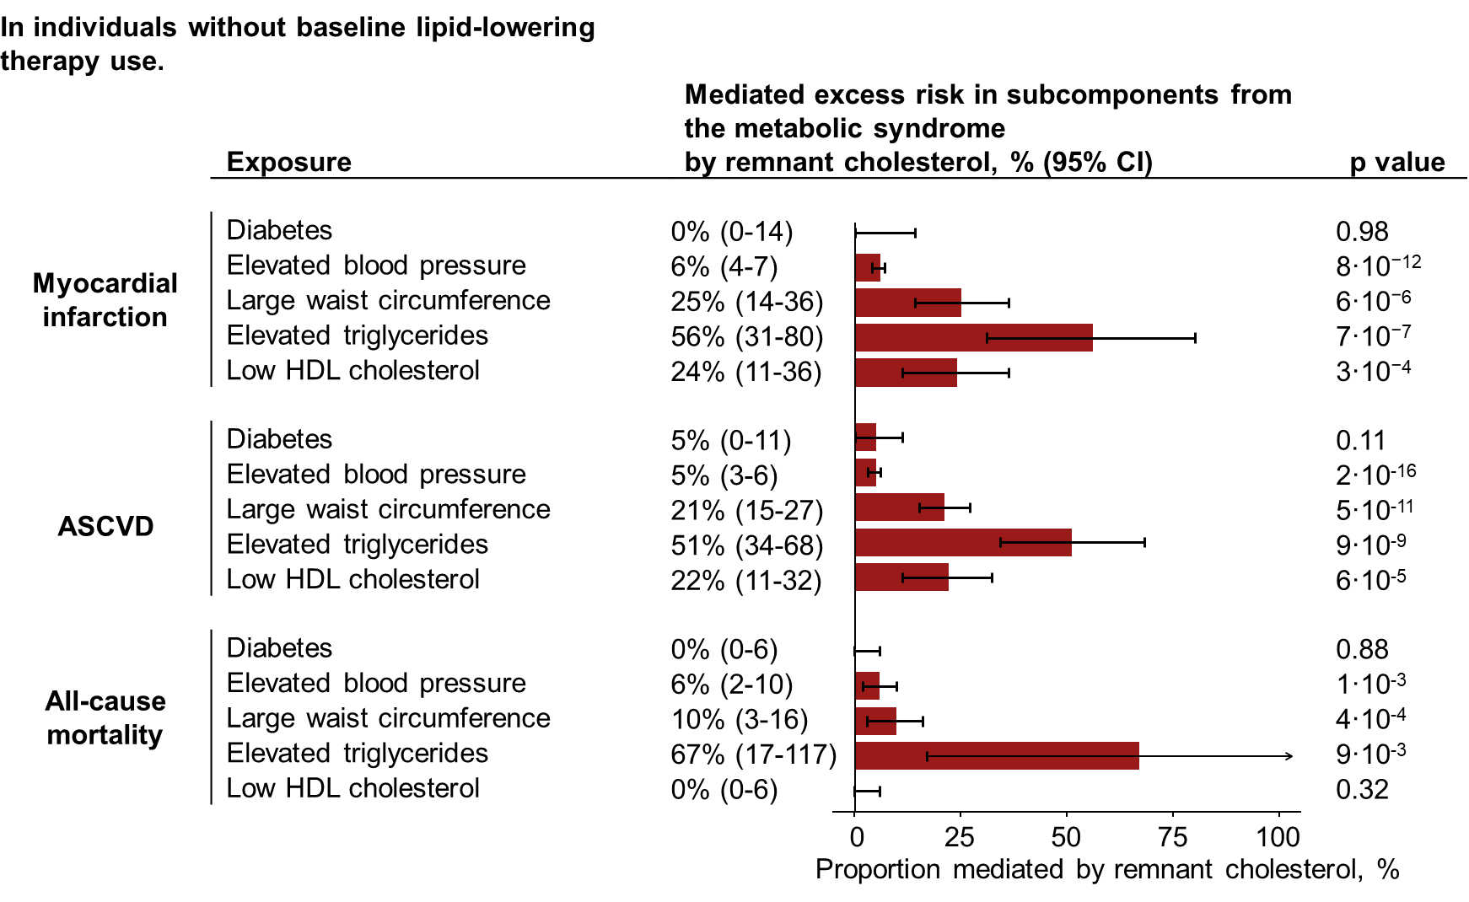
Supplemental figure 27. Mediated excess cardiovascular and all-cause mortality risk from subcomponents of the metabolic syndrome mediated by remnant cholesterol. In individuals without baseline lipid-lowering therapy. In the Copenhagen General Population Study. Based on mediation analyses, adjusted for age, sex, smoking status, and LDL cholesterol. Five different exposures were used in five different models. The exposures were the five criteria for the metabolic syndrome. The mediating factor was remnant cholesterol. ASCVD=Atherosclerotic cardiovascular disease. CI=confidence interval. HDL=high-density lipoprotein.
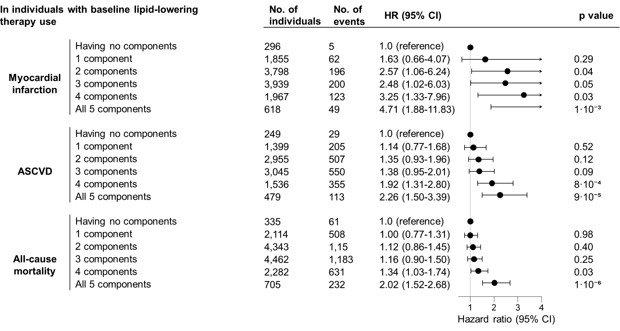
Supplemental Figure 28. Risk of cardiovascular disease and all-cause mortality by number of fulfilled metabolic syndrome criteria. In individuals with baseline lipid-lowering therapy. In the Copenhagen General Population Study. Based on Cox models adjusted for age, sex, birthyear, and smoking status. Exposure was having either 0, 1, 2, 3, 4, or 5 fulfilled metabolic syndrome criteria. Having 0 fulfilled criteria was the reference. ASCVD = Atherosclerotic cardiovascular disease. CI = Confidence interval. HR = hazard ratio. LDL = Low-density lipoprotein.

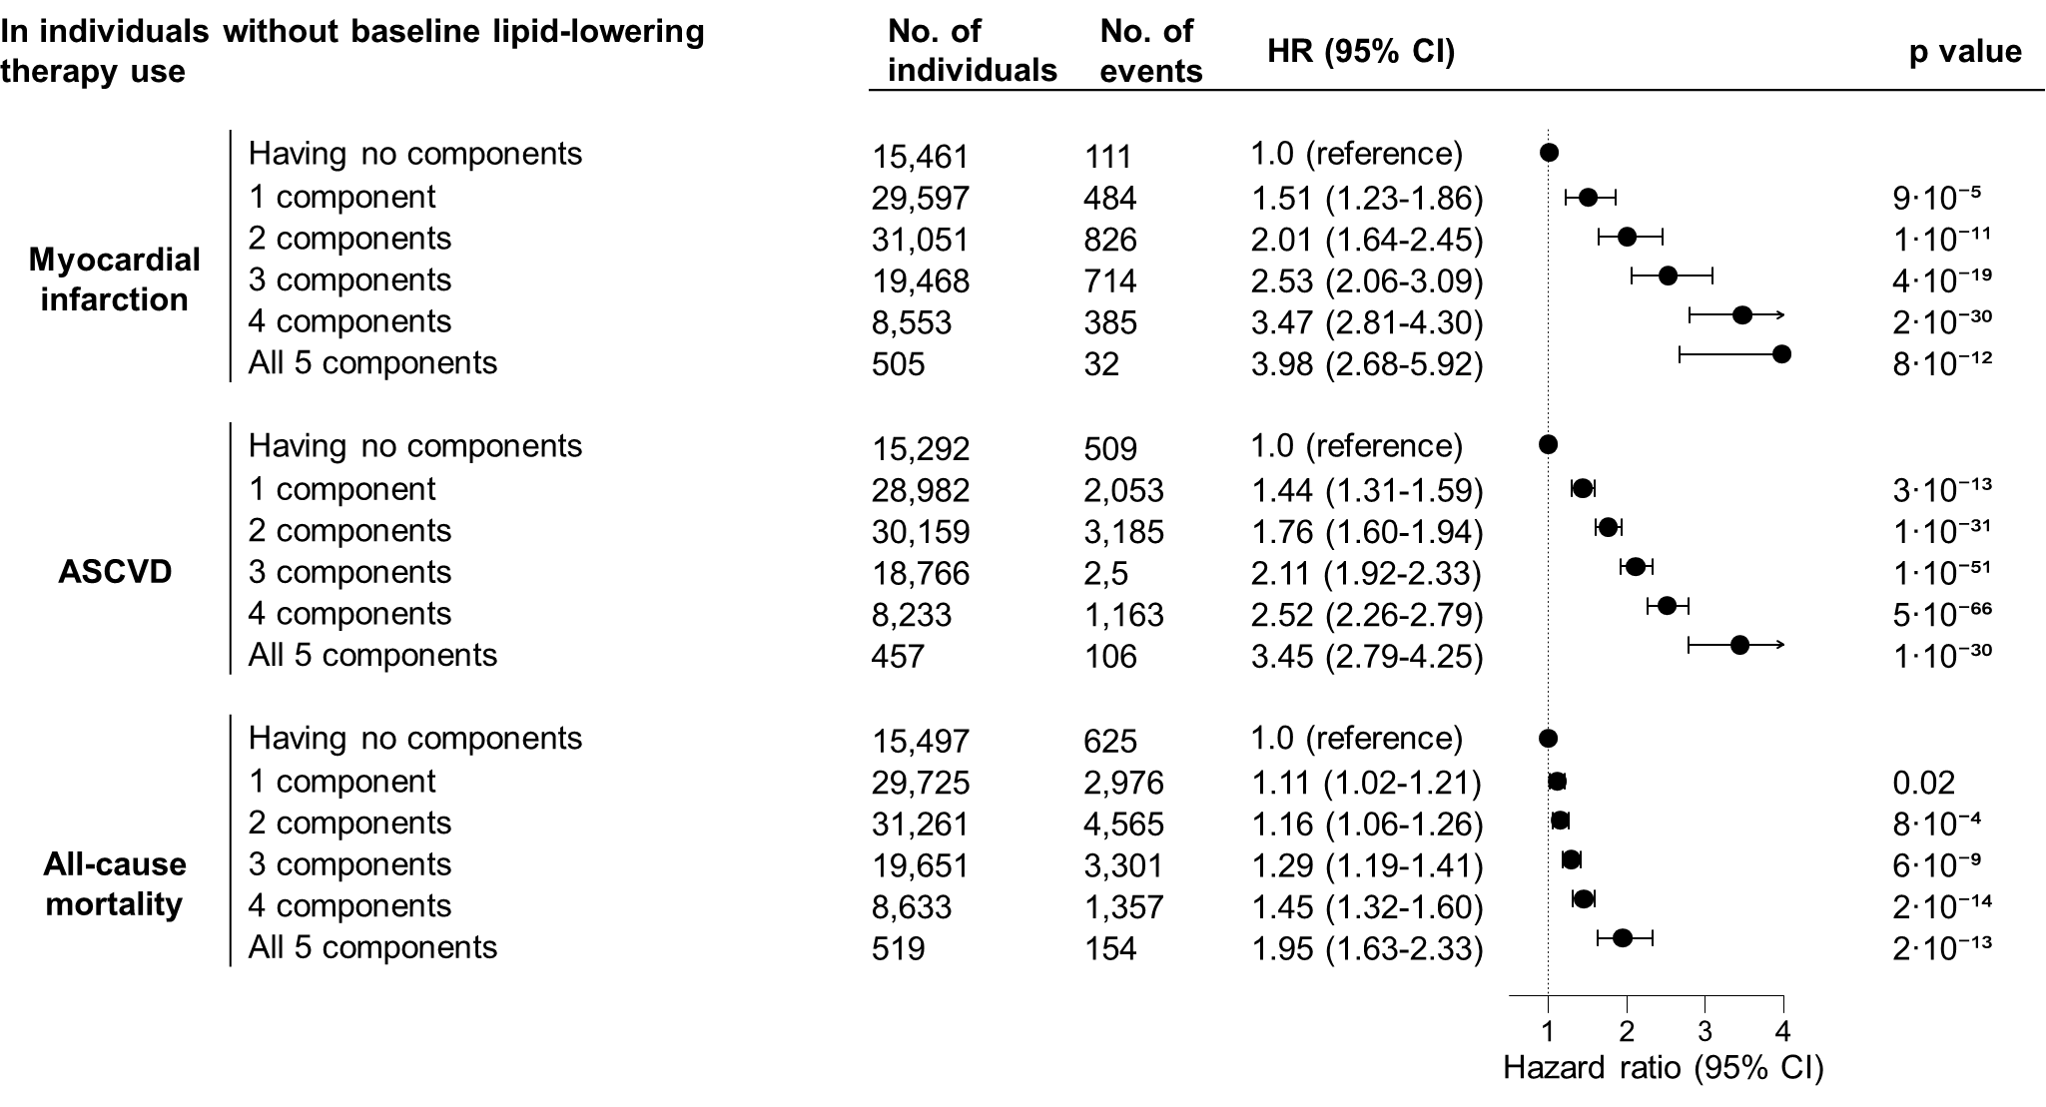
Supplemental Figure 29. Risk of cardiovascular disease and all-cause mortality by number of fulfilled metabolic syndrome criteria. In individuals without baseline lipid-lowering therapy. In the Copenhagen General Population Study. Based on Cox models adjusted for age, sex, birthyear, and smoking status. Exposure was having either 0, 1, 2, 3, 4, or 5 fulfilled metabolic syndrome criteria. Having 0 fulfilled criteria was the reference. ASCVD = Atherosclerotic cardiovascular disease. CI = Confidence interval. HR = hazard ratio. LDL = Low-density lipoprotein.

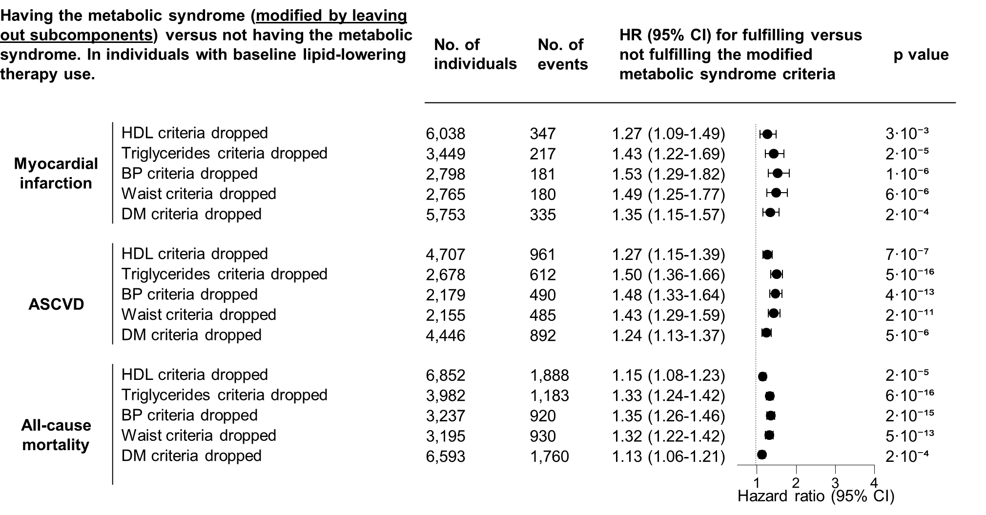
Supplemental Figure 30. Risk of cardiovascular disease and all-cause mortality from different types of metabolic syndrome. The metabolic syndrome modified by leaving out each subcomponent. In individuals with baseline lipid-lowering therapy. In the Copenhagen General Population Study. Based on Cox models in individuals adjusted for age, sex, birthyear, and smoking status. Exposure was five modified metabolic syndrome definitions. For each of the five definitions one of the five qualifying criteria was left out. The metabolic syndrome was defined as fulfilling 3 or more of the remaining criteria. ASCVD = Atherosclerotic cardiovascular disease. BP = blood pressure. CI = Confidence interval. DM = diabetes mellitus. HDL = high-density lipoprotein. HR = hazard ratio. LDL = Low-density lipoprotein. No. = number.

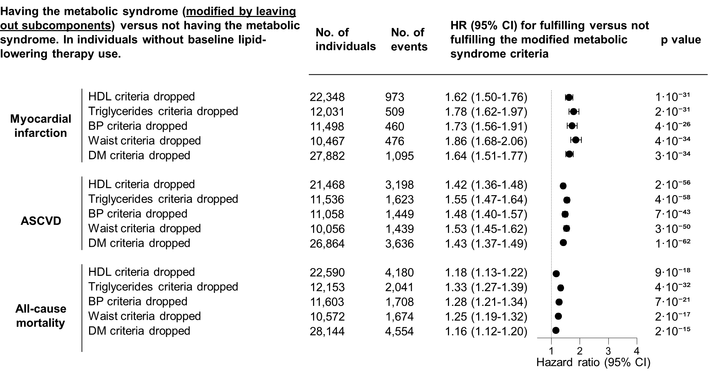
Supplemental Figure 31. Risk of cardiovascular disease and all-cause mortality from different types of metabolic syndrome. The metabolic syndrome modified by leaving out each subcomponent. In individuals without baseline lipid-lowering therapy. In the Copenhagen General Population Study. Based on Cox models adjusted for age, sex, birthyear, and smoking status. Exposure was five modified metabolic syndrome definitions. For each of the five definitions one of the five qualifying criteria was left out. The metabolic syndrome was defined as fulfilling 3 or more of the remaining criteria. ASCVD = Atherosclerotic cardiovascular disease. BP = blood pressure. CI = Confidence interval. DM = diabetes mellitus. HDL = high-density lipoprotein. HR = hazard ratio. LDL = Low-density lipoprotein. No. = number.

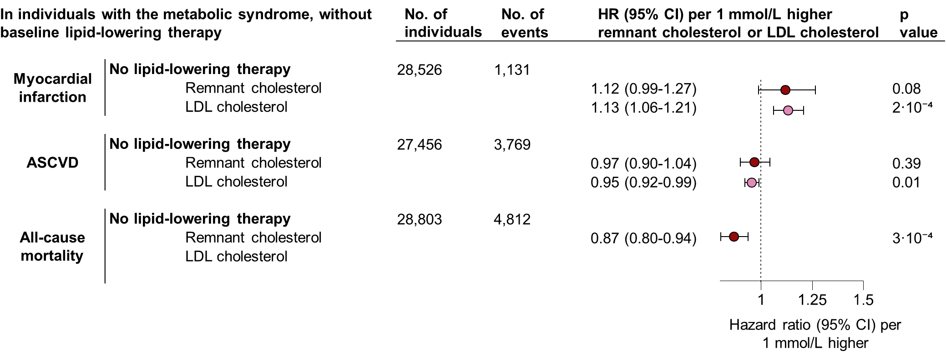
Supplemental Figure 32. Risk of cardiovascular disease and all-cause mortality in individuals with the metabolic syndrome and without baseline lipid-lowering therapy. Additional time-varying adjustment for initiation of lipid-lowering therapy. In the Copenhagen General Population Study. Based on Cox models adjusted for age, sex, birthyear, smoking status, LDL cholesterol, and time-varying adjustment for initiation of lipid-lowering therapy during follow-up. Results should be interpreted with caution, as only lipid-lowering therapy is modelled as time-varying and all other covariates were fixed at baseline, potentially introducing confounding by indication and overadjustment. If the exposure was LDL cholesterol, adjustment was done for remnant cholesterol instead of LDL cholesterol. ASCVD = Atherosclerotic cardiovascular disease. CI = Confidence interval. HR = hazard ratio. LDL = Low-density lipoprotein. No. = number.

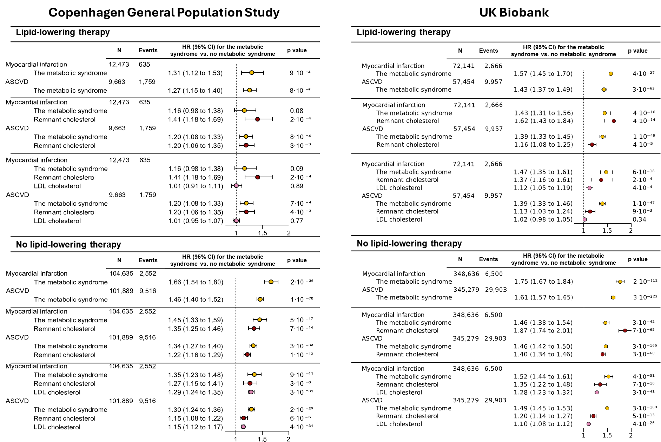
Supplemental Figure 33. Risk of myocardial infarction and ASCVD in individuals with versus without the metabolic syndrome with additional adjustment for remnant cholesterol and LDL cholesterol levels. ASCVD=atherosclerotic cardiovascular disease. CI=confidence interval. HR= hazard ratio. LDL=low-density lipoproteins.

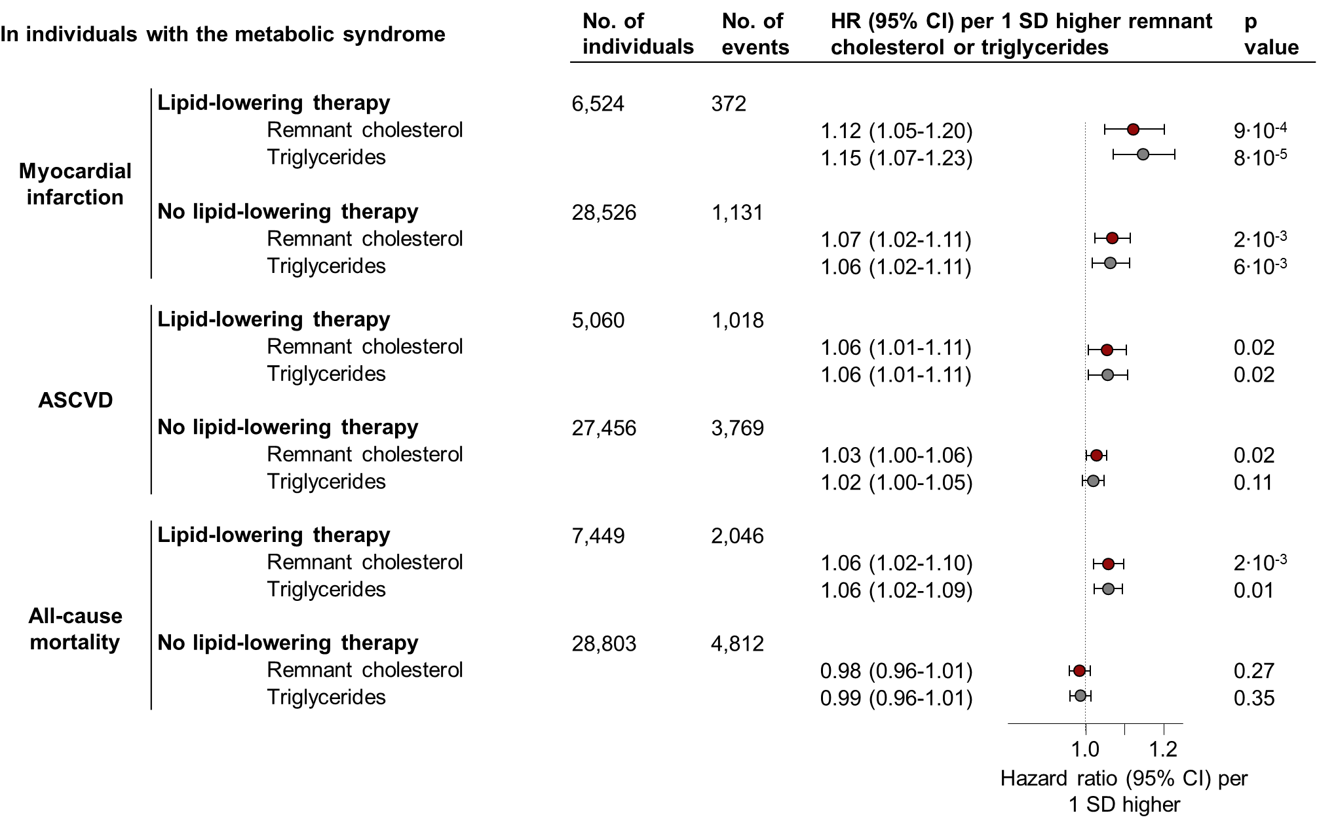
Supplemental Figure 34. Risk of cardiovascular disease and all-cause mortality in individuals with the metabolic syndrome from elevated remnant cholesterol or elevated triglycerides per 1 standard deviation change. In the Copenhagen General Population Study. Based on Cox regression models in individuals with the metabolic syndrome, adjusted for age, sex, birthyear, smoking status, and LDL cholesterol. ASCVD = Atherosclerotic cardiovascular disease. CI = Confidence interval. SD = standard deviation. LDL = Low-density lipoprotein.

