Supplementary Appendix to

Table of Contents
Supplementary Table 1. Distribution of variables with missing data in CHARLS cohort 9
Supplementary Table 2. Comparison of variables included in the CHARLS and UKB cohorts 10
Supplementary Table 3. Criteria for evaluating CKM stages 0-3 11
Supplementary Table 4. Framingham risk score for Men 13
Supplementary Table 5. Framingham risk score for Women 14
Supplementary Table 6. Definitions of diseases used in the study 15
Supplementary Table 7. The 28 items used to construct the frailty index in CHARLS 16
Supplementary Table 8. The distribution of CVD outcomes in the CHARLS and UKB cohorts 17
Supplementary Table 9. Baseline characteristics of participants stratified by tertiles of LFCIs in the CHARLS cohort 18
Supplementary Table 10. Baseline characteristics of the study participants stratified by tertiles of LFCIs in the UKB cohort 30
Supplementary Table 11. Proportional hazards assumption test for the fully adjusted Cox models in CHARLS 48
Supplementary Table 12. Proportional hazards assumption test for the fully adjusted Cox models in UKB. 51
Supplementary Table 13. Adjusted RMST differences and Cox regression estimates for incident CVD comparing the highest versus lowest tertiles of LFCIs in the UK Biobank 54
Supplementary Table 14. Exploratory mediation analyses in two alternative directions of hs-CRP and LFCIs on incident CVD in the CHARLS cohort 55
Supplementary Table 15. Exploratory mediation analyses in two alternative directions of hs-CRP and LFCIs on incident CVD in the UKB cohort 56
Supplementary Table 16. Variables included in the machine learning models for the CHARLS and UKB cohorts 57
Supplementary Table 17. Sensitivity analysis for the association between LFCIs and incident CVD after excluding all missing data in the CHARLS cohort 58
Supplementary Table 18. Sensitivity analysis for the association between LFCIs and incident CVD after excluding patients at CKM Stage 0 in the CHARLS cohort 60
Supplementary Table 19. Sensitivity analysis for the association between LFCIs and incident CVD after excluding patients with all-cause mortality in the CHARLS cohort 62
Supplementary Figure 1. Directed Acyclic Graph illustrating the causal assumptions among LFCIs, hs-CRP, CVD, and covariates 64
Supplementary Figure 2. Cumulative incidence curves of cardiovascular disease across tertiles of six LFCIs in the CHARLS cohort 65
Supplementary Figure 3. Cumulative incidence curves of cardiovascular disease across tertiles of six LFCIs in the UKB cohort 66
Supplementary Figure 4. Subgroup analysis of the association between LFCIs and incident CVD in the CHARLS cohort 67
Supplementary Figure 5. Subgroup analysis of the association between LFCIs and incident CVD in the UKB cohort 70
Supplementary Figure 6. Receiver operating characteristic curves for predicting CVD outcomes using baseline variables in the CHARLS and UKB cohorts 73
Supplementary Figure 7. Receiver operating characteristic curves of six lipid-based models for predicting incident CVD in the CHARLS cohort and in the UKB cohort. 74

Supplementary Methods
Data source and study population
UK Biobank (UKB) is a large population-based prospective study initiated in 2006, encompassing over 500,000 adults aged 37 to 73 years from across the United Kingdom. Between 2006 and 2010, participants completed touchscreen questionnaires and interviews and underwent anthropometric and biological assessments at 22 assessment centers located in England, Scotland, and Wales. This study included 502,248 participants who were registered with UKB between 2006 and 2010 [1,2].
As shown in Fig. 1, this study enrolled 502,248 participants from UKB. We excluded a total of 266,985 participants according to the following exclusion criteria: (1) Without information to define CKM or at stage 4; (2) Age < 45 years or missing age information; (3) Missing data on covariates and outcomes. Finally, 235,263 participants were included in the analysis.
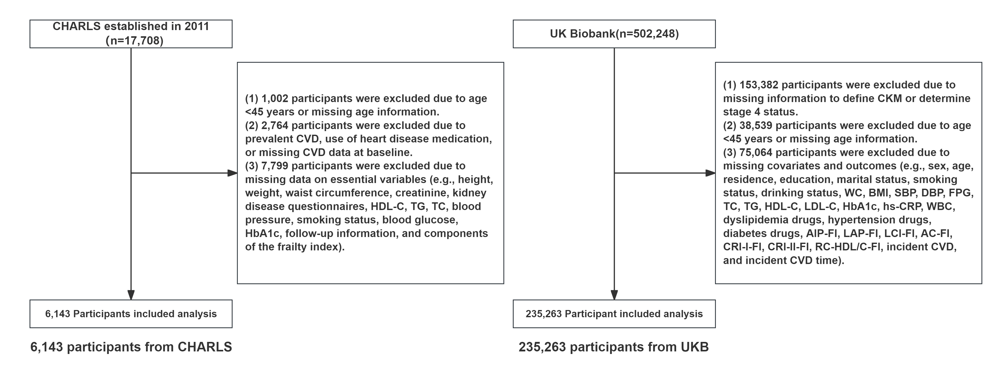
Fig. 1 Flow chart of inclusion and exclusion of participants

Definition of CKM syndrome stages 0 to 4 in the UKB cohort
The AHA Presidential Advisory Statement [3] classified the stages of CKM as follows: (1) Stage 4: self-reported established cardiovascular diseases; (2) Stage 3: very high-risk KDIGO CKD stage, high predicted 10-year CVD (risk ≥ 20%), or self-reported chronic kidney disease, where the race-free CKD-EPI 2021 creatinine equation was used to define very high-risk KDIGO CKD stage as eGFR ≤ 29 (stage G4 or G5 CKD) [4,5], and the AHA prediction of CVD event risk equation [6] was used to calculate the 10-year CVD risk; (3) Stage 2: metabolic risk factors including elevated fasting serum triglycerides (≥ 135 mg/dL), hypertension, diabetes, or metabolic syndrome, or moderate-to-high-risk chronic kidney disease; (4) Stage 1: high waist circumference (WC) (Asian: male ≥ 90 cm, female ≥ 80 cm; other races: male ≥ 102 cm, female ≥ 88 cm) or prediabetes; (5) Stage 0: individuals who did not meet the criteria for the aforementioned stages, with normal WC (<80 and <90 cm for women and men with Asian race, respectively, and <88 and <102 cm for women and men in all other race and ethnicity categories, respectively) and normal body mass index (BMI) (<23 kg/m2 for individuals with Asian ethnicity and <25 kg/m2 for other racial and ethnic groups) Participants with CKM stage 4 were excluded because they had established CVD at baseline.

Definition of CKM syndrome stage 4 in the CHARLS cohort
CKM Stage 4 was defined according to the American Heart Association (AHA) framework as the presence of clinical cardiovascular disease (CVD), including coronary heart disease, heart failure, stroke, peripheral artery disease, or atrial fibrillation. Stage 4 was further classified as Stage 4a in the absence of kidney failure and Stage 4b in the presence of kidney failure [3]. Although the CKM stage 0–4 framework provides a commonly used approach for clinical characterization, other staging and risk-classification systems have also been proposed

Data Collection
In the UKB cohort, we included baseline information on (1) demographic and lifestyle factors: sex, age, race, education, marital status, smoking status, and drinking status; (2) anthropometric indicators: height, weight, WC, BMI, systolic blood pressure (SBP), and diastolic blood pressure (DBP,); (3) laboratory parameters: fasting blood glucose (FBG), total cholesterol (TC), triglycerides (TG), high-density lipoprotein cholesterol (HDL-C), low-density lipoprotein cholesterol (LDL-C), Hemoglobin A1c (HbA1c), high-sensitivity C-reactive protein (hs-CRP), creatinine, and white blood cells (WBC); (4) disease and medication history: hypertension, diabetes, dyslipidemia, and their corresponding medication use. For better comparability with the CHARLS cohort, the UKB used the same features as CHARLS (Table S2).

Definition of exposures
In the UKB, the frailty index (FI) was constructed using 49 self-reported items assessing health conditions, illnesses, physical limitations, and mental well-being. For participants with fewer than ten missing responses, the FI score was computed as the ratio of present deficits to total possible deficits, resulting in a continuous value ranging from 0 to 1 [7]. The six LFCIs were calculated using the same formula in CHARLS.

Definition of outcome
In the UKB cohort, the primary outcome was incident CVD, defined using linked hospital inpatient records and death registry data. Incident CVD included coronary heart disease (ICD-10 codes: I20, I21, I22, I23, I24, and I25), heart failure (I50), and stroke (I60, I61, I62, I63, I64, and I69). For participants with multiple CVD records, the earliest date of diagnosis was considered the date of CVD onset. Participants with prevalent CVD at baseline were excluded. Follow-up continued until the date of incident CVD diagnosis, death, loss to follow-up, or the end of follow-up (September 15, 2024), whichever occurred first.

Mediation analysis
Mediation analyses were conducted to explore the associations observed under both model specifications between lipid-frailty composite indices (LFCIs), hs-CRP, and the risk of new-onset cardiovascular disease (CVD) using the mediation package in R software [10]. All LFCIs (CRI-I-FI, CRI-II-FI, RC/HDL-C-FI, AC-FI, LCI-FI, and AIP-FI) and hs-CRP were dichotomized into binary variables based on the 75th percentile cutoff values to define high-risk and low-risk groups.
Two regression-based approaches were applied for both forward and reverse mediation analyses. For the forward mediation analysis, the exposure variables were LFCIs, and the mediator was hs-CRP. The mediator model (logistic regression) assessed the association between each lipid-frailty index and hs-CRP, adjusted for age, sex, BMI, FBG, TC, HbA1c,LDL-C, Antidiabetic medications, and Antihypertensive medication. The outcome model (logistic regression) evaluated the associations of each lipid-frailty index and hs-CRP with new-onset CVD, adjusted for the same covariates.
For the reverse mediation analysis, hs-CRP was treated as the exposure variable, and each LFCI was set as the mediator, following the identical regression and adjustment strategies as the forward analysis.
The average causal mediation effect (ACME), average direct effect (ADE), and total effect were estimated. Nonparametric bootstrapping with 1000 bootstrap resamples was performed to calculate 95% confidence intervals (CIs) and corresponding p-values. The total effect was decomposed into direct (ADE) and indirect (ACME) components, and the proportion mediated (PM) was computed as the ratio of ACME to the total effect to quantify the magnitude of the mediating role of hs-CRP. All statistical tests were two-sided, and P < 0.05 was considered statistically significant.

Machine learning analysis
As an exploratory analysis, machine learning models were developed to evaluate whether incorporating LFCIs improved the prediction of incident CVD beyond conventional risk factors. The occurrence of incident CVD during follow-up was treated as a binary outcome. All machine learning analyses were performed separately within the CHARLS and UKB cohorts without pooling data.
For each cohort, two types of predictor sets were constructed. The baseline model included conventional demographic, anthropometric, lifestyle, clinical, and laboratory variables. Extended models were generated by adding each individual LFCI separately to the baseline predictor set. The six LFCIs evaluated included AIP-FI, LCI-FI, AC-FI, CRI-I-FI, CRI-II-FI, and RC-HDL-C-FI. To avoid potential information leakage, outcome variables, follow-up time variables, and variables directly used to construct LFCIs or frailty indices were excluded from model development.
Five classification algorithms were evaluated, including logistic regression, k-nearest neighbors (KNN), decision tree, categorical boosting (CatBoost), and a stacking classifier. The stacking classifier incorporated KNN and decision tree models as base learners and logistic regression as the meta-learner. Logistic regression was implemented as a linear benchmark model, whereas tree-based and ensemble algorithms were used to capture potential nonlinear relationships between predictors and CVD risk [11,12].
Within each cohort, participants were randomly divided into a training set (70%) and an independent held-out test set (30%) using stratified sampling according to CVD status to preserve the outcome distribution between datasets. Model development was conducted exclusively in the training set. Five-fold stratified cross-validation was applied within the training data for internal performance evaluation. To address class imbalance, random upsampling of the minority class was performed only within the training data of each fold, while validation and test datasets remained unchanged. This approach was used to prevent information leakage and obtain unbiased estimates of model performance [8,9].
Before model training, missing values among predictors were imputed using median imputation, and continuous variables were standardized using z-score transformation within the modeling pipeline. These preprocessing procedures were performed independently within each training fold and subsequently applied to validation or test data.
Model discrimination was assessed using the area under the receiver operating characteristic curve (AUC). Performance was evaluated using both cross-validation AUC and AUC calculated from the independent held-out test set. Model calibration was assessed using the Brier score, calibration intercept, calibration slope, and discrimination slope. Calibration curves were additionally generated based on predicted probabilities and observed event proportions [13,14].
To improve the robustness of performance comparisons, the complete process of random data splitting, model training, and evaluation was repeated under fixed random seeds. Models were compared according to predictive discrimination and calibration performance. All machine learning analyses were conducted using Python version 3.12.7 with the scikit-learn and CatBoost packages.

References
[1] Wang J-N, Hu W, Liu B-P, Jia C-X. Associations between shift work and biological age acceleration: A population-based study. Geroscience 2025;47:4205–17. https://doi.org/10.1007/s11357-025-01575-z.
[2] Huang X, Li C, Zeng P, et al. Non-traditional lipid-inflammatory parameters estimate the risk of stroke in middle-aged and older Chinese adults: a nationwide prospective cohort study. Journal of Advanced Research. 2025; [article number]. doi:10.1016/j.jare.2025.11.029
[3] Ndumele CE, Rangaswami J, Chow SL, Neeland IJ, Tuttle KR, Khan SS, Coresh J, Mathew RO, Baker-Smith CM, Carnethon MR, Despres J-P, Ho JE, Joseph JJ, Kernan WN, Khera A, Kosiborod MN, Lekavich CL, Lewis EF, Lo KB, Ozkan B, Palaniappan LP, Patel SS, Pencina MJ, Powell-Wiley TM, Sperling LS, Virani SS, Wright JT, Rajgopal Singh R, Elkind MSV, American Heart Association. Cardiovascular-Kidney-Metabolic Health: A Presidential Advisory From the American Heart Association. Circulation 2023;148:1606–35. https://doi.org/10.1161/CIR.0000000000001184.
[4] Li W, Shen C, Kong W, Zhou X, Fan H, Zhang Y, Liu Z, Zheng L. Association between the triglyceride glucose-body mass index and future cardiovascular disease risk in a population with Cardiovascular-Kidney-Metabolic syndrome stage 0-3: a nationwide prospective cohort study. Cardiovasc Diabetol 2024;23:292. https://doi.org/10.1186/s12933-024-02352-6.
[5] Li J, Lei L, Wang W, Ding W, Yu Y, Pu B, Peng Y, Li Y, Zhang L, Guo Y. Social Risk Profile and Cardiovascular-Kidney-Metabolic Syndrome in US Adults. J Am Heart Assoc 2024;13:e034996. https://doi.org/10.1161/JAHA.124.034996.
[6] Khan SS, Matsushita K, Sang Y, Ballew SH, Grams ME, Surapaneni A, Blaha MJ, Carson AP, Chang AR, Ciemins E, Go AS, Gutierrez OM, Hwang S-J, Jassal SK, Kovesdy CP, Lloyd-Jones DM, Shlipak MG, Palaniappan LP, Sperling L, Virani SS, Tuttle K, Neeland IJ, Chow SL, Rangaswami J, Pencina MJ, Ndumele CE, Coresh J, Chronic Kidney Disease Prognosis Consortium and the American Heart Association Cardiovascular-Kidney-Metabolic Science Advisory Group. Development and Validation of the American Heart Association’s PREVENT Equations. Circulation 2024;149:430–49. https://doi.org/10.1161/CIRCULATIONAHA.123.067626.
[7] Zhong Q, Chen H-W, Zhou R, Li F-R, Wu X-B. Reply to: "Comment on “Frailty and risk of metabolic dysfunction-associated steatotic liver disease and other chronic liver diseases” ". J Hepatol 2025;82:e170–1. https://doi.org/10.1016/j.jhep.2024.11.035.
[8] He H, Garcia EA. Learning from Imbalanced Data. IEEE Transactions on Knowledge and Data Engineering 2009;21:1263–84. https://doi.org/10.1109/TKDE.2008.239.
[9] Song Y, Zhu C, Shi B, et al. Social isolation, loneliness, and incident type 2 diabetes mellitus: results from two large prospective cohorts in Europe and East Asia and Mendelian randomization. eClinicalMedicine. 2023;64:102236. doi:10.1016/j.eclinm.2023.102236
[10] Baron RM, Kenny DA. The moderator-mediator variable distinction in social psychological research: conceptual, strategic, and statistical considerations. J Pers Soc Psychol 1986;51:1173–82. https://doi.org/10.1037//0022-3514.51.6.1173.
[11] Pedregosa F, Varoquaux G, Gramfort A, Michel V, Thirion B, Grisel O, Blondel M, Prettenhofer P, Weiss R, Dubourg V, Vanderplas J, Passos A, Cournapeau D, Brucher M, Perrot M, Duchesnay É. Scikit-learn: Machine Learning in Python. J Mach Learn Res 2011;12:2825–30.
[12] Prokhorenkova L, Gusev G, Vorobev A, Dorogush AV, Gulin A. CatBoost: unbiased boosting with categorical features. Advances in Neural Information Processing Systems. 2018;31:6638–6648.
[13] Brier GW. Verification of forecasts expressed in terms of probability. Monthly Weather Review. 1950;78(1):1–3.
[14] Steyerberg EW, Vickers AJ, Cook NR, Gerds T, Gonen M, Obuchowski N, Pencina MJ, Kattan MW. Assessing the performance of prediction models: a framework for traditional and novel measures. Epidemiology 2010;21:128–38. https://doi.org/10.1097/EDE.0b013e3181c30fb2.

Supplementary Table 1. Distribution of variables with missing data in CHARLS cohort
Variables | Number of Missing | Missing proportion
FBG | 586 | 9.54%
HbA1c | 35 | 0.57%
WBC | 109 | 1.77%
Antidiabetic medications | 25 | 0.41%
lipid-lowering medications | 65 | 1.06%
LCI-FI | 8 | 0.13%
CRI-II-FI | 8 | 0.13%
RC/HDL-C-FI | 8 | 0.13%
Drinking | 1 | 0.02%
Abbreviations: FBG,Fasting blood glucose; HbA1c,Hemoglobin A1c; WBC,White blood cells; CRI-II-FI, Castelli Risk Index II-Frailty Index; RC/HDL-C-FI, Remnant Cholesterol/HDL-C-Frailty Index; LCI-FI, Lipoprotein Combined Index-Frailty Index;

Supplementary Table 2. Comparison of variables included in the CHARLS and UKB cohorts
CHARLS | UK Biobank | Full name
HDL-C | HDL-C | High-density lipoprotein cholesterol
TC | TC | Total cholesterol
LDL-C | LDL-C | Low-density lipoprotein cholesterol
WC | WC | Waist circumference
eGFR | eGFR | Estimated glomerular filtration rate
WBC | WBC | White blood cells
TG | TG | Triglycerides
HbA1c | HbA1c | Hemoglobin A1c
FBG | FBG | Fasting blood glucose
SBP | SBP | Systolic blood pressure
DBP | DBP | Diastolic blood pressure
Age | Age | Age
Sex | Sex | Sex
hs-CRP | hs-CRP | high-sensitivity C-reactive protein
Married | Married | Marital status
Resident | Resident | Resident
Education | Education | Education
WHtR | WHtR | Waist-to-height ratio
Lipid-lowering medications | Lipid-lowering medications | Lipid-lowering medications
Antihypertensive medications | Antihypertensive medications | Antihypertensive medications
Antidiabetic medications | Antidiabetic medications | Antidiabetic medications
Drinking | Drinking | Alcohol drinking status
Smoking | Smoking | Smoking status
BMI | BMI | Body mass index
CVD | CVD | incident Cardiovascular Disease
AIP-FI | AIP-FI | Atherogenic Index of Plasma-Frailty Index
LCI-FI | LCI-FI | Lipoprotein Combined Index-Frailty Index
AC-FI | AC-FI | Atherogenic Coefficient-Frailty Index
CRI-I-FI | CRI-I-FI | Castelli Risk Index I-Frailty Index
CRI-II-FI | CRI-II-FI | Castelli Risk Index II-Frailty Index
RC/HDL-C-FI | RC/HDL-C-FI | Remnant Cholesterol/HDL-C-Frailty Index

Supplementary Table 3. Criteria for evaluating CKM stages 0-3
CKM stages | Threshold for CKM conditions
Stages 0 | All criteria are met：  - BMI< 23 kg/m2  - Waist circumference <80/90 cm in female/male  - Fasting blood glucose < 100 mg/dL and HbA1c < 5.7% and without self-reported diagnosis of diabetes, use of insulin, or oral hypoglycemic agents.  - SBP <130 mm Hg and DBP <80 mm Hg without self-reported diagnosis of hypertension or use of antihypertensive medications.  - HDL-C ≥ 50/40 mg/dL in female/male  - TG < 150 mg/dL  - eGFR ≥ 60 ml/min/1.73m2 and without self-reported diagnosis of CKD  - No Subclinical CVD and clinical CVD
Stages 1 | Any of the three criteria is met:  - Overweight/obesity  - Abdominal obesity  - Prediabetes  All criteria are met：  （1）SBP <130 mmHg and DBP <80 mmHg without self-reported diagnosis of hypertension or use of antihypertensive medications.  （2）HDL-C <50/40 mg/dL in female/male  （3）TG < 150 mg/dL  （4）eGFR ≥ 60 ml/min/1.73m2 and without self-reported diagnosis of CKD  （5）No Subclinical CVD and clinical CVD
Stages 2 | Any of the five criteria is met:  - Hypertriglyceridemia  - Hypertension  - Diabetes  - Metabolic Syndrome  - eGFR：30-60 ml/min/1.73m2 and/or with self-reported diagnosis of CKD  All criteria are met：  - No Subclinical CVD and clinical CVD
Stages 3 | Any of the two criteria is met:  - eGFR<30 ml/min/1.73m2  - Subclinical CVD  Any of the eight criteria is met:  - Overweight/obesity  - Abdominal obesity  - Prediabetes  - Hypertriglyceridemia  - Hypertension  - Diabetes  - Metabolic Syndrome  - eGFR：30-60 ml/min/1.73m2 and/or with self-reported diagnosis of CKD  The criterion is met：  - No clinical CVD

Supplementary Table 4. Framingham risk score for Men
Points | Age, years | HDL | TC | SBP Not Treated | SBP Treated | Smoker | Diabetic
-2 |  | 60+ |  | <120
-1 |  | 50–59
0 | 30–34 | 45–49 | <160 | 120–129 | <120 | No | No
1 |  | 35–44 | 160–199 | 130–139
2 | 35–39 | <35 | 200–239 | 140–159 | 120–129
3 |  |  | 240–279 | 160+ | 130–139 |  | Yes
4 |  |  | 280+ |  | 140–159 | Yes
5 | 40–44 |  |  |  | 160+
6 | 45–49
7
8 | 50–54
9
10 | 55–59
11 | 60–64
12 | 65–69
13
14 | 70–74
15 | 75+

Supplementary Table 5. Framingham risk score for Women
Points | Age, years | HDL | TC | SBP Not Treated | SBP Treated | Smoker | Diabetic
-3 |  |  |  | <120
-2 |  | 60+
-1 |  | 50–59 |  |  | <120
0 | 30–34 | 45–49 | <160 | 120–129 |  | No | No
1 |  | 35–44 | 160–199 | 130–139
2 | 35–39 | <35 |  | 140–149 | 120–129
3 |  |  | 200–239 |  | 130–139 | Yes
4 | 40–44 |  | 240–279 | 150–159 |  |  | Yes
5 | 45–49 |  | 280+ | 160+ | 140–149
6 |  |  |  |  | 150–159
7 | 50–54 |  |  |  | 160+
8 | 55–59
9 | 60–64
10 | 65–69
11 | 70–74
12 | 75+

Supplementary Table 6. Definitions of diseases used in the study
Overweight/Obesity | BMI ≥23 kg/m2
Abdominal Obesity | Waist circumference≥80/90 cm in female/male
Prediabetes | Fasting blood glucose ≥ 100-124 mg/dL or HbA1c ≥ 5.7%-6.4% and  without self-reported diagnosis of diabetes, use of insulin, or oral  hypoglycemic agents
Diabetes | Fasting blood glucose ≥ 125 mg/dL or HbA1c ≥ 6.5% or self-reported diagnosis of diabetes, use of insulin, or oral hypoglycemic agents
Hypertension | SBP ≥130 mm Hg or DBP ≥80 mm Hg or self-reported diagnosis of hypertension or use of antihypertensive medications
Chronic Kidney Disease | Any of the two criteria is met：  - Self-reported history of chronic kidney disease  - eGFR < 60 ml/min/1.73m2
Hypertriglyceridemia | Triglycerides ≥ 135 mg/dL
Metabolic Syndrome | Meet any three or more of the five  ① Waist circumference ≥ 80/90 cm in female/male.  ②HDL cholesterol ≤ 50/40 mg/dL in female/male.  ③ Triglycerides ≥150 mg/dL.  ④ Elevated blood pressure (SBP ≥130 mm Hg or DBP ≥80 mm Hg and/or use of antihypertensive medications)  ⑤ Fasting blood glucose ≥100 mg/dL
Clinical CVD | Any of the two criteria is met：  ① Participants were asked "Have you been told by a doctor that you have been diagnosed with a heart disease, including angina, heart attack, congestive heart failure, and other heart problems?"  ②"Have you been told by a doctor that you have been diagnosed with a stroke?"
Subclinical CVD | Any of the two criteria is met：  - Very high-risk CKD in KDIGO classification: eGFR < 30 ml/min/1.73m2.  - Framingham risk score≥21.5/21.6 in female/male

Supplementary Table 7. The 28 items used to construct the frailty index in CHARLS
No | Description of the item | Cut-off value
1 | Self-reported physician diagnosed hypertension | Yes = 1, No = 0
2 | Self-reported physician diagnosed diabetes | Yes = 1, No = 0
3 | Self-reported physician diagnosed cancer | Yes = 1, No = 0
4 | Self-reported physician diagnosed arthritis | Yes = 1, No = 0
5 | Self-reported physician diagnosed chronic lung disease | Yes = 1, No = 0
6 | Self-reported physician diagnosed any emotional, nervous, or psychiatric problems | Yes = 1, No = 0
7 | Self-reported physician diagnosed memory-related disease | Yes = 1, No = 0
8 | Self-reported vision problems | Yes = 1, No = 0
9 | Self-reported hearing problems | Yes = 1, No = 0
10 | Self-reported general health status | Very poor or poor = 1,  Very good, good, or fair = 0
11 | Difficulty with dressing | Yes = 1, No = 0
12 | Difficulty with bathing or showering | Yes = 1, No = 0
13 | Difficulty with eating | Yes = 1, No = 0
14 | Difficulty with getting in and out of bed | Yes = 1, No = 0
15 | Difficulty with using the toilet | Yes = 1, No = 0
16 | Difficulty with managing money | Yes = 1, No = 0
17 | Difficulty with taking medication | Yes = 1, No = 0
18 | Difficulty with shopping for groceries | Yes = 1, No = 0
19 | Difficulty with preparing meals | Yes = 1, No = 0
20 | Mobility: difficulty with walking 100 yards or one block | Yes = 1, No = 0
21 | Mobility: difficulty with getting up from a chair after sitting for long periods | Yes = 1, No = 0
22 | Mobility: difficulty with climbing several flights of stairs without resting | Yes = 1, No = 0
23 | Mobility: difficulty with lifting or carrying weights over 10 pounds/jins | Yes = 1, No = 0
24 | Mobility: difficulty with picking up a coin from the table | Yes = 1, No = 0
25 | Mobility: difficulty with stooping, kneeling, or crouching | Yes = 1, No = 0
26 | Mobility: difficulty with reaching arms above shoulder level | Yes = 1, No = 0
27 | Depression: CESD-10 questionnaire | CESD-10 >10 = 1, ≤10 = 0
28 | Cognition: (memory test score + orientation test score) / 14 | Continuous variable, ranging  from 0 to 1
Memory-related disease indicates Alzheimer’s disease or dementia, organic brain senility, or other serious memory impairment. Depression is evaluated using Center for Epidemiologic Studies Depression Scale (CESD). In the CHARLS, CESD-10 is used, and the total score ranges from 0 to 30. The higher score indicates more severe depressive symptoms. The memory score is the average of words that are not recalled in the immediate and delayed word recall tasks. The memory score ranges from 0 to 10. The orientation test comprises four questions about the day of the week, the month, the date of the month, and the year. One point is given for each wrong answer, and the range is from 0 to 4.

Supplementary Table 8. The distribution of CVD outcomes in the CHARLS and UKB cohorts
CHARLS
 | Cardiovascular disease | Heart disease | Stroke
yes | 1142 (18.6%) | 865 (14.1%) | 391 (6.4%)
no | 5001 (81.4%) | 5278 (85.9%) | 5752 (93.6%)
UKB
 | Cardiovascular disease | Heart disease | Stroke
yes | 28,450 (12.1%) | 6709 (2.9%) | 5707 (2.4%)
no | 206,813 (87.9%) | 228,554 (97.1%) | 229,556(97.6%)

Supplementary Table 9. Baseline characteristics of participants stratified by tertiles of LFCIs in the CHARLS cohort

Participants stratified by CRI-I-FI tertiles
Variables | Total (n=6143) | T1 [0.029, 0.330] (n=2048) | T2 [0.330, 0.578] (n=2047) | T3 [0.578, 5.746] (n=2048) | P value
Age (years) | 57.00 (51.00, 64.00) | 55.00 (49.00, 61.00) | 57.00 (51.00, 63.00) | 60.00 (54.00, 67.00) | <0.001
Sex, n (%) |  |  |  |  | <0.001
Male | 2996 (48.8%) | 1118 (54.6%) | 1023 (50.0%) | 855 (41.7%)
Female | 3147 (51.2%) | 930 (45.4%) | 1024 (50.0%) | 1193 (58.3%)
Smoking, n (%) |  |  |  |  | <0.001
Yes | 2467 (40.2%) | 886 (43.3%) | 833 (40.7%) | 748 (36.5%)
No | 3676 (59.8%) | 1162 (56.7%) | 1214 (59.3%) | 1300 (63.5%)
Drinking, n (%) |  |  |  |  | <0.001
Yes | 2491 (40.6%) | 918 (44.8%) | 828 (40.4%) | 745 (36.4%)
No | 3652 (59.4%) | 1130 (55.2%) | 1219 (59.6%) | 1303 (63.6%)
CKM stages, n (%) |  |  |  |  | <0.001
Stage 0 | 705 (11.5%) | 432 (21.1%) | 198 (9.7%) | 75 (3.7%)
Stage 1 | 737 (12.0%) | 501 (24.5%) | 175 (8.5%) | 61 (3.0%)
Stage 2 | 3298 (53.7%) | 901 (44.0%) | 1228 (60.0%) | 1169 (57.1%)
Stage 3 | 1403 (22.8%) | 214 (10.4%) | 446 (21.8%) | 743 (36.3%)
Waist circumference (cm) | 84.40 (77.90, 91.50) | 82.00 (76.00, 88.02) | 84.50 (77.35, 91.10) | 88.00 (80.38, 95.00) | <0.001
BMI (kg/m²) | 23.16 (20.94, 25.70) | 22.49 (20.56, 24.64) | 23.12 (20.84, 25.57) | 23.93 (21.58, 26.76) | <0.001
Waist-to-height ratio | 0.53 (0.49, 0.58) | 0.51 (0.48, 0.55) | 0.53 (0.49, 0.58) | 0.56 (0.51, 0.61) | <0.001
SBP (mmHg) | 125.50 (113.50, 140.50) | 119.00 (110.00, 130.50) | 128.00 (114.25, 142.00) | 131.50 (118.50, 146.50) | <0.001
DBP (mmHg) | 74.50 (67.00, 82.50) | 71.50 (65.50, 78.50) | 75.50 (67.00, 83.50) | 77.00 (69.50, 85.00) | <0.001
Fasting blood glucose (mmol/L) | 5.64 (5.26, 6.16) | 5.52 (5.17, 5.90) | 5.61 (5.26, 6.11) | 5.82 (5.38, 6.72) | <0.001
Total cholesterol (mmol/L) | 4.93 (4.33, 5.57) | 4.72 (4.15, 5.29) | 4.92 (4.32, 5.52) | 5.18 (4.56, 5.93) | <0.001
Triglycerides (mmol/L) | 1.19 (0.84, 1.74) | 0.96 (0.72, 1.36) | 1.17 (0.84, 1.66) | 1.51 (1.09, 2.25) | <0.001
HDL-C (mmol/L) | 1.28 (1.05, 1.55) | 1.43 (1.19, 1.72) | 1.30 (1.09, 1.54) | 1.13 (0.92, 1.36) | <0.001
LDL-C (mmol/L) | 2.95 (2.41, 3.54) | 2.77 (2.27, 3.29) | 2.97 (2.49, 3.54) | 3.13 (2.54, 3.80) | <0.001
HbA1c (mmol/mol) | 32 (30, 35) | 32 (29, 33) | 32 (30, 35) | 33 (30, 38) | <0.001
High-sensitivity C-reactive protein (mg/L) | 0.99 (0.54, 2.08) | 0.79 (0.45, 1.63) | 0.99 (0.55, 2.08) | 1.23 (0.65, 2.55) | <0.001
White blood cells (×10⁹/L) | 6.00 (5.00, 7.20) | 5.80 (4.88, 7.00) | 5.93 (5.00, 7.20) | 6.20 (5.10, 7.50) | <0.001
eGFR (mL/min/1.73m²) | 99.71 (89.40, 106.36) | 101.87 (92.99, 107.97) | 99.39 (89.14, 106.11) | 97.49 (85.95, 104.59) | <0.001
Antihypertensive medications, n (%) |  |  |  |  | <0.001
Yes | 1558 (25.4%) | 145 (7.1%) | 522 (25.5%) | 891 (43.5%)
No | 4585 (74.6%) | 1903 (92.9%) | 1525 (74.5%) | 1157 (56.5%)
Antidiabetic medications, n (%) |  |  |  |  | <0.001
Yes | 201 (3.3%) | 10 (0.5%) | 45 (2.2%) | 146 (7.1%)
No | 5942 (96.7%) | 2038 (99.5%) | 2002 (97.8%) | 1902 (92.9%)
Lipid-lowing medications, n (%) |  |  |  |  | <0.001
Yes | 214 (3.5%) | 27 (1.3%) | 63 (3.1%) | 124 (6.1%)
No | 5929 (96.5%) | 2021 (98.7%) | 1984 (96.9%) | 1924 (93.9%)
Abdominal obesity, n (%) |  |  |  |  | <0.001
Yes | 3058 (49.8%) | 763 (37.3%) | 1008 (49.2%) | 1287 (62.8%)
No | 3085 (50.2%) | 1285 (62.7%) | 1039 (50.8%) | 761 (37.2%)
CRI-I-FI | 0.44 (0.28, 0.68) | 0.22 (0.16, 0.28) | 0.44 (0.38, 0.50) | 0.83 (0.69, 1.10) | <0.001
CRI-II-FI | 0.26 (0.16, 0.41) | 0.13 (0.09, 0.16) | 0.26 (0.23, 0.31) | 0.49 (0.41, 0.66) | <0.001
RC/HDL-C-FI | 0.04 (0.02, 0.09) | 0.02 (0.01, 0.03) | 0.04 (0.03, 0.07) | 0.12 (0.07, 0.21) | <0.001
AC-FI | 0.32 (0.19, 0.52) | 0.15 (0.10, 0.19) | 0.32 (0.27, 0.37) | 0.65 (0.52, 0.87) | <0.001
LCI-FI | 1.55 (0.73, 3.31) | 0.55(0.31, 0.91) | 1.56 (1.01, 2.32) | 4.28 (2.61, 6.84) | <0.001
AIP-FI | 0.03 (0.01, 0.07) | 0.01 (0.00, 0.02) | 0.04 (0.02, 0.05) | 0.09 (0.06, 0.13) | <0.001

Participants stratified by CRI-II-FI tertiles
Variables | Total (n=6143) | T1 [0.012, 0.191] (n=2048) | T2 (0.191, 0.349] (n=2047) | T3 (0.349, 2.739] (n=2048) | P value
Age (years) | 57.00 (51.00, 64.00) | 55.00 (49.00, 61.00) | 57.00 (51.00, 63.00) | 60.00 (54.00, 67.00) | <0.001
Sex, n (%) |  |  |  |  | <0.001
Male | 2996 (48.8%) | 1137 (55.5%) | 999 (48.8%) | 860 (42.0%)
Female | 3147 (51.2%) | 911 (44.5%) | 1048 (51.2%) | 1188 (58.0%)
Smoking, n (%) |  |  |  |  | <0.001
Yes | 2467 (40.2%) | 905 (44.2%) | 820 (40.1%) | 742 (36.2%)
No | 3676 (59.8%) | 1143 (55.8%) | 1227 (59.9%) | 1306 (63.8%)
Drinking, n (%) |  |  |  |  | <0.001
Yes | 2491 (40.6%) | 948 (46.3%) | 812 (39.7%) | 731 (35.7%)
No | 3652 (59.4%) | 1100 (53.7%) | 1235 (60.3%) | 1317 (64.3%)
CKM stages, n (%) |  |  |  |  | <0.001
Stage 0 | 705 (11.5%) | 407 (19.9%) | 211 (10.3%) | 87 (4.2%)
Stage 1 | 737 (12.0%) | 482 (23.5%) | 189 (9.2%) | 66 (3.2%)
Stage 2 | 3298 (53.7%) | 917 (44.8%) | 1209 (59.1%) | 1172 (57.2%)
Stage 3 | 1403 (22.8%) | 242 (11.8%) | 438 (21.4%) | 723 (35.3%)
Waist circumference (cm) | 84.40 (77.90, 91.50) | 82.00 (76.07, 88.22) | 84.40 (77.40, 91.00) | 87.95 (80.17, 95.00) | <0.001
BMI (kg/m²) | 23.16 (20.94, 25.70) | 22.48 (20.56, 24.71) | 23.15 (20.80, 25.57) | 23.89 (21.61, 26.75) | <0.001
Waist-to-height ratio | 0.53 (0.49, 0.58) | 0.51 (0.48, 0.55) | 0.53 (0.49, 0.58) | 0.56 (0.51, 0.61) | <0.001
SBP (mmHg) | 125.50 (113.50, 140.50) | 119.50 (110.50, 131.50) | 126.50 (114.00, 141.00) | 131.50 (118.50, 146.50) | <0.001
DBP (mmHg) | 74.50 (67.00, 82.50) | 71.50 (65.50, 79.00) | 75.00 (66.50, 83.00) | 76.50 (69.00, 85.00) | <0.001
Fasting blood glucose (mmol/L) | 5.64 (5.27, 6.16) | 5.53 (5.18, 5.94) | 5.61 (5.27, 6.16) | 5.77 (5.35, 6.55) | <0.001
Total cholesterol (mmol/L) | 4.93 (4.33, 5.57) | 4.63 (4.11, 5.23) | 4.93 (4.34, 5.52) | 5.23 (4.62, 5.96) | <0.001
Triglycerides (mmol/L) | 1.19 (0.84, 1.74) | 0.99 (0.72, 1.47) | 1.17 (0.84, 1.68) | 1.43 (1.04, 2.02) | <0.001
HDL-C (mmol/L) | 1.28 (1.05, 1.55) | 1.43 (1.18, 1.73) | 1.29 (1.07, 1.54) | 1.15 (0.96, 1.36) | <0.001
LDL-C (mmol/L) | 2.95 (2.41, 3.54) | 2.60 (2.11, 3.11) | 2.98 (2.50, 3.49) | 3.30 (2.74, 3.92) | <0.001
HbA1c (mmol/mol) | 32 (30, 35) | 32 (29, 33) | 32 (30, 35) | 33 (30, 38) | <0.001
High-sensitivity C-reactive protein (mg/L) | 0.99 (0.54, 2.08) | 0.81 (0.46, 1.68) | 0.97 (0.54, 2.09) | 1.22 (0.65, 2.52) | <0.001
White blood cells (×10⁹/L) | 6.00 (5.00, 7.20) | 5.80 (4.90, 7.00) | 6.00 (5.00, 7.29) | 6.10 (5.10, 7.40) | <0.001
eGFR (mL/min/1.73m²) | 99.71 (89.40, 106.36) | 101.89 (92.94, 108.15) | 99.39 (89.20, 106.18) | 97.55 (86.04, 104.38) | <0.001
Antihypertensive medications, n (%) |  |  |  |  | <0.001
Yes | 1558 (25.4%) | 184 (9.0%) | 500 (24.4%) | 874 (42.7%)
No | 4585 (74.6%) | 1864 (91.0%) | 1547 (75.6%) | 1174 (57.3%)
Antidiabetic medications, n (%) |  |  |  |  | <0.001
Yes | 201 (3.3%) | 20 (1.0%) | 38 (1.9%) | 143 (7.0%)
No | 5942 (96.7%) | 2028 (99.0%) | 2009 (98.1%) | 1905 (93.0%)
Lipid-lowing medications, n (%) |  |  |  |  | <0.001
Yes | 214 (3.5%) | 36 (1.8%) | 55 (2.7%) | 123 (6.0%)
No | 5929 (96.5%) | 2012 (98.2%) | 1992 (97.3%) | 1925 (94.0%)
Abdominal obesity, n (%) |  |  |  |  | <0.001
Yes | 3058 (49.8%) | 765 (37.4%) | 1014 (49.5%) | 1279 (62.5%)
No | 3085 (50.2%) | 1283 (62.6%) | 1033 (50.5%) | 769 (37.5%)
CRI-I-FI | 0.44 (0.28, 0.68) | 0.22 (0.16, 0.28) | 0.43 (0.37, 0.50) | 0.81 (0.66, 1.08) | <0.001
CRI-II-FI | 0.26 (0.16, 0.41) | 0.13 (0.08, 0.16) | 0.26 (0.22, 0.30) | 0.49 (0.41, 0.66) | <0.001
RC/HDL-C-FI | 0.04 (0.02, 0.09) | 0.02 (0.01, 0.03) | 0.04 (0.02, 0.07) | 0.10 (0.06, 0.18) | <0.001
AC-FI | 0.32 (0.19, 0.52) | 0.15 (0.10, 0.19) | 0.31 (0.27, 0.36) | 0.62 (0.50, 0.84) | <0.001
LCI-FI | 1.55 (0.73, 3.31) | 0.55 (0.31, 0.90) | 1.52 (1.00, 2.31) | 4.04 (2.49, 6.48) | <0.001
AIP-FI | 0.03 (0.01, 0.07) | 0.01 (0.00, 0.02) | 0.03 (0.01, 0.05) | 0.08 (0.05, 0.12) | <0.001

Participants stratified by RC/HDL-C-FI tertiles
Variables | Total (n=6143) | T1 [-0.063, 0.026] (n=2048) | T2 (0.026, 0.071] (n=2047) | T3 (0.071, 3.567] (n=2048) | P value
Age (years) | 57.00 (51.00, 64.00) | 56.00 (49.00, 62.00) | 57.00 (51.00, 64.00) | 59.00 (52.00, 65.00) | <0.001
Sex, n (%) |  |  |  |  | <0.001
Male | 2996 (48.8%) | 1074 (52.4%) | 1002 (48.9%) | 920 (44.9%)
Female | 3147 (51.2%) | 974 (47.6%) | 1045 (51.1%) | 1128 (55.1%)
Smoking, n (%) |  |  |  |  | 0.195
Yes | 2467 (40.2%) | 835 (40.8%) | 842 (41.1%) | 790 (38.6%)
No | 3676 (59.8%) | 1213 (59.2%) | 1205 (58.9%) | 1258 (61.4%)
Drinking, n (%) |  |  |  |  | 0.012
Yes | 2491 (40.6%) | 874 (42.7%) | 836 (40.8%) | 781 (38.1%)
No | 3652 (59.4%) | 1174 (57.3%) | 1211 (59.2%) | 1267 (61.9%)
CKM stages, n (%) |  |  |  |  | <0.001
Stage 0 | 705 (11.5%) | 448 (21.9%) | 203 (9.9%) | 54 (2.6%)
Stage 1 | 737 (12.0%) | 533 (26.0%) | 176 (8.6%) | 28 (1.4%)
Stage 2 | 3298 (53.7%) | 824 (40.2%) | 1225 (59.8%) | 1249 (61.0%)
Stage 3 | 1403 (22.8%) | 243 (11.9%) | 443 (21.6%) | 717 (35.0%)
Waist circumference (cm) | 84.40 (77.90, 91.50) | 81.10 (75.60, 87.20) | 84.00 (77.70, 91.20) | 88.20 (81.20, 95.10) | <0.001
BMI (kg/m²) | 23.16 (20.94, 25.70) | 22.26 (20.32, 24.34) | 23.11 (20.91, 25.66) | 24.34 (21.95, 26.93) | <0.001
Waist-to-height ratio | 0.53 (0.49, 0.58) | 0.51 (0.47, 0.55) | 0.53 (0.49, 0.58) | 0.56 (0.52, 0.60) | <0.001
SBP (mmHg) | 125.50 (113.50, 140.50) | 120.00 (110.00, 133.00) | 126.50 (114.50, 140.50) | 131.00 (118.00, 146.00) | <0.001
DBP (mmHg) | 74.50 (67.00, 82.50) | 71.50 (64.50, 79.00) | 75.00 (67.50, 83.00) | 77.00 (69.00, 85.12) | <0.001
Fasting blood glucose (mmol/L) | 5.64 (5.26, 6.16) | 5.51 (5.17, 5.89) | 5.57 (5.23, 6.04) | 5.87 (5.43, 6.69) | <0.001
Total cholesterol (mmol/L) | 4.93 (4.33, 5.57) | 4.81 (4.24, 5.40) | 4.90 (4.33, 5.52) | 5.08 (4.43, 5.79) | <0.001
Triglycerides (mmol/L) | 1.19 (0.84, 1.74) | 0.82 (0.65, 1.04) | 1.20 (0.91, 1.53) | 1.89 (1.39, 2.71) | <0.001
HDL-C (mmol/L) | 1.28 (1.05, 1.55) | 1.53 (1.29, 1.79) | 1.30 (1.12, 1.51) | 1.04 (0.88, 1.23) | <0.001
LDL-C (mmol/L) | 2.95 (2.41, 3.54) | 2.96 (2.44, 3.53) | 3.01 (2.49, 3.60) | 2.89 (2.25, 3.51) | <0.001
HbA1c (mmol/mol) | 32 (30, 35) | 32 (29, 34) | 32 (30, 36) | 33 (30, 38) | <0.001
High-sensitivity C-reactive protein (mg/L) | 0.99 (0.54, 2.08) | 0.78 (0.45, 1.58) | 1.01 (0.55, 2.14) | 1.24 (0.66, 2.59) | <0.001
White blood cells (×10⁹/L) | 6.00 (5.00, 7.20) | 5.63 (4.74, 6.80) | 6.00 (5.00, 7.20) | 6.30 (5.20, 7.50) | <0.001
eGFR (mL/min/1.73m²) | 99.71 (89.40, 106.36) | 101.22 (92.43, 107.66) | 99.76 (89.42, 106.24) | 97.64 (86.10, 105.05) | <0.001
Antihypertensive medications, n (%) |  |  |  |  | <0.001
Yes | 1558 (25.4%) | 238 (11.6%) | 531 (25.9%) | 789 (38.5%)
No | 4585 (74.6%) | 1810 (88.4%) | 1516 (74.1%) | 1259 (61.5%)
Antidiabetic medications, n (%) |  |  |  |  | <0.001
Yes | 201 (3.3%) | 23 (1.1%) | 58 (2.8%) | 120 (5.9%)
No | 5942 (96.7%) | 2025 (98.9%) | 1989 (97.2%) | 1928 (94.1%)
Lipid-lowing medications, n (%) |  |  |  |  | <0.001
Yes | 214 (3.5%) | 30 (1.5%) | 55 (2.7%) | 129 (6.3%)
No | 5929 (96.5%) | 2018 (98.5%) | 1992 (97.3%) | 1919 (93.7%)
Abdominal obesity, n (%) |  |  |  |  | <0.001
Yes | 3058 (49.8%) | 728 (35.5%) | 1014 (49.5%) | 1316 (64.3%)
No | 3085 (50.2%) | 1320 (64.5%) | 1033 (50.5%) | 732 (35.7%)
CRI-I-FI | 0.44 (0.28, 0.68) | 0.25 (0.16, 0.36) | 0.43 (0.32, 0.56) | 0.77 (0.56, 1.07) | <0.001
CRI-II-FI | 0.26 (0.16, 0.41) | 0.15 (0.09, 0.23) | 0.26 (0.19, 0.36) | 0.43 (0.30, 0.62) | <0.001
RC/HDL-C-FI | 0.04 (0.02, 0.09) | 0.01 (0.01, 0.02) | 0.04 (0.03, 0.06) | 0.13 (0.09, 0.22) | <0.001
AC-FI | 0.32 (0.19, 0.52) | 0.16 (0.10, 0.24) | 0.31 (0.23, 0.41) | 0.60 (0.43, 0.85) | <0.001
LCI-FI | 1.55 (0.73, 3.31) | 0.59 (0.33, 0.98) | 1.51 (0.97, 2.34) | 4.15 (2.46, 6.84) | <0.001
AIP-FI | 0.03 (0.01, 0.07) | 0.01 (-0.00, 0.01) | 0.03 (0.02, 0.05) | 0.09 (0.06, 0.13) | <0.001

Participants stratified by AC-FI tertiles
Variables | Total (n=6143) | T1[0.012,0.231](n=2048) | T2 (0.231,0.433](n=2047) | T3 (0.433,5.543](n=2048) | P value
Age (years) | 57.00 (51.00, 64.00) | 55.00 (49.00, 61.00) | 57.00 (51.00, 63.00) | 60.00 (54.00, 66.00) | <0.001
Sex, n (%) |  |  |  |  | <0.001
Male | 2996 (48.8%) | 1136 (55.5%) | 998 (48.8%) | 862 (42.1%)
Female | 3147 (51.2%) | 912 (44.5%) | 1049 (51.2%) | 1186 (57.9%)
Smoking, n (%) |  |  |  |  | <0.001
Yes | 2467 (40.2%) | 909 (44.4%) | 808 (39.5%) | 750 (36.6%)
No | 3676 (59.8%) | 1139 (55.6%) | 1239 (60.5%) | 1298 (63.4%)
Drinking, n (%) |  |  |  |  | <0.001
Yes | 2491 (40.6%) | 941 (45.9%) | 806 (39.4%) | 744 (36.3%)
No | 3652 (59.4%) | 1107 (54.1%) | 1241 (60.6%) | 1304 (63.7%)
CKM stages, n (%) |  |  |  |  | <0.001
Stage 0 | 705 (11.5%) | 429 (20.9%) | 206 (10.1%) | 70 (3.4%)
Stage 1 | 737 (12.0%) | 510 (24.9%) | 176 (8.6%) | 51 (2.5%)
Stage 2 | 3298 (53.7%) | 893 (43.6%) | 1233 (60.2%) | 1172 (57.2%)
Stage 3 | 1403 (22.8%) | 216 (10.5%) | 432 (21.1%) | 755 (36.9%)
Waist circumference (cm) | 84.40 (77.90, 91.50) | 81.20 (76.00, 87.20) | 84.60 (77.30, 91.15) | 88.25 (81.00, 95.20) | <0.001
BMI (kg/m²) | 23.16 (20.94, 25.70) | 22.31 (20.38, 24.47) | 23.16 (20.90, 25.60) | 24.15 (21.75, 26.85) | <0.001
Waist-to-height ratio | 0.53 (0.49, 0.58) | 0.51 (0.47, 0.55) | 0.53 (0.49, 0.58) | 0.56 (0.52, 0.61) | <0.001
SBP (mmHg) | 125.50 (113.50, 140.50) | 119.00 (110.00, 130.50) | 127.00 (114.00, 141.50) | 131.50 (118.88, 146.50) | <0.001
DBP (mmHg) | 74.50 (67.00, 82.50) | 71.50 (65.00, 78.50) | 75.00 (66.75, 83.50) | 77.00 (69.50, 85.00) | <0.001
Fasting blood glucose (mmol/L) | 5.64 (5.27, 6.17) | 5.51 (5.16, 5.90) | 5.60 (5.26, 6.10) | 5.83 (5.40, 6.73) | <0.001
Total cholesterol (mmol/L) | 4.93 (4.33, 5.57) | 4.67 (4.13, 5.26) | 4.92 (4.32, 5.51) | 5.23 (4.60, 5.97) | <0.001
Triglycerides (mmol/L) | 1.19 (0.84, 1.74) | 0.92 (0.70, 1.29) | 1.17 (0.85, 1.64) | 1.57 (1.13, 2.36) | <0.001
HDL-C (mmol/L) | 1.28 (1.05, 1.55) | 1.48 (1.23, 1.77) | 1.29 (1.09, 1.53) | 1.10 (0.91, 1.32) | <0.001
LDL-C (mmol/L) | 2.95 (2.41, 3.54) | 2.71 (2.22, 3.23) | 2.99 (2.50, 3.54) | 3.18 (2.57, 3.85) | <0.001
HbA1c (mmol/mol) | 32 (30, 35) | 32 (29, 34) | 32 (30, 36) | 33 (30, 38) | <0.001
High-sensitivity C-reactive protein (mg/L) | 0.99 (0.54, 2.08) | 0.79 (0.45, 1.58) | 0.97 (0.55, 2.08) | 1.26 (0.66, 2.57) | <0.001
White blood cells (×10⁹/L) | 6.00 (5.00, 7.20) | 5.80 (4.80, 6.99) | 6.00 (5.00, 7.28) | 6.20 (5.10, 7.50) | <0.001
eGFR (mL/min/1.73m²) | 99.71 (89.40, 106.36) | 101.89 (93.03, 108.10) | 99.39 (89.13, 106.23) | 97.40 (85.69, 104.53) | <0.001
Antihypertensive medications, n (%) |  |  |  |  | <0.001
Yes | 1558 (25.4%) | 158 (7.7%) | 527 (25.7%) | 873 (42.6%)
No | 4585 (74.6%) | 1890 (92.3%) | 1520 (74.3%) | 1175 (57.4%)
Antidiabetic medications, n (%) |  |  |  |  | <0.001
Yes | 201 (3.3%) | 15 (0.7%) | 40 (2.0%) | 146 (7.1%)
No | 5942 (96.7%) | 2033 (99.3%) | 2007 (98.0%) | 1902 (92.9%)
Lipid-lowing medications, n (%) |  |  |  |  | <0.001
Yes | 214 (3.5%) | 29 (1.4%) | 55 (2.7%) | 130 (6.3%)
No | 5929 (96.5%) | 2019 (98.6%) | 1992 (97.3%) | 1918 (93.7%)
Abdominal obesity, n (%) |  |  |  |  | <0.001
Yes | 3058 (49.8%) | 715 (34.9%) | 1026 (50.1%) | 1317 (64.3%)
No | 3085 (50.2%) | 1333 (65.1%) | 1021 (49.9%) | 731 (35.7%)
CRI-I-FI | 0.44 (0.28, 0.68) | 0.22 (0.16, 0.28) | 0.44 (0.38, 0.50) | 0.83 (0.68, 1.10) | <0.001
CRI-II-FI | 0.26 (0.16, 0.41) | 0.13 (0.09, 0.16) | 0.27 (0.23, 0.31) | 0.49 (0.41, 0.66) | <0.001
RC/HDL-C-FI | 0.04 (0.02, 0.09) | 0.02 (0.01, 0.03) | 0.04 (0.03, 0.07) | 0.12 (0.07, 0.22) | <0.001
AC-FI | 0.32 (0.19, 0.52) | 0.15 (0.10, 0.19) | 0.32 (0.27, 0.37) | 0.65 (0.52, 0.87) | <0.001
LCI-FI | 1.55 (0.73, 3.31) | 0.54 (0.31, 0.83) | 1.55 (1.06, 2.21) | 4.42 (2.83, 6.87) | <0.001
AIP-FI | 0.03 (0.01, 0.07) | 0.01 (-0.00, 0.02) | 0.03 (0.02, 0.05) | 0.09 (0.06, 0.13) | <0.001

Participants stratified by LCI-FI tertiles
Variables | Total (n=6143) | T1 [0.017, 0.951] (n=2048) | T2 (0.951, 2.473] (n=2047) | T3 (2.473, 51.779] (n=2048) | P value
Age (years) | 57.00 (51.00, 64.00) | 55.00 (49.00, 61.00) | 57.00 (51.00, 64.00) | 59.00 (53.00, 65.00) | <0.001
Sex, n (%) |  |  |  |  | <0.001
Male | 2996 (48.8%) | 1159 (56.6%) | 1008 (49.2%) | 829 (40.5%)
Female | 3147 (51.2%) | 889 (43.4%) | 1039 (50.8%) | 1219 (59.5%)
Smoking, n (%) |  |  |  |  | <0.001
Yes | 2467 (40.2%) | 917 (44.8%) | 827 (40.4%) | 723 (35.3%)
No | 3676 (59.8%) | 1131 (55.2%) | 1220 (59.6%) | 1325 (64.7%)
Drinking, n (%) |  |  |  |  | <0.001
Yes | 2491 (40.6%) | 939 (45.8%) | 832 (40.6%) | 720 (35.2%)
No | 3652 (59.4%) | 1109 (54.2%) | 1215 (59.4%) | 1328 (64.8%)
CKM stages, n (%) |  |  |  |  | <0.001
Stage 0 | 705 (11.5%) | 465 (22.7%) | 198 (9.7%) | 42 (2.1%)
Stage 1 | 737 (12.0%) | 513 (25.0%) | 181 (8.8%) | 43 (2.1%)
Stage 2 | 3298 (53.7%) | 829 (40.5%) | 1231 (60.1%) | 1238 (60.4%)
Stage 3 | 1403 (22.8%) | 241 (11.8%) | 437 (21.3%) | 725 (35.4%)
Waist circumference (cm) | 84.40 (77.90, 91.50) | 81.00 (75.80, 87.00) | 84.10 (77.00, 91.20) | 88.85 (82.00, 95.60) | <0.001
BMI (kg/m²) | 23.16 (20.94, 25.70) | 22.19 (20.26, 24.30) | 23.00 (20.84, 25.55) | 24.46 (22.10, 27.06) | <0.001
Waist-to-height ratio | 0.53 (0.49, 0.58) | 0.51 (0.47, 0.55) | 0.53 (0.49, 0.58) | 0.57 (0.52, 0.61) | <0.001
SBP (mmHg) | 125.50 (113.50, 140.50) | 119.50 (110.00, 131.50) | 126.50 (114.00, 141.00) | 131.50 (119.00, 146.00) | <0.001
DBP (mmHg) | 74.50 (67.00, 82.50) | 71.50 (65.00, 79.00) | 74.50 (67.50, 82.50) | 77.50 (69.50, 85.50) | <0.001
Fasting blood glucose (mmol/L) | 5.64 (5.27, 6.17) | 5.48 (5.13, 5.86) | 5.60 (5.29, 6.10) | 5.86 (5.43, 6.67) | <0.001
Total cholesterol (mmol/L) | 4.93 (4.33, 5.57) | 4.45 (3.94, 4.99) | 4.90 (4.38, 5.40) | 5.50 (4.89, 6.18) | <0.001
Triglycerides (mmol/L) | 1.19 (0.84, 1.74) | 0.80 (0.64, 1.03) | 1.17 (0.91, 1.54) | 1.84 (1.39, 2.60) | <0.001
HDL-C (mmol/L) | 1.28 (1.05, 1.55) | 1.47 (1.24, 1.74) | 1.29 (1.08, 1.53) | 1.10 (0.91, 1.31) | <0.001
LDL-C (mmol/L) | 2.95 (2.41, 3.54) | 2.57 (2.13, 3.04) | 3.00 (2.52, 3.49) | 3.38 (2.77, 4.01) | <0.001
HbA1c (mmol/mol) | 32 (30, 35) | 32 (29, 34) | 32 (30, 36) | 33 (32, 38) | <0.001
High-sensitivity C-reactive protein (mg/L) | 0.99 (0.54, 2.08) | 0.76 (0.44, 1.61) | 0.96 (0.54, 2.08) | 1.28 (0.68, 2.51) | <0.001
White blood cells (×10⁹/L) | 6.00 (5.00, 7.20) | 5.70 (4.70, 6.81) | 6.00 (5.00, 7.29) | 6.20 (5.24, 7.50) | <0.001
eGFR (mL/min/1.73m²) | 99.71 (89.40, 106.36) | 102.01 (93.15, 108.39) | 99.09 (89.13, 105.81) | 97.48 (85.44, 104.55) | <0.001
Antihypertensive medications, n (%) |  |  |  |  | <0.001
Yes | 1558 (25.4%) | 223 (10.9%) | 534 (26.1%) | 801 (39.1%)
No | 4585 (74.6%) | 1825 (89.1%) | 1513 (73.9%) | 1247 (60.9%)
Antidiabetic medications, n (%) |  |  |  |  | <0.001
Yes | 201 (3.3%) | 21 (1.0%) | 53 (2.6%) | 127 (6.2%)
No | 5942 (96.7%) | 2027 (99.0%) | 1994 (97.4%) | 1921 (93.8%)
Lipid-lowing medications, n (%) |  |  |  |  | <0.001
Yes | 214 (3.5%) | 26 (1.3%) | 68 (3.3%) | 120 (5.9%)
No | 5929 (96.5%) | 2022 (98.7%) | 1979 (96.7%) | 1928 (94.1%)
Abdominal obesity, n (%) |  |  |  |  | <0.001
Yes | 3058 (49.8%) | 690 (33.7%) | 997 (48.7%) | 1371 (66.9%)
No | 3085 (50.2%) | 1358 (66.3%) | 1050 (51.3%) | 677 (33.1%)
CRI-I-FI | 0.44 (0.28, 0.68) | 0.23 (0.16, 0.32) | 0.44 (0.34, 0.56) | 0.80 (0.59, 1.08) | <0.001
CRI-II-FI | 0.26 (0.16, 0.41) | 0.13 (0.09, 0.19) | 0.27 (0.20, 0.34) | 0.47 (0.35, 0.65) | <0.001
RC/HDL-C-FI | 0.04 (0.02, 0.09) | 0.02 (0.01, 0.03) | 0.04 (0.03, 0.07) | 0.12 (0.07, 0.21) | <0.001
AC-FI | 0.32 (0.19, 0.52) | 0.15 (0.10, 0.21) | 0.32 (0.25, 0.40) | 0.62 (0.47, 0.86) | <0.001
LCI-FI | 1.55 (0.73, 3.31) | 0.52 (0.31, 0.73) | 1.55 (1.22, 1.93) | 4.61 (3.32, 6.91) | <0.001
AIP-FI | 0.03 (0.01, 0.07) | 0.01 (-0.00, 0.02) | 0.03 (0.02, 0.05) | 0.09 (0.06, 0.13) | <0.001

Participants stratified by AIP-FI tertiles
Variables | Total (n=6143) | T1 [-0.166, 0.017] (n=2048) | T2 (0.017, 0.054] (n=2047) | T3 (0.054, 0.665] (n=2048) | P value
Age (years) | 57.00 (51.00, 64.00) | 56.00 (49.00, 63.00) | 57.00 (50.00, 63.00) | 59.00 (53.00, 65.00) | <0.001
Sex, n (%) |  |  |  |  | <0.001
Male | 2996 (48.8%) | 1108 (54.1%) | 1005 (49.1%) | 883 (43.1%)
Female | 3147 (51.2%) | 940 (45.9%) | 1042 (50.9%) | 1165 (56.9%)
Smoking, n (%) |  |  |  |  | <0.001
Yes | 2467 (40.2%) | 869 (42.4%) | 851 (41.6%) | 747 (36.5%)
No | 3676 (59.8%) | 1179 (57.6%) | 1196 (58.4%) | 1301 (63.5%)
Drinking, n (%) |  |  |  |  | <0.001
Yes | 2491 (40.6%) | 939 (45.8%) | 790 (38.6%) | 762 (37.2%)
No | 3652 (59.4%) | 1109 (54.2%) | 1257 (61.4%) | 1286 (62.8%)
CKM stages, n (%) |  |  |  |  | <0.001
Stage 0 | 705 (11.5%) | 424 (20.7%) | 229 (11.2%) | 52 (2.5%)
Stage 1 | 737 (12.0%) | 539 (26.3%) | 177 (8.6%) | 21 (1.0%)
Stage 2 | 3298 (53.7%) | 822 (40.1%) | 1217 (59.5%) | 1259 (61.5%)
Stage 3 | 1403 (22.8%) | 263 (12.8%) | 424 (20.7%) | 716 (35.0%)
Waist circumference (cm) | 84.40 (77.90, 91.50) | 80.30 (75.38, 87.00) | 84.80 (78.00, 91.20) | 88.80 (81.40, 95.93) | <0.001
BMI (kg/m²) | 23.16 (20.94, 25.70) | 22.05 (20.14, 24.09) | 23.22 (21.04, 25.71) | 24.43 (22.04, 27.05) | <0.001
Waist-to-height ratio | 0.53 (0.49, 0.58) | 0.51 (0.47, 0.55) | 0.53 (0.49, 0.58) | 0.56 (0.52, 0.61) | <0.001
SBP (mmHg) | 125.50 (113.50, 140.50) | 120.00 (110.00, 133.62) | 126.00 (114.00, 140.00) | 131.00 (118.00, 146.00) | <0.001
DBP (mmHg) | 74.50 (67.00, 82.50) | 71.50 (64.50, 79.00) | 75.00 (67.50, 83.00) | 77.00 (69.00, 85.50) | <0.001
Fasting blood glucose (mmol/L) | 5.64 (5.27, 6.17) | 5.50 (5.16, 5.89) | 5.58 (5.24, 6.04) | 5.86 (5.44, 6.74) | <0.001
Total cholesterol (mmol/L) | 4.93 (4.33, 5.57) | 4.79 (4.26, 5.36) | 4.93 (4.33, 5.56) | 5.07 (4.42, 5.79) | <0.001
Triglycerides (mmol/L) | 1.19 (0.84, 1.74) | 0.75 (0.62, 0.91) | 1.21 (1.00, 1.54) | 1.87 (1.44, 2.66) | <0.001
HDL-C (mmol/L) | 1.28 (1.05, 1.55) | 1.59 (1.36, 1.85) | 1.26 (1.08, 1.46) | 1.05 (0.89, 1.23) | <0.001
LDL-C (mmol/L) | 2.95 (2.41, 3.54) | 2.86 (2.37, 3.36) | 3.06 (2.52, 3.66) | 2.94 (2.30, 3.61) | <0.001
HbA1c (mmol/mol) | 32 (30, 36) | 32 (29, 34) | 32 (30, 36) | 33 (30, 38) | <0.001
High-sensitivity C-reactive protein (mg/L) | 0.99 (0.54, 2.08) | 0.76 (0.45, 1.61) | 1.02 (0.55, 2.10) | 1.25 (0.66, 2.49) | <0.001
White blood cells (×10⁹/L) | 6.00 (5.00, 7.20) | 5.70 (4.80, 6.90) | 6.00 (5.00, 7.30) | 6.20 (5.18, 7.40) | <0.001
eGFR (mL/min/1.73m²) | 99.71 (89.40, 106.36) | 101.24 (92.29, 107.59) | 99.55 (89.46, 106.36) | 97.72 (86.21, 105.03) | <0.001
Antihypertensive medications, n (%) |  |  |  |  | <0.001
Yes | 1558 (25.4%) | 275 (13.4%) | 473 (23.1%) | 810 (39.6%)
No | 4585 (74.6%) | 1773 (86.6%) | 1574 (76.9%) | 1238 (60.4%)
Antidiabetic medications, n (%) |  |  |  |  | <0.001
Yes | 201 (3.3%) | 29 (1.4%) | 39 (1.9%) | 133 (6.5%)
No | 5942 (96.7%) | 2019 (98.6%) | 2008 (98.1%) | 1915 (93.5%)
Lipid-lowing medications, n (%) |  |  |  |  | <0.001
Yes | 214 (3.5%) | 26 (1.3%) | 59 (2.9%) | 129 (6.3%)
No | 5929 (96.5%) | 2022 (98.7%) | 1988 (97.1%) | 1919 (93.7%)
Abdominal obesity, n (%) |  |  |  |  | <0.001
Yes | 3058 (49.8%) | 680 (33.2%) | 1039 (50.8%) | 1339 (65.4%)
No | 3085 (50.2%) | 1368 (66.8%) | 1008 (49.2%) | 709 (34.6%)
CRI-I-FI | 0.44 (0.28, 0.68) | 0.25 (0.16, 0.39) | 0.39 (0.30, 0.51) | 0.78 (0.58, 1.07) | <0.001
CRI-II-FI | 0.26 (0.16, 0.41) | 0.15 (0.09, 0.24) | 0.25 (0.18, 0.33) | 0.45 (0.32, 0.63) | <0.001
RC/HDL-C-FI | 0.04 (0.02, 0.09) | 0.01 (0.01, 0.02) | 0.04 (0.03, 0.06) | 0.13 (0.09, 0.22) | <0.001
AC-FI | 0.32 (0.19, 0.52) | 0.17 (0.10, 0.26) | 0.29 (0.22, 0.38) | 0.61 (0.45, 0.85) | <0.001
LCI-FI | 1.55 (0.73, 3.31) | 0.56 (0.32, 0.89) | 1.52 (1.04, 2.19) | 4.41 (2.80, 6.86) | <0.001
AIP-FI | 0.03 (0.01, 0.07) | 0.00 (-0.01, 0.01) | 0.03 (0.02, 0.04) | 0.09 (0.07, 0.13) | <0.001

Supplementary Table 10. Baseline characteristics of the study participants stratified by tertiles of LFCIs in the UKB cohort

Participants stratified by CRI-I-FI tertiles
Variables | Total (n=235,263) | T1 [0.000, 0.291] (n=78,421) | T2 (0.291, 0.532] (n=78,421) | T3 (0.532, 3.864] (n=78,421) | P value
Age (years) | 58.00 (52.00, 63.00) | 57.00 (51.00, 62.00) | 59.00 (52.00, 63.00) | 59.00 (53.00, 63.00) | <0.001
Sex, n (%) |  |  |  |  | <0.001
Male | 106,877 (45.4%) | 34,251 (43.7%) | 35,489 (45.3%) | 37,137 (47.4%)
Female | 128,386 (54.6%) | 44,170 (56.3%) | 42,932 (54.7%) | 41,284 (52.6%)
Smoking, n (%) |  |  |  |  | <0.001
Yes | 103,329 (43.9%) | 29,881 (38.1%) | 34,556 (44.1%) | 38,892 (49.6%)
No | 131,934 (56.1%) | 48,540 (61.9%) | 43,865 (55.9%) | 39,529 (50.4%)
Drinking, n (%) |  |  |  |  | <0.001
Yes | 226,049 (96.1%) | 75,839 (96.7%) | 75,549 (96.3%) | 74,661 (95.2%)
No | 9,214 (3.9%) | 2,582 (3.3%) | 2,872 (3.7%) | 3,760 (4.8%)
CKM stages, n (%) |  |  |  |  | <0.001
Stage 0 | 35,173 (15.0%) | 18,489 (23.6%) | 11,693 (14.9%) | 4,991 (6.4%)
Stage 1 | 37,991 (16.1%) | 14,927 (19.0%) | 13,582 (17.3%) | 9,482 (12.1%)
Stage 2 | 127,700 (54.3%) | 38,433 (49.0%) | 42,124 (53.7%) | 47,143 (60.1%)
Stage 3 | 34,399 (14.6%) | 6,572 (8.4%) | 11,022 (14.1%) | 16,805 (21.4%)
Waist circumference (cm) | 90.00 (80.00, 98.00) | 85.00 (77.00, 94.00) | 89.00 (80.00, 98.00) | 94.00 (86.00, 103.00) | <0.001
BMI (kg/m²) | 26.64 (24.13, 29.65) | 25.36 (23.19, 27.92) | 26.50 (24.12, 29.32) | 28.24 (25.56, 31.52) | <0.001
Waist-to-height ratio | 0.53 (0.48, 0.58) | 0.50 (0.46, 0.55) | 0.53 (0.48, 0.57) | 0.56 (0.51, 0.61) | <0.001
SBP (mmHg) | 139.00 (127.00, 153.00) | 138.00 (125.00, 152.00) | 140.00 (127.00, 154.00) | 141.00 (129.00, 154.00) | <0.001
DBP (mmHg) | 82.00 (75.00, 90.00) | 81.00 (74.00, 88.00) | 82.00 (75.00, 90.00) | 84.00 (77.00, 91.00) | <0.001
Fasting blood glucose (mmol/L) | 4.93 (4.61, 5.31) | 4.91 (4.60, 5.25) | 4.94 (4.62, 5.31) | 4.96 (4.62, 5.37) | <0.001
Total cholesterol (mmol/L) | 5.77 (5.06, 6.52) | 5.68 (5.02, 6.39) | 5.72 (5.01, 6.46) | 5.93 (5.16, 6.71) | <0.001
Triglycerides (mmol/L) | 1.49 (1.06, 2.15) | 1.23 (0.91, 1.73) | 1.44 (1.05, 2.03) | 1.88 (1.35, 2.63) | <0.001
HDL-C (mmol/L) | 1.42 (1.19, 1.70) | 1.57 (1.32, 1.85) | 1.45 (1.22, 1.71) | 1.27 (1.09, 1.50) | <0.001
LDL-C (mmol/L) | 3.61 (3.06, 4.19) | 3.47 (2.95, 4.01) | 3.56 (3.02, 4.13) | 3.81 (3.23, 4.41) | <0.001
HbA1c (mmol/mol) | 35.20 (32.90, 37.70) | 34.60 (32.40, 37.00) | 35.20 (32.80, 37.70) | 35.90 (33.40, 38.70) | <0.001
High-sensitivity C-reactive protein (mg/L) | 1.31 (0.66, 2.69) | 0.98 (0.51, 1.95) | 1.26 (0.65, 2.53) | 1.84 (0.93, 3.66) | <0.001
White blood cells (×10⁹/L) | 6.60 (5.60, 7.75) | 6.35 (5.40, 7.43) | 6.56 (5.60, 7.70) | 6.90 (5.84, 8.10) | <0.001
eGFR (mL/min/1.73m²) | 96.77 (86.84, 102.78) | 97.10 (87.73, 103.08) | 96.69 (86.81, 102.60) | 96.55 (85.97, 102.68) | <0.001
Antihypertensive medications, n (%) |  |  |  |  | <0.001
Yes | 43,999 (18.7%) | 7,218 (9.2%) | 15,276 (19.5%) | 21,505 (27.4%)
No | 191,264 (81.3%) | 71,203 (90.8%) | 63,145 (80.5%) | 56,916 (72.6%)
Antidiabetic medications, n (%) |  |  |  |  | <0.001
Yes | 1,913 (0.8%) | 308 (0.4%) | 654 (0.8%) | 951 (1.2%)
No | 233,350 (99.2%) | 78,113 (99.6%) | 77,767 (99.2%) | 77,470 (98.8%)
Lipid-lowering medications, n (%) |  |  |  |  | <0.001
Yes | 33,409 (14.2%) | 6,219 (7.9%) | 12,160 (15.5%) | 15,030 (19.2%)
No | 201,854 (85.8%) | 72,202 (92.1%) | 66,261 (84.5%) | 63,391 (80.8%)
Abdominal obesity, n (%) |  |  |  |  | <0.001
Yes | 158,365 (67.3%) | 42,216 (53.8%) | 52,483 (66.9%) | 63,666 (81.2%)
No | 76,898 (32.7%) | 36,205 (46.2%) | 25,938 (33.1%) | 14,755 (18.8%)
CRI-I-FI | 0.40 (0.24, 0.62) | 0.18 (0.12, 0.24) | 0.40 (0.34, 0.46) | 0.74 (0.62, 0.93) | <0.001
CRI-II-FI | 0.25 (0.14, 0.39) | 0.11 (0.07, 0.15) | 0.25 (0.21, 0.29) | 0.47 (0.39, 0.60) | <0.001
RC/HDL-C-FI | 0.04 (0.02, 0.08) | 0.02 (0.01, 0.03) | 0.04 (0.03, 0.06) | 0.10 (0.07, 0.14) | <0.001
AC-FI | 0.29 (0.17, 0.47) | 0.13 (0.08, 0.17) | 0.29 (0.25, 0.34) | 0.57 (0.47, 0.74) | <0.001
LCI-FI | 2.05 (0.94, 4.32) | 0.71 (0.40, 1.20) | 2.04 (1.34, 3.14) | 5.41 (3.36, 8.90) | <0.001
AIP-FI | 0.00 (-0.01, 0.02) | -0.00 (-0.01, 0.00) | -0.00 (-0.02, 0.02) | 0.03 (-0.00, 0.06) | <0.001

Participants stratified by CRI-II-FI tertiles
Variables | Total (n=235,263) | T1 [0.000, 0.178] (n=78,421) | T2 (0.178, 0.334] (n=78,421) | T3 (0.334, 2.959] (n=78,421) | P value
Age (years) | 58.00 (52.00, 63.00) | 57.00 (51.00, 62.00) | 59.00 (52.00, 63.00) | 59.00 (53.00, 63.00) | <0.001
Sex, n (%) |  |  |  |  | <0.001
Male | 106,877 (45.4%) | 33,322 (42.5%) | 35,663 (45.5%) | 37,892 (48.3%)
Female | 128,386 (54.6%) | 45,099 (57.5%) | 42,758 (54.5%) | 40,529 (51.7%)
Smoking, n (%) |  |  |  |  | <0.001
Yes | 103,329 (43.9%) | 30,156 (38.5%) | 34,479 (44.0%) | 38,694 (49.3%)
No | 131,934 (56.1%) | 48,265 (61.5%) | 43,942 (56.0%) | 39,727 (50.7%)
Drinking, n (%) |  |  |  |  | <0.001
Yes | 226,049 (96.1%) | 75,843 (96.7%) | 75,556 (96.3%) | 74,650 (95.2%)
No | 9,214 (3.9%) | 2,578 (3.3%) | 2,865 (3.7%) | 3,771 (4.8%)
CKM stages, n (%) |  |  |  |  | <0.001
Stage 0 | 35,173 (15.0%) | 18,981 (24.2%) | 11,359 (14.5%) | 4,833 (6.2%)
Stage 1 | 37,991 (16.1%) | 14,869 (19.0%) | 13,620 (17.4%) | 9,502 (12.1%)
Stage 2 | 127,700 (54.3%) | 38,126 (48.6%) | 42,215 (53.8%) | 47,359 (60.4%)
Stage 3 | 34,399 (14.6%) | 6,445 (8.2%) | 11,227 (14.3%) | 16,727 (21.3%)
Waist circumference (cm) | 90.00 (80.00, 98.00) | 85.00 (76.00, 94.00) | 89.00 (80.00, 98.00) | 94.00 (86.00, 103.00) | <0.001
BMI (kg/m²) | 26.64 (24.13, 29.65) | 25.28 (23.12, 27.84) | 26.55 (24.18, 29.38) | 28.25 (25.59, 31.50) | <0.001
Waist-to-height ratio | 0.53 (0.48, 0.58) | 0.50 (0.46, 0.55) | 0.53 (0.48, 0.57) | 0.56 (0.51, 0.61) | <0.001
SBP (mmHg) | 139.00 (127.00, 153.00) | 138.00 (125.00, 152.00) | 140.00 (127.00, 154.00) | 141.00 (129.00, 154.00) | <0.001
DBP (mmHg) | 82.00 (75.00, 90.00) | 81.00 (74.00, 88.00) | 82.00 (75.00, 90.00) | 84.00 (77.00, 91.00) | <0.001
Fasting blood glucose (mmol/L) | 4.93 (4.61, 5.31) | 4.91 (4.60, 5.26) | 4.94 (4.62, 5.31) | 4.96 (4.62, 5.37) | <0.001
Total cholesterol (mmol/L) | 5.77 (5.06, 6.52) | 5.64 (4.97, 6.34) | 5.72 (5.01, 6.46) | 5.98 (5.22, 6.75) | <0.001
Triglycerides (mmol/L) | 1.49 (1.06, 2.15) | 1.21 (0.89, 1.71) | 1.46 (1.06, 2.04) | 1.88 (1.36, 2.63) | <0.001
HDL-C (mmol/L) | 1.42 (1.19, 1.70) | 1.59 (1.34, 1.88) | 1.44 (1.22, 1.70) | 1.26 (1.09, 1.48) | <0.001
LDL-C (mmol/L) | 3.61 (3.06, 4.19) | 3.40 (2.89, 3.95) | 3.57 (3.03, 4.12) | 3.87 (3.30, 4.45) | <0.001
HbA1c (mmol/mol) | 35.20 (32.90, 37.70) | 34.60 (32.40, 37.00) | 35.20 (32.90, 37.70) | 35.90 (33.40, 38.60) | <0.001
High-sensitivity C-reactive protein (mg/L) | 1.31 (0.66, 2.69) | 0.97 (0.51, 1.93) | 1.27 (0.66, 2.54) | 1.85 (0.94, 3.66) | <0.001
White blood cells (×10⁹/L) | 6.60 (5.60, 7.75) | 6.35 (5.40, 7.44) | 6.56 (5.60, 7.70) | 6.89 (5.83, 8.10) | <0.001
eGFR (mL/min/1.73m²) | 96.77 (86.84, 102.78) | 97.11 (87.73, 103.08) | 96.68 (86.77, 102.61) | 96.53 (86.03, 102.67) | <0.001
Antihypertensive medications, n (%) |  |  |  |  | <0.001
Yes | 43,999 (18.7%) | 7,833 (10.0%) | 15,379 (19.6%) | 20,787 (26.5%)
No | 191,264 (81.3%) | 70,588 (90.0%) | 63,042 (80.4%) | 57,634 (73.5%)
Antidiabetic medications, n (%) |  |  |  |  | <0.001
Yes | 1,913 (0.8%) | 403 (0.5%) | 647 (0.8%) | 863 (1.1%)
No | 233,350 (99.2%) | 78,018 (99.5%) | 77,774 (99.2%) | 77,558 (98.9%)
Lipid-lowering medications, n (%) |  |  |  |  | <0.001
Yes | 33,409 (14.2%) | 7,163 (9.1%) | 12,399 (15.8%) | 13,847 (17.7%)
No | 201,854 (85.8%) | 71,258 (90.9%) | 66,022 (84.2%) | 64,574 (82.3%)
Abdominal obesity, n (%) |  |  |  |  | <0.001
Yes | 158,365 (67.3%) | 41,553 (53.0%) | 52,891 (67.4%) | 63,921 (81.5%)
No | 76,898 (32.7%) | 36,868 (47.0%) | 25,530 (32.6%) | 14,500 (18.5%)
CRI-I-FI | 0.40 (0.24, 0.62) | 0.18 (0.12, 0.24) | 0.40 (0.34, 0.46) | 0.74 (0.62, 0.93) | <0.001
CRI-II-FI | 0.25 (0.14, 0.39) | 0.11 (0.07, 0.14) | 0.25 (0.21, 0.29) | 0.47 (0.39, 0.60) | <0.001
RC/HDL-C-FI | 0.04 (0.02, 0.08) | 0.02 (0.01, 0.03) | 0.04 (0.03, 0.06) | 0.10 (0.07, 0.14) | <0.001
AC-FI | 0.29 (0.17, 0.47) | 0.13 (0.08, 0.17) | 0.29 (0.25, 0.34) | 0.57 (0.47, 0.74) | <0.001
LCI-FI | 2.05 (0.94, 4.32) | 0.69 (0.39, 1.14) | 2.04 (1.37, 3.08) | 5.44 (3.45, 8.89) | <0.001
AIP-FI | 0.00 (-0.01, 0.02) | -0.00 (-0.02, 0.00) | 0.00 (-0.02, 0.02) | 0.03 (-0.00, 0.06) | <0.001

Participants stratified by RC/HDL-C-FI tertiles
Variables | Total (n=235,263) | T1 [-0.034, 0.030] (n=78,421) | T2 (0.030, 0.064] (n=78,421) | T3 (0.064, 1.177] (n=78,421) | P value
Age (years) | 58.00 (52.00, 63.00) | 57.00 (51.00, 62.00) | 59.00 (53.00, 64.00) | 59.00 (53.00, 63.00) | <0.001
Sex, n (%) |  |  |  |  | <0.001
Male | 106,877 (45.4%) | 30,614 (39.0%) | 35,347 (45.1%) | 40,916 (52.2%)
Female | 128,386 (54.6%) | 47,807 (61.0%) | 43,074 (54.9%) | 37,505 (47.8%)
Smoking, n (%) |  |  |  |  | <0.001
Yes | 103,329 (43.9%) | 29,862 (38.1%) | 34,227 (43.6%) | 39,240 (50.0%)
No | 131,934 (56.1%) | 48,559 (61.9%) | 44,194 (56.4%) | 39,181 (50.0%)
Drinking, n (%) |  |  |  |  | <0.001
Yes | 226,049 (96.1%) | 75,879 (96.8%) | 75,453 (96.2%) | 74,717 (95.3%)
No | 9,214 (3.9%) | 2,542 (3.2%) | 2,968 (3.8%) | 3,704 (4.7%)
CKM stages, n (%) |  |  |  |  | <0.001
Stage 0 | 35,173 (15.0%) | 21,582 (27.5%) | 10,765 (13.7%) | 2,826 (3.6%)
Stage 1 | 37,991 (16.1%) | 17,000 (21.7%) | 14,421 (18.4%) | 6,570 (8.4%)
Stage 2 | 127,700 (54.3%) | 35,076 (44.7%) | 42,934 (54.7%) | 49,690 (63.4%)
Stage 3 | 34,399 (14.6%) | 4,763 (6.1%) | 10,301 (13.1%) | 19,335 (24.7%)
Waist circumference (cm) | 90.00 (80.00, 98.00) | 84.00 (75.00, 92.00) | 89.00 (81.00, 98.00) | 95.00 (87.00, 104.00) | <0.001
BMI (kg/m²) | 26.64 (24.13, 29.65) | 25.03 (22.91, 27.50) | 26.56 (24.21, 29.36) | 28.49 (25.91, 31.67) | <0.001
Waist-to-height ratio | 0.53 (0.48, 0.58) | 0.50 (0.46, 0.54) | 0.53 (0.49, 0.57) | 0.56 (0.52, 0.61) | <0.001
SBP (mmHg) | 139.00 (127.00, 153.00) | 137.00 (124.00, 151.00) | 140.00 (127.00, 154.00) | 142.00 (130.00, 155.00) | <0.001
DBP (mmHg) | 82.00 (75.00, 90.00) | 81.00 (74.00, 88.00) | 82.00 (76.00, 90.00) | 84.00 (77.00, 91.00) | <0.001
Fasting blood glucose (mmol/L) | 4.93 (4.61, 5.31) | 4.91 (4.60, 5.25) | 4.94 (4.62, 5.30) | 4.96 (4.62, 5.39) | <0.001
Total cholesterol (mmol/L) | 5.77 (5.06, 6.52) | 5.60 (4.95, 6.30) | 5.76 (5.05, 6.48) | 5.98 (5.20, 6.77) | <0.001
Triglycerides (mmol/L) | 1.49 (1.06, 2.15) | 1.09 (0.84, 1.48) | 1.44 (1.09, 1.94) | 2.13 (1.58, 2.91) | <0.001
HDL-C (mmol/L) | 1.42 (1.19, 1.70) | 1.64 (1.40, 1.92) | 1.44 (1.24, 1.68) | 1.23 (1.06, 1.42) | <0.001
LDL-C (mmol/L) | 3.61 (3.06, 4.19) | 3.39 (2.89, 3.93) | 3.61 (3.08, 4.16) | 3.84 (3.26, 4.44) | <0.001
HbA1c (mmol/mol) | 35.20 (32.90, 37.70) | 34.50 (32.30, 36.90) | 35.20 (32.90, 37.60) | 36.00 (33.50, 38.80) | <0.001
High-sensitivity C-reactive protein (mg/L) | 1.31 (0.66, 2.69) | 0.93 (0.49, 1.86) | 1.29 (0.67, 2.56) | 1.89 (0.97, 3.69) | <0.001
White blood cells (×10⁹/L) | 6.60 (5.60, 7.75) | 6.28 (5.34, 7.36) | 6.55 (5.60, 7.69) | 6.98 (5.91, 8.19) | <0.001
eGFR (mL/min/1.73m²) | 96.77 (86.84, 102.78) | 97.18 (87.85, 103.20) | 96.62 (86.70, 102.52) | 96.51 (85.96, 102.67) | <0.001
Antihypertensive medications, n (%) |  |  |  |  | <0.001
Yes | 43,999 (18.7%) | 7,758 (9.9%) | 14,919 (19.0%) | 21,322 (27.2%)
No | 191,264 (81.3%) | 70,663 (90.1%) | 63,502 (81.0%) | 57,099 (72.8%)
Antidiabetic medications, n (%) |  |  |  |  | <0.001
Yes | 1,913 (0.8%) | 484 (0.6%) | 556 (0.7%) | 873 (1.1%)
No | 233,350 (99.2%) | 77,937 (99.4%) | 77,865 (99.3%) | 77,548 (98.9%)
Lipid-lowering medications, n (%) |  |  |  |  | <0.001
Yes | 33,409 (14.2%) | 6,804 (8.7%) | 11,399 (14.5%) | 15,206 (19.4%)
No | 201,854 (85.8%) | 71,617 (91.3%) | 67,022 (85.5%) | 63,215 (80.6%)
Abdominal obesity, n (%) |  |  |  |  | <0.001
Yes | 158,365 (67.3%) | 38,982 (49.7%) | 53,338 (68.0%) | 66,045 (84.2%)
No | 76,898 (32.7%) | 39,439 (50.3%) | 25,083 (32.0%) | 12,376 (15.8%)
CRI-I-FI | 0.40 (0.24, 0.62) | 0.19 (0.12, 0.25) | 0.40 (0.32, 0.48) | 0.73 (0.59, 0.93) | <0.001
CRI-II-FI | 0.25 (0.14, 0.39) | 0.11 (0.07, 0.15) | 0.25 (0.20, 0.30) | 0.47 (0.37, 0.60) | <0.001
RC/HDL-C-FI | 0.04 (0.02, 0.08) | 0.02 (0.01, 0.02) | 0.04 (0.04, 0.05) | 0.10 (0.08, 0.14) | <0.001
AC-FI | 0.29 (0.17, 0.47) | 0.13 (0.08, 0.17) | 0.29 (0.24, 0.35) | 0.57 (0.46, 0.74) | <0.001
LCI-FI | 2.05 (0.94, 4.32) | 0.68 (0.39, 1.04) | 2.06 (1.48, 2.86) | 5.79 (3.91, 9.08) | <0.001
AIP-FI | 0.00 (-0.01, 0.02) | -0.01 (-0.02, 0.00) | -0.00 (-0.02, 0.01) | 0.03 (0.01, 0.06) | <0.001

Participants stratified by AC-FI tertiles
Variables | Total (n=235,263) | T1 [0.000, 0.210] (n=78,421) | T2 (0.210, 0.400] (n=78,421) | T3 (0.400, 3.593] (n=78,421) | P value
Age (years) | 58.00 (52.00, 63.00) | 57.00 (51.00, 62.00) | 59.00 (52.00, 63.00) | 59.00 (53.00, 63.00) | <0.001
Sex, n (%) |  |  |  |  | <0.001
Male | 106,877 (45.4%) | 32,776 (41.8%) | 35,542 (45.3%) | 38,559 (49.2%)
Female | 128,386 (54.6%) | 45,645 (58.2%) | 42,879 (54.7%) | 39,862 (50.8%)
Smoking, n (%) |  |  |  |  | <0.001
Yes | 103,329 (43.9%) | 29,973 (38.2%) | 34,480 (44.0%) | 38,876 (49.6%)
No | 131,934 (56.1%) | 48,448 (61.8%) | 43,941 (56.0%) | 39,545 (50.4%)
Drinking, n (%) |  |  |  |  | <0.001
Yes | 226,049 (96.1%) | 75,860 (96.7%) | 75,542 (96.3%) | 74,647 (95.2%)
No | 9,214 (3.9%) | 2,561 (3.3%) | 2,879 (3.7%) | 3,774 (4.8%)
CKM stages, n (%) |  |  |  |  | <0.001
Stage 0 | 35,173 (15.0%) | 19,484 (24.8%) | 11,319 (14.4%) | 4,370 (5.6%)
Stage 1 | 37,991 (16.1%) | 15,282 (19.5%) | 13,812 (17.6%) | 8,897 (11.3%)
Stage 2 | 127,700 (54.3%) | 37,615 (48.0%) | 42,288 (53.9%) | 47,797 (60.9%)
Stage 3 | 34,399 (14.6%) | 6,040 (7.7%) | 11,002 (14.0%) | 17,357 (22.1%)
Waist circumference (cm) | 90.00 (80.00, 98.00) | 85.00 (76.00, 93.00) | 89.00 (81.00, 98.00) | 95.00 (86.00, 103.00) | <0.001
BMI (kg/m²) | 26.64 (24.13, 29.65) | 25.22 (23.07, 27.76) | 26.55 (24.18, 29.37) | 28.31 (25.66, 31.55) | <0.001
Waist-to-height ratio | 0.53 (0.48, 0.58) | 0.50 (0.46, 0.54) | 0.53 (0.48, 0.57) | 0.56 (0.52, 0.61) | <0.001
SBP (mmHg) | 139.00 (127.00, 153.00) | 137.00 (125.00, 152.00) | 140.00 (127.00, 154.00) | 141.00 (129.00, 154.00) | <0.001
DBP (mmHg) | 82.00 (75.00, 90.00) | 81.00 (74.00, 88.00) | 82.00 (75.00, 90.00) | 84.00 (77.00, 91.00) | <0.001
Fasting blood glucose (mmol/L) | 4.93 (4.61, 5.31) | 4.91 (4.60, 5.26) | 4.94 (4.62, 5.31) | 4.96 (4.62, 5.37) | <0.001
Total cholesterol (mmol/L) | 5.77 (5.06, 6.52) | 5.63 (4.96, 6.33) | 5.73 (5.02, 6.46) | 5.98 (5.22, 6.76) | <0.001
Triglycerides (mmol/L) | 1.49 (1.06, 2.15) | 1.18 (0.88, 1.66) | 1.45 (1.06, 2.02) | 1.94 (1.40, 2.70) | <0.001
HDL-C (mmol/L) | 1.42 (1.19, 1.70) | 1.60 (1.35, 1.89) | 1.44 (1.23, 1.70) | 1.25 (1.08, 1.46) | <0.001
LDL-C (mmol/L) | 3.61 (3.06, 4.19) | 3.40 (2.89, 3.94) | 3.58 (3.04, 4.13) | 3.87 (3.29, 4.45) | <0.001
HbA1c (mmol/mol) | 35.20 (32.90, 37.70) | 34.60 (32.30, 37.00) | 35.20 (32.90, 37.70) | 35.90 (33.40, 38.70) | <0.001
High-sensitivity C-reactive protein (mg/L) | 1.31 (0.66, 2.69) | 0.96 (0.50, 1.91) | 1.27 (0.66, 2.54) | 1.86 (0.95, 3.67) | <0.001
White blood cells (×10⁹/L) | 6.60 (5.60, 7.75) | 6.32 (5.40, 7.41) | 6.56 (5.60, 7.70) | 6.90 (5.86, 8.10) | <0.001
eGFR (mL/min/1.73m²) | 96.77 (86.84, 102.78) | 97.13 (87.76, 103.10) | 96.67 (86.77, 102.59) | 96.53 (85.98, 102.67) | <0.001
Antihypertensive medications, n (%) |  |  |  |  | <0.001
Yes | 43,999 (18.7%) | 7,764 (9.9%) | 15,318 (19.5%) | 20,917 (26.7%)
No | 191,264 (81.3%) | 70,657 (90.1%) | 63,103 (80.5%) | 57,504 (73.3%)
Antidiabetic medications, n (%) |  |  |  |  | <0.001
Yes | 1,913 (0.8%) | 413 (0.5%) | 637 (0.8%) | 863 (1.1%)
No | 233,350 (99.2%) | 78,008 (99.5%) | 77,784 (99.2%) | 77,558 (98.9%)
Lipid-lowering medications, n (%) |  |  |  |  | <0.001
Yes | 33,409 (14.2%) | 7,055 (9.0%) | 12,227 (15.6%) | 14,127 (18.0%)
No | 201,854 (85.8%) | 71,366 (91.0%) | 66,194 (84.4%) | 64,294 (82.0%)
Abdominal obesity, n (%) |  |  |  |  | <0.001
Yes | 158,365 (67.3%) | 40,937 (52.2%) | 52,994 (67.6%) | 64,434 (82.2%)
No | 76,898 (32.7%) | 37,484 (47.8%) | 25,427 (32.4%) | 13,987 (17.8%)
CRI-I-FI | 0.40 (0.24, 0.62) | 0.18 (0.12, 0.24) | 0.40 (0.34, 0.46) | 0.74 (0.62, 0.93) | <0.001
CRI-II-FI | 0.25 (0.14, 0.39) | 0.11 (0.07, 0.14) | 0.25 (0.21, 0.29) | 0.47 (0.39, 0.60) | <0.001
RC/HDL-C-FI | 0.04 (0.02, 0.08) | 0.02 (0.01, 0.02) | 0.04 (0.04, 0.06) | 0.10 (0.08, 0.14) | <0.001
AC-FI | 0.29 (0.17, 0.47) | 0.13 (0.08, 0.17) | 0.29 (0.25, 0.34) | 0.57 (0.47, 0.74) | <0.001
LCI-FI | 2.05 (0.94, 4.32) | 0.69 (0.39, 1.11) | 2.05 (1.40, 3.01) | 5.57 (3.59, 9.00) | <0.001
AIP-FI | 0.00 (-0.01, 0.02) | -0.01 (-0.02, 0.00) | 0.00 (-0.02, 0.02) | 0.03 (0.00, 0.06) | <0.001

Participants stratified by LCI-FI tertiles
Variables | Total (n=235,263) | T1 [0.000, 1.257] (n=78,421) | T2 (1.257, 3.307] (n=78,421) | T3 (3.307, 124.573] (n=78,421) | P value
Age (years) | 58.00 (52.00, 63.00) | 57.00 (50.00, 62.00) | 59.00 (53.00, 64.00) | 59.00 (53.00, 63.00) | <0.001
Sex, n (%) |  |  |  |  | <0.001
Male | 106,877 (45.4%) | 31,225 (39.8%) | 35,460 (45.2%) | 40,192 (51.3%)
Female | 128,386 (54.6%) | 47,196 (60.2%) | 42,961 (54.8%) | 38,229 (48.7%)
Smoking, n (%) |  |  |  |  | <0.001
Yes | 103,329 (43.9%) | 29,973 (38.2%) | 34,495 (44.0%) | 38,861 (49.6%)
No | 131,934 (56.1%) | 48,448 (61.8%) | 43,926 (56.0%) | 39,560 (50.4%)
Drinking, n (%) |  |  |  |  | <0.001
Yes | 226,049 (96.1%) | 75,779 (96.6%) | 75,376 (96.1%) | 74,894 (95.5%)
No | 9,214 (3.9%) | 2,642 (3.4%) | 3,045 (3.9%) | 3,527 (4.5%)
CKM stages, n (%) |  |  |  |  | <0.001
Stage 0 | 35,173 (15.0%) | 23,561 (30.0%) | 10,044 (12.8%) | 1,568 (2.0%)
Stage 1 | 37,991 (16.1%) | 18,773 (23.9%) | 15,163 (19.3%) | 4,055 (5.2%)
Stage 2 | 127,700 (54.3%) | 30,708 (39.2%) | 42,813 (54.6%) | 54,179 (69.1%)
Stage 3 | 34,399 (14.6%) | 5,379 (6.9%) | 10,401 (13.3%) | 18,619 (23.7%)
Waist circumference (cm) | 90.00 (80.00, 98.00) | 83.00 (75.00, 92.00) | 89.00 (81.00, 98.00) | 95.00 (87.00, 103.00) | <0.001
BMI (kg/m²) | 26.64 (24.13, 29.65) | 24.95 (22.84, 27.44) | 26.64 (24.28, 29.49) | 28.40 (25.90, 31.48) | <0.001
Waist-to-height ratio | 0.53 (0.48, 0.58) | 0.49 (0.45, 0.54) | 0.53 (0.49, 0.57) | 0.56 (0.52, 0.61) | <0.001
SBP (mmHg) | 139.00 (127.00, 153.00) | 136.00 (124.00, 150.00) | 140.00 (128.00, 154.00) | 142.00 (130.00, 155.00) | <0.001
DBP (mmHg) | 82.00 (75.00, 90.00) | 80.00 (73.00, 87.00) | 82.00 (76.00, 90.00) | 84.00 (78.00, 91.00) | <0.001
Fasting blood glucose (mmol/L) | 4.93 (4.61, 5.31) | 4.90 (4.59, 5.25) | 4.94 (4.62, 5.31) | 4.97 (4.63, 5.38) | <0.001
Total cholesterol (mmol/L) | 5.77 (5.06, 6.52) | 5.38 (4.74, 6.04) | 5.73 (5.05, 6.41) | 6.26 (5.55, 7.01) | <0.001
Triglycerides (mmol/L) | 1.49 (1.06, 2.15) | 1.00 (0.79, 1.29) | 1.45 (1.15, 1.85) | 2.31 (1.79, 3.05) | <0.001
HDL-C (mmol/L) | 1.42 (1.19, 1.70) | 1.62 (1.37, 1.90) | 1.43 (1.22, 1.68) | 1.25 (1.08, 1.46) | <0.001
LDL-C (mmol/L) | 3.61 (3.06, 4.19) | 3.21 (2.74, 3.70) | 3.60 (3.10, 4.10) | 4.06 (3.52, 4.62) | <0.001
HbA1c (mmol/mol) | 35.20 (32.90, 37.70) | 34.50 (32.20, 36.90) | 35.20 (32.90, 37.70) | 36.00 (33.50, 38.60) | <0.001
High-sensitivity C-reactive protein (mg/L) | 1.31 (0.66, 2.69) | 0.91 (0.47, 1.83) | 1.30 (0.68, 2.61) | 1.87 (0.99, 3.61) | <0.001
White blood cells (×10⁹/L) | 6.60 (5.60, 7.75) | 6.24 (5.30, 7.34) | 6.60 (5.61, 7.71) | 6.95 (5.92, 8.14) | <0.001
eGFR (mL/min/1.73m²) | 96.77 (86.84, 102.78) | 97.38 (88.13, 103.48) | 96.50 (86.42, 102.39) | 96.45 (85.97, 102.54) | <0.001
Antihypertensive medications, n (%) |  |  |  |  | <0.001
Yes | 43,999 (18.7%) | 9,183 (11.7%) | 15,614 (19.9%) | 19,202 (24.5%)
No | 191,264 (81.3%) | 69,238 (88.3%) | 62,807 (80.1%) | 59,219 (75.5%)
Antidiabetic medications, n (%) |  |  |  |  | 0.006
Yes | 1,913 (0.8%) | 702 (0.9%) | 615 (0.8%) | 596 (0.8%)
No | 233,350 (99.2%) | 77,719 (99.1%) | 77,806 (99.2%) | 77,825 (99.2%)
Lipid-lowering medications, n (%) |  |  |  |  | <0.001
Yes | 33,409 (14.2%) | 8,893 (11.3%) | 12,311 (15.7%) | 12,205 (15.6%)
No | 201,854 (85.8%) | 69,528 (88.7%) | 66,110 (84.3%) | 66,216 (84.4%)
Abdominal obesity, n (%) |  |  |  |  | <0.001
Yes | 158,365 (67.3%) | 38,079 (48.6%) | 53,923 (68.8%) | 66,363 (84.6%)
No | 76,898 (32.7%) | 40,342 (51.4%) | 24,498 (31.2%) | 12,058 (15.4%)
CRI-I-FI | 0.40 (0.24, 0.62) | 0.20 (0.12, 0.28) | 0.40 (0.31, 0.52) | 0.71 (0.54, 0.93) | <0.001
CRI-II-FI | 0.25 (0.14, 0.39) | 0.12 (0.07, 0.17) | 0.25 (0.19, 0.32) | 0.45 (0.34, 0.60) | <0.001
RC/HDL-C-FI | 0.04 (0.02, 0.08) | 0.02 (0.01, 0.03) | 0.04 (0.03, 0.06) | 0.10 (0.07, 0.14) | <0.001
AC-FI | 0.29 (0.17, 0.47) | 0.13 (0.08, 0.19) | 0.30 (0.23, 0.38) | 0.55 (0.42, 0.73) | <0.001
LCI-FI | 2.05 (0.94, 4.32) | 0.66 (0.39, 0.94) | 2.05 (1.62, 2.59) | 5.90 (4.32, 9.09) | <0.001
AIP-FI | 0.00 (-0.01, 0.02) | -0.01 (-0.03, -0.00) | 0.00 (-0.02, 0.01) | 0.03 (0.02, 0.06) | <0.001

Participants stratified by AIP-FI tertiles
Variables | Total (n=235,263) | T1 [-0.295, -0.008] (n=78,421) | T2 (-0.008, 0.013] (n=78,421) | T3 (0.013, 0.427] (n=78,421) | P value
Age (years) | 58.00 (52.00, 63.00) | 58.00 (51.00, 63.00) | 58.00 (52.00, 63.00) | 59.00 (53.00, 64.00) | <0.001
Sex, n (%) |  |  |  |  | <0.001
Male | 106,877 (45.4%) | 21,062 (26.9%) | 38,235 (48.8%) | 47,580 (60.7%)
Female | 128,386 (54.6%) | 57,359 (73.1%) | 40,186 (51.2%) | 30,841 (39.3%)
Smoking, n (%) |  |  |  |  | <0.001
Yes | 103,329 (43.9%) | 32,486 (41.4%) | 31,772 (40.5%) | 39,071 (49.8%)
No | 131,934 (56.1%) | 45,935 (58.6%) | 46,649 (59.5%) | 39,350 (50.2%)
Drinking, n (%) |  |  |  |  | <0.001
Yes | 226,049 (96.1%) | 75,859 (96.7%) | 75,405 (96.2%) | 74,785 (95.4%)
No | 9,214 (3.9%) | 2,562 (3.3%) | 3,016 (3.8%) | 3,636 (4.6%)
CKM stages, n (%) |  |  |  |  | <0.001
Stage 0 | 35,173 (15.0%) | 25,286 (32.2%) | 9,573 (12.2%) | 314 (0.4%)
Stage 1 | 37,991 (16.1%) | 23,095 (29.5%) | 13,979 (17.8%) | 917 (1.2%)
Stage 2 | 127,700 (54.3%) | 26,993 (34.4%) | 46,731 (59.6%) | 53,976 (68.8%)
Stage 3 | 34,399 (14.6%) | 3,047 (3.9%) | 8,138 (10.4%) | 23,214 (29.6%)
Waist circumference (cm) | 90.00 (80.00, 98.00) | 82.00 (74.00, 90.00) | 89.00 (81.00, 97.00) | 97.00 (89.00, 104.00) | <0.001
BMI (kg/m²) | 26.64 (24.13, 29.65) | 24.86 (22.73, 27.48) | 26.40 (24.19, 29.04) | 28.67 (26.21, 31.71) | <0.001
Waist-to-height ratio | 0.53 (0.48, 0.58) | 0.49 (0.45, 0.54) | 0.52 (0.49, 0.57) | 0.57 (0.53, 0.61) | <0.001
SBP (mmHg) | 139.00 (127.00, 153.00) | 136.00 (123.00, 151.00) | 140.00 (127.00, 153.00) | 142.00 (131.00, 155.00) | <0.001
DBP (mmHg) | 82.00 (75.00, 90.00) | 80.00 (73.00, 87.00) | 82.00 (76.00, 89.00) | 84.00 (78.00, 91.00) | <0.001
Fasting blood glucose (mmol/L) | 4.93 (4.61, 5.31) | 4.90 (4.59, 5.24) | 4.93 (4.62, 5.28) | 4.98 (4.63, 5.44) | <0.001
Total cholesterol (mmol/L) | 5.77 (5.06, 6.52) | 5.69 (5.02, 6.39) | 5.82 (5.12, 6.54) | 5.82 (5.04, 6.63) | <0.001
Triglycerides (mmol/L) | 1.49 (1.06, 2.15) | 0.95 (0.78, 1.14) | 1.50 (1.26, 1.78) | 2.44 (1.99, 3.12) | <0.001
HDL-C (mmol/L) | 1.42 (1.19, 1.70) | 1.75 (1.53, 1.99) | 1.42 (1.25, 1.61) | 1.17 (1.02, 1.33) | <0.001
LDL-C (mmol/L) | 3.61 (3.06, 4.19) | 3.40 (2.90, 3.93) | 3.70 (3.16, 4.26) | 3.75 (3.14, 4.35) | <0.001
HbA1c (mmol/mol) | 35.20 (32.90, 37.70) | 34.60 (32.40, 37.00) | 35.10 (32.70, 37.40) | 36.10 (33.50, 39.00) | <0.001
High-sensitivity C-reactive protein (mg/L) | 1.31 (0.66, 2.69) | 0.97 (0.50, 2.01) | 1.24 (0.64, 2.46) | 1.84 (0.97, 3.55) | <0.001
White blood cells (×10⁹/L) | 6.60 (5.60, 7.75) | 6.20 (5.29, 7.30) | 6.53 (5.60, 7.65) | 7.03 (6.00, 8.22) | <0.001
eGFR (mL/min/1.73m²) | 96.77 (86.84, 102.78) | 97.51 (88.09, 103.33) | 96.52 (86.80, 102.50) | 96.27 (85.72, 102.54) | <0.001
Antihypertensive medications, n (%) |  |  |  |  | <0.001
Yes | 43,999 (18.7%) | 11,712 (14.9%) | 10,692 (13.6%) | 21,595 (27.5%)
No | 191,264 (81.3%) | 66,709 (85.1%) | 67,729 (86.4%) | 56,826 (72.5%)
Antidiabetic medications, n (%) |  |  |  |  | <0.001
Yes | 1,913 (0.8%) | 714 (0.9%) | 310 (0.4%) | 889 (1.1%)
No | 233,350 (99.2%) | 77,707 (99.1%) | 78,111 (99.6%) | 77,532 (98.9%)
Lipid-lowering medications, n (%) |  |  |  |  | <0.001
Yes | 33,409 (14.2%) | 8,554 (10.9%) | 7,760 (9.9%) | 17,095 (21.8%)
No | 201,854 (85.8%) | 69,867 (89.1%) | 70,661 (90.1%) | 61,326 (78.2%)
Abdominal obesity, n (%) |  |  |  |  | <0.001
Yes | 158,365 (67.3%) | 37,521 (47.8%) | 52,665 (67.2%) | 68,179 (86.9%)
No | 76,898 (32.7%) | 40,900 (52.2%) | 25,756 (32.8%) | 10,242 (13.1%)
CRI-I-FI | 0.40 (0.24, 0.62) | 0.35 (0.23, 0.50) | 0.27 (0.14, 0.43) | 0.63 (0.44, 0.87) | <0.001
CRI-II-FI | 0.25 (0.14, 0.39) | 0.21 (0.13, 0.31) | 0.17 (0.09, 0.28) | 0.40 (0.28, 0.56) | <0.001
RC/HDL-C-FI | 0.04 (0.02, 0.08) | 0.03 (0.02, 0.05) | 0.03 (0.02, 0.05) | 0.09 (0.06, 0.13) | <0.001
AC-FI | 0.29 (0.17, 0.47) | 0.24 (0.15, 0.35) | 0.20 (0.11, 0.33) | 0.49 (0.35, 0.70) | <0.001
LCI-FI | 2.05 (0.94, 4.32) | 1.09 (0.61, 1.86) | 1.51 (0.76, 2.54) | 5.56 (3.53, 9.00) | <0.001
AIP-FI | 0.00 (-0.01, 0.02) | -0.02 (-0.04, -0.01) | 0.00 (-0.00, 0.01) | 0.04 (0.02, 0.06) | <0.001

Supplementary Table 11. Proportional hazards assumption test for the fully adjusted Cox models in CHARLS
Variable | Chi-square | df | P-value
CRI-I-FI | 1.8419 | 1 | 0.1747
Age | 0.7433 | 1 | 0.3886
Sex | 0.2547 | 1 | 0.6138
BMI | 0.0852 | 1 | 0.7703
FBG | 4.1246 | 1 | 0.0423
Antidiabetic medications | 4.5984 | 1 | 0.0320
Lipid-lowering medications | 0.0990 | 1 | 0.7530
Antihypertensive medications | 0.5412 | 1 | 0.4619
GLOBAL | 7.7663 | 8 | 0.4566
CRI-II-FI | 1.1357 | 1 | 0.2866
Age | 0.7725 | 1 | 0.3794
Sex | 0.2690 | 1 | 0.6040
BMI | 0.0862 | 1 | 0.7691
FBG | 3.6265 | 1 | 0.0569
Antidiabetic medications | 4.1173 | 1 | 0.0424
Lipid-lowering medications | 0.0650 | 1 | 0.7988
Antihypertensive medications | 0.5205 | 1 | 0.4706
GLOBAL | 7.0146 | 8 | 0.5351
RC/HDL-C-FI | 1.9348 | 1 | 0.1642
Age | 0.7446 | 1 | 0.3882
Sex | 0.2495 | 1 | 0.6174
BMI | 0.0817 | 1 | 0.7750
FBG | 4.0222 | 1 | 0.0449
Antidiabetic medications | 4.6308 | 1 | 0.0314
Lipid-lowering medications | 0.1000 | 1 | 0.7519
Antihypertensive medications | 0.5440 | 1 | 0.4608
GLOBAL | 7.8621 | 8 | 0.4471
AC-FI | 1.8854 | 1 | 0.1697
Age | 0.7466 | 1 | 0.3876
Sex | 0.2534 | 1 | 0.6147
BMI | 0.0858 | 1 | 0.7696
FBG | 4.1539 | 1 | 0.0415
Antidiabetic medications | 4.6344 | 1 | 0.0313
Lipid-lowering medications | 0.1015 | 1 | 0.7500
Antihypertensive medications | 0.5460 | 1 | 0.4599
GLOBAL | 7.8315 | 8 | 0.4501
LCI-FI | 0.3317 | 1 | 0.5646
Age | 0.7669 | 1 | 0.3812
Sex | 0.2579 | 1 | 0.6115
BMI | 0.0847 | 1 | 0.7710
FBG | 4.1557 | 1 | 0.0415
Antidiabetic medications | 4.4045 | 1 | 0.0358
Lipid-lowering medications | 0.0670 | 1 | 0.7958
Antihypertensive medications | 0.5292 | 1 | 0.4670
GLOBAL | 7.4184 | 8 | 0.4922
AIP-FI | 1.6012 | 1 | 0.2057
Age | 0.7335 | 1 | 0.3918
Sex | 0.2624 | 1 | 0.6085
BMI | 0.0857 | 1 | 0.7697
FBG | 4.1994 | 1 | 0.0404
Antidiabetic medications | 4.5177 | 1 | 0.0335
Lipid-lowering medications | 0.1003 | 1 | 0.7515
Antihypertensive medications | 0.5424 | 1 | 0.4615
GLOBAL | 7.7552 | 8 | 0.4577

Abbreviations: CRI-I-FI, Castelli risk index I-frailty index; BMI, Body mass index; FBG, Fasting blood glucose; CRI-II-FI, Castelli risk index II-frailty index; RC/HDL-C-FI, Remnant cholesterol/HDL-C-frailty index; AC-FI, Atherogenic coefficient-frailty index; LCI-FI, Lipoprotein combined index-frailty index; AIP-FI, Atherogenic index of plasma-frailty index.

Supplementary Table 12. Proportional hazards assumption test for the fully adjusted Cox models in UKB.
Variable | Chi-square | df | P-value
CRI-I-FI | 41.3778 | 1 | p<0.001
Age | 4.9812 | 1 | 0.0256
Sex | 26.6128 | 1 | p<0.001
BMI | 0.7354 | 1 | 0.3911
FBG | 0 | 1 | 0.9978
Antidiabetic medications | 0.0005 | 1 | 0.9824
Lipid-lowering medications | 8.7742 | 1 | 0.0031
Antihypertensive medications | 0.373 | 1 | 0.5413
GLOBAL | 93.9463 | 8 | p<0.001
CRI-II-FI | 42.9514 | 1 | p<0.001
Age | 4.9281 | 1 | 0.0264
Sex | 26.6046 | 1 | p<0.001
BMI | 0.698 | 1 | 0.4035
FBG | 0.0008 | 1 | 0.9775
Antidiabetic medications | 0.0002 | 1 | 0.9896
Lipid-lowering medications | 8.9228 | 1 | 0.0028
Antihypertensive medications | 0.4045 | 1 | 0.5248
GLOBAL | 96.097 | 8 | p<0.001
RC/HDL-C-FI | 29.6438 | 1 | p<0.001
Age | 4.608 | 1 | 0.0318
Sex | 26.5429 | 1 | p<0.001
BMI | 0.6289 | 1 | 0.4278
FBG | 0.0006 | 1 | 0.981
Antidiabetic medications | 0.0008 | 1 | 0.9781
Lipid-lowering medications | 8.9886 | 1 | 0.0027
Antihypertensive medications | 0.4482 | 1 | 0.5032
GLOBAL | 73.5012 | 8 | p<0.001
AC-FI | 42.6343 | 1 | p<0.001
Age | 4.8705 | 1 | 0.0273
Sex | 26.567 | 1 | p<0.001
BMI | 0.6995 | 1 | 0.403
FBG | 0.0001 | 1 | 0.993
Antidiabetic medications | 0.0005 | 1 | 0.9818
Lipid-lowering medications | 8.8828 | 1 | 0.0029
Antihypertensive medications | 0.4065 | 1 | 0.5238
GLOBAL | 94.2873 | 8 | p<0.001
LCI-FI | 24.196 | 1 | p<0.001
Age | 4.3601 | 1 | 0.0368
Sex | 27.1994 | 1 | p<0.001
BMI | 0.4297 | 1 | 0.5121
FBG | 0.0283 | 1 | 0.8664
Antidiabetic medications | 0.0171 | 1 | 0.8959
Lipid-lowering medications | 9.4669 | 1 | 0.0021
Antihypertensive medications | 0.5596 | 1 | 0.4544
GLOBAL | 71.2615 | 8 | p<0.001
AIP-FI | 22.2655 | 1 | p<0.001
Age | 4.4674 | 1 | 0.0345
Sex | 26.7853 | 1 | p<0.001
BMI | 0.5823 | 1 | 0.4454
FBG | 0.0086 | 1 | 0.9263
Antidiabetic medications | 0.0083 | 1 | 0.9272
Lipid-lowering medications | 9.1836 | 1 | 0.0024
Antihypertensive medications | 0.4548 | 1 | 0.5001
GLOBAL | 60.8294 | 8 | p<0.001
Abbreviations: CRI-I-FI, Castelli risk index I-frailty index; BMI, Body mass index; FBG, Fasting blood glucose; CRI-II-FI, Castelli risk index II-frailty index; RC/HDL-C-FI, Remnant cholesterol/HDL-C-frailty index; AC-FI, Atherogenic coefficient-frailty index; LCI-FI, Lipoprotein combined index-frailty index; AIP-FI, Atherogenic index of plasma-frailty index.

Supplementary Table 13. Adjusted RMST differences and Cox regression estimates for incident CVD comparing the highest versus lowest tertiles of LFCIs in the UK Biobank

LFCI | N (Events) | RMST difference T3−T1  (95% CI) | P-value | RMST ratio T3/T1  (95% CI) | P-value | HR T3 vs T1 (95% CI) | P-value
CRI-I-FI | 156,842 (19,513) | −0.509  (−0.538, −0.479) | <0.001 | 0.965  (0.963, 0.967) | <0.001 | 1.877  (1.816, 1.941) | <0.001
CRI-II-FI | 156,842 (19,411) | −0.506  (−0.536, −0.476) | <0.001 | 0.966  (0.964, 0.968) | <0.001 | 1.869  (1.808, 1.933) | <0.001
RC/HDL-C-FI | 156,842 (19,453) | −0.475  (−0.506, −0.444) | <0.001 | 0.968  (0.966, 0.970) | <0.001 | 1.822  (1.761, 1.886) | <0.001
AC-FI | 156,842 (19,441) | −0.507  (−0.537, −0.477) | <0.001 | 0.966  (0.964, 0.968) | <0.001 | 1.877  (1.815, 1.941) | <0.001
LCI-FI | 156,842 (19,153) | −0.410  (−0.441, −0.380) | <0.001 | 0.972  (0.970, 0.974) | <0.001 | 1.713  (1.657, 1.771) | <0.001
AIP-FI | 156,842 (20,449) | −0.153  (−0.187, −0.119) | <0.001 | 0.990  (0.987, 0.992) | <0.001 | 1.238  (1.198, 1.279) | <0.001

Abbreviations: LFCI, Lipid-frailty composite index; RMST, Restricted mean survival time; T3, Highest tertile; T1, Lowest tertile; CI, Confidence interval; HR, Hazard ratio; CRI-I-FI, Castelli risk index I-frailty index; CRI-II-FI, Castelli risk index II-frailty index; RC/HDL-C-FI, Remnant cholesterol/HDL-C-frailty index; AC-FI, Atherogenic coefficient-frailty index; LCI-FI, Lipoprotein combined index-frailty index; AIP-FI, Atherogenic index of plasma-frailty index.

Supplementary Table 14. Exploratory mediation analyses in two alternative directions of hs-CRP and LFCIs on incident CVD in the CHARLS cohort
LFCIs | Direct effect |  | Indirect effect |  | Total effect |  | Mediation proportion
LFCIs | β | P value | β | P value | β | P value | β | 95%CI | P value
hs-CRP→LFCIs
CRI-I-FI | 0.0264 | 0.036 | 0.0042 | 0.002 | 0.0309 | 0.016 | 13.45% | 4.81%–62.95% | 0.018
CRI-II-FI | 0.0252 | 0.048 | 0.0052 | <0.001 | 0.0310 | 0.016 | 16.86% | 5.87%–77.80% | 0.016
RC/HDL-C-FI | 0.0279 | 0.028 | 0.0028 | 0.006 | 0.0310 | 0.018 | 9.08% | 2.15%–37.88% | 0.024
AC-FI | 0.0259 | 0.036 | 0.0048 | <0.001 | 0.0311 | 0.016 | 15.42% | 4.59%–67.84% | 0.016
LCI-FI | 0.0267 | 0.034 | 0.0041 | <0.001 | 0.0312 | 0.016 | 13.21% | 3.70%–54.27% | 0.016
AIP-FI | 0.0282 | 0.022 | 0.0026 | 0.006 | 0.0311 | 0.016 | 8.42% | 1.51%–37.12% | 0.022
LFCIs→hs-CRP
CRI-I-FI | 0.0833 | <0.001 | 0.0014 | 0.038 | 0.0851 | <0.001 | 1.61% | 0.09%–3.90% | 0.038
CRI-II-FI | 0.0978 | <0.001 | 0.0014 | 0.048 | 0.0997 | <0.001 | 1.36% | 0.04%–3.31% | 0.048
RC/HDL-C-FI | 0.0617 | <0.001 | 0.0013 | 0.034 | 0.0634 | <0.001 | 2.13% | 0.14%–5.74% | 0.034
AC-FI | 0.0876 | <0.001 | 0.0014 | 0.036 | 0.0895 | <0.001 | 1.53% | 0.06%–3.80% | 0.036
LCI-FI | 0.0743 | <0.001 | 0.0015 | 0.034 | 0.0762 | <0.001 | 1.96% | 0.13%–4.70% | 0.034
AIP-FI | 0.0614 | <0.001 | 0.0012 | 0.026 | 0.0629 | <0.001 | 1.94% | 0.14%–5.63% | 0.026

Supplementary Table 15. Exploratory mediation analyses in two alternative directions of hs-CRP and LFCIs on incident CVD in the UKB cohort
LFCIs | Direct effect |  | Indirect effect |  | Total effect |  | Mediation proportion
LFCIs | β | P value | β | P value | β | P value | β | 95%CI | P value
hs-CRP→LFCIs
CRI-I-FI | 0.0263 | <0.001 | 0.0052 | <0.001 | 0.0325 | <0.001 | 16.09% | 13.82%–17.97% | <0.001
CRI-II-FI | 0.0262 | <0.001 | 0.0052 | <0.001 | 0.0324 | <0.001 | 16.14% | 13.91%–18.05% | <0.001
RC/HDL-C-FI | 0.0268 | <0.001 | 0.0049 | <0.001 | 0.0326 | <0.001 | 14.96% | 12.84%–16.68% | <0.001
AC-FI | 0.0262 | <0.001 | 0.0053 | <0.001 | 0.0324 | <0.001 | 16.24% | 14.13%–18.24% | <0.001
LCI-FI | 0.028 | <0.001 | 0.0037 | <0.001 | 0.0324 | <0.001 | 11.45% | 9.85%–13.01% | <0.001
AIP-FI | 0.0293 | <0.001 | 0.0028 | <0.001 | 0.0327 | <0.001 | 8.63% | 7.29%–10.08% | <0.001
LFCIs→hs-CRP
CRI-I-FI | 0.0575 | <0.001 | 0.002 | <0.001 | 0.0604 | <0.001 | 3.39% | 2.90%–3.90% | <0.001
CRI-II-FI | 0.0567 | <0.001 | 0.0021 | <0.001 | 0.0597 | <0.001 | 3.49% | 3.00%–4.00% | <0.001
RC/HDL-C-FI | 0.0519 | <0.001 | 0.0022 | <0.001 | 0.0549 | <0.001 | 3.99% | 3.42%–4.60% | <0.001
AC-FI | 0.0569 | <0.001 | 0.0021 | <0.001 | 0.0598 | <0.001 | 3.51% | 3.01%–4.06% | <0.001
LCI-FI | 0.0447 | <0.001 | 0.0021 | <0.001 | 0.0475 | <0.001 | 4.44% | 3.79%–5.08% | <0.001
AIP-FI | 0.0359 | <0.001 | 0.0021 | <0.001 | 0.0386 | <0.001 | 5.53% | 4.69%–6.41% | <0.001

Supplementary Table 16. Variables included in the machine learning models for the CHARLS and UKB cohorts
CHARLS | UKB | Full name
Age | Age | Age
Sex | Sex | Sex
SBP | SBP | Systolic Blood Pressure
DBP | DBP | Diastolic Blood Pressure
BMI | BMI | Body Mass Index
WC | WC | Waist Circumference
FBG | FBG | Fasting Blood Glucose
HbA1c | HbA1c | Hemoglobin A1c
TC | TC | Total Cholesterol
TG | TG | Triglycerides
HDL-C | HDL-C | High-Density Lipoprotein Cholesterol
LDL-C | LDL-C | Low-Density Lipoprotein Cholesterol
eGFR | eGFR | estimated Glomerular Filtration Rate
Married | Married | Marital Status
Resident | Resident | Residence
Education | Education | Education
Smoking | Smoking | Smoking Status
Drinking | Drinking | Alcohol Drinking Status
Antihypertensive Medications | Antihypertensive Medications | Antihypertensive Medications
Antidiabetic Medications | Antidiabetic Medications | Antidiabetic Medications
Lipid-Lowering Medications | Lipid-Lowering Medications | Lipid-Lowering Medications

Supplementary Table 17. Sensitivity analysis for the association between LFCIs and incident CVD after excluding all missing data in the CHARLS cohort
Indices | Model 1 |  | Model 2 |  | Model 3
Indices | HR (95% CI) | P-value | HR (95% CI) | P-value | HR (95% CI) | P-value
CRI-I-FI | 1.26 (1.22–1.31) | <0.001 | 1.24 (1.19–1.29) | <0.001 | 1.18 (1.12–1.23) | <0.001
(Per 1 SD)
T1 | Reference | — | Reference | — | Reference | —
T2 | 1.79 (1.52–2.10) | <0.001 | 1.72 (1.46–2.03) | <0.001 | 1.60 (1.35–1.88) | <0.001
T3 | 2.45 (2.10–2.86) | <0.001 | 2.24 (1.91–2.62) | <0.001 | 1.89 (1.59–2.24) | <0.001
CRI-II-FI | 1.29 (1.23–1.34) | <0.001 | 1.25 (1.19–1.30) | <0.001 | 1.19 (1.13–1.25) | <0.001
(Per 1 SD)
T1 | Reference | — | Reference | — | Reference | —
T2 | 1.63 (1.38–1.91) | <0.001 | 1.57 (1.33–1.84) | <0.001 | 1.47 (1.25–1.73) | <0.001
T3 | 2.41 (2.06–2.80) | <0.001 | 2.20 (1.88–2.57) | <0.001 | 1.88 (1.59–2.22) | <0.001
RC/HDL-C-FI | 1.13 (1.09–1.17) | <0.001 | 1.12 (1.08–1.16) | <0.001 | 1.07 (1.03–1.12) | <0.001
(Per 1 SD)
T1 | Reference | — | Reference | — | Reference | —
T2 | 1.32 (1.13–1.54) | <0.001 | 1.28 (1.09–1.49) | 0.002 | 1.18 (1.00–1.38) | 0.044
T3 | 1.85 (1.60–2.14) | <0.001 | 1.73 (1.50–2.01) | <0.001 | 1.47 (1.25–1.71) | <0.001
AC-FI | 1.23 (1.19–1.27) | <0.001 | 1.22 (1.17–1.26) | <0.001 | 1.16 (1.11–1.22) | <0.001
(Per 1 SD)
T1 | Reference | — | Reference | — | Reference | —
T2 | 1.51 (1.29–1.78) | <0.001 | 1.46 (1.24–1.72) | <0.001 | 1.35 (1.15–1.60) | <0.001
T3 | 2.30 (1.98–2.68) | <0.001 | 2.11 (1.81–2.46) | <0.001 | 1.78 (1.51–2.10) | <0.001
LCI-FI | 1.19 (1.15–1.24) | <0.001 | 1.17 (1.13–1.22) | <0.001 | 1.12 (1.07–1.17) | <0.001
(Per 1 SD)
T1 | Reference | — | Reference | — | Reference | —
T2 | 1.51 (1.29–1.78) | <0.001 | 1.44 (1.23–1.69) | <0.001 | 1.33 (1.13–1.57) | <0.001
T3 | 2.23 (1.92–2.59) | <0.001 | 2.05 (1.76–2.39) | <0.001 | 1.76 (1.50–2.07) | <0.001
AIP-FI | 1.24 (1.19–1.30) | <0.001 | 1.22 (1.16–1.27) | <0.001 | 1.15 (1.09–1.21) | <0.001
(Per 1 SD)
T1 | Reference | — | Reference | — | Reference | —
T2 | 1.24 (1.07–1.45) | 0.006 | 1.22 (1.05–1.43) | 0.011 | 1.15 (0.98–1.34) | 0.083
T3 | 1.83 (1.59–2.12) | <0.001 | 1.72 (1.49–1.99) | <0.001 | 1.46 (1.25–1.71) | <0.001

Supplementary Table 18. Sensitivity analysis for the association between LFCIs and incident CVD after excluding patients at CKM Stage 0 in the CHARLS cohort
Indices | Model 1 |  | Model 2 |  | Model 3
Indices | HR (95% CI) | P-value | HR (95% CI) | P-value | HR (95% CI) | P-value
CRI-I-FI  (Per 1 SD) | 1.25 (1.20–1.30) | <0.001 | 1.23 (1.17–1.28) | <0.001 | 1.18 (1.12–1.24) | <0.001
T1 | Reference | — | Reference | — | Reference | —
T2 | 1.61 (1.36–1.89) | <0.001 | 1.55 (1.31–1.83) | <0.001 | 1.45 (1.23–1.72) | <0.001
T3 | 2.24 (1.92–2.62) | <0.001 | 2.06 (1.76–2.42) | <0.001 | 1.79 (1.51–2.12) | <0.001
CRI-II-FI  (Per 1 SD) | 1.27 (1.22–1.33) | <0.001 | 1.24 (1.18–1.29) | <0.001 | 1.19 (1.13–1.25) | <0.001
T1 | Reference | — | Reference | — | Reference | —
T2 | 1.57 (1.33–1.85) | <0.001 | 1.52 (1.28–1.79) | <0.001 | 1.43 (1.21–1.70) | <0.001
T3 | 2.31 (1.98–2.70) | <0.001 | 2.12 (1.81–2.50) | <0.001 | 1.86 (1.57–2.20) | <0.001
RC/HDL-C-FI  (Per 1 SD) | 1.12 (1.08–1.17) | <0.001 | 1.12 (1.07–1.16) | <0.001 | 1.16 (1.10–1.23) | <0.001
T1 | Reference | — | Reference | — | Reference | —
T2 | 1.22 (1.05–1.43) | 0.012 | 1.18 (1.01–1.39) | 0.036 | 1.11 (0.95–1.31) | 0.191
T3 | 1.70 (1.46–1.97) | <0.001 | 1.60 (1.38–1.86) | <0.001 | 1.46 (1.24–1.72) | <0.001
AC-FI  (Per 1 SD) | 1.22 (1.18–1.27) | <0.001 | 1.21 (1.16–1.26) | <0.001 | 1.16 (1.11–1.22) | <0.001
T1 | Reference | — | Reference | — | Reference | —
T2 | 1.53 (1.29–1.80) | <0.001 | 1.47 (1.25–1.74) | <0.001 | 1.38 (1.17–1.63) | <0.001
T3 | 2.22 (1.90–2.59) | <0.001 | 2.04 (1.74–2.40) | <0.001 | 1.78 (1.50–2.10) | <0.001
LCI-FI  (Per 1 SD) | 1.18 (1.13–1.23) | <0.001 | 1.16 (1.11–1.21) | <0.001 | 1.12 (1.07–1.17) | <0.001
T1 | Reference | — | Reference | — | Reference | —
T2 | 1.45 (1.23–1.70) | <0.001 | 1.38 (1.17–1.63) | <0.001 | 1.29 (1.10–1.52) | 0.002
T3 | 2.03 (1.74–2.36) | <0.001 | 1.89 (1.62–2.21) | <0.001 | 1.67 (1.42–1.97) | <0.001
AIP-FI  (Per 1 SD) | 1.23 (1.17–1.28) | <0.001 | 1.20 (1.15–1.26) | <0.001 | 1.15 (1.09–1.21) | <0.001
T1 | Reference | — | Reference | — | Reference | —
T2 | 1.30 (1.11–1.52) | 0.001 | 1.29 (1.10–1.51) | 0.002 | 1.21 (1.03–1.42) | 0.021
T3 | 1.73 (1.49–2.02) | <0.001 | 1.64 (1.41–1.91) | <0.001 | 1.43 (1.22–1.68) | <0.001

Supplementary Table 19. Sensitivity analysis for the association between LFCIs and incident CVD after excluding patients with all-cause mortality in the CHARLS cohort
Indices | Model 1 |  | Model 2 |  | Model 3
Indices | HR (95% CI) | P-value | HR (95% CI) | P-value | HR (95% CI) | P-value
CRI-I-FI  (Per 1 SD) | 1.27 (1.22–1.32) | <0.001 | 1.25 (1.20–1.30) | <0.001 | 1.19 (1.14–1.25) | <0.001
T1 | Reference | — | Reference | — | Reference | —
T2 | 1.72 (1.45–2.03) | <0.001 | 1.64 (1.39–1.94) | <0.001 | 1.51 (1.28–1.79) | <0.001
T3 | 2.50 (2.14–2.93) | <0.001 | 2.26 (1.92–2.65) | <0.001 | 1.88 (1.58–2.24) | <0.001
CRI-II-FI  (Per 1 SD) | 1.30（1.25–1.36） | <0.001 | 1.26（1.21–1.32） | <0.001 | 1.20（1.15–1.26） | <0.001
T1 | Reference | — | Reference | — | Reference | —
T2 | 1.63 (1.38–1.92) | <0.001 | 1.55 (1.31–1.83) | <0.001 | 1.45 (1.22–1.71) | <0.001
T3 | 2.42 (2.07–2.83) | <0.001 | 2.18 (1.86–2.56) | <0.001 | 1.84 (1.55–2.17) | <0.001
RC/HDL-C-FI  (Per 1 SD) | 1.13 (1.09–1.17) | <0.001 | 1.13 (1.09–1.17) | <0.001 | 1.08 (1.03–1.12) | <0.001
T1 | Reference | — | Reference | — | Reference | —
T2 | 1.36 (1.16–1.59) | <0.001 | 1.31 (1.12–1.54) | <0.001 | 1.20 (1.02–1.41) | 0.026
T3 | 1.89 (1.63–2.19) | <0.001 | 1.76 (1.52–2.05) | <0.001 | 1.48 (1.26–1.73) | <0.001
AC-FI  (Per 1 SD) | 1.24 (1.19–1.28) | <0.001 | 1.22 (1.18–1.27) | <0.001 | 1.17 (1.12–1.22) | <0.001
T1 | Reference | — | Reference | — | Reference | —
T2 | 1.46 (1.24–1.72) | <0.001 | 1.40 (1.19–1.65) | <0.001 | 1.29 (1.09–1.52) | 0.003
T3 | 2.34 (2.01–2.73) | <0.001 | 2.12 (1.82–2.48) | <0.001 | 1.77 (1.50–2.09) | <0.001
LCI-FI  (Per 1 SD) | 1.19 (1.14–1.23) | <0.001 | 1.17 (1.12–1.22) | <0.001 | 1.12 (1.07–1.17) | <0.001
T1 | Reference | — | Reference | — | Reference | —
T2 | 1.49 (1.27–1.76) | <0.001 | 1.41 (1.20–1.66) | <0.001 | 1.30 (1.10–1.53) | 0.002
T3 | 2.21 (1.89–2.57) | <0.001 | 2.02 (1.73–2.36) | <0.001 | 1.71 (1.45–2.02) | <0.001
AIP-FI  (Per 1 SD) | 1.26 (1.20–1.31) | <0.001 | 1.23 (1.18–1.29) | <0.001 | 1.16 (1.10–1.22) | <0.001
T1 | Reference | — | Reference | — | Reference | —
T2 | 1.25 (1.06–1.46) | 0.006 | 1.23 (1.05–1.44) | 0.011 | 1.15 (0.98–1.35) | 0.092
T3 | 1.82 (1.57–2.11) | <0.001 | 1.70 (1.47–1.98) | <0.001 | 1.43 (1.22–1.67) | <0.001

Supplementary Figure 1. Directed Acyclic Graph illustrating the causal assumptions among LFCIs, hs-CRP, CVD, and covariates
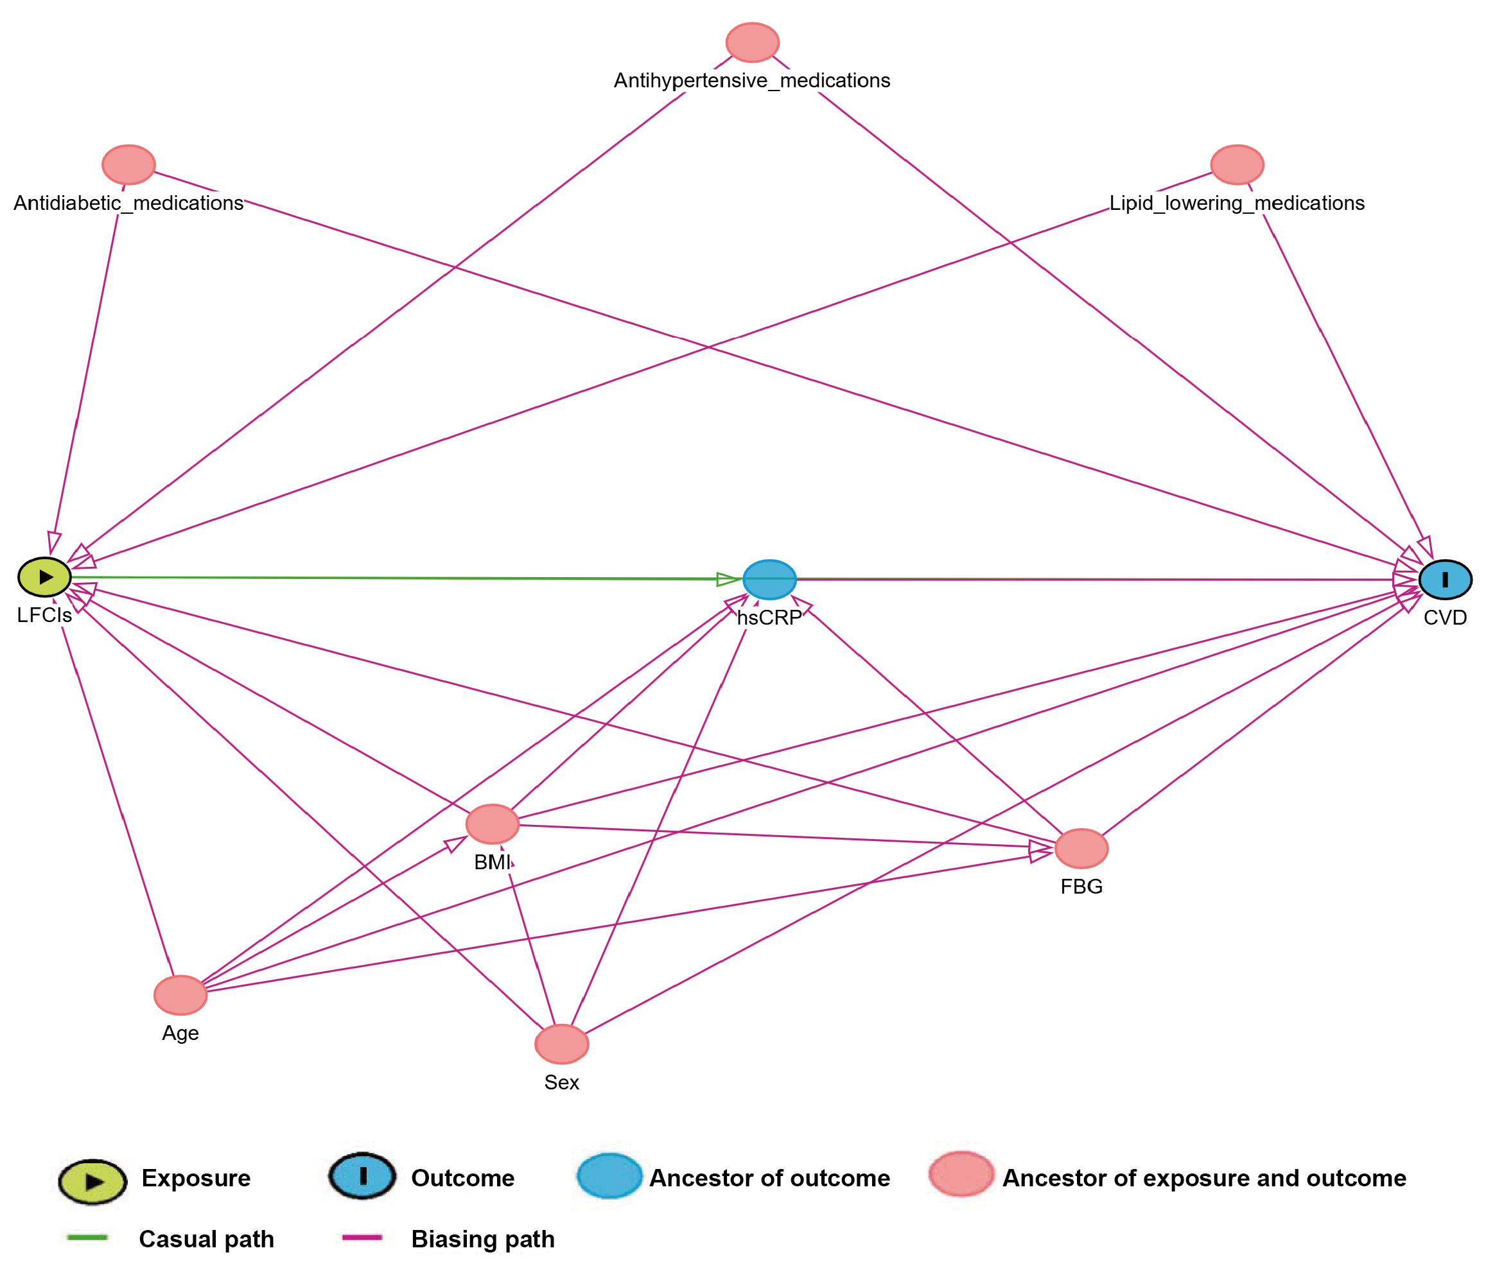

Supplementary Figure 2. Cumulative incidence curves of cardiovascular disease across tertiles of six LFCIs in the CHARLS cohort
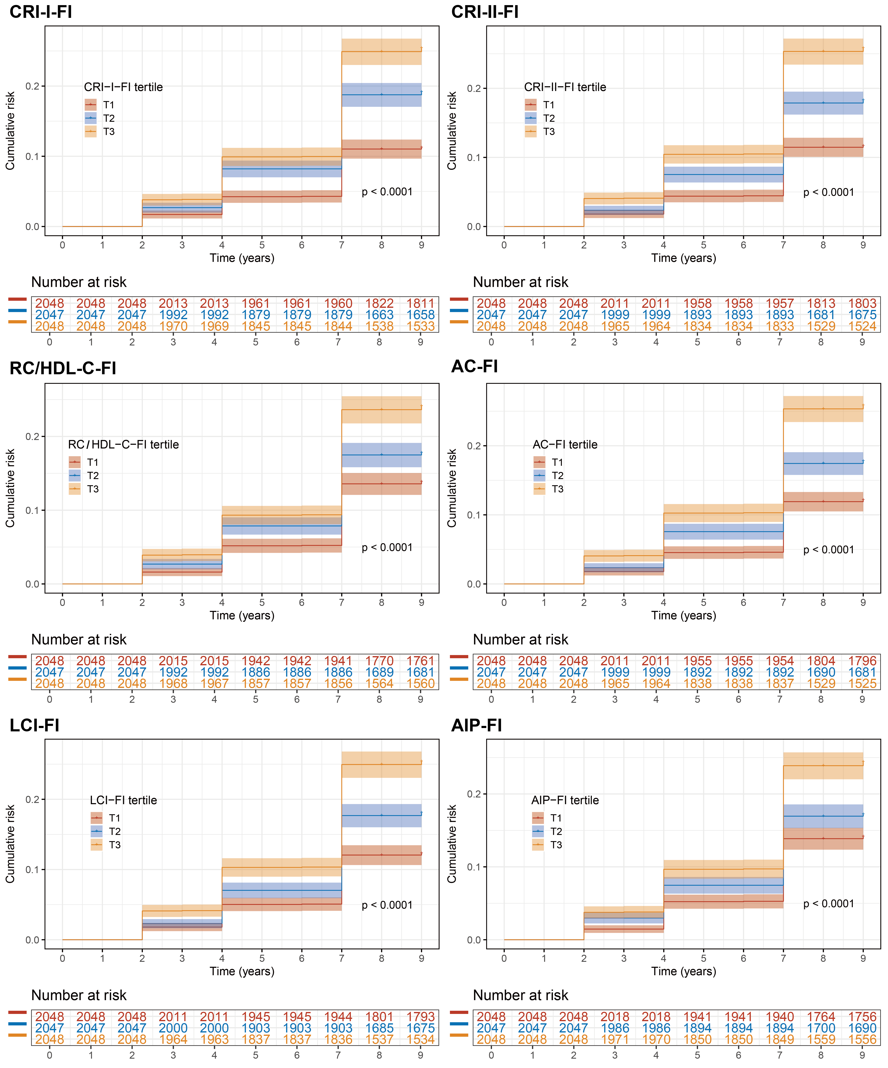

Supplementary Figure 3. Cumulative incidence curves of cardiovascular disease across tertiles of six LFCIs in the UKB cohort
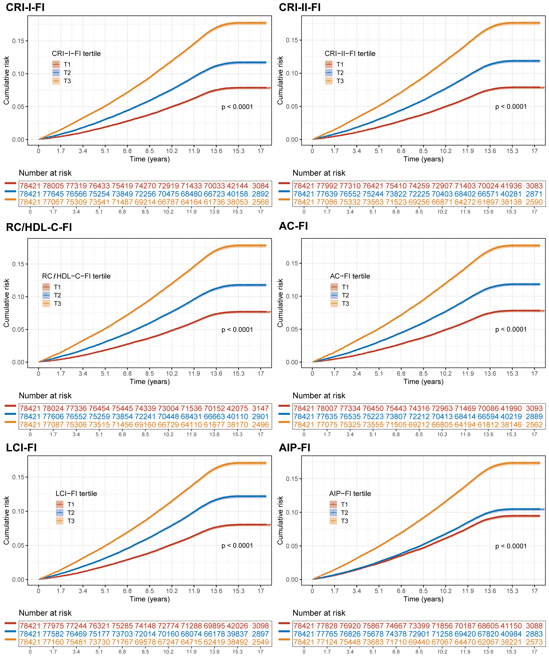

Supplementary Figure 4. Subgroup analysis of the association between LFCIs and incident CVD in the CHARLS cohort
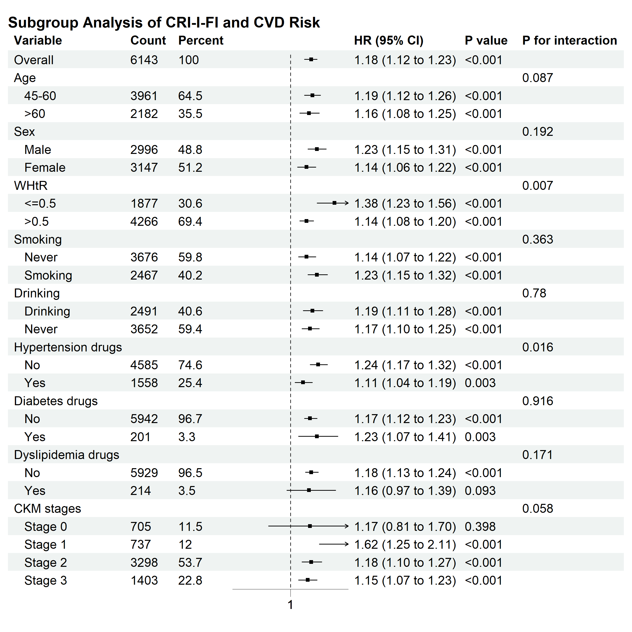
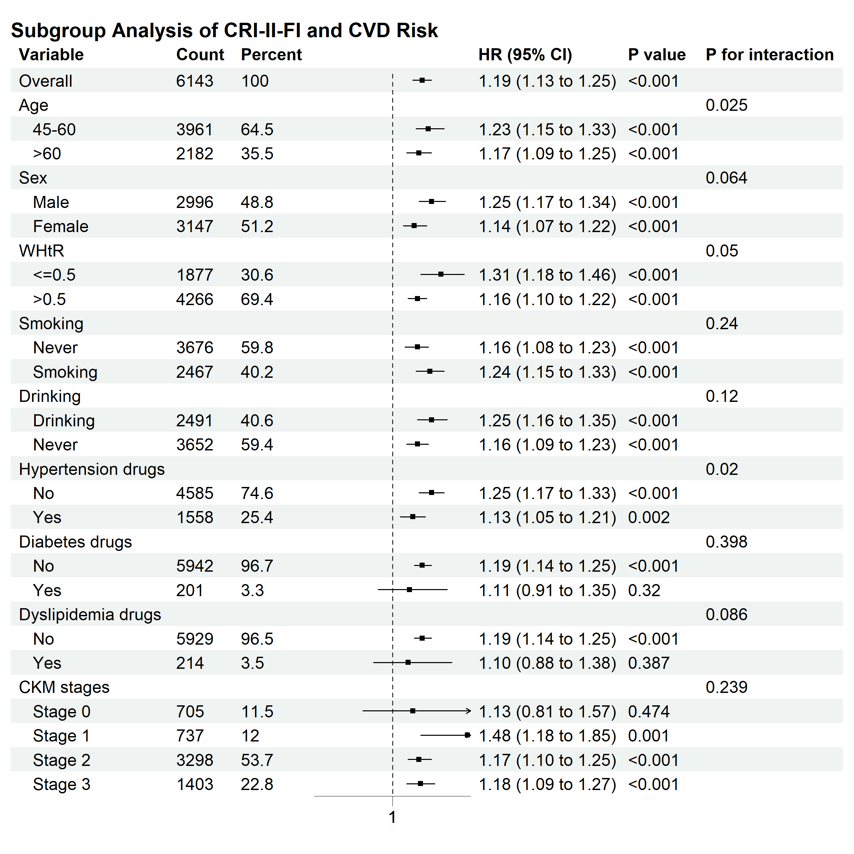
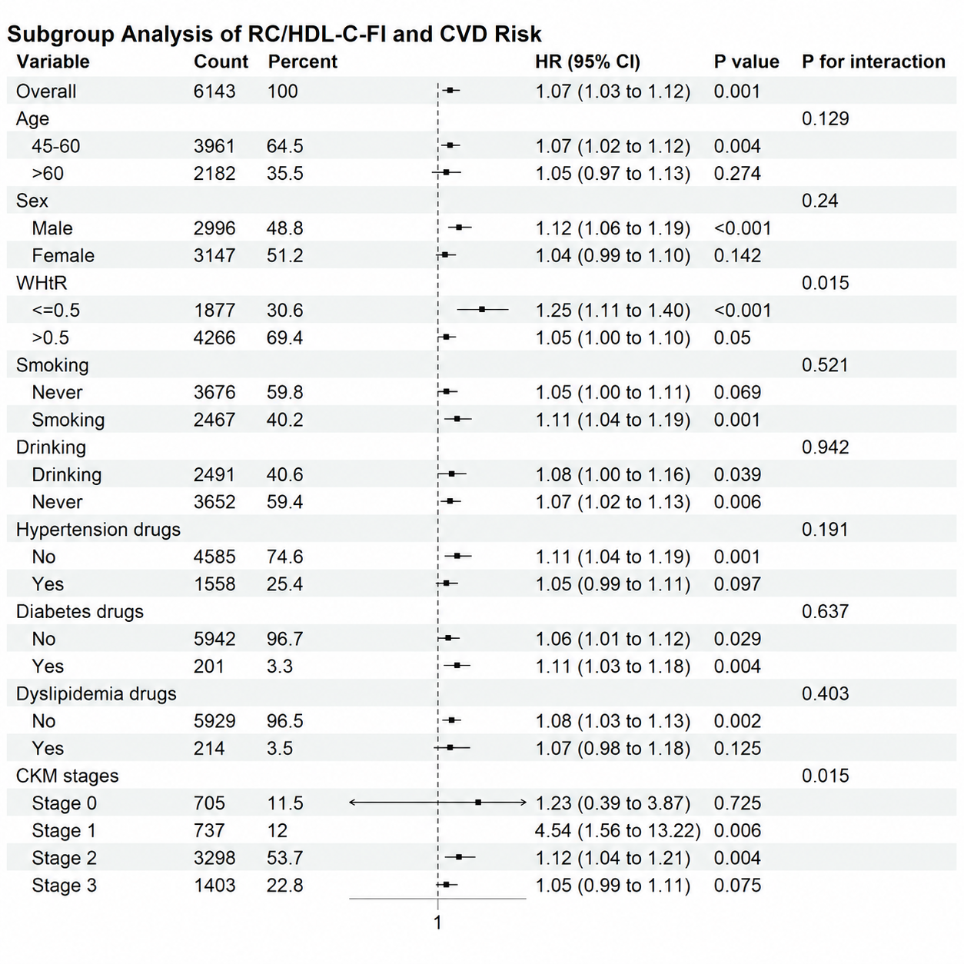

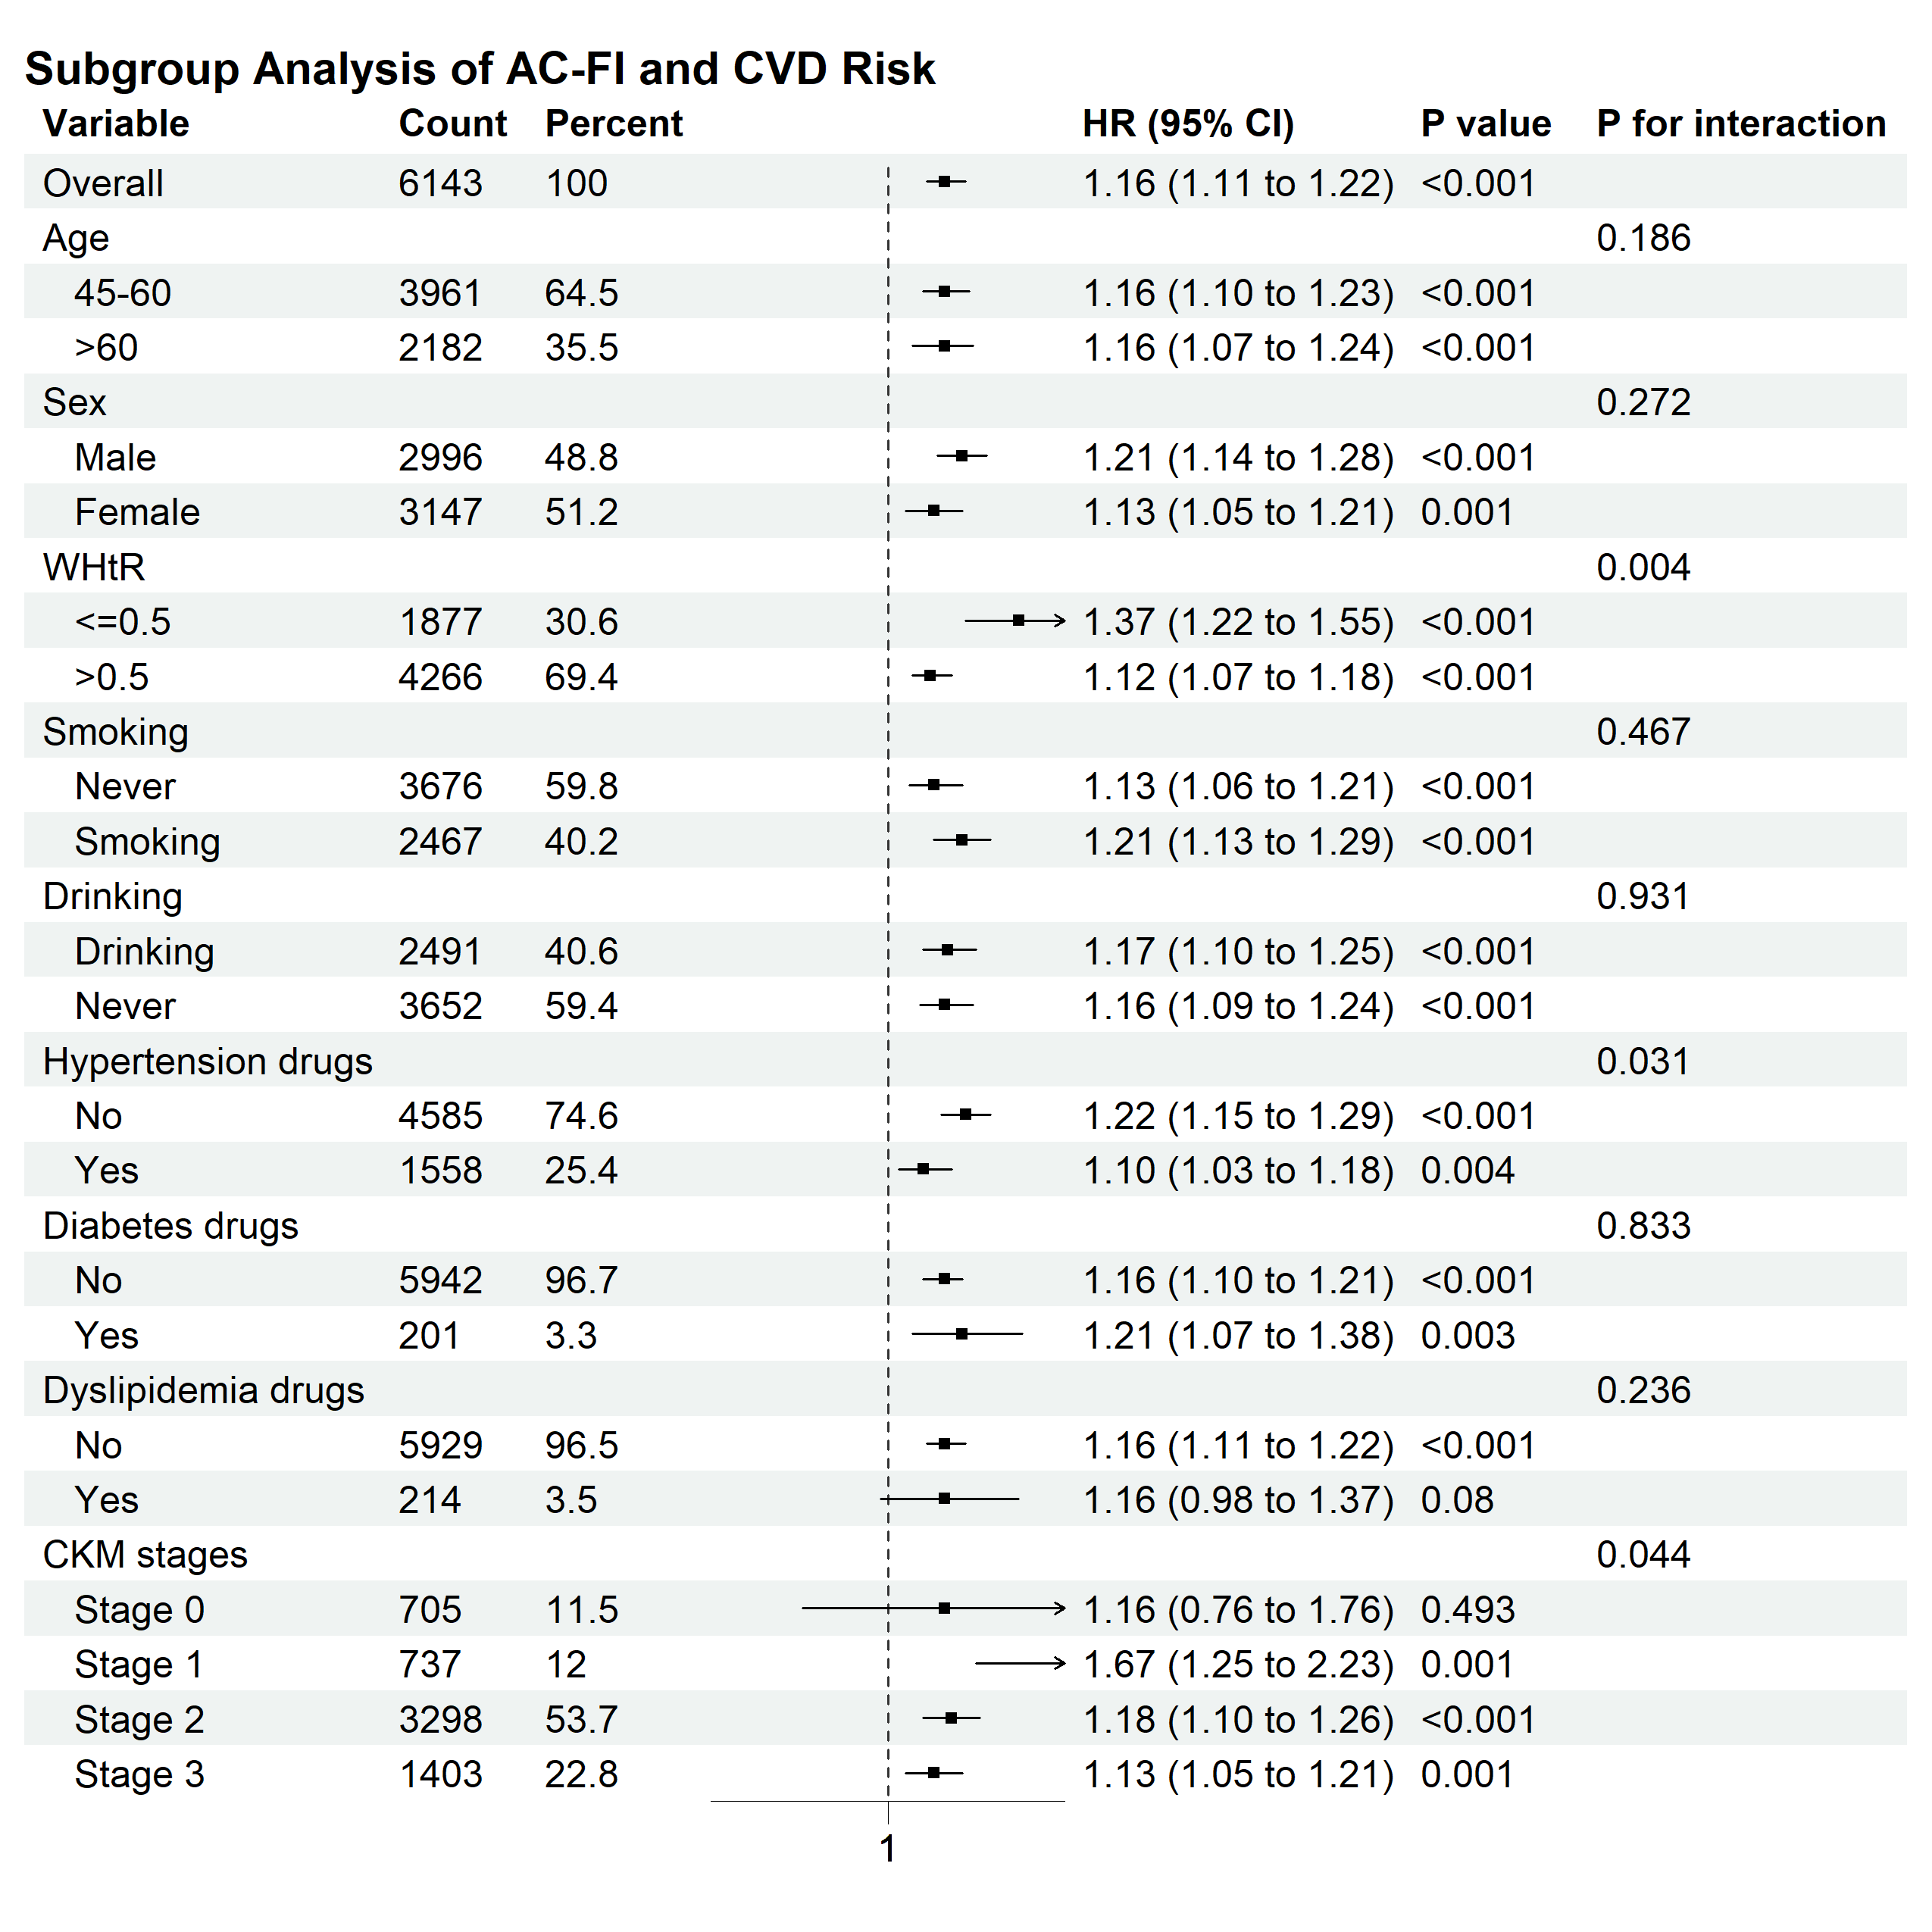
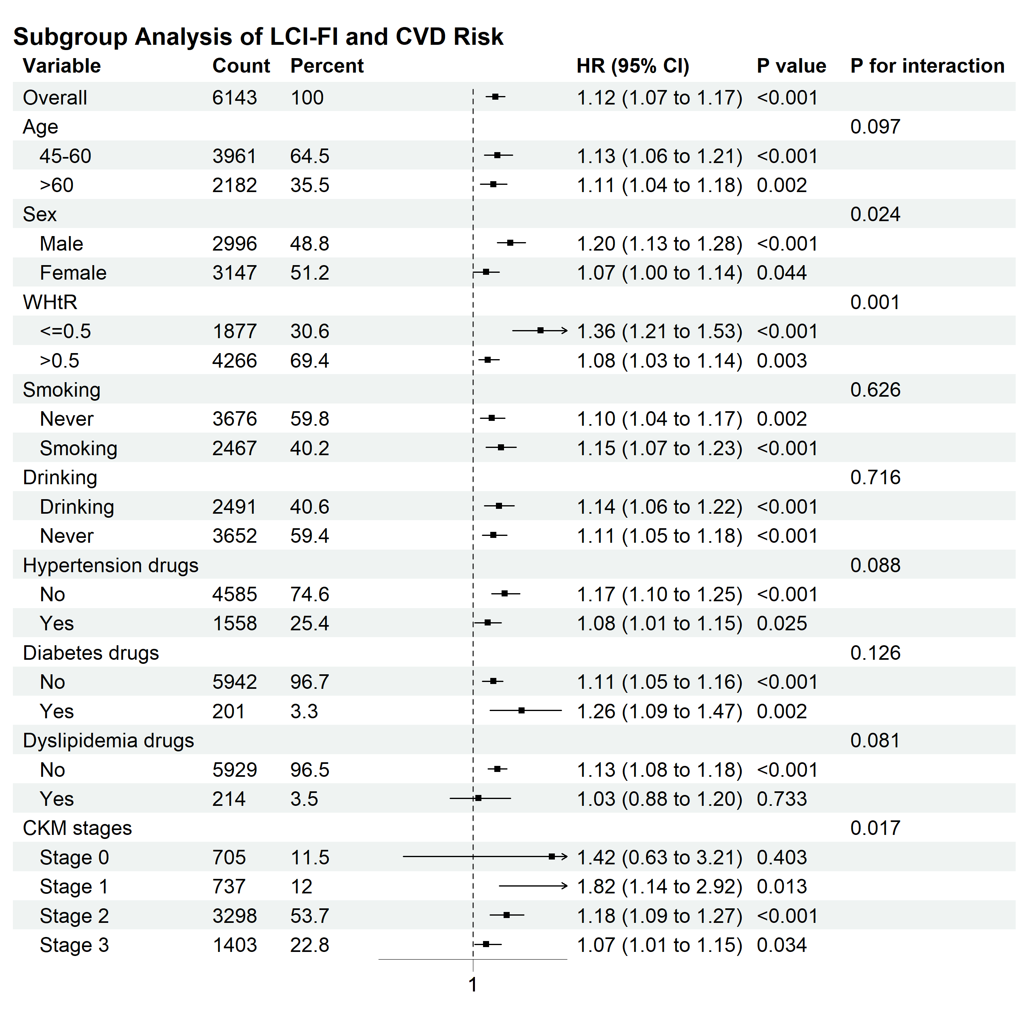
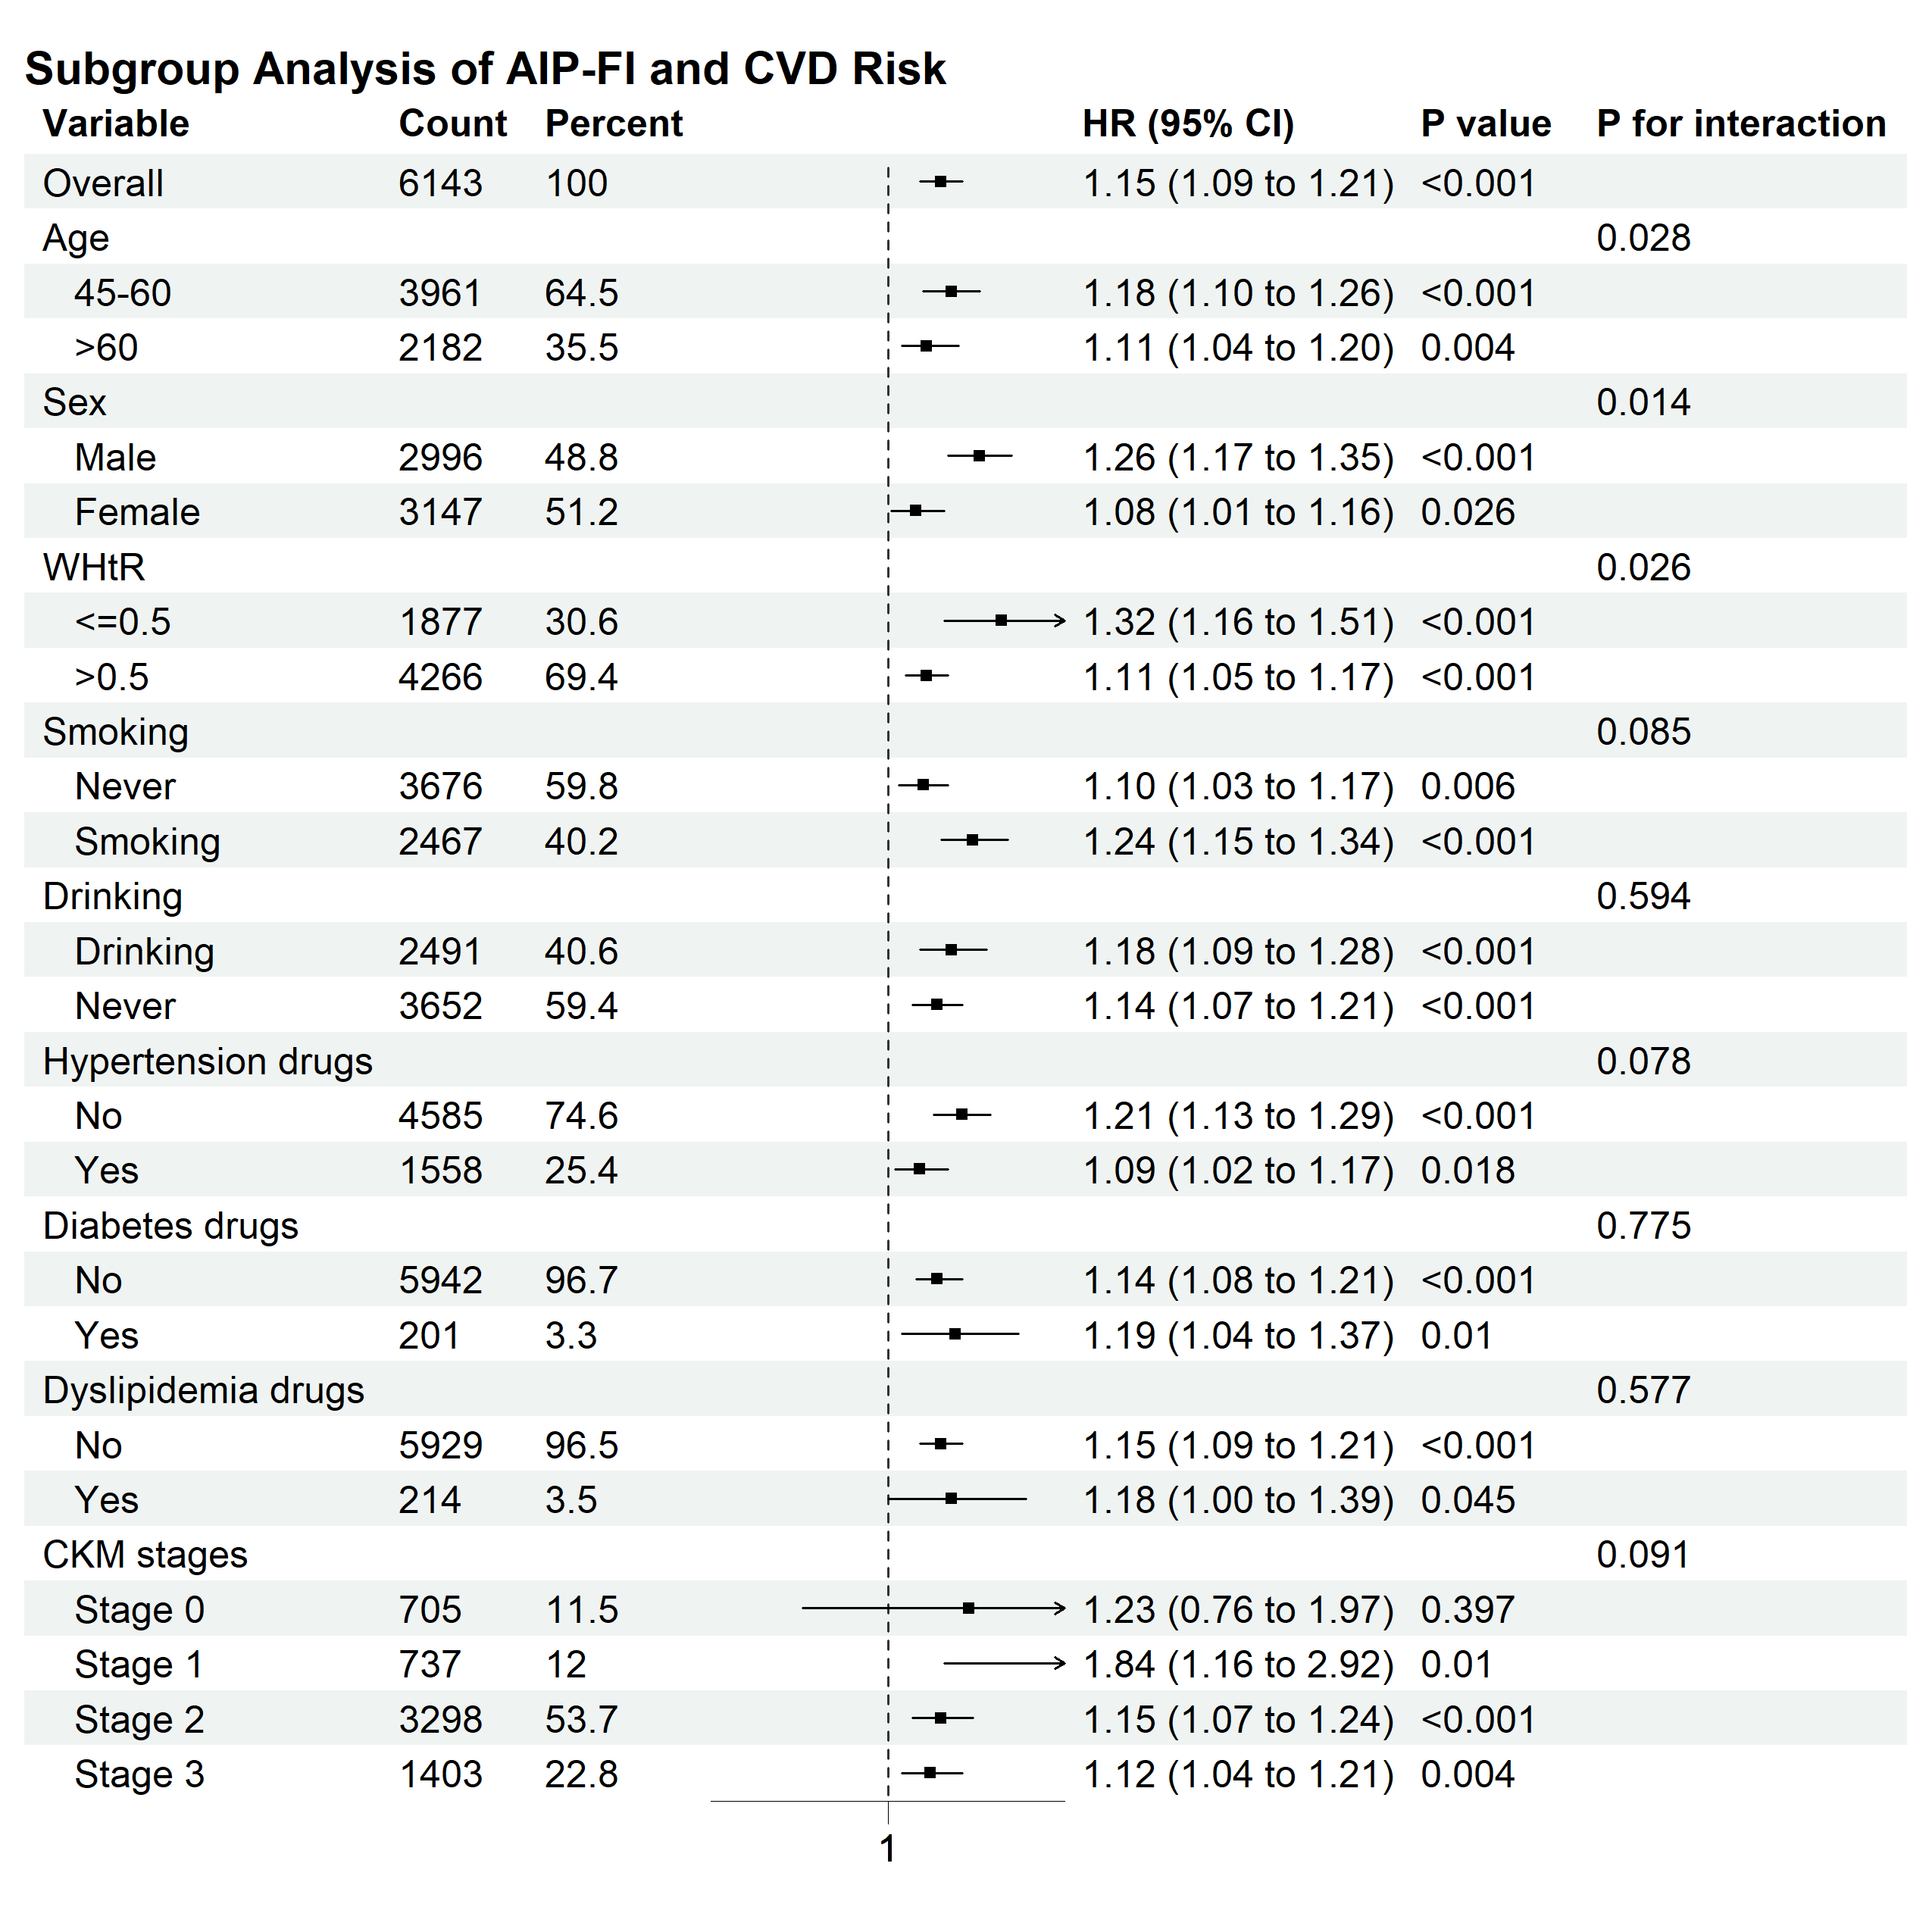

Supplementary Figure 5. Subgroup analysis of the association between LFCIs and incident CVD in the UKB cohort
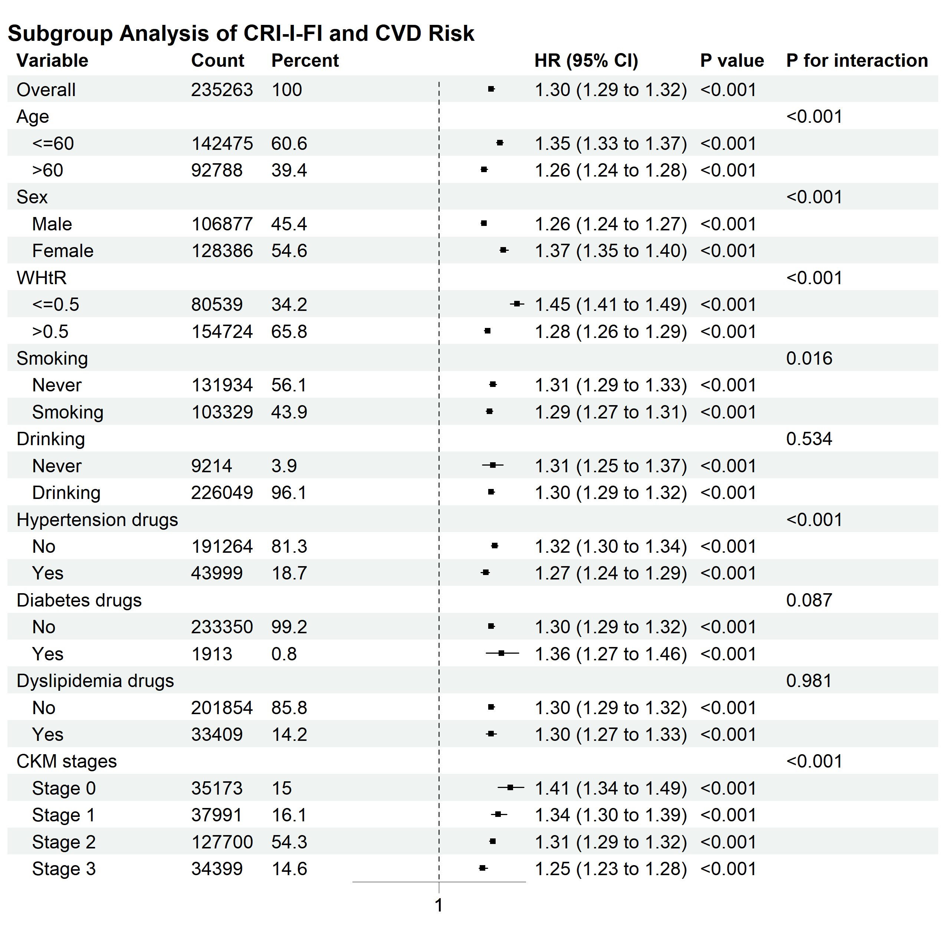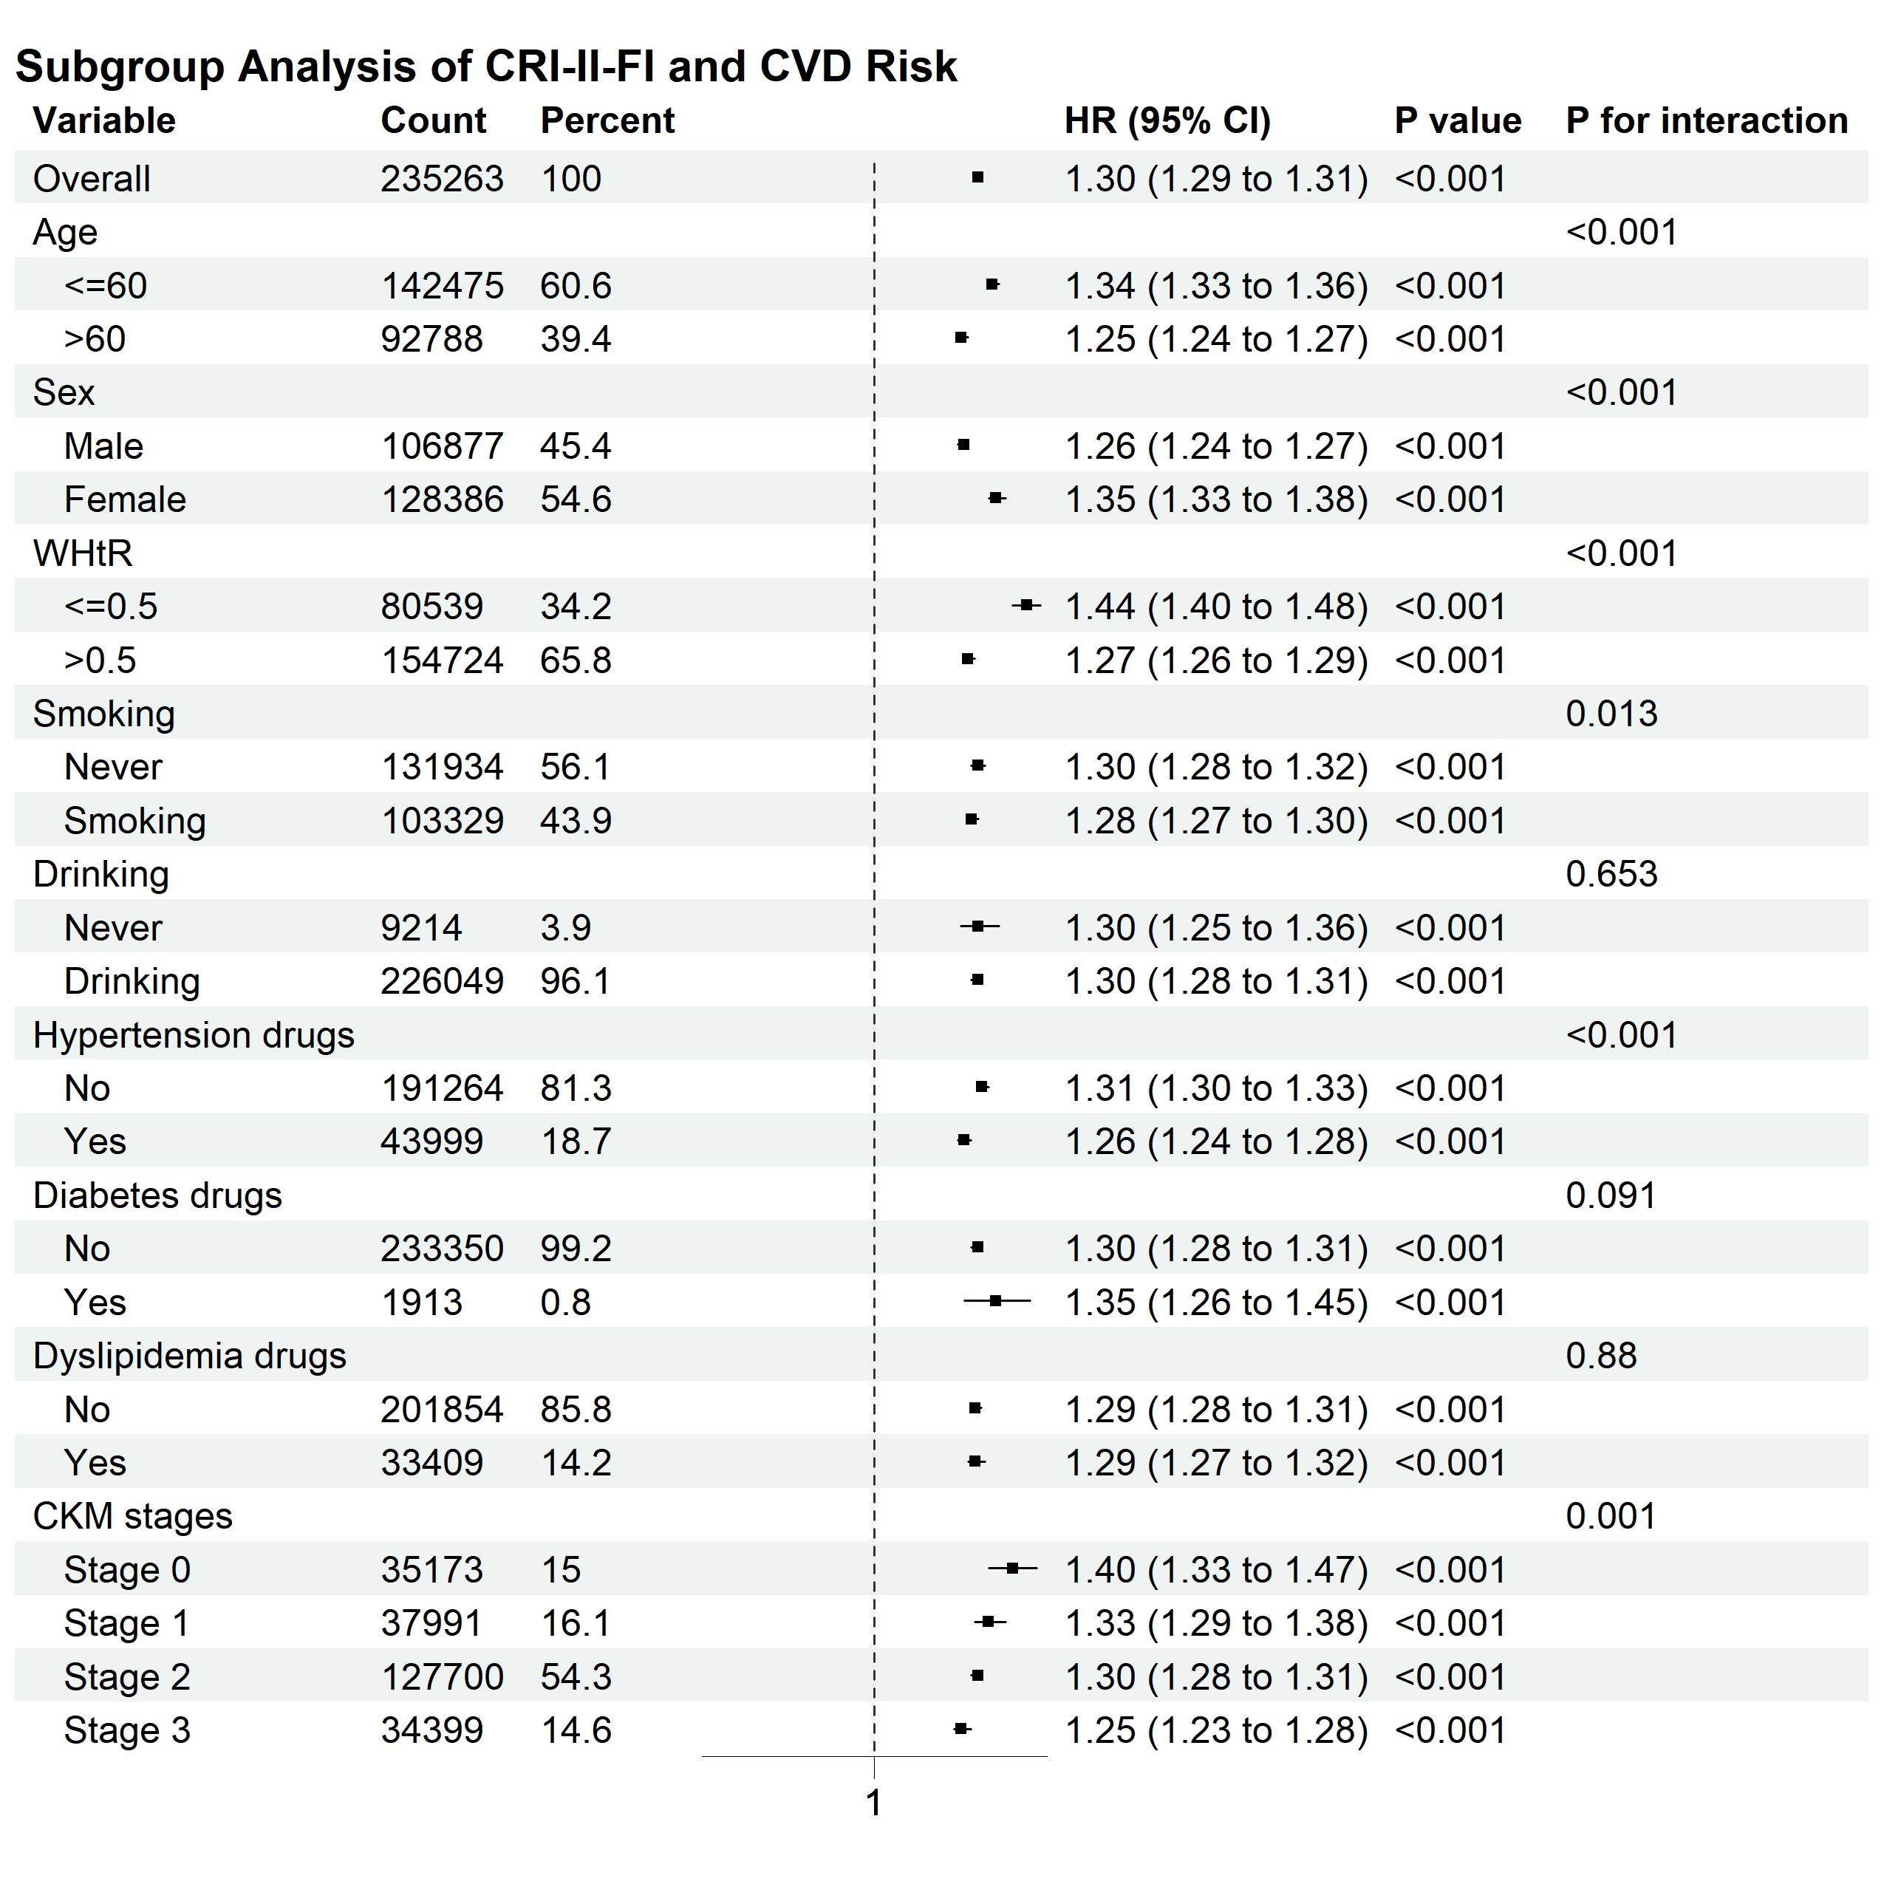
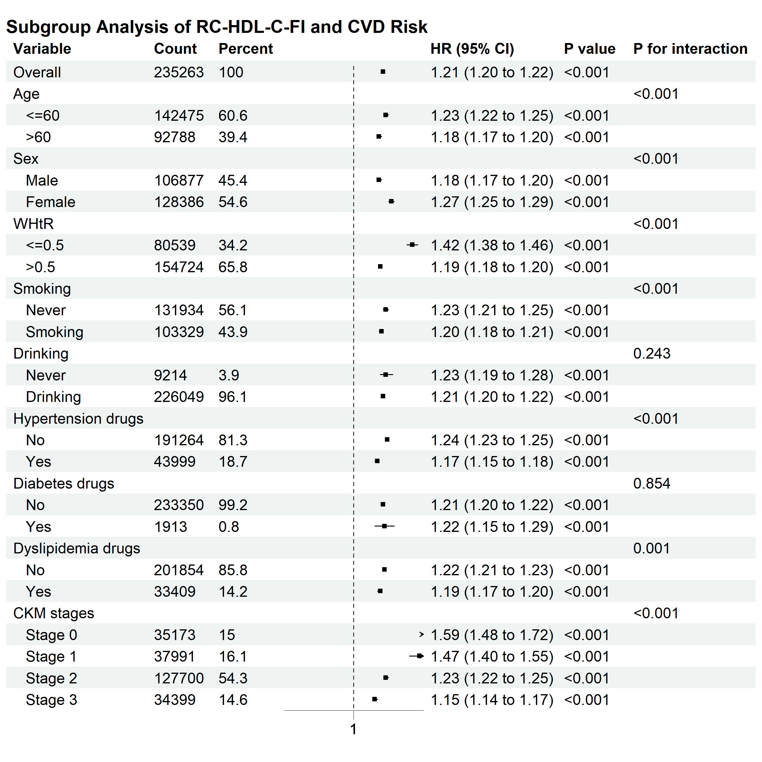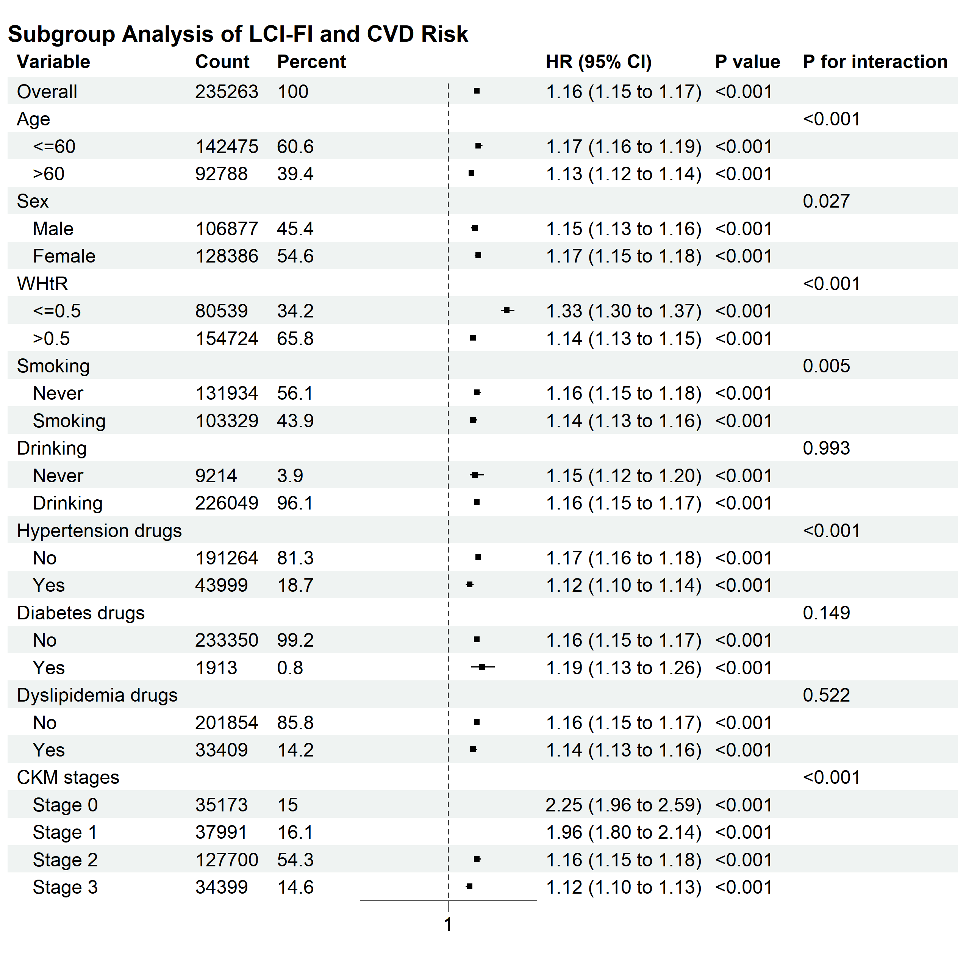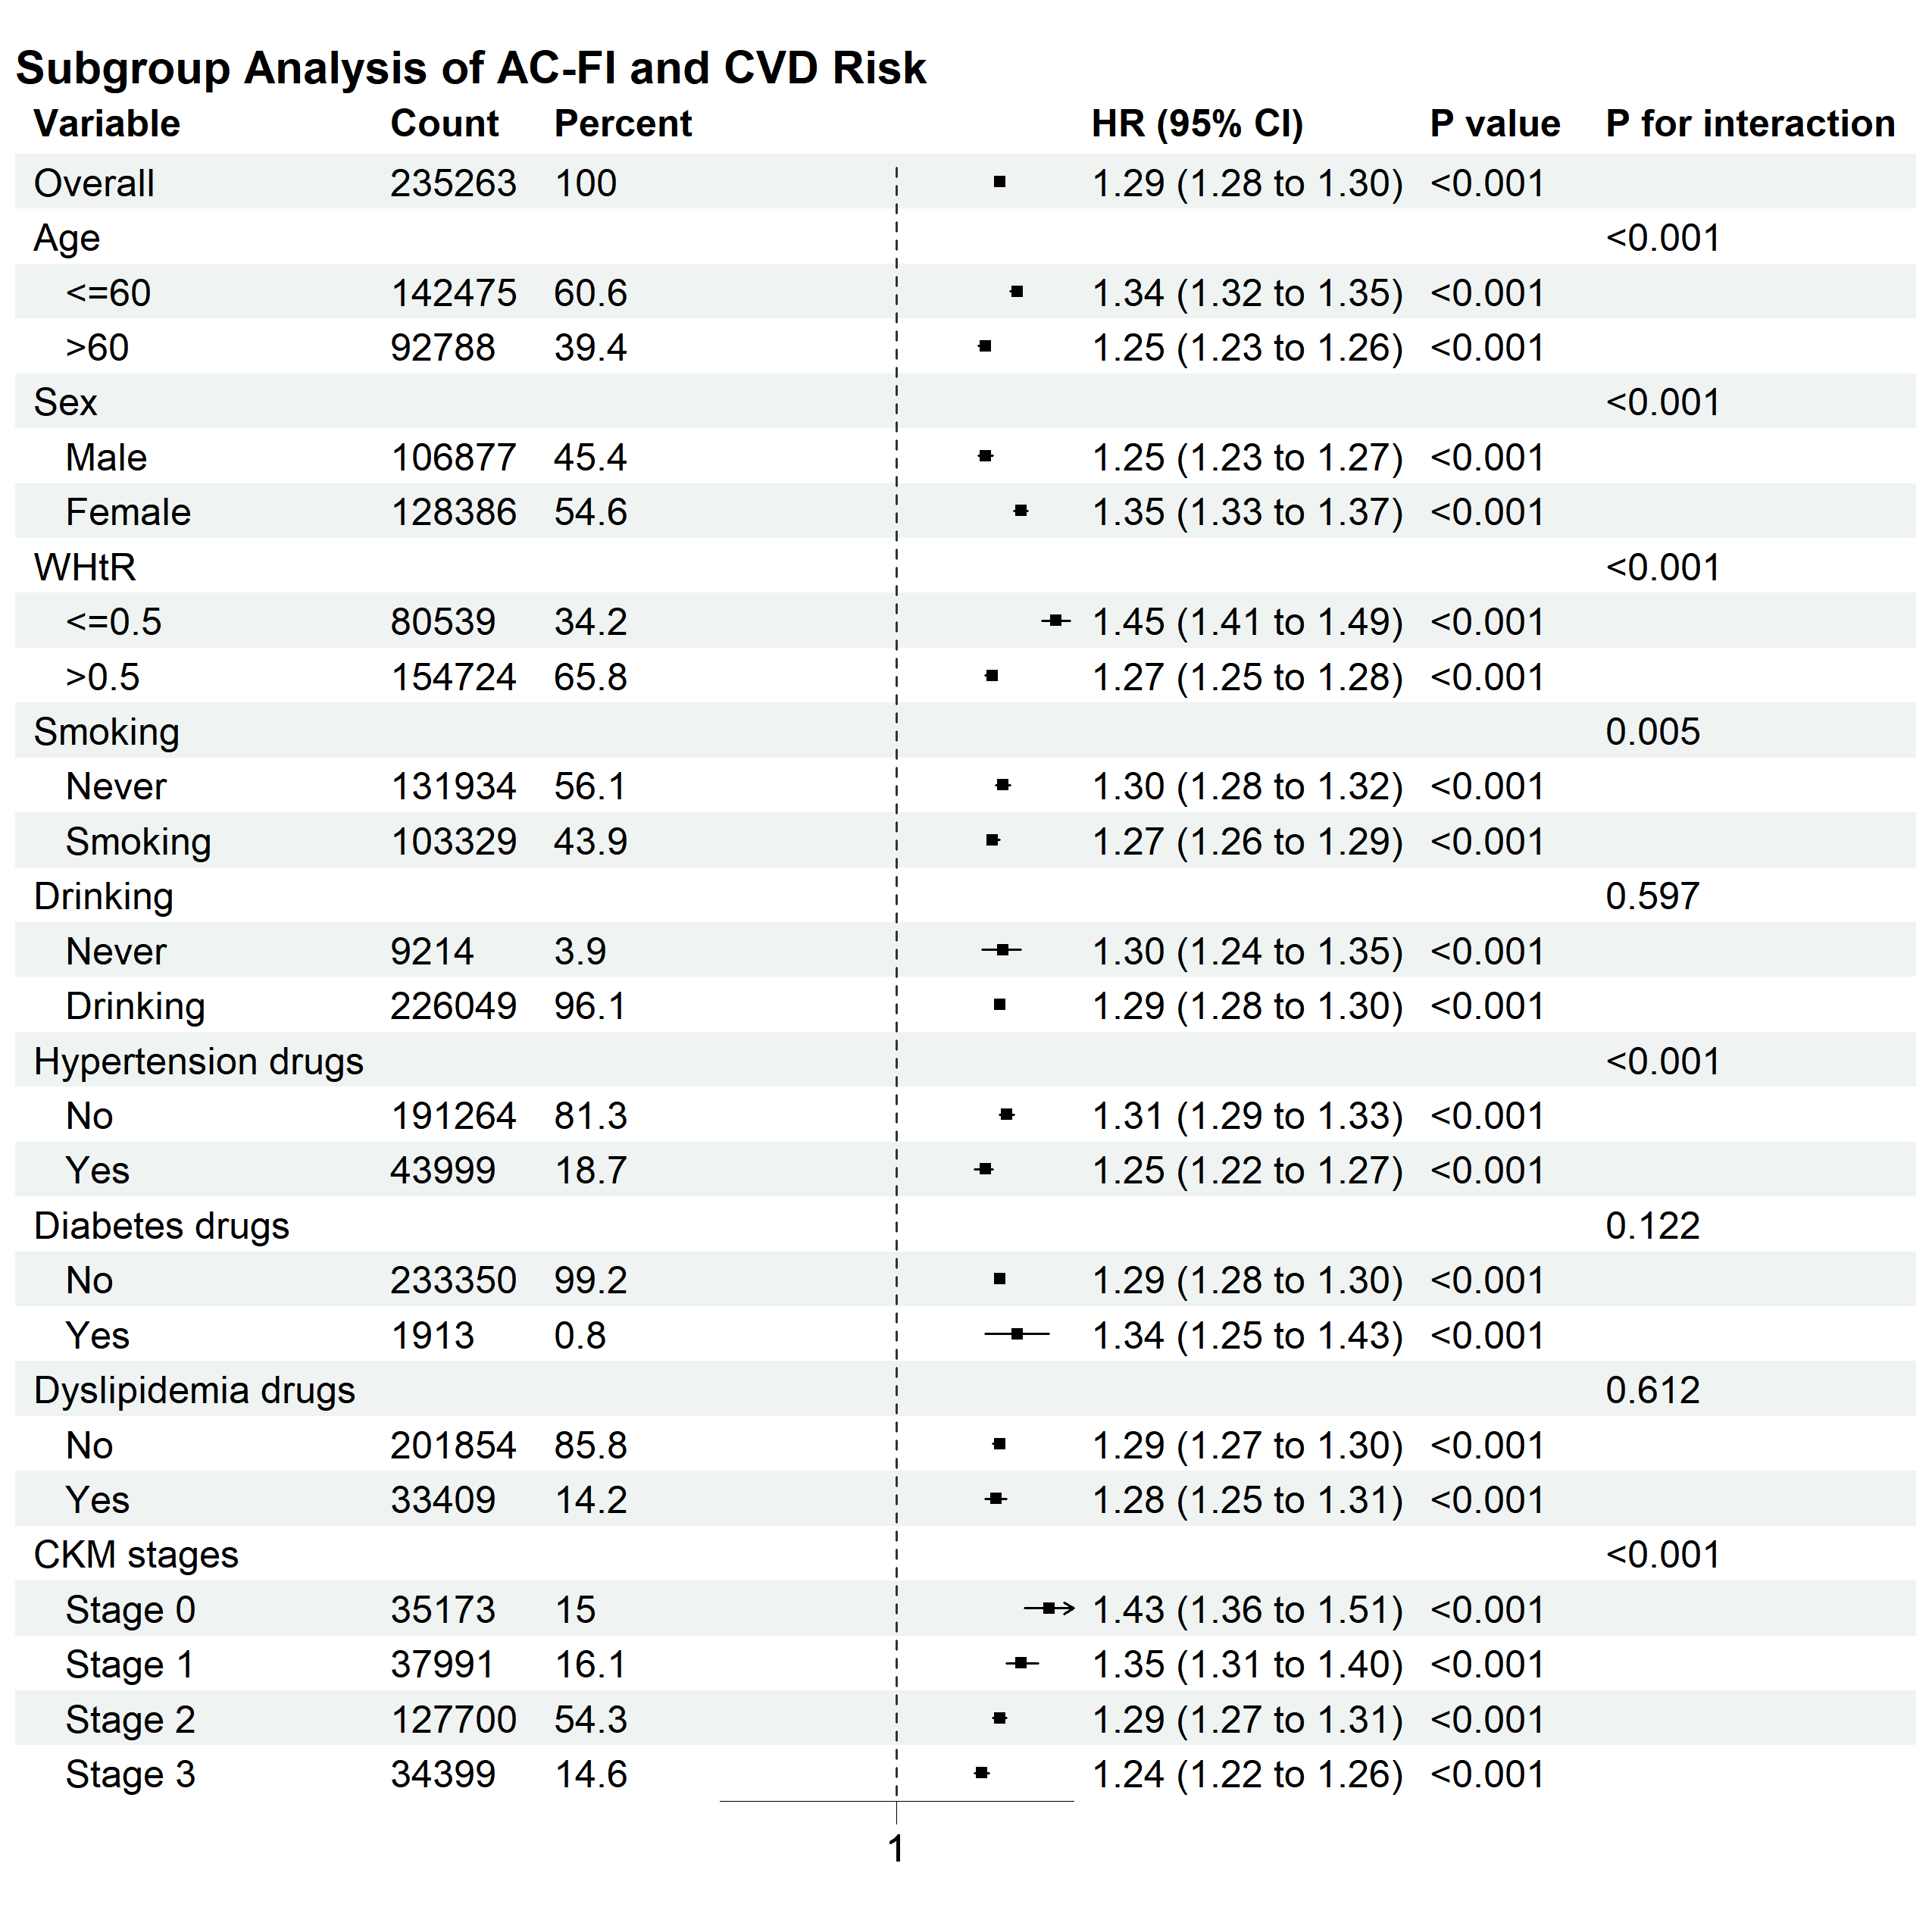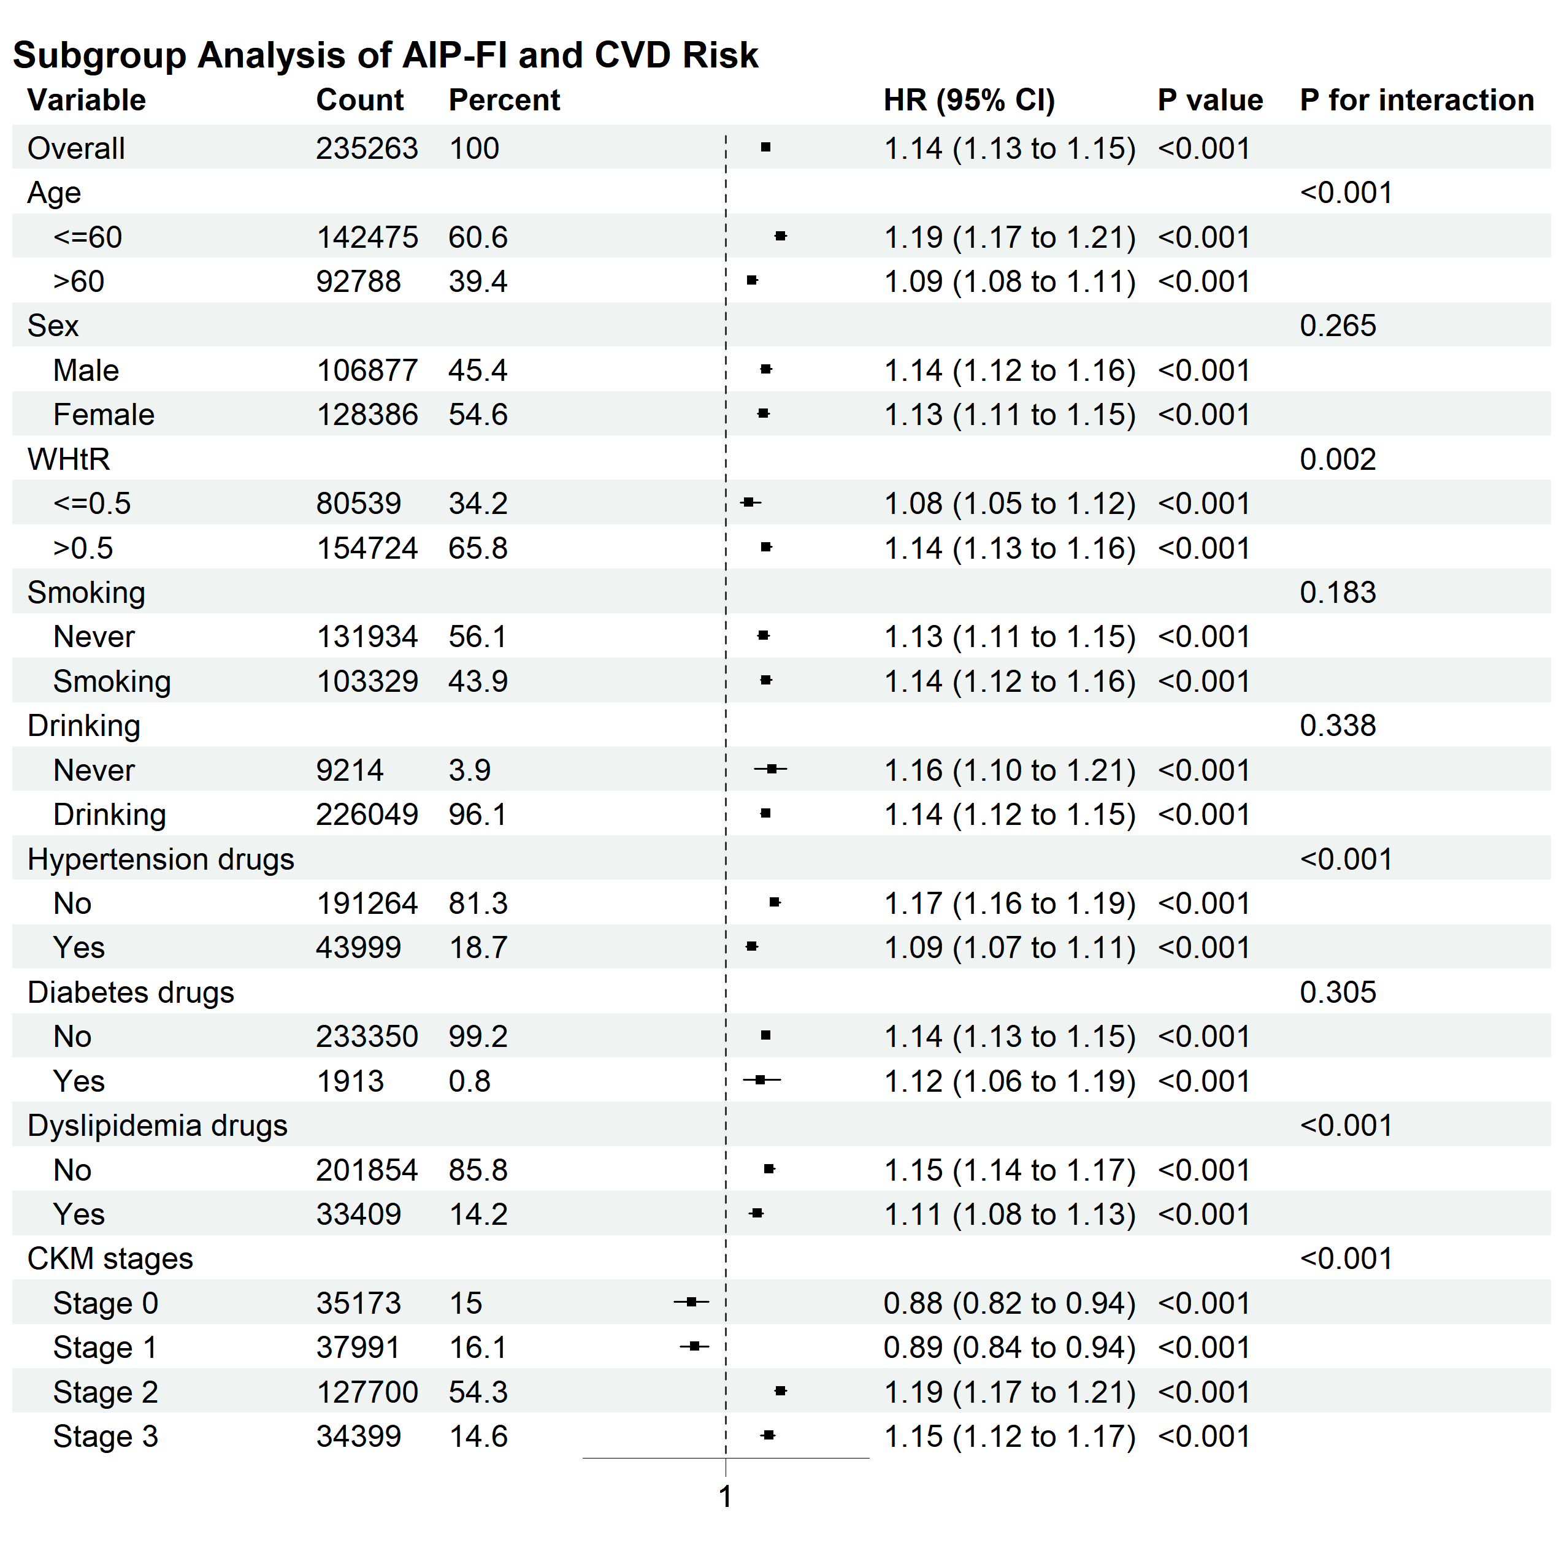

Supplementary Figure 6. Receiver operating characteristic curves for predicting CVD outcomes using baseline variables in the CHARLS and UKB cohorts
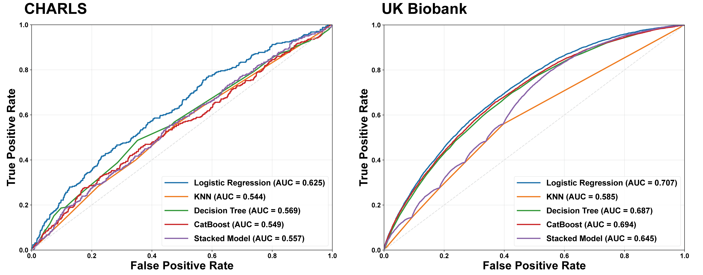

Supplementary Figure 7. Receiver operating characteristic curves of six lipid-based models for predicting incident CVD in the CHARLS cohort and in the UKB cohort.

