Supplementary Materials

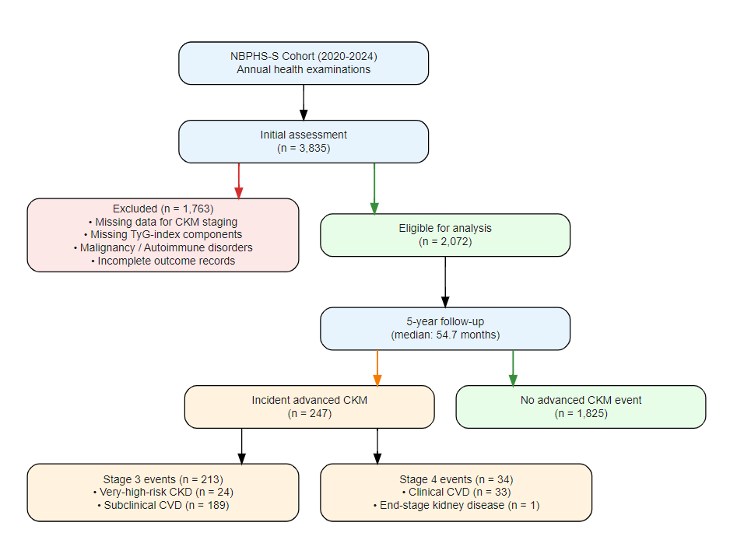
Supplementary Figure S1. Participant flow diagram. NBPHS-S, National Basic Public Health Service Screening; CKM, cardiovascular-kidney-metabolic; TyG, triglyceride-glucose; CVD, cardiovascular disease; CKD, chronic kidney disease; ESKD, end-stage kidney disease.

Table S1. Definitions of Cardiovascular-Kidney-Metabolic syndrome (CKMs) stages.

CKMs stages | Definition according to the AHA statements^{[1]} | Adapted definitions
Stage 0:  No CKMs risk factors | Normal BMI (< 23 kg/m), and  Normal waist circumference (<88/102 cm in women/men), and  Normoglycemia (fasting blood glucose<100 mg/dL or  glycated hemoglobin A_{1c}<5.7%), and  Normotension (systolic blood pressure<130 mmHg or diastolic blood pressure<80 mmHg), and  Normal lipid profile, and  No evidence of CKD or subclinical or clinical CVD | Normal BMI (< 24 kg/m²), and  Normal waist circumference (WC < 85/90 cm in women/men), and participants who didn’t have other metabolic risk factors and didn’t meet criteria for the other stages
Stage 1:  Excess or dysfunctional adiposity | Overweight/obesity (BMI≥25 kg/m², or ≥23 kg/m² if Asian ancestry), or  Abdominal obesity (waist circumference≥88/102 cm in women/men, or if Asian ancestry≥80/90 cm in women/men), or  Dysfunctional adipose tissue, or  Without the presence of other metabolic risk factors (fasting blood glucose 100-125 mg/dL or  glycated hemoglobin A_{1c} 5.7%-6.4%) or  CKD | Elevated BMI (BMI≥24 kg/m²), or  Elevated waist circumference (WC ≥ 85/90 cm in women/men), or  Prediabetes (defined as a fasting plasma glucose (FPG) of 6.1mmol/L to < 7.0 mmol/L)  Glycated hemoglobin A1c (HbA1c) was not available
Stage 2:  Metabolic risk factors and CKD | Metabolic risk factors (fasting serum triglycerides ≥135 mg/dL, hypertension: systolic blood pressure ≥130 mmHg or diastolic blood pressure ≥80 mmHg and/or use of antihypertensive medications, diabetes: fasting blood glucose≥126 mg/dL or glycated hemoglobin A_{1c}≥6.5% or use of anti-diabetes treatment, MetS), or CKD  MetS is defined by the presence of 3 or more of the following: (1) waist circumference≥88 cm for women and ≥102 cm for men (≥80 cm for women and ≥90 cm for men if Asian ancestry); (2) HDL cholesterol<40 mg/dL for men and <50 mg/dL for women; (3) triglycerides≥150 mg/dL; (4) elevated blood pressure (systolic blood pressure≥130 mmHg or diastolic blood pressure≥80 mmHg and/or use of antihypertensive medications); and (5) fasting blood glucose≥100 mg/dL | Metabolic risk factors, or moderate-to-high-risk CKD per Kidney Disease Improving Global Outcomes (KDIGO) criteria ^{[2]}, as recommended by the AHA  Qualifying metabolic risk factors included:  elevated fasting serum triglycerides (≥1.7 mmol/L), hypertension, diabetes (FBG ≥ 7.0 mmol/L or use of anti-diabetes treatment), or metabolic syndrome (≥3 of the following:  - elevated waist circumference (WC ≥ 85/90 cm in women/men)  - low high density lipoprotein cholesterol (HDL) level (HDL < 1.04 mmol/L)  - fasting serum triglycerides ≥ 1.7 mmol/L  - FPG ≥ 6.1mmol/L  - elevated blood pressure [systolic blood pressure≥130, diastolic blood pressure≥85 mmHg, and/or use of blood pressure-lowering medications])  CKD stages were identified based on GFR and urinary albumin-to-creatinine ratio
Stage 3:  Subclinical CVD in CKMs | Subclinical ASCVD or subclinical heart failure among individuals with excess/dysfunctional adiposity, other metabolic risk factors, or CKD  - Subclinical ASCVD to be principally diagnosed by coronary artery calcification (subclinical atherosclerosis by coronary catheterization/CT angiography also meets criteria)  - Subclinical heart failure diagnosed by elevated cardiac biomarkers (NT-proBNP≥125 pg/mL, hs-troponin T≥14 ng/L for women and ≥22 ng/L for men, hs-troponin I≥10 ng/L for women and ≥12 ng/L for men) or by echocardiographic parameters, with a combination of the 2 indicating highest HF risk  Risk equivalents of subclinical CVD  - Very high-risk CKD (stage G4 or G5 CKD or very high risk per Kidney Disease Improving Global Outcomes (KDIGO) classification)  - High predicted 10-year CVD risk | (1) Subclinical cardiovascular disease diagnosed by board-certified physicians (associate chief physician or above) based on instrumental examinations, including but not limited to:  Coronary artery calcification detected by cardiac CT; Abnormal echocardiographic parameters (e.g., left ventricular hypertrophy, reduced ejection fraction, elevated cardiac biomarkers); Carotid artery intima-media thickening.  (2) Very-high-risk chronic kidney disease (CKD), defined as eGFR < 30 mL/min/1.73 m² (KDIGO stages G4–G5) ^{[2]}. eGFR was calculated using the CKD-EPI 2021 equation^{[3]}.
Stage 4:  Clinical CVD in CKMs | Clinical CVD (coronary heart disease, heart failure, stroke, peripheral artery disease, atrial fibrillation) among individuals with excess/dysfunctional adiposity, other CKMs risk factors, or CKD | (1) Clinical cardiovascular disease diagnosed by board-certified physicians (associate chief physician or above) based on instrumental examinations and clinical evaluation, including but not limited to: coronary heart disease (confirmed by coronary angiography or CT angiography), heart failure (confirmed by echocardiography and clinical assessment), stroke (confirmed by brain CT or MRI), peripheral artery disease, or atrial fibrillation (confirmed by electrocardiography).  (2) End-stage kidney disease (ESKD) was defined as eGFR < 15 mL/min/1.73 m², calculated using the CKD‑EPI 2021 equation. Due to data limitations, kidney replacement therapy (hemodialysis, peritoneal dialysis, or kidney transplantation) was not available in the present dataset and was therefore not included in the definition. This corresponded to Stage 4b per AHA classification. eGFR was calculated using the CKD-EPI 2021 equation ^{[3]}.

Abbreviations: ASCVD, atherosclerotic cardiovascular disease; BMI, body mass index; CKD, chronic kidney disease; CKMs, cardiovascular-kidney-metabolic syndrome; CVD, cardiovascular disease; GFR, glomerular filtration rate; HDL, high-density lipoprotein cholesterol; MetS, metabolic syndrome

Supplementary Table S2. Hyperparameter settings for machine learning models.
Algorithm | Package | Phase | Hyperparameter Settings
Random Forest | ranger | Initial | num.trees = 500, mtry = floor(sqrt(p)), min.node.size = 10, max.depth = 8, probability = TRUE, importance = "impurity"
 |  | Final | num.trees = 500, mtry = ncol, min.node.size = 75, max.depth = 4, probability = TRUE, importance = "impurity"
XGBoost | xgboost | Initial | max_depth = 3, learning_rate = 0.1, nrounds = 100, objective = "binary:logistic"
 |  | Final | max_depth = 2, learning_rate = 0.05, nrounds = 200, lambda = 1, alpha = 0.5, subsample = 0.8, colsample_bytree = 0.8, objective = "binary:logistic"
LightGBM | lightgbm | Initial | num_leaves = 31, learning_rate = 0.1, nrounds = 100, objective = "binary", metric = "auc"
 |  | Final | num_leaves = 15, learning_rate = 0.05, nrounds = 200, lambda_l1 = 0.5, lambda_l2 = 1, feature_fraction = 0.8, bagging_fraction = 0.8, objective = "binary", metric = "auc"
MLP | nnet | Initial | size = 5, decay = 0.01, maxit = 200, trace = FALSE
AdaBoost | ada | Initial | iter = 50, nu = 0.1
Bagging | randomForest | Initial | ntree = 500, mtry = ncol
Note: p denotes the number of features in the current feature set. For the final phase, only the selected optimal model's hyperparameters were applied; parameters for non-selected algorithms are listed for completeness of the supplementary table.

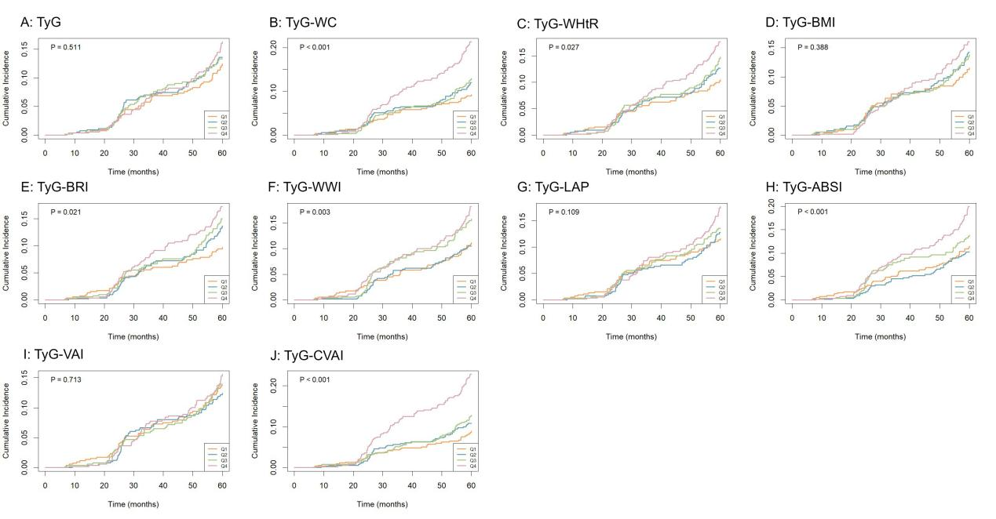

Supplementary Figure S2. Kaplan-Meier survival curves for advanced CKM syndrome by quartiles of TyG and TyG-related indices.

Supplementary Table S3. RCS statistics for TyG and TyG-derived indices with 5-year advanced CKM syndrome.
Index | P for overall | P for nonlinearity | Crossing points (HR = 1)
TyG | 0.038 | 0.172 | 7.983, 8.559
TyG-WC | <0.001 | 0.281 | 738.125
TyG-WHtR | <0.001 | 0.239 | 4.672
TyG-BMI | 0.027 | 0.803 | 203.614
TyG-BRI | <0.001 | 0.777 | 36.499
TyG-WWI | 0.004 | 0.282 | 95.919
TyG-CVAI | <0.001 | 0.562 | 961.192
TyG-ABSI | <0.001 | 0.037 | 0.651, 0.712
TyG-VAI | <0.001 | 0.268 | 14.095
TyG-LAP | <0.001 | 0.635 | 278.700

Supplementary Table S4. Baseline characteristics of participants stratified by the TyG-ABSI crossing points (0.651 and 0.712).
Variable | Overall  (N = 2072) | Low  (< 0.651) | Medium (0.651–0.712) | High  (> 0.712) | P-value
Overall | 2072 | 305 | 747 | 1020
Gender(%)
female | 1341 (64.7%) | 196 (64.3%) | 471 (63.1%) | 674 (66.1%) | 0.414
male | 731 (35.3%) | 109 (35.7%) | 276 (36.9%) | 346 (33.9%)
Age, years | 66.66 ± 7.00 | 64.66 ± 8.07 | 65.92 ± 6.97 | 67.81 ± 6.46 | <0.001
Smoke(%)
No | 1932 (93.2%) | 289 (94.8%) | 695 (93.0%) | 948 (92.9%) | 0.521
Yes | 140 (6.8%) | 16 (5.2%) | 52 (7.0%) | 72 (7.1%)
Drink(%)
No | 1946 (93.9%) | 287 (94.1%) | 700 (93.7%) | 959 (94.0%) | 0.954
Yes | 126 (6.1%) | 18 (5.9%) | 47 (6.3%) | 61 (6.0%)
Exercise(%)
never | 166 (8.0%) | 19 (6.2%) | 63 (8.4%) | 84 (8.2%) | 0.010
some | 59 (2.8%) | 18 (5.9%) | 17 (2.3%) | 24 (2.4%)
frequent | 1847 (89.1%) | 268 (87.9%) | 667 (89.3%) | 912 (89.4%)
Hypertension(%)
No | 1098 (53.0%) | 160 (52.5%) | 391 (52.3%) | 547 (53.6%) | 0.849
Yes | 974 (47.0%) | 145 (47.5%) | 356 (47.7%) | 473 (46.4%)
Diabetes(%)
No | 1761 (85.0%) | 252 (82.6%) | 641 (85.8%) | 868 (85.1%) | 0.418
Yes | 311 (15.0%) | 53 (17.4%) | 106 (14.2%) | 152 (14.9%)
BMI, kg/m2 | 23.74 ± 2.88 | 23.98 ± 2.94 | 23.76 ± 2.79 | 23.66 ± 2.92 | 0.235
WC, cm | 86.31 ± 8.20 | 79.82 ± 6.96 | 84.48 ± 7.09 | 89.59 ± 7.71 | <0.001
SBP, mmHg | 131.72 ± 7.54 | 130.19 ± 7.79 | 131.81 ± 7.63 | 132.12 ± 7.35 | <0.001
DBP, mmHg | 80.48 ± 6.08 | 80.09 ± 6.42 | 80.55 ± 6.17 | 80.54 ± 5.92 | 0.485
FBG, mmol/L | 5.03 [4.50, 5.73] | 4.67 [4.20, 5.35] | 4.84 [4.43, 5.40] | 5.25 [4.67, 6.11] | <0.001
T-CH, mmol/L | 5.02 [4.39, 5.68] | 4.85 [4.25, 5.56] | 4.98 [4.40, 5.66] | 5.13 [4.45, 5.81] | <0.001
TG, mmol/L | 1.27 [0.94, 1.74] | 0.86 [0.68, 1.08] | 1.12 [0.89, 1.47] | 1.58 [1.19, 2.09] | <0.001
HDL-C, mmol/L | 1.32 [1.11, 1.56] | 1.45 [1.23, 1.67] | 1.39 [1.15, 1.59] | 1.25 [1.07, 1.49] | <0.001
LDL-C, mmol/L | 3.16 [2.54, 3.76] | 3.03 ± 0.84 | 3.12 ± 0.89 | 3.21 [2.61, 3.81] | 0.002
eGFR, ml/min per 1.73 m2 | 98.05 [80.70, 117.62] | 100.46 [83.43, 119.55] | 98.02 [80.52, 116.38] | 96.87 [80.00, 117.62] | 0.154
Note: Data are presented as mean ± SD for normally distributed continuous variables, median [IQR] for non-normally distributed continuous variables, and n (%) for categorical variables. P-values were derived from one-way ANOVA for normally distributed continuous variables, Kruskal–Wallis tests for non-normally distributed continuous variables, and χ² tests (or Fisher's exact test when expected cell counts were < 5) for categorical variables.

Supplementary Table S5. Multiple comparison correction for Cox regression analyses of TyG-derived indices with advanced CKM syndrome (Model 2).
Index | HR (95% CI)† | Raw P | FDR-adjusted P | Bonferroni-adjusted P
TyG | 1.135 (2.733–3.601) | 0.041 | 0.041 | 0.408
TyG-WC | 1.286 (3.113–4.290) | <0.001 | <0.001 | 0.001
TyG-WHtR | 1.268 (3.060–4.210) | <0.001 | <0.001 | 0.002
TyG-BMI | 1.187 (2.853–3.839) | 0.007 | 0.008 | 0.069
TyG-BRI | 1.263 (3.050–4.185) | <0.001 | <0.001 | 0.002
TyG-WWI | 1.218 (2.916–4.001) | 0.003 | 0.004 | 0.028
TyG-LAP | 1.267 (3.086–4.153) | <0.001 | <0.001 | 0.001
TyG-ABSI | 1.212 (2.915–3.950) | 0.003 | 0.004 | 0.025
TyG-VAI | 1.278 (3.091–4.251) | <0.001 | <0.001 | 0.001
TyG-CVAI | 1.290 (3.136–4.290) | <0.001 | <0.001 | <0.001
Note: Cox proportional hazards regression was performed with each TyG-derived index modeled as a continuous variable (per 1-SD increase). Model 2 was adjusted for gender, age, smoke, drink, exercise. FDR, false discovery rate (Benjamini–Hochberg method); Bonferroni, Bonferroni correction. A two-sided P < 0.05 was considered statistically significant. † The HR (95% CI) values are presented as reported in the original analysis output; the wide confidence intervals reflect the per-1-SD scaling and the modest number of events.

Supplementary Table S6. Incremental predictive value of TyG and TyG-related indices for 5-year advanced CKM risk (Continuous NRI and IDI).
Index | Continuous NRI (95%CI) | P | IDI (95%CI) | P
Model clinical | Ref
+TyG | 0.121 (-0.038-0.265) | 0.120 | 0.004 (-0.000-0.014) | 0.084
+CVAI | 0.349 (0.200-0.480) | <0.001 | 0.008 (0.001-0.022) | 0.012
+TyG-WC | 0.263 (0.102-0.400) | <0.001 | 0.009 (0.001-0.021) | 0.024
+TyG-WHtR | 0.236 (0.086-0.370) | <0.001 | 0.007 (0.001-0.019) | 0.032
+TyG-BMI | 0.197 (0.037-0.352) | 0.008 | 0.005 (0.000-0.015) | 0.036
+TyG-BRI | 0.210 (0.059-0.378) | <0.001 | 0.006 (0.000-0.017) | 0.040
+TyG-WWI | 0.228 (0.090-0.359) | 0.004 | 0.005 (-0.000-0.016) | 0.056
+TyG-LAP | 0.284 (0.146-0.451) | <0.001 | 0.010 (0.001-0.023) | 0.008
+TyG-ABSI | 0.259 (0.103-0.388) | <0.001 | 0.005 (-0.000-0.017) | 0.060
+TyG-VAI | 0.228 (0.078-0.391) | <0.001 | 0.007 (0.001-0.022) | 0.012
+TyG-CVAI | 0.363 (0.198-0.493) | <0.001 | 0.009 (0.001-0.022) | 0.016
Note: Continuous net reclassification improvement (NRI) and integrated discrimination improvement (IDI) were calculated by adding each TyG or TyG-related index to the model clinical, which was adjusted for gender, age, smoke, drink, exercise, SBP, LDL-C, eGFR and baseline CKM stage (0, 1, or 2). Positive values indicate improved reclassification and discrimination. P-values were derived from bootstrap resampling (1,000 iterations).

Supplementary Table S7. Incremental predictive value of TyG and TyG-related indices for 5-year advanced CKM risk (Continuous NRI and IDI).
Index | Continuous NRI (95%CI) | P | IDI (95%CI) | P
Basic modle | Ref
+TyG | 0.084 (-0.048-0.224) | 0.224 | 0.003 (-0.000-0.012) | 0.128
+CVAI | 0.288 (0.166-0.446) | <0.001 | 0.009 (0.001-0.022) | 0.008
+TyG-WC | 0.235 (0.087-0.372) | 0.004 | 0.009 (0.002-0.021) | 0.012
+TyG-WHtR | 0.158 (0.042-0.314) | 0.008 | 0.008 (0.001-0.019) | 0.016
+TyG-BMI | 0.139 (0.009-0.299) | 0.040 | 0.005 (0.000-0.013) | 0.028
+TyG-BRI | 0.211 (0.060-0.369) | <0.001 | 0.007 (0.000-0.018) | 0.020
+TyG-WWI | 0.201 (0.064-0.352) | 0.004 | 0.005 (-0.000-0.015) | 0.052
+TyG-LAP | 0.259 (0.111-0.413) | <0.001 | 0.009 (0.001-0.022) | 0.008
+TyG-ABSI | 0.263 (0.121-0.399) | <0.001 | 0.005 (0.000-0.016) | 0.044
+TyG-VAI | 0.224 (0.091-0.382) | <0.001 | 0.008 (0.001-0.024) | 0.004
+TyG-CVAI | 0.296 (0.154-0.453) | <0.001 | 0.010 (0.002-0.023) | 0.012
Note: Continuous net reclassification improvement (NRI) and integrated discrimination improvement (IDI) were calculated by adding each TyG or TyG-related index to the base model (Model 2), which was adjusted for gender, age, smoke, drink, and exercise. Positive values indicate improved reclassification and discrimination. P-values were derived from bootstrap resampling (1,000 iterations).

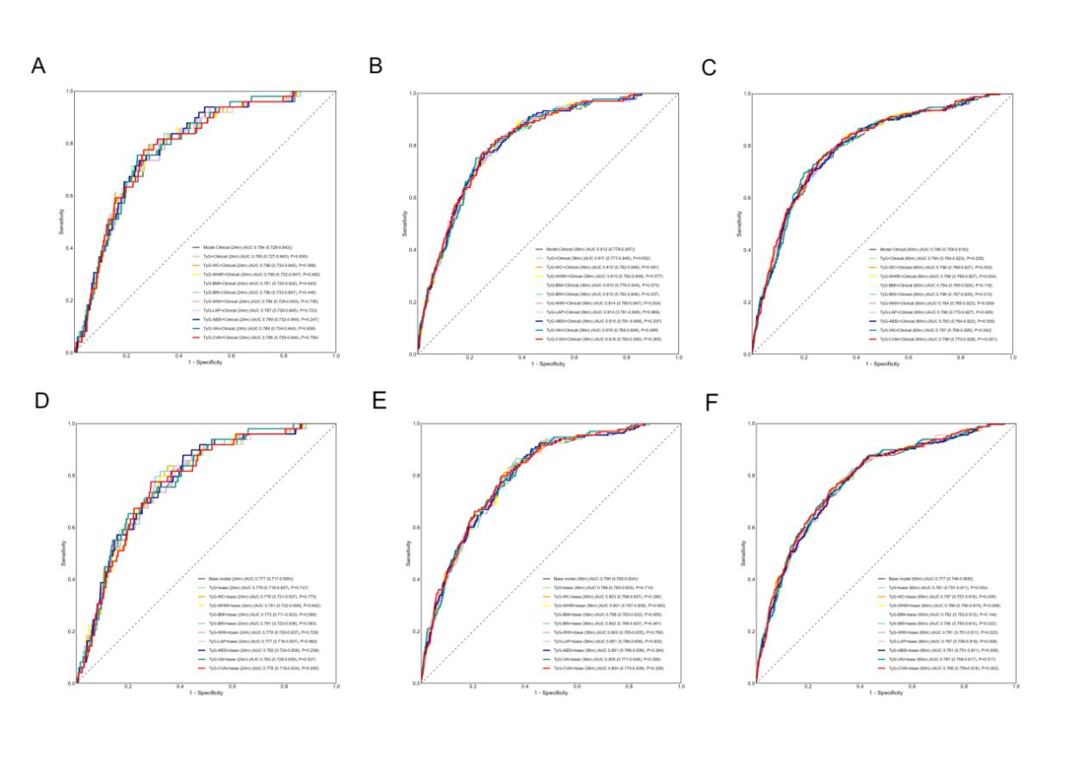

Supplementary Figure S3. Time-dependent ROC curves for TyG and TyG-related indices predicting 5-year advanced CKM syndrome. (A–C) Based on Model Clinical (adjusted for gender, age, smoke, drink, exercise, SBP, LDL-C, eGFR, and baseline CKM stage); (D–F) Based on Model 2 (adjusted for gender, age, smoke, drink, and exercise). Time points are 24, 36, and 60 months, respectively. The AUC of each index was calculated at each time point and compared with the corresponding reference model using DeLong tests.

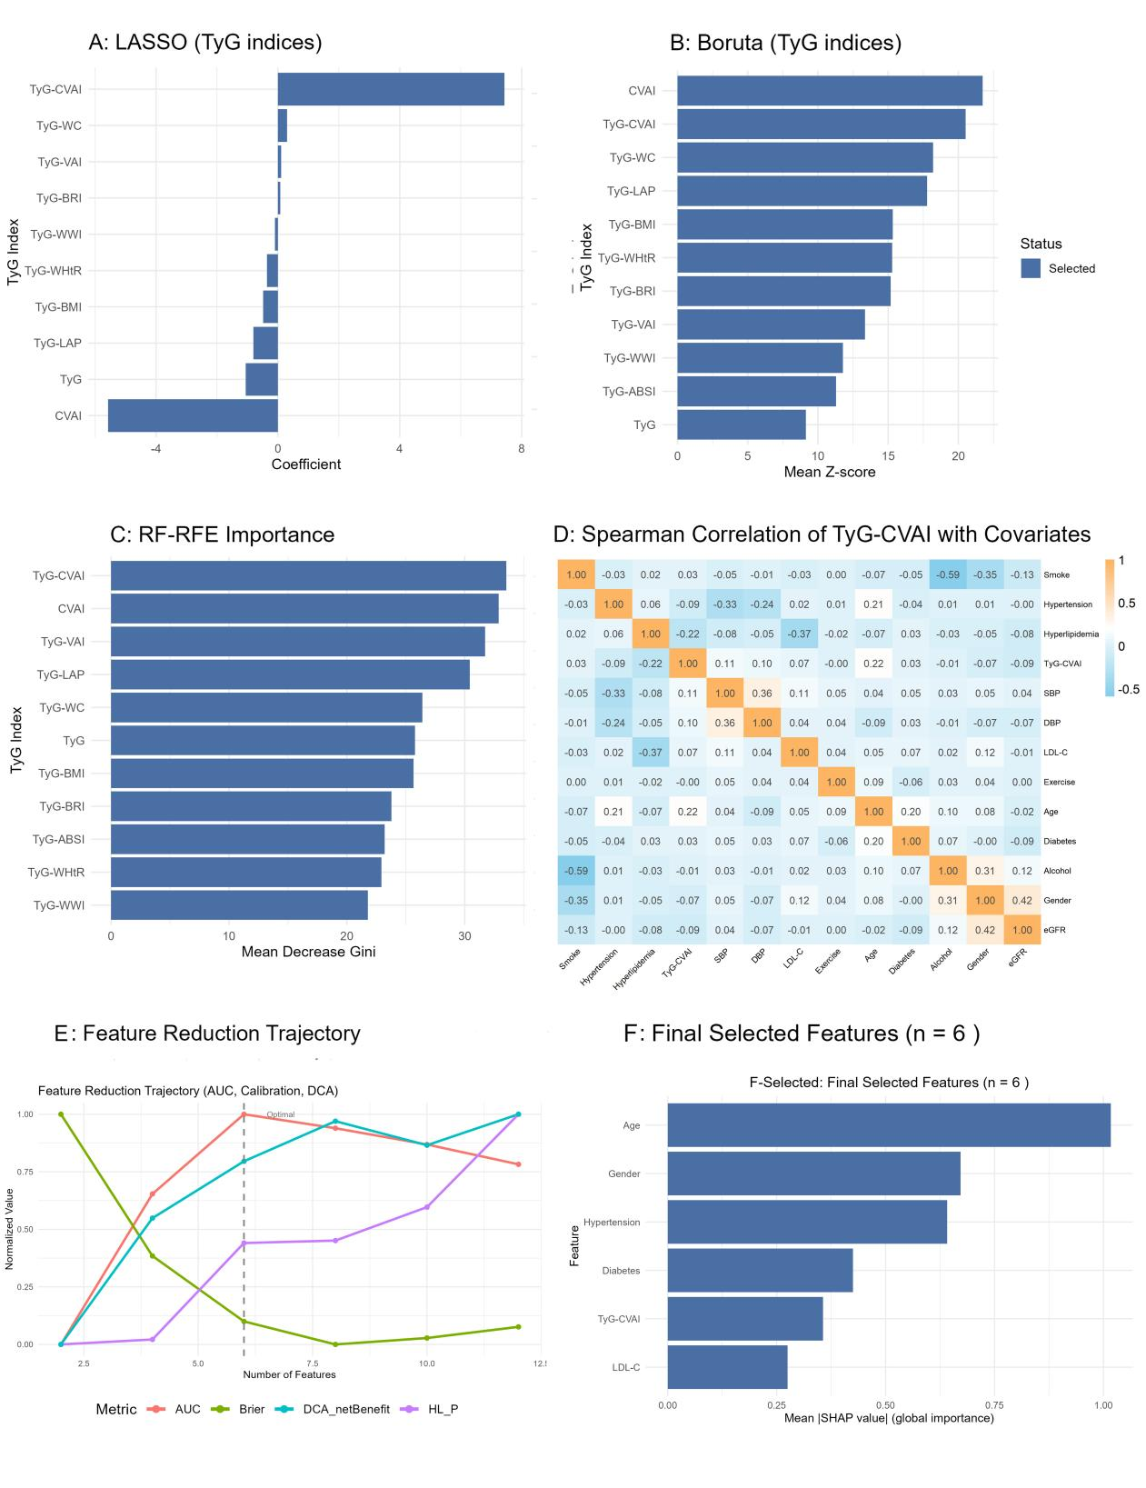
Supplementary Figure S4. Feature selection and importance assessment. (A) LASSO coefficient trajectories (10-fold cross-validation); (B) Boruta variable importance (Z-scores) with confirmed/rejected variables; (C) RF-RFE feature ranking based on mean decrease Gini; (D) Spearman correlation heatmap between the final selected features and key covariates (blue: negative, orange: positive), with |r| < 0.8 indicating no severe multicollinearity; (E) Feature reduction trajectory: the gray dashed line indicates the optimal feature subset (n = 6), selected at the AUC plateau with Brier score, HL-P, and DCA net benefit visualized as reference; (F) Final XGBoost model feature importance (impurity-based).

Supplementary Table S8. Feature selection stability across 1,000 bootstrap resamples.
Index | LASSO selection frequency (%) | Boruta selection frequency (%) | RF-RFE selection frequency (%) | Mean selection frequency (%)
TyG-CVAI | 100.0 | 100.0 | 100.0 | 100.0
TyG-LAP | 98.4 | 100.0 | 97.5 | 98.6
TyG-VAI | 94.9 | 100.0 | 99.3 | 98.1
CVAI | 89.2 | 100.0 | 100.0 | 96.4
TyG-WC | 85.2 | 100.0 | 89.6 | 91.6
TyG-BMI | 87.8 | 100.0 | 64.5 | 84.1
TyG | 89.8 | 100.0 | 59.4 | 83.1
TyG-BRI | 78.3 | 100.0 | 42.8 | 73.7
TyG-ABSI | 79.7 | 100.0 | 22.2 | 67.3
TyG-WWI | 89.2 | 100.0 | 10.9 | 66.7
TyG-WHtR | 74.0 | 100.0 | 13.8 | 62.6
Note: Bootstrap resampling (1,000 iterations) was performed within the training set. In each resample, LASSO (10-fold cross-validation), Boruta (50 random iterations), and RF-RFE were run separately. For RF-RFE, the number of top-ranked features selected was matched to the number of features selected by LASSO in the same resample. Selection frequency indicates the proportion of resamples in which each index was selected by the corresponding method. Mean selection frequency is the average across the three methods. TyG-CVAI was selected in 100% of resamples by all three methods, demonstrating the highest stability.

Supplementary Table S9. Predictive performance of machine learning models on the test set.
Model | AUC (95% CI) | Accuracy | Precision | Recall | F1 | DeLong P
MLP | 0.854 (0.813-0.895) | 0.699 | 0.284 | 0.899 | 0.432 | 0.376
XGB | 0.839 (0.796-0.883) | 0.752 | 0.321 | 0.848 | 0.465 | Ref
AdaBoost | 0.830 (0.783-0.877) | 0.816 | 0.383 | 0.722 | 0.500 | 0.357
LGB | 0.827 (0.781-0.873) | 0.778 | 0.337 | 0.772 | 0.469 | 0.319
RF | 0.822 (0.773-0.871) | 0.783 | 0.337 | 0.734 | 0.462 | 0.058
Bagging | 0.798 (0.739-0.857) | 0.845 | 0.427 | 0.633 | 0.510 | 0.013

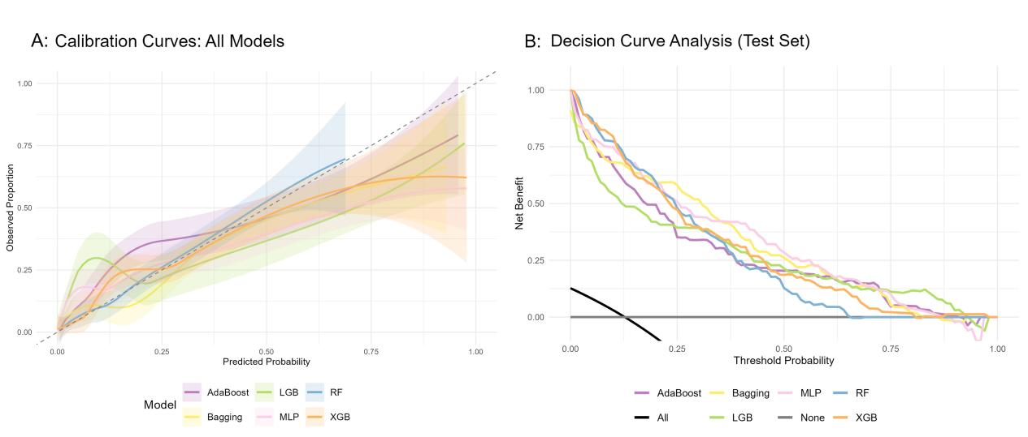
Supplementary Figure S5. Calibration curves with Hosmer‑Lemeshow P‑values and Brier scores across all six models. Calibration curves for MLP, XGBoost, AdaBoost, LightGBM (LGB), Random Forest (RF), and Bagging are shown. The diagonal dashed line represents perfect calibration. H‑L P‑values: RF = 0.568, XGBoost = 0.200, and <0.001 for MLP, AdaBoost, LGB, and Bagging. Brier scores: MLP = 0.089, XGBoost = 0.084, AdaBoost = 0.090, LGB = 0.089, RF = 0.087, and Bagging = 0.088.
Supplementary Table S10. Brier scores and pairwise comparisons versus XGBoost across all machine learning models.
Model | Brier score (95% CI) | Mean difference vs XGB (95% CI) † | P value
XGB | 0.084 (0.068–0.099) | Ref | Ref
RF | 0.087 (0.072–0.102) | −0.003 (−0.007 to 0.001) | 0.144
LGB | 0.089 (0.070–0.107) | −0.005 (−0.013 to 0.002) | 0.158
MLP | 0.089 (0.072–0.106) | −0.005 (−0.015 to 0.006) | 0.350
AdaBoost | 0.090 (0.072–0.107) | −0.006 (−0.011 to −0.001) | 0.024
Bagging | 0.088 (0.072–0.103) | −0.004 (−0.010 to 0.003) | 0.234
Note: Brier scores were calculated on the independent test set. The 95% confidence intervals (CIs) were derived from 1,000 bootstrap resamples (random seed = 2024). † Mean difference = Brier score of XGBoost minus Brier score of the comparator; negative values indicate lower (better) Brier score for XGBoost. P values were obtained from bootstrap paired comparisons. A two-sided P value < 0.05 was considered statistically significant. XGBoost only significantly outperformed AdaBoost; all other pairwise differences were non-significant.

Supplementary Table S11. Internal validation and optimism correction of the final XGBoost model.
Validation method | AUC（95%CI）
Apparent (training set) | 0.909 (95% CI: 0.886–0.931)
10-fold cross-validation | 0.855 (95% CI: 0.828–0.882)
Bootstrap optimism-corrected | 0.870 (95% CI: 0.848–0.891)
Test set | 0.838 (95% CI: 0.794–0.882)
Note: AUC, area under the curve; CI, confidence interval. Internal validation was performed using 10‑fold cross‑validation and bootstrap optimism correction (1,000 resamples, random seed = 123) on the training set. The Apparent AUC was calculated on the full training set. Test set AUC was evaluated on the independent test set with 95% CIs estimated using the DeLong method.

Supplementary Table S12. Risk stratification of TyG-CVAI for 5-year advanced CKM syndrome in the test set.
Risk stratum | Predicted probability range | N | Events | Cumulative incidence at 5 years (%) | HR (95% CI) | P value
Low risk | < 0.14 | 453 | 22 | 5.9 | Ref | Ref
High risk | ≥ 0.14 | 168 | 57 | 38.1 | 8.356 (5.105–13.676) | <0.001

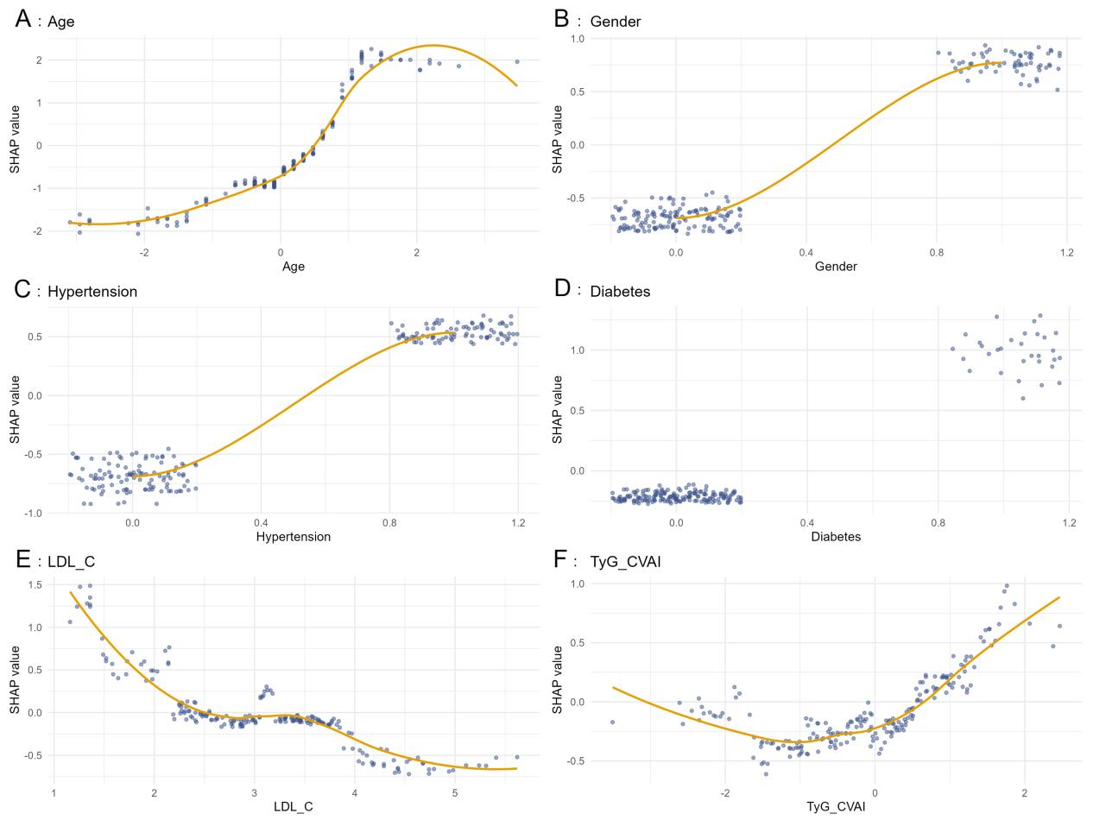
Supplementary Figure S6. SHAP dependence plots for the six selected features. Each plot displays the SHAP value (y-axis) against the feature value (x-axis) for individual observations. Points represent observations; a LOESS smoothing curve (orange line) is overlaid to visualize the overall trend. The features are ordered by mean absolute SHAP values.
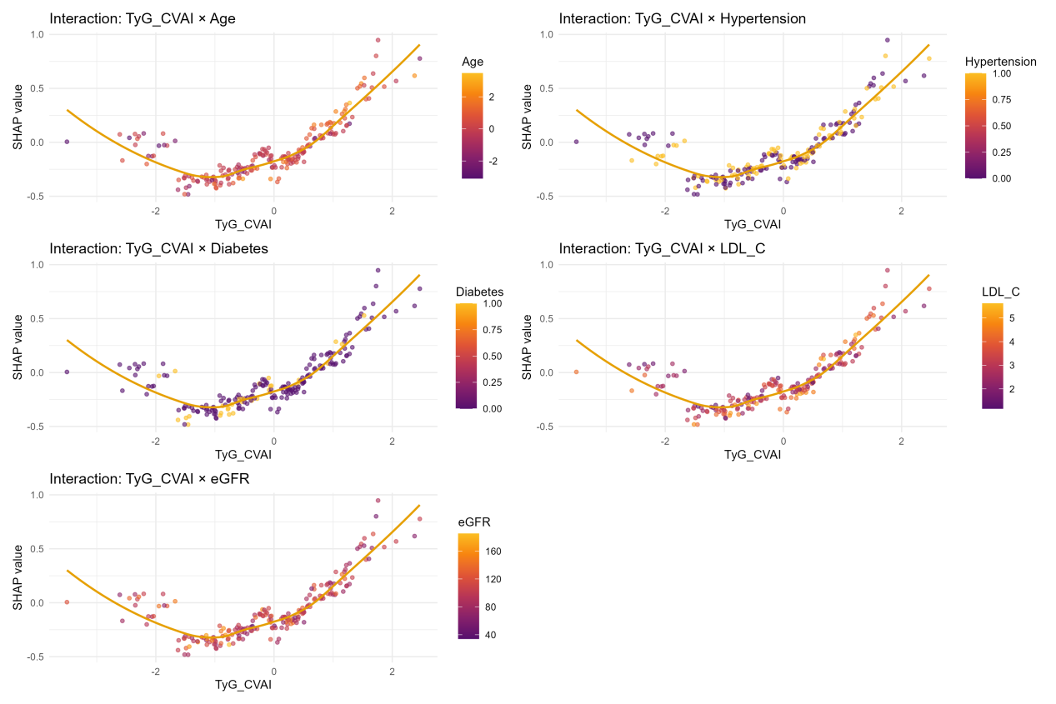
Supplementary Figure S7. SHAP interaction dependence plots for TyG‑CVAI with key covariates. Five panels show TyG‑CVAI interactions with age, hypertension, diabetes, LDL‑C, and eGFR. Each panel displays the SHAP values of TyG‑CVAI (y-axis) against TyG‑CVAI values (x-axis), with point color indicating the value of the interacting covariate. The yellow curve represents a loess-smoothed trend. Pearson correlation coefficients between the SHAP values of TyG‑CVAI and each covariate are provided in Supplementary Table S13.

Supplementary Table S13. SHAP interaction correlations between TyG-CVAI and key covariates.
Variable | Pearson r | P value
Age | 0.188 | 0.008
Hypertension | 0.017 | 0.813
Diabetes | −0.158 | 0.026
LDL-C | 0.012 | 0.868
eGFR | −0.153 | 0.030
Note: Pearson correlation coefficients were calculated between the SHAP values of TyG‑CVAI and the values of each covariate in the final model. A two-sided P value < 0.05 was considered statistically significant. TyG‑CVAI SHAP values were positively correlated with age and negatively correlated with diabetes and eGFR, suggesting potential effect modification by these factors.

Supplementary Table S14. Subgroup analyses of the association between TyG-CVAI and 5-year advanced CKM syndrome.
Subgroup | Control | Case | HR (95% CI) | CI width | P value | Power | P for interaction (LR) | P for interaction (Bootstrap)
Age group |  |  |  |  |  |  | 0.100 | 0.097
<70 | 1379 | 85 | 1.474 (1.196–1.817) | 0.621 | <0.001 | 0.953
≥70 | 693 | 162 | 1.234 (1.067–1.426) | 0.359 | 0.004 | 0.812
Gender |  |  |  |  |  |  | 0.223 | 0.214
Male | 731 | 137 | 1.233 (1.065–1.427) | 0.362 | 0.005 | 0.800
Female | 1341 | 110 | 1.422 (1.146–1.763) | 0.617 | 0.001 | 0.892
Smoke |  |  |  |  |  |  | 0.472 | 0.366
Yes | 140 | 21 | 1.114 (0.771–1.610) | 0.839 | 0.565 | 0.083
No | 1932 | 226 | 1.307 (1.150–1.486) | 0.337 | <0.001 | 0.983
Drink |  |  |  |  |  |  | 0.478 | 0.326
Yes | 126 | 14 | 1.080 (0.662–1.761) | 1.099 | 0.758 | 0.049
No | 1946 | 233 | 1.304 (1.150–1.477) | 0.327 | <0.001 | 0.986
Exercise |  |  |  |  |  |  | 0.782 | 0.213
Never | 166 | 22 | 1.055 (0.666–1.672) | 1.005 | 0.818 | 0.042
Some | 59 | 4 | 2.257 (0.772–6.600) | 5.828 | 0.137 | 0.318
Frequent | 1847 | 221 | 1.308 (1.150–1.487) | 0.337 | <0.001 | 0.984
Note: HR, hazard ratio; CI, confidence interval; LR, likelihood ratio test; Bootstrap, bootstrap resampling (1,000 iterations). Subgroup analyses were based on Cox proportional hazards models adjusted for gender, age, smoke, drink, and exercise (unless the variable itself was the stratification variable). Power denotes post-hoc statistical power for each subgroup. P for interaction was calculated using the likelihood ratio test (LR) and bootstrap resampling (Bootstrap).

Supplementary Table S15. Sensitivity analyses of the relationship between TyG-CVAI index with advanced CKM syndrome.
Scenarios | Case | Continuous TyG-CVAI index |  |  |  | Categorical TyG-CVAI index
Scenarios | Case | HR(95%CI) | Raw P | FDR-adjusted P |  | HR(95%CI) | Raw P | FDR-adjusted P
Basic model | 2072 | 1.001 (1.000-1.001) | <0.001 | <0.001 |  | 1.916 (1.319-2.783) | <0.001 | 0.002
Sensitivity analysis 1 | 1379 | 1.001 (1.001-1.002) | <0.001 | <0.001 |  | 2.274 (1.209-4.277) | 0.011 | 0.002
Sensitivity analysis 2 | 2072 | 1.001 (1.000-1.001) | <0.001 | <0.001 |  | 1.912 (1.316-2.777) | <0.001 | 0.014
Sensitivity analysis 3 | 1098 | 1.001 (1.000-1.002) | 0.003 | 0.003 |  | 2.527 (1.321-4.834) | 0.005 | 0.009
Sensitivity analysis 4 | 1761 | 1.001 (1.000-1.001) | <0.001 | <0.001 |  | 1.672 (1.125-2.484) | 0.011 | 0.014
Sensitivity analysis 5 | 1425 | 1.001 (1.000-1.002) | 0.001 | 0.002 |  | 2.108 (1.265-3.514) | 0.004 | 0.009
Sensitivity analysis 6 | 1872 | 1.001 (1.000-1.001) | <0.001 | <0.001 |  | 1.643 (1.117-2.415) | 0.012 | 0.014
Sensitivity analysis 7 | 2072 | 1.001 (1.000-1.001) | <0.001 | <0.001 |  | 1.860 (1.279-2.704) | 0.001 | 0.003
Sensitivity analysis 8 | 2072 | 1.002 (1.000-1.004) | 0.019 | 0.024 |  | 5.894 (1.670-20.798) | 0.006 | 0.010
Sensitivity analysis 9 | 2072 | 1.001 (1.000-1.001) | <0.001 | <0.001 |  | 2.113 (1.398-3.192) | <0.001 | 0.001
Note: All models were adjusted for covariates as in Model 2 (adjusted for gender, age, smoke, alcohol, exercise). Sensitivity analysis 1: excluding participants aged ≥70 years. Sensitivity analysis 2: additional adjustment for baseline CKM stage (0, 1, or 2). Sensitivity analysis 3: excluding participants with hypertension. Sensitivity analysis 4: excluding participants with diabetes. Sensitivity analysis 5: excluding participants with antihypertensive medications. Sensitivity analysis 6: excluding participants with diabetes drugs. Sensitivity analysis 7: Stage 3 as outcome. Sensitivity analysis 8: Stage 4 as outcome. Categorical index indicates the comparison of the highest quartile (Q4) versus the lowest quartile (Q1). Sensitivity analysis 9: advanced CKM syndrome was redefined to exclude Stage 3 events identified solely by eGFR < 30 mL/min/1.73 m². FDR-adjusted P denotes the Benjamini–Hochberg false discovery rate-adjusted P value.

- Ndumele CE, Rangaswami J, Chow SL, et al. Cardiovascular-kidney-metabolic health: a presidential advisory from the American Heart Association. Circulation. 2023;148(20):1606-1635.
- KDIGO 2024 Clinical Practice Guideline for the Evaluation and Management of Chronic Kidney Disease. Kidney Int 2024, 105(4s):S117-s314.
- Inker LA, Eneanya ND, Coresh J, et al. New Creatinine- and Cystatin C-Based Equations to Estimate GFR without Race. N Engl J Med. 2021;385(19):1737-1749.

