Supplementary material
Non-traditional lipid indices beyond the C-reactive protein-triglyceride glucose index and incident cardiovascular disease: a 2015 landmark analysis in CHARLS participants with operationally defined CKM stages 0-3
Ao-Men Lu et al.
Contents
Item | Title | Page
Table S1 | Operational definitions and timing | 4
Table S2 | Participant flow from Wave 1 to the primary risk set | 5
Table S3 | Endpoint-specific sample sizes, events, deaths, and person-time | 6
Table S4 | Intermeasurement interval distribution | 7
Table S5 | CKM stage-3 qualification routes | 8
Table S6 | Framingham age-range CKM stage reclassification | 9
Table S7 | Framingham age-range qualification counts | 10
Table S8 | Primary CVD sensitivity using the Framingham age range | 11
Table S9 | Fasting status at each biomarker visit | 12
Table S10 | Variable-level missingness in the classifiable source population | 13
Table S11 | Post-landmark follow-up and fatal-event audit | 15
Table S12 | Characteristics by time-weighted CTI quartile | 16
Table S13 | Comparison of 2011, 2015, mean, change, and time-weighted summaries | 21
Table S14 | Mean-versus-time-weighted ranking correlations | 23
Table S15 | Pearson correlations among time-weighted indices | 24
Table S16 | Spearman correlations among time-weighted indices | 25
Table S17 | CTI, TyG, and log hs-CRP component associations | 26
Table S18 | Nested construct-validity models for CTI versus freely estimated TyG and log hs-CRP | 27
Table S19 | Alternative adjustment sets, including CKM stage, diabetes, HbA1c, treatments, and dyslipidemia | 28
Table S20 | Fully adjusted primary-window single-exposure Cox models | 30
Table S21 | Fully adjusted primary-window joint-category Cox models | 31
Table S22 | Multiplicative and additive interaction estimates | 32
Table S23 | Maximum variance-inflation factor by exposure pair | 33
Table S24 | Mutually adjusted continuous CTI-nTLP models | 34
Table S25 | Restricted cubic-spline tests, knots, and sample sizes | 35
Table S26 | Exploratory two-piecewise threshold models | 36
Table S27 | Schoenfeld proportional-hazards tests | 37
Table S28 | Robust standard-error sensitivity models | 38
Table S29 | Community-cluster robust Cox models | 39
Table S30 | Survey-weighted Cox sensitivity models | 40
Table S31 | Fine-Gray competing-risk models | 41
Table S32 | Discrete-time complementary-log-log joint-category models | 43
Table S33 | Joint-category N, events, deaths, person-years, and cutpoints | 44
Table S34 | Index units, SDs, and median cutpoints | 45
Table S35 | Complete-case and design sensitivity analyses | 46
Table S36 | Fasting-both-visits and hs-CRP≤10 mg/L sensitivities | 50
Table S37 | Log-transformed LCI sensitivity | 51
Table S38 | CKM stage 0-2 sensitivity | 52
Table S39 | Inverse-probability-of-selection weighted Cox models | 53
Table S40 | Selection balance standardized mean differences | 54
Table S41 | Post-landmark inverse-probability-of-censoring weighted Cox models | 55
Table S42 | Post-landmark censoring-weight diagnostics | 56
Table S43 | Included-versus-excluded descriptive comparison | 57
Table S44 | Primary-window multiple-imputation sensitivity analyses | 61
Table S45 | Summarized MICE chain-mean convergence diagnostics | 62
Table S46 | MICE logged-event diagnostics | 63
Table S47 | Primary-window exploratory subgroup analyses | 64
Table S48 | Exposure-by-log-time tests | 68
Table S49 | Exploratory apparent prediction performance using the original association covariate set | 69
Table S50 | Bootstrap internal validation against the clinical benchmark | 70
Table S51 | Direct CTI-component prediction and 1,000-bootstrap calibration | 71
Table S52 | Compact numbers at risk for cumulative-incidence figures | 72
Figure S1 | Aalen-Johansen cumulative-incidence functions for all five CTI-nTLP pairs | 74
Figure S2 | Antecedent-2011 Kaplan-Meier sensitivity curves | 75
Figure S3 | Landmark-2015 Kaplan-Meier sensitivity curves | 76
Figure S4 | Time-weighted 2011-2015 Kaplan-Meier sensitivity curves | 77
Figure S5 | Antecedent-2011 restricted cubic-spline associations | 78
Figure S6 | Landmark-2015 restricted cubic-spline associations | 79
Figure S7 | Time-weighted 2011-2015 restricted cubic-spline associations | 80
Figure S8 | Exploratory 5-year ROC curves | 81
Figure S9 | Pair-specific 5-year calibration plots | 82
Figure S10 | Exploratory IPCW decision curves | 83
Each supplementary table and figure begins on a new page. Table captions precede tables; definitions and model notes follow each item.

Supplementary Table S1. Operational definitions and timing.
Variable | Operational definition | Timing
CTI | 0.412×ln[hs-CRP (mg/L)] + ln[(TG, mg/dL × glucose, mg/dL)/2] | 2011 and 2015
AIP | log10[(TG, mmol/L)/(HDL-C, mmol/L)] | 2011 and 2015
Non-HDL-C | Total cholesterol-HDL-C | 2011 and 2015
CRI-I | Total cholesterol/HDL-C | 2011 and 2015
CRI-II | LDL-C/HDL-C | 2011 and 2015
LCI | Total cholesterol × TG × LDL-C/HDL-C | 2011 and 2015
Time-weighted two-visit summary | [(2011 value + 2015 value)/2] × individual interwave years | 2011-2015
Operational CKM stage 0 | No identified CKM risk factor | 2015 landmark
Operational CKM stage 1 | BMI ≥23 kg/m², waist ≥90 cm in men/≥80 cm in women, or prediabetes | 2015 landmark
Operational CKM stage 2 | Hypertension, diabetes, hypertriglyceridemia/dyslipidemia, metabolic syndrome, or kidney disease/eGFR <60 | 2015 landmark
Operational CKM stage 3 | D'Agostino 2008 Framingham general-CVD risk ≥21.5% women/≥21.6% men, or 2009 CKD-EPI eGFR <30; sex-specific thresholds adopted from prior CHARLS-based operationalizations [7,12] as pragmatic proxies, not direct AHA cutoffs | 2015 landmark
FRS age-range sensitivity | For age >74 years, stage 3 could be assigned only by eGFR <30; primary models were also repeated after restricting age to ≤74 years | 2015 landmark
Reported heart disease | Physician-diagnosed heart attack, coronary heart disease, angina, congestive heart failure, or other heart problems, or treatment evidence | Waves 4-5
Reported stroke | Physician-diagnosed stroke or treatment evidence | Waves 4-5
Competing death | Recorded death preceding any reported endpoint; cause unavailable | Waves 4-5
Notes: Definitions correspond to the analytic variables used in the main manuscript. CKM staging is an operational CHARLS approximation rather than the complete AHA phenotype; CTI, C-reactive protein-triglyceride-glucose index; nTLP, non-traditional lipid parameter; eGFR, estimated glomerular filtration rate.

Supplementary Table S2. Participant flow from Wave 1 to the primary risk set.
N | step | excluded_from_previous
17,708 | CHARLS participants interviewed in 2011
17,060 | Aged 45 years or older | 648.000
12,959 | Known CVD status through the 2015 landmark | 4101.000
9,935 | Free of clinical CVD through the 2015 landmark | 3024.000
6,495 | Classifiable CKM stage at the 2015 landmark | 3440.000
4,919 | Complete CTI and nTLP measurements in 2011 and 2015 | 1576.000
4,634 | Positive exposure interval and complete primary-model covariates | 285.000
4,420 | Valid post-2015 follow-up for incident CVD | 214.000
Notes: Counts are sequential; the exclusion column gives the number removed at each step relative to the immediately preceding row. The final 4,420 participants constitute the primary post-2015 CVD risk set.

Supplementary Table S3. Endpoint-specific sample sizes, events, deaths, and person-time.
Stage | Outcome | N | Events | Deaths | Person-years | median_followup
Antecedent 2011 | CVD | 4,420 | 827 | 89 | 20713.7 | 5
Antecedent 2011 | Heart disease | 4,411 | 571 | 101 | 21036.3 | 5
Antecedent 2011 | Stroke | 4,414 | 328 | 97 | 21307.4 | 5
Landmark 2015 | CVD | 4,420 | 827 | 89 | 20713.7 | 5
Landmark 2015 | Heart disease | 4,411 | 571 | 101 | 21036.3 | 5
Landmark 2015 | Stroke | 4,414 | 328 | 97 | 21307.4 | 5
Cumulative 2011-2015 | CVD | 4,420 | 827 | 89 | 20713.7 | 5
Cumulative 2011-2015 | Heart disease | 4,411 | 571 | 101 | 21036.3 | 5
Cumulative 2011-2015 | Stroke | 4,414 | 328 | 97 | 21307.4 | 5
Notes: Endpoint-specific risk sets differ because component outcomes had slightly different missingness. Deaths are recorded deaths preceding a reported endpoint; component event counts can overlap and should not be summed.

Supplementary Table S4. Intermeasurement interval distribution.
statistic | years
N | 4420.000
Mean | 3.983
SD | 0.103
Minimum | 3.333
P5 | 3.833
P25 | 3.917
Median | 4.000
P75 | 4.000
P95 | 4.083
Maximum | 4.417
Notes: The interval is the participant-specific elapsed time between the 2011 and 2015 biomarker assessments and is used in the time-weighted two-visit summary.

Supplementary Table S5. CKM stage-3 qualification routes.
N | qualification | definition
1,910 | FRS-based threshold only | Sex-specific D'Agostino 2008 general-CVD threshold (21.5% women; 21.6% men), adopted from prior CHARLS-based operationalizations [7,12] as a pragmatic risk-equivalent proxy
37 | eGFR <30 only | 2009 CKD-EPI eGFR <30 mL/min/1.73 m2
14 | Both FRS-based threshold and eGFR <30 | Both criteria
1,961 | All stage 3 | Either criterion
Notes: Stage 3 was assigned by the operational Framingham risk-equivalent threshold, eGFR <30 mL/min/1.73 m2, or both. These criteria are study proxies rather than direct AHA stage-3 diagnostic cutoffs.

Supplementary Table S6. Framingham age-range CKM stage reclassification.
original_stage | age_range_stage | N
0 | 0 | 183
1 | 1 | 660
2 | 2 | 2283
3 | 0 | 7
3 | 1 | 14
3 | 2 | 220
3 | 3 | 1053
Notes: The age-range rule limits Framingham-based stage-3 qualification to ages 30-74; participants older than 74 could remain stage 3 only through eGFR <30 mL/min/1.73 m2.

Supplementary Table S7. Framingham age-range qualification counts.
N | item
349 | Participants aged >74 years
247 | Aged >74 and originally stage 3
241 | Aged >74 qualifying stage 3 by FRS only
6 | Aged >74 qualifying stage 3 by eGFR <30
241 | Reclassified from stage 3 under the age-range rule
Notes: Counts quantify the impact of respecting the original Framingham age range among participants older than 74 years and identify those reclassified from operational stage 3.

Supplementary Table S8. Primary CVD sensitivity using the Framingham age range.
Pair | N | Events | HR (95% CI) | P value | FDR P | analysis
CTI + AIP | 4,420 | 827 | 1.33 (1.12-1.58) | 0.001 | 0.001 | Full cohort, adjusted for age-range-respecting CKM stage
CTI + AIP | 4,071 | 753 | 1.47 (1.24-1.76) | <0.001 | <0.001 | Restricted to age <=74 years
CTI + Non-HDL-C | 4,420 | 827 | 1.48 (1.23-1.79) | <0.001 | <0.001 | Full cohort, adjusted for age-range-respecting CKM stage
CTI + Non-HDL-C | 4,071 | 753 | 1.67 (1.37-2.03) | <0.001 | <0.001 | Restricted to age <=74 years
CTI + CRI-I | 4,420 | 827 | 1.41 (1.17-1.69) | <0.001 | <0.001 | Full cohort, adjusted for age-range-respecting CKM stage
CTI + CRI-I | 4,071 | 753 | 1.58 (1.31-1.91) | <0.001 | <0.001 | Restricted to age <=74 years
CTI + CRI-II | 4,420 | 827 | 1.51 (1.24-1.83) | <0.001 | <0.001 | Full cohort, adjusted for age-range-respecting CKM stage
CTI + CRI-II | 4,071 | 753 | 1.69 (1.39-2.06) | <0.001 | <0.001 | Restricted to age <=74 years
CTI + LCI | 4,420 | 827 | 1.47 (1.23-1.76) | <0.001 | <0.001 | Full cohort, adjusted for age-range-respecting CKM stage
CTI + LCI | 4,071 | 753 | 1.65 (1.38-1.98) | <0.001 | <0.001 | Restricted to age <=74 years
Notes: Dual-high versus dual-low HRs are shown after applying the age-range-respecting stage definition and after restricting to age <=74 years. FDR P values use Benjamini-Hochberg correction across the five pairwise contrasts within each analysis.

Supplementary Table S9. Fasting status at each biomarker visit.
N | wave | status
3,998 | 2,011 | Documented fasting
422 | 2,011 | Not documented as fasting / unknown
3,797 | 2,015 | Documented fasting
623 | 2,015 | Not documented as fasting / unknown
Notes: 'Documented fasting' reflects explicit fasting documentation in the analytic extract; the alternative category denotes fasting status not documented/unknown rather than a separately confirmed nonfasting group.

Supplementary Table S10. Variable-level missingness in the classifiable source population.
variable | source_population_n | missing_n | missing_percent
age | 6,495 | 0 | 0.000
sex | 6,495 | 0 | 0.000
bmi | 6,495 | 23 | 0.354
smoking | 6,495 | 0 | 0.000
drinking | 6,495 | 3 | 0.046
education | 6,495 | 0 | 0.000
marital | 6,495 | 0 | 0.000
sleep_duration | 6,495 | 206 | 3.172
residence | 6,495 | 104 | 1.601
sbp | 6,495 | 0 | 0.000
dbp | 6,495 | 11 | 0.169
egfr | 6,495 | 0 | 0.000
cancer | 6,495 | 17 | 0.262
hba1c | 6,495 | 1 | 0.015
baseline_diabetes | 6,495 | 0 | 0.000
hypertension_treatment | 6,495 | 0 | 0.000
diabetes_treatment | 6,495 | 4 | 0.062
lipid_lowering | 6,495 | 23 | 0.354
dyslipidemia | 6,495 | 21 | 0.323
cti_w1 | 6,495 | 1,576 | 24.265
aip_w1 | 6,495 | 1,576 | 24.265
non_hdl_w1 | 6,495 | 1,576 | 24.265
cri1_w1 | 6,495 | 1,576 | 24.265
cri2_w1 | 6,495 | 1,576 | 24.265
lci_w1 | 6,495 | 1,576 | 24.265
cti_w3 | 6,495 | 1 | 0.015
aip_w3 | 6,495 | 1 | 0.015
non_hdl_w3 | 6,495 | 1 | 0.015
cri1_w3 | 6,495 | 1 | 0.015
cri2_w3 | 6,495 | 1 | 0.015
lci_w3 | 6,495 | 1 | 0.015
Notes: Missingness is summarized among the 6,495 participants classifiable as operational CKM stages 0-3. The paired 2011 biomarker variables account for the largest source of analytic-sample loss.

Supplementary Table S11. Post-landmark follow-up and fatal-event audit.
N | item | interpretation
4,634 | Eligible after exposure/covariate requirements | Analysis-eligible at the 2015 landmark
4,420 | Included with valid post-2015 CVD follow-up | Primary CVD risk set
214 | Excluded for no valid post-2015 follow-up | Not assigned an incident CVD outcome
0 | Excluded participants with a recorded death year | A death record alone cannot establish fatal CVD cause
0 | Excluded participants with known wave-4 CVD status | Any known CVD response
0 | Excluded participants with known wave-5 CVD status | Any known CVD response
Notes: The audit distinguishes absence of valid post-landmark outcome follow-up from recorded death or known CVD status; a death record without cause cannot by itself establish a fatal CVD event.

Supplementary Table S12. Characteristics by time-weighted CTI quartile.
Characteristic | Overall | Q1 | Q2 | Q3 | Q4 | P value
Age, years, mean ± SD | 61.74 ± 8.30 | 61.18 ± 8.26 | 62.03 ± 8.20 | 61.88 ± 8.56 | 61.86 ± 8.17 | 0.075
Body mass index, kg/m2, mean ± SD | 23.69 ± 3.58 | 22.06 ± 3.04 | 23.14 ± 3.32 | 24.07 ± 3.41 | 25.50 ± 3.59 | <0.001
Waist circumference, cm, mean ± SD | 85.83 ± 10.20 | 80.60 ± 8.70 | 84.08 ± 9.77 | 87.37 ± 9.57 | 91.34 ± 9.49 | <0.001
Sleep duration, hours/day, mean ± SD | 7.08 ± 2.16 | 6.96 ± 2.16 | 7.03 ± 2.14 | 7.11 ± 2.18 | 7.23 ± 2.17 | 0.025
Systolic blood pressure, mmHg, mean ± SD | 127.53 ± 19.90 | 123.23 ± 19.01 | 124.99 ± 18.94 | 129.53 ± 20.07 | 132.42 ± 20.22 | <0.001
Diastolic blood pressure, mmHg, mean ± SD | 75.14 ± 11.57 | 73.04 ± 10.94 | 74.30 ± 11.56 | 75.81 ± 11.06 | 77.44 ± 12.21 | <0.001
Total cholesterol, mg/dL, mean ± SD | 184.85 ± 35.91 | 175.33 ± 31.68 | 181.54 ± 32.83 | 186.72 ± 35.02 | 195.89 ± 40.36 | <0.001
Triglycerides, mg/dL, median (IQR) | 115.04 (82.30, 168.14) | 76.99 (61.95, 95.58) | 100.88 (81.19, 125.66) | 133.63 (99.12, 171.68) | 207.08 (149.56, 292.04) | <0.001
HDL-C, mg/dL, median (IQR) | 50.19 (43.24, 57.92) | 55.60 (48.26, 64.09) | 52.12 (45.17, 59.46) | 49.03 (42.47, 55.98) | 45.56 (40.15, 51.35) | <0.001
LDL-C, mg/dL, mean ± SD | 102.82 ± 28.50 | 98.37 ± 25.91 | 104.05 ± 26.90 | 105.82 ± 28.94 | 103.09 ± 31.48 | <0.001
Fasting plasma glucose, mg/dL, median (IQR) | 95.50 (88.29, 106.31) | 90.09 (84.68, 97.30) | 93.69 (86.49, 100.90) | 97.30 (90.09, 108.11) | 106.31 (95.50, 127.93) | <0.001
HbA1c, %, median (IQR) | 5.80 (5.50, 6.10) | 5.70 (5.40, 5.90) | 5.70 (5.50, 6.00) | 5.80 (5.50, 6.10) | 6.00 (5.70, 6.70) | <0.001
White blood cell count, 10^9/L, median (IQR) | 5.70 (4.75, 6.84) | 5.20 (4.40, 6.20) | 5.61 (4.69, 6.80) | 5.80 (4.88, 6.80) | 6.20 (5.25, 7.48) | <0.001
High-sensitivity C-reactive protein, mg/L, median (IQR) | 1.40 (0.80, 2.60) | 0.70 (0.40, 1.10) | 1.10 (0.70, 1.90) | 1.60 (1.10, 2.60) | 2.70 (1.80, 4.60) | <0.001
eGFR, mL/min/1.73 m2, median (IQR) | 92.87 (82.21, 99.65) | 93.48 (84.32, 99.06) | 92.59 (82.18, 99.45) | 92.52 (81.48, 99.79) | 92.66 (80.90, 100.53) | 0.271
Framingham 10-year general CVD risk, %, median (IQR) | 13.19 (6.53, 23.89) | 9.90 (4.98, 17.86) | 11.50 (5.89, 21.39) | 13.23 (6.96, 24.65) | 18.46 (10.23, 31.74) | <0.001
Antecedent CTI (2011), median (IQR) | 8.62 (8.11, 9.19) | 7.90 (7.64, 8.18) | 8.40 (8.12, 8.67) | 8.86 (8.57, 9.17) | 9.57 (9.15, 10.03) | <0.001
Antecedent AIP (2011), log10 molar ratio, median (IQR) | -0.04 (-0.24, 0.19) | -0.27 (-0.42, -0.13) | -0.11 (-0.27, 0.02) | 0.05 (-0.12, 0.19) | 0.29 (0.09, 0.50) | <0.001
Antecedent non-HDL-C (2011), median (IQR) | 137.63 (115.21, 163.15) | 119.07 (102.06, 139.95) | 132.22 (112.89, 153.87) | 141.88 (121.01, 166.24) | 159.28 (136.86, 184.79) | <0.001
Antecedent CRI-I (2011), median (IQR) | 3.82 (3.08, 4.75) | 3.08 (2.64, 3.70) | 3.53 (2.98, 4.14) | 4.01 (3.35, 4.80) | 4.98 (4.16, 5.99) | <0.001
Antecedent CRI-II (2011), median (IQR) | 2.33 (1.76, 2.95) | 1.86 (1.45, 2.39) | 2.18 (1.72, 2.72) | 2.47 (1.96, 3.05) | 2.83 (2.24, 3.47) | <0.001
Antecedent LCI (2011), (mg/dL)^2, median (IQR) | 45370.20 (25108.07, 83229.14) | 22885.04 (14798.41, 35953.71) | 37371.12 (24387.31, 55966.16) | 57351.76 (34703.53, 85297.13) | 104366.69 (63409.68, 162204.06) | <0.001
Landmark CTI (2015), median (IQR) | 8.78 (8.24, 9.38) | 7.97 (7.66, 8.29) | 8.55 (8.26, 8.81) | 9.01 (8.73, 9.32) | 9.82 (9.39, 10.27) | <0.001
Landmark AIP (2015), log10 molar ratio, median (IQR) | -0.00 (-0.18, 0.21) | -0.22 (-0.34, -0.10) | -0.06 (-0.19, 0.05) | 0.08 (-0.07, 0.21) | 0.30 (0.13, 0.47) | <0.001
Landmark non-HDL-C (2015), median (IQR) | 130.12 (110.04, 152.90) | 116.80 (99.71, 134.65) | 125.48 (108.11, 146.04) | 134.75 (113.51, 156.76) | 146.72 (124.71, 169.11) | <0.001
Landmark CRI-I (2015), median (IQR) | 3.61 (3.08, 4.23) | 3.10 (2.72, 3.51) | 3.45 (3.04, 3.95) | 3.77 (3.26, 4.27) | 4.25 (3.72, 4.81) | <0.001
Landmark CRI-II (2015), median (IQR) | 2.01 (1.62, 2.44) | 1.74 (1.41, 2.13) | 1.99 (1.62, 2.39) | 2.14 (1.73, 2.53) | 2.19 (1.84, 2.60) | <0.001
Landmark LCI (2015), (mg/dL)^2, median (IQR) | 42989.08 (24636.10, 75766.77) | 23334.05 (15535.93, 34243.72) | 36599.27 (23272.44, 54676.77) | 51979.68 (33148.24, 77972.78) | 91184.58 (56279.96, 131447.92) | <0.001
Cumulative CTI, index-years, median (IQR) | 34.69 (32.74, 36.96) | 31.57 (30.58, 32.20) | 33.75 (33.27, 34.21) | 35.70 (35.18, 36.28) | 38.69 (37.74, 40.01) | <0.001
Cumulative AIP, log10 molar ratio-years, median (IQR) | -0.07 (-0.75, 0.70) | -0.96 (-1.40, -0.53) | -0.34 (-0.75, 0.06) | 0.26 (-0.22, 0.70) | 1.16 (0.62, 1.78) | <0.001
Cumulative non-HDL-C, mg/dL-years, median (IQR) | 535.39 (457.67, 621.31) | 465.31 (404.28, 537.13) | 517.73 (452.00, 587.86) | 553.96 (479.80, 636.68) | 615.28 (539.44, 700.14) | <0.001
Cumulative CRI-I, ratio-years, median (IQR) | 14.87 (12.43, 17.70) | 12.17 (10.70, 14.14) | 14.04 (12.30, 15.90) | 15.68 (13.60, 17.75) | 18.68 (16.20, 21.46) | <0.001
Cumulative CRI-II, ratio-years, median (IQR) | 8.74 (6.92, 10.60) | 7.09 (5.80, 8.78) | 8.38 (6.88, 10.00) | 9.26 (7.60, 10.95) | 10.19 (8.41, 11.95) | <0.001
Cumulative LCI, (mg/dL)^2-years, median (IQR) | 187366.55 (110471.11, 324405.93) | 95589.34 (65600.56, 138158.40) | 154837.35 (109360.48, 217894.16) | 228985.30 (156262.21, 330769.45) | 412527.09 (278659.36, 576936.93) | <0.001
Sex — Female | 2323 (52.6) | 530 (47.6) | 566 (51.1) | 599 (54.8) | 628 (56.8) | <0.001
Sex — Male | 2097 (47.4) | 584 (52.4) | 542 (48.9) | 494 (45.2) | 477 (43.2)
Marital status — Other | 512 (11.6) | 118 (10.6) | 145 (13.1) | 138 (12.6) | 111 (10.0) | 0.065
Marital status — Married | 3908 (88.4) | 996 (89.4) | 963 (86.9) | 955 (87.4) | 994 (90.0)
Education — Middle school or below | 4017 (90.9) | 1014 (91.0) | 1002 (90.4) | 995 (91.0) | 1006 (91.0) | 0.716
Education — High school | 364 (8.2) | 87 (7.8) | 100 (9.0) | 88 (8.1) | 89 (8.1)
Education — College or above | 39 (0.9) | 13 (1.2) | 6 (0.5) | 10 (0.9) | 10 (0.9)
Residence — Urban | 528 (11.9) | 97 (8.7) | 138 (12.5) | 144 (13.2) | 149 (13.5) | 0.001
Residence — Rural | 3892 (88.1) | 1017 (91.3) | 970 (87.5) | 949 (86.8) | 956 (86.5)
Smoking status — No | 2483 (56.2) | 592 (53.1) | 622 (56.1) | 622 (56.9) | 647 (58.6) | 0.074
Smoking status — Yes | 1937 (43.8) | 522 (46.9) | 486 (43.9) | 471 (43.1) | 458 (41.4)
Drinking status — No | 2357 (53.3) | 575 (51.6) | 566 (51.1) | 598 (54.7) | 618 (55.9) | 0.060
Drinking status — Yes | 2063 (46.7) | 539 (48.4) | 542 (48.9) | 495 (45.3) | 487 (44.1)
Hypertension at 2015 landmark — No | 1954 (44.2) | 634 (56.9) | 548 (49.5) | 446 (40.8) | 326 (29.5) | <0.001
Hypertension at 2015 landmark — Yes | 2466 (55.8) | 480 (43.1) | 560 (50.5) | 647 (59.2) | 779 (70.5)
Diabetes at 2015 landmark — No | 3541 (80.1) | 1047 (94.0) | 958 (86.5) | 875 (80.1) | 661 (59.8) | <0.001
Diabetes at 2015 landmark — Yes | 879 (19.9) | 67 (6.0) | 150 (13.5) | 218 (19.9) | 444 (40.2)
Prediabetes at 2015 landmark — No | 2100 (47.5) | 514 (46.1) | 501 (45.2) | 496 (45.4) | 589 (53.3) | <0.001
Prediabetes at 2015 landmark — Yes | 2320 (52.5) | 600 (53.9) | 607 (54.8) | 597 (54.6) | 516 (46.7)
CKD at 2015 landmark — No | 3859 (87.3) | 979 (87.9) | 967 (87.3) | 955 (87.4) | 958 (86.7) | 0.871
CKD at 2015 landmark — Yes | 561 (12.7) | 135 (12.1) | 141 (12.7) | 138 (12.6) | 147 (13.3)
Metabolic syndrome at 2015 landmark — No | 2684 (60.7) | 1012 (90.8) | 852 (76.9) | 590 (54.0) | 230 (20.8) | <0.001
Metabolic syndrome at 2015 landmark — Yes | 1736 (39.3) | 102 (9.2) | 256 (23.1) | 503 (46.0) | 875 (79.2)
CKM stage at 2015 landmark — 0 | 183 (4.1) | 119 (10.7) | 48 (4.3) | 14 (1.3) | 2 (0.2)
CKM stage at 2015 landmark — 1 | 660 (14.9) | 314 (28.2) | 219 (19.8) | 110 (10.1) | 17 (1.5)
CKM stage at 2015 landmark — 2 | 2283 (51.7) | 478 (42.9) | 559 (50.5) | 637 (58.3) | 609 (55.1)
CKM stage at 2015 landmark — 3 | 1294 (29.3) | 203 (18.2) | 282 (25.5) | 332 (30.4) | 477 (43.2)
Sex-specific high Framingham risk proxy — FALSE | 3151 (71.3) | 916 (82.2) | 831 (75.0) | 769 (70.4) | 635 (57.5) | <0.001
Sex-specific high Framingham risk proxy — TRUE | 1269 (28.7) | 198 (17.8) | 277 (25.0) | 324 (29.6) | 470 (42.5)
Cancer — No | 4361 (98.7) | 1100 (98.7) | 1093 (98.6) | 1080 (98.8) | 1088 (98.5) | 0.901
Cancer — Yes | 59 (1.3) | 14 (1.3) | 15 (1.4) | 13 (1.2) | 17 (1.5)
Lipid-lowering treatment — No | 4005 (90.9) | 1079 (96.9) | 1031 (93.1) | 982 (90.4) | 913 (83.0) | <0.001
Lipid-lowering treatment — Yes | 402 (9.1) | 35 (3.1) | 76 (6.9) | 104 (9.6) | 187 (17.0)
Notes: Quartiles are based on the time-weighted CTI distribution. Values are mean +/- SD, median (IQR), or n (%) as appropriate; P values are descriptive across quartiles.

Supplementary Table S13. Comparison of 2011, 2015, mean, change, and time-weighted summaries.
Exposure | representation | N/events | SD | HR per SD (95% CI) | P value | p_fdr_within_exposure | concordance
CTI | 2011 value | 4,420/827 | 0.827 | 1.14 (1.07-1.23) | <0.001 | <0.001 | 0.622
CTI | 2015 value | 4,420/827 | 0.872 | 1.14 (1.06-1.23) | <0.001 | <0.001 | 0.619
CTI | Two-visit mean | 4,420/827 | 0.748 | 1.17 (1.09-1.25) | <0.001 | <0.001 | 0.622
CTI | Change (2015-2011) | 4,420/827 | 0.807 | 0.99 (0.93-1.06) | 0.835 | 0.835 | 0.615
CTI | Time-weighted two-visit summary | 4,420/827 | 3.121 | 1.19 (1.11-1.27) | <0.001 | <0.001 | 0.624
AIP | 2011 value | 4,420/827 | 0.331 | 1.09 (1.02-1.17) | 0.011 | 0.018 | 0.619
AIP | 2015 value | 4,420/827 | 0.282 | 1.09 (1.02-1.18) | 0.016 | 0.020 | 0.618
AIP | Two-visit mean | 4,420/827 | 0.275 | 1.11 (1.03-1.19) | 0.005 | 0.012 | 0.619
AIP | Change (2015-2011) | 4,420/827 | 0.276 | 0.98 (0.91-1.05) | 0.502 | 0.502 | 0.615
AIP | Time-weighted two-visit summary | 4,420/827 | 1.093 | 1.11 (1.03-1.19) | 0.005 | 0.012 | 0.619
Non-HDL-C | 2011 value | 4,420/827 | 36.970 | 1.16 (1.09-1.24) | <0.001 | <0.001 | 0.625
Non-HDL-C | 2015 value | 4,420/827 | 33.663 | 1.09 (1.02-1.17) | 0.013 | 0.013 | 0.618
Non-HDL-C | Two-visit mean | 4,420/827 | 32.232 | 1.14 (1.07-1.22) | <0.001 | <0.001 | 0.622
Non-HDL-C | Change (2015-2011) | 4,420/827 | 29.057 | 0.91 (0.85-0.97) | 0.006 | 0.007 | 0.620
Non-HDL-C | Time-weighted two-visit summary | 4,420/827 | 129.246 | 1.15 (1.08-1.23) | <0.001 | <0.001 | 0.623
CRI-I | 2011 value | 4,420/827 | 1.393 | 1.12 (1.05-1.19) | <0.001 | <0.001 | 0.623
CRI-I | 2015 value | 4,420/827 | 0.914 | 1.09 (1.02-1.16) | 0.007 | 0.009 | 0.619
CRI-I | Two-visit mean | 4,420/827 | 1.045 | 1.13 (1.06-1.20) | <0.001 | <0.001 | 0.623
CRI-I | Change (2015-2011) | 4,420/827 | 1.088 | 0.93 (0.87-0.99) | 0.015 | 0.015 | 0.618
CRI-I | Time-weighted two-visit summary | 4,420/827 | 4.184 | 1.14 (1.06-1.21) | <0.001 | <0.001 | 0.624
CRI-II | 2011 value | 4,420/827 | 0.918 | 1.18 (1.11-1.27) | <0.001 | <0.001 | 0.627
CRI-II | 2015 value | 4,420/827 | 0.630 | 1.09 (1.02-1.17) | 0.012 | 0.012 | 0.619
CRI-II | Two-visit mean | 4,420/827 | 0.705 | 1.17 (1.09-1.25) | <0.001 | <0.001 | 0.625
CRI-II | Change (2015-2011) | 4,420/827 | 0.700 | 0.86 (0.81-0.92) | <0.001 | <0.001 | 0.623
CRI-II | Time-weighted two-visit summary | 4,420/827 | 2.824 | 1.17 (1.10-1.26) | <0.001 | <0.001 | 0.626
LCI | 2011 value | 4,420/827 | 70862.6 | 1.11 (1.05-1.17) | <0.001 | 0.002 | 0.622
LCI | 2015 value | 4,420/827 | 58378.3 | 1.06 (0.99-1.12) | 0.075 | 0.075 | 0.616
LCI | Two-visit mean | 4,420/827 | 56621.1 | 1.10 (1.04-1.17) | 0.001 | 0.002 | 0.620
LCI | Change (2015-2011) | 4,420/827 | 63523.9 | 0.92 (0.86-0.98) | 0.013 | 0.016 | 0.619
LCI | Time-weighted two-visit summary | 4,420/827 | 225152.7 | 1.11 (1.04-1.17) | 0.001 | 0.002 | 0.621
Notes: Each exposure representation is standardized within the same 4,420-person CVD risk set. FDR P values are corrected across the five representations within each exposure; concordance is from the corresponding fitted association model.

Supplementary Table S14. Mean-versus-time-weighted ranking correlations.
Exposure | Pearson_mean_vs_timeweighted | Spearman_mean_vs_timeweighted
CTI | 0.957 | 0.954
AIP | 1.000 | 1.000
Non-HDL-C | 0.994 | 0.993
CRI-I | 0.995 | 0.994
CRI-II | 0.996 | 0.996
LCI | 0.999 | 0.999
Notes: Pearson and Spearman coefficients compare the two-visit mean with the time-weighted two-visit summary. Values close to 1 indicate that the two summaries rank participants very similarly.

Supplementary Table S15. Pearson correlations among time-weighted indices.
index | cti_cum | aip_cum | non_hdl_cum | cri1_cum | cri2_cum | lci_cum
cti_cum | 1.000 | 0.787 | 0.459 | 0.639 | 0.367 | 0.656
aip_cum | 0.787 | 1.000 | 0.422 | 0.789 | 0.471 | 0.735
non_hdl_cum | 0.459 | 0.422 | 1.000 | 0.728 | 0.744 | 0.764
cri1_cum | 0.639 | 0.789 | 0.728 | 1.000 | 0.819 | 0.842
cri2_cum | 0.367 | 0.471 | 0.744 | 0.819 | 1.000 | 0.636
lci_cum | 0.656 | 0.735 | 0.764 | 0.842 | 0.636 | 1.000
Notes: Pearson correlations quantify linear association among the continuous time-weighted CTI and nTLP summaries in the primary risk set.

Supplementary Table S16. Spearman correlations among time-weighted indices.
index | cti_cum | aip_cum | non_hdl_cum | cri1_cum | cri2_cum | lci_cum
cti_cum | 1.000 | 0.771 | 0.456 | 0.623 | 0.404 | 0.718
aip_cum | 0.771 | 1.000 | 0.422 | 0.783 | 0.531 | 0.832
non_hdl_cum | 0.456 | 0.422 | 1.000 | 0.734 | 0.741 | 0.825
cri1_cum | 0.623 | 0.783 | 0.734 | 1.000 | 0.891 | 0.891
cri2_cum | 0.404 | 0.531 | 0.741 | 0.891 | 1.000 | 0.754
lci_cum | 0.718 | 0.832 | 0.825 | 0.891 | 0.754 | 1.000
Notes: Spearman correlations quantify rank association among the continuous time-weighted CTI and nTLP summaries and are less sensitive to skewed distributions than Pearson coefficients.

Supplementary Table S17. Associations of CTI, TyG, and directly measured biochemical components with reported incident CVD.
Exposure | SD on time-weighted scale | Separate model  HR per SD (95% CI); P | Joint raw-component model  HR per SD (95% CI); P
CTI | 3.121 | 1.187 (1.105-1.274); <0.001 | —
TyG | 2.455 | 1.145 (1.066-1.228); <0.001 | —
Triglycerides | 322.876 | 1.063 (0.997-1.135); 0.064 | 1.017 (0.942-1.098); 0.662
HDL-C | 49.562 | 0.930 (0.862-1.002); 0.056 | 0.937 (0.862-1.019); 0.130
LDL-C | 113.047 | 1.131 (1.057-1.210); <0.001 | 1.142 (1.067-1.223); <0.001
Fasting plasma glucose | 116.770 | 1.095 (1.034-1.161); 0.002 | 1.068 (1.005-1.136); 0.034
log hs-CRP | 3.361 | 1.144 (1.067-1.226); <0.001 | 1.115 (1.037-1.198); 0.003
Notes: All exposures are time-weighted two-visit summaries and were standardized before modeling. SDs refer to the original time-weighted scale rather than a single-visit biomarker distribution; units are mg/dL-years for untransformed analytes, log(mg/L)-years for log hs-CRP, and index-years for CTI and TyG. Separate models include one exposure at a time and the primary covariate set. The joint raw-component model simultaneously includes untransformed triglycerides, HDL-C, LDL-C, and fasting plasma glucose plus log hs-CRP with the same covariates; CTI, TyG, and derived lipid indices are excluded to avoid deterministic or algebraic overlap. All rows use N=4,420 with 827 events. P values are nominal because this component analysis is exploratory.

Supplementary Table S18. Nested construct-validity models for CTI versus freely estimated TyG and log hs-CRP.
Model | N | Events | AIC | LRT_p_vs_covariates | concordance | LRT_p_free_components_vs_CTI
Covariates only | 4,420 | 827 | 13295.8 |  | 0.615
Covariates + CTI | 4,420 | 827 | 13276.1 | <0.001 | 0.624
Covariates + separately estimated TyG and log hs-CRP | 4,420 | 827 | 13277.0 | <0.001 | 0.625 | 0.278
Notes: The freely estimated model enters TyG and log hs-CRP as separate terms; the likelihood-ratio test versus CTI evaluates whether freeing the component coefficients materially improves fit beyond the fixed CTI combination.

Supplementary Table S19. Alternative adjustment sets, including CKM stage, diabetes, HbA1c, treatments, and dyslipidemia.
Exposure | adjustment_set | N/events | HR per SD (95% CI) | P value | AIC | concordance
CTI | Primary confounder set | 4,420/827 | 1.19 (1.11-1.27) | <0.001 | 13276.1 | 0.624
CTI | Primary + CKM stage | 4,420/827 | 1.15 (1.07-1.24) | <0.001 | 13276.0 | 0.625
CTI | Primary + diabetes, HbA1c, medication and dyslipidemia | 4,406/825 | 1.09 (1.01-1.18) | 0.028 | 13160.2 | 0.655
AIP | Primary confounder set | 4,420/827 | 1.11 (1.03-1.19) | 0.005 | 13289.9 | 0.619
AIP | Primary + CKM stage | 4,420/827 | 1.07 (1.00-1.16) | 0.067 | 13286.5 | 0.620
AIP | Primary + diabetes, HbA1c, medication and dyslipidemia | 4,406/825 | 1.03 (0.96-1.11) | 0.435 | 13164.4 | 0.654
Non-HDL-C | Primary confounder set | 4,420/827 | 1.15 (1.08-1.23) | <0.001 | 13281.4 | 0.623
Non-HDL-C | Primary + CKM stage | 4,420/827 | 1.13 (1.05-1.21) | <0.001 | 13278.8 | 0.623
Non-HDL-C | Primary + diabetes, HbA1c, medication and dyslipidemia | 4,406/825 | 1.10 (1.03-1.18) | 0.005 | 13157.2 | 0.658
CRI-I | Primary confounder set | 4,420/827 | 1.14 (1.06-1.21) | <0.001 | 13284.3 | 0.624
CRI-I | Primary + CKM stage | 4,420/827 | 1.11 (1.03-1.18) | 0.004 | 13282.0 | 0.623
CRI-I | Primary + diabetes, HbA1c, medication and dyslipidemia | 4,406/825 | 1.07 (1.00-1.15) | 0.039 | 13160.9 | 0.656
CRI-II | Primary confounder set | 4,420/827 | 1.17 (1.10-1.26) | <0.001 | 13277.4 | 0.626
CRI-II | Primary + CKM stage | 4,420/827 | 1.15 (1.07-1.23) | <0.001 | 13275.2 | 0.626
CRI-II | Primary + diabetes, HbA1c, medication and dyslipidemia | 4,406/825 | 1.13 (1.06-1.22) | <0.001 | 13153.0 | 0.659
LCI | Primary confounder set | 4,420/827 | 1.11 (1.04-1.17) | 0.001 | 13288.1 | 0.621
LCI | Primary + CKM stage | 4,420/827 | 1.08 (1.01-1.15) | 0.018 | 13284.6 | 0.621
LCI | Primary + diabetes, HbA1c, medication and dyslipidemia | 4,406/825 | 1.04 (0.97-1.11) | 0.240 | 13163.7 | 0.654
Notes: HRs are per 1-SD increment. The additional adjustment sets intentionally include variables that overlap with CKM status, glycemia, treatment, and dyslipidemia and are interpreted as sensitivity rather than primary confounder models.

Supplementary Table S20. Fully adjusted primary-window single-exposure Cox models.
Exposure | Contrast | N/events | HR (95% CI) | P value | FDR P
CTI per 1 SD | Per 1-SD increment | 4,420/827 | 1.19 (1.10-1.27) | <0.001 | <0.001
AIP per 1 SD | Per 1-SD increment | 4,420/827 | 1.11 (1.03-1.19) | 0.005 | 0.009
Non-HDL-C per 1 SD | Per 1-SD increment | 4,420/827 | 1.15 (1.08-1.23) | <0.001 | <0.001
CRI-I per 1 SD | Per 1-SD increment | 4,420/827 | 1.13 (1.06-1.21) | <0.001 | <0.001
CRI-II per 1 SD | Per 1-SD increment | 4,420/827 | 1.17 (1.10-1.26) | <0.001 | <0.001
LCI per 1 SD | Per 1-SD increment | 4,420/827 | 1.10 (1.04-1.17) | 0.001 | 0.002
Notes: Each exposure is entered separately as a standardized continuous predictor with the primary covariate set. FDR P values apply Benjamini-Hochberg correction across the six single-exposure tests.

Supplementary Table S21. Fully adjusted primary-window joint-category Cox models.
Exposure | Contrast | N/events | HR (95% CI) | P value | FDR P | primary_fdr_q
CTI + AIP | Dual high vs dual low | 4,420/827 | 1.45 (1.22-1.71) | <0.001 | <0.001 | <0.001
CTI + AIP | High CTI/low AIP vs dual low | 4,420/827 | 1.47 (1.16-1.87) | 0.001 | 0.004
CTI + AIP | Low CTI/high AIP vs dual low | 4,420/827 | 1.20 (0.94-1.55) | 0.148 | 0.168
CTI + CRI-I | Dual high vs dual low | 4,420/827 | 1.54 (1.29-1.84) | <0.001 | <0.001 | <0.001
CTI + CRI-I | High CTI/low CRI-I vs dual low | 4,420/827 | 1.44 (1.15-1.79) | 0.002 | 0.004
CTI + CRI-I | Low CTI/high CRI-I vs dual low | 4,420/827 | 1.28 (1.02-1.61) | 0.034 | 0.049
CTI + CRI-II | Dual high vs dual low | 4,420/827 | 1.64 (1.36-1.98) | <0.001 | <0.001 | <0.001
CTI + CRI-II | High CTI/low CRI-II vs dual low | 4,420/827 | 1.33 (1.07-1.65) | 0.011 | 0.019
CTI + CRI-II | Low CTI/high CRI-II vs dual low | 4,420/827 | 1.26 (1.01-1.57) | 0.038 | 0.054
CTI + LCI | Dual high vs dual low | 4,420/827 | 1.59 (1.34-1.89) | <0.001 | <0.001 | <0.001
CTI + LCI | High CTI/low LCI vs dual low | 4,420/827 | 1.33 (1.04-1.69) | 0.023 | 0.034
CTI + LCI | Low CTI/high LCI vs dual low | 4,420/827 | 1.39 (1.10-1.76) | 0.006 | 0.011
CTI + Non-HDL-C | Dual high vs dual low | 4,420/827 | 1.61 (1.34-1.94) | <0.001 | <0.001 | <0.001
CTI + Non-HDL-C | High CTI/low Non-HDL-C vs dual low | 4,420/827 | 1.39 (1.12-1.73) | 0.003 | 0.007
CTI + Non-HDL-C | Low CTI/high Non-HDL-C vs dual low | 4,420/827 | 1.28 (1.03-1.60) | 0.026 | 0.038
Notes: Joint groups are defined from cohort-median high/low categories for CTI and the corresponding nTLP. The primary FDR family in the revised analysis comprises the five dual-high versus dual-low contrasts; other joint contrasts are descriptive.

Supplementary Table S22. Multiplicative and additive interaction estimates.
Pair | N/events | Interaction HR (95% CI) | multiplicative_p | RERI (95% CI) | AP (95% CI)
CTI + AIP | 4,420/827 | 0.81 (0.58-1.14) | 0.233 | -0.232 (-0.680-0.216) | -0.160 (-0.470-0.150)
CTI + Non-HDL-C | 4,420/827 | 0.90 (0.68-1.21) | 0.499 | -0.060 (-0.446-0.325) | -0.038 (-0.277-0.201)
CTI + CRI-I | 4,420/827 | 0.84 (0.62-1.14) | 0.252 | -0.179 (-0.593-0.234) | -0.117 (-0.386-0.152)
CTI + CRI-II | 4,420/827 | 0.98 (0.73-1.32) | 0.910 | 0.057 (-0.317-0.431) | 0.035 (-0.193-0.262)
CTI + LCI | 4,420/827 | 0.86 (0.62-1.19) | 0.372 | -0.127 (-0.568-0.315) | -0.079 (-0.357-0.198)
Notes: Multiplicative interaction uses the product term; RERI and AP are exploratory hazard-scale quantities derived from dichotomous joint categories. Confidence intervals crossing zero indicate limited evidence for additive interaction on this scale.

Supplementary Table S23. Maximum variance-inflation factor by exposure pair.
Pair | Term | VIF
CTI + AIP | sexMale | 2.885
CTI + CRI-I | sexMale | 2.885
CTI + CRI-II | sexMale | 2.885
CTI + LCI | sexMale | 2.896
CTI + Non-HDL-C | sexMale | 2.915
Notes: The maximum VIF is reported for each CTI-nTLP model to summarize linear collinearity among model terms; VIF does not by itself address shared biological or arithmetic components.

Supplementary Table S24. Mutually adjusted continuous CTI-nTLP models.
Pair | Term | N/events | HR (95% CI) | P value
CTI + AIP | CTI per 1 SD | 4,420/827 | 1.25 (1.12-1.40) | <0.001
CTI + AIP | AIP per 1 SD | 4,420/827 | 0.93 (0.84-1.04) | 0.230
CTI + Non-HDL-C | CTI per 1 SD | 4,420/827 | 1.14 (1.05-1.23) | 0.001
CTI + Non-HDL-C | Non-HDL-C per 1 SD | 4,420/827 | 1.09 (1.01-1.18) | 0.021
CTI + CRI-I | CTI per 1 SD | 4,420/827 | 1.15 (1.05-1.26) | 0.002
CTI + CRI-I | CRI-I per 1 SD | 4,420/827 | 1.05 (0.96-1.14) | 0.281
CTI + CRI-II | CTI per 1 SD | 4,420/827 | 1.15 (1.06-1.23) | <0.001
CTI + CRI-II | CRI-II per 1 SD | 4,420/827 | 1.13 (1.05-1.21) | <0.001
CTI + LCI | CTI per 1 SD | 4,420/827 | 1.18 (1.07-1.29) | <0.001
CTI + LCI | LCI per 1 SD | 4,420/827 | 1.01 (0.93-1.10) | 0.762
Notes: CTI and each nTLP are standardized and entered simultaneously with the primary covariate set. These models estimate residual association of each component conditional on the other composite exposure.

Supplementary Table S25. Restricted cubic-spline tests, knots, and sample sizes.
Exposure | N/events | reference | Knots | p_overall | p_nonlinear
CTI | 4,420/827 | 34.687 | 30.30/33.56/35.91/40.43 | <0.001 | 0.746
AIP | 4,420/827 | -0.070 | -1.59/-0.46/0.37/1.99 | 0.003 | 0.054
Non-HDL-C | 4,420/827 | 535.391 | 357.75/488.77/585.27/768.90 | <0.001 | 0.565
CRI-I | 4,420/827 | 14.867 | 9.84/13.47/16.49/22.76 | <0.001 | 0.075
CRI-II | 4,420/827 | 8.741 | 4.78/7.62/9.77/13.78 | <0.001 | 0.803
LCI | 4,420/827 | 187366.5 | 54180.56/138253.56/254913.95/653712.05 | <0.001 | 0.003
Notes: Splines use four prespecified knots at the 5th, 35th, 65th, and 95th percentiles and the median as reference. Models use the full eligible sample; the 1st-99th percentile restriction is for display only.

Supplementary Table S26. Exploratory two-piecewise threshold models.
Exposure | threshold | Below-threshold HR (95% CI) | Above-threshold HR (95% CI) | threshold_LRT_p
AIP | 0.092 | 1.32 (1.15-1.51) | 0.91 (0.80-1.05) | 0.002
CRI-I | 4.205 | 1.37 (1.15-1.64) | 1.03 (0.94-1.14) | 0.015
LCI | 57850.8 | 2.04 (1.46-2.85) | 1.03 (0.96-1.11) | <0.001
AIP | 0.432 | 1.16 (1.04-1.30) | 0.62 (0.41-0.93) | 0.003
LCI | 91617.2 | 1.47 (1.16-1.85) | 0.94 (0.83-1.07) | 0.004
CRI-I | 4.319 | 1.70 (1.29-2.24) | 1.07 (0.93-1.24) | 0.009
LCI | 48302.9 | 4.50 (2.15-9.43) | 1.10 (1.00-1.21) | <0.001
LCI | 42989.1 | 1.96 (1.27-3.00) | 1.01 (0.93-1.09) | 0.004
LCI | 44998.0 | 2.37 (1.24-4.54) | 1.05 (0.94-1.17) | 0.017
LCI | 197584.1 | 2.13 (1.47-3.08) | 1.03 (0.96-1.11) | <0.001
LCI | 220324.4 | 1.80 (1.24-2.61) | 0.97 (0.87-1.08) | 0.004
LCI | 324262.9 | 2.02 (1.49-2.72) | 1.02 (0.89-1.16) | <0.001
Notes: Threshold models are exploratory. The likelihood-ratio test compares the two-piece specification with the corresponding single-slope model; estimates should be interpreted alongside the prespecified spline analysis.

Supplementary Table S27. Schoenfeld proportional-hazards tests.
Exposure | Term | chisq | df | P value
CTI per 1 SD | cti_z | 1.485 | 1 | 0.223
CTI per 1 SD | GLOBAL | 14.812 | 15 | 0.465
AIP per 1 SD | aip_z | 0.600 | 1 | 0.438
AIP per 1 SD | GLOBAL | 14.678 | 15 | 0.475
Non-HDL-C per 1 SD | non_hdl_z | 0.830 | 1 | 0.362
Non-HDL-C per 1 SD | GLOBAL | 15.263 | 15 | 0.433
CRI-I per 1 SD | cri1_z | 0.096 | 1 | 0.757
CRI-I per 1 SD | GLOBAL | 14.778 | 15 | 0.468
CRI-II per 1 SD | cri2_z | 0.362 | 1 | 0.547
CRI-II per 1 SD | GLOBAL | 14.835 | 15 | 0.463
LCI per 1 SD | lci_z | 1.811 | 1 | 0.178
LCI per 1 SD | GLOBAL | 15.633 | 15 | 0.407
CTI + AIP | GLOBAL | 15.846 | 17 | 0.535
CTI + Non-HDL-C | GLOBAL | 16.684 | 17 | 0.476
CTI + CRI-I | GLOBAL | 15.818 | 17 | 0.537
CTI + CRI-II | GLOBAL | 16.227 | 17 | 0.508
CTI + LCI | GLOBAL | 18.819 | 17 | 0.339
Notes: Schoenfeld tests evaluate proportional-hazards assumptions for the listed exposure terms. These diagnostics complement the exposure-by-log-time analyses in Supplementary Table S48.

Supplementary Table S28. Robust standard-error sensitivity models.
Exposure | Contrast | N/events | HR (95% CI) | P value
CTI per 1 SD | Per 1-SD increment | 4,420/827 | 1.19 (1.10-1.27) | <0.001
AIP per 1 SD | Per 1-SD increment | 4,420/827 | 1.11 (1.03-1.19) | 0.004
Non-HDL-C per 1 SD | Per 1-SD increment | 4,420/827 | 1.15 (1.08-1.23) | <0.001
CRI-I per 1 SD | Per 1-SD increment | 4,420/827 | 1.13 (1.06-1.21) | <0.001
CRI-II per 1 SD | Per 1-SD increment | 4,420/827 | 1.17 (1.10-1.26) | <0.001
LCI per 1 SD | Per 1-SD increment | 4,420/827 | 1.10 (1.05-1.17) | <0.001
Notes: Estimates use robust standard errors as a sensitivity to model-based variance assumptions while retaining the same exposure contrasts and primary covariate specification.

Supplementary Table S29. Community-cluster robust Cox models.
index | N/events | communities | HR per SD (95% CI) | P value
CTI | 4,420/827 | 411 | 1.19 (1.10-1.27) | <0.001
AIP | 4,420/827 | 411 | 1.11 (1.03-1.19) | 0.003
Non-HDL-C | 4,420/827 | 411 | 1.15 (1.08-1.24) | <0.001
CRI-I | 4,420/827 | 411 | 1.14 (1.06-1.21) | <0.001
CRI-II | 4,420/827 | 411 | 1.17 (1.09-1.26) | <0.001
LCI | 4,420/827 | 411 | 1.11 (1.05-1.17) | <0.001
Notes: Cox models use community-cluster robust standard errors; the number of contributing communities is shown for each standardized exposure model.

Supplementary Table S30. Survey-weighted Cox sensitivity models.
index | N/events | HR per SD (95% CI) | P value | weight | strata | clusters
CTI | 4,393/822 | 1.23 (1.09-1.37) | <0.001 | CHARLS 2015 blood biomarker weight | province-stratified baseline hazard | community-cluster sandwich variance; households nested within community
AIP | 4,393/822 | 1.14 (1.04-1.24) | 0.004 | CHARLS 2015 blood biomarker weight | province-stratified baseline hazard | community-cluster sandwich variance; households nested within community
Non-HDL-C | 4,393/822 | 1.20 (1.09-1.33) | <0.001 | CHARLS 2015 blood biomarker weight | province-stratified baseline hazard | community-cluster sandwich variance; households nested within community
CRI-I | 4,393/822 | 1.17 (1.08-1.27) | <0.001 | CHARLS 2015 blood biomarker weight | province-stratified baseline hazard | community-cluster sandwich variance; households nested within community
CRI-II | 4,393/822 | 1.21 (1.11-1.31) | <0.001 | CHARLS 2015 blood biomarker weight | province-stratified baseline hazard | community-cluster sandwich variance; households nested within community
LCI | 4,393/822 | 1.14 (1.07-1.22) | <0.001 | CHARLS 2015 blood biomarker weight | province-stratified baseline hazard | community-cluster sandwich variance; households nested within community
Notes: Survey sensitivity models incorporate the 2015 blood weight together with the listed province strata and community/household clustering structure where estimable. Survey-weighted models were restricted to the 4,393 of 4,420 primary-cohort participants with an available 2015 blood biomarker sampling weight; the remaining 27 participants did not contribute to this weighted sensitivity analysis.

Supplementary Table S31. Fine-Gray competing-risk models.
Exposure | Contrast | N/events/deaths | SHR (95% CI) | P value | FDR P | primary_fdr_q
AIP per 1 SD | Per 1-SD increment | 4,420/827/89 | 1.10 (1.03-1.18) | 0.003 | 0.008
CRI-I per 1 SD | Per 1-SD increment | 4,420/827/89 | 1.13 (1.06-1.20) | <0.001 | <0.001
CRI-II per 1 SD | Per 1-SD increment | 4,420/827/89 | 1.17 (1.09-1.25) | <0.001 | <0.001
CTI + AIP | High-High vs reference | 4,420/827/89 | 1.43 (1.21-1.69) | <0.001 | <0.001 | <0.001
CTI + AIP | High-Low vs reference | 4,420/827/89 | 1.46 (1.16-1.84) | 0.001 | 0.004
CTI + AIP | Low-High vs reference | 4,420/827/89 | 1.20 (0.94-1.53) | 0.142 | 0.161
CTI + CRI-I | High-High vs reference | 4,420/827/89 | 1.52 (1.27-1.81) | <0.001 | <0.001 | <0.001
CTI + CRI-I | High-Low vs reference | 4,420/827/89 | 1.42 (1.15-1.77) | 0.001 | 0.004
CTI + CRI-I | Low-High vs reference | 4,420/827/89 | 1.28 (1.02-1.60) | 0.031 | 0.046
CTI + CRI-II | High-High vs reference | 4,420/827/89 | 1.62 (1.35-1.94) | <0.001 | <0.001 | <0.001
CTI + CRI-II | High-Low vs reference | 4,420/827/89 | 1.32 (1.07-1.64) | 0.010 | 0.019
CTI + CRI-II | Low-High vs reference | 4,420/827/89 | 1.26 (1.02-1.56) | 0.034 | 0.050
CTI + LCI | High-High vs reference | 4,420/827/89 | 1.57 (1.33-1.86) | <0.001 | <0.001 | <0.001
CTI + LCI | High-Low vs reference | 4,420/827/89 | 1.32 (1.04-1.67) | 0.023 | 0.036
CTI + LCI | Low-High vs reference | 4,420/827/89 | 1.39 (1.11-1.75) | 0.005 | 0.011
CTI + Non-HDL-C | High-High vs reference | 4,420/827/89 | 1.59 (1.33-1.91) | <0.001 | <0.001 | <0.001
CTI + Non-HDL-C | High-Low vs reference | 4,420/827/89 | 1.38 (1.11-1.70) | 0.003 | 0.008
CTI + Non-HDL-C | Low-High vs reference | 4,420/827/89 | 1.28 (1.04-1.59) | 0.022 | 0.036
CTI per 1 SD | Per 1-SD increment | 4,420/827/89 | 1.18 (1.10-1.26) | <0.001 | <0.001
LCI per 1 SD | Per 1-SD increment | 4,420/827/89 | 1.10 (1.04-1.16) | <0.001 | 0.001
Non-HDL-C per 1 SD | Per 1-SD increment | 4,420/827/89 | 1.15 (1.08-1.23) | <0.001 | <0.001
Notes: Fine-Gray models treat death before reported CVD as a competing event. Primary FDR q values correspond to the five dual-high versus dual-low contrasts, allowing direct comparison with the primary Cox family.

Supplementary Table S32. Discrete-time complementary-log-log models for median-defined joint CTI-nTLP categories in the full landmark risk set.
Pair | Contrast | Adjusted relative hazard (95% CI) | P value | Primary-family FDR q
CTI + AIP | Low-High vs Low-Low | 1.22 (0.95-1.57) | 0.115 | —
CTI + AIP | High-Low vs Low-Low | 1.38 (1.09-1.75) | 0.008 | —
CTI + AIP | High-High vs Low-Low | 1.37 (1.15-1.62) | <0.001 | <0.001
CTI + Non-HDL-C | Low-High vs Low-Low | 1.27 (1.02-1.59) | 0.031 | —
CTI + Non-HDL-C | High-Low vs Low-Low | 1.32 (1.06-1.64) | 0.013 | —
CTI + Non-HDL-C | High-High vs Low-Low | 1.50 (1.25-1.81) | <0.001 | <0.001
CTI + CRI-I | Low-High vs Low-Low | 1.25 (0.99-1.57) | 0.058 | —
CTI + CRI-I | High-Low vs Low-Low | 1.35 (1.08-1.69) | 0.008 | —
CTI + CRI-I | High-High vs Low-Low | 1.43 (1.19-1.71) | <0.001 | <0.001
CTI + CRI-II | Low-High vs Low-Low | 1.23 (0.99-1.53) | 0.064 | —
CTI + CRI-II | High-Low vs Low-Low | 1.25 (1.01-1.56) | 0.042 | —
CTI + CRI-II | High-High vs Low-Low | 1.52 (1.26-1.83) | <0.001 | <0.001
CTI + LCI | Low-High vs Low-Low | 1.38 (1.09-1.74) | 0.008 | —
CTI + LCI | High-Low vs Low-Low | 1.25 (0.98-1.60) | 0.071 | —
CTI + LCI | High-High vs Low-Low | 1.49 (1.25-1.77) | <0.001 | <0.001
Notes: Models include all 4,420 participants, 8,182 eligible at-risk person-intervals, and 827 first reported CVD events. Interval-specific intercepts and log interval duration as an offset accommodate differences in observed interval length. Models adjust for the primary 2015 covariate set and use participant-clustered sandwich standard errors. Zero-event intervals from participants who never reported CVD are retained. Death before reported CVD ends follow-up and is treated as censoring in this sensitivity analysis. Joint-category labels list CTI first and the nTLP second; low-low is the reference. Primary-family FDR q values apply Benjamini-Hochberg correction across the five primary high-high versus low-low contrasts only.

Supplementary Table S33. Joint-category N, events, deaths, person-years, and cutpoints.
Pair | N | Competing deaths | Person-years | group | CVD_events | CTI_cutpoint | nTLP_cutpoint
CTI + AIP | 1,772 | 37 | 8437.083 | Low-Low | 258 | 34.687 | -0.070
CTI + AIP | 450 | 7 | 2113.083 | Low-High | 80 | 34.687 | -0.070
CTI + AIP | 430 | 11 | 1994.583 | High-Low | 97 | 34.687 | -0.070
CTI + AIP | 1,768 | 34 | 8168.917 | High-High | 392 | 34.687 | -0.070
CTI + Non-HDL-C | 1,469 | 35 | 7001.917 | Low-Low | 201 | 34.687 | 535.391
CTI + Non-HDL-C | 753 | 9 | 3548.250 | Low-High | 137 | 34.687 | 535.391
CTI + Non-HDL-C | 739 | 17 | 3440.500 | High-Low | 146 | 34.687 | 535.391
CTI + Non-HDL-C | 1,459 | 28 | 6723.000 | High-High | 343 | 34.687 | 535.391
CTI + CRI-I | 1,606 | 37 | 7664.333 | Low-Low | 227 | 34.687 | 14.867
CTI + CRI-I | 616 | 7 | 2885.833 | Low-High | 111 | 34.687 | 14.867
CTI + CRI-I | 591 | 12 | 2747.417 | High-Low | 123 | 34.687 | 14.867
CTI + CRI-I | 1,607 | 33 | 7416.083 | High-High | 366 | 34.687 | 14.867
CTI + CRI-II | 1,440 | 35 | 6864.833 | Low-Low | 201 | 34.687 | 8.741
CTI + CRI-II | 782 | 9 | 3685.333 | Low-High | 137 | 34.687 | 8.741
CTI + CRI-II | 760 | 13 | 3544.833 | High-Low | 145 | 34.687 | 8.741
CTI + CRI-II | 1,438 | 32 | 6618.667 | High-High | 344 | 34.687 | 8.741
CTI + LCI | 1,711 | 40 | 8164.917 | Low-Low | 238 | 34.687 | 187366.5
CTI + LCI | 511 | 4 | 2385.250 | Low-High | 100 | 34.687 | 187366.5
CTI + LCI | 494 | 13 | 2298.417 | High-Low | 93 | 34.687 | 187366.5
CTI + LCI | 1,704 | 32 | 7865.083 | High-High | 396 | 34.687 | 187366.5
Notes: Counts, competing deaths, person-years, events, and exposure cutpoints are shown for each joint category to make the risk-set composition behind the joint-category models transparent.

Supplementary Table S34. Index units, SDs, and median cutpoints.
N | index | unit | mean | SD | median_cutpoint | p25 | p75
4,420 | CTI | index-years | 34.962 | 3.121 | 34.687 | 32.744 | 36.961
4,420 | AIP | index-years | 0.027 | 1.093 | -0.070 | -0.753 | 0.700
4,420 | Non-HDL-C | mg/dL-years | 545.907 | 129.246 | 535.391 | 457.675 | 621.307
4,420 | CRI-I | index-years | 15.444 | 4.184 | 14.867 | 12.430 | 17.703
4,420 | CRI-II | index-years | 8.909 | 2.824 | 8.741 | 6.919 | 10.598
4,420 | LCI | (mg/dL)^2-years | 254160.4 | 225152.7 | 187366.5 | 110471.1 | 324405.9
Notes: Units, means, SDs, medians, and interquartile values refer to the time-weighted two-visit exposure summaries used in the primary-window analyses.

Supplementary Table S35. Complete-case and design sensitivity analyses.
Pair | Scenario | N/events | HR (95% CI) | P value | FDR P
CTI + AIP | Main analysis | 4,420/827 | 1.45 (1.22-1.71) | <0.001 | <0.001
CTI + Non-HDL-C | Main analysis | 4,420/827 | 1.61 (1.34-1.94) | <0.001 | <0.001
CTI + CRI-I | Main analysis | 4,420/827 | 1.54 (1.29-1.84) | <0.001 | <0.001
CTI + CRI-II | Main analysis | 4,420/827 | 1.64 (1.36-1.98) | <0.001 | <0.001
CTI + LCI | Main analysis | 4,420/827 | 1.59 (1.34-1.89) | <0.001 | <0.001
CTI + AIP | Assign event time to midpoint of ascertainment interval | 4,420/827 | 1.37 (1.16-1.62) | <0.001 | 0.001
CTI + Non-HDL-C | Assign event time to midpoint of ascertainment interval | 4,420/827 | 1.51 (1.25-1.81) | <0.001 | <0.001
CTI + CRI-I | Assign event time to midpoint of ascertainment interval | 4,420/827 | 1.44 (1.20-1.72) | <0.001 | <0.001
CTI + CRI-II | Assign event time to midpoint of ascertainment interval | 4,420/827 | 1.53 (1.27-1.84) | <0.001 | <0.001
CTI + LCI | Assign event time to midpoint of ascertainment interval | 4,420/827 | 1.50 (1.26-1.78) | <0.001 | <0.001
CTI + AIP | Restrict to CKM stages 0-2 | 3,126/511 | 1.37 (1.11-1.69) | 0.003 | 0.007
CTI + Non-HDL-C | Restrict to CKM stages 0-2 | 3,126/511 | 1.56 (1.23-1.97) | <0.001 | <0.001
CTI + CRI-I | Restrict to CKM stages 0-2 | 3,126/511 | 1.49 (1.20-1.86) | <0.001 | 0.001
CTI + CRI-II | Restrict to CKM stages 0-2 | 3,126/511 | 1.61 (1.28-2.03) | <0.001 | <0.001
CTI + LCI | Restrict to CKM stages 0-2 | 3,126/511 | 1.53 (1.24-1.90) | <0.001 | <0.001
CTI + AIP | Restrict to CKM stages 0-2 using FRS >=20% for stage 3 | 2,991/480 | 1.37 (1.10-1.70) | 0.004 | 0.009
CTI + Non-HDL-C | Restrict to CKM stages 0-2 using FRS >=20% for stage 3 | 2,991/480 | 1.63 (1.28-2.08) | <0.001 | <0.001
CTI + CRI-I | Restrict to CKM stages 0-2 using FRS >=20% for stage 3 | 2,991/480 | 1.54 (1.22-1.93) | <0.001 | <0.001
CTI + CRI-II | Restrict to CKM stages 0-2 using FRS >=20% for stage 3 | 2,991/480 | 1.66 (1.31-2.11) | <0.001 | <0.001
CTI + LCI | Restrict to CKM stages 0-2 using FRS >=20% for stage 3 | 2,991/480 | 1.57 (1.26-1.96) | <0.001 | <0.001
CTI + AIP | Exclude events first reported at the first post-landmark wave (2018) | 3,864/271 | 1.66 (1.23-2.23) | <0.001 | 0.003
CTI + Non-HDL-C | Exclude events first reported at the first post-landmark wave (2018) | 3,864/271 | 1.92 (1.39-2.64) | <0.001 | <0.001
CTI + CRI-I | Exclude events first reported at the first post-landmark wave (2018) | 3,864/271 | 1.89 (1.39-2.58) | <0.001 | <0.001
CTI + CRI-II | Exclude events first reported at the first post-landmark wave (2018) | 3,864/271 | 2.17 (1.56-3.01) | <0.001 | <0.001
CTI + LCI | Exclude events first reported at the first post-landmark wave (2018) | 3,864/271 | 1.96 (1.45-2.64) | <0.001 | <0.001
CTI + AIP | Exclude lipid-lowering treatment | 4,005/676 | 1.36 (1.13-1.64) | 0.001 | 0.003
CTI + Non-HDL-C | Exclude lipid-lowering treatment | 4,005/676 | 1.52 (1.24-1.86) | <0.001 | <0.001
CTI + CRI-I | Exclude lipid-lowering treatment | 4,005/676 | 1.39 (1.14-1.69) | <0.001 | 0.003
CTI + CRI-II | Exclude lipid-lowering treatment | 4,005/676 | 1.55 (1.26-1.90) | <0.001 | <0.001
CTI + LCI | Exclude lipid-lowering treatment | 4,005/676 | 1.48 (1.22-1.79) | <0.001 | <0.001
CTI + AIP | Exclude glucose, BP, or lipid treatment | 3,026/427 | 1.23 (0.98-1.55) | 0.080 | 0.106
CTI + Non-HDL-C | Exclude glucose, BP, or lipid treatment | 3,026/427 | 1.48 (1.15-1.90) | 0.002 | 0.006
CTI + CRI-I | Exclude glucose, BP, or lipid treatment | 3,026/427 | 1.29 (1.01-1.64) | 0.041 | 0.061
CTI + CRI-II | Exclude glucose, BP, or lipid treatment | 3,026/427 | 1.43 (1.11-1.83) | 0.005 | 0.011
CTI + LCI | Exclude glucose, BP, or lipid treatment | 3,026/427 | 1.35 (1.07-1.71) | 0.011 | 0.021
CTI + AIP | Exclude baseline diabetes | 3,541/591 | 1.36 (1.12-1.65) | 0.002 | 0.005
CTI + Non-HDL-C | Exclude baseline diabetes | 3,541/591 | 1.57 (1.27-1.95) | <0.001 | <0.001
CTI + CRI-I | Exclude baseline diabetes | 3,541/591 | 1.48 (1.20-1.83) | <0.001 | <0.001
CTI + CRI-II | Exclude baseline diabetes | 3,541/591 | 1.62 (1.30-2.01) | <0.001 | <0.001
CTI + LCI | Exclude baseline diabetes | 3,541/591 | 1.52 (1.25-1.86) | <0.001 | <0.001
CTI + AIP | Exclude baseline hypertension, diabetes, or cancer | 1,651/204 | 1.12 (0.81-1.56) | 0.483 | 0.514
CTI + Non-HDL-C | Exclude baseline hypertension, diabetes, or cancer | 1,651/204 | 1.55 (1.07-2.25) | 0.020 | 0.033
CTI + CRI-I | Exclude baseline hypertension, diabetes, or cancer | 1,651/204 | 1.32 (0.93-1.88) | 0.124 | 0.153
CTI + CRI-II | Exclude baseline hypertension, diabetes, or cancer | 1,651/204 | 1.52 (1.05-2.19) | 0.027 | 0.042
CTI + LCI | Exclude baseline hypertension, diabetes, or cancer | 1,651/204 | 1.39 (0.98-1.95) | 0.061 | 0.085
CTI + AIP | Exclude hs-CRP >10 mg/L | 4,282/795 | 1.43 (1.21-1.70) | <0.001 | <0.001
CTI + Non-HDL-C | Exclude hs-CRP >10 mg/L | 4,282/795 | 1.63 (1.35-1.96) | <0.001 | <0.001
CTI + CRI-I | Exclude hs-CRP >10 mg/L | 4,282/795 | 1.55 (1.29-1.86) | <0.001 | <0.001
CTI + CRI-II | Exclude hs-CRP >10 mg/L | 4,282/795 | 1.64 (1.35-1.98) | <0.001 | <0.001
CTI + LCI | Exclude hs-CRP >10 mg/L | 4,282/795 | 1.59 (1.34-1.90) | <0.001 | <0.001
Notes: Scenarios summarize complete-case and design-related sensitivity analyses. HRs are for the primary dual-high versus dual-low contrasts; FDR correction is applied within the five-pair family for each scenario.

Supplementary Table S36. Fasting-both-visits and hs-CRP≤10 mg/L sensitivities.
Exposure | restriction | N/events | HR per SD (95% CI) | P value
CTI | Fasting at both biomarker visits | 3,429/662 | 1.20 (1.11-1.30) | <0.001
CTI | hs-CRP <=10 mg/L at both visits | 4,147/771 | 1.20 (1.11-1.29) | <0.001
AIP | Fasting at both biomarker visits | 3,429/662 | 1.13 (1.04-1.22) | 0.004
AIP | hs-CRP <=10 mg/L at both visits | 4,147/771 | 1.11 (1.03-1.20) | 0.005
Non-HDL-C | Fasting at both biomarker visits | 3,429/662 | 1.16 (1.08-1.25) | <0.001
Non-HDL-C | hs-CRP <=10 mg/L at both visits | 4,147/771 | 1.17 (1.09-1.25) | <0.001
CRI-I | Fasting at both biomarker visits | 3,429/662 | 1.15 (1.07-1.24) | <0.001
CRI-I | hs-CRP <=10 mg/L at both visits | 4,147/771 | 1.15 (1.08-1.24) | <0.001
CRI-II | Fasting at both biomarker visits | 3,429/662 | 1.19 (1.10-1.29) | <0.001
CRI-II | hs-CRP <=10 mg/L at both visits | 4,147/771 | 1.18 (1.10-1.27) | <0.001
LCI | Fasting at both biomarker visits | 3,429/662 | 1.12 (1.05-1.19) | <0.001
LCI | hs-CRP <=10 mg/L at both visits | 4,147/771 | 1.12 (1.06-1.20) | <0.001
Notes: Analyses restrict the risk set to participants with documented fasting at both visits or hs-CRP <=10 mg/L at both visits. HRs are per 1-SD increment within the restricted analysis.

Supplementary Table S37. Log-transformed LCI sensitivity.
Exposure | N/events | HR per SD (95% CI) | P value
Log-transformed LCI | 4,420/827 | 1.18 (1.09-1.27) | <0.001
Notes: LCI is log-transformed before standardization to assess sensitivity to right-skewness; the HR is reported per 1-SD increment of log-LCI.

Supplementary Table S38. CKM stage 0-2 sensitivity.
Exposure | population | N/events | HR per SD (95% CI) | P value
CTI | CKM stages 0-2 | 3,126/511 | 1.20 (1.10-1.31) | <0.001
AIP | CKM stages 0-2 | 3,126/511 | 1.11 (1.01-1.22) | 0.028
Non-HDL-C | CKM stages 0-2 | 3,126/511 | 1.12 (1.02-1.22) | 0.013
CRI-I | CKM stages 0-2 | 3,126/511 | 1.14 (1.04-1.25) | 0.003
CRI-II | CKM stages 0-2 | 3,126/511 | 1.15 (1.05-1.26) | 0.002
LCI | CKM stages 0-2 | 3,126/511 | 1.09 (1.00-1.18) | 0.041
Notes: This sensitivity excludes operational CKM stage 3 and repeats standardized exposure models among participants in stages 0-2 only.

Supplementary Table S39. Inverse-probability-of-selection-weighted Cox models within the complete-selection-covariate source subset.
Index | Classifiable / weight-model / selected / events | HR per SD (95% CI) | P value
CTI | 6,495 / 6,366 / 4,420 / 827 | 1.19 (1.10-1.27) | <0.001
AIP | 6,495 / 6,366 / 4,420 / 827 | 1.11 (1.04-1.19) | 0.003
Non-HDL-C | 6,495 / 6,366 / 4,420 / 827 | 1.15 (1.08-1.23) | <0.001
CRI-I | 6,495 / 6,366 / 4,420 / 827 | 1.13 (1.06-1.21) | <0.001
CRI-II | 6,495 / 6,366 / 4,420 / 827 | 1.17 (1.09-1.26) | <0.001
LCI | 6,495 / 6,366 / 4,420 / 827 | 1.11 (1.05-1.17) | <0.001
Notes: Of 6,495 participants classifiable as operational CKM stages 0-3, 6,366 had complete covariates for the selection model and contributed to weight estimation; all 4,420 selected analytic participants were retained. The 129 excluded participants were all nonselected and had missing BMI (n=23), drinking status (n=3), and/or residence (n=104); one participant had both BMI and residence missing. The selection model included age, sex, BMI, smoking, drinking, education, residence, systolic blood pressure, eGFR, diabetes, hypertension, and CKM stage. Stabilized weights were truncated at the 1st and 99th percentiles (0.876 and 1.209, respectively). Weighted Cox models use robust standard errors.

Supplementary Table S40. Selection balance standardized mean differences.
Level | variable | SMD_unweighted | SMD_IPSW
 | age | -0.043 | -0.004
Female | sex | 0.029 | -0.001
Male | sex | -0.029 | 0.001
 | bmi | 0.036 | 0.002
No | smoking | 0.036 | 0.000
Yes | smoking | -0.036 | -0.000
No | drinking | -0.005 | -0.002
Yes | drinking | 0.005 | 0.002
Middle school or below | education | 0.013 | 0.000
High school | education | -0.010 | -0.000
College or above | education | -0.011 | -0.001
Urban | residence | -0.024 | -0.001
Rural | residence | 0.024 | 0.001
 | sbp | -0.003 | -0.000
 | egfr | 0.021 | 0.003
No | baseline_diabetes | 0.005 | 0.001
Yes | baseline_diabetes | -0.005 | -0.001
No | baseline_hypertension | 0.004 | 0.000
Yes | baseline_hypertension | -0.004 | -0.000
0 | ckm_stage | -0.007 | 0.001
1 | ckm_stage | 0.001 | -0.000
2 | ckm_stage | 0.021 | 0.001
3 | ckm_stage | -0.021 | -0.001
Notes: Standardized mean differences compare measured covariate balance before and after inverse-probability-of-selection weighting; smaller absolute SMDs indicate improved measured balance.

Supplementary Table S41. Post-landmark inverse-probability-of-censoring weighted Cox models.
Pair | N/events/losses | Unweighted HR (95% CI) | unweighted_p | IPCW HR (95% CI) | IPCW_p | IPCW_p_fdr
CTI + AIP | 4,420/827/102 | 1.45 (1.22-1.71) | <0.001 | 1.45 (1.22-1.71) | <0.001 | <0.001
CTI + Non-HDL-C | 4,420/827/102 | 1.61 (1.34-1.94) | <0.001 | 1.61 (1.34-1.94) | <0.001 | <0.001
CTI + CRI-I | 4,420/827/102 | 1.54 (1.29-1.84) | <0.001 | 1.54 (1.28-1.84) | <0.001 | <0.001
CTI + CRI-II | 4,420/827/102 | 1.64 (1.36-1.98) | <0.001 | 1.64 (1.36-1.98) | <0.001 | <0.001
CTI + LCI | 4,420/827/102 | 1.59 (1.34-1.89) | <0.001 | 1.59 (1.34-1.90) | <0.001 | <0.001
Notes: IPCW addresses loss after the 2018 assessment among participants still outcome-free. The table presents paired unweighted and weighted dual-high versus dual-low estimates and FDR-corrected weighted P values.

Supplementary Table S42. Post-landmark censoring-weight diagnostics.
Pair | losses_after_2018 | weight_mean | weight_SD | weight_p1 | weight_median | weight_p99 | effective_n_second_interval
CTI + AIP | 102 | 1.000 | 0.012 | 0.985 | 0.996 | 1.050 | 3898.405
CTI + Non-HDL-C | 102 | 1.000 | 0.012 | 0.985 | 0.997 | 1.050 | 3898.425
CTI + CRI-I | 102 | 1.000 | 0.012 | 0.986 | 0.997 | 1.051 | 3898.421
CTI + CRI-II | 102 | 1.000 | 0.012 | 0.986 | 0.997 | 1.050 | 3898.424
CTI + LCI | 102 | 1.000 | 0.012 | 0.985 | 0.997 | 1.050 | 3898.416
Notes: Diagnostics summarize the stabilized, truncated censoring weights for each pair, the number lost after 2018, and the effective sample size in the second follow-up interval.

Supplementary Table S43. Included-versus-excluded descriptive comparison.
Characteristic | Overall | Excluded | Included | P value
Age, years, mean ± SD | 62.11 ± 8.66 | 62.91 ± 9.34 | 61.74 ± 8.30 | <0.001
Body mass index, kg/m2, mean ± SD | 23.59 ± 3.62 | 23.36 ± 3.70 | 23.69 ± 3.58 | <0.001
Waist circumference, cm, mean ± SD | 85.75 ± 10.29 | 85.58 ± 10.47 | 85.83 ± 10.20 | 0.366
Sleep duration, hours/day, mean ± SD | 7.06 ± 2.16 | 7.03 ± 2.16 | 7.08 ± 2.16 | 0.341
Systolic blood pressure, mmHg, mean ± SD | 127.61 ± 20.08 | 127.78 ± 20.48 | 127.53 ± 19.90 | 0.632
Diastolic blood pressure, mmHg, mean ± SD | 75.11 ± 11.66 | 75.03 ± 11.85 | 75.14 ± 11.57 | 0.733
Total cholesterol, mg/dL, mean ± SD | 184.49 ± 36.18 | 183.74 ± 36.73 | 184.85 ± 35.91 | 0.253
Triglycerides, mg/dL, median (IQR) | 112.39 (81.42, 166.37) | 107.08 (80.53, 161.06) | 115.04 (82.30, 168.14) | 0.004
HDL-C, mg/dL, median (IQR) | 50.19 (43.24, 58.30) | 50.58 (43.63, 58.30) | 50.19 (43.24, 57.92) | 0.406
LDL-C, mg/dL, mean ± SD | 102.76 ± 28.81 | 102.65 ± 29.46 | 102.82 ± 28.50 | 0.829
Fasting plasma glucose, mg/dL, median (IQR) | 95.50 (88.29, 106.31) | 95.50 (88.29, 106.31) | 95.50 (88.29, 106.31) | 0.289
HbA1c, %, median (IQR) | 5.80 (5.50, 6.10) | 5.80 (5.50, 6.10) | 5.80 (5.50, 6.10) | 0.216
White blood cell count, 10^9/L, median (IQR) | 5.70 (4.77, 6.87) | 5.70 (4.79, 6.90) | 5.70 (4.75, 6.84) | 0.491
High-sensitivity C-reactive protein, mg/L, median (IQR) | 1.40 (0.80, 2.60) | 1.40 (0.70, 2.60) | 1.40 (0.80, 2.60) | 0.637
eGFR, mL/min/1.73 m2, median (IQR) | 92.62 (81.83, 99.58) | 92.31 (81.10, 99.47) | 92.87 (82.21, 99.65) | 0.057
Framingham 10-year general CVD risk, %, median (IQR) | 13.50 (6.79, 24.50) | 14.19 (7.22, 25.93) | 13.19 (6.53, 23.89) | 0.001
Antecedent CTI (2011), median (IQR) | 8.63 (8.12, 9.19) | 8.68 (8.22, 9.23) | 8.62 (8.11, 9.19) | 0.063
Antecedent AIP (2011), log10 molar ratio, median (IQR) | -0.04 (-0.24, 0.19) | -0.05 (-0.26, 0.16) | -0.04 (-0.24, 0.19) | 0.226
Antecedent non-HDL-C (2011), median (IQR) | 137.63 (115.21, 163.53) | 138.40 (112.50, 167.98) | 137.63 (115.21, 163.15) | 0.625
Antecedent CRI-I (2011), median (IQR) | 3.81 (3.07, 4.74) | 3.74 (3.03, 4.68) | 3.82 (3.08, 4.75) | 0.402
Antecedent CRI-II (2011), median (IQR) | 2.32 (1.75, 2.96) | 2.29 (1.68, 3.07) | 2.33 (1.76, 2.95) | 0.702
Antecedent LCI (2011), (mg/dL)^2, median (IQR) | 45236.31 (25026.91, 83510.64) | 42602.68 (24431.73, 84704.16) | 45370.20 (25108.07, 83229.14) | 0.458
Landmark CTI (2015), median (IQR) | 8.77 (8.24, 9.37) | 8.75 (8.23, 9.36) | 8.78 (8.24, 9.38) | 0.326
Landmark AIP (2015), log10 molar ratio, median (IQR) | -0.01 (-0.19, 0.19) | -0.03 (-0.20, 0.17) | -0.00 (-0.18, 0.21) | 0.010
Landmark non-HDL-C (2015), median (IQR) | 129.73 (109.27, 152.51) | 128.57 (107.34, 152.12) | 130.12 (110.04, 152.90) | 0.103
Landmark CRI-I (2015), median (IQR) | 3.60 (3.06, 4.20) | 3.57 (3.03, 4.16) | 3.61 (3.08, 4.23) | 0.061
Landmark CRI-II (2015), median (IQR) | 2.01 (1.62, 2.44) | 2.00 (1.61, 2.42) | 2.01 (1.62, 2.44) | 0.485
Landmark LCI (2015), (mg/dL)^2, median (IQR) | 42095.68 (24227.89, 74893.37) | 40586.88 (23105.29, 72783.84) | 42989.08 (24636.10, 75766.77) | 0.014
Cumulative CTI, index-years, median (IQR) | 34.74 (32.78, 36.97) | 35.13 (33.10, 37.00) | 34.69 (32.74, 36.96) | 0.023
Cumulative AIP, log10 molar ratio-years, median (IQR) | -0.07 (-0.75, 0.69) | -0.09 (-0.75, 0.60) | -0.07 (-0.75, 0.70) | 0.349
Cumulative non-HDL-C, mg/dL-years, median (IQR) | 535.67 (456.75, 622.71) | 539.46 (446.25, 631.17) | 535.39 (457.67, 621.31) | 0.982
Cumulative CRI-I, ratio-years, median (IQR) | 14.85 (12.40, 17.72) | 14.59 (12.25, 18.01) | 14.87 (12.43, 17.70) | 0.414
Cumulative CRI-II, ratio-years, median (IQR) | 8.72 (6.89, 10.63) | 8.53 (6.67, 11.01) | 8.74 (6.92, 10.60) | 0.851
Cumulative LCI, (mg/dL)^2-years, median (IQR) | 187146.74 (109793.11, 323310.89) | 184730.92 (102641.33, 315043.76) | 187366.55 (110471.11, 324405.93) | 0.418
Sex — Female | 3332 (51.3) | 1009 (48.6) | 2323 (52.6) | 0.003
Sex — Male | 3163 (48.7) | 1066 (51.4) | 2097 (47.4)
Marital status — Other | 874 (13.5) | 362 (17.4) | 512 (11.6) | <0.001
Marital status — Married | 5621 (86.5) | 1713 (82.6) | 3908 (88.4)
Education — Middle school or below | 5872 (90.4) | 1855 (89.4) | 4017 (90.9) | 0.115
Education — High school | 558 (8.6) | 194 (9.3) | 364 (8.2)
Education — College or above | 65 (1.0) | 26 (1.3) | 39 (0.9)
Residence — Urban | 813 (12.7) | 285 (14.5) | 528 (11.9) | 0.005
Residence — Rural | 5578 (87.3) | 1686 (85.5) | 3892 (88.1)
Smoking status — No | 3547 (54.6) | 1064 (51.3) | 2483 (56.2) | <0.001
Smoking status — Yes | 2948 (45.4) | 1011 (48.7) | 1937 (43.8)
Drinking status — No | 3474 (53.5) | 1117 (53.9) | 2357 (53.3) | 0.660
Drinking status — Yes | 3018 (46.5) | 955 (46.1) | 2063 (46.7)
Hypertension at 2015 landmark — No | 2849 (43.9) | 895 (43.1) | 1954 (44.2) | 0.415
Hypertension at 2015 landmark — Yes | 3646 (56.1) | 1180 (56.9) | 2466 (55.8)
Diabetes at 2015 landmark — No | 5183 (79.8) | 1642 (79.1) | 3541 (80.1) | 0.359
Diabetes at 2015 landmark — Yes | 1312 (20.2) | 433 (20.9) | 879 (19.9)
Prediabetes at 2015 landmark — No | 3049 (46.9) | 949 (45.7) | 2100 (47.5) | 0.181
Prediabetes at 2015 landmark — Yes | 3446 (53.1) | 1126 (54.3) | 2320 (52.5)
CKD at 2015 landmark — No | 5647 (86.9) | 1788 (86.2) | 3859 (87.3) | 0.204
CKD at 2015 landmark — Yes | 848 (13.1) | 287 (13.8) | 561 (12.7)
Metabolic syndrome at 2015 landmark — No | 3993 (61.5) | 1309 (63.1) | 2684 (60.7) | 0.068
Metabolic syndrome at 2015 landmark — Yes | 2502 (38.5) | 766 (36.9) | 1736 (39.3)
CKM stage at 2015 landmark — 0 | 278 (4.3) | 95 (4.6) | 183 (4.1)
CKM stage at 2015 landmark — 1 | 962 (14.8) | 302 (14.6) | 660 (14.9)
CKM stage at 2015 landmark — 2 | 3294 (50.7) | 1011 (48.7) | 2283 (51.7)
CKM stage at 2015 landmark — 3 | 1961 (30.2) | 667 (32.1) | 1294 (29.3)
Sex-specific high Framingham risk proxy — FALSE | 4571 (70.4) | 1420 (68.4) | 3151 (71.3) | 0.019
Sex-specific high Framingham risk proxy — TRUE | 1924 (29.6) | 655 (31.6) | 1269 (28.7)
Cancer — No | 6391 (98.7) | 2030 (98.6) | 4361 (98.7) | 0.933
Cancer — Yes | 87 (1.3) | 28 (1.4) | 59 (1.3)
Lipid-lowering treatment — No | 5888 (91.0) | 1883 (91.2) | 4005 (90.9) | 0.687
Lipid-lowering treatment — Yes | 584 (9.0) | 182 (8.8) | 402 (9.1)
Notes: Characteristics are compared between participants included in the final risk set and those excluded after the relevant source-population step. P values are descriptive and are not causal tests of selection bias.

Supplementary Table S44. Primary-window multiple-imputation sensitivity analyses.
Exposure | N/events | Missing n | Max missing (%) | MI m/iterations | HR (95% CI) | P value
CTI per 1 SD | 4,676/886 | 256 | 2.973 | 50/20 | 1.17 (1.10-1.26) | <0.001
AIP per 1 SD | 4,676/886 | 256 | 2.973 | 50/20 | 1.10 (1.02-1.17) | 0.009
Non-HDL-C per 1 SD | 4,676/886 | 256 | 2.973 | 50/20 | 1.15 (1.08-1.23) | <0.001
CRI-I per 1 SD | 4,676/886 | 256 | 2.973 | 50/20 | 1.13 (1.06-1.20) | <0.001
CRI-II per 1 SD | 4,676/886 | 256 | 2.973 | 50/20 | 1.17 (1.10-1.25) | <0.001
LCI per 1 SD | 4,676/886 | 256 | 2.973 | 50/20 | 1.09 (1.03-1.16) | 0.004
CTI + AIP | 4,676/886 | 256 | 2.973 | 50/20 | 1.26 (0.99-1.61) | 0.059
CTI + AIP | 4,676/886 | 256 | 2.973 | 50/20 | 1.49 (1.19-1.88) | <0.001
CTI + AIP | 4,676/886 | 256 | 2.973 | 50/20 | 1.42 (1.21-1.67) | <0.001
CTI + Non-HDL-C | 4,676/886 | 256 | 2.973 | 50/20 | 1.25 (1.01-1.54) | 0.037
CTI + Non-HDL-C | 4,676/886 | 256 | 2.973 | 50/20 | 1.32 (1.07-1.64) | 0.010
CTI + Non-HDL-C | 4,676/886 | 256 | 2.973 | 50/20 | 1.57 (1.31-1.88) | <0.001
CTI + CRI-I | 4,676/886 | 256 | 2.973 | 50/20 | 1.33 (1.07-1.66) | 0.011
CTI + CRI-I | 4,676/886 | 256 | 2.973 | 50/20 | 1.42 (1.14-1.76) | 0.002
CTI + CRI-I | 4,676/886 | 256 | 2.973 | 50/20 | 1.53 (1.29-1.82) | <0.001
CTI + CRI-II | 4,676/886 | 256 | 2.973 | 50/20 | 1.28 (1.03-1.58) | 0.023
CTI + CRI-II | 4,676/886 | 256 | 2.973 | 50/20 | 1.31 (1.06-1.61) | 0.014
CTI + CRI-II | 4,676/886 | 256 | 2.973 | 50/20 | 1.62 (1.35-1.94) | <0.001
CTI + LCI | 4,676/886 | 256 | 2.973 | 50/20 | 1.42 (1.13-1.78) | 0.002
CTI + LCI | 4,676/886 | 256 | 2.973 | 50/20 | 1.24 (0.98-1.58) | 0.077
CTI + LCI | 4,676/886 | 256 | 2.973 | 50/20 | 1.59 (1.34-1.88) | <0.001
Notes: Multiple imputation uses 50 datasets and 20 iterations among exposure-complete participants with valid follow-up. Outcome time and event indicator are predictors but are not imputed; estimates are pooled with Rubin's rules.

Supplementary Table S45. Summarized MICE chain-mean convergence diagnostics.
Outcome | Variable | Chains | Iterations | Mean at iteration 1 | Mean at final iteration | Largest across-chain range
CVD | bmi | 50 | 20 | 23.711 | 23.678 | 5.766
CVD | drinking | 50 | 20 | 1.860 | 1.820 | 1.000
CVD | sleep_duration | 50 | 20 | 6.885 | 6.928 | 1.014
CVD | residence | 50 | 20 | 1.844 | 1.845 | 0.195
CVD | dbp | 50 | 20 | 76.655 | 75.262 | 39.333
CVD | cancer | 50 | 20 | 1.013 | 1.013 | 0.133
HEART | bmi | 50 | 20 | 23.571 | 23.597 | 6.152
HEART | drinking | 50 | 20 | 1.800 | 1.760 | 1.000
HEART | sleep_duration | 50 | 20 | 6.935 | 6.903 | 1.227
HEART | residence | 50 | 20 | 1.857 | 1.840 | 0.207
HEART | dbp | 50 | 20 | 77.570 | 78.160 | 40.750
HEART | cancer | 50 | 20 | 1.009 | 1.011 | 0.143
STROKE | bmi | 50 | 20 | 23.650 | 23.555 | 5.171
STROKE | drinking | 50 | 20 | 1.840 | 1.790 | 1.000
STROKE | sleep_duration | 50 | 20 | 6.857 | 6.905 | 1.224
STROKE | residence | 50 | 20 | 1.849 | 1.843 | 0.183
STROKE | dbp | 50 | 20 | 76.557 | 75.715 | 39.500
STROKE | cancer | 50 | 20 | 1.009 | 1.010 | 0.143
Notes: Chain-mean summaries are compact convergence diagnostics across the 50 imputation chains. Stability of means across iterations and small across-chain ranges support, but do not alone prove, adequate convergence.

Supplementary Table S46. MICE logged-event diagnostics.
Outcome | logged_events | Imputations | iterations
cvd | 0 | 50 | 20
heart | 0 | 50 | 20
stroke | 0 | 50 | 20
Notes: Logged events are warnings or corrective events produced by the MICE procedure across imputations and iterations; zero indicates that no such events were recorded.

Supplementary Table S47. Primary-window exploratory subgroup analyses.
Pair | Subgroup | Level | N/events | HR (95% CI) | p_interaction
CTI + AIP | Age | 45-59 | 1,881/287 | 1.41 (1.06-1.88) | 0.871
CTI + AIP | Age | 60 or older | 2,539/540 | 1.48 (1.20-1.82) | 0.871
CTI + AIP | Sex | Female | 2,323/467 | 1.33 (1.06-1.67) | 0.641
CTI + AIP | Sex | Male | 2,097/360 | 1.59 (1.23-2.05) | 0.641
CTI + AIP | BMI | <24 kg/m2 | 2,495/418 | 1.72 (1.38-2.14) | 0.093
CTI + AIP | BMI | >=24 kg/m2 | 1,925/409 | 1.27 (0.99-1.63) | 0.093
CTI + AIP | Smoking | No | 2,483/470 | 1.42 (1.13-1.77) | 0.951
CTI + AIP | Smoking | Yes | 1,937/357 | 1.47 (1.13-1.90) | 0.951
CTI + AIP | Drinking | No | 2,357/447 | 1.41 (1.12-1.77) | 0.945
CTI + AIP | Drinking | Yes | 2,063/380 | 1.47 (1.14-1.88) | 0.945
CTI + AIP | Marital | Other | 512/111 | 1.28 (0.80-2.05) | 0.356
CTI + AIP | Marital | Married | 3,908/716 | 1.49 (1.24-1.79) | 0.356
CTI + AIP | Residence | Urban | 528/101 | 1.39 (0.80-2.43) | 0.074
CTI + AIP | Residence | Rural | 3,892/726 | 1.44 (1.21-1.73) | 0.074
CTI + AIP | Hypertension | No | 1,954/265 | 1.26 (0.94-1.67) | 0.060
CTI + AIP | Hypertension | Yes | 2,466/562 | 1.54 (1.25-1.91) | 0.060
CTI + AIP | Diabetes | No | 3,541/591 | 1.36 (1.12-1.65) | 0.168
CTI + AIP | Diabetes | Yes | 879/236 | 1.42 (0.95-2.12) | 0.168
CTI + AIP | CKM stage | Stages 0-1 | 843/96 | 1.08 (0.51-2.30) | 0.738
CTI + AIP | CKM stage | Stage 2 | 2,283/415 | 1.37 (1.08-1.74) | 0.738
CTI + AIP | CKM stage | Stage 3 | 1,294/316 | 1.40 (1.03-1.91) | 0.738
CTI + Non-HDL-C | Age | 45-59 | 1,881/287 | 1.65 (1.20-2.26) | 0.585
CTI + Non-HDL-C | Age | 60 or older | 2,539/540 | 1.62 (1.29-2.04) | 0.585
CTI + Non-HDL-C | Sex | Female | 2,323/467 | 1.55 (1.20-2.00) | 0.301
CTI + Non-HDL-C | Sex | Male | 2,097/360 | 1.72 (1.31-2.26) | 0.301
CTI + Non-HDL-C | BMI | <24 kg/m2 | 2,495/418 | 1.91 (1.49-2.45) | 0.127
CTI + Non-HDL-C | BMI | >=24 kg/m2 | 1,925/409 | 1.36 (1.03-1.78) | 0.127
CTI + Non-HDL-C | Smoking | No | 2,483/470 | 1.59 (1.23-2.05) | 0.377
CTI + Non-HDL-C | Smoking | Yes | 1,937/357 | 1.67 (1.27-2.21) | 0.377
CTI + Non-HDL-C | Drinking | No | 2,357/447 | 1.66 (1.28-2.16) | 0.131
CTI + Non-HDL-C | Drinking | Yes | 2,063/380 | 1.56 (1.19-2.03) | 0.131
CTI + Non-HDL-C | Marital | Other | 512/111 | 1.49 (0.90-2.47) | 0.357
CTI + Non-HDL-C | Marital | Married | 3,908/716 | 1.66 (1.36-2.03) | 0.357
CTI + Non-HDL-C | Residence | Urban | 528/101 | 1.14 (0.67-1.94) | 0.557
CTI + Non-HDL-C | Residence | Rural | 3,892/726 | 1.65 (1.35-2.01) | 0.557
CTI + Non-HDL-C | Hypertension | No | 1,954/265 | 1.62 (1.17-2.23) | 0.574
CTI + Non-HDL-C | Hypertension | Yes | 2,466/562 | 1.54 (1.22-1.93) | 0.574
CTI + Non-HDL-C | Diabetes | No | 3,541/591 | 1.57 (1.27-1.95) | 0.549
CTI + Non-HDL-C | Diabetes | Yes | 879/236 | 1.18 (0.79-1.78) | 0.549
CTI + Non-HDL-C | CKM stage | Stages 0-1 | 843/96 | 2.02 (1.05-3.90) | 0.419
CTI + Non-HDL-C | CKM stage | Stage 2 | 2,283/415 | 1.44 (1.11-1.87) | 0.419
CTI + Non-HDL-C | CKM stage | Stage 3 | 1,294/316 | 1.44 (1.04-1.99) | 0.419
CTI + CRI-I | Age | 45-59 | 1,881/287 | 1.58 (1.17-2.15) | 0.510
CTI + CRI-I | Age | 60 or older | 2,539/540 | 1.54 (1.24-1.92) | 0.510
CTI + CRI-I | Sex | Female | 2,323/467 | 1.41 (1.11-1.79) | 0.378
CTI + CRI-I | Sex | Male | 2,097/360 | 1.69 (1.29-2.22) | 0.378
CTI + CRI-I | BMI | <24 kg/m2 | 2,495/418 | 1.90 (1.50-2.40) | 0.119
CTI + CRI-I | BMI | >=24 kg/m2 | 1,925/409 | 1.25 (0.96-1.63) | 0.119
CTI + CRI-I | Smoking | No | 2,483/470 | 1.54 (1.21-1.96) | 0.672
CTI + CRI-I | Smoking | Yes | 1,937/357 | 1.53 (1.16-2.00) | 0.672
CTI + CRI-I | Drinking | No | 2,357/447 | 1.50 (1.17-1.92) | 0.610
CTI + CRI-I | Drinking | Yes | 2,063/380 | 1.56 (1.20-2.03) | 0.610
CTI + CRI-I | Marital | Other | 512/111 | 1.68 (1.02-2.75) | 0.688
CTI + CRI-I | Marital | Married | 3,908/716 | 1.54 (1.27-1.87) | 0.688
CTI + CRI-I | Residence | Urban | 528/101 | 1.17 (0.68-2.02) | 0.484
CTI + CRI-I | Residence | Rural | 3,892/726 | 1.57 (1.30-1.90) | 0.484
CTI + CRI-I | Hypertension | No | 1,954/265 | 1.43 (1.05-1.94) | 0.772
CTI + CRI-I | Hypertension | Yes | 2,466/562 | 1.56 (1.24-1.95) | 0.772
CTI + CRI-I | Diabetes | No | 3,541/591 | 1.48 (1.20-1.83) | 0.606
CTI + CRI-I | Diabetes | Yes | 879/236 | 1.16 (0.78-1.73) | 0.606
CTI + CRI-I | CKM stage | Stages 0-1 | 843/96 | 1.31 (0.63-2.72) | 0.998
CTI + CRI-I | CKM stage | Stage 2 | 2,283/415 | 1.47 (1.15-1.90) | 0.998
CTI + CRI-I | CKM stage | Stage 3 | 1,294/316 | 1.38 (0.99-1.91) | 0.998
CTI + CRI-II | Age | 45-59 | 1,881/287 | 1.76 (1.28-2.43) | 0.605
CTI + CRI-II | Age | 60 or older | 2,539/540 | 1.62 (1.29-2.04) | 0.605
CTI + CRI-II | Sex | Female | 2,323/467 | 1.53 (1.19-1.97) | 0.165
CTI + CRI-II | Sex | Male | 2,097/360 | 1.78 (1.34-2.37) | 0.165
CTI + CRI-II | BMI | <24 kg/m2 | 2,495/418 | 1.98 (1.55-2.52) | 0.130
CTI + CRI-II | BMI | >=24 kg/m2 | 1,925/409 | 1.36 (1.02-1.80) | 0.130
CTI + CRI-II | Smoking | No | 2,483/470 | 1.69 (1.31-2.17) | 0.218
CTI + CRI-II | Smoking | Yes | 1,937/357 | 1.59 (1.20-2.11) | 0.218
CTI + CRI-II | Drinking | No | 2,357/447 | 1.57 (1.21-2.03) | 0.321
CTI + CRI-II | Drinking | Yes | 2,063/380 | 1.72 (1.31-2.26) | 0.321
CTI + CRI-II | Marital | Other | 512/111 | 2.12 (1.27-3.53) | 0.347
CTI + CRI-II | Marital | Married | 3,908/716 | 1.61 (1.31-1.97) | 0.347
CTI + CRI-II | Residence | Urban | 528/101 | 1.46 (0.81-2.62) | 0.306
CTI + CRI-II | Residence | Rural | 3,892/726 | 1.65 (1.35-2.01) | 0.306
CTI + CRI-II | Hypertension | No | 1,954/265 | 1.54 (1.12-2.13) | 0.996
CTI + CRI-II | Hypertension | Yes | 2,466/562 | 1.64 (1.30-2.07) | 0.996
CTI + CRI-II | Diabetes | No | 3,541/591 | 1.62 (1.30-2.01) | 0.552
CTI + CRI-II | Diabetes | Yes | 879/236 | 1.18 (0.78-1.78) | 0.552
CTI + CRI-II | CKM stage | Stages 0-1 | 843/96 | 1.69 (0.83-3.41) | 0.956
CTI + CRI-II | CKM stage | Stage 2 | 2,283/415 | 1.52 (1.18-1.97) | 0.956
CTI + CRI-II | CKM stage | Stage 3 | 1,294/316 | 1.48 (1.04-2.09) | 0.956
CTI + LCI | Age | 45-59 | 1,881/287 | 1.71 (1.27-2.30) | 0.153
CTI + LCI | Age | 60 or older | 2,539/540 | 1.55 (1.26-1.93) | 0.153
CTI + LCI | Sex | Female | 2,323/467 | 1.45 (1.15-1.83) | 0.488
CTI + LCI | Sex | Male | 2,097/360 | 1.78 (1.37-2.32) | 0.488
CTI + LCI | BMI | <24 kg/m2 | 2,495/418 | 1.87 (1.49-2.35) | 0.127
CTI + LCI | BMI | >=24 kg/m2 | 1,925/409 | 1.39 (1.07-1.80) | 0.127
CTI + LCI | Smoking | No | 2,483/470 | 1.57 (1.25-1.98) | 0.916
CTI + LCI | Smoking | Yes | 1,937/357 | 1.62 (1.24-2.11) | 0.916
CTI + LCI | Drinking | No | 2,357/447 | 1.55 (1.22-1.97) | 0.864
CTI + LCI | Drinking | Yes | 2,063/380 | 1.62 (1.25-2.09) | 0.864
CTI + LCI | Marital | Other | 512/111 | 1.61 (1.00-2.58) | 0.632
CTI + LCI | Marital | Married | 3,908/716 | 1.62 (1.35-1.96) | 0.632
CTI + LCI | Residence | Urban | 528/101 | 1.39 (0.81-2.39) | 0.348
CTI + LCI | Residence | Rural | 3,892/726 | 1.60 (1.33-1.92) | 0.348
CTI + LCI | Hypertension | No | 1,954/265 | 1.48 (1.10-2.00) | 0.959
CTI + LCI | Hypertension | Yes | 2,466/562 | 1.61 (1.30-2.00) | 0.959
CTI + LCI | Diabetes | No | 3,541/591 | 1.52 (1.25-1.86) | 0.830
CTI + LCI | Diabetes | Yes | 879/236 | 1.34 (0.89-2.01) | 0.830
CTI + LCI | CKM stage | Stages 0-1 | 843/96 | 1.65 (0.85-3.20) | 0.919
CTI + LCI | CKM stage | Stage 2 | 2,283/415 | 1.53 (1.19-1.95) | 0.919
CTI + LCI | CKM stage | Stage 3 | 1,294/316 | 1.47 (1.08-2.01) | 0.919
Notes: Subgroup HRs are exploratory and use the primary time-weighted dual-high versus dual-low contrast. Interaction P values test heterogeneity across the listed subgroup levels rather than significance within individual strata.

Supplementary Table S48. Exposure-by-log-time tests.
Exposure | N/events | time_interaction_beta | time_interaction_p
CTI per 1 SD | 4,420/827 | 0.225 | 0.104
AIP per 1 SD | 4,420/827 | 0.003 | 0.986
Non-HDL-C per 1 SD | 4,420/827 | 0.203 | 0.137
CRI-I per 1 SD | 4,420/827 | 0.032 | 0.809
CRI-II per 1 SD | 4,420/827 | 0.106 | 0.435
LCI per 1 SD | 4,420/827 | 0.156 | 0.184
Notes: The exposure-by-log-time coefficient tests time-varying association as a sensitivity to the proportional-hazards assumption; P values should be interpreted with the Schoenfeld diagnostics in Supplementary Table S27.

Supplementary Table S49. Exploratory apparent prediction performance using the original association covariate set.
Pair | N/events | C_index | delta_C_index | AUC_5y | Brier_5y | LRT_p_vs_covariates
CTI + AIP | 4,420/827 | 0.615 | 0.000 | 0.631 | 0.140
CTI + AIP | 4,420/827 | 0.625 | 0.010 | 0.663 | 0.138 | <0.001
CTI + Non-HDL-C | 4,420/827 | 0.615 | 0.000 | 0.631 | 0.140
CTI + Non-HDL-C | 4,420/827 | 0.628 | 0.012 | 0.665 | 0.138 | <0.001
CTI + CRI-I | 4,420/827 | 0.615 | 0.000 | 0.631 | 0.140
CTI + CRI-I | 4,420/827 | 0.626 | 0.011 | 0.663 | 0.138 | <0.001
CTI + CRI-II | 4,420/827 | 0.615 | 0.000 | 0.631 | 0.140
CTI + CRI-II | 4,420/827 | 0.630 | 0.015 | 0.669 | 0.137 | <0.001
CTI + LCI | 4,420/827 | 0.615 | 0.000 | 0.631 | 0.140
CTI + LCI | 4,420/827 | 0.625 | 0.009 | 0.661 | 0.138 | <0.001
Notes: These apparent prediction estimates use the association covariate set. Clinical interpretation is based primarily on the common clinical benchmark and internally validated results in the main Table 5 and Supplementary Tables S50-S51.

Supplementary Table S50. Bootstrap internal validation and paired C-index differences for CTI-nTLP models relative to the clinical benchmark.
Pair | Model | Apparent / corrected C | Corrected ΔC  (point estimate) | Paired-bootstrap 95% CI  for ΔC | Corrected calibration slope
CTI + AIP | Clinical benchmark | 0.641 / 0.635 | Reference | — | 0.959
 | Benchmark + CTI | 0.642 / 0.635 | −0.0001 | −0.0012 to 0.0040 | 0.956
 | Benchmark + CTI + AIP | 0.643 / 0.636 | +0.0002 | −0.0009 to 0.0070 | 0.951
CTI + Non-HDL-C | Clinical benchmark | 0.641 / 0.635 | Reference | — | 0.959
 | Benchmark + CTI | 0.642 / 0.635 | −0.0001 | −0.0012 to 0.0040 | 0.956
 | Benchmark + CTI + Non-HDL-C | 0.646 / 0.639 | +0.0039 | 0.0008 to 0.0130 | 0.953
CTI + CRI-I | Clinical benchmark | 0.641 / 0.635 | Reference | — | 0.959
 | Benchmark + CTI | 0.642 / 0.635 | −0.0001 | −0.0012 to 0.0040 | 0.956
 | Benchmark + CTI + CRI-I | 0.642 / 0.635 | −0.0001 | −0.0010 to 0.0063 | 0.951
CTI + CRI-II | Clinical benchmark | 0.641 / 0.635 | Reference | — | 0.959
 | Benchmark + CTI | 0.642 / 0.635 | −0.0001 | −0.0012 to 0.0040 | 0.956
 | Benchmark + CTI + CRI-II | 0.647 / 0.640 | +0.0046 | 0.0007 to 0.0130 | 0.955
CTI + LCI | Clinical benchmark | 0.641 / 0.635 | Reference | — | 0.959
 | Benchmark + CTI | 0.642 / 0.635 | −0.0001 | −0.0012 to 0.0040 | 0.956
 | Benchmark + CTI + LCI | 0.642 / 0.635 | −0.0005 | −0.0011 to 0.0053 | 0.951
Notes: All models use the same 4,420 participants with 827 reported CVD events, the same clinical benchmark, and the same 1,000 participant-level bootstrap resamples. Values in the third column are apparent / optimism-corrected C-index. Corrected ΔC is the difference between optimism-corrected C-index point estimates. The paired 95% CI is the 2.5th-97.5th percentile of within-resample ΔC after the benchmark and augmented models were refitted and evaluated in each common bootstrap sample. Calibration slopes are optimism-corrected. Paired out-of-bag sensitivity intervals included zero for all augmented models. These internal-validation estimates do not replace external validation.

Supplementary Table S51. Direct CTI-component prediction with paired bootstrap C-index differences and calibration.
Model | Corrected C | Corrected ΔC  (point estimate) | Paired-bootstrap 95% CI  for ΔC | Apparent AUC / Brier at 5 y | Corrected CITL / slope
Clinical benchmark | 0.635 | Reference | — | 0.653 / 0.139 | -0.004 / 0.948
Benchmark + TyG | 0.635 | −0.0008 | −0.0011 to 0.0018 | 0.654 / 0.139 | -0.002 / 0.949
Benchmark + log hs-CRP | 0.636 | +0.0011 | −0.0008 to 0.0076 | 0.655 / 0.139 | -0.005 / 0.946
Benchmark + TyG + log hs-CRP | 0.636 | +0.0004 | −0.0010 to 0.0079 | 0.656 / 0.139 | -0.004 / 0.945
Benchmark + CTI | 0.635 | −0.0001 | −0.0012 to 0.0040 | 0.655 / 0.139 | -0.002 / 0.956
Notes: Direct CTI-component models use the same clinical benchmark, 4,420-participant risk set, 827 reported CVD events, 89 competing deaths, and time-weighted exposure scale. Corrected C-index, CITL, and calibration slope are based on 1,000 common-resample bootstrap replicates. Corrected ΔC and the paired-bootstrap 95% CI for ΔC are defined as in Supplementary Table S50. All paired-bootstrap intervals for the direct component additions included zero. Five-year AUC and Brier score are apparent estimates that account for censoring and competing death.

Supplementary Table S52. Compact numbers at risk for cumulative-incidence figures.
Pair | group | Year 0 | Year 1 | Year 2 | Year 3 | Year 4 | Year 5
CTI + AIP | High-High | 1,768 | 1,768 | 1,768 | 1,682 | 1,440 | 1,124
CTI + AIP | High-Low | 430 | 430 | 430 | 411 | 358 | 262
CTI + AIP | Low-High | 450 | 450 | 450 | 441 | 381 | 326
CTI + AIP | Low-Low | 1,772 | 1,772 | 1,772 | 1,729 | 1,559 | 1,306
CTI + CRI-I | High-High | 1,607 | 1,607 | 1,607 | 1,523 | 1,306 | 1,004
CTI + CRI-I | High-Low | 591 | 591 | 591 | 570 | 492 | 382
CTI + CRI-I | Low-High | 616 | 616 | 616 | 597 | 519 | 432
CTI + CRI-I | Low-Low | 1,606 | 1,606 | 1,606 | 1,573 | 1,421 | 1,200
CTI + CRI-II | High-High | 1,438 | 1,438 | 1,438 | 1,359 | 1,161 | 883
CTI + CRI-II | High-Low | 760 | 760 | 760 | 734 | 637 | 503
CTI + CRI-II | Low-High | 782 | 782 | 782 | 764 | 669 | 550
CTI + CRI-II | Low-Low | 1,440 | 1,440 | 1,440 | 1,406 | 1,271 | 1,082
CTI + LCI | High-High | 1,704 | 1,704 | 1,704 | 1,618 | 1,384 | 1,070
CTI + LCI | High-Low | 494 | 494 | 494 | 475 | 414 | 316
CTI + LCI | Low-High | 511 | 511 | 511 | 496 | 425 | 357
CTI + LCI | Low-Low | 1,711 | 1,711 | 1,711 | 1,674 | 1,515 | 1,275
CTI + Non-HDL-C | High-High | 1,459 | 1,459 | 1,459 | 1,381 | 1,182 | 893
CTI + Non-HDL-C | High-Low | 739 | 739 | 739 | 712 | 616 | 493
CTI + Non-HDL-C | Low-High | 753 | 753 | 753 | 732 | 644 | 534
CTI + Non-HDL-C | Low-Low | 1,469 | 1,469 | 1,469 | 1,438 | 1,296 | 1,098
Notes: Numbers at risk are shown at yearly landmarks for each median-defined CTI-nTLP joint category and correspond to the Aalen-Johansen cumulative-incidence displays in Supplementary Figure S1.

Supplementary figures
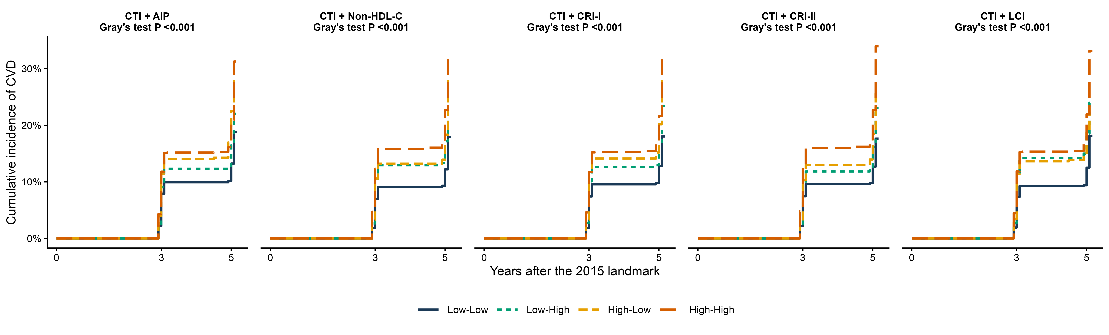
Supplementary Figure S1. Aalen-Johansen cumulative-incidence functions for reported incident CVD across the four median-defined joint categories of CTI with AIP, non-HDL-C, CRI-I, CRI-II, and LCI. Death before a reported CVD event is treated as a competing event. Each panel compares dual-low, high-CTI/low-nTLP, low-CTI/high-nTLP, and dual-high groups; Gray's test P values are displayed in the panels. Numbers at risk at yearly landmarks are provided in Supplementary Table S52. CTI, C-reactive protein-triglyceride-glucose index; nTLP, non-traditional lipid parameter.
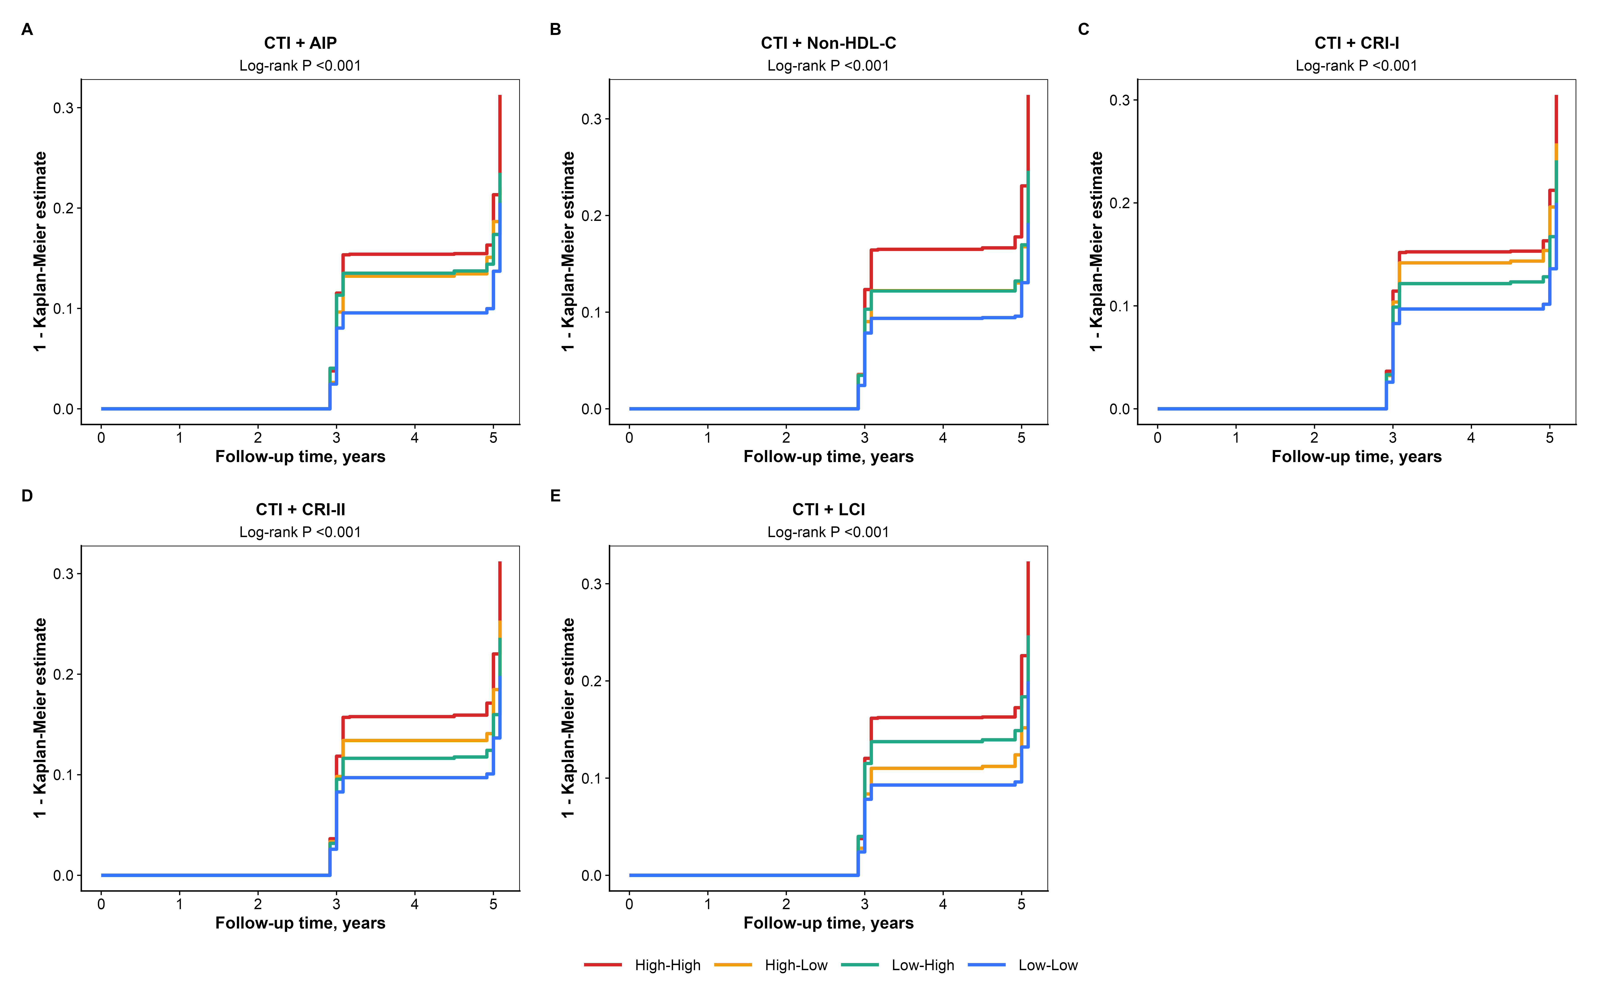
Supplementary Figure S2. Kaplan-Meier (1-KM) event-probability sensitivity curves for antecedent 2011 CTI-nTLP joint categories. High and low groups are defined by the corresponding 2011 exposure medians. Death is treated as censoring in this descriptive sensitivity analysis; the competing-death-aware Aalen-Johansen analysis in Supplementary Figure S1 remains the primary cumulative-incidence display. Curves are shown for all five CTI-nTLP pairs.
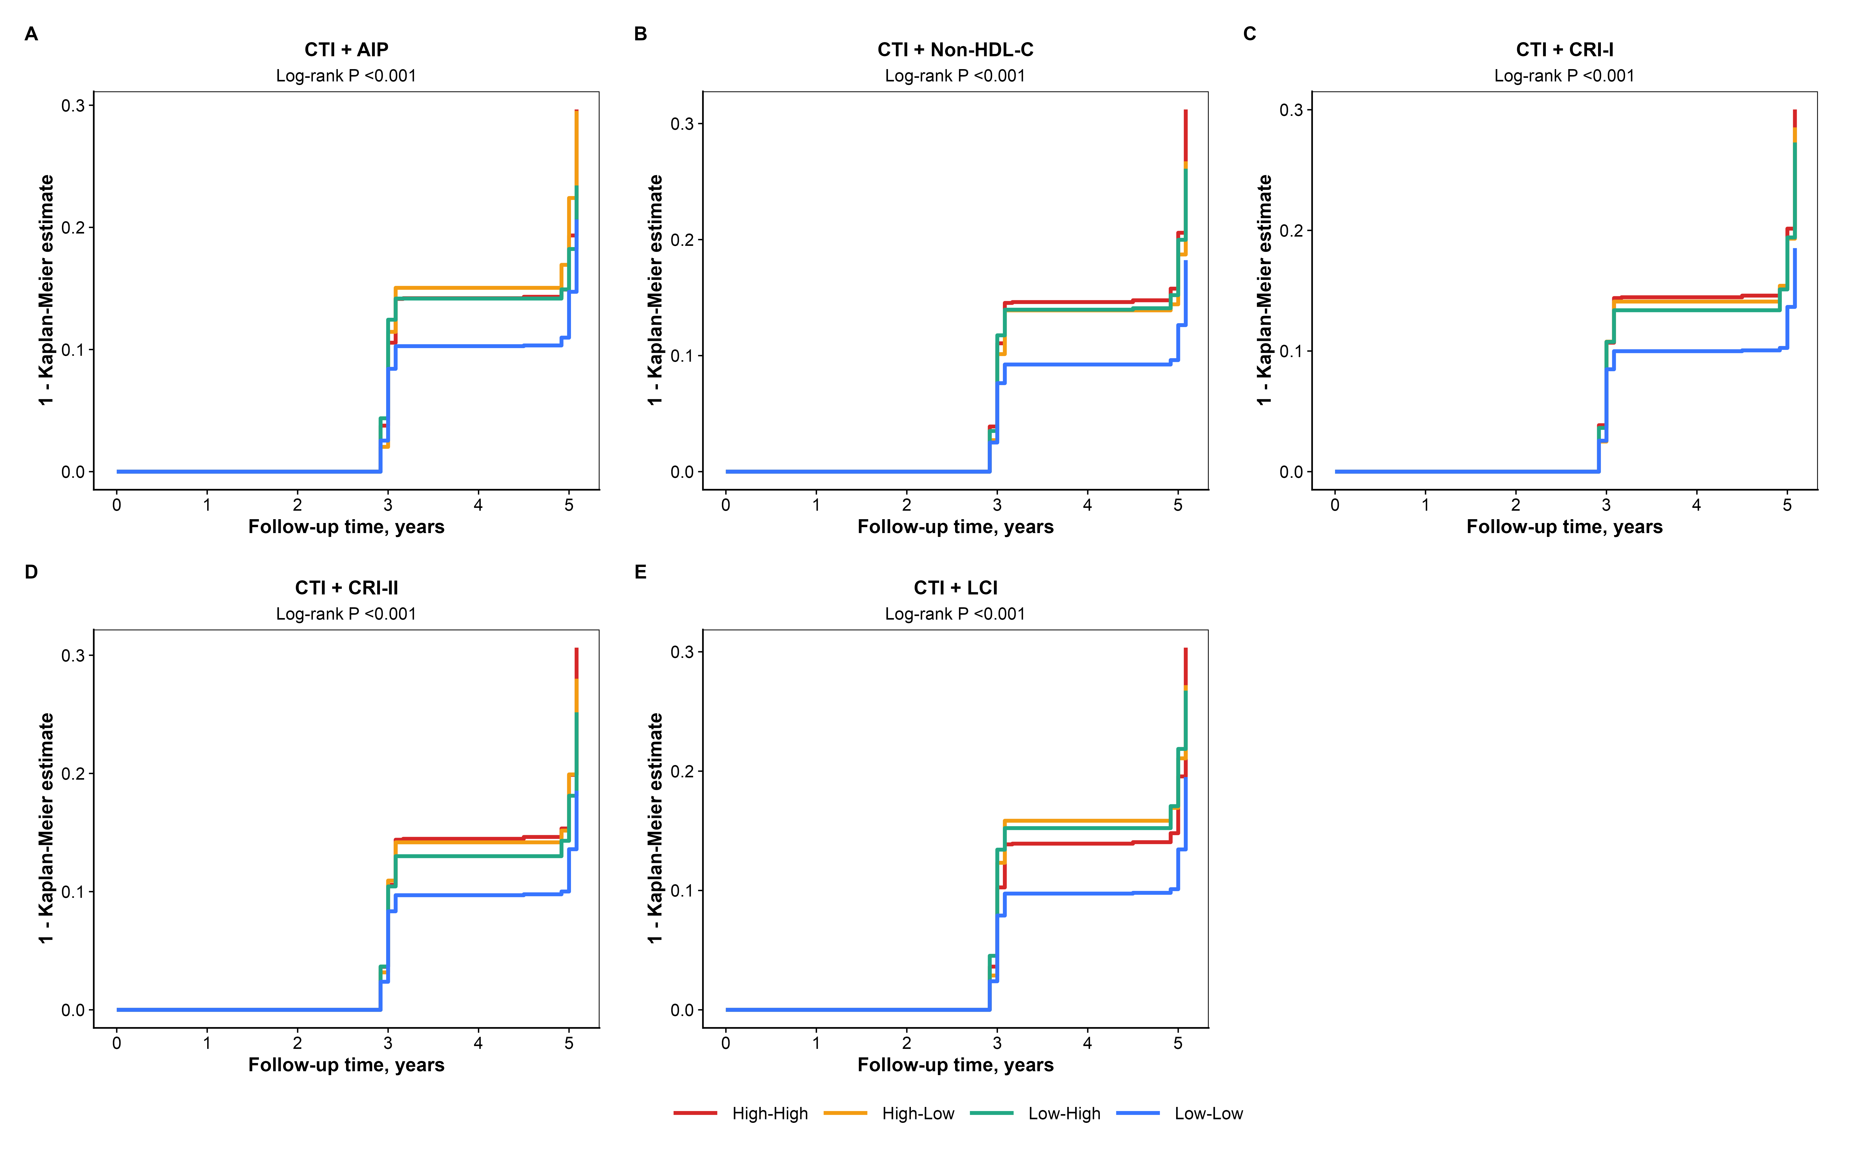
Supplementary Figure S3. Kaplan-Meier (1-KM) event-probability sensitivity curves for landmark 2015 CTI-nTLP joint categories. High and low groups are defined by the corresponding 2015 exposure medians. Death is treated as censoring in this descriptive sensitivity analysis, and log-rank comparisons are reported with the accompanying results. Curves are shown for all five CTI-nTLP pairs.
Supplementary Figure S4. Kaplan-Meier (1-KM) event-probability sensitivity curves for the time-weighted 2011-2015 CTI-nTLP joint categories used in the primary exposure window. Groups are defined by cohort medians of CTI and the corresponding nTLP. Death is treated as censoring in this descriptive display; competing-death-aware Aalen-Johansen estimates are shown in Supplementary Figure S1.
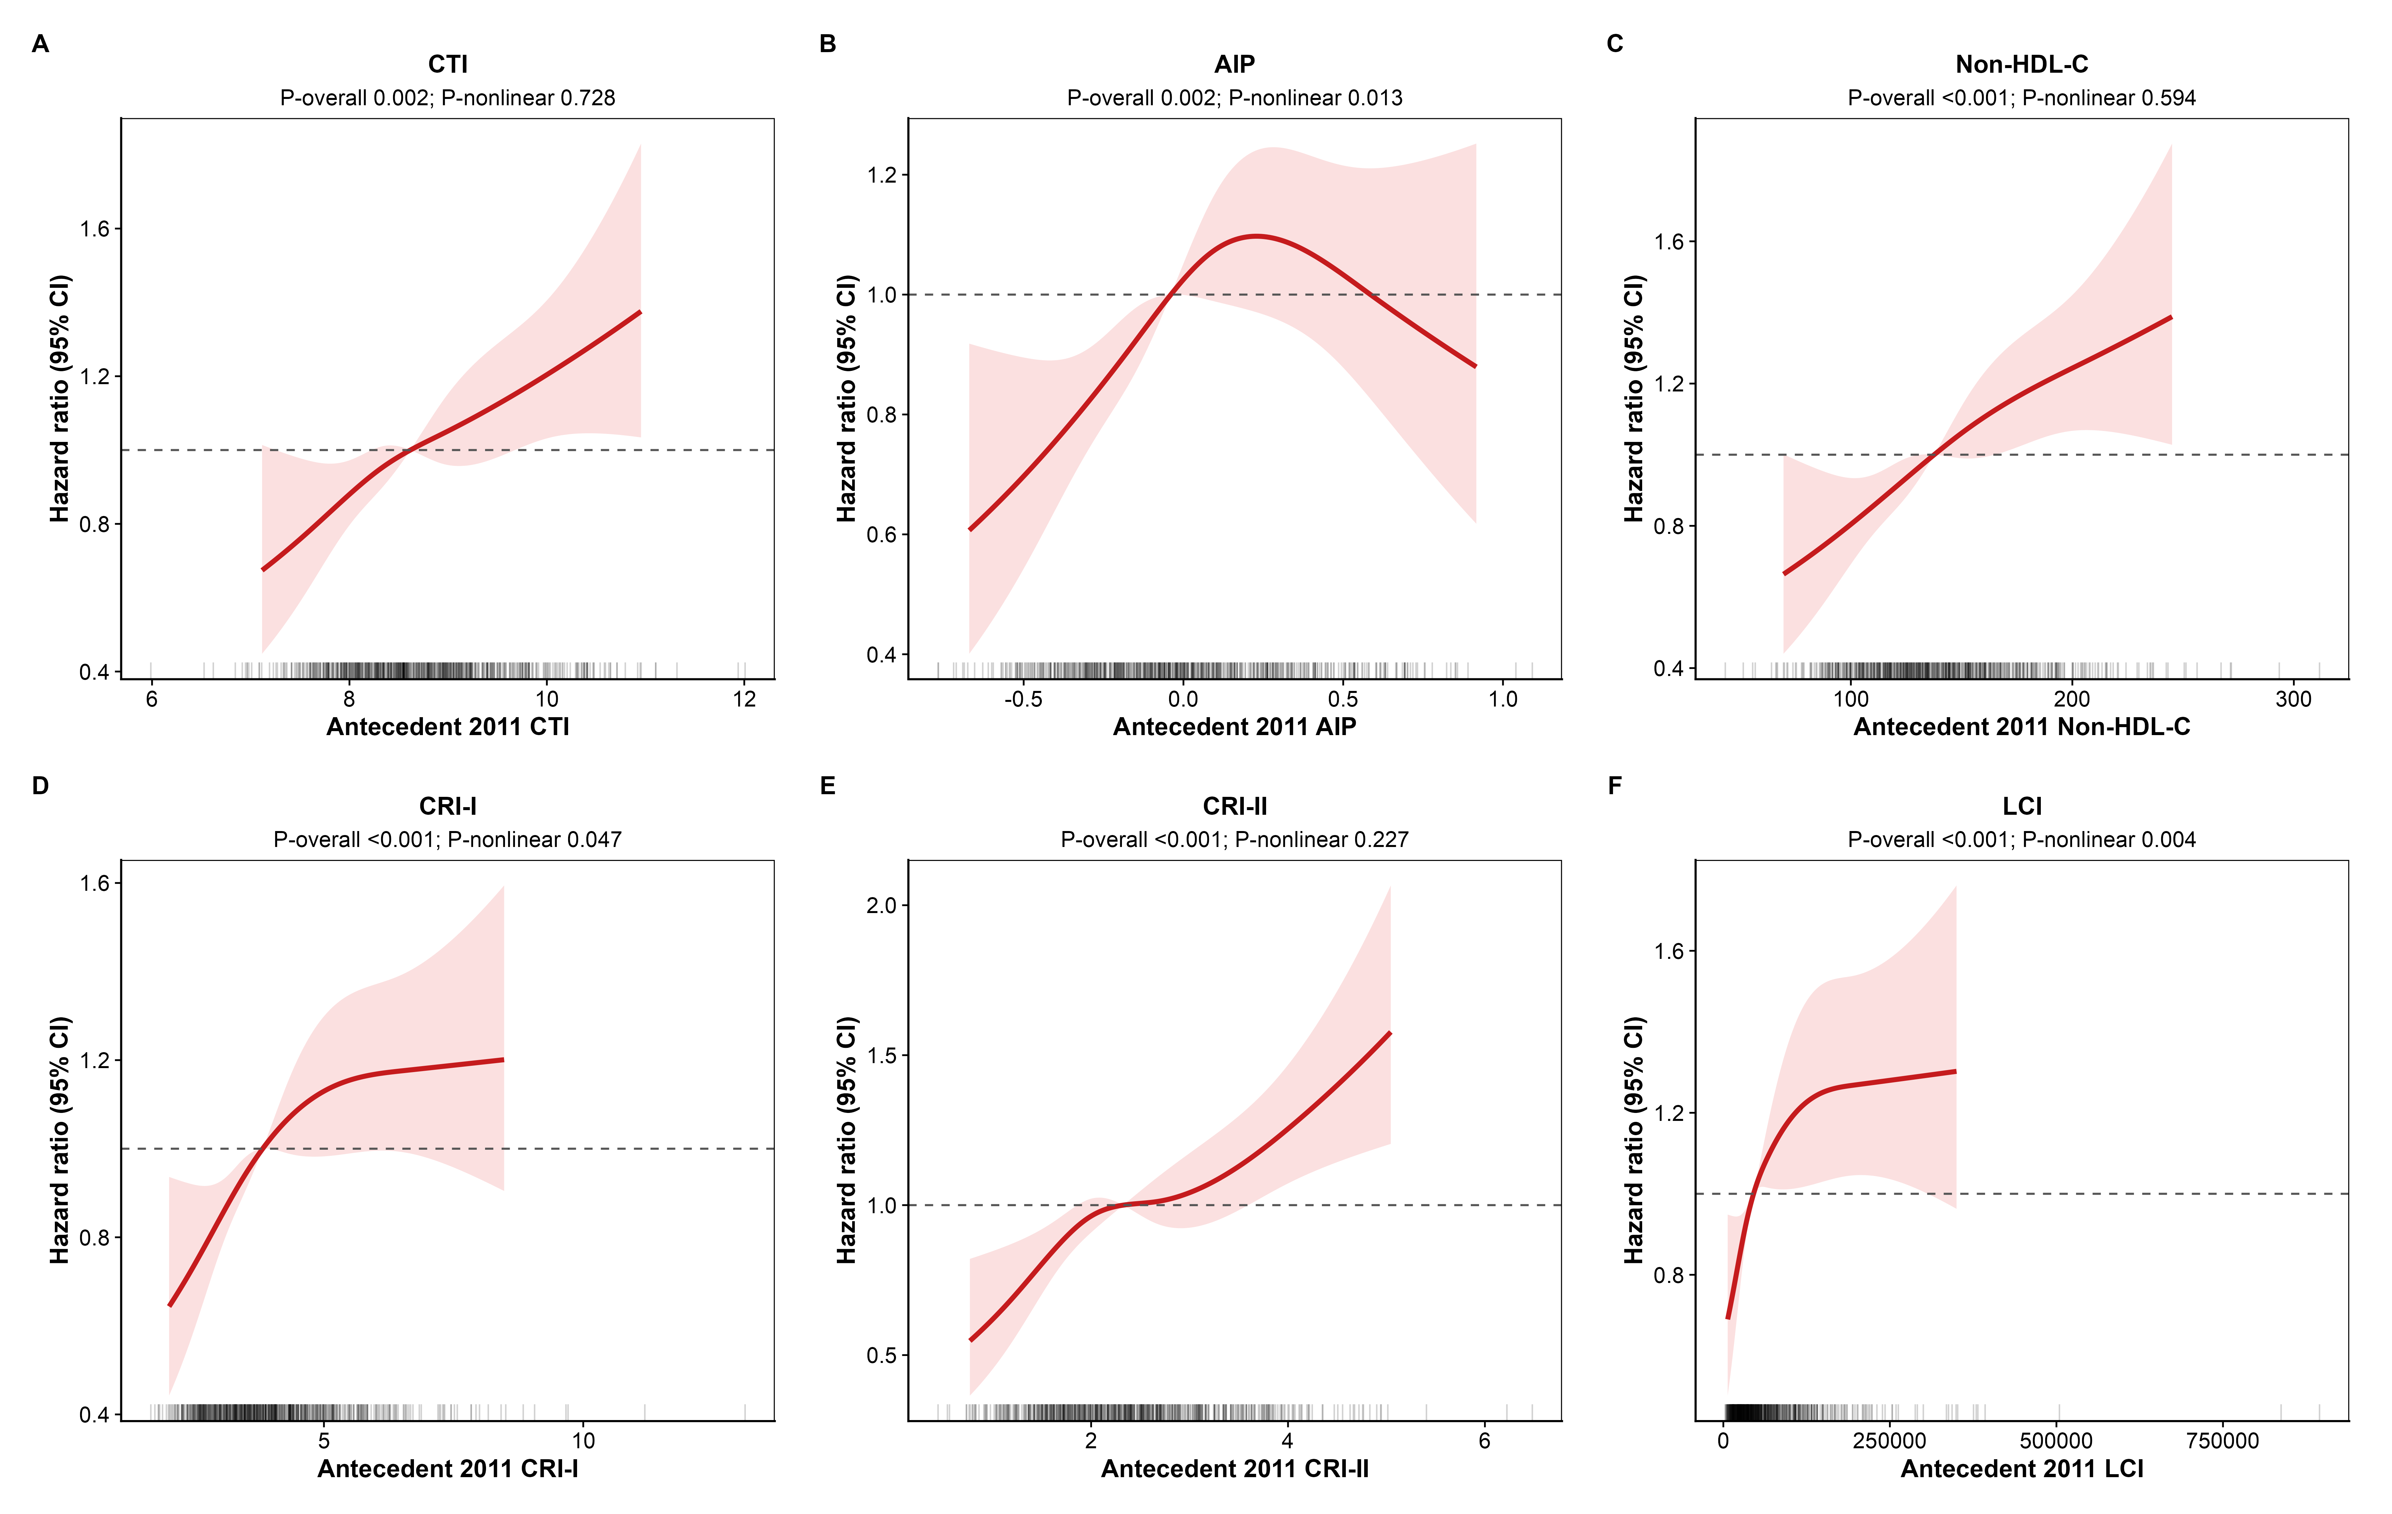
Supplementary Figure S5. Restricted cubic-spline associations of antecedent 2011 CTI and nTLP values with reported incident CVD. Models adjust for the primary 2015 covariate set and use four prespecified knots at the 5th, 35th, 65th, and 95th percentiles. Hazard ratios are expressed relative to the exposure median; models are fit in the full eligible sample, while curves are displayed over the 1st-99th percentile range. Confidence intervals for contrasts with the median incorporate the reference-contrast covariance.
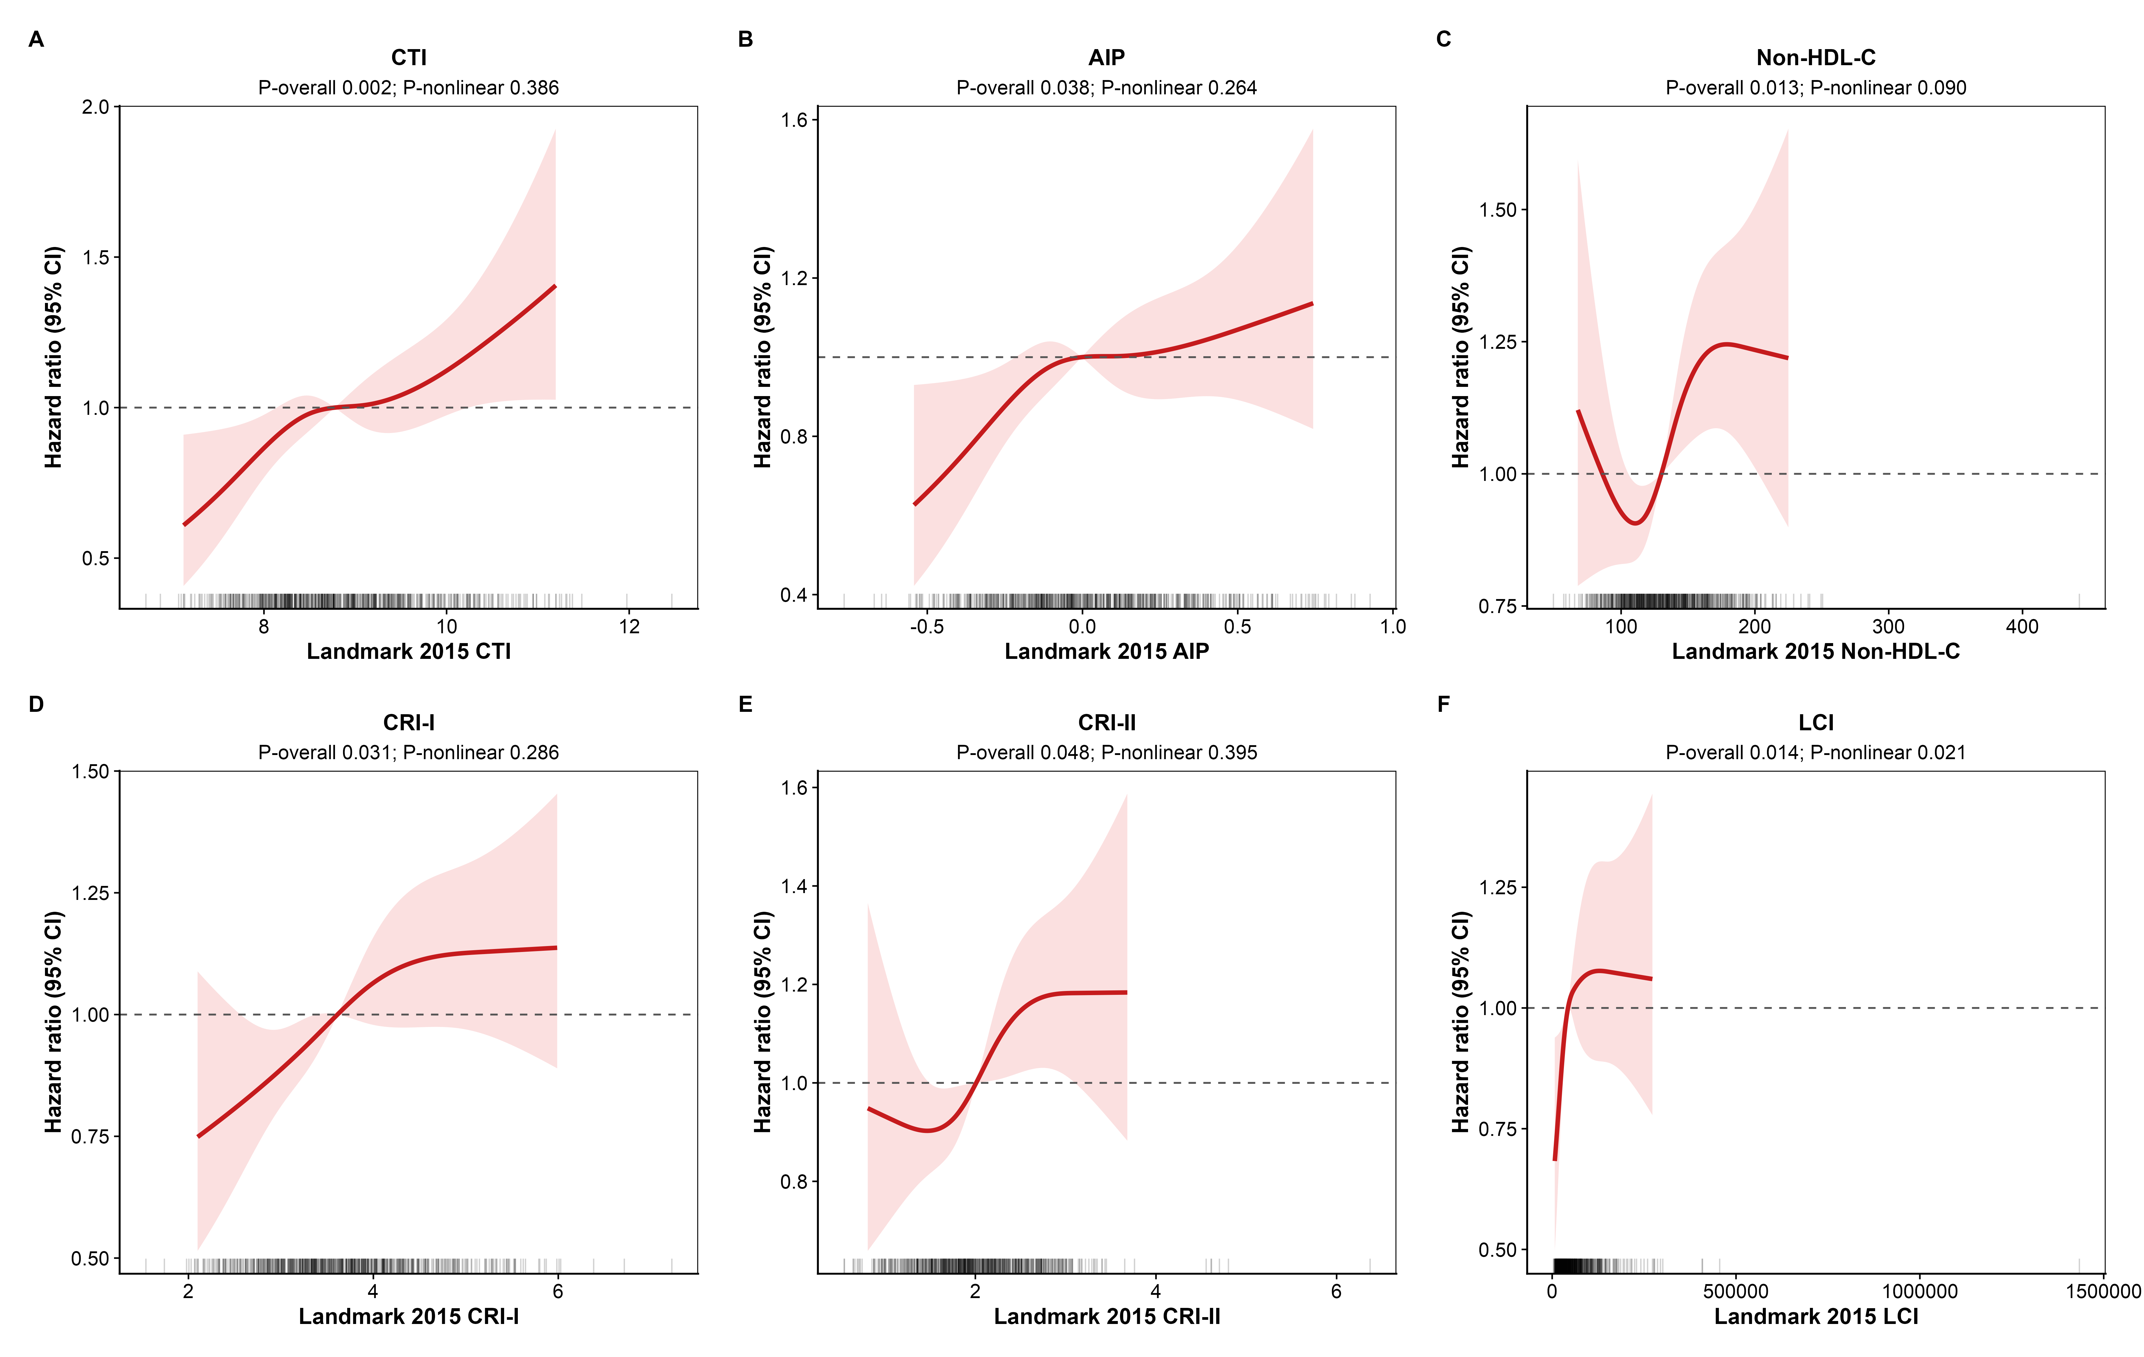
Supplementary Figure S6. Restricted cubic-spline associations of landmark 2015 CTI and nTLP values with reported incident CVD. Models adjust for the primary 2015 covariate set and use knots at the 5th, 35th, 65th, and 95th percentiles. Hazard ratios are referenced to the exposure median; all eligible observations contribute to fitting, with the 1st-99th percentile range used only for display. Overall and nonlinearity tests are reported in Supplementary Table S25.
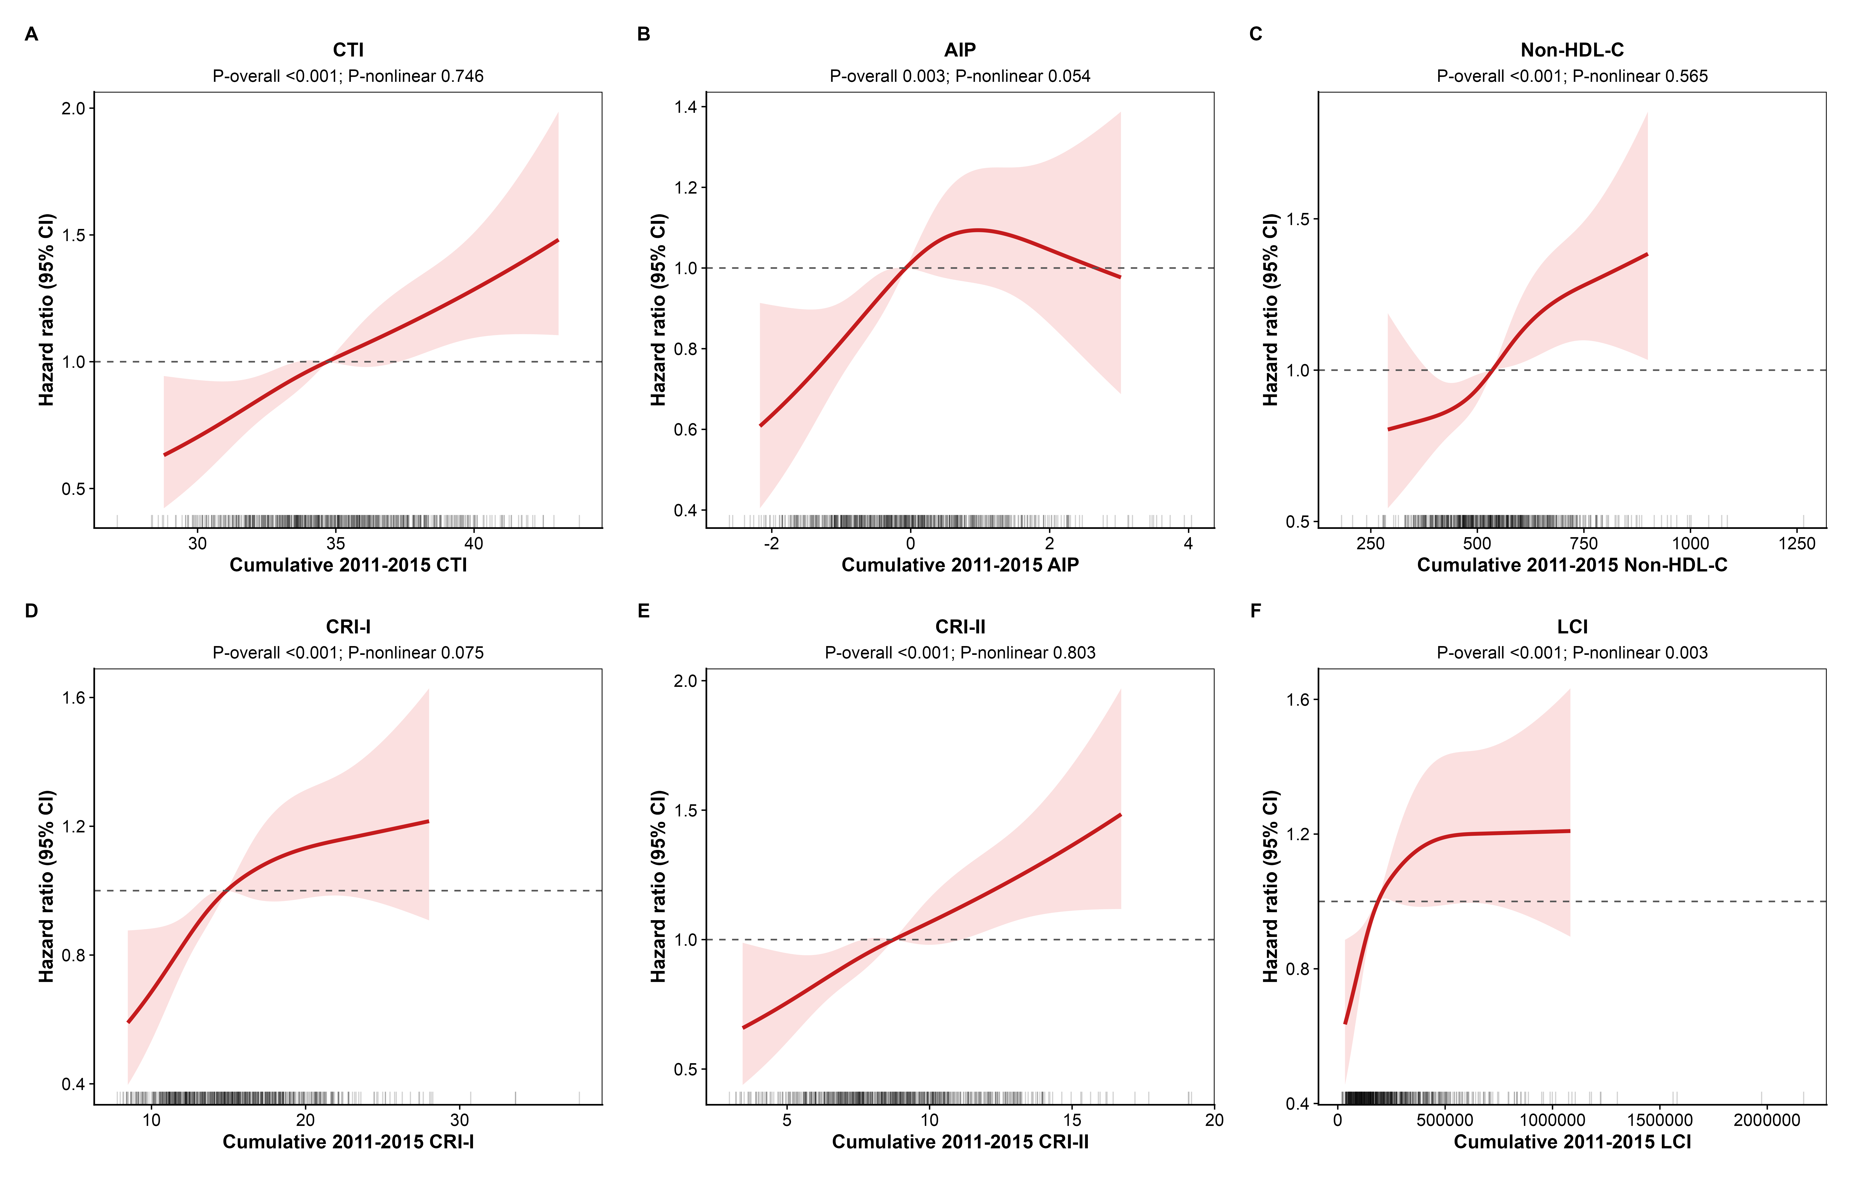
Supplementary Figure S7. Restricted cubic-spline associations of the time-weighted 2011-2015 CTI and nTLP summaries with reported incident CVD. The primary covariate set and four prespecified knots are used. Curves show hazard ratios relative to the median over the 1st-99th percentile display range, while model fitting retains the full eligible sample. Spline tests and exploratory threshold models are reported in Supplementary Tables S25-S26.
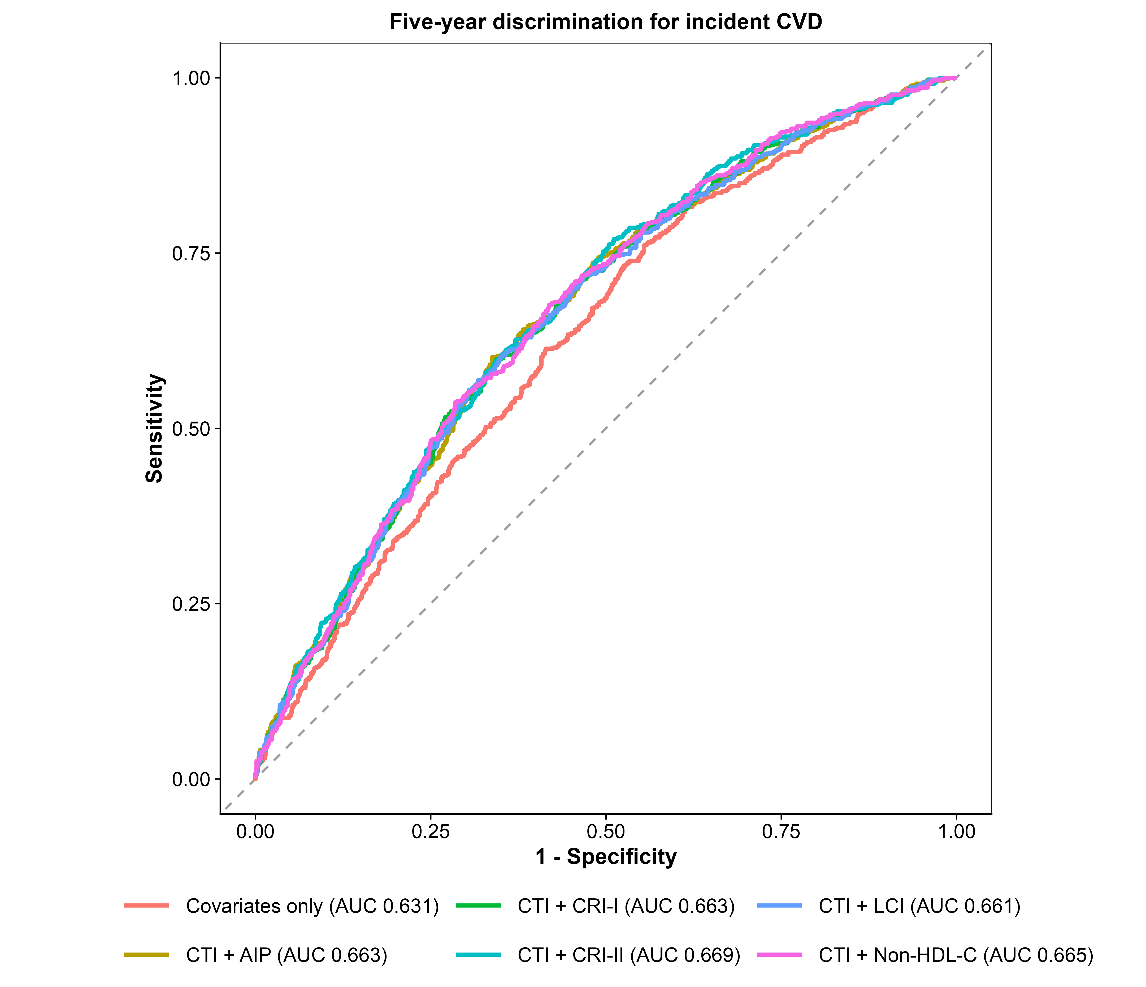
Supplementary Figure S8. Exploratory 5-year receiver-operating-characteristic curves for reported incident CVD using the original association covariate set. For each CTI-nTLP pair, the covariates-only model is compared with the corresponding augmented model. Displayed AUCs are descriptive apparent estimates from this fixed-horizon ROC sensitivity analysis; the primary 5-year performance assessment uses censoring- and competing-risk-aware AUC/Brier estimates and bootstrap optimism-corrected discrimination and calibration reported in the main Table 5 and Supplementary Tables S50-S51.
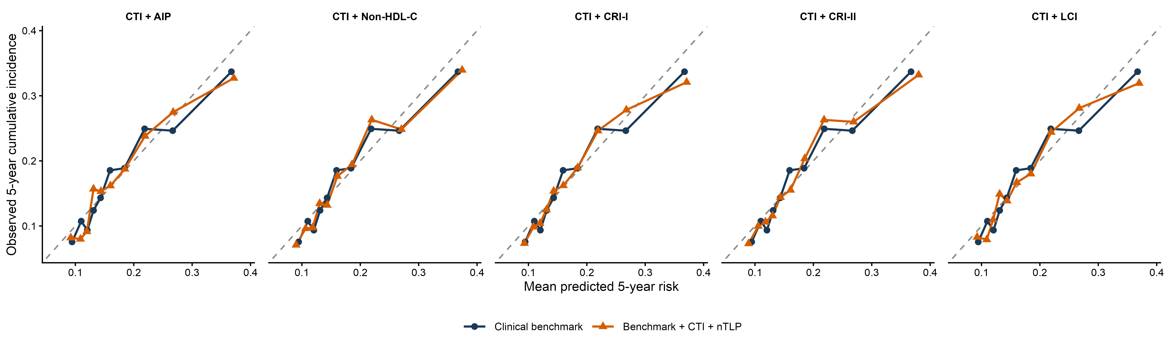
Supplementary Figure S9. Pair-specific 5-year calibration plots for CTI-nTLP prediction models. Participants are grouped by predicted-risk decile, and observed risk is estimated with the Aalen-Johansen approach so that death before reported CVD is treated as a competing event. The dashed 45-degree line denotes ideal agreement between predicted and observed risk; numerical calibration measures are reported in the main Table 5 and Supplementary Tables S50-S51.
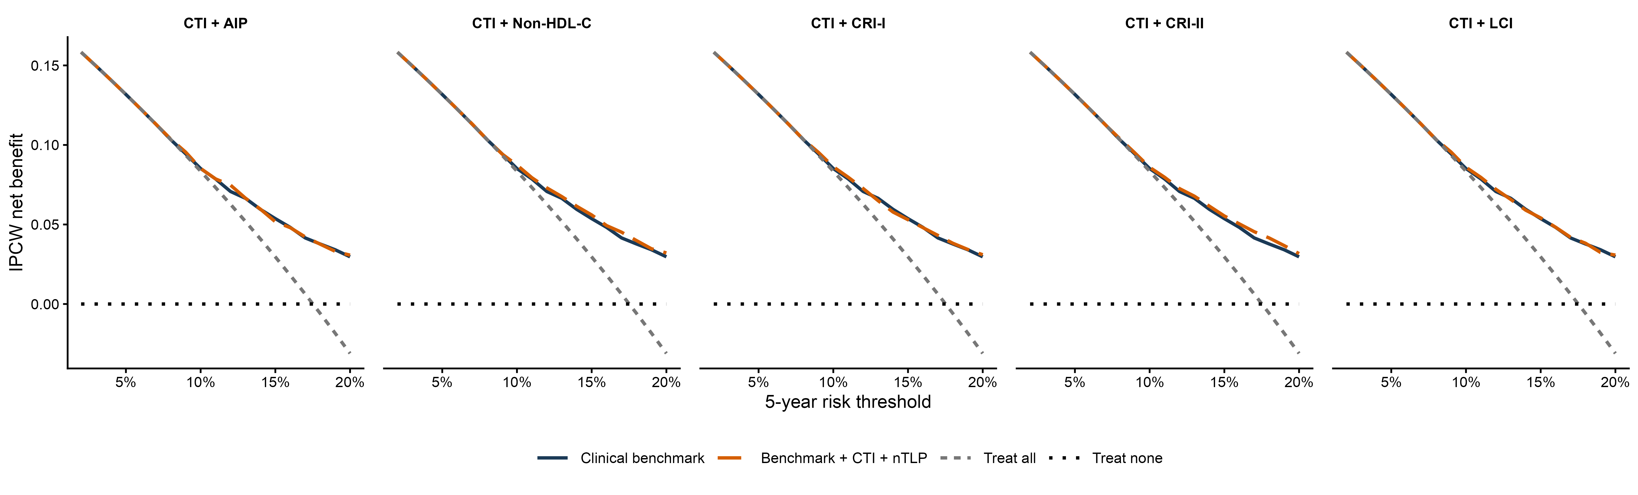
Supplementary Figure S10. Exploratory inverse-probability-of-censoring-weighted decision curves comparing the clinical benchmark with CTI-nTLP augmented models over clinically relevant risk thresholds. Net benefit is interpreted relative to the benchmark and standard treat-all/treat-none strategies. The substantial overlap of augmented and benchmark curves is consistent with the small internally validated increments in discrimination reported in Supplementary Table S50.

