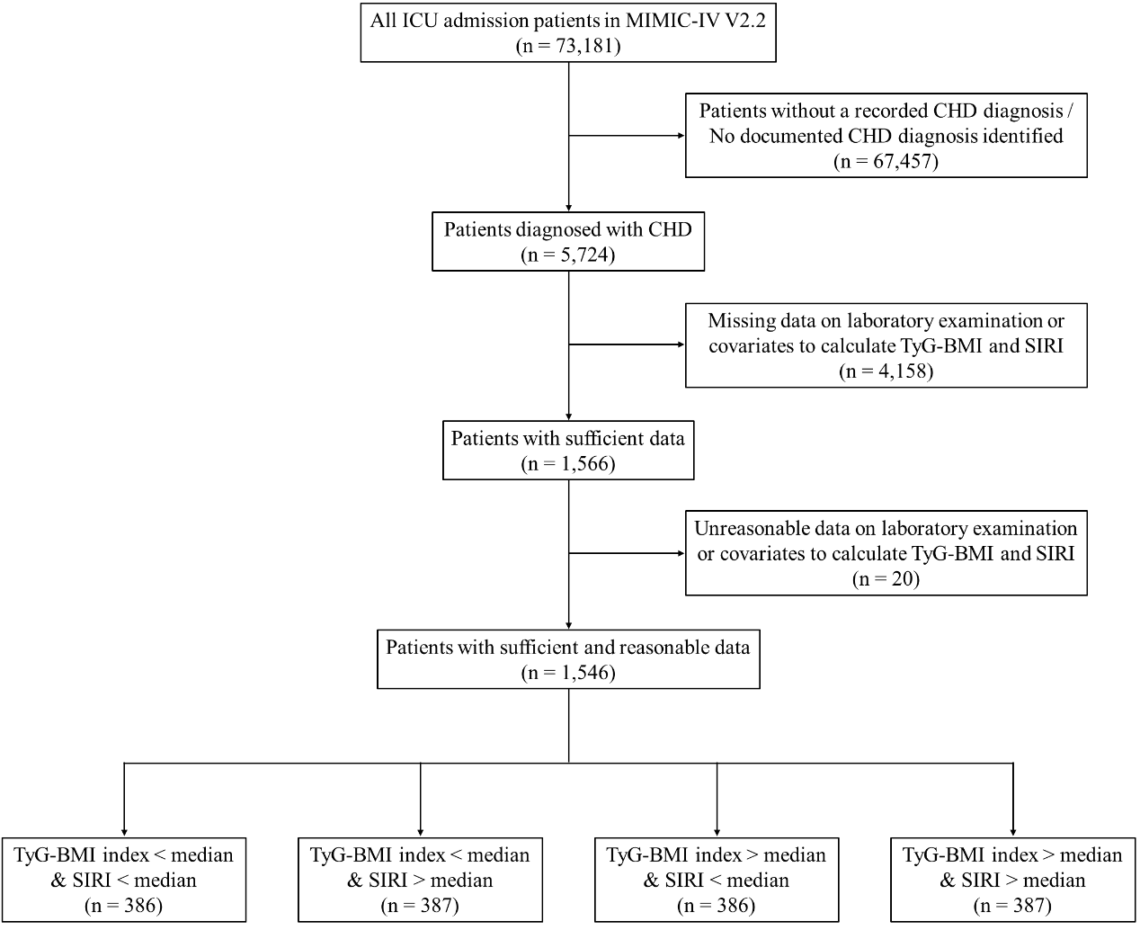
SUPPLEMENT FIGURE 1. Flowchart showing the selection of patients. MIMIC-IV, Medical Information Mart for Intensive Care IV; CHD, Coronary heart disease; TyG-BMI index, Triglyceride glucose-body mass index; SIRI, Systemic inflammation response index.

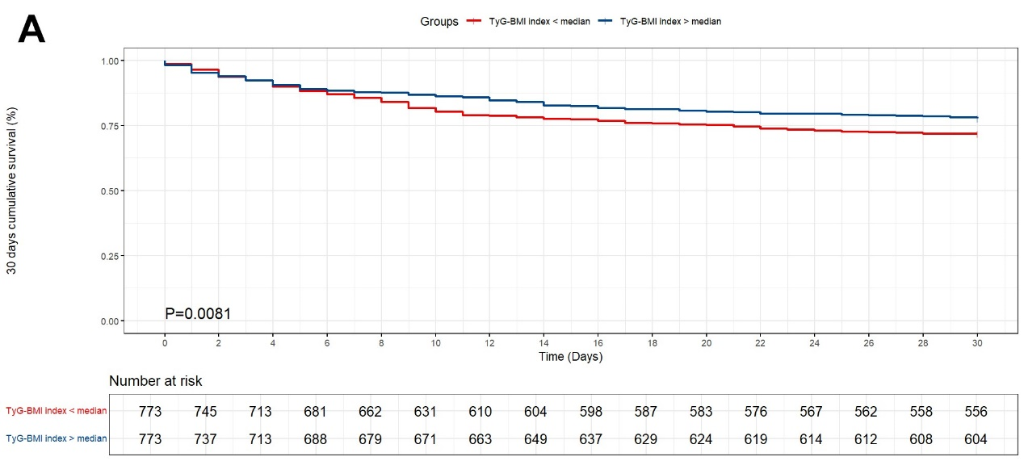
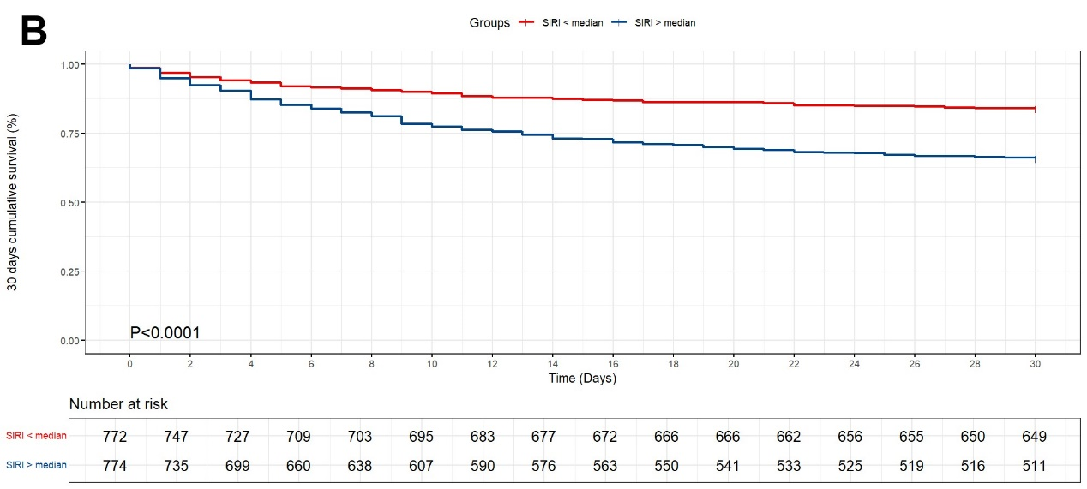
SUPPLEMENT FIGURE 2. Kaplan-Meier curves of 30-day survival by TyG-BMI index (A) and SIRI level (B). TyG-BMI index, Triglyceride glucose-body mass index; SIRI, Systemic inflammation response index.

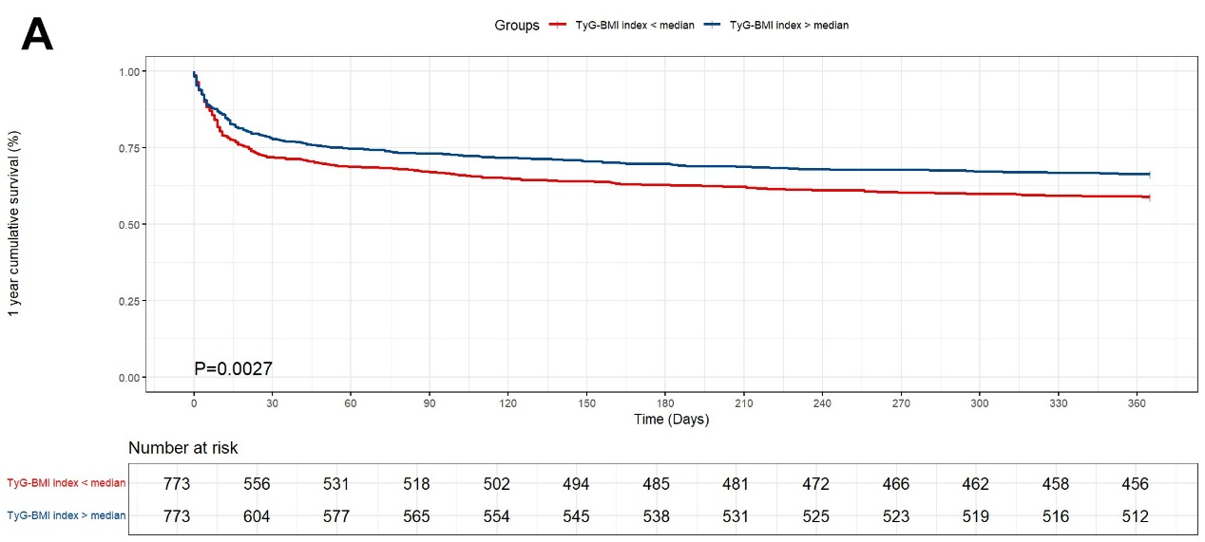
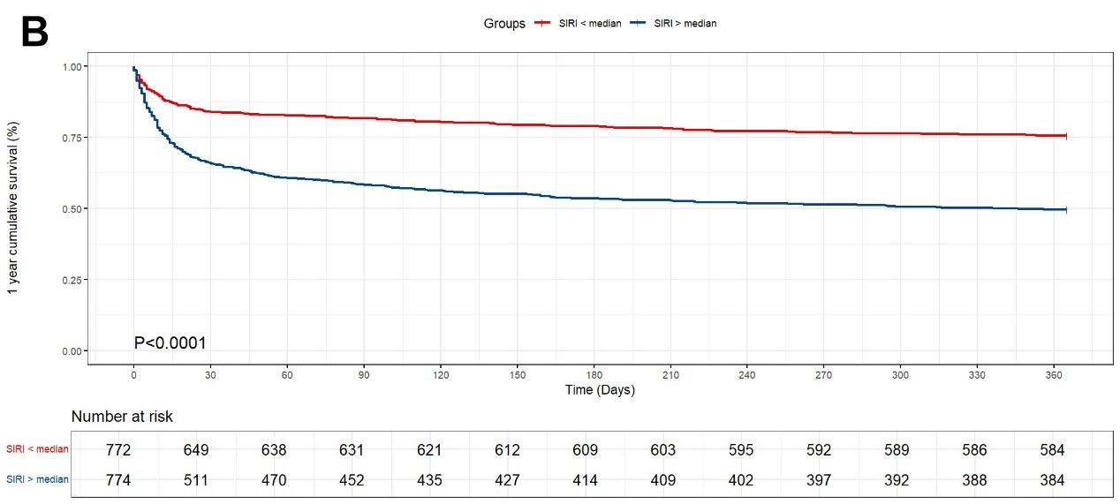
SUPPLEMENT FIGURE 3. Kaplan-Meier curves of one-year survival by TyG-BMI index (A) and SIRI level (B). TyG-BMI index, Triglyceride glucose-body mass index; SIRI, Systemic inflammation response index.

SUPPLEMENT TABLE 1. ICD-9 and ICD-10 codes used to identify disease in this study.
Diagnosis | ICD-9 | ICD-10
Myocardial infarction | 410.00, 410.01, 410.02, 410.10, 410.11, 410.12, 410.20, 410.21, 410.22, 410.30, 410.31, 410.32, 410.40, 410.41, 410.42, 410.50, 410.51, 410.52, 410.80, 410.81, 410.82, 410.90, 410.91, 410.92 | I21, I21.0, I21.01, I21.02, I21.09, I21.1, I21.11, I21.19, I21.2, I21.21, I21.29, I21.3, I21.4, I21.9, I21.A, I21.A1, I21.A9, I22, I22.0, I22.1, I22.2, I22.8, I22.9
Ischemic heart disease | — | I24, I24.8, I24.9
Unstable angina | — | I20.0, I25.110, I25.700, I25.710, I25.720, I25.730, I25.750, I25.760, I25.790
ICD, International Classification of Diseases. No eligible patients were identified by ICD-9 codes in this cohort; all included patients were identified using ICD-10 codes.

SUPPLEMENT TABLE 2. Item IDs, original and converted units, and selection rules for every component of TyG-BMI and SIRI.
Item | Item ID | Original unit | Converted unit | Selection rules
Triglycerides | 51000 | mg/dL | mg/dL | First value within the first 24 h after ICU admission
Blood glucose | 50931 | mg/dL | mg/dL | First value within the first 24 h after ICU admission
 | 52569 | mg/dL | mg/dL | First value within the first 24 h after ICU admission
Weight | 226512 | kg | kg | First value within the first 24 h after ICU admission
 | 224639 | kg | kg | First value within the first 24 h after ICU admission
Height | 226707 | Inch | m | First value within the first 24 h after ICU admission
 | 226730 | cm | m | First value within the first 24 h after ICU admission
Neutrophils | 52075 | K/uL | ×10⁹/L | Worst value within the first 24 h after ICU admission
Monocytes | 52074 | K/uL | ×10⁹/L | Worst value within the first 24 h after ICU admission
 | 51253 | /uL | ×10⁹/L | Worst value within the first 24 h after ICU admission
Lymphocytes | 51133 | K/uL | ×10⁹/L | Worst value within the first 24 h after ICU admission
 | 52769 | /uL | ×10⁹/L | Worst value within the first 24 h after ICU admission; values in /uL converted to ×10⁹/L
TyG-BMI index, Triglyceride glucose-body mass index; SIRI, Systemic inflammation response index. Laboratory measurements (triglycerides, blood glucose, and leukocyte differential counts) were extracted from the labevents table; weight and height were extracted from the chartevents table of MIMIC-IV.

SUPPLEMENT TABLE 3. The baseline characteristics of participants across the four groups.
Variables | Total participants  (n = 1546) | TyG-BMI index < median & SIRI < median  (n = 386) | TyG-BMI index < median & SIRI > median  (n = 387) | TyG-BMI index > median & SIRI < median  (n = 386) | TyG-BMI index > median & SIRI > median  (n = 387) | P-value
Age, years | 70.90±13.04 | 72.94±13.26 | 72.23±13.85 | 68.59±12.32 | 69.83±12.24 | <0.0001
Age, n (%)
≤ 65 | 499 (32.28) | 108 (27.98) | 108 (27.91) | 148 (38.34) | 135 (34.88) | 0.0025
> 65 | 1047 (67.72) | 278 (72.02) | 279 (72.09) | 238 (61.66) | 252 (65.12)
Gender, n (%) |  |  |  |  |  | 0.8632
Female | 605 (39.13) | 151 (39.12) | 145 (37.47) | 156 (40.41) | 153 (39.53)
Male | 941 (60.87) | 235 (60.88) | 242 (62.53) | 230 (59.59) | 234 (60.47)
Race, n (%) |  |  |  |  |  | 0.1074
White | 977 (63.20) | 241 (62.44) | 264 (68.22) | 231 (59.84) | 241 (62.27)
Black | 212 (13.71) | 55 (14.25) | 36 (9.30) | 63 (16.32) | 58 (14.99)
Others | 357 (23.09) | 90 (23.32) | 87 (22.48) | 92 (23.83) | 88 (22.74)
Marital status, n (%) |  |  |  |  |  | 0.4371
Married | 721 (46.64) | 185 (47.93) | 175 (45.22) | 178 (46.11) | 183 (47.29)
Single | 405 (26.20) | 90 (23.32) | 99 (25.58) | 115 (29.79) | 101 (26.10)
Others | 420 (27.17) | 111 (28.76) | 113 (29.20) | 93 (24.09) | 103 (26.61)
Shock, n (%) |  |  |  |  |  | 0.1990
Yes | 61(3.95) | 11(2.85) | 15(3.88) | 13(3.37) | 22(5.68)
No | 1485(96.05) | 375(97.15) | 372(96.12) | 373(96.63) | 365(94.32)
Myocardial Infarction, n (%) |  |  |  |  |  | 0.1210
Yes | 103(6.66) | 28(7.25) | 27(6.98) | 16(4.15) | 32(8.27)
No | 1443(93.34) | 358(92.75) | 360(93.02) | 370(95.85) | 355(91.73)
Hypertension, n (%) |  |  |  |  |  | <0.0001
Yes | 998 (64.55) | 233 (60.36) | 228 (58.91) | 241 (62.44) | 296 (76.49)
No | 548 (35.45) | 153 (39.64) | 159 (41.09) | 145 (37.56) | 91 (23.51)
Diabetes, n (%) |  |  |  |  |  | <0.0001
Yes | 792 (51.23) | 157 (40.67) | 145 (37.47) | 237 (61.40) | 253 (65.37)
No | 754 (48.77) | 229 (59.33) | 242 (62.53) | 149 (38.60) | 134 (34.63)
Triglycerides, mg/dL | 156.00  (104.00-238.00) | 116.00  (87.00-167.00) | 128.00  (92.00-189.00) | 195.00  (135.00-312.00) | 196.00  (138.00-305.00) | <0.0001
Glucose, mg/dL | 259.00  (178.00-398.00) | 203.50  (155.00-316.00) | 233.00  (179.00-357.00) | 290.50  (174.00-414.00) | 335.00  (228.00-498.00) | <0.0001
TyG index | 10.03±0.94 | 9.52±0.78 | 9.78±0.82 | 10.31±0.90 | 10.49±0.90 | <0.0001
BMI, kg/m² | 29.17±6.99 | 24.84±3.05 | 23.99±3.21 | 33.78±5.94 | 34.09±7.05 | <0.0001
TyG-BMI index | 293.43±80.10 | 235.97±29.64 | 233.67±30.49 | 347.37±64.09 | 356.71±77.26 | <0.0001
Neutrophils, × 10⁹/L | 12.56  (8.64-18.23) | 8.47  (6.13-11.10) | 17.46  (12.27-23.72) | 9.56  (7.17-13.19) | 17.27  (13.62-22.35) | <0.0001
Monocytes, × 10⁹/L | 1.07  (0.77-1.52) | 0.79  (0.60-0.98) | 1.42  (1.10-1.80) | 0.85  (0.65-1.07) | 1.47  (1.12-1.96) | <0.0001
Lymphocytes, × 10⁹/L | 1.98  (1.41-2.76) | 2.04  (1.49-2.75) | 1.69  (1.17-2.34) | 2.44  (1.65-3.41) | 1.85  (1.31-2.59) | <0.0001
SIRI | 6.64  (3.44-13.43) | 3.28  (2.24-4.88) | 13.44  (9.24-22.06) | 3.58  (2.37-4.93) | 13.19  (9.55-20.23) | <0.0001
TyG-BMI index, Triglyceride glucose-body mass index; SIRI, Systemic inflammation response index; TyG index, Triglyceride glucose index; BMI, Body mass index.

SUPPLEMENT TABLE 4. Schoenfeld residual-based tests for the proportional hazards assumption.
Variables | Level | HR (95% CI) | P value | P_{PH} value
Primary exposures
TyG-BMI index group | TyG-BMI index < median | Reference
 | TyG-BMI index > median | 0.78 (0.66-0.92) | 0.0030 | 0.3520
SIRI group | SIRI < median | Reference
 | SIRI > median | 2.49 (2.09-2.96) | <0.0001 | 0.1800
TyG-BMI index and SIRI Group | TyG-BMI index < median & SIRI < median | Reference
 | TyG-BMI index < median & SIRI > median | 2.25 (1.78-2.83) | <0.0001 | 0.1540
 | TyG-BMI index > median & SIRI < median | 0.67 (0.50-0.89) | 0.0067 | 0.2270
 | TyG-BMI index > median & SIRI > median | 1.89 (1.49-2.39) | <0.0001 | 0.4630
Adjustment covariates
Age | ≤ 65 | Reference
 | > 65 | 1.72 (1.42-2.09) | <0.0001 | 0.7350
Gender | Female | Reference
 | Male | 0.76 (0.64-0.89) | 0.0010 | 0.9980
Hypertension | No | Reference
 | Yes | 1.42 (1.19-1.70) | 0.0001 | 0.2050
Diabetes | No | Reference
 | Yes | 1.25 (1.06-1.47) | 0.0077 | 0.8340
Shock | No | Reference
 | Yes | 1.41 (0.97-2.05) | 0.0726 | 0.2360
Myocardial Infarction | No | Reference
 | Yes | 1.10 (0.80-1.50) | 0.5587 | 0.4320
Marital status | Single | Reference
 | Married | 1.15 (0.94-1.42) | 0.1808 | 0.9150
 | Others | 1.53 (1.22-1.91) | 0.0002 | 0.4330
Race | White | Reference
 | Black | 1.17 (0.93-1.48) | 0.1837 | 0.2160
 | Others | 1.02 (0.84-1.25) | 0.8242 | 0.0020
HR, Hazard ratio; CI, Confidence interval; TyG-BMI index, Triglyceride glucose-body mass index; SIRI, Systemic inflammation response index. HRs are unadjusted (single-variable) estimates used for PH-assumption screening; in the final multivariable models, race was included as a stratification factor without estimating its hazard ratio.

SUPPLEMENT TABLE 5. The baseline characteristics of participants in different TyG-BMI index groups.
Variables | Total participants  (n = 1546) | TyG-BMI < median  (n = 773) | TyG-BMI > median  (n = 773) | P-value
Age, years | 70.90±13.04 | 72.59±13.56 | 69.21±12.29 | <0.001
Age, n (%) |  |  |  | <0.001
≤ 65 | 499 (32.28) | 216 (27.94) | 283 (36.61)
> 65 | 1047 (67.72) | 557 (72.06) | 490 (63.39)
Gender, n (%) |  |  |  | 0.498
Female | 605 (39.13) | 296 (38.29) | 309 (39.97)
Male | 941 (60.87) | 477 (61.71) | 464 (60.03)
Race, n (%) |  |  |  | 0.068
White | 977 (63.20) | 505 (65.33) | 472 (61.06)
Black | 212 (13.71) | 91 (11.77) | 121 (15.65)
Others | 357 (23.09) | 177 (22.90) | 180 (23.29)
Marital status, n (%) |  |  |  | 0.160
Married | 721 (46.64) | 360 (46.57) | 361 (46.70)
Single | 405 (26.20) | 189 (24.45) | 216 (27.94)
Others | 420 (27.17) | 224 (28.98) | 196 (25.36)
Hypertension, n (%) |  |  |  | <0.001
Yes | 998 (64.55) | 461 (59.64) | 537 (69.47)
No | 548 (35.45) | 312 (40.36) | 236 (30.53)
Diabetes, n (%) |  |  |  | <0.001
Yes | 792 (51.23) | 302 (39.07) | 490 (63.39)
No | 754 (48.77) | 471 (60.93) | 283 (36.61)
Shock, n (%) |  |  |  | 0.240
Yes | 61(3.95) | 26(3.36) | 35(4.53)
No | 1485(96.05) | 747(96.64) | 738(95.47)
Myocardial Infarction, n (%) |  |  |  | 0.475
Yes | 103(6.66) | 55(7.12) | 48(6.21)
No | 1443(93.34) | 718(92.88) | 725(93.79)
Triglycerides, mg/dL | 156.00  (104.00-238.00) | 122.00  (89.00-179.00) | 196.00  (137.00-310.00) | <0.001
Glucose, mg/dL | 259.00  (178.00-398.00) | 218.00  (165.00-338.00) | 312.00  (200.00-458.00) | <0.001
TyG index | 10.03±0.94 | 9.65±0.81 | 10.40±0.90 | <0.001
BMI | 29.17±6.99 | 24.42±3.16 | 33.93±6.52 | <0.001
TyG-BMI index | 293.43±80.10 | 234.82±30.07 | 352.04±71.10 | <0.001
Neutrophils, × 10⁹/L | 12.56  (8.64-18.23) | 11.79  (8.08-17.92) | 13.29  (9.27-18.29) | 0.002
Monocytes, × 10⁹/L | 1.07 (0.77-1.52) | 1.04 (0.75-1.51) | 1.11 (0.80-1.53) | 0.034
Lymphocytes, × 10⁹/L | 1.98 (1.41-2.76) | 1.86 (1.32-2.58) | 2.12 (1.49-2.97) | <0.001
SIRI | 6.64 (3.44-13.43) | 6.64 (3.28-13.44) | 6.66 (3.58-13.19) | 0.846
TyG-BMI index, Triglyceride glucose-body mass index; SIRI, Systemic inflammation response index; TyG index, Triglyceride glucose index; BMI, Body mass index.

SUPPLEMENT TABLE 6. The baseline characteristics of participants in different SIRI groups.
Variables | Total participants (n = 1546) | SIRI < median  (n = 772) | SIRI > median  (n = 774) | P-value
Age, years | 70.90±13.04 | 70.77±12.98 | 71.03±13.12 | 0.695
Age, n (%) |  |  |  | 0.458
≤ 65 | 499 (32.28) | 256 (33.16) | 243 (31.40)
> 65 | 1047 (67.72) | 516 (66.84) | 531 (68.60)
Gender, n (%) |  |  |  | 0.610
Female | 605 (39.13) | 307 (39.77) | 298 (38.50)
Male | 941 (60.87) | 465 (60.23) | 476 (61.50)
Race, n (%) |  |  |  | 0.138
White | 977 (63.20) | 472 (61.14) | 505 (65.25)
Black | 212 (13.71) | 118 (15.28) | 94 (12.14)
Others | 357 (23.09) | 182 (23.58) | 175 (22.61)
Marital status, n (%) |  |  |  | 0.804
Married | 721 (46.64) | 363 (47.02) | 358 (46.25)
Single | 405 (26.20) | 205 (26.55) | 200 (25.84)
Others | 420 (27.17) | 204 (26.42) | 216 (27.91)
Hypertension, n (%) |  |  |  | 0.010
Yes | 998 (64.55) | 474 (61.40) | 524 (67.70)
No | 548 (35.45) | 298 (38.60) | 250 (32.30)
Diabetes, n (%) |  |  |  | 0.880
Yes | 792 (51.23) | 394 (51.04) | 398 (51.42)
No | 754 (48.77) | 378 (48.96) | 376 (48.58)
Shock, n (%) |  |  |  | 0.091
Yes | 61(3.95) | 24(3.11) | 37(4.78)
No | 1485(96.05) | 748(96.89) | 737(95.22)
Myocardial Infarction, n (%) |  |  |  | 0.129
Yes | 103(6.66) | 44(5.70) | 59(7.62)
No | 1443(93.34) | 728(94.30) | 715(92.38)
Triglycerides, mg/dL | 156.00  (104.00-238.00) | 150.00  (101.00-236.50) | 162.00  (108.00-239.00) | 0.191
Glucose, mg/dL | 259.00  (178.00-398.00) | 229.50  (164.00-370.50) | 284.50  (200.00-438.00) | <0.001
TyG index | 10.03±0.94 | 9.92±0.93 | 10.13±0.93 | <0.001
BMI, kg/m² | 29.17±6.99 | 29.31±6.50 | 29.04±7.45 | 0.445
TyG-BMI index | 293.43±80.10 | 291.67±74.81 | 295.19±85.06 | 0.387
Neutrophils, × 10⁹/L | 12.56  (8.64-18.23) | 9.00  (6.66-12.09) | 17.29  (12.87-22.86) | <0.001
Monocytes, × 10⁹/L | 1.07 (0.77-1.52) | 0.81 (0.62-1.04) | 1.45 (1.11-1.89) | <0.001
Lymphocytes, × 10⁹/L | 1.98 (1.41-2.76) | 2.23 (1.59-3.08) | 1.78 (1.21-2.49) | <0.001
SIRI | 6.64 (3.44-13.43) | 3.44 (2.29-4.89) | 13.43 (9.41-20.68) | <0.001
TyG-BMI index, Triglyceride glucose-body mass index; SIRI, Systemic inflammation response index; TyG index, Triglyceride glucose index; BMI, Body mass index.

SUPPLEMENT TABLE 7. Covariate associations with one-year all-cause mortality in the TyG-BMI index < median group.
Variables | Univariate analysis |  | Multivariate analysis
Variables | HR  (95% CI) | P-value | HR  (95% CI) | P-value
Age (> 65 vs. ≤ 65) | 1.716  (1.304-2.258) | 0.0001 | 1.578  (1.189-2.095) | 0.0016
Gender (Male vs. Female) | 0.697  (0.558-0.869) | 0.0014 | 0.756  (0.601-0.951) | 0.0169
Marital status
Single | Reference |  | Reference
Married | 0.994  (0.744-1.328) | 0.9696 | 0.954  (0.708-1.285) | 0.7554
Others | 1.550  (1.152-2.087) | 0.0038 | 1.361  (1.000-1.852) | 0.0497
Hypertension (Yes vs. No) | 1.358  (1.078-1.711) | 0.0095 | 1.135  (0.885-1.455) | 0.3186
Diabetes (Yes vs. No) | 1.404  (1.126-1.751) | 0.0026 | 1.305  (1.033-1.648) | 0.0255
Shock (Yes vs. No) | 0.602  (0.358-1.011) | 0.0553 | 0.656  (0.389-1.106) | 0.114
Myocardial Infarction (Yes vs. No) | 1.060  (0.687-1.634) | 0.7931 | 1.136  (0.735-1.756) | 0.5652
Variables that satisfied the PH assumption, including gender, hypertension, diabetes, shock, myocardial infarction, marital status, and age, were entered as covariates in the Cox regression model. Race did not meet the PH assumption and was included as a stratification factor in the stratified Cox regression model without estimating its hazard ratio.
HR, Hazard ratio; CI, Confidence interval; TyG-BMI index, Triglyceride glucose-body mass index.
SUPPLEMENT TABLE 8. Covariate associations with one-year all-cause mortality in the SIRI > median group.
Variables | Univariate analysis |  | Multivariate analysis
Variables | HR  (95% CI) | P-value | HR  (95% CI) | P-value
Age (> 65 vs. ≤ 65) | 1.506  (1.200-1.890) | 0.0004 | 1.434  (1.136-1.811) | 0.0025
Gender (Male vs. Female) | 0.731  (0.599-0.893) | 0.0022 | 0.741  (0.602-0.911) | 0.0045
Marital status
Single | Reference |  | Reference
Married | 1.282  (0.991-1.659) | 0.0586 | 1.242  (0.951-1.623) | 0.1118
Others | 1.571  (1.192-2.070) | 0.0013 | 1.434  (1.075-1.911) | 0.0141
Hypertension (Yes vs. No) | 1.198  (0.964-1.489) | 0.1037 | 1.048  (0.827-1.329) | 0.6987
Diabetes (Yes vs. No) | 1.3304  (1.092-1.630) | 0.0047 | 1.355  (1.090-1.684) | 0.0063
Shock (Yes vs. No) | 0.823  (0.530-1.278) | 0.3866 | 0.851  (0.547-1.324) | 0.4743
Myocardial Infarction (Yes vs. No) | 0.968  (0.671-1.397) | 0.8622 | 0.921  (0.636-1.335) | 0.6637
Variables that satisfied the PH assumption, including gender, hypertension, diabetes, shock, myocardial infarction, marital status, and age, were entered as covariates in the Cox regression model. Race did not meet the PH assumption and was included as a stratification factor in the stratified Cox regression model without estimating its hazard ratio.
HR, Hazard ratio; CI, Confidence interval; TyG-BMI index, Triglyceride glucose-body mass index.

SUPPLEMENT TABLE 9. Multivariable Cox regression analysis of the interaction between TyG-BMI index group and SIRI group for one-year all-cause mortality.
Variables | Estimate | Standard error | Wald $χ^{2}$ | P-value
TyG-BMI index group ⅹ SIRI group | 0.16 | 0.18 | 0.81 | 0.3668
TyG-BMI index group | -0.43 | 0.15 | 8.44 | 0.0037
SIRI group | 0.85 | 0.12 | 51.03 | <0.0001
Variables that satisfied the PH assumption, including gender, hypertension, diabetes, shock, myocardial infarction, marital status, and age, were entered as covariates in the Cox regression model. Race did not meet the PH assumption and was included as a stratification factor in the stratified Cox regression model without estimating its hazard ratio.
HR, Hazard ratio; CI, Confidence interval; TyG-BMI index, Triglyceride glucose-body mass index; SIRI, Systemic inflammation response index.

