Supplementary Materials

Supplementary Methods
S2.5.1 Data resources, development-cohort partitioning, local annotation, and preprocessing
1. Sparse local annotation protocol
For the primary model, 100 participants from the 1,547-participant training set were selected after stratification by view availability and image quality for sparse local annotation. Each participant contributed A4C, A2C, and APLAX cine loops. For each cine, an experienced echocardiographer identified the end-diastolic (ED) and end-systolic (ES) frames and corrected pre-annotations of the LV cavity, myocardium, and left atrium (LA) on these two frames. The primary sparse-label set therefore comprised 300 view-level cine sequences and 600 manually verified frames, while intermediate frames were not manually contoured. A4C and A2C images generally required limited correction of the initialized contours, whereas APLAX images underwent more focused review. The remaining 1,447 participants contributed unlabelled cine sequences for weakly supervised anatomical and phase learning and self-supervised myocardial motion learning.
To assess annotation consistency, a randomly selected subset of 30 of the 100 sparsely labelled participants underwent independent repeat review by a second experienced echocardiographer using the same annotation protocol. Agreement was summarized using Dice coefficients for the LV cavity, myocardium, and LA and absolute ED/ES frame differences. The corresponding inter-observer results are reported in Supplementary Table S2.
Representative examples of sparse ED/ES anatomical supervision and automated ED/ES localization are shown in Supplementary Figure S1A.
2. Public resources and component initialization
Public echocardiographic datasets and publicly available model resources were used to initialize selected model components before local Cohort 1 development. EchoNet-Dynamic was used for A4C cine representation and LV-cavity segmentation initialization [25]. CAMUS was used for A2C/A4C sparse ED/ES anatomical supervision, including LV cavity, myocardium, and LA contours [26]. Public multi-view contour resources containing A4C, A2C, and APLAX images were additionally reviewed for view-conditioned anatomical initialization where their license and label definitions permitted. EchoXFlow was used to assess the feasibility of continuous APLAX cine processing and ECG-assisted phase quality control [27]. The temporal-attention design was informed by a plug-and-play temporal attention module previously shown to improve cardiac segmentation under sparse temporal supervision [28].
These public resources were used for component initialization and methodological development, whereas local Cohort 1 data were used for subsequent model training, validation, scalar calibration, and held-out internal testing.
3. Development-cohort partitioning
Cohort 1 comprised 2,547 participants spanning the broad echocardiographic spectrum defined in the study protocol. Before model development, participants were divided at the participant level into a training set (n=1,547), validation set (n=375), calibration set (n=250), and held-out internal test set (n=375).
The validation subset was used for model selection and determination of quality-control thresholds. The calibration subset was reserved exclusively for fitting the scalar affine mapping between the raw AI-derived three-view GLS and the TomTec-derived GLS scale. The held-out internal test set was not used for model selection, quality-control threshold determination, or scalar calibration.
For each participant, A4C, A2C, and APLAX cine loops containing a complete cardiac cycle were retained. The cine sequences were variable in length and typically contained 15–32 frames. Both the temporal anatomical and phase network and the self-supervised myocardial motion network accepted variable-length cine sequences and did not require a fixed number of input frames.
4. Geometry-preserving preprocessing
All cine loops underwent geometry-preserving preprocessing before network input. The ultrasound imaging sector was extracted, followed by within-sector intensity normalization. Images were resized while preserving the original aspect ratio and were zero-padded to 320 × 320 pixels. View orientation was standardized while preserving the original temporal order of each cine sequence.
Original frame indices, view labels, and temporal mapping information were retained throughout preprocessing to preserve traceability to the source cine. ED/ES localization and representative cardiac-cycle selection were subsequently performed by the temporal anatomical and phase network rather than during preprocessing.
S2.5.2 Weakly supervised temporal anatomical and phase network
1. Network architecture
The temporal anatomical and phase network was designed to jointly estimate cardiac anatomy and cardiac-cycle phase from variable-length apical cine sequences. The network used a four-class U-Net-based segmentation architecture [29] with a temporal attention module at the bottleneck. The temporal-attention design was informed by a previously described plug-and-play temporal attention module for cardiac image segmentation under sparse temporal supervision [28].
Each cine sequence was processed by a shared two-dimensional U-Net encoder–decoder. Encoder features were extracted independently at progressively coarser spatial scales and passed through skip connections to the corresponding decoder levels. At the bottleneck, features from all $T$cine frames were reorganized along the temporal dimension and refined using multi-head self-attention across cardiac frames at corresponding spatial locations. The temporally refined features were subsequently decoded to generate frame-wise four-class probability maps for background, LV cavity, myocardium, and left atrium (LA).
A separate phase head operated on the temporally encoded bottleneck representation and generated frame-wise probabilities for end-diastole (ED) and end-systole (ES). Thus, the anatomical segmentation branch and the phase branch shared the spatial encoder and temporal representation but produced independent anatomical and phase outputs. The network architecture is summarized in Supplementary Figure S2, and the locked architecture and implementation parameters are provided in Supplementary Table S3.
2. Weakly supervised anatomical and phase learning
Direct anatomical supervision was applied only to the physician-verified ED and ES frames. For a labelled frame, the segmentation loss combined multi-class cross-entropy and soft Dice loss:
$$L_{seg}=L_{CE}+λ_{Dice}L_{Dice}.$$
The phase head was supervised using the verified ED and ES frame indices. Its classification loss was written as:
Lphase=-t=1Tc∈{ED,ES}​yt,clogpt,c,
where $T$ is the number of frames in the retained cine, $y_{t,c}$ is the phase label, and $p_{t,c}$ is the predicted probability for phase $c$ at frame $t$.
Unlabelled information entered training in two ways. First, intermediate frames from sparsely labelled cines and complete cines without local labels were still processed by the shared encoder and temporal attention module, allowing temporal context from the full sequence to influence the ED/ES-supervised representations. Second, confidence-filtered predictions from the public-resource-initialized model and augmentation-consistent predictions were used as soft consistency targets on unlabelled frames rather than as ground truth. The manual ED/ES contours therefore acted as anatomical anchors, whereas the remaining frames contributed temporal and consistency information.
Phase supervision was handled separately. Hard phase loss was applied only when physician-verified ED/ES indices were available. For unlabelled cines, no hard ED/ES pseudo-label was imposed. Their phase outputs contributed through the shared temporal representation and structural regularization that discouraged implausible ED/ES ordering and excessive overlap between the ED and ES temporal probability profiles. During inference, the final ED/ES labels were obtained only after fusion with the smoothed LV-cavity area curve.
$$L_{anat}=λ_{seg}L_{seg}+λ_{phase}L_{phase}+λ_{order}L_{order}+λ_{overlap}L_{overlap}+λ_{cons}L_{cons}$$
Here, the consistency term denotes confidence-filtered prediction consistency and augmentation consistency on unlabelled frames. Intermediate frames were not treated as manually labelled ground truth.
Additional temporal regularization was used to discourage physiologically implausible ED/ES ordering and excessive overlap between the ED and ES temporal probability distributions. For the remaining 1,447 unlabelled participants, no manually verified frame-wise anatomical labels or hard ED/ES pseudo-labels were introduced. Instead, unlabelled cine sequences contributed to learning through the shared temporal representation, augmentation consistency, and confidence-filtered predictions generated from the public-resource-initialized model. These predictions were used as soft consistency targets rather than as ground-truth anatomical labels. Accordingly, the manually corrected ED/ES frames acted as sparse anatomical anchors, whereas intermediate frames and completely unlabelled cine sequences contributed temporal and consistency information. This strategy enabled the model to exploit complete cine sequences while limiting direct manual supervision to a small number of frames. ECG information, when available, was used only as an additional phase-consistency check and was not required for model training or clinical deployment.
3. Automated ED/ES localization and phase fusion
At inference, the phase head generated temporal probability profiles $p\left(ED\right)$and $p\left(ES\right)$across the complete cine sequence. These phase probabilities were combined with the temporally smoothed LV-cavity area curve to determine the final ED and ES frames. The anatomical segmentation and phase predictions were therefore complementary: the phase head provided frame-wise temporal probabilities, whereas the LV-cavity area trajectory provided an independent physiological representation of ventricular expansion and contraction. Phase confidence was additionally incorporated into the predefined quality-control process. Representative sparse ED/ES anatomical supervision and the corresponding automated ED/ES localization process are illustrated in Supplementary Figure S1B. Panel A shows sparse anatomical supervision restricted to ED and ES, whereas Panel B illustrates fusion of the phase-head probabilities and LV-cavity area curve for final ED/ES localization. The validation subset was used for model selection and determination of quality-control thresholds. The calibration subset and held-out internal test subset were not used for model selection or quality-control threshold optimization.
4. Segmentation and phase-detection performance
Technical performance of the final locked anatomical and phase network was evaluated in the 375-participant held-out internal test set. Independent reference annotations were obtained at ED and ES using the same anatomical and phase annotation protocol after network architecture, model-selection rules, and quality-control thresholds had been fixed. These held-out reference annotations were not used for training, scalar calibration, model selection, or threshold determination. Segmentation performance was quantified using Dice coefficients for the LV cavity, myocardium, and LA separately for A4C, A2C, and APLAX views. The corresponding results are reported in Supplementary Table S4. Phase-detection performance was evaluated using the final fused ED/ES output derived from the phase-probability profiles and LV-cavity area curve. Metrics included exact-frame accuracy, accuracy within ±1 frame of the reference, and mean absolute frame error. These results are reported in Supplementary Table S5.
5. Label-efficiency analysis
To examine the amount of manual annotation required for stable model development, an expanded development-only annotation pool of 350 participants was created from the 1,547-participant training set. Only the prespecified 100-participant sparse-label subset contributed manual annotations to training of the primary model. Otherwise identical models were trained using nested labelled subsets of 50, 75, 100, 125, 150, 200, and 300 participants. Participants outside each labelled subset remained available as unlabelled cine sequences for weakly supervised learning. All label-budget comparisons used the same 375-participant validation subset, and the held-out internal test set remained unopened during this analysis. Performance was compared using mean Dice coefficient across the three anatomical structures, ED/ES localization error, forward–backward tracking error, and uncalibrated three-view GLS mean absolute error relative to TomTec-derived GLS. The largest improvement occurred between 50 and 100 labelled participants, whereas gains beyond 100 participants were comparatively small. This diminishing-return pattern supported the prespecified use of 100 sparsely annotated participants for the primary model without implying that 100 represented an absolute optimum. The label-efficiency analysis is shown in Supplementary Figure S3.
6. Weak supervision versus sparse and dense supervision
A separate supervision experiment was performed to distinguish the contribution of unlabelled cine data from that of additional manual annotation. A common 200-participant labelled subset was used for all comparator models. The sparse ED/ES-only model used manual anatomical contours and phase labels from the ED and ES frames of these 200 participants but did not use the remaining 1,347 unlabelled participants. The proposed weakly supervised model used exactly the same manual labels while additionally learning from the 1,347 unlabelled participants through temporal consistency, augmentation consistency, confidence-filtered auxiliary targets, and the shared temporal representation. A dense full-supervision comparator used frame-level anatomical contours across approximately 20 frames per cine in the same 200 participants. Because the sparse and proposed weak-supervision models used the same number of manually labelled frames, differences between these two models reflected the contribution of unlabelled cine data rather than additional manual annotation. The proposed weak-supervision strategy approached the performance of dense full supervision while requiring approximately one-tenth of the manual contouring burden. Quantitative results are summarized in Supplementary Table S6, and the comparison is illustrated in Supplementary Figure S4.
S2.5.3 Anatomy-guided self-supervised myocardial motion network, strain calculation, and calibration
1. Network architecture and anatomical anchor initialization
The final anatomical and phase network was frozen before myocardial motion learning. At the reference end-diastolic (ED) frame of each view, the predicted LV-cavity and myocardial masks were used to identify two basal mitral-annular endpoints, the anatomical apex, and two ordered mid-myocardial wall paths. Twenty-four indexed anchor points were sampled along each wall from the basal endpoint to the apex, producing 48 persistent myocardial points per view. For trajectory indexing, the apical endpoint was retained separately for the two wall paths even though both were initialized at the same anatomical apex. Basal closure between the two walls was excluded from tracking and strain calculation. In APLAX, initialization was restricted to the LV myocardium and mitral annulus to avoid propagation into the LV outflow tract or aortic root.
Each wall was divided according to its ED reference arc length into basal, midventricular, and apical regions, yielding six regions per view. Each cine frame was encoded into multiscale feature maps. A recurrent local-correlation tracker, incorporating principles of bidirectional self-supervised correspondence and local cost-volume matching [30, 31], propagated the myocardial anchors through the cardiac cycle. The recurrent update used the previous displacement, point state, and frame-position/phase encoding derived from the frozen anatomical/phase network, while a lightweight graph-attention interaction exchanged information among neighbouring points to preserve wall ordering and discourage point crossing. The motion-network architecture is summarized in Supplementary Figure S5, and the locked architecture and optimization parameters are listed in Supplementary Table S3.
2. Local image correspondence and recurrent trajectory propagation
For each tracked myocardial point, multiscale features in the current frame were compared with candidate locations within a local search window in the subsequent frame. The local correspondence score for a candidate displacement was defined as:
Cpi,t,δ=l​FlIt,pi,t⊤FlIt+1,pi,t+δ∥FlIt,pi,t∥2 ∥FlIt+1,pi,t+δ∥2
Here, C is the multiscale correspondence score; p_i,t denotes the two-dimensional position of myocardial anchor point i at frame t; δ denotes a candidate two-dimensional displacement from frame t to frame t+1; I_t and I_t+1 denote the current and subsequent cine frames, respectively; F_l denotes the feature vector extracted at feature-pyramid scale l; and ||·||_2 denotes the Euclidean norm.
The correspondence scores within the local search window were converted to a probability distribution by softmax weighting:
Pδ∣pi,t=exp​Cpi,t,δ/τδ'∈Ω​exp​Cpi,t,δ'/τ
Here, P(δ | p_i,t) is the normalized probability assigned to candidate displacement δ for myocardial point p_i,t; τ is the softmax temperature controlling the sharpness of the displacement distribution; and Ω denotes the complete set of candidate displacements within the local search window.
The expected displacement derived from the correspondence distribution was passed to the recurrent update unit together with the previous displacement and point state, generating persistent trajectories through consecutive cine frames. Representative persistent myocardial trajectories are shown in Supplementary Figure S6, whereas the local feature-correspondence mechanism and similarity map are illustrated in Supplementary Figure S7.
3. Self-supervised learning objectives
Motion learning was constrained by five complementary self-supervised objectives: local feature correspondence, forward-backward consistency, ED-to-ED cycle closure, topology preservation, and weak myocardial adherence. Local feature correspondence promoted feature-consistent frame-to-frame matching; forward-backward consistency penalized disagreement after forward and reverse propagation; ED-to-ED cycle closure limited accumulated drift across complete cardiac cycles; topology preservation maintained ordered wall geometry; and weak myocardial adherence kept trajectories within a soft myocardial corridor without prescribing the exact frame-wise path.
For point i at frame t, forward-backward consistency was defined as:
$$L_{FB}=\frac{1}{N\left(T-1\right)}\sum_{i=1}^{N}{\sum_{t=1}^{T-1}{{∥{\tilde{x}}_{i,t}^{b}-x_{i,t}∥}_{1}}}$$
For a complete ED-to-ED cardiac cycle, cycle closure was defined as:
$$L_{cycle}=\frac{1}{N}\sum_{i=1}^{N}{{∥x_{i,T_{ED2}}-x_{i,T_{ED1}}∥}_{1}}$$
Here, N = 48 indexed points per view, T_ED1 is the reference ED frame, and T_ED2 is the subsequent ED frame.
The total motion objective was:
$$L_{motion}=λ_{corr}L_{corr}+λ_{FB}L_{FB}+λ_{cycle}L_{cycle}+λ_{topo}L_{topo}+λ_{myo}L_{myo}$$
Here, L_corr, L_FB, L_cycle, L_topo, and L_myo denote the correspondence, forward-backward, cycle-closure, topology-preservation, and myocardial-adherence losses, respectively; their corresponding λ terms denote the prespecified weighting coefficients. Cycle closure was enabled only when the input cine covered a complete ED-to-ED cardiac cycle. The anatomical masks served as soft spatial constraints rather than trajectory labels. Simulated displacement fields, dense synthetic trajectories, TomTec-derived trajectories, and TomTec strain curves were not used as motion targets. The five loss weights were selected using the validation subset and fixed before held-out testing; their locked values are reported in Supplementary Table S3.
4. Regional strain and three-view GLS calculation
Longitudinal strain was calculated from deformation of the persistent myocardial paths according to the conventional signed longitudinal-strain definition [32]. For view v, region s, and frame t, regional strain was defined as:
$$ε_{v,s}\left(t\right)=100×\frac{L_{v,s}\left(t\right)-L_{v,s}\left(t_{ED}\right)}{L_{v,s}\left(t_{ED}\right)},$$
where L_v,s(t) is the tracked myocardial arc length of region s in view v at frame t, and t_ED is the reference ED frame. Regional boundaries were defined from ED arc length and remained fixed throughout the cardiac cycle. Peak systolic strain was defined as the most negative regional strain value between ED and the corresponding end-systolic (ES) frame.
Each view produced six regional strain curves and six regional peak strain values. View-level and complete three-view GLS were calculated as:
$$GLS_{v}=\frac{1}{6}\sum_{s=1}^{6}{S_{v,s}^{peak}}, GLS_{3view}=\frac{1}{18}\sum_{v=1}^{3}{\sum_{s=1}^{6}{S_{v,s}^{peak}}}.$$
Here, GLS_v is the GLS for a single apical view, GLS_3view is the complete three-view GLS, v indexes A4C, A2C, and APLAX, and s indexes the six regions within each view. A complete three-view GLS value was reported only when all three views satisfied the prespecified quality-control criteria; otherwise, the examination was returned as non-analyzable.
5. Scalar calibration of the final three-view GLS
To align the numerical scale of the AI-derived GLS with the conventional TomTec reference, a scalar calibration model was fitted exclusively using the Cohort 1 calibration subset (n=250). For each participant, the raw AI-derived three-view GLS was paired with the corresponding TomTec-derived three-view GLS, and an affine transformation was estimated as:
$$GLS_{cal}=a+b×GLS_{raw}.$$
Here, GLS_raw denotes the uncalibrated three-view AI-derived GLS and GLS_cal denotes the calibrated GLS. The coefficients a and b were fixed after calibration and subsequently applied without modification to the held-out internal test set and Cohorts 2 and 3. Calibration affected only the final three-view GLS scalar and did not alter anatomical segmentation, ED/ES localization, myocardial trajectories, regional strain curves, or quality-control variables.
6. Interpretability of myocardial tracking
Interpretability was assessed by visualizing persistent myocardial point trajectories over complete real cine cycles and by quantifying two internal consistency measures. Forward-backward error measured the distance between a point and its location after forward and reverse propagation, whereas ED-to-ED return error measured the residual displacement after one complete cardiac cycle. These analyses were used to assess whether the tracker followed temporally coherent image features rather than relying on static anatomical masks alone. Representative persistent trajectories and internal consistency analyses are shown in Supplementary Figure S6, and the underlying local correspondence process is illustrated in Supplementary Figure S7.
S2.5.4 Locked implementation settings, clinical deployment, quality control, and technical validation
1. Locked implementation settings
All local transthoracic echocardiographic (TTE) images were processed at 320 x 320 pixels. The temporal anatomical/phase network used a U-Net backbone with 16 base channels, four segmentation classes, and a four-head temporal attention module. It was optimized with AdamW using an initial learning rate of 2 x 10⁻⁴ and weight decay of 1 x 10⁻⁴ for up to 60 epochs, with cosine learning-rate annealing, mixed-precision training when CUDA was available, and gradient clipping at a norm of 1.0. The final anatomical/phase checkpoint was selected on the Cohort 1 validation subset using a prespecified composite criterion based on ED/ES foreground Dice and ED/ES frame-localization error.
The myocardial motion model used 24 indexed anchor points per wall, a 128-dimensional tracker hidden state, two recurrent update iterations, a local cost-volume radius of 2 pixels at a 0.5-pixel sampling stride, and a correlation temperature of 0.10. The recurrent update incorporated previous displacement, point state, and frame-position/phase encoding. The topology module used four graph-attention heads across two layers, a graph-neighbour radius of 2, and four topology control points. The motion network was optimized with AdamW using a learning rate of 2 x 10⁻⁵ and weight decay of 1 x 10⁻⁴ for up to 40 epochs, with mixed precision and gradient clipping at a norm of 1.0. Final checkpoint selection used validation loss without parameter updates. The five self-supervised loss weights were fixed before held-out testing. Locked architecture, optimization, and loss-weight parameters are summarized in Supplementary Table S3.
2. Clinical deployment workflow
For clinical deployment in Cohorts 2 and 3, operators selected representative apical four-chamber (A4C), apical two-chamber (A2C), and apical long-axis (APLAX) cine loops during routine TTE examination. Manual cardiac-cycle selection was not required. The temporal anatomical and phase network generated frame-wise anatomical predictions and ED/ES probabilities, which were combined with the temporally smoothed LV-cavity area curve to automatically identify a representative ED-to-ED cardiac cycle.
At the reference ED frame, myocardial anchor points were initialized from the predicted ventricular anatomy and propagated throughout the selected cardiac cycle by the anatomy-guided motion network. Persistent myocardial trajectories were then used to derive six regional strain curves and six regional peak strain values per apical view, yielding 18 regional peak strain values across A4C, A2C, and APLAX. The final three-view LV GLS was subsequently calculated and the locked scalar calibration derived exclusively from the Cohort 1 calibration subset was applied to the final GLS estimate. No TomTec-derived trajectories or strain curves were used during motion-network inference or training. The clinical deployment workflow is summarized in Figure 4 of the main manuscript.
3. Quality control and analyzability
Quality control was applied at both view and examination levels using predefined criteria for valid LV/LA/myocardial segmentation, ED/ES phase confidence, correspondence confidence, forward-backward consistency, ED-to-ED return error, trajectory validity, and preservation of myocardial point ordering. All thresholds were determined only from the Cohort 1 validation subset and were locked before scalar calibration, held-out internal testing, and application to Cohorts 2 and 3.
A valid primary three-view GLS result required analyzable A4C, A2C, and APLAX views. Failure of any required view or any prespecified quality-control criterion resulted in the examination being returned as non-analyzable rather than receiving an imputed GLS value. Using the locked pipeline, valid automated three-view GLS output was obtained in 2,501 of 2,547 participants in Cohort 1 (98.2%), 856 of 877 imaging-eligible participants in Cohort 2 (97.6%), and 194 of 200 imaging-eligible participants in Cohort 3 (97.0%). These percentages represent conditional AI analyzability among examinations that had already satisfied the study-specific imaging eligibility criteria and should not be interpreted as all-comers screening success rates. Detailed cohort-specific quality-control results are provided in Supplementary Table S7.
Pre-analysis exclusions due to unavailable or non-analyzable echocardiographic images, incomplete laboratory data, or unavailable follow-up were considered separately from failures of the AI quality-control criteria. This distinction was maintained when reporting screening yield and AI analyzability.
4. Technical validation against TomTec-derived LV GLS
For technical validation, the same A4C, A2C, and APLAX cine sequences were analyzed independently using the AI framework and TomTec software. TomTec measurements were performed by experienced echocardiographic operators who were blinded to the AI-derived results. Agreement between calibrated AI-derived and TomTec-derived three-view LV GLS was evaluated using mean absolute error (MAE), root mean square error (RMSE), Pearson correlation, intraclass correlation coefficient (ICC), and Bland-Altman analysis with mean bias and 95% limits of agreement [33]. Analysis time and AI quality-control pass rate were also recorded.
TomTec-derived three-view GLS served as the reference for scalar calibration only within the prespecified Cohort 1 calibration subset and as an independent comparator for technical validation. TomTec-derived myocardial trajectories and strain curves were not used as motion-network training targets. Calibration parameters, quality-control thresholds, and model weights were locked before evaluation in the held-out internal test set and the two T2DM clinical cohorts.

Supplementary Tables
Supplementary Table S1. Characteristics and relationships of the three study cohorts
Cohort | Institution | Enrollment period | Ultrasound platform | Role in study
Model-development cohort | The First Hospital of Jilin University | 2010–2020 | Philips | AI model development and technical validation
Retrospective clinical cohort | The First Hospital of Jilin University | 2010–2020 | Philips | Clinical phenotype assessment and 5-year MACE analysis
Prospective external validation cohort | The First Affiliated Hospital of Harbin Medical University; The Second Affiliated Hospital of Harbin Medical University; Suzhou Kowloon Hospital, Shanghai Jiao Tong University School of Medicine | 2025-2026 | Philips | Independent external validation of AI-derived LV GLS measurement and imaging-defined myocardial dysfunction phenotype

Supplementary Table S2. Inter-observer consistency of sparse ED/ES annotation
Measure | A4C | A2C | APLAX | Overall
LV cavity Dice | 0.966 | 0.962 | 0.955 | 0.961
Myocardium Dice | 0.954 | 0.949 | 0.941 | 0.948
LA Dice | 0.970 | 0.967 | 0.958 | 0.965
ED absolute frame difference | 0.28 | 0.31 | 0.36 | 0.32
ES absolute frame difference | 0.34 | 0.39 | 0.44 | 0.39
Values are Dice coefficients or mean absolute frame differences, as appropriate. Inter-observer consistency was assessed in a randomly selected double-read subset of 30 participants. A4C, apical four-chamber; A2C, apical two-chamber; APLAX, apical long-axis; LV, left ventricular; LA, left atrial; ED, end-diastole; ES, end-systole.

Supplementary Table S3. Locked architecture and optimization parameters
Component | Parameter | Locked value
Anatomical/phase | Input resolution | 320 × 320
Anatomical/phase | Base channels | 16
Anatomical/phase | Segmentation classes | 4
Anatomical/phase | Temporal-attention heads | 4
Anatomical/phase | Optimizer | AdamW
Anatomical/phase | Learning rate | 2 × 10⁻⁴
Anatomical/phase | Weight decay | 1 × 10⁻⁴
Anatomical/phase | Maximum epochs | 60
Anatomical/phase | LR schedule | Cosine annealing
Anatomical/phase | Gradient clipping | Norm 1.0
Anatomical/phase | Anatomical/phase loss weights | CE 1.00; soft Dice 1.00; phase classification 0.25; temporal order 0.05; phase overlap 0.05; consistency 0.10;
Motion | Anchor points | 24 per wall; 48 per view
Motion | Tracker hidden state | 128
Motion | Recurrent update iterations | 2
Motion | Local search radius | 2 pixels
Motion | Sampling stride | 0.5 pixel
Motion | Correlation temperature | 0.10
Motion | Graph-attention heads/layers | 4 heads / 2 layers
Motion | Graph-neighbour radius | 2
Motion | Topology control points | 4
Motion | Optimizer | AdamW
Motion | Learning rate | 2 × 10⁻⁵
Motion | Weight decay | 1 × 10⁻⁴
Motion | Maximum epochs | 40
Motion | Gradient clipping | Norm 1.0
Motion | Recurrent auxiliary input | Displacement + point state + frame-position/phase encoding
Motion | Motion loss weights | Local correlation 0.50; forward-backward consistency 0.10; ED-to-ED cycle closure 2.00; topology preservation 0.20; weak myocardial adherence 2.00.
All architecture, optimization, and loss-weight parameters were fixed before held-out testing. CE, cross-entropy; LR, learning rate; ED, end-diastole; ES, end-systole.

Supplementary Table S4. Segmentation performance in the held-out internal test set.
View | LV cavity Dice | Myocardium Dice | LA Dice
A4C | 0.925 | 0.815 | 0.881
A2C | 0.918 | 0.806 | 0.874
APLAX | 0.906 | 0.789 | 0.854
Overall | 0.916 | 0.803 | 0.870
Performance was evaluated in the held-out internal test set (n = 375) after model development and quality-control thresholds had been locked. Dice coefficients were calculated against independent reference annotations at ED and ES. A4C, apical four-chamber; A2C, apical two-chamber; APLAX, apical long-axis; LV, left ventricular; LA, left atrial; ED, end-diastole; ES, end-systole.

Supplementary Table S5. ED/ES phase-detection performance in the held-out internal test set
Phase | Exact-frame accuracy | Within ±1 frame | Mean absolute frame error
ED | 87.1% | 95.5% | 0.54 frames
ES | 85.7% | 94.3% | 0.61 frames
Overall | 86.4% | 94.9% | 0.58 frames
Phase-detection performance was evaluated in the held-out internal test set (n = 375). Exact-frame accuracy denotes exact agreement between predicted and reference phase frames. Within ±1-frame accuracy denotes predictions within one frame of the reference. Mean absolute frame error represents the average absolute difference between predicted and reference frame indices. ED, end-diastole; ES, end-systole

Supplementary Table S6. Supervision strategy, annotation burden, and validation performance
Training strategy | Manual contour frames | Unlabelled participants used | Mean three-structure Dice | ED/ES exact-frame accuracy
Sparse ED/ES-only | 1,200 | 0 | 80.2% | 79.2%
Proposed weak supervision | 1,200 | 1,347 | 87.0% | 87.1%
Dense full supervision | 12,000 | 0 | 87.2% | 88.0%
Manual contour frames refer to the total number of manually annotated view-level frames used for training. Mean three-structure Dice represents the average Dice coefficient across the LV cavity, myocardium, and LA. ED/ES exact-frame accuracy indicates the proportion of cases in which the predicted ED or ES frame exactly matched the reference frame. ED, end-diastole; ES, end-systole; LV, left ventricular; LA, left atrial.

Supplementary Table S7. Conditional AI quality-control pass rate among imaging-eligible examinations
Cohort | Eligible n | Valid n | QC pass rate | Failed n
Cohort 1 | 2,547 | 2,501 | 98.2% | 46
Cohort 2 | 877 | 856 | 97.6% | 21
Cohort 3 | 200 | 194 | 97.0% | 6
QC pass rate represents examination-level analyzability after all predefined quality-control criteria were applied. A valid three-view GLS result required analyzable A4C, A2C, and APLAX views. Failure of any required view resulted in classification of the examination as non-analyzable without imputation. QC, quality control; GLS, global longitudinal strain; A4C, apical four-chamber; A2C, apical two-chamber; APLAX, apical long-axis. Eligible n represents examinations that had already satisfied the study-specific imaging eligibility criteria before AI processing. Therefore, the reported QC pass rates quantify conditional AI analyzability and should not be interpreted as the proportion of all initially screened patients successfully analyzed.

Supplementary Table S8. Comparison of patients entering the final pre-AI retrospective cohort and patients excluded during pre-analysis screening
Variable | Included participants | Excluded participants | P-value
No. of participants | 877 | 146 | —
Age, years | 61.8 ± 9.7 | 62.5 ± 10.1 | 0.417
Male sex, n (%) | 515 (58.7) | 82 (56.2) | 0.566
Hypertension, n (%) | 564 (64.3) | 98 (67.1) | 0.514
Diabetes mellitus, n (%) | 877 (100.0) | 146 (100.0) | —
LVEF, % | 59.7 ± 5.8 | 59.1 ± 6.2 | 0.250
Available echocardiographic images, n (%) | 877 (100.0) | 103 (70.5) | < 0.001
Available laboratory data, n (%) | 877 (100.0) | 111 (76.0) | < 0.001
Available follow-up data, n (%) | 877 (100.0) | 95 (65.1) | < 0.001
Values are presented as mean ± SD, median (IQR), or n (%), as appropriate. Excluded participants were patients who met the initial screening criteria but were not included in the final retrospective clinical cohort because of unavailable or non-analyzable echocardiographic images, incomplete laboratory data, or missing 5-year follow-up. LVEF, left ventricular ejection fraction. Reasons for exclusion were not mutually exclusive. Availability refers to the presence of the corresponding data and does not imply that an available echocardiographic study necessarily met all strain-analysis eligibility criteria.

Supplementary Table S9. Association between AI-derived LV GLS and individual components of 5-year cardiovascular outcomes
Outcome | Events | HR per 1% worsening of AI-derived LV GLS | 95% CI | P value
MACE | 94 | 1.266 | 1.174–1.365 | <0.001
MACE excluding revascularization | 23 | 1.180 | 1.012–1.376 | 0.035
Cardiovascular death | 7 | 1.272 | 0.964–1.678 | 0.089
Heart failure hospitalization | 25 | 1.309 | 1.131–1.515 | <0.001
Myocardial infarction | 18 | 1.330 | 1.119–1.579 | 0.001
Stroke | 21 | 1.255 | 1.069–1.473 | 0.005

Supplementary Table S10. Head-to-head prognostic comparison of AI-derived and TomTec-derived LV GLS
Metric | Clinical + AI GLS | Clinical + TomTec GLS | Difference | P
Adjusted HR/1% | 1.272 (1.178–1.374) | 1.271 (1.178–1.371) | — | both <0.001
Apparent AUC | 0.729 | 0.732 | −0.002 (−0.011 to 0.006) | 0.601
Calibration slope | 1.000 | 1.000 | ~0 | —
Brier score | 0.09132 | 0.09138 | −0.00006 (−0.00068 to 0.00050) | 0.835
Continuous NRI | — | — | −0.083 (−0.288 to 0.134) | 0.454
IDI | — | — | 0.00031 (−0.00286 to 0.00377) | 0.855
The clinical model included age, sex, body mass index, hypertension, diabetes duration, HbA1c, eGFR, LVEF, and stable coronary artery disease. AI-derived and TomTec-derived LV GLS were entered separately as continuous variables. Differences in discrimination and reclassification were evaluated using paired patient-level bootstrap resampling. NRI and IDI were considered exploratory and were not used for primary prognostic inference because of the limited number of outcome events.

Supplementary Table S11. Sensitivity analyses for 5-year MACE prediction in the retrospective clinical cohort
Sensitivity analysis | n | Events | HR | 95% CI | P | C-statistic
Primary Model 3 | 856 | 94 | 2.002 | 1.268–3.160 | 0.003 | 0.668
Excluding LVEF 50–55% | 677 | 85 | 2.029 | 1.248–3.297 | 0.004 | 0.673
Excluding early events ≤90 d | 856 | 94 | 2.002 | 1.268–3.160 | 0.003 | 0.668
TomTec GLS >−18% instead of AI GLS | 856 | 94 | 1.867 | 1.188–2.936 | 0.007 | 0.661
AI GLS continuous | 856 | 94 | 1.273 | 1.178–1.375 | <0.001 | 0.733
Excluding stable CAD | 808 | 89 | 1.979 | 1.240–3.159 | 0.004 | 0.672
HR, hazard ratio; CV, cardiovascular; MACE, major adverse cardiovascular events; LVEF, left ventricular ejection fraction; LV, left ventricular; GLS, global longitudinal strain; AI, artificial intelligence. No MACE occurred within 90 days in the QC-valid retrospective cohort; therefore, this sensitivity analysis yielded the same analytical sample and effect estimate as the primary analysis.

Supplementary Figures
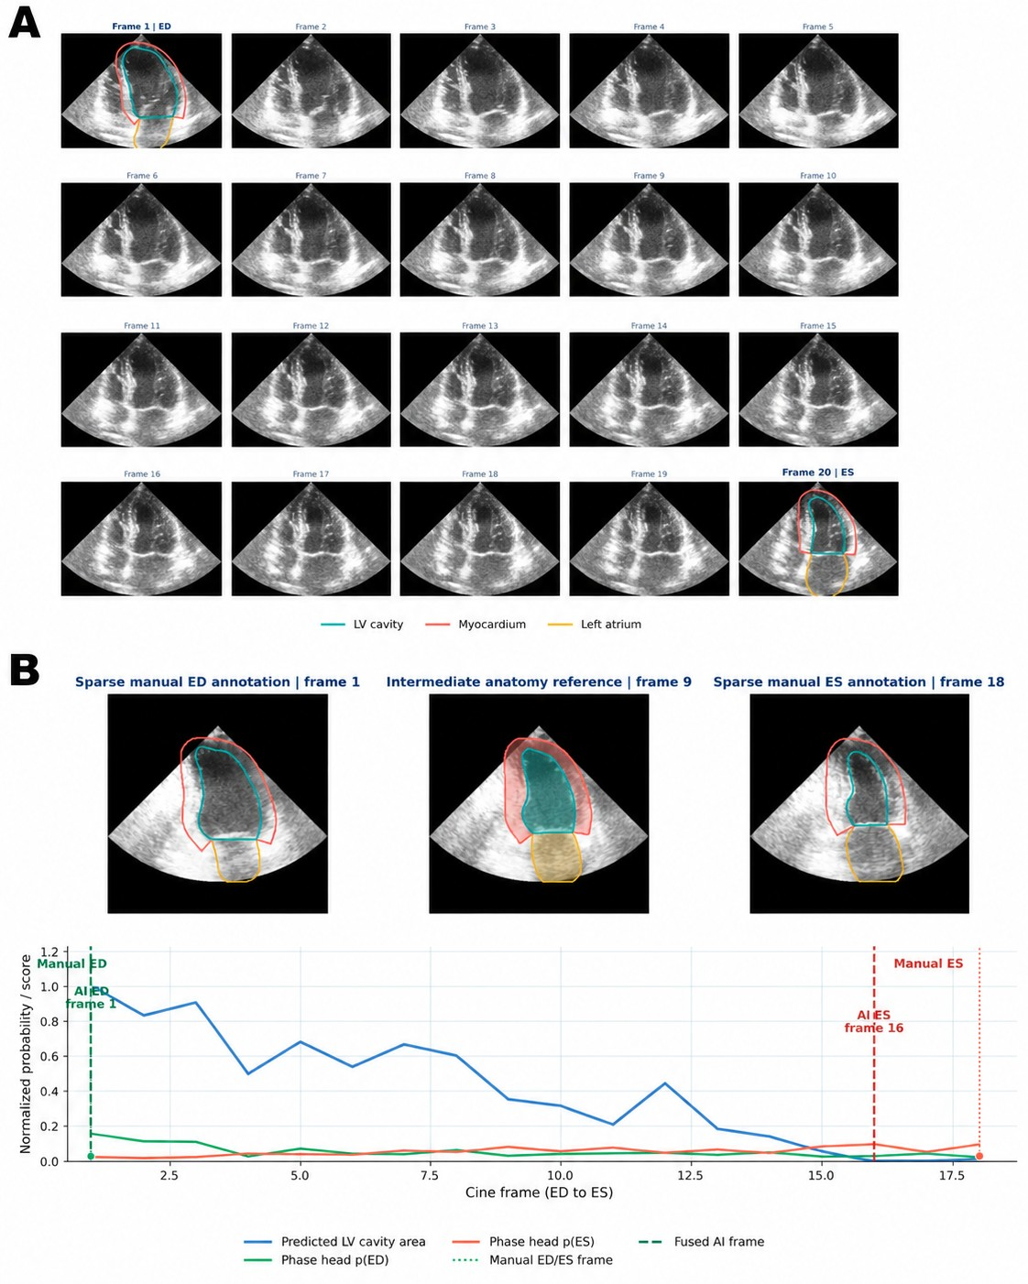
Supplementary Figure S1. Sparse anatomical supervision and automated ED/ES localization. (A) Representative A4C cine showing physician-verified LV cavity, myocardium, and LA contours at the ED and ES frames; intermediate frames were not manually annotated. (B) Representative example of automated ED/ES localization using the predicted LV-cavity area curve and phase-head probabilities. Dashed lines indicate AI-selected ED/ES frames and dotted lines indicate manual reference frames.

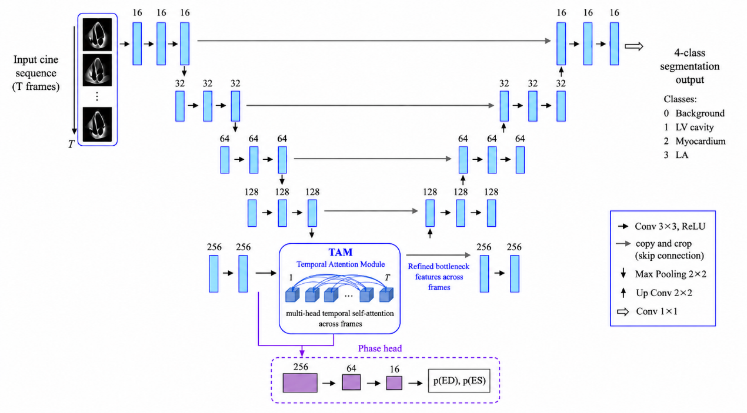
Supplementary Figure S2. Architecture of the weakly supervised temporal anatomical and phase network. A variable-length cine sequence is processed by a shared U-Net with bottleneck temporal attention to generate frame-wise four-class anatomical maps and ED/ES phase probabilities.

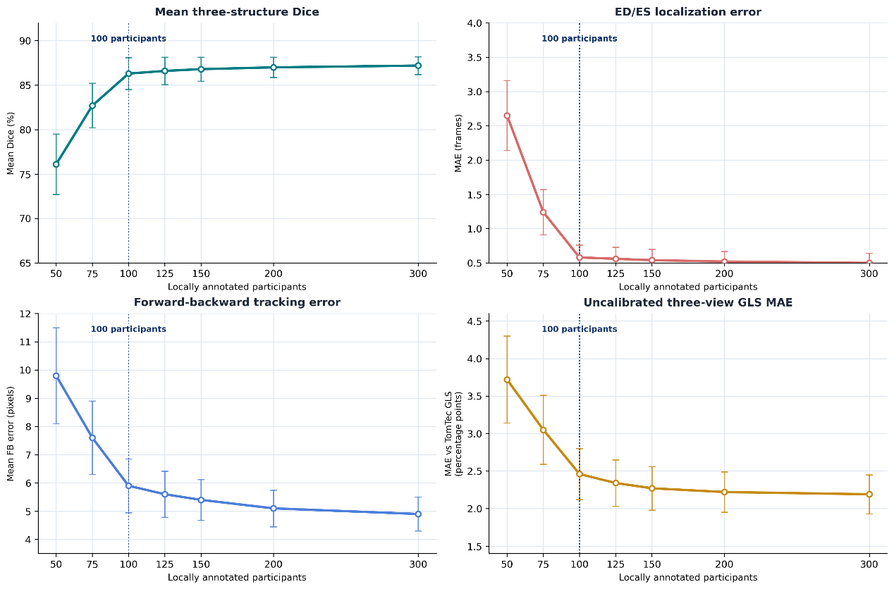
Supplementary Figure S3. Label-efficiency analysis. Performance is shown across increasing numbers of locally annotated participants for mean three-structure Dice, ED/ES localization error, forward-backward tracking error, and uncalibrated three-view GLS MAE versus TomTec GLS. The GLS comparison is performed before the independent scalar-calibration step. The dotted line denotes the 100-participant primary annotation set.

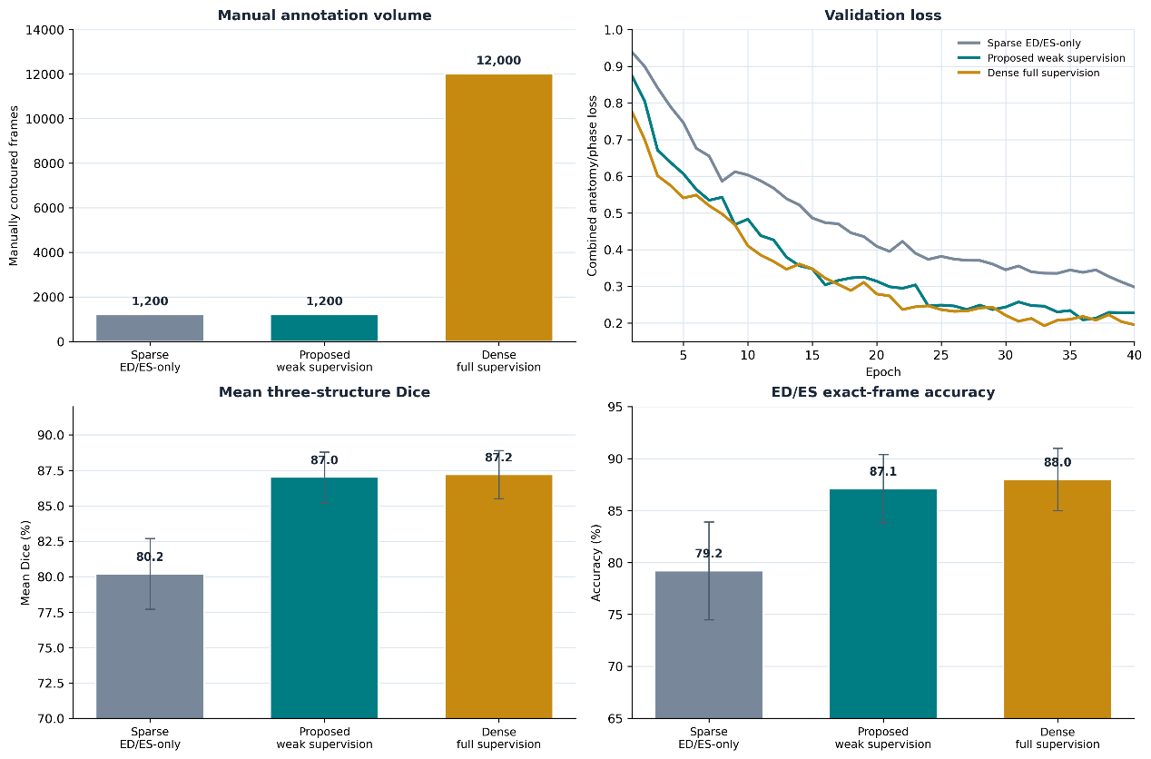
Supplementary Figure S4. Comparison of sparse ED/ES-only supervision, proposed weak supervision, and dense full supervision. The panels show manual annotation volume, validation loss, mean three-structure Dice, and ED/ES exact-frame accuracy.

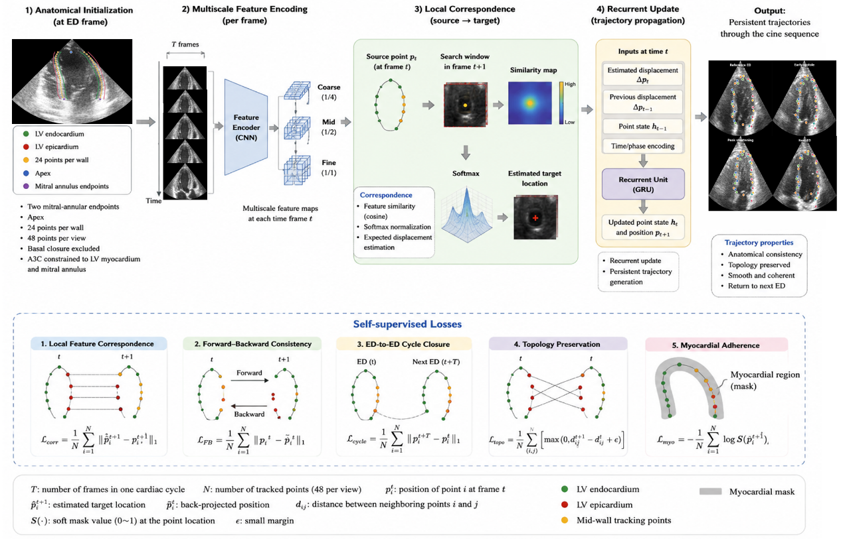
Supplementary Figure S5. Anatomy-guided self-supervised myocardial motion network. Segmentation-derived landmarks initialize ordered mid-myocardial anchors; multiscale local correspondence and recurrent updates generate persistent trajectories under self-supervised temporal and anatomical constraints.

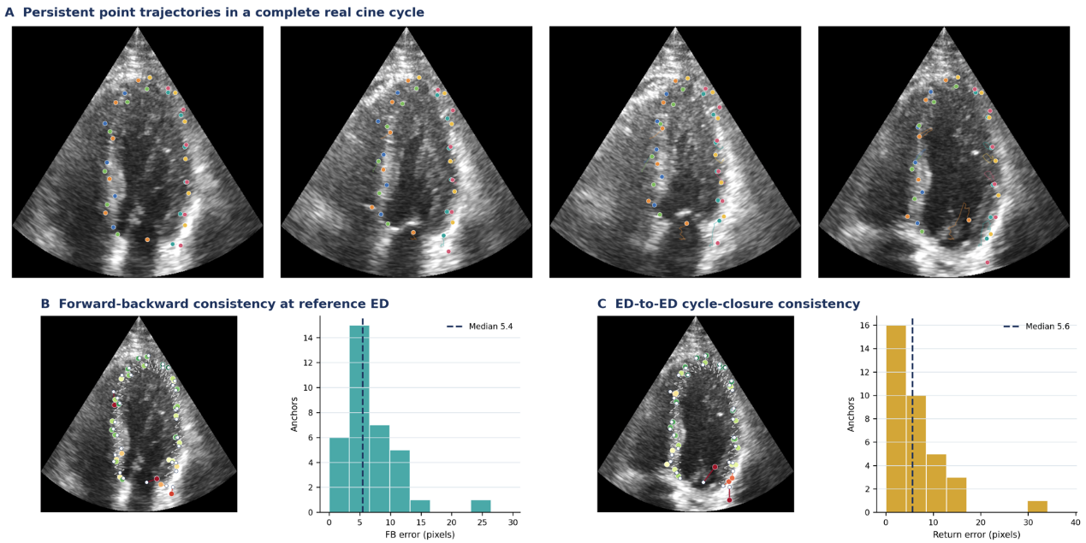
Supplementary Figure S6. Interpretability of image-driven persistent myocardial tracking. Representative real cine frames show persistent myocardial anchors over a complete cardiac cycle, with forward-backward and ED-to-ED return errors summarized at the reference ED frame.

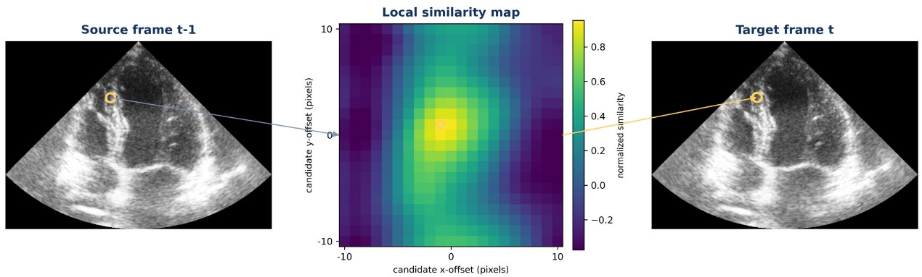
Supplementary Figure S7. Representative local image correspondence used for self-supervised myocardial motion tracking. A myocardial point in the source frame is matched to candidate locations in the subsequent target frame using a local feature-similarity map. The highest-similarity candidate determines the image-driven frame-to-frame correspondence used for trajectory propagation.

