Supplementary materials

Supplementary methods

Table
Table S1 Distribution of variables with missing data for baseline eGDR cohort in ELSA
Table S2 Distribution of variables with missing data for baseline eGDR cohort in HRS
Table S3 Distribution of variables with missing data for cumulative eGDR cohort in ELSA
Table S4 Distribution of variables with missing data for cumulative eGDR cohort in HRS
Table S5 Fit indices of GBTM model on eGDR trajectories in ELSA and HRS
Table S6 Collinearity Statistics for baseline eGDR in ELSA
Table S7 Collinearity Statistics for baseline eGDR in HRS
Table S8 Collinearity Statistics for cumulative eGDR in ELSA
Table S9 Collinearity Statistics for cumulative eGDR in HRS
Table S10 Collinearity Statistics for the trajectory of eGDR in ELSA
Table S11 Collinearity Statistics for the trajectory of eGDR in HRS
Table S12 Patient demographics and baseline characteristics based on trajectory of eGDR
Table S13 Baseline characteristics between included and excluded participants who provided blood samples in Baseline eGDR cohort
Table S14 Baseline characteristics between included and excluded participants who provided blood samples in Cumulative eGDR cohort
Table S15 Proportional hazards diagnostics and time-varying coefficient analyses of eGDR and incident CMM
Table S16 Bootstrap-corrected predictive performance and calibration of the prediction models in ELSA and HRS
Table S17 Subgroup and interaction analyses of the associations between trajectory of eGDR and CMM risk.
Table S18 Multivariate Cox regression of the relationships between eGDR and the risk of incident CMM in ELSA and HRS after excluding missing covariates
Table S19 Pooled analysis of associations between eGDR and CMM risk in different models after excluding missing covariates
Table S20 Multivariate logistic regression of the relationships between eGDR and the risk of incident CMM in ELSA and HRS
Table S21 Pooled analysis of associations between eGDR and CMM risk in different logistic regression models
Table S22 Multivariate Cox regression of the relationships between eGDR and the risk of incident CMM in ELSA and HRS after excluding subjects receiving medications for heart disease, stroke, diabetes, hypertension, or dyslipidemia at baseline
Table S23 Pooled analysis of associations between eGDR and CMM risk in different models after excluding subjects receiving medications for heart disease, stroke, diabetes, hypertension, or dyslipidemia at baseline
Table S24 Multivariate Cox regression of the relationships between eGDR and the risk of incident CMM in ELSA and HRS after excluding participants with less than 2 years of follow-up
Table S25 Pooled analysis of associations between eGDR and CMM risk in different models after excluding participants with less than 2 years of follow-up
Table S26 Multivariate Cox regression of the relationships between eGDR and the risk of incident heart disease in ELSA and HRS
Table S27 Pooled analysis of associations between eGDR and heart disease risk in different models
Table S28 Multivariate Cox regression of the relationships between eGDR and the risk of incident stroke in ELSA and HRS
Table S29 Pooled analysis of associations between eGDR and stroke risk in different models
Table S30 Multivariate Cox regression of the relationships between eGDR and the risk of incident diabetes in ELSA and HRS
Table S31 Pooled analysis of associations between eGDR and diabetes risk in different models
Table S32 Multivariate Cox regression of the relationships between eGDR-BMI and the risk of incident CMM in ELSA and HRS
Table S33 Pooled analysis of associations between eGDR-BMI and CMM risk in different models
Table S34 E-values for the association between baseline, cumulative eGDR and newly-onset CMM
Table S35 Relationships between eGDR and the risk of incident CMM in fully adjusted model stratified by different baseline CMD patterns
Table S36 Multivariate Cox regression of the relationships between eGDR and the risk of non−glycemic CMM outcome in ELSA and HRS
Table S37 Pooled analysis of associations between eGDR and non−glycemic CMM outcome in different models

Figure
Figure S1 Study design and timeline
Figure S2 Trajectories of eGDR using five-class quadratic models during V1 to V5 in ELSA (A) and HRS (B).
Figure S3 Proportional hazards assessment and time-varying association of baseline eGDR with CMM in ELSA
Figure S4 ROC curves evaluating the predictive performance of baseline eGDR for incident CMM at 2 years, 4 years, 6 years, 8 years and 10 years follow-up in ELSA
Figure S5 ROC curves evaluating the predictive performance of baseline eGDR for incident CMM at 2 years, 4 years, 6 years, 8 years and 10 years follow-up in HRS
Figure S6 ROC curves evaluating the predictive performance of cumulative eGDR for incident CMM at 2 years, 4 years, 6 years follow-up in ELSA
Figure S7 ROC curves evaluating the predictive performance of eGDR trajectory for incident CMM at 2 years, 4 years, 6 years follow-up in ELSA
Figure S8 ROC curves evaluating the predictive performance of cumulative eGDR for incident CMM at 2 years, 4 years, 6 years follow-up in HRS
Figure S9 ROC curves evaluating the predictive performance of eGDR trajectory for incident CMM at 2 years, 4 years, 6 years follow-up in HRS
Figure S10 Calibration plots for models predicting incident CMM based on baseline eGDR in ELSA and HRS
Figure S11 Calibration plots for models predicting incident CMM based on cumulative eGDR and eGDR trajectories in ELSA and HRS

Supplementary methods

Detailed information of ELSA and HRS
The English Longitudinal Study of Ageing (ELSA) is an ongoing longitudinal cohort study designed to investigate ageing-related processes and quality of life among adults aged 50 years and older in the United Kingdom. The first wave of data collection was conducted between March 2002 and March 2003, enrolling a total of 11,050 participants. Since then, follow-up surveys have been conducted biennially to capture changes in participants’ health, socioeconomic circumstances, and well-being over time. ELSA collects comprehensive information on a wide range of domains, including demographic characteristics, income and wealth, physical and mental health, cognitive function, family structure and social networks, health care utilization and associated expenditures, housing, employment and occupational history, expectations, and insurance coverage. Data are collected through computer-assisted personal interviews supplemented by self-completed questionnaires. From wave 2 onwards, eligible participants have been invited to undergo nurse visits every four years. These assessments are performed by trained nursing staff and include the collection of biological samples, objective physical measurements, and performance-based assessments. These additional measures provide valuable opportunities for investigating biological, functional, and clinical aspects of ageing. Ethical approval for all ELSA waves was obtained from the National Health Service Research Ethics Committees within the National Research and Ethics Service (NRES).
The Health and Retirement Study (HRS) is a prospective, nationally representative longitudinal cohort study of ageing among adults aged 50 years and older in the United States. Established in 1992, the HRS initiated its baseline survey and has continued to conduct follow-up assessments at two-year intervals. The study collects extensive data covering demographic characteristics, health status, cognitive performance, family structure, housing, employment and pension status, health care utilization and expenditures, expectations, assets, and income. Beginning with wave 8 in 2006, the HRS expanded its data collection framework by incorporating biomarker assessments and more comprehensive evaluations of psychological and psychosocial characteristics. During this wave, half of the participants were randomly selected to complete an enhanced face-to-face interview (EFTF), which included physical performance tests, anthropometric measurements, collection of blood and saliva samples, and a self-administered questionnaire assessing psychosocial factors. These objectively measured data facilitate the validation and refinement of self-reported health information and enable the identification of health-related conditions that may be unknown to participants or inadequately captured through conventional self-report approaches. Ethical approval for the HRS was obtained from the Institutional Review Board of the University of Michigan.

Table

Table S1 Distribution of variables with missing data for baseline eGDR cohort in ELSA
Variables | Number of missing | Missing proportion
Education | 438 | 8.79%
Marital status | 1 | 0.02%
Drinking | 393 | 7.88%
BMI | 150 | 3.01%
Height | 93 | 1.87%
Weight | 87 | 1.75%
SBP | 59 | 1.18%
DBP | 59 | 1.18%
Hypertension treatment | 4 | 0.08%
Diabetes treatment | 2 | 0.04%
TC | 35 | 0.70%
HDL-C | 37 | 0.74%
LDL-C | 165 | 3.31%
TG | 35 | 0.70%
FPG | 1,930 | 38.72%
CRP | 38 | 0.76%

Table S2 Distribution of variables with missing data for baseline eGDR cohort in HRS
Variables | Number of missing | Missing proportion
Education | 2 | 0.02%
Marital status | 1 | 0.01%
Residence | 17 | 0.17%
Smoking | 72 | 0.72%
Drinking | 1 | 0.01%
BMI | 307 | 3.07%
Height | 70 | 0.70%
Weight | 257 | 2.57%
SBP | 168 | 1.68%
DBP | 168 | 1.68%
Dyslipidemia | 1 | 0.01%
Dyslipidemia treatment | 16 | 0.16%
Hypertension treatment | 29 | 0.29%
Diabetes treatment | 7 | 0.07%
TC | 427 | 4.28%
HDL-C | 1,685 | 16.88%
CRP | 410 | 4.11%

Table S3 Distribution of variables with missing data for cumulative eGDR cohort in ELSA
Variables | Number of missing | Missing proportion
Education | 164 | 8.68%
Drinking | 107 | 5.66%
BMI | 35 | 1.85%
Height | 23 | 1.22%
Weight | 20 | 1.06%
SBP | 13 | 0.69%
DBP | 13 | 0.69%
TC | 14 | 0.74%
HDL-C | 15 | 0.79%
LDL-C | 63 | 3.34%
TG | 14 | 0.74%
FPG | 581 | 30.76%
CRP | 15 | 0.79%

Table S4 Distribution of variables with missing data for cumulative eGDR cohort in HRS
Variables | Number of missing | Missing proportion
Marital status | 1 | 0.03%
Residence | 7 | 0.18%
Smoking | 31 | 0.78%
Drinking | 1 | 0.03%
BMI | 86 | 2.17%
Height | 12 | 0.30%
Weight | 76 | 1.92%
SBP | 44 | 1.11%
DBP | 44 | 1.11%
Hypertension treatment | 3 | 0.08%
Diabetes treatment | 4 | 0.10%
TC | 128 | 3.23%
HDL-C | 660 | 16.65%
CRP | 143 | 3.61%

Table S5 Fit indices of GBTM model on eGDR trajectories in ELSA and HRS
Cohort | Polynomial | Trajectory | AIC | BIC | aBIC | Entropy | APP | OCC | Class (%)
ELSA | Linear | 1 | 25357.05 | 25373.68 | 25364.15 | NA | 1.000 | NA | 100.00
ELSA | Linear | 2 | 22461.04 | 22494.3 | 22475.24 | 0.873 | 0.963/0.965 | 23.54/30.08 | 52.57/47.43
ELSA | Linear | 3 | 21821.24 | 21871.13 | 21842.54 | 0.805 | 0.927/0.865/0.937 | 24.65/12.65/31.10 | 33.77/33.56/32.66
ELSA | Linear | 4 | 21575.67 | 21642.2 | 21604.08 | 0.786 | 0.829/0.873/0.849/0.913 | 41.43/12.90/14.43/28.97 | 9.74/35.63/27.90/26.73
ELSA | Linear | 5 | 21445.19 | 21528.34 | 21480.69 | 0.782 | 0.847/0.877/0.795/0.795/0.907 | 42.35/14.27/33.74/15.05/30.21 | 11.01/33.99/10.22/20.12/24.67
ELSA | Quadratic | 1 | 25345.32 | 25367.49 | 25354.78 | NA | 1.000 | NA | 100.00
ELSA | Quadratic | 2 | 22429.04 | 22473.39 | 22447.97 | 0.874 | 0.963/0.965 | 23.71/30.25 | 52.57/47.43
ELSA | Quadratic | 3 | 21776.24 | 21842.76 | 21804.64 | 0.807 | 0.927/0.865/0.941 | 24.86/12.60/33.03 | 33.67/33.83/32.50
ELSA | Quadratic | 4 | 21523.99 | 21612.69 | 21561.86 | 0.784 | 0.841/0.869/0.851/0.911 | 41.39/12.55/14.63/28.86 | 10.38/35.52/27.79/26.31
ELSA | Quadratic | 5 | 21370.42 | 21481.3 | 21417.76 | 0.795 | 0.849/0.876/0.790/0.837/0.910 | 39.35/15.32/49.18/14.49/34.51 | 12.12/31.87/6.93/26.68/22.39
HRS | Linear | 1 | 54507.35 | 54526.21 | 54516.68 | NA | 1.000 | NA | 100.00
HRS | Linear | 2 | 48915.77 | 48953.48 | 48934.42 | 0.861 | 0.966/0.948 | 17.18/30.26 | 62.70/37.30
HRS | Linear | 3 | 47151.7 | 47208.27 | 47179.67 | 0.811 | 0.895/0.900/0.952 | 22.70/10.81/52.73 | 26.83/45.85/27.31
HRS | Linear | 4 | 46343.74 | 46419.16 | 46381.03 | 0.809 | 0.870/0.894/0.860/0.927 | 53.68/11.74/16.81/50.02 | 10.72/42.60/26.25/20.43
HRS | Linear | 5 | 46016.25 | 46110.53 | 46062.87 | 0.795 | 0.900/0.850/0.853/0.839/0.908 | 312.77/18.90/10.29/18.42/52.70 | 2.45/23.08/36.77/22.07/15.64
HRS | Quadratic | 1 | 54507 | 54532.15 | 54519.43 | NA | 1.000 | NA | 100.00
HRS | Quadratic | 2 | 48913.55 | 48963.83 | 48938.41 | 0.861 | 0.966/0.948 | 16.97/30.74 | 62.77/37.23
HRS | Quadratic | 3 | 47138.66 | 47214.08 | 47175.95 | 0.812 | 0.897/0.900/0.951 | 22.89/10.92/52.22 | 27.04/45.67/27.29
HRS | Quadratic | 4 | 46327.44 | 46428 | 46377.16 | 0.809 | 0.869/0.893/0.861/0.930 | 54.29/11.78/16.81/50.58 | 10.49/42.30/26.36/20.86
HRS | Quadratic | 5 | 46004 | 46129.7 | 46066.15 | 0.786 | 0.879/0.869/0.830/0.842/0.874 | 83.93/12.04/12.79/22.41/64.12 | 7.41/36.57/27.57/19.22/9.23
Abbreviations: GBTM, Group-based trajectory modeling; eGDR, estimated glucose disposal rate; AIC, akaike information criterion; BIC, bayesian information criterion; aBIC, adjusted bayesian information criterion; APP, average posterior probability, OCC, odds of correct classification.

Table S6 Collinearity Statistics for baseline eGDR in ELSA
Characteristic | GVIF | Df | GVIF^(1/(2*Df))
Baseline eGDR (z-score) | 1.649 | 1 | 1.284
Age | 1.136 | 1 | 1.066
Gender | 1.453 | 1 | 1.205
Education | 1.077 | 2 | 1.019
Marital status | 1.114 | 1 | 1.055
Smoking | 1.047 | 1 | 1.023
Drinking | 1.045 | 1 | 1.022
BMI | 1.687 | 1 | 1.299
Dyslipidemia | 1.199 | 1 | 1.095
Cancer | 1.009 | 1 | 1.004
TC | 1.487 | 1 | 1.219
HDL-C | 1.625 | 1 | 1.275
CRP | 1.028 | 1 | 1.014

Table S7 Collinearity Statistics for baseline eGDR in HRS
Characteristic | GVIF | Df | GVIF^(1/(2*Df))
Baseline eGDR (z-score) | 1.571 | 1 | 1.253
Age | 1.139 | 1 | 1.067
Gender | 1.34 | 1 | 1.157
Education | 1.093 | 2 | 1.023
Marital status | 1.125 | 1 | 1.061
Smoking | 1.091 | 1 | 1.045
Drinking | 1.157 | 1 | 1.076
BMI | 1.574 | 1 | 1.255
Dyslipidemia | 1.059 | 1 | 1.029
Cancer | 1.026 | 1 | 1.013
TC | 1.21 | 1 | 1.1
HDL-C | 1.349 | 1 | 1.162
CRP | 1.041 | 1 | 1.02
Table S8 Collinearity Statistics for cumulative eGDR in ELSA
Characteristic | GVIF | Df | GVIF^(1/(2*Df))
Cumulative eGDR (z-score) | 1.644 | 1 | 1.282
Age | 1.112 | 1 | 1.054
Gender | 1.424 | 1 | 1.193
Education | 1.066 | 2 | 1.016
Marital status | 1.093 | 1 | 1.046
Smoking | 1.045 | 1 | 1.022
Drinking | 1.044 | 1 | 1.022
BMI | 1.677 | 1 | 1.295
Dyslipidemia | 1.206 | 1 | 1.098
Cancer | 1.02 | 1 | 1.01
TC | 1.532 | 1 | 1.238
HDL-C | 1.65 | 1 | 1.284
CRP | 1.05 | 1 | 1.025

Table S9 Collinearity Statistics for cumulative eGDR in HRS
Characteristic | GVIF | Df | GVIF^(1/(2*Df))
Cumulative eGDR (z-score) | 1.639 | 1 | 1.28
Age | 1.112 | 1 | 1.054
Gender | 1.324 | 1 | 1.151
Education | 1.102 | 2 | 1.025
Marital status | 1.088 | 1 | 1.043
Smoking | 1.077 | 1 | 1.038
Drinking | 1.159 | 1 | 1.076
BMI | 1.58 | 1 | 1.257
Dyslipidemia | 1.086 | 1 | 1.042
Cancer | 1.028 | 1 | 1.014
TC | 1.201 | 1 | 1.096
HDL-C | 1.357 | 1 | 1.165
CRP | 1.072 | 1 | 1.035
Table S10 Collinearity Statistics for the trajectory of eGDR in ELSA
Characteristic | GVIF | Df | GVIF^(1/(2*Df))
Trajectory of eGDR | 1.64 | 3 | 1.086
Age | 1.117 | 1 | 1.057
Gender | 1.449 | 1 | 1.204
Education | 1.065 | 2 | 1.016
Marital status | 1.106 | 1 | 1.052
Smoking | 1.041 | 1 | 1.02
Drinking | 1.051 | 1 | 1.025
BMI | 1.614 | 1 | 1.27
Dyslipidemia | 1.213 | 1 | 1.101
Cancer | 1.023 | 1 | 1.012
TC | 1.527 | 1 | 1.236
HDL-C | 1.664 | 1 | 1.29
CRP | 1.052 | 1 | 1.026

Table S11 Collinearity Statistics for the trajectory of eGDR in HRS
Characteristic | GVIF | Df | GVIF^(1/(2*Df))
Trajectory of eGDR | 1.644 | 3 | 1.086
Age | 1.136 | 1 | 1.066
Gender | 1.308 | 1 | 1.144
Education | 1.101 | 2 | 1.024
Marital status | 1.081 | 1 | 1.04
Smoking | 1.074 | 1 | 1.036
Drinking | 1.148 | 1 | 1.072
BMI | 1.591 | 1 | 1.261
Dyslipidemia | 1.09 | 1 | 1.044
Cancer | 1.028 | 1 | 1.014
TC | 1.195 | 1 | 1.093
HDL-C | 1.341 | 1 | 1.158
CRP | 1.077 | 1 | 1.038

Table S12 Patient demographics and baseline characteristics based on trajectory of eGDR
Characteristic | ELSA |  |  |  |  |  | HRS
Characteristic | Overall (N = 1,889) | Persistently low eGDR trajectory (N = 196) | Moderately low eGDR trajectory (N = 671) | Moderately high eGDR trajectory (N = 525) | Persistently high eGDR trajectory (N = 497) | P-value | Overall (N = 3,965) | Persistently low eGDR trajectory (N = 416) | Moderately low eGDR trajectory (N = 1,677) | Moderately high eGDR trajectory (N = 1,045) | Persistently high eGDR trajectory (N = 827) | P-value
Age | 61.00 (57.00, 68.00) | 62.00 (57.00, 68.00) | 63.00 (57.00, 70.00) | 61.00 (57.00, 68.00) | 59.00 (55.00, 64.00) | <0.001 | 65.00 (58.00, 71.00) | 63.00 (57.00, 69.00) | 67.00 (59.00, 72.00) | 65.00 (58.00, 72.00) | 61.00 (56.00, 68.00) | <0.001
Gender |  |  |  |  |  | <0.001 |  |  |  |  |  | <0.001
Male | 825 (43.7%) | 131 (66.8%) | 318 (47.4%) | 227 (43.2%) | 149 (30.0%) |  | 1,497 (37.8%) | 188 (45.2%) | 715 (42.6%) | 378 (36.2%) | 216 (26.1%)
Female | 1,064 (56.3%) | 65 (33.2%) | 353 (52.6%) | 298 (56.8%) | 348 (70.0%) |  | 2,468 (62.2%) | 228 (54.8%) | 962 (57.4%) | 667 (63.8%) | 611 (73.9%)
Education |  |  |  |  |  | 0.159 |  |  |  |  |  | <0.001
Below high school | 1,074 (56.9%) | 120 (61.2%) | 400 (59.6%) | 295 (56.2%) | 259 (52.1%) |  | 539 (13.6%) | 69 (16.6%) | 300 (17.9%) | 105 (10.0%) | 65 (7.9%)
High school | 162 (8.6%) | 18 (9.2%) | 55 (8.2%) | 46 (8.8%) | 43 (8.7%) |  | 1,410 (35.6%) | 179 (43.0%) | 617 (36.8%) | 357 (34.2%) | 257 (31.1%)
Above high school | 653 (34.6%) | 58 (29.6%) | 216 (32.2%) | 184 (35.0%) | 195 (39.2%) |  | 2,016 (50.8%) | 168 (40.4%) | 760 (45.3%) | 583 (55.8%) | 505 (61.1%)
Marital status |  |  |  |  |  | 0.463 |  |  |  |  |  | 0.621
Married | 1,374 (72.7%) | 146 (74.5%) | 477 (71.1%) | 393 (74.9%) | 358 (72.0%) |  | 2,809 (70.8%) | 292 (70.2%) | 1,173 (69.9%) | 746 (71.4%) | 598 (72.3%)
Others | 515 (27.3%) | 50 (25.5%) | 194 (28.9%) | 132 (25.1%) | 139 (28.0%) |  | 1,156 (29.2%) | 124 (29.8%) | 504 (30.1%) | 299 (28.6%) | 229 (27.7%)
Residence |  |  |  |  |  | NA |  |  |  |  |  | 0.445
Urban | NA | NA | NA | NA | NA |  | 2,677 (67.5%) | 271 (65.1%) | 1,139 (67.9%) | 695 (66.5%) | 572 (69.2%)
Rural | NA | NA | NA | NA | NA |  | 1,288 (32.5%) | 145 (34.9%) | 538 (32.1%) | 350 (33.5%) | 255 (30.8%)
Ever smoking | 1,128 (59.7%) | 127 (64.8%) | 403 (60.1%) | 314 (59.8%) | 284 (57.1%) | 0.317 | 2,038 (51.4%) | 228 (54.8%) | 873 (52.1%) | 542 (51.9%) | 395 (47.8%) | 0.078
Ever drinking | 1,757 (93.0%) | 178 (90.8%) | 624 (93.0%) | 486 (92.6%) | 469 (94.4%) | 0.396 | 2,308 (58.2%) | 195 (46.9%) | 939 (56.0%) | 641 (61.3%) | 533 (64.4%) | <0.001
BMI (kg/m²) | 27.53 (4.41) | 32.87 (4.78) | 28.43 (3.71) | 27.08 (3.87) | 24.70 (3.14) | <0.001 | 29.23 (5.64) | 36.77 (6.10) | 30.30 (4.62) | 27.46 (4.53) | 25.52 (3.95) | <0.001
Waist circumference (cm) | 93.94 (12.27) | 111.36 (8.45) | 96.92 (9.22) | 92.59 (11.02) | 84.49 (8.86) | <0.001 | 99.06 (14.36) | 121.65 (12.08) | 102.23 (9.69) | 94.20 (12.10) | 87.40 (9.88) | <0.001
Height (m) | 1.66 (0.09) | 1.70 (0.09) | 1.66 (0.09) | 1.66 (0.09) | 1.65 (0.09) | <0.001 | 1.66 (0.10) | 1.67 (0.11) | 1.66 (0.10) | 1.66 (0.10) | 1.65 (0.09) | <0.001
Weight (kg) | 76.37 (14.39) | 95.18 (12.66) | 78.73 (11.98) | 74.74 (13.58) | 67.48 (10.37) | <0.001 | 80.42 (16.91) | 102.69 (16.01) | 83.46 (13.59) | 75.54 (15.42) | 69.23 (11.97) | <0.001
SBP (mmHg) | 132.54 (17.22) | 143.61 (16.69) | 141.24 (16.45) | 129.15 (13.76) | 119.99 (11.53) | <0.001 | 128.59 (18.76) | 134.81 (18.94) | 134.33 (18.70) | 127.45 (16.74) | 115.25 (13.40) | <0.001
DBP (mmHg) | 75.97 (10.30) | 80.99 (11.46) | 79.39 (10.71) | 74.78 (8.60) | 70.63 (7.94) | <0.001 | 79.53 (10.88) | 83.32 (11.99) | 81.96 (11.03) | 78.80 (9.89) | 73.62 (8.42) | <0.001
Dyslipidemia | 1,331 (70.5%) | 148 (75.5%) | 525 (78.2%) | 367 (69.9%) | 291 (58.6%) | <0.001 | 2,297 (57.9%) | 283 (68.0%) | 1,050 (62.6%) | 575 (55.0%) | 389 (47.0%) | <0.001
Dyslipidemia treatment | NA | NA | NA | NA | NA | NA | 1,401 (35.3%) | 199 (47.8%) | 714 (42.6%) | 322 (30.8%) | 166 (20.1%) | <0.001
Hypertension | 909 (48.1%) | 188 (95.9%) | 568 (84.6%) | 135 (25.7%) | 18 (3.6%) | <0.001 | 2,385 (60.2%) | 401 (96.4%) | 1,535 (91.5%) | 407 (38.9%) | 42 (5.1%) | <0.001
Hypertension treatment | 209 (11.1%) | 51 (26.0%) | 136 (20.3%) | 21 (4.0%) | 1 (0.2%) | <0.001 | 1,784 (45.0%) | 339 (81.5%) | 1,187 (70.8%) | 249 (23.8%) | 9 (1.1%) | <0.001
Diabetes | 87 (4.6%) | 42 (21.4%) | 23 (3.4%) | 17 (3.2%) | 5 (1.0%) | <0.001 | 508 (12.8%) | 173 (41.6%) | 251 (15.0%) | 61 (5.8%) | 23 (2.8%) | <0.001
Diabetes treatment | 46 (2.4%) | 29 (14.8%) | 9 (1.3%) | 6 (1.1%) | 2 (0.4%) | <0.001 | 342 (8.6%) | 134 (32.2%) | 160 (9.5%) | 38 (3.6%) | 10 (1.2%) | <0.001
Heart disease | 153 (8.1%) | 11 (5.6%) | 62 (9.2%) | 28 (5.3%) | 52 (10.5%) | 0.007 | 441 (11.1%) | 37 (8.9%) | 204 (12.2%) | 119 (11.4%) | 81 (9.8%) | 0.153
Stroke | 20 (1.1%) | 7 (3.6%) | 10 (1.5%) | 2 (0.4%) | 1 (0.2%) | <0.001 | 57 (1.4%) | 3 (0.7%) | 36 (2.1%) | 8 (0.8%) | 10 (1.2%) | 0.012
Cancer | 85 (4.5%) | 6 (3.1%) | 29 (4.3%) | 23 (4.4%) | 27 (5.4%) | 0.571 | 411 (10.4%) | 42 (10.1%) | 180 (10.7%) | 118 (11.3%) | 71 (8.6%) | 0.245
TC (mg/dL) | 234.23 (45.42) | 219.97 (47.68) | 235.03 (46.65) | 238.44 (45.03) | 234.35 (42.15) | <0.001 | 205.78 (40.61) | 200.66 (40.52) | 203.21 (40.01) | 206.83 (40.71) | 212.24 (40.97) | <0.001
HDL-C (mg/dL) | 60.20 (14.84) | 50.92 (12.08) | 58.75 (13.82) | 61.31 (14.23) | 64.65 (15.84) | <0.001 | 56.36 (16.34) | 49.76 (13.26) | 54.21 (15.35) | 57.59 (16.33) | 62.51 (17.51) | <0.001
HbA1c (%) | 5.47 (0.57) | 5.95 (1.08) | 5.46 (0.46) | 5.42 (0.49) | 5.34 (0.33) | <0.001 | 5.70 (0.82) | 6.37 (1.52) | 5.75 (0.75) | 5.56 (0.54) | 5.44 (0.50) | <0.001
CRP (µg/mL) | 1.70 (0.80, 3.50) | 3.15 (1.50, 5.95) | 2.10 (1.10, 4.10) | 1.70 (0.80, 3.40) | 1.10 (0.50, 2.30) | <0.001 | 1.80 (0.86, 4.07) | 3.92 (1.68, 8.14) | 2.01 (1.02, 4.41) | 1.55 (0.80, 3.44) | 1.24 (0.56, 2.58) | <0.001
LDL-C (mg/dL) | 143.10 (38.26) | 130.49 (39.91) | 143.11 (38.74) | 146.43 (39.10) | 144.54 (35.03) | <0.001 | NA | NA | NA | NA | NA | NA
TG (mg/dL) | 132.86 (97.43, 186.00) | 159.43 (115.14, 239.14) | 141.71 (106.28, 203.71) | 132.86 (97.43, 186.00) | 106.28 (79.71, 150.57) | <0.001 | NA | NA | NA | NA | NA | NA
FPG (mg/dL) | 88.20 (82.80, 95.40) | 93.60 (86.40, 106.20) | 88.20 (82.80, 95.40) | 88.20 (82.80, 93.60) | 84.60 (81.00, 91.80) | <0.001 | NA | NA | NA | NA | NA | NA
Cumulative eGDR | 60.54 (16.77) | 33.85 (5.40) | 48.54 (5.06) | 65.64 (5.31) | 81.88 (5.92) | <0.001 | 53.81 (17.81) | 25.62 (6.98) | 43.75 (5.69) | 60.55 (5.78) | 79.88 (6.79) | <0.001
eGDR at V1 | 8.05 (2.26) | 4.59 (0.85) | 6.54 (1.17) | 8.96 (1.29) | 10.49 (0.97) | <0.001 | 7.05 (2.44) | 3.42 (1.19) | 5.67 (1.05) | 8.29 (1.36) | 10.12 (1.17) | <0.001
eGDR at V3 | 7.45 (2.27) | 4.17 (0.79) | 5.90 (0.89) | 8.07 (1.35) | 10.18 (0.97) | <0.001 | 6.69 (2.38) | 3.18 (1.11) | 5.45 (0.99) | 7.45 (1.35) | 10.02 (1.07) | <0.001
eGDR at V5 | 7.32 (2.26) | 4.01 (0.98) | 5.92 (1.01) | 7.73 (1.34) | 10.09 (0.97) | <0.001 | 6.47 (2.36) | 3.04 (1.15) | 5.30 (0.99) | 7.09 (1.38) | 9.79 (1.16) | <0.001
CMM during follow-up | 153 (8.1%) | 34 (17.3%) | 59 (8.8%) | 43 (8.2%) | 17 (3.4%) | <0.001 | 373 (9.4%) | 76 (18.3%) | 202 (12.0%) | 71 (6.8%) | 24 (2.9%) | <0.001
Abbreviations: eGDR, estimated glucose disposal rate; BMI, body mass index; SBP, systolic blood pressure; DBP, diastolic blood pressure; TC, total cholesterol; HDL-C, high-density lipoprotein cholesterol; CRP, C-reactive protein; LDL-C, low-density lipoprotein cholesterol; TG, triglycerides; FPG, fasting plasma glucose; V1, visit 1; V3, visit 3; V5, visit 5; CMM, cardiometabolic multimorbidity.
Table S13 Baseline characteristics between included and excluded participants who provided blood samples in Baseline eGDR cohort
Characteristic | ELSA |  |  |  | HRS
Characteristic | Overall  N = 7,666 | Excluded  N = 2,681 | Included  N = 4,985 | P-value | Overall  N = 13,064 | Excluded  N = 3,079 | Included  N = 9,985 | P-value
Age (years) | 65.00 (58.00, 74.00) | 68.00 (60.00, 76.00) | 64.00 (58.00, 72.00) | <0.001 | 68.00 (60.00, 75.00) | 70.00 (60.00, 79.00) | 68.00 (60.00, 74.00) | <0.001
Gender |  |  |  | 0.842 |  |  |  | 0.009
Male | 3,451 (45.0%) | 1,211 (45.2%) | 2,240 (44.9%) |  | 5,287 (40.5%) | 1,311 (42.6%) | 3,976 (39.8%)
Female | 4,215 (55.0%) | 1,470 (54.8%) | 2,745 (55.1%) |  | 7,777 (59.5%) | 1,768 (57.4%) | 6,009 (60.2%)
Education |  |  |  | <0.001 |  |  |  | <0.001
Below high school | 4,596 (65.8%) | 1,748 (71.8%) | 2,848 (62.6%) |  | 2,659 (20.4%) | 837 (27.2%) | 1,822 (18.3%)
High school | 514 (7.4%) | 168 (6.9%) | 346 (7.6%) |  | 4,699 (36.0%) | 1,068 (34.7%) | 3,631 (36.4%)
Above high school | 1,871 (26.8%) | 518 (21.3%) | 1,353 (29.8%) |  | 5,704 (43.7%) | 1,174 (38.1%) | 4,530 (45.4%)
Marital status |  |  |  | <0.001 |  |  |  | <0.001
Married | 5,163 (67.4%) | 1,705 (63.6%) | 3,458 (69.4%) |  | 8,464 (64.8%) | 1,824 (59.2%) | 6,640 (66.5%)
Others | 2,502 (32.6%) | 976 (36.4%) | 1,526 (30.6%) |  | 4,599 (35.2%) | 1,255 (40.8%) | 3,344 (33.5%)
Residence |  |  |  | NA |  |  |  | 0.048
Urban | NA | NA | NA |  | 8,802 (67.5%) | 2,121 (69.0%) | 6,681 (67.0%)
Rural | NA | NA | NA |  | 4,241 (32.5%) | 954 (31.0%) | 3,287 (33.0%)
Smoking | 4,862 (63.4%) | 1,772 (66.1%) | 3,090 (62.0%) | <0.001 | 7,375 (56.9%) | 1,885 (61.6%) | 5,490 (55.4%) | <0.001
Drinking | 6,134 (89.5%) | 1,946 (86.0%) | 4,188 (91.2%) | <0.001 | 6,722 (51.5%) | 1,338 (43.5%) | 5,384 (53.9%) | <0.001
BMI (kg/m²) | 27.93 (4.89) | 28.41 (5.24) | 27.69 (4.69) | <0.001 | 29.22 (5.92) | 29.57 (6.29) | 29.13 (5.82) | <0.001
Waist circumference (cm) | 95.67 (13.17) | 97.22 (13.84) | 94.91 (12.77) | <0.001 | 100.87 (15.46) | 103.52 (16.98) | 100.17 (14.96) | <0.001
Height (m) | 1.65 (0.10) | 1.64 (0.10) | 1.66 (0.09) | <0.001 | 1.65 (0.10) | 1.65 (0.10) | 1.66 (0.10) | 0.486
Weight (kg) | 76.47 (15.66) | 77.13 (16.70) | 76.13 (15.09) | 0.010 | 80.14 (18.01) | 81.17 (19.33) | 79.86 (17.63) | 0.001
SBP (mmHg) | 135.38 (18.99) | 136.45 (19.85) | 134.81 (18.49) | <0.001 | 131.04 (20.57) | 130.93 (21.91) | 131.08 (20.16) | 0.726
DBP (mmHg) | 75.02 (11.27) | 74.06 (11.82) | 75.53 (10.93) | <0.001 | 79.17 (11.61) | 77.74 (12.47) | 79.58 (11.32) | <0.001
Dyslipidemia | 4,492 (58.6%) | 1,012 (37.7%) | 3,480 (69.8%) | <0.001 | 8,048 (61.6%) | 1,991 (64.7%) | 6,057 (60.7%) | <0.001
Dyslipidemia treatment | NA | NA | NA | NA | 5,429 (41.7%) | 1,544 (50.6%) | 3,885 (39.0%) | <0.001
Hypertension | 4,515 (58.9%) | 1,747 (65.2%) | 2,768 (55.5%) | <0.001 | 8,845 (67.7%) | 2,251 (73.1%) | 6,594 (66.0%) | <0.001
Hypertension treatment | 1,124 (14.7%) | 460 (17.2%) | 664 (13.3%) | <0.001 | 6,834 (52.5%) | 1,841 (60.1%) | 4,993 (50.2%) | <0.001
Diabetes | 747 (9.7%) | 422 (15.7%) | 325 (6.5%) | <0.001 | 3,067 (23.5%) | 1,469 (47.7%) | 1,598 (16.0%) | <0.001
Diabetes treatment | 500 (6.5%) | 312 (11.6%) | 188 (3.8%) | <0.001 | 2,277 (17.4%) | 1,142 (37.2%) | 1,135 (11.4%) | <0.001
Heart disease | 1,371 (17.9%) | 772 (28.8%) | 599 (12.0%) | <0.001 | 3,174 (24.3%) | 1,613 (52.4%) | 1,561 (15.6%) | <0.001
Stroke | 341 (4.4%) | 259 (9.7%) | 82 (1.6%) | <0.001 | 986 (7.5%) | 686 (22.3%) | 300 (3.0%) | <0.001
Cancer | 562 (7.3%) | 247 (9.2%) | 315 (6.3%) | <0.001 | 1,853 (14.2%) | 547 (17.8%) | 1,306 (13.1%) | <0.001
TC (mg/dL) | 228.59 (46.58) | 216.05 (47.93) | 231.00 (45.93) | <0.001 | 201.35 (42.06) | 190.75 (41.48) | 204.30 (41.74) | <0.001
HDL-C (mg/dL) | 58.94 (15.02) | 55.38 (14.42) | 59.62 (15.04) | <0.001 | 54.70 (16.19) | 51.57 (15.67) | 55.57 (16.22) | <0.001
HbA1c (%) | 5.50 (5.30, 5.70) | 5.60 (5.30, 6.10) | 5.50 (5.20, 5.70) | <0.001 | 5.69 (5.34, 6.14) | 5.92 (5.46, 6.61) | 5.58 (5.34, 6.03) | <0.001
CRP (µg/mL) | 2.00 (0.90, 4.20) | 2.50 (1.20, 5.40) | 1.90 (0.90, 4.00) | <0.001 | 2.13 (0.99, 4.90) | 2.58 (1.15, 6.27) | 1.97 (0.95, 4.46) | <0.001
LDL-C (mg/dL) | 138.68 (38.64) | 128.48 (38.70) | 140.64 (38.32) | <0.001 | NA | NA | NA | NA
TG (mg/dL) | 132.86 (97.43, 194.85) | 141.71 (106.28, 203.71) | 132.86 (97.43, 194.85) | 0.002 | NA | NA | NA | NA
FPG (mg/dL) | 88.20 (81.00, 93.60) | 88.20 (81.00, 97.20) | 88.20 (82.80, 93.60) | 0.418 | NA | NA | NA | NA
Baseline eGDR | 7.55 (2.34) | 6.72 (2.42) | 7.66 (2.31) | <0.001 | 6.54 (2.50) | 5.81 (2.65) | 6.71 (2.43) | <0.001
CMM during follow-up | 960 (14.0%) | 465 (25.1%) | 495 (9.9%) | <0.001 | 3,064 (25.2%) | 1,341 (61.4%) | 1,723 (17.3%) | <0.001
Abbreviations: eGDR, estimated glucose disposal rate; BMI, body mass index; SBP, systolic blood pressure; DBP, diastolic blood pressure; TC, total cholesterol; HDL-C, high-density lipoprotein cholesterol; CRP, C-reactive protein; LDL-C, low-density lipoprotein cholesterol; TG, triglycerides; FPG, fasting plasma glucose; CMM, cardiometabolic multimorbidity.

Table S14 Baseline characteristics between included and excluded participants who provided blood samples in Cumulative eGDR cohort
Characteristic | ELSA |  |  |  | HRS
Characteristic | Overall  N = 7,666 | Excluded  N = 5,777 | Included  N = 1,889 | P-value | Overall  N = 13,064 | Excluded  N = 9,099 | Included  N = 3,965 | P-value
Age (years) | 65.00 (58.00, 74.00) | 67.00 (59.00, 75.00) | 61.00 (57.00, 68.00) | <0.001 | 68.00 (60.00, 75.00) | 69.00 (61.00, 77.00) | 65.00 (58.00, 71.00) | <0.001
Gender |  |  |  | 0.178 |  |  |  | <0.001
Male | 3,451 (45.0%) | 2,626 (45.5%) | 825 (43.7%) |  | 5,287 (40.5%) | 3,790 (41.7%) | 1,497 (37.8%)
Female | 4,215 (55.0%) | 3,151 (54.5%) | 1,064 (56.3%) |  | 7,777 (59.5%) | 5,309 (58.3%) | 2,468 (62.2%)
Education |  |  |  | <0.001 |  |  |  | <0.001
Below high school | 4,596 (65.8%) | 3,624 (68.9%) | 972 (56.3%) |  | 2,659 (20.4%) | 2,120 (23.3%) | 539 (13.6%)
High school | 514 (7.4%) | 361 (6.9%) | 153 (8.9%) |  | 4,699 (36.0%) | 3,289 (36.2%) | 1,410 (35.6%)
Above high school | 1,871 (26.8%) | 1,271 (24.2%) | 600 (34.8%) |  | 5,704 (43.7%) | 3,688 (40.5%) | 2,016 (50.8%)
Marital status |  |  |  | <0.001 |  |  |  | <0.001
Married | 5,163 (67.4%) | 3,789 (65.6%) | 1,374 (72.7%) |  | 8,464 (64.8%) | 5,655 (62.1%) | 2,809 (70.9%)
Others | 2,502 (32.6%) | 1,987 (34.4%) | 515 (27.3%) |  | 4,599 (35.2%) | 3,444 (37.9%) | 1,155 (29.1%)
Residence |  |  |  | NA |  |  |  | >0.999
Urban | NA | NA | NA |  | 8,802 (67.5%) | 6,131 (67.5%) | 2,671 (67.5%)
Rural | NA | NA | NA |  | 4,241 (32.5%) | 2,954 (32.5%) | 1,287 (32.5%)
Smoking | 4,862 (63.4%) | 3,734 (64.6%) | 1,128 (59.7%) | <0.001 | 7,375 (56.9%) | 5,347 (59.2%) | 2,028 (51.6%) | <0.001
Drinking | 6,134 (89.5%) | 4,469 (88.1%) | 1,665 (93.4%) | <0.001 | 6,722 (51.5%) | 4,415 (48.5%) | 2,307 (58.2%) | <0.001
BMI (kg/m²) | 27.93 (4.89) | 28.07 (5.04) | 27.52 (4.40) | <0.001 | 29.22 (5.92) | 29.21 (6.05) | 29.24 (5.64) | 0.788
Waist circumference (cm) | 95.67 (13.17) | 96.26 (13.42) | 93.94 (12.27) | <0.001 | 100.87 (15.46) | 101.70 (15.87) | 99.06 (14.36) | <0.001
Height (m) | 1.65 (0.10) | 1.65 (0.10) | 1.66 (0.09) | <0.001 | 1.65 (0.10) | 1.65 (0.10) | 1.66 (0.10) | 0.015
Weight (kg) | 76.47 (15.66) | 76.50 (16.06) | 76.37 (14.40) | 0.757 | 80.14 (18.01) | 80.01 (18.51) | 80.42 (16.88) | 0.240
SBP (mmHg) | 135.38 (18.99) | 136.32 (19.44) | 132.55 (17.24) | <0.001 | 131.04 (20.57) | 132.15 (21.23) | 128.57 (18.79) | <0.001
DBP (mmHg) | 75.02 (11.27) | 74.68 (11.57) | 76.06 (10.24) | <0.001 | 79.17 (11.61) | 79.01 (11.92) | 79.52 (10.88) | 0.023
Dyslipidemia | 4,492 (58.6%) | 3,161 (54.7%) | 1,331 (70.5%) | <0.001 | 8,048 (61.6%) | 5,751 (63.2%) | 2,297 (57.9%) | <0.001
Dyslipidemia treatment | NA | NA | NA | NA | 5,429 (41.7%) | 4,028 (44.5%) | 1,401 (35.3%) | <0.001
Hypertension | 4,515 (58.9%) | 3,606 (62.4%) | 909 (48.1%) | <0.001 | 8,845 (67.7%) | 6,460 (71.0%) | 2,385 (60.2%) | <0.001
Hypertension treatment | 1,124 (14.7%) | 915 (15.9%) | 209 (11.1%) | <0.001 | 6,834 (52.5%) | 5,053 (55.8%) | 1,781 (45.0%) | <0.001
Diabetes | 747 (9.7%) | 660 (11.4%) | 87 (4.6%) | <0.001 | 3,067 (23.5%) | 2,559 (28.1%) | 508 (12.8%) | <0.001
Diabetes treatment | 500 (6.5%) | 454 (7.9%) | 46 (2.4%) | <0.001 | 2,277 (17.4%) | 1,938 (21.3%) | 339 (8.6%) | <0.001
Heart disease | 1,371 (17.9%) | 1,218 (21.1%) | 153 (8.1%) | <0.001 | 3,174 (24.3%) | 2,733 (30.0%) | 441 (11.1%) | <0.001
Stroke | 341 (4.4%) | 321 (5.6%) | 20 (1.1%) | <0.001 | 986 (7.5%) | 929 (10.2%) | 57 (1.4%) | <0.001
Cancer | 562 (7.3%) | 477 (8.3%) | 85 (4.5%) | <0.001 | 1,853 (14.2%) | 1,442 (15.8%) | 411 (10.4%) | <0.001
TC (mg/dL) | 228.59 (46.58) | 226.04 (46.94) | 234.05 (45.31) | <0.001 | 201.35 (42.06) | 199.13 (42.48) | 206.19 (40.71) | <0.001
HDL-C (mg/dL) | 58.94 (15.02) | 58.32 (15.09) | 60.26 (14.80) | <0.001 | 54.70 (16.19) | 53.88 (16.00) | 56.52 (16.45) | <0.001
HbA1c (%) | 5.50 (5.30, 5.70) | 5.50 (5.30, 5.80) | 5.40 (5.20, 5.60) | <0.001 | 5.69 (5.34, 6.14) | 5.69 (5.36, 6.25) | 5.57 (5.22, 5.92) | <0.001
CRP (µg/mL) | 2.00 (0.90, 4.20) | 2.20 (1.00, 4.50) | 1.70 (0.80, 3.50) | <0.001 | 2.13 (0.99, 4.90) | 2.23 (1.06, 5.22) | 1.78 (0.86, 4.09) | <0.001
LDL-C (mg/dL) | 138.68 (38.64) | 136.38 (38.88) | 143.63 (37.65) | <0.001 | NA | NA | NA | NA
TG (mg/dL) | 132.86 (97.43, 194.85) | 132.86 (97.43, 194.85) | 132.86 (97.43, 186.00) | 0.003 | NA | NA | NA | NA
FPG (mg/dL) | 88.20 (81.00, 93.60) | 88.20 (82.80, 95.40) | 88.20 (81.00, 93.60) | 0.199 | NA | NA | NA | NA
Cumulative eGDR | 59.46 (17.10) | 52.07 (17.55) | 60.54 (16.77) | <0.001 | 51.40 (18.57) | 44.92 (19.02) | 53.81 (17.81) | <0.001
eGDR at V1 | 7.55 (2.34) | 7.30 (2.34) | 8.05 (2.26) | <0.001 | 6.54 (2.50) | 6.29 (2.49) | 7.05 (2.44) | <0.001
eGDR at V3 | 7.17 (2.35) | 6.89 (2.41) | 7.45 (2.27) | <0.001 | 6.30 (2.45) | 5.95 (2.46) | 6.69 (2.38) | <0.001
eGDR at V5 | 7.11 (2.35) | 6.79 (2.45) | 7.32 (2.26) | <0.001 | 6.17 (2.57) | 5.73 (2.81) | 6.47 (2.36) | <0.001
CMM during follow-up | 616 (14.3%) | 463 (19.2%) | 153 (8.1%) | <0.001 | 1,736 (22.7%) | 1,363 (37.2%) | 373 (9.4%) | <0.001
Abbreviations: eGDR, estimated glucose disposal rate; BMI, body mass index; SBP, systolic blood pressure; DBP, diastolic blood pressure; TC, total cholesterol; HDL-C, high-density lipoprotein cholesterol; CRP, C-reactive protein; LDL-C, low-density lipoprotein cholesterol; TG, triglycerides; FPG, fasting plasma glucose; V1, visit 1; V3, visit 3; V5, visit 5; CMM, cardiometabolic multimorbidity.
Table S15 Proportional hazards diagnostics and time-varying coefficient analyses of eGDR and incident CMM
Panel A Schoenfeld residual tests in fully adjusted models
Cohort | Exposure | Coding | Exposure  χ² | df | Exposure  P value | Global  χ² | df | Global  P value
ELSA | Baseline eGDR | Continuous | 4.360 | 1 | 0.037 | 31.529 | 14 | 0.005
ELSA | Baseline eGDR | Quartile | 10.745 | 3 | 0.013 | 39.474 | 16 | <0.001
ELSA | Cumulative eGDR | Continuous | 0.004 | 1 | 0.952 | 14.482 | 14 | 0.414
ELSA | Cumulative eGDR | Quartile | 2.135 | 3 | 0.545 | 16.177 | 16 | 0.441
ELSA | eGDR trajectory | Trajectory | 0.786 | 3 | 0.853 | 15.102 | 16 | 0.517
HRS | Baseline eGDR | Continuous | 3.179 | 1 | 0.075 | 17.223 | 14 | 0.244
HRS | Baseline eGDR | Quartile | 3.721 | 3 | 0.293 | 17.448 | 16 | 0.357
HRS | Cumulative eGDR | Continuous | 0.407 | 1 | 0.524 | 9.964 | 14 | 0.765
HRS | Cumulative eGDR | Quartile | 0.609 | 3 | 0.894 | 10.399 | 16 | 0.845
HRS | eGDR trajectory | Trajectory | 0.268 | 3 | 0.966 | 10.299 | 16 | 0.851
Panel B Likelihood-ratio tests for time-varying coefficients
Cohort | Exposure model |  | Time-varying term |  |  | LRT χ² | df | P value
ELSA | Baseline eGDR  (continuous) |  | Age × log(time) |  |  | 6.823 | 1 | 0.009
ELSA | Baseline eGDR  (continuous) |  | eGDR × log(time)ᵃ |  |  | 5.348 | 1 | 0.021
ELSA | Baseline eGDR  (quartiles) |  | Age × log(time) |  |  | 7.111 | 1 | 0.008
ELSA | Baseline eGDR  (quartiles) |  | eGDR quartiles × log(time)ᵃ |  |  | 7.290 | 3 | 0.063
HRS | Baseline eGDR  (continuous) |  | Dyslipidemia × log(time) |  |  | 4.319 | 1 | 0.038
HRS | Baseline eGDR  (quartiles) |  | Dyslipidemia × log(time) |  |  | 4.178 | 1 | 0.041
Note: All analyses used Model 3 adjustment. Panel A reports exposure-specific and global Schoenfeld residual tests. Panel B compares nested Cox models with and without interactions with log(time), where time is follow-up in years. ᵃTested after including age*log(time); quartile interactions were assessed jointly.
Abbreviations: eGDR, estimated glucose disposal rate; CMM, cardiometabolic multimorbidity; LRT, likelihood-ratio test; df, degrees of freedom.

Table S16 Bootstrap-corrected predictive performance and calibration of the prediction models in ELSA and HRS
Panel A. Bootstrap optimism-corrected AUC and Brier score
Cohort | Analysis | Model | 2-year follow-up |  | 4-year follow-up |  | 6-year follow-up |  | 8-year follow-up |  | 10-year follow-up
Cohort | Analysis | Model | AUC | Brier score | AUC | Brier score | AUC | Brier score | AUC | Brier score | AUC | Brier score
ELSA | Baseline | Base model | 0.804 | 0.006 | 0.805 | 0.021 | 0.805 | 0.031 | 0.783 | 0.047 | 0.783 | 0.057
ELSA | Baseline | Base model + eGDR | 0.828 | 0.006 | 0.834 | 0.021 | 0.828 | 0.031 | 0.807 | 0.046 | 0.808 | 0.056
ELSA | Baseline | Base model + eGDR components | 0.823 | 0.006 | 0.842 | 0.021 | 0.842 | 0.031 | 0.825 | 0.046 | 0.823 | 0.056
ELSA | Cumulative | Base model | 0.673 | 0.012 | 0.653 | 0.030 | 0.668 | 0.047 | — | — | — | —
ELSA | Cumulative | Base model + eGDR | 0.706 | 0.012 | 0.680 | 0.030 | 0.687 | 0.047 | — | — | — | —
ELSA | Cumulative | Base model + eGDR components | 0.700 | 0.012 | 0.678 | 0.030 | 0.695 | 0.047 | — | — | — | —
ELSA | Trajectory | Base model | 0.673 | 0.012 | 0.656 | 0.030 | 0.669 | 0.047 | — | — | — | —
ELSA | Trajectory | Base model + eGDR | 0.678 | 0.012 | 0.668 | 0.030 | 0.676 | 0.047 | — | — | — | —
ELSA | Trajectory | Base model + eGDR components | 0.703 | 0.012 | 0.682 | 0.030 | 0.695 | 0.046 | — | — | — | —
HRS | Baseline | Base model | 0.706 | 0.027 | 0.681 | 0.060 | 0.686 | 0.080 | 0.699 | 0.108 | 0.708 | 0.124
HRS | Baseline | Base model + eGDR | 0.728 | 0.027 | 0.707 | 0.060 | 0.717 | 0.079 | 0.728 | 0.106 | 0.734 | 0.121
HRS | Baseline | Base model + eGDR components | 0.744 | 0.026 | 0.719 | 0.059 | 0.726 | 0.079 | 0.737 | 0.105 | 0.744 | 0.120
HRS | Cumulative | Base model | 0.659 | 0.026 | 0.637 | 0.055 | 0.658 | 0.079 | — | — | — | —
HRS | Cumulative | Base model + eGDR | 0.709 | 0.026 | 0.692 | 0.055 | 0.704 | 0.078 | — | — | — | —
HRS | Cumulative | Base model + eGDR components | 0.728 | 0.026 | 0.713 | 0.054 | 0.724 | 0.077 | — | — | — | —
HRS | Trajectory | Base model | 0.658 | 0.026 | 0.636 | 0.055 | 0.656 | 0.079 | — | — | — | —
HRS | Trajectory | Base model + eGDR | 0.679 | 0.026 | 0.672 | 0.054 | 0.687 | 0.078 | — | — | — | —
HRS | Trajectory | Base model + eGDR components | 0.726 | 0.026 | 0.712 | 0.054 | 0.722 | 0.077 | — | — | — | —
Panel B. Calibration slope and observed-to-expected ratio
Cohort | Analysis | Model | Bootstrap-corrected calibration slope |  | O/E ratio
 |  |  |  |  | 2 years | 4 years | 6 years | 8 years | 10 years
ELSA | Baseline | Base model | 0.969 |  | 0.999 | 0.969 | 0.950 | 0.928 | 0.911
ELSA | Baseline | Base model + eGDR | 0.969 |  | 0.999 | 0.970 | 0.952 | 0.928 | 0.908
ELSA | Baseline | Base model + eGDR components | 0.971 |  | 1.003 | 0.980 | 0.959 | 0.934 | 0.914
ELSA | Cumulative | Base model | 0.867 |  | 1.001 | 0.984 | 0.968 | — | —
ELSA | Cumulative | Base model + eGDR | 0.869 |  | 1.001 | 0.981 | 0.964 | — | —
ELSA | Cumulative | Base model + eGDR components | 0.879 |  | 1.003 | 0.984 | 0.967 | — | —
ELSA | Trajectory | Base model | 0.868 |  | 1.001 | 0.984 | 0.968 | — | —
ELSA | Trajectory | Base model + eGDR | 0.851 |  | 1.002 | 0.981 | 0.965 | — | —
ELSA | Trajectory | Base model + eGDR components | 0.885 |  | 1.003 | 0.984 | 0.967 | — | —
HRS | Baseline | Base model | 0.976 |  | 1.000 | 0.991 | 0.984 | 0.972 | 0.962
HRS | Baseline | Base model + eGDR | 0.983 |  | 1.000 | 0.990 | 0.983 | 0.968 | 0.957
HRS | Baseline | Base model + eGDR components | 0.980 |  | 1.000 | 0.991 | 0.984 | 0.969 | 0.958
HRS | Cumulative | Base model | 0.865 |  | 1.000 | 0.988 | 0.977 | — | —
HRS | Cumulative | Base model + eGDR | 0.913 |  | 1.001 | 0.989 | 0.979 | — | —
HRS | Cumulative | Base model + eGDR components | 0.920 |  | 1.003 | 0.991 | 0.981 | — | —
HRS | Trajectory | Base model | 0.863 |  | 1.000 | 0.988 | 0.977 | — | —
HRS | Trajectory | Base model + eGDR | 0.878 |  | 1.000 | 0.987 | 0.977 | — | —
HRS | Trajectory | Base model + eGDR components | 0.913 |  | 1.003 | 0.991 | 0.981 | — | —
Note: AUC, Brier score, and calibration slope are bootstrap optimism-corrected estimates. The component model includes WC, hypertension, and HbA1c corresponding to each exposure definition.
Abbreviations: AUC, area under the curve; O/E, observed-to-expected; eGDR, estimated glucose disposal rate; WC, waist circumference; HbA1c, glycated hemoglobin.

Table S17 Subgroup and interaction analyses of the associations between trajectory of eGDR and CMM risk.
Characteristic | ELSA |  |  |  |  |  | HRS
Variable | Count | Percent (%) | eGDR trajectory | HR (95% CI) | P value | P for interaction | Count | Percent (%) | eGDR trajectory | HR (95% CI) | P value | P for interaction
Overall | 1889 | 100 | Persistently low eGDR trajectory | Reference |  |  | 3965 | 100 | Persistently low eGDR trajectory | Reference
 |  |  | Moderately low eGDR trajectory | 0.6 (0.38, 0.97) | 0.036 |  |  |  | Moderately low eGDR trajectory | 0.62 (0.46, 0.84) | 0.002
 |  |  | Moderately high eGDR trajectory | 0.65 (0.39, 1.09) | 0.104 |  |  |  | Moderately high eGDR trajectory | 0.34 (0.23, 0.5) | <0.001
 |  |  | Persistently high eGDR trajectory | 0.31 (0.15, 0.63) | 0.001 |  |  |  | Persistently high eGDR trajectory | 0.15 (0.09, 0.25) | <0.001
Age group |  |  |  |  |  | 0.233 |  |  |  |  |  | 0.058
< 65 | 1195 | 63.3 | Persistently low eGDR trajectory | Reference |  |  | 1922 | 48.5 | Persistently low eGDR trajectory | Reference
 |  |  | Moderately low eGDR trajectory | 0.66 (0.34, 1.29) | 0.228 |  |  |  | Moderately low eGDR trajectory | 0.68 (0.45, 1.05) | 0.08
 |  |  | Moderately high eGDR trajectory | 0.71 (0.35, 1.44) | 0.346 |  |  |  | Moderately high eGDR trajectory | 0.42 (0.25, 0.72) | 0.001
 |  |  | Persistently high eGDR trajectory | 0.23 (0.09, 0.61) | 0.003 |  |  |  | Persistently high eGDR trajectory | 0.1 (0.05, 0.22) | <0.001
≥65 | 694 | 36.7 | Persistently low eGDR trajectory | Reference |  |  | 2043 | 51.5 | Persistently low eGDR trajectory | Reference
 |  |  | Moderately low eGDR trajectory | 0.51 (0.26, 1.01) | 0.054 |  |  |  | Moderately low eGDR trajectory | 0.56 (0.36, 0.85) | 0.007
 |  |  | Moderately high eGDR trajectory | 0.51 (0.23, 1.13) | 0.098 |  |  |  | Moderately high eGDR trajectory | 0.27 (0.16, 0.49) | <0.001
 |  |  | Persistently high eGDR trajectory | 0.48 (0.17, 1.35) | 0.165 |  |  |  | Persistently high eGDR trajectory | 0.21 (0.1, 0.43) | <0.001
Gender |  |  |  |  |  | 0.463 |  |  |  |  |  | 0.539
Male | 825 | 43.7 | Persistently low eGDR trajectory | Reference |  |  | 1497 | 37.8 | Persistently low eGDR trajectory | Reference
 |  |  | Moderately low eGDR trajectory | 0.8 (0.44, 1.43) | 0.448 |  |  |  | Moderately low eGDR trajectory | 0.59 (0.37, 0.94) | 0.026
 |  |  | Moderately high eGDR trajectory | 0.78 (0.41, 1.48) | 0.441 |  |  |  | Moderately high eGDR trajectory | 0.37 (0.2, 0.66) | 0.001
 |  |  | Persistently high eGDR trajectory | 0.32 (0.11, 0.89) | 0.029 |  |  |  | Persistently high eGDR trajectory | 0.23 (0.1, 0.52) | 0.001
Female | 1064 | 56.3 | Persistently low eGDR trajectory | Reference |  |  | 2468 | 62.2 | Persistently low eGDR trajectory | Reference
 |  |  | Moderately low eGDR trajectory | 0.34 (0.15, 0.78) | 0.011 |  |  |  | Moderately low eGDR trajectory | 0.69 (0.46, 1.03) | 0.072
 |  |  | Moderately high eGDR trajectory | 0.44 (0.17, 1.11) | 0.082 |  |  |  | Moderately high eGDR trajectory | 0.34 (0.2, 0.57) | <0.001
 |  |  | Persistently high eGDR trajectory | 0.24 (0.08, 0.72) | 0.011 |  |  |  | Persistently high eGDR trajectory | 0.13 (0.06, 0.25) | <0.001
Education |  |  |  |  |  | 0.004 |  |  |  |  |  | 0.081
Below high school | 1074 | 56.9 | Persistently low eGDR trajectory | Reference |  |  | 539 | 13.6 | Persistently low eGDR trajectory | Reference
 |  |  | Moderately low eGDR trajectory | 0.51 (0.28, 0.93) | 0.027 |  |  |  | Moderately low eGDR trajectory | 0.33 (0.17, 0.65) | 0.001
 |  |  | Moderately high eGDR trajectory | 0.5 (0.25, 0.97) | 0.04 |  |  |  | Moderately high eGDR trajectory | 0.19 (0.07, 0.52) | 0.001
 |  |  | Persistently high eGDR trajectory | 0.38 (0.16, 0.89) | 0.026 |  |  |  | Persistently high eGDR trajectory | 0.11 (0.03, 0.43) | 0.001
High school | 162 | 8.6 | Persistently low eGDR trajectory | Reference |  |  | 1410 | 35.6 | Persistently low eGDR trajectory | Reference
 |  |  | Moderately low eGDR trajectory | NE | NE |  |  |  | Moderately low eGDR trajectory | 0.95 (0.58, 1.57) | 0.845
 |  |  | Moderately high eGDR trajectory | NE | NE |  |  |  | Moderately high eGDR trajectory | 0.37 (0.19, 0.72) | 0.004
 |  |  | Persistently high eGDR trajectory | NE | NE |  |  |  | Persistently high eGDR trajectory | 0.28 (0.12, 0.66) | 0.003
Above high school | 653 | 34.6 | Persistently low eGDR trajectory | Reference |  |  | 2016 | 50.8 | Persistently low eGDR trajectory | Reference
 |  |  | Moderately low eGDR trajectory | 0.53 (0.23, 1.24) | 0.143 |  |  |  | Moderately low eGDR trajectory | 0.58 (0.36, 0.93) | 0.024
 |  |  | Moderately high eGDR trajectory | 0.76 (0.31, 1.88) | 0.552 |  |  |  | Moderately high eGDR trajectory | 0.39 (0.22, 0.69) | 0.001
 |  |  | Persistently high eGDR trajectory | 0.05 (0.01, 0.48) | 0.009 |  |  |  | Persistently high eGDR trajectory | 0.11 (0.05, 0.25) | <0.001
Marital status |  |  |  |  |  | 0.396 |  |  |  |  |  | 0.186
Married | 1374 | 72.7 | Persistently low eGDR trajectory | Reference |  |  | 2809 | 70.8 | Persistently low eGDR trajectory | Reference
 |  |  | Moderately low eGDR trajectory | 0.66 (0.38, 1.17) | 0.155 |  |  |  | Moderately low eGDR trajectory | 0.56 (0.39, 0.8) | 0.001
 |  |  | Moderately high eGDR trajectory | 0.61 (0.33, 1.12) | 0.111 |  |  |  | Moderately high eGDR trajectory | 0.26 (0.16, 0.42) | <0.001
 |  |  | Persistently high eGDR trajectory | 0.22 (0.09, 0.54) | 0.001 |  |  |  | Persistently high eGDR trajectory | 0.09 (0.05, 0.19) | <0.001
Others | 515 | 27.3 | Persistently low eGDR trajectory | Reference |  |  | 1156 | 29.2 | Persistently low eGDR trajectory | Reference
 |  |  | Moderately low eGDR trajectory | 0.48 (0.2, 1.18) | 0.112 |  |  |  | Moderately low eGDR trajectory | 0.77 (0.44, 1.36) | 0.375
 |  |  | Moderately high eGDR trajectory | 0.95 (0.34, 2.61) | 0.915 |  |  |  | Moderately high eGDR trajectory | 0.6 (0.3, 1.19) | 0.144
 |  |  | Persistently high eGDR trajectory | 0.69 (0.2, 2.34) | 0.549 |  |  |  | Persistently high eGDR trajectory | 0.35 (0.15, 0.83) | 0.017
Smoking |  |  |  |  |  | 0.126 |  |  |  |  |  | 0.081
Yes | 1128 | 59.7 | Persistently low eGDR trajectory | Reference |  |  | 2038 | 51.4 | Persistently low eGDR trajectory | Reference
 |  |  | Moderately low eGDR trajectory | 0.62 (0.34, 1.11) | 0.108 |  |  |  | Moderately low eGDR trajectory | 0.59 (0.4, 0.86) | 0.006
 |  |  | Moderately high eGDR trajectory | 0.6 (0.31, 1.16) | 0.131 |  |  |  | Moderately high eGDR trajectory | 0.26 (0.16, 0.44) | <0.001
 |  |  | Persistently high eGDR trajectory | 0.15 (0.05, 0.45) | 0.001 |  |  |  | Persistently high eGDR trajectory | 0.08 (0.03, 0.18) | <0.001
No | 761 | 40.3 | Persistently low eGDR trajectory | Reference |  |  | 1927 | 48.6 | Persistently low eGDR trajectory | Reference
 |  |  | Moderately low eGDR trajectory | 0.56 (0.25, 1.25) | 0.158 |  |  |  | Moderately low eGDR trajectory | 0.68 (0.41, 1.12) | 0.127
 |  |  | Moderately high eGDR trajectory | 0.7 (0.3, 1.67) | 0.424 |  |  |  | Moderately high eGDR trajectory | 0.48 (0.26, 0.87) | 0.016
 |  |  | Persistently high eGDR trajectory | 0.51 (0.18, 1.44) | 0.206 |  |  |  | Persistently high eGDR trajectory | 0.28 (0.13, 0.58) | 0.001
Drinking |  |  |  |  |  | 0.193 |  |  |  |  |  | 0.249
Yes | 1757 | 93 | Persistently low eGDR trajectory | Reference |  |  | 2308 | 58.2 | Persistently low eGDR trajectory | Reference
 |  |  | Moderately low eGDR trajectory | 0.53 (0.32, 0.88) | 0.013 |  |  |  | Moderately low eGDR trajectory | 0.83 (0.53, 1.3) | 0.415
 |  |  | Moderately high eGDR trajectory | 0.57 (0.33, 0.99) | 0.045 |  |  |  | Moderately high eGDR trajectory | 0.44 (0.25, 0.76) | 0.003
 |  |  | Persistently high eGDR trajectory | 0.31 (0.15, 0.63) | 0.001 |  |  |  | Persistently high eGDR trajectory | 0.16 (0.08, 0.35) | <0.001
No | 132 | 7 | Persistently low eGDR trajectory | Reference |  |  | 1657 | 41.8 | Persistently low eGDR trajectory | Reference
 |  |  | Moderately low eGDR trajectory | 0.69 (0.13, 3.61) | 0.661 |  |  |  | Moderately low eGDR trajectory | 0.46 (0.31, 0.7) | <0.001
 |  |  | Moderately high eGDR trajectory | 0.53 (0.06, 4.44) | 0.562 |  |  |  | Moderately high eGDR trajectory | 0.27 (0.16, 0.48) | <0.001
 |  |  | Persistently high eGDR trajectory | NE | NE |  |  |  | Persistently high eGDR trajectory | 0.15 (0.07, 0.32) | <0.001
BMI group |  |  |  |  |  | 0.378 |  |  |  |  |  | 0.809
< 25 | 549 | 29.1 | Persistently low eGDR trajectory | Reference |  |  | 893 | 22.5 | Persistently low eGDR trajectory | Reference
 |  |  | Moderately low eGDR trajectory | 0.28 (0.05, 1.63) | 0.157 |  |  |  | Moderately low eGDR trajectory | 1.35 (0.29, 6.29) | 0.704
 |  |  | Moderately high eGDR trajectory | 0.18 (0.03, 1.11) | 0.064 |  |  |  | Moderately high eGDR trajectory | 0.59 (0.13, 2.7) | 0.496
 |  |  | Persistently high eGDR trajectory | 0.07 (0.01, 0.43) | 0.005 |  |  |  | Persistently high eGDR trajectory | 0.31 (0.07, 1.49) | 0.144
≥25 | 1340 | 70.9 | Persistently low eGDR trajectory | Reference |  |  | 3072 | 77.5 | Persistently low eGDR trajectory | Reference
 |  |  | Moderately low eGDR trajectory | 0.67 (0.4, 1.11) | 0.117 |  |  |  | Moderately low eGDR trajectory | 0.62 (0.45, 0.86) | 0.004
 |  |  | Moderately high eGDR trajectory | 0.73 (0.42, 1.28) | 0.271 |  |  |  | Moderately high eGDR trajectory | 0.35 (0.23, 0.54) | <0.001
 |  |  | Persistently high eGDR trajectory | 0.45 (0.2, 1.03) | 0.06 |  |  |  | Persistently high eGDR trajectory | 0.13 (0.07, 0.26) | <0.001
Dyslipidemia |  |  |  |  |  | 0.321 |  |  |  |  |  | 0.222
Yes | 1331 | 70.5 | Persistently low eGDR trajectory | Reference |  |  | 2297 | 57.9 | Persistently low eGDR trajectory | Reference
 |  |  | Moderately low eGDR trajectory | 0.62 (0.36, 1.07) | 0.086 |  |  |  | Moderately low eGDR trajectory | 0.65 (0.45, 0.94) | 0.021
 |  |  | Moderately high eGDR trajectory | 0.67 (0.36, 1.23) | 0.195 |  |  |  | Moderately high eGDR trajectory | 0.43 (0.27, 0.7) | 0.001
 |  |  | Persistently high eGDR trajectory | 0.21 (0.08, 0.54) | 0.001 |  |  |  | Persistently high eGDR trajectory | 0.17 (0.09, 0.34) | <0.001
No | 558 | 29.5 | Persistently low eGDR trajectory | Reference |  |  | 1668 | 42.1 | Persistently low eGDR trajectory | Reference
 |  |  | Moderately low eGDR trajectory | 0.5 (0.17, 1.44) | 0.2 |  |  |  | Moderately low eGDR trajectory | 0.55 (0.33, 0.93) | 0.024
 |  |  | Moderately high eGDR trajectory | 0.67 (0.24, 1.9) | 0.453 |  |  |  | Moderately high eGDR trajectory | 0.22 (0.11, 0.43) | <0.001
 |  |  | Persistently high eGDR trajectory | 0.65 (0.19, 2.23) | 0.495 |  |  |  | Persistently high eGDR trajectory | 0.12 (0.05, 0.28) | <0.001
Cancer |  |  |  |  |  | 0.72 |  |  |  |  |  | 0.412
Yes | 85 | 4.5 | Persistently low eGDR trajectory | Reference |  |  | 411 | 10.4 | Persistently low eGDR trajectory | Reference
 |  |  | Moderately low eGDR trajectory | 0.01 (0, 4.9) | 0.15 |  |  |  | Moderately low eGDR trajectory | 0.9 (0.35, 2.32) | 0.826
 |  |  | Moderately high eGDR trajectory | 0 (0, 2.26) | 0.083 |  |  |  | Moderately high eGDR trajectory | 0.81 (0.26, 2.51) | 0.718
 |  |  | Persistently high eGDR trajectory | 0 (0, 10.11) | 0.165 |  |  |  | Persistently high eGDR trajectory | 0.5 (0.11, 2.16) | 0.351
No | 1804 | 95.5 | Persistently low eGDR trajectory | Reference |  |  | 3554 | 89.6 | Persistently low eGDR trajectory | Reference
 |  |  | Moderately low eGDR trajectory | 0.62 (0.39, 1.01) | 0.056 |  |  |  | Moderately low eGDR trajectory | 0.6 (0.44, 0.83) | 0.002
 |  |  | Moderately high eGDR trajectory | 0.69 (0.41, 1.18) | 0.173 |  |  |  | Moderately high eGDR trajectory | 0.3 (0.2, 0.46) | <0.001
 |  |  | Persistently high eGDR trajectory | 0.32 (0.15, 0.66) | 0.002 |  |  |  | Persistently high eGDR trajectory | 0.13 (0.07, 0.23) | <0.001
Note: The model was adjusted for age group, sex, marital status, educational level, smoking status, drinking status, BMI, dyslipidemia, cancer, TC, HDL-C and CRP, except the stratifying variable.
Abbreviation: eGDR, estimated glucose disposal rate; CMM, cardiometabolic multimorbidity; NE, not estimable; BMI, body mass index.

Table S18 Multivariate Cox regression of the relationships between eGDR and the risk of incident CMM in ELSA and HRS after excluding missing covariates
Characteristic | ELSA |  |  |  |  |  | HRS
Characteristic | Model 1 |  | Model 2 |  | Model 3 |  | Model 1 |  | Model 2 |  | Model 3
Characteristic | HR (95% CI) | P-value | HR (95% CI) | P-value | HR (95% CI) | P-value | HR (95% CI) | P-value | HR (95% CI) | P-value | HR (95% CI) | P-value
Baseline eGDR
Per 1-SD increase | 0.52 (0.47, 0.58) | <0.001 | 0.59 (0.52, 0.68) | <0.001 | 0.62 (0.54, 0.71) | <0.001 | 0.58 (0.55, 0.62) | <0.001 | 0.59 (0.54, 0.64) | <0.001 | 0.61 (0.56, 0.66) | <0.001
Quartile
Q1 | Ref |  | Ref |  | Ref |  | Ref |  | Ref |  | Ref
Q2 | 0.49 (0.38, 0.63) | <0.001 | 0.63 (0.47, 0.83) | <0.001 | 0.67 (0.51, 0.89) | 0.005 | 0.60 (0.52, 0.68) | <0.001 | 0.64 (0.55, 0.74) | <0.001 | 0.65 (0.56, 0.75) | <0.001
Q3 | 0.43 (0.33, 0.55) | <0.001 | 0.52 (0.40, 0.69) | <0.001 | 0.55 (0.42, 0.72) | <0.001 | 0.47 (0.41, 0.55) | <0.001 | 0.51 (0.43, 0.61) | <0.001 | 0.54 (0.46, 0.64) | <0.001
Q4 | 0.16 (0.11, 0.23) | <0.001 | 0.24 (0.16, 0.37) | <0.001 | 0.27 (0.17, 0.42) | <0.001 | 0.24 (0.20, 0.28) | <0.001 | 0.27 (0.22, 0.33) | <0.001 | 0.29 (0.23, 0.36) | <0.001
P for trend |  | <0.001 |  | <0.001 |  | <0.001 |  | <0.001 |  | <0.001 |  | <0.001
Cumulative eGDR
Per 1-SD increase | 0.60 (0.49, 0.73) | <0.001 | 0.68 (0.53, 0.86) | 0.001 | 0.73 (0.57, 0.92) | 0.009 | 0.51 (0.44, 0.58) | <0.001 | 0.44 (0.36, 0.53) | <0.001 | 0.45 (0.37, 0.54) | <0.001
Quartile
Q1 | Ref |  | Ref |  | Ref |  | Ref |  | Ref |  | Ref
Q2 | 0.68 (0.43, 1.05) | 0.081 | 0.86 (0.54, 1.39) | 0.549 | 0.91 (0.56, 1.47) | 0.696 | 0.56 (0.42, 0.74) | <0.001 | 0.53 (0.39, 0.72) | <0.001 | 0.54 (0.40, 0.74) | <0.001
Q3 | 0.60 (0.38, 0.95) | 0.028 | 0.77 (0.47, 1.26) | 0.302 | 0.89 (0.54, 1.46) | 0.650 | 0.41 (0.30, 0.55) | <0.001 | 0.37 (0.26, 0.54) | <0.001 | 0.39 (0.27, 0.56) | <0.001
Q4 | 0.28 (0.15, 0.51) | <0.001 | 0.43 (0.21, 0.87) | 0.019 | 0.50 (0.25, 1.02) | 0.057 | 0.14 (0.08, 0.22) | <0.001 | 0.12 (0.07, 0.21) | <0.001 | 0.13 (0.08, 0.22) | <0.001
P for trend |  | <0.001 |  | 0.028 |  | 0.111 |  | <0.001 |  | <0.001 |  | <0.001
Trajectory of eGDR
Persistently low eGDR trajectory | Ref |  | Ref |  | Ref |  | Ref |  | Ref |  | Ref
Moderately low eGDR trajectory | 0.48 (0.30, 0.77) | 0.002 | 0.60 (0.36, 1.00) | 0.052 | 0.63 (0.38, 1.06) | 0.083 | 0.59 (0.43, 0.79) | <0.001 | 0.55 (0.38, 0.77) | <0.001 | 0.55 (0.39, 0.79) | 0.001
Moderately high eGDR trajectory | 0.48 (0.29, 0.79) | 0.004 | 0.64 (0.36, 1.13) | 0.123 | 0.74 (0.42, 1.31) | 0.305 | 0.31 (0.21, 0.45) | <0.001 | 0.28 (0.18, 0.44) | <0.001 | 0.29 (0.18, 0.45) | <0.001
Persistently high eGDR trajectory | 0.20 (0.10, 0.38) | <0.001 | 0.31 (0.14, 0.67) | 0.003 | 0.37 (0.17, 0.79) | 0.010 | 0.12 (0.07, 0.21) | <0.001 | 0.11 (0.06, 0.20) | <0.001 | 0.11 (0.06, 0.21) | <0.001
P for trend |  | <0.001 |  | 0.014 |  | 0.054 |  | <0.001 |  | <0.001 |  | <0.001
Note: Model 1 included adjustment for age and sex. Model 2 was further adjusted for marital status, educational level, smoking status, drinking status and BMI. Model 3 additionally controlled for dyslipidemia, cancer, TC, HDL-C and CRP.
Abbreviations: eGDR, estimated glucose disposal rate; CMM, cardiometabolic multimorbidity.

Table S19 Pooled analysis of associations between eGDR and CMM risk in different models after excluding missing covariates
Pooled analysis
Characteristic | Model 1 |  |  |  | Model 2 |  |  |  | Model 3
Characteristic | HR (95% CI) | P-value* | I² (%) | P-value# | HR (95% CI) | P-value* | I² (%) | P-value# | HR (95% CI) | P-value* | I² (%) | P-value#
Baseline eGDR
Per 1-SD increase | 0.55 (0.50, 0.62) | <0.001 | 63.4 | 0.098 | 0.59 (0.55, 0.63) | <0.001 | 0.0 | 0.908 | 0.61 (0.57, 0.65) | <0.001 | 0.0 | 0.764
Quartile
Q1 | Ref |  |  |  | Ref |  |  |  | Ref
Q2 | 0.56 (0.46, 0.67) | <0.001 | 49.2 | 0.161 | 0.63 (0.56, 0.72) | <0.001 | 0.0 | 0.924 | 0.65 (0.57, 0.75) | <0.001 | 0.0 | 0.828
Q3 | 0.46 (0.41, 0.52) | <0.001 | 0.0 | 0.517 | 0.52 (0.45, 0.60) | <0.001 | 0.0 | 0.945 | 0.54 (0.47, 0.63) | <0.001 | 0.0 | 0.915
Q4 | 0.20 (0.14, 0.30) | <0.001 | 70.9 | 0.064 | 0.26 (0.22, 0.32) | <0.001 | 0.0 | 0.690 | 0.28 (0.23, 0.35) | <0.001 | 0.0 | 0.804
P for trend |  | <0.001 |  |  |  | <0.001 |  |  |  | <0.001
Cumulative eGDR
Per 1-SD increase | 0.54 (0.46, 0.64) | <0.001 | 49.3 | 0.160 | 0.54 (0.35, 0.83) | 0.005 | 87.4 | 0.005 | 0.57 (0.35, 0.91) | 0.020 | 89.7 | 0.002
Quartile
Q1 | Ref |  |  |  | Ref |  |  |  | Ref
Q2 | 0.59 (0.47, 0.75) | <0.001 | 0.0 | 0.484 | 0.65 (0.41, 1.05) | 0.079 | 64.9 | 0.091 | 0.68 (0.41, 1.12) | 0.128 | 67.2 | 0.081
Q3 | 0.48 (0.33, 0.70) | <0.001 | 50.4 | 0.156 | 0.53 (0.26, 1.08) | 0.078 | 81.8 | 0.019 | 0.58 (0.26, 1.31) | 0.187 | 85.7 | 0.008
Q4 | 0.19 (0.09, 0.38) | <0.001 | 69.7 | 0.069 | 0.22 (0.06, 0.77) | 0.018 | 87.4 | 0.005 | 0.25 (0.07, 0.95) | 0.041 | 89.0 | 0.003
P for trend |  | <0.001 |  |  |  | 0.032 |  |  |  | 0.077
Trajectory of eGDR
Persistently low eGDR trajectory | Ref |  |  |  | Ref |  |  |  | Ref
Moderately low eGDR trajectory | 0.55 (0.43, 0.71) | <0.001 | 0.0 | 0.479 | 0.56 (0.42, 0.75) | <0.001 | 0.0 | 0.767 | 0.58 (0.43, 0.77) | <0.001 | 0.0 | 0.682
Moderately high eGDR trajectory | 0.37 (0.24, 0.57) | <0.001 | 47.7 | 0.167 | 0.41 (0.18, 0.94) | 0.035 | 80.3 | 0.024 | 0.45 (0.18, 1.15) | 0.097 | 84.6 | 0.011
Persistently high eGDR trajectory | 0.15 (0.09, 0.25) | <0.001 | 27.7 | 0.240 | 0.18 (0.06, 0.51) | 0.001 | 77.6 | 0.035 | 0.20 (0.06, 0.63) | 0.006 | 81.0 | 0.022
P for trend |  | <0.001 |  |  |  | 0.020 |  |  |  | 0.051
Note: Model 1 included adjustment for age and sex. Model 2 was further adjusted for marital status, educational level, smoking status, drinking status and BMI. Model 3 additionally controlled for dyslipidemia, cancer, TC, HDL-C and CRP. P-value* for the pooled HR 95%CI. P-value# for the heterogeneity.
Abbreviations: eGDR, estimated glucose disposal rate; CMM, cardiometabolic multimorbidity.

Table S20 Multivariate logistic regression of the relationships between eGDR and the risk of incident CMM in ELSA and HRS
Characteristic | ELSA |  |  |  |  |  | HRS
Characteristic | Model 1 |  | Model 2 |  | Model 3 |  | Model 1 |  | Model 2 |  | Model 3
Characteristic | OR (95% CI) | P-value | OR (95% CI) | P-value | OR (95% CI) | P-value | OR (95% CI) | P-value | OR (95% CI) | P-value | OR (95% CI) | P-value
Baseline eGDR
Per 1-SD increase | 0.54 (0.48, 0.60) | <0.001 | 0.61 (0.54, 0.69) | <0.001 | 0.64 (0.56, 0.73) | <0.001 | 0.54 (0.51, 0.58) | <0.001 | 0.57 (0.53, 0.61) | <0.001 | 0.58 (0.54, 0.63) | <0.001
Quartile
Q1 | Ref |  | Ref |  | Ref |  | Ref |  | Ref |  | Ref
Q2 | 0.52 (0.41, 0.66) | <0.001 | 0.66 (0.51, 0.86) | 0.002 | 0.70 (0.54, 0.92) | 0.009 | 0.57 (0.50, 0.65) | <0.001 | 0.62 (0.54, 0.71) | <0.001 | 0.63 (0.54, 0.73) | <0.001
Q3 | 0.42 (0.33, 0.54) | <0.001 | 0.51 (0.39, 0.67) | <0.001 | 0.55 (0.42, 0.72) | <0.001 | 0.42 (0.36, 0.48) | <0.001 | 0.47 (0.40, 0.55) | <0.001 | 0.49 (0.41, 0.57) | <0.001
Q4 | 0.18 (0.12, 0.25) | <0.001 | 0.26 (0.17, 0.38) | <0.001 | 0.29 (0.19, 0.43) | <0.001 | 0.20 (0.17, 0.24) | <0.001 | 0.23 (0.19, 0.28) | <0.001 | 0.25 (0.20, 0.31) | <0.001
P for trend |  | <0.001 |  | <0.001 |  | <0.001 |  | <0.001 |  | <0.001 |  | <0.001
Cumulative eGDR
Per 1-SD increase | 0.60 (0.50, 0.72) | <0.001 | 0.64 (0.51, 0.80) | <0.001 | 0.68 (0.54, 0.85) | 0.001 | 0.52 (0.46, 0.58) | <0.001 | 0.47 (0.40, 0.55) | <0.001 | 0.49 (0.41, 0.57) | <0.001
Quartile
Q1 | Ref |  | Ref |  | Ref |  | Ref |  | Ref |  | Ref
Q2 | 0.70 (0.46, 1.07) | 0.102 | 0.84 (0.53, 1.34) | 0.472 | 0.89 (0.55, 1.42) | 0.620 | 0.55 (0.42, 0.71) | <0.001 | 0.51 (0.38, 0.68) | <0.001 | 0.53 (0.40, 0.71) | <0.001
Q3 | 0.58 (0.37, 0.89) | 0.015 | 0.69 (0.42, 1.11) | 0.132 | 0.78 (0.47, 1.26) | 0.309 | 0.41 (0.30, 0.54) | <0.001 | 0.37 (0.26, 0.51) | <0.001 | 0.39 (0.28, 0.55) | <0.001
Q4 | 0.28 (0.15, 0.48) | <0.001 | 0.38 (0.19, 0.73) | 0.005 | 0.43 (0.21, 0.83) | 0.014 | 0.14 (0.09, 0.21) | <0.001 | 0.12 (0.08, 0.20) | <0.001 | 0.13 (0.08, 0.21) | <0.001
P for trend |  | <0.001 |  | 0.005 |  | 0.021 |  | <0.001 |  | <0.001 |  | <0.001
Trajectory of eGDR
Persistently low eGDR trajectory | Ref |  | Ref |  | Ref |  | Ref |  | Ref |  | Ref
Moderately low eGDR trajectory | 0.49 (0.31, 0.79) | 0.003 | 0.57 (0.35, 0.95) | 0.029 | 0.61 (0.37, 1.03) | 0.061 | 0.60 (0.45, 0.81) | <0.001 | 0.58 (0.42, 0.80) | <0.001 | 0.59 (0.43, 0.83) | 0.002
Moderately high eGDR trajectory | 0.47 (0.29, 0.77) | 0.002 | 0.57 (0.33, 1.00) | 0.048 | 0.66 (0.37, 1.16) | 0.146 | 0.32 (0.23, 0.46) | <0.001 | 0.30 (0.20, 0.46) | <0.001 | 0.32 (0.21, 0.48) | <0.001
Persistently high eGDR trajectory | 0.20 (0.10, 0.37) | <0.001 | 0.27 (0.13, 0.55) | <0.001 | 0.31 (0.14, 0.64) | 0.002 | 0.14 (0.08, 0.21) | <0.001 | 0.13 (0.07, 0.22) | <0.001 | 0.14 (0.08, 0.24) | <0.001
P for trend |  | <0.001 |  | 0.002 |  | 0.009 |  | <0.001 |  | <0.001 |  | <0.001
Note: Model 1 included adjustment for age and sex. Model 2 was further adjusted for marital status, educational level, smoking status, drinking status and BMI. Model 3 additionally controlled for dyslipidemia, cancer, TC, HDL-C and CRP.
Abbreviations: eGDR, estimated glucose disposal rate; CMM, cardiometabolic multimorbidity.

Table S21 Pooled analysis of associations between eGDR and CMM risk in different logistic regression models
Pooled analysis
Characteristic | Model 1 |  |  |  | Model 2 |  |  |  | Model 3
Characteristic | OR (95% CI) | P-value* | I² (%) | P-value# | OR (95% CI) | P-value* | I² (%) | P-value# | OR (95% CI) | P-value* | I² (%) | P-value#
Baseline eGDR
Per 1-SD increase | 0.54 (0.52, 0.57) | <0.001 | 0.0 | 0.863 | 0.58 (0.54, 0.61) | <0.001 | 0.0 | 0.323 | 0.60 (0.55, 0.65) | <0.001 | 29.9 | 0.232
Quartile
Q1 | Ref |  |  |  | Ref |  |  |  | Ref
Q2 | 0.56 (0.50, 0.63) | <0.001 | 0.0 | 0.521 | 0.63 (0.55, 0.71) | <0.001 | 0.0 | 0.677 | 0.64 (0.57, 0.73) | <0.001 | 0.0 | 0.467
Q3 | 0.42 (0.37, 0.47) | <0.001 | 0.0 | 0.905 | 0.48 (0.42, 0.55) | <0.001 | 0.0 | 0.538 | 0.50 (0.44, 0.58) | <0.001 | 0.0 | 0.446
Q4 | 0.19 (0.16, 0.23) | <0.001 | 0.0 | 0.551 | 0.24 (0.20, 0.28) | <0.001 | 0.0 | 0.602 | 0.26 (0.21, 0.31) | <0.001 | 0.0 | 0.537
P for trend |  | <0.001 |  |  |  | <0.001 |  |  |  | <0.001
Cumulative eGDR
Per 1-SD increase | 0.55 (0.48, 0.63) | <0.001 | 42.9 | 0.186 | 0.54 (0.40, 0.73) | <0.001 | 78.6 | 0.031 | 0.57 (0.41, 0.79) | <0.001 | 81.6 | 0.020
Quartile
Q1 | Ref |  |  |  | Ref |  |  |  | Ref
Q2 | 0.59 (0.47, 0.74) | <0.001 | 0.0 | 0.334 | 0.63 (0.39, 1.03) | 0.068 | 69.2 | 0.072 | 0.67 (0.41, 1.09) | 0.106 | 69.4 | 0.071
Q3 | 0.47 (0.33, 0.65) | <0.001 | 39.5 | 0.199 | 0.49 (0.27, 0.91) | 0.023 | 77.3 | 0.036 | 0.54 (0.28, 1.05) | 0.070 | 80.6 | 0.023
Q4 | 0.19 (0.10, 0.37) | <0.001 | 71.5 | 0.061 | 0.21 (0.07, 0.63) | 0.005 | 85.9 | 0.008 | 0.23 (0.08, 0.72) | 0.012 | 86.6 | 0.006
P for trend |  | <0.001 |  |  |  | 0.008 |  |  |  | 0.021
Trajectory of eGDR
Persistently low eGDR trajectory | Ref |  |  |  | Ref |  |  |  | Ref
Moderately low eGDR trajectory | 0.57 (0.44, 0.72) | <0.001 | 0.0 | 0.479 | 0.57 (0.44, 0.75) | <0.001 | 0.0 | 0.981 | 0.60 (0.46, 0.79) | <0.001 | 0.0 | 0.917
Moderately high eGDR trajectory | 0.37 (0.26, 0.53) | <0.001 | 33.9 | 0.219 | 0.40 (0.22, 0.75) | 0.004 | 68.4 | 0.075 | 0.45 (0.22, 0.90) | 0.025 | 75.3 | 0.044
Persistently high eGDR trajectory | 0.16 (0.11, 0.23) | <0.001 | 0.0 | 0.330 | 0.18 (0.09, 0.36) | <0.001 | 59.7 | 0.115 | 0.20 (0.09, 0.43) | <0.001 | 63.8 | 0.096
P for trend |  | <0.001 |  |  |  | 0.002 |  |  |  | 0.006
Note: Model 1 included adjustment for age and sex. Model 2 was further adjusted for marital status, educational level, smoking status, drinking status and BMI. Model 3 additionally controlled for dyslipidemia, cancer, TC, HDL-C and CRP. P-value* for the pooled OR 95%CI. P-value# for the heterogeneity.
Abbreviations: eGDR, estimated glucose disposal rate; CMM, cardiometabolic multimorbidity.

Table S22 Multivariate Cox regression of the relationships between eGDR and the risk of incident CMM in ELSA and HRS after excluding subjects receiving medications for heart disease, stroke, diabetes, hypertension, or dyslipidemia at baseline
Characteristic | ELSA |  |  |  |  |  | HRS
Characteristic | Model 1 |  | Model 2 |  | Model 3 |  | Model 1 |  | Model 2 |  | Model 3
Characteristic | HR (95% CI) | P-value | HR (95% CI) | P-value | HR (95% CI) | P-value | HR (95% CI) | P-value | HR (95% CI) | P-value | HR (95% CI) | P-value
Baseline eGDR
Per 1-SD increase | 0.57 (0.51, 0.64) | <0.001 | 0.65 (0.57, 0.75) | <0.001 | 0.67 (0.58, 0.77) | <0.001 | 0.57 (0.51, 0.64) | <0.001 | 0.63 (0.55, 0.73) | <0.001 | 0.64 (0.56, 0.73) | <0.001
Quartile
Q1 | Ref |  | Ref |  | Ref |  | Ref |  | Ref |  | Ref
Q2 | 0.56 (0.43, 0.75) | <0.001 | 0.72 (0.53, 0.97) | 0.029 | 0.76 (0.56, 1.03) | 0.078 | 0.71 (0.50, 1.01) | 0.053 | 0.81 (0.56, 1.17) | 0.258 | 0.81 (0.56, 1.18) | 0.270
Q3 | 0.49 (0.38, 0.65) | <0.001 | 0.60 (0.45, 0.80) | <0.001 | 0.62 (0.47, 0.83) | 0.001 | 0.51 (0.36, 0.70) | <0.001 | 0.62 (0.43, 0.88) | 0.007 | 0.62 (0.43, 0.88) | 0.007
Q4 | 0.21 (0.15, 0.31) | <0.001 | 0.32 (0.21, 0.49) | <0.001 | 0.35 (0.23, 0.53) | <0.001 | 0.23 (0.16, 0.32) | <0.001 | 0.31 (0.21, 0.47) | <0.001 | 0.32 (0.21, 0.47) | <0.001
P for trend |  | <0.001 |  | <0.001 |  | <0.001 |  | <0.001 |  | <0.001 |  | <0.001
Cumulative eGDR
Per 1-SD increase | 0.60 (0.49, 0.74) | <0.001 | 0.67 (0.52, 0.85) | 0.001 | 0.70 (0.55, 0.90) | 0.005 | 0.48 (0.38, 0.60) | <0.001 | 0.45 (0.34, 0.60) | <0.001 | 0.47 (0.36, 0.63) | <0.001
Quartile
Q1 | Ref |  | Ref |  | Ref |  | Ref |  | Ref |  | Ref
Q2 | 0.76 (0.48, 1.22) | 0.264 | 0.96 (0.58, 1.60) | 0.881 | 0.98 (0.59, 1.63) | 0.939 | 0.67 (0.37, 1.23) | 0.197 | 0.65 (0.34, 1.23) | 0.186 | 0.71 (0.37, 1.36) | 0.301
Q3 | 0.61 (0.38, 0.98) | 0.041 | 0.75 (0.45, 1.26) | 0.282 | 0.83 (0.49, 1.39) | 0.478 | 0.42 (0.24, 0.74) | 0.003 | 0.40 (0.21, 0.76) | 0.005 | 0.41 (0.22, 0.79) | 0.007
Q4 | 0.29 (0.16, 0.54) | <0.001 | 0.43 (0.21, 0.89) | 0.023 | 0.48 (0.23, 0.99) | 0.047 | 0.12 (0.06, 0.25) | <0.001 | 0.12 (0.05, 0.28) | <0.001 | 0.14 (0.06, 0.31) | <0.001
P for trend |  | <0.001 |  | 0.020 |  | 0.055 |  | <0.001 |  | <0.001 |  | <0.001
Trajectory of eGDR
Persistently low eGDR trajectory | Ref |  | Ref |  | Ref |  | Ref |  | Ref |  | Ref
Moderately low eGDR trajectory | 0.60 (0.34, 1.05) | 0.072 | 0.75 (0.41, 1.36) | 0.345 | 0.78 (0.43, 1.41) | 0.409 | 1.07 (0.45, 2.53) | 0.885 | 1.08 (0.44, 2.66) | 0.869 | 1.19 (0.48, 2.94) | 0.707
Moderately high eGDR trajectory | 0.55 (0.31, 0.98) | 0.044 | 0.73 (0.39, 1.38) | 0.340 | 0.81 (0.43, 1.53) | 0.515 | 0.46 (0.19, 1.12) | 0.086 | 0.48 (0.18, 1.26) | 0.134 | 0.52 (0.20, 1.38) | 0.190
Persistently high eGDR trajectory | 0.23 (0.11, 0.47) | <0.001 | 0.36 (0.16, 0.81) | 0.014 | 0.39 (0.17, 0.89) | 0.026 | 0.16 (0.06, 0.43) | <0.001 | 0.17 (0.06, 0.53) | 0.002 | 0.20 (0.07, 0.63) | 0.006
P for trend |  | <0.001 |  | 0.022 |  | 0.049 |  | <0.001 |  | <0.001 |  | <0.001
Note: Model 1 included adjustment for age and sex. Model 2 was further adjusted for marital status, educational level, smoking status, drinking status and BMI. Model 3 additionally controlled for dyslipidemia, cancer, TC, HDL-C and CRP.
Abbreviations: eGDR, estimated glucose disposal rate; CMM, cardiometabolic multimorbidity.

Table S23 Pooled analysis of associations between eGDR and CMM risk in different models after excluding subjects receiving medications for heart disease, stroke, diabetes, hypertension, or dyslipidemia at baseline
Pooled analysis
Characteristic | Model 1 |  |  |  | Model 2 |  |  |  | Model 3
Characteristic | HR (95% CI) | P-value* | I² (%) | P-value# | HR (95% CI) | P-value* | I² (%) | P-value# | HR (95% CI) | P-value* | I² (%) | P-value#
Baseline eGDR
Per 1-SD increase | 0.57 (0.52, 0.62) | <0.001 | 0.0 | 0.993 | 0.64 (0.58, 0.71) | <0.001 | 0.0 | 0.777 | 0.65 (0.59, 0.72) | <0.001 | 0.0 | 0.629
Quartile
Q1 | Ref |  |  |  | Ref |  |  |  | Ref
Q2 | 0.62 (0.49, 0.77) | <0.001 | 0.0 | 0.321 | 0.75 (0.59, 0.95) | 0.016 | 0.0 | 0.615 | 0.78 (0.62, 0.99) | 0.039 | 0.0 | 0.796
Q3 | 0.50 (0.40, 0.61) | <0.001 | 0.0 | 0.909 | 0.61 (0.49, 0.76) | <0.001 | 0.0 | 0.912 | 0.62 (0.50, 0.78) | <0.001 | 0.0 | 0.956
Q4 | 0.22 (0.17, 0.28) | <0.001 | 0.0 | 0.802 | 0.32 (0.24, 0.42) | <0.001 | 0.0 | 0.943 | 0.33 (0.25, 0.44) | <0.001 | 0.0 | 0.766
P for trend |  | <0.001 |  |  |  | <0.001 |  |  |  | <0.001
Cumulative eGDR
Per 1-SD increase | 0.54 (0.43, 0.68) | <0.001 | 58.9 | 0.119 | 0.55 (0.38, 0.81) | 0.002 | 75.8 | 0.042 | 0.58 (0.39, 0.85) | 0.006 | 76.6 | 0.039
Quartile
Q1 | Ref |  |  |  | Ref |  |  |  | Ref
Q2 | 0.73 (0.50, 1.06) | 0.094 | 0.0 | 0.738 | 0.83 (0.56, 1.23) | 0.348 | 0.0 | 0.345 | 0.87 (0.58, 1.29) | 0.484 | 0.0 | 0.444
Q3 | 0.52 (0.36, 0.75) | <0.001 | 0.0 | 0.330 | 0.57 (0.31, 1.05) | 0.070 | 55.7 | 0.133 | 0.60 (0.31, 1.18) | 0.142 | 62.7 | 0.101
Q4 | 0.19 (0.08, 0.44) | <0.001 | 69.1 | 0.072 | 0.23 (0.07, 0.81) | 0.022 | 81.0 | 0.022 | 0.26 (0.08, 0.89) | 0.031 | 80.2 | 0.024
P for trend |  | <0.001 |  |  |  | 0.032 |  |  |  | 0.054
Trajectory of eGDR
Persistently low eGDR trajectory | Ref |  |  |  | Ref |  |  |  | Ref
Moderately low eGDR trajectory | 0.72 (0.43, 1.23) | 0.236 | 17.3 | 0.272 | 0.84 (0.51, 1.38) | 0.486 | 0.0 | 0.510 | 0.88 (0.54, 1.46) | 0.630 | 0.0 | 0.442
Moderately high eGDR trajectory | 0.52 (0.32, 0.85) | 0.009 | 0.0 | 0.738 | 0.65 (0.38, 1.10) | 0.106 | 0.0 | 0.463 | 0.71 (0.42, 1.21) | 0.207 | 0.0 | 0.458
Persistently high eGDR trajectory | 0.20 (0.12, 0.36) | <0.001 | 0.0 | 0.562 | 0.28 (0.14, 0.55) | <0.001 | 6.3 | 0.302 | 0.31 (0.16, 0.61) | <0.001 | 0.0 | 0.358
P for trend |  | <0.001 |  |  |  | 0.030 |  |  |  | 0.044
Note: Model 1 included adjustment for age and sex. Model 2 was further adjusted for marital status, educational level, smoking status, drinking status and BMI. Model 3 additionally controlled for dyslipidemia, cancer, TC, HDL-C and CRP. P-value* for the pooled HR 95%CI. P-value# for the heterogeneity.
Abbreviations: eGDR, estimated glucose disposal rate; CMM, cardiometabolic multimorbidity.

Table S24 Multivariate Cox regression of the relationships between eGDR and the risk of incident CMM in ELSA and HRS after excluding participants with less than 2 years of follow-up
Characteristic | ELSA |  |  |  |  |  | HRS
Characteristic | Model 1 |  | Model 2 |  | Model 3 |  | Model 1 |  | Model 2 |  | Model 3
Characteristic | HR (95% CI) | P-value | HR (95% CI) | P-value | HR (95% CI) | P-value | HR (95% CI) | P-value | HR (95% CI) | P-value | HR (95% CI) | P-value
Baseline eGDR
Per 1-SD increase | 0.52 (0.47, 0.58) | <0.001 | 0.58 (0.51, 0.66) | <0.001 | 0.62 (0.54, 0.70) | <0.001 | 0.58 (0.55, 0.62) | <0.001 | 0.59 (0.55, 0.63) | <0.001 | 0.60 (0.56, 0.65) | <0.001
Quartile
Q1 | Ref |  | Ref |  | Ref |  | Ref |  | Ref |  | Ref
Q2 | 0.51 (0.40, 0.64) | <0.001 | 0.63 (0.48, 0.81) | <0.001 | 0.67 (0.52, 0.87) | 0.002 | 0.61 (0.54, 0.70) | <0.001 | 0.63 (0.55, 0.72) | <0.001 | 0.64 (0.55, 0.73) | <0.001
Q3 | 0.41 (0.32, 0.52) | <0.001 | 0.48 (0.37, 0.63) | <0.001 | 0.52 (0.40, 0.67) | <0.001 | 0.49 (0.43, 0.56) | <0.001 | 0.51 (0.44, 0.60) | <0.001 | 0.53 (0.45, 0.62) | <0.001
Q4 | 0.17 (0.12, 0.25) | <0.001 | 0.25 (0.17, 0.37) | <0.001 | 0.28 (0.19, 0.42) | <0.001 | 0.22 (0.19, 0.27) | <0.001 | 0.24 (0.19, 0.29) | <0.001 | 0.26 (0.21, 0.31) | <0.001
P for trend |  | <0.001 |  | <0.001 |  | <0.001 |  | <0.001 |  | <0.001 |  | <0.001
Cumulative eGDR
Per 1-SD increase | 0.59 (0.49, 0.72) | <0.001 | 0.65 (0.51, 0.82) | <0.001 | 0.70 (0.55, 0.88) | 0.003 | 0.55 (0.49, 0.63) | <0.001 | 0.52 (0.44, 0.61) | <0.001 | 0.53 (0.45, 0.62) | <0.001
Quartile
Q1 | Ref |  | Ref |  | Ref |  | Ref |  | Ref |  | Ref
Q2 | 0.66 (0.43, 1.03) | 0.069 | 0.81 (0.50, 1.32) | 0.404 | 0.84 (0.52, 1.36) | 0.478 | 0.59 (0.44, 0.79) | <0.001 | 0.57 (0.41, 0.78) | <0.001 | 0.58 (0.42, 0.80) | 0.001
Q3 | 0.59 (0.38, 0.93) | 0.021 | 0.71 (0.44, 1.15) | 0.169 | 0.83 (0.51, 1.35) | 0.446 | 0.44 (0.32, 0.61) | <0.001 | 0.42 (0.29, 0.61) | <0.001 | 0.43 (0.30, 0.63) | <0.001
Q4 | 0.24 (0.13, 0.45) | <0.001 | 0.35 (0.17, 0.71) | 0.004 | 0.40 (0.20, 0.83) | 0.013 | 0.17 (0.11, 0.26) | <0.001 | 0.16 (0.09, 0.26) | <0.001 | 0.16 (0.10, 0.27) | <0.001
P for trend |  | <0.001 |  | 0.006 |  | 0.033 |  | <0.001 |  | <0.001 |  | <0.001
Trajectory of eGDR
Persistently low eGDR trajectory | Ref |  | Ref |  | Ref |  | Ref |  | Ref |  | Ref
Moderately low eGDR trajectory | 0.45 (0.28, 0.73) | 0.001 | 0.54 (0.32, 0.91) | 0.021 | 0.57 (0.34, 0.96) | 0.036 | 0.60 (0.44, 0.82) | 0.002 | 0.57 (0.40, 0.81) | 0.002 | 0.58 (0.41, 0.82) | 0.002
Moderately high eGDR trajectory | 0.48 (0.29, 0.78) | 0.003 | 0.60 (0.34, 1.04) | 0.070 | 0.70 (0.40, 1.23) | 0.217 | 0.32 (0.22, 0.47) | <0.001 | 0.30 (0.19, 0.47) | <0.001 | 0.30 (0.19, 0.48) | <0.001
Persistently high eGDR trajectory | 0.17 (0.09, 0.33) | <0.001 | 0.24 (0.11, 0.52) | <0.001 | 0.28 (0.13, 0.61) | 0.001 | 0.16 (0.09, 0.26) | <0.001 | 0.15 (0.08, 0.26) | <0.001 | 0.15 (0.08, 0.28) | <0.001
P for trend |  | <0.001 |  | 0.003 |  | 0.016 |  | <0.001 |  | <0.001 |  | <0.001
Note: Model 1 included adjustment for age and sex. Model 2 was further adjusted for marital status, educational level, smoking status, drinking status and BMI. Model 3 additionally controlled for dyslipidemia, cancer, TC, HDL-C and CRP.
Abbreviations: eGDR, estimated glucose disposal rate; CMM, cardiometabolic multimorbidity.

Table S25 Pooled analysis of associations between eGDR and CMM risk in different models after excluding participants with less than 2 years of follow-up
Pooled analysis
Characteristic | Model 1 |  |  |  | Model 2 |  |  |  | Model 3
Characteristic | HR (95% CI) | P-value* | I² (%) | P-value# | HR (95% CI) | P-value* | I² (%) | P-value# | HR (95% CI) | P-value* | I² (%) | P-value#
Baseline eGDR
Per 1-SD increase | 0.56 (0.50, 0.62) | <0.001 | 68.7 | 0.074 | 0.58 (0.55, 0.62) | <0.001 | 0.0 | 0.931 | 0.61 (0.57, 0.64) | <0.001 | 0.0 | 0.768
Quartile
Q1 | Ref |  |  |  | Ref |  |  |  | Ref
Q2 | 0.57 (0.48, 0.68) | <0.001 | 50.6 | 0.155 | 0.63 (0.56, 0.71) | <0.001 | 0.0 | 0.973 | 0.65 (0.57, 0.73) | <0.001 | 0.0 | 0.719
Q3 | 0.46 (0.39, 0.54) | <0.001 | 35.9 | 0.212 | 0.50 (0.44, 0.58) | <0.001 | 0.0 | 0.727 | 0.53 (0.46, 0.61) | <0.001 | 0.0 | 0.867
Q4 | 0.21 (0.16, 0.26) | <0.001 | 37.5 | 0.206 | 0.24 (0.20, 0.29) | <0.001 | 0.0 | 0.833 | 0.26 (0.22, 0.31) | <0.001 | 0.0 | 0.671
P for trend |  | <0.001 |  |  |  | <0.001 |  |  |  | <0.001
Cumulative eGDR
Per 1-SD increase | 0.57 (0.51, 0.63) | <0.001 | 0.0 | 0.569 | 0.57 (0.46, 0.71) | <0.001 | 56.4 | 0.130 | 0.60 (0.46, 0.79) | <0.001 | 72.1 | 0.058
Quartile
Q1 | Ref |  |  |  | Ref |  |  |  | Ref
Q2 | 0.61 (0.48, 0.78) | <0.001 | 0.0 | 0.655 | 0.65 (0.46, 0.91) | 0.013 | 32.7 | 0.223 | 0.67 (0.47, 0.95) | 0.023 | 34.6 | 0.216
Q3 | 0.49 (0.37, 0.65) | <0.001 | 7.0 | 0.300 | 0.54 (0.32, 0.89) | 0.017 | 65.0 | 0.091 | 0.59 (0.31, 1.11) | 0.099 | 76.5 | 0.039
Q4 | 0.19 (0.13, 0.28) | <0.001 | 0.0 | 0.346 | 0.22 (0.10, 0.48) | <0.001 | 67.2 | 0.081 | 0.25 (0.10, 0.60) | 0.002 | 74.9 | 0.046
P for trend |  | <0.001 |  |  |  | 0.002 |  |  |  | 0.016
Trajectory of eGDR
Persistently low eGDR trajectory | Ref |  |  |  | Ref |  |  |  | Ref
Moderately low eGDR trajectory | 0.55 (0.43, 0.72) | <0.001 | 0.0 | 0.326 | 0.56 (0.42, 0.75) | <0.001 | 0.0 | 0.885 | 0.58 (0.43, 0.77) | <0.001 | 0.0 | 0.974
Moderately high eGDR trajectory | 0.38 (0.25, 0.57) | <0.001 | 41.0 | 0.193 | 0.41 (0.21, 0.82) | 0.012 | 73.0 | 0.054 | 0.45 (0.20, 1.03) | 0.060 | 80.8 | 0.023
Persistently high eGDR trajectory | 0.16 (0.11, 0.24) | <0.001 | 0.0 | 0.844 | 0.18 (0.11, 0.28) | <0.001 | 3.4 | 0.309 | 0.20 (0.11, 0.36) | <0.001 | 34.3 | 0.217
P for trend |  | <0.001 |  |  |  | <0.001 |  |  |  | 0.010
Note: Model 1 included adjustment for age and sex. Model 2 was further adjusted for marital status, educational level, smoking status, drinking status and BMI. Model 3 additionally controlled for dyslipidemia, cancer, TC, HDL-C and CRP. P-value* for the pooled HR 95%CI. P-value# for the heterogeneity.
Abbreviations: eGDR, estimated glucose disposal rate; CMM, cardiometabolic multimorbidity.

Table S26 Multivariate Cox regression of the relationships between eGDR and the risk of incident heart disease in ELSA and HRS
Characteristic | ELSA |  |  |  |  |  | HRS
Characteristic | Model 1 |  | Model 2 |  | Model 3 |  | Model 1 |  | Model 2 |  | Model 3
Characteristic | HR (95% CI) | P-value | HR (95% CI) | P-value | HR (95% CI) | P-value | HR (95% CI) | P-value | HR (95% CI) | P-value | HR (95% CI) | P-value
Baseline eGDR
Per 1-SD increase | 0.78 (0.74, 0.83) | <0.001 | 0.81 (0.75, 0.87) | <0.001 | 0.82 (0.75, 0.88) | <0.001 | 0.78 (0.75, 0.82) | <0.001 | 0.79 (0.74, 0.83) | <0.001 | 0.79 (0.75, 0.83) | <0.001
Quartile
Q1 | Ref |  | Ref |  | Ref |  | Ref |  | Ref |  | Ref
Q2 | 0.95 (0.81, 1.11) | 0.509 | 1.04 (0.87, 1.24) | 0.678 | 1.07 (0.90, 1.27) | 0.462 | 0.82 (0.74, 0.92) | <0.001 | 0.85 (0.75, 0.95) | 0.006 | 0.85 (0.75, 0.96) | 0.008
Q3 | 0.82 (0.70, 0.96) | 0.015 | 0.88 (0.74, 1.04) | 0.143 | 0.89 (0.75, 1.06) | 0.178 | 0.74 (0.66, 0.84) | <0.001 | 0.78 (0.68, 0.88) | <0.001 | 0.78 (0.69, 0.89) | <0.001
Q4 | 0.51 (0.42, 0.61) | <0.001 | 0.59 (0.47, 0.74) | <0.001 | 0.61 (0.48, 0.76) | <0.001 | 0.53 (0.47, 0.60) | <0.001 | 0.55 (0.48, 0.64) | <0.001 | 0.57 (0.49, 0.66) | <0.001
P for trend |  | <0.001 |  | <0.001 |  | <0.001 |  | <0.001 |  | <0.001 |  | <0.001
Cumulative eGDR
Per 1-SD increase | 0.79 (0.71, 0.88) | <0.001 | 0.81 (0.71, 0.92) | 0.001 | 0.82 (0.72, 0.93) | 0.003 | 0.76 (0.69, 0.83) | <0.001 | 0.73 (0.66, 0.82) | <0.001 | 0.73 (0.65, 0.83) | <0.001
Quartile
Q1 | Ref |  | Ref |  | Ref |  | Ref |  | Ref |  | Ref
Q2 | 1.04 (0.80, 1.34) | 0.788 | 1.12 (0.85, 1.49) | 0.422 | 1.13 (0.85, 1.50) | 0.414 | 0.85 (0.68, 1.07) | 0.162 | 0.86 (0.67, 1.09) | 0.210 | 0.86 (0.67, 1.10) | 0.220
Q3 | 0.84 (0.64, 1.09) | 0.196 | 0.90 (0.67, 1.20) | 0.462 | 0.92 (0.69, 1.23) | 0.564 | 0.74 (0.59, 0.94) | 0.013 | 0.74 (0.57, 0.96) | 0.025 | 0.74 (0.56, 0.97) | 0.028
Q4 | 0.51 (0.37, 0.69) | <0.001 | 0.58 (0.40, 0.84) | 0.004 | 0.59 (0.40, 0.86) | 0.006 | 0.46 (0.35, 0.60) | <0.001 | 0.46 (0.33, 0.63) | <0.001 | 0.46 (0.33, 0.63) | <0.001
P for trend |  | <0.001 |  | 0.002 |  | 0.004 |  | <0.001 |  | <0.001 |  | <0.001
Trajectory of eGDR
Persistently low eGDR trajectory | Ref |  | Ref |  | Ref |  | Ref |  | Ref |  | Ref
Moderately low eGDR trajectory | 1.04 (0.75, 1.44) | 0.822 | 1.13 (0.80, 1.60) | 0.487 | 1.17 (0.82, 1.65) | 0.391 | 0.76 (0.59, 0.98) | 0.033 | 0.76 (0.57, 1.00) | 0.049 | 0.75 (0.57, 0.99) | 0.046
Moderately high eGDR trajectory | 0.91 (0.65, 1.28) | 0.594 | 1.01 (0.69, 1.47) | 0.959 | 1.05 (0.72, 1.53) | 0.813 | 0.63 (0.47, 0.83) | 0.001 | 0.61 (0.44, 0.85) | 0.003 | 0.60 (0.43, 0.84) | 0.003
Persistently high eGDR trajectory | 0.54 (0.37, 0.79) | 0.001 | 0.63 (0.40, 0.98) | 0.043 | 0.65 (0.42, 1.02) | 0.063 | 0.40 (0.28, 0.55) | <0.001 | 0.38 (0.26, 0.57) | <0.001 | 0.38 (0.26, 0.57) | <0.001
P for trend |  | <0.001 |  | 0.005 |  | 0.009 |  | <0.001 |  | <0.001 |  | <0.001
Note: Model 1 included adjustment for age and sex. Model 2 was further adjusted for marital status, educational level, smoking status, drinking status and BMI. Model 3 additionally controlled for dyslipidemia, cancer, TC, HDL-C and CRP.
Abbreviations: eGDR, estimated glucose disposal rate.

Table S27 Pooled analysis of associations between eGDR and heart disease risk in different models
Pooled analysis
Characteristic | Model 1 |  |  |  | Model 2 |  |  |  | Model 3
Characteristic | HR (95% CI) | P-value* | I² (%) | P-value# | HR (95% CI) | P-value* | I² (%) | P-value# | HR (95% CI) | P-value* | I² (%) | P-value#
Baseline eGDR
Per 1-SD increase | 0.78 (0.76, 0.81) | <0.001 | 0.0 | 0.995 | 0.79 (0.76, 0.83) | <0.001 | 0.0 | 0.520 | 0.80 (0.76, 0.84) | <0.001 | 0.0 | 0.514
Quartile
Q1 | Ref |  |  |  | Ref |  |  |  | Ref
Q2 | 0.87 (0.76, 1.00) | 0.052 | 52.4 | 0.147 | 0.93 (0.76, 1.13) | 0.457 | 72.3 | 0.057 | 0.94 (0.76, 1.18) | 0.611 | 77.5 | 0.035
Q3 | 0.77 (0.70, 0.84) | <0.001 | 0.0 | 0.352 | 0.81 (0.72, 0.92) | <0.001 | 19.7 | 0.265 | 0.82 (0.73, 0.93) | 0.001 | 18.0 | 0.269
Q4 | 0.52 (0.47, 0.58) | <0.001 | 0.0 | 0.772 | 0.56 (0.50, 0.64) | <0.001 | 0.0 | 0.642 | 0.58 (0.51, 0.65) | <0.001 | 0.0 | 0.616
P for trend |  | <0.001 |  |  |  | <0.001 |  |  |  | <0.001
Cumulative eGDR
Per 1-SD increase | 0.77 (0.72, 0.83) | <0.001 | 0.0 | 0.573 | 0.77 (0.70, 0.84) | <0.001 | 18.5 | 0.268 | 0.77 (0.69, 0.86) | <0.001 | 33.9 | 0.219
Quartile
Q1 | Ref |  |  |  | Ref |  |  |  | Ref
Q2 | 0.93 (0.77, 1.12) | 0.450 | 19.9 | 0.264 | 0.97 (0.74, 1.27) | 0.825 | 50.9 | 0.154 | 0.97 (0.75, 1.27) | 0.841 | 50.4 | 0.156
Q3 | 0.78 (0.66, 0.93) | 0.007 | 0.0 | 0.508 | 0.81 (0.66, 0.98) | 0.032 | 0.0 | 0.332 | 0.82 (0.66, 1.01) | 0.063 | 12.9 | 0.284
Q4 | 0.48 (0.39, 0.59) | <0.001 | 0.0 | 0.666 | 0.50 (0.40, 0.64) | <0.001 | 0.0 | 0.351 | 0.51 (0.40, 0.65) | <0.001 | 0.0 | 0.328
P for trend |  | <0.001 |  |  |  | <0.001 |  |  |  | <0.001
Trajectory of eGDR
Persistently low eGDR trajectory | Ref |  |  |  | Ref |  |  |  | Ref
Moderately low eGDR trajectory | 0.87 (0.64, 1.18) | 0.379 | 54.4 | 0.138 | 0.91 (0.61, 1.35) | 0.646 | 68.3 | 0.076 | 0.92 (0.60, 1.42) | 0.717 | 72.8 | 0.055
Moderately high eGDR trajectory | 0.75 (0.52, 1.08) | 0.117 | 63.9 | 0.096 | 0.78 (0.47, 1.28) | 0.320 | 74.4 | 0.048 | 0.79 (0.46, 1.35) | 0.389 | 78.2 | 0.032
Persistently high eGDR trajectory | 0.45 (0.34, 0.61) | <0.001 | 31.3 | 0.228 | 0.49 (0.30, 0.79) | 0.004 | 63.2 | 0.099 | 0.50 (0.29, 0.84) | 0.009 | 67.3 | 0.080
P for trend |  | <0.001 |  |  |  | <0.001 |  |  |  | <0.001
Note: Model 1 included adjustment for age and sex. Model 2 was further adjusted for marital status, educational level, smoking status, drinking status and BMI. Model 3 additionally controlled for dyslipidemia, cancer, TC, HDL-C and CRP. P-value* for the pooled HR 95%CI. P-value# for the heterogeneity.
Abbreviations: eGDR, estimated glucose disposal rate.

Table S28 Multivariate Cox regression of the relationships between eGDR and the risk of incident stroke in ELSA and HRS
Characteristic | ELSA |  |  |  |  |  | HRS
Characteristic | Model 1 |  | Model 2 |  | Model 3 |  | Model 1 |  | Model 2 |  | Model 3
Characteristic | HR (95% CI) | P-value | HR (95% CI) | P-value | HR (95% CI) | P-value | HR (95% CI) | P-value | HR (95% CI) | P-value | HR (95% CI) | P-value
Baseline eGDR
Per 1-SD increase | 0.83 (0.74, 0.92) | <0.001 | 0.82 (0.72, 0.94) | 0.004 | 0.83 (0.72, 0.95) | 0.006 | 0.79 (0.74, 0.84) | <0.001 | 0.76 (0.70, 0.82) | <0.001 | 0.76 (0.70, 0.82) | <0.001
Quartile
Q1 | Ref |  | Ref |  | Ref |  | Ref |  | Ref |  | Ref
Q2 | 1.05 (0.80, 1.38) | 0.709 | 1.07 (0.79, 1.44) | 0.671 | 1.08 (0.80, 1.46) | 0.593 | 0.90 (0.77, 1.06) | 0.199 | 0.88 (0.74, 1.05) | 0.147 | 0.88 (0.74, 1.05) | 0.151
Q3 | 0.79 (0.59, 1.05) | 0.109 | 0.79 (0.58, 1.08) | 0.141 | 0.81 (0.59, 1.10) | 0.177 | 0.90 (0.76, 1.06) | 0.194 | 0.87 (0.72, 1.05) | 0.159 | 0.88 (0.72, 1.06) | 0.172
Q4 | 0.62 (0.44, 0.85) | 0.004 | 0.63 (0.43, 0.93) | 0.021 | 0.65 (0.44, 0.96) | 0.032 | 0.50 (0.41, 0.61) | <0.001 | 0.49 (0.39, 0.61) | <0.001 | 0.49 (0.39, 0.62) | <0.001
P for trend |  | <0.001 |  | 0.003 |  | 0.006 |  | <0.001 |  | <0.001 |  | <0.001
Cumulative eGDR
Per 1-SD increase | 0.96 (0.80, 1.17) | 0.716 | 0.92 (0.73, 1.17) | 0.500 | 0.95 (0.75, 1.21) | 0.674 | 0.77 (0.66, 0.89) | <0.001 | 0.71 (0.59, 0.86) | <0.001 | 0.74 (0.61, 0.89) | 0.002
Quartile
Q1 | Ref |  | Ref |  | Ref |  | Ref |  | Ref |  | Ref
Q2 | 1.50 (0.92, 2.44) | 0.108 | 1.45 (0.84, 2.49) | 0.178 | 1.48 (0.86, 2.54) | 0.159 | 0.81 (0.56, 1.17) | 0.258 | 0.78 (0.52, 1.15) | 0.206 | 0.81 (0.55, 1.21) | 0.306
Q3 | 0.98 (0.57, 1.67) | 0.929 | 0.95 (0.53, 1.70) | 0.865 | 1.00 (0.56, 1.80) | 0.995 | 0.98 (0.69, 1.40) | 0.925 | 0.94 (0.62, 1.41) | 0.759 | 0.99 (0.66, 1.50) | 0.977
Q4 | 0.97 (0.55, 1.71) | 0.904 | 0.91 (0.46, 1.80) | 0.795 | 0.97 (0.49, 1.92) | 0.927 | 0.44 (0.28, 0.69) | <0.001 | 0.41 (0.25, 0.70) | <0.001 | 0.45 (0.27, 0.77) | 0.003
P for trend |  | 0.513 |  | 0.335 |  | 0.460 |  | 0.004 |  | 0.007 |  | 0.020
Trajectory of eGDR
Persistently low eGDR trajectory | Ref |  | Ref |  | Ref |  | Ref |  | Ref |  | Ref
Moderately low eGDR trajectory | 2.14 (0.97, 4.72) | 0.059 | 2.02 (0.89, 4.60) | 0.092 | 2.05 (0.90, 4.66) | 0.087 | 0.97 (0.62, 1.52) | 0.894 | 0.89 (0.55, 1.44) | 0.631 | 0.91 (0.56, 1.49) | 0.721
Moderately high eGDR trajectory | 1.81 (0.80, 4.08) | 0.156 | 1.69 (0.71, 4.01) | 0.238 | 1.76 (0.74, 4.20) | 0.200 | 0.90 (0.56, 1.45) | 0.670 | 0.81 (0.46, 1.42) | 0.460 | 0.85 (0.49, 1.49) | 0.582
Persistently high eGDR trajectory | 1.33 (0.56, 3.15) | 0.515 | 1.21 (0.46, 3.15) | 0.699 | 1.27 (0.49, 3.30) | 0.630 | 0.39 (0.22, 0.71) | 0.002 | 0.34 (0.17, 0.68) | 0.002 | 0.37 (0.19, 0.75) | 0.006
P for trend |  | 0.528 |  | 0.353 |  | 0.449 |  | <0.001 |  | 0.001 |  | 0.003
Note: Model 1 included adjustment for age and sex. Model 2 was further adjusted for marital status, educational level, smoking status, drinking status and BMI. Model 3 additionally controlled for dyslipidemia, cancer, TC, HDL-C and CRP.
Abbreviations: eGDR, estimated glucose disposal rate.

Table S29 Pooled analysis of associations between eGDR and stroke risk in different models
Pooled analysis
Characteristic | Model 1 |  |  |  | Model 2 |  |  |  | Model 3
Characteristic | HR (95% CI) | P-value* | I² (%) | P-value# | HR (95% CI) | P-value* | I² (%) | P-value# | HR (95% CI) | P-value* | I² (%) | P-value#
Baseline eGDR
Per 1-SD increase | 0.80 (0.76, 0.85) | <0.001 | 0.0 | 0.473 | 0.77 (0.72, 0.83) | <0.001 | 0.0 | 0.339 | 0.78 (0.72, 0.84) | <0.001 | 9.3 | 0.294
Quartile
Q1 | Ref |  |  |  | Ref |  |  |  | Ref
Q2 | 0.94 (0.82, 1.08) | 0.362 | 0.0 | 0.328 | 0.93 (0.78, 1.11) | 0.419 | 17.2 | 0.272 | 0.94 (0.78, 1.14) | 0.541 | 28.7 | 0.236
Q3 | 0.87 (0.75, 1.00) | 0.055 | 0.0 | 0.452 | 0.85 (0.72, 1.00) | 0.049 | 0.0 | 0.601 | 0.86 (0.73, 1.01) | 0.062 | 0.0 | 0.658
Q4 | 0.53 (0.45, 0.64) | <0.001 | 7.8 | 0.298 | 0.53 (0.42, 0.67) | <0.001 | 21.3 | 0.260 | 0.54 (0.42, 0.70) | <0.001 | 32.7 | 0.223
P for trend |  | <0.001 |  |  |  | <0.001 |  |  |  | <0.001
Cumulative eGDR
Per 1-SD increase | 0.85 (0.68, 1.07) | 0.162 | 70.7 | 0.065 | 0.80 (0.62, 1.03) | 0.088 | 65.5 | 0.088 | 0.83 (0.65, 1.06) | 0.134 | 62.1 | 0.104
Quartile
Q1 | Ref |  |  |  | Ref |  |  |  | Ref
Q2 | 1.08 (0.59, 1.96) | 0.813 | 74.1 | 0.049 | 1.03 (0.56, 1.90) | 0.922 | 70.2 | 0.067 | 1.06 (0.60, 1.90) | 0.835 | 67.1 | 0.081
Q3 | 0.98 (0.73, 1.32) | 0.899 | 0.0 | 0.981 | 0.94 (0.67, 1.32) | 0.727 | 0.0 | 0.970 | 1.00 (0.71, 1.39) | 0.984 | 0.0 | 0.982
Q4 | 0.64 (0.29, 1.38) | 0.254 | 77.9 | 0.033 | 0.60 (0.28, 1.29) | 0.190 | 69.4 | 0.071 | 0.64 (0.30, 1.35) | 0.241 | 66.7 | 0.083
P for trend |  | 0.034 |  |  |  | 0.006 |  |  |  | 0.022
Trajectory of eGDR
Persistently low eGDR trajectory | Ref |  |  |  | Ref |  |  |  | Ref
Moderately low eGDR trajectory | 1.34 (0.63, 2.89) | 0.448 | 65.8 | 0.087 | 1.25 (0.56, 2.77) | 0.582 | 65.1 | 0.091 | 1.28 (0.59, 2.78) | 0.539 | 63.5 | 0.098
Moderately high eGDR trajectory | 1.18 (0.61, 2.28) | 0.632 | 51.9 | 0.150 | 1.08 (0.54, 2.18) | 0.828 | 48.4 | 0.164 | 1.13 (0.57, 2.27) | 0.721 | 47.2 | 0.169
Persistently high eGDR trajectory | 0.69 (0.21, 2.30) | 0.547 | 81.1 | 0.022 | 0.61 (0.18, 2.11) | 0.439 | 77.1 | 0.036 | 0.66 (0.20, 2.16) | 0.490 | 75.3 | 0.044
P for trend |  | 0.083 |  |  |  | 0.032 |  |  |  | 0.045
Note: Model 1 included adjustment for age and sex. Model 2 was further adjusted for marital status, educational level, smoking status, drinking status and BMI. Model 3 additionally controlled for dyslipidemia, cancer, TC, HDL-C and CRP. P-value* for the pooled HR 95%CI. P-value# for the heterogeneity.
Abbreviations: eGDR, estimated glucose disposal rate.

Table S30 Multivariate Cox regression of the relationships between eGDR and the risk of incident diabetes in ELSA and HRS
Characteristic | ELSA |  |  |  |  |  | HRS
Characteristic | Model 1 |  | Model 2 |  | Model 3 |  | Model 1 |  | Model 2 |  | Model 3
Characteristic | HR (95% CI) | P-value | HR (95% CI) | P-value | HR (95% CI) | P-value | HR (95% CI) | P-value | HR (95% CI) | P-value | HR (95% CI) | P-value
Baseline eGDR
Per 1-SD increase | 0.48 (0.43, 0.53) | <0.001 | 0.57 (0.50, 0.64) | <0.001 | 0.60 (0.53, 0.68) | <0.001 | 0.60 (0.57, 0.63) | <0.001 | 0.67 (0.63, 0.72) | <0.001 | 0.69 (0.65, 0.74) | <0.001
Quartile
Q1 | Ref |  | Ref |  | Ref |  | Ref |  | Ref |  | Ref
Q2 | 0.42 (0.33, 0.52) | <0.001 | 0.54 (0.42, 0.70) | <0.001 | 0.58 (0.45, 0.74) | <0.001 | 0.58 (0.51, 0.66) | <0.001 | 0.69 (0.60, 0.80) | <0.001 | 0.70 (0.61, 0.81) | <0.001
Q3 | 0.38 (0.30, 0.47) | <0.001 | 0.47 (0.37, 0.60) | <0.001 | 0.50 (0.39, 0.64) | <0.001 | 0.41 (0.36, 0.48) | <0.001 | 0.53 (0.45, 0.62) | <0.001 | 0.55 (0.46, 0.65) | <0.001
Q4 | 0.12 (0.09, 0.17) | <0.001 | 0.19 (0.13, 0.28) | <0.001 | 0.22 (0.15, 0.32) | <0.001 | 0.28 (0.24, 0.33) | <0.001 | 0.39 (0.33, 0.47) | <0.001 | 0.42 (0.35, 0.50) | <0.001
P for trend |  | <0.001 |  | <0.001 |  | <0.001 |  | <0.001 |  | <0.001 |  | <0.001
Cumulative eGDR
Per 1-SD increase | 0.46 (0.37, 0.57) | <0.001 | 0.49 (0.37, 0.65) | <0.001 | 0.54 (0.40, 0.71) | <0.001 | 0.68 (0.59, 0.78) | <0.001 | 0.72 (0.60, 0.87) | <0.001 | 0.73 (0.61, 0.88) | 0.001
Quartile
Q1 | Ref |  | Ref |  | Ref |  | Ref |  | Ref |  | Ref
Q2 | 0.59 (0.36, 0.96) | 0.035 | 0.73 (0.43, 1.25) | 0.258 | 0.74 (0.43, 1.27) | 0.276 | 0.71 (0.49, 1.01) | 0.060 | 0.78 (0.53, 1.16) | 0.224 | 0.79 (0.53, 1.18) | 0.246
Q3 | 0.44 (0.27, 0.73) | 0.001 | 0.55 (0.32, 0.94) | 0.030 | 0.61 (0.35, 1.07) | 0.085 | 0.53 (0.36, 0.77) | <0.001 | 0.62 (0.40, 0.96) | 0.033 | 0.63 (0.40, 0.97) | 0.038
Q4 | 0.11 (0.05, 0.25) | <0.001 | 0.17 (0.07, 0.40) | <0.001 | 0.20 (0.09, 0.48) | <0.001 | 0.35 (0.23, 0.53) | <0.001 | 0.43 (0.26, 0.70) | <0.001 | 0.44 (0.27, 0.72) | 0.001
P for trend |  | <0.001 |  | <0.001 |  | <0.001 |  | <0.001 |  | <0.001 |  | <0.001
Trajectory of eGDR
Persistently low eGDR trajectory | Ref |  | Ref |  | Ref |  | Ref |  | Ref |  | Ref
Moderately low eGDR trajectory | 0.50 (0.29, 0.85) | 0.011 | 0.66 (0.36, 1.21) | 0.181 | 0.68 (0.37, 1.27) | 0.227 | 0.98 (0.58, 1.66) | 0.949 | 1.19 (0.68, 2.11) | 0.543 | 1.20 (0.68, 2.12) | 0.534
Moderately high eGDR trajectory | 0.28 (0.15, 0.52) | <0.001 | 0.39 (0.20, 0.79) | 0.008 | 0.45 (0.22, 0.90) | 0.025 | 0.67 (0.39, 1.17) | 0.160 | 0.92 (0.49, 1.74) | 0.809 | 0.94 (0.50, 1.77) | 0.837
Persistently high eGDR trajectory | 0.10 (0.05, 0.22) | <0.001 | 0.17 (0.07, 0.42) | <0.001 | 0.21 (0.08, 0.52) | <0.001 | 0.40 (0.22, 0.73) | 0.003 | 0.60 (0.29, 1.21) | 0.154 | 0.61 (0.30, 1.25) | 0.175
P for trend |  | <0.001 |  | <0.001 |  | <0.001 |  | <0.001 |  | 0.006 |  | 0.009
Note: Model 1 included adjustment for age and sex. Model 2 was further adjusted for marital status, educational level, smoking status, drinking status and BMI. Model 3 additionally controlled for dyslipidemia, cancer, TC, HDL-C and CRP.
Abbreviations: eGDR, estimated glucose disposal rate.

Table S31 Pooled analysis of associations between eGDR and diabetes risk in different models
Pooled analysis
Characteristic | Model 1 |  |  |  | Model 2 |  |  |  | Model 3
Characteristic | HR (95% CI) | P-value* | I² (%) | P-value# | HR (95% CI) | P-value* | I² (%) | P-value# | HR (95% CI) | P-value* | I² (%) | P-value#
Baseline eGDR
Per 1-SD increase | 0.54 (0.43, 0.67) | <0.001 | 92.9 | <0.001 | 0.62 (0.53, 0.74) | <0.001 | 81.8 | 0.019 | 0.65 (0.56, 0.75) | <0.001 | 75.9 | 0.042
Quartile
Q1 | Ref |  |  |  | Ref |  |  |  | Ref
Q2 | 0.50 (0.36, 0.69) | <0.001 | 84.2 | 0.012 | 0.63 (0.50, 0.79) | <0.001 | 64.0 | 0.096 | 0.65 (0.55, 0.78) | <0.001 | 41.3 | 0.192
Q3 | 0.40 (0.36, 0.45) | <0.001 | 0.0 | 0.527 | 0.51 (0.44, 0.58) | <0.001 | 0.0 | 0.454 | 0.53 (0.46, 0.61) | <0.001 | 0.0 | 0.533
Q4 | 0.19 (0.08, 0.43) | <0.001 | 95.2 | <0.001 | 0.28 (0.14, 0.56) | <0.001 | 91.0 | <0.001 | 0.31 (0.17, 0.58) | <0.001 | 88.8 | 0.003
P for trend |  | <0.001 |  |  |  | <0.001 |  |  |  | <0.001
Cumulative eGDR
Per 1-SD increase | 0.56 (0.39, 0.82) | 0.003 | 88.1 | 0.004 | 0.61 (0.42, 0.88) | 0.009 | 80.2 | 0.025 | 0.64 (0.47, 0.86) | 0.004 | 68.9 | 0.073
Quartile
Q1 | Ref |  |  |  | Ref |  |  |  | Ref
Q2 | 0.66 (0.50, 0.89) | 0.006 | 0.0 | 0.558 | 0.77 (0.56, 1.05) | 0.099 | 0.0 | 0.854 | 0.77 (0.56, 1.06) | 0.114 | 0.0 | 0.852
Q3 | 0.49 (0.36, 0.67) | <0.001 | 0.0 | 0.575 | 0.59 (0.42, 0.83) | 0.003 | 0.0 | 0.725 | 0.62 (0.44, 0.88) | 0.007 | 0.0 | 0.958
Q4 | 0.21 (0.07, 0.63) | 0.006 | 84.4 | 0.011 | 0.29 (0.12, 0.72) | 0.007 | 70.6 | 0.065 | 0.33 (0.16, 0.68) | 0.003 | 56.5 | 0.130
P for trend |  | <0.001 |  |  |  | <0.001 |  |  |  | <0.001
Trajectory of eGDR
Persistently low eGDR trajectory | Ref |  |  |  | Ref |  |  |  | Ref
Moderately low eGDR trajectory | 0.70 (0.36, 1.37) | 0.297 | 68.5 | 0.075 | 0.90 (0.50, 1.60) | 0.711 | 48.4 | 0.164 | 0.92 (0.53, 1.59) | 0.756 | 41.7 | 0.190
Moderately high eGDR trajectory | 0.44 (0.19, 1.03) | 0.058 | 76.8 | 0.038 | 0.61 (0.26, 1.41) | 0.248 | 68.4 | 0.075 | 0.66 (0.32, 1.35) | 0.255 | 57.0 | 0.127
Persistently high eGDR trajectory | 0.21 (0.06, 0.78) | 0.020 | 86.6 | 0.006 | 0.33 (0.10, 1.12) | 0.076 | 78.1 | 0.033 | 0.37 (0.13, 1.06) | 0.065 | 70.0 | 0.068
P for trend |  | 0.003 |  |  |  | 0.011 |  |  |  | 0.004
Note: Model 1 included adjustment for age and sex. Model 2 was further adjusted for marital status, educational level, smoking status, drinking status and BMI. Model 3 additionally controlled for dyslipidemia, cancer, TC, HDL-C and CRP. P-value* for the pooled HR 95%CI. P-value# for the heterogeneity.
Abbreviations: eGDR, estimated glucose disposal rate.

Table S32 Multivariate Cox regression of the relationships between eGDR-BMI and the risk of incident CMM in ELSA and HRS
Characteristic | ELSA |  |  |  |  |  | HRS
Characteristic | Model 1 |  | Model 2 |  | Model 3 |  | Model 1 |  | Model 2 |  | Model 3
Characteristic | HR (95% CI) | P-value | HR (95% CI) | P-value | HR (95% CI) | P-value | HR (95% CI) | P-value | HR (95% CI) | P-value | HR (95% CI) | P-value
Baseline eGDR-BMI
Per 1-SD increase | 0.54 (0.49, 0.59) | <0.001 | 0.62 (0.55, 0.70) | <0.001 | 0.64 (0.57, 0.72) | <0.001 | 0.60 (0.57, 0.63) | <0.001 | 0.65 (0.62, 0.70) | <0.001 | 0.67 (0.63, 0.71) | <0.001
Quartile
Q1 | Ref |  | Ref |  | Ref |  | Ref |  | Ref |  | Ref
Q2 | 0.49 (0.40, 0.62) | <0.001 | 0.63 (0.50, 0.81) | <0.001 | 0.67 (0.53, 0.86) | 0.002 | 0.60 (0.53, 0.67) | <0.001 | 0.69 (0.61, 0.78) | <0.001 | 0.70 (0.61, 0.79) | <0.001
Q3 | 0.44 (0.35, 0.55) | <0.001 | 0.53 (0.41, 0.68) | <0.001 | 0.56 (0.44, 0.72) | <0.001 | 0.45 (0.40, 0.51) | <0.001 | 0.54 (0.47, 0.63) | <0.001 | 0.56 (0.48, 0.65) | <0.001
Q4 | 0.17 (0.12, 0.23) | <0.001 | 0.26 (0.17, 0.37) | <0.001 | 0.27 (0.19, 0.40) | <0.001 | 0.24 (0.21, 0.28) | <0.001 | 0.31 (0.26, 0.37) | <0.001 | 0.33 (0.28, 0.39) | <0.001
P for trend |  | <0.001 |  | <0.001 |  | <0.001 |  | <0.001 |  | <0.001 |  | <0.001
Cumulative eGDR-BMI
Per 1-SD increase | 0.61 (0.51, 0.72) | <0.001 | 0.68 (0.55, 0.84) | <0.001 | 0.72 (0.58, 0.89) | 0.002 | 0.56 (0.50, 0.62) | <0.001 | 0.53 (0.46, 0.62) | <0.001 | 0.54 (0.47, 0.62) | <0.001
Quartile
Q1 | Ref |  | Ref |  | Ref |  | Ref |  | Ref |  | Ref
Q2 | 0.71 (0.47, 1.06) | 0.090 | 0.91 (0.59, 1.42) | 0.686 | 0.97 (0.63, 1.51) | 0.901 | 0.65 (0.51, 0.83) | <0.001 | 0.66 (0.51, 0.86) | 0.002 | 0.68 (0.52, 0.89) | 0.004
Q3 | 0.75 (0.50, 1.12) | 0.159 | 0.94 (0.61, 1.45) | 0.783 | 1.05 (0.68, 1.62) | 0.829 | 0.37 (0.28, 0.50) | <0.001 | 0.39 (0.28, 0.54) | <0.001 | 0.40 (0.29, 0.55) | <0.001
Q4 | 0.20 (0.11, 0.37) | <0.001 | 0.30 (0.15, 0.60) | <0.001 | 0.34 (0.17, 0.67) | 0.002 | 0.20 (0.14, 0.29) | <0.001 | 0.21 (0.14, 0.32) | <0.001 | 0.22 (0.15, 0.34) | <0.001
P for trend |  | <0.001 |  | 0.007 |  | 0.026 |  | <0.001 |  | <0.001 |  | <0.001
Note: Model 1 included adjustment for age and sex. Model 2 was further adjusted for marital status, educational level, smoking status, drinking status and WC. Model 3 additionally controlled for dyslipidemia, cancer, TC, HDL-C and CRP.
Abbreviations: eGDR, estimated glucose disposal rate.
Table S33 Pooled analysis of associations between eGDR-BMI and CMM risk in different models
Pooled analysis
Characteristic | Model 1 |  |  |  | Model 2 |  |  |  | Model 3
Characteristic | HR (95% CI) | P-value* | I² (%) | P-value# | HR (95% CI) | P-value* | I² (%) | P-value# | HR (95% CI) | P-value* | I² (%) | P-value#
Baseline eGDR-BMI
Per 1-SD increase | 0.57 (0.51, 0.64) | <0.001 | 77.7 | 0.034 | 0.65 (0.61, 0.68) | <0.001 | 0.0 | 0.387 | 0.66 (0.62, 0.70) | <0.001 | 0.0 | 0.508
Quartile
Q1 | Ref |  |  |  | Ref |  |  |  | Ref
Q2 | 0.56 (0.47, 0.67) | <0.001 | 54.6 | 0.138 | 0.68 (0.60, 0.76) | <0.001 | 0.0 | 0.568 | 0.69 (0.62, 0.77) | <0.001 | 0.0 | 0.825
Q3 | 0.45 (0.40, 0.50) | <0.001 | 0.0 | 0.821 | 0.54 (0.47, 0.61) | <0.001 | 0.0 | 0.847 | 0.56 (0.49, 0.64) | <0.001 | 0.0 | 0.983
Q4 | 0.21 (0.15, 0.30) | <0.001 | 73.7 | 0.051 | 0.30 (0.26, 0.35) | <0.001 | 0.0 | 0.353 | 0.32 (0.27, 0.37) | <0.001 | 0.0 | 0.390
P for trend |  | <0.001 |  |  |  | <0.001 |  |  |  | <0.001
Cumulative eGDR-BMI
Per 1-SD increase | 0.57 (0.52, 0.63) | <0.001 | 0.0 | 0.416 | 0.60 (0.47, 0.76) | <0.001 | 72.6 | 0.056 | 0.62 (0.47, 0.82) | <0.001 | 79.3 | 0.028
Quartile
Q1 | Ref |  |  |  | Ref |  |  |  | Ref
Q2 | 0.66 (0.54, 0.82) | <0.001 | 0.0 | 0.731 | 0.74 (0.55, 1.00) | 0.049 | 33.7 | 0.219 | 0.78 (0.55, 1.10) | 0.151 | 47.4 | 0.168
Q3 | 0.52 (0.26, 1.04) | 0.063 | 87.0 | 0.006 | 0.60 (0.25, 1.43) | 0.246 | 90.4 | 0.001 | 0.64 (0.25, 1.65) | 0.356 | 91.8 | <0.001
Q4 | 0.20 (0.15, 0.28) | <0.001 | 0.0 | 0.946 | 0.23 (0.16, 0.33) | <0.001 | 0.0 | 0.403 | 0.25 (0.17, 0.36) | <0.001 | 1.6 | 0.313
P for trend |  | <0.001 |  |  |  | 0.004 |  |  |  | 0.016
Note: Model 1 included adjustment for age and sex. Model 2 was further adjusted for marital status, educational level, smoking status, drinking status and WC. Model 3 additionally controlled for dyslipidemia, cancer, TC, HDL-C and CRP. P-value* for the pooled HR 95%CI. P-value# for the heterogeneity.
Abbreviations: eGDR, estimated glucose disposal rate.
Table S34 E-values for the association between baseline, cumulative eGDR and newly-onset CMM
Variable | ELSA | HRS | Pooled
Baseline eGDR | 2.13 (1.88) | 2.20 (2.06) | 2.20 (2.06)
Cumulative eGDR | 2.30 (1.67) | 3.26 (2.72) | 2.84 (1.96)
Note: Data were expressed as E-value (E-value for upper limit of 95% CI). E-values were calculated based on hazard ratios from the fully adjusted model (Model 3).
Abbreviations: eGDR, estimated glucose disposal rate; CMM, cardiometabolic multimorbidity.

Table S35 Relationships between eGDR and the risk of incident CMM in fully adjusted model stratified by different baseline CMD patterns
Characteristic | No baseline CMD |  |  |  |  |  |  |  | One baseline CMD
Characteristic | ELSA |  | HRS |  | Pooled analysis |  |  |  | ELSA |  | HRS |  | Pooled analysis
Characteristic | HR (95%CI) | P-value | HR (95%CI) | P-value | HR (95% CI) | P-value* | I² (%) | P-value# | HR (95%CI) | P-value | HR (95%CI) | P-value | HR (95% CI) | P-value* | I² (%) | P-value#
Baseline eGDR
Per 1-SD increase | 0.75 (0.63, 0.89) | 0.001 | 0.63 (0.56, 0.71) | <0.001 | 0.68 (0.57, 0.81) | <0.001 | 64.1 | 0.095 | 0.66 (0.56, 0.78) | <0.001 | 0.78 (0.72, 0.85) | <0.001 | 0.73 (0.62, 0.86) | <0.001 | 68.9 | 0.073
Quartile
Q1 | Ref |  | Ref |  | Ref |  |  |  | Ref |  | Ref |  | Ref
Q2 | 0.87 (0.61, 1.25) | 0.452 | 0.70 (0.55, 0.89) | 0.004 | 0.75 (0.62, 0.91) | 0.004 | 0.0 | 0.318 | 0.81 (0.56, 1.15) | 0.233 | 0.87 (0.75, 1.01) | 0.065 | 0.86 (0.75, 0.99) | 0.030 | 0.0 | 0.708
Q3 | 0.78 (0.55, 1.11) | 0.165 | 0.62 (0.48, 0.81) | <0.001 | 0.68 (0.54, 0.84) | <0.001 | 7.8 | 0.298 | 0.48 (0.32, 0.71) | <0.001 | 0.70 (0.59, 0.84) | <0.001 | 0.60 (0.42, 0.87) | 0.007 | 67.6 | 0.079
Q4 | 0.39 (0.23, 0.66) | <0.001 | 0.32 (0.24, 0.44) | <0.001 | 0.34 (0.26, 0.45) | <0.001 | 0.0 | 0.525 | 0.30 (0.16, 0.57) | <0.001 | 0.50 (0.39, 0.64) | <0.001 | 0.43 (0.27, 0.67) | <0.001 | 53.2 | 0.144
P for trend |  | 0.001 |  | <0.001 |  | <0.001 |  |  |  | <0.001 |  | <0.001 |  | <0.001
Cumulative eGDR
Per 1-SD increase | 0.91 (0.64, 1.28) | 0.576 | 0.55 (0.38, 0.78) | 0.001 | 0.71 (0.43, 1.16) | 0.167 | 74.5 | 0.048 | 0.71 (0.53, 0.94) | 0.016 | 0.69 (0.59, 0.81) | <0.001 | 0.69 (0.61, 0.80) | <0.001 | 0.0 | 0.892
Quartile
Q1 | Ref |  | Ref |  | Ref |  |  |  | Ref |  | Ref |  | Ref
Q2 | 1.18 (0.54, 2.56) | 0.682 | 0.57 (0.27, 1.19) | 0.131 | 0.81 (0.39, 1.65) | 0.559 | 44.0 | 0.182 | 1.17 (0.68, 2.01) | 0.576 | 0.78 (0.58, 1.05) | 0.099 | 0.89 (0.62, 1.29) | 0.547 | 38.4 | 0.202
Q3 | 1.33 (0.63, 2.79) | 0.457 | 0.61 (0.28, 1.32) | 0.209 | 0.91 (0.42, 1.93) | 0.799 | 50.4 | 0.156 | 0.72 (0.38, 1.36) | 0.305 | 0.61 (0.43, 0.87) | 0.007 | 0.64 (0.47, 0.87) | 0.004 | 0.0 | 0.682
Q4 | 0.56 (0.19, 1.65) | 0.296 | 0.20 (0.07, 0.53) | 0.001 | 0.33 (0.12, 0.90) | 0.031 | 48.9 | 0.162 | 0.65 (0.28, 1.50) | 0.312 | 0.28 (0.17, 0.48) | <0.001 | 0.40 (0.18, 0.89) | 0.025 | 62.5 | 0.102
P for trend |  | 0.574 |  | 0.003 |  | 0.144 |  |  |  | 0.193 |  | <0.001 |  | 0.002
Trajectory of eGDR
Persistently low eGDR trajectory | Ref |  | Ref |  | Ref |  |  |  | Ref |  | Ref |  | Ref
Moderately low eGDR trajectory | 1.31 (0.45, 3.79) | 0.618 | 0.72 (0.27, 1.95) | 0.522 | 0.95 (0.46, 1.97) | 0.898 | 0.0 | 0.423 | 0.72 (0.42, 1.25) | 0.249 | 0.90 (0.66, 1.24) | 0.532 | 0.85 (0.65, 1.13) | 0.263 | 0.0 | 0.495
Moderately high eGDR trajectory | 1.82 (0.62, 5.32) | 0.275 | 0.51 (0.17, 1.56) | 0.239 | 0.97 (0.28, 3.38) | 0.966 | 61.1 | 0.109 | 0.70 (0.37, 1.34) | 0.284 | 0.58 (0.38, 0.89) | 0.013 | 0.62 (0.43, 0.88) | 0.007 | 0.0 | 0.648
Persistently high eGDR trajectory | 0.86 (0.23, 3.13) | 0.814 | 0.22 (0.06, 0.81) | 0.023 | 0.43 (0.11, 1.66) | 0.222 | 52.5 | 0.147 | 0.38 (0.15, 0.98) | 0.045 | 0.33 (0.18, 0.61) | <0.001 | 0.35 (0.21, 0.58) | <0.001 | 0.0 | 0.804
P for trend |  | 0.919 |  | 0.005 |  | 0.293 |  |  |  | 0.065 |  | <0.001 |  | <0.001
Note: age, sex, marital status, educational level, smoking status, drinking status, BMI, dyslipidemia, cancer, TC, HDL-C and CRP were adjusted. P-value* for the pooled HR 95%CI. P-value# for the heterogeneity.
Abbreviations: eGDR, estimated glucose disposal rate; CMM, cardiometabolic multimorbidity; CMD, cardiometabolic disease.

Table S36 Multivariate Cox regression of the relationships between eGDR and the risk of non−glycemic CMM outcome in ELSA and HRS
Characteristic | ELSA |  |  |  |  |  | HRS
Characteristic | Model 1 |  | Model 2 |  | Model 3 |  | Model 1 |  | Model 2 |  | Model 3
Characteristic | HR (95% CI) | P-value | HR (95% CI) | P-value | HR (95% CI) | P-value | HR (95% CI) | P-value | HR (95% CI) | P-value | HR (95% CI) | P-value
Baseline eGDR
Per 1-SD increase | 0.77 (0.66, 0.90) | <0.001 | 0.78 (0.65, 0.94) | 0.008 | 0.80 (0.66, 0.96) | 0.016 | 0.74 (0.68, 0.81) | <0.001 | 0.72 (0.65, 0.80) | <0.001 | 0.72 (0.65, 0.80) | <0.001
Quartile
Q1 | Ref |  | Ref |  | Ref |  | Ref |  | Ref |  | Ref
Q2 | 1.21 (0.85, 1.71) | 0.285 | 1.32 (0.90, 1.94) | 0.160 | 1.37 (0.93, 2.02) | 0.107 | 0.85 (0.70, 1.03) | 0.096 | 0.84 (0.68, 1.04) | 0.112 | 0.84 (0.68, 1.04) | 0.116
Q3 | 0.74 (0.51, 1.10) | 0.137 | 0.80 (0.53, 1.21) | 0.290 | 0.83 (0.55, 1.26) | 0.375 | 0.88 (0.72, 1.07) | 0.198 | 0.88 (0.70, 1.11) | 0.273 | 0.88 (0.70, 1.11) | 0.295
Q4 | 0.49 (0.31, 0.80) | 0.004 | 0.58 (0.33, 1.00) | 0.051 | 0.60 (0.34, 1.05) | 0.073 | 0.40 (0.31, 0.52) | <0.001 | 0.40 (0.30, 0.54) | <0.001 | 0.41 (0.31, 0.55) | <0.001
P for trend |  | <0.001 |  | 0.007 |  | 0.011 |  | <0.001 |  | <0.001 |  | <0.001
Cumulative eGDR
Per 1-SD increase | 0.80 (0.62, 1.02) | 0.076 | 0.79 (0.58, 1.07) | 0.129 | 0.83 (0.61, 1.13) | 0.230 | 0.68 (0.56, 0.82) | <0.001 | 0.59 (0.46, 0.75) | <0.001 | 0.61 (0.48, 0.77) | <0.001
Quartile
Q1 | Ref |  | Ref |  | Ref |  | Ref |  | Ref |  | Ref
Q2 | 1.47 (0.82, 2.61) | 0.193 | 1.62 (0.85, 3.09) | 0.139 | 1.67 (0.88, 3.18) | 0.117 | 0.75 (0.48, 1.18) | 0.215 | 0.67 (0.41, 1.07) | 0.095 | 0.69 (0.43, 1.11) | 0.128
Q3 | 0.60 (0.29, 1.24) | 0.166 | 0.66 (0.31, 1.43) | 0.293 | 0.73 (0.34, 1.58) | 0.427 | 0.78 (0.51, 1.22) | 0.279 | 0.65 (0.39, 1.09) | 0.100 | 0.67 (0.40, 1.13) | 0.137
Q4 | 0.69 (0.33, 1.45) | 0.324 | 0.81 (0.34, 1.93) | 0.629 | 0.88 (0.36, 2.12) | 0.773 | 0.24 (0.12, 0.47) | <0.001 | 0.19 (0.09, 0.41) | <0.001 | 0.20 (0.10, 0.43) | <0.001
P for trend |  | 0.079 |  | 0.135 |  | 0.234 |  | <0.001 |  | <0.001 |  | <0.001
Trajectory of eGDR
Persistently low eGDR trajectory | Ref |  | Ref |  | Ref |  | Ref |  | Ref |  | Ref
Moderately low eGDR trajectory | 1.01 (0.48, 2.12) | 0.985 | 1.04 (0.47, 2.31) | 0.915 | 1.09 (0.49, 2.41) | 0.841 | 1.00 (0.58, 1.72) | 0.992 | 0.84 (0.46, 1.53) | 0.574 | 0.85 (0.47, 1.55) | 0.604
Moderately high eGDR trajectory | 0.73 (0.33, 1.64) | 0.447 | 0.78 (0.32, 1.88) | 0.574 | 0.86 (0.35, 2.09) | 0.740 | 0.65 (0.35, 1.19) | 0.164 | 0.51 (0.25, 1.04) | 0.065 | 0.52 (0.25, 1.07) | 0.076
Persistently high eGDR trajectory | 0.61 (0.25, 1.46) | 0.266 | 0.66 (0.24, 1.83) | 0.422 | 0.72 (0.26, 2.01) | 0.529 | 0.32 (0.15, 0.69) | 0.004 | 0.24 (0.10, 0.59) | 0.002 | 0.25 (0.10, 0.62) | 0.003
P for trend |  | 0.112 |  | 0.207 |  | 0.308 |  | <0.001 |  | <0.001 |  | <0.001
Note: Model 1 included adjustment for age and sex. Model 2 was further adjusted for marital status, educational level, smoking status, drinking status and BMI. Model 3 additionally controlled for dyslipidemia, cancer, TC, HDL-C and CRP.
Abbreviations: eGDR, estimated glucose disposal rate; CMM, cardiometabolic multimorbidity.

Table S37 Pooled analysis of associations between eGDR and non−glycemic CMM outcome in different models
Pooled analysis
Characteristic | Model 1 |  |  |  | Model 2 |  |  |  | Model 3
Characteristic | HR (95% CI) | P-value* | I² (%) | P-value# | HR (95% CI) | P-value* | I² (%) | P-value# | HR (95% CI) | P-value* | I² (%) | P-value#
Baseline eGDR
Per 1-SD increase | 0.75 (0.70, 0.80) | <0.001 | 0.0 | 0.678 | 0.73 (0.67, 0.80) | <0.001 | 0.0 | 0.436 | 0.74 (0.68, 0.81) | <0.001 | 0.0 | 0.355
Quartile
Q1 | Ref |  |  |  | Ref |  |  |  | Ref
Q2 | 0.98 (0.70, 1.38) | 0.916 | 67.2 | 0.081 | 1.02 (0.66, 1.58) | 0.919 | 74.8 | 0.046 | 1.05 (0.65, 1.68) | 0.849 | 78.7 | 0.030
Q3 | 0.85 (0.71, 1.01) | 0.068 | 0.0 | 0.457 | 0.86 (0.70, 1.05) | 0.141 | 0.0 | 0.691 | 0.87 (0.71, 1.07) | 0.178 | 0.0 | 0.787
Q4 | 0.42 (0.34, 0.53) | <0.001 | 0.0 | 0.451 | 0.44 (0.33, 0.60) | <0.001 | 17.6 | 0.271 | 0.46 (0.33, 0.64) | <0.001 | 26.9 | 0.242
P for trend |  | <0.001 |  |  |  | <0.001 |  |  |  | <0.001
Cumulative eGDR
Per 1-SD increase | 0.72 (0.62, 0.84) | <0.001 | 0.0 | 0.318 | 0.67 (0.51, 0.89) | 0.006 | 53.5 | 0.143 | 0.70 (0.52, 0.95) | 0.020 | 58.4 | 0.121
Quartile
Q1 | Ref |  |  |  | Ref |  |  |  | Ref
Q2 | 1.02 (0.54, 1.96) | 0.941 | 68.7 | 0.074 | 1.01 (0.42, 2.42) | 0.978 | 79.0 | 0.029 | 1.05 (0.44, 2.49) | 0.921 | 78.7 | 0.030
Q3 | 0.73 (0.50, 1.06) | 0.100 | 0.0 | 0.536 | 0.65 (0.42, 1.00) | 0.051 | 0.0 | 0.960 | 0.69 (0.45, 1.06) | 0.093 | 0.0 | 0.861
Q4 | 0.40 (0.14, 1.12) | 0.081 | 76.3 | 0.040 | 0.39 (0.10, 1.57) | 0.184 | 83.1 | 0.015 | 0.42 (0.10, 1.73) | 0.229 | 83.5 | 0.014
P for trend |  | <0.001 |  |  |  | 0.004 |  |  |  | 0.016
Trajectory of eGDR
Persistently low eGDR trajectory | Ref |  |  |  | Ref |  |  |  | Ref
Moderately low eGDR trajectory | 1.00 (0.64, 1.55) | 0.997 | 0.0 | 0.983 | 0.91 (0.56, 1.47) | 0.700 | 0.0 | 0.672 | 0.93 (0.58, 1.50) | 0.769 | 0.0 | 0.637
Moderately high eGDR trajectory | 0.68 (0.42, 1.10) | 0.117 | 0.0 | 0.815 | 0.60 (0.34, 1.05) | 0.074 | 0.0 | 0.469 | 0.64 (0.36, 1.11) | 0.113 | 0.0 | 0.391
Persistently high eGDR trajectory | 0.43 (0.23, 0.80) | 0.008 | 15.2 | 0.278 | 0.38 (0.14, 1.03) | 0.057 | 52.5 | 0.147 | 0.41 (0.15, 1.15) | 0.090 | 55.2 | 0.135
P for trend |  | <0.001 |  |  |  | 0.021 |  |  |  | 0.045
Note: Model 1 included adjustment for age and sex. Model 2 was further adjusted for marital status, educational level, smoking status, drinking status and BMI. Model 3 additionally controlled for dyslipidemia, cancer, TC, HDL-C and CRP. P-value* for the pooled HR 95%CI. P-value# for the heterogeneity.
Abbreviations: eGDR, estimated glucose disposal rate; CMM, cardiometabolic multimorbidity.

Figure
Figure S1 Study design and timeline
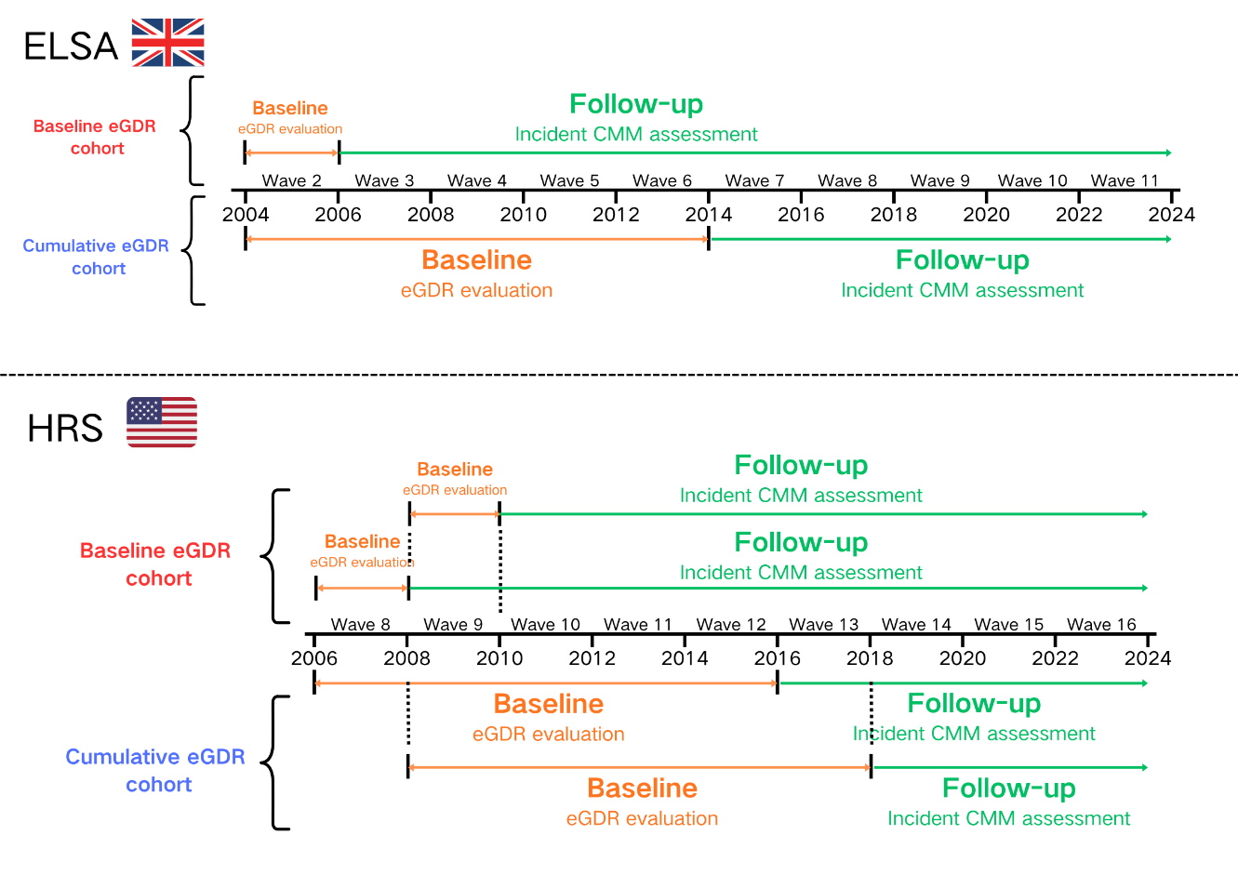
Abbreviations: eGDR, estimated glucose disposal rate; CMM, cardiometabolic multimorbidity.
Figure S2 Trajectories of eGDR using five-class quadratic models during V1 to V5 in ELSA (A) and HRS (B).
Note: Solid lines are the estimated trajectories, and the shaded bands indicate the corresponding 95% CI.
Abbreviations: eGDR, estimated glucose disposal rate; V1, visit 1; V5, visit 5.

Figure S3 Proportional hazards assessment and time-varying association of baseline eGDR with CMM in ELSA
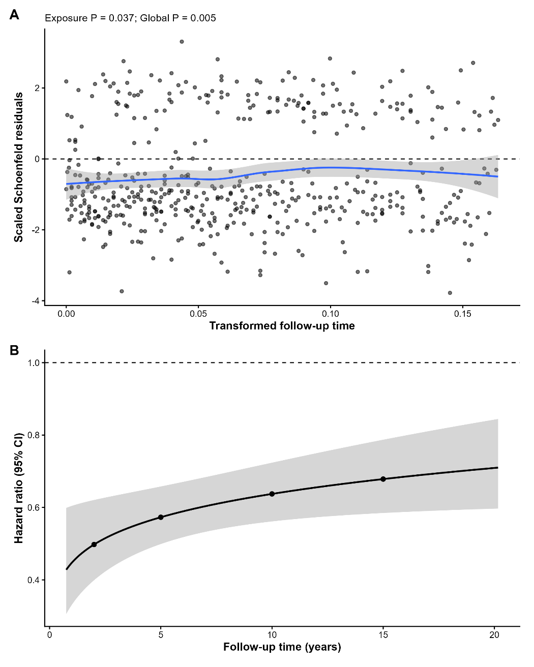
Note: (A) Scaled Schoenfeld residual plot for baseline eGDR. (B) Time-varying HR per 1-SD increase in baseline eGDR from Model 3 extended with eGDR*log(time) and age*log(time). Shading indicates the 95% CI; points mark estimates at 2, 5, 10, and 15 years.
Abbreviations: eGDR, estimated glucose disposal rate; CMM, cardiometabolic multimorbidity.

Figure S4 ROC curves evaluating the predictive performance of baseline eGDR for incident CMM at 2 years, 4 years, 6 years, 8 years and 10 years follow-up in ELSA
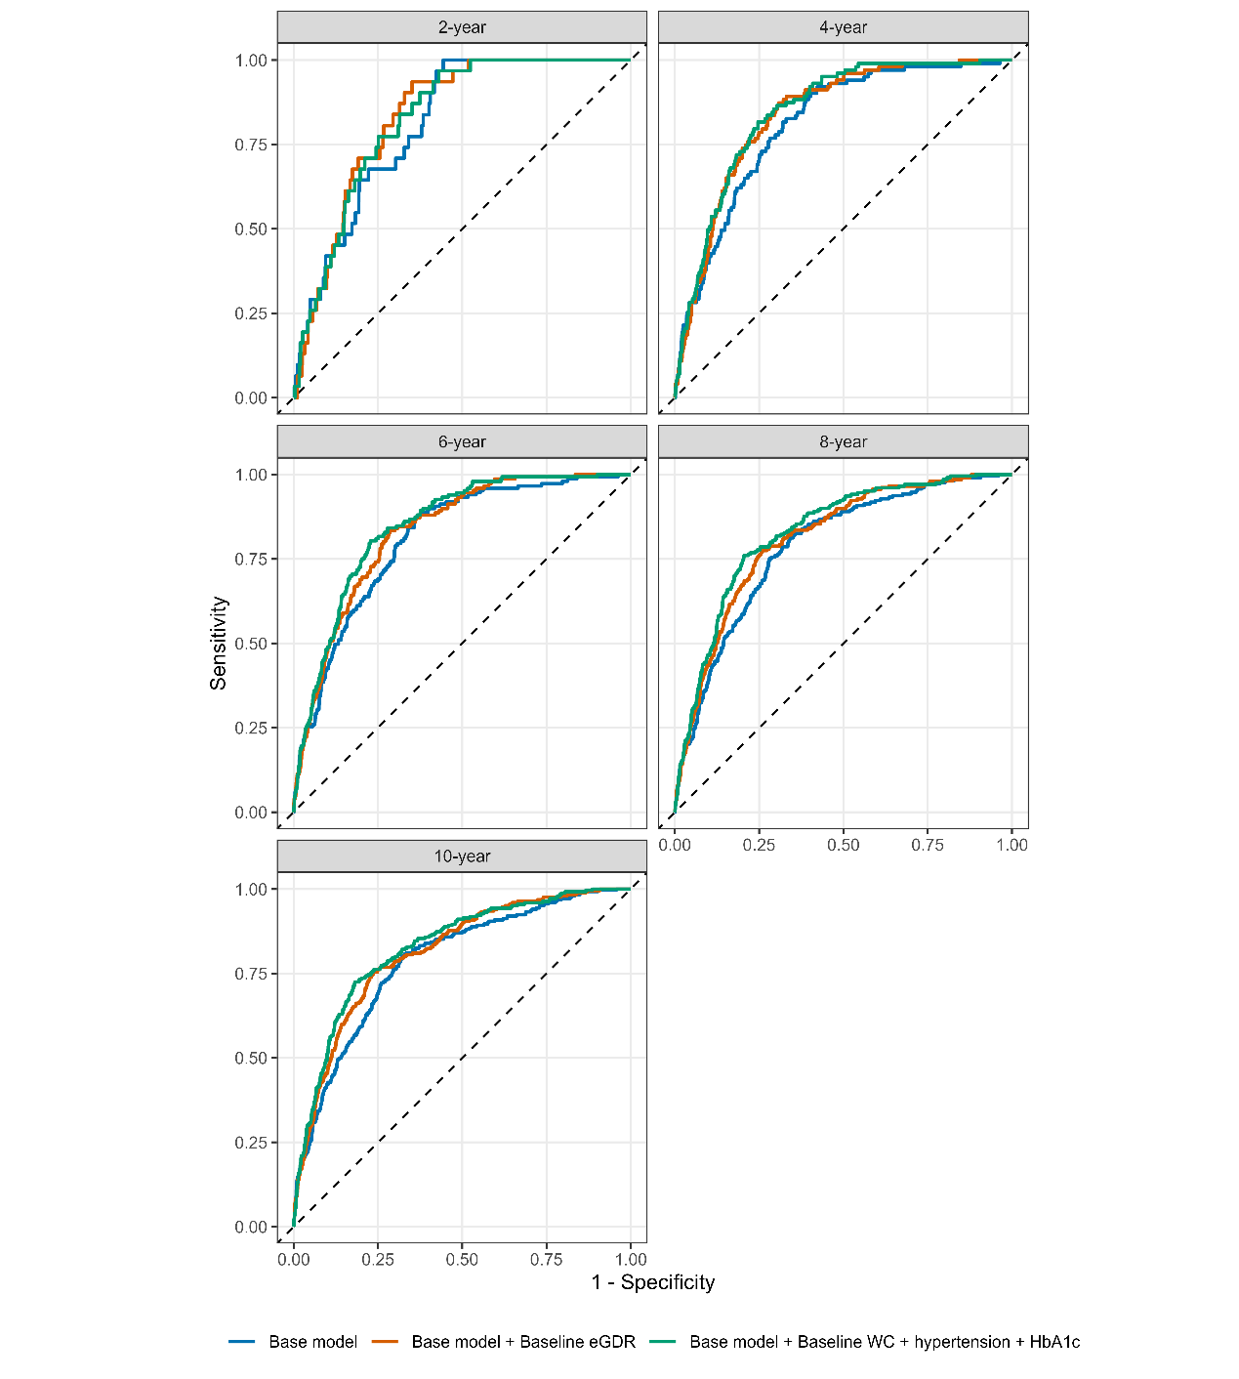
Note: Basic model included age, sex, marital status, educational level, smoking status, drinking status, BMI, dyslipidemia, cancer, TC, HDL-C and CRP.
Abbreviations: ROC, receiver operating characteristic; eGDR, estimated glucose disposal rate; CMM, cardiometabolic multimorbidity.

Figure S5 ROC curves evaluating the predictive performance of baseline eGDR for incident CMM at 2 years, 4 years, 6 years, 8 years and 10 years follow-up in HRS
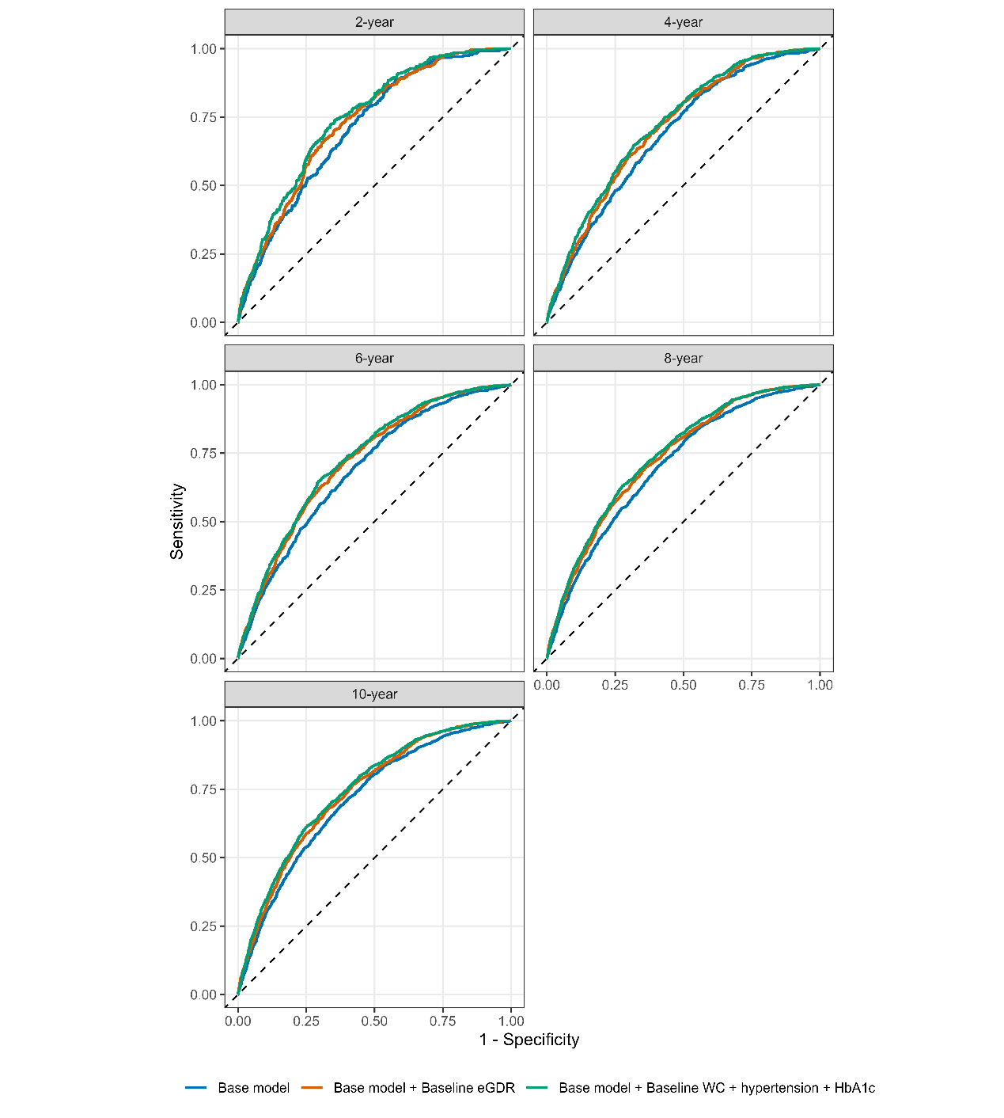
Note: Basic model included age, sex, marital status, educational level, smoking status, drinking status, BMI, dyslipidemia, cancer, TC, HDL-C and CRP.
Abbreviations: ROC, receiver operating characteristic; eGDR, estimated glucose disposal rate; CMM, cardiometabolic multimorbidity.

Figure S6 ROC curves evaluating the predictive performance of cumulative eGDR for incident CMM at 2 years, 4 years, 6 years follow-up in ELSA
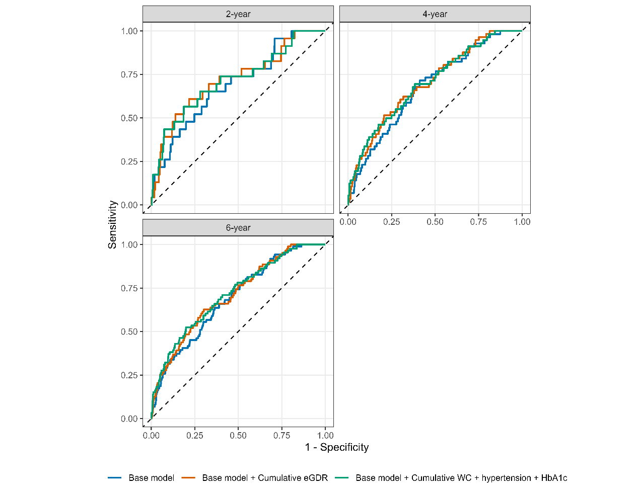
Note: Basic model included age, sex, marital status, educational level, smoking status, drinking status, BMI, dyslipidemia, cancer, TC, HDL-C and CRP.
Abbreviations: ROC, receiver operating characteristic; eGDR, estimated glucose disposal rate; CMM, cardiometabolic multimorbidity.

Figure S7 ROC curves evaluating the predictive performance of eGDR trajectory for incident CMM at 2 years, 4 years, 6 years follow-up in ELSA
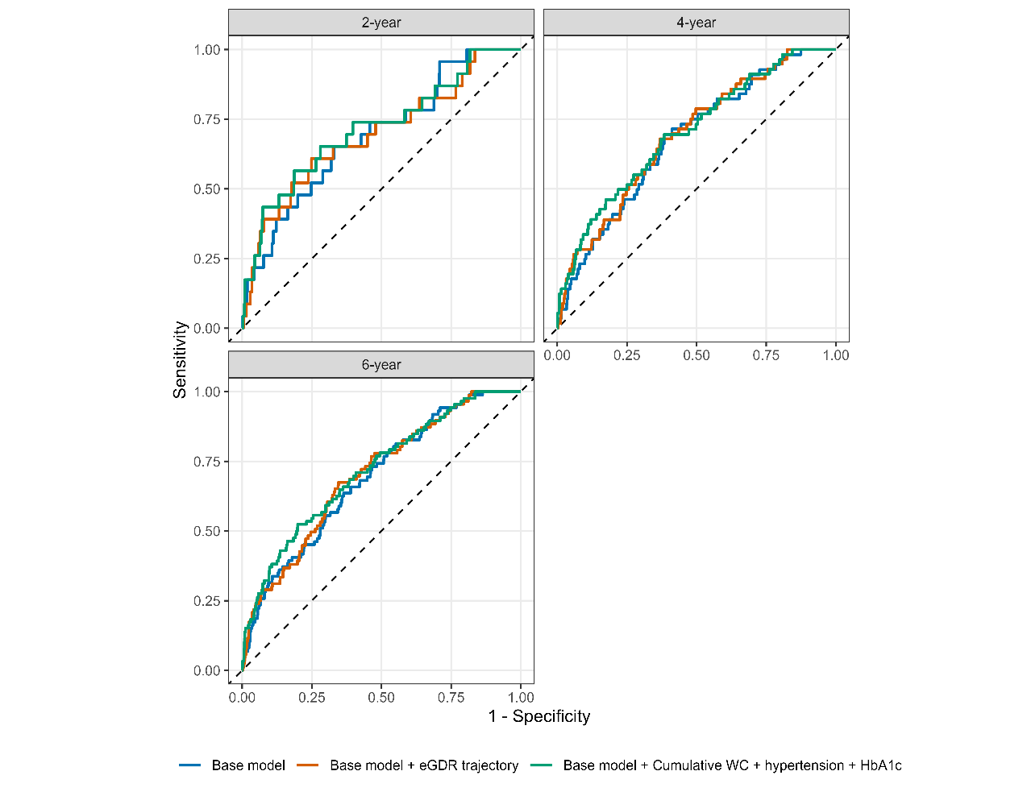
Note: Basic model included age, sex, marital status, educational level, smoking status, drinking status, BMI, dyslipidemia, cancer, TC, HDL-C and CRP.
Abbreviations: ROC, receiver operating characteristic; eGDR, estimated glucose disposal rate; CMM, cardiometabolic multimorbidity.

Figure S8 ROC curves evaluating the predictive performance of cumulative eGDR for incident CMM at 2 years, 4 years, 6 years follow-up in HRS
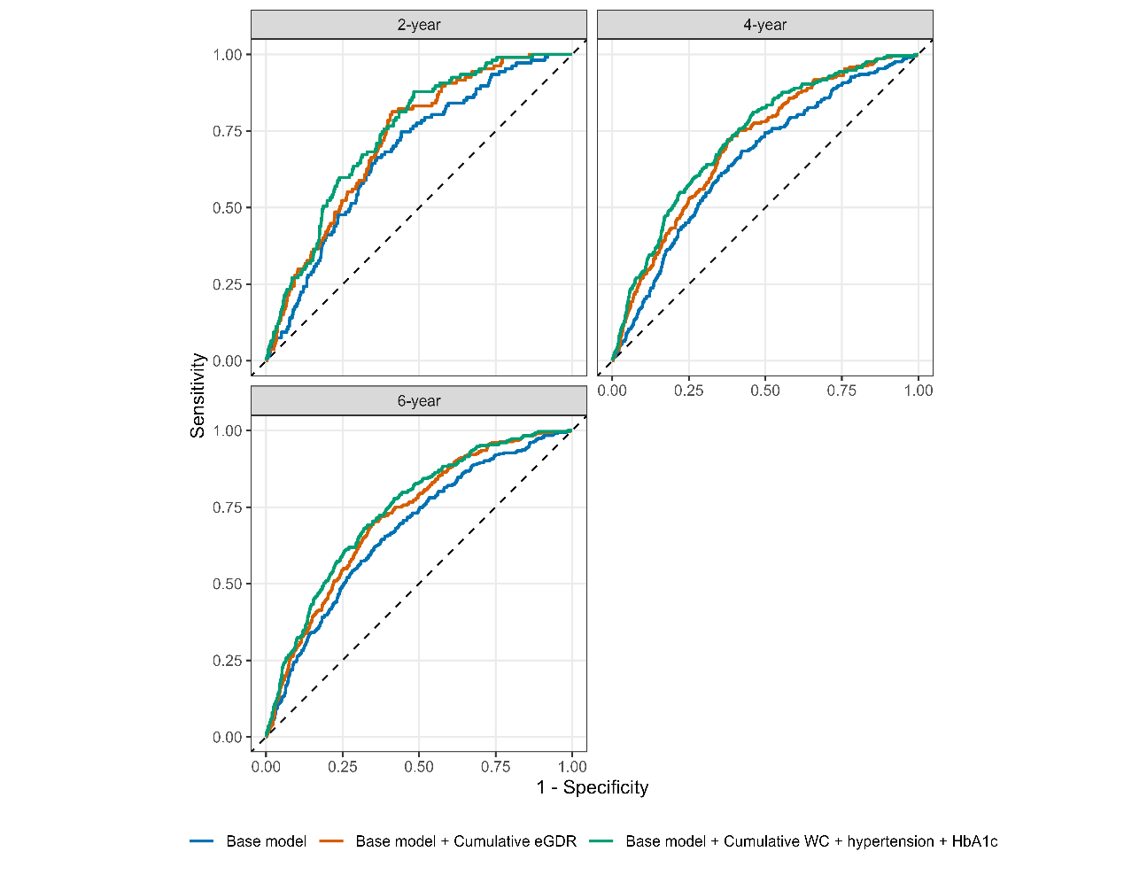
Note: Basic model included age, sex, marital status, educational level, smoking status, drinking status, BMI, dyslipidemia, cancer, TC, HDL-C and CRP.
Abbreviations: ROC, receiver operating characteristic; eGDR, estimated glucose disposal rate; CMM, cardiometabolic multimorbidity.

Figure S9 ROC curves evaluating the predictive performance of eGDR trajectory for incident CMM at 2 years, 4 years, 6 years follow-up in HRS
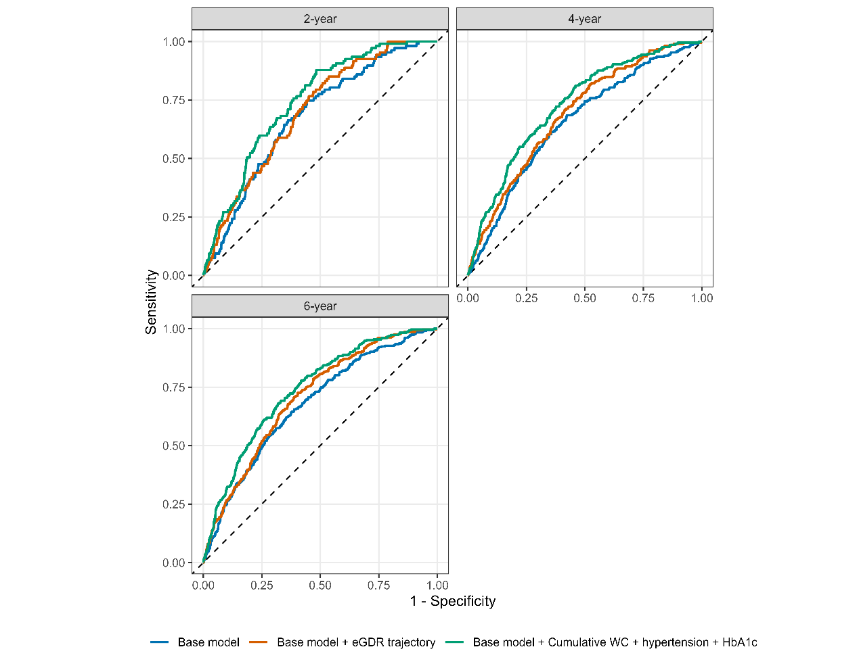
Note: Basic model included age, sex, marital status, educational level, smoking status, drinking status, BMI, dyslipidemia, cancer, TC, HDL-C and CRP.
Abbreviations: ROC, receiver operating characteristic; eGDR, estimated glucose disposal rate; CMM, cardiometabolic multimorbidity.

Figure S10 Calibration plots for models predicting incident CMM based on baseline eGDR in ELSA and HRS
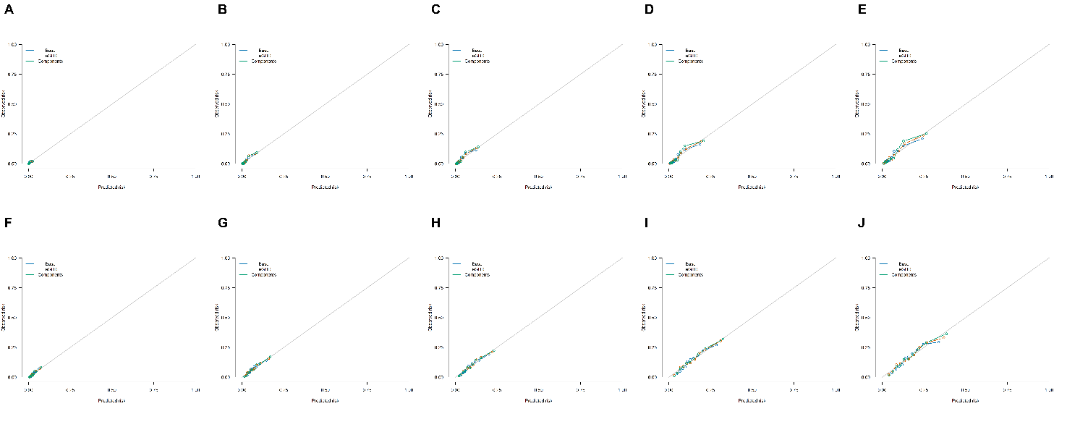
Note: Panels A–E represent the 2-, 4-, 6-, 8-, and 10-year predictions in ELSA, respectively; panels F–J show the corresponding results in HRS. The diagonal line indicates perfect calibration. Base denotes the covariate-only model; eGDR and Components denote the base model additionally including eGDR and its components, respectively.
Abbreviations: CMM, cardiometabolic multimorbidity; eGDR, estimated glucose disposal rate.

Figure S11 Calibration plots for models predicting incident CMM based on cumulative eGDR and eGDR trajectories in ELSA and HRS
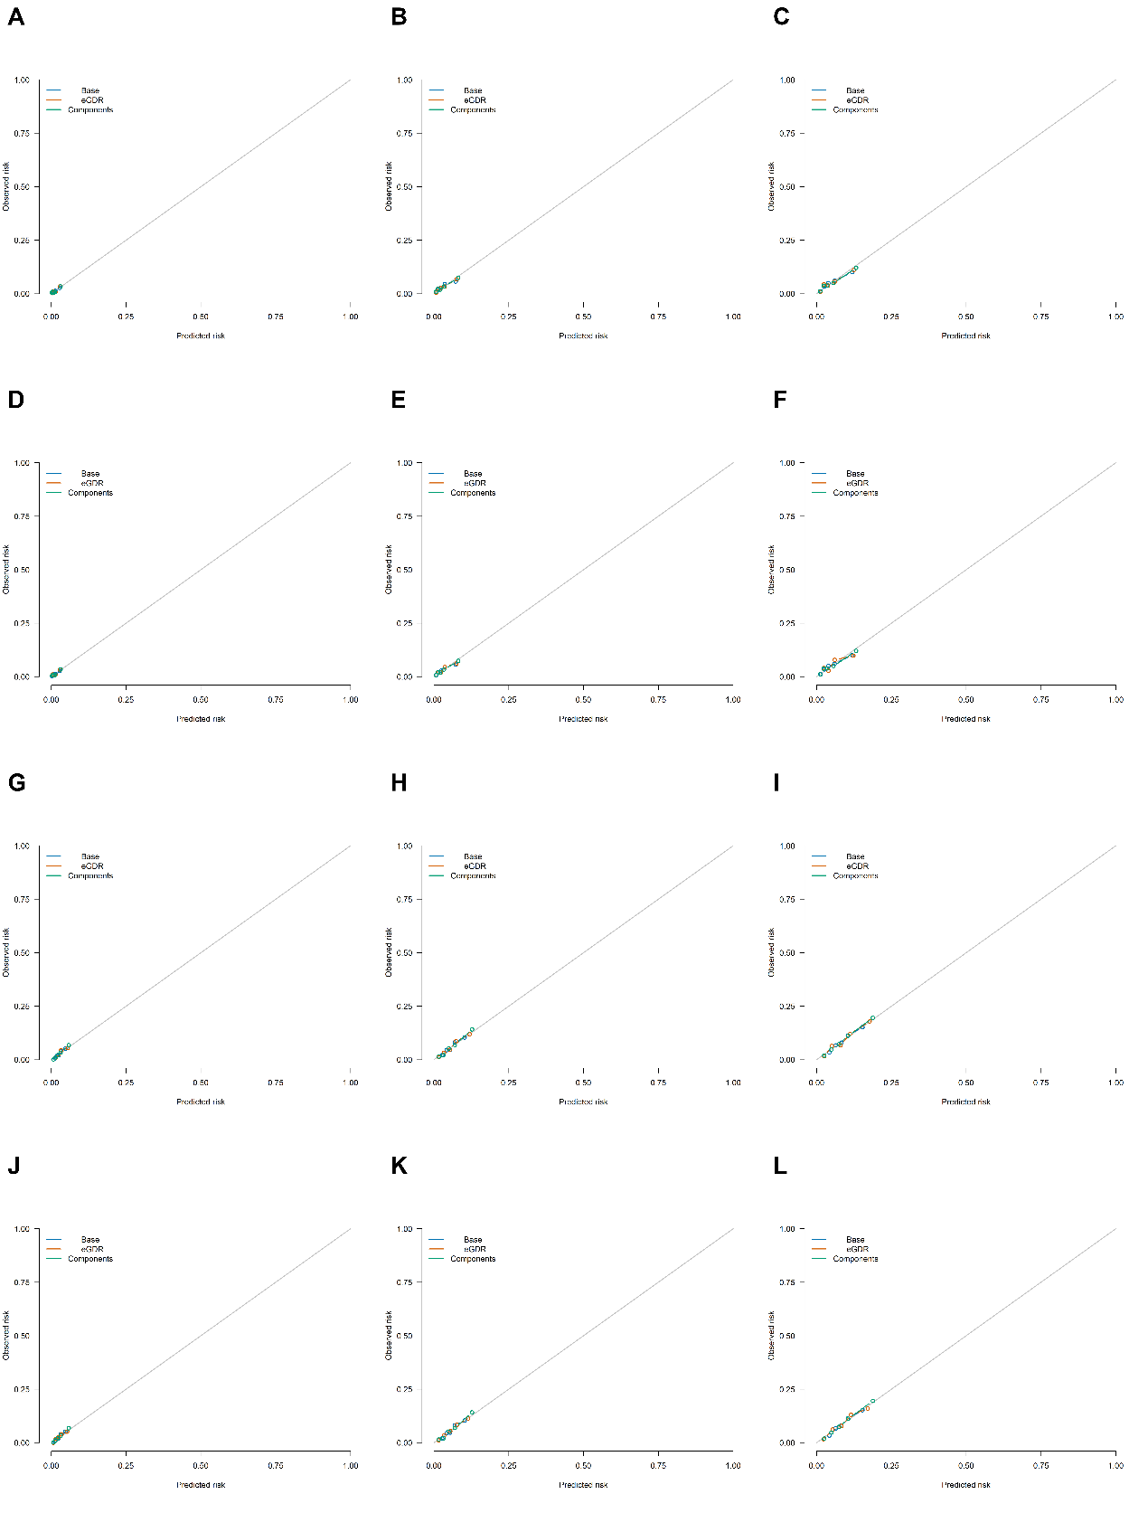
Note: Panels A–C and D–F represent the 2-, 4-, and 6-year predictions for cumulative eGDR and eGDR trajectories in ELSA, respectively; panels G–I and J–L show the corresponding results in HRS. The diagonal line indicates perfect calibration. Base denotes the covariate-only model; eGDR and Components denote the base model additionally including the corresponding eGDR exposure and its components, respectively.
Abbreviations: CMM, cardiometabolic multimorbidity; eGDR, estimated glucose disposal rate.

