Supplementary Material
eGDR, NCCR and incident cardiovascular disease in CHARLS

Supplementary methods
The revised primary analysis used the complete-case cohort after exposure trimming and Model 3 covariate assessment (n=4,935; 1,235 incident CVD events). Multiple imputation with 20 completed datasets was retained as a sensitivity analysis because Model 3 covariate missingness was approximately 1%. Unless otherwise specified, numerical estimates are reported to three decimal places.

Supplementary Table S1. Sample selection and complete-case restriction
Step | Remaining n | Excluded n
Baseline CHARLS wave 1 participants | 17708 | 0
Age >=45 years | 17060 | 648
Known baseline CVD status | 16818 | 242
Free of baseline CVD | 14399 | 2419
Complete eGDR and NCCR components | 5953 | 8446
Baseline fasting blood sample | 5385 | 568
BMI between 15 and 45 kg/m2 | 5334 | 51
At least one follow-up wave with CVD information | 5191 | 143
Both eGDR and NCCR within P1-P99 | 4988 | 203
Complete Model 3 covariates: final analytic cohort | 4935 | 53

Supplementary Table S2. Missingness relevant to Model 3
variable | n_missing | pct
education | 0 | 0
married | 0 | 0
rural | 0 | 0
ever_smoking | 1 | 0.02
ever_drinking | 2 | 0.04
systolic_bp | 50 | 1.002
a_dm_nohba1c | 0 | 0
a_dyslip | 0 | 0
log_crp | 0 | 0
egfr | 0 | 0

Supplementary Table S3. Proportional-hazards diagnostics
model | term | chisq | df | p
Model 3 + eGDR (continuous) | egdr_z | 0.801 | 1.000 | 0.371
Model 3 + eGDR (continuous) | age | 0.023 | 1.000 | 0.880
Model 3 + eGDR (continuous) | sex | 1.583 | 1.000 | 0.208
Model 3 + eGDR (continuous) | education | 6.720 | 3.000 | 0.081
Model 3 + eGDR (continuous) | married | 1.618 | 1.000 | 0.203
Model 3 + eGDR (continuous) | rural | 0.464 | 1.000 | 0.496
Model 3 + eGDR (continuous) | ever_smoking | 0.010 | 1.000 | 0.919
Model 3 + eGDR (continuous) | ever_drinking | 2.178 | 1.000 | 0.140
Model 3 + eGDR (continuous) | systolic_bp | 0.002 | 1.000 | 0.967
Model 3 + eGDR (continuous) | a_dm_nohba1c | 0.009 | 1.000 | 0.927
Model 3 + eGDR (continuous) | a_dyslip | 0.008 | 1.000 | 0.929
Model 3 + eGDR (continuous) | log_crp | 0.668 | 1.000 | 0.414
Model 3 + eGDR (continuous) | egfr | 0.049 | 1.000 | 0.825
Model 3 + eGDR (continuous) | GLOBAL | 14.370 | 15.000 | 0.498
Model 3 + NCCR (continuous) | nccr_z | 1.114 | 1.000 | 0.291
Model 3 + NCCR (continuous) | age | 0.000 | 1.000 | 0.996
Model 3 + NCCR (continuous) | sex | 1.635 | 1.000 | 0.201
Model 3 + NCCR (continuous) | education | 6.662 | 3.000 | 0.084
Model 3 + NCCR (continuous) | married | 1.530 | 1.000 | 0.216
Model 3 + NCCR (continuous) | rural | 0.505 | 1.000 | 0.477
Model 3 + NCCR (continuous) | ever_smoking | 0.016 | 1.000 | 0.901
Model 3 + NCCR (continuous) | ever_drinking | 2.279 | 1.000 | 0.131
Model 3 + NCCR (continuous) | systolic_bp | 0.000 | 1.000 | 0.990
Model 3 + NCCR (continuous) | a_dm_nohba1c | 0.001 | 1.000 | 0.973
Model 3 + NCCR (continuous) | a_dyslip | 0.004 | 1.000 | 0.952
Model 3 + NCCR (continuous) | log_crp | 0.541 | 1.000 | 0.462
Model 3 + NCCR (continuous) | egfr | 0.101 | 1.000 | 0.750
Model 3 + NCCR (continuous) | GLOBAL | 13.921 | 15.000 | 0.532
Model 3 + joint group | joint_group | 0.708 | 3.000 | 0.871
Model 3 + joint group | age | 0.001 | 1.000 | 0.981
Model 3 + joint group | sex | 1.579 | 1.000 | 0.209
Model 3 + joint group | education | 6.686 | 3.000 | 0.083
Model 3 + joint group | married | 1.446 | 1.000 | 0.229
Model 3 + joint group | rural | 0.464 | 1.000 | 0.496
Model 3 + joint group | ever_smoking | 0.013 | 1.000 | 0.909
Model 3 + joint group | ever_drinking | 2.187 | 1.000 | 0.139
Model 3 + joint group | systolic_bp | 0.000 | 1.000 | 0.996
Model 3 + joint group | a_dm_nohba1c | 0.000 | 1.000 | 0.991
Model 3 + joint group | a_dyslip | 0.003 | 1.000 | 0.955
Model 3 + joint group | log_crp | 0.619 | 1.000 | 0.431
Model 3 + joint group | egfr | 0.074 | 1.000 | 0.786
Model 3 + joint group | GLOBAL | 13.622 | 17.000 | 0.694

Supplementary Table S4. Continuous eGDR and NCCR Cox models
Exposure | Model | HR (95% CI) | P
egdr_z | Crude | 0.716 (0.680-0.754) | P<0.001
egdr_z | Model 1 | 0.739 (0.702-0.778) | P<0.001
egdr_z | Model 2 | 0.735 (0.698-0.774) | P<0.001
egdr_z | Model 3 | 0.757 (0.713-0.803) | P<0.001
nccr_z | Crude | 0.833 (0.785-0.884) | P<0.001
nccr_z | Model 1 | 0.843 (0.795-0.894) | P<0.001
nccr_z | Model 2 | 0.844 (0.796-0.895) | P<0.001
nccr_z | Model 3 | 0.862 (0.809-0.918) | P<0.001

Supplementary Table S5. Quartile eGDR and NCCR Cox models
Exposure | Model | Quartile | HR (95% CI) | P
egdr_quartile | Crude | 2 | 0.585 (0.505-0.678) | <0.001
egdr_quartile | Crude | 3 | 0.487 (0.418-0.567) | <0.001
egdr_quartile | Crude | 4 | 0.439 (0.374-0.515) | <0.001
egdr_quartile | Model 1 | 2 | 0.627 (0.541-0.726) | <0.001
egdr_quartile | Model 1 | 3 | 0.527 (0.452-0.614) | <0.001
egdr_quartile | Model 1 | 4 | 0.472 (0.402-0.554) | <0.001
egdr_quartile | Model 2 | 2 | 0.623 (0.537-0.722) | <0.001
egdr_quartile | Model 2 | 3 | 0.524 (0.449-0.612) | <0.001
egdr_quartile | Model 2 | 4 | 0.466 (0.396-0.547) | <0.001
egdr_quartile | Model 3 | 2 | 0.647 (0.556-0.753) | <0.001
egdr_quartile | Model 3 | 3 | 0.564 (0.478-0.666) | <0.001
egdr_quartile | Model 3 | 4 | 0.516 (0.432-0.616) | <0.001
nccr_quartile | Crude | 2 | 0.745 (0.642-0.866) | <0.001
nccr_quartile | Crude | 3 | 0.676 (0.580-0.787) | <0.001
nccr_quartile | Crude | 4 | 0.614 (0.523-0.720) | <0.001
nccr_quartile | Model 1 | 2 | 0.760 (0.654-0.883) | <0.001
nccr_quartile | Model 1 | 3 | 0.689 (0.591-0.803) | <0.001
nccr_quartile | Model 1 | 4 | 0.636 (0.542-0.746) | <0.001
nccr_quartile | Model 2 | 2 | 0.764 (0.657-0.888) | <0.001
nccr_quartile | Model 2 | 3 | 0.695 (0.595-0.810) | <0.001
nccr_quartile | Model 2 | 4 | 0.639 (0.544-0.750) | <0.001
nccr_quartile | Model 3 | 2 | 0.786 (0.675-0.915) | 0.002
nccr_quartile | Model 3 | 3 | 0.722 (0.616-0.846) | <0.001
nccr_quartile | Model 3 | 4 | 0.672 (0.566-0.798) | <0.001

Supplementary Table S6. Formal interaction analyses
Scale | Measure | Estimate (95% CI) | P | Resampling
Continuous (per 1 SD, risk direction) | Multiplicative interaction HR | 1.002 (0.950-1.057) | 0.932 | 20 imputations
Binary (below vs at/above median, matches submitted Table 3) | Multiplicative interaction HR | 1.071 (0.847-1.356) | 0.566 | 20 imputations
Nine-year standardized cumulative risk (binary low indicators) | RERI | 0.023 (-0.031-0.077) | 0.424 | 1000 bootstrap samples
Nine-year standardized cumulative risk (binary low indicators) | AP | 0.067 (-0.091-0.223) | 0.424 | 1000 bootstrap samples
Nine-year standardized cumulative risk (binary low indicators) | SI | 1.507 (0.792-3.498) | 0.426 | 1000 bootstrap samples

Supplementary Table S7. Prediction performance at 2, 4, 7, and 9 years
Model | Year | AUC (95% CI)
Model 3 | 2 | 0.580 (0.521-0.643)
Model 3 | 4 | 0.609 (0.576-0.641)
Model 3 | 7 | 0.608 (0.586-0.631)
Model 3 | 9 | 0.618 (0.595-0.640)
Model 3 + NCCR | 2 | 0.598 (0.539-0.661)
Model 3 + NCCR | 4 | 0.619 (0.586-0.652)
Model 3 + NCCR | 7 | 0.612 (0.589-0.635)
Model 3 + NCCR | 9 | 0.623 (0.600-0.645)
Model 3 + eGDR | 2 | 0.598 (0.539-0.661)
Model 3 + eGDR | 4 | 0.630 (0.596-0.662)
Model 3 + eGDR | 7 | 0.627 (0.605-0.649)
Model 3 + eGDR | 9 | 0.638 (0.617-0.660)
Model 3 + eGDR + NCCR | 2 | 0.602 (0.543-0.665)
Model 3 + eGDR + NCCR | 4 | 0.632 (0.597-0.664)
Model 3 + eGDR + NCCR | 7 | 0.626 (0.604-0.649)
Model 3 + eGDR + NCCR | 9 | 0.638 (0.617-0.661)

Supplementary Table S8. AUC differences
Model | Reference | Year | Difference (95% CI) | P
Model 3 + NCCR | Model 3 | 2 | 0.019 (-0.008-0.042) | P=0.116
Model 3 + NCCR | Model 3 | 4 | 0.010 (-0.003-0.022) | P=0.142
Model 3 + NCCR | Model 3 | 7 | 0.004 (-0.007-0.012) | P=0.398
Model 3 + NCCR | Model 3 | 9 | 0.005 (-0.007-0.013) | P=0.318
Model 3 + eGDR | Model 3 | 2 | 0.018 (-0.018-0.053) | P=0.304
Model 3 + eGDR | Model 3 | 4 | 0.021 (-0.001-0.042) | P=0.062
Model 3 + eGDR | Model 3 | 7 | 0.019 (0.003-0.032) | P=0.026
Model 3 + eGDR | Model 3 | 9 | 0.021 (0.005-0.033) | P=0.012
Model 3 + eGDR + NCCR | Model 3 | 2 | 0.022 (-0.015-0.059) | P=0.248
Model 3 + eGDR + NCCR | Model 3 | 4 | 0.023 (-0.001-0.045) | P=0.056
Model 3 + eGDR + NCCR | Model 3 | 7 | 0.018 (0.002-0.032) | P=0.032
Model 3 + eGDR + NCCR | Model 3 | 9 | 0.020 (0.004-0.033) | P=0.018
Model 3 + eGDR + NCCR | Model 3 + NCCR | 2 | 0.004 (-0.028-0.034) | P=0.780
Model 3 + eGDR + NCCR | Model 3 + NCCR | 4 | 0.013 (-0.007-0.030) | P=0.204
Model 3 + eGDR + NCCR | Model 3 + NCCR | 7 | 0.014 (-0.000-0.025) | P=0.054
Model 3 + eGDR + NCCR | Model 3 + NCCR | 9 | 0.015 (0.001-0.026) | P=0.038
Model 3 + eGDR + NCCR | Model 3 + eGDR | 2 | 0.004 (-0.006-0.015) | P=0.312
Model 3 + eGDR + NCCR | Model 3 + eGDR | 4 | 0.002 (-0.004-0.007) | P=0.452
Model 3 + eGDR + NCCR | Model 3 + eGDR | 7 | -0.001 (-0.006-0.003) | P=0.992
Model 3 + eGDR + NCCR | Model 3 + eGDR | 9 | -0.000 (-0.006-0.003) | P=0.844

Supplementary Table S9. Category-free NRI and IDI
Model | Reference | Year | Metric | Estimate (95% CI) | P | Valid perturbations
Model 3 + eGDR | Model 3 | 2 | IDI | 0.002 (0.000-0.004) | 0.010 | 1000
Model 3 + eGDR | Model 3 | 2 | NRI | 0.099 (0.019-0.184) | 0.022 | 1000
Model 3 + NCCR | Model 3 | 2 | IDI | 0.001 (0.000-0.002) | 0.008 | 250
Model 3 + NCCR | Model 3 | 2 | NRI | 0.066 (0.000-0.170) | 0.048 | 250
Model 3 + eGDR + NCCR | Model 3 + eGDR | 2 | IDI | 0.000 (-0.000-0.001) | 0.096 | 250
Model 3 + eGDR + NCCR | Model 3 + eGDR | 2 | NRI | 0.070 (-0.035-0.143) | 0.143 | 250
Model 3 + eGDR + NCCR | Model 3 + NCCR | 2 | IDI | 0.001 (-0.000-0.003) | 0.120 | 250
Model 3 + eGDR + NCCR | Model 3 + NCCR | 2 | NRI | 0.070 (-0.027-0.159) | 0.120 | 250
Model 3 + eGDR | Model 3 | 4 | IDI | 0.006 (0.000-0.012) | 0.016 | 250
Model 3 + eGDR | Model 3 | 4 | NRI | 0.096 (-0.006-0.178) | 0.064 | 250
Model 3 + NCCR | Model 3 | 4 | IDI | 0.003 (0.001-0.006) | 0.008 | 250
Model 3 + NCCR | Model 3 | 4 | NRI | 0.063 (-0.003-0.168) | 0.056 | 250
Model 3 + eGDR + NCCR | Model 3 + eGDR | 4 | IDI | 0.001 (-0.000-0.003) | 0.080 | 250
Model 3 + eGDR + NCCR | Model 3 + eGDR | 4 | NRI | 0.067 (-0.033-0.151) | 0.151 | 250
Model 3 + eGDR + NCCR | Model 3 + NCCR | 4 | IDI | 0.004 (-0.001-0.009) | 0.112 | 250
Model 3 + eGDR + NCCR | Model 3 + NCCR | 4 | NRI | 0.072 (-0.028-0.153) | 0.120 | 250
Model 3 + eGDR | Model 3 | 7 | IDI | 0.018 (0.010-0.029) | <0.001 | 250
Model 3 + eGDR | Model 3 | 7 | NRI | 0.149 (0.082-0.206) | <0.001 | 250
Model 3 + NCCR | Model 3 | 7 | IDI | 0.006 (0.002-0.012) | <0.001 | 250
Model 3 + NCCR | Model 3 | 7 | NRI | 0.097 (0.041-0.147) | <0.001 | 250
Model 3 + eGDR + NCCR | Model 3 + eGDR | 7 | IDI | 0.002 (0.000-0.004) | <0.001 | 250
Model 3 + eGDR + NCCR | Model 3 + eGDR | 7 | NRI | 0.056 (-0.005-0.094) | 0.064 | 250
Model 3 + eGDR + NCCR | Model 3 + NCCR | 7 | IDI | 0.013 (0.007-0.022) | <0.001 | 250
Model 3 + eGDR + NCCR | Model 3 + NCCR | 7 | NRI | 0.107 (0.058-0.163) | <0.001 | 250
Model 3 + eGDR | Model 3 | 9 | IDI | 0.020 (0.012-0.029) | <0.001 | 1000
Model 3 + eGDR | Model 3 | 9 | NRI | 0.148 (0.113-0.190) | <0.001 | 1000
Model 3 + NCCR | Model 3 | 9 | IDI | 0.005 (0.002-0.010) | <0.001 | 1000
Model 3 + NCCR | Model 3 | 9 | NRI | 0.055 (0.017-0.092) | 0.006 | 1000
Model 3 + eGDR + NCCR | Model 3 + eGDR | 9 | IDI | 0.001 (0.000-0.003) | <0.001 | 1000
Model 3 + eGDR + NCCR | Model 3 + eGDR | 9 | NRI | -0.005 (-0.028-0.044) | >0.99 | 1000
Model 3 + eGDR + NCCR | Model 3 + NCCR | 9 | IDI | 0.016 (0.009-0.024) | <0.001 | 1000
Model 3 + eGDR + NCCR | Model 3 + NCCR | 9 | NRI | 0.121 (0.084-0.157) | <0.001 | 1000
NRI/IDI were treated as supplementary. The table reports the actual valid perturbation count; records with 250 valid perturbations are not described as 1,000-repeat results.

Supplementary Table S10. Construct validity and body-weight coupling
Marker | Grip measure | Partial r (95% CI) | Spearman rho | P
NCCR | Absolute grip strength | -0.082 (-0.112--0.052) | 0.012 | <0.001
NCCR | Grip strength/body weight | 0.255 (0.227-0.282) | 0.294 | <0.001
NCCR | Grip strength/BMI | 0.163 (0.134-0.192) | 0.205 | <0.001
CCR | Absolute grip strength | 0.111 (0.081-0.140) | 0.384 | <0.001
CCR | Grip strength/body weight | -0.009 (-0.038-0.021) | 0.234 | 0.548
CCR | Grip strength/BMI | 0.013 (-0.017-0.043) | 0.308 | 0.370
eGDR | Absolute grip strength | -0.074 (-0.104--0.045) | 0.011 | <0.001
eGDR | Grip strength/body weight | 0.269 (0.241-0.296) | 0.327 | <0.001
eGDR | Grip strength/BMI | 0.222 (0.193-0.250) | 0.261 | <0.001
NCCR was retained as a literature-supported relative, body-weight-normalized muscle-metabolic biomarker. The construct-validity analyses show that NCCR tracks relative grip indices more clearly than absolute grip strength and also includes substantial body-weight information.
Indicator | n | Events | HR (95% CI) | P
CCR per SD | 4935 | 1235 | 0.969 (0.901-1.043) | 0.404
NCCR per SD | 4935 | 1235 | 0.862 (0.809-0.918) | <0.001
Both estimates use the final complete-case cohort and Model 3. NCCR was associated with incident CVD, whereas unnormalized CCR was not independently associated after adjustment. This divergence supports distinguishing a relative body-weight-normalized phenotype from an absolute creatinine-to-cystatin C phenotype.

Supplementary Table S11. Sensitivity analyses
Category | Analysis | n | Events | HR (95% CI) | P
Primary | Primary P1-P99 complete-case analysis | 4935 | 1235 | 0.629 (0.538-0.734) | <0.001
Extreme values | Untrimmed cohort (recalculated cut points) | 5138 | 1301 | 0.618 (0.531-0.719) | <0.001
Event time | Event time at interval midpoint | 4935 | 1235 | 0.623 (0.534-0.728) | <0.001
Reverse causation | Excluded events within first 2 years | 4787 | 1087 | 0.620 (0.526-0.731) | <0.001
Reverse causation | Excluded events within first 4 years | 4490 | 790 | 0.651 (0.537-0.789) | <0.001
Adjustment set | Model 2 (fewer clinical covariates) | 4935 | 1235 | 0.555 (0.480-0.642) | <0.001
Adjustment set | Submitted-version adjustment set | 4839 | 1213 | 0.643 (0.549-0.754) | <0.001
Body size and muscle | Model 3 + BMI | 4935 | 1235 | 0.707 (0.585-0.855) | <0.001
Body size and muscle | Model 3 + waist circumference | 4935 | 1235 | 0.684 (0.559-0.836) | <0.001
Body size and muscle | Model 3 + body weight | 4935 | 1235 | 0.773 (0.635-0.942) | 0.011
Metabolic conditions | Excluded baseline hypertension | 3017 | 632 | 0.762 (0.618-0.941) | 0.011
Body size and muscle | Model 3 + grip strength (potential overadjustment) | 3141 | 800 | 0.604 (0.514-0.710) | <0.001
Kidney function | Model 3 without eGFR | 3141 | 800 | 0.598 (0.510-0.700) | <0.001
Kidney function | Model 3 with BUN and self-reported kidney disease instead of eGFR | 3131 | 798 | 0.599 (0.511-0.702) | <0.001
Kidney function | Excluded CKD (eGFR <60) | 3025 | 774 | 0.625 (0.531-0.736) | <0.001
Metabolic conditions | Excluded baseline diabetes (composite definition) | 2737 | 692 | 0.624 (0.526-0.740) | <0.001
Loss to follow-up | IPW for follow-up through event or 2020 | 2682 | 790 | 0.602 (0.511-0.708) | <0.001
Loss to follow-up | Restricted to complete follow-up through 2020 or incident CVD | 2682 | 790 | 0.615 (0.523-0.723) | <0.001
Additional BMI adjustment attenuated but did not remove the joint association. Direct body-weight adjustment produced greater attenuation because body weight is the denominator of NCCR and is therefore a component-removal analysis as well as a confounding analysis.

Supplementary Table S12. Component and competing-risk outcomes
Analysis | n | Events | Estimate (95% CI) | P
Incident heart disease, high eGDR + high NCCR vs low eGDR + low NCCR | 3141 | 615 | 0.630 (0.524-0.756) | P<0.001
Incident stroke, high eGDR + high NCCR vs low eGDR + low NCCR | 3141 | 272 | 0.539 (0.405-0.716) | P<0.001
Heart disease, eGDR per SD | 4988 | 956 | 0.761 (0.711-0.814) | P<0.001
Heart disease, NCCR per SD | 4988 | 956 | 0.839 (0.781-0.902) | P<0.001
Stroke, eGDR per SD | 4988 | 429 | 0.732 (0.664-0.807) | P<0.001
Stroke, NCCR per SD | 4988 | 429 | 0.902 (0.812-1.003) | P=0.057
Fine-Gray CVD with death as competing event | 3108 | 790 | 0.628 (0.539-0.730) | P<0.001
Death-data audit item | Value
Exposure- and follow-up-eligible P1-P99 cohort | 4988
Death status available | 4988
Deaths during follow-up | 590
Deaths with recorded death year | 589
Row-level missingness of death follow-up time (%) | 88.19
Interpretation | Missing death time is concentrated among survivors because a death year is only defined for deceased participants; this is structural missingness, not missing death status.

Supplementary Table S13. Discrete-time sensitivity model
Analysis | Person-periods | Events | Estimate (95% CI) | P
Discrete-time logistic (pooled MI) | 10208 | 800 | 0.592 (0.500-0.702) | P<0.001

Supplementary Table S14. Associations of 2011 exposures with 2015 body-size variables
Structural assumption | Status | Interpretation
(1) No unmeasured exposure-outcome confounding | Assumed, conditional on Model 3 covariates | Model 3 covariates (age, sex, education, marital status, rural residence, smoking, drinking, systolic blood pressure, diabetes, dyslipidaemia, log CRP and eGFR) are assumed to capture confounding of the exposure-outcome relation.
(2) No unmeasured mediator-outcome confounding | Assumed, conditional on Model 3 covariates | No unmeasured common cause of the 2015 mediator and incident CVD is assumed beyond the same covariate set.
(3) No unmeasured exposure-mediator confounding | Assumed, conditional on Model 3 covariates | No unmeasured common cause of the 2011 exposure and the 2015 mediator is assumed beyond the same covariate set.
(4) No mediator-outcome confounder affected by the exposure | Relaxed in the g-formula analysis by modelling post-exposure body size (BMI in 2015 and change in waist circumference) as post-exposure confounders (postc) | Body size in 2015 is plausibly affected by the 2011 exposure and affects both the mediator and the outcome. The 'rb' estimator does not accommodate such a variable; the mediational g-formula does, so both are reported and compared.
2011 exposure | 2015 outcome | Beta (95% CI) | P | n | Adjustment
Lower eGDR in 2011 (per SD) | BMI in 2015 (kg/m2) | 0.388 (0.294-0.482) | <0.001 | 2605 | Baseline BMI and Model 3 covariates
Lower eGDR in 2011 (per SD) | Change in BMI 2011-2015 (kg/m2) | 0.388 (0.294-0.482) | <0.001 | 2605 | Baseline BMI and Model 3 covariates
Lower eGDR in 2011 (per SD) | Waist circumference in 2015 (cm) | 0.499 (0.164-0.834) | 0.003 | 2605 | Baseline waist circumference and Model 3 covariates
Lower eGDR in 2011 (per SD) | Change in waist circumference 2011-2015 (cm) | 0.499 (0.164-0.834) | 0.003 | 2605 | Baseline waist circumference and Model 3 covariates
Lower NCCR in 2011 (per SD) | BMI in 2015 (kg/m2) | 0.105 (0.014-0.196) | 0.023 | 2605 | Baseline BMI and Model 3 covariates
Lower NCCR in 2011 (per SD) | Change in BMI 2011-2015 (kg/m2) | 0.105 (0.014-0.196) | 0.023 | 2605 | Baseline BMI and Model 3 covariates
Lower NCCR in 2011 (per SD) | Waist circumference in 2015 (cm) | 0.919 (0.630-1.208) | <0.001 | 2605 | Baseline waist circumference and Model 3 covariates
Lower NCCR in 2011 (per SD) | Change in waist circumference 2011-2015 (cm) | 0.919 (0.630-1.208) | <0.001 | 2605 | Baseline waist circumference and Model 3 covariates

Supplementary Table S15. Exploratory longitudinal mediation
Pathway | Effect | Estimate (95% CI) | P | n | Events | Bootstrap
2011 low eGDR -> 2015 low NCCR -> CVD after 2015 | Controlled direct effect | 1.226 (1.109-1.357) | <0.001 | 2605 | 516 | 1000
2011 low eGDR -> 2015 low NCCR -> CVD after 2015 | Pure natural direct effect | 1.226 (1.109-1.357) | <0.001 | 2605 | 516 | 1000
2011 low eGDR -> 2015 low NCCR -> CVD after 2015 | Total natural direct effect | 1.226 (1.109-1.357) | <0.001 | 2605 | 516 | 1000
2011 low eGDR -> 2015 low NCCR -> CVD after 2015 | Pure natural indirect effect | 1.009 (0.979-1.045) | 0.578 | 2605 | 516 | 1000
2011 low eGDR -> 2015 low NCCR -> CVD after 2015 | Total natural indirect effect | 1.009 (0.979-1.045) | 0.578 | 2605 | 516 | 1000
2011 low eGDR -> 2015 low NCCR -> CVD after 2015 | Total effect | 1.237 (1.125-1.360) | <0.001 | 2605 | 516 | 1000
2011 low eGDR -> 2015 low NCCR -> CVD after 2015 | Proportion mediated | 0.045 (-0.125-0.243) | 0.578 | 2605 | 516 | 1000
2011 low NCCR -> 2015 low eGDR -> CVD after 2015 | Controlled direct effect | 1.053 (0.955-1.174) | 0.344 | 2605 | 516 | 1000
2011 low NCCR -> 2015 low eGDR -> CVD after 2015 | Pure natural direct effect | 1.053 (0.955-1.174) | 0.344 | 2605 | 516 | 1000
2011 low NCCR -> 2015 low eGDR -> CVD after 2015 | Total natural direct effect | 1.053 (0.955-1.174) | 0.344 | 2605 | 516 | 1000
2011 low NCCR -> 2015 low eGDR -> CVD after 2015 | Pure natural indirect effect | 1.079 (1.051-1.113) | <0.001 | 2605 | 516 | 1000
2011 low NCCR -> 2015 low eGDR -> CVD after 2015 | Total natural indirect effect | 1.079 (1.051-1.113) | <0.001 | 2605 | 516 | 1000
2011 low NCCR -> 2015 low eGDR -> CVD after 2015 | Total effect | 1.136 (1.033-1.254) | 0.010 | 2605 | 516 | 1000
2011 low NCCR -> 2015 low eGDR -> CVD after 2015 | Proportion mediated | 0.612 (0.284-2.197) | 0.010 | 2605 | 516 | 1000
The longitudinal mediation analysis improves temporal ordering but does not prove causality. The proportion-mediated estimate for the NCCR-to-eGDR pathway had a wide confidence interval and was deliberately down-weighted in the manuscript.

Supplementary Table S16. Regression-based and mediational g-formula comparison
Pathway | Effect | Regression-based estimate (95% CI) | G-formula estimate (95% CI) | Direction consistent
2011 low eGDR -> 2015 low NCCR -> CVD after 2015 | Total natural indirect effect | 1.009 (0.979-1.045) | 1.007 (0.974-1.051) | TRUE
2011 low eGDR -> 2015 low NCCR -> CVD after 2015 | Total effect | 1.237 (1.125-1.360) | 1.235 (1.130-1.348) | TRUE
2011 low eGDR -> 2015 low NCCR -> CVD after 2015 | Proportion mediated | 0.045 (-0.125-0.243) | 0.039 (-0.147-0.297) | TRUE
2011 low NCCR -> 2015 low eGDR -> CVD after 2015 | Total natural indirect effect | 1.079 (1.051-1.113) | 1.092 (1.055-1.125) | TRUE
2011 low NCCR -> 2015 low eGDR -> CVD after 2015 | Total effect | 1.136 (1.033-1.254) | 1.142 (1.026-1.256) | TRUE
2011 low NCCR -> 2015 low eGDR -> CVD after 2015 | Proportion mediated | 0.612 (0.284-2.197) | 0.675 (0.322-2.998) | TRUE
2011 low eGDR -> 2015 BMI gain -> CVD after 2015 | Total natural indirect effect | 1.013 (0.955-1.071) | 1.005 (0.951-1.062) | TRUE
2011 low eGDR -> 2015 BMI gain -> CVD after 2015 | Total effect | 1.237 (1.120-1.358) | 1.234 (1.123-1.358) | TRUE
2011 low eGDR -> 2015 BMI gain -> CVD after 2015 | Proportion mediated | 0.068 (-0.263-0.387) | 0.024 (-0.323-0.323) | TRUE

Supplementary Table S17. Exclude-indirect-pathway mediation sensitivity analysis
Restricted sample | Pathway | Effect | Estimate (95% CI) | P | n | Events
Waist change |delta| <= median (3.7 cm) | 2011 low NCCR -> 2015 low eGDR -> CVD after 2015 | Controlled direct effect | 1.087 (0.937-1.283) | 0.286 | 1306 | 259
Waist change |delta| <= median (3.7 cm) | 2011 low NCCR -> 2015 low eGDR -> CVD after 2015 | Total natural indirect effect | 1.097 (1.044-1.157) | <0.001 | 1306 | 259
Waist change |delta| <= median (3.7 cm) | 2011 low NCCR -> 2015 low eGDR -> CVD after 2015 | Total effect | 1.193 (1.032-1.414) | 0.014 | 1306 | 259
Waist change |delta| <= median (3.7 cm) | 2011 low NCCR -> 2015 low eGDR -> CVD after 2015 | Proportion mediated | 0.547 (0.188-2.381) | 0.014 | 1306 | 259

Supplementary figures
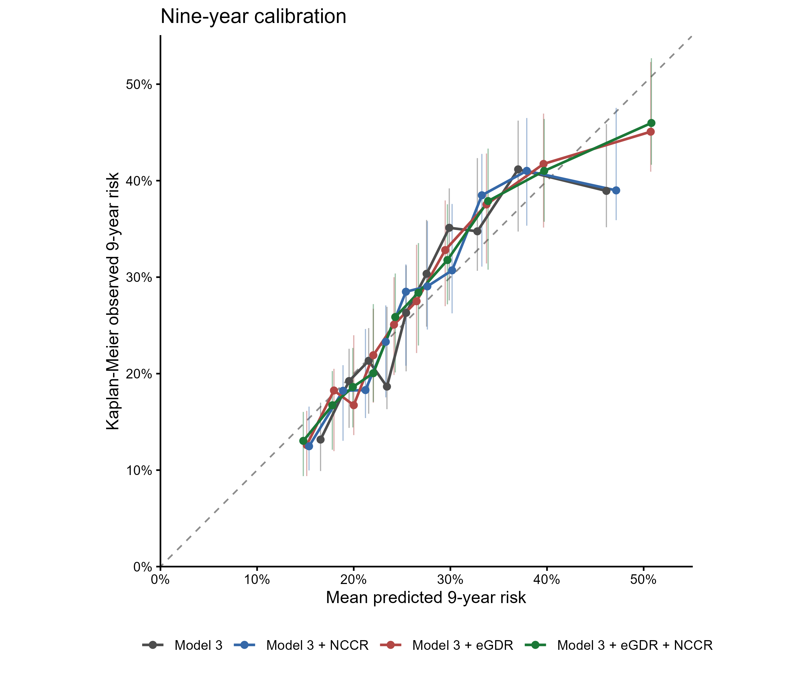
Supplementary Figure S1. Nine-year calibration. Vertical bars indicate 95% confidence intervals from 500 bootstrap resamples.
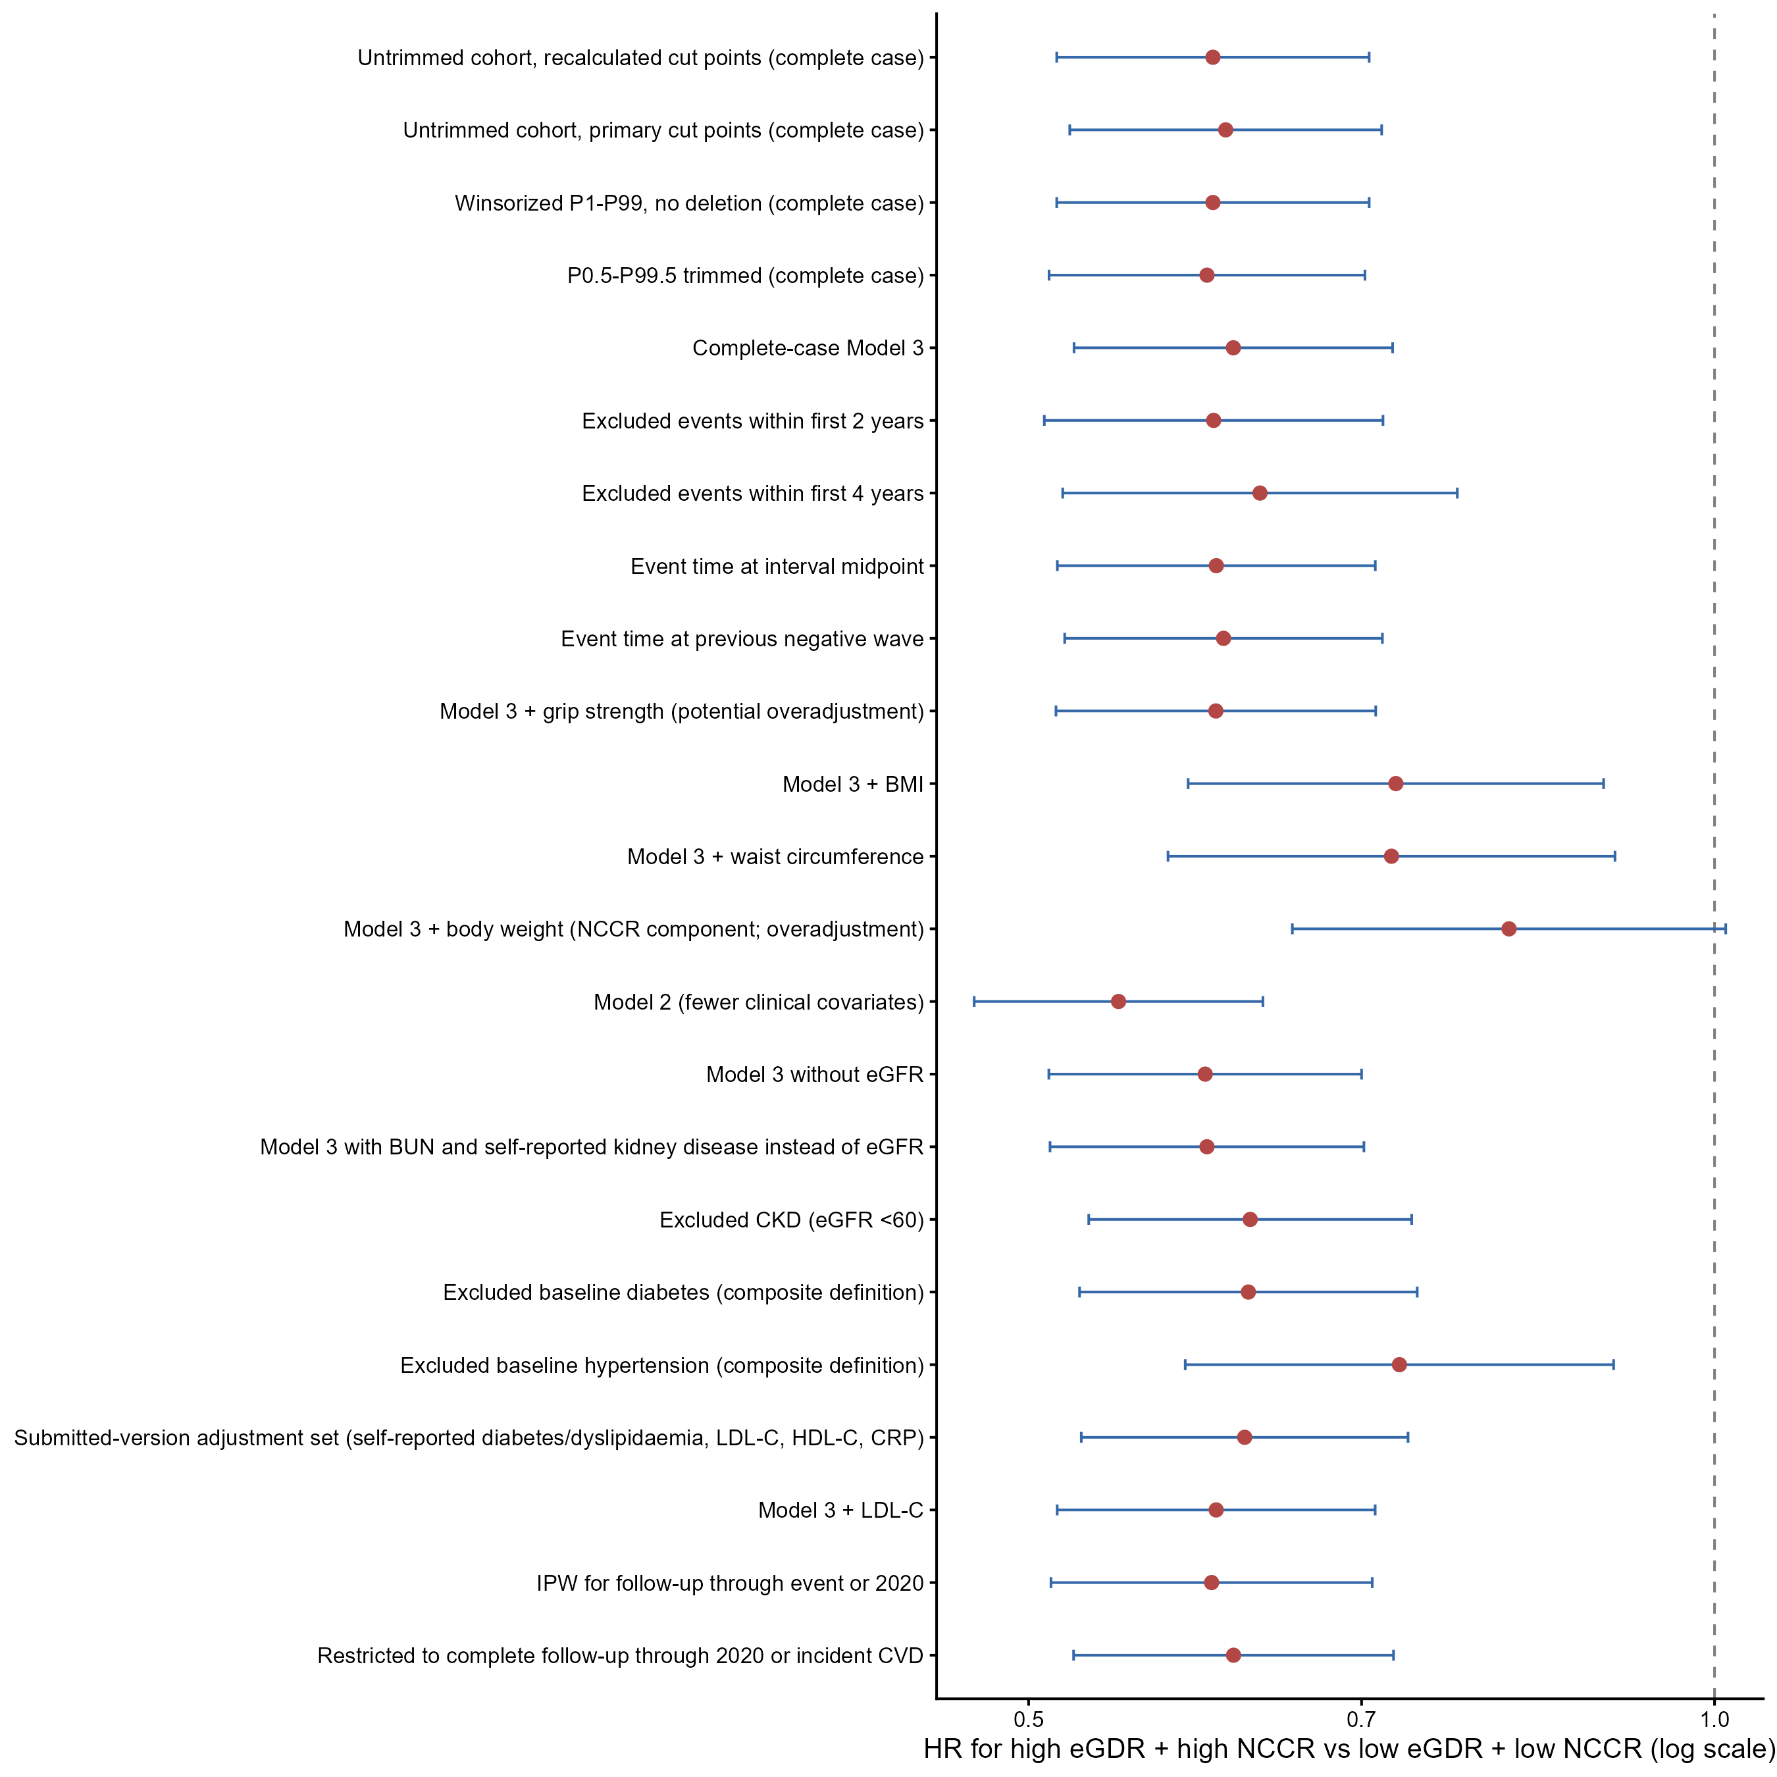
Supplementary Figure S2. Prespecified sensitivity analyses.
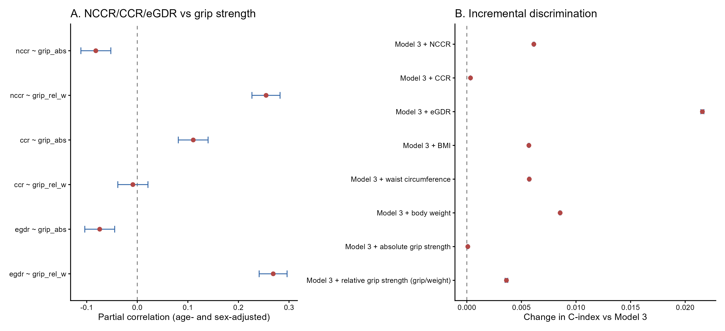
Supplementary Figure S3. Construct-validity analyses.
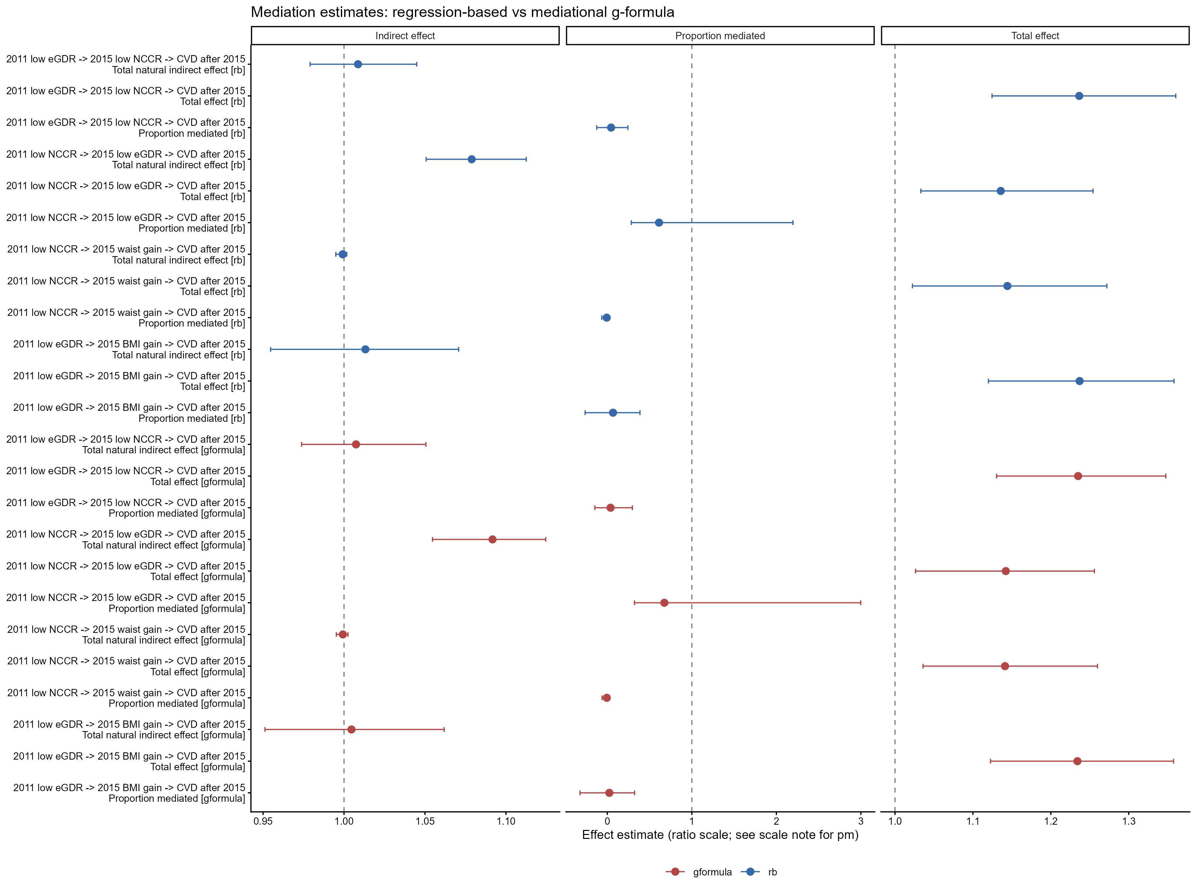
Supplementary Figure S4. Exploratory longitudinal mediation analyses.

