Triglyceride-Glucose Normalized Creatinine-to-Cystatin C Ratio (TyG-NCCR) predicts Cardiovascular-Kidney-Metabolic syndrome (CKM）stage progression: evidence from CHARLS and UK Biobank

Supplementary Files

Supplementary Table 1. Staging Criteria and Definitions for CKM Stages 0-3. 2
Supplementary Table 2. Comparison of baseline characteristics across CKM stages 0-3. 3
Supplementary Table 3. Predictive performance of TyG‑NCCR, TyG, and TG/HDL‑C for progression from CKM stages 0–3 to stage 4. 5
Supplementary Table 4. Sensitivity analysis of the association of TyG-NCCR with the endpoint event. 6
Supplementary Table 5. Baseline characteristics by progression to CKM stage 4 in the UK Biobank cohort. 7
Supplementary Table 6. Cox regression analysis of TyG-NCCR for the risk of progression to CKM stage 4 in the UK Biobank. 9
Supplementary Fig. 1. Proportion of missing data for each variable. 10
Supplementary Fig. 2. Time‑dependent ROC analysis of TyG‑NCCR, TyG, and TG/HDL‑C before and after covariate adjustment in the CHARLS cohort. 11
Supplementary Fig. 3. Joint association of TyG index tertiles and NCCR tertiles with the risk of progression to CKM stage 4. 12
Supplementary Fig. 4. RCS curves for TyG-NCCR, TyG, and TG/HDL-C in the UK Biobank validation cohort. 13
Supplementary Fig. 5. Time-dependent AUCs of TyG-NCCR, TyG, and TG/HDL-C at 5 and 8 years in the UK Biobank. 14

Supplementary Table 1. Staging Criteria and Definitions for CKM Stages 0-3.
CKM stages | CHARLS | UK Biobank
Stage 0 | BMI < 23 kg/m²  Waist circumference <80/90 cm (female/male)  Fasting blood glucose < 100 mg/dL  HbA1c < 5.7%  No diabetes diagnosis or medication  SBP <130 mmHg  DBP <80 mmHg  No hypertension diagnosis or medication  HDL-C ≥50/40 mg/dL (female/male)  TG < 150 mg/dL  eGFR ≥ 60 ml/min/1.73m²  No CKD diagnosis  No subclinical CVD  No clinical CVD | Normal BMI (<25 kg/m2 or ＜23 kg/m2 if Asian ethnicity )  Normal waist circumference (<88/102 cm in women/men)  Normoglycemia  Normotension  Normal lipid status  No evidence of CKD  No evidence of CVD
Stage 1 | Overweight/obesity  Abdominal obesity  Prediabetes | Elevated BMI (≥25 kg/m2 or ≥23 kg/m2 if Asian ethnicity);  Elevated waist circumference (≥88/102 cm in women/men or ≥80/90 cm in women/men if Asian ethnicity);  Prediabetes (fasting blood glucose between 100 mg/dL and 126 mg/dL or glycated hemoglobin between 5.7% and 6.4%).
Stage 2 | Clinical (any one):  Hypertriglyceridemia  Hypertension  Diabetes  Metabolic syndrome  eGFR 30-60 ml/min/1.73m² and/or CKD diagnosis  Other (all required):  No subclinical CVD  No clinical CVD | Elevated fasting serum triglycerides (≥135 mg/dL);  Hypertension (blood pressure ≥140/90 mmHg, self-reported history of hypertension, or current antihypertensive treatment);  Diabetes (fasting blood glucose ≥126 mg/dL, glycated hemoglobin ≥ 6.5%, self-reported history of diabetes, or current hypoglycemic treatment);  Metabolic syndrome (≥3 of the following: elevated waist circumference,  high density lipoprotein cholesterol <40 mg/dL for men and <50 mg/dL for women,  fasting serum triglycerides ≥ 150 mg/dL, blood pressure ≥ 130/80 mmHg and/or current antihypertensive treatment, fasting blood glucose ≥100 mg/dL);  Moderate-to-high-risk CKD¹.
Stage 3 | Advanced (any one):  eGFR <30 ml/min/1.73m²  Subclinical CVD²  Metabolic/clinical (any one):  Overweight/obesity  Abdominal obesity  Prediabetes  Hypertriglyceridemia  Hypertension  Diabetes  Metabolic syndrome  eGFR 30-60 ml/min/1.73m² and/or CKD diagnosis  Other (required):  No clinical CVD | Very-high-risk CKD¹;  High predicted 10-year CVD risk².

Abbreviations: BMI, Body Mass Index; CKM: Cardio-Kidney-Metabolic Syndrome; CKD: chronic kidney disease; CVD: cardiovascular diseases; SBP: systolic blood pressure; DBP: diastolic blood pressure; HDL-C: high-density lipoprotein cholesterol; LDL-C: low-density lipoprotein cholesterol; eGFR: estimated glomerular filtration rate; TG: triglyceride; BMI: body mass index; HbA1c: glycated hemoglobin.
¹CKD stages were identified based on GFR and urinary albumin-to creatinine ratio.

²The 10-year CVD risk was calculated using the Framingham risk calculation based on the Framingham risk score.

Supplementary Table 2. Comparison of baseline characteristics across CKM stages 0-3.

Variables | Overall (N=5474) | Stage 0  (n=743) | Stage 1  (n=937) | Stage 2  (n=3576) | Stage 3  (n=218) | P value
Age, mean (SD) | 60.06 (9.91) | 58.82 (9.39) | 56.41 (8.40) | 60.59 (9.90) | 71.27 (7.96) | <0.001
Sex, n (%) |  |  |  |  |  | <0.001
Female | 2859 (52.2) | 311 (41.9) | 571 (60.9) | 1910 (53.4) | 67 (30.7)
Male | 2615 (47.8) | 432 (58.1) | 366 (39.1) | 1666 (46.6) | 151 (69.3)
Place, n (%) |  |  |  |  |  | 0.023
Agricultual | 4670 (85.3) | 660 (88.8) | 802 (85.6) | 3027 (84.6) | 181 (83.0)
Non-Agricultural | 804 (14.7) | 83 (11.2) | 135 (14.4) | 549 (15.4) | 37 (17.0)
Education, n (%) |  |  |  |  |  | 0.044
Below high school | 4966 (90.7) | 670 (90.2) | 835 (89.1) | 3254 (91.0) | 207 (95.0)
High school or above | 508 (9.3) | 73 (9.8) | 102 (10.9) | 322 (9.0) | 11 (5.0)
Marriage, n (%) |  |  |  |  |  | <0.001
No | 746 (13.6) | 75 (10.1) | 88 (9.4) | 535 (15.0) | 48 (22.0)
Yes | 4728 (86.4) | 668 (89.9) | 849 (90.6) | 3041 (85.0) | 170 (78.0)
Smoking, n (%) |  |  |  |  |  | <0.001
No | 3310 (60.5) | 393 (52.9) | 632 (67.4) | 2229 (62.3) | 56 (25.7)
Yes | 2164 (39.5) | 350 (47.1) | 305 (32.6) | 1347 (37.7) | 162 (74.3)
Drinking, n (%) |  |  |  |  |  | 0.001
No | 4033 (73.7) | 510 (68.6) | 728 (77.7) | 2633 (73.6) | 162 (74.3)
Yes | 1441 (26.3) | 233 (31.4) | 209 (22.3) | 943 (26.4) | 56 (25.7)
Hypertension, n (%) |  |  |  |  |  | <0.001
No | 3411 (62.3) | 743 (100.0) | 937 (100.0) | 1708 (47.8) | 23 (10.6)
Yes | 2063 (37.7) | 0 (0.0) | 0 (0.0) | 1868 (52.2) | 195 (89.4)
Diabetes, n (%) |  |  |  |  |  | <0.001
No | 4587 (83.8) | 743 (100.0) | 937 (100.0) | 2833 (79.2) | 74 (33.9)
Yes | 887 (16.2) | 0 (0.0) | 0 (0.0) | 743 (20.8) | 144 (66.1)
Cholesterol, mean (SD) | 193.72 (38.85) | 184.69 (31.99) | 185.06 (36.83) | 196.71 (38.95) | 212.65 (51.22) | <0.001
Triglycerides, median (IQR) | 104.43 [74.34, 152.22] | 77.00 [60.18, 98.24] | 89.39 [69.03, 113.28] | 120.36 [81.20, 177.88] | 143.81 [102.00, 212.84] | <0.001
HbA1c, median (IQR) | 5.10 [4.90, 5.40] | 5.00 [4.80, 5.30] | 5.10 [4.80, 5.40] | 5.20 [4.90, 5.50] | 5.40 [5.10, 5.90] | <0.001
TyG, mean (SD) | 8.67 (0.66) | 8.18 (0.36) | 8.37 (0.37) | 8.81 (0.67) | 9.29 (0.86) | <0.001
NCCR, median (IQR) | 0.14 [0.12, 0.16] | 0.15 [0.13, 0.18] | 0.13 [0.11, 0.15] | 0.13 [0.11, 0.16] | 0.13 [0.11, 0.16] | <0.001
TyG-NCCR, mean (SD) | 10.67 (0.71) | 10.07 (0.42) | 10.39 (0.44) | 10.82 (0.70) | 11.32 (0.95) | <0.001
TG/HDL-C ratio, median (IQR) | 2.06 [1.30, 3.48] | 1.31 [0.96, 1.77] | 1.76 [1.23, 2.51] | 2.46 [1.47, 4.28] | 3.56 [2.21, 6.40] | <0.001

Abbreviations: CKM, Cardiovascular-Kidney-Metabolic Syndrome; HbA1c, glycated hemoglobin; HDL-C, High-Density Lipoprotein Cholesterol; IQR, interquartile range; SD, standard deviation; TG, triglycerides; TyG, triglyceride-glucose; NCCR, Normalized Creatinine-to-Cystatin C Ratio.

Supplementary Table 3. Predictive performance of TyG‑NCCR, TyG, and TG/HDL‑C for progression from CKM stages 0–3 to stage 4.
Characteristic | IDI (95%CI) | P value | NRI (95%CI) | P value
Clinical model | - |  | -
Clinical model + TyG | 0.003 (0.001, 0.007) | <0.001 | 0.159 (0.085, 0.227) | <0.001
Clinical model + NCCR | 0.002 (0.000, 0.005) | 0.024 | 0.101 (0.026, 0.162) | 0.004
Clinical model + TyG-NCCR | 0.005 (0.002, 0.009) | <0.001 | 0.172 (0.096, 0.244) | <0.001
Clinical model + TG/HDL-C | 0.000 (0.000, 0.001) | 0.524 | 0.055 (-0.065, 0.126) | 0.456

Abbreviation: CI, confidence interval; CKM, Cardiovascular-Kidney-Metabolic Syndrome; HDL-C, High-Density Lipoprotein Cholesterol; IDI, integrated discrimination improvement; NRI, net reclassification improvement; TG, triglycerides; TyG, triglyceride-glucose; NCCR, Normalized Creatinine-to-Cystatin C Ratio.

Supplementary Table 4. Sensitivity analysis of the association of TyG-NCCR with the endpoint event.

Characteristic | Sensitivity# |  | Sensitivity## |  | Sensitivity### |  | Sensitivity#### |  | Sensitivity#####
Characteristic | HR (95% CI) | P value | HR (95% CI) | P value | HR (95% CI) | P value | HR (95% CI) | P value | HR (95% CI) | P value
TyG-NCCR
Q1 | 1.0 (Ref) |  | 1.0 (Ref) |  | 1.0 (Ref) |  | 1.0 (Ref) |  | 1.0 (Ref)
Q2 | 1.44 (1.18, 1.76) |  | 2.73 (0.72, 10.3) |  | 1.50 (1.21, 1.86) |  | 1.50 (1.21, 1.86) |  | 1.37 (1.10, 1.70)
Q3 | 1.61 (1.32, 1.96) |  | 3.36 (0.92, 12.3) |  | 1.67 (1.35, 2.06) |  | 1.66 (1.34, 2.05) |  | 1.44 (1.16, 1.79)
Q4 | 1.66 (1.35, 2.04) |  | 4.89 (1.35, 17.7) |  | 1.70 (1.36, 2.11) |  | 1.71 (1.37, 2.12) |  | 1.51 (1.21, 1.89)
P for trend |  | <0.001 |  | 0.011 |  | <0.001 |  | <0.001 |  | <0.001
TyG-NCCR (per SD) | 1.19 (1.12, 1.26) | 0.002 | 1.64 (1.20, 2.25) | 0.002 | 1.19 (1.11, 1.28) | <0.001 | 1.20 (1.12, 1.29) | <0.001 | 1.16 (1.08, 1.25) | <0.001
Abbreviation: CI, confidence interval; CKM, Cardiovascular-Kidney-Metabolic Syndrome; HR, hazard ratio; SD, standard deviation; TyG, triglyceride-glucose; NCCR, Normalized Creatinine-to-Cystatin C Ratio.
#Competing risk analysis.
##Lag-time analysis after excluding individuals who progressed to CKM stage 4 within 1 year of follow-up.
###Based on Model 3, further adjustment was made for history of glucose-lowering and lipid-lowering medication use.
####Complete-case sensitivity analysis.
#####Further adjustment for baseline CKM stages based on the fully adjusted model.

Supplementary Table 5. Baseline characteristics by progression to CKM stage 4 in the UK Biobank cohort.

Variables | Overall (N=315391) | CKM Stage 0-3 (n=259792) | CKM Stage 4 (n=55599) | P value
Age, mean (SD) | 57.78 (6.83) | 57.15 (6.79) | 60.74 (6.23) | <0.001
Sex, n (%) |  |  |  | <0.001
Female | 178049 (56.5) | 152904 (58.9) | 25145 (45.2)
Male | 137342 (43.5) | 106888 (41.1) | 30454 (54.8)
Ethnic background, n (%) |  |  |  | <0.001
White | 299301 (95.0) | 246262 (94.9) | 53039 (95.5)
Others | 14678 (4.7) | 12434 (4.8) | 2244 (4.0)
Prefer not to answer | 1008 (0.3) | 783 (0.3) | 225 (0.4)
Do not know | 116 (0.0) | 94 (0.0) | 22 (0.0)
Education, n (%) |  |  |  | <0.001
University degree or above | 101545 (32.2) | 86908 (33.5) | 14637 (26.4)
Other | 210288 (66.7) | 170151 (65.5) | 40137 (72.3)
Prefer not to answer | 3272 (1.0) | 2516 (1.0) | 756 (1.4)
Household income, n (%) |  |  |  | <0.001
High | 68131 (21.7) | 60132 (23.2) | 7999 (14.5)
Low | 59828 (19.0) | 45372 (17.5) | 14456 (26.2)
Medium | 140643 (44.7) | 116914 (45.1) | 23729 (42.9)
Do not know | 13409 (4.3) | 10579 (4.1) | 2830 (5.1)
Prefer not to answer | 32358 (10.3) | 26102 (10.1) | 6256 (11.3)
Smoking status, n (%) |  |  |  | <0.001
Current | 30667 (9.7) | 23362 (9.0) | 7305 (13.2)
Never | 173848 (55.2) | 147741 (56.9) | 26107 (47.0)
Previous | 109375 (34.7) | 87560 (33.7) | 21815 (39.3)
Prefer not to answer | 1214 (0.4) | 911 (0.4) | 303 (0.5)
Drinking status, n (%) |  |  |  | <0.001
Current | 291140 (92.4) | 240711 (92.7) | 50429 (90.8)
Never | 13088 (4.2) | 10551 (4.1) | 2537 (4.6)
Previous | 10485 (3.3) | 8011 (3.1) | 2474 (4.5)
Prefer not to answer | 390 (0.1) | 300 (0.1) | 90 (0.2)
Hypertension, n (%) |  |  |  | <0.001
No | 138166 (43.8) | 121769 (46.9) | 16397 (29.5)
Yes | 177225 (56.2) | 138023 (53.1) | 39202 (70.5)
Diabetes, n (%) |  |  |  | <0.001
No | 297665 (94.4) | 247454 (95.3) | 50211 (90.3)
Yes | 17726 (5.6) | 12338 (4.7) | 5388 (9.7)
Cholesterol, mean (SD) | 5.82 (1.11) | 5.84 (1.10) | 5.74 (1.17) | <0.001
Triglycerides, median (IQR) | 1.50 [1.06, 2.15] | 1.47 [1.04, 2.11] | 1.64 [1.16, 2.34] | <0.001
Glucose, median(IQR) | 4.94 [4.61, 5.32] | 4.93 [4.61, 5.30] | 4.99 [4.65, 5.42] | <0.001
HbA1c, median (IQR) | 35.30 [33.00, 37.90] | 35.20 [32.80, 37.60] | 36.10 [33.50, 39.00] | <0.001
TyG-NCCR, mean (SD) | 3.50 (0.68) | 3.46 (0.67) | 3.67 (0.68) | <0.001
TyG, mean (SD) | 1.35 (0.56) | 1.33 (0.55) | 1.45 (0.56) | <0.001
NCCR, mean (SD) | 0.12 (0.03) | 0.12 (0.03) | 0.11 (0.03) | <0.001
TG/HDL ratio, median(IQR) | 1.05 [0.66, 1.70] | 1.02 [0.64, 1.65] | 1.22 [0.76, 1.95] | <0.001
Abbreviations: CKM, Cardiovascular-Kidney-Metabolic Syndrome; HbA1c, glycated hemoglobin; HDL-C, High-Density Lipoprotein Cholesterol; IQR, interquartile range; SD, standard deviation; TG, triglycerides; TyG, triglyceride-glucose; NCCR, Normalized Creatinine-to-Cystatin C Ratio.

Supplementary Table 6. Cox regression analysis of TyG-NCCR for the risk of progression to CKM stage 4 in the UK Biobank.
Characteristic | Model 1# |  | Model 2## |  |  | Model 3###
Characteristic | HR (95%CI) | P value | HR (95%CI) | P value |  | HR (95%CI) |  | P value
TyG-NCCR
Q1 | - |  | - |  |  | -
Q2 | 1.40 (1.36, 1.44) | <0.001 | 1.16 (1.13, 1.20) | <0.001 |  | 1.10 (1.07, 1.13) |  | <0.001
Q3 | 1.70 (1.66, 1.75) | <0.001 | 1.33 (1.30, 1.37) | <0.001 |  | 1.21 (1.18, 1.24) |  | <0.001
Q4 | 2.14 (2.09, 2.19) | <0.001 | 1.66 (1.62, 1.70) | <0.001 |  | 1.37 (1.33, 1.41) |  | <0.001
P for trend |  | <0.001 |  | <0.001 |  |  |  | <0.001
TyG-NCCR std | 1.33 (1.32, 1.34) | <0.001 | 1.23 (1.22, 1.25) | <0.001 |  | 1.14 (1.13, 1.15) |  | <0.001
Abbreviation: CI, confidence interval; HR, hazard ratio; SD, standard deviation; TyG, triglyceride-glucose; NCCR, Normalized Creatinine-to-Cystatin C Ratio.
#Model 1: unadjusted. ##Model 2: adjusted for sex, age. ###Model 3: adjusted for age, sex, ethnic background, education, income, smoking, drinking, hypertension, diabetes.

Supplementary Fig. 1. Proportion of missing data for each variable.
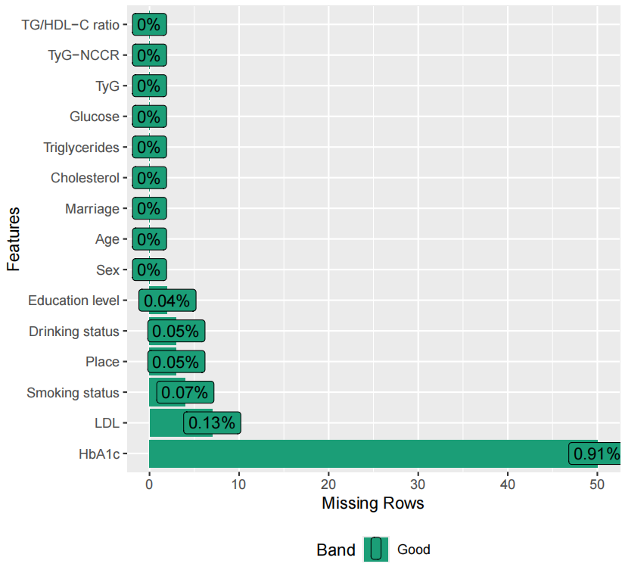
Abbreviation: HbA1c, glycated hemoglobin; HDL-C, high-density lipoprotein cholesterol; LDL, low-density lipoprotein; TG, triglycerides; TyG, triglyceride-glucose; NCCR, normalized creatinine-to-Cystatin C ratio.

Supplementary Fig. 2. Time‑dependent ROC analysis of TyG‑NCCR, TyG, and TG/HDL‑C before and after covariate adjustment in the CHARLS cohort.
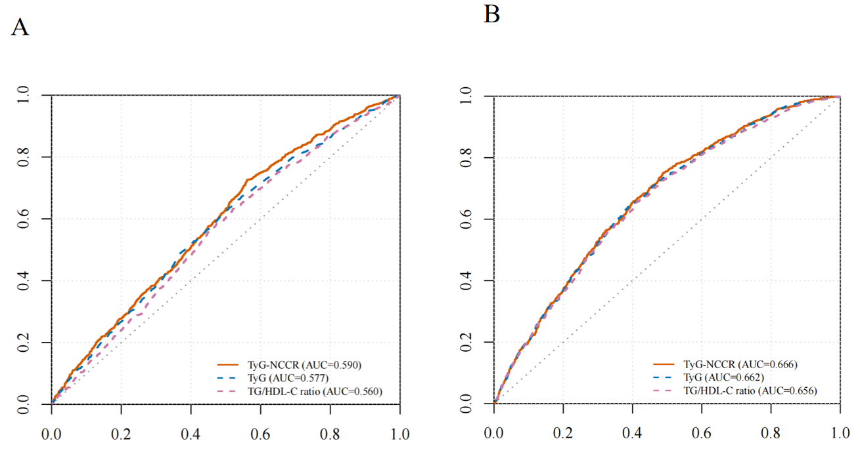
(A) Unadjusted; (B) Adjusted. Abbreviation: AUC, area under the curve; HDL-C, high-density lipoprotein cholesterol; TG, triglycerides; TyG, triglyceride-glucose; NCCR, normalized creatinine-to-Cystatin C ratio.

Supplementary Fig. 3. Joint association of TyG index tertiles and NCCR tertiles with the risk of progression to CKM stage 4.
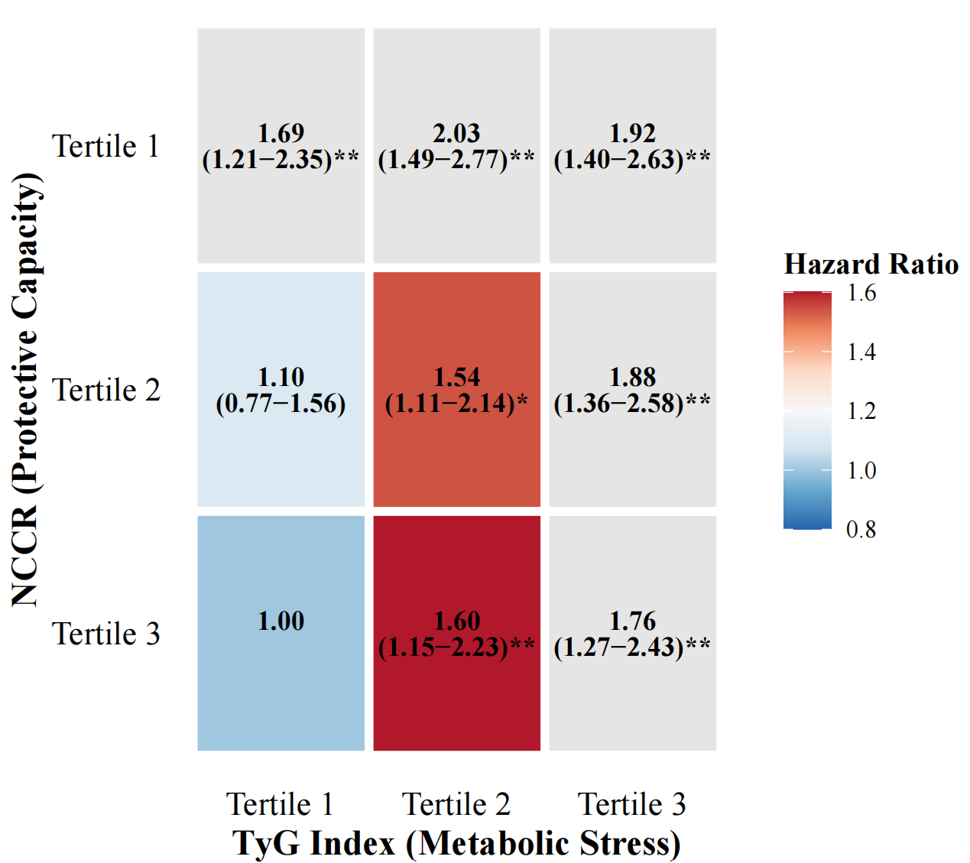
Abbreviation: TyG, triglyceride-glucose; NCCR, normalized creatinine-to-Cystatin C ratio.
*P < 0.05, **P < 0.01.

Supplementary Fig. 4. RCS curves for TyG-NCCR, TyG, and TG/HDL-C in the UK Biobank validation cohort.
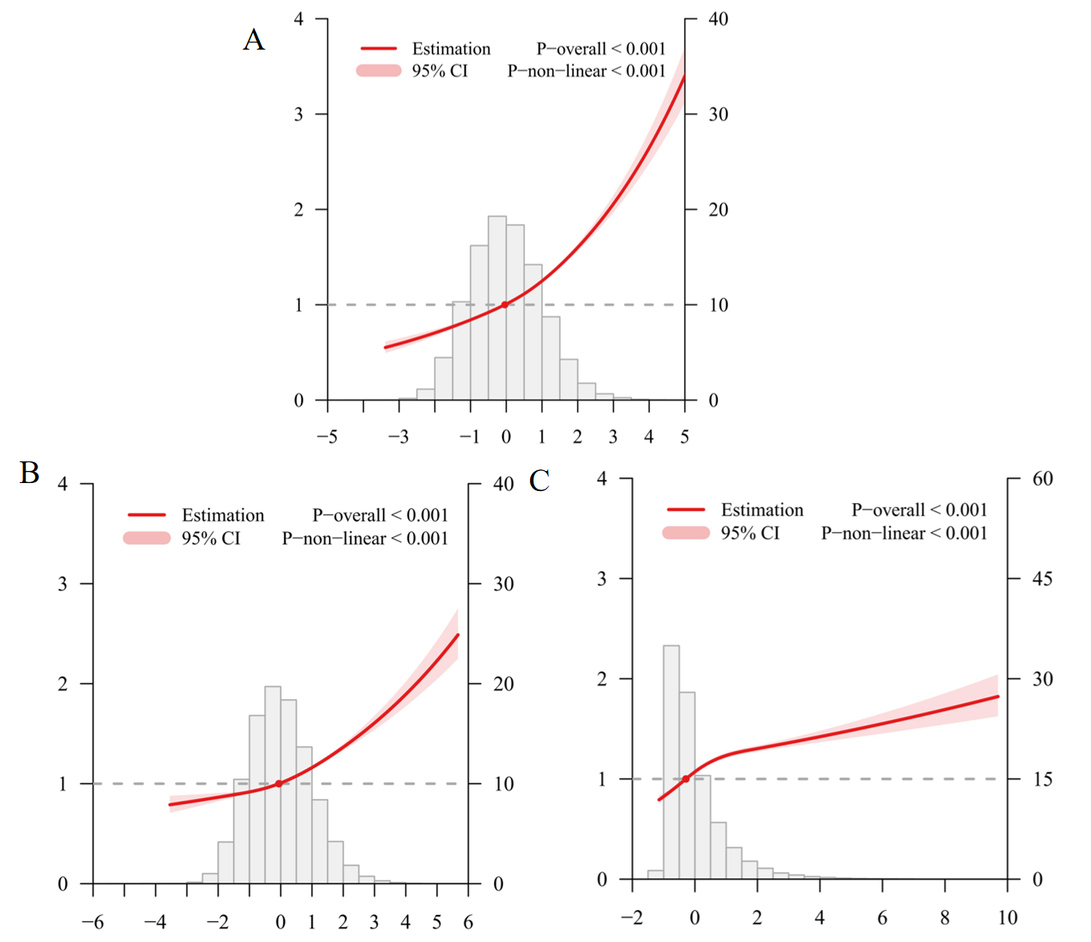
- TyG-NCCR. (B) TyG. (C) TG/HDL-C. Abbreviation: CI, confidence interval.

Supplementary Fig. 5. Time-dependent AUCs of TyG-NCCR, TyG, and TG/HDL-C at 5 and 8 years in the UK Biobank.
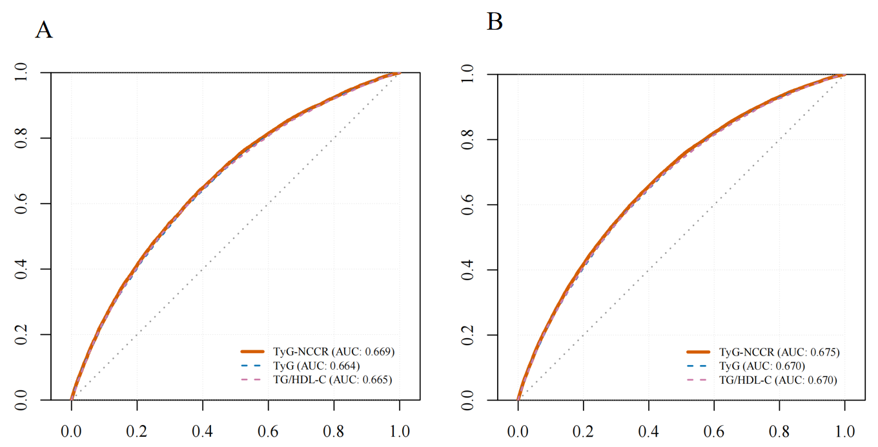
(A) Time-dependent ROC curves at 5 years. (B) Time-dependent ROC curves at 8 years. Abbreviation: AUC, area under the curve; HDL-C, high-density lipoprotein cholesterol; TG, triglycerides; TyG, triglyceride-glucose; NCCR, normalized creatinine-to-Cystatin C ratio.

