Figure legends
Figure S1. Flowchart of participant selection.
Figure S2. MR estimates of the associations between genetically predicted BMI and CKM-related conditions.
Figure S3. Funnel plots of the MR analyses of BMI and CKM-related conditions.
Figure S4. Scatter plots of the MR analyses of BMI and CKM-related conditions.
Figure S5. Leave-one-out analysis of the association between genetically predicted BMI and AF/AFL.
Figure S6. Leave-one-out analysis of the association between genetically predicted BMI and CKD.
Figure S7. Leave-one-out analysis of the association between genetically predicted BMI and DM.
Figure S8. Leave-one-out analysis of the association between genetically predicted BMI and IHD.
Figure S9. Leave-one-out analysis of the association between genetically predicted BMI and PAD.
Figure S10. Leave-one-out analysis of the association between genetically predicted BMI and ischemic stroke.
Figure S11. Global distribution of the age-standardized percentage of deaths attributable to high BMI in 1990.
Figure S12. Global distribution of the age-standardized percentage of deaths attributable to high BMI in 2021.
Figure S13. GWAS and gene-set enrichment analyses of CKM phenotypes.

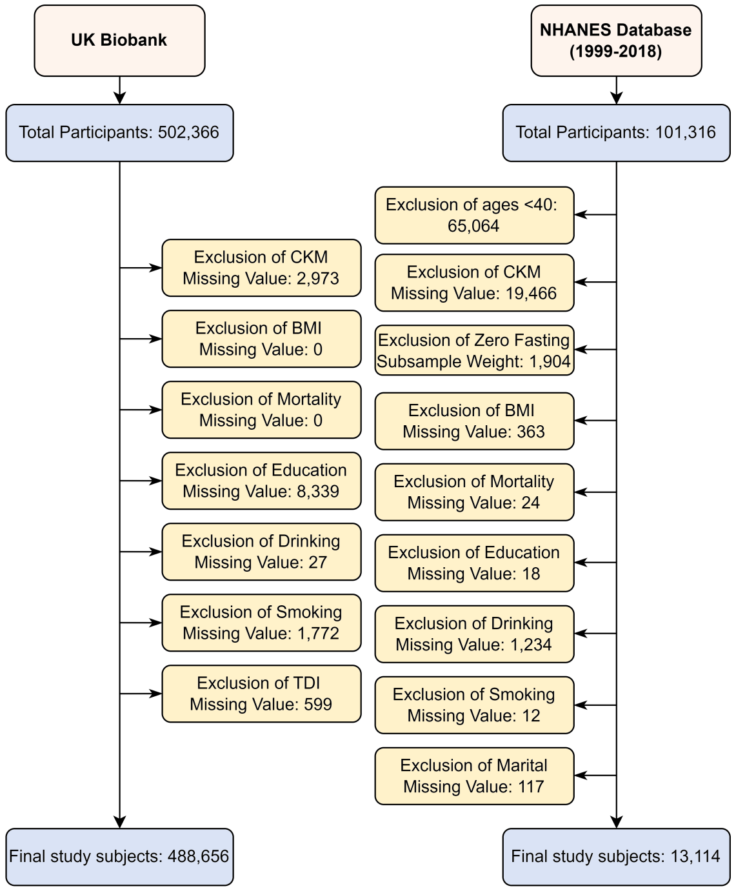
Figure S1. Flowchart of participant selection. Abbreviations: BMI, body mass index; CKM, cardiovascular-kidney-metabolic; NHANES, National Health and Nutrition Examination Survey; TDI, Townsend deprivation index.

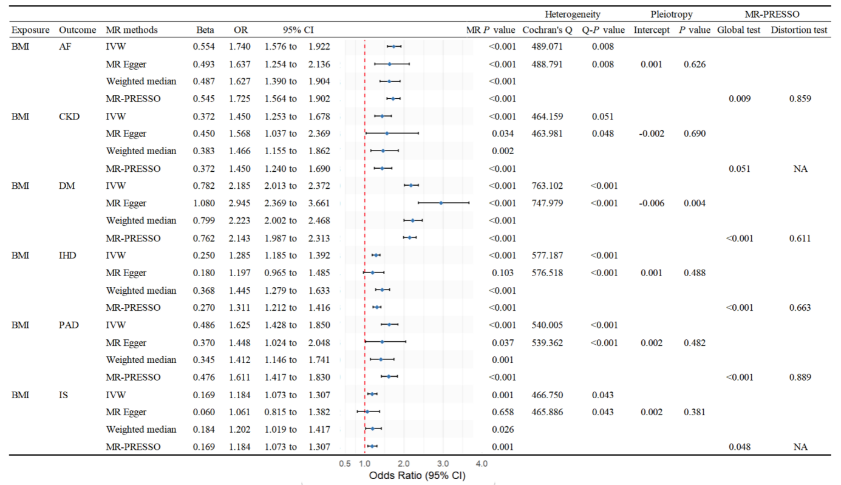
Figure S2. MR estimates of the associations between genetically predicted BMI and CKM-related conditions. Abbreviations: AF, atrial fibrillation and flutter; BMI, body mass index; CI, confidence interval; CKD, chronic kidney disease; DM, diabetes mellitus; IHD, ischemic heart disease; IS, ischemic stroke; IVW, inverse-variance weighted; MR, Mendelian randomization; MR-PRESSO, Mendelian Randomization Pleiotropy RESidual Sum and Outlier; NA, not applicable; OR, odds ratio; PAD, peripheral arterial disease.

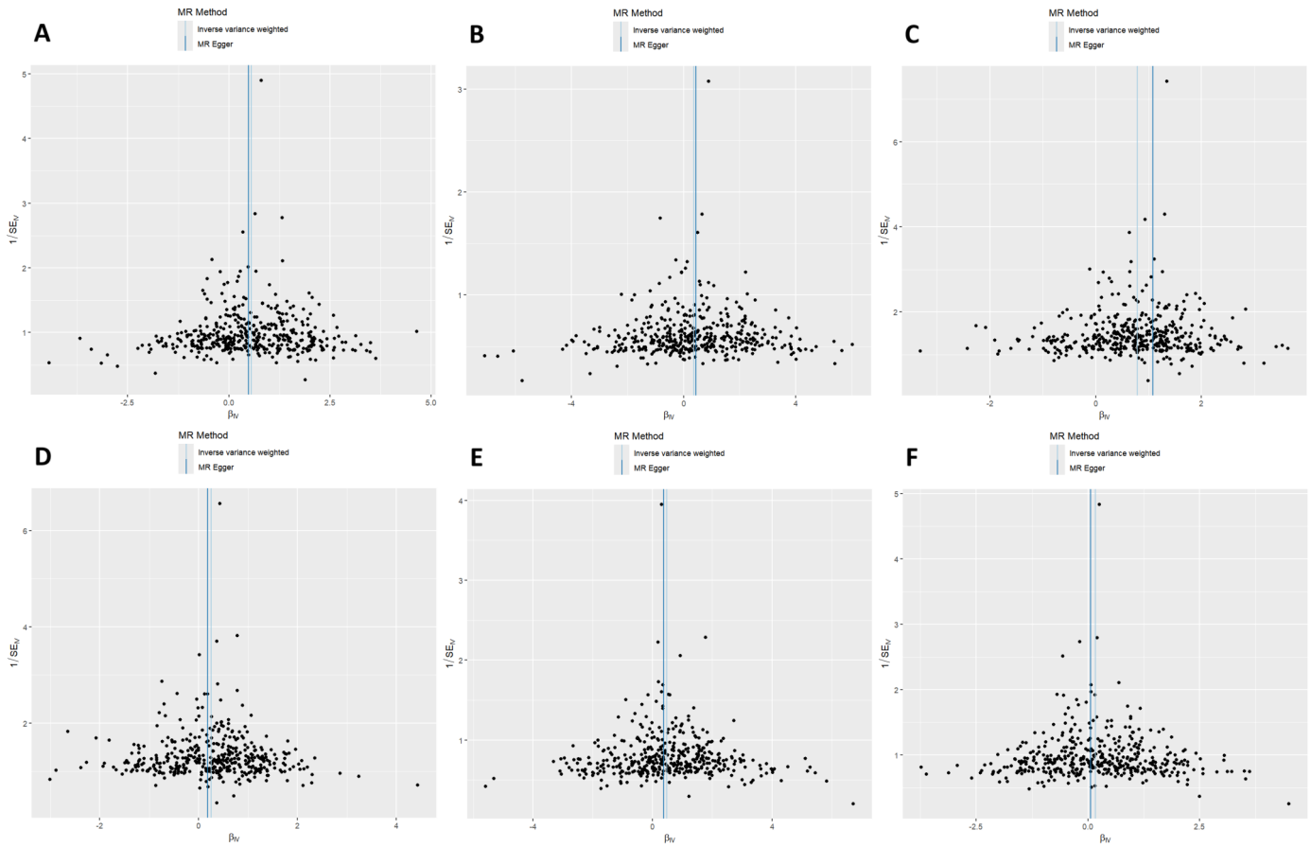
Figure S3. Funnel plots of the MR analyses of BMI and CKM-related conditions. (A) atrial fibrillation and flutter, (B) chronic kidney disease, (C) diabetes mellitus, (D) ischemic heart disease, (E) peripheral arterial disease, and (F) ischemic stroke. Abbreviations: BMI, body mass index; CKM, cardiovascular-kidney-metabolic; IVW, inverse-variance weighted; MR, Mendelian randomization; SE, standard error; SNP, single-nucleotide polymorphism.
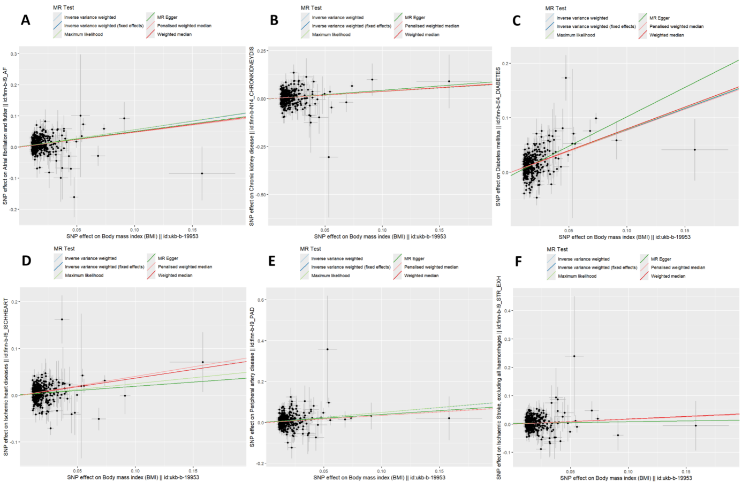
Figure S4. Scatter plots of the MR analyses of BMI and CKM-related conditions. (A) atrial fibrillation and flutter, (B) chronic kidney disease, (C) diabetes mellitus, (D) ischemic heart disease, (E) peripheral arterial disease, and (F) ischemic stroke. Abbreviations: BMI, body mass index; CKM, cardiovascular-kidney-metabolic; MR, Mendelian randomization; SNP, single-nucleotide polymorphism.
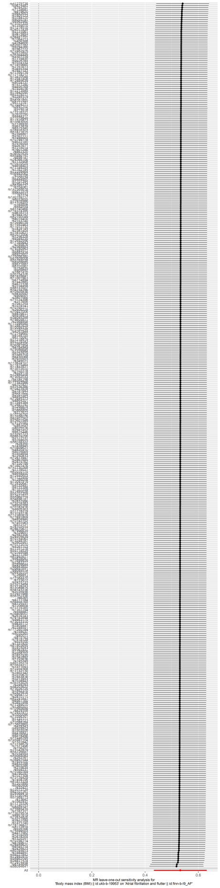
Figure S5. Leave-one-out analysis of the association between genetically predicted BMI and AF/AFL. Abbreviations: AF/AFL, atrial fibrillation and flutter; BMI, body mass index; CI, confidence interval; IVW, inverse-variance weighted; SNP, single-nucleotide polymorphism.
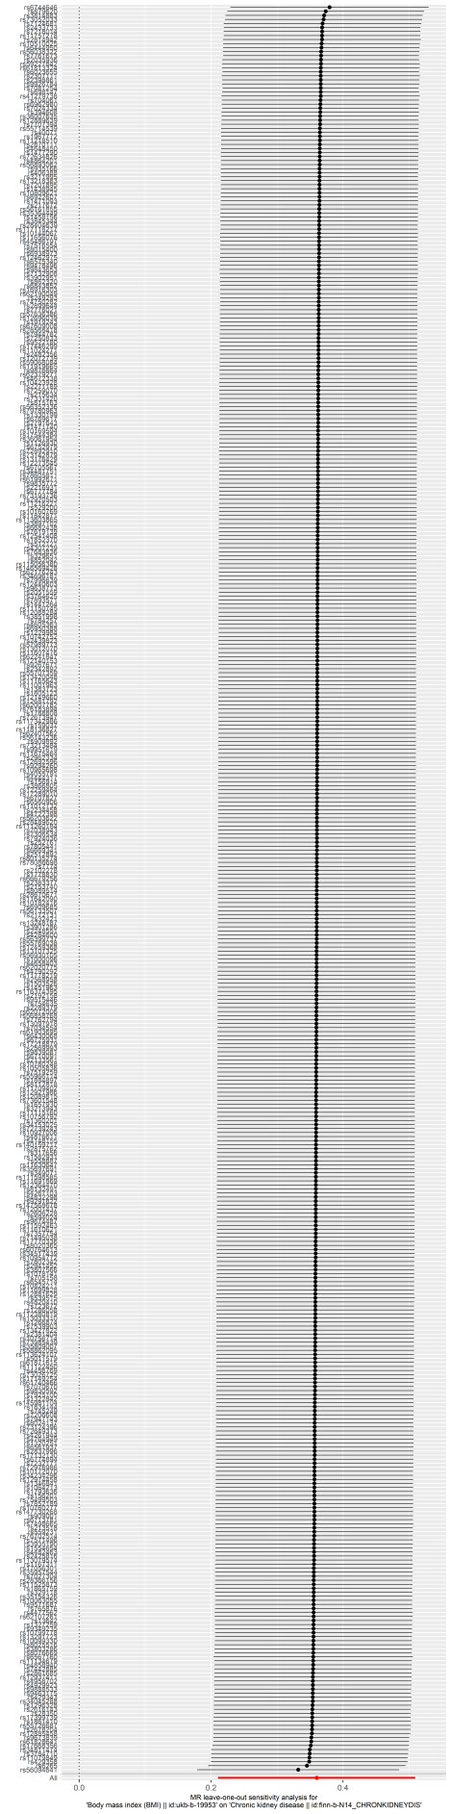
Figure S6. Leave-one-out analysis of the association between genetically predicted BMI and CKD. Abbreviations: BMI, body mass index; CI, confidence interval; CKD, chronic kidney disease; IVW, inverse-variance weighted; SNP, single-nucleotide polymorphism.
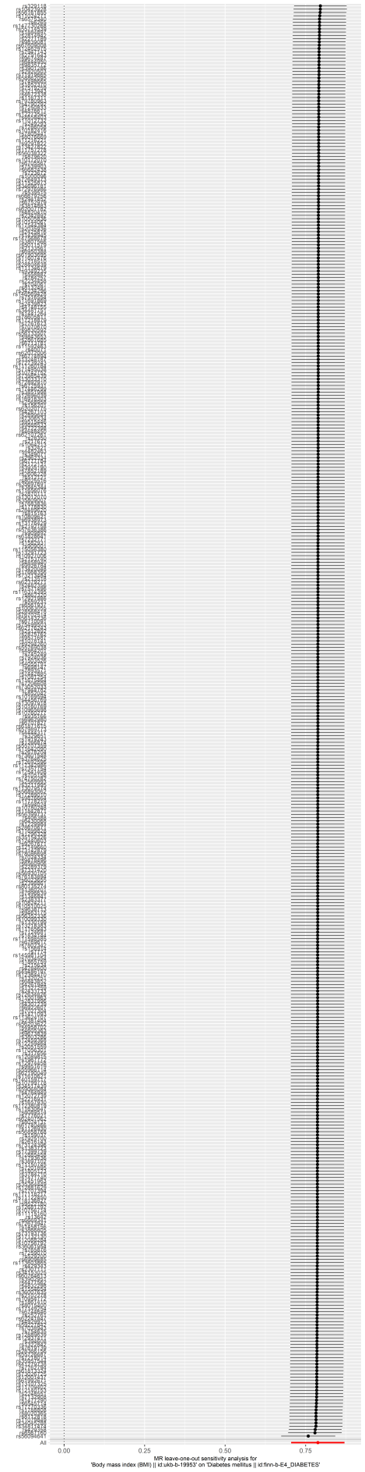
Figure S7. Leave-one-out analysis of the association between genetically predicted BMI and DM. Abbreviations: BMI, body mass index; CI, confidence interval; DM, diabetes mellitus; IVW, inverse-variance weighted; SNP, single-nucleotide polymorphism.
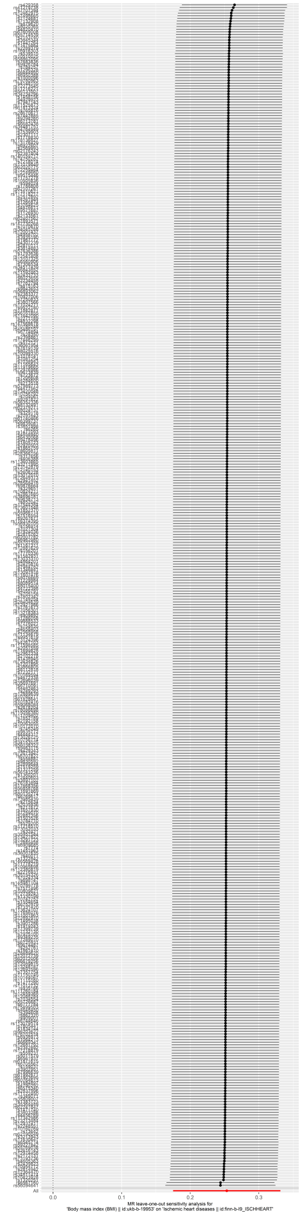
Figure S8. Leave-one-out analysis of the association between genetically predicted BMI and IHD. Abbreviations: BMI, body mass index; CI, confidence interval; IHD, ischemic heart disease; IVW, inverse-variance weighted; SNP, single-nucleotide polymorphism.
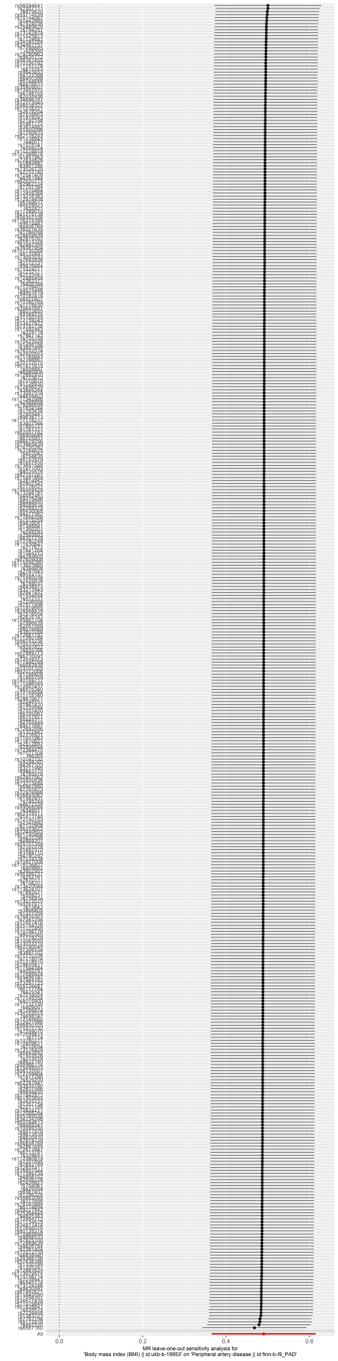
Figure S9. Leave-one-out analysis of the association between genetically predicted BMI and PAD. Abbreviations: BMI, body mass index; CI, confidence interval; IVW, inverse-variance weighted; PAD, peripheral arterial disease; SNP, single-nucleotide polymorphism.
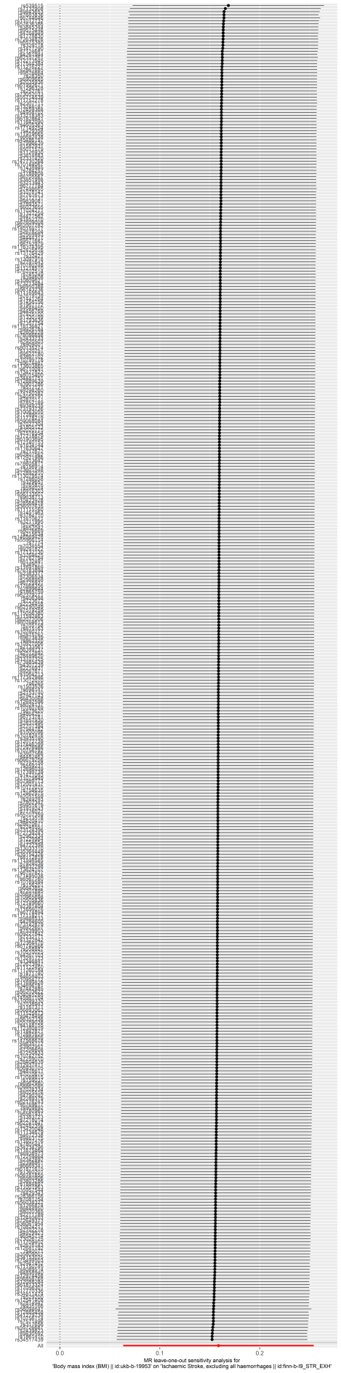
Figure S10. Leave-one-out analysis of the association between genetically predicted BMI and ischemic stroke. Abbreviations: BMI, body mass index; CI, confidence interval; IVW, inverse-variance weighted; SNP, single-nucleotide polymorphism.

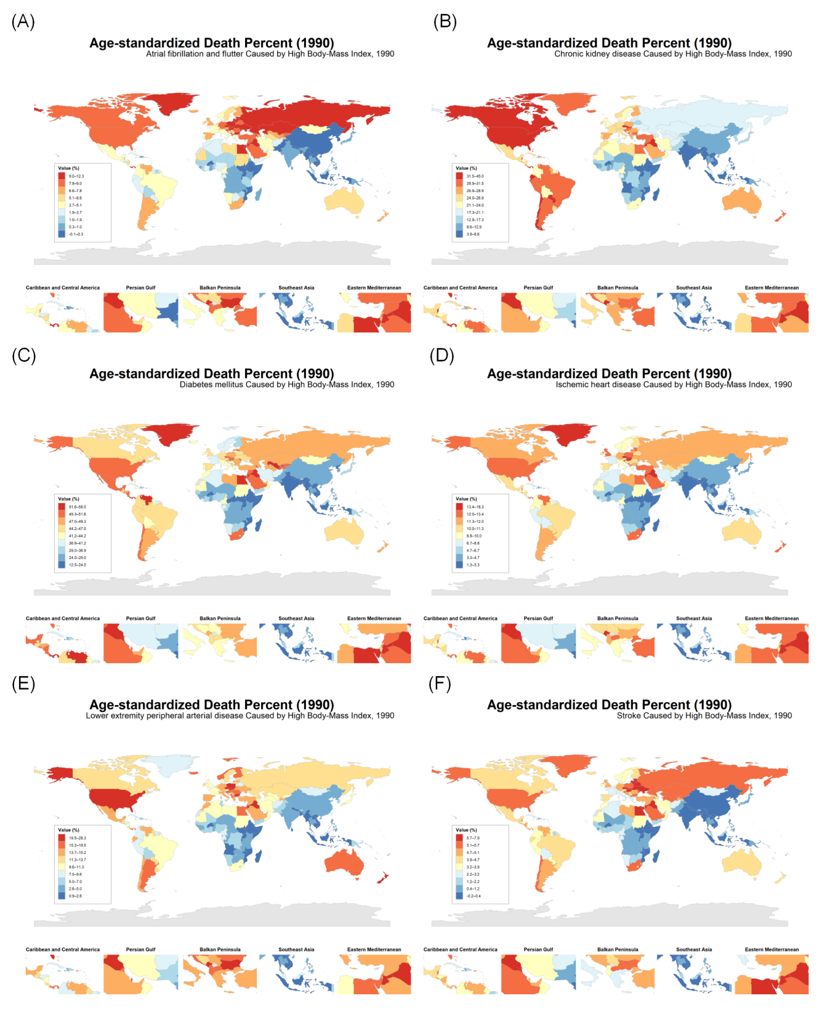
Figure S11. Global distribution of the age-standardized percentage of deaths attributable to high BMI in 1990. Maps show the corresponding percentages for (A) atrial fibrillation and flutter, (B) chronic kidney disease, (C) diabetes mellitus, (D) ischemic heart disease, (E) lower extremity peripheral arterial disease, and (F) stroke. Abbreviation: BMI, body mass index.

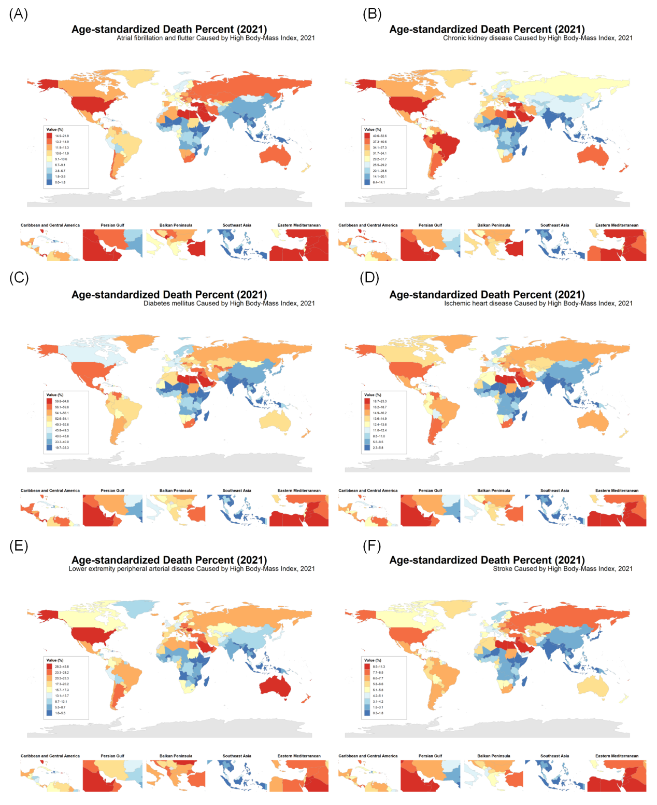
Figure S12. Global distribution of the age-standardized percentage of deaths attributable to high BMI in 2021. Maps show the corresponding percentages for (A) atrial fibrillation and flutter, (B) chronic kidney disease, (C) diabetes mellitus, (D) ischemic heart disease, (E) lower-extremity peripheral arterial disease, and (F) stroke. Abbreviation: BMI, body mass index.

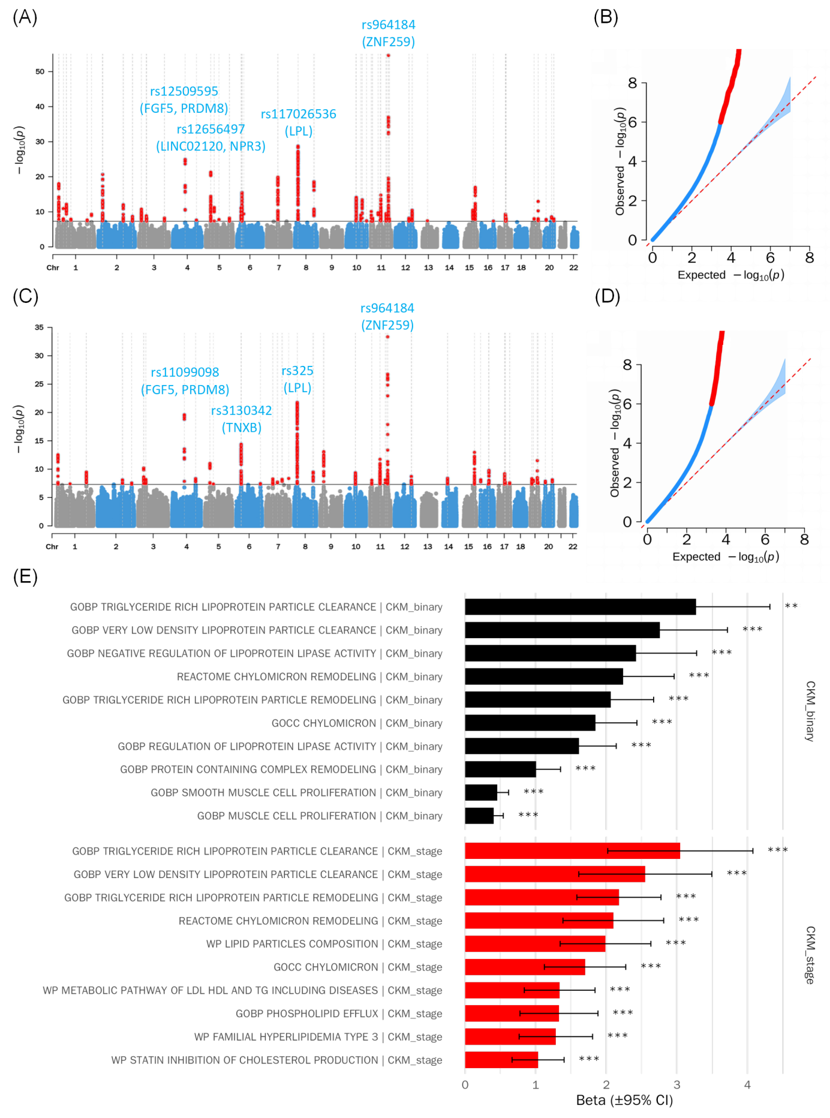
Figure S13. GWAS and gene-set enrichment analyses of CKM syndrome phenotypes.
(A) Manhattan plots and (B) quantile–quantile plot for the binary CKM phenotype, defined as CKM stage 2–4 versus stages 0–1. (C) Manhattan plots and (D) quantile–quantile plot for ordinal CKM stage, coded from 0 to 4. (E) Top gene sets identified by MAGMA enrichment analyses. Abbreviations: Chr, chromosome; CI, confidence interval; CKM, cardiovascular-kidney-metabolic; GOBP, Gene Ontology Biological Process; GOCC, Gene Ontology Cellular Component; GWAS, genome-wide association study; MAGMA, Multi-marker Analysis of GenoMic Annotation; WP, WikiPathways.

