Supplementary Materials for
Dissecting microbial community structure and methane-producing pathways through metagenomic sequencing in a full-scale anaerobic digester
Jianhua Guo^{1,2*}, Yongzhen Peng¹, Bing-Jie Ni², Xiaoyu Han¹, Lu Fan², Zhiguo Yuan²
¹ Key Laboratory of Beijing for Water Quality Science and Water Environmental Recovery Engineering, Engineering Research Center of Beijing, Beijing University of Technology, Beijing 100124, PR China
² Advanced Water Management Centre (AWMC), The University of Queensland, St Lucia, Brisbane, QLD 4072, Australia

*Corresponding authors: Jianhua Guo, Phone: +61 (0)7 3346 3215; Fax: +61 (0)7 3365 4726;
E-mail: gjh@bjut.edu.cn; j.guo@awmc.uq.edu.au

List of tables
Table S1. Operation condition and performance of the second-stage anaerobic digester in a full-scale WWTP
Table S2. Percentage of dominant class in major phylum from Bacteria and Archaea
Table S3. Abundances of Top 50 genera in the ADS sample. The abundance is presented in terms of percentages of the total sequences in the sample
Table S4. Level 1 subsystems in the ADS sample, annotated by SEED sub-systems databases with E-value cutoff of 1e-5 and minimum alignment length of 17 aa

List of figure

Figure S1. The interactive Krona chart of the full taxonomy
Figure S2. KEGG mapper for the anaerobic digestion sample
Figure S3. Schematic diagram of the full-scale wastewater treatment plant and the sampling point (sampling point as shown by a red star)

Table S1 Operation condition and performance of the second-stage anaerobic digester in Gaobeidian WWTP
 | Volume  (m³) | Temperature  (ºC) | pH | Retention time  (d) | Sludge feeding volume  (m³) | VS  (%) | H₂S  (%) | CH₄  (%) | CO₂  (%)
Range | -- | -- | 7.3-7.8 | -- | -- | 22-87 | 0.1-0.4 | 53.8-74.2 | 17.6-30.8
Average | 7080 | 35 | -- | 5 | 900 | 51 | 0.3 | 70.8 | 22.8
STD | -- | -- | -- | -- |  | 15 | 0.1 | 3.0 | 2.5
No. | -- | -- | -- | -- | -- | 63 | 54 | 55 | 55

Table S2. Percentage of dominant class in major phylum from Bacteria and Archaea
Phylum | Class | Abundance percentage (%)
Proteobacteria | Betaproteobacteria | 24.32
Proteobacteria | Deltaproteobacteria | 20.94
Proteobacteria | Alphaproteobacteria | 36.43
Proteobacteria | Gammaproteobacteria | 16.47
Proteobacteria | Epsilonproteobacteria | 1.50
Proteobacteria | Others | 0.35
Firmicutes | Clostridia | 72.50
Firmicutes | Bacilli | 22.56
Firmicutes | Erysipelotrichi | 1.62
Firmicutes | Negativicutes | 3.32
Bacteroidetes | Bacteroidia | 52.44
Bacteroidetes | Cytophagia | 12.54
Bacteroidetes | Flavobacteriia | 19.76
Bacteroidetes | Sphingobacteriia | 10.25
Bacteroidetes | Others | 5.01
Euryarchaeota | Methanomicrobia | 85.41
Euryarchaeota | Thermoplasmata | 1.13
Euryarchaeota | Methanobacteria | 6.04
Euryarchaeota | Halobacteria | 2.98
Euryarchaeota | Others | 4.44

Table S3. Abundances of Top 50 genera in the ADS sample. The abundance is presented in terms of percentages of the total sequences in the sample
ADS | ADS | ADS
Phylum | Genus | Percentage (%)
unclassified Bacteria | Candidatus Cloacamonas | 5.40
Bacteroidetes | Bacteroides | 2.48
Firmicutes | Clostridium | 2.22
Chloroflexi | Anaerolinea | 1.83
Proteobacteria | Rhodobacter | 1.70
Proteobacteria | Acidovorax | 1.59
Proteobacteria | Syntrophus | 1.53
Proteobacteria | Geobacter | 1.40
Euryarchaeota | Methanosaeta | 1.13
Proteobacteria | Rhodopseudomonas | 1.04
Proteobacteria | Dechloromonas | 0.97
Proteobacteria | Desulfovibrio | 0.94
Proteobacteria | Bradyrhizobium | 0.92
Firmicutes | Bacillus | 0.87
Bacteroidetes | Parabacteroides | 0.81
Proteobacteria | Burkholderia | 0.79
Planctomycetes | Planctomyces | 0.78
Proteobacteria | Xanthomonas | 0.75
Proteobacteria | Pseudomonas | 0.66
Proteobacteria | Syntrophobacter | 0.66
Bacteroidetes | Prevotella | 0.64
Chloroflexi | Roseiflexus | 0.63
Thermotogae | Fervidobacterium | 0.61
Proteobacteria | Polaromonas | 0.58
Euryarchaeota | Methanospirillum | 0.56
Bacteroidetes | Paludibacter | 0.55
Euryarchaeota | Methanosarcina | 0.55
Planctomycetes | Rhodopirellula | 0.55
Proteobacteria | Pelobacter | 0.54
Proteobacteria | Thauera | 0.52
Proteobacteria | Ruegeria | 0.51
Actinobacteria | Streptomyces | 0.49
Acidobacteria | Candidatus Solibacter | 0.49
Planctomycetes | Pirellula | 0.49
Spirochaetes | Treponema | 0.48
Euryarchaeota | Methanoculleus | 0.48
Proteobacteria | Mesorhizobium | 0.47
Planctomycetes | Blastopirellula | 0.47
Spirochaetes | Spirochaeta | 0.47
Proteobacteria | Rhizobium | 0.45
Bacteroidetes | Chlorobium | 0.45
Proteobacteria | Nitrobacter | 0.44
Thermotogae | Thermotoga | 0.44
Bacteroidetes | Pedobacter | 0.42
Proteobacteria | Roseobacter | 0.41
Proteobacteria | Sinorhizobium | 0.41
Firmicutes | Desulfotomaculum | 0.41
Actinobacteria | Mycobacterium | 0.41
Proteobacteria | Paracoccus | 0.40
Proteobacteria | Caulobacter | 0.40

Table S4. Level 1 subsystems in the ADS sample, annotated by SEED sub-systems databases with E-value cutoff of 1e-5 and minimum alignment length of 17 aa
Level 1 | Abundance/%
Amino Acids and Derivatives | 8.53
Carbohydrates | 9.95
Cell Division and Cell Cycle | 1.57
Cell Wall and Capsule | 3.32
Clustering-based subsystems | 15.16
Cofactors, Vitamins, Prosthetic Groups, Pigments | 6.12
DNA Metabolism | 5.34
Dormancy and Sporulation | 0.24
Fatty Acids, Lipids, and Isoprenoids | 2.52
Iron acquisition and metabolism | 0.45
Membrane Transport | 3.11
Metabolism of Aromatic Compounds | 1.14
Miscellaneous | 7.77
Motility and Chemotaxis | 0.73
Nitrogen Metabolism | 1.18
Nucleosides and Nucleotides | 3.32
Phages, Prophages, Transposable elements, Plasmids | 1.96
Phosphorus Metabolism | 0.82
Photosynthesis | 0.06
Potassium metabolism | 0.33
Protein Metabolism | 10.71
RNA Metabolism | 4.45
Regulation and Cell signaling | 1.20
Respiration | 3.46
Secondary Metabolism | 0.38
Stress Response | 2.49
Sulfur Metabolism | 0.85
Virulence, Disease and Defense | 2.83

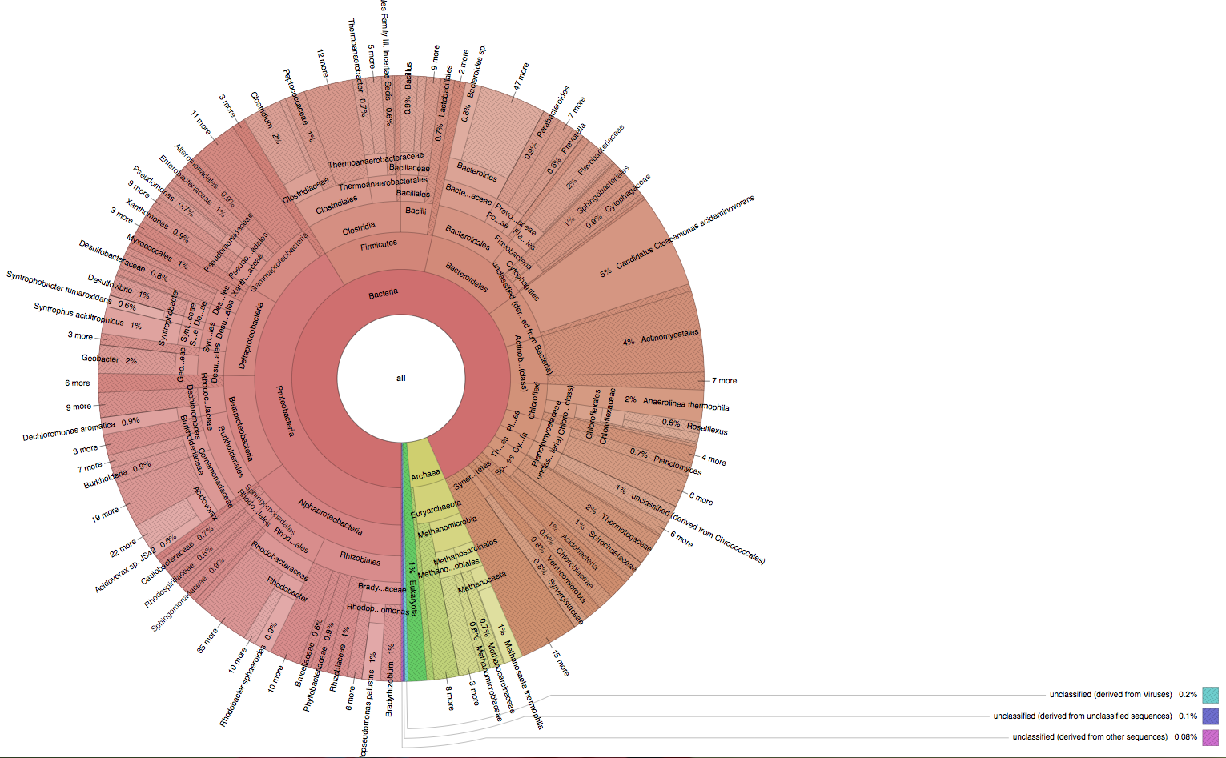
Figure S1. The interactive Krona chart of the full taxonomy
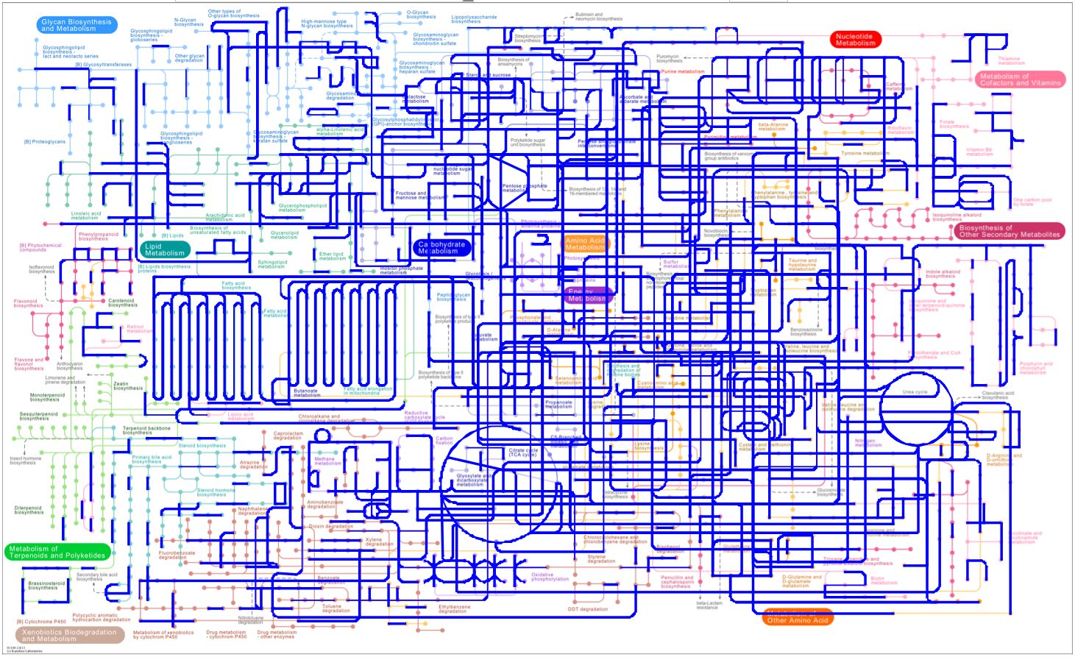
Figure S2. KEGG mapper for the anaerobic digestion sample

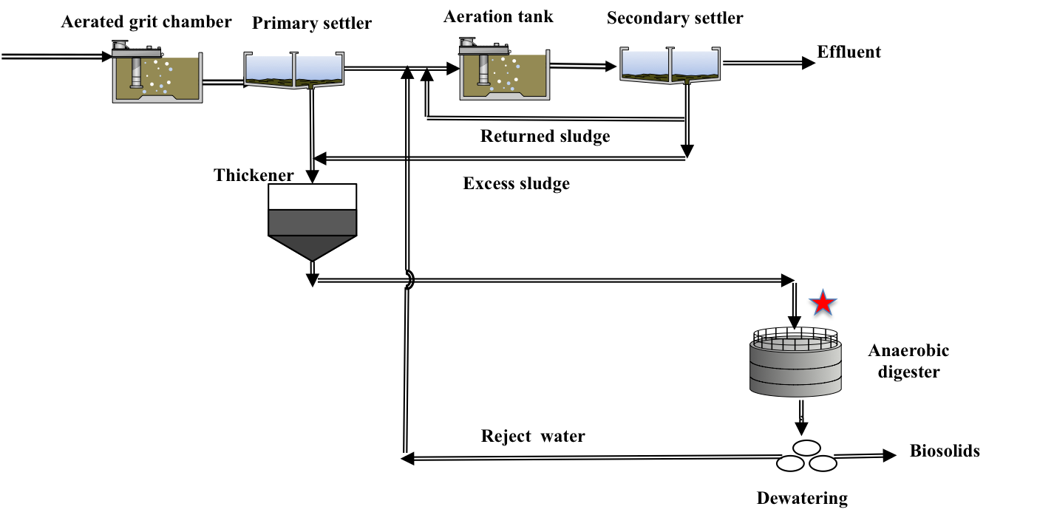

Figure S3. Schematic diagram of the full-scale wastewater treatment plant and the sampling point (sampling point as shown by a red star)

