Additional File 1: Further details of relevance to this study

Artificial de novo biosynthesis of hydroxystyrene derivatives in a tyrosine overproducing Escherichia coli strain

GC/MS identification of produced hydroxystyrene derivatives
The recombinant E. coli cells harboring the pET22-baPAD plasmid produced the 14.5 min retention time peak with the 4-coumaric acid, which is the same retention time as the authentic 4-hydroxystyrene. Further GC/MS identification revealed that this compound had m/z 120.2, confirming the identity of the product as 4-hydroxystyrene. Additionally, a major peak was present at the same retention time (9.3 min) as the authentic 3,4-dihydroxystyene in the HPLC analysis and with a mass ion peak at m/z 136.2 using the caffeic acid. This peak confirmed the identity of the product as 3,4-dihydroxystyene. Finally, when using ferulic acid or sinapic acid as a substrate, it produced 15.2 min and 13.6 min retention time peaks, which were the same mass peaks at m/z 150.2 and 180.2 with 4-hydroxy-3-methoxystyrene and 4-hydroxy-3,5-dimethoxystyrene, respectively (Supporting Figure 1).

Figure S1. Selected GC/MS data of bioconversion experiments
(A) 4-hydroxystyrene (m/z 120.2) produced by 4-coumaric acid supplemented E. coli harboring the pET22-baPAD plasmid; (B) 3,4-dihydroxystyene (m/z 136.2) produced by caffeic acid, (C) 4-hydroxy-3-methoxystyrene (m/z 150.2) produced by ferulic acid, and (D) 4-hydroxy-3,5-dimethoxystyrene (m/z 180.2) produced by sinapic acid supplemented E. coli harboring the pET22-baPAD plasmid.

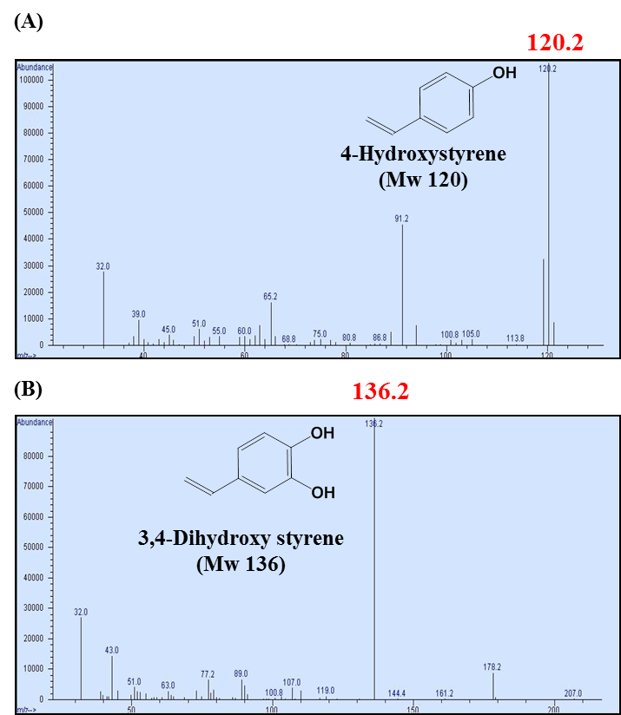
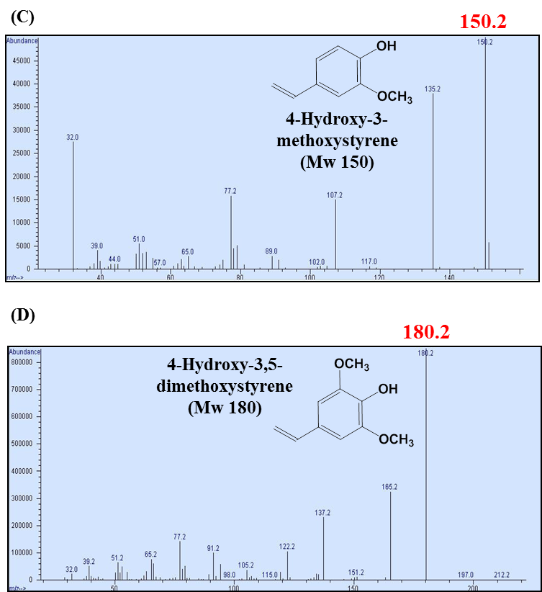
Figure S1

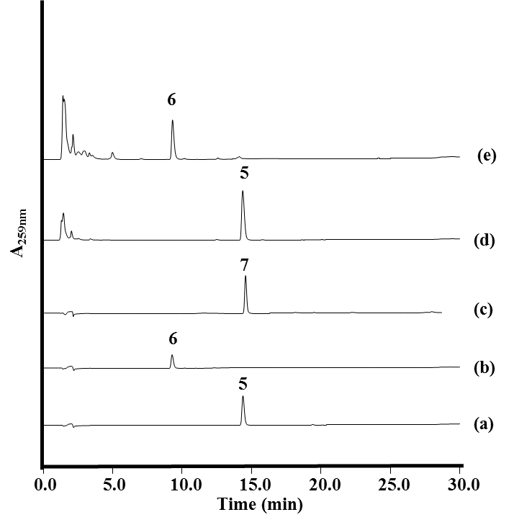
Figure S2.

Figure S2. HPLC profiles of the production of 4-hydroxystyrene (d) and 3,4-dihydroxystyrene (e) by wild type E. coli strains expressed tal and pad (pET-opTD) and tal, sam5, and pad (pET-opT5D). The absorbance was monitored at 259 nm. Peak 5, 4-hydroxystyrene; peak 6, 3,4-dihydroxystyrene; peak 7, 4-hydroxy-3-methoxystyrene. HPLC profiles of standard 4-hydroxystyrene (a); 3,4-dihydroxystyrene (b); 4-hydroxy-3-methoxystyrene (c); the culture broth of wild type E. coli harboring pET-opTD (d); pET-opT5D (e);

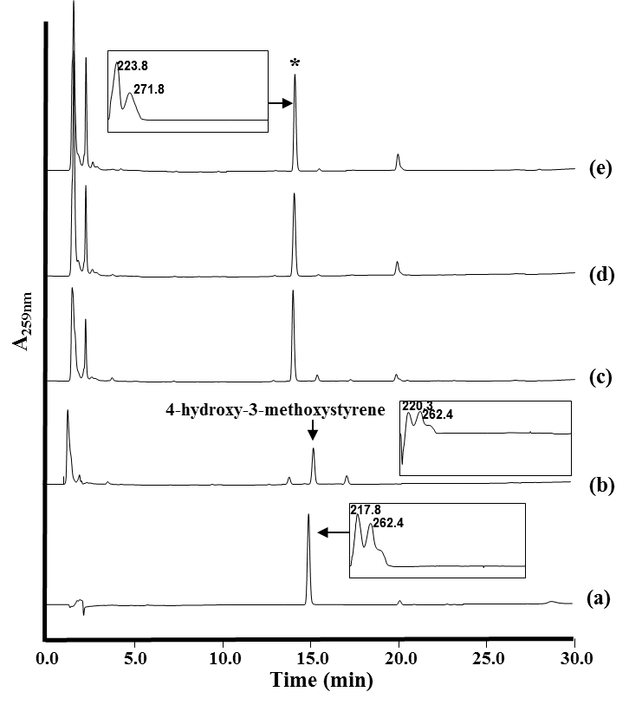
Figure S3
Figure S3. HPLC profiles of the time-course cultivation (2, 12, 24, and 36 hours) of wild type E. coli harboring pET-opT5MD. The cell was cultured in modified synthetic medium at 26°C for 2 hours (b), 12 hours (c), 24 hours (d), 36 hours (e). (a), profile of standard 4-hydroxy-3-methoxystyrene; *, unknown peak. The insets show the UV/Vis spectra of the compounds with the indicated HPLC peaks

Confirmation of tyrR gene insertional mutant (ΔCOS1 ) by PCR
The gene replacement of tyrR, a repressor gene of aromatic amino acid biosynthesis, with the tyrA^{fbr} and aroG^{fbr} gene cassette was constructed by RED/ET recombination (Supporting Fig 4). The insertional inactivation mutant (ΔCOS1) was verified with PCR using the following primers: tyrA-F (5’- CCATGGTTGCTGAATTGACCGCATTACG-3’) and aroG-R (5’- AAGCTTAACCACGACGCGCTTTCACAGC-3’). The PCR product was sequenced and verified. As result, a 3.1 kb of the PCR product with the tyrA-F and aroG-R primer set was detected from ΔCOS1 and the PCR product was not seen in the wild type. This result shows the insertion of the tyrA^{fbr} and aroG^{fbr} gene cassette in the tyrR gene (Supporting Fig 5).
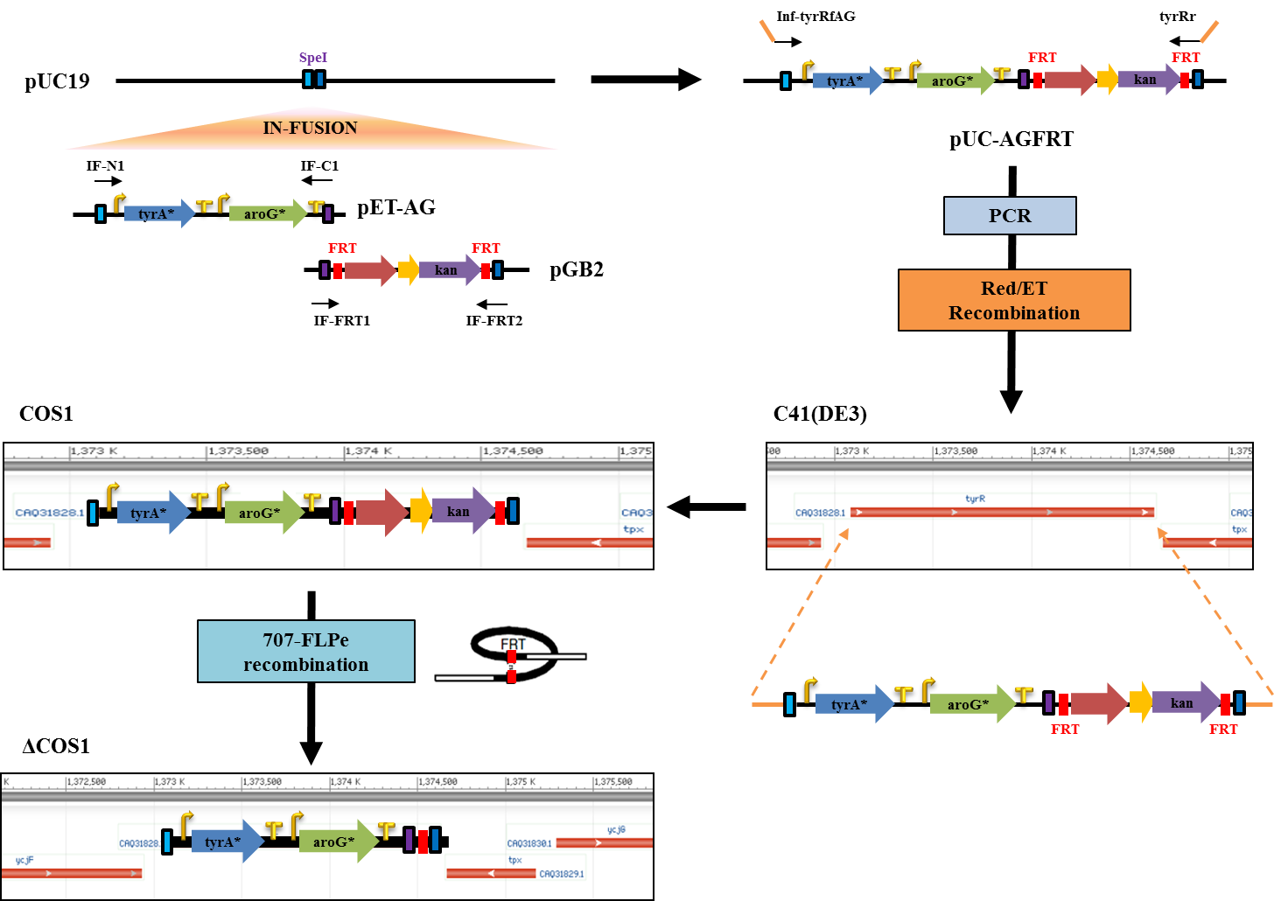
Figure S4.
Figure S4. Strategy for the gene insertion in the tyrR region on the E. coli chromosome.
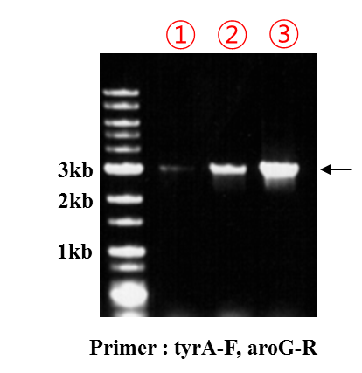
Figure S5.
Figure S5. Confirmation of insertional gene inactivation by PCR
Analysis of L-tyrosine
To quantify L-tyrosine, 1 mL of cell-free culture supernatants was filtered through a 0.2 μm Cellulose membrane syringe filter (Sartorius) and used for HPLC analysis with a Dionex Separations module connected with a Photodiode Array detector (Dionex) set. The L-tyrosine was separated on a YMC C18 column (150 × 4.6 mm, 4 μm). The following gradient was used at a flow rate of 1 mL/min: 5% to 80% acetonitrile for 25 min, 80% to 100% acetonitrile for 3 min, 100% acetonitrile for 3 min, 100% to 5% acetonitrile for 3 min, and 5% acetonitrile for an additional 3 min.
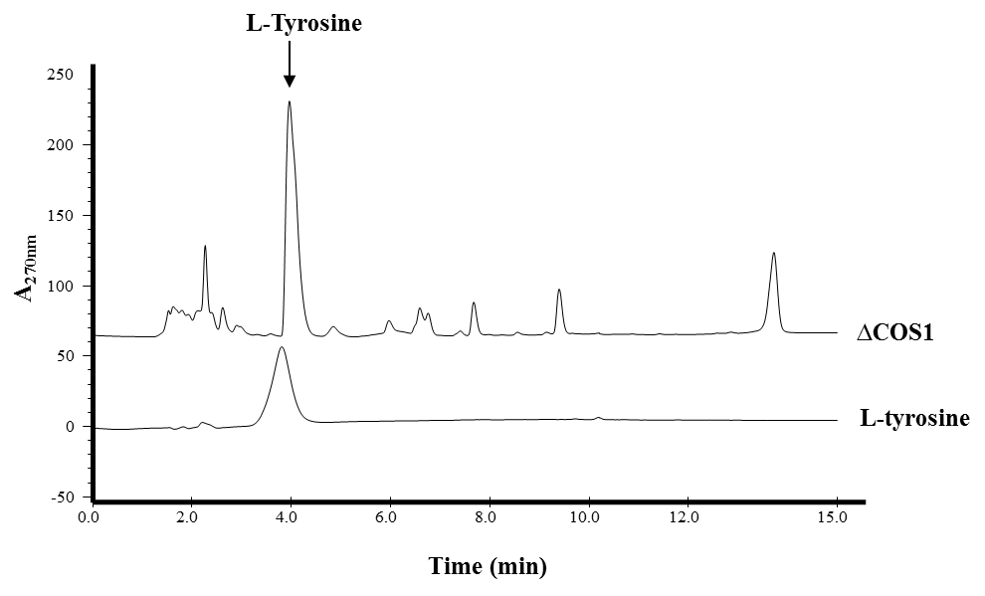
Figure S6.
Figure S6. HPLC profile of L-tyrosine production in the engineered tyrosine overproducing strain (ΔCOS1)
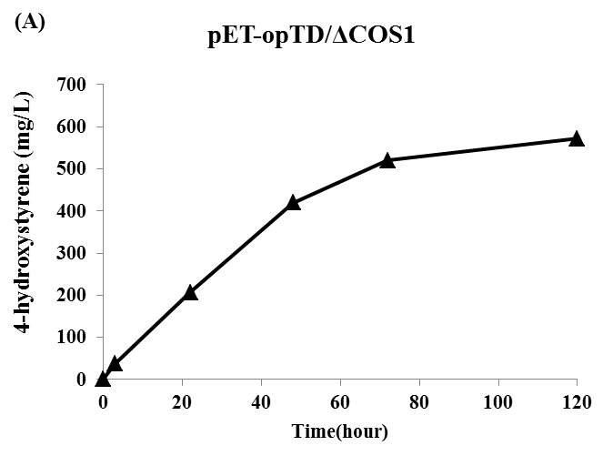
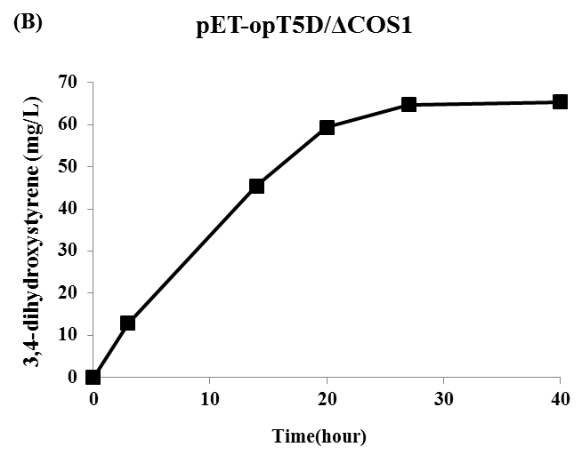
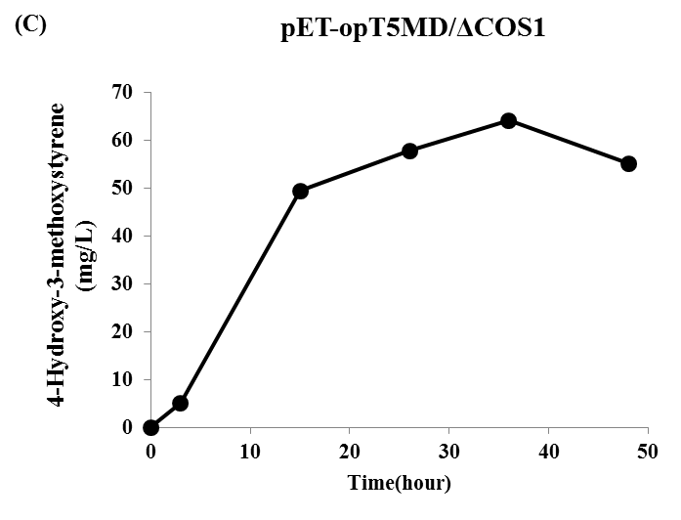
Figure S7.
Figure S7. Accumulation of 4-hydroxystyrene, 3,4-dihydroxystyrene and 4-hydroxy-3-methoxystyrene in minimal media upon culturing of the tyrosine over-producing strains harboring pET-opTD (A); pET-opT5D (B); pET-opT5MD (C). The cells were cultured in modified synthetic medium at 26℃. ▲, 4-hydroxystyrene; ■, 3,4-dihydroxystyren; ●, 4-hydroxy-3-methoxystyrene. Compounds concentration quantified as absorbance area at 259 nm.

