Additional file 1

Supplementary materials for:

Controlling heterologous gene expression in yeast cell factories on different carbon substrates and across the diauxic shift: a comparison of yeast promoter activities

Authors
Bingyin Peng: Australian Institute for Bioengineering and Nanotechnology (AIBN), The University of Queensland, St. Lucia, QLD 4072, Australia; bingyin.peng@uq.net.au
Thomas C. Williams: Australian Institute for Bioengineering and Nanotechnology (AIBN), The University of Queensland, St. Lucia, QLD 4072, Australia; thomas.williams1@uqconnect.edu.au
Matthew Henry: Australian Institute for Bioengineering and Nanotechnology (AIBN), The University of Queensland, St. Lucia, QLD 4072, Australia; matthew.henry2@uq.net.au
Lars K. Nielsen: Australian Institute for Bioengineering and Nanotechnology (AIBN), The University of Queensland, St. Lucia, QLD 4072, Australia; lars.nielsen@uq.edu.au
Claudia E. Vickers*: Australian Institute for Bioengineering and Nanotechnology (AIBN), The University of Queensland, St. Lucia, QLD 4072, Australia; c.vickers@uq.edu.au
*, the corresponding author

Additional file 1: Table S1: Fluorescence of the destabilized GFP (yEGFP-CLN2_{PEST}) in the strains cultivated on 2% v/v ethanol to OD₆₀₀= 0.90±0.03
Promoter | The relative GFP fluorescence (% Auto-fluorescence)
PGK1 | 2±3
TDH3 | 5±7
ADH1 | 3±10
ENO2 | 2±4
TPI1 | 6±6
GAL1 | 2±11
YEF3p | 8±12
TEF1p | 32±16
TEF2p | 22±13
PDA1p | 5±3
CYC1p | 23±20
RPL4A | 1±2
RPL15A | 16±7
RPL8B | 4±3
RPL3 | 17±14
SSA1 | 4±2
SSB1 | 4±2

The auto-fluorescence was determined from the reference strain on parallel; the value is represented as mean ± standard derivation in the triplicate cultivations.
Additional file 1: Table S2: Effect of difference glucose concentrations (linear regression) and different carbon sources (one-way ANOVA) on GFP fluorescence driven by various promoters.
- Glucose concentrations of 30 g L⁻¹, 20 g L⁻¹ and 10 g L⁻¹.
- Glucose concentrations of 40 g L⁻¹, 30 g L⁻¹, 20 g L⁻¹ and 10 g L⁻¹.
- Carbon sources: 20 g L⁻¹ glucose, 20 g L⁻¹ sucrose, 20 g L⁻¹ galactose and 2% v/v ethanol
Additional file 1: Table S3: The primers, the plasmids and the strains used in this work
- pITGFP__ plasmids contain the expression cassette of the destabilized GFP, yEGFP-CLN2PEST; pILGFP__ plasmids contain the expression cassette of the normal yEGFP.
- ILHA G__ strains (except of ILHA GH4) contain the expression cassette of the destabilized GFP, yEGFP-CLN2PEST; ILHA G__S strains contain the expression cassette of the normal yEGFP.

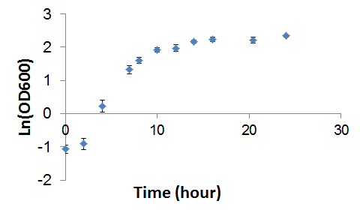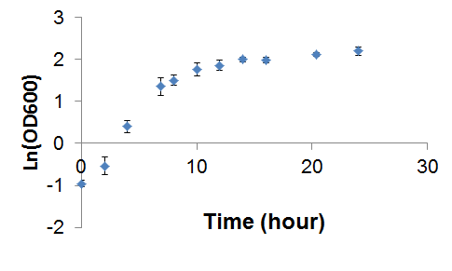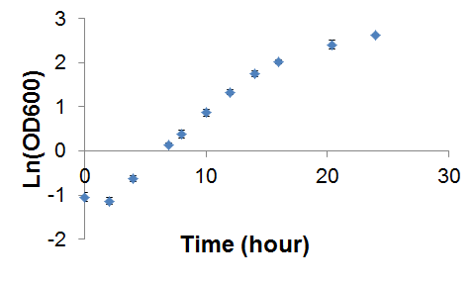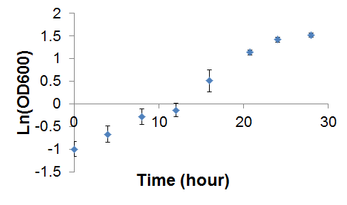
A
B
C
D
Additional file 1: Fig. S1: Pre-evaluation of mid-log phase for microplate cultivation. Microplate cultivation was performed by inoculating 5 μL over-night 20 g L⁻¹ glucose pre-culture into 95 μL fresh YNB media with 20 g L⁻¹ glucose (A), 20 g L⁻¹ sucrose (B), 20 g L⁻¹ galactose (C) or 2% v/v ethanol (D); Mean values ± standard deviations are shown from quadruplicate measurements.

P_{PDA1}
P_{SSA1}
P_{SSB1}
P_{RPL8B}
P_{RPL4}
P_{YEF3}
P_{RPL15A}
P_{RPL3}
P_{TEF2}
P_{TEF1}
P_{PGK1}
P_{TDH3}
Additional file 1: Fig. S2: Correlation of GFP fluorescence determination in the strains using either the destabilized GFP (yEGFP-CLN2_{PEST}) or the normal GFP (yEGFP) as the reporter. The strains were cultivated on YNB media with 20 g L⁻¹ glucose in microplates. Each data point represents the relative GFP fluorescence level (% auto-fluorescence) driven by different promoters, as annotated on the figure. N = 3 for each data point.

Additional file 1: Fig. S3: Post-hoc test for fluorescence levels (sorted from low to high) of various promoter-yEGFP strains on different carbon source. When Bartlett's test p value was > 0.05, Tukey’s test was used; else, Games-howell’s test was used. Ranges with p >0.05 were highlighted. The auto-fluorescence (Ref) was determined from the reference strain (ILHA GH4) in parallel.

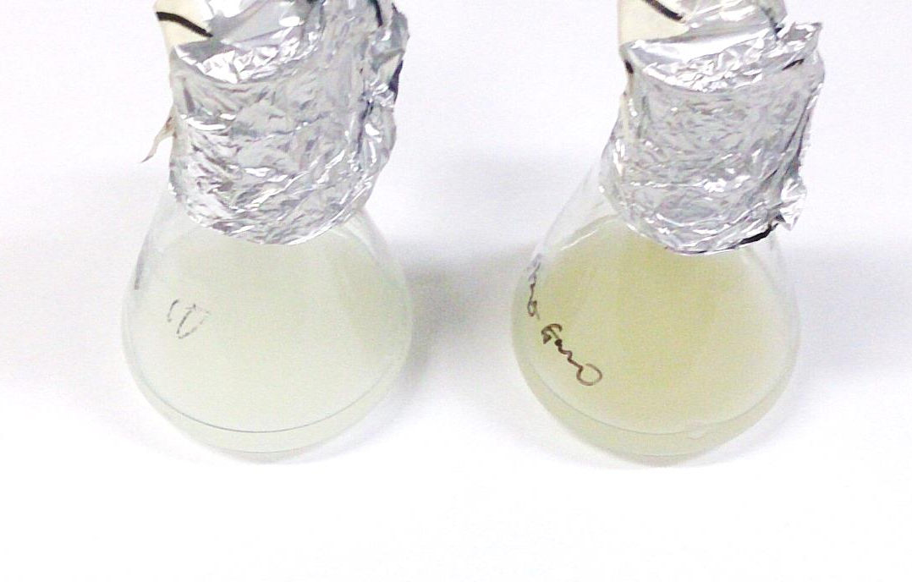
With copper
Without copper
Additional file 1: Fig. S4: Yeast cultures with/without copper addition.
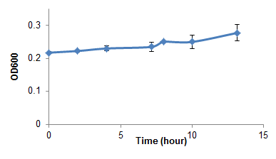
A
C
E
Log10(FL1.A/FSC.A)
24 hour
36 hour
B
Log10(FL1.A/FSC.A)
-5 -4 -3 -2 -1
Kernel density
0 0.5 1.0 1.5 2.0 2.5

Kernel density
0 0.5 1.0 1.5 2.0 2.5

Log10(FL1.A/FSC.A)
24 hour
36 hour
-5 -4 -3 -2 -1
Kernel density
0 0.5 1.0 1.5 2.0 2.5

Kernel density
0 0.5 1.0 1.5 2.0 2.5

0 hour
2 hour
13 hour
D
Log10(FL1.A/FSC.A)
-5 -4 -3 -2 -1
Kernel density
0 0.5 1.0 1.5 2.0 2.5

Kernel density
0 0.5 1.0 1.5 2.0 2.5

Kernel density
0 0.5 1.0 1.5 2.0 2.5

0 hour
2 hour
13 hour
-5 -4 -3 -2 -1
Kernel density
0 0.5 1.0 1.5 2.0 2.5

Kernel density
0 0.5 1.0 1.5 2.0 2.5

Kernel density
0 0.5 1.0 1.5 2.0 2.5

Additional file 1: Fig. S5: De-repression of ADH2 promoter: A & B, batch cultivation of 20 g L⁻¹ glucose (MES-buffered); C, D & E, batch cultivation of 2% v/v ethanol, initiated by inoculating 24 hour cultures from MES-buffered batch cultivation of 20 g L⁻¹ glucose. A, C & E, the reference strain (ILHA GH4, without GFP); B & D, the strain (ILHA GH7S) with GFP controlled by ADH2 promoter.

