Mass spectrum profiles of AXP for two strains
A.niger DS03043
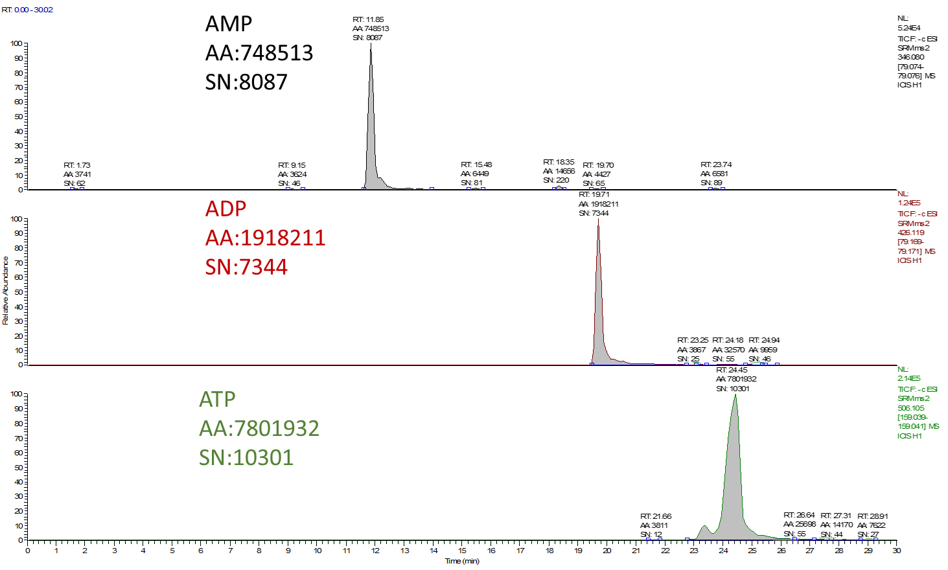
A.niger CBS513.88
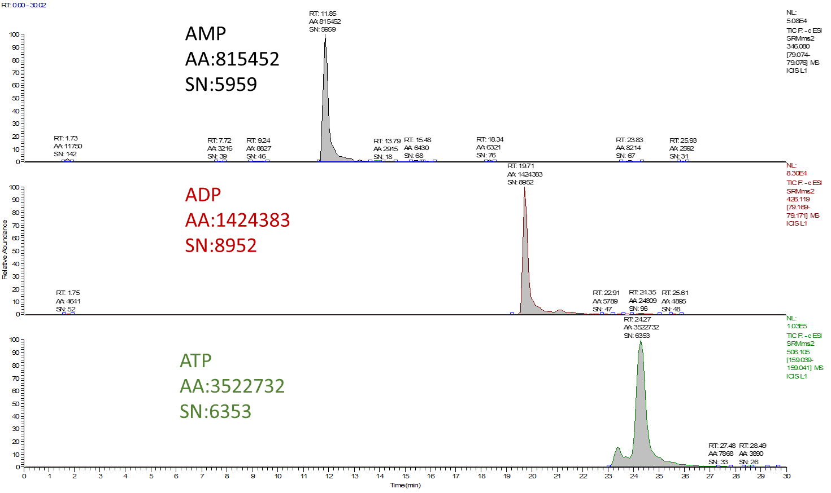
Note: AA-area; SN-signal to noise ratio
Standard curves of AMP, ADP, ATP with ¹³C labelled metabolites as internal standards

