Supplementary information
Metabolomics investigation of recombinant mTNFα production in Streptomyces lividans
Howbeer Muhamadali, Yun Xu, David I. Ellis, Drupad K. Trivedi, Nicholas J.W. Rattray, Kristel Bernaerts and Royston Goodacre

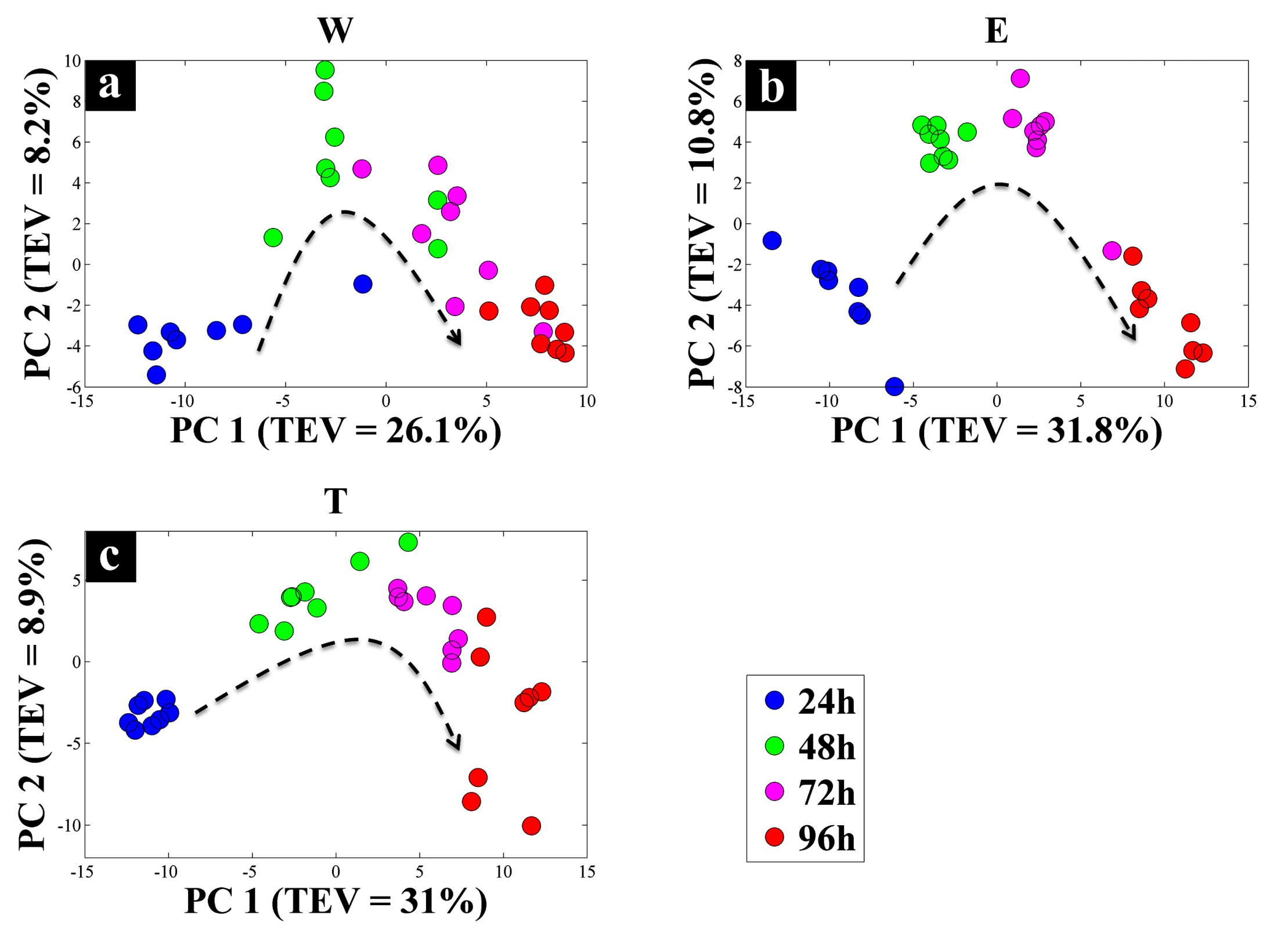
Figure S1. CPCA-W scores plots of the strain-blocked GC-MS metabolic footprint data. The scores plots for each of the strain-blocked data are presented on a-c plots, where samples taken at separate time points are presented by different coloured circles. The dashed arrows display the direction of the separation according to incubation time. Different alphabets on each plot indicate the S. lividans strains; wild (W), empty plasmid (E), and mTNF-producing (T).

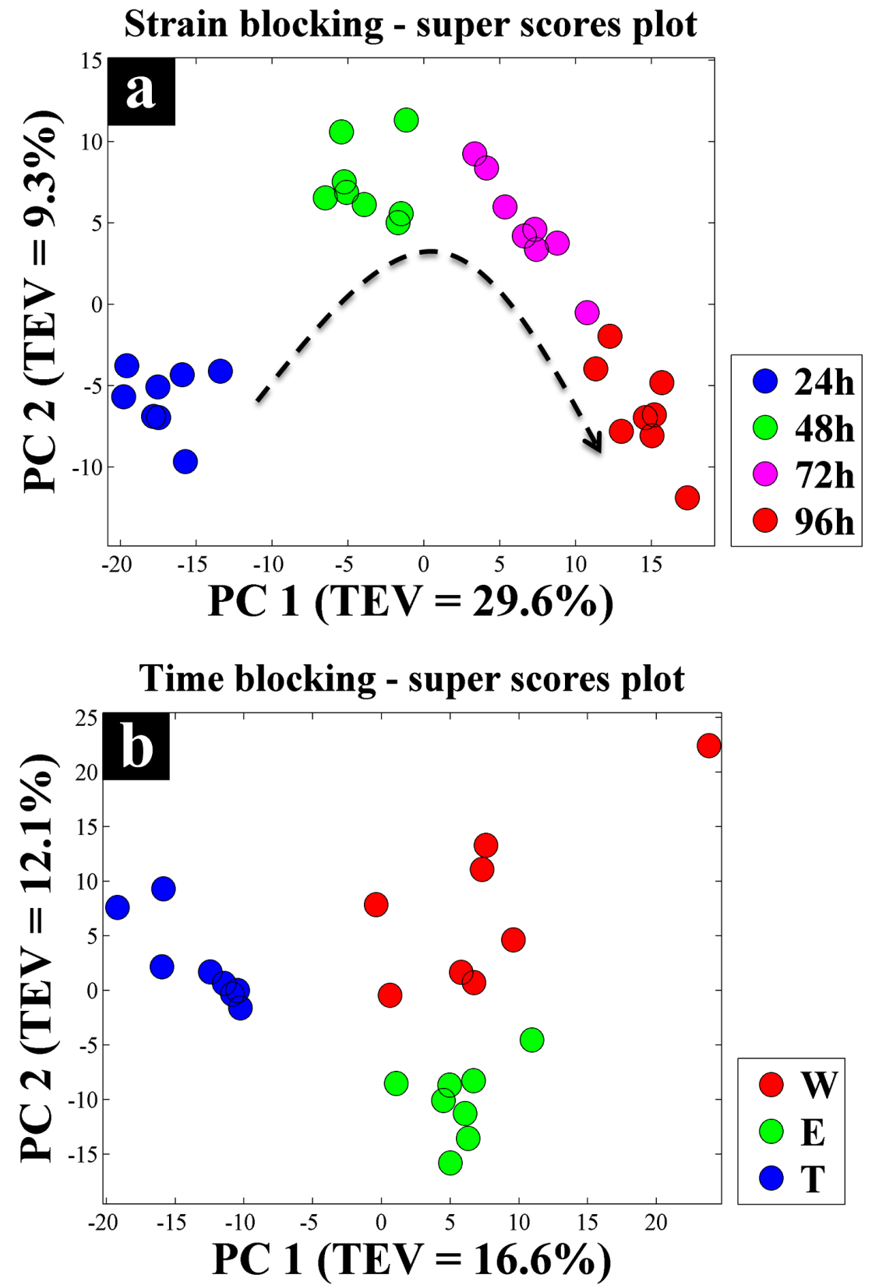
Figure S2. CPCA-W super scores plots of GC-MS metabolic footprint data set. (a) Super scores plot of the strain-blocked model, different coloured symbols indicate sampling time. (b) Super scores plot of the time-blocked model, where coloured symbols represent different S. lividans strains.

96h
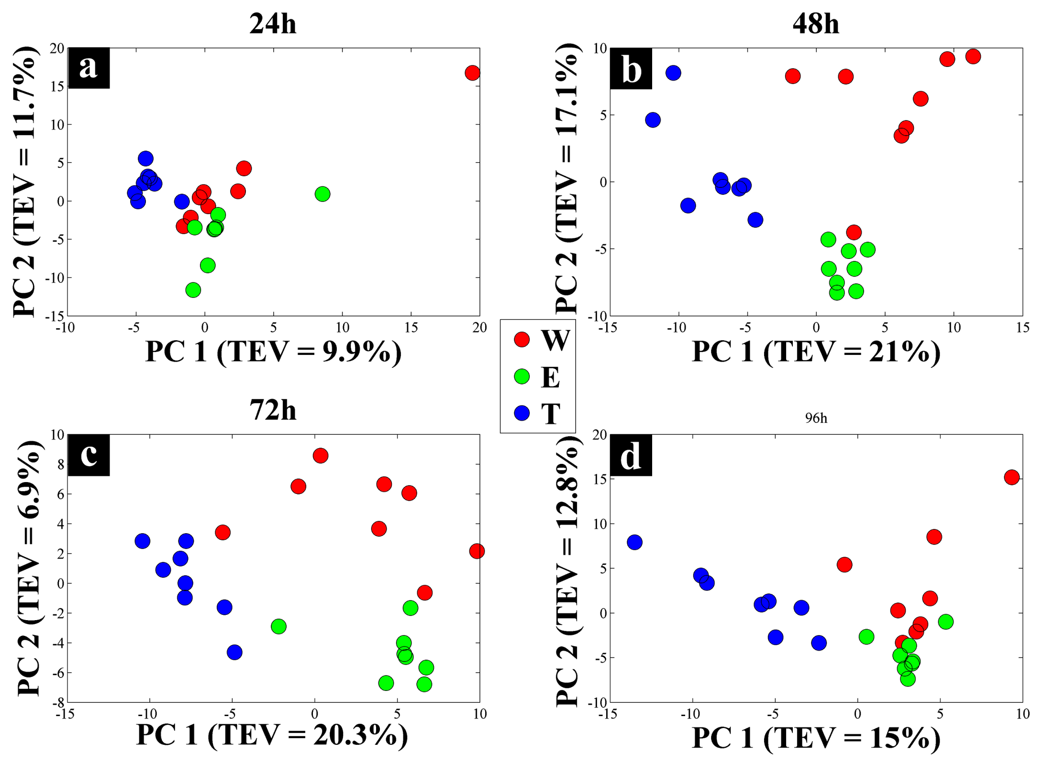
Figure S3. CPCA-W scores plots of the time-blocked GC-MS metabolic footprint data. The scores plots for each of the time-blocked data are presented on a-d plots, where different coloured circles represent different S. lividans strains.

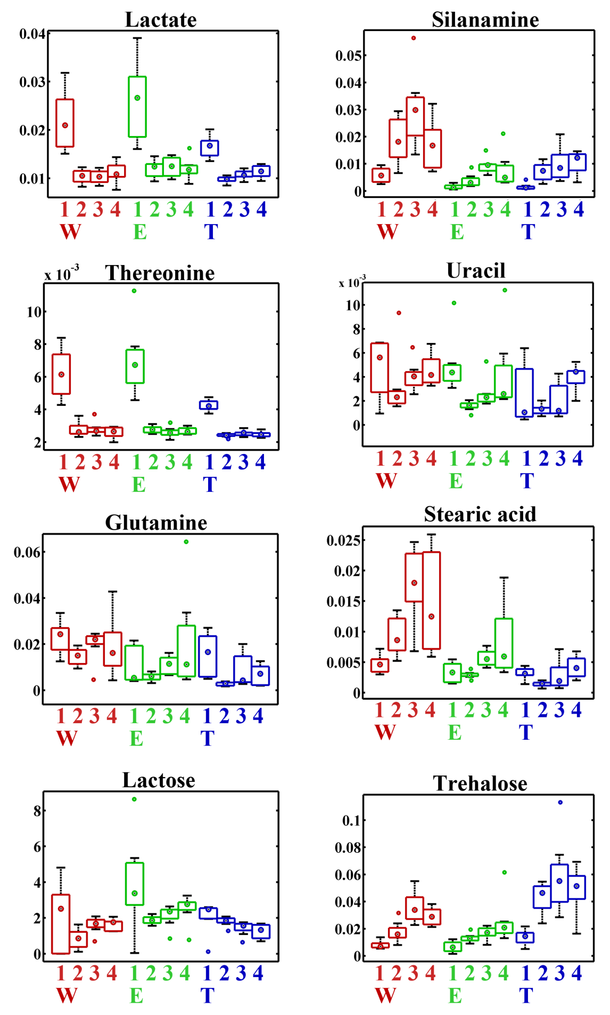
Figure S4. Relative peak area (box whisker plots) of the significant metabolites identified by CPCA-W of cell extract data. Different colours of the box plots indicate different strains, wild (W, red), empty plasmid (E, green) and mTNF-producer (T, blue). While the numbers 1-4 represent separate sampling time points, 24, 48, 72 and 96 h respectively.

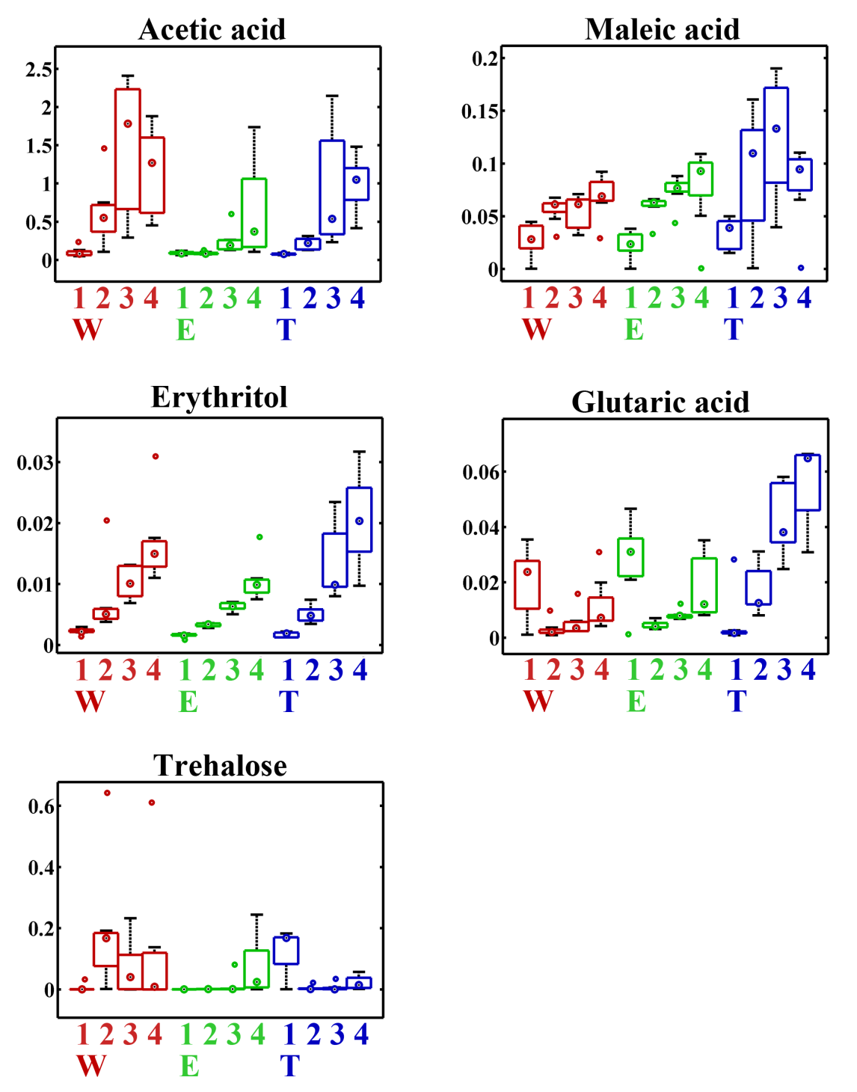
Figure S5. The relative peak area (box whisker plots) of the significant metabolites identified by CPCA-W of footprint data is presented. Different colours of the box plots indicate different strains, wild (W, red), empty plasmid (E, green) and mTNF-producer (T, blue). While the numbers 1-4 represent separate sampling time points, 24, 48, 72 and 96 h respectively.

Table S1. List of the significant metabolites identified by CPCA-W of GC-MS metabolic profile data. All identifications are based on MSI minimum metabolite reporting standards.
Variable ID | RT | RI | Metabolite | MSI ID level | chEBI code
5 | 349.028 | 1040.9 | Lactic acid | 1 | 42111
9 | 373.928 | 1091.7 | Alanine | 1 | 16977
14 | 409.978 | 1165.3 | Pyruvic acid | 1 | 32816
19 | 440.478 | 1227.5 | Valine | 1 | 27266
21 | 445.878 | 1238.5 | Silanamine | 2 | NA
39 | 520.378 | 1390.6 | Threonine | 1 | 16857
45 | 530.378 | 1411 | Succinic acid | 1 | 15741
52 | 556.578 | 1464.4 | Uracil | 1 | 17568
75 | 614.528 | 1616.6 | Arginine | 1 | 29016
97 | 652.878 | 1727 | 2-ketoglutaric acid | 1 | 30915
105 | 660.278 | 1748.3 | Aspartic acid | 1 | 22660
112 | 666.528 | 1766.3 | Fructose | 1 | 28757
119 | 685.428 | 1820.7 | Mannose | 1 | 37684
127 | 700.778 | 1864.8 | Glutamine | 1 | 28300
164 | 812.028 | 2249.5 | Fructose-6-phosphate | 1 | 78697
169 | 819.678 | 2276.5 | Stearic acid | 1 | 28842
170 | 822.378 | 2286 | Glucose-6-phosphate | 1 | 17665
189 | 885.928 | 2510.3 | Lactose | 1 | 36219
194 | 902.428 | 2568.6 | Trehalose | 1 | 16551

Code: ID, identifier on plots; RT, retention time; RI, retention index; MSI, Metabolomics Standards Initiative identification level; for chEBI codes see: https://www.ebi.ac.uk/chebi/
Table S2. List of the significant metabolites identified by CPCA-W of GC-MS metabolic footprint data. All identifications are based on MSI minimum metabolite reporting standards.
Variable ID | RT | RI | Metabolite | MSI ID level | chEBI code
8 | 353.378 | 1049.8 | Lactic acid | 1 | 42111
12 | 380.778 | 1105.7 | Propanoic acid | 2
15 | 410.928 | 1167.2 | Pyruvic acid | 1 | 32816
19 | 436.578 | 1219.5 | Acetic acid | 2 | 15366
37 | 501.128 | 1351.3 | Phosphate | 1
53 | 530.428 | 1411.1 | Maleic acid | 1 | 18300
59 | 546.328 | 1443.5 | Erythritol | 1
65 | 568.228 | 1488.2 | Glutaric acid | 1 | 17859
70 | 586.528 | 1536.1 | Aspartic acid | 1 | 22660
88 | 616.928 | 1623.5 | Xylitol | 2 | 17151
105 | 653.128 | 1727.7 | 2-ketoglutaric acid | 1 | 30915
114 | 675.328 | 1791.6 | Mannose | 2 | 37684
117 | 684.328 | 1817.5 | Glucose | 1 | 17234
162 | 827.428 | 2303.9 | Inositol 3-phosphate | 1 | 18169
197 | 886.578 | 2512.6 | Trehalose | 2 | 16551

Table S3. List of relative ratio of amino acid components of mTNFα.
Amino acids | Number | Total relative ratio %
Alanine | 25 | 13.4
Leucine | 22 | 11.8
Valine | 19 | 10.2
Serine | 13 | 7.0
Glycine | 12 | 6.5
Glutamine | 12 | 6.5
Glutamic acid | 11 | 5.9
Lysine | 10 | 5.4
Proline | 9 | 4.8
Tyrosine | 8 | 4.3
Aspartic acid | 8 | 4.3
Threonine | 7 | 3.8
Asparagine | 7 | 3.8
Phenylalanine | 5 | 2.7
Arginine | 5 | 2.7
Isoleucine | 3 | 1.6
Cysteine | 3 | 1.6
Histidine | 3 | 1.6
Methionine | 2 | 1.1
Tryptophan | 2 | 1.1

