Supplementary Methods
Supplementary table S1. Primer sequence used for genome manipulation in this study
Primer name | Primer sequence (5’→3’)
Primer used for genome manipulation
kblp U_F | AAATAATAACATTGTGGACGA
kblp U_R | AATGAGCCGGATGATTAATTGTCAACAGCTCATCAACACCTACAGATAGTAGA
kblp L_F | ATAATGTGTGGTCACACAGTCGACGGAGTAACGACTCTCGTAAATAAGGAGTTTAAAATGCGTGGAGAATTTTATC
kblp L_R | CGCAAATAAAACGCACCGAA
SdaAp U_F | TATACCGCCTTCCGCCGTTG
SdaAp U_R | AATGAGCCGGATGATTAATTGTCAACAGCTCATTAGTCAGGGTTTCACACCAA
SdaAp T_F | ATGAGCTGTTGACAATTAATCATCCGGCTCATTACCCTGTTATCCCTACTAAGC
SdaAp T_R | TACTCCGTCGACTGTGTGACCACACATTATACGAGCCGGATGATTAATTGTCAACAGCTCATTAGGGATAACAGGGTAATGTACC
SdaAp L_F | ATAATGTGTGGTCACACAGTCGACGGAGTAACGACTCTCGTAAATAAGGAGTTTAAAGTGATTAGTCTATTCGACAT
SdaAp L_R | AAACCGGGAATACTGTCGAT
glyAp U_F | AGCCCTGCAATGTAAATGGTT
glyAp U_R | GAGCCGGATGATTAATTGTCAACAGCTCATCCGCATCTCCTGACTCAGCT
glyAp L_F
glyAp L_R | TGCGCCAGGTTCATACCCAGA
Tet_F | AGCTGAGTCAGGAGATGCGG
Tet_R | AGCTGTTTCCTGGTTTAAAC
gcv U_F | ATAAACTAATTTCACCTCCGTT
gcv U_R | CCGCATCTCCTGACTCAGCTCTTGTCCTCATTGAATAAGCG
gcv L_F | GTTTAAACCAGGAAACAGCTATGGCACAACAGACTCCTTT
gcv L_R | GGCATTCAACATCCCCGAGT
thrAm U_F | GAGCTTTCCTACTTCGGCGCTA
thrAm U_R | ACATTACCCTGTTATCCCTACAGCACCACGAAAATACGGG
thrAm T_F | TATTTTCGTGGTGCTGTAGGGATAACAGGGTAATGTACCA
thrAm T_R | ATACGGGCGCGTGACATATTACCCTGTTATCCCTACTAAGCA
thrAm L_F | TAGTAGGGATAACAGGGTAATATGTCACGCGCCCGTATTTTCGTG
thrAm L_R | TTCGCCGAGATCCCACGCAAG
thrABCp U_F | TGACATAAAACTGGTCGACT
thrABCp U_R | AACAGCTCATCCGCATCTCCTGACTCAGCTGGATGTTGTGTACTCTGTA
thrABCp L_F | TACTTCAATTTGTTTAAACCAGGAAACAGCTATGCGAGTGTTGAAGTTCGG
thrABCp L_R | TCTAATACGCCGGCCATAATG
ppc U_F | ACTCAAACGATGCCCAACC
ppc U_R | AACAGGGTAATTTAATTGTCAACAGCTCACGAATAAATAGCAGGAATT
ppc T_F | GCTATTTATTCGTGAGCTGTTGACAATTAAATTACCCTGTTATCCCTACTAAGC
ppc T_R | CGATGATTAATTGTCAACAGCTCACGAATAAATAGCTAGGGATAACAGGGTAATGTACC
ppc L_F | GAGCTGTTGACAATTAATCATCGGCTCGTATAATGTGTGGACCCGAGCATATTCGCGCC
ppc L_R | ATCACTTCCGGGTTGCTG
pntAB U_F | TCAGTCTTTATCCGGCGTTC
pntAB U_R | GTCAACAGCTCATCCGCATCTCCTGACTCAGCTTTCCATCGGTTTTATTGATG
pntAB L_F | GTACTTCAATTTGTTTAAACCAGGAAACAGCTGGGAATATCATGCGAATTGG
pntAB L_R | AAACTCACCAGCGTTGTCC
Primers for RT-PCR
RTthrA_F/R | CGAAGTGGATGGTAATGA/ GGCTGATAATAGTGGCTA
RTthrB_F/R | GCATTGCTCGGAGATGTA/ GAGGTTGTTGAGACTGAATG
RTthrC_F/R | GTCGCTTTATGGCACAAATG/ TCAGAATGGTCACTGGCTTA
RTkbl_F/R | TTATTGATGGTGTGCGTCTGT/ GCATATCGTTGTTGGCATAGC
RTtdh_F/R | TGCTTGACACCATGAATC/ ATATCAGACGGCGGAATA
RTsdaA_F/R | CTATGAAGGCAGGTAAACAG/ CGAGTAACGCTATCCAGTA
RTppc_F/R | TGCGTAGTAATGTCAGTATG/ GCGTTCAAGAATGTGTTC
RTglyA_F/R | CGATTATGATGCCGAACTGT/ CGATGTGCTCTTCCTGAC
RTgcvT_F/R | TGGCGGTGTGATAGATGAC/ AACAACGAGGCGGAAGAA
RTgcvH_F/R | TGAACAGCGAACCGTATG / CCAGCAGTGATTCCAGTT
RTgcvP_F/R | TCAACTTCCAGCAGGTAA / TCCAGAAGAGAAGCAGAG
RTpntA_F/R | TGTCAAAGTGATTGGTTA / AACAGTTTCAGCAGATTA
RTrrsA_F/R | TACGACCAGGGCTACACACG/ATCCGGACTACGACGCACTT

Figure S1. Strategies for chromosomal replacement. A. Genome editing cassettes are constructed by three rounds of PCR and recombinants after the first round of recombineering were selected by tetracycline; B. In the second step, the tetA marker was eliminated by simultaneous induction of I-SceI and Red recombinase expression. C. Fragments for promoter replacement or insertion.

Figure. S2. Results of relative transcriptional level. A. The transcription level of the genes in threonine utilizing pathway; B. The transcription level of the pntAB genes. Histogram shows the mean of three biological replicates, and error bars show standard deviations.

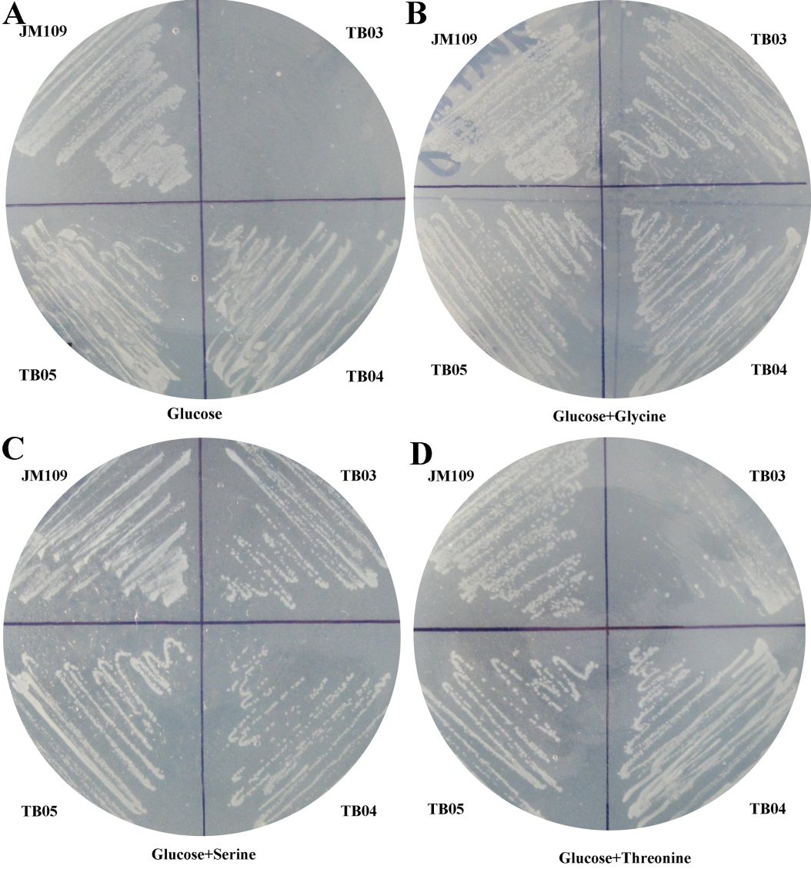
Figure. S3. Versions of serB⁻ strain overexpressing combinations of native kbl-tdh and sdaA genes were tested for their ability to grow on glucose minimal medium with the additives glucose (A), glucose and glycine (B), glucose and serine (C), glucose and threonine (D).

