Figure S1
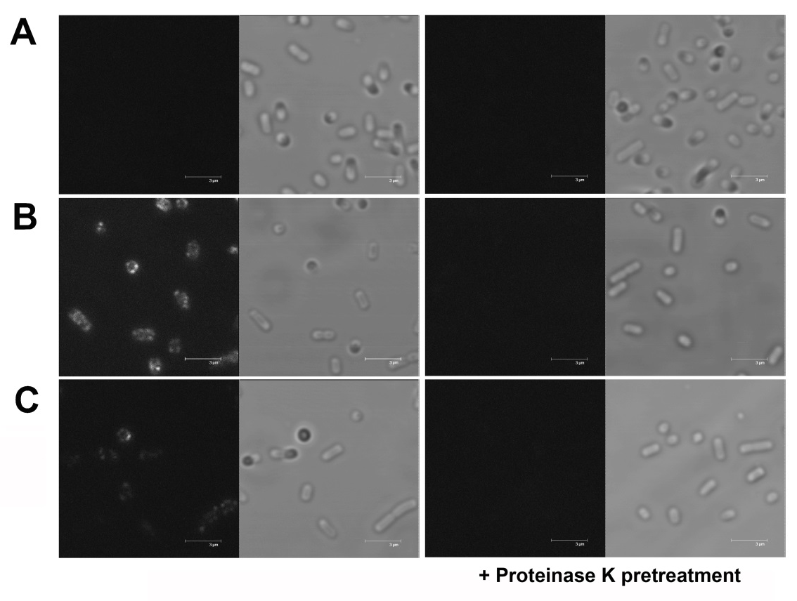

Surface localization of CPR and CYP1A2 analyzed by immunofluorescence microscopy
For each cell sample, fluorescence (left panel) and phase contrast graphs (right panel) of the same field are shown. Treatment with a mouse anti-myc antibody and a secondary Dyligh488 conjugated anti-mouse IgG antibody was conducted as described for flow cytometry analysis. A portion of the cells were subjected to proteinase K treatment prior to the antibody labelling procedure as described for outer membrane protein isolation. For microscopy, 10 µL of each cell suspension in PBS were put under a cover slip and sealed with nail polish. A: E. coli BL21 (DE3) cells, B: Cells expressing the CPR autotransporter fusion protein with myc-tag (pPQ61); C: cells expressing CYP1A2 autotransporter fusion protein with myc-tag (pPQ62).

