Supplementary information

Engineering and systems-level analysis of Saccharomyces cerevisiae for production of 3-hydroxypropionic acid via malonyl-CoA reductase-dependent pathway
Kanchana R. Kildegaard^{a*}, Niels B. Jensen^{a*,}, Konstantin Schneiderª, Eik Czarnotta^{b}, Emre Özdemirª, Tobias Kleinª, Jérôme Mauryª, Birgitta E. Ebert^{b}, Hanne B. Christensenª, Yun Chen^{c,d}, Il-Kwon Kim^{c,d,}, Markus J. Herrgårdª, Lars M. Blank^{b}, Jochen Forsterª, Jens Nielsen^{a,c}, Irina Borodina^{a#}
ªThe Novo Nordisk Foundation Center for Biosustainability, Technical University of Denmark, Kogle Allé 6, 2970 Hørsholm, Denmark, ^{b}Institute of Applied Microbiology, RWTH Aachen University, Worringer Weg 1, 52056 Aachen, Germany, ^{c}Department of Biology and Biological Engineering, Chalmers University of Technology, Kemivägen 10, SE-41296 Gothenburg, Sweden, ^{d}The Novo Nordisk Foundation Center for Biosustainability, Chalmers University of Technology, Kemivägen 10, SE-41296 Gothenburg, Sweden.

Additional file 1. Supplementary methods and supplementary results

Intracellular redox cofactors analysis
Extraction
Tubes containing boiling ethanol were prepared by placing 5 mL 75% ethanol in a preheated water bath at 95 °C for 5 min. The extraction was done quickly by adding 5 ml boiling ethanol to the cell pellet and immediately vortexed. The samples was placed in the water bath (95 °C) for 3 min. Hereafter they were transferred to dry ice with ethanol to cool down as fast as possible. The samples were spun down at max speed, 5 min, 4°C, and then dried down to dryness in a spec vac. The samples were the re-dissolve in 100 μL 20 mM ammonium formate, adjusted to pH 7.5 with ammonia hydroxide. Then the samples were vortex, spun down at max speed, 5 min, 4°C and finally transferred to LC-MS vials for analysis. The samples were analyzed by LC-MS/MS immediately hereafter.

LC/MS analysis
The LC-MS/MS system consisted of a CTC autosampler module, a high pressure mixing pump and a column module (Advance, Bruker, Fremont, CA, USA). The injection volume was 1 µL. The chromatography was performed on a hypergold PFP column, 150mm × 2.1 mm, 1.9 µm pore size (Thermoscientific, MA, USA). In front of the separation column was a 0.5 µ depth filter and guard column, the filter (KrudKatcher Classic, phenomenex). Column temperature was at 30 °C and the flow rate was set at 300 µL·min⁻¹. Eluent A: 20 mM ammonium acetate pH adjusted to 7.5 with ammonium hydroxide in milliQ water. Eluent B: Acetonitrile. Calibration standards were prepared in eluent A, and the concentration was in the range from 1.25 µg·mL⁻¹ -500 µg·mL⁻¹.
The MS/MS detection was performed on a EVOQ triple quadrupole instrument (Bruker, Freemont, CA, USA) equipped with an atmospheric pressure ionization (API) interface. The mass spectrometer was operated with electrospray in the positive ion mode (ESI+). The spray voltage was set to 4500 V. The con gas flow was 20 L·h⁻¹, and the cone temperature was set at 350°C. The heated probe gas flow was set at 50 L·h⁻¹ with a temperature of 350°C. Nebulizer flow was set at 50 L·h⁻¹, and the exhaust gas was turned on. Argon was used as collision gas at a pressure of 1.5 mTorr. Detection was performed in multiple reacting monitoring (MRM) mode. The transition for the investigated compounds was optimized with regard to collision energy. The MRM transitions are given in Table S5.

Yeast model.
Model adjustments and modifications:
TDH2 reaction is added (Glyceraldehyde 3-phosphate + NADP -> 3-phospho-D-glyceroyl phosphate + NADPH).
CaMCR reaction is added (Malonyl-CoA + 2 NADPH --> 3-hydroxypropionic acid + CoA + 2 NADP).
Transport across membrane and export of 3-hydroxypropionic acid is allowed.
Reaction U98 is blocked and replaced with ALD22x reaction (3-Aminopropanal +NAD--> B-alanine + NADH) based on [ref:PMC1462426].
Reaction U214's lower bound is set to 1 mmol/gDW/h to account for non-growth associated maintenance.
Catalytically inactive YDR111C (ALT2) reaction is blocked. [ref:PMC3458083]

Supplementary Figures

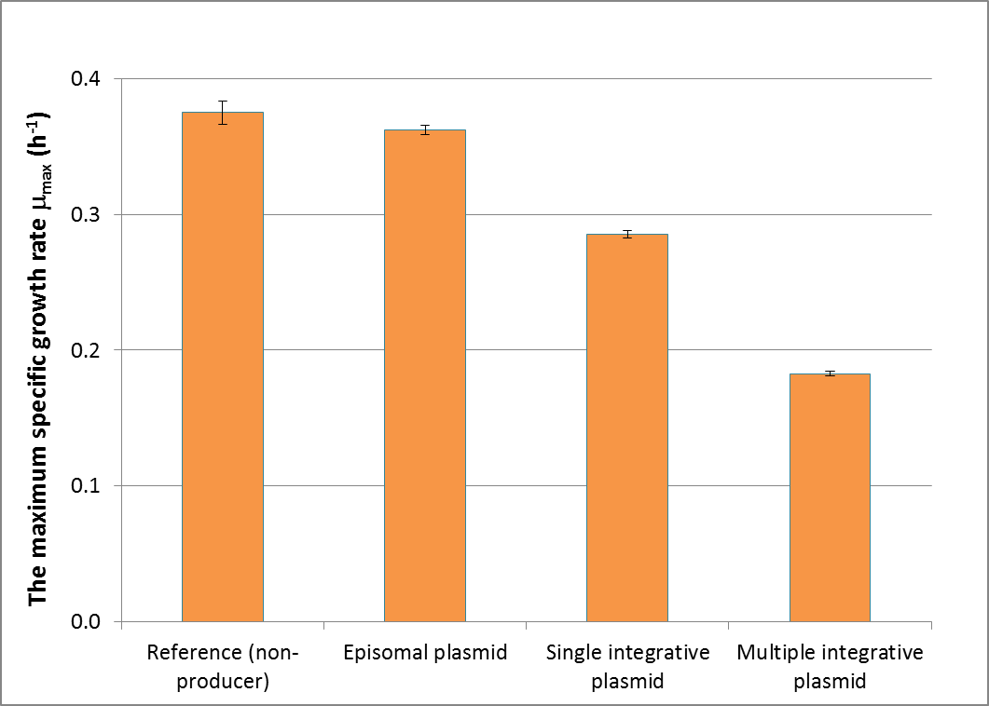
Figure S1. The maximum specific growth rate (μ_{max}) of the recombinant strains grown in defined mineral medium in 96-well plate. Data are mean and + standard deviations from six independent colonies from each strains. The experiments were performed in triplicates.

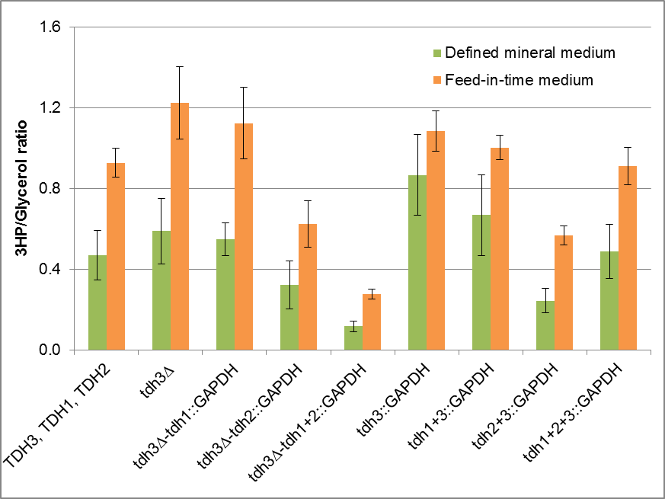
Figure S2.The ratio of 3HP/Glycerol in the recombinant strains grown in defined mineral or feed-in-time media. Data are mean and + standard deviation from six independent colonies from each strains. The cultivations were performed in biological triplicates.

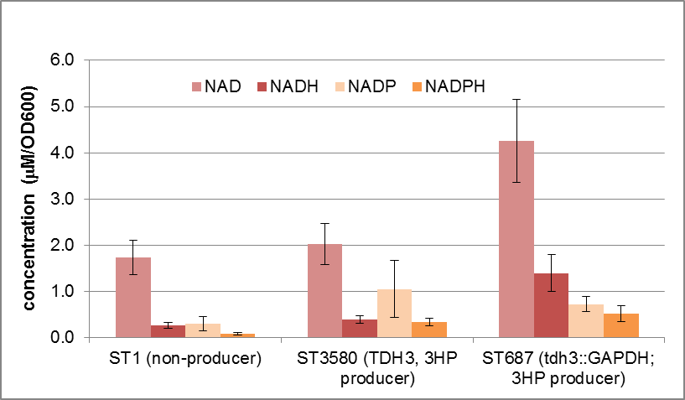
Figure S3. Intracellular concentrations of redox cofactors in the engineered strains. Data are mean and + standard deviations from biological triplicates.

Figure S4. Growth and metabolites production profiles of the best 3HP-producing strain ST687 grown in C-limited fed-batch fermentation (a and b) and N/C-limited fed-batch fermentation (c and d). The cultivations were performed in triplicates; here the replicates of fermentations from Figure 4 are shown.

Supplementary Tables

Table S1. Oligonucleotide sequences. Underlined sequences represent overhangs used in USER cloning.
Primer name | Sequence (5’ ->3’)
ID53_ACC1**_fw | CGTGCGAUTCATTTCAAAGTCTTCAACAATTT
ID54_ACC1**_rv | AGTGCAGGUAAAACAATGAGCGAAGAAAGCTTA
ID176_CaMCR_fw_NEW | ATCTGTCAUAAAACAATGAGTGGTACAGGTAG
ID177_CaMCR_rv_NEW | CACGCGAUTCAGACTGTAATGGCTCTACCTC
ID5_PTEF1_fw | ACCTGCACUTTGTAATTAAAACTTAG
ID6_PTEF1_rv | CACGCGAUGCACACACCATAGCTTC
ID7_PPGK1_fw | cgtgcgauggaagtaccttcaaaga
ID8_PPGK1_rv | ATGACAGAUTTGTTTTATATTTGTTG
ID644_ACSse_U1_fw | AGTGCAGGUAAAACAATGTCACAAACACAC
ID645_ACSse_U1_rv | CGTGCGAUTCATGATGGCATAGCAATAG
ID738_ALD6_U2_fw | ATCTGTCAUAAAACAATGACTAAGCTACACTTTGACAC
ID739_ALD6_U2_rv | CACGCGAUTCACAACTTAATTCTGACAGCTTTTAC
ID1187_PDC1_U1longer_fw | AGTGCAGGUAAAACAATGTCTGAAATTACTTTGGGtaaatatttg
ID1188_PDC1_U1longer_rv | CGTGCGAUTCATTGCTTAGCGTTGGTAGCAGCAGTC
ID092_URA3-DW-rev | CGCTTCCCATCCAGCATTTC
ID093_URA3-UP-rev | CTGTCGTTCCATTGAAAGC
ID141_marker-UP-fwd | AGAACAGCUGAAGCTTCGTACG
ID150_KlLEU2-UP-rev | CAGAAGCATAACTACCCATTCC
ID142_marker-DW-rev | AGGCCACUAGTGGATCTGATATCAC
ID151_KlLEU2-DW-fwd | TGGAAGAGGCAAGCACGTTAGC
ID504_TDH3-UP-FWD1 | GCAATTGACCCACGCATGTA
ID506_TDH3-UP-Rev | AGCTGTTCUCGAAACCGTTAATAGCAACTC
ID507_TDH3-DW-fwd | AGTGGCCUACGTTGCCAAGGCTTAAGTG
ID508_TDH3-DW-rev1 | GGAAGAAATGAGGATTGAGC
ID337_CaGAPDH-fwd | ACAAAACAAAAUGGCAAAGATAGCTATTAATGG
ID322_CaGAPDH-rev | AGCTGTTCUCTATTTTGCTATTTTTGCAAAGTAAGC
ID10657_tdh3UPrevU2 | ATTTTGTTTTGUATGTGTGTTTATTCGAAACTAAG
ID155_TDH1-UP-rev | ATTTTGTTTTGUGTGTAAATTTAGTGAAGTACTG
ID157_TDH1-UP-fwd2 | AGTTGGGCTGAGCTTCTGATCC
ID160_TDH1-DW-fwd | AGTGGCCUCTTGATCGAATATGTTGCCAAGGC
ID161_TDH1-DW-rev1 | AGAGCACTTCCGAACTTGATCC
ID163_TDH2-UP-rev | ATTTTGTTTTGUTTGTTTGTGTGATG
ID164_TDH2-UP-fwd1 | GTACCAACATCGGTTGAAACAG
ID166_TDH2-DW-fwd | GGAGTTAAAUTTAAGCCTTGGCAACGAGGCCACT
ID167_TDH2-DW-Rev1 | CATTCAAGAGGAAACAGAAGTGG
Table S1. (Continue)
Primer name | Sequence (5’ ->3’)
Genotying primers
ID903_X-3-up-out | TGACGAATCGTTAGGCACAG
ID905_X-4-up-out | CTCACAAAGGGACGAATCCT
ID2221_ColoPCR_vec_TADH1_towards out | GTTGACACTTCTAAATAAGCGAATTTC
ID505_TDH3-UP-test-fwd | CCTCTTAACAGGTTCAGACG
ID509_TDH3-DW-rev2 | GACTTCTCTGTTCCCATTAGG
ID156_TDH1-UP-fwd1 | GTAACCACACCACATTTTCAGG
ID162_TDH1-DW-rev2 | TGGTCGTGGAACTTGCATAGC
ID165_TDH2-UP-fwd2 | TATCTTGACGGGTATTCTGAGC
ID168_TDH2-DW-Rev2 | CATTCCTTAGAGATGCAGCTCC
qPCR primers
ID434_ALG9_fw | CACGGATAGTGGCTTTGGTGAACAATTAC
ID435_ALG9_rv | TATGATTATCTGGCAGCAGGAAAGAACTTGGG
ID980_ACC1**_fw | TTGTTAAGAGTCACGGTGGT
ID981_ACC1**_rv | CGGCCATACGGATATATTCTG
ID982_CaMCR_fw | TGCCTTGGCTGAAAGAATG
ID983_CaMCR_rv | CCTGGACCCAATTCTGCTT

Table S2. Oligos and templates used to generate gene fragments for USER cloning and yeast transformation by PCR
Fragment ID | Description | Oligo forward | Oligo Reverse | Template
BB12_ACC1**<- | ACC1^{S659A, S1157A} from S. cerevisiae (ACC1**) | ID53 | ID54 | pSP-GM2-ACC1^{S659A, S1157A}
BB11_->CaMCR | Malonyl-CoA reductase from Chloroflexus aurantiacus | ID176 | ID177 | pYC6
BB10_<-P_{TEF1}-P_{PGK1}-> | Fused promoters of TEF1 and PGK1 genes from S. cerevisiae | ID5 | ID8 | plasmid pSP-GM1
BB157_ACC1**<-pTEF-pPGK->CaMCR | ACC1**<-P_{TEF1}-P_{PGK1}->CaMCR | ID53 | ID177 | pCfB298
BB119_SEacs^{L641P} <- | Acetyl-CoA synthetase from Salmonella enterica (SEacs^{L641P}) | ID644 | ID645 | pCfB324
BB158_ALD6-> | Acetaldehyde dehydrogenase 6 from S. cerevisiae | ID738 | ID739 | S. cerevisiae gDNA (CEN.PK102-5B)
BB159_PDC1<- | Pyruvate decarboxylase isozyme 1 from S. cerevisiae | ID1187 | ID1188 | S. cerevisiae gDNA (CEN.PK102-5B)
BB8_<-P_{TEF1} | TEF1 promoter from S. cerevisiae | ID5 | ID6 | S. cerevisiae gDNA (CEN.PK102-5B)
BB43_KlURA3-UP | Upper part of LoxP-KlURA3-LoxP selection marker cassette | ID141 | ID093 | pUG72
BB44_KlURA3-DW | Down part of LoxP-KlURA3-LoxP selection marker cassette | ID092 | ID142 | pUG72
BB47_KlLEU2-UP | Upper part of LoxP-KlLEU2-LoxP selection marker cassette | ID141 | ID150 | pUG73
BB48_KlLEU2-DW | Down part of LoxP-KlLEU2-LoxP selection marker cassette | ID151 | ID142 | pUG73
tdh3-null-UP | Upstream part of TDH3 locus | ID504 | ID506 | S. cerevisiae gDNA (CEN.PK102-5B)
tdh3-DW | Downstream part of TDH3 locus | ID507 | ID508 | S. cerevisiae gDNA (CEN.PK102-5B)
tdh3-null-up-LEU2 | UP transformation fragment for deletion of TDH3 | ID504 | ID150 | tdh3-null-up + BB47
tdh3-DW-LEU2 | DW transformation fragment for deletion/CDS exchange of TDH3 | ID151 | ID508 | BB48 + tdh3-DW
BB93-CaGAPDH | CaGAPDH for TDH::CaGAPDH | ID337 | ID322 | Clostridium acetobutylicum gDNA
tdh3-cdsex-UP | Upstream part of TDH3 for CDS exchange | ID504 | ID10657 | S. cerevisiae gDNA (CEN.PK102-5B)
tdh3::CaGAPDH-UP-LEU | UP transformation fragment for tdh3::CaGAPDH | ID504 | ID150 | tdh3-cdsex-UP + BB93 + BB47
BB52-tdh2-UP | Upstream part of TDH2 for CDS exchange | ID164 | ID163 | S. cerevisiae gDNA (CEN.PK102-5B)
BB53-tdh2-DW | Downstream part of TDH2 locus | ID166 | ID167 | S. cerevisiae gDNA (CEN.PK102-5B)
tdh2::CaGAPDH-UP-LEU | UP transformation fragment for tdh2::CaGAPDH | ID164 | ID150 | BB52-tdh2-UP + BB93 + BB47
tdh2-DW-LEU | DW transformation fragment for tdh2::CaGAPDH | ID151 | ID167 | BB53-tdh2-DW + BB48
BB49-tdh1-UP | Upstream part of TDH2 for CDS exchange | ID157 | ID155 | S. cerevisiae gDNA (CEN.PK102-5B)
BB50-tdh1-DW | Downstream part of TDH2 locus | ID160 | ID161 | S. cerevisiae gDNA (CEN.PK102-5B)
tdh1::CaGAPDH-UP-URA | UP transformation fragment for tdh1::CaGAPDH | ID157 | ID093 | BB49-tdh1-UP + BB93 + BB43
tdh1-DW-URA | DW transformation fragment for tdh1::CaGAPDH | ID092 | ID161 | BB50-tdh1-DW + BB44

Table S3. Plasmids
Plasmid name | Parent plasmid | Description | Reference/Source
pCfB54 | - | pESC-URA-USER | Jensen et al., 2014 [1]
pCfB255 | - | pX-2-LoxP-KlURA3 | Jensen et al., 2014 [1]
pCfB257 | - | pX-3-LoxP-KlLEU2 | Jensen et al., 2014 [1]
pCfB258 | - | pX-4-LoxP-SpHIS5 | Jensen et al., 2014 [1]
pCfB322 | - | pTY4-LoxP-KlURA3tag | Borodina et al., 2014 [2]
pSP-GM1 | - | plasmid contains double promoters P_{TEF1}-P_{PGK1} | Chen et al., 2014 [3]
pSP-GM2- ACC1^{Ser659Ala, Ser1157Ala} | - | Plasmid contains ACC1** from S. cerevisiae | Shi et al., 2014 [4]
pYC1 | - | Plasmid contains MCR from Chloroflexus aurantiacus (CaMCR) | Chen et al., 2014 [3]
pYC9 | - | Plasmid contains ACS from Salmonella enterica (SEacs^{L641P}) | Chen et al., 2014 [3]
pUG73 | - | Plasmid contains LoxP-KlLEU2 | Euroscarft
pCfB298 | pCfB54 | pESC-URA-ACC1**<-P_{TEF1}-P_{PGK1}-> CaMCR | This study
pCfB343 | pCfB255 | pX-2-LoxP-KlURA3tag- ACC1**<-P_{TEF1}-P_{PGK1}-> CaMCR | This study
pCfB376 | pCfB322 | pTY4-LoxP-KlURA3- ACC1**<-P_{TEF1}-P_{PGK1}-> CaMCR | This study
pCfB474 | pCfB376 | pTY4- KlURA3- ACC1**<-P_{TEF1}-P_{PGK1}-> CaMCR  (removed LoxP sites from pCfB376) | This study
pCfB380 | pCfB257 | pX-3-LoxP-KlLEU2 - SEacs^{L641P} <-P_{TEF1}-P_{PGK1}-> ALD6 | This study
pCfB382 | pCfB258 | pX-4-LoxP-SpHiS5-PDC1<-P_{TEF1} | This study

Table S4. Yeast strains
Strain | Parent strain | Insertion fragments/plasmid | Genotype | Reference/ Source
CEN.PK113-7D (ST1; reference strain) | - | - | MATa URA3-52 HIS3 LEU2 TRP1 MAL2-8^{c} SUC2 | Peter Kötter
CEN.PK102-5B | - | - | MATa ura3-52 his3 Δ1 leu2-3/112 MAL2-8c SUC2 [ura⁻ his⁻ leu⁻] | Peter Kötter
CEN.PK102-5D | - | - | MATa ura3-52 HIS3 LEU2 TRP1 MAL2-8^{c} SUC2 [ura⁻] | Peter Kötter
tdh3-null | CEN.PK102-5B | tdh3-null-up-LEU2 +  tdh3-DW-LEU2 | MATa ura⁻ his⁻ leu⁻  tdh3::LoxP | This study
tdh1::CaGAPDH,  tdh3-null | tdh3-null | tdh1::CaGAPDH-UP-URA + tdh1-DW-URA | MATa ura⁻ his⁻ leu⁻  tdh1::CaGAPDH-LoxP,tdh3::LoxP | This study
tdh2::CaGAPDH,  tdh3-null | tdh3-null | tdh2::CaGAPDH-UP-LEU + tdh2-DW-LEU | MATa ura⁻ his⁻ leu⁻  tdh2::CaGAPDH-LoxP,tdh3::LoxP | This study
tdh1+2::CaGAPDH,  tdh3-null | tdh2::CaGAPDH,  tdh3-null | tdh1::CaGAPDH-UP-URA + tdh1-DW-URA | MATa ura⁻ his⁻ leu⁻  tdh1::CaGAPDH-LoxP,tdh2::CaGAPDH-LoxP,tdh3::LoxP | This study
tdh3::CaGAPDH | CEN.PK102-5B | tdh3::CaGAPDH-UP-LEU + tdh3-DW-LEU | MATa ura⁻ his⁻ leu⁻  tdh3::CaGAPDH-LoxP | This study
tdh1+3::CaGAPDH | tdh3::CaGAPDH | tdh1::CaGAPDH-UP-URA +tdh1-DW-URA | MATa ura⁻ his⁻ leu⁻  tdh1::CaGAPDH-LoxP,tdh3::CaGAPDH-LoxP | This study
tdh2+3::CaGAPDH | tdh3::CaGAPDH | tdh2::CaGAPDH-UP-LEU +tdh2-DW-LEU | MATa ura⁻ his⁻ leu⁻  tdh2::CaGAPDH-LoxP,tdh3::CaGAPDH-LoxP | This study
tdh1+2+3::CaGAPDH | tdh2+3::CaGAPDH | tdh1::CaGAPDH-UP-URA +tdh1-DW-URA | MATa ura⁻ his⁻ leu⁻  tdh1::CaGAPDH-LoxP,tdh2::CaGAPDH-LoxP,tdh3::CaGAPDH-LoxP | This study
3HP-M1 | CEN.PK102-5D | pCfB298 | MATa ura3-52,  2 μ, P_{TEF1}::ACC1** P_{PGK1}::CaMCR URA3 | This study
3HP-M2 | CEN.PK102-5D | pCfB343 | MATa ura3-52,  P_{TEF1}::ACC1** P_{PGK1}::CaMCR KlURA3 | This study
3HP-M3 | CEN.PK102-5D | pCfB474 | MATa ura3-52,  (P_{TEF1}::ACC1** P_{PGK1}::CaMCR KlURA3tag)n | This study
3HP-M4 | CEN.PK102-5B | pCfB474  pCfB257  pCfB258 | MATa ura⁻ his⁻ leu⁻  (P_{TEF1}::ACC1** P_{PGK1}::CaMCR KlURA3tag)n  LoxP-KlLEU2, LoxP-SpHIS5 | This study
3HP-M5 | CEN.PK102-5B | pCfB380  pCfB474  pCfB258 | MATa ura⁻ his⁻ leu⁻  P_{TEF1}:: SEacs^{L641P} P_{PGK1}::ALD6 KlLEU2  (P_{TEF1}::ACC1** P_{PGK1}::CaMCR KlURA3tag)n, LoxP-SpHIS5 | This study
3HP-M6 | CEN.PK102-5B | pCfB382  pCfB380  pCfB474 | MATa ura⁻ his⁻ leu⁻  P_{TEF1}:: PDC1 SpHIS5  P_{TEF1}:: SEacs^{L641P} P_{PGK1}::ALD6 KlLEU2  (P_{TEF1}::ACC1** P_{PGK1}::CaMCR KlURA3tag)n | This study
3HP-M7 | tdh3-null | pCfB382  pCfB380  pCfB474 | MATa ura⁻ his⁻ leu⁻ tdh3 ∆  P_{TEF1}:: PDC1 SpHIS5  P_{TEF1}:: SEacs^{L641P} P_{PGK1}::ALD6 KlLEU2  (P_{TEF1}::ACC1** P_{PGK1}::CaMCR KlURA3tag)n | This study
3HP-M8 | tdh3-null  tdh1::CaGAPDH | pCfB382  pCfB380  pCfB474 | MATa ura⁻ his⁻ leu⁻ tdh3 ∆ tdh1::CaGAPDH, P_{TEF1}:: PDC1 SpHIS5  P_{TEF1}:: SEacs^{L641P} P_{PGK1}::ALD6 KlLEU2  (P_{TEF1}::ACC1** P_{PGK1}::CaMCR KlURA3tag)n | This study
3HP-M9 | tdh3-null  tdh2::CaGAPDH, | pCfB382  pCfB380  pCfB474 | MATa ura⁻ his⁻ leu⁻ tdh3 ∆ tdh2::CaGAPDH, P_{TEF1}:: PDC1 SpHIS5  P_{TEF1}:: SEacs^{L641P} P_{PGK1}::ALD6 KlLEU2  (P_{TEF1}::ACC1** P_{PGK1}::CaMCR KlURA3tag)n | This study
3HP-M10 | tdh3-null  tdh1+2::CaGAPDH | pCfB382  pCfB380  pCfB474 | MATa ura⁻ his⁻ leu⁻ tdh3 ∆ tdh1+2::CaGAPDH, P_{TEF1}:: PDC1 SpHIS5  P_{TEF1}:: SEacs^{L641P} P_{PGK1}::ALD6 KlLEU2  (P_{TEF1}::ACC1** P_{PGK1}::CaMCR KlURA3tag)n | This study
3HP-M11 | tdh3::CaGAPDH | pCfB382  pCfB380  pCfB474 | MATa ura⁻ his⁻ leu⁻  tdh3::CaGAPDH P_{TEF1}:: PDC1 SpHIS5  P_{TEF1}:: SEacs^{L641P} P_{PGK1}::ALD6 KlLEU2  (P_{TEF1}::ACC1** P_{PGK1}::CaMCR KlURA3tag)n | This study
3HP-M12 | tdh1+3::CaGAPDH | pCfB382  pCfB380  pCfB474 | MATa ura⁻ his⁻ leu⁻  tdh1+3::CaGAPDH P_{TEF1}:: PDC1 SpHIS5  P_{TEF1}:: SEacs^{L641P} P_{PGK1}::ALD6 KlLEU2  (P_{TEF1}::ACC1** P_{PGK1}::CaMCR KlURA3tag)n | This study
3HP-M13 | tdh2+3::CaGAPDH | pCfB382  pCfB380  pCfB474 | MATa ura⁻ his⁻ leu⁻  tdh2+3::CaGAPDH P_{TEF1}:: PDC1 SpHIS5  P_{TEF1}:: SEacs^{L641P} P_{PGK1}::ALD6 KlLEU2  (P_{TEF1}::ACC1** P_{PGK1}::CaMCR KlURA3tag)n | This study
3HP-M14 | tdh1+2+3::CaGAPDH | pCfB382  pCfB380  pCfB474 | MATa ura⁻ his⁻ leu⁻  tdh1+2+3::CaGAPDH  P_{TEF1}:: PDC1 SpHIS5  P_{TEF1}:: SEacs^{L641P} P_{PGK1}::ALD6 KlLEU2  (P_{TEF1}::ACC1** P_{PGK1}::CaMCR KlURA3tag)n | This study

Table S5. MRM transitions for NAD⁺, NADH, NADP⁺ and NADPH

 |  | Precursor ion | Product ion | CE, eV | Product ion | CE, eV
NAD | [ESI]+ | 664 | 428 | 23 | 136 | 33
NADH | [ESI]+ | 666 | 643 | 15 | 514 | 25
NADP | [ESI]+ | 744 | 604 | 20 | 622 | 12
NADPH | [ESI]+ | 745 | 605 | 17 | 623 | 12

References
1. Jensen NB, Strucko T, Kildegaard KR, David F, Maury J, Mortensen UH, Forster J, Nielsen J, Borodina I. EasyClone: method for iterative chromosomal integration of multiple genes in Saccharomyces cerevisiae. FEMS Yeast Res. 2014,14:238–248.
2. Borodina I, Kildegaard KR, Jensen NB, Blicher TH, Maury J, Sherstyk S, Schneider K, Lamosa P, Herrgård MJ, Rosenstand I, Öberg F, Forster J, Nielsen J. Establishing a synthetic pathway for high-level production of 3-hydroxypropionic acid in Saccharomyces cerevisiae via β-alanine. Metab Eng. 2015,27:57–64.
3. Chen Y, Bao J, Kim I-K, Siewers V, Nielsen J. Coupled incremental precursor and co-factor supply improves 3-hydroxypropionic acid production in Saccharomyces cerevisiae. Metab Eng. 2014,22:104–109.
4. Shi S, Chen Y, Siewers V, Nielsen J. Improving Production of Malonyl Coenzyme A-Derived Metabolites by Abolishing Snf1-Dependent Regulation of Acc1. mBio. 2014,5:e01130–14.

* These authors contributed equally to the work. Present address: Evolva Biotech A/S, Lersø Park Allé 42-44, DK-2100 Copenhagen Ø, Denmark. 2 Present address: Bio R&D Center, Paikkwang Industrial Co. Ltd., 57 Oehang-4 gil, Gunsans-si, Jellabukdo, Korea. # Corresponding author. Fax: +45 4525 80 01. E-mail address: irbo@biosustain.dtu.dk.

