Supplementary Material: Deregulation of S-adenosylmethionine biosynthesis and regeneration improves methylation in E. coli de novo vanillin pathway
Authors: Aditya M. Kunjapur†, Jason C. Hyun, Kristala L. J. Prather
Affiliations:
Department of Chemical Engineering, Massachusetts Institute of Technology, Cambridge, MA 02139, USA
Synthetic Biology Engineering Research Center (SynBERC), Massachusetts Institute of Technology, Cambridge, MA 02139, USA
† Present address: Department of Genetics, Harvard Medical School, Boston, MA 02115

Figures:
Figure S1. Effect of ppsA and tktA overexpression on specific yields of protocatechuate and vanillate, as well as the effect on culture density, glucose consumption, and acetate production. The increased protocatechuate specific yield from 24-36 h with ppsA and tktA overexpression indicates greater production of protocatechuate per cell rather than a greater number of cells.

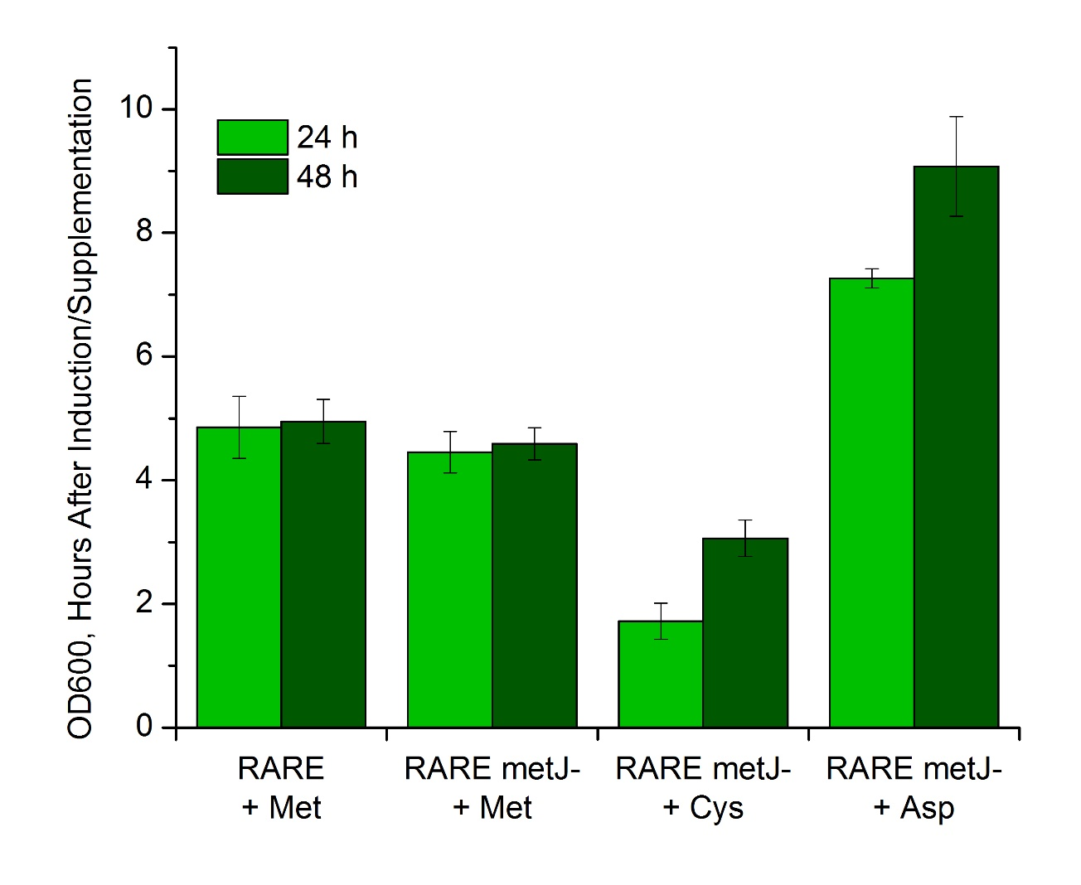
Figure S2. OD₆₀₀ values for cultures supplemented with different amino acids. Cultures subjected to cysteine supplementation displayed significant impairment of biomass formation, whereas cultures subjected to aspartate supplementation displayed accelerated biomass formation and greater final cell density.
Figure S3. Effect of methionine supplementation on cultures containing cells expressing metA* and cysE*.
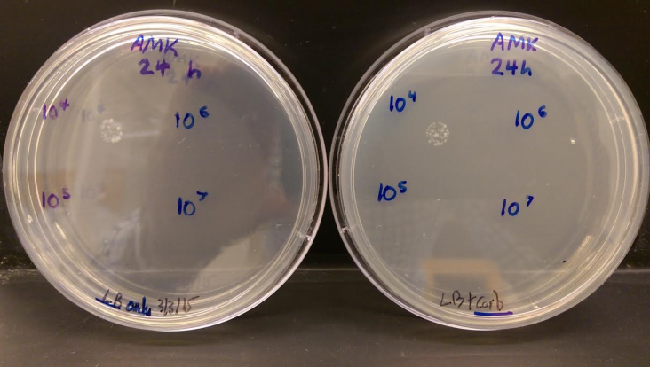
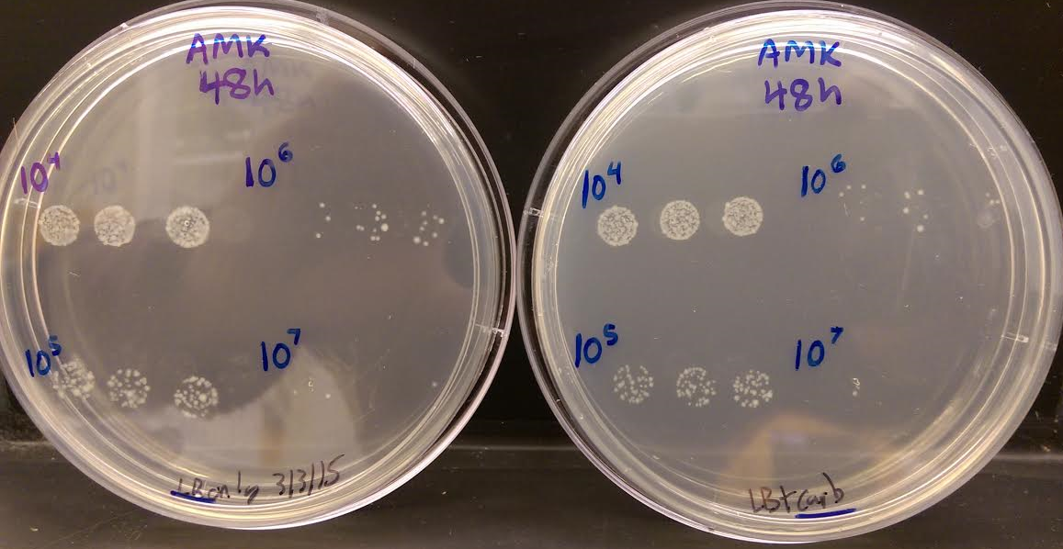
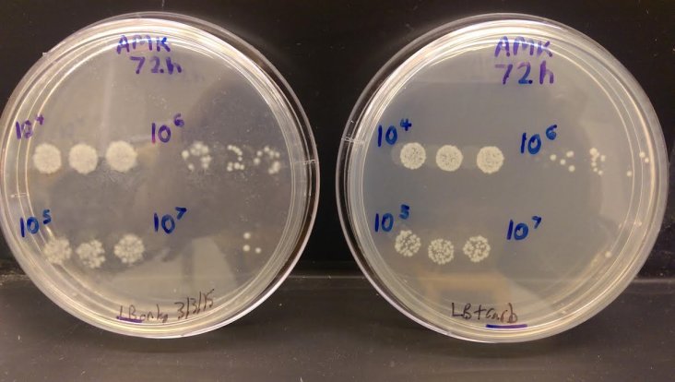
Figure S4. Images of plates testing for potential loss of ampicillin-resistant plasmid. Cells were sampled from cultures overexpressing metA*-cysE* at 24, 48, and 72 hours. Each sample was serially diluted in sterile deionized water to the range of 10⁴-10⁷ fold and then immediately plated by pipetting 10 uL droplets on plates containing LB or LB and 100 mg/L carbenicillin. Carbenicillin was used instead of ampicillin for a more stringent selection. No significant plasmid loss was observed for samples taken at 24, 48, and 72 h.

