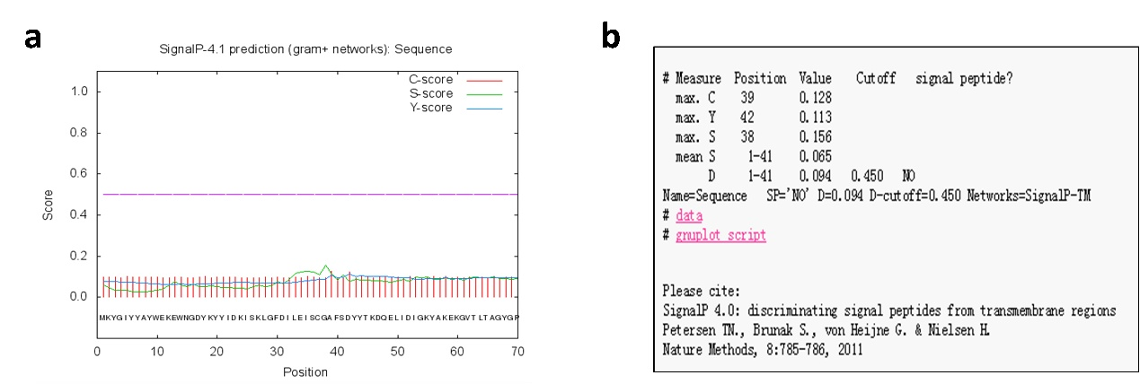

Fig. S1 Prediction of signal peptide by SignalIP 4.1. Signal peptide was predicted by SignalIP 4.1 (http://www.cbs.dtu.dk/services/SignalP/). By analysis of 291 amino acids using SignalIP 4.1, we can see RDPE doesn’t contain any typical signal peptides.

