Additional files for:
Microbial Cell Factories
Hydroxylation of diverse flavonoids by CYP450 BM3 variants: biosynthesis of eriodictyol from naringenin in whole cells and its biological activities

Luan Luong Chu
chuluongluan218@gmail.com
Ramesh Prasad Pandey
pandey@sunmoon.ac.kr
Narae Jung,
jnr583@naver.com
Hye Jin Jung,
poka96@sunmoon.ac.kr
Eun-Hee Kim
keh@kbsi.re.kr
Jae Kyung Sohng*
sohng@sunmoon.ac.kr

*Corresponding author: Department of BT-Convergent Pharmaceutical Engineering, Sun Moon University, 70 Sunmoon-ro 221, Tangjeong-myeon, Asan-si, Chungnam 336-708, Republic of Korea.
Tel: +82(41)530-2246 Fax: +82(41)544-2919

Abstract
Background: Cytochrome P450 monooxygenase constitutes a significant group of oxidative enzymes that can introduce an oxygen atom in a high regio- and stereo-selectivity mode. We used the Bacillus megaterium cytochrome P450 BM3 (CYP450 BM3) and its variants namely mutant 13 (M13) and mutant 15 (M15) for the hydroxylation of diverse class of flavonoids.
Results: Among twenty flavonoids, maximum seven flavonoids were hydroxylated by the variants while none of these molecules were accepted by CYP450 BM3 in in vitro reaction. Moreover, M13 exhibited higher conversion of substrates than M15 and CYP450 BM3 enzymes. We found that M13 carried out regiospecific 3ʹ-hydroxylation reaction of naringenin with the highest conversion among all the tested flavonoids. The apparent K_{m} and k_{cat} values of M13 for naringenin were 446 µM and 1.955 s⁻¹, respectively. In whole-cell biotransformation experiment with 100 µM of naringenin in M9 minimal medium with 2% glucose in shake flask culture, M13 showed 2.14 and 13.96 folds higher conversion yield in comparison with M15 (16.11%) and wild type (2.47%). The yield of eriodictyol was 46.95 µM (~ 40.7 mg (13.5 mg/L)) in a 3-L volume lab scale fermentor at 48 h in the same medium exhibiting approximately 49.81% conversion of the substrate. In addition, eriodictyol exhibited higher antibacterial and anticancer potential than naringenin, flavanone and hesperetin against various Gram positive and Gram negative bacteria.
Conclusions: We elucidated that eriodictyol being produced from naringenin using recombinant CYP450 BM3 and its variants from B. megaterium, which shows an approach for the production of important hydroxylated compounds of various polyphenols in an industrial that may span pharmaceutical industries.
Keywords: Cytochrome P450 BM3, monooxygenase, hydroxylation, flavonoids
Table of contents
Table S1. Inhibition zone diameter (mm) of four flavonoids along with kanamycin against various Gram-positive and Gram-negative bacteria in disc-diffusion assay.
Table S2. IC₅₀ values of four compounds against AGS, HTC116, Hela, HepG2.
Figure S1. The UV maxima absorbance and exact mass analysis of naringenin (A) and reaction products P1 (B), P2 (C), P3 (D). P1 have been identified as hydroxylated naringenin while P2 and P3 have been identified as apigenin and hydroxylated apigenin, respectively.
Figure S2. HPLC-PDA, the UV maxima absorbance and HR-QTOF ESI/MS analysis of reaction products and apigenin standard. (A) HPLC-PDA chromatogram; (B) The maxima UV absorbance and exact mass of apigenin and (C) hydroxylated apigenin (a1) are shown.
Figure S3. HPLC-PDA, the UV maxima absorbance and HR-QTOF ESI/MS analysis of reaction products and 3-HF standard. (A) HPLC-PDA chromatogram; (B) The maxima UV absorbance and exact mass of 3-HF and (C) hydroxylated 3-HF (h1) are shown.
Figure S4. HPLC-PDA, the UV maxima absorbance and HR-QTOF ESI/MS analysis of reaction products and flavanone standard. (A) HPLC-PDA chromatogram; (B) The UV maxima absorbance and exact mass of flavanone, (C) mono-hydroxylated (f2), (D) mono-hydroxylated (f3) and (E) di-hydoxylated (f1) are shown.
Figure S5. HPLC-PDA, the UV maxima absorbance and HR-QTOF ESI/MS analysis of reaction products and genistein standard. (A) HPLC-PDA chromatogram; (B) The UV maxima absorbance and exact mass of standard, (C) mono-hydroxylated (g1) and mono-hydroxylated (g2) are shown.
Figure S6. HPLC-PDA, the UV maxima absorbance and HR-QTOF ESI/MS analysis of reaction products and daizein standard. (A) HPLC-PDA chromatogram; (B) The UV maxima absorbance and exact mass of standard, (C) and (D) two mono-hydroxylated (d1, d2) are shown.
Figure S7. HPLC-PDA, the UV maxima absorbance and HR-QTOF ESI/MS analysis of reaction products and biochanin A standard. (A) HPLC-PDA chromatogram; (B) The maxima UV absorbance and exact mass of standard, (C) mono-hydroxylated (b3), (D) demethylated (b2) and (E) combination between demethylated and hydroxylated (b1) are shown.
Figure S8. 1-Dimensional NMR of naringenin standard. (A) ¹H-NMR, (B) ¹³C-NMR.
Figure S9. 1-Dimensional NMR of eriodictyol. (A) ¹H-NMR, (B) ¹³C-NMR.

Table S1.
Pathogens | B. subtilis | M. luteus | S. aureus | P. aeruginosa | E. cloaceae
Flavanone | – | – | – | + | –
Hesperetin | – | – | – | + | +
Naringenin | – | – | – | – | –
Eriodictyol | 11 ± 0.12 | 22.5 ± 0.47 | 16 ± 0.19 | – | –
Kanamycin | 20 ± 0.27 | 9 ± 0.18 | 19 ± 0.43 | 16 ± 0.36 | 21.5 ± 0.24
(–) denotes no inhibition zone; (+), inhibition zone detected .
Values are mean ± standard deviation of at least three independent experiments (p < 0.05)

Table S2.
IC₅₀ (μM) | Naringenin | Eriodictyol | Hesperetin | Flavonone
AGS | > 100 | 19.64 | > 100 | 98.24
HCT116 | > 100 | 35.85 | 48.73 | 48.10
HeLa | > 100 | 100 | > 100 | 33.40
HepG2 | > 100 | 37.72 | > 100 | 102.4

Figure S1.
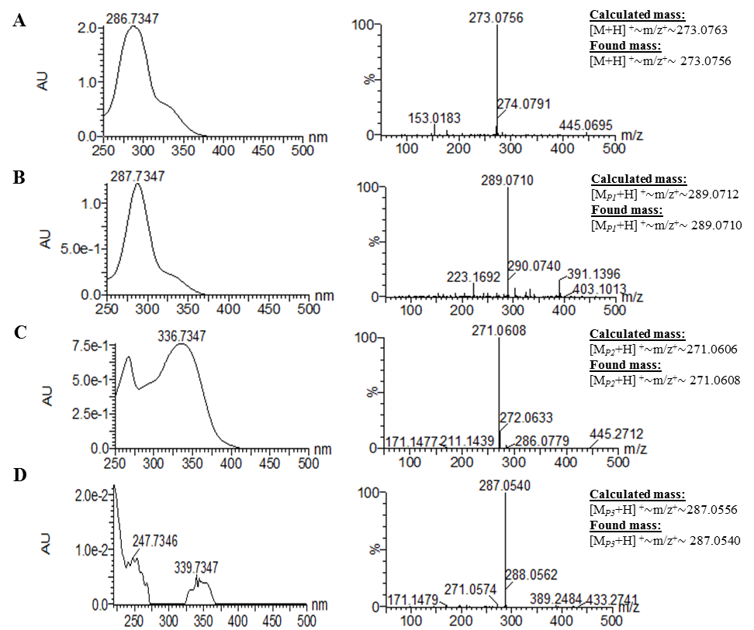
Figure S2
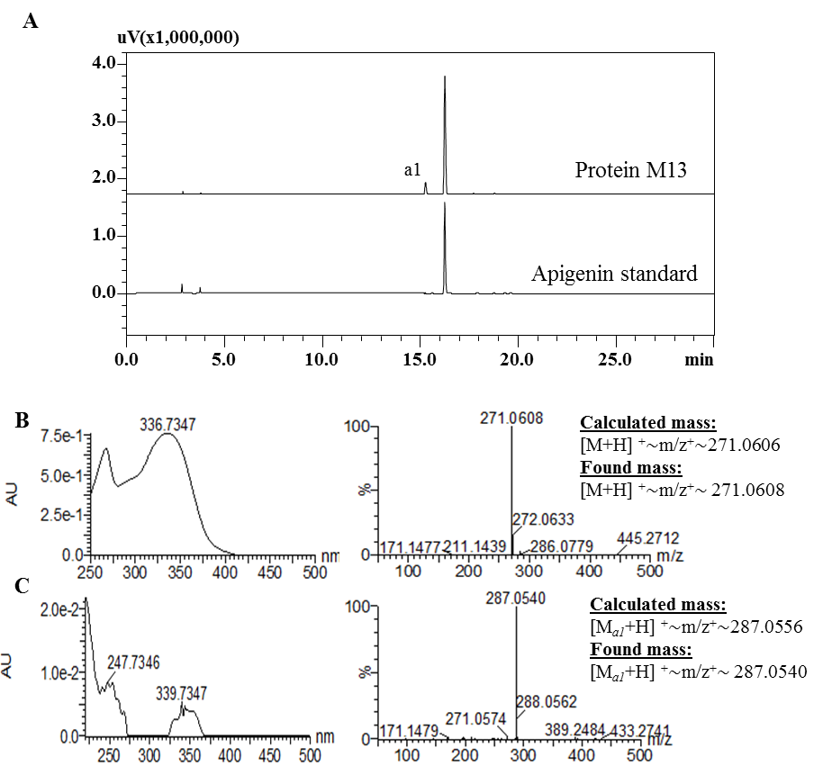
Figure S3
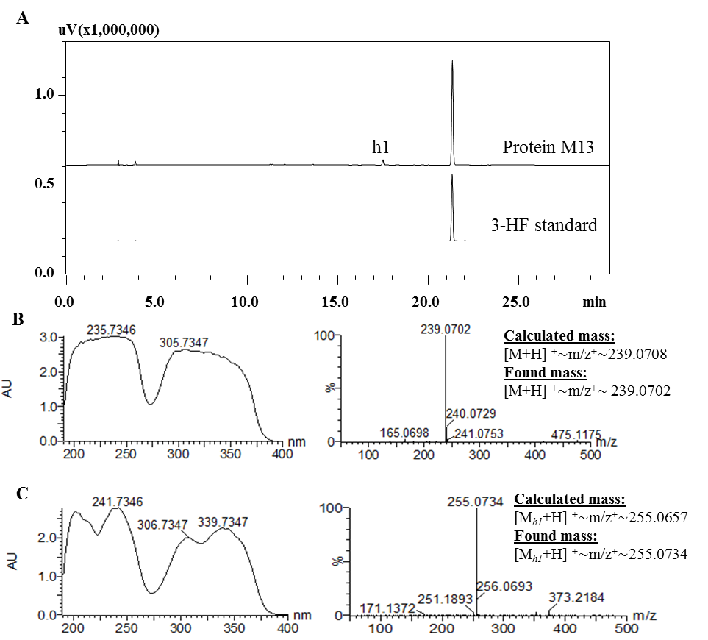

Figure S4
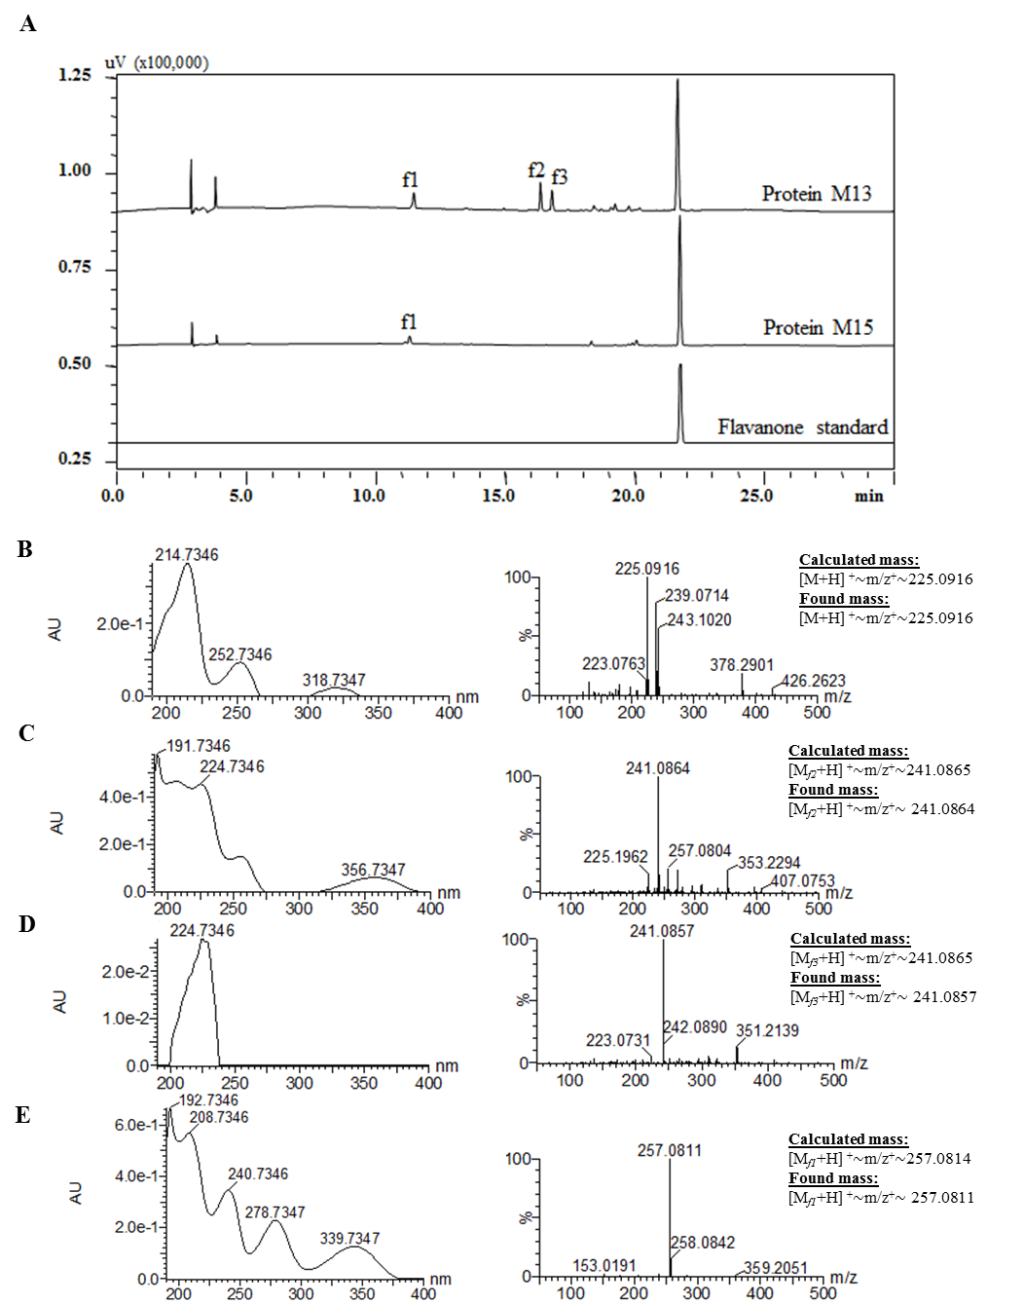
Figure S5
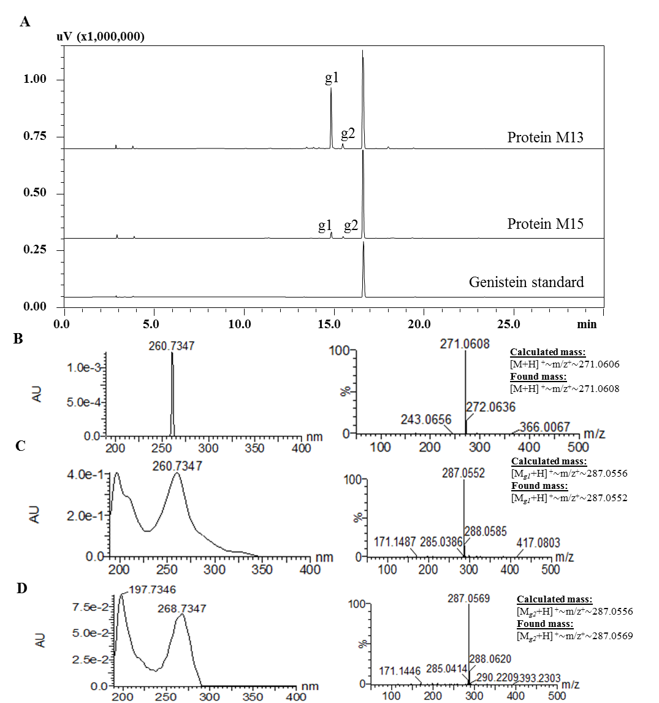
Figure S6
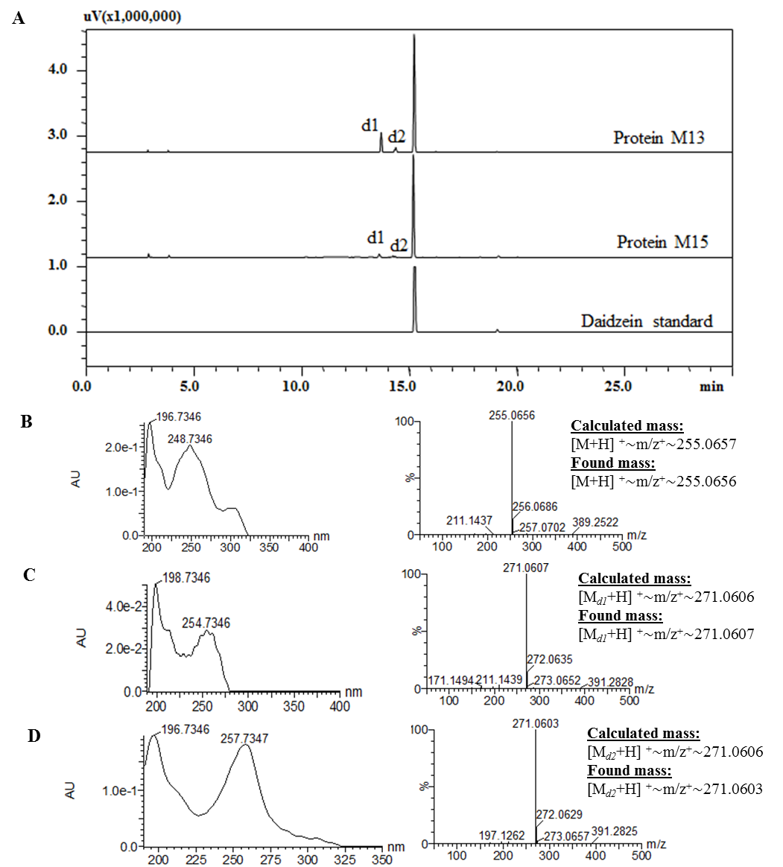
Figure S7
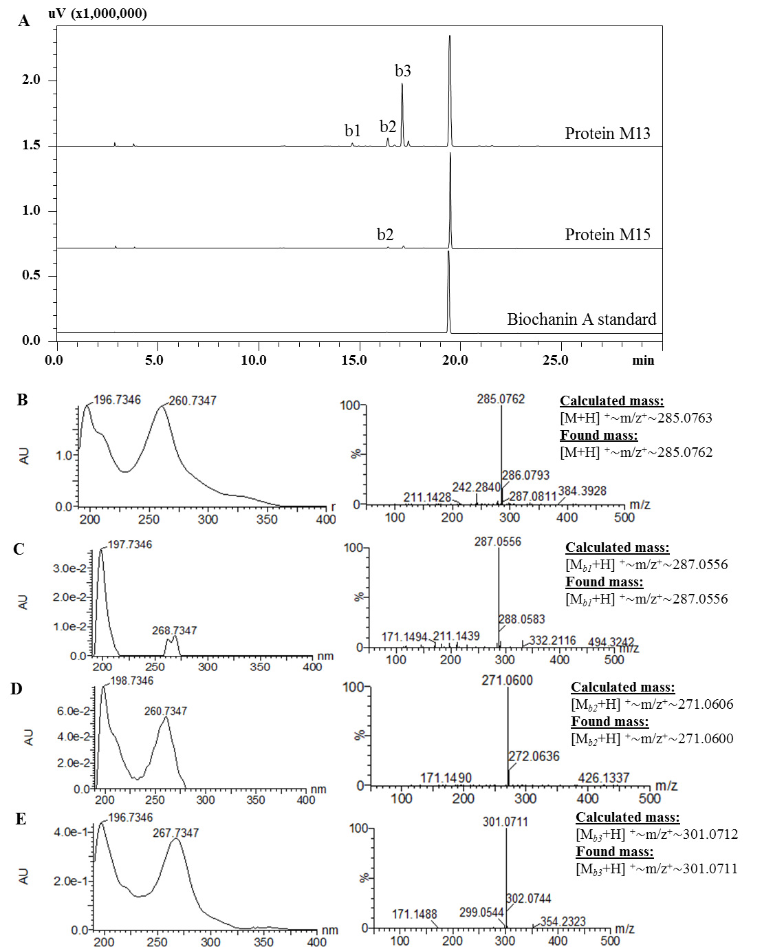
Figure S8. 1-Dimensional NMR of naringenin standard
A. ¹H NMR
B. ¹³C NMR
Figure S9. 1-Dimensional NMR of eriodictyol
A. ¹H NMR
B. ¹³C NMR

