Supplementary information

The new host of Corynebacterium glutamicum for production of the crude violacein

Hongnian Sun¹, Dongdong Zhao², Bin Xiong², Chungzhi Zhang^{1*}, Changhao Bi^{2∗}

¹College of Biotechnology, Dalian Polytechnic University, Ministry of Education, Dalian 116034, P R China.

²Tianjin Institute of Industrial Biotechnology, Chinese Academy of Sciences, Tianjin 300308, P R China.

Supplemental Table S1. Strains, plasmids, and oligonucleotides used in this study.
Strains/plasmids/primers | Relevant characteristics/sequences | Source/reference/notes
Strains
E. coli DH5α | F⁻endA1thi-1 recA1 relA1 gyrA96deoRΦ80dlacΔ(lacZ) M15 Δ(lacZYA-argF)U169hsdR17(r_{K}⁻, m_{K}⁺) λ–supE44 phoA | Invitrogen
ATCC 13032 | C. glutamicum wild-type | ATCC
ATCC 21850 | 4-MT^{r} 5-MT^{r} 6-FT^{r} 4-Ap^{r} 4-FP^{r} TyrHx^{r} Phe⁻ Tyr⁻ | ATCC
Plasmids
pEC-XK99E | C. glutamicum/E. coli shuttle expression vector, Ptrc,lacIq,Kanr | Add gene
pEC-vioABCDE | derived from pEC-XK99E, constitutive expression of C. violaceum vio operon | This study
pEC-J-vio-1 | pEC-XK99E derivative containing vio operon from J. lividum, expressed under control of inducible promoter Ptrc | This study
pEC-J-vio-2 | pEC-XK99E derivative containing synthetic J. lividum vio operon with each gene containing complete C. glutamicum RBS sequence | This study
pEC-C-vio-1 | pEC-XK99E derivative containing synthetic C. violaceum vio operon with each gene containing complete C. glutamicum RBS sequence | This study
pEC-C-vio-2 | pEC-XK99E derivative containing synthetic C. violaceum vio operon with each gene containing complete C. glutamicum RBS sequence, which gene order changed to vioB, vioA, vioE, vioC, vioD | This study
pKMV-vioA | cloning vector in E. coli，Kanr，colE1 ori, containing vioA from C. violaceum | This study
pKMV-vioB | cloning vector in E. coli，Kanr，colE1 ori, containing vioB from C. violaceum | This study
pKMV-vioC | cloning vector in E. coli，Kanr，colE1 ori, containing vioC from C. violaceum | This study
pKMV-vioD | cloning vector in E. coli，Kanr，colE1 ori, containing vioD from C. violaceum | This study
pKMV-vioE | cloning vector in E. coli，Kanr，colE1 ori, containing vioE from C. violaceum | This study
Oligonucleotides
SD sequences | GAAAGGAGGTTTGGACA | This study
pEC-P1-F | CCAGGTCTCAAGCCGGATAAAACGAAAGGCTCAGTCG | This study
pEC-P1-R | CCAGGTCTCAGCATTCACCACCCTGAATTGACTCTCTTCCGG | This study
pEC-P2-F | CCAGGTCTCAATGCGCAACGCAATTAATGTGAGTTAGC | This study
pEC-P2-R | CCAGGTCTCATACGAAATTCCTTTTTAACGTTCACTGTTTCC | This study
C-vioA-F | CCAGGTCTCACGTATGAAGCACTCTTCTGACATCTGTATCG | This study
C-vioA-R | CCAGGTCTCAACCTCCTTTCCTATCTTCTCAAAGCAGCGATTCTTTGC | This study
C-vioB-F | CCAGGTCTCAAGGTTTGGACAATGAGCATTCTGGATTTCCCGCGT | This study
C-vioB-R | CCAGGTCTCACTCCTTTCCTATTAGGCCTCGCGGCTCAGT | This study
C-vioC-F | CCAGGTCTCAGGAGGTTTGGACAATGAAAAGAGCTATCATCGTTGGTGGTGG | This study
C-vioC-R | CCAGGTCTCAAAACCTCCTTTCCTAGTTAACTCTACCGATCTTGTACCAAACG | This study
C-vioD-F | CCAGGTCTCAGTTTGGACAATGAAAATCTTGGTTATCGGTGCTGGTCC | This study
C-vioD-R | CCAGGTCTCACCAAACCTCCTTTCCTATCTTTGCAAAGCGTATCTCAAGTTTTGAGCC | This study
C-vioE-F | CCAGGTCTCATTGGACAATGGAAAACAGAGAACCACCATTGTTGCC | This study
C-vioE-R | CCAGGTCTCAGGCTATCTCTTAGCAGCGAAAACAGCG | This study
J -pec1-F | CCAGGTCTCAGGATAAAACGAAAGGCTCAGTCGAAAG | This study
J -pec1-R | CCAGGTCTCACCTCGCTAGCGCGTTGCTGCTTCGC | This study
J -pec2-F | CCAGGTCTCAGAGGAAGAGCCAGAGCAGAAGG | This study
J -pec2-R | CCAGGTCTCACACTGTTTCCTGTGTGAAATTGTTATCCGC | This study
J -vio-F | TGAACGTTAAAAAGGAATTTCGTATGAAGCATTCTTCCGATATCTGCATTGTCGGC | This study
J- vio-R | TCGTTTTATCCGGCTAGCGCTTGGCGGCGAAGACG | This study
J-vioA-F | CCAGGTCTCAGTATGAGCACGTATTCTGACATTTGCATCG | This study
J-vioA-R | CCAGGTCTCAACCTCCTTTCTCATGCGCGCTCGGTCGAGG | This study
J-vioB-F | CCAGGTCTCAAGGTTTGGACAATGAGCCTACTTGACTTCCCCCGCC | This study
J-vioB-R | CCAGGTCTCACTCCTTTCTCAAGCCTCTCTTGACATCTTTCCCCG | This study
J-vioC-F | CCAGGTCTCAGGAGGTTTGGACAATGCATAAAATCATTATCGTCGGCGG | This study
J-vioC-R | CCAGGTCTCACAAACCTCCTTTCTTAATTTACCCTTCCAAGTTTGTACCA | This study
J-vioD-F | CCAGGTCTCATTTGGACAATGAAAATTCTCGTCATCGGCGCAGG | This study
J-vioD-R | CCAGGTCTCATTCTTAGCGGCCCAGCGCGTAG | This study
J-vioE-F | CCAGGTCTCAAGAAAGGAGGTTTGGACAATGCCGACACACGTCTCCCC | This study
J-vioE-R | CCAGGTCTCAGTCAGGTGTTGCAAGACGTAAAGAC | This study
C-pec-F | CCAGGTCTCAAGCCGGATAAAACGAAAGGCTCAGTCG | This study
C-pec-R | CCAGGTCTCAATACGAAATTCCTTTTTAACGTTCACTGTTTCC | This study
C-vio-F | CCAGGTCTCAGTATGAAGCACTCTTCTGACATCTGTATCG | This study
C-vio-R | CCAGGTCTCAGGCTATCTCTTAGCAGCGAAAACAGCG | This study
2C-pec-F | CCAGGTCTCAAGCCGGATAAAACGAAAGGCTCAGTCG | This study
2C-pec-R | CCAGGTCTCAATACGAAATTCCTTTTTAACGTTCACTGTTTCC | This study
2C-vioB-F | CCAGGTCTCAAGCCGGATAAAACGAAAGGCTCAGTCG | This study
2C-vioB-R | CCAGGTCTCAATACGAAATTCCTTTTTAACGTTCACTGTTTCC | This study
2C-vioA-F | CCAGGTCTCAAGGTTTGGACAATGAAGCACTCTTCTGACATCTGTATCG | This study
2C-vioA-R | CCAGGTCTCACTCCTTTCCTATCTTCTCAAAGCAGCGATTCTTTGC | This study
2C-vioE-F | CCAGGTCTCAGGAGGTTTGGACAATGGAAAACAGAGAACCACCATTGTTGCC | This study
2C-vioE-R | CCAGGTCTCACAAACCTCCTTTCCTATCTCTTAGCAGCGAAAACAGCG | This study
2C-vioC-F | CCAGGTCTCATTTGGACAATGAAAAGAGCTATCATCGTTGGTGGTGG | This study
2C-vioC-R | CCAGGTCTCATGTCCAAACCTCCTTTCCTAGTTAACTCTACCGATCTTGTACCAAACG | This study
2C-vioD-F | CCAGGTCTCAGACAATGAAAATCTTGGTTATCGGTGCTGGTCC | This study
2C-vioD-R | CCAGGTCTCAGGCTATCTTTGCAAAGCGTATCTCAAGTTTTGAGCC | This study

Supplemental Figure S1
- The correlation of Absorbance at 570nm and concentration of crude violacein.
- The correlation of Absorbance at 600nm and concentration of L-tryptophan

- The correlation of Absorbance at 600nm and cell dry weight.
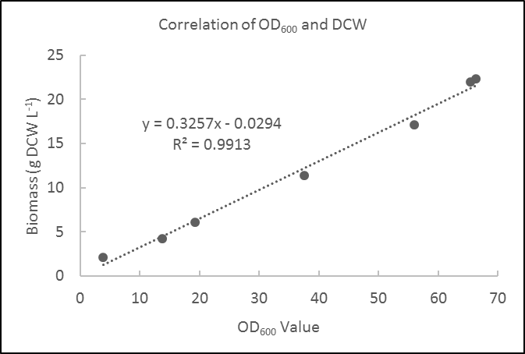

Figure S2. Batch cultivations of C. glutamicum in LBHIS broth.
Following activated cultivation in LBHIS at 30°C and 200 rpm for 24h, 4% of inoculum was transferred into 25 mL LBHIS broth and then was incubated for 4h at 30°C and 200 rpm followed by cultivating with 0.5 mM IPTG at 20°C for 48h.

